A Guidance Booklet for Childcare Practitioners.
Welcoming new children into the setting.
‘Transition is a process, not an event.’
Birthto5matters (2018).

(Source: Discover, 2023)

Contents Page Numbers

Introduction – Page 3, 4

How to use the Guidance booklet - Page 5

The needs of the child - Page 6, 7

The role of the adult – Page 8, 9

Partnership - Page 10

Interventions – 11, 12

Outcomes - 13

Reference list - 14, 15, 16

Introduction

This booklet will discuss transitions made from home to educational childcare for children aged six weeks to 2 years.
Education Scotland (2021) describes transitions as steps young children make from their home environment with their caregivers to early learning and could be their first experience of leaving their loved ones. Transitions and changes are something everyone experiences but can be overwhelming for children and loved ones. Understanding the importance of communication is significantly important when transitioning children into new environments and supplying the best care for them. ACT Government (2023) says the way to an effective transition involves communication from practitioners, families and multi-agencies to ensure the child's needs are met and practitioners know their story. ACT government (2023) also discusses the importance of positive experiences during transitions and understands the meaning behind a successful experience for children.
Effective transitions even from a young age allows children to:
- Feel a sense of belonging
- Feel part of the community
- Build new relationships
- Improve their confidence
- Promote their learning and wellbeing.
- Feel safe and secure

The scientific evidence proves the importance of effective transitions as many brain development experiments have taken place. Harvard University (2011) implies that brain development begins after contraception and continues through life, the brain of an infant develops through experiences and has a lasting impact on the architecture of their brains. Experiences shape each Childs brain and decides if their brains will be strong proving the importance of positive experiences even through transitions.
Brain Architecture – comprised of billions of connections between individual neurons across different areas of the brain. Lightning-fast communications that specialize in different brain functions. (Center on the developing child, 2022).
Bronfenbrenner (1979, 1986) supports this when he found that children who experience smooth transitions from their home into early education were more likely to be successful in future transitions. The outcomes of a child's learning would depend on the environment they were going into and how neutering practitioners were.
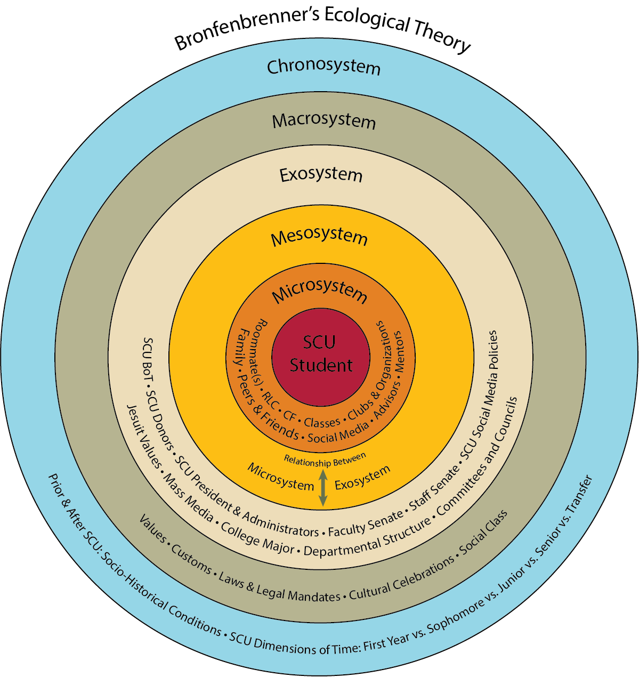
(Source: Santa Clara University 2023)

How to use this guidance booklet

‘Research shows that the quality and consistency of a child’s relationships with adults is critical to health brain development’ (National scientific council on the developing child, 2004)
This guidance booklet is used by childcare practitioners to understand if they can supply an effective transition for family and children. This booklet is designed for professionals working with children aged six weeks up to 2 years old and based in a secluded setting. it should be used to enhance the understanding of effective transition by communication which will help promote Childrens learning and development.
This handbook is divided into 9 sections which can be found on the context page. It will explain the separate ways to help with transitions and how to make it go as smoothly as possible. Understanding that every child is different and treating each child and family as their own individual is vital when going through this process.
Birthto5matters (2021). states that childcare practitioners are specifically responsible for groups of children which includes them building strong relationships with them and their families. This is described as the ‘triangle of trust’, appointing a key member of staff to each child and their family allows them to build nurturing relationships with. The key worker job is to ensure the child feels emotionally secure and supplies a source of contact for the parents.

The Needs of The Child

WJEC (2019) Meeting the needs of each child is part of your job as a practitioner, but each child is different and when integrating from home into nursery, they may have different routines. This may include:
- Sleeping times
- Where the child sleeps
- Eating times
- Activities
- Religions
- Toileting
- Comforters
Ensuring you respect the child’s needs, and the parents' wishes is vital. Communicating with the parents during the transition stage is an important way to find out about routines at home and allows you to continue within the nursery setting. Discussing with the family at the end of the day about the routine ensures consistency is kept between nursery and home, which gives the child a sense of normality and self-confidence. Flexibility is needed when working with young children to attend to their needs and close attention should be provided. (WJEC 2019)
The theory of Winnicott (1964) significantly focuses on the importance of a primary care giver for a baby and presents the idea of a ‘good-enough mother’. He tells, a baby would not survive without their primary care giver to give them their needs, understanding the care and needs of a child ensures them a happy and positive future. Each child within the care of the practitioner needs to be cared for, nurtured and respected as they become the primary care giver during their stay in nursery.

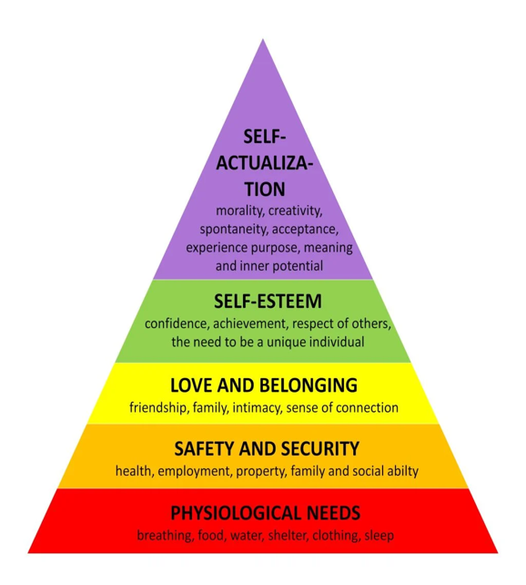
Maslow hierarchy of needs is a five-tier model of the necessary needs of the human needs. It consists of 5 tiers of hierarchy which demonstrate the importance of safety, love, esteem, self actualisation and physiology.
(Source: Maslow’s Hierarchy of Needs, 1943)
Maslow (1943, 1954) theory shows what is needed from the bottom to reach the top of the pyramid. Maslow (1943, 1954). argues that survival is significant in achieving the hierarchy of the Pyramid. He argues humans are motivated by our needs and if they are not met, we cannot thrive and reach our potential. Understanding this is important to reach the needs of each individual child.
Play is an important part of a child's needs as it allows them to learn and develop happily and freely. As Nidirect (no date) suggests. Playing is an enjoyable way where children can express themselves in an enjoyable and natural way, it allows children to stay active enhancing healthy development. Children need unstructured play chances from birth up to puberty. Play is important to develop confidence, self-esteem, social skills and Independance which is vital to learn for adulthood.

Role Of the Adult

Young children and babies are dependent and incapable of their own self-care, supplying a high standard of service and showing general care and empathy ensures you are a professional practitioner. UNICEF (2023) convention on the rights of the child ensures every child has the right to life, development and survival. It allows children to live and reach their full potential:
- Physically
- Emotionally
- Spiritually
- Socially
- Mentally.
This should be at the forefront of every practitioner, caregiver's mind when caring for babies and young children.
Bowlby (1990) theory focuses on the emotional and social development of the child and how the relationship between the infant and the primary caregiver is shaped. He believes that infants born into the world are already preprogrammed to build attachments with their primary caregivers, this is because babies cannot survive without relying on someone. He focuses on an attachment called primary attachment which focuses on the relationships with the baby that helps them survive. Although he doesn’t rule out other attachments and explains other attachments are essential but forces more on the mother and baby bond. Bowlby (1951) talks about if the attachment between mother and child is disturbed during the 2-year period from birth the child will suffer consequences in the future from material deprivation.

Vygotsky’s (1896-1934) theory focuses on the social interactions and the influence of the infant's cognitive development. He talks about the importance of more knowledgeable adults like a parent or teaching to develop the child's learning and describes learning as a guided social process. Infants and babies learn from what they are taught and what they see around them, he believed that religion played a huge part in cognitive development and varies across diverse cultures.
When working with young children it is important to provide them with a primary caregiver when in the setting, this is known as a key worker. A key worker handles working closely with the families and children and ensuring that specific child’s needs are met. It is important every child has a key worker as research shows that children receive help from having one key person to attend to their personal needs and thrive when having that one person they trust and respect. The key person is there to develop the children's personal, emotional and social development and help them learn more effectively.
Tatalović Vorkapić, S. & LoCasale-Crouch, J. (2021). They imply that as children grow, they learn to be more independent, this begins when they transition from spending every day in the same routine with the same individual to a new foreign place like nursery which is based around early years learning. Some children are faced with strong feelings of fear and anxiety whereas other children are curious about their new adventure. As practitioners, its our job to understand each child and how they are feeling at each time and working around them. Providing comfort, security, nurture and care.

Partnerships

Gov.uk (No Date). Discussing the importance of working in partnerships with parents, multiagency and children. It is an important part of all practitioners' jobs but essential in ensuring the transition from home to nursery goes as smoothly as possible. Working in partnerships allows us to share knowledge and understand what children like and discover the best way to support them in their early years of learning. Gov.uk (No Date) also suggests that working in partnership with the parents allows practitioners to be aware of the child's routine and try keeping home life the same as nursery life, by doing this stops the child going through too much change at one time.
Although partnerships will all parties is important, Brooker, L. (2008). states partnerships with parents and main caregivers should be priority as they know the child better than anyone. It is the most effective way to help transitions go smoothly as they know the experiences of the child and can supply information on the curriculum the child has been offered. A smooth transition is based on effective partnerships with the community, the child and the caregivers.
Every early year, practitioner must work together to share and provide as much information as possible about each child in their care. Gov.uk (2018) says sharing information will give a clear understanding of their role when supporting each individual child, without this communication and relationships will begin to break down which will prevent the child receiving the quality of care they need. The NSPCC (2023) supported this and said that it is vital for practitioners to work together to gain a full overview of each child's experiences and a harmonized approach to support.
The second system of Bronfenbrenner (1979). Theory discusses the mesosystem, this is about the partnerships between different environments like school, nursery and home. He believed the solid partnerships been the environments and people in the mircrosystem allows the child’s development to grow and be positively affected.

Interventions

There are many ways to help a transition from home to nursery go more smoothly.
Effective interventions for transitions may include:
- Transitional objects
- Stay and play sessions
- Meet and greet with parents and children
- At home books (all about me)
- Supply a clear ‘setting in’ policy
Healthy children (2021). Describes transitional objects to help the children grow from dependance to independence. They work as a way of comfort due to their soft, cuddly textures allowing the child to have something to cuddy when feeling sad or scared. Cuddly toys or blankets are effective as they are familiar for the child and allow them to bring a part of ‘home’ to nursery with them. The comforter also carries the scent from home and from their loved ones giving them the feeling of comfort and security.
Oasis Academy (No Date) says Stay and play sessions are extremely important for each child when starting their transition journey from home into early years learning as it allows the child to play and explore their new setting with their parents alongside them. It also allows the parents to introduce themselves to the teachers and ask any questions they need too. It allows both parent and child to become less anxious about drop off and removes some of the nerves that may be there, the less nerves and anxious feelings there from loved ones allows the child to feel more at ease.

When starting in a new setting each parent and family is given an information pack about the nursery. But some may include an ‘all about me’ pack. This is a great way for parents and caregivers to write down important information about their child, providing this back to the nursery before the child starts their transition allows staff to read and understand more about the child. It allows the practitioners to be more prepared when welcoming the child and can gain their trust and confidence by interacting with activities and toys the child may like. It also allows the practitioners to have a better understanding of the child's routine and try to keep home life the same as nursery life.
Ofsted requires all settings to supply policies and procedures detailed in the Early Years Foundation Stage Statutory framework, ensuring consistency is kept throughout the nursery. Ensure there are no misunderstandings, or your own perspective is used in situations and can lead to a more efficient and effective service. Supplying a clear ‘setting in’ policy is important for all staff, careers and children. It allows children to feel more at ease and can provide parents with a step-to-step technique on their child journey through transition.
The national minimum standards provide a guide for all settings to use which must be followed within the setting. It is designed to ensure that care and provision is met throughout all nurseries and school settings, each setting is assessed and must be fit for people using their service. (gov.uk, 2013).

Outcomes
The outcomes of a positive transition will mean the child is settled, learning, developing and engaging with adults aswell as being happy, playing and exploring with confidence. NCT (No Date). Explains every child is different and some children will cry whereas some children can settle very quickly, so remembering to be patient and caring to each child is important. Recognizing and understanding the needs of each child can ensure transition goes as smoothly as possible.
The new curriculum for Wales (2022) has been developed to enhance children and young people's learning experiences and to provide them with the support necessary to reach their full potential. The aim of the curriculum is to support learners in becoming capable learners, ambitious, creative and to play a role in life and work.
An effective transition will be clear once the child has settled, the child will feel more confident coming into the setting and will feel reassurance a lot quicker or even stop crying completely. Once the child is happy to start playing independently on their own, it is clear they have settled. They then might start building other relationships with other children or practitioners in the setting when they are happy to do so. The child will soon start showing understanding of the environment they are in and feel confident in participating in other activities like singing, dancing, craft and role play. Once a child is settled, they will start demonstrating different emotions and go to different members of staff for support and nurturing.

References
ACT Government (2023). Effective Transitions. Available at: https://www.education.act.gov.au/early-childhood/set-up-for-success-an-early-childhood-strategy-for-the-act/effective-transitions. (Accessed: 18/11/2023)
Birthto5matters (2021). Attachment and the role of the key person. Available at: https://birthto5matters.org.uk/attachment-and-the-role-of-the-key-person/. (Accessed: 23/11/2023)
Birthto5matters. Transitions. [image] Available at: https://birthto5matters.org.uk/transitions/. (Accessed: 18/11/2023).
Bowlby (1951). John Bowlby's Attachment Theory. Available at: https://www.simplypsychology.org/bowlby.html. (Accessed: 29/11/2023)
Bowlby (1990). John Bowlby's Attachment Theory. Available at: https://www.simplypsychology.org/bowlby.html. (Accessed: 29/11/2023)
Bronfenbrenner (1979). What's theory got to do with it?. Available at: https://www.engagingcurriculumsolutions.com. (Accessed: 02/12/2023)
Bronfenbrenner (1979, 1986). Ecological Systems Understandings Of development and Illness. Available at: https://www.ncbi.nlm.nih.gov/pmc/articles/. (Accessed: 20/11/23)
Brooker, L. (2008). Supporting Transitions in the Early Years. McGraw-Hill Education.
Center on the developing child (2022). Brain Architecture. https://developingchild.harvard.edu/science/key-concepts/brain-architecture (Accessed: 01/12/2023)
Discover. (2023). Importance of Unstructured Play to Children’s Development. Available at: https://try.discoverchildcare.co.nz/2023/03/importance-of-unstructured-play-to-childrens-development/. (Accessed: 18/11/2023).

Education Scotland (2023). What are transitions? Available at: https://education.gov.scot/parentzone/my-child/transitions/what-are-transitions/. (Accessed: 18/11/2023).
Gov.uk (2013). National minimum standards for the welfare of children. Available at: https://www.gov.uk/government/collections/national-minimum-standards (Accessed: 01/12/2023)
Gov.uk (2018). Multi-agency safeguarding arrangement. Available: https://www.gov.uk/government/speeches/social-care-commentary-multi-agency-safeguarding. (Accessed: 02/12/2023)
Gov.uk (No Date). Working in partnership with parents and carers. Available at: https://help-for-early-years-providers.education.gov.uk/get-help-to-improve-your-practice/working-in-partnership-with-parents-and-carers (Accessed: 30/11/2023)
Harvard University (2011). Three Core Concepts in Early Development. Available at: https://developingchild.harvard.edu/resources/three-core-concepts-in-early-development (Accessed: 20/11/2023)
Healthy children (2021). Transitional Objects. Available at: https://www.healthychildren.org/English/ages-stages/baby/Pages/Transitional-Objects (Accessed: 02/12/2023)
Maslow (1943, 1954). Maslow’s Hierarchy of Needs. Available at: https://www.simplypsychology.org/maslow.html (Accessed: 27/11/2023)
Maslow’s Hierarchy Of Needs. [Image] Available at: https://www.simplypsychology.org/maslow.html (Accessed: 27/11/2023)
National scientific council on the developing child (2004). Establishing Lifelong Relationships with Supportive Adults and Peers. Available at: https://portal.ct.gov/-/media/DCF/Adolescents/VITAL-Policies/. (Accessed: 23/11/2023)
Nidirect (no date). How Play Helps Children’s Development. Available at: https://www.nidirect.gov.uk/articles/how-play-helps-childrens-development#:~:text=Play. (Accessed: 29/11/2023)

NSPCC (2023). Multi agency working. Available at: https://learning.nspcc.org.uk/child-protection-system/multi-agency-working-child-protection/. (Accessed: 02/12/2023)
Oasis Academy (No Date). Transitions into Nursery. Available at: https://www.oasisacademyshortheath.org/academy-life/nursery/transition-into-nursery. (Accessed: 02/12/2023)
Santa Clara University. Theoretical Framework. [image] Available at: https://www.scu.edu/oml/about-us/theoretical-framework/ (Accessed: 18/11/2023)
Tatalović Vorkapić, S. & LoCasale-Crouch, J. (Eds.). (2021). Supporting Children’s Well-Being During Early Childhood Transition to School. IGI Global. (Accessed 02/12/2023)
The new curriculum for Wales (2022). Six Things You May Not Know about the new curriculum for Wales. Available at: https://www.gov.wales/six-things-you-may-not-know-about-new-curriculum-wales (Accessed: 02/12/2023)
WJEC (2019). The Importance of safe physical care routine for children. Available at: http://resource.download.wjec.co.uk.s3-eu-west-1.amazonaws.com (Accessed: 24/11/2023)

.

