4.0 Wi-Fi connectivity

The NodeMCU (ESP8266 WiFi Module) can be interfaced to any other microcontroller (like Arduino or 8051) through UART and with the help of AT Commands, the Microcontroller can control the ESP8266 (connect to WiFi, update Firmware, etc.).
In order to use the NodeMCU in our Internet related projects, we need to first connect ESP8266 to WiFi and then access it from the internet.
Before going into the details of how to connect NodeMCU to WiFi, you need to understand the WiFi modes of operation of the NodeMCU Module.
WiFi Modes of Operation of NodeMCU
There are three modes of WiFi Operation in the ESP8266 WiFi Module. They are:
- Station Mode (STA)
- Soft Access Point (AP)
- Soft AP + Station
- Station Mode (STA)
1- Station Mode
In Station Mode (STA), the NodeMCU will be connected to a Wi-Fi Route (Access Point). It will be treated as an End node or server.
2- Soft Access Point (AP)
The second mode of operation is Access Point (AP) Mode. In this mode, the NodeMCU acts as an access point and provide WiFi Network to other stations (like mobile or laptop). This mode is widely called Soft Access Point.
3- Soft AP + Station
In the third mode, the NodeMCU Module is configured to act in both Station Mode and Soft AP Mode.

4.1 Testing the Setup: Wi-Fi Scanner

The NodeMCU allows you to easily locate visible wireless networks and its corresponding information. This program obtains the network name (SSID), signal strength (RSSI) and MAC Address.
Wi-Fi Scanner is useful for normal access point users who need to find out the signal strength distribution for their wireless network at home or choose a position for their access point for optimal signal quality.

Task 1: Upload the file WIFIScan.ino (the file is on Moodle) to the NodeMCU.
- If everything went correctly, you now can click the serial link display and you should be able to see a list of the Wireless networks around the device.
- Your real task is to analysis the code and try to divide it to three main phases.
  - Initialising phase
  - Setup phase
  - Loop phase.

Reminder
Click on the magnifying glass on the top right of the window to access the serial console.
Make sure that the baud rate is set to 115200. This rate is also set in the example code, and you can set the baud rate on the bottom left of the serial monitor.
Can you explain how the scanner works?

4.2 Connecting to Wi-Fi
First, you need to know that the ESP8266 can operate as a WiFi client (like a smartphone or laptop) and/or as an access point (like a WiFi router or extender). You can set this modewith:
WiFi.mode(m);
where (m) must be one of the following modes:
WIFI_AP (access point), WIFI_STA (client),
WIFI_AP_STA (AP and client) or WIFI_OFF.
Now let’s connect to your access point:
WiFi.begin(WIFI_SSID, WIFI_PWD);
This will connect you to an access point given its SSID and the password. Please note that this call is not blocking. This means that the code will immediately proceed to the next instruction whether the ESP successfully connects to the access point or not.
Read IP
As mentioned earlier in the lecture to establish any connection with any server you need to know what the IP address of that server is.
If the connection is active and the session is already established, you can use this IP address to access the server. i.e. webserver.

Task: Using the code provided in the file ( Print_IP_address.ino)- (the file is on Moodle).
You need to modify the following two variables with your network credentials, so that your ESP8266 can establish a connection with your router.
// Replace with your network credentials
const char* ssid = "xxxxx";
const char* password = "xxxxx";

Compile and upload the code to your NodeMCU. Press the ESP8266 RESET button, and it will output the NodeMCU IP address on the Serial Monitor similar to the following.
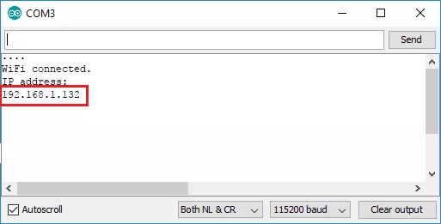

4.3 Sending Local data to a webserver

Task: Modify the code (webserver-e.ino)- (find the file on Moodle) and add the necessary code to control the internal LED where it prompts you.
You should be able to write the missing code as it is the same code we used in previous labs.
Please remember that you would need to
- Initialise the Pin number
- Setup the Pin mode
- Add the control code in the loop , remember to read the cooments in the code to identify where I the code you need to add the mentioned functions
Accessing the Web Server
Open your browser, type the ESP IP address, and you will see the following page. This page is sent by the NodeMCU when you make a request on the ESP IP address.

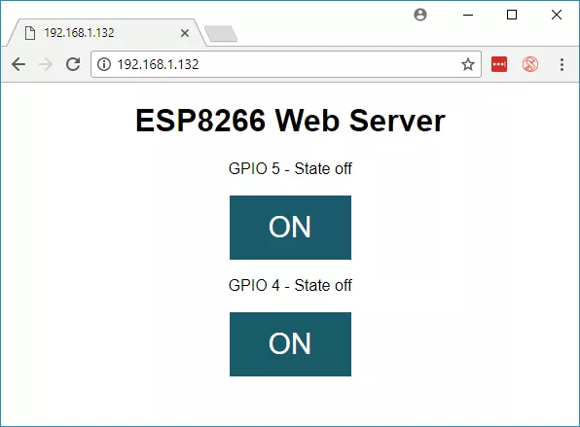
If you take a look at the serial monitor, you can see what’s going on the background. The NodeMCU receives an HTTP request from a new client – in this case, your browser.
- You can also see other information about the HTTP request – these fields are called HTTP header fields, and they define the operating parameters of an HTTP transaction.

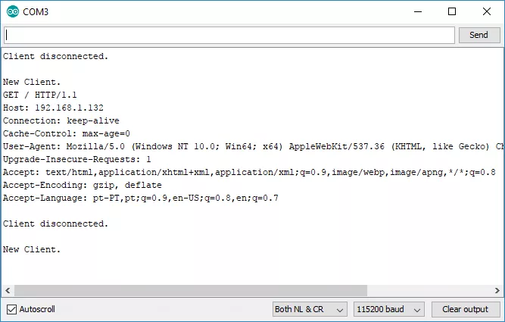

Functions you should understand
WiFi.scanNetworks()
There is on overload of this function that accepts two optional parameters to provide extended functionality of asynchronous scanning as well as looking for hidden networks.
WiFi.scanNetworks(async, show_hidden)
Both function parameters are of boolean type. They provide the flowing functionality:
- asysnc – if set to true then scanning will start in background and function will exit without waiting for result. To check for result use separate function scanCompletethat is described below.
- show_hidden – set it to true to include in scan result networks with hidden SSID.
WiFi.scanComplete()
Check for result of asynchronous scanning. On scan completion function returns the number of discovered networks.
If scan is not done, then returned value is < 0 as follows:
- Scanning still in progress: -1
- Scanning has not been triggered: -2
WiFi.scanDelete()
Delete the last scan result from memory.
WiFi.scanNetworksAsync(onComplete, show_hidden)
Start scanning for available Wi-Fi networks. On completion execute another function.
Function parameters:
- onComplete – the event handler executed when the scan is done
- show_hidden – optional boolean parameter, set it to true to scan for hidden networks
WiFi.SSID(networkItem)
Return the SSID of a network discovered during the scan. Returned SSID is of the String type. The networkItem is a zero-based index of network discovered during scan.
WiFi.encryptionType(networkItem)
Return the encryption type of a network discovered during the scan.
Function returns a number that encodes encryption type as follows:
- 4: ENC_TYPE_CCMP – WPA2 / PSK
- 7: ENC_TYPE_NONE – open network
- 8: ENC_TYPE_AUTO – WPA / WPA2 / PSK
WiFi.RSSI(networkItem)
Return the RSSI (Received Signal Strength Indication) of a network discovered during the scan.

