

Effective Teaching, Learning and Assessment (ETLA)
45 – Minute Micro-teach Reflection Document
Kierran Tomkins | PGCE (PCET) |3rd December 2018

Contents Page

Introduction 3
Lesson Design
Lesson Objective 1 4
Lesson Objective 2 4
Task 1 5
Task 2 5
Critique of Lesson Deployment
Description 5
Personal Feelings & Thoughts 5
Evaluation & Analysis 6
Contemporary Pedagogy (1) 6
Advantages of Pedagogy (1) 6
Disadvantages of Pedagogy (1) 7
Contemporary Pedagogy (2) 7
Advantages of Pedagogy (2) 7
Disadvantages of Pedagogy (2) 7
Crosscutting Enhancement Theme 7
Peer Led Critique 8
Conclusion & Action 8
References 9
Appendices
Appendices 1 10
Appendices 2 11
Appendices 3 12

Introduction
This report will examine the previous micro-teaching session. The written report will be split into sections that will be made up of the lesson plan and design, contemporary teaching pedagogies applied, the cross-cutting enhancement theme, the personal reflection and critique of the lesson deployment.
The personal reflection throughout this document will be linked to the reflective model of Gibbs (1988) who originated the philosophical cycle of ‘Learning by doing’. The reflection throughout this document will flow through the cycle and will be constructed of the following fundamentals that Gibbs presents; description, feelings, evaluation, analysis, conclusion and action, see appendix (1). The personal reflection within this document will flow throughout the lesson design, the applied contemporary pedagogies, the cross-cutting enhancement theme and within the critique on the delivery of the second micro-teach. To culminate the levels of reflection, an evaluation that targets the peer-led critique will be prevalent within this document as it is fundamental in applying this for future development and professional practice, as an aspiring teacher.

Lesson Design
The second micro-teaching session was designed around the time scale of 45 minutes, and there was a continuous decision of basing this second session on the genres of music or an introductory lesson on music theory, as they are two follow up topics that are relevant and were mentioned within in the initial micro-teach. Prior to making any decisions on the topic, the PCET class was divided into 4 different groups that consisted of an average of 6-8 students per cohort.
By knowing the number of students within the class I would be teaching, gave me a greater idea into what topics I could implement, and how many tasks I could set throughout the session. I grew concerned about the class getting divided as I felt this could be a limitation and a disadvantage as some tasks may require more than 6-8 people. Many teachers may favor teaching a smaller class as it is easier to build relationships with the students and allocate more time to their educational needs as individuals (Feldman, 2016, pp. 60-63). To put Feldman’s positive into context I seen this as an advantage as I could adapt the tasks in mind, to suit a smaller class as I felt giving an effective lesson was more important and I could scope in on any gaps in knowledge of the cohort. As being rather indecisive, around what topic, I would deliver, I settled on basing my session around the different genres of music, as the students were still novices around music holistically. This choice made sense, as the next step in expanding their knowledge, as it correlates itself with the knowledge the students had attained in the initial micro-teach.
The objective of the lesson was to present an array of musical genres that consisted of Jazz, Funk, Classical, Heavy Metal and Rap, which are all popular and well-known genres. As I had a vague understanding of what the students already knew about the topic, this decision was made to give the current students a greater awareness of the music they consume daily. Learning about the different genres of music in education is important because it can get students to think of music in a wider context, it can be used to connect music with communities and cultures, and most importantly, it is essential in developing a student’s creativity (Hargreaves, et al, 2012 p. 394). Therefore, the purpose of this lesson was to demonstrate the main fundamentals and articulations of the different genres. My intention behind this lesson was not just to educate the cohort but to heighten their overall connection with music. By having a clear illustration of the lesson rationale, and what I was yet to deliver, I mapped out two learning objectives that would be accomplished within the lesson.
Learning objective (1): The students are required to identify a variety of musical genres, by understanding the fundamentals that differentiate them.
To be able to identify the different genres of music, principles and fundamentals of each genre were to be presented to the students in presentation form, and PowerPoint was the foundation that housed all subject information. (L/O1) was set to heighten the knowledge of the students by presenting facts, figures and videos. This objective was set with the intention of developing the ‘critical thinking’ skills of the present students, giving them the opportunity to “analyse”, “evaluate evidence”, and “draw conclusions” based upon the topic, (Cottrell, 2017, pp 02-03).
Learning objective (2): Identify the genres of music by using ‘Aural perception’ skills, identifying the genres by sound.
As a continuation from (L/O1) the students were required to contextualize the information they had gained. The students were required to identify the genres by using ‘Aural perception’ skills and listen to different songs, that incorporated the fundamentals presented in (L/O1). Aural perception is also known as ‘auditory perception’, it requires a learner to listen to an element of music and visualize and understand what the extract is demonstrating, aural perception is seen as a ‘core’ skill in music education (Brown, 2012, pp 233-234).
To create synthesis, by combining both learning objectives, I constructed two tasks that incorporated critical thinking and aural perception characteristics. An important strategy behind this was to interlink my tasks with the HEA standards, and I strived in meeting a new professional standard which was (V3). This was also a critical element within my personal development as a professional teacher and showing a clear advancement from the initial micro-teach. Appendix (2) shows how the professional standards were met with the lesson plan.
Task (1): This task was constructed of five questions, that were based around the information incorporated from (L/O1), see appendix (3) for questions. I felt that generating an array of different questions within this task would be an ideal way of assessing the knowledge of the cohort. It is important to assess throughout the course of the lesson, as it is a way of determining if a ‘learning goal’ has been accomplished, (Suskie, 2018, pp 36-41).
Task (2): Consolidated within task two was an ‘Aural Perception’ test, and the students were required to listen to five different genres and identify them using only audio. The students were required to answer each question through Kahoot. This task scoped in on focusing the students learning down the avenue of ‘Heutagogy’, which is when the lesson or the learning is led by the students or initiated by them and is a key concept in proactively stretching the capabilities, and the holistic knowledge of the cohort, (Blaschke, 2012, pp 56-59). The self-directed learning in this instance, was set out so that the students could make assumptions, and decisions on what the correct answers were as a response to an array of questions. The students had the option to work in pairs throughout this task as a method of collaboration, and a chance to formulate the learning towards the realms of discovery and learning by doing. Therefore, the learning environment would culminate in a way that all students could learn from each other.

Critique of lesson deployment
Description: On the 29th of October, I had the privilege of delivering my second micro-teach, within this session I had to incorporate two contemporary teaching pedagogies and a cross-cutting enhancement theme. The micro-teaching session was set out to follow the lesson plan accurately and execute it in a practical form. This session differentiated from the first micro-teach as it was a peer-assessed lesson, that utilized a smaller class and was made up of 6 students. The session took place in the new SA1 waterfront campus, at 9.00 am, and I was to deliver my session, that was titled ‘Exploring the genres of music’.
Personal feelings and thoughts: I were the first in for the slaughter, yet again at 9.00 am, but this time I felt confident and revitalized to teach. However, there was still a slight feeling of nervousness as I was still stepping into the unknown, giving that this micro-teach incorporated a different assessment rationale and requirements. I was determined to deliver this in a professional manner, and act as if I had been teaching for Trinity St. David for twenty years.
Leading up to this session, Caroline gave the class an option of undertaking the micro-teaching session a week early. The reason I did this was because Caroline’s words to me were “you could easily get up and teach a 45-minute lesson on music today, if you wanted”. Most importantly, I felt this was very encouraging, and inspired me to put my name down on the list for delivering my session at an earlier date.
Evaluation & Analysis: A critical requirement within the second micro-teach was to incorporate two contemporary teaching ‘pedagogies’ to enhance the lesson. Pedagogy refers to ‘Methodological’ learning, which is correlated around the different methods a teacher will use to deliver a lesson by interacting with the classroom environment and involving the students within it (Lewthwaite et al, 2016, pp 414-416). Contemporary is summarized as something new or modern, and introducing contemporary or modernized pedagogies to education can enhance the learning process of the teacher and the learner (Fanuza et al, 2018, pp 10-17). I researched and experimented with a selection of different contemporary pedagogies to implement within my session. I narrowed the selection down to two pedagogies that would inject flavor and innovation within my session, with clear routes in meeting the learning objectives, my two favorite choices are listed as follows:
Contemporary Pedagogy (1) ‘Programmed instruction’: Programmed instruction is a contemporary pedagogy that requires the teaching and learning to be done in small steps with continuous assessment throughout. Therefore, the leaner becomes an “active participant” within the learning and assessing (Canton, 2007, pp 13-14). To experiment with the programmed instruction technique, I adapted this to constant recapping throughout the session for example, I would ask the students, “can you name another artist of this genre?” or “can anyone remember what rhythmic syncopation means?”. If the students would get the answers correct, we would move on and if the answers we incorrect, there would be more examples, given in assessing and expanding their knowledge, met (L/O1).
Advantages of pedagogy (1): As there was continuous assessment throughout this session, it provided immediate results in showing what the cohort understood within the different stages of the session. This technique individualized the learning, as the assessing was set out to target individuals. It provided instant results on what everyone knew and how they contextualized the knowledge. This technique was the back bone in how I could target the individuals who had the least knowledge, and continuously assess them. This was a major enhancement within the lesson as it assisted in heightening the knowledge of all students present.
Disadvantage of pedagogy (1): As this was a new subject, the students could have been embarrassed to take part, but luckily, I was blessed with a class that really enjoyed the session and participated in every element of the lesson, however, this was a major consideration. Another disadvantage of this technique was that, I was targeting the students who kept having a go at answering and missing some of the ‘quieter’ students out. Overall, there was a definite emphasis on the ‘best’ students, or better participating.
Contemporary pedagogy (2) ‘Productive Failure’: Productive failure is a contemporary pedagogy which is prevalent in mathematics and its purpose is situated around solving problems, and creating solutions by working collaboratively, (Kapur et al, 2015, pp 06-13). (Kennedy et al, 2018, pp 120-125) suggests that productive failure is a learning cycle that gives the students the opportunity to present incorrect answers and learn from their mistakes to strengthen their knowledge.
By comparing both concepts of productive failure presented by Kapur and Kennedy, my understanding is that both factors they have presented are correct. The way I adapted productive failure, was that I was allowing the students to give the wrong answers to learn from their mistakes, and generating solutions to problematic questions, within both task (1) and (2). Overall this technique strengthened the knowledge of the cohort, by adapting it to suit incorrect answers and problem solving. I felt that this technique was the prime factor that assisted the students in contextualizing the information from (L/O1) and applying in within the aural perception test, which accomplished (L/O2).
Advantage of pedagogy (2): An advantage of productive failure is that it lets the students learn from their mistake and see where they went wrong the first time and correcting it for the next. Productive failure enhanced the lesson as it gave all the students the equal opportunity to learn from their mistakes in a collaborative manner, and to learn from the mistakes other students made within the session. This resulted in the students learning from each other.
Disadvantage of pedagogy (2): The overall disadvantage of this technique is that students may feel left out and frustrated, if they continue to make mistakes and ‘fail’ questions. To overcome this potential feeling the student may pursue, I ensured to recap and reiterate the aspects of information they did not understand to develop the understanding further.
Cross-cutting enhancement theme: Cross-cutting themes in education are used as an additional strategy that a tutor can implement within a lesson, to support the students in gaining a multitude of supplementary skills within the classroom. In education today, there is a higher demand for cross-cutting themes to be consolidated within the planning of lessons to give the learners a deeper learning experience, that not only targets their knowledge of the core subject, but all the additional skills around this, (Chesnutt, et al, 2018, pp. 876-879).
The cross-cutting theme that I implemented within my session was an ‘employability skills’ enhancement theme, that was achieved within both learning objectives, and nurtured the skills of team work, communication, and critical thinking all of which are favored skills when seeking employment. As employment is the next stepping stone for the students that participated within this session, this was a highly relevant and an effective choice of theme as it targeted fundamental skills, which the students can refer to when seeking future employment.
Peer-led critique: An important part of reflection and development as an aspiring teacher is having peer-led feedback, and I just wanted to praise and make a point of how supportive my class were within this second micro-teach.
I felt very calm and collected delivering this session, and I was blessed with the correspondence and participation of all members within this session. The peers of my class stated that they favored my lesson plan that met the professional standards and the needs of the class, as this was a development and continuation from the previous session. They praised and were very fond of the black and white PowerPoint theme, as I linked the pictures to the different genres of music I was explaining. At the back of my mind I was continuously thinking that I may have caused a distraction by presenting something visually appealing, but my peers complimented on how well all the visuals correlated with the topic. The students felt I was very relaxed, with a great pace in pitch and delivery of the lesson that was enhanced by formulating good analogies, making the information relatable throughout.
Conclusion & action: To conclude my experience, I felt that the second micro-teach was a clear step up from the initial session, starting with how I felt. My nerves were at bay and I felt very relaxed knowing that my peers were assessing me, and the overall class was smaller. I felt that I could have implemented some practical examples of the techniques I mentioned within the presentation, by physically playing them but due to the restriction of time and the lack of equipment, this would have been difficult, but something I can consider and plan out for the next teaching assessment. Over the past two micro-teaching sessions, I have mentioned about planning a session that involves music theory and harmony, and I have started to generate ideas for the following session. As music theory and harmony are complexed and detailed subjects, I will be planning a session that will be constructed in a way that all abilities can take part and gain knowledge, as this is will be a key concept in demonstrating innovation and creativity.

References

Blaschke, M, L (2012) Heutagogy and lifelong learning: A review of Heutagogical practice and self-determined learning. International review of research in open and distance learning. Athabasca University. [Accessed 21/11/18]
Brown, A (2012) Computers in music education: Amplifying Musicality. Routledge Publishing. New York. London. [Accessed 19/11/18]
Canton, R, L (2007) Programmed instruction in online learning. Cambria press publishing, Youngstown, New York. [Accessed 24/11/18]
Chesnutt, K. Jones, G, M. Hite, R. Cayton, E. Ennes, M. Corin, E, N. Childers, G (2018) Next generation crosscutting themes: Factors that contribute to students’ understanding of size and scale. Journal of research in science teaching. Volume 55. Wiley publishing. University of south Florida, USA. [Accessed 25/11/18]
Cottrell, S (2017) Critical thinking skills: Effective analysis, and reflection. Macmillan International higher education publishing. London. [Accessed 19/11/18]
Fanuza, G. Ungureanu, C (2018) Modern journal of language teaching methods. Volume 8, number 11. Lulu Publishing. Iran. [Accessed 23/11/18]
Feldman, J (2016) Teaching without bells: What we can learn from powerful practice in small schools, teacher’s toolkit. Routledge Publishing. London & New York. [Accessed 09/11/18]
Gibbs, G (1988) Learning by doing: a guide to teaching and learning methods. FEU. [Accessed 08/11/18]
Hargreaves, D. Miell, D. Macdonald, R (2012) Musical imaginations, multidisciplinary, perspectives on creativity and perception. OUP, Oxford Publishing. New York. [Accessed 14/11/18]
Kennedy, J, K. Chi-kin Lee, J (2018) Routledge international handbook of schools and schooling in Asia. Routledge international handbooks. Routledge publishing. Abingdon, Oxon. New York. [Accessed 25/11/18]
Lewthwaite, S. Nind, M (2016) Teaching research methods in the social sciences: Expert perspectives on pedagogy and practice. British journal of educational studies. Routledge, Taylor & Francis Group. [Accessed 23/11/18]
Suskie, L (2018) Assessing student learning: A common sense guide. Third edition. John Wiley & Sons publishing. San Francisco. [Accessed 20/11/18]
Young, H, C. Caleon, S, I. Kapur, M (2015) Authentic problem solving and learning in the 21st century: Perspectives from Singapore, and beyond. Education innovation series. Illustrated, Springer publishing. Singapore, New York, London. [Accessed 25/11/18]

Appendices

[1]


[2]
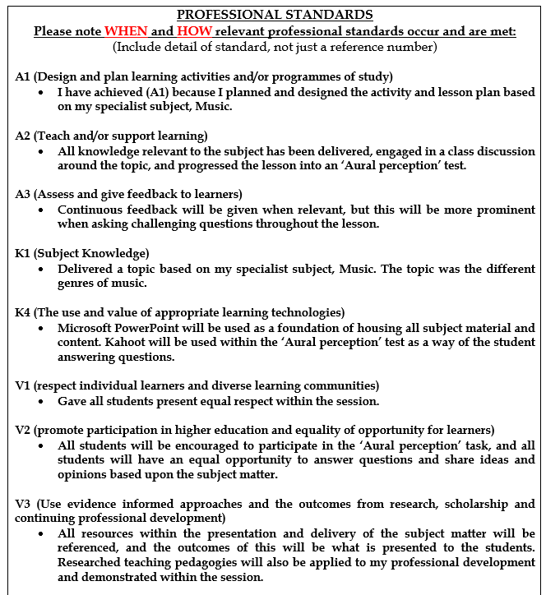

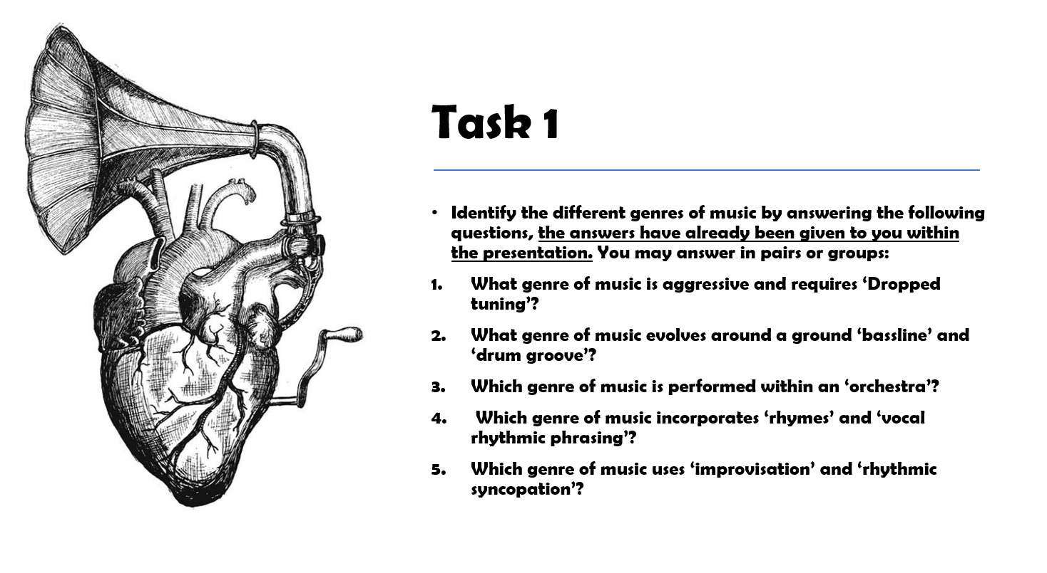
[3]

