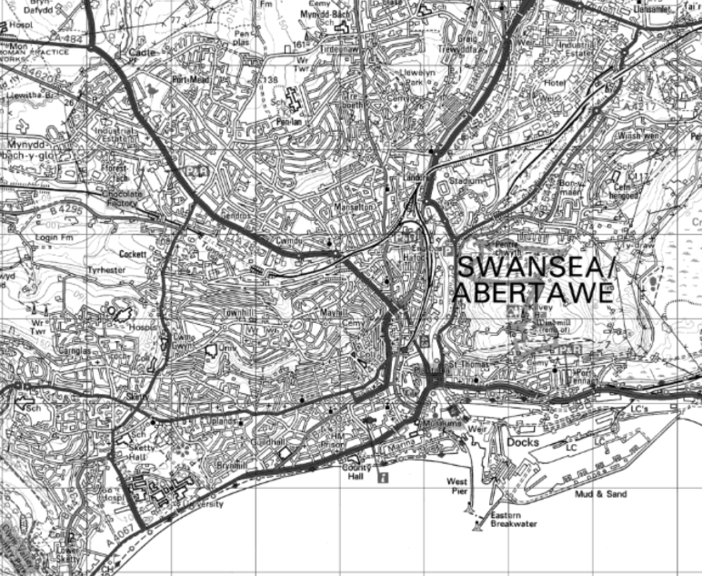
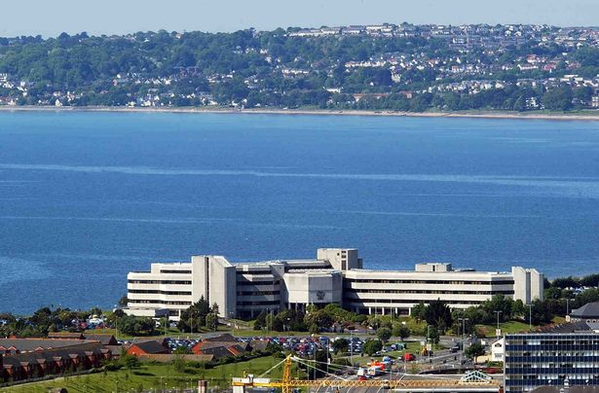
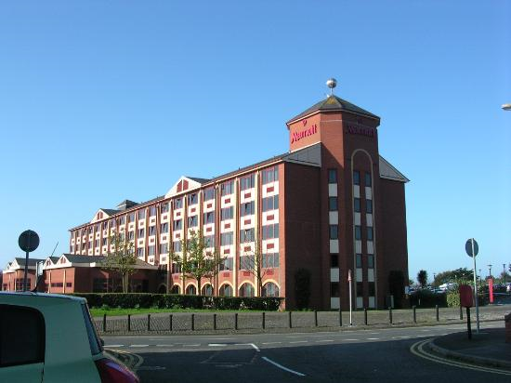
Fundamentals of Construction Technology
Site investigation
Teifion Evans
1902141
Introduction
This study was carried out for the City and County of Swansea and Mariot hotels. They have chosen to enter into a joint agreement to create a new restaurant and ice-cream parlour on Swansea foreshore.
This report contains a full site investigation of the area and historical background of the area. This study will contain plans, photographs and information from reliable sources regarding the contents of the site. I will use articles and websites such as Digi maps in order to discover any activity that has taken place in the area in the past that might have had an effect on the soil and the site where the building will be constructed. After giving the historical background of the site, I will recommend what elements of the site investigation is significant and applicable to this site. Building regulations and codes of practice will also be included in this report and also recommendations for the site investigation that will be carried out by others. Through carrying out this ground investigation, I will lastly describe a suitable foundation for the building while considering the soil type and any other factors. The foundation I recommend will be influenced on what type of soil that is in the substrata and therefore will decide the correct foundation for the building.

This is the location to where the building will be constructed, as seen with in the red outline. Through researching for information, I will carry out a thorough site investigation for the area. This site investigation will consist of looking for the history around the area in order to see what could have affected the soil of the location. I will also research of what type of soil is present in the location in order to decide what type of foundation is best suited for this particular location. I will also include a suitable sketch in order to explain the foundation.
Desktop Study
Through research of the mumbles are I have discovered that there was once an old tram railway. The mumbles Tram railway opened in 1807 and closed in 1960. BBC wales has a blog written on it’s website giving additional information. It reads ‘’in 1807 the Mumbles railway opened, the first fee paying passenger railway service in the world.’’ The railway was opened for over 150 years and therefore we must assume that this railway had in somewhat contaminated the soil is some sort of way. Whether that would be from old parts or other materials that were left along the track. We can also assume that fuel tanks, and the tracks themselves that would’ve eroded and become over grown will affect the ground. The article also says ‘’For some years the line was almost derelict although it was still used for occasional deliveries of coal from mines in the Clyne valley’’. From this statement we can again safely assume that there must be contamination from bits of coal and old parts from the trams.
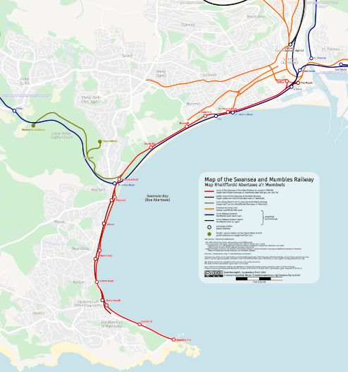
This map shows the route that the track would’ve been. The area where the building will be constructed is highlighted in the map. It is clear that the railway would ‘ve passed through the area therefore we must assume that there is some contamination in the ground.

Through more research of the Swansea area I have found that the Swansea blitz had a massive effect in the area during World war 2 and even today. The bombing raids in Swansea took place between 1940 to 1943. A ‘Wales online’ article states that the worst bombing raid took place over 3 nights between February 19 to 21 1941. It reads ‘’ estimated 1,273 high explosive bombs and 56,000 incendiary bombs, where dropped in 14 hours of terrifying enemy activity, resulting in 230 people being killed and 397 injured as 857 buildings were destroyed and more than 11,000 damaged’’. It would be wise to assume that there is debris in the area that could’ve contaminated the area. Bits of metal from the exploding bombs could be buried within the ground alongside parts of buildings, cars and anything else that the blasts would’ve destroyed.
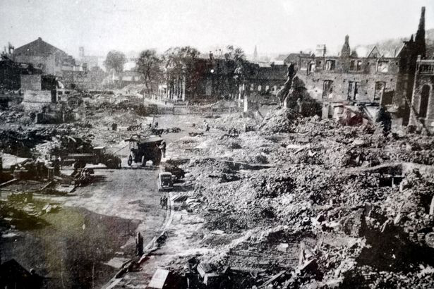
This Photograph puts into perspective how badly the raids affected the Swansea area. The photograph shows buildings that have been destroyed beyond repair. It’s is clear to how much debris that has been scattered. The bombs themselves would’ve had a powerful blast which would’ve buried bits of metal deep within the ground. We can understand that bombs can lay dormant and are being discovered across the UK. This could be massive problem when constructing the foundation and therefore we must highly consider this when carrying out a ground investigation.
After further research I have discovered that Swansea has a long history in the tin industry. Swansea was the leading producer of tin in the 19th century and therefore we can expect to more contamination in the ground on site. There is an article on Swansea Museum that states ‘’During the nineteenth century, it was a world centre for tinplate production, it smelted 90 percent of the worlds copper’’. When constructing the building we can assume that there must be contamination from tin that might affect the area. The tin would be shipped around the world also from the dock. By looking at a map we can clearly see that the site is near the docks, so we could guess that some tin would’ve found its way underneath the sites surface.

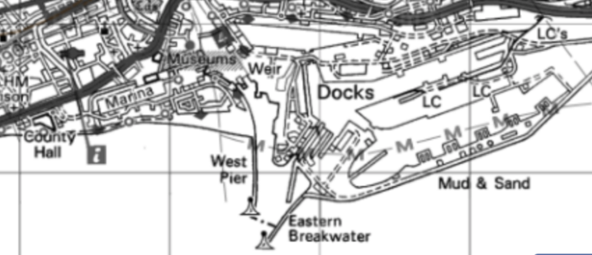
From this map we can see how close the docks are to the area to which the building will be built. We could expect for some tin in the past to be accidently dropped or purposely disposed by the site.

Substrata
In order to research and discover substrata is beneath the site, I have used ‘Digi Maps’. From using this site we can uncover the contents of the soil to where the building is going to be built.
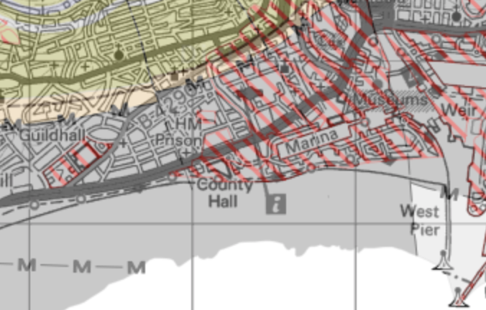

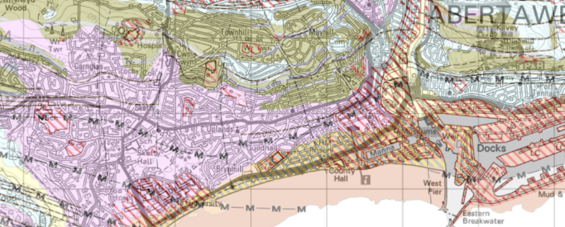
From this I have discovered that the contents beneath the site is predominantly sand. The issue with this is that sand isn’t strong enough, especially when considering the size of the building that will be constructed. A shallow foundation will not be able to be used in this situation as there will be too much settlement. A deeper foundation is crucial here in order to build on top of sand.

Beneath the sand there is stronger soil such as mudstone. Pile foundation will be suitable here as there will be a need to transfer the load of the building further down to a higher bearing substrate than sand

Building regulations/Codes of Practice
After researching the historical background of the site, we can understand there might be a lot of contamination in the soil from metal and possibly other big pieces of old material within the substrata that can affect the construction of the foundation and the building. Therefore, when constructing, we must keep this in mind. I recommend a GPR (Ground-penetrating radar) survey in order to detect any pieces of metal with in the ground. If by any chance there are big deposits of metal that could have accumulated in the past from dumping waste, we will be able to spot it and then deal with the matter.
Before construction begins, locations of gas supplies, water supplies and electrical supplies must be noted. The reason for this is of course for health and safety of the builders on site. If a builder were to cut through an electrical main, it could result in injury or even death. The locations of these supplies are very important to know when excavating on site. Again, this is where a GPR survey can be used to detect and topographically record the position, depth and routes of buried services and utilities. Also, knowing where water supply is important in case there were to be a fire on site. A risk assessment should be made before construction starts in order for all people who work on site are aware of the danger that are present.
Planning permission in the area is of course needed before building. There must be duty of care requirements for local residents. Any noise and vibration might affect there day to day life. Location of fibre optics and electrical supply locations should be known. If these were to be damaged during the construction of the building, it could affect the residents living in the local area. The site itself should be blocked off from the public and should be fenced from roads. This is for health and safety reasons as an accident might occur during construction hours.
The environment should be considered. Materials and waste should not be dumped anywhere. The should be skips on site in order to store the waste. Air pollution should be kept to a minimum. Under the Clean air act 1993 that is administrated by local authorities. Being aware of local wildlife is also important. There might be a protected species that lives or is present in the surrounding area.
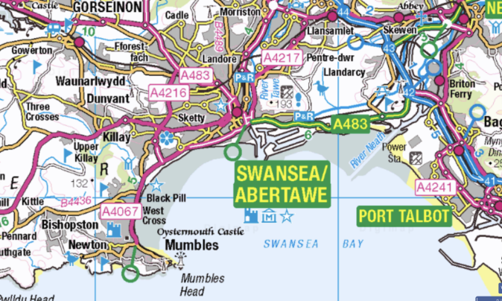
When considering the area surrounding the construction site, we can see that the site will mainly be accessible by road. There might be traffic during the day which is expected from a city. Any materials and machinery should be delivered in the night to avoid any delays. Deliveries to the site could also be transported by boat as there is a dock nearby. From the dock transports by land will be needed.

Foundation
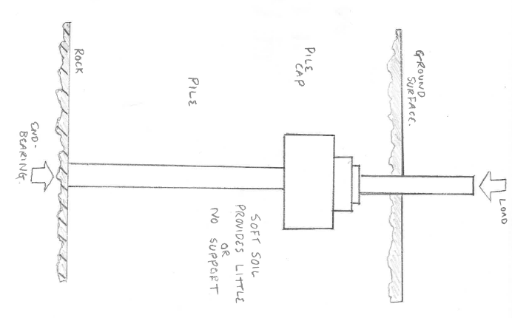
Due to the sandy soil beneath the site I have come to the conclusion that a deep foundation is needed. The ground beneath the site isn't strong enough to hold the buildings load. Therefore, we must use a deep foundation in order to carry the load farther down than the sandy substrate and to a stronger substrate such as rock. A deep foundation such as a pile foundation would be suitable in this situation. A pile foundation will carry the load of the building further down to a strong substrate as the sandy soil will not be able to hold the building’s mass. A foundation such as a pad foundation would not be suitable on this site on its own as there would be too much settlement due to the soil not having a high bearing capacity. Piles are normally made from steel or reinforced concrete. It can even be made from timber but in this case, it should not be used as the size and weight of the building will be too much and the pile would be put under excessive stress. I recommend a reinforced concrete friction pile for the foundation as steel on its own will erode and rust in the wet sandy substrate and will certainly lose its shear strength. Concrete is also strong under compression and will be able to bear the vertical weight of the building. Pile caps and beams will should also be used for the foundation. It is very difficult to bore or drive piles exactly vertical and therefore a pile cap will be suitable to correct the position of the pile heads. The pile caps will then be connected with reinforced concrete. The result of this will create capping beams which will be beneficial as they’re suitable for distributing the weight of a load-bearing wall, or of close-centre columns to a line of piles.
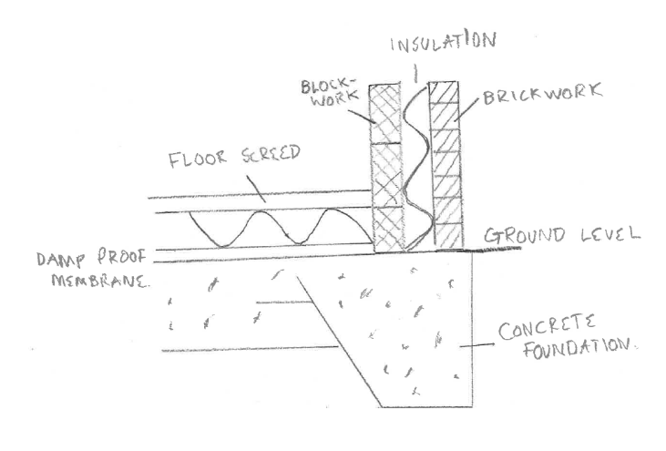
The construction technique in order to fit the piles would intake boring. Bored piles will be augured and then concrete will be poured in situ. Bored piles will be ideal in this situation as they can be used in urban areas as there is minimal vibration. The bored piles will remove the spoil from the hole and because the soil beneath the site is sandy, the hole must be supported and provided with in order to avoid falling.
Alongside with piles and pile cap beams, a suitable foundation would be using raft. Raft foundations can cover a wide area which is needed for the construction of this building as it covers 300 square metres. Raft foundations can incorporate beams for extra support. The beams will be placed where the walls are in order to help spread the load of the building.

Referencing
Maps used -
https://digimap.edina.ac.uk/os

Carradice, P. (2011). BBC - Wales History: The Mumbles Railway. [online] Bbc.co.uk. Available at: https://www.bbc.co.uk/blogs/waleshistory/2011/03/the_mumbles_railway.html

Thomas, G. (2018). Telltale evidence of the Swansea blitz you walk past every day. [online] walesonline. Available at: https://www.walesonline.co.uk/news/wales-news/telltale-

https://www.swansea.gov.uk/localhistory
http://www.swanseamuseum.co.uk/swansea-a-brief-history/industry

Clean air act - http://www.legislation.gov.uk/ukpga/1993/11/contents

Photos –
https://www.walesonline.co.uk/news/wales-news/uk-city-culture-2017-swansea-6321276
https://www.tripadvisor.com/LocationPhotoDirectLink-g186466-d192327-i151240570-Swansea_Marriott_Hotel-Swansea_Swansea_County_South_Wales_Wales.html
https://commons.wikimedia.org/wiki/File:Map_of_the_Swansea_and_Mumbles_Railway.png
https://www.walesonline.co.uk/news/wales-news/telltale-evidence-swansea-blitz-you-14422515

