ACCB6017
Usability Engineering – Component 1 Technical Report

Name: Toqeer Hussain Shah

Student ID: 2232808

Module Tutor: Nassir Ibrahim

​​Contents
1 Abstract ………………………………………………………………………………………………. 1
2 Introduction …………………………………………………………………………………………. 2
3 four detailed personas and associated scenarios ………………………………………. 3
4 Usability issues to be addressed ……………………………………………………………… 8
5 Initial wireframe storyboards …………………………………………………………………... 9
6 feedback collection process on storyboard design ……………………………………. 17
7 Conclusion …………………………………………………………………………………………. 18
8 References ………………………………………………………………………………………… 18
9 Appendices ………………………………………………………………………………………… 20

1 ABSTRACT:
The goal of this project is to create a digital version of the famous board game CLUEDO with a UWTSD theme and focus its usability and accessibility. It is redesigned as a murder mystery that takes place on university campuses. The Vice-Chancellor's murder must be solved by up to eight players, each of whom study in different university. Using interaction design theory to guarantee usability, making mobile-friendly wireframe storyboards, and constructing inclusive personas based on actual user research are all steps in the design process. Focus groups, interviews, and questionnaires are used to collect feedback, and Moscow prioritisation is used to classify the results [1]. Storyboard functionality, emotional reactions to the prototype, and user experience criteria are all covered in the final report.
2 INTRODUCATION:
The process of user research and persona building for UWTSD CLUEDO, a digital version of the classic board game Cluedo that takes place on the campuses of the University of Wales Trinity Saint David, is described in this section. Players must investigate different campus buildings such as Dynevor, Townhill, Carmarthen's Trinity Building, and Lampeter's Library to find the mystery of the Vice-Chancellor's murder, which opens the game scenario. To ensure for best practise interface design is inclusive, interesting, and true to UWTSD life, the research sought to determine the needs, preferences, and accessibility requirements of potential participants selected from the university community [2].
3 Four detailed personas & associated scenarios
PERSONA 1 is a mature student at the Carmarthen Campus.
Age: 34
Role: Graphic Design Student
Background: A father of two, a part-time university student, and has little gaming experience.
Technical ability: Extremely comfortable using consoles, mobile devices, and PCs.
Situation: He performs in the late evenings or on her commute. He likes simple controls and brief sessions.
Requirements for the User Experience
Must have Mobile compatibility and pause/resume capabilities.
Should have Clear training and reduced user interface are also necessary.
Could include Voice narration for accessibility.
Don’t require quick reflexes or intricate mechanics [3].

Persona 2: Visually Impaired Student, Swansea Campus
Age 23
Role: Computer Science Student
Background: Lives in shared accommodation with John wants to use navigation and screen readers.
Technical ability: Excellent in digital tools yet loves simple designs.
Situation: He wants to play in a completely accessible setting with his friends.
Requirements for the User Experience
Must have Screen readers and keyboard navigation are required.
Should have High contrast images and audio cues included.
Could provide narration and text sizes that are customisable
Don’t depend on visual-only cues or mouse-only interactions.

Persona 3: International Student, Lampeter Campus
Age: 21 years old
Role: Business student from India
Background: Passionate about logic puzzles and strategy games. Fluent in English but prefers visual storytelling.
Technical ability: Moderate to high but likes straightforward user interfaces.
Situation: Socialises with friends on different campuses
Requirements for the User Experience
Must support Cross-campus and multiplayer play.
Should include Character animations and visual narrative.
Could provide a variety of character options and cultural allusions.
Wont specialised UK references or extremely complicated English will be required.
Persona 4: is a student in Swansea Campus
Age: 22
Role: Computer Science Student.
Background: An ADHD creative writing student who enjoys fast-paced, captivating games
Technical ability: High level of comfort using console, smartphone, and PC gaming.
Situation: Enjoys completing puzzles fast and plays in short bursts.
Requirements for the User Experience
Must have Mini games that move quickly and have progress indicators.
Should include Modifiable difficulty and sensory parameters.
could provide achievement badges and gamified learning.
Won’t stand crowded interfaces or lengthy loading times.
Methods of User Research
Focus groups were combined. questionnaires, and casual interviews in a mixed-methods approach to make sure the design was based on real user needs.
Information Collection for Persona Design Support
To create appropriate characters for the computer game Cluedo, required to research the demographics, game preferences, and potential expectations of my target audience. Getting information from people with a variety of experiences, skills, and interests was crucial because UWTSD has a varied student body and staff spread across multiple campuses.
Data was collected data using three primary techniques: focus groups, semi-structured interviews, and questionnaires [4]. Using these techniques, I was able to determine the kinds of players who might find the game entertaining as well as the features they would like to see included in the finished version.
1 Survey Questionnaire
To swiftly gather information from students used Microsoft Teams, Google Forms, and email to build an online poll. [5]. Student group chats were used to distribute the survey to students from Swansea, Carmarthen, and Lampeter campuses.
Objective of these Questionnaire
To learn more about the general preferences, gaming habits, and accessibility requirements of the participants.
Questions posed
1. What position do you hold at UWTSD?
2. How frequently do you engage in online gaming.
3. Which kinds of games are your favourites? (e.g., puzzle, adventure, strategy, mystery)
4. On what kind of device do you typically play games? (Mobile, console, tablet, PC/laptop).
5. Do you like to play with other people or by yourself?
6. What aspects of a game appeal to you? (plot, visuals, difficulty, humour, contest)
7. Do you play games differently because of any accessibility requirements? (For instance, hearing loss, colour blindness, and mobility issues)
Findings
Participants: The survey was filled out by 6 respondents.
Age Range: The age range is 18–55.
Gender: 90% are Women, 10% are men, and 5% would rather remain anonymous.
Preferences for games: Mystery (68%) and strategy Four respondents brought up mobility or vision problems, emphasising the necessity for uncomplicated controls and clear graphics.
Desired features: Include a user-friendly UI, an engaging plot, a well-known (54%) were the most popular genres.
Devices: 25% used consoles, 60% used mobile phones, and 75% used laptops or PCs to play games.
Accessibility: academic environment, and multiplayer capabilities [6].
The poll revealed that the majority of potential participants preferred straightforward, social games that required logical problem-solving, and that usability and accessibility are important factors.
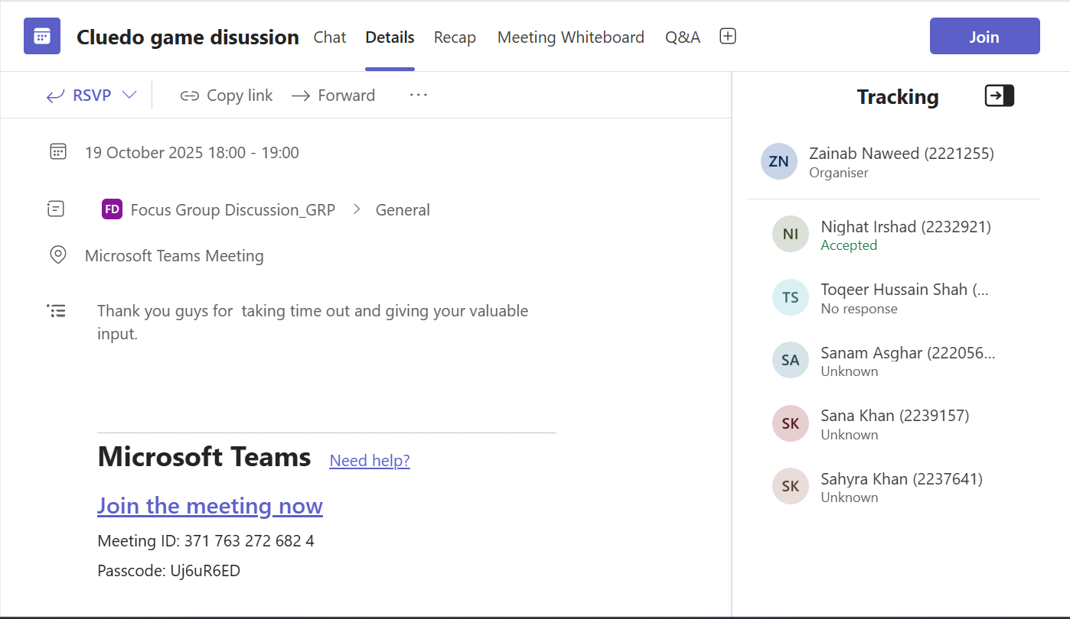
Figure 1 (CLUEDO GAME DICUSSION)
2 Semi-formal Interviews
Five brief interviews were conducted (10–15 minutes each) with a variety of participants. Utilised a series of leading questions during the semi-structured interviews and also gave participants free reign to speak [7].
Objective of Interviews
Understanding each player's motivations for playing games, their thoughts on the Cluedo concept, and their expectations for a mystery game set in a university are the goals [8].
Important queries:
1 What is your favourite aspect of playing puzzle or Cluedo games?
2 A digital version set at UWTSD could be of interest to you?
3 Which storylines or characters would you like to see?
4 What features would make using the UI simple and enjoyable?
5 Do you face any difficulties when playing games, such as accessibility issues or device restrictions?
Results:
Making the game amusing and relevant to actual UWTSD life was a good concept, according to the participants.
student were the possible player characters.
Short, simple games that could be played at home or during breaks were preferred by interviewees.
Everyone agreed that a bright and straightforward interface is preferable to one that is realistic or dark.
A participant with a moderate vision impairment recommended high contrast colours and large icons to improve visibility.
Important qualitative information regarding tone, style, and inclusivity was obtained from the interviews.

3: Focus group:
Four students participated in a small focus group that I conducted after assessing the questionnaire and interview data [9]. They got an early game board concepts, potential character designs, and UI layout.
Objective:
To get input on style, accessibility, and gameplay concepts while testing preliminary graphic designs.
Activities:
1 Participants examined several interface design mock-ups.
2 They talked about what they understood and what they didn't.
3 They offered feedback on button location, font size, and colour schemes.
4 They also talked about what makes a mystery game on the internet interesting.
Results:
1 Many participants favoured a cartoon-style design with straightforward forms and vibrant colours.
2 They desired that the game depict actual UWTSD structures as "rooms," such as the lecture halls, cafeteria, and library.
3 The committee recommended keyboard navigation, readable fonts, and the ability to change sound levels to highlight the significance of accessibility.
4 Fun hints about university life, such "spilt coffee," "broken projector," or "missing coursework," were appreciated by several participants.
Players want the game to be simple to use, accessible to everybody, and have a humorous, campus-based plot, according to the focus group.
Key Findings
Gamers are looking for an enjoyable mystery-style game that relates to well-known academic settings. All users, including those who have visual or mobility impairments, should find the interface easy to use, accessible, and visually clear. Players should feel represented, whether they are staff, instructors, or students, so character variety is crucial. Short sessions and simple controls that were appropriate for casual gaming were selected by most participants. The game's plot is more inventive and humorous, which increases player engagement. The construction of realistic personas was directly influenced by these findings, which will also lead the next phase of the project's user interface and experience design.
4 Usability Issues to be Addressed
How are you designing for usability? What usability issues need to be addressed within your storyboards? What recommendations from the literature have you used?
Creating Usable Designs: To make the game usable, I concentrated on the following crucial areas:
Clarity and simplicity: The interface design makes advantage of a straightforward layout and big, obvious buttons. Players can quickly notice the actions that are available to them, such as move, view clue, and accuse. To avoid confusion, there are just three options on the home screen: Start Game, Instructions, and Exit [10].
Consistency: The game makes consistent use of fonts, colours, and icons. This makes it easier for users to pick up controls and identify game elements fast.
Responses and visibility: Every action is followed by unambiguous feedback for players. When they pick up a hint, for instance, a pop-up message like "You found a broken laptop!" displays. The locations of player movement and interaction are indicated by visual cues, such as highlighted tiles or illuminated icons [11].
Error recovery and prevention: The design stops unintentional acts like accusing someone or confirming before ending a game. A basic "back" or "undo" button is available to fix errors [12].
Accessibility: Following the guidelines of the Web Content Accessibility Guidelines (WCAG), I included choices like
1 Adaptable text size
2 Colour settings with high contrast for gamers who are blind or visually impaired
3 For gamers with restricted mobility.
4 keyboard or mouse-only navigation with subtitles and visual cues for sound effects
Learnability: Based on the idea that users shouldn't have to read lengthy instructions to begin playing, a brief, interactive lesson introduces new players to controls and rules [13].
Storyboards Address Usability Issues: As I was making the storyboards for my interface design, I noticed a few usability problems that required extra care.
Usability Problem How Design/Storyboard Handles It

cluttered user interface Every screen was made simpler by using white space,
having fewer buttons, and having a clear visual hierarchy.

Usability for those with Storyboards include a toggle for large text and an optional high contrast setting. contract settings

compatibility of devices Storyboards with touch-sensitive buttons were designed for both desktop and mobile layouts.

Confusion in navigation Colour-coded rooms and a clear map icon make it simple for users to find destinations.

Player errors (e.g., incorrect click) Are you certain? Prior to significant activities, confirmation boxes are included.

An abundance of information One by one, hints appear in pop-up windows with brief text and icons.

Controls may be confusing to new user A detailed tutorial overlay was added and is visible in the first few moves. Contrast, and layout clarity.

During the focus group, participants discussed these concerns and offered input on
button size, contrast, and layout clarity.

Suggestions from the Referenced Literature

Design decisions were influenced by the following usability and design guideline
from industry and academic sources:

The Ten Usability Heuristics by Jakob Nielsen (1994):
To enhance the user experience, the game design adheres to important usability
guidelines. When hints are discovered, it gives unambiguous feedback,
guaranteeing clear system status visibility [14]. The game is more realistic because to
the utilisation of well-known UWTSD campus sites. Undo and confirmation buttons
give players autonomy and control. The same icons and colours are used
consistently, and confirmation alerts prior to significant activities help to prevent
errors.
The Principles of Design by Don Norman (1988):
Icons and buttons appear to be clickable. Every user action is instantly addressed.
Controls are positioned where users anticipate them to be (e.g., major actions at the
middle, navigation buttons at the bottom) [15].

WCAG Guidelines for Accessibility (W3C, 2018):
Make sure the backdrop and text have enough colour contrast. Make sure a
keyboard can be used to control every feature. Offer text substitutes for visual and
aural material [16].

The Eight Golden Rules of Interface Design by Schneiderman (2010):
Try to be consistent. Provide insightful critiques. Ensure error recovery and closure
in your design. Save short-term memory strain by maintaining screen visibility [17].

5 Initial Wireframe Storyboards
Storyboards should be wireframe only, rather than full colour design. They should show
all the major functionality of the app at a size appropriate for a mobile phone and
should take all the usual aspects of interaction design theory into account in the
design [18].

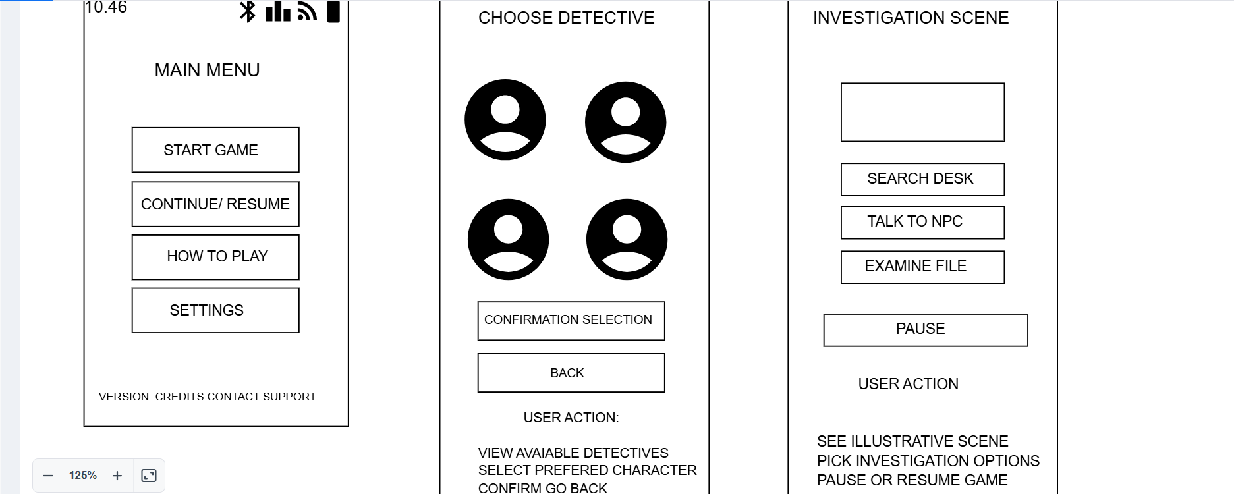
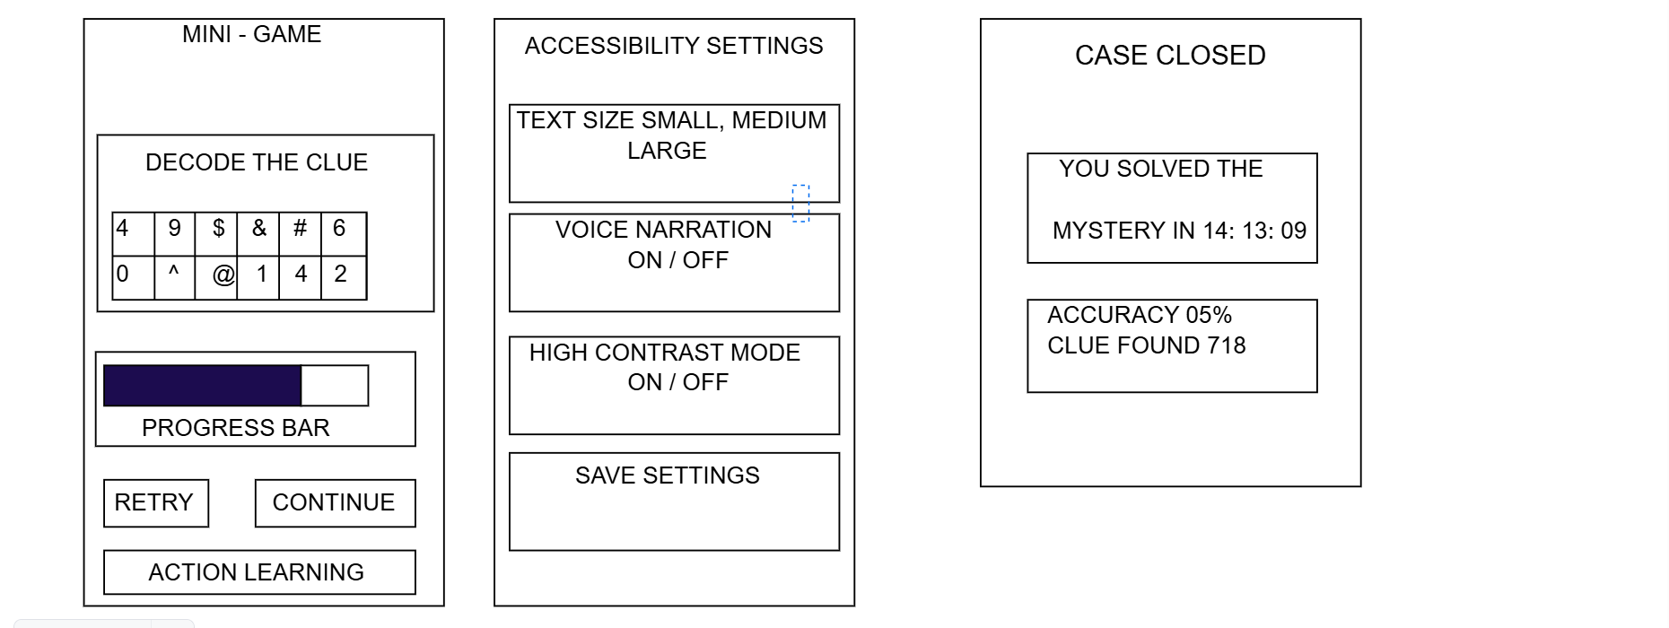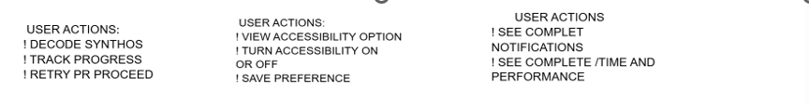
Figure 2 (Step by step game flow start to finish)
Storyboards should be wireframe only, rather than full colour design. It shows all the major functionality of the app at a size appropriate for a mobile phone and should take all the usual aspects of interaction design theory into account in the design. Significant elements such as the main screen designs should be discussed in the main body of the report. These can be created using any suitable software, remember to show not only the screens but how the user moves between the screens.
Key Screen Designs & Interaction Design Principles: The Report's Main Body
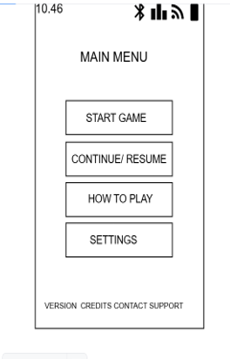
Figure 3(main menu display)
1: Main Menu Display
The ability to function: Start Game, Resume, How to Play, Settings, and Credits/Support are the main features' entry points.
Considerations for Interaction Design:
Visibility: Options are logically grouped and clearly labelled.
Affordability: For mobile use, buttons are sizable, tactile, and easily distinguishable.
Feedback: When you tap a button, you should get haptic or visual response.
Regularity: Learnability is supported by consistent button styles and spacing.
Notes regarding accessibility:
Users with visual impairments are supported by readable fonts and high contrast.
Compatibility with screen readers and a logical tab order should be guaranteed.
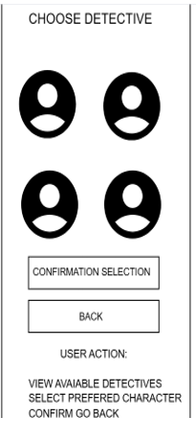
Figure 4(Choose Detective)
2: The Character Selection Screen
The ability to function: Users can view and select from a variety of detective avatars.
Considerations for Interaction Design:
Recognition as opposed to recollection: Users can identify characters with the use of visual icons.
The user's control: The Back and Confirm buttons provide intuitive navigation.
Adaptability: For character qualities, this could involve voice narration or tooltips.
Notes regarding accessibility:
For screen readers, icons ought to contain alt text.
Clarity is enhanced by selection feedback (such as highlight or animation).
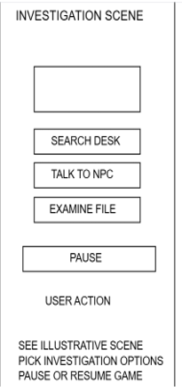
Figure 5( investigate Scene)
3 Screenshot of an Investigative Scene:
The ability to function: Search Desk, talk to NPC, Examine File, and Pause are among the choices available in the core gameplay interface.
NPC EXPLAIN: NPC describes a character that is not under the player's control. NPCs in this detective game give the player background information, clues, or crucial dialogue that advances the investigation.
Considerations for Interaction Design:
Charting: The buttons are positioned in relation to their in-game environment.
Responses: Animations or narrative reactions should be triggered by actions.
Preventing errors: The pause button enables a secure escape without erasing work.
Notes regarding accessibility:
Minimum size requirements are met by touch targets.
Simplified mode is an optional feature for cognitive accessibility.
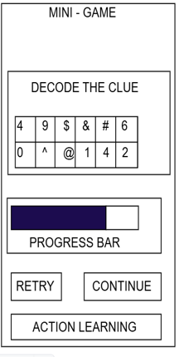
Figure 6( Mini- Game)
4: Interface for Mini-Games:
Usability:
Puzzle solving grid featuring learning options and progress tracking.
Considerations for Interaction Design:
Decode the clue: In the mini-game Decode the Clue mean that player decodes a case-related code or secret message. For a code-breaking task, the user interface shows symbols and numbers, and a progress bar indicates how close the player is to finishing the task. Match patterns, crack codes, or enter the right order. To convert symbols into letters or words, use logic. A crucial hint that advances the plot is revealed by correctly decoding.
gradual disclosure: Complexity progressively rises.
Responses: Time and accuracy updates in real time.
Learnability: Support for instructional scaffolding is provided via the Action Learning button
Notes regarding accessibility:
The grid should be navigable by speech or keyboard.
Neurodivergent users are supported by adjustable text size and voiceover.
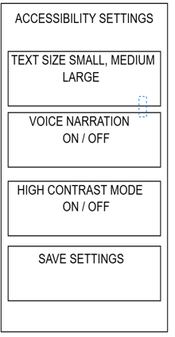
Figure 7(Accessibility settings)
5: Accessibility Configuration Page:
Usability:
Text size, narration, contrast, and saving options can all be customised.
Considerations for Interaction Design:
Freedom and control of the user: Users can save preferences and toggle functionality.
Reliability: The arrangement of the settings follows common mobile practices.
Recovery from errors: Save Settings verifies modifications and permits undoing if necessary.
Notes regarding accessibility:
Made to adhere to WCAG 2.1 AA guidelines.
Allows for customisation to meet a range of user needs.
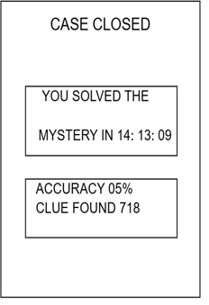
Figure 8( Game finished)
6: Closed Case/Summary of Performance:
Usability:
shows the time spent, the accuracy, and the hints discovered.
Considerations for Interaction Design:
System status visibility: Metrics that are easy to understand support user progress.
Reliability: Sounds or images of celebration increase contentment.
Regularity: The layout is like previous summary displays for ease of use.
Notes regarding accessibility:
It should be possible to read and optionally narrate performance data.
When using icons or colour coding, text should be included in addition.
6 Feedback Collection Process on Storyboard Design
I used focus groups, interviews, and surveys to get input on the storyboard prototypes from a variety of users, including those with disabilities and neurodivergent traits.
POSTIVE RESPONSE: The simple layout, interesting character choices, and robust accessibility features like contrast mode and text size adjustment were all well received by users. The results page was commended for its inspiration and clarity, and the mini-game components were viewed as entertaining and thought-provoking.
NEGATIVE RESONSE: Some users, however, felt that some scenes were overly text-heavy, had trouble switching between screens, and recommended more culturally inclusive avatars and alternative problem hints. This input was crucial in improving the design to better facilitate inclusive, user-friendly gameplay.
USABILITY OF GAME: To represent a variety of personas, including age, gaming experience, cognitive abilities, and accessibility requirements, participants were chosen. Most comments were favourable; people thought the interface was easy to use and interesting, particularly the progress tracking and detective avatars. Some, however, preferred more culturally accurate avatars or felt overpowered by scenes with a lot of text. These observations highlighted opportunities for development and validated the significance of inclusive testing.
IMPROVEMENT IN FUTURE: Adaptive font settings, multilingual support, and customisable avatars are potential future enhancements to increase accessibility. To increase engagement, branching stories, cooperative play, and assistive technology integration should be added. Analytics and real-time feedback could direct continuous inclusive design.
7 Conclusion
To sum up, the UWTSD Cluedo project effectively integrated inclusive design, user research, and iterative feedback to provide an approachable and captivating mystery game. The interface satisfied a variety of user needs while preserving playability and immersion thanks to the personas, storyboards, and usability testing. Based on ongoing user feedback, future work will improve accessibility and gaming flow.
8 REFERENCES
[1] The Emergence of Moscow, 1304-1359,” Google Books, 2022. https://books.google.co.uk/books?hl=en&lr=&id=xo2EEAAAQBAJ&oi=fnd&pg=PA7&dq=moscow++technique&ots=YaL0-DB5yb&sig=DlGuhN4pl5CBLVSA1qIQ2visy4w&redir_esc=y#v=onepage&q=moscow%20%20technique&f=false (accessed Oct. 26, 2025).
[2] Q. An, X. Tao, and B. Xiong, “Benchmarking with data envelopment analysis: An agency perspective,” Omega, vol. 101, p. 102235, Jun. 2021, doi: https://doi.org/10.1016/j.omega.2020.102235.
[3] “MCBRank Method to Improve Software Requirements Prioritization - ProQuest,” www.proquest.com. https://www.proquest.com/openview/091b07f6d3ae292d5c1c0443b355e73e/1?pq-origsite=gscholar&cbl=5444811
[4] J. Salminen, K. Wenyun Guan, S.-G. Jung, and B. Jansen, “Use Cases for Design Personas: A Systematic Review and New Frontiers,” CHI Conference on Human Factors in Computing Systems, pp. 1–21, Apr. 2022, doi: https://doi.org/10.1145/3491102.3517589.
[5] “View of Designing a Questionnaire for a Research Paper: A Comprehensive Guide to Design and Develop an Effective Questionnaire,” Ajmsjournal.org, 2024. https://ajmsjournal.org/index.php/ajms/article/view/3087/6202
[6] Marek Pycia and P. Troyan, “A Theory of Simplicity in Games and Mechanism Design,” Econometrica, vol. 91, no. 4, pp. 1495–1526, Jan. 2023, doi: https://doi.org/10.3982/ecta16310.
[7] S. Mashuri, M. Sarib, A. Rasak, F. Alhabsyi, and R. Ruslin, “Semi-structured interview: A methodological reflection on the development of a qualitative research instrument in educational studies ruslin,” IOSR Journal of Research & Method in Education, vol. 12, no. 1, pp. 22–29, 2022, doi: https://doi.org/10.9790/7388-1201052229.
[8] J. Owen, A. Barron, and L. Pottinger, “Object-oriented Interviews Methods for Change.” Available: https://aspect.ac.uk/wp-content/uploads/2021/10/Jen-Owen-A4-Guide-12-Oct-21.pdf
[9] S. T. Akyildiz and K. H. Ahmed, “An Overview of Qualitative Research and Focus Group Discussion,” International Journal of Academic Research in Education, vol. 7, no. 1, pp. 1–15, May 2021.
[10] S. Hemraj, “Press Start Defining Art Styles in Games Defining Art Styles in Games and Their Influence on Creative Expression.” Available: https://westminsterresearch.westminster.ac.uk/download/61377e8e40f6a114244f80cd0b791e7de8abde9fdfe61113c7ba3ff78e29f095/978628/305-Article%20Text-1792-3-10-20240513.pdf
[11] K. Tang, Terra Mae Gasque, R. Donley, and A. Sullivan, “‘It Has to Ignite Their Creativity’: Opportunities for Generative Tools for Game Masters,” Apr. 2023, doi: https://doi.org/10.1145/3582437.3587204.
[12] B. Markovitch, N. J. Evans, and M. V. Birk, “The value of error-correcting responses for cognitive assessment in games,” Scientific Reports, vol. 14, no. 1, Sep. 2024, doi: https://doi.org/10.1038/s41598-024-71762-z.
[13] “View of Redesigning for Accessibility: Design Decisions and Compromises in Educational Game Design,” Seriousgamessociety.org, 2025. https://journal.seriousgamessociety.org/index.php/IJSG/article/view/469/447
[14] A. Sesha, S. Kumar, D. Satya, and S. Chunduri, “Heuristic Usability Evaluation of the BTH Student Portal by applying Nielsen’s Heuristics,” 2022. Available: https://www.diva-portal.org/smash/get/diva2:1680527/FULLTEXT02
[15] A. Berni and Y. Borgianni, “FROM THE DEFINITION OF USER EXPERIENCE TO A FRAMEWORK TO CLASSIFY ITS APPLICATIONS IN DESIGN,” Proceedings of the Design Society, vol. 1, pp. 1627–1636, Jul. 2021, doi: https://doi.org/10.1017/pds.2021.424.
[16] L. Tateo, “Web accessibility and usability: limits and perspectives.” Available: https://ceur-ws.org/Vol-2817/paper35.pdf
[17] L. Bianchi, “Human-Computer Interaction Interface Design, Usability, and Design Rules HCI course notes about interface design principles and usability rules.” Available: https://blog.radixia.ai/content/files/2025/06/N-HCI-04---Design-and-Usability---notebook.pdf
[18] M. Asgari and T. Hurtut, “A Design Language for Prototyping and Storyboarding Data-Driven Stories,” Applied Sciences, vol. 14, no. 4, p. 1387, Jan. 2024, doi: https://doi.org/10.3390/app14041387.

9 APPENDICES
FLOWCHART
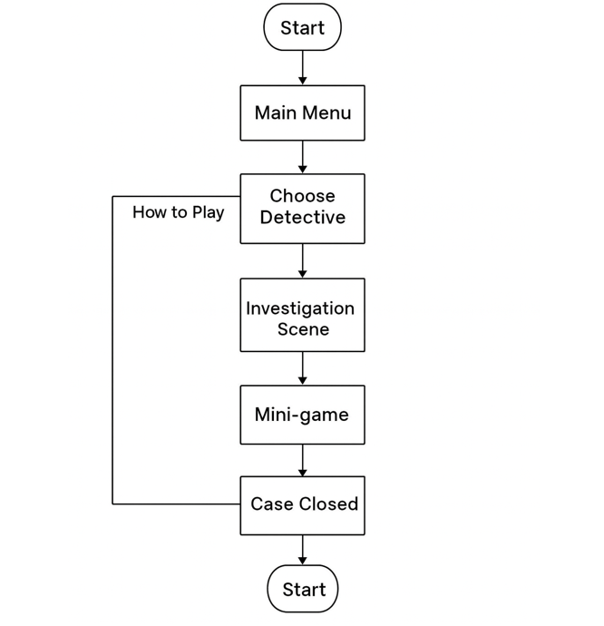
Figure 9 (FLOWCHART OF CLUEDO GAME)

SURVEY FOR CLUEDO GAME
https://surveymars.com/q/N0VBifFNm

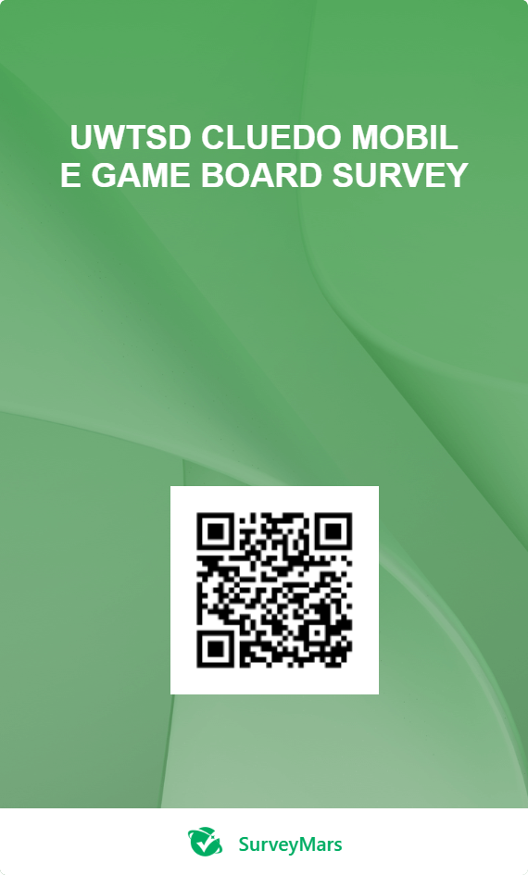
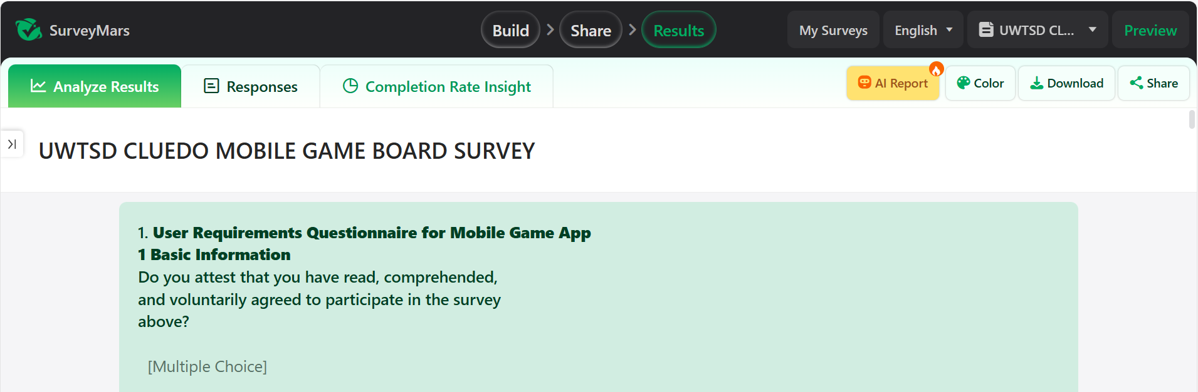
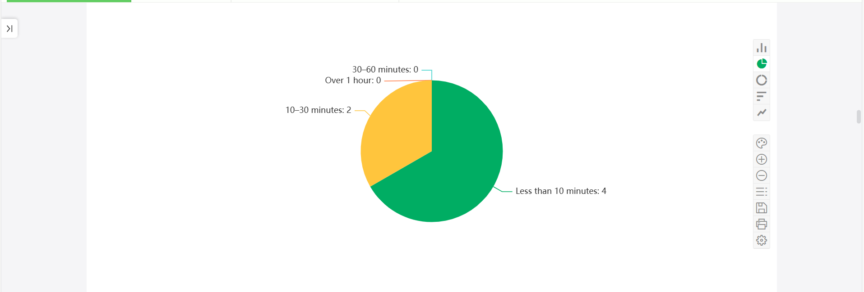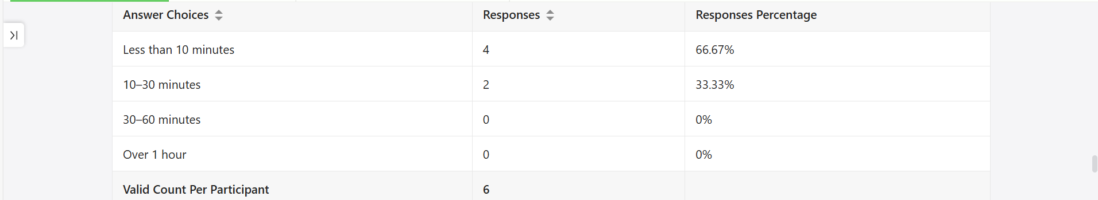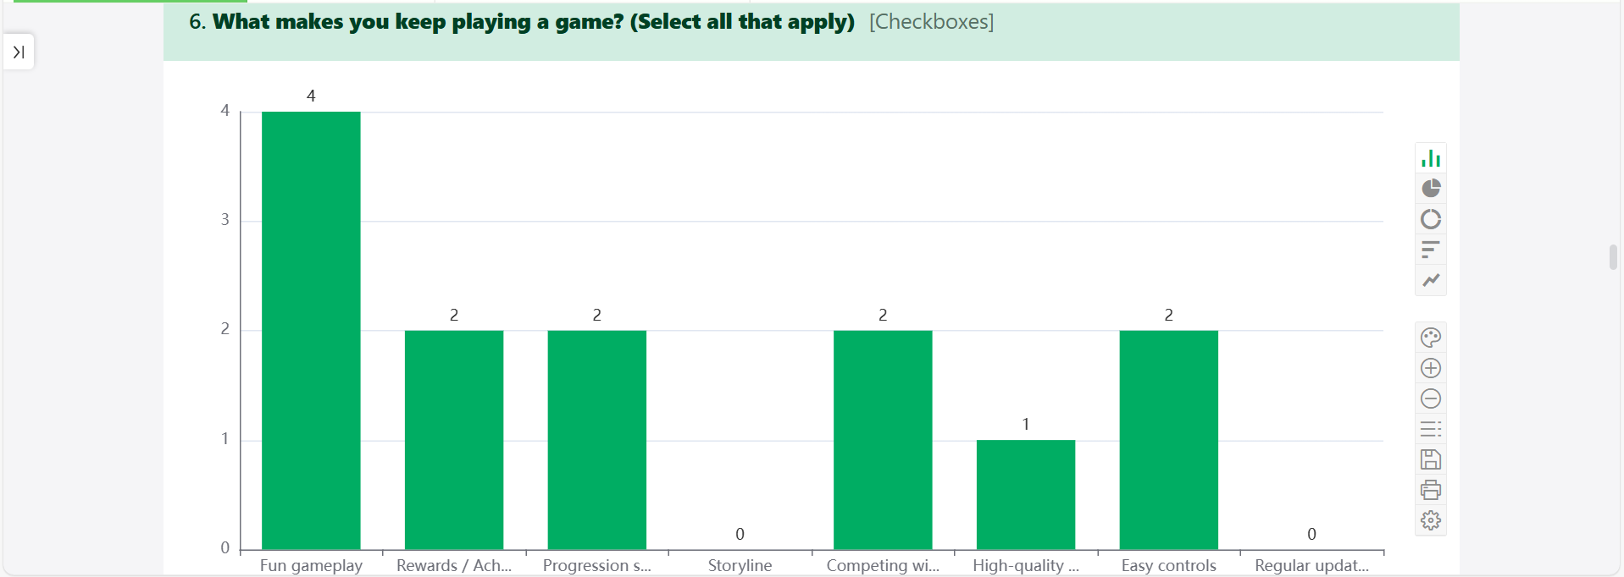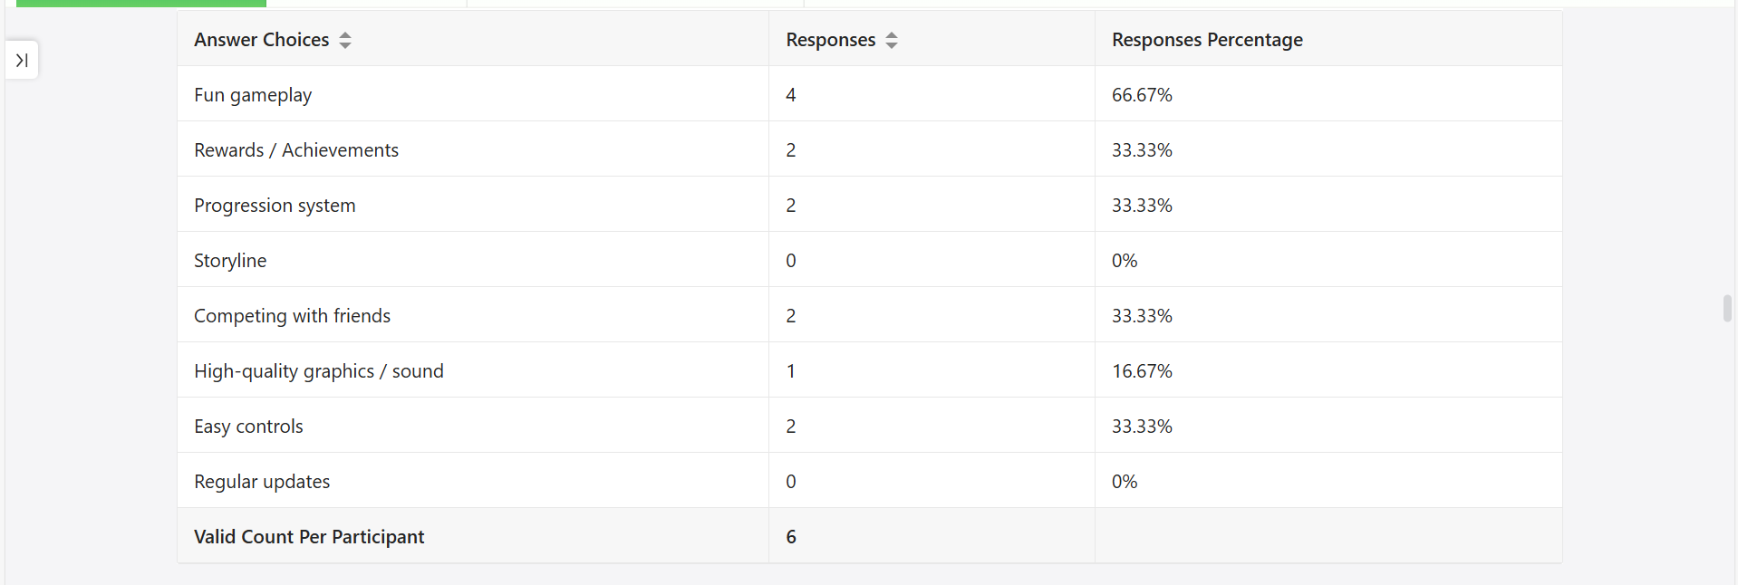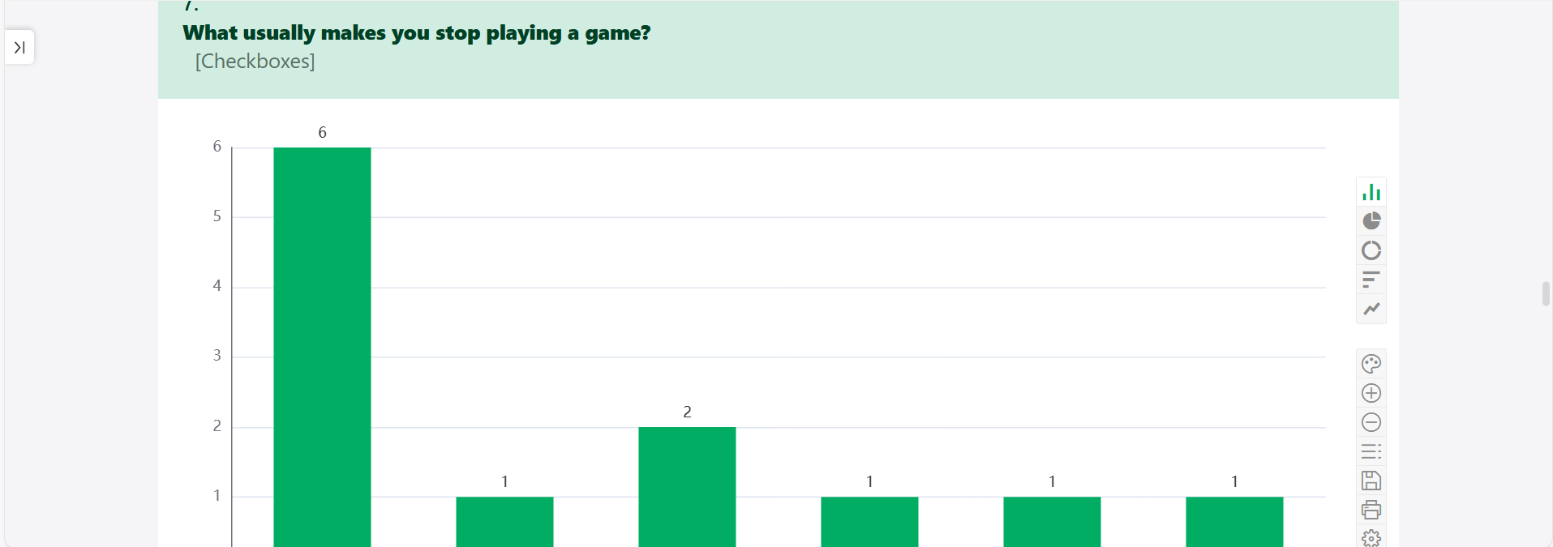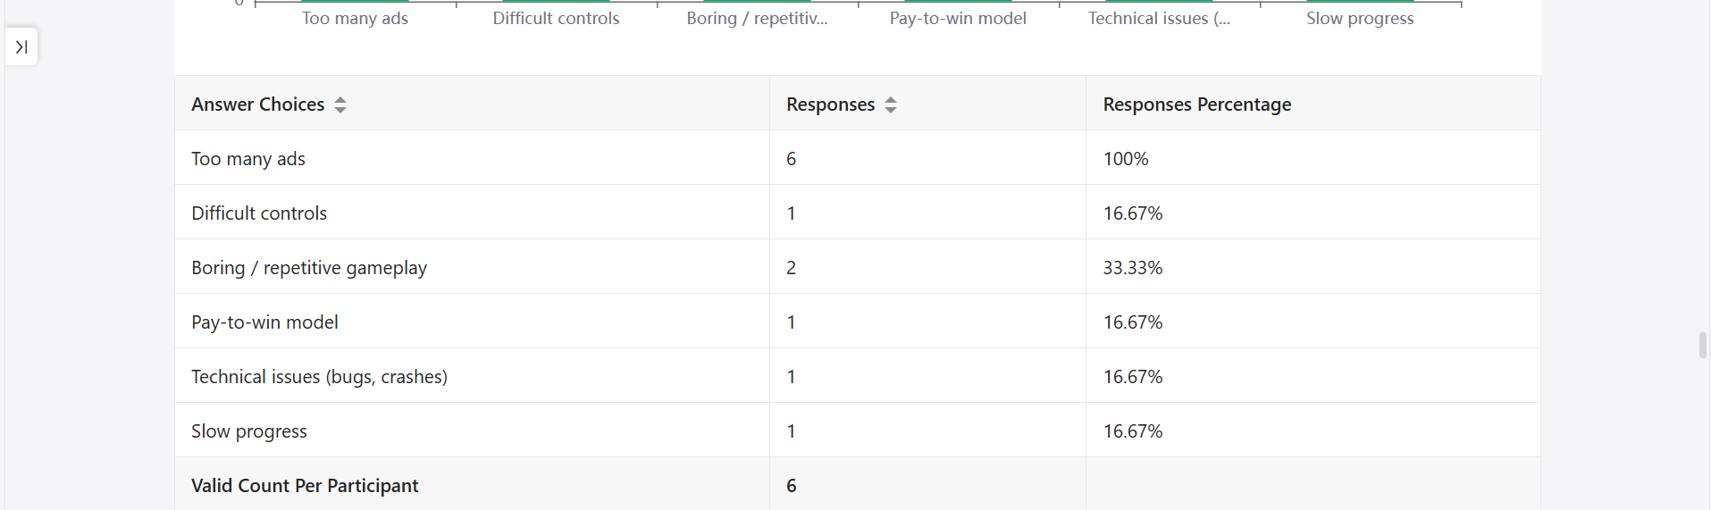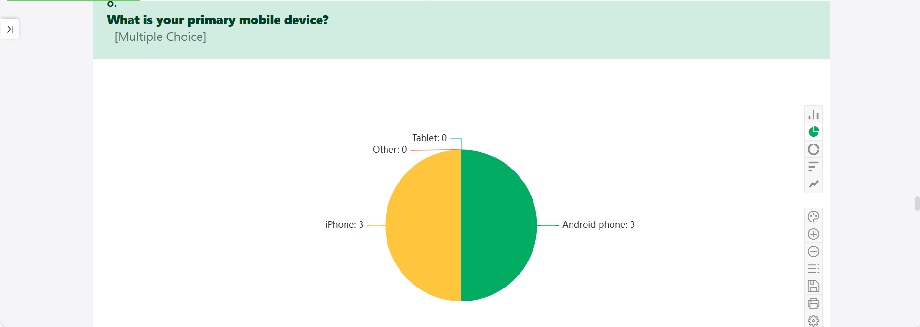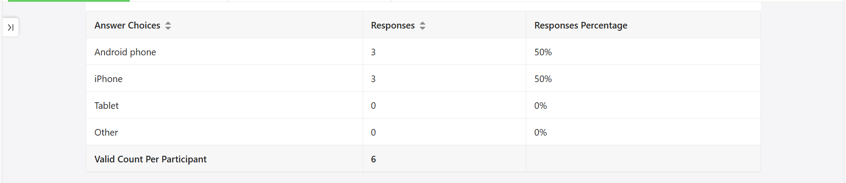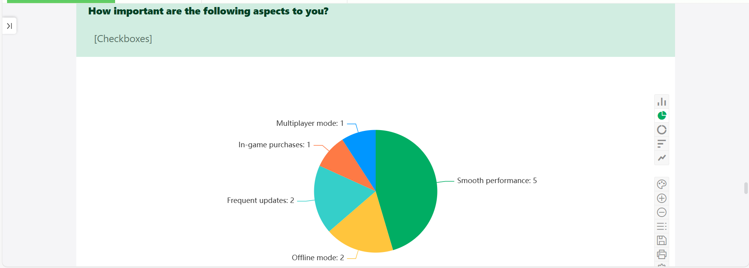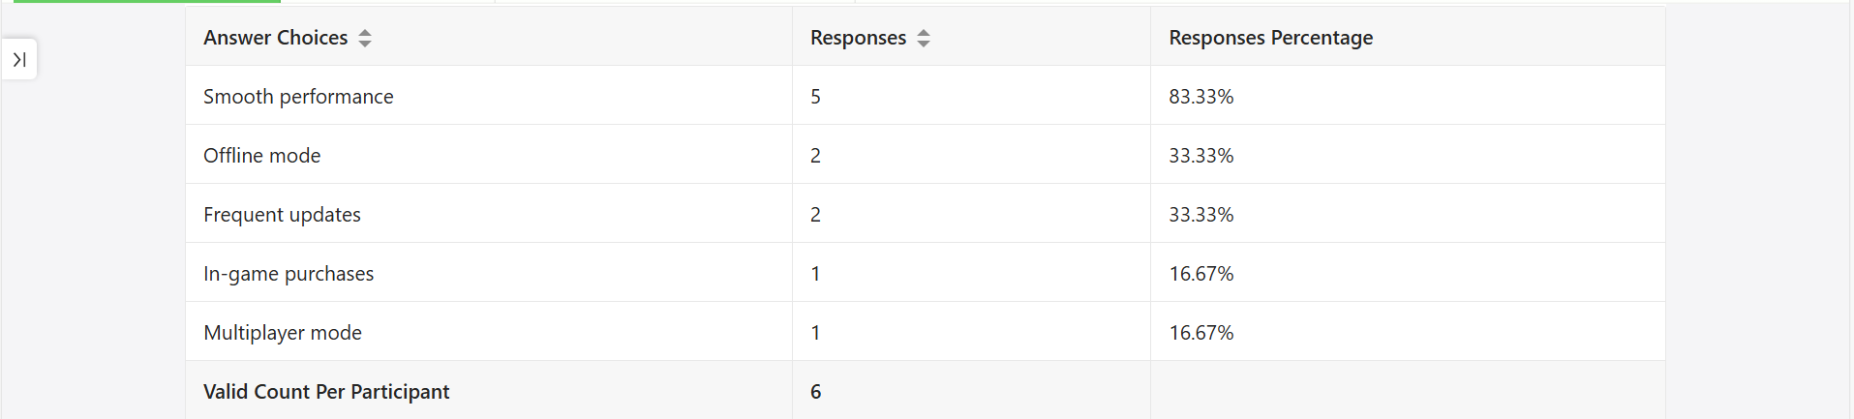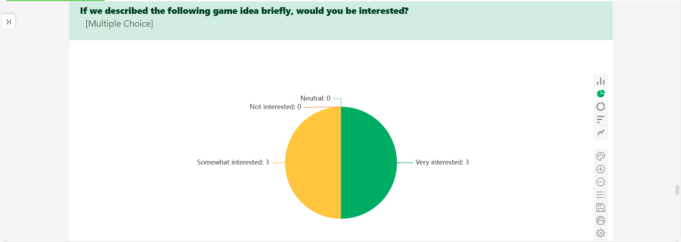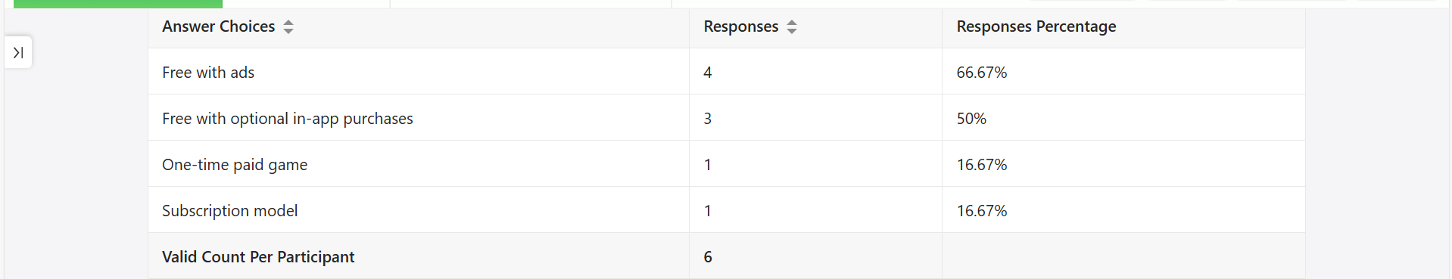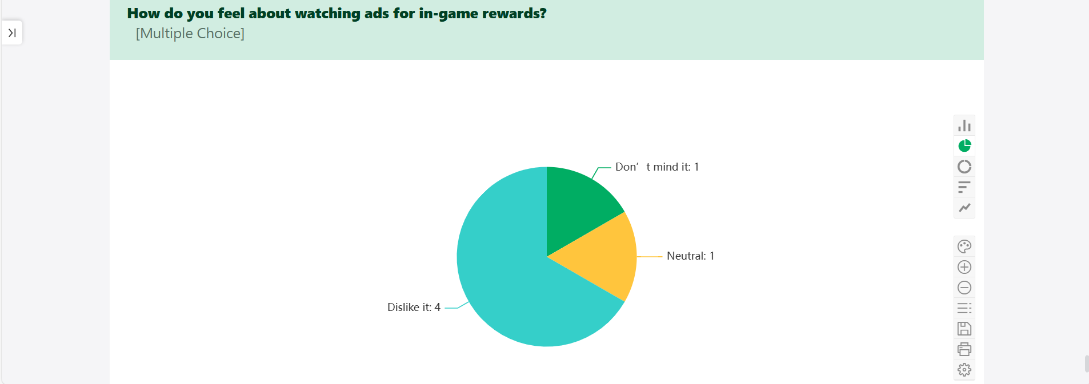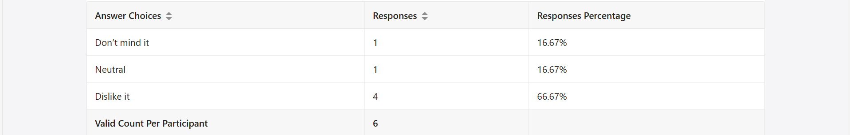
Figure 10 (CLUEDO GAME SURVEY REPORT)

FEEBACK FOR CLUEDO GAME
https://surveymars.com/q/7ne5dhKog
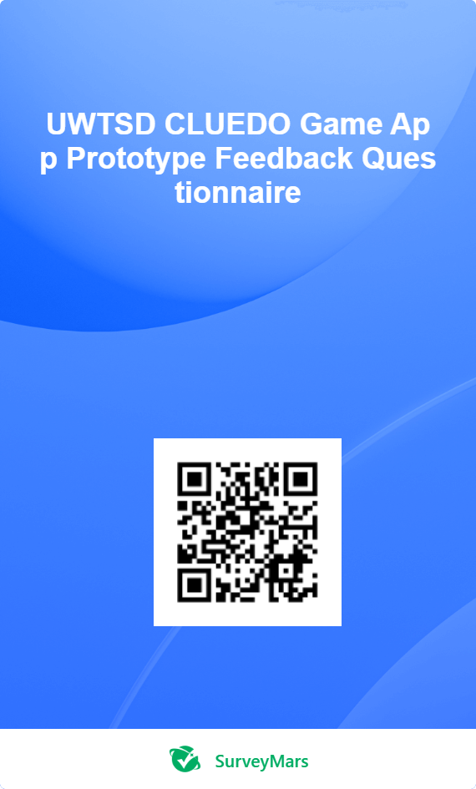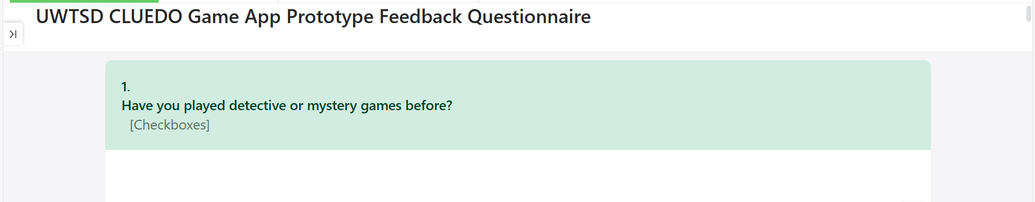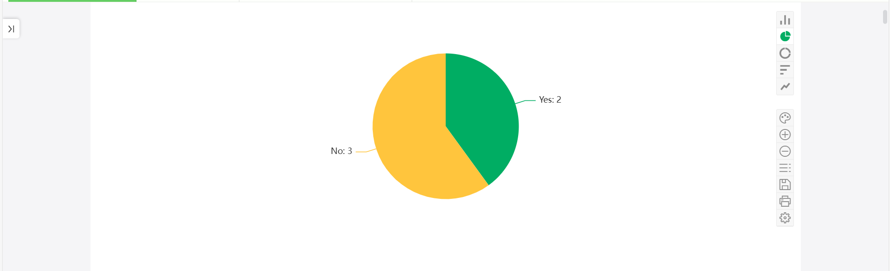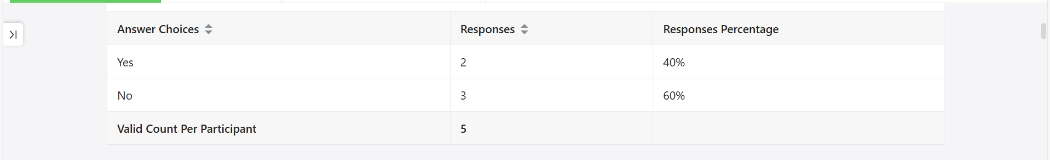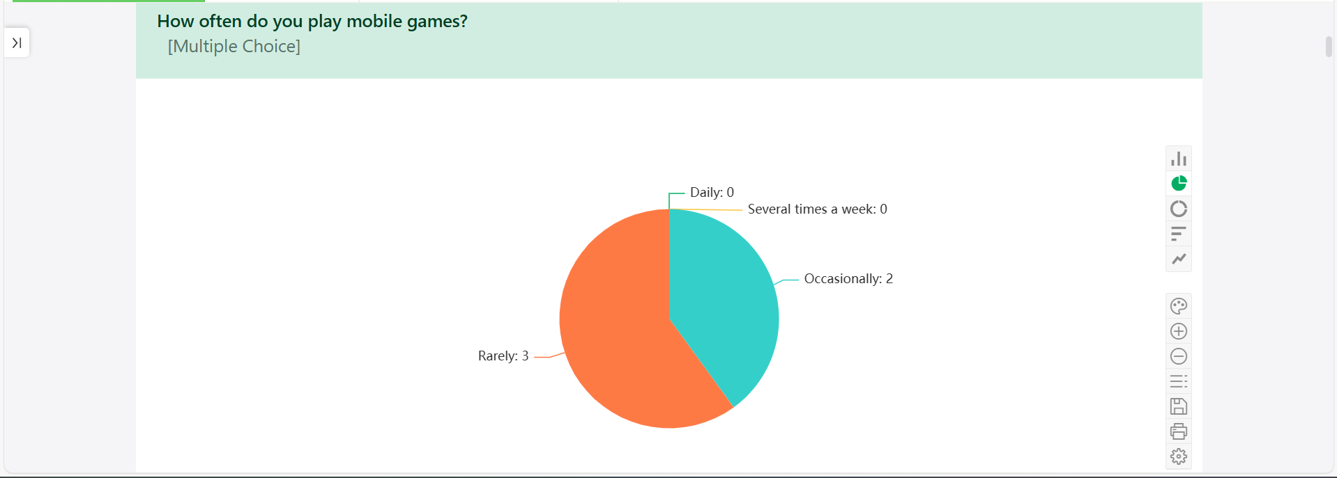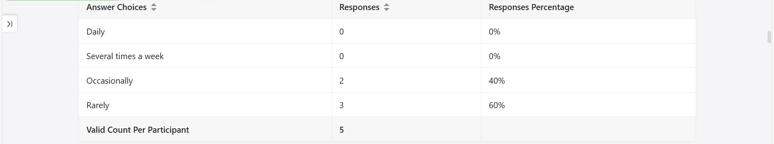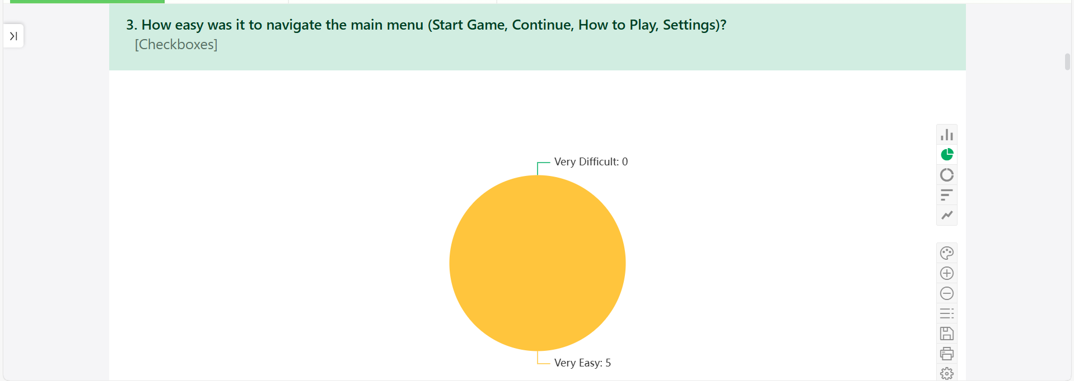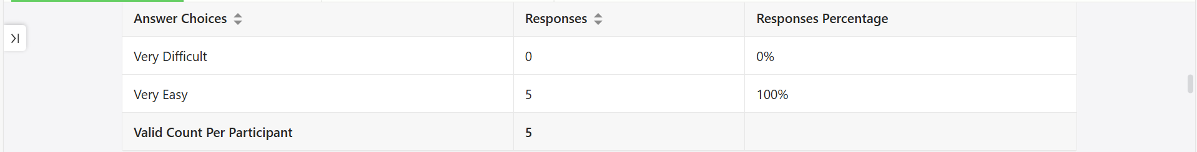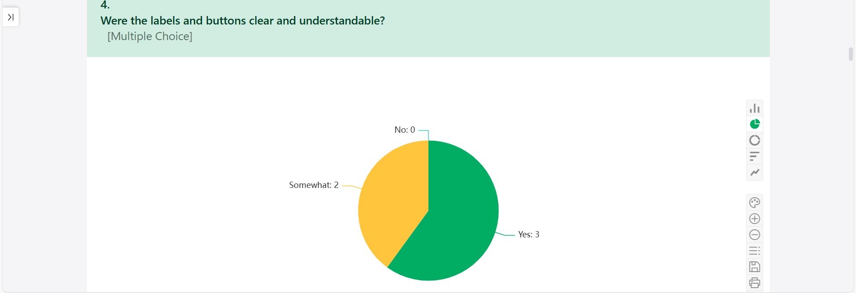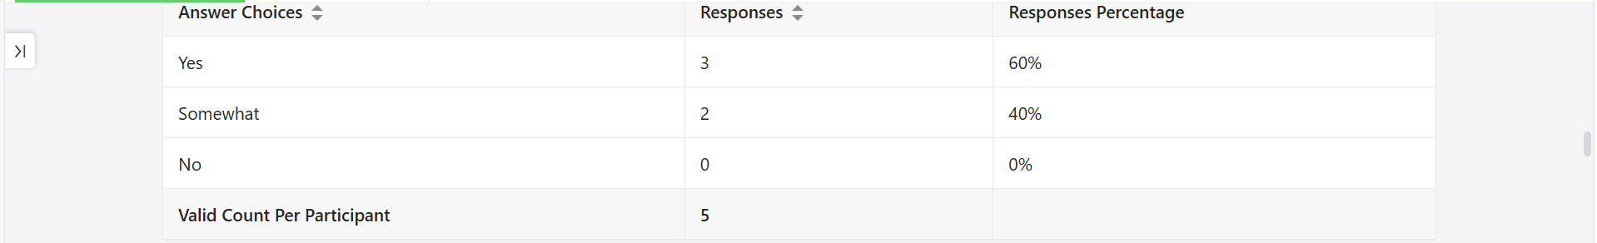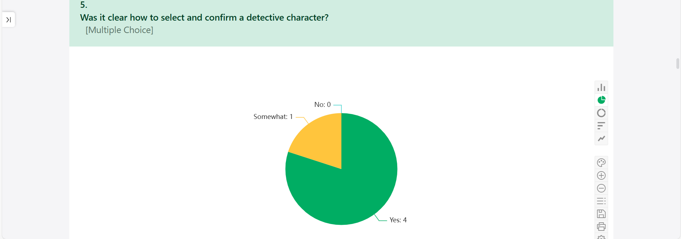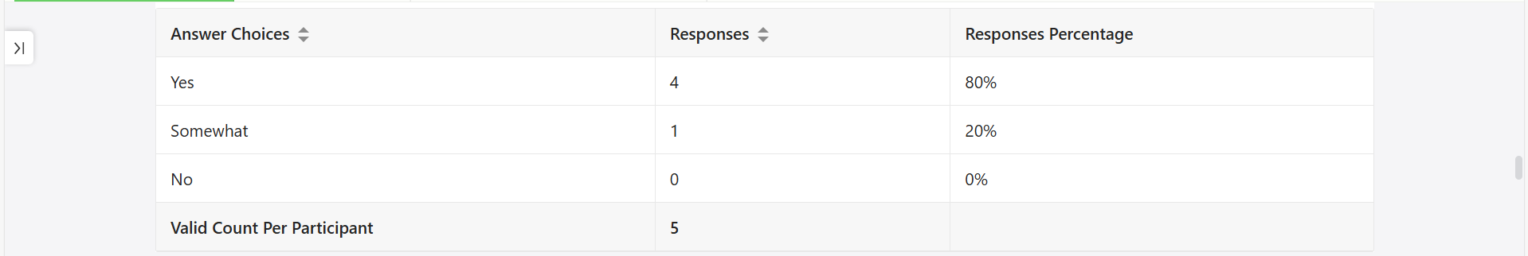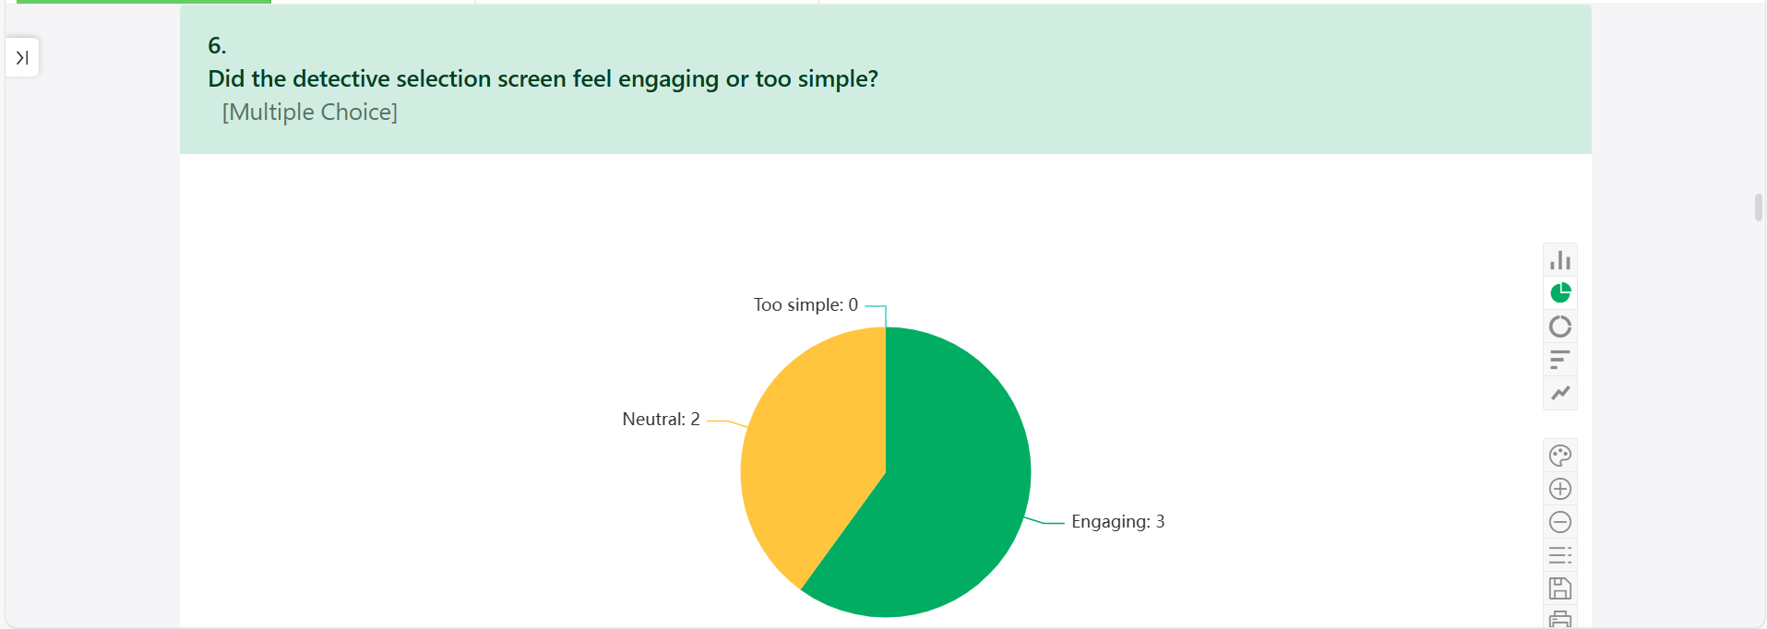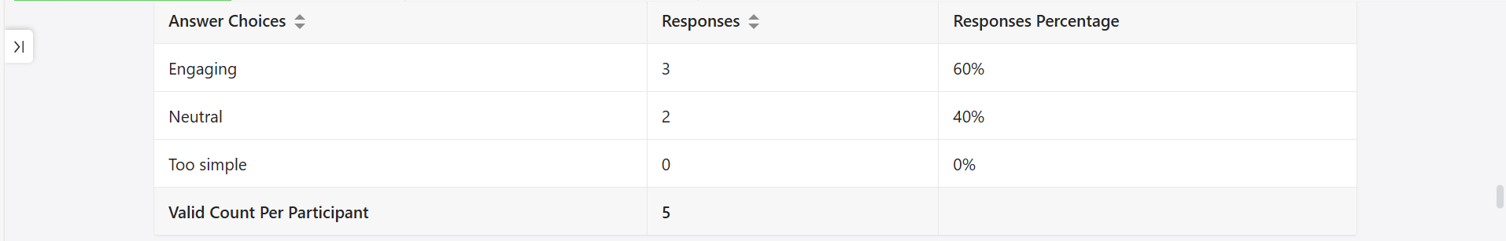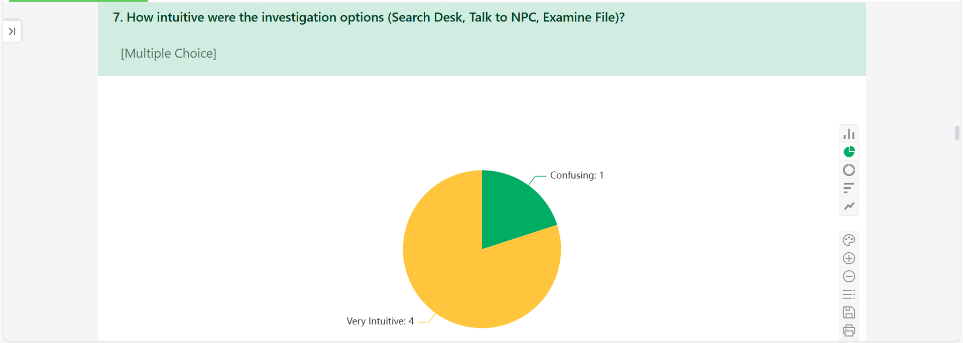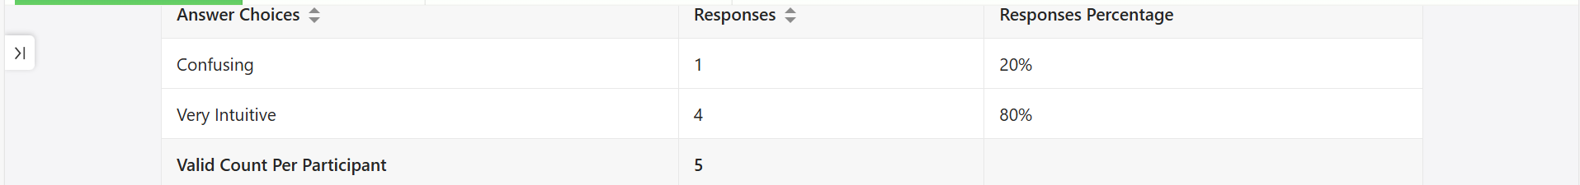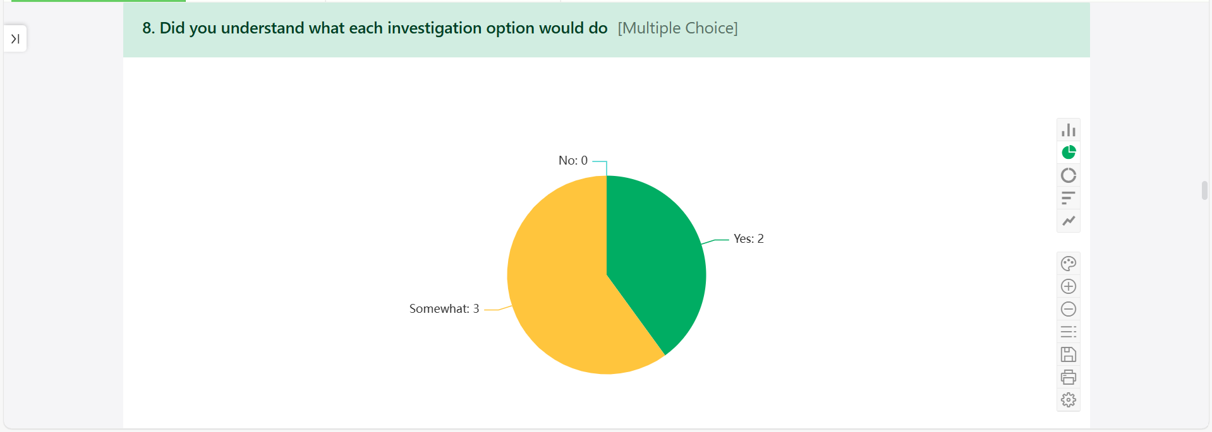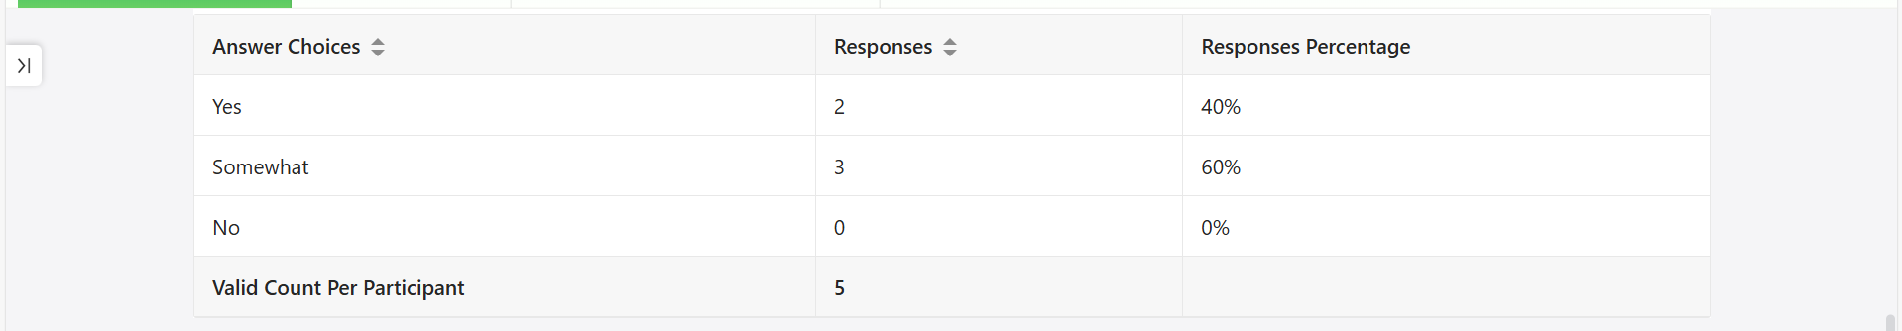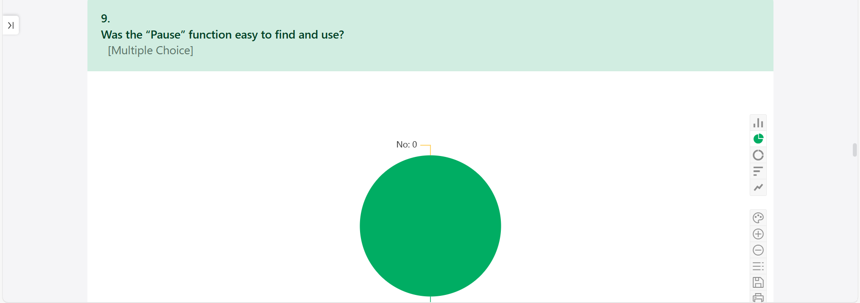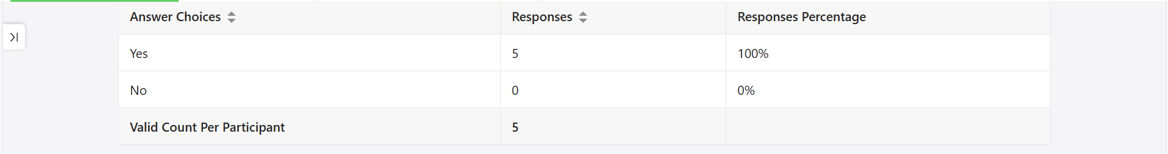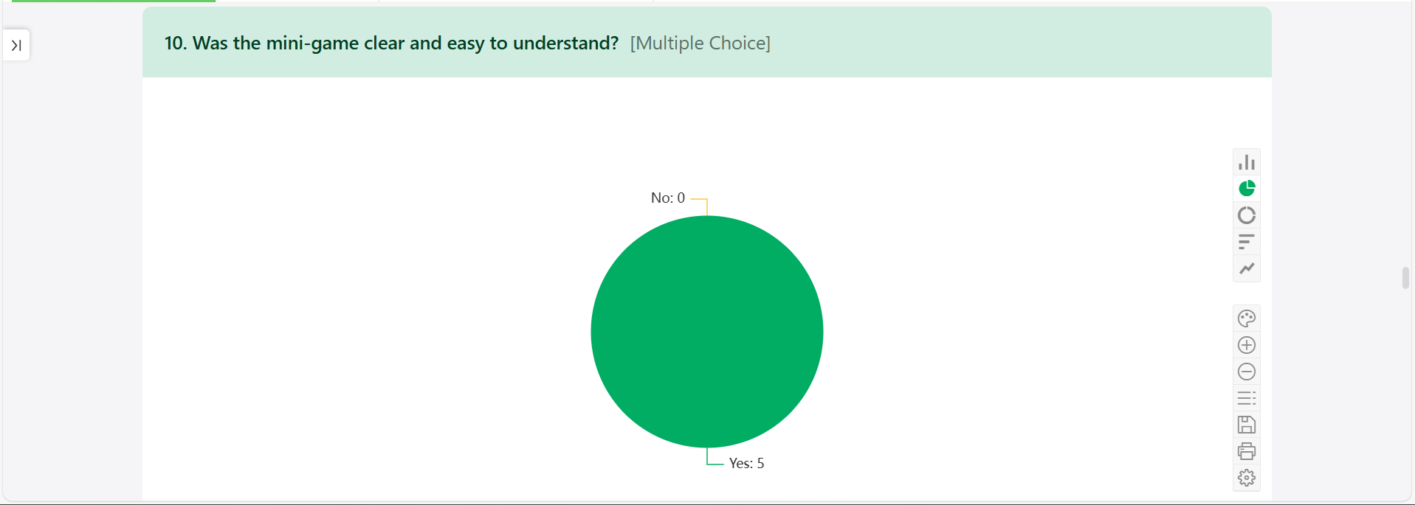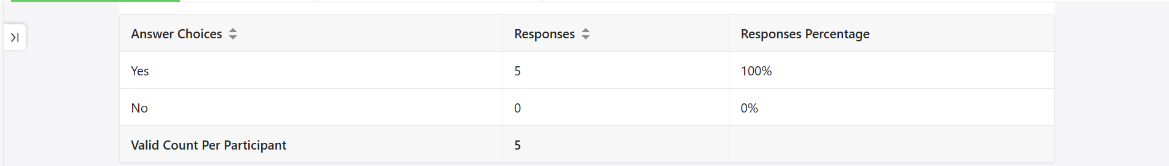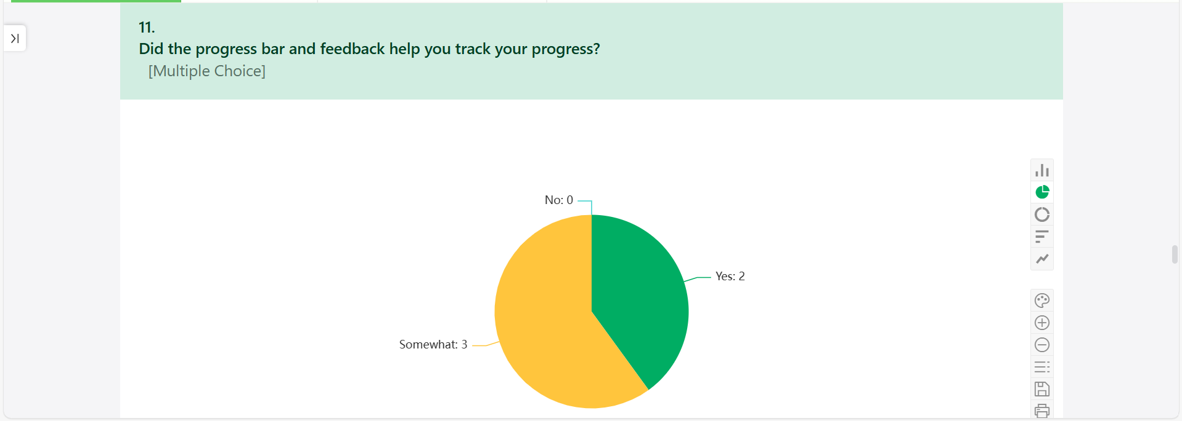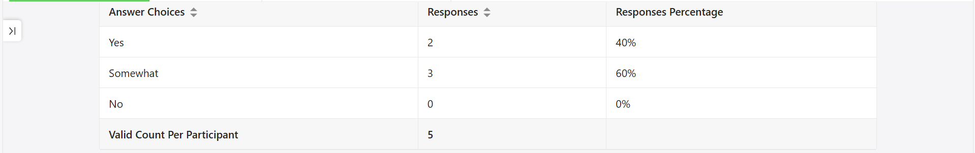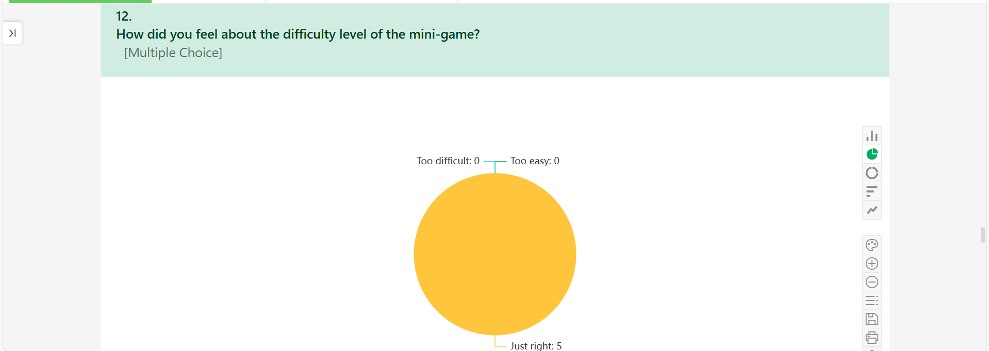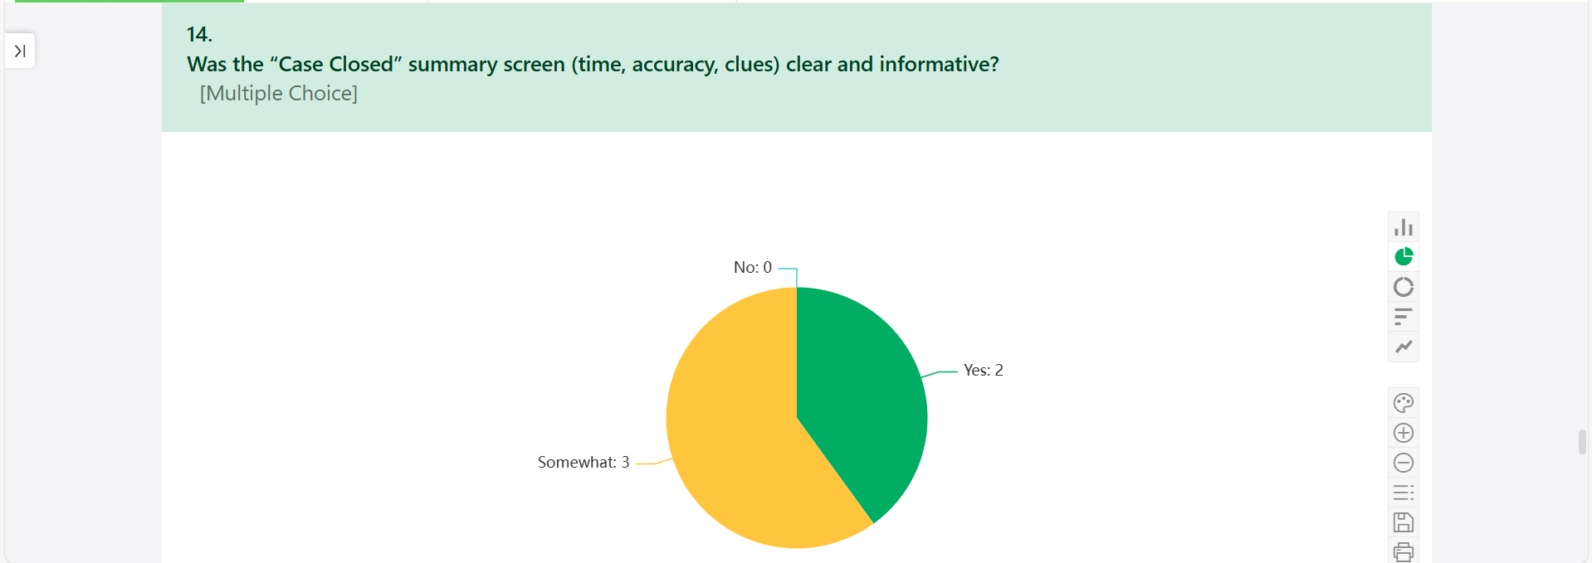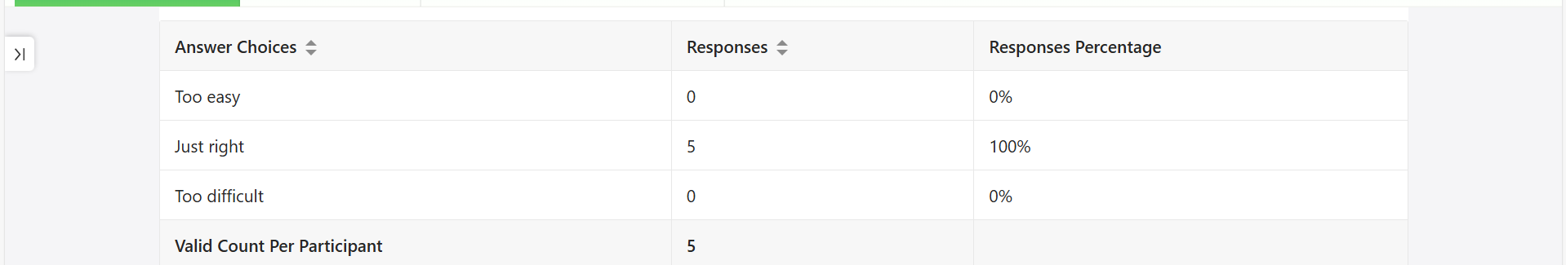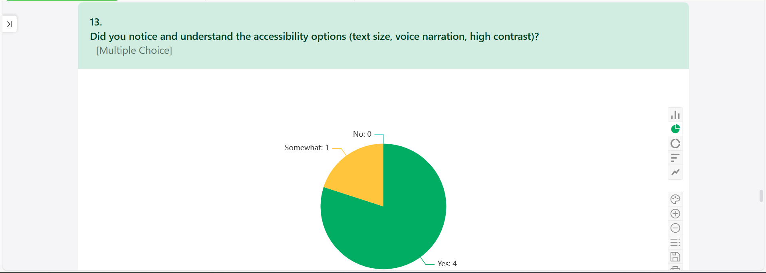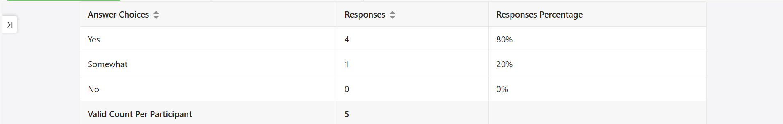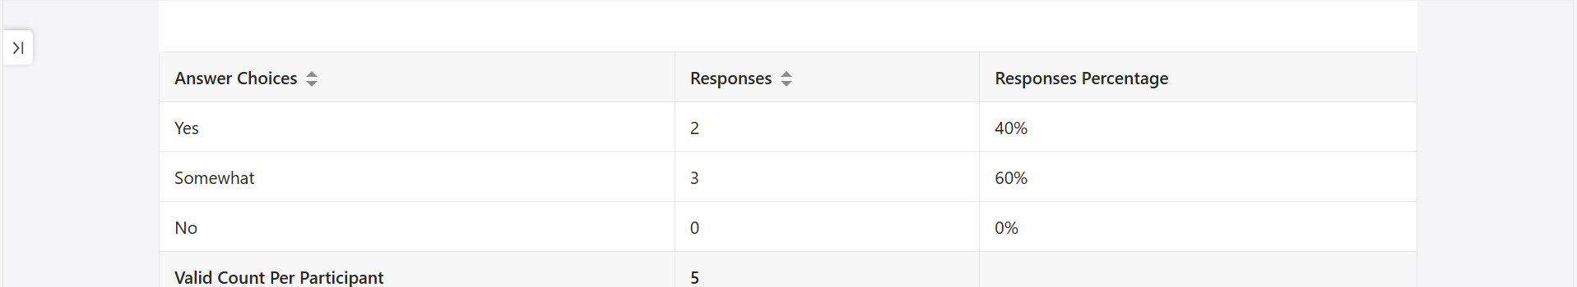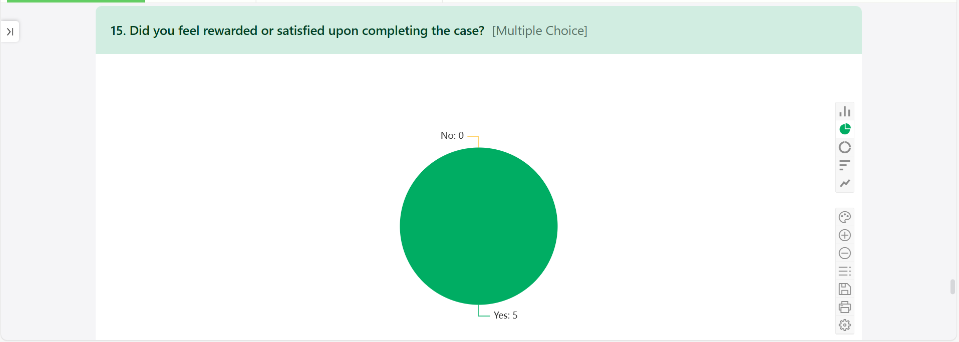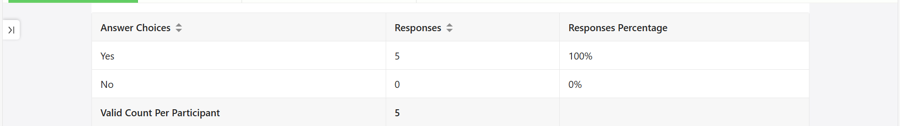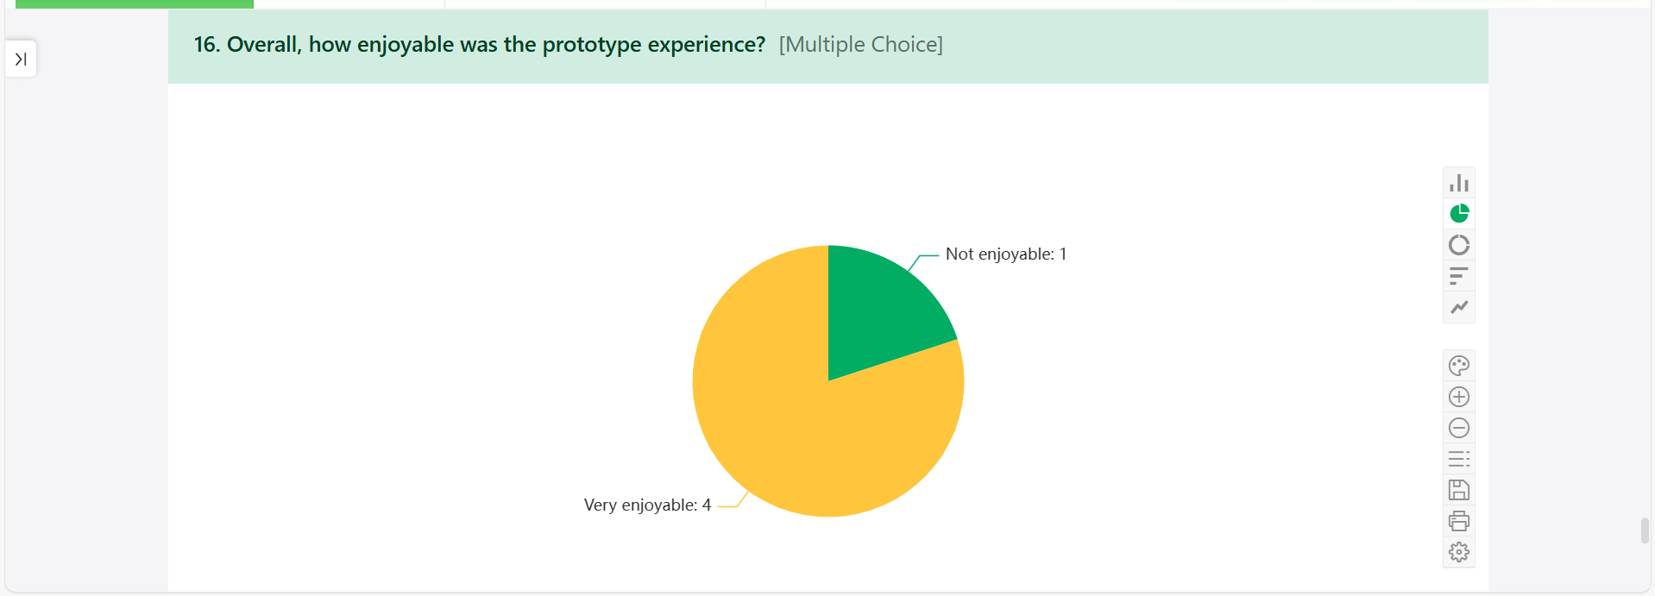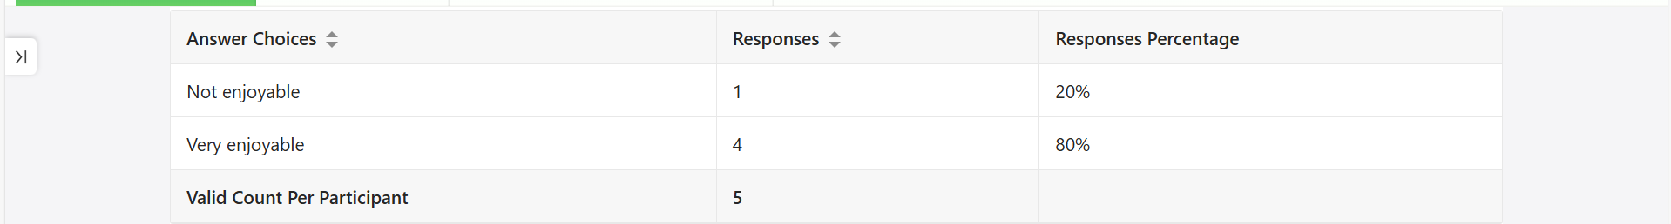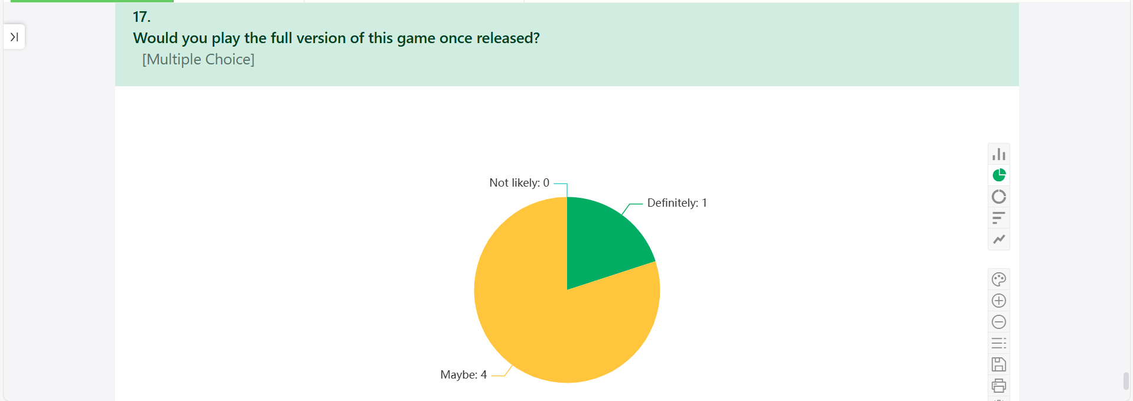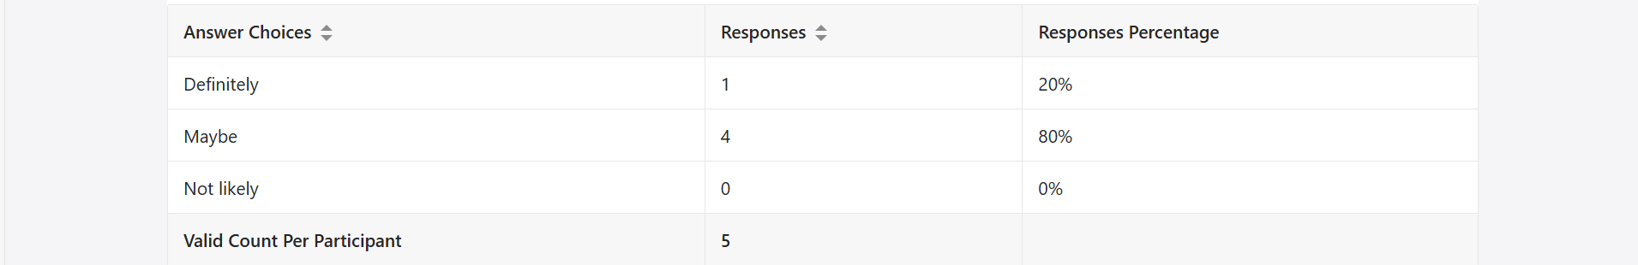
Figure 11 (CLUEDO GAME FEEDBACK REPORT)

PARTICIPENT CONSENT FORM 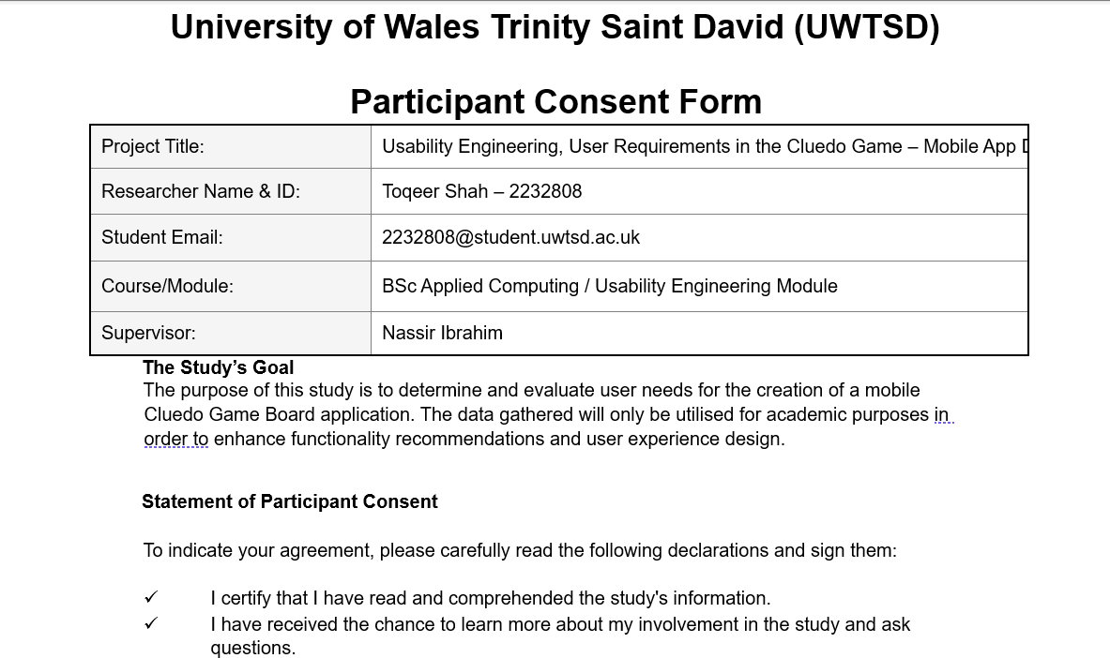 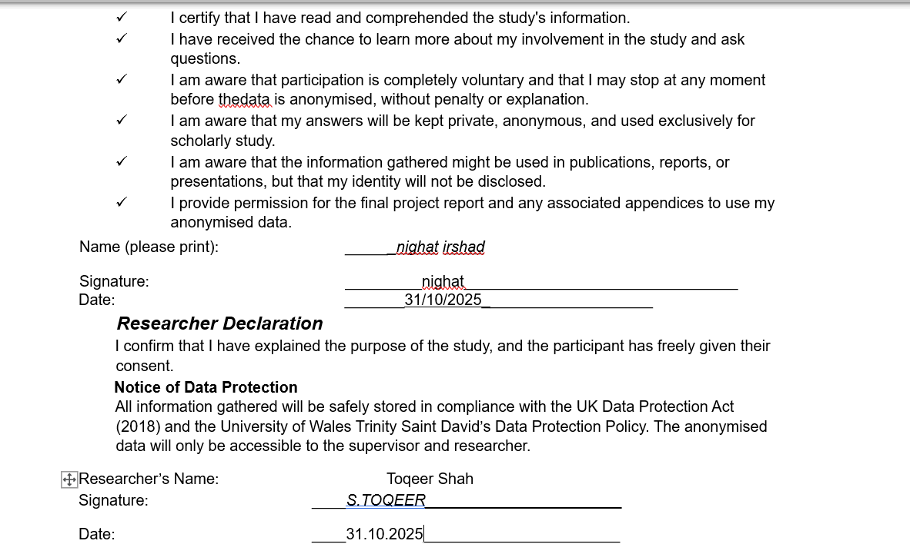

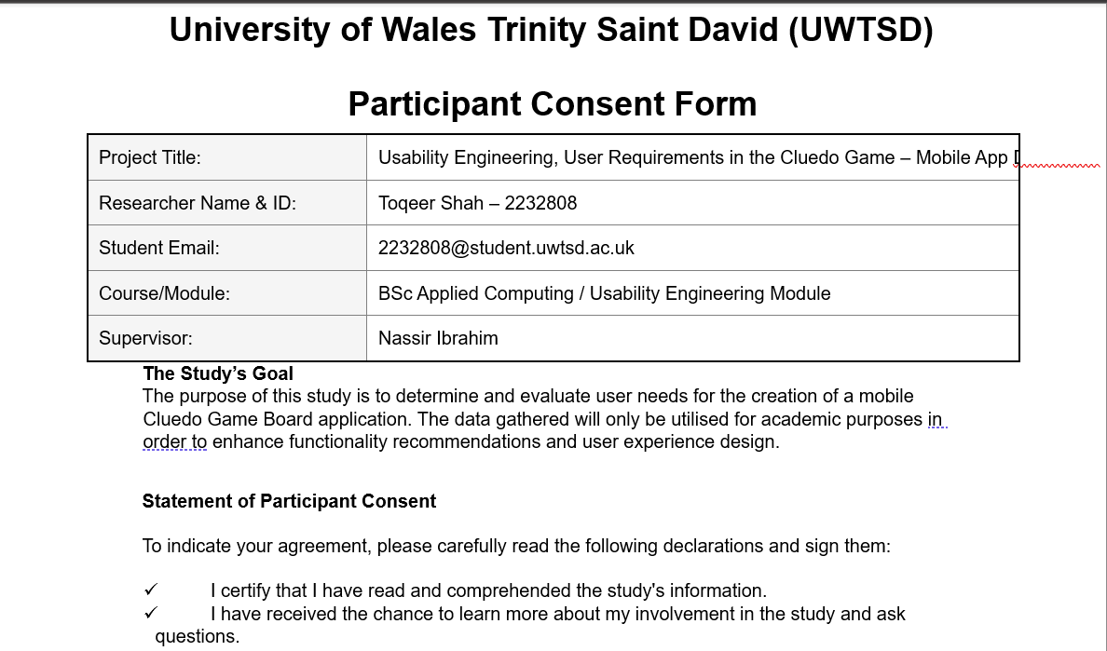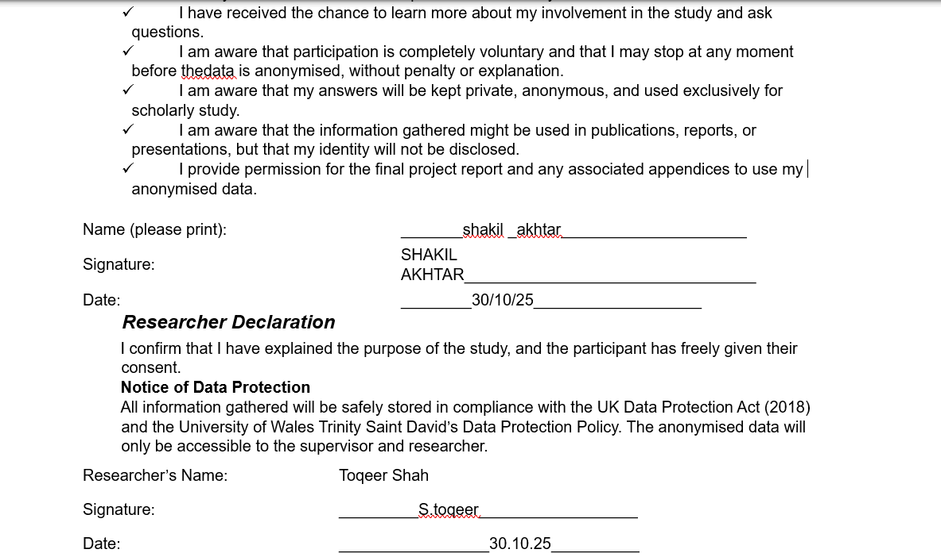
CONSENT FORM SIGN BY PARTICIPENT

​
​
​
​
​
​
​
​​

​
​
​
​
​
​
​
​

​
​
​
​
​
​
​
​

​
​
​
​
​
​
​
​

