Control System Design of a CIWS Turret
Contents

Abstract 1
Introduction 2
Simulation Steps 3
Results 5
Oscilloscope 5
Pole Zero Map 6
Bode Diagram 8
Nyquist Diagram 8
Discussion 9
Oscilloscope 9
Bode Plot 9
Pole Zero Map 9
Nyquist diagram 10
Limitations 11
Assumptions 11
Conclusion 12
Bibliography 12

Abstract
The simulation below represents a closed loop control system for the angular positioning system attached to an automatic Close-In-Weapon-Systems (CIWS) turret. The closed loop control system was designed in MATLAB Simulink and tuned to manipulate both rotation speed and accuracy of the turret. This system was then replicated using a closed loop transfer function, and oscilloscope readings used to compare readings in the time domain. Nyquist, Bode and pole-zero diagrams were used to assess the stability of the model. Overall, the systems were found to be stable and identical.

Introduction
CIWS turrets are point defence weapon systems often on warships, designed to detect and protect against enemy aircraft and short-range missiles. A well-known example is the MK 15 Phalanx, which features a six-barrel cannon that fires 20mm armour-piercing tungsten shells at speeds of up to 4500 rounds per minute. It is all controlled through a radar-and computer-guided fire-control system, which determine the targets position, and if it has been engaged successfully through a search and tracking radar [1]. The emphasis on the stability, reliability and accuracy of this control system is therefore paramount, as any mistakes could result in casualties.
Control systems are designed to provide a desired response by controlling the output. To do this, they utilise two components: sensors and actuators. Sensors monitor conditions and emit signals when set conditions change within certain parameters set up by the system. Actuators are devices that after receiving a signal, cause a mechanism or system to operate. An example of this is a heating thermostat. The sensor monitors the temperature, and if this temperature were to drop below a set value, the actuator would turn the heating system back on. This is an example of a closed loop system, where the output is fed back into the input.
In open loop systems, the output is not fed back into the input, resulting in the control action being independent of the desired output. Tumble driers are examples of open loop systems because after the selected time has run out, they will turn off, regardless of if the washing is dry or not. When compared to closed loop systems, open loop systems are easier to design, require less maintenance and are cheaper to install. Closed loop systems, however, are more accurate and reliable, which are essential qualities when designing a CWIS defence system.
The simulation below will test the control systems response to an input. Firstly, it is vital that any process is kept under control in as short a time as possible, as any delay could result in an area being exposed to fire from the enemy. The maximum time for the output to settle (the settling time) is therefore 2 seconds. The overshoot must also be as low as possible, to ensure the turret can be accurate in a shorter time frame. As a result, the maximum system requirements were set as a 5% overshoot.
When designing the system, it was important to consider the systems response in terms of stability. A systems initial response has two components- transient and steady state. The transient response is evident immediately after the system is turned on and can be the first sign of instability. An unstable system will cause this response to vary exponentially in time, causing the system to be unusable or even break. Alternatively, a stable system will cause the transient response to disappear, and the system will produce a steady state response, producing the intended outputs of that system. In this design, it is therefore crucial stability is monitored and analysed, so the system can reach this steady state response [2] .

Simulation Steps
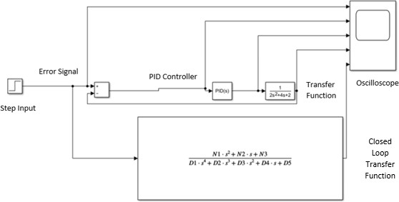
Figure 1-The angular positioning system attached to a CIWS turret

When designing this linear circuit, a Proportional-Integral-Derivative Closed Loop system was been used, as shown in figure 1. The step input creates the demand (turret movement), then an error signal is generated based upon the difference between the process value and the set point. The PID controller than uses a proportion of this error to compensate for the current error. It removes steady state error by using the integral of the error signal. To reduce overshoot and oscillation, it then uses the derivative of the error to compensate for possible future errors. The advantages of this technique are there is a small settling time, meaning the turret can quickly move to its correct position.
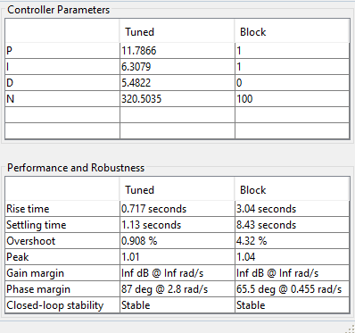
Figure 2-Performance parameters for the simulation

The system was then manually tuned, using the parameters in figure 2. Definitions of these parameters can be found below:

Rise time = the time taken for the output to reach within 98% of the steady state.
Settling time = the time taken for the output to settle into this value, with no further oscillation.
Gain margin = the change in open-loop gain required at 180◦ of phase shift to make the closed-loop system unstable. For a system to be deemed stable, this value must be positive, so it can withstand greater changes in system parameters before becoming unstable.
Phase margin = the margin is the change in open-loop phase shift, required at unity gain to make a closed-loop system unstable.
Overshoot= the maximum response received from the system [3].

The transfer function in equation 1 mathematically describes the behaviour of the system by representing the relationship of output to input signals. It does this by converting both signals from the time domain into the frequency domain, using the Laplace transform. It utilises the equation below to do this, with positioning variables: a=2, b=4 c=2. This makes the signals easier to solve, as they are each converted into linear ordinary differential equations. The result is then converted into a ratio of output to input, which when multiplied with the input function, creates the output function [4].

$$G\left(s\right)=\frac{1}{2s^{2}+4s+2}$$

Equation 1-Transfer function of the system

The closed loop transfer function combines the feedback, PID controller and transfer function mathematically into one equation as shown in figure 1 [5]. Equations 2-5 go through this mathematical process.

$$The controller C\left(s\right)=Kp+Ki\frac{1}{s}+Kd\left(\frac{s}{\frac{1}{N}s+1}\right)$$
Equation 2-Controller function of the system
$$The plant G\left(s\right)=\frac{1}{as^{2}+bs+c}$$

Equation 3-Plant of the system
$C\left(s\right)×G\left(s\right)=\frac{\left(Kp+Nkd\right)s^{2}+\left(Nkp+Ki\right)s+NKi}{as^{4}+\left(aN+b\right)s^{3}+\left(bn+c\right)s^{2}+cNs}$
Equation 4-Forward transfer function

Transfer Function= $\frac{G}{1+GH}$ where H=1 (the gain of the sensor is equal to one as there is unity feedback).

$$\frac{\left(Kp+NKd\right)s^{2}+\left(NKp+Ki\right)s+NKi}{as^{4}+\left(aN+b\right)s^{3}+\left(bn+c\right)s^{2}+cNs}÷1+\frac{\left(Kp+NKd\right)s^{2}+\left(NKp+Ki\right)s+NKi}{as^{4}+\left(aN+b\right)s^{3}+\left(bn+c\right)s^{2}+cNs}$$

=
$$\frac{\left(Kp+Nkd\right)s^{2}+\left(Nkp+Ki\right)s+NKi}{as^{4}+\left(an+b\right)s^{3}+\left(Kp+NKd+bN+c\right)s^{2}+\left(NKp+Ki+cN\right)s+NK}$$
Equation 5- Closed loop transfer function of the system

The tuning data found in figure 2 was then added into this equation for the Ki, Kd and Kp variables. The Kp represents the proportional gain, Ki the integral gain, and Kd the derivative gain. This system will then be compared against the original system by comparing the oscilloscope readings of the two.

Results

Oscilloscope
The oscilloscope readings of each circuit component can be found below in figure 3. As shown, the controller output and closed loop transfer function graphs are identical.

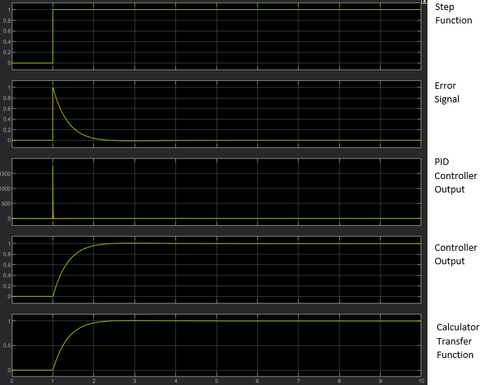 Figure 3-Oscilloscope readings for each circuit component

Pole Zero Map
Figures 4 and 5 display the poles and zeros of the transfer function. The poles are represented by an x, which is the part of the transfer function that tends to infinity. The zeroes of the polynomial plot are represented by 0 and can be found at the origin. This is where the transfer function tends to zero.
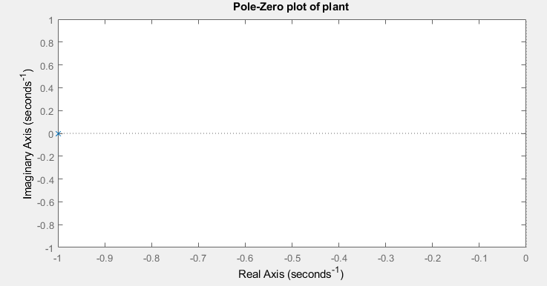
Figure 4-Pole-Zero plot of transfer function

As seen above, figure 4 displays a pole at -1.
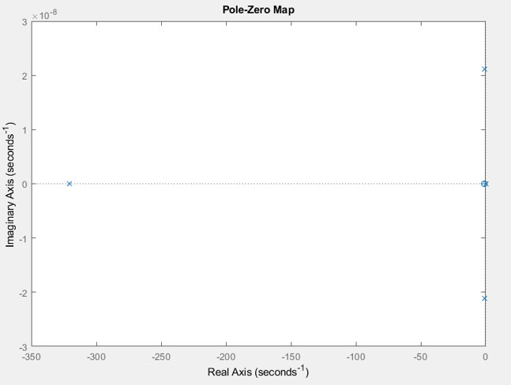
Figure 5-Pole-Zero map of control system

Figure 5 has a complex conjugate pole pair just left of the s-plane, as well as a pole at -1.

Bode Diagram

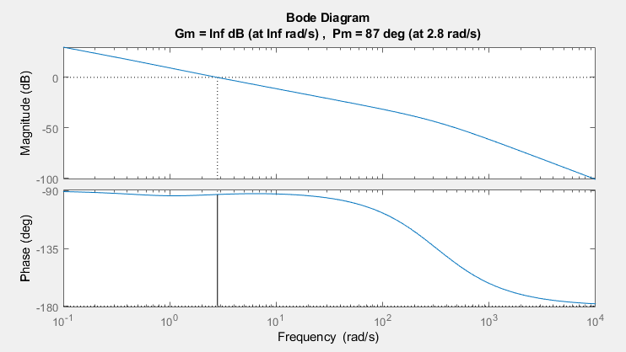
The Bode diagram, shown in figure 6, represents the frequency response of the system.
Figure 6-Bode Diagram of the system

Nyquist Diagram
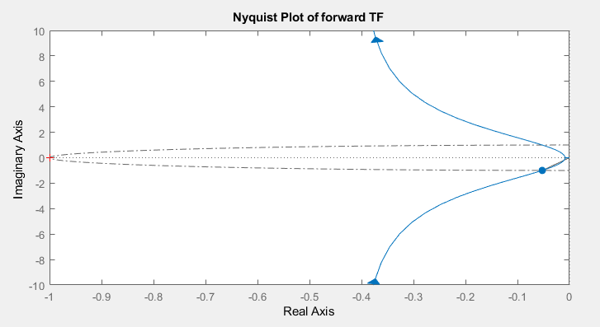
The Nyquist diagram in figure 7 represents the complex frequencies the system can work in without becoming unstable. It does this by showing both the frequency and phase response on a single plot. Every frequency within the blue line is stable, and everything outside the blue line therefore can cause the system to become unstable. The grey circle is called the unit circle and is centered on the origin with radius 1. This plot excludes the feedback to enable gain and phase margins to be calculated.
Figure 7-Bode Diagram of the system

Discussion

Oscilloscope
As demonstrated in figure 3, all the signals start at the same time, indicating there is no lag to the system. When looking at the transfer function and closed loop transfer function plots, both signals are identical in time response and amplitude. Therefore, the circuits themselves must then be identical, thus proving the calculations for the closed loop transfer function are correct.

Bode Plot
As shown in figure 6, the phase plot does not pass the -180 frequency, so therefore has an infinite gain margin.
The vertical distance between the phase curve and the x-axis at the frequency where the Bode magnitude plot is 0 dB represents the gain crossover frequency. Figure 3 shows it to be approximately -93°. Using the equation for this in equation 6, the phase margin of the system is therefore found to be 87°, matching the one calculated by MATLAB in figure 3 [6] . This means 87° of phase can be increased or decreased without the system becoming unstable [7].
$$PM=ϕ-(-180)$$
Equation 6-Equation for the phase margin

Pole Zero Map
As illustrated in figure 4, the pole of the transfer function is -1. These should be identical to the values that make the denominator of the transfer function 0. The proof for this can be seen below, when mathematically solving the original transfer function:

2s²+4s+2=0
=2(s+1) (s+1) =0
Root: -1

The location of these poles gives an insight into the stability of the system. The pole in figure 4 is negative. Using the reverse Laplace transform, the initial transfer function can be placed into the time domain and known values inputted, as shown below in equation 7 [8]:

$$y_{h}\left(t\right)=\sum_{i=1}^{n}{C_{i}e^{P_{i}t}} → 1e^{-1t}$$
Equation 7-Formula for the time domain response of a system, with the pole values inputted

As the pole is negative, this would produce a negative exponential where the time function tends to zero as time continues. Therefore, this demonstrates the system is stable as the function reaches one single point (0) over time. As the poles are close to the origin, the value of e will therefore be low. As a result, the function will decay slowly, which is not an ideal characteristic for this control system as fast response times are required for quick firings.
The location of the poles show it is a critically dampened response, as it has a damping ratio of 1. This means the oscillations stop in the shortest time possible. Having little/no oscillation is highly beneficial to the system as it means the turret can accurately reach its position first time, without having to move around further. This ensures a fast turnaround between firings, which will be highly beneficial in a battlefield environment.
This pole is shown again in figure 5, demonstrating the stability of the entire system. The diagram also features a complex conjugate pole pair, which represents the oscillatory response of the control system. As it is to the left of the imaginary axis, it shows a decaying sinusoid, meaning the turret will oscillate closer and closer to the target position before eventually reaching it. Although this is still acceptably stable, it will result in lost time, where the turret will not be in its correct position.
The figure also shows a pole at -320 seconds. As this is far away from the origin, it will emit a fast response.

Nyquist diagram
To know if the Nyquist diagram shown in figure 7 is stable, the number of poles and zeroes in the right-hand side of the s-plane must be calculated. This is because, as explained above, any poles in the right-hand side of the graph would cause the transfer function to grow exponentially with time, causing instability. This can be done using the Nyquist Criterion in equation 8:

N = Z − P
Equation 8-The Nyquist Criterion
Where N is the which is the number of encirclements of the -1+j0 coordinate of the plot, Z is the number of zeros, and P is the number of poles both on the right-hand side of the graph.
As shown by figure 7, the Nyquist plot does not encircle -1+j0 in a counter-clockwise manner, therefore N=0. The P value of zero is already determined by the pole-zero diagram in figure 6. Therefore, when these numbers are substituted back into the equation, Z is found to equal zero.
The gain margin can be calculated in the Nyquist plot by measuring the distance between the point at which the curve crosses the real axis and the unit circle at the 180° point. The gain margin is infinite, because the path of the Nyquist diagram never crosses the real axis in the left half plane [8].
The phase margin can also be calculated by measuring the angle between where the curve crosses the unit circle and the negative real axis at the 180° point. This was measured at 87°, matching the result from the Bode plot.

Limitations
Due to time constraints, one method of stability analysis not explored was the Root Locus method. This demonstrates how the roots of the characteristic equation (the combination of the controller, the plant, and the feedback) move around the s-plane as a single parameter varies, thus allowing stability to be determined as system gain is changed. Additionally, it can also be used in the design of the system, as it can reveal both the damping ratio and natural frequency of a feedback system.
Figure 8 is an example of a Root Locus, with sections analysed to gain more data. It shows the systems natural frequency (ωn), damping ratio(ζ), damped natural frequency (ωd=ωn ($\sqrt{1 -ζ2}$)), and θ=(cos−1ζ). To then implement this into the control system design, gain must be calculated by selecting a point along this graph that coincides with the required damping ratio and natural
frequency [9] .

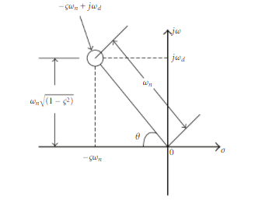
Figure 8-Root Locus plot showing how natural frequency and the damping ratio can be calculated [9]

If the system were to reach resonance, it would cause huge oscillations to occur, causing the accuracy of the turret to deteriorate. Knowing the systems natural frequency and being able to tune it to an unattainable level, will therefore prevent this problem occurring. The damping ratio is also crucial, because as mentioned earlier, having any ratio other than 1 (critically damped response), will cause either unwanted oscillation (underdamped), or would take longer to create the intended response (overdamped).

Assumptions
The circuit above has assumed the turret itself is weightless, with negligible air resistance upon rotation. In the real world, however, these assumptions are not possible, as CIWS turrets such as the Rheinmetall Oerlikon Millennium Gun weigh 3300kg, meaning greater considerations need to be made about the speed of rotation and the power required from the system to rotate it [10].

Conclusion
The simulation above has met all its designated design criteria and brought it under control in 1.13 seconds with an overshoot of 0.908%. The closed loop transfer function has been found to replicate the results of the initial circuit, proving the mathematical formula are correct. Furthermore, it has been concluded the system is stable, with the poles in the right-hand stable region of both the pole zero diagram and the Nyquist plot. Additionally, the system is critically dampened, ensuring the turret does not oscillate before reaching its target position. Therefore, the simulation has been successful in representing a turret simulation, however, requires adjustment to work in real life applications.

Table of Equations
Equation 1-Transfer function of the system 4
Equation 2-Controller function of the system 4
Equation 3-Plant of the system 4
Equation 4-Forward transfer function 5
Equation 5- Closed loop transfer function of the system 5
Equation 6-Equation for the phase margin 9
Equation 7-Formula for the time domain response of a system, with the pole values inputted 9
Equation 8-The Nyquist Criterion 10

Table of Figures
Figure 1-The angular positioning system attached to a CIWS turret 3
Figure 2-Performance parameters for the simulation 3
Figure 3-Oscilloscope readings for each circuit component 6
Figure 4-Pole-Zero plot of transfer function 6
Figure 5-Pole-Zero map of control system 7
Figure 6-Bode Diagram of the system 8
Figure 7-Bode Diagram of the system 8
Figure 8-Root Locus plot showing how natural frequency and the damping ratio can be calculated [7] 11

Bibliography

[1] | N. Friedman, "Oerlikon 35 mm gas operated," in The Naval Institute Guide to World Naval Weapons Systems, 1997-1998, Naval Institute Press, 1997, p. 808.
[2] | Rutgers University, "Chapter Six Transient and Steady State Responses," in Analysis and Design, Semantic Scholar, pp. 261-262.
[3] | R. A. itendra R. Raol, "Linear Systems and Control," in Control Systems, Boca Raton, CRC Press, 2019, pp. 3-64.
[4] | Z.-F. F. Jimin He, "Mathmatics for Modal Analysis," in Modal Analysis, Elsevier, 2001, pp. 12-48.
[5] | W. R. Perkins, "William R. Perkins," Radio, Electronics, Computer, and Communications, no. 9, pp. 15-1-15-33, 2002.
[6] | Electrical4U, "Bode Plot, Gain Margin and Phase Margin (Plus Diagrams)," Electrical4U, 21 1 2021. [Online]. Available: https://www.electrical4u.com/bode-plot-gain-margin-phase-margin/. [Accessed 22 12 2021].
[7] | University of Arkansas at Little Rock, "Libre Texts," University of Arkansas at Little Rock, 5 March 2021. [Online]. Available: https://eng.libretexts.org/Bookshelves/Industrial_and_Systems_Engineering/Book%3A_Introduction_to_Control_Systems_%28Iqbal%29/04%3A_Control_System_Design_Objectives/4.01%3A_Stability_of_the_Closed-Loop_System. [Accessed 23 12 2021].
[8] | P. D. Trumper, "Understanding Poles and Zeros," in 2.14 Analysis and Design of Feedback Control Systems, Massachusetts, MASSACHUSETTS INSTITUTE OF TECHNOLOGY, 2014, pp. 1-13.
[9] | M. M. G. a. N. H. Ki-Young Song, "Design of an Error-Based Adaptive Controller for a Flexible Robot Arm Using Dynamic Pole Motion Approach," Journal of Robotics, p. 9, 2011.
[10] | J.Guttman, "MK 15 Phalanx Close-In Weapons System," Military History, vol. 26, no. 1, p. 25.

