DS 1 Template

My Screenshots/Photos
- Please add 4–6 screenshots or photos of your digital life.
- You can use your phone or laptop.
- For each screenshot, write one or two sentences explaining what it shows.

Screenshot/Photo 1
[Insert Photo/Screenshot below]
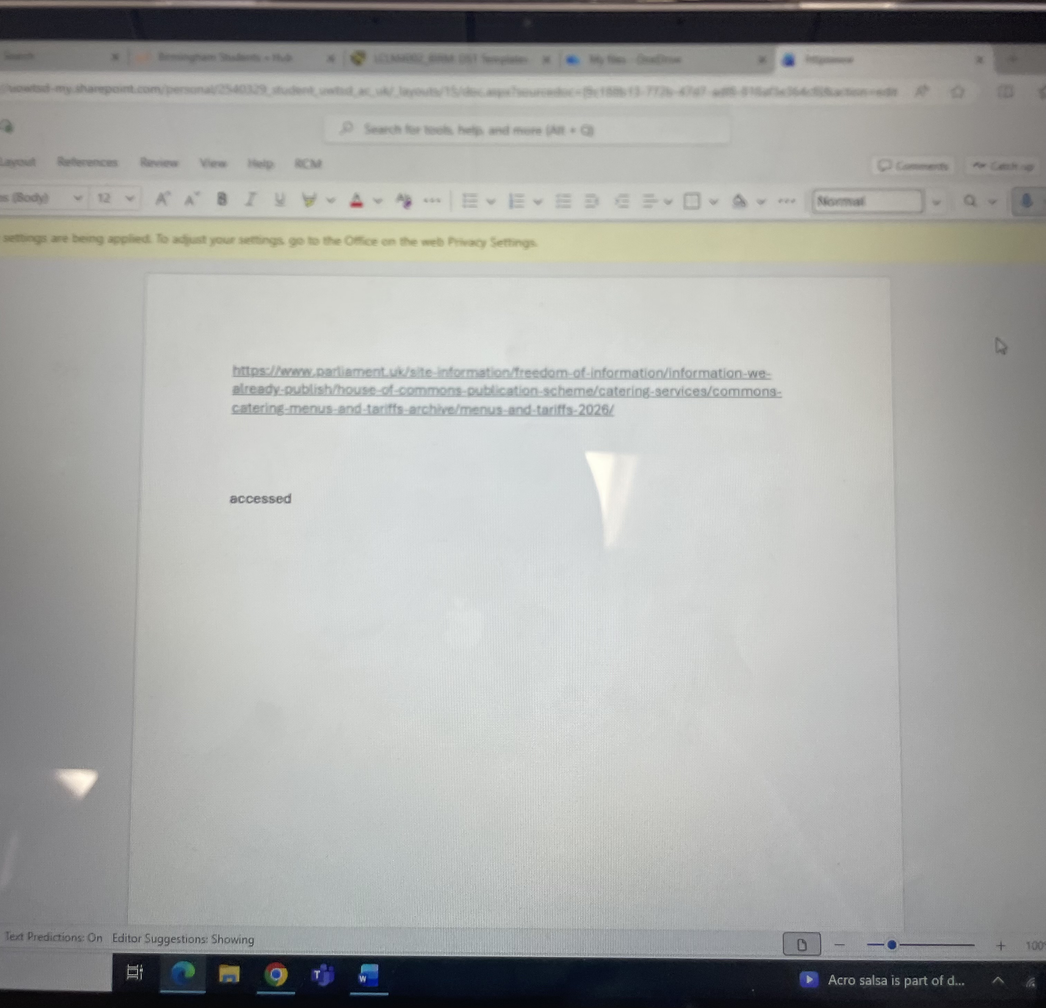
This is a hyperlink where I have found a website with information I need and I have copied and pasted the site into Microsoft where I can now go back and press the link at any time to get back to the web page.

Screenshot/Photo 2
[Insert Photo/Screenshot below]
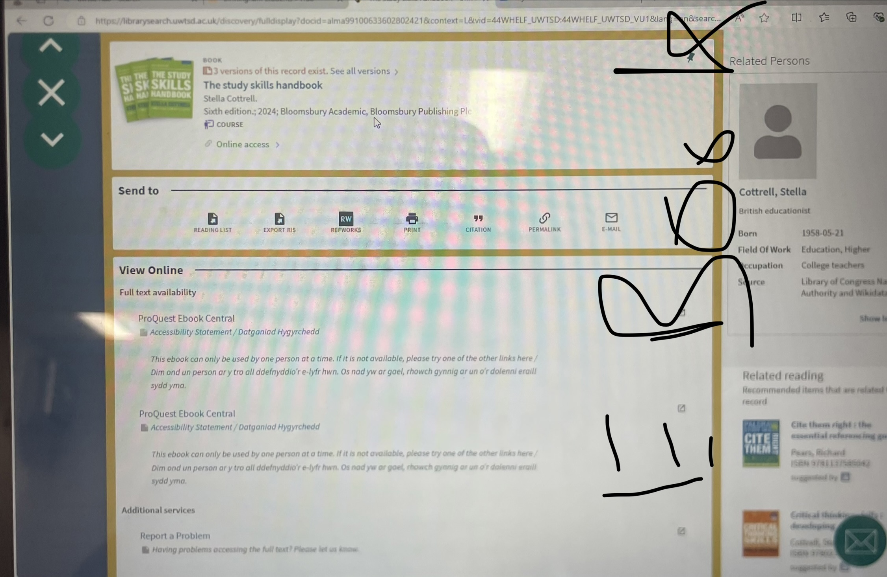
This image shows that I can screen shot fact checked information on a e-book and crop the image to size needed.

Screenshot/Photo 3
[Insert Photo/Screenshot below]
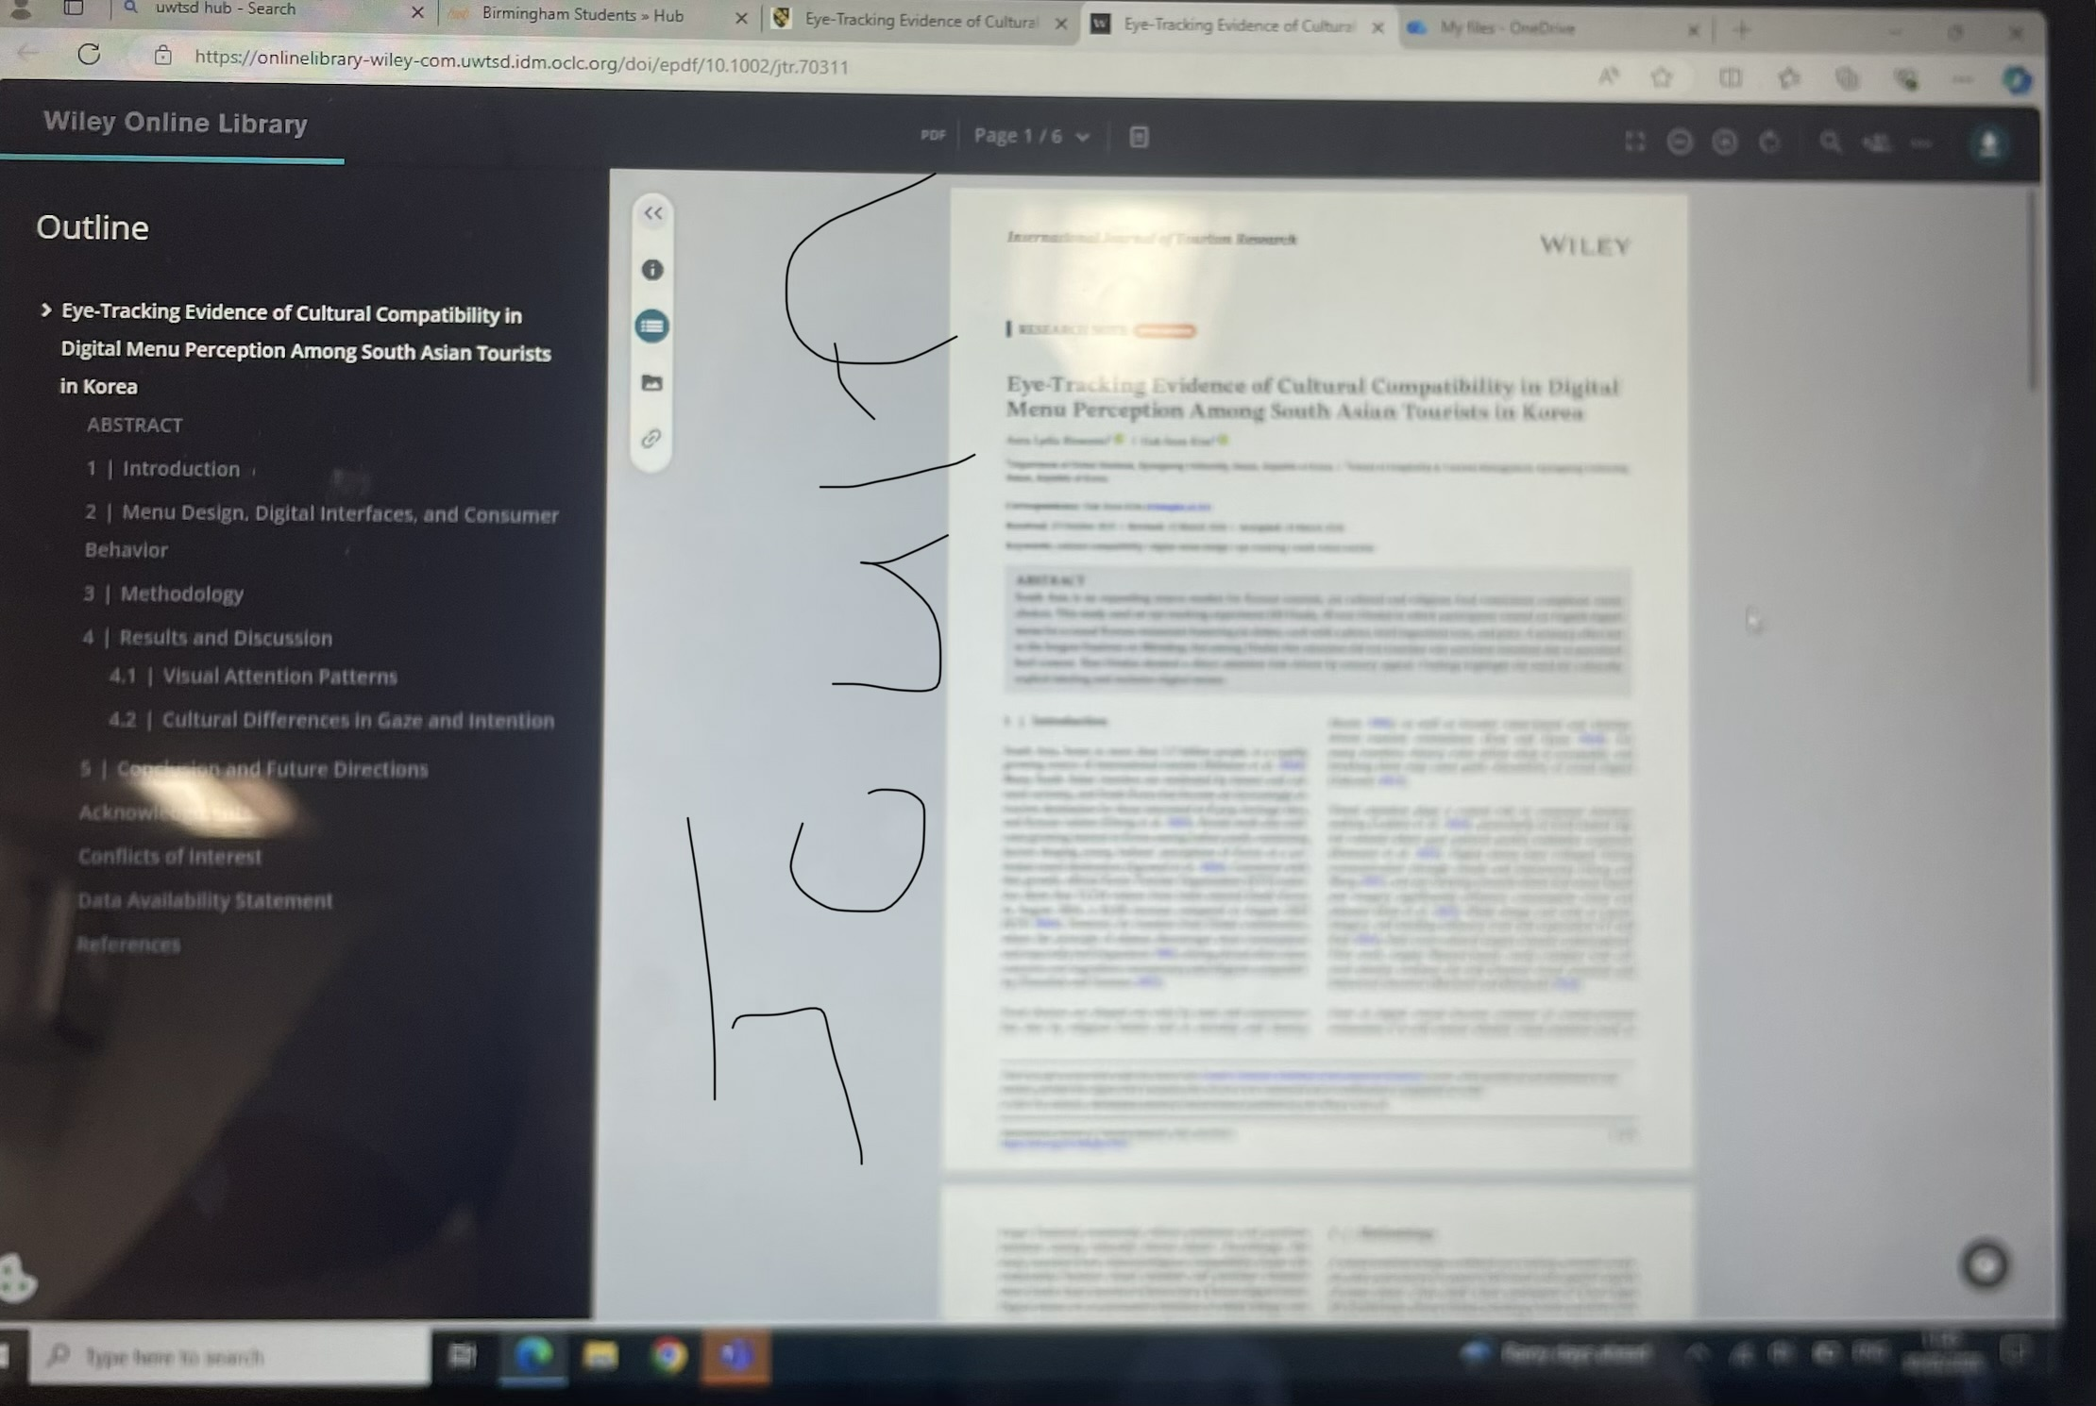
This is a screen shot of me using a journal for proof of information and for fact that have been checked and backed with proof.

Screenshot/Photo 4
[Insert Photo/Screenshot below]
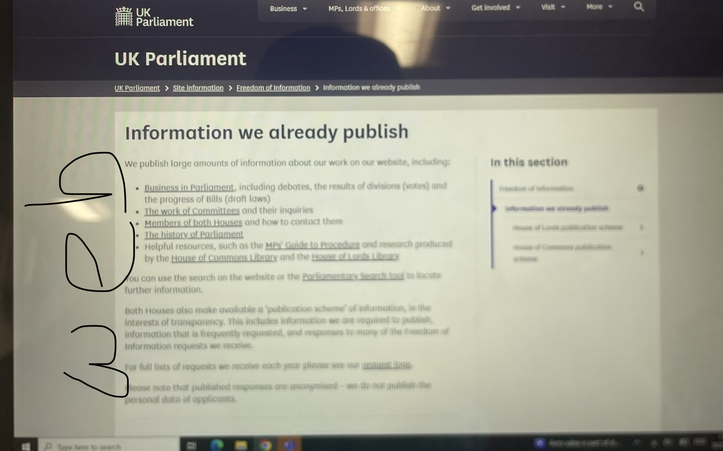
This is me showing I can use and search for stuff on the internet and make sure the information is credible and reliable and not incorrect. Also shows my skills of screen shotting.

Screenshot/Photo 5
[Insert Photo/Screenshot below]

This is a picture I taken off my mobile phone camera of home cooking food. This shows my skill to take a picture correctly and defined enough.

Screenshot/Photo 6
[Insert Photo/Screenshot below]
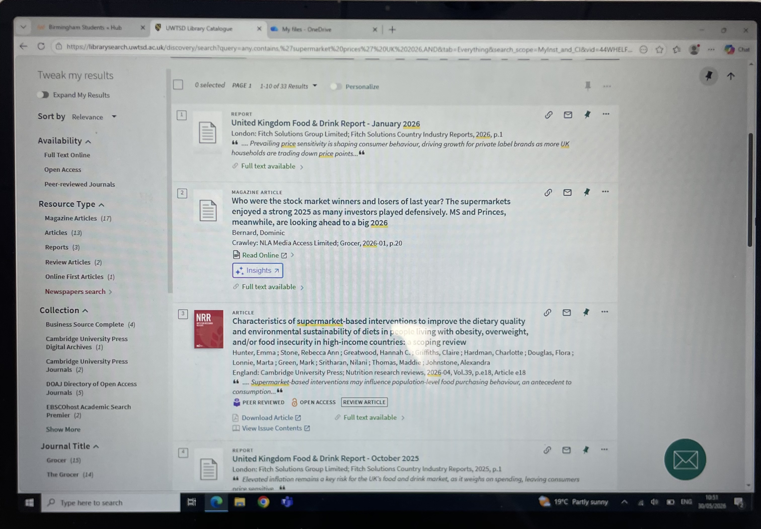
This here shows my knowledge of the university library online. This is also somewhere I have learned to use recently and is quite easy to navigate for correct information.

My Short Reflection
- Write 5–8 simple sentences about your digital life.
- You can use the sentence starters below if helpful.
I use digital tools to makes things easier, faster, and more professional.
I feel confident taking screen shots on my phone and uploading them to my one drive so I can bring them up on the laptop to then transfer onto my Microsoft word.
I want to improve my insight within the internet and other tools that I have not looked up or play about with yet.
I often use these tools at home within my leisure time or even with homework at home. I also use screen shots to show people what I’ve seen and where from.
I sometime feel nervous about typing as I don’t always check my grammar and can forget that there no auto corrects.
I hope this module will help me advance so much more, so I develop I deeper understanding for digital skills.
Digital skills are important for me because I use internet and digital tools and on daily basis and will be moving forward in life after and during my course.

Sentence starters
- I use digital tools to …
- I feel confident when I …
- I want to improve …
- I often use these tools: …
- I sometimes feel nervous about …
- I hope this module will help me …
- Digital skills are important for me because …
You can write more if you want.

Submission Checklist
Before you submit, please check:
​​​ ☐ I added 4–6 screenshots
☐ I wrote short sentences for each screenshot
☐ I wrote my short reflection
☐ My work is my own
☐ My file opens correctly
​​☐ My file opens correctly

