

Student Name: FENIL BHARATBHAI SUTARIYA

Student ID: 2433115

Module Name: International Business Concepts

Module Code: LCMB7034

Lecturer’s Name: JEAN WANG

Work Count: 4959

Term 2

Executive Summary
The current International Business Consultancy Report critically evaluates the international operations of Primark with specific reference to its strategic involvement in India, which is an emerging economy. The report confirms that Primark is a multinational corporation, which can be explained by a wide range of geographic presence, the global nature of the value chain, and the strong focus on the international sourcing and selling operations. The analysis of the global value chain at Primark shows that it is characterized by a highly centralized, cost-leadership structure that is supported by outsourced production, ethical sourcing frameworks, and standardized retail process.
Using the Ownership-Location-Internalisation (OLI) framework developed by Dunning, it can be seen that Primark has salient ownership advantages in its cost control, brand position, and control over supply chains, but India has salient advantages in terms of location, that is, favourable sourcing conditions, low labour costs, and strong prospects of a long-run market. However, the challenge of highly regulated environment and institutional constraints are more likely to moderate the feasibility of high-control entry mode within the retail industry. An assessment of culture using the Hofstede framework reveals that there exist substantial differences between Ireland and India particularly with regard to power distance, collectivism, and long-term orientation, which directly translate to governance, management of human resource as well as supply-chain practices.
To overcome these issues, the report suggests three main changes to the Standard Operating Procedure (SOP): the hierarchical nature of governing structure, the localisation of human resource management procedures and the increased supply-chain governance and the escalation of ethical compliance. Taken together, these recommendations can help Primark to combine global standardisation and local responsiveness, reduce operational and reputation risks, and support sustainable long-term success in the Indian market.

Table of Contents
Executive Summary 2
1. Introduction 6
2. Benefits and Challenges of International Operations 6
2.1 Primark as a Multinational / Transnational Corporation 6
2.2 Nature of Primark’s Global Operations Across the Value Chain 8
2.2.1 Product Design and Research & Development 8
2.2.2 Global Sourcing and Procurement 8
2.2.3 Manufacturing and Production 9
2.2.4 Logistics, Distribution and Inventory Management 10
2.2.5 Sales, Marketing and Retail Operations 10
2.2.6 Financing and Cost Management 11
2.3 International Market Entry Modes Adopted by Primark 11
2.4 Key Benefits and Challenges of Primark’s International Operations 12
3. OLI Factors and International Market Entry Mode: Primark–India 13
3.1 Overview of the OLI Paradigm in Market Entry Decisions 13
3.2 Ownership Advantages (O) and Their Impact on Entry Mode Choice 14
3.3 Location Advantages (L) of India as an Emerging Economy 15
3.4 Internalisation Advantages (I) and Control Considerations 17
3.5 Synthesis of OLI Factors and Entry Mode Outcomes for Primark in India 18
3.6 Strategic Implications for Future Market Entry Decisions 18
4. Cultural Differences and Market Etry Strategy: Primark (Ireland)–India 18
4.1 Application of Hofstede’s Cultural Dimensions to International Market Entry 18
4.2 Power Distance and Its Impact on Entry Strategy and Operations 19
4.3 Individualism vs. Collectivism and Market Adaptation 20
4.4 Masculinity (Achievement Orientation) and Competitive Positioning 20
4.5 Uncertainty Avoidance and Strategic Risk Management 21
4.6 Long-Term Orientation and Sustainability Expectations 21
4.7 Indulgence vs. Restraint and Consumer Behaviour 22
4.8 Cultural Distance and Overall Impact on Market Entry Success 22
4.9 Strategic Cultural Alignment Considerations for Primark in India 22
5. Strategic Adjustments to Standard Operating Procedures (SOPs): Primark - India 23
5.1 Rationale for SOP Adaptation in Emerging Economies 23
5.2 SOP Adjustment 1: Revising Governance and Leadership SOPs 23
5.3 SOP Adjustment 2: Localising HR and People Management SOPs 25
5.4 SOP Adjustment 3: Strengthening Supply Chain and Compliance SOPs 26
5.5 Integrative Evaluation of SOP Adjustments 28
5.6 Implementation Considerations and Risk Management 28
6. Conclusion 29
7. References 30

List of Figures
Figure 1: Primark Corporate Logo 6
Figure 2: Primark Global Expansion Timeline 7
Figure 3: Models of Centralized and Decentralized Production Networks 8
Figure 4: Primark Global Sourcing Map – India 9
Figure 5: A Primark Retail Store 10
Figure 6: Wholly Owned Subsidiary Ownership 11
Figure 7: Benefits of a Partnership-Based Approach 12
Figure 8: Dunning’s OLI Paradigm 13
Figure 9: Primark Cares Sustainability Impact 14
Figure 10: India’s 30% Local Sourcing Rule for Single-Brand and Multi-Brand Retail FDI 16
Figure 11: India Retail Market Growth and Consumer Spending 17
Figure 12: Hofstede’s Cultural Dimensions Framework 19
Figure 13: Hofstede’s Cultural Dimensions Comparison Chart: India vs. Ireland 20
Figure 14: Hierarchical Organizational Structurex 24
Figure 15: Importance of Cross-Cultural Training 25
Figure 16: Importance of Grievance Redressal Mechanism 27

List of Tables
Table 1: Key Benefits and Challenges of Primark’s International Operations 13
Table 2: Strategic Implications for Future Market Entry Decisions 18
Table 3: Recommended SOP Adjustments for Primark’s Market Entry and Operations in India 28
Table 4: Implementation Considerations and Risk Management 29

1. Introduction
This consultancy report provides the critical analysis of international business operation of Primark. The focus of the analysis is Primark, a multinational fashion retailer with an extensive business presence in Europe, North America, and selected emerging markets. The report aims to assess how the internationalization strategy of Primark is the basis of its competitive positioning, along with the complexities involved in the work of organizations in non-homogenous economic and cultural environments.
The discussion which is particularly focusing on India as an emerging economy examines the global value chain within the country, mode of entry into the foreign market and the strategic benefits that internationalisation provides to the firm. Moreover, the report also uses Dunning paradigm of Ownership-Location-A Internalisation (OLI) with cross-cultural paradigms to analyse the aptness of entry strategy and practices of Primark. Through the insights, the paper makes strategic recommendations that would effectively streamline the standard operating procedures of Primark and strengthen its success in the Indian market in the long run.

2. Benefits and Challenges of International Operations

2.1 Primark as a Multinational / Transnational Corporation
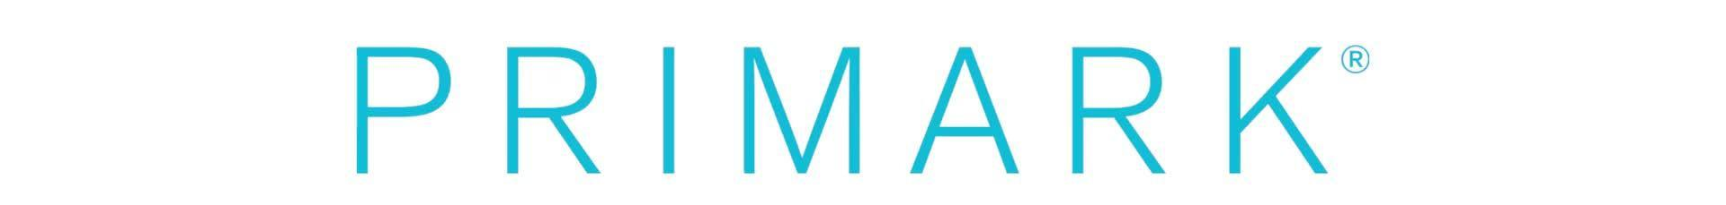
Figure 1: Primark Corporate Logo
An MNC or transnational corporation (MNC/TNC) is referred to as a firm that owns or controls value-added operations in more than one country coordinating strategy and resource allocation within national borders (Uzma et al., 2025). An example of this categorisation is Primark that operates retail and sourcing business in over 17 countries in Europe, North America, and Asia with large market share in the United Kingdom, United States, and France (Primark, 2024a). By 2024, Primark has over 440 stores across the globe and had around 80,000 employees, thus demonstrating a significant presence on the global level (Primark, 2024a).
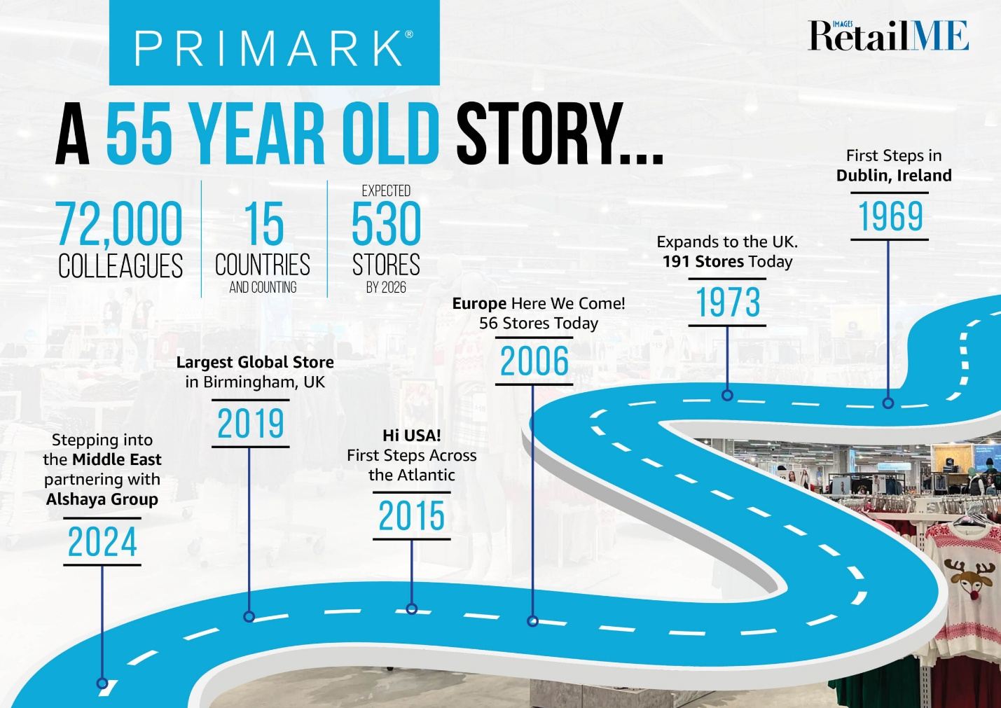
Figure 2: Primark Global Expansion Timeline
The operational structure of Primark reflects a transnational design, which is centrally coordinated strategic governance and limited responsiveness to local market contingencies. All essentials of product design, price structuring, supplier selection, and sustainability standards are discussed and executed in a central center based in the United Kingdom, while store operations adapt moderately to local regulatory and consumer conditions (Jain, 2024). The enterprise creates value across the national boundaries through its involvement in global sourcing networks, international retail transactions, and the integration of cross border logistics systems hence demonstrating resounding value creation across borders. In addition, the revenue foundation of Primark is becoming more global, thus reducing its dependence on the UK market, and intensifying its need to rely on cross-border business to develop and stabilize (Primark, 2024b). Large-scale global supply chain coordination (especially in the emerging markets like India and Bangladesh) also contributes to the fact that Primark is a multinational corporation/transnational enterprise.

2.2 Nature of Primark’s Global Operations Across the Value Chain

2.2.1 Product Design and Research & Development
Primark has a centralized product design and development model with design teams that are mostly based in UK and Europe. Instead, these teams are more focused on trend forecasting, shortened design cycles, and cost optimisation instead of innovation related to technology (Primark, 2024a). Unlike the high-end fashion brands, Primark does not invest a lot in high technologies and uses market intelligence, supplier feedback, and consumer trend monitoring to support fast-fashion cycles (Nugroho, 2025). The approach allows quick adaptability to emerging trends in the global fashion at a low-cost value proposition.
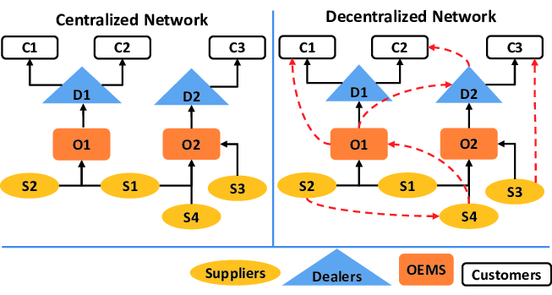
Figure 3: Models of Centralized and Decentralized Production Networks

2.2.2 Global Sourcing and Procurement
Global sourcing is one of the pillars of the international business of Primark. The company heavily relies on the emerging markets, especially India, Bangladesh, Vietnam, and China to source their apparel and textile (Shenglu Fashion, 2023). India is strategically positioned as a manufacturer of cotton garments, woven fabrics and finished goods, which is supported by a vast supplier network that is outlined by the Primark Global Sourcing Map (Primark, 2024c). Ethical sourcing standards, factory audits, and adherence to the labour and environmental requirements are all regulated under the Primark Cares programme that regulates supplier selection (Primark, 2023). Even though this sourcing model has significant cost benefits, it also places Primark at risk of failures in its supply-chain, including labour-compliance failure, geopolitical unpredictability, and sustainability scepticism (Bai et al., 2025).
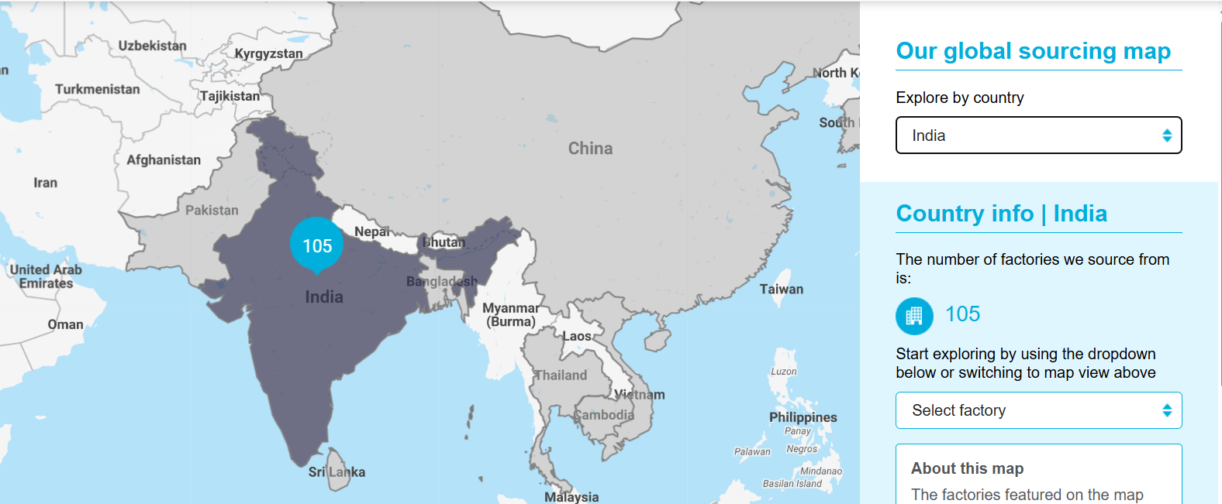
Figure 4: Primark Global Sourcing Map – India

2.2.3 Manufacturing and Production
Primark utilizes a completely outsourced model of production and does not have production facilities. Third-party suppliers do the manufacturing, which provides flexibility and cost-efficiency but does not provide direct control over operation (Primark, 2023). The structure poses difficulties in the quality assurance and labour standards, which need consistent monitoring and auditing to reduce reputational risks (Zacharias, 2022). The issue of managing scattered suppliers in many emerging markets is a major issue of operations.

2.2.4 Logistics, Distribution and Inventory Management
Primark uses the central distribution centers particularly in the United Kingdom and Europe, to coordinate the movement of inventory across- the marketings globally. The shipping and warehousing economies of scale allow the realization of cost efficiencies that are aligned with its low prices policy (Vaka, 2024). The inventory management systems are designed to reduce overstocking and maintain high volume sales; however, the global supply-chain disruptions may negatively impact the lead times and the availability of stores (Bai et al., 2025).

2.2.5 Sales, Marketing and Retail Operations
International sales policy at Primark is mainly based on the brick-and-mortar retail business, with a small use of e-commerce. Stores are mainly structured to standard formats across markets, such as the United States, United Kingdom, and France, and only slight localisation is made on layout and product mix (Primark, 2024a).
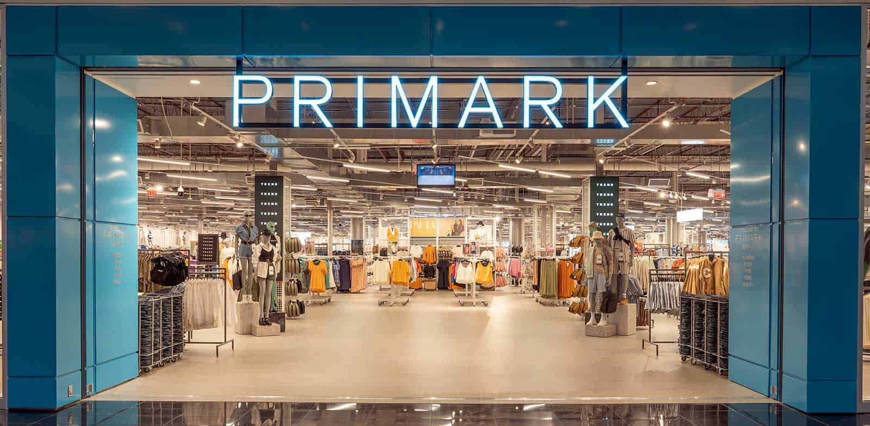
Figure 5: A Primark Retail Store
The pricing strategy embraced by the company is the value-based pricing strategy, which focuses on volume and low prices rather than differentiation by branding or online interaction (Majka, 2024).

2.2.6 Financing and Cost Management
A strong financial backing of its parent company, Associated British Foods (ABF), helps Primark to allocate internal capital and plan investments over the long-term (Primark, 2024b). However, the global business activities of the firm present the firm with the currency risk especially against the dollar of the U.S. and the Euro and emerging-market currencies and in the process affect the cost structures and profitability.

2.3 International Market Entry Modes Adopted by Primark
Primark is entering the international markets mostly by using wholly-owned subsidiaries and greenfield retail-investments, thus retaining complete ownership and the management of its store business (Wasik, 2025). In Europe and the United Kingdom and France in particular, the business is largely based on wholly-owned subsidiaries, which are expected to ensure brand consistency and help increase efficiency (Coudounaris et al., 2021). In the US, the company has predominantly used greenfield entry modes, which have made it possible to set up large format stores that are aligned to its normal operating paradigm.
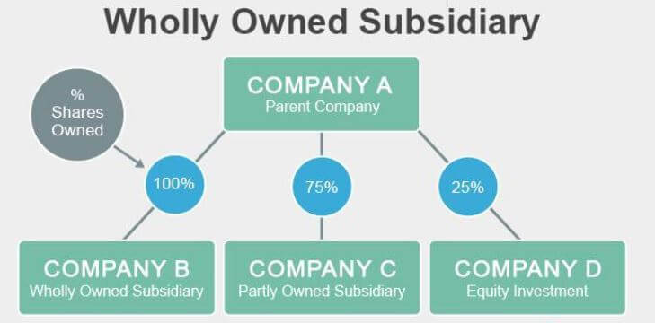
Figure 6: Wholly Owned Subsidiary Ownership
In the developing economies such as India, Primark uses a cautious, partnership-based approach by focusing on sourcing and supply-chain operations rather than retail expansion. The strategic partnerships with the suppliers locally reduce the market uncertainty, and provide an ease of complying with regulations (Chakraborty et al., 2025).
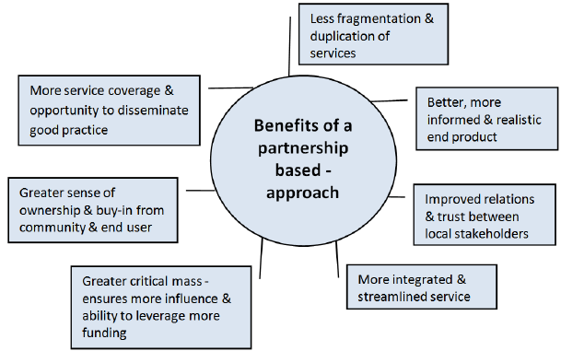
Figure 7: Benefits of a Partnership-Based Approach
All in all, wholly owned subsidiaries continue to be the most popular form of entry by Primark and this is necessitated by the need to exercise strict cost management, consistent brand presence and operating procedures. However, with this strategy, there is the huge investment of capital, there is also a lack of flexibility in exiting but also there is increased sensitivity to the risk of emerging markets.

2.4 Key Benefits and Challenges of Primark’s International Operations
Key Benefits | Associated Challenges
Economies of scale through bulk sourcing and centralised logistics (Primark, 2024a) | Ethical sourcing and labour compliance pressures in emerging economies (Primark, 2023)
Market diversification across the UK, US, France and Asia reduces revenue volatility (Pareek et al., 2025) | Cultural differences in consumer preferences affecting standardised retail formats (Jain, 2024)
Competitive advantage from low-cost global sourcing networks (Shenglu Fashion, 2023) | Regulatory complexity across multiple jurisdictions
Enhanced global brand recognition as a value-fashion retailer | Supply-chain disruptions and geopolitical risks (Bai et al., 2025)
Organisational learning and supply-chain resilience development | Sustainability scrutiny and reputational exposure
Table 1: Key Benefits and Challenges of Primark’s International Operations

3. OLI Factors and International Market Entry Mode: Primark–India

3.1 Overview of the OLI Paradigm in Market Entry Decisions
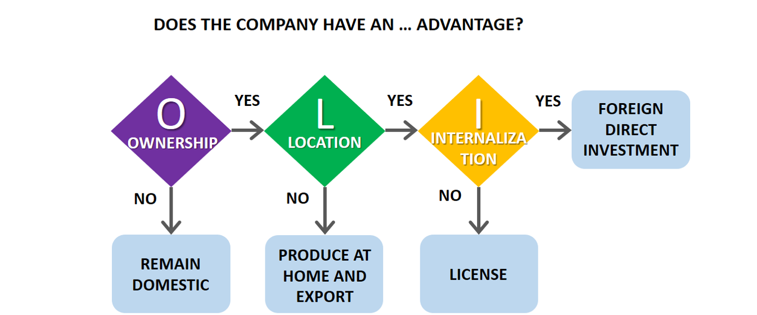
Figure 8: Dunning’s OLI Paradigm
The Ownership-Location-Internalisation (OLI) paradigm introduced by Dunning explains entry into the foreign market by critically comparing advantages of firms, the preference of following the international route, and the gain of having an inside control of the influence concerning cross-border operations (Mat Isa et al., 2017). The framework has an especially strong relevance in the case of emerging economies, where the help of institutional uncertainty, regulations of entry, and cost asymmetries shape the choice of entry mode significantly (Amankwah-Amoah et al., 2022). Applying the OLI paradigm to the case of Primark - India makes it easier to logically evaluate the rationale of the choice made by Primark to consider India as the main base of sourcing and not the main retail market despite its high possibilities of consumption in the long term (Primark, 2024a).

3.2 Ownership Advantages (O) and Their Impact on Entry Mode Choice
The main competitive advantage that Primark leverages is based on its cost-leadership approach that is maintained through centralised design, rigorous pricing, and massive sourcing operations across the globe (Primark, 2024b). With the centralisation of design and procurement decisions, the retailer attains the standardisation of product-range as well as strict cost control in various markets. Moreover, the Primark Cares programme is a complex system of ethical sourcing and compliance, which includes audits of suppliers, traceability, and implementation of labour standards (Primark, 2023).
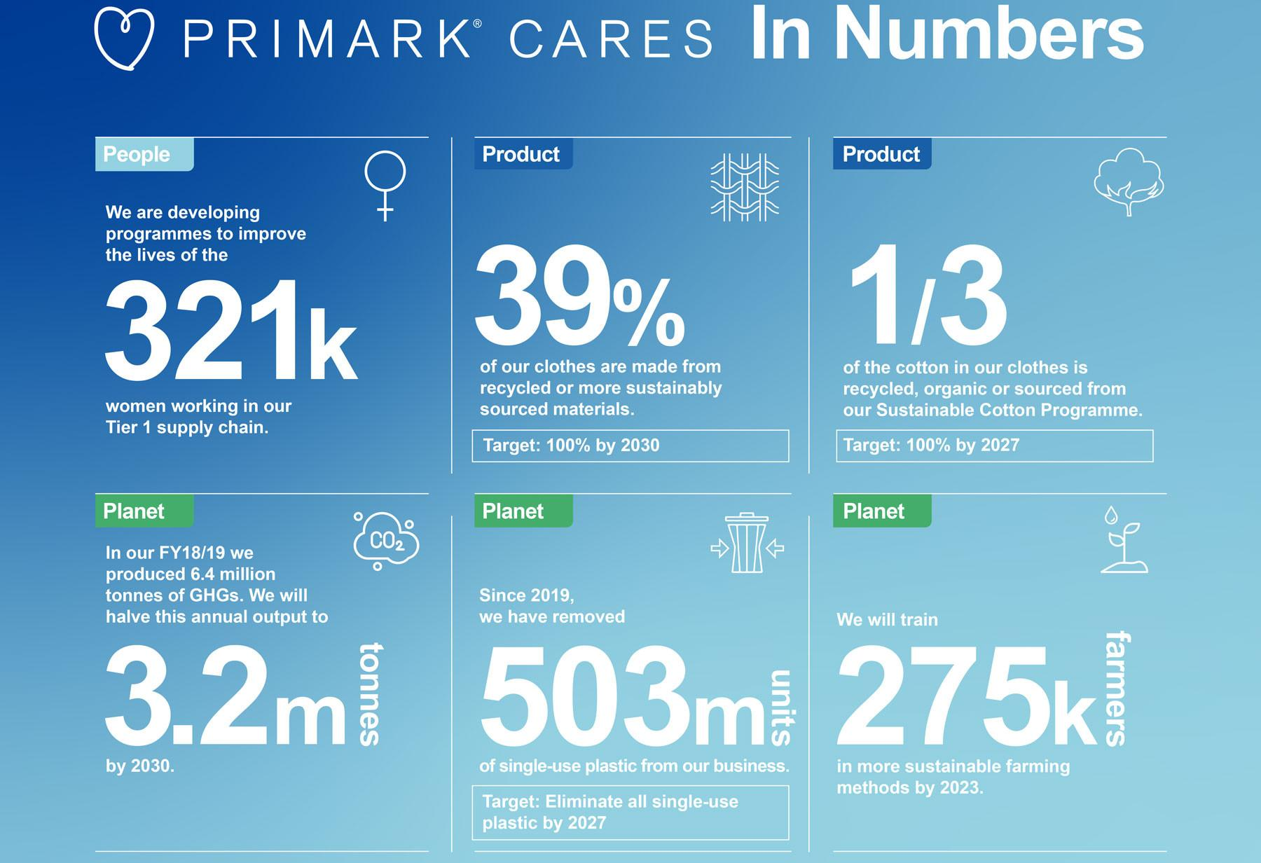
Figure 9: Primark Cares Sustainability Impact
Such capabilities are consistent with the resource-based view, as it assumes that extremely unique organisational routines represent the source of long-term competitive advantage (El‑Chaarani et al., 2022).
Primark has built a significant brand equity as a value-fashion retailer, which was facilitated by its experience in running large-format, high-traffic stores in the mature markets (United Kingdom, the United States, and France) (Primark, 2024a). In addition, its exposure to culturally varied consumer settings has enhanced the firm in terms of its knowledge in operations and scalability. However, the branding position is strictly dependent on the volume, cost efficacy, and standardized retail format, therefore, increasing its riskiness to regulatory restriction and infrastructural limitation, which is very common in the emerging economies (Picot-Coupey et al., 2014).
The ownership benefits of Primark are more geared towards high-control entry modes because the protection of proprietary cost structure, supplier relationships and brand consistency are very critical. However, these preferences in India are bound by the institutional and regulatory conditions especially when it comes to multi-brand retailing. As a result, the benefits associated with ownership by Primark are more ruthlessly exploited by using supply-chain internalisation rather than direct expansion of retail business.

3.3 Location Advantages (L) of India as an Emerging Economy
India is also showing considerable locational benefits as a sourcing location, including cheap inexpensive labour, large clusters of textile industries, and a good base of cotton (Zhang et al., 2025). Primark has a wide range of Indian suppliers to leverage on the benefits of skilled artisanal skills alongside economies of scale, which is supported by its Global Sourcing Map (Primark, 2024c). These aspects explain the strategic importance of India in the global value chain of Primark.
India is also a promising market with a rapidly growing population of middle-income people, accelerating urbanisation, and growing demand of inexpensive fashion (IBEF, 2024). Scholarly research brings out that India has long-term appeal to international retailers despite volatile short-term fluctuations and income inequality (Chand et al., 2025).
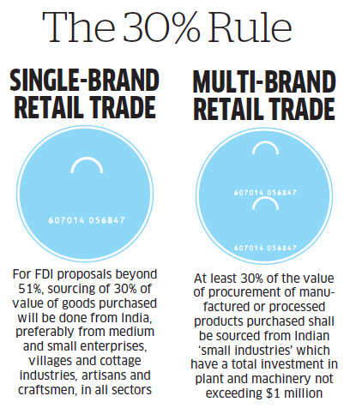
Figure 10: India’s 30% Local Sourcing Rule for Single-Brand and Multi-Brand Retail FDI
In spite of these benefits, there are significant limitations of the institutional environment in India. The India Foreign Direct Investment (FDI) laws in the multi-brand retail, demand sourcing requirements in the country and state authorities, which complicates the process and limits the ability to be strategic (IIA, 2023). Operation risk is also further enhanced by gaps in infrastructure, poorly integrated logistics, and strict labour and sustainability rules (Acclime India, 2024).
Thus, in the short run, India is more attractive to Primark as a sourcing and production location than a mass retail destination. There is a high effect of regulatory barriers on ownership-structure decisions, which promotes cautious and gradual entry modes instead of the development of wholly owned retail subsidiaries.
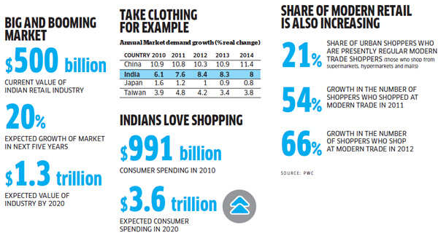
Figure 11: India Retail Market Growth and Consumer Spending

3.4 Internalisation Advantages (I) and Control Considerations
The use of arm-length market transactions in the emerging economies exposes companies to quality, knowledge and reputation losses, especially in labour-intensive industries (Filani et al., 2019). In the case of Primark, brand credibility in foreign markets can be reduced as a direct result of failures of supplier factories to comply with ethics.
Internalization enables Primark to have more influence on quality, costs, and ethical demands by integrating supplier monitoring and auditing at its governance schemes and capacity-building programs (Primark, 2023). Direct control improves the resilience of the supply-chain and alters transaction costs relating to opportunistic behaviour.
Nevertheless, full internalization by formation of totally owned retail subsidiaries in India would imply a high rate of capital investment, regulatory risk, and flexibility of operations. In its turn, such balance allows Primark to balance control and partnership-related sourcing relationships, internalizing key governance functions without excessive devotion to the retail-market relations.

3.5 Synthesis of OLI Factors and Entry Mode Outcomes for Primark in India
The strong ownership advantages of Primark interact synergetically with the resource-based locational benefits of India, hence support the conceptual validity of the deep sourcing integration. Internalisation incentives on the other hand are moderated by regulatory restraints and institutional complexity and thus restrains high-control entry by retailers.
Primark focuses on long term sourcing relationships and supply-chain integration in India, and has a relatively small retail presence compared with developed markets. This strategy allows Primark to gain cost-efficiencies, risk management, and strategic flexibility.

3.6 Strategic Implications for Future Market Entry Decisions
Strategic Condition | Implication for Entry Mode
Liberalisation of FDI regulations | Increased feasibility of wholly owned retail subsidiaries
Infrastructure and logistics improvements | Lower operational risk for store expansion
Growth of organised retail demand | Stronger case for greenfield retail investments
Alignment of OLI factors | Gradual shift towards higher-control entry modes
Table 2: Strategic Implications for Future Market Entry Decisions

4. Cultural Differences and Market Etry Strategy: Primark (Ireland)–India

4.1 Application of Hofstede’s Cultural Dimensions to International Market Entry
The Cultural Dimensions Theory by Hofstede has been widely used to explain how national culture shapes organisational behaviour, market-entry policies, and general firm outputs in the sphere of international business (Leonaviciene et al., 2022). Cultural distance has an influence on the managerial control, employee engagement, consumer behaviour and effectiveness of the standardised business model.
The comparative analysis of Ireland (country of origin of Primark) and India (country with a developing economy) is especially relevant as the disparity between the two countries in terms of Hofstede dimensions are rather high. The low-cost and standardised retail paradigm of Primark requires a strong alignment with the local cultures to succeed in the foreign markets (The Culture Factor, 2025).
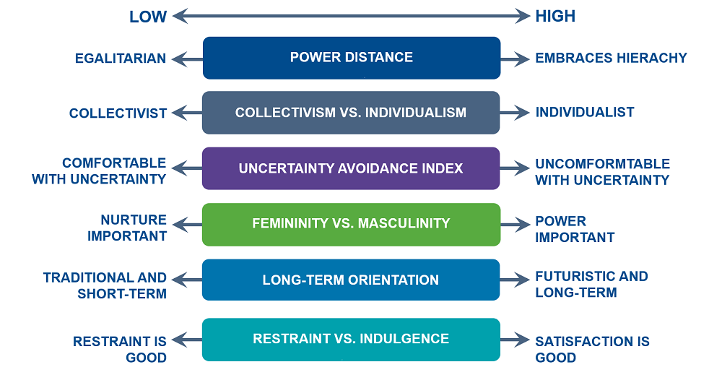
Figure 12: Hofstede’s Cultural Dimensions Framework

4.2 Power Distance and Its Impact on Entry Strategy and Operations
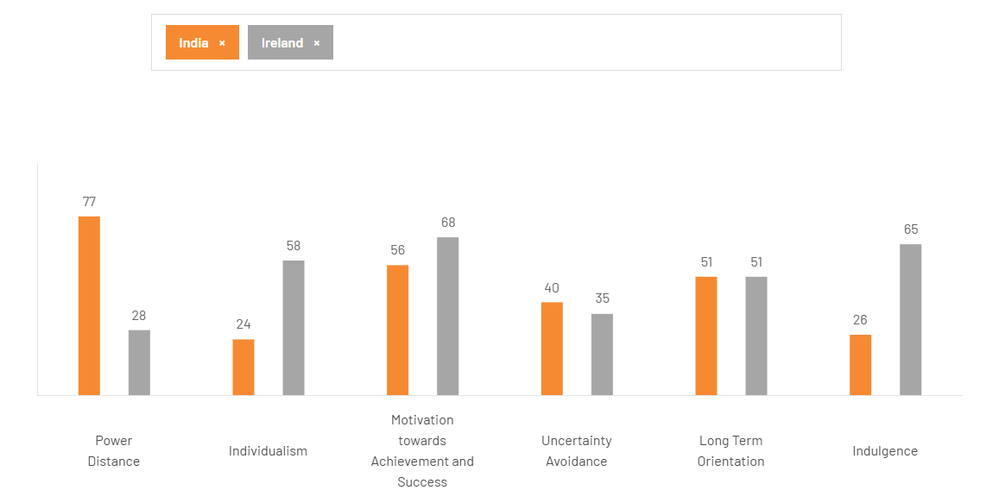
Figure 13: Hofstede’s Cultural Dimensions Comparison Chart: India vs. Ireland
The power distance index in Ireland is low, which reflects egalitarian working relations and a decentralized managerial decision-making process, and power distance disposition is high in India, which is characterized by the acceptance of a hierarchical order and authoritative governance (The Culture Factor, 2025). Employees in India tend to expect top-down leadership, clearly defined reporting relationships, and visible authority as opposed to Primark, which features a relatively flat management culture built in Ireland (Abbate et al., 2025). Therefore, effective market penetration would require more definite hierarchal and stronger supervisory functions in India operations. Lack of adaptation may reduce the work commitment and performance efficiency because the circumstances with high power distance prefer formal leadership to a participative decision-making process (Shrivastava et al., 2025).

4.3 Individualism vs. Collectivism and Market Adaptation
Ireland is a highly individualistic oriented country that values individual success and autonomy, but India is a collectivist-oriented country that values group harmony and social relationship (The Culture Factor, 2025). This cultural difference affects the motivation systems, team work as well as the human resources practices. The standardised individual performance-based rewards that Primark applies in the West might have a lower level of effectiveness in the Indian environment, as such culture is characterised by the focus on relationship-based leadership and collective rewards (Cheng et al., 2020; Girişken, 2020). Regarding the consumer perspective, the collectivist cultural norms affect the shopping behaviour in the form of family-based purchasing behaviour and social influence processes. Therefore, strategic market entry of Primark in India would be enhanced by community engagement activity and culturally sensitive human-resources activities, thus enhancing the brand acceptance and customer loyalty (Gupta, 2025).

4.4 Masculinity (Achievement Orientation) and Competitive Positioning
India records higher score on masculinity dimension compared to Ireland hence indicating greater emphasis on achievement, status, and success (The Culture Factor, 2025). This distinction has both labour market expectation and consumer desire implications. Workers located in India will most likely expect to anticipate career growth, official reward, and actual achievement, and Primark will have to adjust its rewards and promotion systems, respectively (Koc et al., 2021). In terms of market-analytic, increased masculinity can cultivate a consumer desire to connect with a brand and its signs of social elevated status and esteem. As a result, the low-end positioning by Primark can be seen as less aspirational, until the message of affordability is effectively combined with the acceptable rates of quality and fashion-directional design. Therefore, a strategic balance between the pricing of value and the perceived status is mandatory to the long-term and sustained success.

4.5 Uncertainty Avoidance and Strategic Risk Management
Ireland has a moderate uncertainty avoidance approach, and India has rather lower levels of uncertainty avoidance, which means that they are more tolerant to ambiguity and tend to interpret the rules flexibly (The Culture Factor, 2025). This variance affects regulatory navigation, supplier relations and flexibility of operations. In India, it is often essential to be part of informal networks and adaptive decision-making to navigate sophisticated regulatory settings. Stiff operational structures can also turn out to be less effective. Based on this, the entry approach of Primark must involve the local management expertise and flexible governance systems that maintain the reliability and responsiveness of the supply-chain (Gleißner, 2023).

4.6 Long-Term Orientation and Sustainability Expectations
Compared to Ireland, India has a strong long-term orientation indicating a cultural tendency to perseverance, long-term relationships and future-oriented investment (The Culture Factor, 2025). This aspect matches perfectly with the long-term supplier development and ethical sourcing prioritisation of Primark within the Primark Cares programme (Primark, 2023). The ability to build durable relationships with the Indian suppliers and invest in the human resource can build trust and operational stability, thereby having a positive impact on the post-entry performance at Primark (Frimpong et al., 2025).

4.7 Indulgence vs. Restraint and Consumer Behaviour
Ireland has greater indulgence, which signs of discretionary spending habits and consumption motives that are oriented on pleasure, and India is marked by prudential consumer behaviour patterns and increased price sensitivity (The Culture Factor, 2025). This accord supports a strategic fit with the model of Primark, which focuses on affordability. However, cultures that exhibit moderate consumption habits require culturally sensitive marketing that focuses on the value, longevity, and need rather than on impulse buying (Ikechykwu et al., 2025). Lack of alignment between promotional strategies can dilute brand resonance, despite competitive price.

4.8 Cultural Distance and Overall Impact on Market Entry Success
The cumulative cultural difference between Ireland and India adds to the exposure of risk to human resource management, retail operations, and the perception of brand image. Such high risks are conducive to a low-risk entry approach that matches the high focus on sourcing that Primark applies today instead of extensive retail penetration in India (Primark, 2024a). In order to eliminate cultural friction, strategic localisation in the framework of global standardisation is necessary (Lee et al., 2021).

4.9 Strategic Cultural Alignment Considerations for Primark in India

In order to make its long-term position more viable, Primark needs to align the leadership styles and staff training with the cultural specifics of India as well as customer interaction norms. The legitimacy and trust of the firm may be enhanced with the help of relationship-oriented leadership and culturally aligned HR practices and value-oriented marketing. Cultural fit not only forms the basis of scalability, but also the cost advantage of Primark can be translated into long-term competitive performance in the Indian market.

5. Strategic Adjustments to Standard Operating Procedures (SOPs): Primark - India

5.1 Rationale for SOP Adaptation in Emerging Economies
The flexibility of standard operating procedures (SOPs) is essential in the dynamic economies with institutional volatility, heterogeneity of regulation, and a strong sense of cultural distance, which can neutralise the effectiveness of standardised operating models (Rufino et al., 2025). In the context of Primark - India case, the effectiveness of SOPs depends on the alignment to the local institutional system and dominant cultural practices, as well as the ability to retain the benefits of primacy to Primark at the same time. Previous OLI analysis stressed the necessity of protecting cost leadership and moral brand equity (ownership), balancing the regulatory and labour challenges (location), and selectively sourcing the governance and compliance functions (internalisation). Culturally, the differences between Ireland and India, especially the extreme power distance, collectivism, and high long-term orientation require the localisation of the standard operating procedures that would guarantee legitimacy, commitment to work, and reliability of operations (Leonaviciene et al., 2022; The Culture Factor, 2025).

5.2 SOP Adjustment 1: Revising Governance and Leadership SOPs
The currently used governance and leadership standard operating procedures are largely across the existing Primark due to its low power-distance and Western backgrounds, especially Ireland. These practices focus on rather low-layered organisational structures, decentralised decision-making, and uniform leadership behaviours that promote autonomy and informal communication (Primark, 2024a). Although, it can be efficient in the context of the developed market, in the case of the activities in India, the hierarchical power and formal control systems influence organisational legitimacy and operational efficiency to a greater extent and make this approach inappropriate.
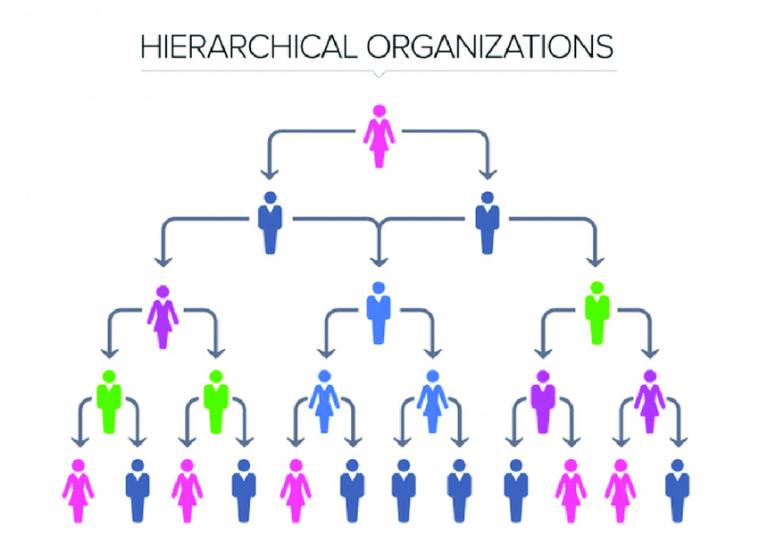
Figure 14: Hierarchical Organizational Structurex
To be successful in the Indian context, standard operating procedures of Primark should include well-defined hierarchical authority, clear reporting channels, and explicitly established escalation procedures, in the context of operation, labour, and compliance related issues. Increasing the power endowed in store managers and regional heads would help in faster decision-making of common struggles and improve the interaction with local stakeholders, regulatory agencies, and suppliers. Such changes are especially important in the context of a demanding institutional environment where doubt can serve as a drawback of decision-making and accountability.
According to the OLI paradigm, internalization of improvement of governance protects the ownership benefits of Primark by preserving its working patterns, brand quality and ethical obligations. Also, high managerial control allows internalization by reducing quality and compliance risk, and at the same time allows governing structures to be adapted to the regulatory and institutional environment of India (Jain, 2024). The strong power distance and collectivist culture of India encourages directive leadership and leadership conspicuity. It has been empirically shown that well-defined hierarchical frameworks promote accountability, trust and prosocial behaviour in such settings (Abbate et al., 2025). Comprehensively, these governance modifications are bound to improve speed in decision-making, minimize operational ambiguity, and increase employee confidence in the leadership, which will result in higher store-level performance.

5.3 SOP Adjustment 2: Localising HR and People Management SOPs
The human-resource standard operating procedures of Primark focus on individual performance measurements, standard training programs, and behavioural expectations alike among all international markets (Primark, 2024b). Although this strategy can be used to reinforce consistency, it also creates a threat of deviation to the collectivist, relationship-oriented cultures, as it is the case in India, where teamwork, long-term relationship relationships, and social recognition are the key drivers of employee engagement.
Primark, therefore, should make some changes to its human resource standard operating procedures in India to include team-based performance appraisal, relationship-focused leadership, and systemized mentoring mechanisms.
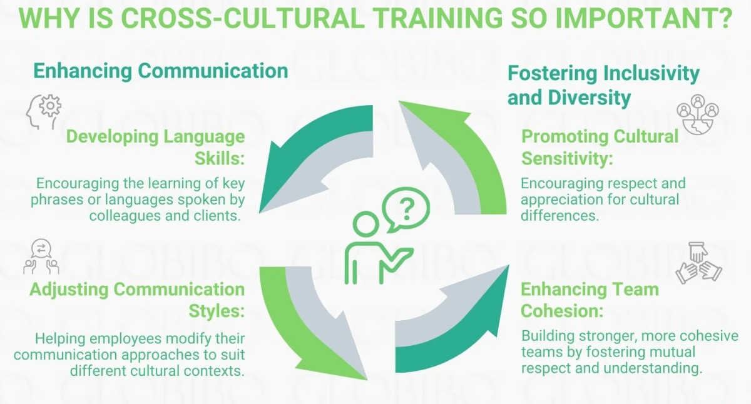
Figure 15: Importance of Cross-Cultural Training
The cultural orientations to training and induction programmes should be localized to reflect the local communication practices, career expectations and norms of society. This type of localisation reinforces the ownership benefits of Primark through its ability to leverage human capital as a strategic source and enhanced internalisation reduces the rate of employee turnover and loss of knowledge in the competitive labour market (Stanikzai et al., 2025).
These adjustments are further justified by cultural considerations. The collectivist orientation and high levels of achievement motivation in India demand the adoption of reward systems that reward group performance, besides the individual development (Cheng et al., 2020). Moreover, the strong long-term orientation provides an emphasis on loyalty, a stable career, and constant progress (Pinillos et al., 2011). By aligning HR standard operating procedures with the cultural peculiarities named, Primark can impact employee engagement, organizational commitment, and more consistency in the quality of the offered services in its stores, making this crucial in supporting its low-cost, high-volume retail paradigm sustainability (Wang, 2023).

5.4 SOP Adjustment 3: Strengthening Supply Chain and Compliance SOPs
Primark currently manages its global supply chain through centrally sourced standards of Primark Cares, which is then supported by regular supplier audits and compliance reporting (Primark, 2023). Despite the fact that this arrangement provides a baseline of control, the regulatory environment of India is complex, and its broad supplier network will require more powerful and local-responsive governance systems.
The India specific standard operating procedures must demand increased and decentralized supplier audits which need to be complemented by capacity building programs to suppliers with focus on labour standards, health and safety and environmental compliance. Furthermore, grievance channels must be improved by making them more transparent and allowing employees to report without fear of recompisition. All these enhance the ownership benefits of Primark by shielding its ethical capital of professional brands, and further internalisation of the supply chain reduces transaction costs, reputational risks linked to supply-chain malpractices (Onuma, 2025).
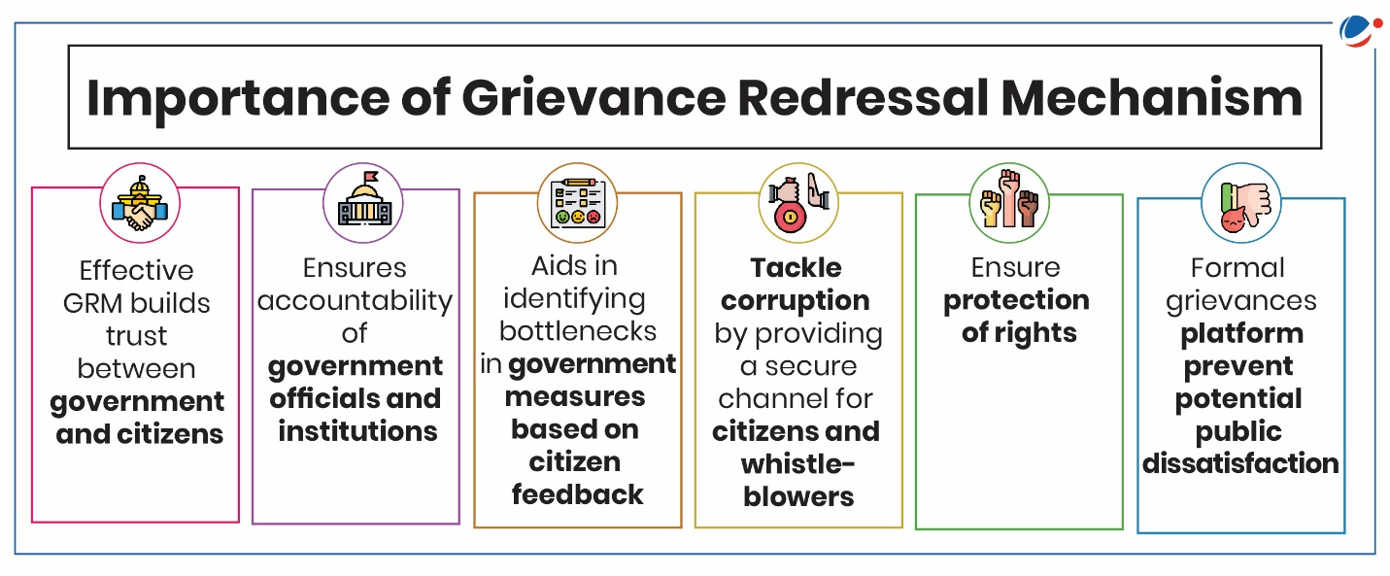
Figure 16: Importance of Grievance Redressal Mechanism
Culturally, India has a long-term orientation that has evolved over time and the relationship-oriented business ethos inclines business firms to engage collaboratively with their suppliers, unlike their transactional model of governance. Simultaneously, the growing pressure of sustainability requirements supported by regulators, civil society, and consumers increases the urgency of the need to lead conspicuously with regard to ethics (Frimpong et al., 2025). Therefore, the fortification of the supply-chain standard operating procedures is expected to increase the resilience of the organization, reduce the risk of ethical problems, and strengthen the principles of Primark in comparison with key stakeholders, which in turn would enhance sustainable operations in the Indian market.
SOP Area | Key Adjustments Required | Link to OLI & Cultural Factors | Expected Outcomes
Governance & Leadership | Introduce clearer hierarchies, formal reporting lines and defined escalation protocols; strengthen authority of store managers and regional heads | Supports Ownership by protecting brand standards; enhances Internalisation through tighter control; aligns with India’s high power distance culture | Faster decision-making, reduced ambiguity, higher employee trust and accountability
Human Resource Management | Shift from individual-based to team-based performance metrics; adopt relationship-oriented leadership; localise training and induction programmes | Leverages Ownership via human capital; reduces turnover through Internalisation; aligns with collectivism and long-term orientation | Improved employee engagement, retention and consistent service quality
Supply Chain & Sustainability | Increase frequency of supplier audits; implement capacity-building initiatives; enhance grievance mechanisms and transparency | Protects ethical brand capital (Ownership); mitigates reputational risk (Internalisation); suits India’s relationship-based business culture | Greater supply-chain resilience, reduced ethical risk and enhanced legitimacy with stakeholders
Table 3: Recommended SOP Adjustments for Primark’s Market Entry and Operations in India

5.5 Integrative Evaluation of SOP Adjustments
These changes to governance, HR and supply chain standard operating procedures, taken together, support each other through harmonization of leadership authority, labor motivation and ethical sourcing. Such integration promotes the cost-leadership strategy of Primark and allows it to enter the market gradually and at a low risk, which aligns with its OLI profile and cultural limitations (Huang, 2023).

5.6 Implementation Considerations and Risk Management
Implementation Area | Key Actions | Risk Mitigation
Phased rollout | Pilot SOPs in selected regions | Limits operational disruption
Monitoring | KPIs on compliance, turnover, audit outcomes | Early issue detection
Standardisation vs localisation | Global SOP core with India-specific annexes | Balances efficiency and responsiveness
Table 4: Implementation Considerations and Risk Management

6. Conclusion
The consultancy report is a critical exploration of international operation of Primark to be prospectively engaged with the emerging economy of India. The discussion shows that Primark can be listed as a multinational corporation as it has a large global value chain, centralized cost-leadership strategy, and aligning international business. Since the use of the OLI framework reveals that though Primark has strong ownership advantages and enjoys the location specific sourcing advantages of India, the presence of regulatory and institutional limits dilutes the viability of high controlling retail entry development. The cultural analysis based on the Hofstede dimensions highlighted significant differences between Ireland and India, especially regarding power distance, collectivism, and long-term orientation, which directly reflect on the practices of managers and the responsiveness of the market. The suggested changes of standard operating procedures in such fields like governance, human resource management, and supply-chain sustainability, therefore, map out a strategic path towards streamlining global efficiencies alongside the local responsiveness. Overall, the success of Primark in India will depend on its ability to balance the process of standardisation and cultural and institutional adaptability to ensure that its ethical priorities and the cost-of-operations competitive advantages remain intact.

7. References
Abbate, C.S., Bonfanti, R.C., Misuraca, R. and Ruggieri, S. (2025) ‘Power distance in the workplace and its effect on prosocial behavioral intentions’, Acta Psychologica, 253, 104695. https://doi.org/10.1016/j.actpsy.2025.104695
Acclime India (2024) Regulatory compliance requirements in India. Available at: https://india.acclime.com
Amankwah-Amoah, J., Adomako, S., Danquah, J.K., Opoku, R.A. and Zahoor, N. (2022) ‘Foreign market knowledge, entry mode choice and SME performance’, Journal of International Management, 28(4), 100955. https://doi.org/10.1016/j.intman.2022.100955
Bai, H., Chen, Y. and Zhang, Z. (2025) ‘Exploring the mitigating role of sustainable innovation in supply chain disruption risks under the digital economy’, International Review of Economics & Finance, 103, 104372. https://doi.org/10.1016/j.iref.2025.104372
Chakraborty, S. and Singla, C. (2025) ‘Navigating international entry via strategic alliances’, Journal of International Management, 31(3), 101250. https://doi.org/10.1016/j.intman.2025.101250
Chand, S., Mehta, M., Jain, H. and Sarmah, P. (2025) ‘Global strategic marketing in the Indian market’, International Journal for Multidisciplinary Research, 7(1).
Cheng, A., Rizkallah, S., Narizhnaya, M., Carducci, B., Nave, C., Mio, J. and Riggio, R. (2020) ‘Individualism vs. collectivism’, in Handbook of Personality and Social Psychology. https://doi.org/10.1002/9781119547181.ch313
Coudounaris, D. and Valtonen, A. (2021) ‘Foreign operation entry mode of wholly-owned subsidiary’, International Journal of Globalisation and Small Business, 12(4), pp. 341–368. https://doi.org/10.1504/IJGSB.2021.10043050
El-Chaarani, H., El Nemar, S., El Dandachi, I. and Castellano, S. (2022) ‘Resource-based view and sustainable advantage’, Journal of Strategic Marketing, 33(1), pp. 1–23. https://doi.org/10.1080/0965254X.2022.2160486
Filani, O., Nwokocha, G. and Alao, O. (2019) ‘Framework for ethical sourcing’, Manufacturing and Retail Sectors, 2.
Frimpong, K., Adomako, S., Nguyen, N.P. and Al-Shuridah, O. (2025) ‘Sustainability orientation and post-entry performance’, Business Strategy and the Environment, 34(1), pp. 1189–1205. https://doi.org/10.1002/bse.4043
Huang, H. (2023) ‘Cross-cultural integration in international business’, Modern Economics & Management Forum, 4, p. 171. https://doi.org/10.32629/memf.v4i6.1502
IBEF (2024) Retail industry in India. Available at: https://www.ibef.org
IIA (2023) FDI in multi brand retail. Available at: https://www.iiaonline.in
Jain, P.K. (2024) ‘Global integration vs. local responsiveness’, Journal of Advanced Management Studies, 1(3), pp. 27–31. https://doi.org/10.36676/jams.v1.i3.16
Leonavičienė, E. and Burinskienė, A. (2022) ‘Accelerating cultural dimensions’, Sustainability, 14(3), 1524. https://doi.org/10.3390/su14031524
Majka, M. (2024) Maximizing revenue with value-based pricing.
Mat Isa, C.M., Mohd Saman, H. and Preece, C. (2017) ‘Development of OLI+S entry decision model’, Construction Economics and Building, 17(4), pp. 66–77. https://doi.org/10.5130/AJCEB.v17i4.5573
Nugroho, D. (2025) ‘New product development with a customer-centric approach’, Eduvest – Journal of Universal Studies, 5(2), pp. 1545–1557. https://doi.org/10.59188/eduvest.v5i2.1712
Onuma, E. (2025) ‘Multi-tier supplier visibility and ethical sourcing’, International Journal of Research Publication and Reviews, 6, pp. 3579–3593. https://doi.org/10.55248/gengpi.6.0325.11145
Picot-Coupey, K., Burt, S. and Cliquet, G. (2014) ‘Retailers’ expansion mode choice’, Journal of Retailing and Consumer Services, 21(6), pp. 976–991. https://doi.org/10.1016/j.jretconser.2014.08.018
Pinillos, M.-J. and Recio, L. (2011) ‘Individualist–collectivist culture and entrepreneurial activity’, Small Business Economics, 37, pp. 23–37.
Primark (2023) Sustainability and ethics progress report 2022–23. Available at: https://primark.a.bigcontent.io
Primark (2024a) Who we are. Available at: https://corporate.primark.com
Primark (2024b) Basis of reporting 2024. Available at: https://primark.a.bigcontent.io
Primark (2024c) Global sourcing map. Available at: https://globalsourcingmap.primark.com
Rufino, L., Drumond, T., Luiz, D. and Soliani, R. (2025) ‘Standard operating procedures: a proposed framework’, Revista Gestão da Produção Operações e Sistemas, 20. https://doi.org/10.15675/gepros.3047
Shenglu Fashion (2023) Primark’s global sourcing for apparel. Available at: https://shenglufashion.com
Stanikzai, M.E. and Mittal, E. (2025) ‘Strategic alignment of organisational structure’, Cogent Business & Management, 12(1). https://doi.org/10.1080/23311975.2025.2560650
The Culture Factor (2025) Ireland vs India comparison. Available at: https://www.theculturefactor.com
Uzma, T., Momin, P.K.S. and Hada, V. (2025) International business strategies. https://doi.org/10.59646/ibs17/441
Vaka, D.K. (2024) ‘Integrating inventory management and distribution’, International Journal of Managing Value and Supply Chains, 15, pp. 13–23. https://doi.org/10.5121/ijmvsc.2024.15202
Wang, T. (2023) ‘Team performance: a review’, BCP Business & Management, 39, pp. 394–406.
Zacharias, M. (2022) ‘The importance of quality control’, Asian Journal of Logistics Management, 1, pp. 99–106. https://doi.org/10.14710/ajlm.2022.16787
Zhang, X., Li, Y., Zhu, K. and others (2025) ‘India’s emergence as a global manufacturing hub’, Humanities and Social Sciences Communications, 12, 189. https://doi.org/10.1057/s41599-024-04356-9

