
Master of Business Administration
Marketing Management (LCMB7024)
Assessment component 2: Marketing Strategies Portfolio

Lecturer:
Laila Maazouz
Dian Mayasari

Student Name: Hani Gaurangbhai Patel
Student ID :2532566

Table of Contents
Element 1: Brand Extension Poster Presentation 3
Element 2: Segmentation, Targeting, Differentiation, and Positioning (STDP) Analysis 4
1. Market Segmentation 4
2. Targeting Strategy 5
3. Differentiation Strategy 5
4. Positioning Strategy 6
Element 3: Marketing Mix (7Ps) for Apple Health-Hub 7
1. Product Strategy 7
2. Price Strategy 8
3. Place (Distribution) Strategy 8
4. Promotion Strategy 9
5. People Strategy 9
6. Process Strategy 10
7. Physical Evidence Strategy 10
Element 4: Reflection 10
Reference List 13

Element 1: Brand Extension Poster Presentation
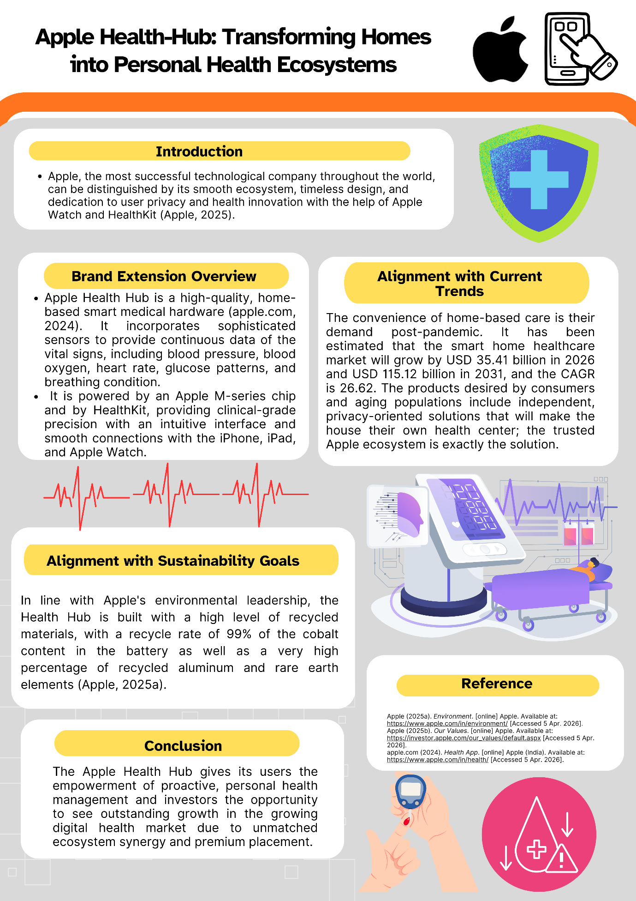

Element 2: Segmentation, Targeting, Differentiation, and Positioning (STDP) Analysis

1. Market Segmentation
The Apple Health-Hub is in the fast-developing digital health and smart home healthcare industry. In order to do this effectively to create value, Apple can segment the market using geographic, demographic, psychographic and behavioural factors.
Geographic Segmentation:
These are the leading markets which are developed areas like North America, Europe and some sections in Asia-Pacific where the digital infrastructure, healthcare spending and uptake of smart devices are highly developed. Japan, the United States, and Germany are especially promising markets since they have ageing populations, and hence the demand would be inclined towards home-based solutions in healthcare.
Demographic Segmentation:
The most important demographics will be people aged 40 years and above, with a more pronounced trend of being susceptible to the middle- and high-income consumers, and having more permanent chronic illnesses like hypertension or diabetes. Another secondary group of caregivers (30-55 years old) also attends to the elderly relatives. This demographic range also includes healthcare workers and pioneers of medical technology.
Psychographic Segmentation:
Its target market is the health-conscious generation that is interested in wellness, preventive and proactive health. It is also aimed at the technologically-oriented customers, who are aware of innovation, harmonious digital ecology, and high-quality experiences. Another important psychographic segment that fits best with the Apple brand ethos is privacy-conscious users, i.e. those who are apprehensive about disclosing sensitive health information.
Behavioural Segmentation:
The behavioural category of the market entails having users who want to monitor their health at all times, patients living with chronic illnesses and those who want to prevent or care about their health (Ekstedt et al., 2023). The first and most powerful force is the loyalty that the customers have towards the brand, since once introduced into the Apple ecosystem with purchases of iPhones and Apple Watch, they become a part of Apple. In addition, highly-engaging clients who utilise health apps or wearables data become an excellent prospect.

2. Targeting Strategy
Another approach that Apple employs is the differentiated targeting approach, where focus is given to multiple high-value segments, but it has been adopting a high-value positioning.
The target audience is the wealthier middle-aged to older adults (40-70years) who need regular health checkups. They often have chronic diseases (high blood pressure, heart-related problems or diabetes) and they would be interested in a solution that is believable and of a quality to save them from hospital visits (Shah et al., 2025).
The secondary target audience will be caregivers and family members who are keeping track of the health of older relatives. Other characteristics (Family Health Sharing and Critical Alerts) practically showcase themselves before this community, promising this group instant information and monitoring an individual through a small device (Jain et al., 2024).
A tertiary segment comprises providers and institutions, which are capable of incorporating patient-generated data into electronic health records (EHR systems such as Epic or Cerner) (Furtado, 2024). The specified model (the doctor-in-the-loop) will complement the clinical decision-making and enable Apple's existence in the healthcare ecosystem.
In addition, the existing clients of the Apple brand may also be viewed as a major strategic group since they would be more inclined toward the Health-Hub due to their prior knowledge of the platform, their trust in Apple's privacy provisions, and their ability to incorporate the new device into their existing one.

3. Differentiation Strategy
Apple Health-Hub is no exception over competitors in the market who include Withing’s, Samsung, Omron and Dexcom.
Clinical-Grade Ecosystem:
Possessing a range of FDA-cleared hardware that presents diagnostic-quality results, Apple is unique in the market, based on its wide range of single-function modular platforms (Lee et al., 2026). This is pushing the brand to the level of wellness monitoring to advanced healthcare.
Seamless Integration:
Health-Hub is inseparable from the Apple ecosystem (iPhone, iPad, Apple Watch) that constitutes one user experience that is not easily replicated by other competitors (Siahaan, 2023). This gets rid of the friction and makes it more usable.
Privacy Leadership:
The fact that Apple has a powerful position concerning data privacy is a major point of difference (Krämer, 2026). On-device AI processing has ensured that sensitive health information is secure, hence addressing the growing concerns over data breaches.
Doctor Connectivity:
The consumer devices versus the clinical systems barrier is crossed with the "Export to Provider" option that supports the export of this information into the hospital records, which are not supported by most competitors (Schäfer et al., 2023).
Non-Invasive Innovation:
Needs like needle-free glucose will be a great competitive edge over the more traditional invasive technologies that will be offered by Dexcom or Abbott (Aggarwal, 2025).
Premium User Experience:
A combination of high-technological medical and the end-user design is the method used by Apple, and that way, complex health monitoring can be offered to ordinary people with no perception that it will make it seem more mysterious.

4. Positioning Strategy
Apple Health-Hub will be positioned as a Quality, medically credible, and privacy-conscious in-home care platform.
Positioning can be summed up as:
A professional-grade health system for the home, seamlessly integrated into your digital life.
The stance puts Apple apart from both traditional medical device firms, which typically simply strive to be accurate, but not user-friendly, and consumer tech firms, which focus on convenience but are not clinically credible.
Apple is also attempting to position itself as a special niche between consumer technology and healthcare to offer the advantages of reliability in a medical grade, although with a superior user experience. The brand projects the image of the reputation that the company has developed to date in the fields of innovativeness, trust, and integration into the ecosystem to reinforce this positioning.
Besides, the Health-Hub also upgrades the transformation of Apple as a technological company into a complete health solutions provider that complies with its long-term strategic vision. Coupled with being integrated into everyday health care management and clinical procedures, Apple raises customer dependency and loyalty, practically forming an ecosystem which is challenging to leave.

Element 3: Marketing Mix (7Ps) for Apple Health-Hub
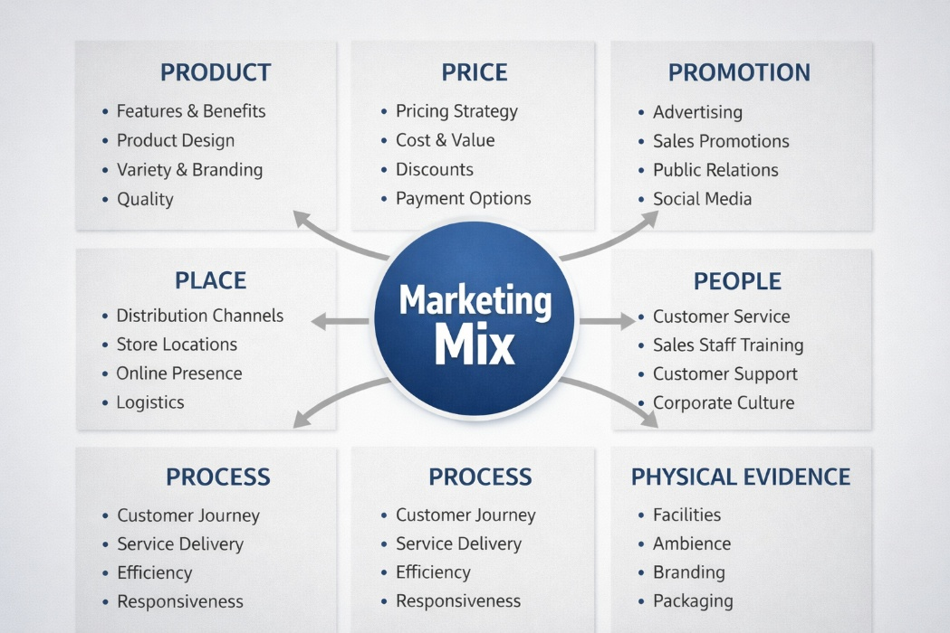
Figure 1: 7Ps marketing mix for Apple Health-Hub
(Source: Author)

1. Product Strategy
Apple Health-Hub is a very high-involvement and technology product that can succeed Apple as a brand out of consumer electronics into the realm of clinically grade medical devices (Apple.com, 2024). This product turns into a modular cloud that consists of interconnected devices such as a main hub, blood pressure, non-invasive glucose and a digital stethoscope. This corresponds to the approach, who mention an augmented product, in which not just basic functionality is implemented to provide value but also supplementary services, such as data integration, real-time monitoring, and connecting with physicians. These perceived attributes of quality and trust are compounded by the FDA-cleared medical functionalities, as the product has been raised to the masses as a diagnostic device, as opposed to a wellness device.
The product is maximising the ecosystem advantage of Apple by way of compatibility with other products like the iPhone and the Apple Watch. It can be perceived as a product ecosystem policy that enhances the switching costs and customer retention. Besides, a lack of association with information and consideration of how artificial intelligence processing is carried out on the device favours the Apple brand, which is supplementary to the brand equity model proposed by Sinaga and Husda (2023), where trust and perceived quality are the major factors of brand loyalty.

2. Price Strategy
The Apple Health-Hub pricing strategy is a premium pricing strategy that complies with its brand positioning as a whole. The high price per unit is a sign of high quality and reliability, as it possesses the capabilities of being clinical grade, regulatory permissibility, and having high-quality technology (Yusuf and Matiin, 2022). This would be along a price-quality inference, where consumers attach more significance to higher prices, particularly in a healthcare setting where accuracy and trust are the most crucial factors.
Additionally, Apple will be able to think about a value-based pricing scheme where the pricing will be determined by the long-term benefits, which include reduced hospital admissions, early diagnosis, and improved health practices (Sestino, Leoni and Gastaldi, 2025). Recurring revenue could also be served by subscription services, which can be added like advanced analytics or physician integration, just as the Apple ecosystem of today's services (Apple (2025a). However, this near-price discrimination may be limiting access, raising the question of inclusivity and market penetration among less-fortunate groups. In this way, Apple will have to find the balance between exclusivity and scalability, which it can reach with the cooperation of insurance agencies or healthcare organisations.

3. Place (Distribution) Strategy
The distribution strategy integrates direct and indirect channels to ensure that it is readily accessible and allows control of the brand. The existing retail format that Apple enjoys with its retail locations (Apple Stores) and its online format presently provides a good foundation for direct-to-consumer sales. This can be compared to the concept of selective distribution, a characteristic in which the brands get control over customer experience and product positioning.
Further, coordination with hospitals, clinics, and telehealth providers will also help in making gains towards reaching. Electronic Health Records (EHR) systems can be connected with the product to be embedded into a clinical workflow, contributing to its research and adoption (Hazan, 2025). It is a hybrid distribution approach which combines consumer retail/ institutional healthcare.
Furthermore, the trend of decentralisation of healthcare provision can also apply to the product, courtesy of its workability in the home environment. Locating the Health-Hub to users at home as a self-reported option allows Apple to capitalise on telemedicine and remote monitoring by providing users with added convenience and accessibility.

4. Promotion Strategy
Promotion as an activity is founded on trust development, awareness and perceived value that is part of integrated marketing communications (IMC). The branding that Apple will likely emphasise will be a storytelling and emotional approach, and real-life scenarios in which the Health-Hub will contribute to the quality of life (Apple, 2025b). This follows the relationship marketing theory that supports long-term contact as opposed to transactional communication.
Digital channels implement channels like social media, collaboration with influencers and targeted advertising that will assist in reaching out to the audience of tech-savvy and health-conscious individuals (Geißler, 2025). Collaboration with doctors and other hospitals can assist in developing trust, as fears over the quality of medicine amongst consumers are overcome.
PR with the advice of medical professionals, certifications of regulatory authorities, etc., will even enhance trust. Apple has a good competitive advantage in this regard due to its high brand name (Apple.com, 2024). Nevertheless, the company is to carefully address ethical aspects with promotional messages, not exaggerating any medical claims, in accordance with the rules of marketing in healthcare.

5. People Strategy
In a business, people are the most important aspect of a healthcare-related offering. Apple ought to ensure that its employees, as well as other stakeholders such as the medical practitioners, embrace the brand value proposition (Filip, 2025). One of the most crucial processes involved in communicating to customers the complex medical capabilities of the Apple Store is training the staff to use it effectively, as well as to build a favourable perception of the store and its products.
The collaboration with physicians, nurses and telehealth professionals helps to make the so-called doctor-in-the-loop model look different to make the product appear not as an independent system but as a supportive one. This is in line with service-dominant logic () wherein value is co- created via the interactions between the company, the customers and the stakeholders.

6. Process Strategy
The process aspect deals with delivering an efficient and user-friendly user experience. It has to be user-friendly and safe in terms of onboarding and configuring devices, as well as exchanging data with healthcare providers (Kumar, 2024). The success of Apple in designing user interfaces will help in achieving this goal, since there will be a low level of outrage about the introduction of complicated health technologies.
Collaborating with automated warnings and AI-based insights, the system becomes more efficient, which enables active health management to be prevented. Also, the compliance with such healthcare policies as the HIPAA stipulates that the processes are both legal and ethical. This is due to the fact that the service quality models like SERVQ are those that integrate such determinants of customer satisfaction as reliability, responsiveness and assurance.

7. Physical Evidence Strategy
Physical evidence is very important in building trust in and the credibility of healthcare products. In its most minimal and advanced design, the Apple Health-Hub will aim to convey the higher brand image of Apple, but it should also convey a professional and trustworthy image.
Packaging in Apple stores, User interfaces and even the physical environment contribute to the perception of quality as a whole. Besides, certifications, regulatory checks, and integration with accepted healthcare systems are more tangible evidence of the soundness of the item. This is in line with the service concept, which posits that the physical environment has an effect on the perceptions and experiences of the customers (Mowar, 2022).

Element 4: Reflection
Developing the Apple Health-Hub as a brand extension of Apple has been a valuable yet provocative experience, and it has taught me valuable lessons about strategic marketing and management of innovation. Some of the most significant lessons that have been learned in the process included a need to position a new concept of a product with the main brand identity. The emphasis on making the ecosystem, privacy, and quality design a core resource of Apple, but the translation of these intangible brand values into a healthcare-sourced product required critical thinking and a tight rationale to be made. This process helped me to become more efficient in applying the theoretical frameworks, such as STDP and marketing mix, to practice and to a certain situation.
Among the key learning outcomes, the opportunity to critically analyse the market trends and consumer behaviour was included. These studies of why more healthcare is required at home and digital health solutions reinforced in my mind just how the external environment affects the strategic decision-making process, such as an ageing population and changing lifestyles post-pandemic. Secondly, on competition-based analysis, it was understood that differentiation is crucial, particularly when a market is competitive, and in this case, trust and reliability are crucial. This enhanced my analytic and synthesising abilities to amass information from multiple sources into a consistent strategy.
Preparation of the poster presentation was another area in my development of communication and visual design skills. It took time to think clearly and creatively so as to reduce the long and complex notions into short and interesting pictures. I have also mastered the importance of prioritising the critical information, effective utilisation of an organised structure and making the content informative and user-friendly. The presentation also enabled me to be more confident in presenting the ideas and answering possible questions, which are crucial skills both in academic and professional experience.
Furthermore, this project helped me to develop my research and critical assessment skills. Being exposed to reading academic theories and manipulating them to a concept fabricated on the basis of real life cemented my knowledge of the marketing principles and how they apply in real life. It further highlighted the importance of evidence-based decision-making when bringing an innovation to the market with high stakes, such as a health product.
There are, however, corners which my style needs to work on. In order to deepen the analysis, next time I will work on a paper, I will aim to incorporate a wider range of academic sources and more up-to-date ones. Furthermore, I could design better data visualisations and infographics as I can reinforce the main points in the poster. Presentation-wise, it would be beneficial to practice more and get feedback before the presentation to practice delivery and be more certain and clearer.
Overall, the provided experience has been an excellent source of my personal and professional development since it allowed me to enhance my strategic thinking level, research skills, and communication. It has also boosted my confidence in developing market-based solutions in an innovative manner and sharing them, which will be of enormous benefit in subsequent research and career.

Reference List
Aggarwal, V., (2025). Globalizing Continuous Glucose Monitoring Systems: A Paradigm Shift from Traditional Self-Monitoring Blood Glucose Devices. https://nhsjs.com/wp-content/uploads/2025/05/Globalizing-Continuous-Glucose-Monitoring-Systems-A-Paradigm-Shift-from-Traditional-Self-Monitoring-Blood-Glucose-Devices.pdf
Apple (2025a). Environment. [online] Apple. Available at: https://www.apple.com/in/environment/ [Accessed 19 Apr. 2026]
Apple (2025b). Our Values. [online] Apple. Available at: https://investor.apple.com/our_values/default.aspx [Accessed 20 Apr. 2026]
Apple.com (2024). Health App. [online] Apple (India). Available at: https://www.apple.com/in/health/ [Accessed 21 Apr. 2026]
Ekstedt, M., Nordheim, E.S., Hellström, A., Strandberg, S. and Hagerman, H., (2023). Patient safety and sense of security when telemonitoring chronic conditions at home: the views of patients and healthcare professionals-a qualitative study. BMC health services research, 23(1), p.581. https://link.springer.com/content/pdf/10.1186/s12913-023-09428-1.pdf
Filip, C., (2025). Strategic positioning in wearable health technology: leveraging consumer centric analytical approaches for market leadership–perceptual map analysis. https://run.unl.pt/bitstreams/7fb23eeb-266b-44e0-baaa-8f3bdc7ad5e6/download
Furtado, S.J., (2024). ICT-Enabled Change in Healthcare Organisations: Examining Implementation Practice of Healthcare Documentation Projects. https://arrow.tudublin.ie/cgi/viewcontent.cgi?article=1293&context=sciendoc
Geißler, F., (2025). Strategic positioning in wearable health technology: leveraging consumer centric analytical approaches for market leadership-a literature review on technology adoption and family purchasing. https://run.unl.pt/bitstreams/2bb8f294-6154-4e1b-bbdb-a8b0e278df3d/download
Hazan, M., (2025). Strategic Positioning in Wearable Health Technology: Leveraging Consumer Centric Analytical Approaches for Market Leadership A Literature Review on Advanced Applications, Addressing Adoption Challenges, and Innovative Solutions for Healthcare Technology (Master's thesis, Universidade NOVA de Lisboa (Portugal)). https://run.unl.pt/bitstreams/3ab41c62-5bef-4d1e-be62-d1e6955fa051/download
Jain, P., Joshi, A.M., Mohanty, S.P. and Cenkeramaddi, L.R., (2024). Non-invasive glucose measurement technologies: Recent advancements and future challenges. IEEE Access, 12, pp.61907-61936. https://ieeexplore.ieee.org/iel7/6287639/6514899/10501933.pdf
Krämer, J., (2026). Balancing privacy and platform power in the mobile ecosystem: The case of Apple’s App Tracking Transparency. Computer Law & Security Review, 60, p.106255. https://www.sciencedirect.com/science/article/pii/S2212473X25001270
Kumar, V., (2024). International marketing research: A transformative approach. Springer Nature. https://www.academia.edu/download/39425849/inernational_marketing_research.pdf
Lee, B., Jay, M., Fox, H., Padley, J., Dai, T. and Levin, A.S., (2026). FDA-Cleared Artificial Intelligence Medical Devices in Orthopaedic Surgery. JAAOS Global Research & Reviews, 10(2), pp.e25-00170. https://pmc.ncbi.nlm.nih.gov/articles/PMC12879955/
Mowar, A., (2022). Marketing management. Blue Rose Publishers. https://books.google.com/books?hl=en&lr=&id=lOyZEAAAQBAJ&oi=fnd&pg=PA1&dq=marketing+decision+book&ots=4IslZCsGQ6&sig=2YsEKpf2Qv1b4v-VG4S4uZxnvPs
Schäfer, F., Gebauer, H., Gröger, C., Gassmann, O. and Wortmann, F., (2023). Data-driven business and data privacy: Challenges and measures for product-based companies. Business Horizons, 66(4), pp.493-504. https://www.sciencedirect.com/science/article/pii/S0007681322001288
Sestino, A., Leoni, E. and Gastaldi, L., (2025). Exploring the effects of digital transformation from a dual (internal vs external) marketing management perspective. European Journal of Innovation Management, 28(8), pp.3619-3647. https://re.public.polimi.it/bitstream/11311/1278810/1/Sestino%2C%20A.%2C%20Leoni%2C%20E.%20%26%20Gastaldi%2C%20L.%20%282024%29.%20Exploring%20the%20effects%20of%20digital%20transformation%20from%20a%20dual%20%28internal%20vs%20external%29%20marketing%20management%20perspective%20.pdf
Shah, G.H., Chanar, S., Tedders, S.H., Joshi, K. and Harbaugh, K., (2025, November). The Interaction of Health Behaviors and Cardiovascular Diseases: Investigating Morbidity Risks of Disparities in US Adults. In Healthcare (Vol. 13, No. 23, p. 3072). MDPI. https://www.mdpi.com/2227-9032/13/23/3072
Siahaan, M., (2023). Analysis and Evaluation of the Business Innovation Strategy: A Case Study of Apple Inc. Enigma in Economics, 1(2), pp.42-48. https://www.enigma.or.id/index.php/economy/article/download/30/33
Sinaga, A.R. and Husda, N.E., (2023). The effect of the marketing mix on purchase decisions and customer satisfaction. Journal of Community Service and Empowerment, 4(3), pp.492-499. https://ejournal.umm.ac.id/index.php/jcse/article/download/29154/12896
Yusuf, M. and Matiin, N., (2022). Analysis of the effect of the marketing mix on purchasing decisions. International Journal of Economics and Management Research, 1(3), pp.177-182. https://ijemr.asia/index.php/ijemr/article/download/56/63

