Name:__Christian Evans_______________________________

Student Number: _2526458_______________________
__________________________________________________________

WORKSHEET 1 – TESTING (Using Variables)

- Original code:
[Copy and paste your original code from Moodle into this box. Do not change it.]
surname = str(input("Enter your surname: "))
carReg = str(input("Enter your car registration number: "))
age = int(input("Enter your age: "))
hoursPerWeekOfLectures = int(input("Enter your hours per week of lectures: "))

print(f" Surname: {surname}\n Car Registration: {carReg}\n Age: {age}\n Hoursoflecturesperweek: {hoursPerWeekOfLectures}")

- Code Testing

For each test below, run your code and enter the values provided. Provide a screenshot of the programme running. Did the programme behave correctly or did it do something unexpected? Fill in a box for each test below. You should present 14 separate boxes, 1 for each test. (Note: the first box is provided as a template)

Surname:
- Enter JONES
- Leave blank
- Enter 123

Car registration:
- Enter BG56UDU
- Leave blank
- Enter BG56345DFE (ie too long for a UK car registration number)

Age
- Enter 34
- Enter 150
- Enter -4
- Enter a letter

Hours per week of lectures
- Enter 12
- Enter 15.5
- Enter -4
- Enter 150 (ie longer than the maximum possible hours that the University is open in a week)

Test:
Surname i. Enter JONES

Screenshot(s) of output:
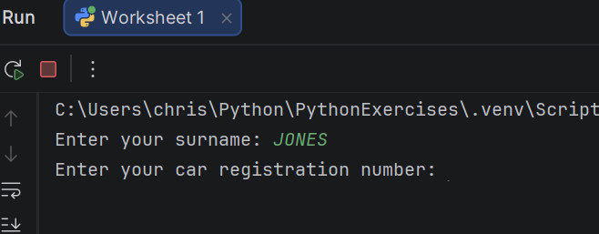
Result: Did the program behave as expected ie syntactically and logically correct?
Yes (delete as appropriate)
If NO, what problems were encountered and why? Suggest how things could be improved.

(Copy and paste a box similar to the above for each of the rest of the tests)
Test: Leave surname blank
Surname ii. Leave blank
Screenshot(s) of output:
Result: Did the program behave as expected ie syntactically and logically correct?
No (delete as appropriate)
If NO, what problems were encountered and why? Suggest how things could be improved.

Accept the enter character as input, again could have an IF statement to validate against this so the user has to enter characters.

Test: Enter 123
Surname iii. Enter 123
Screenshot(s) of output:
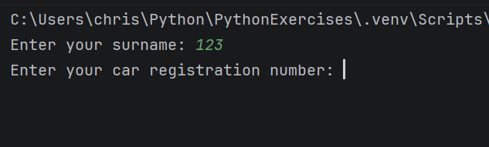
Result: Did the program behave as expected ie syntactically and logically correct?
No (delete as appropriate)
If NO, what problems were encountered and why? Suggest how things could be improved.

Usually a surname doesn’t contain numbers, so I would include validation next time to stop numbers being added into this field. Would have to add an IF statement to the code as I think numbers can be accepted as strings automatically.

Test: Enter BG56UDU
Car registration i. Enter BG56UDU
Screenshot(s) of output:
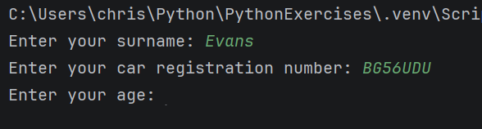
Result: Did the program behave as expected ie syntactically and logically correct?
Yes (delete as appropriate)
If NO, what problems were encountered and why? Suggest how things could be improved.

Test: Leave blank
Car registration ii. Leave blank
Screenshot(s) of output:
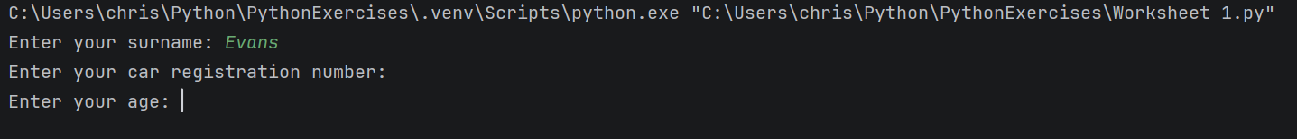
Result: Did the program behave as expected ie syntactically and logically correct?
No (delete as appropriate)
If NO, what problems were encountered and why? Suggest how things could be improved.

The input has accepted the enter character as input so would need to have validation logic to prevent this from happening, if statements for example.

Test: Enter BG56345DFE
Car registration iii. Enter BG56345DFE (ie too long for a UK car registration number)
Screenshot(s) of output:
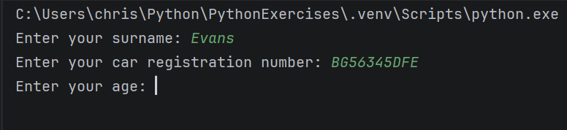
Result: Did the program behave as expected ie syntactically and logically correct?
No (delete as appropriate)
If NO, what problems were encountered and why? Suggest how things could be improved.

The validation isn’t in place within my original code to prevent this, would have to write a conditional statement to only accept values of 7 characters.

Test: Enter 34
Age i. Enter 34
Screenshot(s) of output:
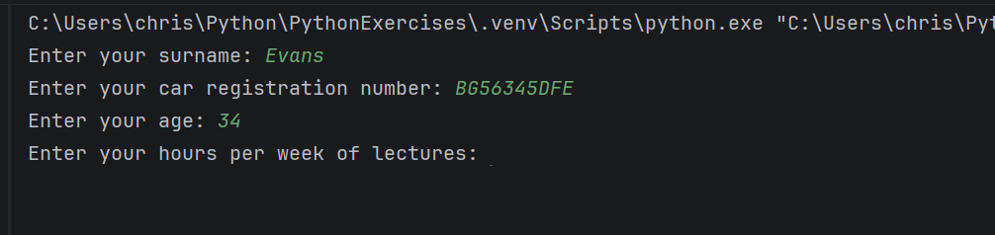
Result: Did the program behave as expected ie syntactically and logically correct?
Yes (delete as appropriate)
If NO, what problems were encountered and why? Suggest how things could be improved.

Test: Enter 150
Age ii. Enter 150
Screenshot(s) of output:
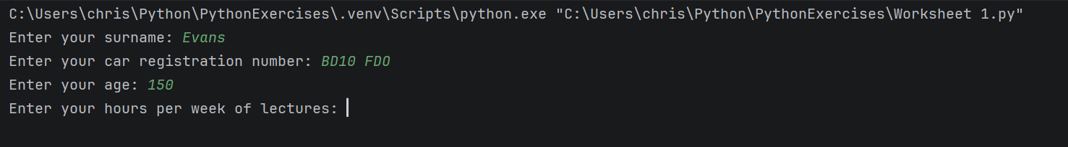
Result: Did the program behave as expected ie syntactically and logically correct?
Yes (delete as appropriate)
If NO, what problems were encountered and why? Suggest how things could be improved.

Test: Enter -4
Age iii. Enter -4
Screenshot(s) of output:
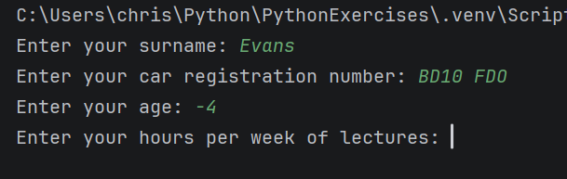
Result: Did the program behave as expected ie syntactically and logically correct?
No (delete as appropriate)
If NO, what problems were encountered and why? Suggest how things could be improved.
Would need to add in more validation to not accept the minus character within the input field.

Test: Enter a letter
Age iiii. Enter a letter
Screenshot(s) of output:
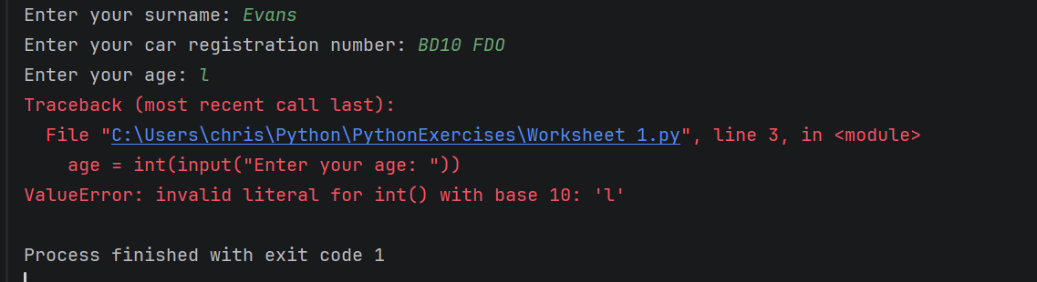
Result: Did the program behave as expected ie syntactically and logically correct?
Yes (delete as appropriate)

Test: Enter 12
Hours Per Week of Lectures i. Enter 12
Screenshot(s) of output:
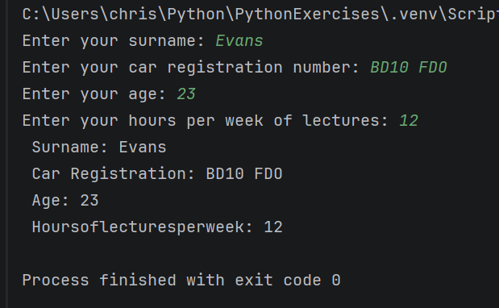
Result: Did the program behave as expected ie syntactically and logically correct?
Yes (delete as appropriate)
If NO, what problems were encountered and why? Suggest how things could be improved.

Test: Enter 15.5
Hours Per Week of Lectures ii. Enter 15.5
Screenshot(s) of output:
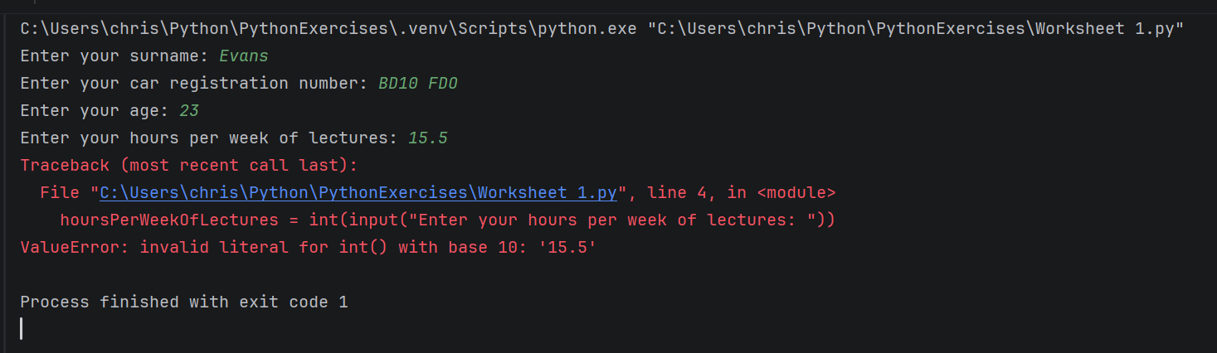
Result: Did the program behave as expected ie syntactically and logically correct?
No (delete as appropriate)
If NO, what problems were encountered and why? Suggest how things could be improved.
Technically, should have declared age as a float and then it would accept any number through, could always use the trunc method to cut off any additional decimal places if needed to.

Test: Enter -4
Hours Per Week of Lectures iii. Enter -4
Screenshot(s) of output:
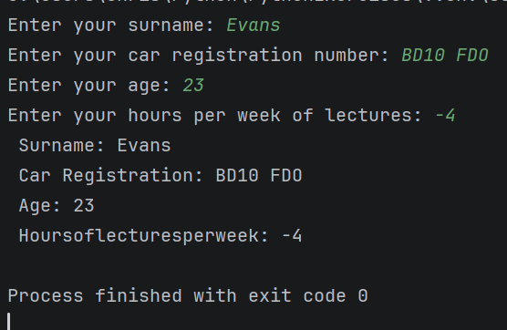
Result: Did the program behave as expected ie syntactically and logically correct?
No (delete as appropriate)
If NO, what problems were encountered and why? Suggest how things could be improved.
Could add in validation to stop users from entering the minus character within the input.

Test: Enter 150 (ie longer than the maximum possible hours that the University is open in a week)
Hours Per Week of Lectures iiii. Enter 150 (ie longer than the maximum possible hours that the University is open in a week)

Screenshot(s) of output:
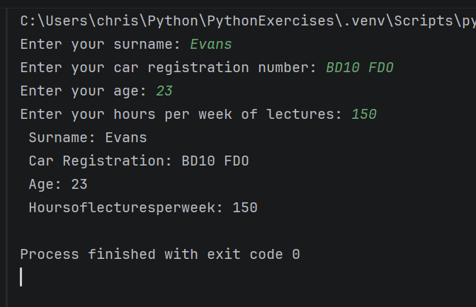
Result: Did the program behave as expected ie syntactically and logically correct?
No (delete as appropriate)
If NO, what problems were encountered and why? Suggest how things could be improved.
Could add in validation in the form of an IF statement to stop the user from entering a certain amount of hours over the limit.

- Consider the results of the above tests and revisit your original code in order to address the tests that failed. (Note: you may not be able to solve all of the problems that were originally encountered, but solve as many as you can.)

Paste your full revised code here :

[Copy and paste your full revised code here – note, do not use a screenshot]
surname = str(input("Enter your surname: "))
carReg = str(input("Enter your car registration number: "))
age = int(input("Enter your age: "))
hoursPerWeekOfLectures = float(input("Enter your hours per week of lectures: "))
if hoursPerWeekOfLectures >= 150:
var = {
print("That is more hours than the maximum amount of hours the university is open!"):
print("Please re-enter the number of hours you have attended lectures per week")
}
print(f" Surname: {surname}\n Car Registration: {carReg}\n Age: {age}\n Hoursoflecturesperweek: {hoursPerWeekOfLectures}")

