Doyle, Nathan (N.L.)
Ndoyle.151450@student.uwtsd.ac.uk
Advanced stress analysis and FEA
M6X00420

Executive Summary

The increase in competition, production cost and market fluctuation, has forced many organisations to create a culture where focus is on improving quality and product reliability. It is vitally important that products are produced efficiently, with zero defects, so that they achieve high customer satisfaction and excellent feedback. Non-destructive testing methods such as thermography, radiology and visual testing are effective tools that companies utilise to identify abnormalities in their products as a means of quality control. A company may decide that a single technique may not provide enough information, therefore, the use of two or more combined can provide meaningful results. This paper focuses on the application of these methods within industry and the improvements that can be made when analysing stress.

Table of Contents

Executive Summary 1
Table of Contents 2
List of Figures 3
Introduction 4
Principles of NDT 5
Compare and Contrast with Traditional Destructive Methods 5
Visual Testing 7
Scientific Principles 8
Benefits and Limitation 9
Applications 10
Sources of Errors and Assumptions 12
The Improvement of Stress Analysis 13
Radiography 15
Scientific Principles 15
Benefits and Limitations 16
Applications 17
Sources of Errors and Assumptions 18
The Improvement of Stress Analysis 19
Infrared Thermography 20
Scientific Principles 20
Benefits and Limitations 21
Applications 21
Sources of Errors and Assumptions 24
The Improvement of Stress Analysis 24
Conclusion 26
References 27

List of Figures

FIG. 1. The usage of different NDT techniques within industry ………........................... 6
FIG. 2. The stages of inspection in a manufacturing process ………………………….………… 8
FIG. 3. Defect observed in aircraft engine……………………………………….………………...…… 11
FIG. 4. Final crankshaft inspection station at Ford Motor Company..…………....…….... 11
FIG. 5. Microscopic image of worn blood extraction needle.………………………………….. 12
FIG. 6. Change in design can improve stress analysis ……………………………….……………. 13
FIG. 7. Different location of holes produces different stress ………………………………….. 14
FIG. 8. Radiographic image of dense bones compared to less dense outer tissue ….. 15
FIG. 9. Electromagnetic Spectrum …………………………………………………………………….……. 16
FIG. 10. A Micro CT scan of an aircraft casting………………………………………..………………… 18
FIG. 11. Different bands of infrared radiation in the electromagnetic spectrum…..….. 20
FIG. 12. Using Lock in technique to determine rivet tightness………………..………………… 22
FIG. 13. Using Lock in to analyse aircraft Tail cone and Rudder………………………………… 22
FIG. 14. Overheating cable……………………………………………………………………………………….. 23
FIG. 15. Infrared camera to detect leaks in tanks and pipes……………………..……..……….. 23
FIG. 16. Graph comparing emissivity with viewing angle…………………………………………… 24
FIG. 17. Stress analysis of a component with a thermal imaging camera…………………… 25

Introduction

Non-Destructive Testing is central to the daily running of many different organisations; however, the precise use and techniques vary, dependant on the product function and application. The purpose of this report is to research the topic of non-destructive testing and outline three popular techniques used within a range of industries. These three include visual testing, radiography and thermography. It will explain the scientific principles behind each testing method and examine the many unique benefits and limitations that may have to be considered before being fully utilised. The report will also demonstrate the variety of applications that currently adopt each method and describe how the non-destructive testing approach, can be used to help improve stress analysis.
A recent study on non-destructive testing (Henderson, 2019) shows that whole global market is projected to substantially grow from $3 Billion to just over $4.5 Billion by 2025. The rise in safety, fire and government regulations due to increasing accidents, along with higher competition and quality demands from the consumer has forced companies to become more prudent with NDT techniques instead of other methods. As a result of this change, the report compares the use of older traditional destructive methods against NDT and outlines the advantages and disadvantages of utilising both. The aim of this report will be to provide further knowledge of current scientific principles for the three techniques and research though peer reviewed journals and books, the many diverse industries in which they are used.

Principles of NDT

The quality of a material such as steel is dependent on the levels of stress located on its volume or surface and any weakness may result in fractures or even total failure. With the steel market estimated to cover over 5% of the world’s GDP, involving the automotive, construction and steel production industries, it is important that steel health monitoring and quality management techniques are effective to cope with the market demand (Hristoforou, 2018). Even though steel is widely used, Prasad (2009) demonstrates that materials used in activities involved with engineering usually fall into four categories that are composites, ceramics, polymers and alloys. Each of these have distinct properties and it is important that an effective defect management method is used to identify potential flaws.
Non-destructive testing (NDT) is an inspection methodology that evaluates the mechanical, physical and chemical state of the material being tested. The inspection gathers specific information that is used to detect defects and plan a suitable maintenance strategy according to the defect’s location or severity (Marquez, 2016). Raj, (2002) argues that there are a variety of ways in which a products imperfection can be established, and these range from the process used, defects in the original material or even human error. Prasad, (2009) explains that an advantageous benefit of NDT is the ability for it not to deform or damage the component being tested, therefore, it is seen as a very useful technique in terms of saving costs and time. As suggested by Balayssac & Garnier, (2017) NDT has been conducted even in the early primitive stages of engineering in the form of visual inspections using the five senses and since then, methods have evolved significantly with the increase in competition, accidents, legislation and technology. At this present time, well established methods such as magnetic-particle, eddy currents, ultrasonic testing, radiography and liquid penetrant, are used in a variety of different ways with an extensive range of equipment (Hull & John, 2015).

Compare and Contrast with Traditional Destructive Methods
Unlike NDT, whereby the testing does not deteriorate or impair the product, traditional destructive techniques (DT) involve testing the specimen to complete failure to understand its performance under certain loads. In terms of cost, Gholizadeh, (2016) argues that NDT provides a complete cost effective way of analysing a material for defects as it does not alter or cut the product, allowing for it to be passed onto the customer for full use without increasing the cost per unit. Pastuszak, et al., (2013) agrees by suggesting that NDT cost benefits completely surpass those of destructive methods. Not only do NDT methods produce less wastes but they also completely reduce production downtime. Omar, (2012) however, disagrees by suggesting that NDT techniques usually require a considerable preparation process prior to the actual testing which can affect product lead times. A significant part of the preparation stage is cleaning which aids the identification of surface defects, whereas clean surfaces used in a destructive method such as a crash test, are less important. Omar, (2012) remarks that destructive methods can be hugely beneficial to mass produced products whereby the waste of one specimen will not be a big financial burden. They can provide important information of the materials properties and specifications.
According to Gupta, (2018) concrete is the most commonly used material for construction in the world and there is an assortment of DT techniques used to determine the mechanical properties. These include tensile testing, Bending testing, compressive testing and impact testing. Gupta, (2018) adds that the DT yields considerably more useful information when compared with NDT, such as the materials modulus of elasticity and service life, however any internal defects cannot be determined. On the other hand, Arooj & Yadav, (2017) state that important information like the concretes compressive strength can be determined by NDTs such as the rebound hammer test. Arooj & Yadav, (2017) go on to suggest that combining two or more Non-destructive techniques like ultra-pulse velocity and rebound hammer, give far more valuable and reliable information than any destructive method. On a material such as concrete, Wiggenhauser & Kopp, (2018) summarise, by stating NDT as being extremely low cost, simple to use and obtains quick results, however, the results are more of an approximation. With DT, the process requires more energy and equipment, with slower results, however, they contain quantitative measurements.

Visual Testing

Due to high quality expectations from end consumers, companies are driven to find cost effective procedures to produce defect free products (Krishnan & Ajai, 2012). Even though there are a variety of useful NDT available to utilise, visual testing is the most widely and popular used method because of its low cost and ease of operation (Greissel, 2003). A straightforward test can discover surface defects such as cracks and porosity that may lead to the elimination of the part from the process and therefore, saving money and time (Raj, et al., 2012). Figure 1 demonstrates the popularity of visual testing within industry.
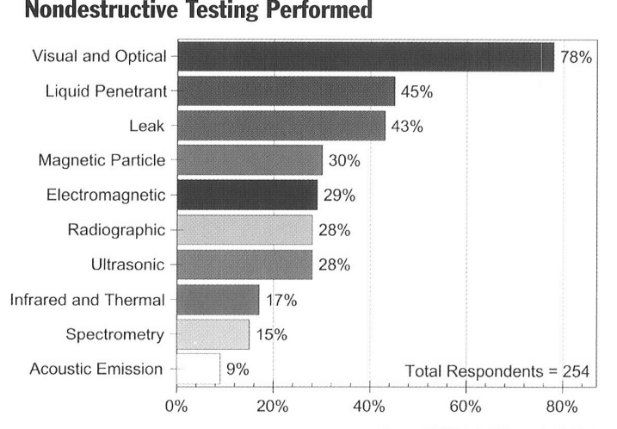
FIG. 1. Table depicting the use of different NDT performed within industry (Greissel, 2003)

Raman & Raj, (2019) explain that a highly trained inspector can easily observe the internal or external surfaces of many different types of equipment such as piping or pressure vessels. Other visual techniques can also be applied to enhance the examination and detect small defects. These may include the use of visual aids such as microscopes, endoscopes and borescopes. To ensure which visual techniques/equipment are needed or to involve further non-destructive techniques, the follow questions need to be considered:

After examining the assembly or manufacturing process, what product defects are likely to occur?
Where would you expect the defects to be located? Any they internal or external?
What is the size of the defects that may occur?

Scientific Principles
Regarding the implementation of the visual technique in a manufacturing process, a company will usually adopt a three-stage inspection system. These are the input, process and output inspections (Newman & Jain, 1995). Figure 2 below displays the location of each inspection stage in a typical manufacturing process:
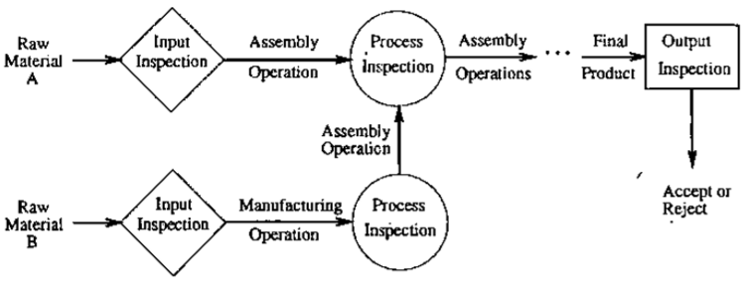

FIG. 2. Stages of inspection in a manufacturing process (Gao & Wang, 2006)

Before a product or component is inspected, it is imperative that good lighting is available to locate the suspected defect area, especially if it involves heavy machinery and large frameworks. The lighting will benefit the inspection capabilities by allowing the observer to detect any colour changes, the extent of any corrosion and material erosion (Mix, 2005). Raj, et al., (2012) recommends that the light source emits about 800-1000 lux and that the inspection technician spends no more than 2 hours observing the components, otherwise a decrease in visual reliability may occur. Anand, (2018) also agrees that a source of light is imperative and advises using a Fluorescent lamp, however, the intensity of light can be as low as 500 lux. A human with 20/20 vision is able to detect a defect as small as 75µm in size, however, this can easily be reduced to cracks as small as 10 µm in optimum light conditions (Cumblidge & Anderson, 2004)
Once an object has been selected for visual inspection, it is important to identify the correct visual technique. According to Mix, (2005) a visual standard known as MSS-SP-55 can be implemented which requires photographs of the correct and incorrect surface conditions to be shown. A quick glance by an operator can easily visually distinguish between the two. There are many types of defects that can be identified. Depending on the product being examined, an inspection focuses on finding defective connections, evidence of leaking, porosity, cracking, erosion damage, rust. To assist in identifying defects, a magnifying lens can be placed between the object and the eye. A lens is a curved piece of glass that refracts two parallel lights rays towards its centre or focal point. The shorter the focal point, the more magnifying power the lens possesses (Vancleave, 2007).
In the event of examining the internal features of a part either a borescope, an endoscope or a fiberscope can be used. This is known as Aided Visual Inspection. Davies, (1998) ackowledges the usefulness of these devices in inspecting components with long narrow bores and states that the relatively low cost equipment is becoming popular with companies that may want to opt out of expensive internal non-destructive testing methods. There is however, an argument that borescopes are rigid and can only focus on images directly in its line of sight, whereas an endescopes camera is flexible and able to manevur internally through the component (Mudali & Raj, 2008).

Benefits and Limitation
The human eye is described by Matzkanin, (2007) as being able to match the most sophisticated camera for accuracy and precision, and it can be trained to focus on the most specific details. It not only can detect changes in colour, surface texture, shape and size, but it can allow the brain to make rational decisions and recommendations. If a defect is found, then an investigation can be quickly embarked upon or the use of low-cost optical aids can be used to focus on the problem. Even though optical aids such as cameras and microscopes can be used, Sukhorukov & Sukhorukov, (2012) point out that increasing the magnification, decreases the area that can be observed at one time. This can become a problem if a large component needs a full visual inspection and may require more time. Forsyth, et al., (2006) agree with this view, by adding that other NDT procedures such as radiography can cover a huge area on components to locate deep cracks, in a faster time, without the requirement of any visual inspection.
Visual tests are implemented by organisations as they are seen as a very simple way of increasing product quality, reducing defects and enhancing customer satisfaction. Not only do they not interfere with the component but they are seen as extremely cost effective compared with other NDT techniques (unnporsson, et al., 2004). Cavalli & Togni, (2013) suggest that visual inspections are often overlooked but can provide a company with the greatest financial saving. The item can be tested for a variety of defects, with relatively low cost equipment, whilst moving on the production line. Even though the cost benefit
may seem obvious, the testing can create additional stress on employees that can increase costs . Visual inspection requires tough mental concentration, with added pressures of finding critical defects without delaying production. See, (2015) states that in the US, 35% of components were incorrectly rejected after inspection, which is associated with the penalty consequences for employees of allowing the passing of defective items. This can increase the cost per unit, with less products reaching the output stage of the process.

Applications
The process of visual inspection is one of the most widely used NDT method for detecting surface abnormalities within organisations and a diverse range of industries have taken advantage of its simple procedures in their ambition of producing high quality products. Due to its ability of detecting macroscopic flaws such as undercutting, penetration and slag inclusion, visual testing is extremely effective in the welding industry, especially when used with a lighting source. According to Jeffus & Bower, (2009) visual inspection within the welding industry, can reduce the weld rejection rate by more that 75%. In nana, et al. (2019) view, this application is very important because poor welding profiles can decrease a joints mechanical properties which could cause structural failures.
Visual inspections are also a fundamental part of the aircraft industry. Since the aircraft are continuously loaded and unloaded with constant pressurisation, components are prone to becoming fatigued. As a result, Busse, et al., (2008) claim that over 80% of all inspections carried out within the aeronautical industry are visual inspections. Potential aircraft defects are fusilage cracks, corrosion on wings and disbonding. This also includes examining potential failures in engine blades as seen in figure 3. Papa & Ponte, (2018) agree that visual inspections are a popular NDT method in inspecting aircraft, however it is not just limited to this. They add that it is also ustilised in inspecting large drones as well as in the space and arms industry.
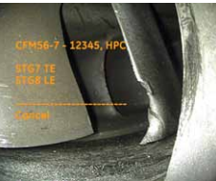

FIG. 3. Defect observed in aircraft engine blade (GE, 2012)

In manufacturing, visual testing is very common ,with regular inspections occuring on equipment such as pressure vessels, piping and electrical cabinets. In some instances, whereby a conveyor system is used, it may require a faster method of visual inspection, therefore an integrated computer system with a PLC can be operated to quickly determine a defect free part (Prabuwono & Away, 2004). In the case of many manufacturing processes however, visual inspection is applied before and after a particular machining operation. Figure 4 shows a crankshaft inspection station at Ford Motor Company. The crankshaft is inspected thoroughly under a light for porosity, damaged bearings and misaligned oil holes, before it is transported to the assembly line (Doyle, 2019).
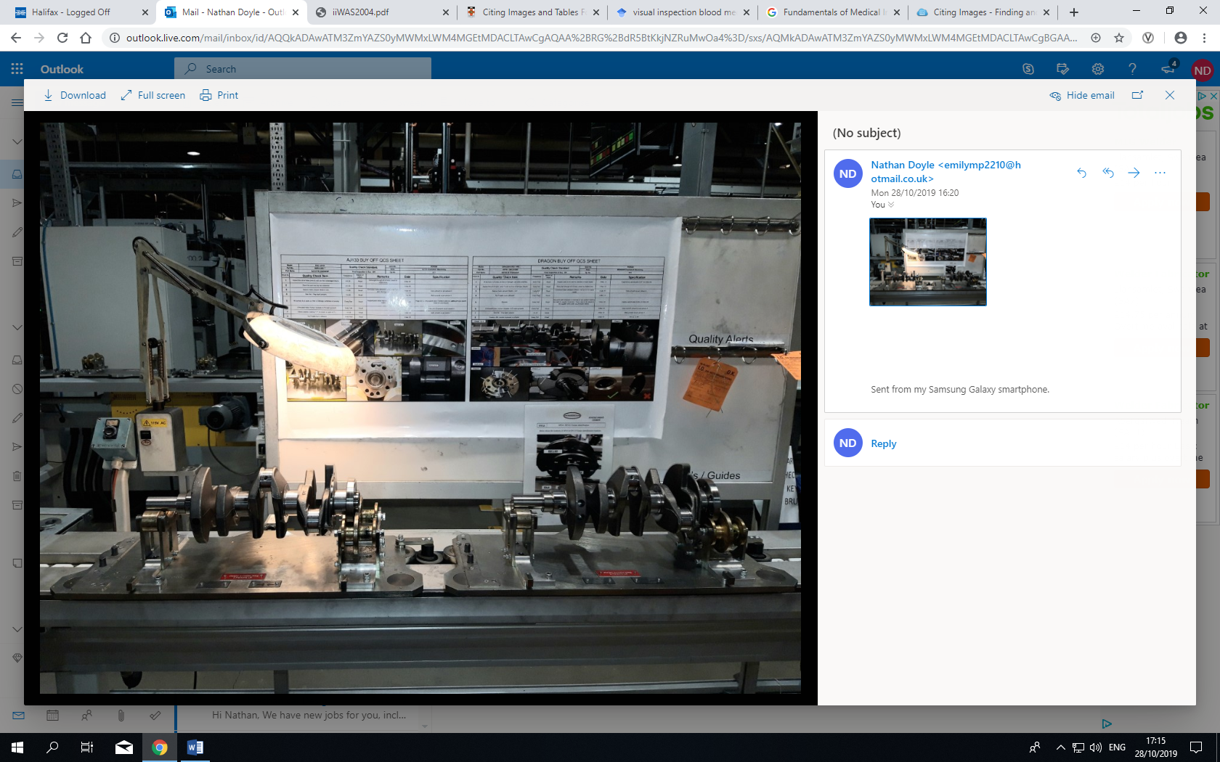

FIG. 4. The final Crankshaft inspection station at Ford Motor Company (Doyle, 2019)

Even though there are numerous uses in the manufacturing industry, many other sectors such as the food, medical and building industries benefit from visual inspections. In the medical proffession for example, many surgical tools are visual inspected prior to use, using a microsope to identify very small defects and wear. Figure 5 shows signs of wear in a puncture needle used in collecting a patients blood
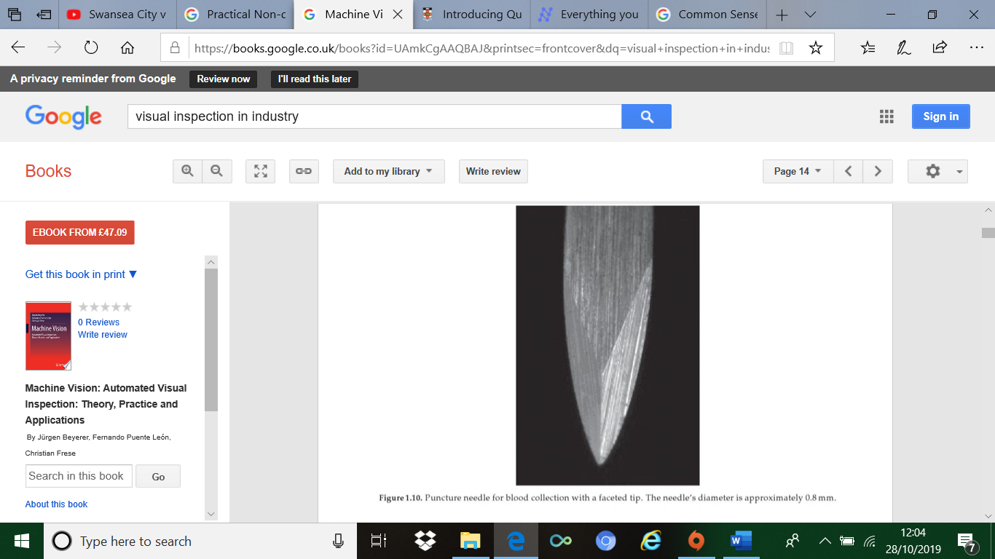

FIG. 5. Microscopic image of worn blood extraction needle (Davies, 1998)

Sources of Errors and Assumptions
Visual inspectors are regarded as being highly trained operators or tradesman that possess good product knowledge and can identify a clear and obvious defect. In despite of this, See, (2015) suggests that human error resulted in missed defects in the range of 20 – 30% of all inspected products. Even though this seems high, Melchore, (2011) argues that several assumptions should me made when investigating an effective visual inspection programme. These include factors such as the recommended time limit of inpsection before eye fatigue becomes a concern, adequate training has been provided by the organisation in indentifying abnormalities and the required visual enviroment to easily locate the defects. Melchore, (2011) goes on to explain that human error figures assume that the company has the correct documentation needed to reduce errors and the ergonomics of visual performance is analysed for each operator. Even though a company can erradicate most problems associated with the application of visual inspections, Quan, et al., (2013) explain the difficulty to maintain a completey objective view on defects because each persons perception is different.
In the practice of visual inspections carried out by cameras or machines, Yongjin & Richard, (2009) acknowledge the need for an increase in automated inspections; suggesting that this can improve detection results by up to 10%. Forcinio, (2014) however, highlights sources of uncertainty that can influence the detection results. These include the image quality, speed of object being inspected, illumination and placement of material from inspection source. Forcinio, (2014) goes on to suggest that any data that compares automated and visual inspection, must assume that the same automated equipment is being used.

The Improvement of Stress Analysis
When a component is subjected to a load in the manufacturing process or during its life cycle, there is a possibility of failure occurring either as cracks, fatigue or wear, due to the stresses on the individual particles within that product. When a crack in a component is detected after a visual inspection, this can instigate a thorough investigation using stress analysis on CAD software examining the stresses when a load is applied. This can lead to either changes in the design, material or even the cutting process (Kececioglu, 2003).
From a visual inspection, a description of the geometrical structure can be ascertained which can give a clear indication of potential areas with high stress concentration. Taylor, et al., (2010) recognise that corners are areas with a substantial stress concentration and an operator with knowledge of the load position, can easily identify a weak point in a product. Visually, evidence of stress in corners include, cracks, bucking and warped material. Once a defect or potential area is observed, Taylor, et al., (2010) suggest that a redesign, such as an angled fillet leading diagonally away from the stress concentration, can drastically reduce the stress. This is illustrated in figure 6 whereby a slight design change can reduce the tangential stress.

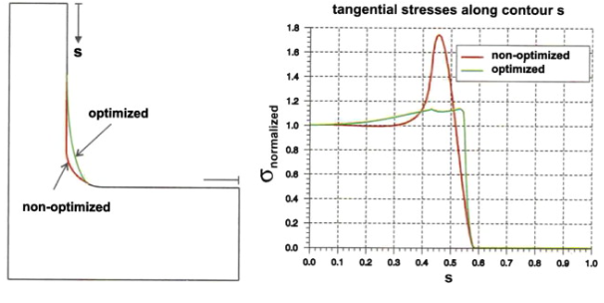

FIG. 6. How a change in design can improve stress analysis identified by visual inspection (Taylor, et al., 2010)
Visual inspection can also be used to observe stress concentrations in the locations of rivets and bolts in a component. Khoshravan, et al., (2011) explain that the location of the same diameter holes produce contrasting stress concentrations. From figure 7 below, (Khoshravan, et al., 2011) observes that second type produces far greater stress and is more likely to produce a defect than type 1.
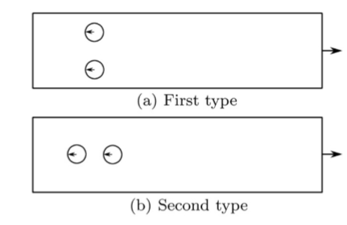

FIG. 7. Different location of holes produces different stress (Khoshravan, et al., 2011)

Radiography

Using both gamma and X-rays, radiography is an effective NDT method used to detect sub surface defects in an array of different materials. It is a powerful tool used within industry that can provide a clear depiction of cracks and inclusions in material over seven inches thick. Turkmen, (2019) claims that radiographic inspection can present an opportunity to investigate microstructures, thickness changes and inner defects whilst not giving any damage to the tested specimen. Once the size of these defects or inclusions are analysed, then maintenance intervention may be considered (Haith, et al., 2017). The basic principle involves placing the component to be inspected between the radiation source and radiation film. The results of the test depict a black and white shadowgraph, whereby the white colour is the denser material blocking the radiation from entering the sensitive film. The black portion of the shadowgraph shows an area of high radiation intensity (Turkmen, 2019). Figure 8 illustrates the density contrast in black and white in the medical profession. It is seen that the denser bones have absorbed most the radiation compared to the outer tissue.
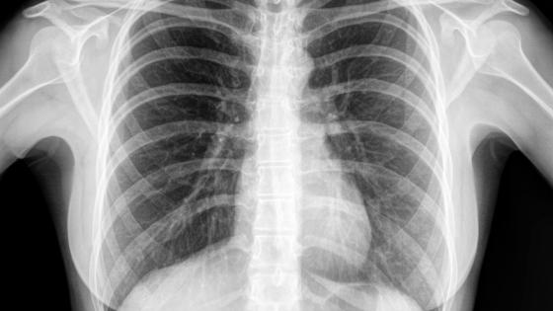

FIG. 8. Radiographic image of dense bones compared to less dense outer tissue (Rohman, 2018)

Scientific Principles
X rays are located at the high energy, far right end of the electromagnetic spectrum and are created by passing a voltage between two terminals in a single vacuum. Electrons begin moving very quickly from the cathode to the anode and this rapid influx of electrons produces x rays (Harvey, 2008). Figure 9 shows the location of X ray and gamma rays in the electromagnetic spectrum.
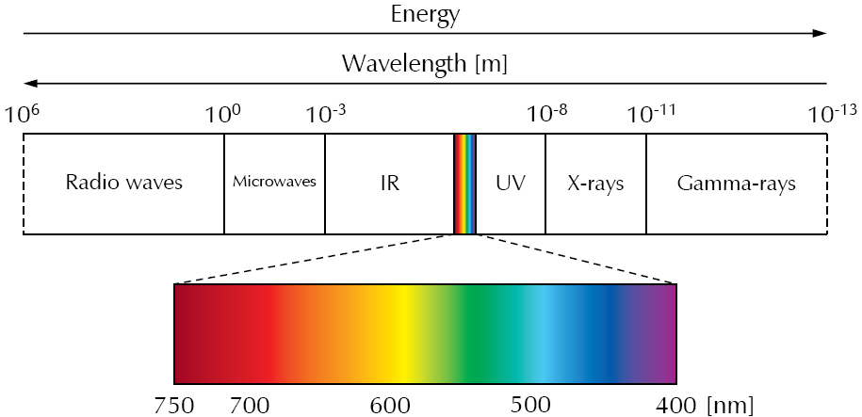

FIG. 9. Electromagnetic Spectrum (Rene, 2018)

Hettiarachchi, et al., (2017) go further by suggesting that X rays are produced when electrons are fired onto a metal target with enough energy to knock an inner electron out of its orbital. This results in higher state electrons, moving to fill the void of the missing electron. The consequental action, is the emitting of X ray photons.
When an x ray is taken of an object, it is exposed to photons as rays. The volume of penetration of a component is dependent on the thickness and the type of materials that it is made of. Wilcox & Downs, (2003) explain that the penetrating power of the x rays depends on the voltage applied and recommend that a material such as steel, requires 1000 volts. The rays are absorbed by the materials that are present; the greater the thickness or density of a component, the greater the absorption. The source of the radiation is positioned the other side of the test component and the X ray or Gamma radiograph is position directly behind so that the radiation passes through and onto the film. Any defect such as porosity, will results in a difference in absorption levels across the test specimen and would easily display itself on the X ray image.

Benefits and Limitations
With the development of modern digital detectors, radiographic images can be viewed in real time which can lead to quick decisions over defects and potential anomalies. In the instance of checking underwater pipes, current NDT methods such as eddy currents or ultrasonic testing are not suited due to the requirement of being near the surface of the pipes and the removal of concrete or insulation materials. As a result, radiography has a distinct advantage of being able to pass through water and does not require surface preparation (Haith, et al., 2017).
Even though radiography can work extremely well for pipe inspection underground, Turkmen, (2019) argues that radiography needs experienced operaters to use the equipment and it does not give information of the exact material depth of the defect within the pipework. As well as this, x rays have a sensitivity of 2% of the thickness of the material, therefore, the smallest defect that can usually be detect is no less that 0.5mm. To overcome this, the product would need to be tested from a variety of angles (Dwivedi, et al., 2018). Even though indentifying the depth of the defect is troublesome, Lopez, et al., (2018) explain that theres is a huge array of information that can be gathered from one radiography scan which can be extremely useful to the inspector. These include corrosion tests, weld inspections, crack growth and wall thickness.
One of the major limitations of operating a radiographic inspection is the risk of radiation posioning. Industrial radiographic sources which emanate gamma or X rays, can emit very harmful doses in the range of hundreds of milligrays at 2 metres or less, which can cause radiation sickness and burns in a short time after use (Wise, 2014). As a result, an organisation must implement a thorough risk assessment compiled with a permit to work system, whereby the control measures are discussed along with the checks that need to be made. Wise, (2014) insists that when testing with a portable radiographic machine, adequate lead shielding must be established, along with notices notifying other employees that radiographic testing is in progress. It is due to the vast safety measures, along with the cost of the traditional X ray film, that radiography is very expensive to operate, however, Quirk, (1999) points out that digital radiographic in carrying out NDT is not only less expensive, but it produces 80% less radiation than traditional methods. Larsen, (2008) and Bhandari, 92006) both agree by arguing that digital radiography not only permits shorter exposure times, but also reduces the safety zone around the source of radiation.

Applications
Even though x rays are typically used in the medical industry, there are many different applications that are exploited by companies for quality control. In Good & Steniers view, (2017) a compelling application known as Computed Topography (CT), is used to create an entire 3D visualisation of a component by rotating the part 360° around an x ray source. Images are subsequently taken and stored for analyses. The techniques enables the user to understand all wall thicknesses, quantify the percentage of porosity and compare part dimensions against its CAD files. It is extremely usefull in the identification of moulded plastic components which can be prone to porosity after cooling. Huthwaite & Jones, (2018) note that complex parts and shapes are continually changing through advancements in modern engineering, therefore, CT is a powerfull tool to help create accurate 3D images to indentify flaws and dimenisonal inaccuracies.
Industrial radiography can be applied and utilised by a variety of industries. In the aerospace industry, Plessis & Rossouw, (2015) acknowledges the advantages that micro computed tomography has in inspecting titanium castings and how it enables an effective defect detection system. Figure 10 displays an image of a micro CT image of a typical aircraft casting.
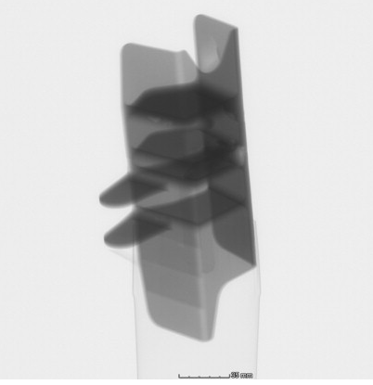

FIG. 10. A Micro CT scan of an aircraft casting (Plessis & Rossouw, 2015)
In the automotive sector, x rays can be adequate in detecting the life expectancy or efficiency of brake pads. A technique using an X ray fluorescence spectrometer, can identify the various elements remaining after 50% use compared to a new full life brake pad. This can allow research on different materials as well as allowing a customer to know when to change the pads.

Sources of Errors and Assumptions
When an x ray image has been taken, it cannot be translated into an equation or solved by software, therefore, Jones, (1997) notes the demand for a highly skilled personal to interpret the film which can reduce errors. Misinterpretation is common and due to lack of experience that can lead to defect being missed or a good part being rejected. An assumption that is often made is that a casting or component is anatomically sound when first installed, however this is not always the case. Most materials contain very slight porosity, density patterns and casting defects that do not disrupt the performance of a product but will display themselves on an x ray film as a potential defect (Bosserman, 2007). This again, can lead to improper rejection of the part.

The Improvement of Stress Analysis
In the gas industry, the leak or rupture of pipe work has the potential to cause huge environmental, business and human costs. According to Makhlouf & Aliofkhazraei, (2015) over 60% of all pipework in the US was installed prior to the 1970s, therefore, defects such as corrosion, cracking and fatigue are a serious possiblitly. Garrity, et al.,(2010) note that stress can increase in time where cracks have propogated or in areas whereby corrosion has decreased the thickness of the walls, especially if there is fluid or gas at high pressure and temperature. Garrity, et al., (2010) also report that a technique known as X-ray diffraction can be used as a tool to improve stress analysis, especially by analysing pipe thickness in insulated areas. The forumla below, known as the barlow formula (Stewart, 2015), can be used to determine if the corrosion has reduced the wall thickness to a value that is beyound the pipework materials yield stress –
$$σ_{h = \frac{Pd}{2t}}$$
$σ_{h = }$ Cylinder hoop stress Pa
$p=$Internal pressure Pa
$d=$Cylinder inside diameter M
$t=$Wall thickness M

If it is determined that the hoop stress (the inside pressure acting on the pipe walls) is greater that the materials yield stress then immediate actions can be taken to rectify the problem.

Infrared Thermography

Otherwise known as infrared inspection (IR), thermography is a non-destructive testing method that measures temperature differences in a component. The amount of thermal radiation that is emitted from a specimen directly correlates to temperature variance, therefore, this change can be detected and analysed using a thermal imaging camera (Lin, et al., 2014). The purpose of conducting thermal imaging of an object is to detect any weaknesses or failures, and these are usually discovered in areas of high thermal radiation or hot spots. In Redding & Roys (2014) view, IR can be a powerfull tool in detecting delaminations, inclusions and voids that affect heat transfer. However, the detection of these defects can only be obtained if there are significant temperature differences.
In IR, a range of sources can be used to create an energy source In which to produce a contrast in temperature. Optical techniques such as pulsed or lock in thermography can be used to excite external features, whereas techniques such as vibrothermography can used to excite internal parts of a component. Any defect present would stop the propogation of the thermal radiation which would allow it to be easily seen by a thermal imaging camera (Hau, 2007).

Scientific Principles
All objects that create a temperature above absolute zero emit infrared radiation and this is found just before the visible section on the electromagnetic spectrum with a frequency between 300-450hz. It is composed of wavelengths between 700nm and 1mm. Due to infrared radiation coinciding bands in the electromagnetic spectrum amidst 0.74 and 1000µm, it is possible to use a radiometer to measure the variations in thermal energy (Hau, 2007). Figure 11 shows the different bands with infrared radiation, ranging from near infrared waves, to very long infrared waves.
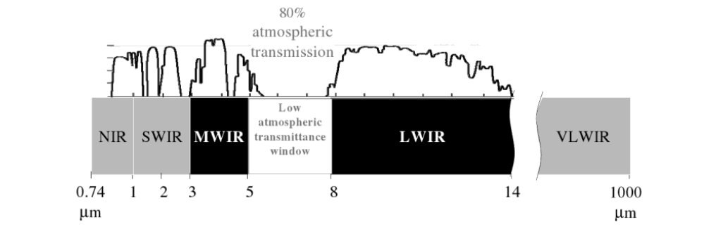
FIG. 11. Different bands of infrared radiation in the electromagnetic spectrum (Hau, 2007)

An infrared camera defects heat in the form of infrared rays and displays this heat, in a variety of colours depending on the temperature. According to Yalvac, et al., (2011) heat is described as the total internal state or molecular motion of an object, as well as the transfer of thermal energy between two objects or into the surroundings. The size of the object is a factor. Temperature on the other hand, can be directly measured and the size of the object is not a factor.

Benefits and Limitations
From an organisations point of view, thermography offers a real time, cost effective way of inspecting, without having to transport or position a product to get the correct viewing angle. Along with this, it has the unique advantage of being capable of viewing the temperature of a component over a much larger area, which can decrease inspection time (Ring, 2015). In despite of these benefits, Manuel, et al., (2016) explains that temperature measure errors often occur when background radiation is high which results in radiation interference. It is also difficult for the camera to distinguish boundaries and different shapes of the objects. Manuel, et al., (2016) go on to suggest that some objects with high reflectivity can sometimes give unreliable measurements.

Applications
Lock in thermography is a technique whereby a subject is illuminated by a heat source such as a halogen lamp to inject thermal waves into a component to discover an internal defect. According to Vladmir, et al., (2019) an object is supplied energy, causing a thermal wave to excite particles in order to detect anomolies in a component. A common application for this technique is to try and determine irregularites in electronic devices such as resistors. Busse, (2015) explains however, that the Lock in technique is also deployed universaly in aircraft NDT to determine if bolts, screws or rivets are tightened to their required torque. Figures 12 and 13 show halogen lamps heating an aircraft tailcone for defets examining and examining bolts and rivets for torque levels.
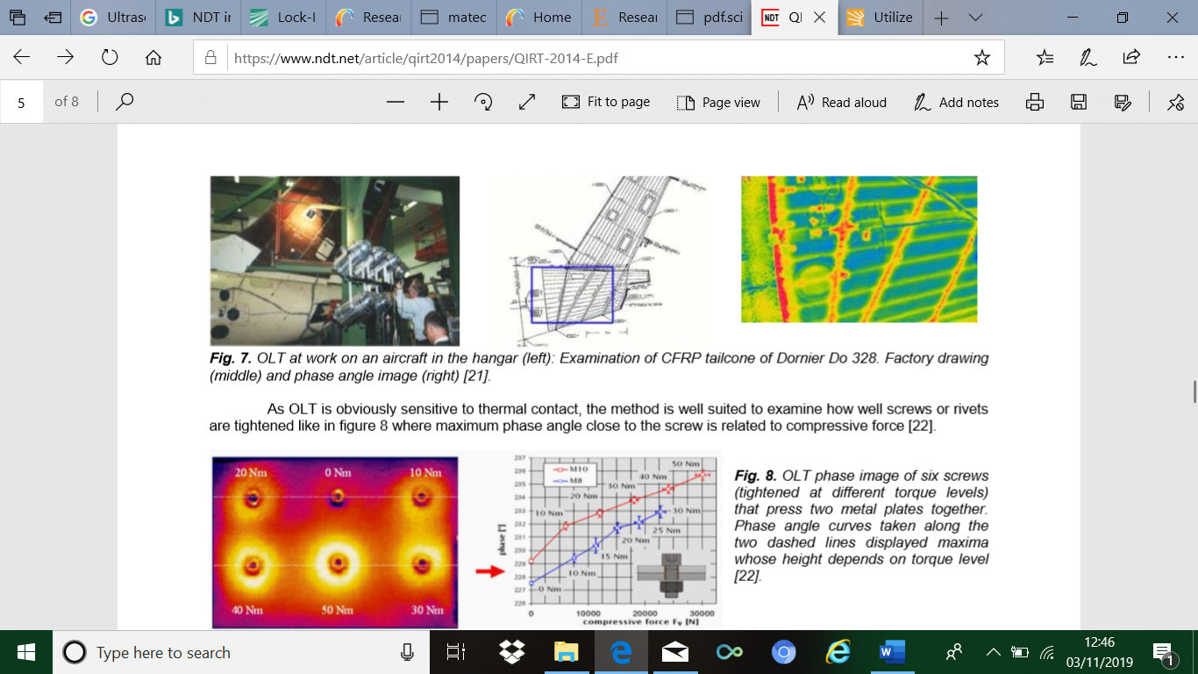

FIG. 12. Using Lock in technique to determine rivet tightness (Busse, 2015)

FIG. 13. Using Lock in to analyse aircraft Tail cone and Rudder (Busse, 2015).

The use of infrared cameras is forever growing, with new applications now beginning in agriculture, marine surveying and in the medical industry. In terms of predictive maintenance, organisations are using the technology in electrical inspection such as motor temperatures, connections, breakers and transformers, whilst in mechanical inspections, it is being used in control of bearings, hydraulic and air conditioning systems (Meola, 2012). This technology is proving a success with detecting or predicting failures before they occur. Figure 14 demonstrates this with an image highlighting one cable showing signs of overheating compared to the others.
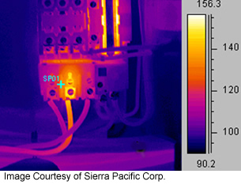

FIG. 14. Overheating cable (Frank, 2010).

One important application exploited by a thermal camera is the detection of leaks of liquid or gases. Zhou & Zeng, (2007) suggest that accidents can occur from the leak of high-pressure propane in which infrared cameras can lead to detection, improved safety installations and better future designs. This can be seen from pipes or tanks as shown in figure 15.
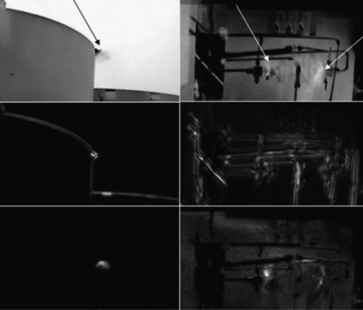

FIG. 15. Infrared camera to detect leaks in tanks and pipes (Zhou & Zeng, 2007).

Sources of Errors and Assumptions
When investigating using a thermal imaging camera, there are variety of factors that can reduce accuracy and give unreliable results. According to Ball & Pinkerton, (2006) emissivity is a ratio of how well an object emits radiation and a vital factor that’s contributes to its detection is the viewing angle. Figure 16 demonstrates the reduction of the emissivity of an object with the change in the viewing angle. Cesaratto & Marinetti, (2012) acknowledge that the viewing angle produces innaccurate results, however one of the main sources of error is surface roughness. Research shows that rougher surfaces significantly increases the emissivity of a component due to air velocity and heat flow rate.

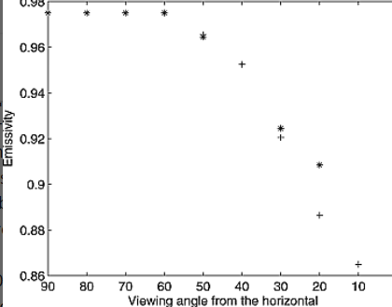

FIG. 16. Graph comparing emissivity with viewing angle (Ball & Pinkerton, 2006).

Thermal imaging cameras usually detect radiation between 8-15 nanonmeters therefore, it must be assumed that radiation emitted from a component will give a large temperature difference to produce visible results and that the camera is able to detect this. Other sources of error that may produce unreliable results are the component geometry, material and wavelength of camera used (Cesaratto & Marinetti, 2012).

The Improvement of Stress Analysis
A thermal imaging camera can be very effective in improving the stress analysis of the thermoelastic effect of a component undergoing contraction. This is the temperature change of an object due to internal friction, observed when a material is experiencing stress (Goken & Riehemann, 2002). In a recent study (Choi, et al., 2006) to detect temperature changes of a specimen under a tensile load, a product was contracted under a press and a thermal imaging camera was placed to detect any temperature fluctuation. The tensile load was increased steadily from 140Mpa to 240Mpa so that transitions in temperature could be witnessed. Choi, et al., (2006) state that the study can help to improve defect detection and fatigue analysis as the area of weakness as displayed in figure 17, shows a higher temperature change as the load increased.

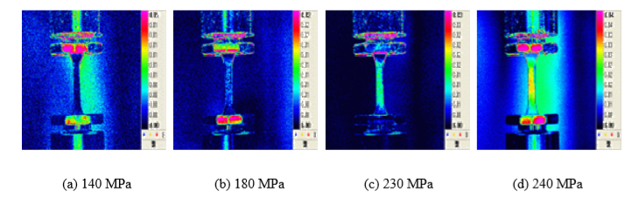
FIG. 17. Stress analysis of a component with a thermal imaging camera (Choi, et al., 2006)

When a temperature change occurs, most materials react by expanding under heat and contracting when cooled, therefore, as known by the linear of thermal expansion, its length may change. Measuring the distribution of temperature using an infrared camera, when a system is undergoing a thermal cycle, can highlight areas of high stress. This can be applied in the measurement of thermal stress in a pipe system in the equation (Baldi, et al., 2018) -

$σ_{dt = }E α dt$

$σ_{dt = }$Stress due to temperature change Pa
$α$ = Temperature Expansion Coefficient K
$E$ = Youngs Modulus Pa
$dt=$ Temperature difference Ks

Conclusion

The report’s findings have indicated that organisations are employing and promoting a wide range of NDT techniques in their business to improve quality and customer satisfaction. The use of visual inspection, as demonstrated in the report, is the oldest method of locating abnormalities in products, yet it is evolving and integrating with new technologies to explore internally as well as externally. In the past, x-rays have only been used in the medical profession and safety has usually been a barrier in exploring other potential uses. The report shows however, that advances in digital radiography has reduced radiation emission by up to 80% which reduces the exposure to harmful radiation. This has not only provided confidence in employee safety to organisations, but it also allows thorough internal inspection of products that are already in use, that may otherwise not have been inspected. The report also examines the NDT method of infrared thermography and explores techniques such as lock in thermography, which help to locate defects by injecting thermal waves into an object and detecting defects with a camera.
In the last decade, a variety of techniques have been explored to help locate potential stress concentrations in components, with many studies focusing on reducing fatigue and changing designs. This includes visually inspecting components for areas of potential stress such as corners and to recommend different shape fillets. The report also finds that drilled hole locations can significantly add stress to areas that may otherwise have been overlooked.
Within the current economic climate, companies are continually determined to reduce cost yet increase quality and production, therefore the use of NDTs may increase along with research into more elaborate ways of inspection. Even though this report outlines three major NDT techniques, there are numerous other methods that could easily incorporate all three and could be a recommendation for future research.

References

Anand, S., 2018. Welding and NDT. [Online]
Available at: https://www.weldingandndt.com/visual-inspection-of-weld-joints/
[Accessed 11 October 2019].
Arooj, M. & Yadav, G., 2017. Comparison of Destructive and Non-Destructive Testing of Concrete. International Journal of Engineering Research and Technology, 6(11), pp. 62-67.
Balayssac, J.-P. & Garnier, V., 2017. Non Destructive Testing and Evaluation of Civil Engineering Structures. London: Elsevier.
Baldi, A. et al., 2018. Residual Stress, Thermomechanics and Infrared Imaging, Hybrid Techniques and Inverse Problems. 7 ed. London: Springer.
Ball, M. & Pinkerton, H., 2006. Factors affecting the accuracy of thermal imaging cameras in volcanology. Journal of Geophysical Research, Volume 1, pp. 1-35.
Bhandari, A., 2006. The Digital Revolution in NDT is here. Pipeline and Gas Journal, 233(2), pp. 52-55.
Bosserman, D. W., 2007. The Future of NDT Testing: Radiography Meets Robotics. Quality Journal , 46(9), pp. 34-38.
Busse, G., 2015. Lockin-Thermography: Principles, NDE-Applications and Trends. 12th International Conference on Quantitative Infrared Thermography, Volume 1, pp. 1-13.
Busse, G., HemelriJck, D. V., Solodov, I. & Anastasopoulos, A., 2008. Emerging Technologies in NDT. London: CRC Press.
Cavalli, A. & Togni, M., 2013. How to improve the on site MOE assessment of old timber beams combining NDT and Visual strength grading. Non Destructive Testing and Evaluation, 28(3), pp. 252-262.
Cesaratto, P. G. & Marinetti, S., 2012. Emissivity estimation for accurate quantitative thermography. NDT and E International , Volume 51, pp. 127-134.
Choi, M.-y., Park, J.-H., Kang, K. s. & Kim, W.-T., 2006. Application of Thermography to Analysis of Thermal Stress in the NDT for Compact Tensile Specimen, Auckland: Kongju National University.
Cumblidge, S. E. & Anderson, M. T., 2004. An Assessment of Visual Testing, Richland: s.n.
Davies, A., 1998. Handbook of Condition Monitoring: Techniques and Methodology. London: Springer Science and Buisness Media.
Doyle, N., 2019. Final Visual Inspection Station on Crankshaft Line. [Art] (Ford Motor Company).
Drury, C. G., 2002. Good Practices in Visual Inspection, s.l.: s.n.
Dwivedi, S., Vishwakarma, M. & Soni, P. A., 2018. Advances and Researches on Non Destructive Testing. Materials Today, Volume 5, pp. 3690-3698.
Forcinio, H., 2014. Trends and Best Practices in Visual Inspection. Pharmaceutical Technology , 38(3), pp. 42-47.
Forsyth, D. S., Matzkanin, G. A. & Yolken, T., 2006. A Brief Introduction to Non Destructive Testing. AMMTIAC Journal, Volume 1, pp. 7-10.
Frank, S. E., 2010. NDT. [Online]
Available at: https://www.nde-ed.org/EducationResources/CommunityCollege/Other%20Methods/IRT/IR_Applications.php
[Accessed 3 November 2019].
Gao, R. X. & Wang, L., 2006. Condition Monitoring and Control for Intelligent Manufacturing. London: Springer Science and Business Media.
Garrity, D. J. et al., 2010. Development of a prototype pipework scanning system based upon energy dispersive X ray diffraction. Nuclear Instruments and Methods in Physics , 619(1-3), pp. 287-290.
GE, 2012. Inspection Technologies, Boston: GE.
Gholizadeh, S., 2016. A review of non-destructive testing methods of composite materials. Science Direct Journal, Volume 1, pp. 50-57.
Goken, J. & Riehemann, W., 2002. Thermoelastic damping of the low density metals AZ91 and DISPAL. Materials Science and Engineering, 324(2), pp. 134-140.
Good, A. & Stenier, D., 2017. X-Rays for NDT of Composites. Composites World, 3(2), pp. 12-16.
Greissel, M., 2003. NDT Shows Strong Growth. Quality, 42(10), pp. 4-5.
Gupta, S., 2018. Comparison of Non-Destructive and Destructive Testing on Concrete: A Review. Trends in Civil Engineering and its Architecture, Volume 3, pp. 351-357.
Haith, M. I., Huthwaite, P. & Lowe, M. J. S., 2017. Defect characterisation from limited view pipeline radiography. NDT&E International Journal , Volume 86, pp. 186-198.
Harvey, C. J., 2008. Principles of Radiology. Surgery (Oxford), 26(6), pp. 235-238.
Hau, C. C., 2007. Ultrasonic and Advanced Methods for Non-destructive Testing and Material Characterization. London: World Scientific .
Henderson, J., 2019. NDT Service Markets to Cross USD4.5B By 2025. Quality, 58(8), pp. 5-7.
hettiarachchi, P., Rahman, M., Cooray, V. & Dwyer, J., 2017. X rays from negative laboratory sparks in air. Journal of Atmospheric and Solar-Terrestrial Physics, Volume 154, pp. 190-194.
Hristoforou, E., 2018. Advanced Non - Destructive Testing in Steels. Metals, 8(7), p. 492.
Hull, J. & John, V., 2015. Non-Destructive Testing. 2nd ed. New York: Macmillan International Higher Education.
Huthwaite, P. & Jones, G. A., 2018. Limited View X ray tomography for dimensional elements. NDT and E International , Volume 93, pp. 98-109.
Jeffus, L. & Bower, L., 2009. Welding Skills, Processes and Practices for Entry-Level Welders. Boston: Cengage Learning .
Jones, F. J., 1997. Manuals Combined: Non Destructive Testing and Inspection. s.l.:Departments of the army, navy and airforce.
Kasai, N. et al., 2011. Propane gas leak detection by infrared absorption using carbon infrared emitter and infrared camera. NDT and E International, Volume 44, pp. 57-60.
Kececioglu, D., 2003. Robust Engineering Design by Reliability with Emphasis on Mechanical Components and Structural Reliability. Lancaster : Destech Publications.
Khoshravan, M. R., Samaei, M. & Paykani, A., 2011. Numerical investigation on the position of holes for reducing stress concentration in composite plates with bolted and riveted joints. Theoretical and Applied Mechanicals letters, 4(1), p. 041005.
Krishnan, S. & Ajai, M., 2012. Robust Gnome Percolation Model Segmentation for Automatic Visual Quality Inspection and NDT. International Journal of Advanced Research in Computer Science , 3(2), pp. 141-145.
Larsen, K. R., 2008. Advances in radiology techniques assist in pipeline integrity assessments. Material Performance , 47(6), pp. 22-23.
Lin, H., Peng, L., Li, C. & Jian, Z., 2014. Electromagnetic Exitation for Infrared Thermography. Applied Mechanics and Materials , Volume 530, pp. 273-276.
Lopez, A. et al., 2018. Non-Destructive testing application of radiography and ultrasound for wire and arc additive manufacturing. Additive Manufacturing , 21(3), pp. 298-306.
Makhlouf, A. & Aliofkhazraei, M., 2015. Handbook of Materials Failure Analysis with Case Studies from the Oil and Gas Industry. 2nd ed. Oxford: Butterworth-Heinemann.
Manuel, M. C. E., Shu-Ping, L., Wei-Hao, L. & Lin, P. T., 2016. Errors in Thermographic Camera Measurement Caused by Known Heat Sources and Depth Based Correction. International Journal of Automation and Smart Technology , 6(1), pp. 5-12.
Marquez, F. P. G., 2016. Non Destructive Testing. InTechOpen Journal, Volume 2, p. 51.
Matzkanin, G. A., 2007. Selecting a Non Destructive Testing Method. AMMTIAC Journal, Volume 1, pp. 7-10.
Melchore, J. A., 2011. Sound Practices for Consistent Human Visual Inspection. AAPS PharmSciTech , 12(1), pp. 215-221.
Meola, C., 2012. Infrared Thermography Recent Advances and Future Trends. Sharjah: Bentham .
Mix, P. E., 2005. Introduction to Non-Destructive Testing. 2nd ed. Oxford: John Wiley and Sons.
Mudali, K. U. & Raj, B., 2008. Corrosion Science and Technology. Oxford: Alpha Science International .
nana, J. et al., 2019. A 3D reconstruction method based on grid laser and gray scale photo for visual inspection of welds. Optics and Laser Technology, Volume 119.
Newman, T. S. & Jain, A. K., 1995. A Survey of Automated Visual Inspection. Journal of Computer Vision and Image Understanding, 61(2), pp. 231-262.
Omar, M., 2012. Nondestructive Testing Methods and New Applications. 2nd ed. Janeza: Intech.
Papa, U. & Ponte, S., 2018. Preliminary Design of an Unmanned Aircraft System for Aircraft General Visual Inspection. Electronics, 7(12), p. 435.
Pastuszak, P. D., Muc, A. & Barski, M., 2013. Methods of Infrared Non-Destructive Techniques: Review and Experimental Studies. Key Engineering Materials, Volume 542, pp. 131-141.
Plessis, A. D. & Rossouw, P., 2015. X ray Computed tomography of a titanium aerospace investment casting. Case Sudies in Non Destructive Testing and Evaluation , Volume 3, pp. 21-26.
Prabuwono, A. S. & Away, Y., 2004. Visual Inspection Application in Industry by Integrated Computing System. Semantics Scholar , Volume 2, pp. 707-711.
Prasad, V. J., 2009. Non-Destructive Test and Evaluation Of Materials. New York City: Tata McGraw - Hill Education .
Quan, W., Song, G. & Wang, Z.-Q., 2013. An objective inspection method of visual acuity based on wave front aberrations of human eye. Optik, 124(12), pp. 1320-1323.
Quirk, J., 1999. Achieving greater efficiency in NDT inspections. Sensor review , 19(4), pp. 268-290.
Raj, B., T, J. & M, T., 2012. Practical Non-Destructive Testing. Sawston: Woodhead Publishing .
Raj, V. B., 2002. Practical Non-Destructive Testing. Cambridge: Woodhead Publishing.
Raman, S. & Raj, B., 2019. Non-Destructive Evaluation of Corrosion and Corrosion-assisted Cracking. London: Technology and Engineering.
Redding, L. & Roy, R., 2014. Through life engineering services: Motivation, Theory and Practice. New York: Technology and Engineering.
Rene, C., 2018. What are the Catergories of the Electromagnetic Spectrum. [Online]
Available at: https://www.quora.com/What-are-the-categories-of-the-Electromagnetic-Spectrum
[Accessed 28 10 2019].
Ring, F., 2015. Infrared Imaging: A Casebook in Clinical Medicine. Bristol : Institute of Physics Publishing .
Rohman, M., 2018. Health Imagining. [Online]
Available at: https://www.healthimaging.com/topics/artificial-intelligence/google-ai-algorithm-may-improve-chest-x-ray-interpretation
[Accessed 27 10 2019].
See, J. E., 2015. Visual Inpsection Reliability for Precision Manufactured Parts. Visual Inspection, 4 09, pp. 1-25.
See, J. E., 2015. Visual Inspection Reliability for Precision Manufactured Parts. Human Factors: The Journal of the Human Factors and Ergonomics Society , 57(8), pp. 1427-1442.
Stewart, M., 2015. Surface Production Operations. Houston: Gulf Professional .
Sukhorukov, V. & Sukhorukov, D., 2012. Non Destructive Testing of Bridge Stay Cables. Structure Materials Technology, Volume 1, pp. 347-352.
Taylor, D., Kelly, A., Toso, M. & Susmel, L., 2010. The Variable-Radius notch: Two new methods for reducing stress concentration. Engineering Failure Analysis, 18(3), pp. 1009-1017.
Thomas, V. A. M. K. & Banerjee, A. K., 2013. The History of Radiology. 1st ed. Oxford: OUP.
Turkmen, M., 2019. X Ray Radiography of Micro-alloyed Steel Joined by Submerged Arc Welding. Sakarya University Journal of Science , 23(5), pp. 896-901.
unnporsson, R., Jonsson, M. T. & Runarsson, T. P., 2004. NDT Methods for Evaluating Carbon Fiber Composites. Proceedings of the Composites Testing and Model Identification, Volume 1, pp. 21-23.
Vancleave, J., 2007. Janice Vancleaves super science challenges. Hoboken: John Wiley and Sons.
Vladmir, D. et al., 2019. Detection of composite damage by IR NDT using ultrasonic and optic excitation. MATEC Web of Conferences, Volume 254, p. 05004.
Wiggenhauser, H. & Kopp, C., 2018. Controlled Creating of Cracks in Concrete for Non Destructive Testing. Journal of Non Destructive Evaluation, Volume 1, pp. 15-36.
Wilcox, M. & Downs, G., 2003. A Brief Description of NDT Techniques, Kings Thorn: Insight NDT Equipment.
Wise, V., 2014. Introduction to Oil and Gas Operational Safety. London: Routledge.
Yalvac, G. H., Ozturk, N. & Kartal, T., 2011. Misconceptions of science teacher candidates about heat and temperature. Procedia - Social and Behavioral Sciences, Volume 15, pp. 2758-2763.
Yang, C. C., Marefat, M. M. & Ciarallo, F. W., 1998. Error Analysis and Planning Accuracy for Dimensional Measurement in Active Vision Inspection. IEEE Transactions on Robotics and Automation , 14(3), pp. 476-487.
Yongjin, k. & Richard, C., 2009. Automated Vision Inspection in Network-Based Productive Environment. The International Journal of Advanced Manufacturing Technology , 45(1), pp. 81-90.
Zhou, L. & Zeng, Y., 2007. Automatic alignment of infrared video frames for equipment leak detection. Analytica Chimica Acta, 584(1), pp. 223-227.

