Dementia; Approaches of support.

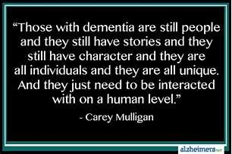

BY
CHARLENE DREWETT

Contents

Page 3 Abstract
Page 3 Introduction
Page 3 Person centred care
Page 5 Support for families and individuals
Page 6 Conclusion
Page 7 References

Abstract
Dementia is a general term for a decline in mental ability severe enough to interfere with daily life, memory, communication and language are the first things to be affected by the diseases (Alzheimer's Association, 2019). This report will evaluate two approaches that support people living with dementia, one will look at personal centred support and the other care homes that offer respite in order to support the families. It will outline why person-centred care is important. The impact on the families and the individual. The fear that an individual can feel being placed in a nursing home and the impact the family feels with the burden of the illness to their loved one.
Introduction
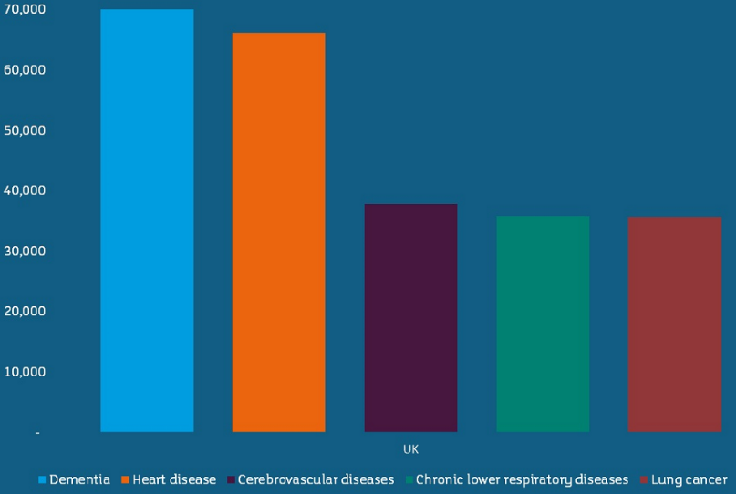
Most cases of dementia are a symptom of a specific disease. Different diseases cause different types of dementia. Alzheimer’s makes up the biggest of these with 60-80% with vascular dementia and Lewy bodies coming up behind (Healthline, 2005). This graph was taken from alzhimers reasearch and it illustrates that dementia is now the biggest cause of death. Beating heart diseases and some types of cancer. 850,000 people live with dementia within the UK today and this is estimated to increase to 1,142,677 by 2025(Alzheimer’s research,2015).
This report is going to look at the impact that this disease has on the individual and the family. Its going to cover why person-centred care is important and how it maintains the individual’s cognitive impairments and reduces use of medication. Lastly, it is going to investigate additional support available to the individual and families today. The evidence taken will be cross examined with sources provided from the internet and from experts in the field. A conclusion will be drawn of the findings of this report.

Person centred care
The person-centred approach was developed in the UK by Professor Thomas Kitwood, a pioneer in the field of dementia care in the 1980s and has since received worldwide recognition and praise. In the ethic of dementia care, dignity emerges as the resonant quality and is a guiding principle (Journal of aging studies, 2003) Jackson (2002) says “Those caring for patients with dementia must therefore be ever vigilant, and ensure that, at all times, the person is at the centre of his/her care”. In his article Jackson emprises, the importance of routine, he mentions that there are homes adapted for a dementia sufferer. Jackson also emphasises om these saying they are built around the staff off the homes rather than the individual, contact is made with them on a routine basis and doesn’t give the individual stability. There has been evidence of the individual becoming withdrawn due to being put in a home. Jackson is very clear when he says that home help in the community is the way forward, in that keeping the individual at home makes them less afraid of their disease.

Corr (2019) agree with Jackson by saying that when someone we know, or love has dementia its very hard to remember the person that they were. She implements that the individual with dementia becomes the focus not the illness. Therefore, person centred care is important. Corr, also states that in a recent study it been proven individuals that have had the focus of person-centred care, have not needed medication or be hospitalised due to aggressive behaviour linked with dementia. Corr believes that person centred care is something that we do as an individual as family members and friends as we know this person suffering better then a outside person. However, if there is outside assistance Corr says it Is important to have up to date care plans, so the carer knows what the individual likes, dislikes and enjoys.
When comparing the above to an internet source, very well health (2018) use Thomas Kitwoods theory’s and say, “On a moment-by-moment basis, person-centred care strives to see the world through the eyes of the particular person with dementia”. It’s a very strong statement and very well health strongly agree that holistic person-centred care is the way forward for a dementia sufferer. They agree that it’s the disease that takes a person its not the persons choice to have the diseases. By providing person centred care it helps the individual understand and be at peace with themselves.
In conclusion to the person-centred approach in holistic views, it is also important to address some of the key concerns listed above. These concerns turn to the fact of nursing homes and hospital staff. The nursing times, (2011) state that more frame work is being met and implemented in order to mange and care for dementia individuals. this framework proposes that in an ‘enriched’ environment of care, all people experience six senses, security, belonging, continuity, purpose, achievement and significance. To develop that bond with them and their families. Person centred care is highly important to help the individual maintain their dignity and respect. The hospital setting can be very terrifying for an individual without the added burden of dementia. The NHS trusts are making every effort possible to ensure person centred care is better highlighted in acute medical wards as well as throughout the systems. This is outlined in the Scottish government strategy (2011)
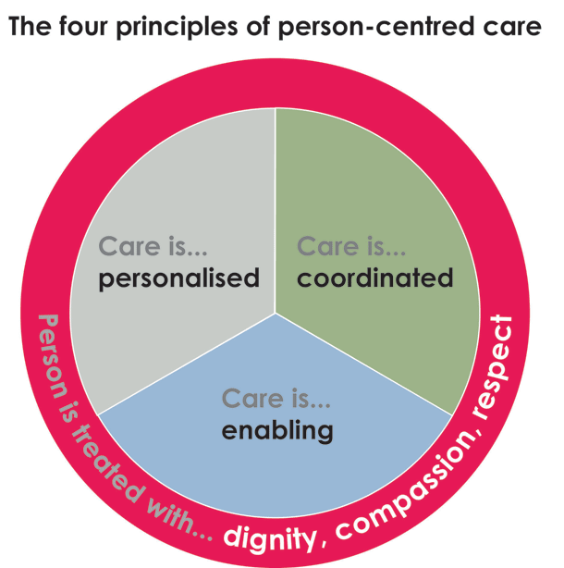
This image taken from pinsdaddy, (2019). Really sums up what has been highlighted in the facts above. Person centred care is what is helping dementia patients live a life without medication and hospital intervention. More care homes and hospitals are now frame working to provide more, better and efficient person-centred care.

The principles of person‑centred care are good practice in dementia care. These include the value of the individual living with dementia (regardless of age or cognitive impairment) and their families and carers. The individuality of people living with dementia, it is believed how their personality and life experiences influence their response to dementia. The person's perspective is deemed very important. The importance of relationships and interactions with others to the person living with dementia, when a person is diagnosed its almost that people feel scared and almost treat them differently, so its vitally important to promote wellbeing. Its also important for family and friends to have their input, as this is the missing link between the individual and dementia (Nice, (2018).

Carrying on from the person-centred approach with dementia, this paper will now look at the flip side of support for the families and the individual. Some of the literature will be repeated in the fact of respite care and person-centred care provided by them or lack of it. As mentioned in the previous section “person centred care “it is better for the individual to have holistic care as it promotes better wellbeing and self-preservation. However, this is not always possible if the individual has no family members or they are on their own. This report is now going to explore some additional help available and support that is offered to the individual and their families.
Support for families and individuals
Regarding help and support, if we think about the individual for this instance. When they find out they have dementia, they must be thinking a whole host of things and questioning why? An interesting read came up on support and independence for the Individual, enabling them to support themselves for as long as possible. Cognitive stimulation therapy is a popular way to help keep an individual’s mind active. Its repetitive and sessions are over several weeks, its proven to help remembrance. Cognitive rehabilitation can enable an individual to retain skills and cope better. Things can be done at home, from devices such as pill boxes or calendar clocks to breaking tasks into simpler steps, even writing notes to where things go and what to do. Taking part in activities improves self esteem and confidence. Its important dementia suffers aren’t isolated (Alzheimer's Society,2019). This is support that is offered and recommended for an individual who has been newly diagnosed with dementia.
When looking at help and support available the national health service (NHS) website mentions an admiral nurse, these nurses are fully qualified and offer help and support to the individual and the family. They work within a community setting. As well as visiting hospitals and nursing homes. These nurses are specialists that try and help manage the individuals needs as well as mental and physical, spiritual needs (NHS, 2018). Dementia, UK (2019) claim that an admiral nurse brings is a lifeline, it helps families to live more positively with dementia in the present, and to face the challenges of tomorrow with more confidence and less fear. They are designed to help keep the individual at home if possible. As mentioned in person centred care these nurses help families deal with care plans and are more experienced with challenges and behaviours that families may find upsetting and hard to manage.
A lot of people with dementia usually the elderly, go undetected mainly due to them living on their own and having no family, its usually a neighbour who pops in now and again. Support is available for them but unfortunately, due to sometimes it being too late for intervention these people are put into care homes. However, if the person has good friends around them support can be offered to the individual if these friends cannot care for the individual. These include sheltered accommodation; this accommodation is warden assisted so they have someone to check on them daily. These shelters also offer additional support such as personal hygiene, cooking and cleaning. As mentioned in person centred care it’s important to maintain the individual’s dignity and respect (AgeUK, 2019).
When looking at supporting the family and the individual its apparent that some families find the diagnosis of dementia a very difficult tie. They may experience grief, anger and resentment. The resentment then leads to them not being able to cope with the physical demands of a loved one trying to cope with their illness. This then leads to them being put into a home. Nursing homes are typically designed for the patient. Social Care Institute for Excellence (2015) suggest that when families visit loved ones in a home that they do not find it easy to know what to say or do, they might need to help. So, making suggestions about things they can do together or where they might want to spend time. Sometimes encouraging them to take their loved one home can ease a burden. Nursing homes are not here to judge they are here to help ease the pressure, offer respite care and look after the individual around the person-centred care plan that has been put together.
In conclusion to this there are companies who offer live in carers, these are available twenty-four hours a day seven days a week, they also offer respite care if needed to give the family a break. They are able to assist with personal hygiene though to medication. They give additional support to the family’s and are highly trained. They can help the family’s deal with the coping of caring for a loved one as well as being on call to assist with matters the family find frightening. These companies are considered a god send to families who have shared their stories with the care provider. The families found it easier having someone not related to the individual to off load to or have as moral support. As well as the carers offering the support mentioned above these carers also encourage the families to take their loved ones out on outings. Things they used to do before the individual was diagnosed with the diseases (Helping hands, 2015).

Conclusion
It is clear from the evidence found throughout this essay that dementia is a very cruel and wide spread disease it doesn’t take any prisoners. Dementia affects an individual differently; no two types of dementia are the same, so every case is different, and every family is different in how they react and respond to the individuals care. It is apparent that person centred care and keeping a loved one in their own home and surroundings has a better outcome of events and helps the individual come to terms with the diseases slowly. Even though evidence does not show the effects of nursing homes accelerating dementia faster, its apparent that in a statement above in person centred care that its been proven that holistic care and memory clinics have help suppress the need for medication and hospitalisation due to behaviour changes. Its apparent that due to the increase in dementia and how widespread it is that new methods and care plans are always developing and changing for the specific needs of the individual.

References
AgeUK, (2019) Getting care and support [online] https://www.ageuk.org.uk/information-advice/health-wellbeing/conditions-illnesses/dementia/getting-care-and-support/. Accessed 01/04/2019.
Alzheimer's Association, (2019) What Is Dementia? [online] https://www.alz.org/alzheimers-dementia/what-is-dementia. Accessed 09/04/2019.
Alzheimer's Society, (2019) Treatments for dementia [online] https://www.alzheimers.org.uk/about-dementia/types-dementia/treatments-dementia#content-start. Accessed 01/04/2019.
Alzheimer’s research, (2015) Statistics about dementia / Prevalence [online] https://www.dementiastatistics.org/statistics-about-dementia/prevalence/. Accessed on 10/04/2019.
Corr, K. (2002) What is a person-centred approach (PCA) to dementia care? Blog Page 1
Dementia, Uk (2019) How an Admiral Nurse can help? [online] https://www.dementiauk.org/get-support/admiral-nursing/. Accessed 01/04/2019.
Healthline, (2005) What Do You Want to Know About Dementia? [online] https://www.healthline.com/health/dementia#forgetfulness. Accessed 09/04/2019.
Helping hands, (2015) Dementia care, where do you need care? [online] https://www.helpinghandshomecare.co.uk/home-care-services/dementia-care/. Accessed 09/04/2019.
Jackson, G. (2002) Person centred care in dementia, 98 (48), pg30.
Journal of aging studies volume 17, issue 4 November 2003, Dignity in dementia; person centred care in community, pages 473-484.
NHS, (2018) Dementia guide [online] https://www.nhs.uk/conditions/dementia/help-and-support/. Accessed 01/04/2019.
Nice, (2018). Dementia: assessment, management and support for people living with dementia and their carers [online] https://www.nice.org.uk/guidance/ng97/chapter/Person-centred-care. Accessed on 01/04/2019.
Nursing times, (2011). Improving person-centred care in dementia.
Social Care Institute for Excellence, (2015) Involving the family and friends of people with dementia [online] https://www.scie.org.uk/dementia/living-with-dementia/keeping-active/involving-family-friends.asp. Accessed 01/04/2019.
Scottish Government (2011) Standards of Care for Dementia in Scotland: Action to Support the Change Programme, Scotland’s National Dementia Strategy. Edinburgh: Scottish Government
Pins daddy (2019) Person centred care image [online] http://www.pinsdaddy.com/what-is-person-centred-care-resource_ha*p*lthojR1dywMBso45Q2ku5n4yzjSjLywV9fiUQiC74orxZ0wMdscIIxf|38UWaPsTWCaOusQ6H5RtgNF9g/G5756sNQ|GX6noSdFjn8O4AuYoX05a03vJt6QFLBpYzpbaaB7prkL8lsZv21EssvRFXTqGwaCtWNgO7rLS|PR*YUprCnST3H1tqB1FGVrPemgKPqtGQXR9qFnNNf3TiVfGgDTiF7TQNnuYUHD9sMiwz9bb5JEiP9F*rmyOs2who/. Accessed on 01/04/2019.
Very well health, (2018). A Practical Way to Improve Quality of Life [online] https://www.verywellhealth.com/what-is-person-centered-care-in-dementia-97737. Accessed on 01/04/2019.

