
DISSERTATION
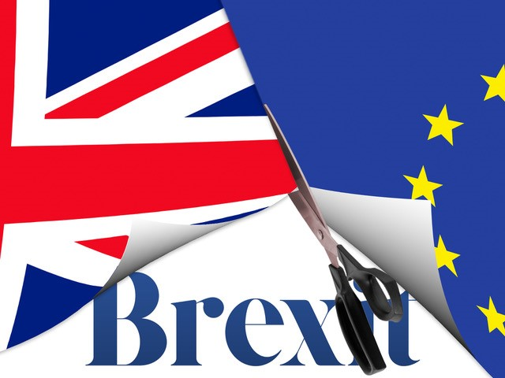

Evaluating the role and extend of Brexit on International Businesses and Operations

Student Name: Elsa Almeida
Student Number: 1906940
Supervisor: Dr Husam Alharahsheh


Master’s Degrees by Examination and Dissertation
Declaration Form.
1. This work has not previously been accepted in substance for any degree and is not being concurrently submitted in candidature for any degree.
Signed…….……Elsa Almeida…………………………………………………………………...
Date …………19-10-2023……………………………………………………………………...

2. This dissertation is being submitted in partial fulfilment of the requirements for the degree of Master’s in Business Administration.
Signed …………Elsa Almeida………………………………………………………………….
Date ……………19-10-2023……………………………………………………..…………...
3. This dissertation is the result of my own independent work/investigation, except where otherwise stated.
Other sources are acknowledged by footnotes giving explicit references.
A bibliography is appended.
Signed candidate: ……Elsa Almeida………………………………………….……………….
Date: ……………19-10-2023……………………………………….……………………….

4. I hereby give consent for my dissertation, if accepted, to be available for photocopying, inter- library loan, and for deposit in the University’s digital repository
Signed (candidate)…………Elsa Almeida…………………………….………….…………...
Date……………………19-10-2023…………………………….…………….……………..
Supervisor’s Declaration.
I am satisfied that this work is the result of the student’s own efforts.
Signed: …………………………………………………………………………..
Date: ……………………………………………………………………………...
Table of Contents

Overview

Chapter one: Introduction

Brexit, known as the withdrawal of the United Kingdom from the European Union, that officially took place on the 31st of January 2020, and that has had a significant impact on international businesses and operations (UK Parliament, 2019).
The idea for this research arose as curiosity about the impact on other businesses and operations, after experiencing some of the effects of Brexit in my workplace.
Aims and objectives of the research.
Therefore, the aim and objective of evaluating the role and extent of Brexit on international businesses and operations, as well as to assess the impact of Brexit on trade between the UK and the EU, will be explored during this research. This will include the value of trade, the volume of trade, and the composition of trade, as well as identify the key challenges that businesses faced and are facing as a result of Brexit (UK Parliament, 2021). These challenges include increased costs, a new complexity, and uncertainty. Also, to explore the opportunities that Brexit may create for businesses. These opportunities include new market access on a global scale and the ability to operate more flexibly. Develop recommendations for businesses that operate in the UK and the EU. These recommendations are to help businesses to mitigate the risks of Brexit and take advantage of the opportunities that it may create or have created ‌(UK Parliament, 2021).
For the evaluation to be comprehensive, as tried by the researcher, it should consider a wide range of factors, including, the impact of Brexit on different sectors of the economy. For example, the impact of Brexit on the manufacturing sector is likely to be different from the impact on the services sector. The impact of Brexit on different types of businesses. For example, the impact of Brexit on small businesses is likely to be different from the impact on large businesses. ‌(UK Parliament, 2021). The impact of Brexit on different countries. For example, the impact of Brexit on the UK is likely to be different from the impact on the EU. The objective is to conduct the evaluation in a rigorous and objective manner. In every business as concluded from the author’s research, through questionnaires and in person conversation with some of the participants, a person was appointed to research findings and evaluate, of what they expected the implications of Brexit would be for the business, draw up a new implementation plan and be communicated to businesses and policymakers so that they can take steps to mitigate the risks of Brexit and take advantage of the opportunities that it may create, or could create ‌(UK Parliament, 2021).
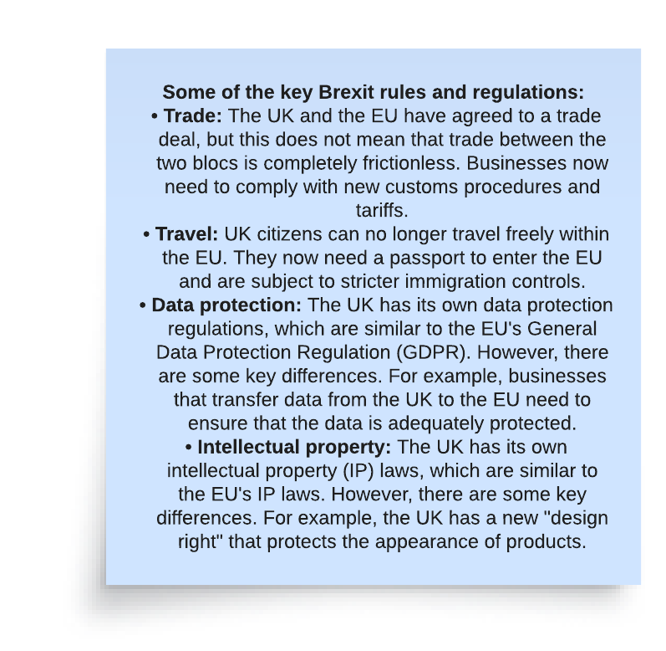
Image created by author, (UK Parliament, 2021)
As per finding, the following are some of the key ways in which Brexit has affected international businesses and operations. Brexit meant increased paperwork and bureaucracy for the businesses. Because as a result, and since Brexit, businesses that trade between the UK and the EU have had to deal with a significant increase in paperwork and bureaucracy (UK Parliament, 2021). This has added complexity and costs of doing business and to move goods and services quickly and efficiently has become more difficult for businesses. New customs arrangements had to be made. The UK and the EU have agreed on a new customs arrangement, but this arrangement is still complex and has led to some disruption to trade. Businesses have had to adapt to new rules and procedures, and some have had to invest in new IT systems to comply with the new requirements (UK Parliament, 2021).
Since Brexit, there have been many changes to the rules on immigration between the UK and the EU. This has made it more difficult to recruit skilled workers that are from the EU for businesses and has led to some businesses having to relocate their operations to other countries in the EU to minimise costs and hire local. The full implications of Brexit are still uncertain and are still ongoing and this has created uncertainty for some businesses. Businesses are not sure what the future trading relationship between the UK and the EU will be, and making long-term plans has become more difficult (UK Parliament, 2021).
Overall, Brexit has had a significant negative impact on international businesses and operations. The increased paperwork, bureaucracy, and uncertainty have made it more difficult for businesses to trade between the UK and the EU and have led to some businesses relocating their operations and headquarters to other countries in the EU. The full impact of Brexit is still unknown, but it is likely to continue to have a negative impact on international businesses for some time to come (UK Parliament, 2021).
In addition to the above mentioned, there will be changes in the currency exchange rates. The value of the pound sterling has fluctuated since Brexit, which has made it more difficult for businesses to predict their costs and revenues. But on the other hand, it has created new market opportunities. Brexit has created new market opportunities for businesses that are able to export to the UK. However, these opportunities are also accompanied by new challenges, such as the need to comply with new regulations. Changed competitive landscape. The competitive landscape in the UK has changed since Brexit, as some businesses have relocated their operations to other countries. Whereas this has created new opportunities for some businesses but has also made it more difficult for others to compete. The impact of Brexit on international businesses will continue to evolve over time. However, it is clear that Brexit has had a significant negative impact on many businesses, and that it is likely to continue to do so for some time to come.
On the other hand, the withdrawal also came with some opportunities. Here are some of the opportunities for international businesses after Brexit, new markets to explore, the UK is now free to negotiate its own trade deals with countries around the world, opening up new opportunities for businesses to export their goods and services. The UK has already signed trade deals with countries such as Canada, Japan, and Australia, and is in negotiations with many others. As a consequence of the withdrawal, there will be less regulation for the UK, as the UK is no longer subjected to EU regulations, which some businesses believe will give them more flexibility and freedom to operate, on a global scale. This could lead to increased innovation and productivity (Institute for Government, 2017).
In some cases, it also means lower costs, as a consequence of the fall in the value of the pound and has made UK goods and services more competitive on the global market. This could attract more investment from overseas businesses and boost exports (Institute for Government, 2017).
This can also mean an opportunity to become more self-sufficient. Brexit could provide an opportunity for the UK to become more self-sufficient in certain industries, such as food and energy. This could reduce the UK's reliance on imports and make it more resilient to future economic shocks. Even though there are some challenges that international businesses will need to navigate in the post-Brexit world. Which include new customs procedures, tariffs, and exchange rate volatility. It also means that the opportunities for growth and expansion are significant, and businesses that are able to adapt to the new environment will be well-positioned to succeed (Institute for Government, 2017). Some specific examples of how international businesses have already benefited from Brexit, for example Scotch whisky exports, the Scotch whisky exports to China have increased by 60% since the UK left the EU. This is due in part to the fall in the value of the pound, which has made Scotch whisky more affordable for Chinese consumers (HM Government, 2022). British car exports to the United States have increased by 20% since the UK left the EU. This is due to the UK's new trade deal with the US, which eliminates tariffs on cars (HM Government, 2022) Furthermore, the financial services. The UK is now the leading destination for foreign investment in financial services. This is because the UK is seen as a stable and well-regulated market (HM Government, 2022). Overall, the opportunities for international businesses after Brexit are significant. However, businesses will need to be prepared for the challenges that come with the new environment. By carefully planning and adapting to the new rules, businesses can seize the opportunities that Brexit presents and take them.

Chapter two: Literature Review
Here are some of the key literatures found and that evaluates the role and extent of Brexit on international businesses and operations:
"The Impact of Brexit on International Business" by the Economist Intelligence Unit. The Economist Intelligence Unit (EIU) published a report in 2020 titled "The Impact of Brexit on International Business". The report found that Brexit had had a significant impact on international business, with businesses facing a number of challenges, including new customs procedures. Businesses now have to comply with new customs procedures when importing and exporting goods between the European Union and the United Kingdom. This has added costs and delays to the supply chain. Tariffs. Businesses now have to pay tariffs on goods imported from the EU. This has increased the cost of goods for businesses and consumers. Exchange rate volatility. The value of the pound has fluctuated since the UK left the EU. This has made it difficult for businesses planning their finances. Uncertainty. The long-term impact of Brexit is still of uncertainty, which has made it difficult for businesses to make investment decisions (The Economist Intelligence Unit, 2020).
The EIU report found that the impact of Brexit had been felt most keenly by businesses that trade heavily with the EU. These businesses had seen a decline in exports to the EU and an increase in costs. The report also found that Brexit had had a negative impact on the UK's economy, with GDP growth slowing and unemployment rising (The Economist Intelligence Unit, 2020). However, the EIU report also found that there were some opportunities for businesses in the post-Brexit world. The UK is now free to negotiate its own trade deals with other countries, which could open up new markets for businesses. The fall in the value of the pound has also made UK goods and services more competitive on the global market (The Economist Intelligence Unit, 2020). Overall, the EIU report found that Brexit had had a mixed impact on international business. While there were some challenges, there were also some opportunities. Businesses that were able to adapt to the new environment were well-positioned to succeed (The Economist Intelligence Unit, 2020).
Here are some additional insights from the EIU report: The impact of Brexit has been greater on businesses that are more integrated with the EU economy. Businesses in the automotive, food and beverage, and chemical industries have been particularly affected by Brexit. Businesses that have been able to diversify their markets and suppliers have been less affected by Brexit. (The Economist Intelligence Unit, 2020).
The UK government has taken some steps to mitigate the impact of Brexit, financial assistance to businesses was provided and negotiating trade deals with other countries. The EIU report concluded that the full impact of Brexit on international business is still uncertain. However, the report found that businesses that were able to adapt to the new environment were well-positioned to succeed in the post-Brexit world (The Economist Intelligence Unit, 2020).
"Brexit: The Impact on International Trade" by the World Trade Organization
The World Trade Organization (WTO) published a report in 2020 titled "Brexit: The Impact on International Trade". The report found that Brexit had had a significant impact on international trade, with businesses facing a number of challenges, including new tariffs, businesses now have to pay tariffs on goods imported from the EU. This has increased the cost of goods for businesses and consumers (The World Trade Organization, 2020) New customs procedures, as businesses now have to comply with new customs procedures when importing and exporting goods between the UK and the EU. This has added costs and delays to the supply chain. Increased uncertainty on the long-term impact of Brexit, which has made it difficult for businesses to make investment decisions (The World Trade Organization, 2020). The WTO report found that the impact of Brexit had been felt most keenly by businesses that trade heavily with the EU. These businesses had seen a decline in exports to the EU and an increase in costs. The report also found that Brexit had had a negative impact on the UK's economy, with GDP growth slowing and unemployment rising. However, the WTO report also found that there were some prospects for companies in the aftermath of Brexit. Now that the UK is free to negotiate its own trade agreements with other nations, firms may be able to access new markets The fall in the value of the pound has also made UK goods and services more competitive on the global market (The World Trade Organization, 2020).
Overall, the WTO report found that Brexit had had a mixed impact on international trade. While there were some challenges, there were also some opportunities. Businesses that were able to adapt to the new environment were well-positioned to succeed. Here are some additional insights from the WTO report:
1.The impact of Brexit has been greater on businesses that are more integrated with the EU economy market (The World Trade Organization, 2020).
2.Businesses in the automotive, food and beverage, and chemical industries have been particularly affected by Brexit market (The World Trade Organization, 2020).
3.Businesses that have been able to diversify their markets and suppliers have been less affected by Brexit market (The World Trade Organization, 2020).
4. The UK government has made some efforts to lessen the effects of Brexit, including negotiating trade agreements with other nations and offering financial support to companies’ market (The World Trade Organization, 2020).
The WTO report concluded that the full impact of Brexit on international trade is still uncertain. However, the report found that businesses that were able to adapt to the new environment were well-positioned to succeed in the post-Brexit world.
In addition to the challenges and opportunities mentioned in the WTO report, there are a number of other factors that businesses need to consider when navigating the post-Brexit world. These include the new trade agreements that the UK has negotiated with other countries. The Brexit impact on the economy as well as the changing global trade environment market (The World Trade Organization, 2020).
Businesses that are able to understand these factors and adapt their strategies accordingly will be well-positioned to succeed in the post-Brexit world.
"Brexit: The Implications for International Business" by the European Commission
The European Commission published a report in 2020 titled "Brexit: The Implications for International Business". The report found that Brexit had a significant impact on international business, with businesses facing a number of challenges, including, all the same findings as the other reports, but additionally mentioned some insights on certain impacts of Brexit.
1.The impact of Brexit has been greater on businesses that are more integrated with the EU economy (The European Commission, 2020).
2.Businesses in the automotive, food and beverage, and chemical industries have been particularly affected by Brexit (The European Commission, 2020).
3.Businesses that have been able to diversify their markets and suppliers have been less affected by Brexit (The European Commission, 2020).
4. In an effort to lessen the effects of Brexit, the UK governance has negotiated trade agreements with other nations and given financial support to companies (The European Commission, 2020).
And if businesses that are able to understand these factors and adapt their strategies accordingly will be well-positioned to succeed in the post-Brexit world (The European Commission, 2020).
"Brexit: The Challenges for International Business" by the Confederation of British Industry Here are some of the challenges for international businesses after Brexit, as identified by the Confederation of British Industry (CBI). Businesses now have to comply with new customs procedures when importing and exporting goods between the UK and the EU. This has added costs and delays to the supply chain. Businesses now have to pay tariffs on goods imported from the EU. This has increased the cost of goods for businesses and consumers. Since the UK exited the EU, the worth of the pound has changed. Businesses now find it challenging to plan their financial operations. Due to the uncertainty around Brexit's long-term effects, businesses have found it challenging to decide which investments to undertake. Businesses operating in Northern Ireland now face additional difficulties as a result of the Northern Ireland Protocol, which was a component of the Brexit agreement. Trade between the Northern Ireland and the rest of the UK has been somewhat disrupted as a result of the protocol (CBI, 2023).
Brexit's effects on the UK economy have been negative, resulting in slower GDP growth and higher unemployment rates. Businesses now find it more challenging to do international commerce as a result. The climate of evolving global trade: Because to the COVID-19 epidemic and the increase of protectionism, the landscape of international commerce is shifting. As a result, conducting business globally has become more difficult (CBI, 2023).
The CBI has also identified some opportunities for international businesses in the post-Brexit world, such as: The UK's new trade deals: The UK has negotiated new trade deals with a number of countries, including Japan, Australia, and New Zealand. These trade deals could open up new markets for businesses. The fall in the value of the pound: The fall in the value of the pound has made UK goods and services more competitive on the global market (CBI, 2023). The UK's skilled workforce. The UK has a skilled workforce that is attractive to businesses from other countries. The UK's strong research and development base: The UK has a strong research and development base that could help businesses to innovate and compete in the global economy (CBI, 2023).
The CBI has concluded that the impact of Brexit on international businesses will vary depending on the sector and the individual business. However, the CBI has warned that businesses need to be prepared for the challenges that Brexit will create and to take steps to mitigate the impact (CBI, 2023).
Some important additional suggestions to have in consideration for international businesses that are navigating the post-Brexit world:
1.Staying updated on the latest developments: The Brexit process is still ongoing and there are likely to be further changes in the future. Businesses need to stay updated on the latest developments so that they can adapt their strategies accordingly (CBI, 2023).
2.Understanding the new rules and regulations: Businesses need to understand the new rules and regulations that apply to trade between the UK and the EU. The UK government has published a number of guides and resources that businesses can use to help them understand the new rules (CBI, 2023).
3.Taking action to lessen the effects of Brexit: Companies may reduce the effects of Brexit by diversifying their markets, examining their supply chains, and being ready for new customs procedures (CBI, 2023).
4.Working with government and other stakeholders: Businesses can work with government and other stakeholders to get support and advice on navigating the post-Brexit world. The UK government has a number of schemes in place to help businesses, such as the Export Support Service and the Trade and Investment Framework (CBI, 2023) Overall, the impact of Brexit on international businesses will vary depending on the sector and the individual business. However, businesses need to be prepared for the challenges that Brexit will create and to take steps to mitigate the impact (CBI, 2023).
"Brexit: The Impact on Global Supply Chains" by the McKinsey Global Institute
Here are some of the key findings from the McKinsey Global Institute (MGI) report on the impact of Brexit on global supply chains:
Businesses that trade between the UK and the EU may face increased prices and delays as a result of Brexit. This is because new taxes and customs procedures have been implemented. Brexit will make it more difficult for businesses to source components and finished goods from the EU (McKinsey, 2019). This is because businesses will now have to comply with new rules and regulations when importing goods from the EU. Brexit will lead to a loss of jobs in the UK manufacturing sector. This is because businesses will be less likely to invest in the UK if they face higher costs and delays (McKinsey, 2019).
Brexit will make it more difficult for businesses to innovate. This is because businesses will be less likely to collaborate with partners in the EU if they face higher costs and delays (McKinsey, 2019) Brexit will make it more difficult for businesses to compete in the global economy. This is because businesses in the UK will be at a disadvantage to businesses in other countries that do not have to comply with the same rules and regulations (McKinsey, 2019) These reports and articles provide a comprehensive overview of the impact of Brexit on international businesses. They discuss the key challenges that businesses face, as well as the opportunities that Brexit may create. Businesses that operate in the UK and the EU should read these reports to understand the implications of Brexit for their operations (McKinsey, 2019).
The MGI report also found that the impact of Brexit will vary depending on the sector and the individual business. Some sectors, such as the automotive and pharmaceutical sectors, are more likely to be affected by Brexit than others. The report also found that businesses that are more integrated with the EU economy are more likely to be affected by Brexit than businesses that are less integrated (McKinsey, 2019) The MGI report concludes that Brexit will have a negative impact on global supply chains. The report recommends that businesses take steps to mitigate the impact of Brexit, such as:
1.Diversifying their supply chains and sourcing components and finished goods from other countries.
2.Reducing their reliance on the EU market.
3.Preparing for new customs procedures and tariffs.
4.Working with government and other stakeholders to get support and advice on navigating the post-Brexit world.
These reports and articles provide a comprehensive overview of the impact of Brexit on international businesses. They discuss the key challenges that businesses face, as well as the opportunities that Brexit may create. Businesses that operate in the UK and the EU should read these reports to understand the implications of Brexit for their operations.
Concepts and Theories
There are a number of concepts and theories that are relevant to evaluating the role and extent of Brexit on international businesses and operations. These include:
Internationalisation theory: This theory seeks to explain why and how firms expand their operations beyond their home country. It argues that firms internationalise in order to exploit market opportunities, achieve economies of scale, and reduce risk.
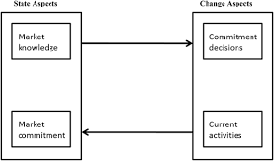
(Francis, 2018)

Internationalisation theory can be used to understand the potential impact of Brexit on the UK's internationalisation. The Uppsala model of internationalisation, which is one of the most popular internationalisation theories, suggests that firms tend to internationalise gradually, starting with exporting and then moving on to other forms of internationalisation, such as setting up subsidiaries or joint ventures. This is because firms need to learn about foreign markets and build up experience before they can commit to more extensive internationalisation (Hombrecher, 2019).
This slow process of internationalisation for UK businesses might be hampered by Brexit. Exporting goods to the EU will become more challenging and expensive for UK businesses as a result of the loss of the single market and the customs union. This can result in some businesses completely leaving the EU market (Hombrecher, 2019).
In addition, Brexit could make it more difficult for UK firms to attract and retain international talent. The UK has long been a popular destination for international students and researchers, but Brexit could make it more difficult for them to come and stay in the UK. This could negatively impact the UK's research and innovation capabilities (Hombrecher, 2019).
The network approach to internationalisation also suggests that Brexit could have a negative impact on the UK's internationalisation. This approach argues that firms internationalise through their networks of relationships with other firms, such as suppliers, customers, and partners. Brexit could disrupt these networks, making it more difficult for UK firms to do business with other European firms (Hombrecher, 2019).
The international new venture (INV) approach to internationalisation argues that some firms are born global, meaning that they internationalise from the outset. These firms are typically small and innovative, and they use technology to overcome the challenges of internationalisation. Brexit could make it more difficult for INVs to internationalise, as they may not have the resources or experience to navigate the new rules and regulations that will apply to trade between the UK and the EU (Hombrecher, 2019).
Overall, internationalisation theory suggests that Brexit could have negatively impact on the UK's internationalisation. However, it is important to note that the full impact of Brexit is still unknown, and it is possible that some firms will be able to adapt and continue to internationalise successfully (Hombrecher, 2019).
Transaction cost theory: This theory argues that firms choose to internalise transactions within their own organisation when the costs of doing so are lower than the costs of relying on external markets. Brexit is likely to increase the transaction costs of doing business with the EU, which could lead some firms to re-shore their operations or switch to other trading partners (Williamson, 2013).
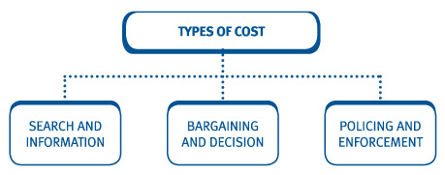
(Kaplan Financial Limited, 2020)
Transaction cost theory (TCT) can be used to understand the potential impact of Brexit on the UK economy. TCT argues that firms choose the governance structure that minimises the total costs of transacting, which include production costs, transaction costs, and uncertainty costs (Williamson, 2013).
The withdrawal of UK from the EU will increase the transaction costs of doing business between the UK and the EU. This is because firms will have to comply with new rules and regulations, and they will have to deal with customs and border controls. These additional costs could lead some firms to withdraw from the EU market altogether (Williamson, 2013). In addition, Brexit could increase the uncertainty costs of doing business in the UK. This is because the future relationship between the UK and the EU is still uncertain, and this uncertainty could make it difficult for firms to make investment decisions (Williamson, 2013). The overall impact of Brexit on the UK economy is still unknown. However, TCT suggests that Brexit could lead to an increase in transaction costs and uncertainty costs, which could have a negative impact on the UK economy (Williamson, 2013).
Here are some specific examples of how Brexit could increase transaction costs:
1.Firms will need to comply with new rules and regulations, such as the EU's General Data Protection Regulation (GDPR).
2.Firms will need to deal with customs and border controls, which could add delays and costs to trade.
3.Firms may need to set up new subsidiaries or joint ventures in the EU in order to comply with the new rules and regulations.
4.Firms may need to invest in new technology in order to manage the increased complexity of cross-border trade.
The impact of Brexit on uncertainty costs is more difficult to predict. Brexit, though, is probably going to make things more unclear for companies in a lot of ways. For instance, it is unknown how the UK and the EU will interact in the future, and this uncertainty may make it challenging for companies to decide which investments to undertake. Additionally, the UK's economic performance is likely to be affected by Brexit, and this could also lead to uncertainty for businesses (Williamson, 2013).
Political risk theory: This theory argues that firms face risks when operating in countries with unstable political environments. Brexit is likely to increase the political risk of doing business in the UK, which could deter some firms from investing there (Sottilotta, 2016).
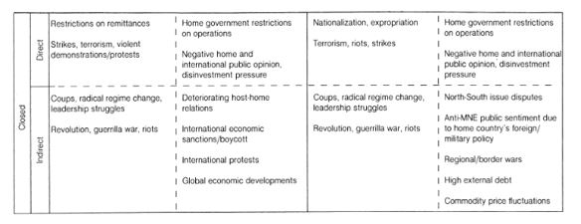
(Hernández, 2018)
Political risk theory can be used to understand the potential impact of Brexit on the UK economy. Political risk theory argues that the profitability of an investment can be negatively affected by political events, such as changes in government, political instability, or war (Sottilotta, 2016).
Brexit could increase political risk in the UK in a number of ways. First, the UK's withdrawal from the EU could lead to political instability in the UK. There has been so far five Prime Ministers since Brexit came into effect. This is because there is a lot of uncertainty about what the future relationship between the UK and the EU will be, and this uncertainty could lead to social unrest and political instability (Sottilotta, 2016).
Second, Brexit could increase the risk of trade wars between the UK and the EU. This is because the UK and the EU will need to negotiate new trade deals, and these negotiations could be difficult and protracted. If the UK and the EU are unable to reach a mutually agreeable trade deal, this could lead to a trade war, which would have a negative impact on the UK economy (Sottilotta, 2016).
Third, Brexit could increase the risk of investment strikes by foreign investors. This is because foreign investors may be concerned about the political uncertainty in the UK, and they may be reluctant to invest in the UK until the future relationship between the UK and the EU is clarified. The overall impact of Brexit on political risk in the UK is still unknown. However, political risk theory suggests that Brexit could increase political risk in the UK, which could have a negative impact on the UK economy.
Here are some specific examples of how Brexit could increase political risk:
1.The UK government may be less stable after Brexit, has it has shown to be, by already being on the 5th prime Minister, up till present day. There is also the risk of a hung parliament or a coalition government.
2.The UK may be more vulnerable to political interference from other countries, as it will no longer be part of the EU.
3.The UK may be more likely to experience social unrest or political violence, as there is a lot of uncertainty about the future of the UK.
The impact of Brexit on political risk is still difficult to predict. However, it is likely that Brexit will increase political risk in the UK, which could have a negative impact on the UK economy.
Institutional theory: This theory argues that firms are influenced by the institutions of the countries in which they operate. Brexit is likely to lead to changes in the institutions of the UK, which could have a significant impact on businesses operating there (Institutional Theory in International Business, 2012).
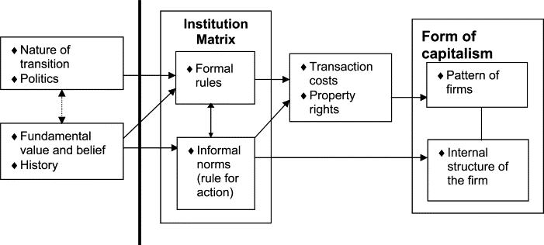
(ScienceDirect, 2015)
Institutional theory can be used to understand the potential impact of Brexit on the UK's institutions. Institutional theory argues that institutions are the rules, norms, and beliefs that shape social behaviour. These institutions might be informal, like social norms and practises, or formal, like laws and regulations (Institutional Theory in International Business, 2012). Brexit could have a significant impact on the UK's institutions in a number of ways. First, the UK will need to renegotiate its relationship with the EU, which will involve changes to the laws and regulations that govern trade and investment between the UK and the EU. These changes could have a significant impact on businesses and other organizations in the UK (Institutional Theory in International Business, 2012).
Second, Brexit could lead to changes in the UK's political institutions. The UK Parliament will need to decide how to make laws and regulations in the absence of the EU, and this could lead to changes in the way that the UK government operates (Institutional Theory in International Business, 2012).
Third, Brexit could lead to changes in the UK's social institutions. The UK's relationship with the EU has been a major part of the UK's identity for many years, and Brexit could lead to changes in the way that people in the UK think about themselves and their place in the world (Institutional Theory in International Business, 2012).
The overall impact of Brexit on the UK's institutions is still unknown. However, institutional theory suggests that Brexit could have a significant impact on the UK's institutions, which could have a lasting impact on the UK's society and economy.
Here are some specific examples of how Brexit could impact the UK's institutions:
1.The UK Parliament may need to pass new laws to regulate trade and investment with the EU.
2.The UK government may need to create new agencies to manage the UK's relationship with the EU.
3.The UK may need to renegotiate its relationship with other countries, such as Canada and the United States.
3.The UK may need to invest in new infrastructure, such as ports and airports, to facilitate trade with the EU.
4.The UK may need to change its education system to prepare young people for the challenges of Brexit.
The impact of Brexit on the UK's institutions is still difficult to predict. However, it is likely that Brexit will have a significant impact on the UK's institutions, which could have a lasting impact on the UK's society and economy.

Resource-based view: This theory argues that firms are heterogeneous and that their performance is determined by their resources and capabilities. Brexit is likely to affect the resources and capabilities of UK businesses, which could have a significant impact on their performance ‌(Barney & Clark, 2007).
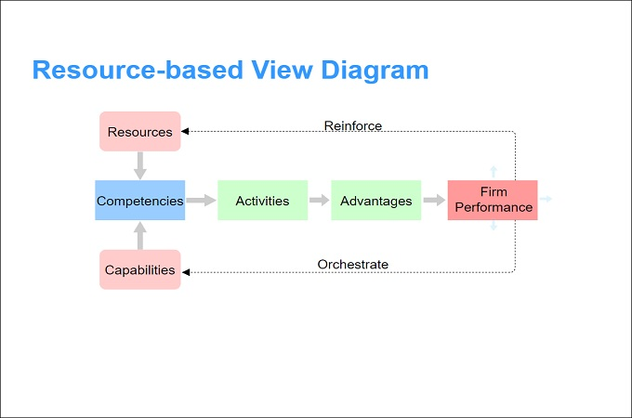
(Opinaldo, 2022)
A theory in strategic management known as the resource-based view (RBV) contends that a company's capacity and resources determine its ability to maintain a competitive edge over time. The inputs a company employs to produce value are called resources; they include money, material, human, and intellectual resources. According to Barney and Clark (2007), a company's capabilities are its capacity to use its resources to produce value. These include its ability to develop, promote its goods, and manage its supply chain.
The RBV makes the case that businesses may maintain a competitive edge if they have rare, valuable, unique, and non-substitutable resources and skills. Resources that enable a business to add value for its clients are considered valuable. Resources that are uncommon are ones that not many other businesses own. Resources that are difficult for rival businesses to get or duplicate are known as inimitable resources. Resources that are non-substitutable are ones that cannot be obtained through other means (Barney & Clark, 2007).
Here are some examples of resources and capabilities that can be sources of sustained competitive advantage:
1.Financial resources: A firm with a lot of financial resources can invest in new technologies, acquire new businesses, and weather difficult economic times (Barney & Clark, 2007).
2.Physical resources: A firm with a lot of physical resources, such as land, factories, and equipment, can produce goods and services on a large scale (Barney & Clark, 2007).
3.Human resources: A firm with a talented workforce can develop new products and services, improve its operations, and provide better customer service (Barney & Clark, 2007).
4.Intellectual resources: A firm with valuable patents, trademarks, and copyrights can protect its products and services from imitation (Barney & Clark, 2007).
5.Brand reputation: A firm with a strong brand reputation can charge premium prices for its products and services (Barney & Clark, 2007).
6.Customer relationships: A firm with strong customer relationships can build customer loyalty and repeat business (Barney & Clark, 2007).
7.Distribution channels: A firm with a well-developed distribution network can reach its customers more easily and efficiently (Barney & Clark, 2007).
8.Technology: A firm with cutting-edge technology can develop new products and services, improve its operations, and reduce its costs (Barney & Clark, 2007).
The RBV is a valuable tool for understanding how firms can achieve sustained competitive advantage. However, it is important to note that the RBV is not the only factor that determines a firm's success. Other factors, such as the firm's strategy, its management, and its environment, can also play a role (Barney & Clark, 2007).
These are just some of the concepts and theories that can be used to evaluate the role and extent of Brexit on international businesses and operations. The specific impact of Brexit will vary depending on the industry, the size of the firm, and the specific circumstances of each firm.
In addition to the theories mentioned above, other factors that could also affect the impact of Brexit on international businesses and operations include:
1.The terms of the UK's withdrawal agreement with the EU.
2.The future relationship between the UK and the EU, including the level of trade and investment between the two entities.
3.The impact of Brexit on the UK economy.
4.The response of businesses to Brexit.
It is still too early to say definitively what the long-term impact of Brexit will be on international businesses and operations. However, the concepts and theories mentioned above can be used to help businesses assess the potential risks and opportunities posed by Brexit and develop strategies to mitigate the negative impacts.
Research Methods and Strategies
There are a variety of research methods and strategies that have been used to evaluate the role and extent of Brexit on international businesses and operations. These include:
1.Quantitative methods: These methods use statistical analysis to collect and analyse data. They can be used to measure the impact of Brexit on variables such as trade, investment, and employment.
2.Qualitative methods: These methods involve collecting and analysing non-numerical data, such as interviews, focus groups, and document analysis. They can be used to understand the experiences and perceptions of businesses and individuals affected by Brexit.
3.Simulation models: These models are used to create a hypothetical scenario and then simulate the impact of different factors, such as Brexit, on that scenario. They can be used to explore the potential impact of Brexit on businesses and operations.
4.Case studies: These studies focus on a particular business or industry to understand how Brexit has affected them. They can be used to provide insights into the specific challenges and opportunities faced by businesses in different sectors.
5.Questionnaires: These questionnaires will be used to collect data from a few numbers of businesses to understand their experiences of Brexit. They can be used to identify trends and patterns in the data.
The choice of research method or strategy will depend on the specific research question being asked and the type of data that is available. For example, if the research question is about the impact of Brexit on trade, then a quantitative method such as statistical analysis would be appropriate. However, if the research question is about the experiences of businesses affected by Brexit, then a qualitative method such as interviews or questionnaires to focus would be more appropriate.
It is crucial to remember that no single study approach or plan is ideal. Every approach has advantages and disadvantages of its own. Consequently, in order to have a more comprehensive understanding of the effects of Brexit on global operations and enterprises, it is sometimes required to employ a variety of techniques.
In addition to the research methods mentioned above, other methods that have been used to evaluate the impact of Brexit by companies, could include:
1.Economic modelling: This involves using economic models to simulate the impact of Brexit on the UK economy.
2.Legal analysis: This involves analysing the legal implications of Brexit for businesses and individuals.
3.Political analysis: This involves analysing the political implications of Brexit for businesses and individuals.
The use of these methods has helped to provide a better understanding of the potential impact of Brexit on international businesses and operations. However, it is important to remember that the impact of Brexit is still evolving and that it is too early to say definitively what the long-term consequences will be. And controversies will occur, regardless of the method or strategy used, since it is still an ongoing process.
Inconsistencies in the findings?
Yes, there are some inconsistencies in the findings of studies that have evaluated the role and extent of Brexit on international businesses and operations. This is because the impact of Brexit is complex and depends on a number of factors, such as the terms of the UK's withdrawal agreement with the EU, the future relationship between the UK and the EU, and the response of businesses to Brexit.
Some studies have found that Brexit has had a negative impact on international businesses and operations. For example, a study by the Centre for Economic Policy Research found that Brexit could lead to a 7% decline in UK GDP by 2030. Another study by the National Institute of Economic and Social Research found that Brexit could lead to the loss of 750,000 jobs in the UK.
However, other studies have found that the impact of Brexit has been more positive or neutral. For example, a study by the Institute for Fiscal Studies found that Brexit could have a small positive impact on UK GDP in the long run. Another study by the Confederation of British Industry found that Brexit could lead to an increase in investment in the UK.
The inconsistencies in the findings of these studies can be attributed to a number of factors, such as the different methods used by the studies, the different time periods that the studies cover, and the different assumptions that the studies make. It is also important to note that the impact of Brexit is still evolving and that it is too early to say definitively what the long-term consequences will be.
Here are some of the reasons for the inconsistencies in the findings of studies on Brexit:
1.The different methods used by the studies: Some studies have used quantitative methods, while others have used qualitative methods. Quantitative methods are more reliable for measuring the impact of Brexit on specific variables, such as trade and investment. However, qualitative methods can provide insights into the experiences and perceptions of businesses and individuals affected by Brexit.
2.The different time periods that the studies cover: Some studies have focused on the short-term impact of Brexit, while others have focused on the long-term impact. The short-term impact of Brexit is likely to be more negative than the long-term impact, as businesses adjust to the new trading environment.
3.The different assumptions that the studies make: Some studies have made optimistic assumptions about the future relationship between the UK and the EU, while others have made pessimistic assumptions. The more optimistic the assumptions, the less negative the impact of Brexit is likely to be.
Overall, there is conflicting information on how Brexit would affect global operations and enterprises. While there is evidence that Brexit has had a negative effect, there is also evidence that it has had a more neutral or beneficial effect. Brexit's long-term effects are yet unknown and will rely on a variety of variables, including the conditions of the UK's departure deal with the EU, the nature of the UK and EU's future relationship, and how companies react to Brexit.
Chapter three: Methodology

Methodology is the overarching approach to research, and as such, it will dictate the methodologies to be utilised and aligned with the established study aim. Instead, then dictating a specific course of action, methodology emphasises the nature of the process employed to achieve the study's objective. One may employ qualitative or quantitative research methods.
Quantity is measured, applied to a specific phenomenon, and then expressed in terms of quantity in quantitative research. Furthermore, quantitative research is often used to investigate conventional wisdom (Alharahsheh, 2020). Articles that have been published written about the subject will be examined for quantitative data..
Qualitative research focuses on meaning and process, areas that may not lend themselves to quantitative analysis. Qualitative research aims to provide particular information about a phenomenon based on individuals experiencing it, with less emphasis on generalisation. Furthermore, qualitative research aims to gain a comprehensive understanding of a certain situation by means of in-depth exploratory investigations that enable the discovery of great answers throughout the research. The comprehensive research strategy known as methodology specifies the approaches that will be used in a project and how it will be carried out, among other things. (Alharahsheh, 2020). I'll be conducting a few interviews to gather qualitative data. I'll use the convenience sampling approach for qualitative research, which involves selecting a small number of those participating based on how quickly and easily they can respond to my questions. This will allow me to obtain perspectives from a variety of organisations.
The procedures for gathering the data are described in these methods, that are detailed in the methodology.
After careful consideration on which method to use for the research, and for the chosen topic, the best way to get the responses to the questions, intended, the chosen method was questionnaires, with open questions that can help snowball sample, where one question can lead to another, and that way get more answers than originally anticipated. Here are some of the specific questions that I would like to explore in the evaluation of the role and extent of Brexit on international businesses and operations:
- How has Brexit affected trade between the UK and the EU?
- What are the key challenges that the business face as a result of Brexit?
- What are the opportunities that Brexit created for business, if any?
- How can businesses mitigate the risks of Brexit?
- How can businesses take advantage of the opportunities that Brexit may create?
The answers to these questions will help determine and understand the impact of Brexit on businesses and international operations and evaluate the risks and opportunities that it created.
These questions were given to eight different participants from various markets in the form of a questionnaire about evaluating the role and extent of Brexit on international businesses and operations, that I then used to do my personal analysis about the topic.
- What industry do you operate in?
- What is your main market?
- Do you have any operations in the EU?
- If yes, what are the main challenges you have faced since Brexit?
- Have you had to make any changes to your operations since Brexit?
- What are your expectations for the future relationship between the UK and the EU?
- How do you think Brexit will impact your business in the long term?
- What are the main risks and opportunities you face as a result of Brexit?
- What strategies are you using to mitigate the risks of Brexit?
- What advice would you give to other businesses about Brexit?
These specific questions were asked to conclude, in relation to the research and the question that I was trying to answer. The questions were tailor to a specific audience and context. I tried surveying businesses in the manufacturing sector, asking questions about the impact of Brexit on their supply chains. As well as surveying businesses in the services sector, asking questions about the impact of Brexit on their customers.
Methodology is concerned with the entire research approach used to conduct research; as a result, this will dictate the procedures to be applied and align with the research plan that has been created. Methodology emphasises the nature of the process utilised to achieve the research purpose rather than prescribing a specific course of action. One may employ qualitative or quantitative research methods (The SAGE Handbook of Survey Methodology, 2016).
Qualitative research focuses on meaning and process, areas that may not lend themselves to quantitative analysis. Qualitative research aims to provide particular information about a phenomenon based on individuals experiencing it, with less emphasis on generalisation. Furthermore, qualitative research aims to gain a comprehensive understanding of a certain situation by means of in-depth exploratory investigations that enable the discovery of great answers throughout the research. The general research strategy known as methodology specifies the approaches that will be used in a project and how it will be carried out, among other things (The SAGE Handbook of Survey Methodology, 2016).
These Methods, which are outlined in the methodology, specify the ways in which data will be gathered or, occasionally, how a certain result will be derived. (Alharahsheh, 2020)
Ethical Considerations when conducting the research:
Here are some of the ethical considerations to keep in mind when writing a dissertation:
1.Respect for human subjects: When conducting research with human subjects, it is important to respect their privacy and autonomy. This means obtaining informed consent from all participants, ensuring that they are not harmed in any way, and protecting their confidentiality (Scribbr, n.d.).
2.Avoidance of plagiarism: Plagiarism is the act of using someone else's work without giving them credit. It is a serious academic offense, and it can lead to disciplinary action. To avoid plagiarism, it is important to cite all sources of information that you use in your dissertation (Scribbr, n.d.).
3.Accuracy and honesty: Your dissertation should be accurate and honest. This means presenting your findings in a fair and unbiased way, and not making any false or misleading statements (Scribbr, n.d.).
4.Objectivity: It is important to be objective in your dissertation. This means not letting your personal opinions or beliefs influence your findings or conclusions (Scribbr, n.d.).
5.Fairness: Your dissertation should be fair to all sides of the issue that you are discussing. This means presenting all of the evidence, even if it does not support your own argument (Scribbr, n.d.).
6.Integrity: It is important to be honest and ethical in all aspects of your dissertation research and writing. This means being truthful about your methods and findings, and not falsifying data or results (Scribbr, n.d.).
7.Confidentiality: It is important to protect the confidentiality of your research participants. This means not disclosing any personal information about them without their consent (Scribbr, n.d.).
8.Ownership: You should own the copyright to your dissertation. This means that no one else can publish it without your permission (Scribbr, n.d.).
Following these ethical considerations will help you to write a dissertation that is both credible and ethical (Scribbr, n.d.).
Here are some additional considerations, to respect for writing an ethical dissertation:
Be aware of the ethical guidelines of your institution. Most universities have their own ethical guidelines for research, and it is important to be familiar with them.
Consult with your supervisor. Your supervisor is a valuable resource for getting advice on ethical research.
Be transparent about your research. In your dissertation, be sure to explain your research methods and how you obtained your data.
Be respectful of your research participants. Obtain informed consent from all participants, and make sure that they understand your research and the risks involved.
Protect the confidentiality of your research participants. Do not disclose any personal information about them without their consent.
Avoid plagiarism. Cite all sources of information that you use in your dissertation.
By following these tips, you can write an ethical dissertation that is both credible and respectful of others.
Respecting GDPR: (Consent Management Platform (CMP) Usercentrics, n.d.)
Obtain informed consent: If you are using personal data in your dissertation, you must obtain informed consent from the individuals whose data you are using. This means that they must be aware of the purpose of the data collection, how their data will be used, and their rights under the GDPR (Consent Management Platform (CMP) Usercentrics, n.d.)
Protect the confidentiality of personal data: You must take steps to protect the confidentiality of personal data that you use in your dissertation. This means not sharing the data with anyone who does not need to have access to it and taking steps to encrypt the data if necessary (Consent Management Platform (CMP) Usercentrics, n.d.)
Be transparent about your data collection and use: In your dissertation, you must be transparent about how you collected and used personal data. This means providing information on the purpose of the data collection, the categories of personal data collected, and the recipients of the data. Delete personal data when no longer needed: You must delete personal data that you use in your dissertation when it is no longer needed for the purpose for which it was collected (Consent Management Platform (CMP) Usercentrics, n.d.)
Respect the rights of individuals: You must respect the rights of individuals whose personal data you use in your dissertation. This means allowing individuals to access their data, to rectify any inaccuracies in their data, to request the erasure of their data, to restrict the processing of their data, to request the portability of their data, to object to the processing of their data, and to withdraw their consent to the processing of their data (Consent Management Platform (CMP) Usercentrics, n.d.)
By following these guidelines, you can ensure that you are respecting GDPR when writing your dissertation.

Chapter four: Key findings and discussion
There are a number of limitations when writing about how Brexit affected international businesses.
1.The impact of Brexit is still unfolding: The full impact of Brexit on international businesses is still unfolding. It is difficult to predict with certainty how Brexit will affect businesses in the long term.
2.The impact of Brexit varies by sector: The impact of Brexit varies by sector. Some sectors, such as the automotive and pharmaceutical sectors, are more likely to be affected by Brexit than others.
3.The impact of Brexit varies by company: The impact of Brexit also varies by company. Some companies are better prepared for Brexit than others.
4.It is difficult to collect data: It is difficult to collect data on the impact of Brexit on international businesses. Many businesses are reluctant to share information about their financial performance.
5.The situation is constantly changing: The situation is constantly changing. New developments in the Brexit negotiations could have a significant impact on the way businesses operate.
Despite these limitations, it is important to try to understand the impact of Brexit on international businesses. By understanding the challenges that businesses are facing, we can better support them as they navigate the post-Brexit world.
When writing about the impact of Brexit on international businesses, I would like to focus on the following:
1.Focus on the long-term impact: The short-term impact of Brexit may be difficult to predict, but the long-term impact is likely to be more significant. Focus on the changes that are likely to have a lasting impact on businesses.
2.Consider the impact on different sectors: The impact of Brexit will vary by sector. Some sectors are more likely to be affected than others. Consider the impact of Brexit on different sectors and how it could affect businesses in those sectors.
3.Talk to businesses: The best way to understand the impact of Brexit is to talk to businesses that are affected. Learn about their challenges and how they are adapting to the new environment.
4.Be aware of the limitations: There are a number of limitations when writing about the impact of Brexit. Be aware of these limitations and try to mitigate them as much as possible.
For this research 8 different participants were approached, from diverse market fields, to get a clearer understanding of the challenges faced by companies, and on how they were impacted by Brexit. In the below tables and charts are the responses collected from the participants of the questionnaires to the questions that were presented to them. There were participants from financial services, Insurance companies, hospitality, accountancy and construction.
- What industry do you operate in?
Participant | Response
C 1 | Executive Search (Recruitment)
C 2 | Construction
C 3 | Financial Services
C 4 | Financial Services (International Regulatory Relations)
C 5 | Insurance
C 6 | Insurance
C 7 | Hospitality industry, Business Intelligence company
C 8 | Professional Services- Accountancy

- What is your main market?
Participant | Response
C 1 | Financial Services
C 2 | Commercial, residential, technology
C 3 | Banking, Capital Markets
C 4 | Commercial, Investment Bank
C 5 | Marine Insurance - Worldwide
C 6 | Professional indemnity insurance for architects
C 7 | Globally, Head Quarters are based in London, but company has another 30 offices
C 8 | Owner-managed businesses (OMBs) based in South East UK

- Do you have any operations in the EU?
Participant | Response
C 1 | Yes
C 2 | Yes
C 3 | Yes
C 4 | Yes, Bank in Ireland with a branch in Germany. Broker dealer in France.
C 5 | Yes
C 6 | No
C 7 | Yes, Netherlands (Amsterdam), Spain (Barcelona), Ireland (Dublin)
C 8 | No, but some of our clients do.
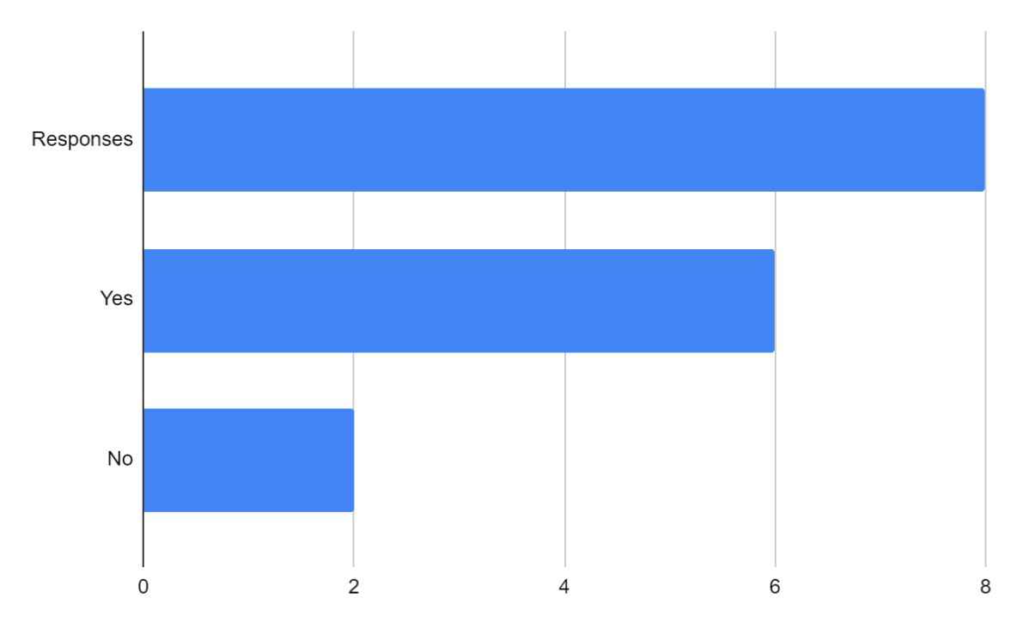
From the eight participants of the questionnaire, 6 of the participants responded that their company has operations in the EU, the financial services that consist mainly of banking operations, the construction company, one of the insurance companies, as well as the hospitality company, responded no.
- If yes, what are the main challenges you have faced since Brexit?
Participant | Response
C 1 | A greater need to have “boots on the ground” in Europe. People physically in location, rather than people in the UK travelling into Europe to lead on searches.
C 2 | Material supply challenges, duty taxes, labour supply and increased costs, but these are now factored into current prices and plans.
C 3 | Restrictions around marketing to countries in the EU27.
C 4 | Dependent of EU and UK regulation. Cross border travel. Limitations of “Regulatory Passporting” to UK or EU only, so duplicate infrastructure and costs.
C 5 | Setting up an office in Luxemburg, so we can “Passport” into European business.
C 6 | N/A
C 7 | Regarding business as usual, but we are lacking people, so as an international company we recruit foreign, so problems with recruitment.
C 8 | Dealing with import/export documentation and regulation, tight labour market
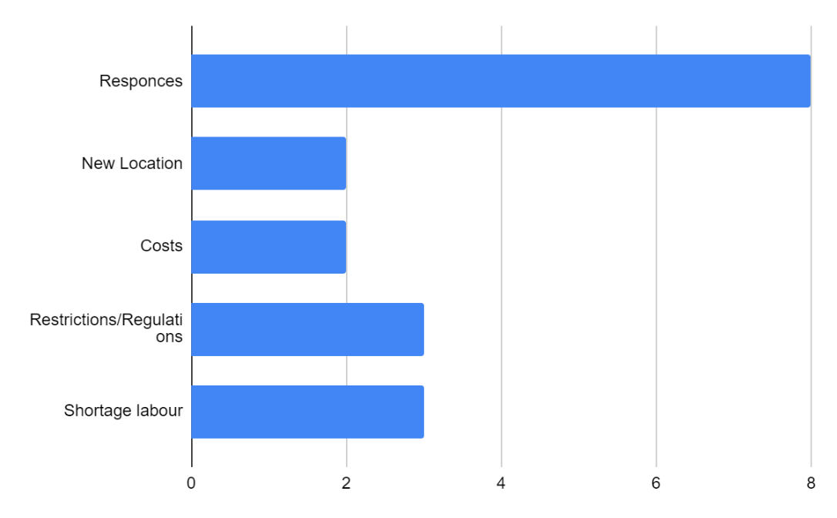
In response to the challenges faced by the respective companies, the responses were as follow. Company 1, Executive Search (Recruitment), Financial Services. That there would be a need to have people physically in location in Europe, rather than people from the UK travelling into Europe to lead on searches. As for Company 2. Construction, with main market Commercial, residential, technology, responded that material supply was one of the main challenges, duty taxes, labour supply and increased costs, but these are now factored into current prices and plans. Company 3, also financial Services, Banking, Capital Markets, replied that the challenges faced were the restrictions around marketing to countries in the EU27. As for Company 4, Commercial, Investment Bank, the main challenges were dependent of EU and UK regulation. Cross border travel. Limitations of “Regulatory Passporting” to UK or EU only, so duplicate infrastructure and costs. Company 5, Marine Insurance – Worldwide company, they tackled their challenge by setting up an office in Luxemburg, so we can “Passport” into European business. Company 6, Professional indemnity insurance for architects, did not faced any immediate challenges with Brexit. As for company 7, Hospitality industry, Business Intelligence company Globally, Head Quarters are based in London, but company has another 30 offices Regarding business as usual, but we are lacking people, so as an international company we recruit foreign, so problems with recruitment. Company 8, Professional Services- Accountancy, Owner-managed businesses (OMBs) based in South East UK, did not face any challenges, but their clients did.
- Have you had to make any changes to your operations since Brexit?
Participant | Response
C 1 | Hire a couple more people locally in our key European locations.
C 2 | No specific changes, prices, and consideration to extend procurement periods now factored into forward planning. Consideration from government to free ports and need to stockpile materials.
C 3 | Yes, we have opened an office in Dublin, Ireland to market to clients in the EU.
C 4 | Duplication of operational services to illustrate appropriate substance in the EU. Managing material outsourcing to a small level.
C 5 | Yes, Luxemburg office and change of regulator to CAA (Luxemburg)
C 6 | When Brexit rules entered, it meant the insurance could not insure any of our architects operative (offices) in Europe, we looked at ways of providing cover via third parties in Europe, but the cost of doing this was prohibitively expensive compared to the premium received from the EU office and so we had to stop insuring those offices and we had to tell our insureds that they had to go to another insurer for cover for their EU offices.
C 7 | No
C 8 | Additional research and training needs
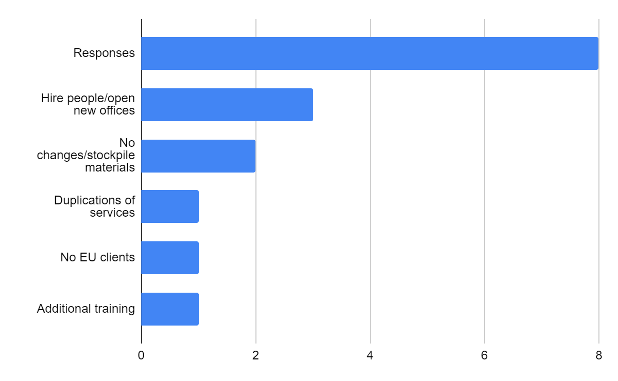
As for the changes that had to be made to their operations since Brexit, the responses were as follow. Company 1 responded that they had to hire a couple more people locally in their key European locations. Company 2, that no specific changes, only prices, and consideration to extend procurement periods now factored into forward planning. Consideration from government to free ports and need to stockpile materials. Company 3, responded yes, that they had to open an office in Dublin, Ireland to market to clients in the EU. Company 4, duplication of operational services to illustrate appropriate substance in the EU. Managing material outsourcing to a small level. Company 5, responded yes, they opened an office in Luxemburg and change of regulator to CAA (Civil Aviation Authority) in Luxemburg. Company 6 responded that when Brexit rules entered, it meant the insurance could not insure any of our architects operative (offices) in Europe, and that they looked at ways of providing cover via third parties in Europe, but the cost of doing that was prohibitively expensive compared to the premium received from the EU office and so they had to stop insuring those offices and they had to tell their insureds that they had to go to another insurer for cover for their EU offices. Company 7 did not have to make any changes, as for Company 8, they had to do additional research and training was needed to adapt to the new rules and regulations.
- What are your expectations for the future relationship between the UK and the EU?
Participant | Response
C 1 | I believe it will improve but will never get back to where it was pre-Brexit.
C 2 | Now part of everyday business, distribution issues, costs and availability now factored into normal working practices. EU and UK trade deals may change but construction will have to flex with the changes that arise. Costs will be passed on to clients and customers, so costs of living will be reflective of these enhanced costs.
C 3 | Our relationships remain good. We are still in a transitional period whereby we are growing a base in our Dublin office and trying to attract talent and increase the team there so that we can in turn increase business in Europe once more.  The UK left the EU on 31 January 2020 with the Withdrawal Agreement and entered a transition period that ended on 31 December 2020. Following this new or early relationship with the clients in Europe were difficult as we couldn’t pro-actively sell or market to them, we could only respond to enquiries so two-way engagement was not possible and relationships with all, but our most longstanding clients suffered. Hopefully by growing a larger team in Dublin this will mitigate this.
C 4 | EU needs to consider its role in the global markets, which is very dominated by US banks, many based in the UK. Should there be more convergence? Politics will be a major factor.
C 5 | Positive
C 6 | It depends on who wins the next general election. We would expect a Labour government to try to build bridge but not a Conservative government.
C 7 | The company is going to move and open another office outside of the UK.
C 8 | EU is a main trading partner for many UK businesses and overtime will call for closer ties and links with member states.
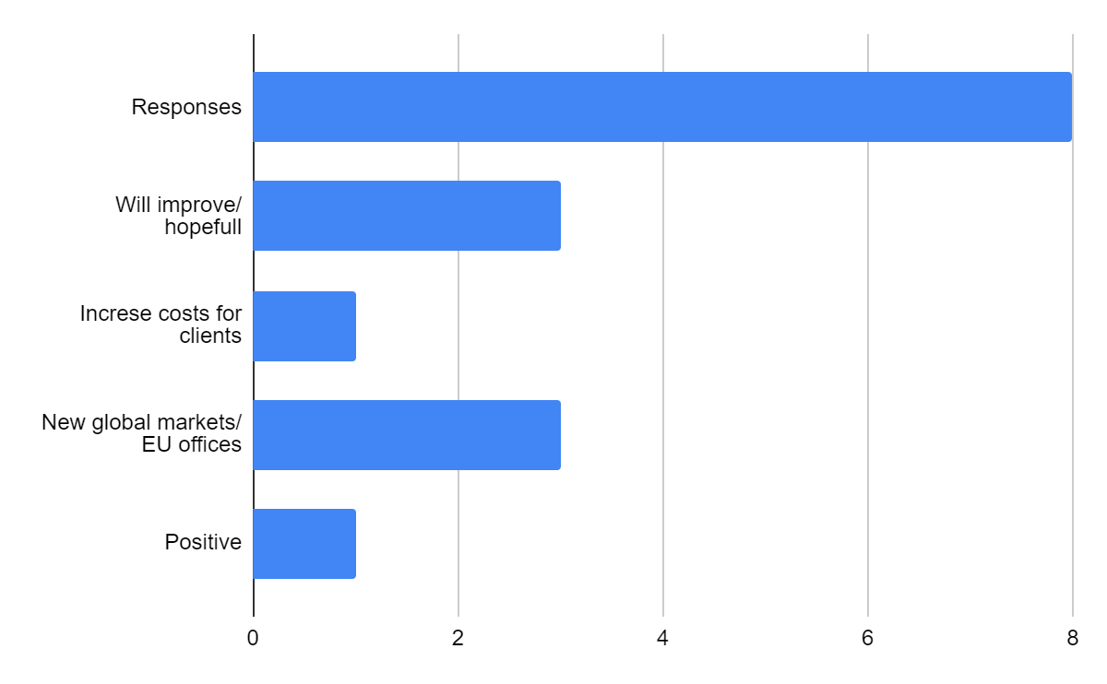

To the question about what are the expectations for the future relationship between the UK and the EU? Company 1 I believes that it will improve but will never get back to where it was pre-Brexit. Company 2 that it is now part of everyday business, distribution issues, costs and availability now factored into normal working practices. EU and UK trade deals may change but construction will have to flex with the changes that arise. Costs will be passed on to clients and customers, so costs of living will be reflective of these enhanced costs. Company 3 that their relationships remain good. They are still in a transitional period whereby they are growing a base in their Dublin office and trying to attract talent and increase their team there so that they can in turn increase business in Europe once more. Furthermore, the UK left the EU on 31 January 2020 with the Withdrawal Agreement and entered a transition period that ended on 31 December 2020. Following this new or early relationship with the clients in Europe were difficult as they couldn’t pro-actively sell or market to them, they could only respond to enquiries so two-way engagement was not possible and relationships with all, but with their most longstanding clients suffered. Hopefully by growing a larger team in Dublin this will mitigate the issue. Company 4, EU needs to consider its role in the global markets, which is very dominated by US banks, many based in the UK. Should there be more convergence? Politics will be a major factor. Company 5 said that it was positive. Company 6 that it depends on who wins the next general election. We would expect a Labour government to try to build bridge but not a Conservative government. Company 7 that the company is going to move and open another office outside of the UK. Company 8 EU is a main trading partner for many UK businesses and overtime will call for closer ties and links with member states.
- How do you think Brexit will impact your business in the long term?
Participant | Response
C 1 | I do not see it being a huge problem, as Europe makes up a very small proportion of our overall revenue, however as we have broken our sector coverage and client base, we may find it harder too.
C 2 | The impact broadly, similarly to the finance markets has already adjusted to Brexit and it is part of “normal life”. Costs incurred will be passed on (included for) which ultimately hit the consumer.
C 3 | It has made it harder to operate in the short to medium turn. Long term we are hopeful we will not be negatively impacted.
C 4 | We will adjust but will create higher costs basis and lower return.
C 5 | Worst impact is over, should be more easily manageable now.
C 6 | Damaging to long term relationships with existing and new clients, as we can’t meet all their needs.
C 7 | Not directly. Brexit did not have impact on the business, but problems with recruitment, such as work permits.
C 8 | No expectation for long term impact. OMBs will find a way to overcome obstacles and adapt accordingly.
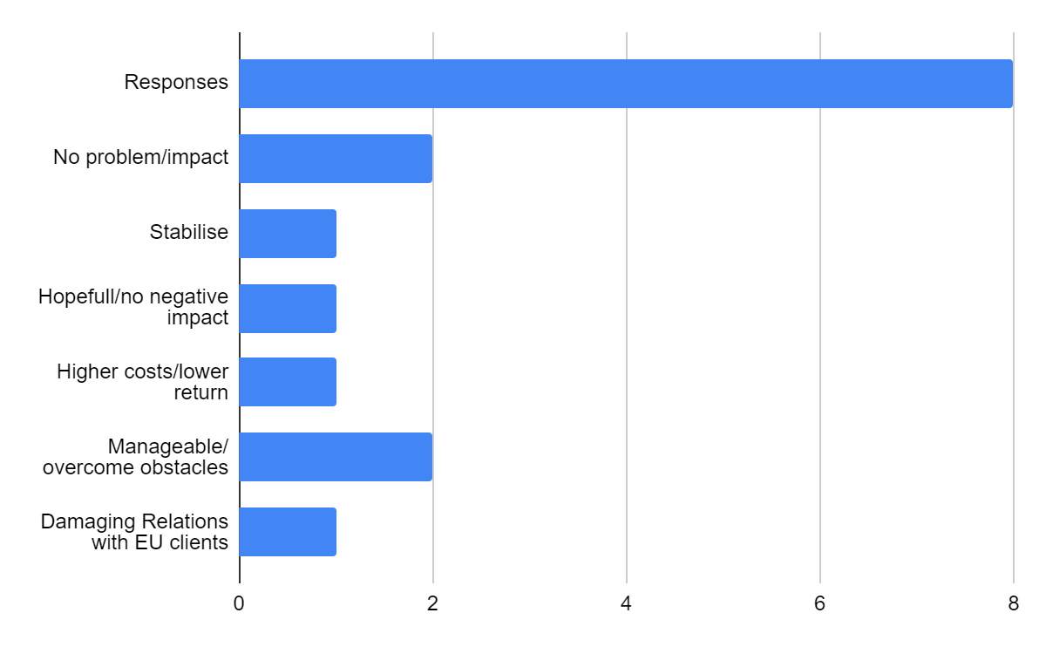
The responses to the question on how do you think Brexit will impact your business in the long term? The responses were Company 1 that they do not see it being a huge problem, as Europe make up a very small proportion of their overall revenue, however as they have broken our sector coverage and client base, they may find it harder too. As for Company 2 the impact was broadly, similarly to the finance markets has already adjusted to Brexit and it is part of “normal life”. Costs incurred will be passed on or included, which ultimately will hit the consumer. Company 3 that it has made it harder to operate in the short to medium turn. Long term they are hopeful they will not be negatively impacted. Company 4 that they will adjust but will create higher costs basis and lower return. Company 5 that the worst impact is over, and that it should be more easily manageable now. Company 6 that it created damaging to long term relationships with existing and new clients, as they can’t meet all their needs. Company 7 that it did not affect them directly. Brexit did not have impact on the business, but problems with recruitment, such as work permits arose. Company 8 that they have no expectation for long term impact. OMBs will find a way to overcome obstacles and adapt accordingly.
- What are the main risks and opportunities you face as a result of Brexit?
Participant | Response
C 1 | Cost of travelling is higher. Greater level of international expansion, with the UK not constrained by EU trade agreements, we could negotiate deals further infield with countries like Canada or across Asia. Potential case for more innovation as the UK has more chance to set its own laws.
C 2 | We expect to see an increased level of activity led by the bigger firms as prices go up and the smaller firms with less cash flow and capital get squeezed out. Could well be more labour opportunities in some of our EU locations which could also means a shortage of workers in the UK for the lower paid roles.
C 3 | Risks were that we would see our client base significantly reduce.
C 4 | Very long term is role of London in global markets. One reason the PRA (Prudential Regulation Authority) has a secondary objective of UK competitiveness.
C 5 | Risk mostly associated with increased costs and relationship with oversea regulator.
C 6 | That a larger international insurer with the ability to cover EU risks will steal our business.
C 7 | Risk for companies regarding not having enough people to work. Opportunities, not really.
C 8 | Further opportunities for international tax and advisory services establishing country specialism for businesses from EU to operate in the UK.
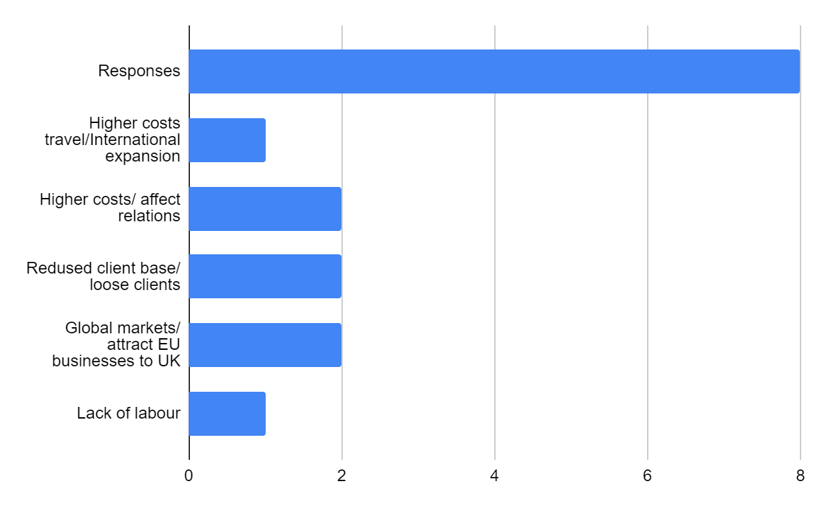

Regarding the question about the main risks and opportunities, that the company face as a result of Brexit. Company 1 responded that the cost of travelling is higher. Greater level of international expansion, with the UK not constrained by EU trade agreements, that they could negotiate deals further infield with countries like Canada or across Asia. Potential case for more innovation as the UK has more chance to set its own laws. Company 2 that they expect to see an increased level of activity led by the bigger firms as prices go up and the smaller firms with less cash flow and capital get squeezed out. Could well be more labour opportunities in some of our EU locations which could also means a shortage of workers in the UK for the lower paid roles. Company 3, responded that the risks were that they would see their client base significantly reduced. Company 4 responded that very long term is the role of London in global markets. One reason the PRA (Prudential Regulation Authority) has a secondary objective of UK competitiveness. Company 5 that the risk is mostly associated with increased costs and relationship with oversea regulators. As for Company 6 is that a larger international insurer with the ability to cover EU risks will steal their business. Company 7 their main risk for the company is, regarding not having enough people to work. Opportunities, it has not really created any. Company 8, that it can create further opportunities for international tax and advisory services establishing country specialism for businesses from EU to operate in the UK.
- What strategies are you using to mitigate the risks of Brexit?
Participant | Response
C 1 | More due diligence on what our competitors are doing and how they are mitigating their risks.
C 2 | Knowledge is key, speed over elegance, the first to react can usually sustain for longer. Understanding the data and impacts and using appropriately at the right levels. Seeking alternatives outside of the EU also widely considered so we are not tied purely to impacts here.
C 3 | Opening an office in Dublin and growing a strong workforce there.
C 4 | Efficiency reviews, though not a material factor as most business. US and for global clients
C 5 | Enhanced risk and compliance.
C 6 | Open and transparent communication with our clients about what we can and cannot do and why.
C 7 | The company intends on opening an office outside of the UK if necessary.
C 8 | Keeping a watching brief and advising clients on opportunities as they arise.
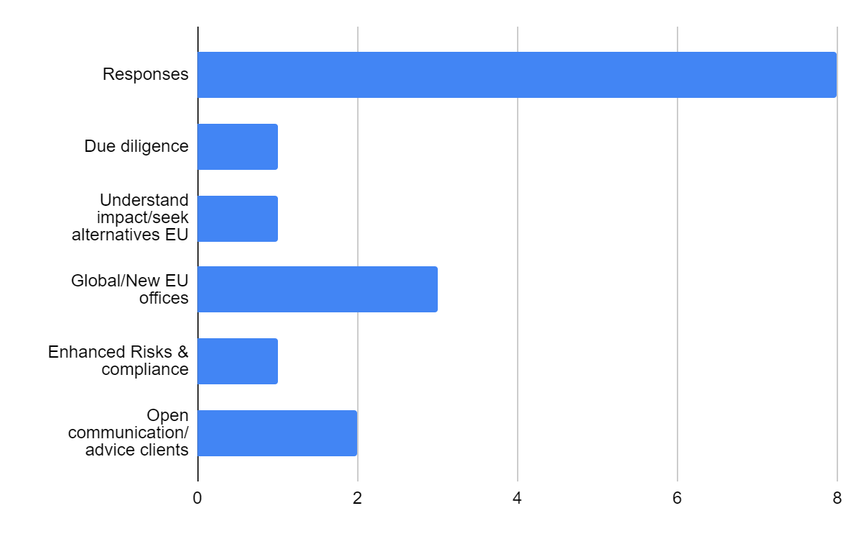

What strategies are you using to mitigate the risks of Brexit? Company 1 responded that more due diligence on what their competitors are doing and how they are mitigating their risks. Company 2 that knowledge is key, speed over elegance, the first to react can usually sustain for longer. Understanding the data and impacts and using appropriately at the right levels. Seeking alternatives outside of the EU also widely considered so they are not tied purely to impacts here. Company 3 responded that opening an office in Dublin and growing a strong workforce there, was how they are mitigating the risks. Company 4 Efficiency reviews, though not a material factor as most business. US and for global clients. Company 5 responded enhanced risk and compliance. Company 6 that open and transparent communication with their clients about what they can and cannot do and why, hence forward. Company 7 responded that the company intends on opening an office outside of the UK if necessary. Company 8 Keeping a watching brief and advising clients on opportunities as they arise.
- What advice would you give to other businesses about Brexit?
Participant | Response
C 1 | Be more creative when thinking about where in the globe you can create partnerships and not relying on Europe.
C 2 | Understand what it means to you fully. Its here to stay so we need to have it incorporated in any planning. Consider alternatives to minimise risk.
C 3 | Ensure that you are knowledgeable about the legislation and how you are impacted hiring staff and dealing with customers.
C 4 | Think GLOBAL
C 5 | Engage fully with European authorities and take advantage of opportunities.
C 6 | Pay for proper advice because the rules on what you can and cannot do are complex and the implication if you get it wrong, damaging financially and reputationally and a threat to your ability to trade.
C 7 | Look at different locations, such as tax free friendly, such as Portugal, Estonia, where people can work remotely.
C 8 | Find a way to deal with short term changes in regulation and look out for future opportunities to expand trade.
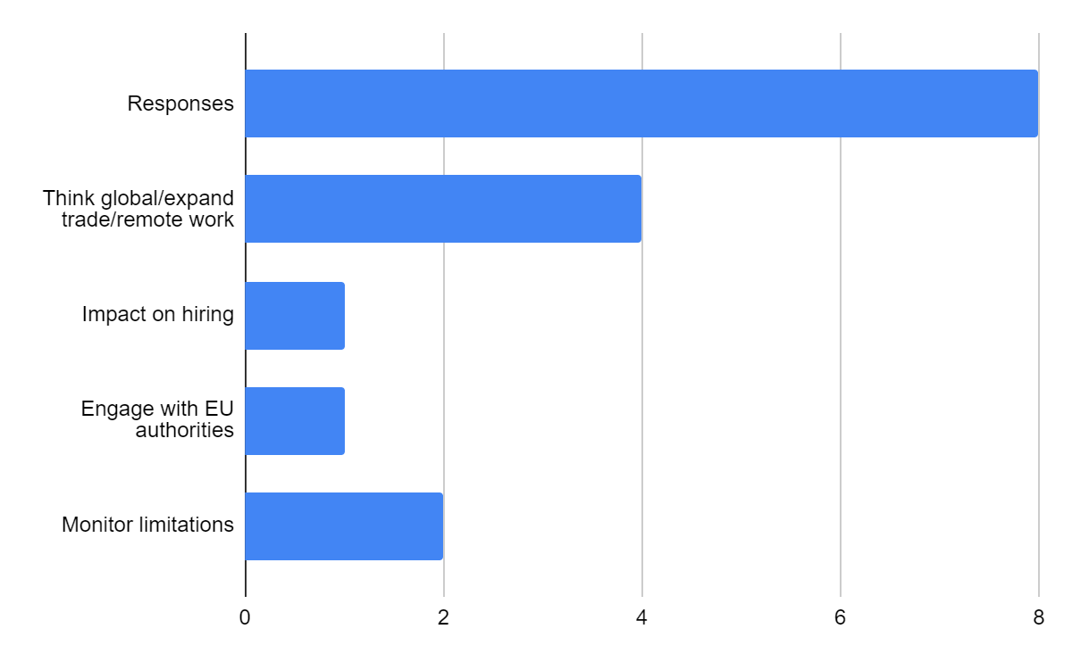
On the question about what advice would you give to other businesses about Brexit? Company 1 response was to be more creative when thinking about where in the globe you can create partnerships and not relying solely on Europe. Company 2 to understand what it means fully. It’s here to stay so they need to have it incorporated in any future planning. Consider alternatives to minimise risk. Company 3 to ensure that they are knowledgeable about the legislation and how they are impacted hiring staff and dealing with customers. Company 4 their advice is to think Global. Company 5 Engage fully with European authorities and take advantage of opportunities. Company 6 that companies should pay for proper advice because the rules on what you can and cannot do, are complex and the implication if you get it wrong, can be damaging financially and reputationally and a threat to your ability to trade. Company 7 suggested to look at different locations, such as tax-free friendly countries, such as Portugal, Estonia, and others, where people can work remotely. Company 8 suggested finding a way to deal with short term changes in regulation and look out for future opportunities to expand trade.

Primary observation as a result of Brexit, whereas before Brexit you could receive or sent anything without having problems with customs, after Brexit it is unimaginable sending anything to the EU countries without paying customs on everything. As per experience I sent my mother, who lives in Portugal, my BA (Hons) graduation picture as a gift, and it was held up at customs and considerate a dangerous object. I had to pay a customs fee, for her to receive it. Whereas sending something from Portugal to the UK, regardless of the fact that it involves filling in many forms, so far I have had no problem receiving or had to pay for anything.
As per an informal conversation with the CEO of the company where I work, Pret a Manger, and also gaining information from the company’s website (Pret,2023), and as a on field worker, during the transition period, this is how Brexit affected the company. Brexit has had a number of negative impacts on Pret a Manger, these including, increased costs, prices increased considerably, labor shortages, reduced demand for the company’s products, since it coincided with the Covid-19 pandemic and most people started working from home. Pret a Manger imported quite a significant amount of its food and ingredients from the EU, but since Brexit, the cost to these imports increased as a result of the tariffs and other trade barriers that were implemented, having the company to find some alternatives from UK traders and in some cases adapted their recipes to the new products. (Pret, 2023). Since Brexit, and because Pret a Manger relied mainly on EU workers, it has become more difficult and expensive for Pret a Manger to hire and retain some of the EU workers, many of them returned to their home countries during lockdown, and as Brexit transition happened, they did not return. It was especially notable, in the companies delivery drivers for the supplies to the shops, many days they did not have enough drivers to deliver to all shops in London, many times goods being supplied, after opening hours, and those drivers being exhausted has they were already on several delivery trips. As well as the demand for customers buying reduced significantly because of the slowdown to the UK economy, which is slowing picking up and is starting to reflect on the company’s sales, now 3 years into Brexit. As a worker in one of the shops, in London’s financial area, many of our customers from the surrounding offices relocated to cities in the EU, thus seeing the effect of Brexit on the company’s business sales.
In addition to all these direct impacts, and because Brexit created uncertainty and instability in the UK economy, and it has made it difficult for the company to plan for its future and invest in its future growth. As a result of these challenges, and the massive loss of income during the lockdown, Pret a Manger has seen its profits decline in these last recent years. The company has also been forced to close some of its shops and was forced to raise its prices, as a result of the higher tariffs of imports on its goods, many of the products and goods that are imported, rose to double the price (Pret, 2023).
However, the company took a number of steps to mitigate the impact of Brexit and is trying to ensure its long-term success. For example, the company is constantly working to reduce its reliance on imported food and ingredients, by getting UK suppliers. It also invested in new technologies to improve efficiency and reduce costs. Even though the company tried to attract and retain more British workers, by launching a number of initiatives to promote Pret a Manger as a good place to work for British people, it has been a challenging battle (Pret, 2023).
ETIAS -The European Travel Information and Authorisation System
ETIAS will be the new European travel information and authorisation system required to access 30 EU nations, and even though it has not come yet into practice, it will in future be a requirement for tourists and travellers on business, a therefore when it comes into effect, you will soon be required to purchase a permit. As a response to Brexit, the ETIAS adds more red tape for travellers visiting countries like France, Greece, and Spain and other EU countries (Ashmore, 2023).
This permit will be for individuals over 18, the authorization will cost about £6 (€7) and will be connected to your passport entirely electronically. UK citizens will be able to stay in Europe for up to 90 days in a 180-day period using this three-year passport, which will be valid until it expires, or whichever comes first (Ashmore, 2023). Although it will not ensure that people are eligible for entrance at border control. It will consist of an online application form with a fee, that will ask for basic information, and asked questions about the travel plans and criminal history (Ashmore, 2023). Applications can have immediate approval or can take longer to process (Ashmore, 2023).
The European Travel Information and Authorisation System (ETIAS) is an upcoming electronic authorisation system for visa-exempt travellers to the Schengen Area, as well as Bulgaria, Cyprus, and Romania. It is expected to be fully operational in May 2025(Ashmore, 2023). The ETIAS system is being implemented to improve the security of the Schengen Area by identifying potential security threats before travellers arrive in Europe. The system will also help to reduce illegal immigration and fraud (Ashmore, 2023). All visa-exempt travellers to the Schengen Area will need an ETIAS, including citizens of the United States, Canada, Australia, New Zealand, and the United Kingdom (Ashmore, 2023).

Chapter five: Conclusions and recommendations
Conclusion
In conclusion to the research, it is viable to say that international businesses and operations will always find a way around the consequences of Brexit. A great deal of financial companies relocated their headquarters to other EU destinations. Whereas London was pre- Brexit the hub of most of the financial company’s headquarters, it has presently lost a lot of those companies. Not only did Brexit affected greatly the United Kingdom, but it also coincided with the breakout of Covid 19 pandemic, leaving the country in a less favourable economic stability. Big companies will always find a way around and did find a way around all the new trade regulations, in my personal opinion it was the small and medium enterprises that suffered more with the transition.
Recommendations
As for recommendations, the businesses need to understand the new trade rules and regulations. This includes understanding the new tariffs, quotas, and other trade barriers that will apply to your goods and services. You should also assess the potential impact of Brexit on your supply chain, workforce, and customers.
Develop a Brexit plan. This plan should outline how you will mitigate the risks and capitalize on the opportunities of Brexit. It should also include a contingency plan in case of a no-deal Brexit.
Communicate with your stakeholders. Keep your employees, customers, and suppliers informed of your Brexit plans and how they may be affected. This will help to build trust and confidence in your business.
Seek professional advice. If you need help understanding the impact of Brexit on your business or developing a Brexit plan, you should seek professional advice from an accountant, lawyer, or other business consultant.
Here are some specific recommendations for international operations and businesses:
Operations:
Review your supply chain and identify any potential disruptions that Brexit may cause.
Consider stockpiling goods and materials if necessary.
Develop new customs procedures and train your staff on the new requirements.
Consider investing in new technologies and processes to improve efficiency and reduce costs.
Businesses:
Assess the impact of Brexit on your market and develop a plan to maintain or increase sales.
Consider expanding into new markets outside of the UK and the EU.
Invest in new technologies and processes to improve efficiency and reduce costs.
Consider establishing a base in the UK or the EU to maintain access to these markets.
In addition to the above, here are some other key things to consider:
Data compliance: Businesses will need to comply with the new UK data protection regulations, such as the UK General Data Protection Regulation (UK GDPR). This may require changes to the way data is collected, stored, and transferred.
Intellectual property: Businesses should review their intellectual property rights (IPRs) to ensure that they are protected in the UK and the EU after Brexit. This may involve filing new IPR applications or updating existing ones.
Employment: Businesses should review their employment contracts and policies to ensure that they comply with the new UK immigration rules. They should also consider how they will attract and retain skilled workers from overseas after Brexit.
It is important to note that the impact of Brexit will vary depending on the specific industry and business model. It is therefore important for businesses to carefully assess their own situation and develop a tailored plan.
Here are some additional recommendations for international operations and businesses:
Consider establishing a presence in the UK or the EU. This will give you direct access to these markets and make it easier to comply with the new trade rules and regulations.
Partner with local businesses. This can help you to navigate the new regulatory environment and reach new customers.
Invest in your employees. Train your staff on the new trade rules and regulations, and help them to develop the skills they need to succeed in the new post-Brexit environment.
Be adaptable and flexible. The post-Brexit landscape is likely to be complex and dynamic. Be prepared to adapt your business model and operations as needed.
By following these recommendations, international operations and businesses can mitigate the risks and capitalize on the opportunities of Brexit.

Reflection:
As a reflection on my journey for doing this research, and on the skills that I developed during the process. Once I decided that I wanted to write about this topic, I started to do my research, there is still not too much written about this topic, as it is fairly resent and books take a long time until they are officially published, the articles that I found were practically all the same and most of them repetitive in what they say, some of them are speculation on what is going to happen after Brexit, and only the future will really show the true impact that Brexit has had on the economy and on how it affected the UK businesses and the international operations of the companies.
The reason for choosing this topic was the fact that I closely observed the effect of Brexit on the operations of the company where I worked, and also the fact that I work in one of the financial areas of London, and I knew that I would have the opportunity to talk in person with some of my customers and obtain from them answers to the questions that I needed answers to conclude my research.
As an introvert it was quite complicated to gain courage to approach the people, but I managed to overcome that and ended up having quite meaningful and interesting insights on how, some of the companies developed a plan to overcome some of the challenges that companies faced with the transition from the UK out of the EU. This led to me as a researcher having the opportunity to talk to certain people, on a more profound talk, instead of just me being the assistant manager that greeted them and served them at the till. Even with the company CEO, it gave me the opportunity to have a more meaningful conversation.
But the fact that some of the people that agreed to answer my questionnaire, because of them travelling in between UK and the EU destinations where they opened new offices as a result of Brexit, in some cases I had to wait for them to return to e able to schedule time.
As well I learned that once you start researching on topic, you start gaining more insight on the topic, because one information will lead you to other information.
The key considerations I tried to follow as a researcher, were to determine what I wanted to achieve with the research topic, accessing my weakness and strengths as a researcher, to help me realise what I could do well and what I needed to improve on to achieve all, I established a development plan and tried to stick to it, although at times it was challenging juggling between a full time job and getting home and still do my research. In between trying to achieve all this, it did help me to be resilient and stick to my goals. I tried to read as much as I could to discover what is expected of a researcher. I tried to develop as much skills as I could, but there where times that I felt completely blocked in my progress, and felt completely drained out.

References:
Alharahsheh, H. and Pius, A. (2020). A Review of Key paradigms: Positivism VS Interpretivism. Global Academic Journal of Humanities and Social Sciences, 2(3), pp.39–43.

Ashmore, K. (2023). Date ‘visa’ fee for Spain, France, Portugal and other EU countries comes in. [online] BirminghamLive. Available at: https://www.birminghammail.co.uk/news/uk-news/date-visa-fee-spain-france-27376311 [Accessed 7 Oct. 2023].

Casadei, P. and Iammarino, S., (2021). Trade policy shocks in the UK textile and apparel value chain: Firm perceptions of Brexit uncertainty. Journal of International Business Policy, 4, pp.262-285.
Carrapico, H., Niehuss, A., Berthélémy, C. (2018). Brexit and Internal Security: Political and Legal Concerns on the Future UK-EU Relationship. Germany: Springer International Publishing.
European Union Committee 14th Report. Brexit: UK-EU Movement of People. Oral and written evidence. (2017). United Kingdom: Dandy Booksellers Limited.

Institute for Government. (2017). Trade after Brexit. [online] Available at: https://www.instituteforgovernment.org.uk/publication/report/trade-after-brexit.

McKinsey (2019). Brexit: The bigger picture--Rethinking supply chains in a time of uncertainty. [online] McKinsey & Company. Available at: https://www.mckinsey.com/featured-insights/europe/brexit-the-bigger-picture-rethinking-supply-chains-in-a-time-of-uncertainty.

The Economic Consequences of Brexit: A Taxing Decision - OECD. [online] (n.d) Available at: https://www.oecd.org/unitedkingdom/the-economic-consequences-of-brexit-a-taxing-decision.htm.

UK Parliament. (2019). Brexit: research and analysis. [online] Available at: https://www.parliament.uk/business/publications/research/eu-referendum/

