ASSIGNMENT 2:
Report - 2,500 Words
Event Theme: Technology and Innovation

Name: Parbes Ali
student number:2127517

The assignment title: Planning and Delivering an International Meeting/Event.
The module title: International Meetings Management BMIH6007
Lecturer’s name: Kathryn Flynn (Module Lead),
Jemma Smith (Lecturer)
Internal Verifier: Lisa Bassler

Report Title: Technology and Innovation within the Hospitality Sector, Event at Premier in Birmingham

\

Table of Contents
Introduction 3
Event Cycle 3
Event Concept 6
Aim and Objectives of the Meeting/Event 7
Event Operations 8
Event Budget 11
Industry Trends/Issues/Impacts 13
Cultural and Situational Considerations 15
Conclusion 16
Reference 17

Introduction
Strategic planning is a methodical procedure for visualising a desirable future and converting this vision into broadly outlined goals or objectives, along with a series of actions to accomplish them (Fox, et al. 2014). Furthermore, understanding each stage of the planning process allows us to ensure that the event not only achieves its objectives but also offers value to stakeholders and attendees (Getz, D. and Page, 2019). This report examines the proposed event, "Technology and Innovation in the Hospitality Sector," as well as the strategic planning and execution as described in Assignment 1. In addition, the purpose is to bring together industry leaders, local businesses, and technology enthusiasts to encourage information sharing, networking, and teamwork in the application of technology and innovation in the hospitality sector (O’Toole, 2011). Similarly, this report goes beyond the feasibility analysis and focuses on the strategic planning required to ensure the event's success.

Event Cycle
The event cycle, often known as the event management process, is an important conceptual framework in event management (Getz, 2012). Furthermore, the steps involved in planning, scheduling, and carrying out an event in sequential order. The event cycle is divided into five basic phases: Initiation, Planning, Implementation, Event, and Closure (Getz, and Page, 2019)
1. Initiation: At this point, the event concept is first initiated. It entails establishing the event's purpose, admitting that it is required, and doing a feasibility study to evaluate whether it is possible.
2. Planning: This part of the event involves the creation of detailed plans. This includes goal setting, concept development, programme or agenda organisation, financial resource allocation, asset identification, and operational protocol definition.
3. Implementation: The responsibility of this phase is to put the plans created in the previous phase into action. Its responsibilities include procuring materials, planning event logistics, advertising it, and preparing for unforeseen circumstances.
4. Event: This refers to the event's execution or carrying out. Now, the primary objectives are to effectively manage the event, ensure that everything runs smoothly, and ensure that attendees have a great experience.
5. Closure: In this final stage, the event is ended, a review or debrief is conducted to assess its efficacy, chances for improvement are identified, and each participant's contributions are recognised. Follow-up with attendees, sponsors, and other relevant parties, as well as participation in post-event communication, are common activities during this phase.
The first stage in organising event was to determine its necessity and conduct a feasibility study. The final phase of the process was to secure the venue, the Premiere Inn in Birmingham. The primary focus of this study is on the planning phase, which includes goal setting, developing an event concept, distributing financing, and describing operational requirements. The two primary goals of this phase are to decide on the event's strategic direction and to ensure that all necessary preparations are completed. The plans developed in the previous step, known as the execution stage, include purchasing resources, coordinating logistics, and publicising the event. The main aims of the event stage, which is when the event is actively being held, are a great participant experience and effective management of event operations. When all is said and done, the closure stage involves wrapping up the event, analysing its success, identifying areas for improvement, and thanking everyone for their participation. To be methodical and successful, event management must first be understood and implemented. The assurance that all important aspects will be considered and managed efficiently raises the likelihood of an event's success.

Event Concept
The aim of this event is to provide a forum for collaboration and discourse about technology and innovation in the hospitality business (Booth, 2010). The event's goal is to bring together IT enthusiasts, industry professionals, and surrounding companies to foster networking, knowledge exchange, and teamwork. The event will highlight the most recent technical developments, cutting-edge practices, and emerging trends affecting the hospitality industry. Presenters from the industry's leading names will take the stage, as will interactively workshops, exciting panel discussions, real-time technology demos, and lots of networking opportunities (Smith, 2012).
The day will begin with a welcome message, followed by keynote speeches from prominent industry executives. These courses, which emphasise the importance of innovation and technology in the hotel sector, will provide interesting perspectives. This will set the tone for the day and provide structure for the other presentations. The morning session will focus on three topics: "The Role of Artificial Intelligence in the Hospitality Industry," "The Influence of Digital Transformation on Customer Experience," and "Cutting-edge Approaches for Sustainable Hospitality." The event will improve participants' understanding of current industry trends and issues. After lunch for networking, there will be interactive seminars in the afternoon where guests may learn about the most recent and innovative technology affecting the hotel industry. Some of these advancements include virtual reality travel experiences, artificial intelligence-powered customer assistance systems, and long-term advances in the hospitality business.
Following the programming, there will be a networking cocktail hour when attendees may socialise, discuss what they've learned over the day, and possibly build partnerships. The suggested timetable offers a combination of practical training, information sharing, and networking opportunities for professionals. Participants should depart with a wealth of information, insight, and networks to enable them to foster technical innovation in their respective companies. This event's goal is to promote technology and innovation in the hospitality industry. It provides a rewarding and exciting experience for all participants.

Aim and Objectives of the Meeting/Event
The primary goal of this event, which aims to promote the integration of technology and innovation in the hospitality sector, is to create an environment that encourages information sharing, networking, and teamwork. The fundamental objective of this event, which aims to promote the integration of technology and innovation into the hospitality sector, is to develop an environment that encourages information sharing, networking, and collaboration.
Objectives 1.
To bring together at least 100 industry professionals, including IT enthusiasts, business owners, and industry experts.
Objective 2
To enable the exchange of at least 20 new technical concepts or practices in the hospitality business
Objective 3
To form at least five new partnerships or collaborations amongst participants by end of the event.

Event Operations
The successful implementation of the event relies on the effective administration of its activities (Carter, 2007). Some of the abilities required for the event include project management, risk management, and budgeting. Effective communication and interpersonal skills are essential for developing and maintaining connections with speakers, audiences, and stakeholders. Because the event is centred on technology and innovation, technical expertise is essential. This category includes digital marketing tools, online registration systems, and presentation-related technological equipment.
Tangible resources for the event include audio-visual equipment for presentations, furniture for seating arrangements, food services for participants. On the other hand, Intangible resources include the experience and work ethic of the speakers, the event's digital presence (website and social media accounts), and the time and effort put in by staff members to prepare the event (Dowson, Albert,. and Lomax, 2022). Mobilising these resources necessitates a solid operating plan. In addition to defining a work schedule for the event, this plan should clearly explain the duties of the event planning team and include contingency plans for any unanticipated occurrences (Akgöz, and Engin, 2016). To do so, ensure that the venue is safe and licensed, arrange for speakers and caterers, manage event marketing, and set up attendee registration. A safe and comfortable atmosphere for all participants should be ensured by considering the operating strategy's safety and health requirements, particularly in light of the ongoing COVID-19 outbreak. Events may run well and achieve their intended aims and objectives with efficient event management. Furthermore, certain crucial skills are necessary for the successful implementation of the event (Dowson, and Bassett, 2015):
1. Proficiency in event management and planning is required in order to successfully monitor the entire event process from start to finish. To guarantee the event runs smoothly, project management, risk management, budgeting, and logistics experience are all necessary.
2. Strong interpersonal and communication skills are required for creating relationships and maintaining connections with speakers, participants, and stakeholders. Good relationship management, good activity coordination, and clear goal communication are all required for the event to be a success.
3. Technical skills: Because technology is an important part of the event, technical knowledge is required. This involves maintaining control over presentation-related technical equipment, comprehending the newest innovations in hospitality technology, and administering digital marketing and online registration systems.
4. Problem-solving skills are required to effectively manage any unplanned issues or challenges that may develop during event preparation or execution. This encompasses the ability to think ahead and make quick decisions, as well as the act of anticipating potential future events.
5. Strong leadership skills are required for effective event staff management, task delegation, and ensuring that all attendees actively contribute to the event's goals.
6. Strong negotiating abilities are useful for resource acquisition, agreements with sponsors and vendors, and problem resolution. When these skills are combined, they lead to successful event execution and outcomes.

Event Budget
The financing for the conference has been meticulously planned to cover all costs and maximise revenue prospects (Smith, et al 2010). Furthermore, The budget, which contains different cost factors and income sources, serves as the event's overall financial strategy (Brax, 2010). The event's cost includes hiring space, purchasing materials, paying staff, and implementing marketing strategies. The Premiere Inn in Birmingham will host the event, which is expected to cost £100,000 in total. Audio-visual technology and lighting are among the items of equipment necessary for the event, with a cost estimate of £3,000. £2000 is set aside for staff compensation, which includes both tech-savvy event workers and hospitality specialists. Finally, the £2,500 marketing fee includes expenses for print, web, and social media activities. The entire cost of this event is £17,500. The revenue side of the event is to generate revenue from multiple sources. The estimated revenue from ticket sales is £20,000, assuming 400 tickets are sold for an average of £50 per ticket. Sponsorships for the event are expected to total $10,000 from tech companies and surrounding businesses. In addition, the sale of event items, such as t-shirts and mugs, is expected to generate around £2000. Finally, renting out exhibition space to tech companies at the event is estimated to generate an extra £5,000. £37,000 is the total revenue. Deducting the entire cost of £17,500 from the total revenue of £37,000 yields a profit of £19,500, which can then be used to calculate the predicted profit. As a result, the budget breakdown ensures the event's feasibility and profitability by constructing an effective financial strategy. In addition to matching the event's aims and strategy, the budget ensures that the event benefits both the organisers and the participants.

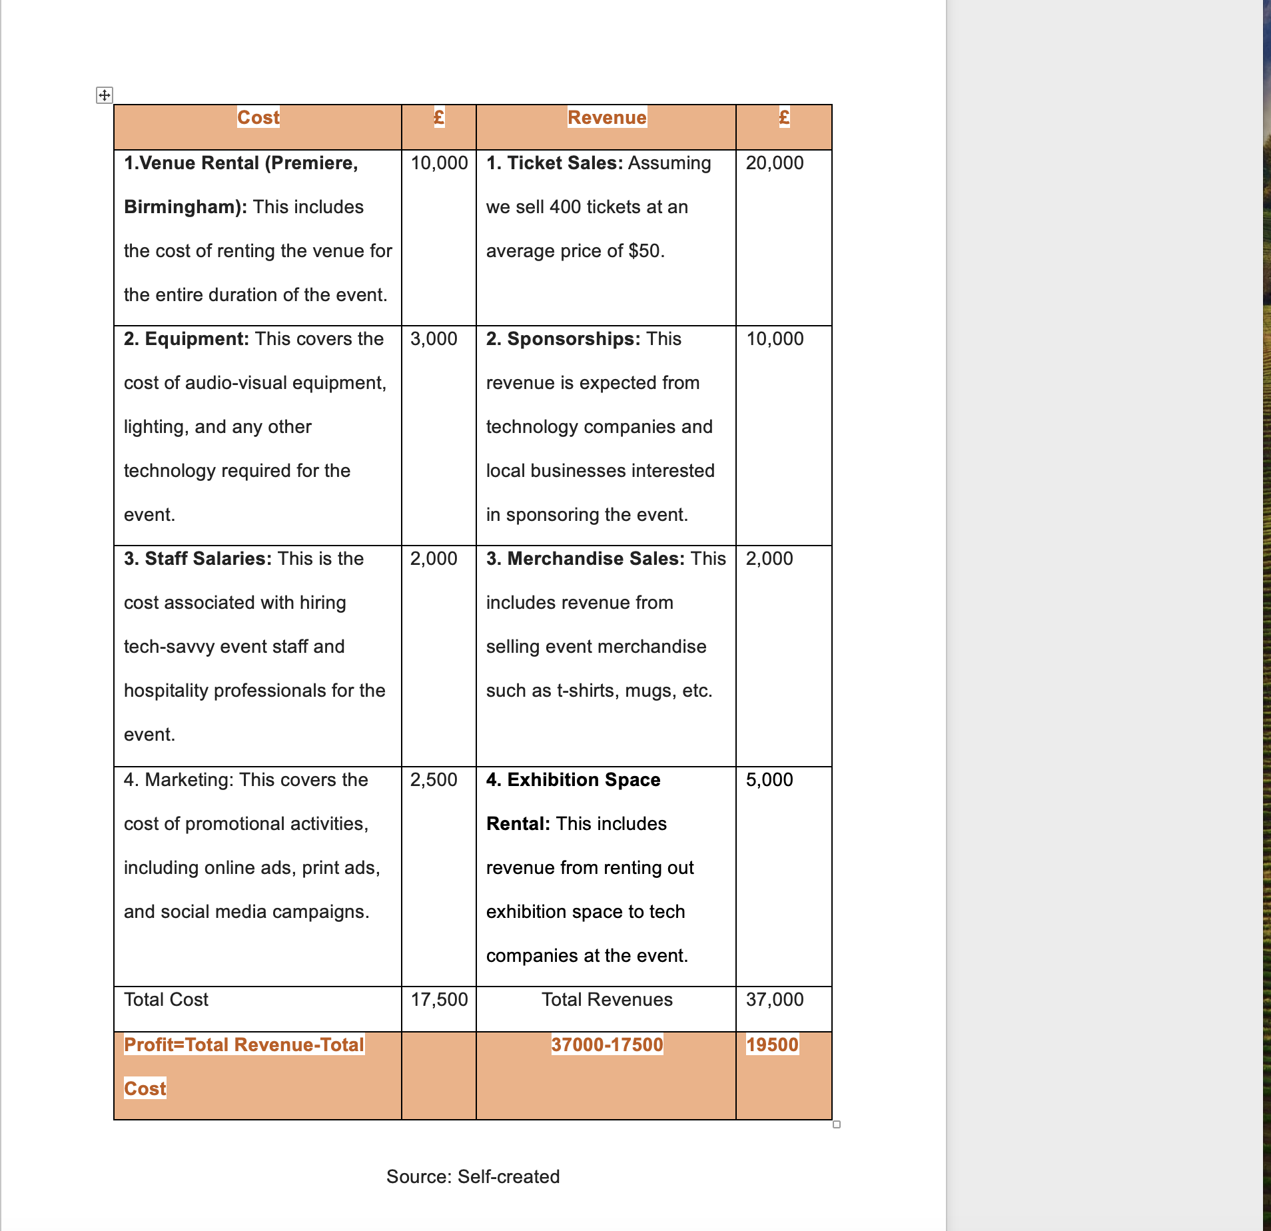
The budget thoroughly analyses the entire cost structure, which includes venue leasing, equipment, personnel salaries, and marketing expenses. The budget section successfully displays the event's comprehensive financial preparation process by explicitly identifying each financial facet.

Industry Trends/Issues/Impacts
To ensure the event's relevance and success, it is critical to be fully aware of the most recent advancements, issues, and consequences affecting these industries. The digitalization of services, which includes the use of artificial intelligence to improve customer service and the implementation of online reservation platforms, is a notable trend in the hotel industry (Morrison, and Buhalis,2023). Individualised, effective, and frictionless experiences are in high demand, which has been accelerated by the COVID-19 pandemic. However, there are some drawbacks to this transition to digital platforms, such as concerns about data security and the need for constant technological advancements. Virtual reality, machine learning, and artificial intelligence are transforming a number of industries, including hospitality (Huang, et al 2022). Nonetheless, due to the rapid rate of technological change, businesses may struggle to keep up with and effectively use this technology (Day, and Schoemaker, 2016). These current sector issues and trends provide both opportunities and risks for our event. The event is relevant and current because it emphasises technology and innovation in the hotel industry, which is consistent with current trends. Nonetheless, the event must address the challenges posed by these advancements by providing relevant information and solutions (McGrath, 2013).
A SWOT analysis can assist in determining the event's strengths and weaknesses, as well as the opportunities and risks associated with it. A PESTLE study can thoroughly evaluate all of the broader political, economic, social, technical, legal, and environmental factors that influence the event. These evaluations can provide useful information for event strategic planning, ensuring that it not only aligns with industry trends but also addresses relevant issues and seizes new opportunities (Cadle, et al; 2010).
furthermore, A SWOT analysis can be used to understand the industry's impact on the proposed event. This is accomplished by recognising the opportunities and threats that exist outside of the event, as well as its internal strengths and weaknesses. Weaknesses and strengths are inherent factors that can influence event outcomes. For example, having a skilled event crew may be a strength, but a limited budget may be a disadvantage. Opportunities and threat are exogenous elements that arise from the industry or environment. A growing proclivity for technology may provide an opportunity in the hotel industry. A competing event, on the other hand, that occurs concurrently could pose a threat. A PESTLE analysis, on the other hand, aids in understanding the macro-environmental factors (political, economic, social, technological, legal, and environmental) that may influence the event (Ratlhagane, 2022). Political factors include the level of political stability as well as the impact of government policies, both of which can influence the event. Economic factors include the current state of the economy as well as any developments that may affect participants' ability to attend an event. Social variables encompass population characteristics and societal tendencies. Technological factors investigate the impact of modern technologies and how they affect the event. Legal considerations include any applicable laws or rules that the event must follow. Environmental considerations include ecological and environmental factors that may impact the event. Event planners can improve strategic planning and decision-making by conducting a SWOT and PESTLE analysis (Jamil, 2023).

Cultural and Situational Considerations
This entails considering the participants' expectations and cultural backgrounds, as well as the technological, sociological, and economic context in which the event occurs (Scholnick, and Friedman, 1993). The occasion must consider the diverse cultural backgrounds of those in attendance, which may include visitors from other countries, professionals in the field, and members of the community. Dietary restrictions, cultural customs, and language barriers should all be considered when planning. The event takes place against the backdrop of the hotel industry's digital revolution as well as a broader societal shift caused by the COVID-19 pandemic towards remote work and digital interactions. The context of an event has an immediate impact on its format, content, and delivery, which has important implications. For example, it may be necessary to provide remote involvement options or to follow social distancing guidelines. Additionally, given the event's emphasis on innovation and technology, it is critical to consider the attendees' technological aptitudes and preferences (Ozdamar-Keskin, et al 2015). This could include incorporating cutting-edge technology to appeal to tech-savvy attendees or ensuring that the event is accessible to people with varying levels of computer proficiency. Considering these cultural and environmental aspects helps to ensure that the event is inclusive, relevant, and considerate of its attendees' needs and expectations (Jones, 2017. It can also assist in identifying potential benefits and roadblocks, providing valuable information for the event's strategic planning and decision-making processes.

Conclusion
In conclusion, the event is a well-planned and strategically positioned project. By combining technology with hospitality, this innovative and timely event strategically capitalises on current market trends and addresses important concerns. To assure the event's success, the idea, objectives, implementation, and money have all been meticulously planned. Important industry advancements and difficulties, as well as broader cultural and social concerns, have been explored. The use of methodologies such as the event cycle, SWOT analysis, and PESTLE analysis yielded significant insights on the event's strategic posture and potential consequences. This event not only demonstrates a complete understanding of event planning roles and theories, but it also demonstrates how these concepts are applied in practice. The event's practicality and likelihood of delivering positive results are underlined by its precise and detailed planning, as well as its ability to forecast future events.

Reference
- Akgöz, B.E. and Engin, E., 2016. Event planning: A strategic key for uniqueness. International Journal of Humanities and Social Science Invention, 5(3), pp.2319-7722. Available via https://d1wqtxts1xzle7.cloudfront.net/95009953/A5320107-libre.pdf?1669725470=&response-content-disposition=inline%3B+filename%3DEvent_Planning_A_Strategic_Key_for_Uniqu.pdf&Expires=1716306973&Signature=G8exJu22zAHprcDUxoqo1PmmP4ybEexkkzdN9QIXkJlXfSfYU93FLGOUNUaouxc2nm7ZLonO5M1EPvBnvZQmZiR-4ny-8bYcsCQwbwK9oGxwTi2W~pWP7ldLGr9un8sLy6ETMGQd7YOwUGBw~YjKFflr6kLccXtwnW6J2GiXgREn0xcN7w0zMIxLHpxQyusL7gkPu9An5YtY--oeIeJrcwI1NxW5ysaNnNqRz5A2wiLrn83UHF2BtetOEYakPJQ9pqro3q8dxhVcHcOHjruuQMluFg2wTH0E5HDP9zVgu38o6V~q~aYB33zHQDkOPB59YB2Dg0gWI6ZPuM6dgc0xdg__&Key-Pair-Id=APKAJLOHF5GGSLRBV4ZA (Accessed on 21st May 2024)

- Booth, A., 2010. Developing the event concept. Events management, pp.19-31. Available via https://books.google.co.uk/books?hl=en&lr=&id=5cwFsf174PIC&oi=fnd&pg=PA19&dq=2.%09Booth,+A.,+2010.+Developing+the+event+concept.+Events+management,+pp.19-31.&ots=Fk5Sbxlxmi&sig=ECAFYcYzpJ24qCiqU3FeglUiNAE#v=onepage&q&f=false (Accessed on 20th May 2024)

- Brax, M.M., 2010. Small budget music event production process: case: Rock n’Flow, NPITA Club.
- Cadle, J., Paul, D. and Turner, P., 2010. Business analysis techniques. British Informatics Society Limited.
Carter, L., 2007. Event planning. AuthorHouse. Available via https://books.google.co.uk/books?hl=en&lr=&id=vl_2PVFxOfQC&oi=fnd&pg=PP2&dq=Event+Concept+planning+an+event+&ots=HatXYOEP0c&sig=lg87fpAec5sUGvXpdWya3tgPmMA#v=onepage&q=Event%20Concept%20planning%20an%20event&f=false(Accessed on 19th May 2024)

- Day, G.S. and Schoemaker, P.J., 2016. Adapting to fast-changing markets and technologies. California Management Review, 58(4), pp.59-77.
- Dowson, R. and Bassett, D., 2015. Event planning and Management: A practical handbook for pr and events professionals. Kogan Page Publishers.
- Dowson, R., Albert, B. and Lomax, D., 2022. Event planning and management: Principles, planning and practice. Kogan Page Publishers.
- Fox, D. et al. (2014) Doing events research: from theory to practice. Routledge: Oxford
- Getz, D. and Page, S. (2019) Event studies: theory, research and policy for planned events. 3rd Edition. Routledge: Oxford
- Huang, A., Chao, Y., de la Mora Velasco, E., Bilgihan, A. and Wei, W., 2022. When artificial intelligence meets the hospitality and tourism industry: an assessment framework to inform theory and management. Journal of Hospitality and Tourism Insights, 5(5), pp.1080-1100.
- Jamil, J., 2023. PESTLE Analysis and Sustainable Event Marketing-Evidences from Mount Kinabalu International Climbathon Destination, Borneo. Journal of Event, Travel and Tour Management, pp.1-18.
- McGrath, R.G., 2013. The end of competitive advantage: How to keep your strategy moving as fast as your business. Harvard Business Review Press.
- Meredith, J. (2022) Project management: a managerial approach
- Morrison, A.M. and Buhalis, D. eds., 2023. Routledge Handbook of Trends and Issues in Global Tourism Supply and Demand. Taylor & Francis.
- O’Toole, W. (2011) Events feasibility and development: from strategy to operations. Elsevier: Oxford
- Ozdamar-Keskin, N., Ozata, F.Z., Banar, K. and Royle, K., 2015. Examining digital literacy competences and learning habits of open and distance learners. Contemporary Educational Technology, 6(1), pp.74-90.
- Ratlhagane, K., 2022. The influence of macro-environmental factors on strategy implementation (Doctoral dissertation, University of Johannesburg).
- Rogers, T. Wynn-Moylan, P (2022) Conferences and conventions: a global industry. 4th Edition. Routledge: Oxford
- Scholnick, E.K. and Friedman, S.L., 1993. Planning in context: Developmental and situational considerations. International Journal of Behavioral Development, 16(2), pp.145-167.
- Smith, A. (2012) Events and urban regeneration: the strategic use of events to revitalise cities. Routledge: Oxford
- Smith, W.W., Litvin, S.W., Canberg, A. and Tomas, S.R., 2010. Setting parameters: operational budget size and allocation of resources. International Journal of Event and Festival Management, 1(3), pp.238-243.

