EMERGING NETWORK TECHNOLOGIES

Module Code – M7X01691
Ross Thomas P146741
School of Applied Computing
University of Wales Trinity Saint David’s
Swansea, United Kingdom
Dr. Carlene Campbell

Abstract – In telecommunications it is imperative that there is a modulation and demodulation scheme in place. This is necessary for signals to be modulated into a carrier signal, sent to a receiver for it to be filtered in order for it to remove the carrier signal, which is called demodulation.

Throughout this report, examples of modulation can be seen, along with implementation of the modulation schemes in Simulink and Netsim. The goal of this paper is to identify the best use of modulation methods linked with network simulation to achieve measurable results in order to compare. Furthermore, in order to do this, experiments were made for each modulation method with varies levels of interference called noise via an AWGN (Additive White Gaussian Noise). Other tests were made by comparing WLAN (Wireless Local Area Network) standards such as 802.11ac and 802.11b which lead to an understanding of how WLAN uses modulation over a network.

Keywords – Network Simulation, WLAN, Wireless, Simulink, Modulation, QAM, ASK, PSK, Netsim, MATLAB, Cisco Packet Tracer
Tables of Contents

I. Introduction 1
II. Part 1 - Modulation Techniques 2
A. Modulation and Demodulation Methods 2
1) ASK (Amplitude shift keying) 3
2) PSK (Phase shift keying) 3
3) QAM (Quadrature Amplitude Modulation) 3
B. Experimentation of Modulation Methods 4
1) ASK (Amplitude shift keying) 5
2) PSK (Phase shift keying) 6
3) QAM (Quadrature Amplitude Modulation) 7
C. Comparison of Selected Modulation Methods 10
III. Part 2 – Wireless Networks Design 10
A. Background Information 10
B. Physical Topology 11
C. Network Simulation – Netsim 12
D. Netsim Results 13
1) 802.11b 13
2) 802.11ac 13
E. Comparison of Simulation Results 14
IV. Future Work 15
V. Conclusion 16
VI. References 16

Introduction
This report is split up into two parts. One key role of a computer network professional is having the professional knowledge to implement and design models, then taking the information produced, and analyze it for real life scenarios. In this report, after being hired by UWTSD (University of Wales Trinity Saint David) as a consultant. The task was to investigate modulation methods, as well as test them to find out the best modulation scheme in Simulink. For which is then put into practice in part 2 as part of a network simulation using software called Netsim, to avoid crime throughout the Caribbean cities and farms via wireless sensors.

Throughout this simulation it was advised to test for multiple levels of noise through all simulations, as well as research and test various different wireless standards, that could then be implemented on the farms network for the wireless sensors for a more advanced network. Examples of this can be seen as considerations throughout this report, e.g. Zigbee and LoRa, along with other wireless standards like 802.11b and 802.11ac which is part of the WLAN (Wireless Local Area Networks) family.

Part 1 - Modulation Techniques
Typical in radio transmission, radio stations transmit audio signals over larger areas to a receiver, these signals and receivers are usually wireless, where there are no cables that help aid the signal directly to the desired destination. An example of this is the signal waves (radio waves) that use a modulation process, whereas the receiver would use a demodulation process. [1]

There are two types of modulation schemes for two types of signals, analog and digital modulation. When comparing them, they are very different to one another. This is because one is simply better than the other, unlike digital modulation analog is very susceptible to noise and interference on the channel.

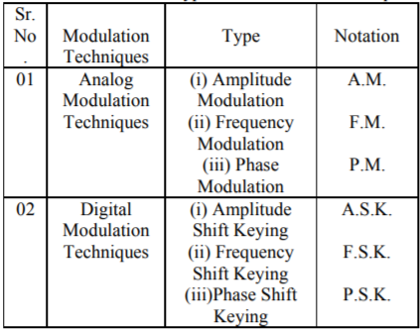
Figure 1. Showing the different modulation methods between the modulation schemes, analog and digital. [3]

As seen in figure 1, modulation methods are split up into the two modulation schemes as previously discussed. Analog uses simple modulation methods, named Amplitude, frequency and phase modulation also known as AM, FM and PM. “Analog modulation techniques are the representation of analog information by an analog signal.” [2] Whereas digital modulation methods are considerable similar, despite being a shift keying method, which introduces a few advantages.

The main difference between these signals is that an analog signal, like what comes from an old RCA jack, or as another example being voice. These methods would represent a larger range signal graph, compared to digital signals that are represented by one of two values, usually being binary 0 and 1 which creates a blocky type graph as seen later in this report. Because of this, digital communications are as previously mention, less likely to be interrupted by noise along with having a great advantage of being more flexible and cheaper than analog circuits.

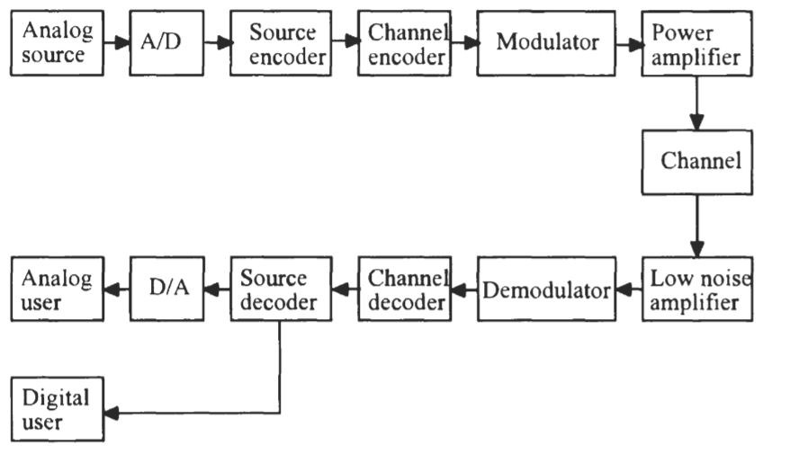
Figure 2. A block diagram showing the process of turning an analog signal into a digital signal. [4]

This process allows for the any analog information to be transformed using the A/D (Analog to Digital) converter, then quantizes the signal and turned it into the digital signal.

As seen in figure 2. The process of modulation must also have a demodulator, also known as “MODEM” [5]. The term demodulator was introduced and used because the modulated signals had to be demodulated, turning the signal back into its original form. Without demodulation the signal would result in being so distorted that the original signal would be lost. The types of distortion introduced into the signal could be amplitude, frequency or phase which would depend on the type of methods used. [6]

Modulation and Demodulation Methods
In this section, before implementation it will be discussed the fundamentals of each digital modulation methods signal form. These signal forms being, ASK (Amplitude Shift Keying), PSK (Phase Shift Keying) and QAM (Quadrature Amplitude Modulation) and extension of ASK. The examples below are methods that are also called on off keying, due to its keyed nature of presenting binary bits of 0 or 1 for example, Morse code. [7]

ASK (Amplitude shift keying)
By looking at figure 3, it can be seen by the blocky type graph on the top section of the diagram, for which uses binary in order to complete the graph, usually represented by 0 and 1. The lower model in the diagram shows the ASK via sine wave. Once converted, it can be compared showing that where there is 1 bit shown on the blocky graph, the sine wave forms peaks, where there is 0 bits there is no sine wave and then gives off a flat line effect. This method is also called on off keying for its on off wave format as displayed.

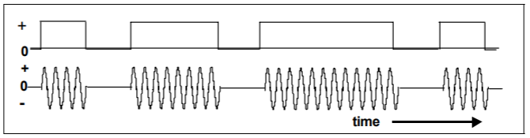
Figure 3. Showing the graph structure for ASK. [8]

PSK (Phase shift keying)
After looking at figure 4. An example of BPSK (Binary Phase Shift Keying), the simplest form of PSK (Phase Shift Keying). Similarities are seen in comparison to ASK, where the keyed (on off keying) method of binary 0 and 1’s are represented. PSK does this by turning a simple digital signal into binary, then using the PSK modulation method it creates a sine wave structure, that then forms a unique sine wave that shifts direction every time the binary signal changes from 0 to 1. It does this by just using 2 phases that are separated by 180 degrees. PSK is in fact considered the most robust scheme of modulation when it comes down to noise as it can take the highest level of distortion and still demodulate successfully, resulting in this method being one of the most widely used wireless LAN communication application. [9]
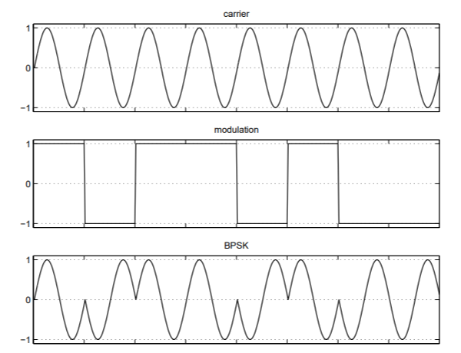
Figure 4. Showing an acceptable scope of BPSK. Note that the bottom section of this figure shows the 180 degrees phase shift on the sine wave. [10]

QAM (Quadrature Amplitude Modulation)
Used by Virgin Media as their modulation and demodulation method, QAM does not only use scopes which helps present information in wave forms on Simulink, like ASK and PSK as seen later in the report.

16 QAM, also known as QASK is both an analog and digital modulation method. While quadrature means it has 2 waves called the cosine and sine wave. These waves are out of phase by 90 degrees (see fig 5 & 8).
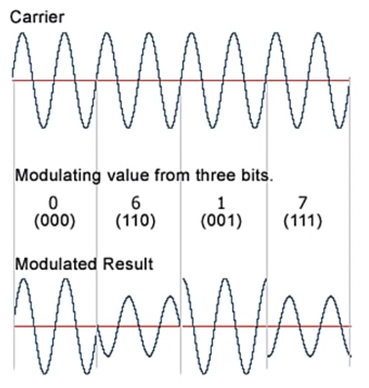
Figure 5. QAM works by both amplitude and shift keying, this figure shows the phase shift and amplitude in the modulation result of 16 QAM, in this example the result has an amplitude of 2 and a shift key of 90 degrees. [11]

QAM makes use of constellation diagrams as seen in fig 6. An example of this can be seen with 8PSK, which is an advanced version of PSK, it uses 8 symbols that’s are represented by a binary form like the constellation seen in fig 6. Looking further into figure 6, QAM uses 16 symbols and each symbol has its own binary form from 0000 to 1111, whereas 8PSK uses 000 to 111.

By going more in depth with figure 6, it can be seen that QAM has a 3 phases and also has 3 amplitudes, this is called multilevel modulation. This can be seen as an example for each quadrant.

- 1001 = phase 1 at 25 degree / amplitude 1
- 1101 = phase 2 at 50 degree / amplitude 2
- 1100 = phase 3 at 75 degree
- 1000 = amplitude 3
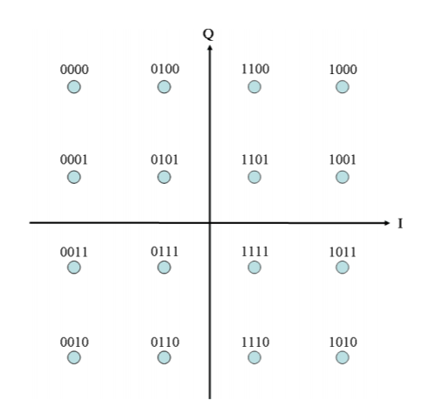
Figure 6. Showing the 4 quadrants that consist each of 4 symbols making up 16 binary symbols that make up basic QAM. [12]

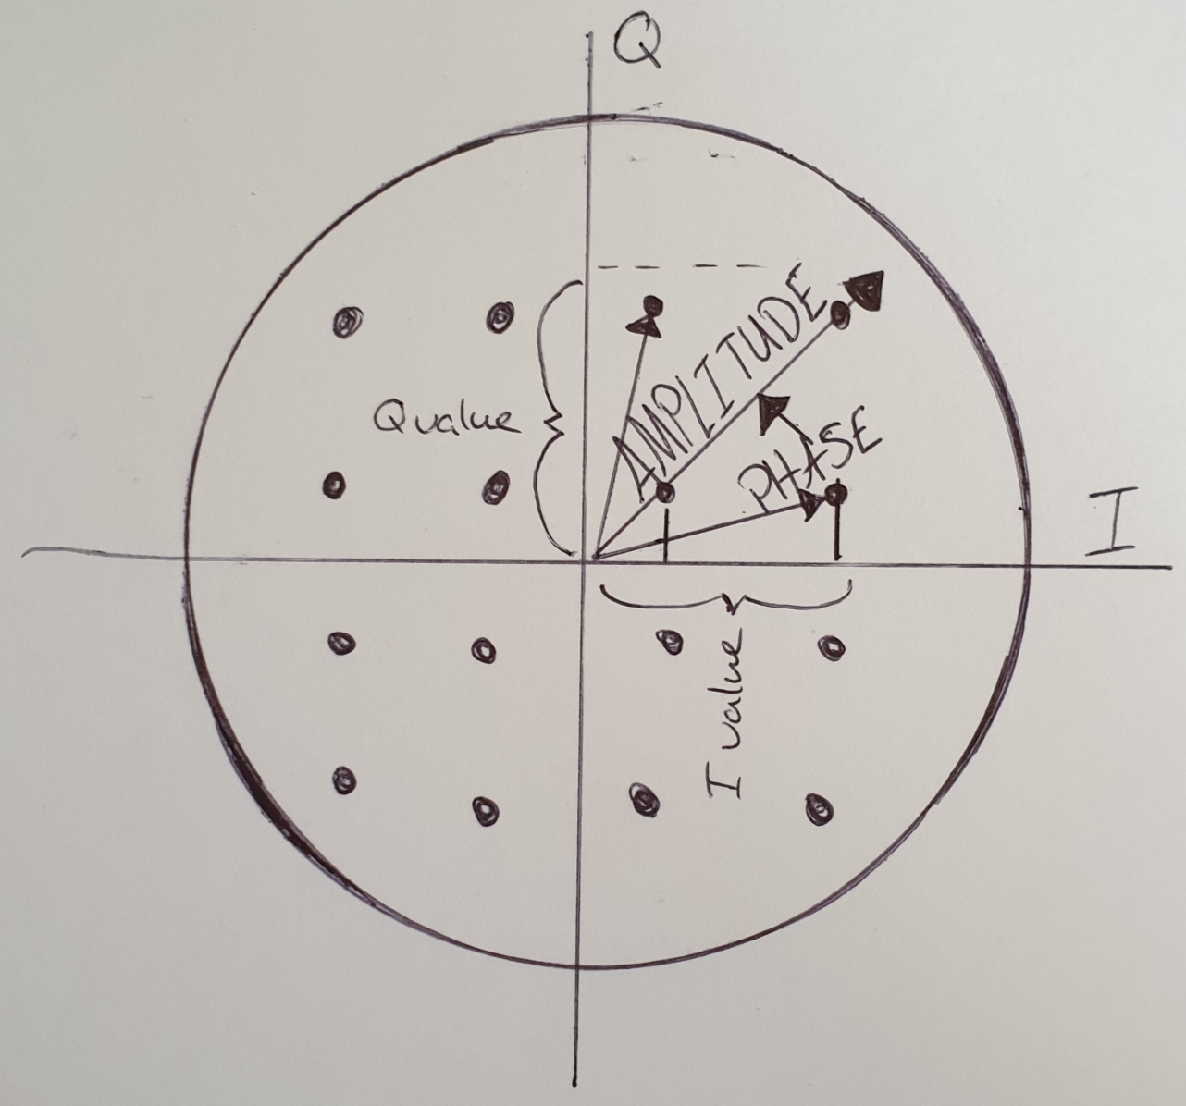
Figure 7. In comparison with figure 6, it can be seen the 3 amplitudes and 3 phases that make up the constellation diagram for 16 QAM. [13]

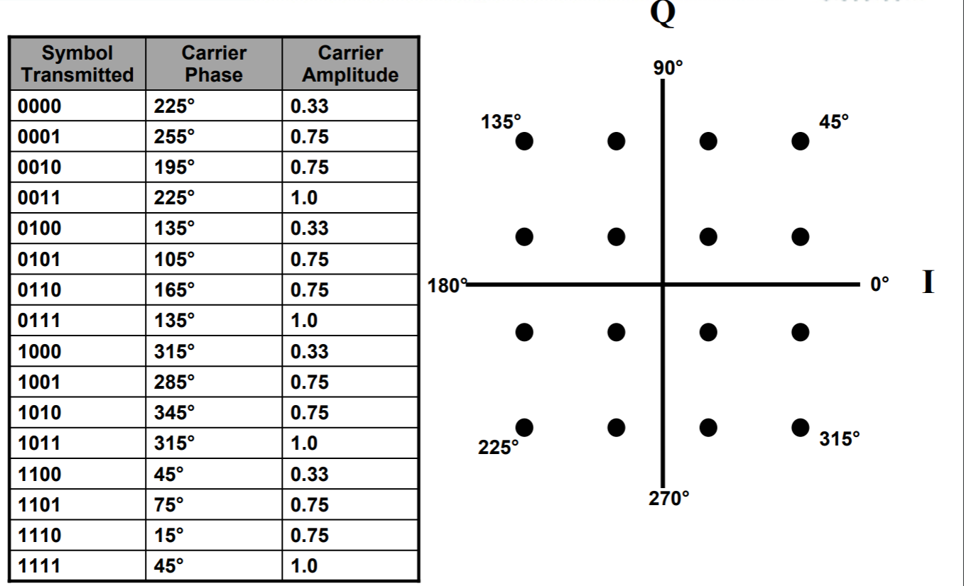
Figure 8. Showing the 90 degrees phases of 16 QAM. [14]

Experimentation of Modulation Methods
In order to understand these modulation techniques, three experiments have been done for each modulation scheme previously discussed. These experiments were done by using MATLAB’s Simulink, simulation software for modulation and demodulation. As part of the scenario, it was advised to get results with noise and without noise for each modulation method, as well as being advised to try and avoid using premade blocks. Sadly, due to a few limitations, ASK and PSK were done as individual custom blocks while QAM had to be done with premade Simulink blocks. However, with these premade blocks, it shows proof of concept and backs up everything previously discussed.

ASK (Amplitude shift keying)
In order to create a successful ASK modulation system there are a few important steps that must be applied. For instance, in order to make an ASK modulator, a binary generator will need to be introduced. This generator is called a Bernoulli binary generator that will just simulate random binary data for the simulation to work. The next block that completes the modulation is a switch which modulates the binary signal into and ASK signal. Which is then linked to a noise block, that generated a level of controllable noise that will aid the simulation in order to gather more realistic results.

After adding noise into the simulation, the next process is for the signal that was created to go through a filter, the job of the filter is to filter out certain frequencies in order to get back the same data as was sent originally.

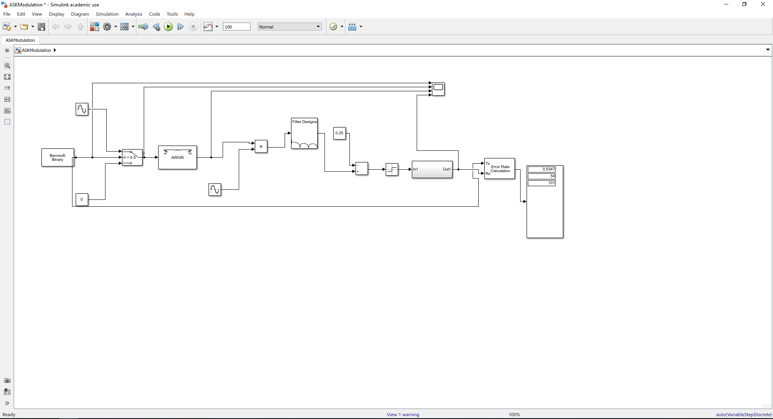
Figure 9. Showing the complete simulation structure for ASK.
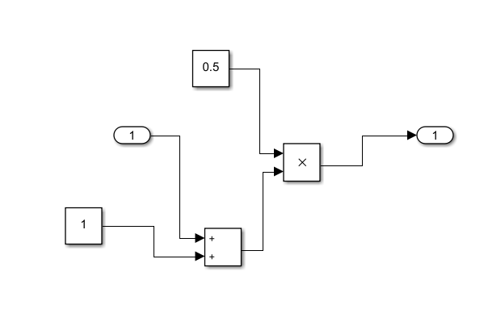
Figure 10. Inside the cluster block before the error rate calculator.
Figure 11. Showing the error rate for ASK. The error rate for this is not great with a run time of 101, the simulation had 54 errors with 0.5347 percent error rate. This is because of the similarities with AM (Amplitude Modulation), interference can cause the information to become easily corrupted.

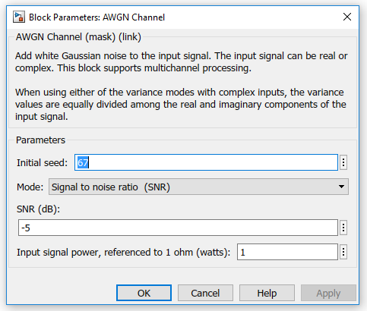
Figure 12. Showing the characteristics of the AWGN Channel (Additive White Gaussian Noise) block in the ASK simulation.

AWGN is a basic noise model than generates “random radio noise characterized by a wide frequency range with regards to a signal in the communications channel.” [15] The main configuration setting in this block is SNR (Signal to Noise Ratio) configuration, where the level of radio noise for example is set in decibels (dB), in this example -5 is high noise.

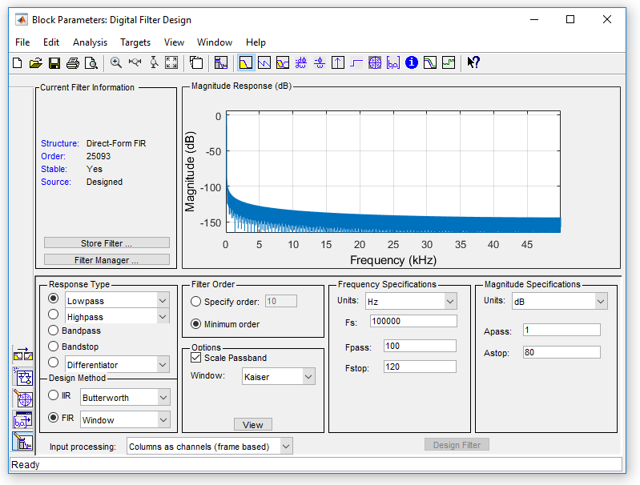
Figure 13. Showing the filter block for ASK, showing filtering of 100 Hz and 120Hz with a magnitude of 1 to 80 dB filtered out. In comparison to the graph the block pictates, it can clearly be seen where the filter is being applied.

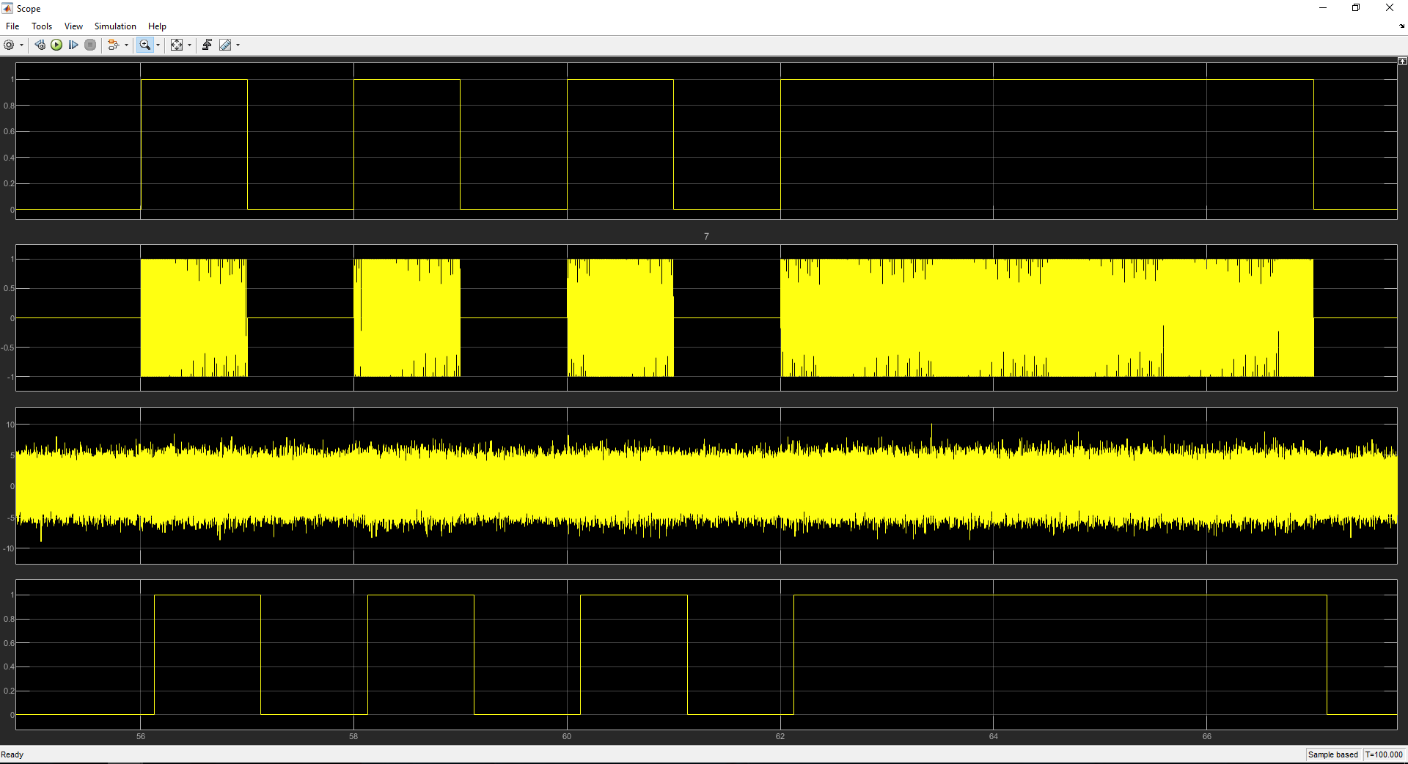
Figure 14. The outcome from the scope in the Simulink simulation for ASK.

Showing clearly that the signal sent has been received successfully. However, because of the high level of noise added it shows that there is a slight delay in the received ASK signal.

PSK (Phase shift keying)
In this example, the PSK model can be see with an array of similar blocks that have been used previously in ASK. For instance, the same binary generator, switch and noise generator. However, in this experiment, a custom filter had to be designed in order to keep the error rate low, with use of the filter design wizard as seen in fig 18.
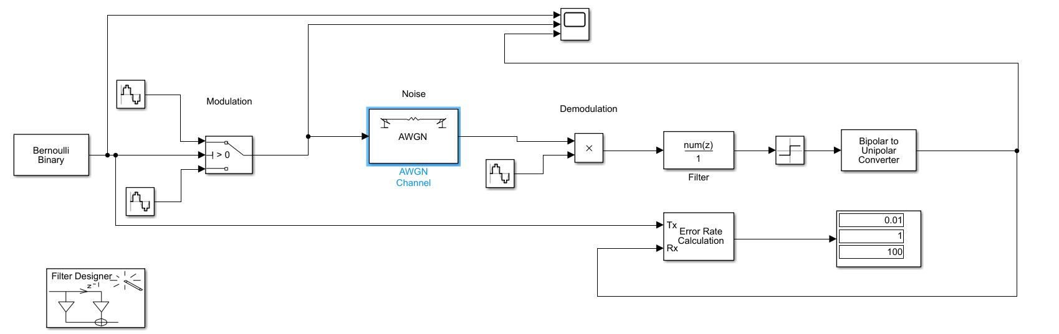

Figure 15. Showing the structure of PSK in MATLAB.
Figure 16. Showing the error rate calculation, as it can be seen by the display box within MATLAB, out of the run time which was 100, there was only 1 percent error rate.

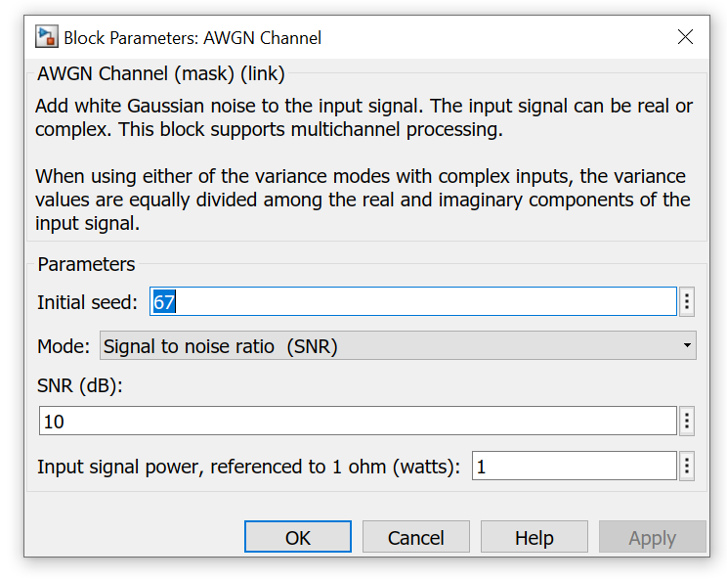
Figure 17. Showing the high noise level for PSK modulation.

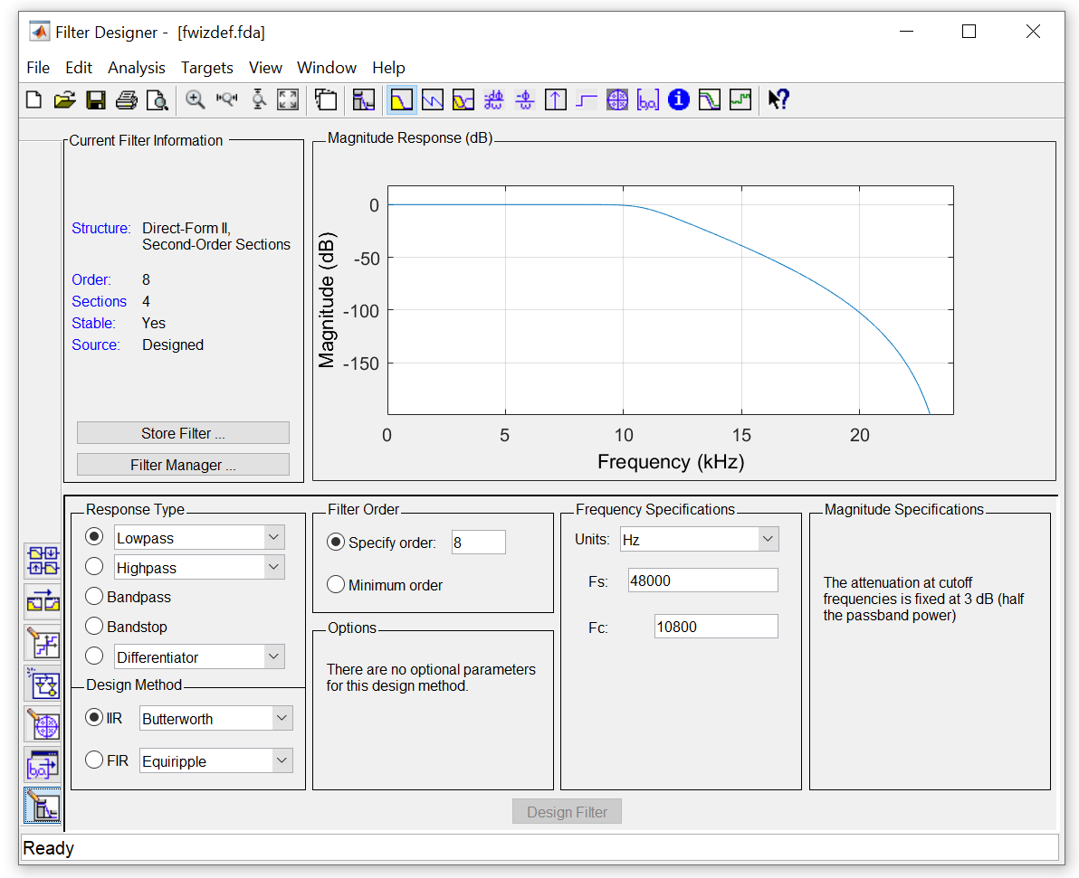
Figure 18. Showing the filter design wizard that was used in order to filter out the correct frequencies to avoid a large set of errors.

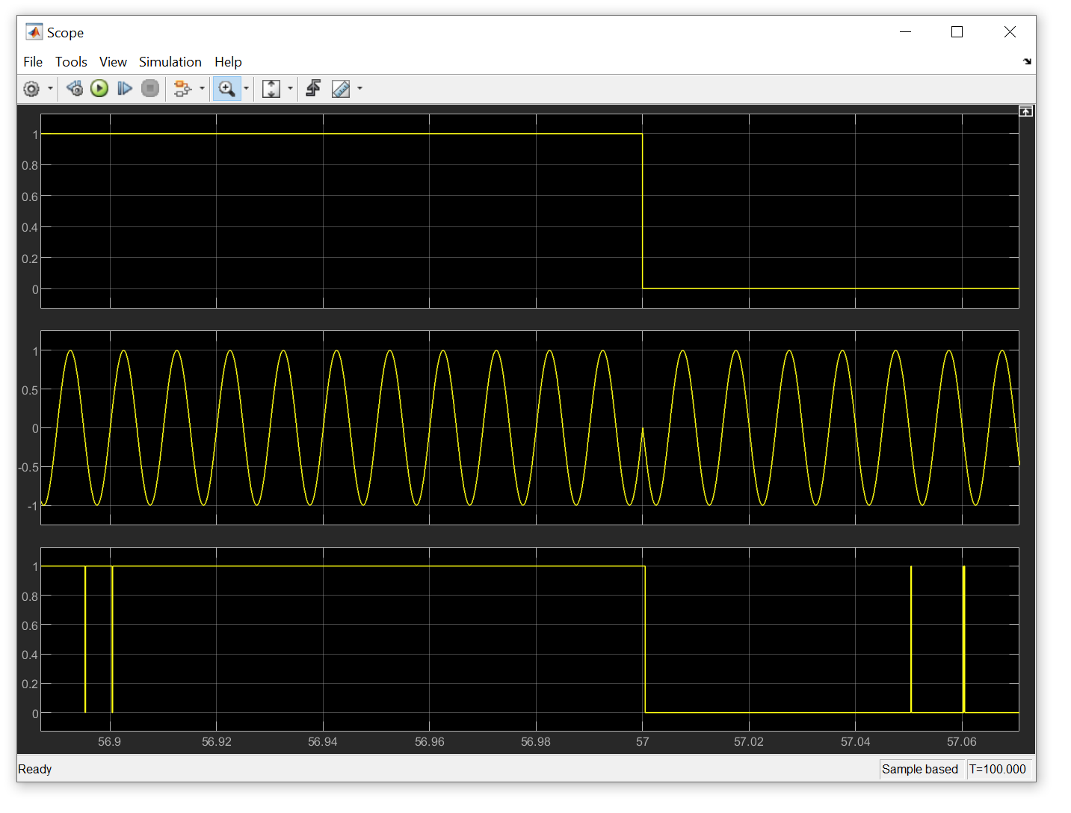
Figure 19. Showing PSK scope with 10dB noise level configured on the AWGN channel.

As it can be seen, the data sent have been successfully received, however due to the higher level of noise compared to fig 20. There are small spikes of interference where noise has affected the demodulated signal. This is a very realistic simulation because there are very little errors along with small amount of interference with successful results and no delay.

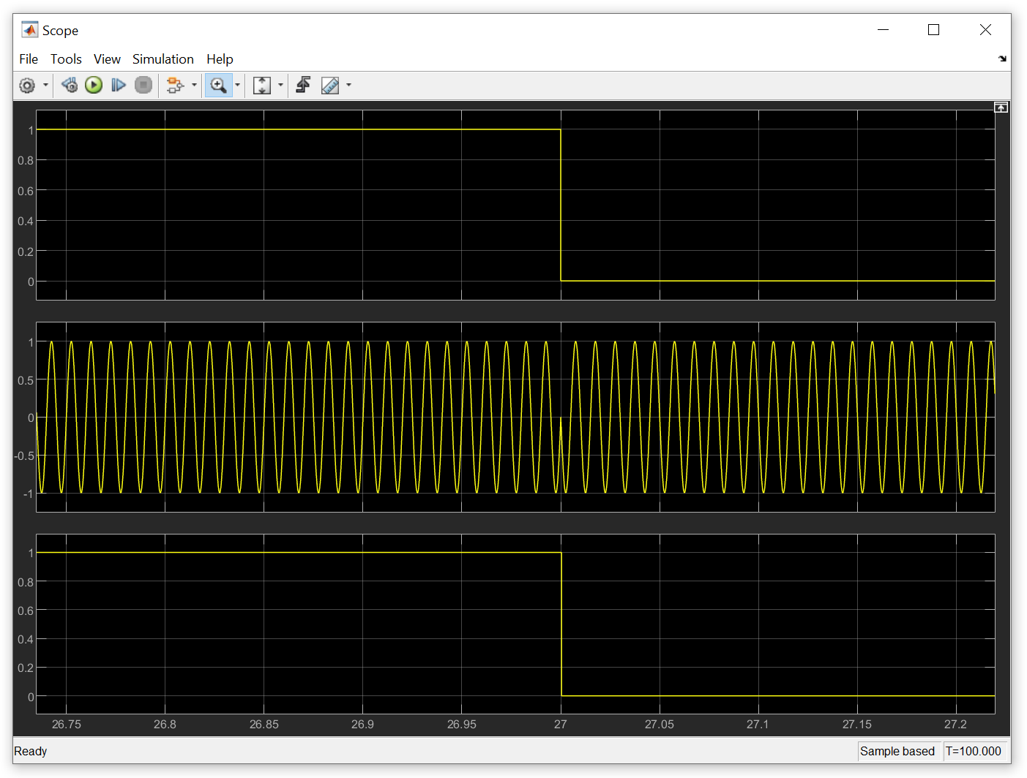
Figure 20. Showing a perfect world scenario at 20dB noise, with no interference at all. As well as showing the 180 degrees shift in the middle column as previously discussed in fig 4.

QAM (Quadrature Amplitude Modulation)
QAM is a simply a hybrid between ASK and PSK, however after some implementation of QAM. A few complications in the MATLAB design for QAM, resulted in the use and implementation of pre made blocks for both the QAM modulation and demodulation systems. However, after configuring the premade blocks, it can be seen later that proof of concept has been achieved.

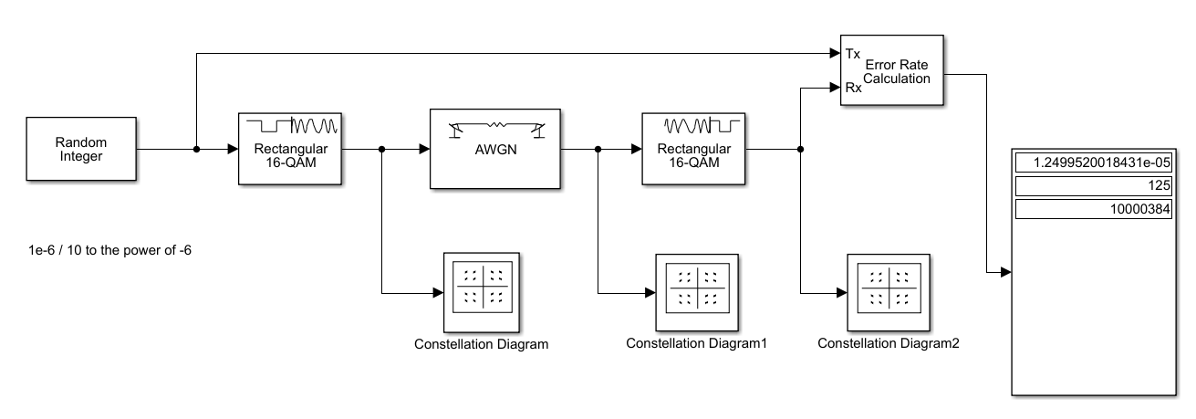
Figure 21. Showing, the structure of the QAM modulation methods.

This simulation consists of a binary and noise generator like the previous modulation methods. The main difference that can be seen is the individual blocks for QAM modulation and demodulation, see fig 24 & 25 for configurations.

Figure 22. Showing the error rate for QAM modulation.

As it can be seen there is not a lot of errors compared to the run time. This would only be 1.25 percent error rate compared to the run time.

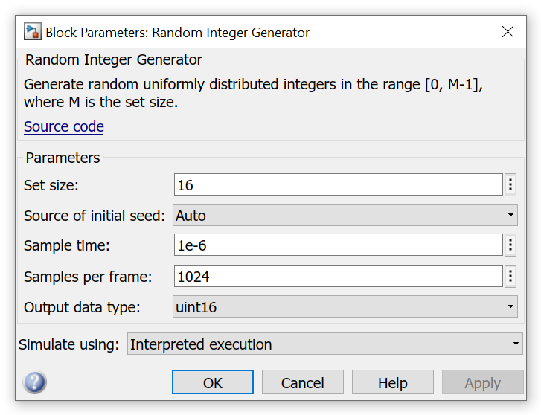
Figure 23. Showing the configuration for the random integer generator.

The set size in fig 23 is 16 in order to create the 16 QAM simulation, along with 1e-6 (10 to the power of -6) as the sample time along with the samples per frame being 1024, making the simulation time longer causing a longer effect in the error rate calculator in fig 22.

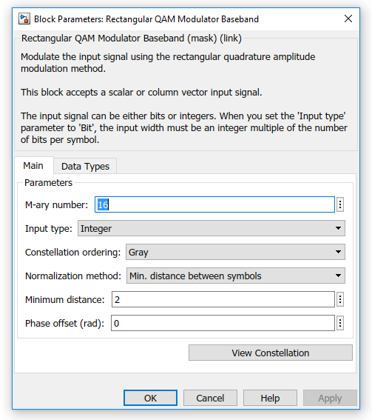
Figure 24. Showing a simple configuration of the QAM modulator with the M-ary number as 16, which represented the number of symbols. Along with a minimum distance of 2 between each symbol. If this was closer, then this could result in more interference from one another (symbol to symbol).

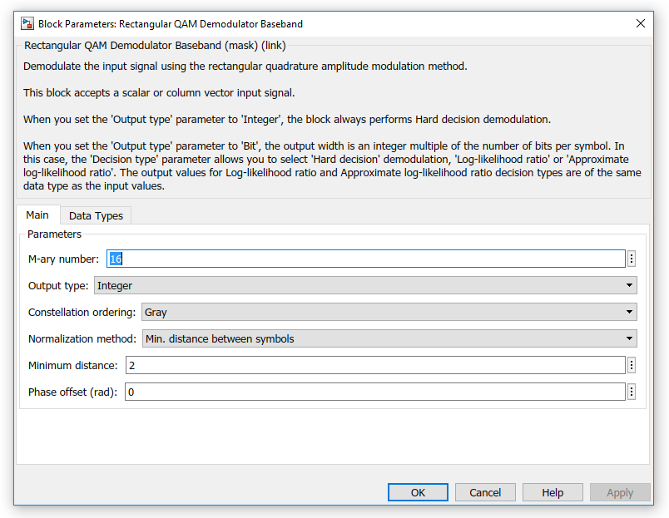
Figure 25. Showing a simple configuration of the QAM demodulator with the M-ary number as 16, which represented the number of symbols. Along with a minimum distance of 2 between each symbol. If this was closer, then this could result in more interference from one another (symbol to symbol).

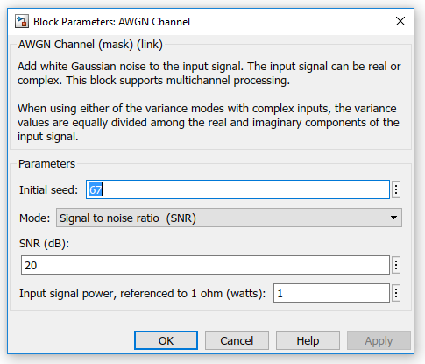
Figure 26. Showing the lower level of interference generated for this QAM example as 20dB.

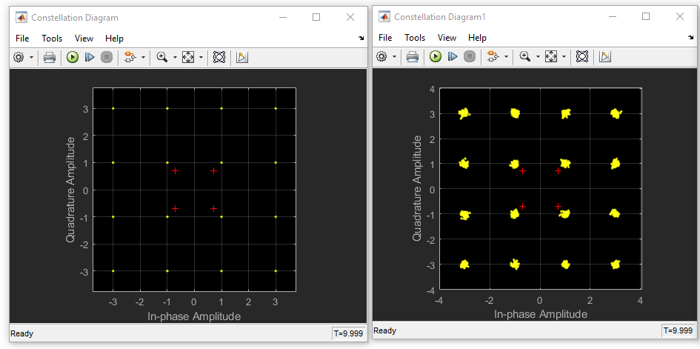
Figure 27. Showing the results of a successful modulation after noise was introduced with 16 symbols.
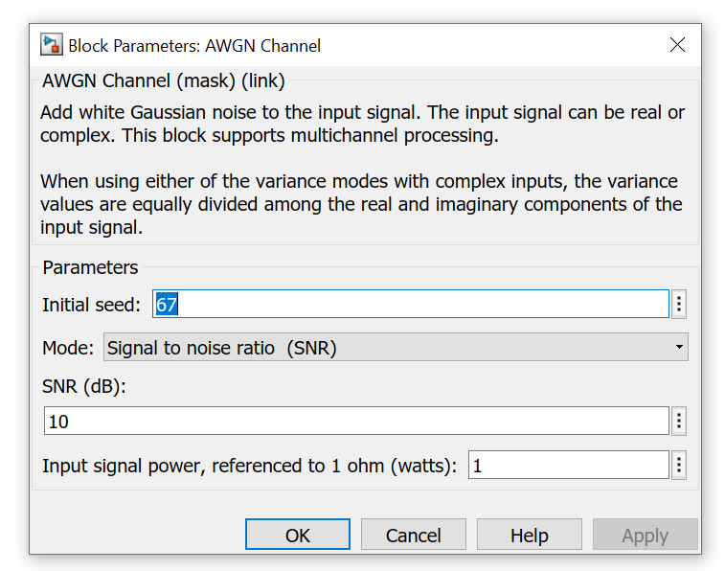
Figure 28. Showing a higher level of noise for QAM at 10dB.

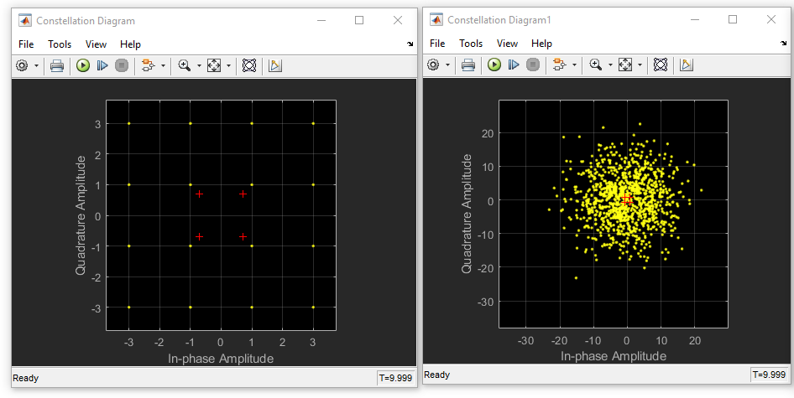
Figure 29. Showing the result of a higher noise level, where the symbols information is just getting lost amongst itself.

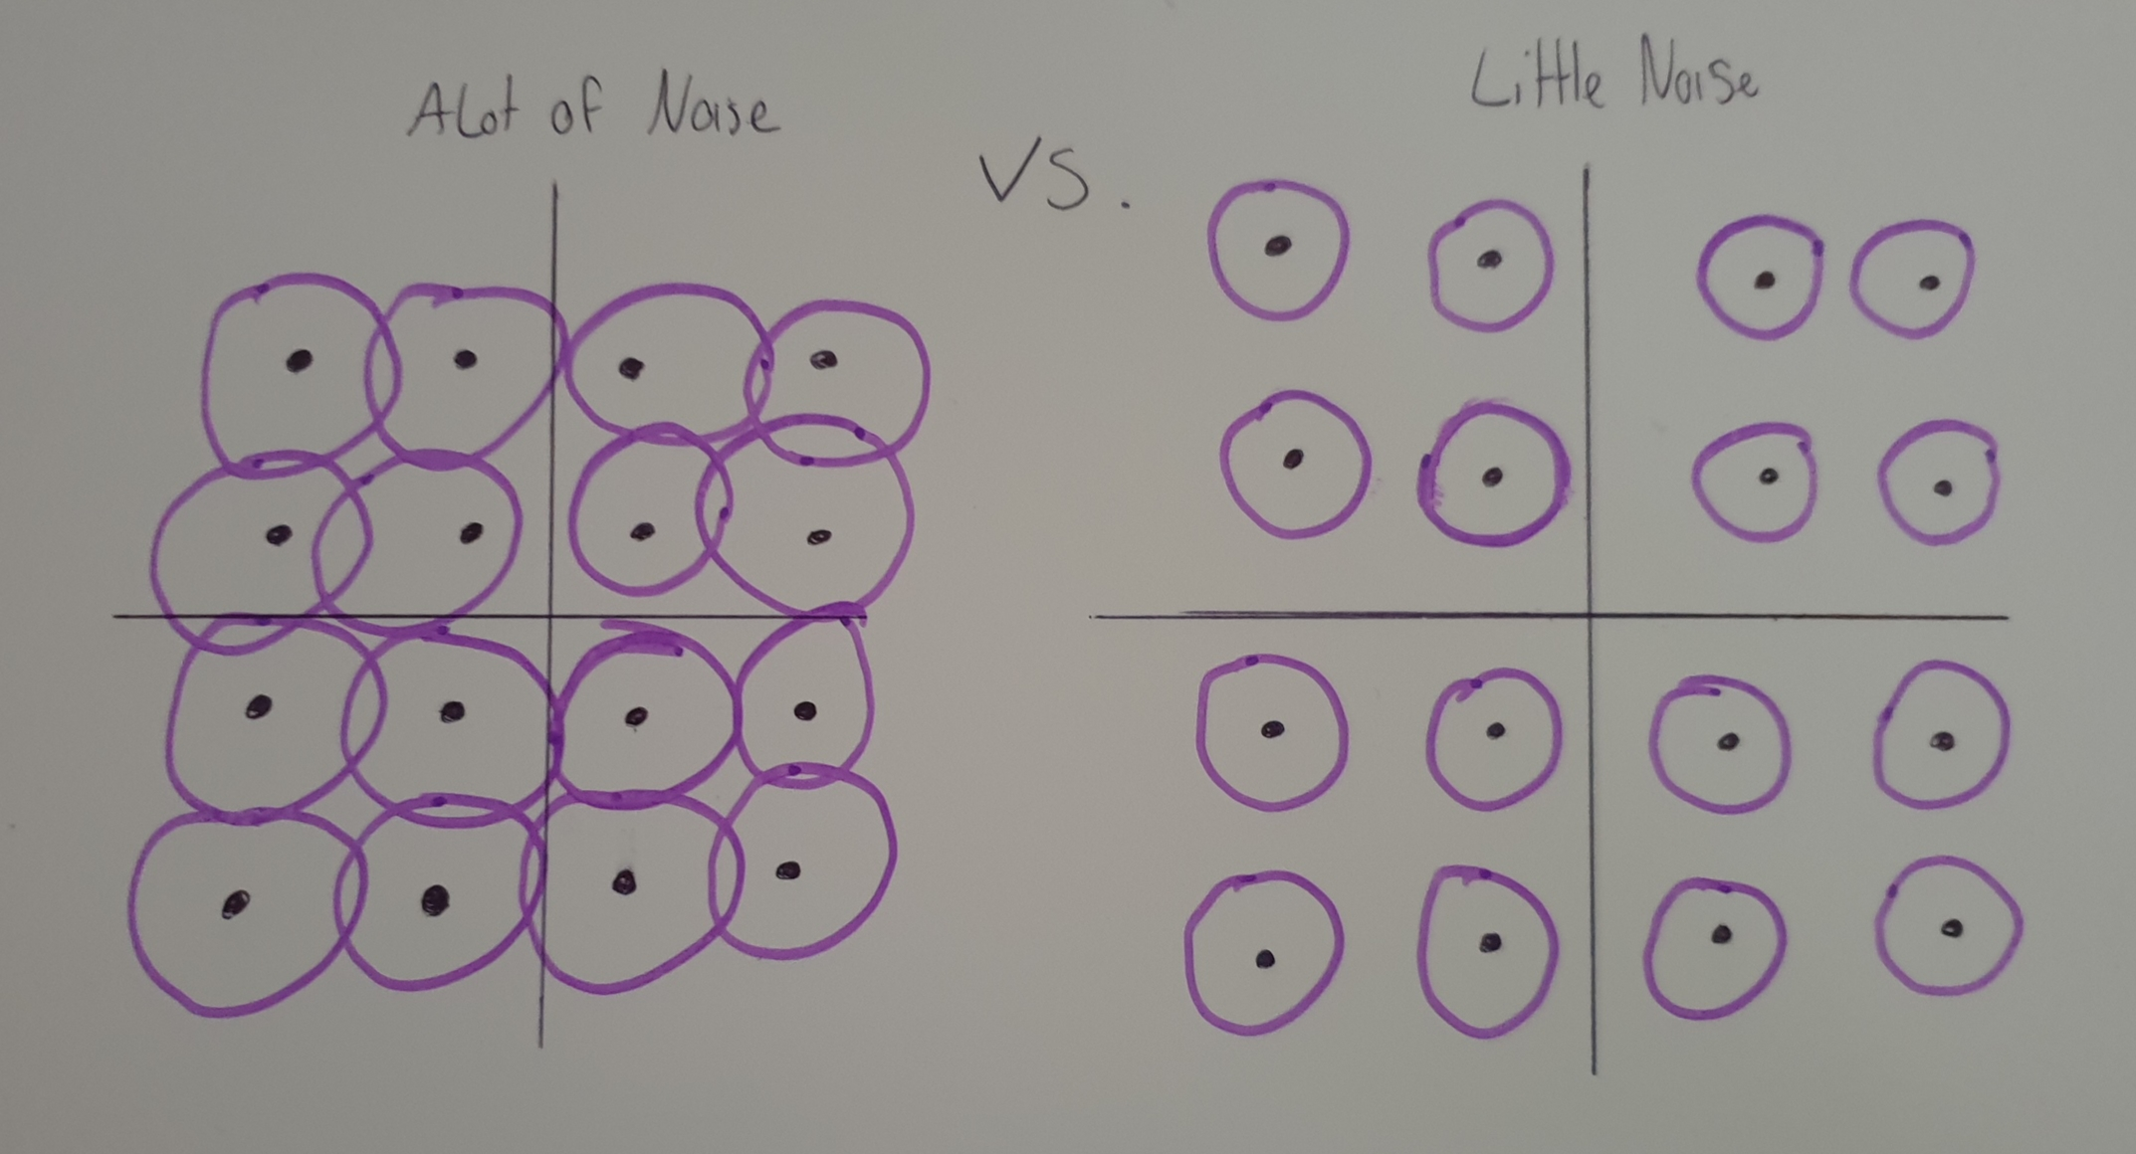
Figure 30. An example of what a lot of noise and little noise does in these simulations.

Take little noise, with this example the rings around the symbols are not touching one another or colliding. Whereas with a lot of noise they are colliding and even going into each other’s zones. If this happens, it will look like fig 29, where there is a lot of interference and the signal is no longer clean enough to be able to read again. However, with some filtering and demodulation it could be possible, however this would result in a lot of errors on the error rate calculator as seen in fig 31.

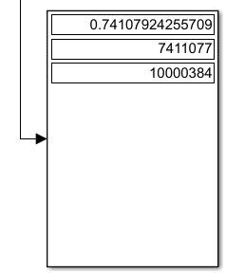
Figure 31. Showing the result in -10dB noise added to QAM, displaying over 70 percent error rate.

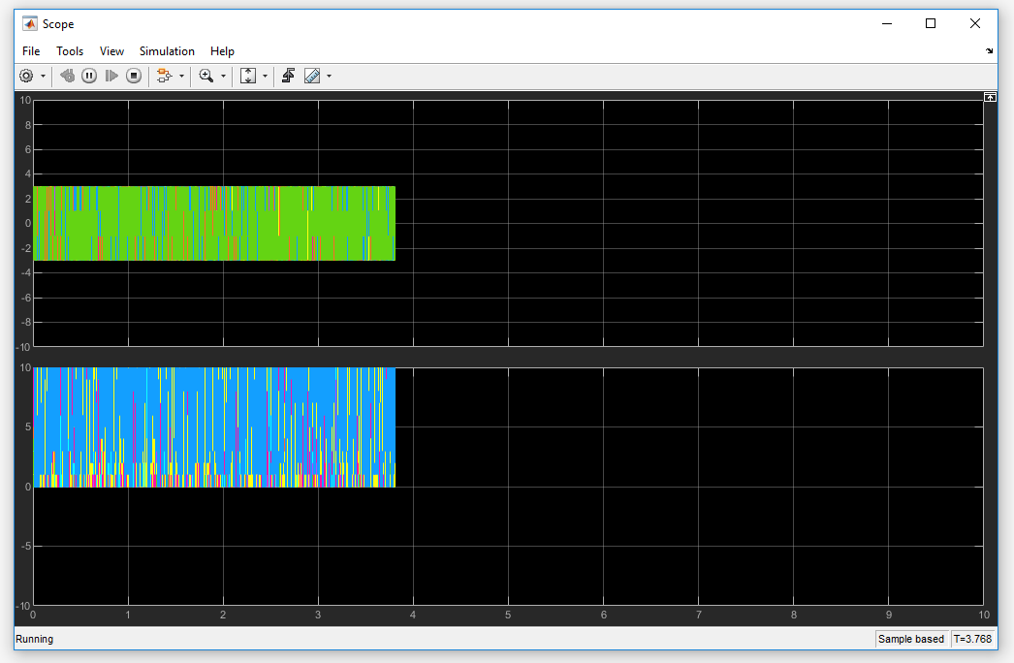
Figure 32. Showing what happens when a scope is added to QAM.

Sadly, this is because of a hardware limitation that the scope could not run successful and would crash part way. However despite this, if this was to work it would not be an accurate reading due to QAM being 16 symbols in this example, and the scope becomes confusing with many colours representing each symbol in the constellation diagram.

Comparison of Selected Modulation Methods
After doing the necessary experiments on each modulation method, it seems they were all successful but with minor flaws on each. It seems that ASK is very susceptible to noise according to the error rate calculator, however with a good filter the signal is received successfully but minor with delay.

Because of this, it seems the comparison is left down to QAM and PSK, however it does seem both are very good dealing with noise, according the error rate calculator and it would be assumed that both of these are used in the real world most often than any other modulation method because of this. However, after further investigation into PSK’s simulation on MATLAB, it seems as seen in fig 33 that PSK has a lower error rate when both set at the time SNR of -10dB.

See fig 33 and 31 to compare.

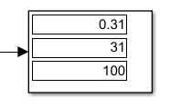
Figure 33. Showing PSK at -10dB, with 31 percent error rate.

Part 2 – Wireless Networks Design
In this section of the report underlines the implementation of wireless devices in the Caribbean, where there is an issue with farming and theft, along with issues amongst the Caribbean’s cities involving knife crime. With these issues in mind, the wireless system that will be implemented will try to solve and aid the workers on the farm in order to protect against such larceny problems throughout the island.

Background Information
Before the implementation can take place, a bit of background research must be done in order to decide what wireless communications standard will be used throughout the network. There are many standards that could be considered, from LoRa to Zigbee, along with other standards like Cellular and Wi-Fi.

LoRa is part of a wireless modulation scheme that is utilized in order to make long range communication links possible by using FSK (Frequency Shift Keying). If this was implemented it could mean that one single gateway could cover entire cities if needed. However, the range does depend highly on the environment around it, as if there are large skyscrapers it could cause large interference for the wireless signal. LoRa could have been implemented in the design, via LPWAN. “LPWAN offers multi-year battery lifetime and is designed for sensors and applications that need to send small amounts of data over long distances a few times per hour from varying environments” [16], making a great contender for the network.

Zigbee was created with the a main aim to run on the smallest devices, never to control any more than a small area. Whereas many other standards are striving to go faster, Zigbee aims for low data rates over small 8-bit microcontrollers. Which is perfect for a small farm with many small sensors. “ZigBee looks to control a light or send temperature data to a thermostat.” [17] Yet, they may not want to be a high-powered giant like other standards, the biggest advantage to Zigbee is that their devices can run for years.

The main idea of implementation would be a WLAN design [18], after considering using many other methods it comes down to what is best on the software used, in this case Netsim. The standard that will be implemented in 802.11ac [19], however later comparing the differences between an alternative wireless standard 802.11b [20].

As for the implementation design on Netsim, it had been decided to use an internetwork infrastructure which uses WLAN standards. The reason this was chosen, was because it was necessary to make this network as realistic as possibly with a design than could aid in the hardest task of all for the computer industry, moving information between computer of complex design. “This linking of computer systems, software, and communications devices into strategic infrastructures is called internetworking.” [21] This concept will allow for many devices to be setup and communicate with each other in a diverse manager across many kinds of networks. This will be a main focus as it will help aid against crime, along with giving the farm ease of life through the IoT (Internet of Things) services implemented as wireless nodes on Netsim. This also means that Zigbee could not be implemented in this network as it is not apart of the internetworking package on Netsim.

Another consideration was to use the IoT design on netsim because of the Zigbee integration for wireless sensors, however it is not very realistic when connecting multiple locations, especially when these locations need more than one IoT gateway. Basically, with the IoT design it would only allow one gateway where there would need to be more than one for the farm to have a connection to the cities police station as seen later in the report, whereas within internetworking an access point can be used instead, either as wireless or wired.

Physical Topology
Before a logical topology is implemented, one last step must be taken. A physical topology must be designed, this aids in the final design of the network as it enables easier understanding of where and what devices will be linked to what.

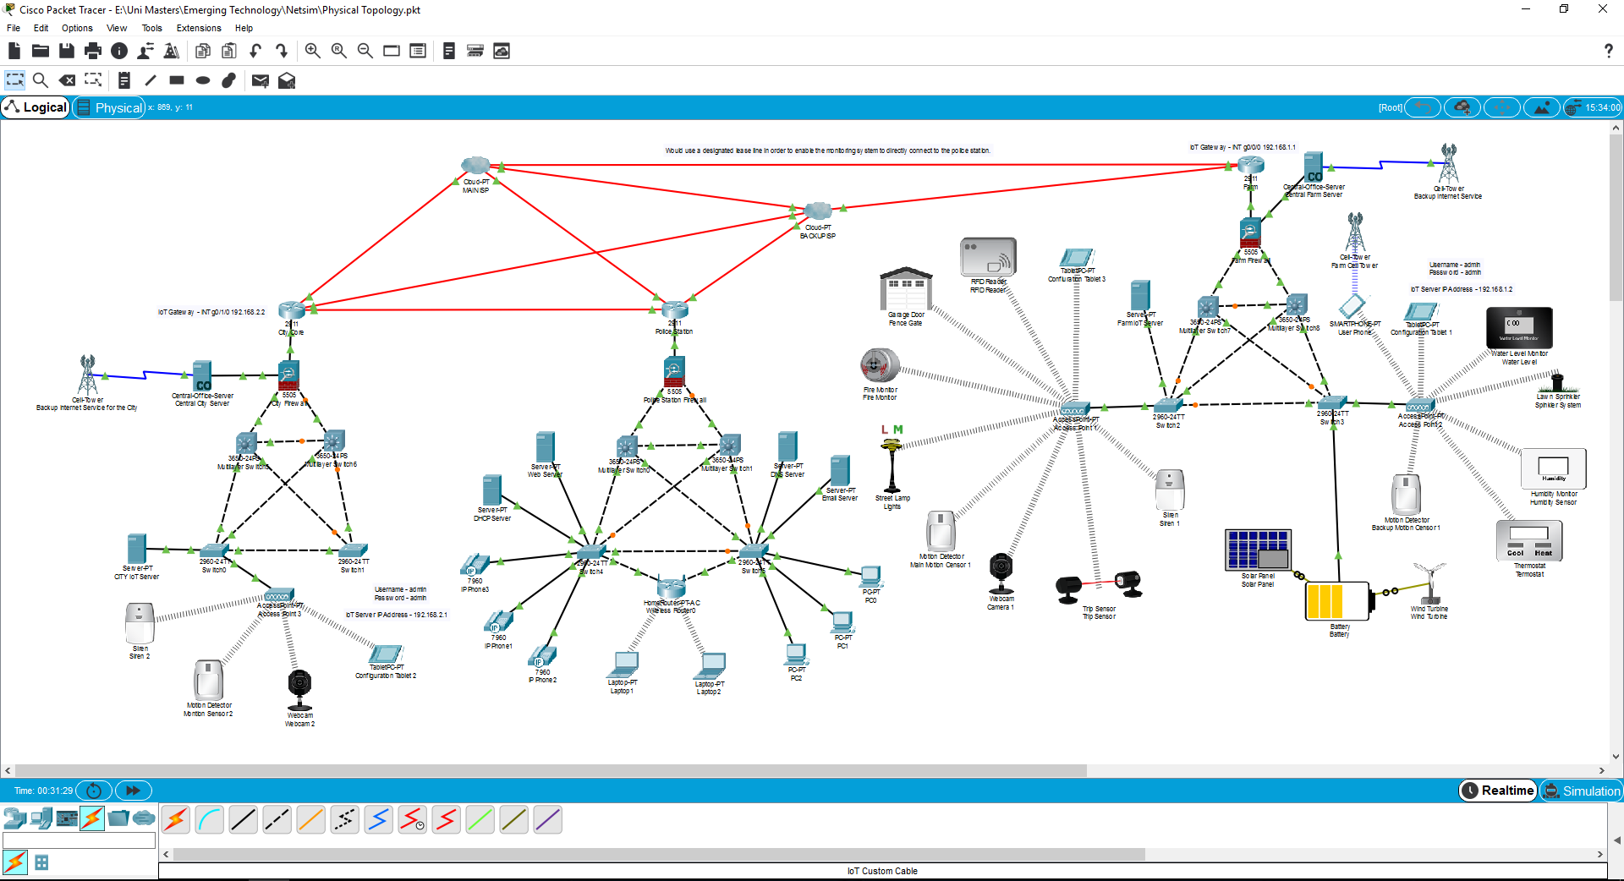
Figure 34. Showing an example in Cisco Packet Tracer of the physical topology for the entire network.

This simulation features the farm network on the right, the city on the left and linked to the city, a police station at the core. All connected via wireless links, fiber optic cables and many more. Along with the implementation of a hierarchal network model (core, distribution and access layers) for each area of the network while implementing firewalls for added security.

This physical topology also shows, in comparison to the logical topology later in the report, shows the use of cellular towers not only for cellular devices, but also as a backup internet supplier for the farm that could be in a remote location. With this, the whole Caribbean network is linked to two ISP’s (internet service providers) for redundancy, in order for good redundancy. Another feature of this network is that a designated lease line will be implemented in order for the farm to reach the police station directly.
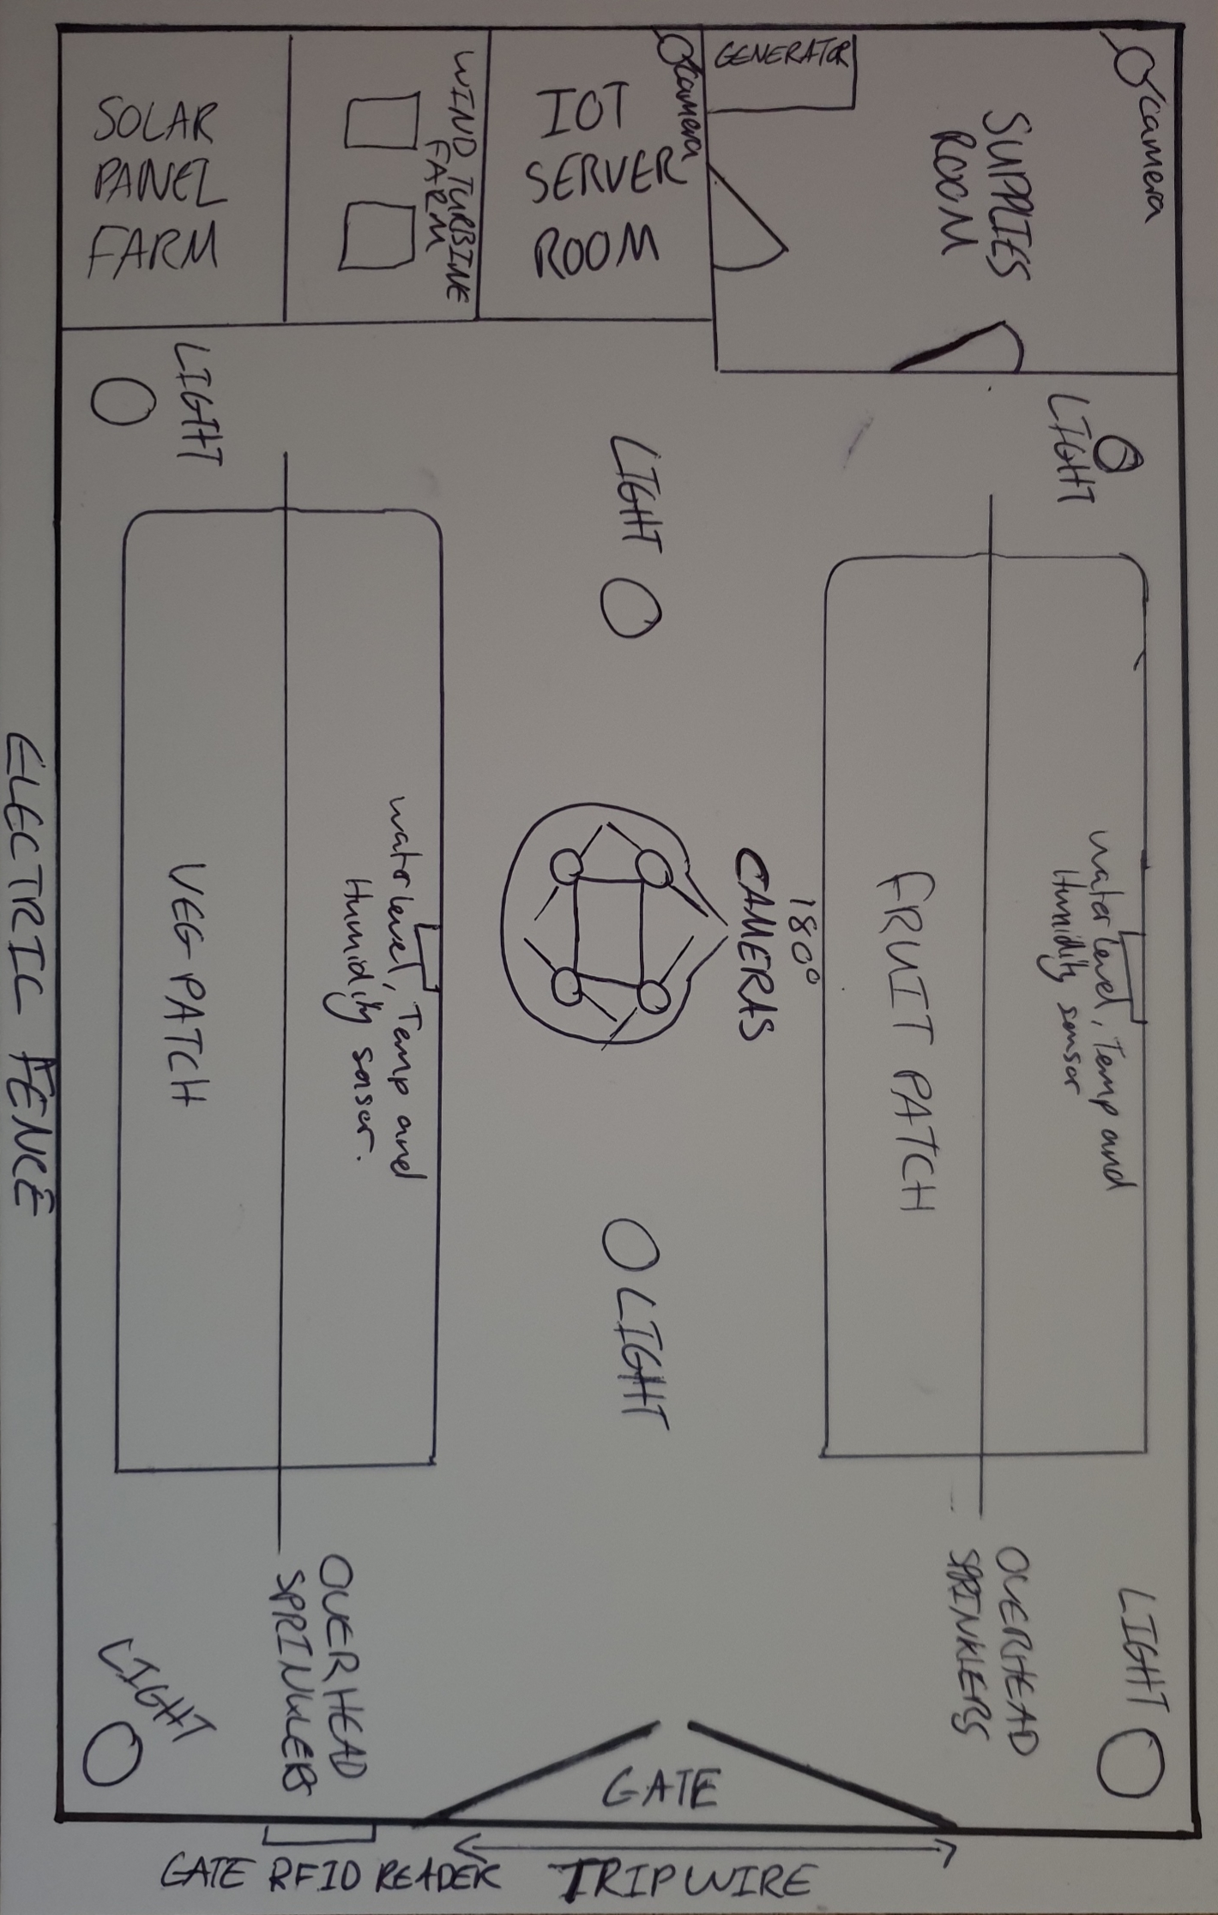
Figure 35. Showing a rough drawing of where all wireless devices will be placed in the farm, including 180 degree cameras, a variety of sensor devices in the veg and fruit patched to measure the growth, along with many other security devices like electric fence and an RFID controlled gate.

It is proposed that certain equipment is used in order to protect again knife crime throughout the Caribbean city, a suggestion that could be implemented is these new microwave vision cameras, that can see through solid materials in real time. “Its inventors envision airport scanners that screen passengers for weapons or explosives as they walk by.” [22]

Another possible solution to the rise in knife crime, could also be deterred by simple methods has checkpoints throughout the city that have body scanners that reveal weapons. [23] Not only will these suggestions prevent crime; it will also be a deterrent of crime for the future somewhat causing the criminals to worry about constantly getting caught through high tech means.

Network Simulation – Netsim
Netsim is a network simulation software, “that enables users to virtually create a network along with its components such as devices, links, and applications etc. To study the behavior and performance of the Network.” [24] It is standard that OQPSK (Offset Quadrature Phase Shift Keying) is the default modulation method for netsim, however one of the limitations of netsim is the issue where you can not select a particular modulation method.

However, with much research is seems possible to come close in comparing two modulation methods for the internetworking simulation design, as seen in the simulation results section of this report.

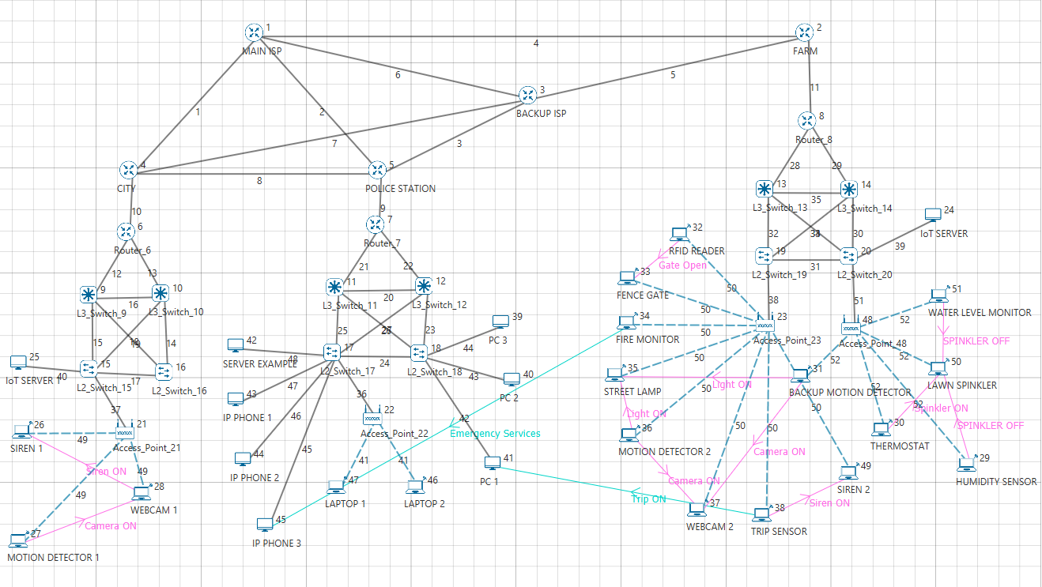
Figure 36. The logical topology in netsim, with custom links for the wireless devices to talk and work with one another, for example a motion sensor that turns on the camera when it detects movement, allowing for better economics throughout the farm.

In this example, it can be seen in figure 37 the connections made within the simulation, one example is an FTP (file transport protocol) application shows it is sending sensor data transfer from sensor 46 to sensor 46, while also having encryption set as AES (Advanced Encryption Standard) [25]. This is an example of a trip wire sending information to the police station, as request by the UWTSD for added security.

Another example linked to the trip sensor could be the custom links made in order to connect a sensor to another sensor. In the farm the trip sensor will alert sirens with in the farm to unauthorized access. Unfortunately, due to a limitation within Netsims internetworking infrastructure, it was impossible to simulation these links with sensor links. So custom links had to be made to get the closed results possible.

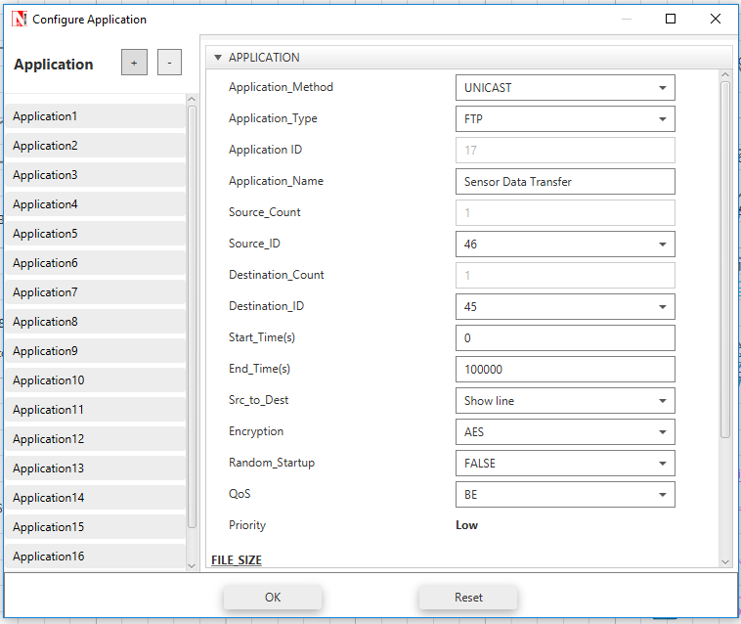
Figure 37. Showing basic connections made through the applications process in netsim.

Netsim Results
After the network implementation in netsim it is then possible to run the simulation in order to gather simulated results of how the network would operate. In this section there will be a discussion on wireless protocols used along with the modulation method they use.

802.11b
As previously mentioned Netsim uses by default OQPSK, however for internetworking wireless devices as default use DSSS (Direct Sequence Spread Spectrum) modulation as part of the wireless protocol 802.11b as seen in fig 38.

Through more research it can also be found that other modulation methods used with the 802.11b standard are also CCK (Complementary Code Keying) [26] and PBCC (Packet Binary Convolutional Coding) [27].

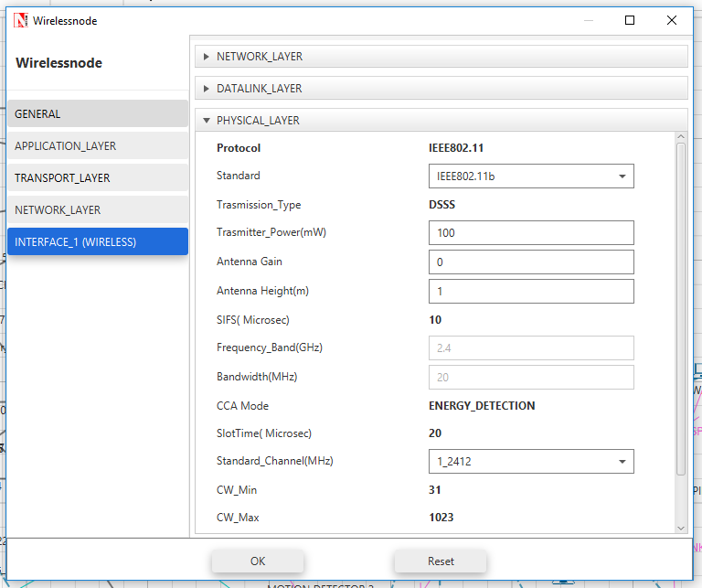
Figure 38. Showing the default wireless standard used in Netsim.

802.11ac
As far as wireless standards go in Netsim, 802.11ac is assumed to be the best. After some research it can be seen in fig 40, 802.11ac uses a variety of different modulation methods in the VHT (Very High Throughput) family, for instance the possibility of using BPSK, QPSK and 3 different QAM types all under VHT in the netsim simulation.

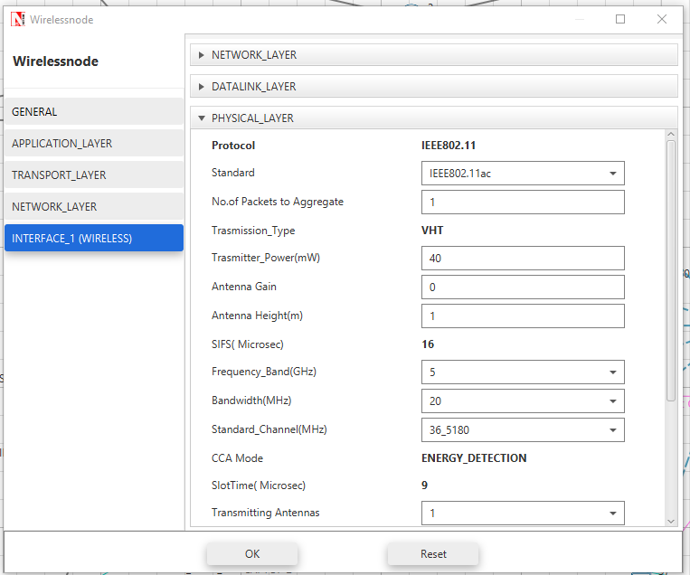
Figure 39. Showing the change of wireless standard used along with transmission type used, also know as the modulation method for the standard.

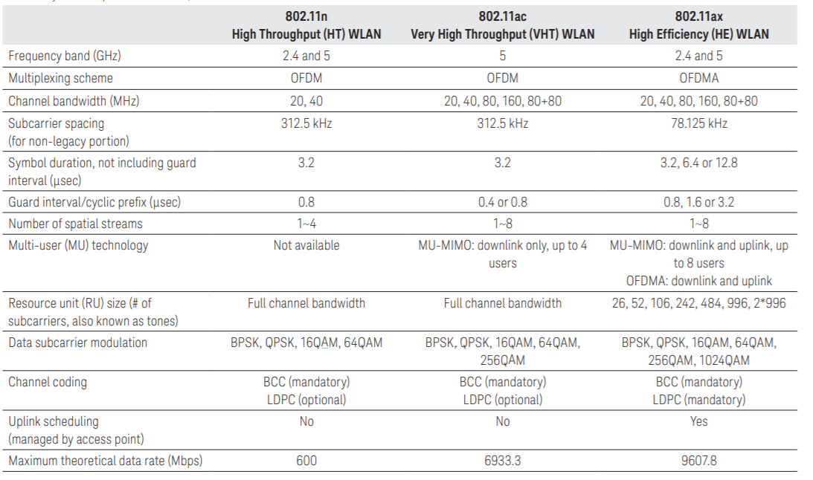
Figure 40. As seen in relation to 802.11ac, under VHT. 802.11ac’s modulation method can be many different modulation techniques, from BPSK, 16-QAM to 256-QAM. [28]

Comparison of Simulation Results
In this section, a comparison will be done between different levels of noise that will be introduced onto the wireless sensors. Further on showing a comparison between the two different wireless standards, for which use two different modulation methods.

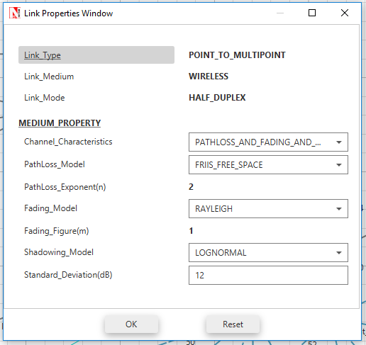
Figure 41. No noise as seen by 12dB (max). In order to keep the results as realistic as possibly it was decided to keep the channel characteristics with pathloss and fading and shadowing. Meaning that the environment has objects in the way that causes fading of the signal.

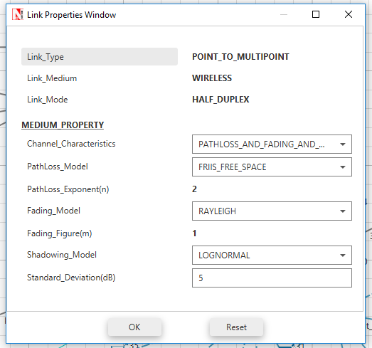
Figure 42. With maximum noise level at 5dB (lowest). While implementing Rayleigh instead of Nakagami.

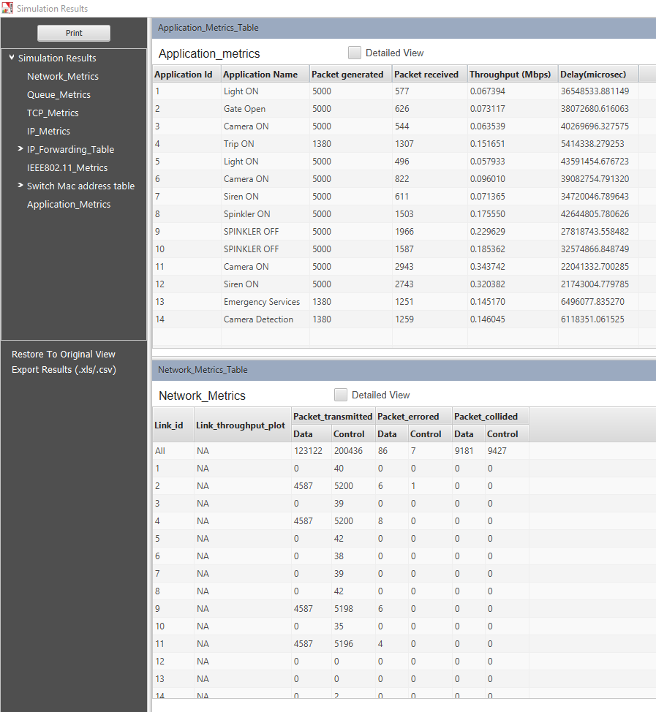
Figure 43. 802.11b with 12dB noise.

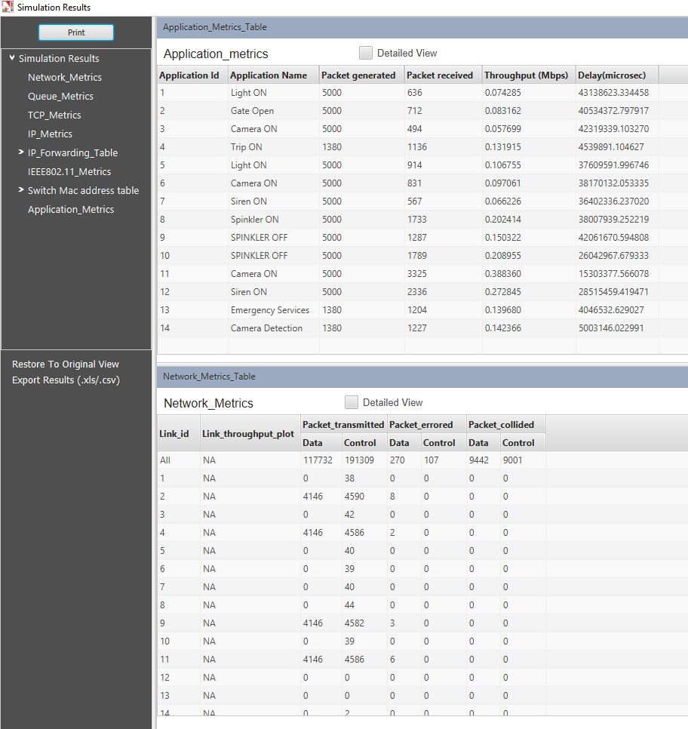
Figure 44. 802.11b with 5dB noise.

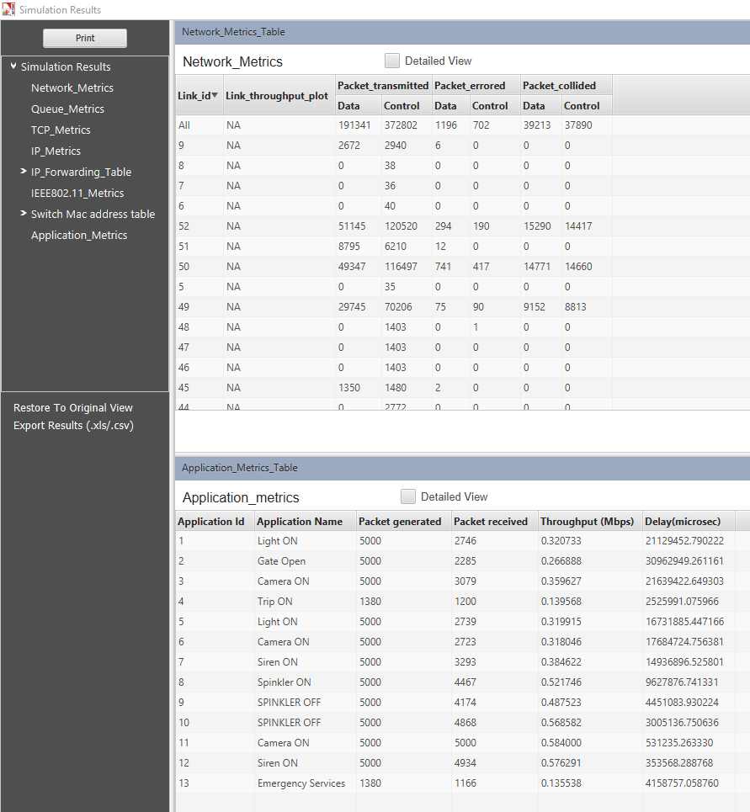
Figure 45. This is 802.11ac at 5dB, showing the comparison between 802.11b with 2.4Ghz.

In theory after testing the environment within Netsim, 802.11ac should be faster with 5Ghz frequency range. However, after quick analyses of the data it can be seen that there is in fact a big difference between 802.11ac and 802.11b, where as 802.11b at 5dB in fig 44 has a lot of packets dropped compared to the how many packets received with 802.11ac in fig 45. It can also be assumed that the modulation method used out of the three different types in VHT for 802.11ac, QPSK is thought to be used because of the how well it deals with the high level of noise introduced into the simulation.

Not only has 802.11ac received more packets than 802.11b but the throughput seems constantly better throughout all the application links with lower Mbps (Megabits per second), whereas 802.11b has only one or two application links that have got a good number of packets received. However, comparing fig 43 and 44, there doesn’t seem to be much different between high level noise and low level noise. Despite that 802.11b should be better with range, it seems the placement of these sensors is letting down the simulation because the results seem to be very similar for both levels of noise, an assumption would be if the sensors were closer together then the test with no noise should receive all the packets back.

It also seems to appear that there is less delay as well as throughput with 802.11ac than compared with 802.11b. The main measurement however is throughput and it seems that the throughput is also far better with 802.11ac, meaning that the amount of data has moved successfully in the certain time given for the simulation. This could be because 802.11ac’s modulation methods are better than 802.11b’s DSSS, however because of a limitation with Netsim, it is not clear of what modulation method VHT uses for 802.11ac.

Future Work
If this was to be done again, further work would be done to assure more information is gather about each wireless standard, going into more comparative detail about the other wireless standards not discussed, along with more levels of noise introduced for 802.11ac. However, despite netsim being a good simulation tool, there is a limitation of how much noise can be introduced on to the network, meaning it seems like it could be difficult to reproduce similar results to -10 noise in Simulink’s QAM modulation.

With this knowledge it could be a good idea to search and learn another alternative network simulation software in order to configure both simulations to be very similar between Simulink and netsim. With different software it could also be possible to choose the specific modulation method for 802.11ac rather than having to rely on netsim picking a random modulation scheme from the VHT family.

Another small improvement in the future would be to base the simulation on netsim around Zigbee standards for sensors, resulting in more realistic results due to its advantages on small sensors.

Conclusion
To conclude, after much research and development there is clear proof of which modulation method has been the best out of the three. With much analysis, PSK seems to show the best results when dealing with noise compared to QAM, by producing a lower error rate of 1 percent out of the 100 seconds. However, through this experiment QAM should of proven better due to having better performance and throughput, with wide bandwidth availability [29].

To conclude part 2, after taken what was learnt and put into practice in part 1 with modulation, it can be seen after making the simulation with much planning through cisco packet tracer and drawings of the physical topology. That after testing the Netsim simulation, the conclusion is that 802.11ac that used a possible of 3 modulation types (BPSK, QPSK and QAM) is better than its predecessor 802.11b (DSSS) through basic analysis of throughput and packet loss, it seems that 802.11ac is the better wireless standard in practice. This is believed through the use of QPSK as its modulation type, which allows for the network to have the wider bandwidth, better performance and throughput as previously discussed [30].

References
[1] “412 Principles of Electronics.”
[2] International journal of engineering sciences et research technology IJESRT. [Verlag nicht ermittelbar].
[3] D. . Sharma, A. Mishra, and R. Saxena, Analog &amp; Digital Modulation Techniquies: An Overview. TeCHNIA, 2010.
[4] F. Xiong, Digital Modulation Techniques. Artech House, 2000.
[5] “Chapter 2 Modulation and Demodulation.”
[6] “DEMODULATION LEARNING OBJECTIVES.”
[7] “Amplitude Shift Keying &amp; Frequency Shift Keying.”
[8] “ASK-amplitude shift keying.”
[9] Y.-T. Toh Ali Niknejad and E. Borivoje Nikolic, “BPSK Demodulation for RF Applications,” 2017.
[10] J. E. Gilley, “Digital Phase Modulation: A Review of Basic Concepts,” 2003.
[11] FOSCO Fiber Optics, “What is 16 qam modulation,” 2013. [Online]. Available: https://www.slideshare.net/fiberoptics4sale/what-is-16-qam-modulation. [Accessed: 09-Apr-2019].
[12] K. Kisiel, D. Sahota, and G. Swaminathan, “Quadrature Amplitude Modulation : A simulation study,” 2005.
[13] K. Abdullah, A. F. Ismail, W. Hashim, and Z. M. Hussain, “An optimal circular 16-QAM modulation technique for wavelet and fourier based OFDM,” in International Conference on Computer and Communication Engineering (ICCCE’10), 2010, pp. 1–6.
[14] R. Hranac, “QPSK and 16-QAM,” 2001.
[15] M. Telecommunications and P. Xiao, “Introduction to Data Communications (ECI-M-917) Assignment On Effect of Additive White Gaussian Noise (AWGN) on the Transmitted Data,” 2008.
[16] LoRa Alliance, “A technical overview of LoRa ® and LoRaWAN TM What is it?,” 2015.
[17] D. Gislason, “ZIGBEE WIRELESS NETWORKING,” 2002.
[18] Cisco, “Campus LAN and Wireless LAN Design Guide,” 2018.
[19] Aruba Networking, “802.11AC IN-DEPTH,” 2014.
[20] 3Com, “IEEE 802.11b Wireless LANs Wireless Freedom at Ethernet Speeds Contents,” 2000.
[21] 3Com, “INTERNETWORKING CONCEPTS GUIDE,” 1997.
[22] N. Drake, “New Metamaterial Camera Has Super-Fast Microwave Vision | WIRED,” 2013. [Online]. Available: https://www.wired.com/2013/01/new-metamaterial-camera/. [Accessed: 09-Apr-2019].
[23] S. F. Brown, “Weapons Revealed,” Sci. Am., vol. 298, no. 4, pp. 110–111, Apr. 2008.
[24] “NetSim User Manual Contents.”
[25] H. Lee, K. Lee, and Y. Shin, “AES Implementation and Performance Evaluation on 8-bit Microcontrollers,” Nov. 2009.
[26] A. Sharma and S. K. Kak, “Performance Analysis of Enhanced CCK Modulation Under Multi-User Environment,” in 2008 4th International Conference on Wireless Communications, Networking and Mobile Computing, 2008, pp. 1–4.
[27] Institution of Engineering and Technology., Wireless, Mobile and Multimedia Networks, 2006 IET International Conference on : date, 6-9 Nov. 2006. [Institution of Engineering and Technology], 2006.
[28] Keysight Technologies, “WLAN 802.11n/ac and 802.11ax Modulation Analysis 89600 VSA Software,” 2018.
[29] M. Nakazawa, S. Okamoto, T. Omiya, K. Kasai, and M. Yoshida, “256-QAM (64 Gb/s) Coherent Optical Transmission Over 160 km With an Optical Bandwidth of 5.4 GHz,” IEEE Photonics Technol. Lett., vol. 22, no. 3, pp. 185–187, Feb. 2010.
[30] G. Soni and C. Verma, “Performance investigation of the WLAN link using QAM and QPSK based on vector signal transceiver 5644R,” in 2017 7th International Conference on Communication Systems and Network Technologies (CSNT), 2017, pp. 34–37.

