Problem Solving and Decision Making

Table of Contents
Introduction 3
Define a complex in the workplace 3
Pestle analysis 3
Analysis of the information of the identified problem that leads to the decision making 4
SWOT analysis of the company 5
Alternative Solutions 6
USE of PMI tool to identify the most appropriate option 7
SMART plan for implementing the solution 8
Communication of the plan with the stakeholders 10
Conclusion 10
Reference 12

Introduction
The purpose of this reporter is to discuss a complex in the workplace, Pestle analysis of the company, analysis of the information of the identified problem that leads to the decision making, cause and effect analysis of the problem, SWOT analysis of the company, alternative solution of the problem. ,use of PMI tools to identify the most appropriate option,SMART plan for implementing the solution, communication of the plan with the stakeholders,monitoring and review techniques etc. In this case, the company taken here is TESCO (Tesco. 2022). The progress of a company largely depends on its employees but also the employee's performance depends on some of the company's weaknesses, strengths, environment, etc. Some of the problems will be discussed here and how it affects the productivity of the company and even how to solve these problems will be discussed in this report.

Define a complex in the workplace
This report will discuss the problems of the Tesco company. Most of the problems in the workplace happen due to poor staff satisfaction and less communication issues. Communication is the key point for any company to retain staff and increase productivity. If communication is not good among colleagues or between employees and management, employees become disengaged and lose interest in their work. Currently Tesco is facing internal communication problem.Communication is very essential to get the daily work statistics and communication is essential to motivate the employees to work it is essential to sustain the success achieved. Bad communication not only affects the mind of the employees but also affects their work resulting in disruption of production.Communication gap also affects Tesco's company culture in a meaningful way. Like other pillars, communication is an important pillar for Tesco's success.Currently, this communication problem is a cause of concern for Tesco.

Pestle analysis
Tesco is the UK's second largest company by volume. It is a highly diversified multinational food retailing company. Not only food but Tesco has other products as well as its headquarters in the UK and branches in 12 countries all over the world. Analysis was done on Tesco's Pestle-
- Political Factors-As Tesco branches all over the world, Tesco has to face the legal complexities of all countries such as tax rates, laws and of course, the stability of the countries in which it operates. However, Tesco provides employment as per the government requirements of different countries (Adamyk, 2019 ).
- Economic Factors-As economic affects any business it naturally affects Tesco as well. Tesco has branches all over the world but post pandemic all countries are slowly recovering from the economic downturn so Tesco's high value items are not acceptable but Tesco is replacing the high value items with pocket friendly items. TESCO’s revenue is 5,788.7 crores GBS (statista, 2022)
- Social Factors-As nowadays people are health conscious so the demand of food is changing day by day and there are some social influences on the demand of food so Tesco is changing its products keeping in mind the customer (Adamyk, 2019).
- Technical Factors-In tune with the times, Tesco is basing its business on technology. Firstly Tesco has opted for a home delivery system i.e. online shopping and secondly self-service checkout points are bringing convenience and comfort to the customers.
- Environmental Factor-Keeping the environment in mind, Tesco has reduced its carbon footprint by 50% by 2020 and reduced its factory waste generation.
- Legal Factors-Government policies and laws directly affect Tesco's business. Such as reducing the price of its products without notice which disturbs Tesco a lot. However, it has maintained a balance by attracting its customers through various strategies and promotions.

Analysis of the information of the identified problem that leads to the decision making
Cause and effect analysis of the problem
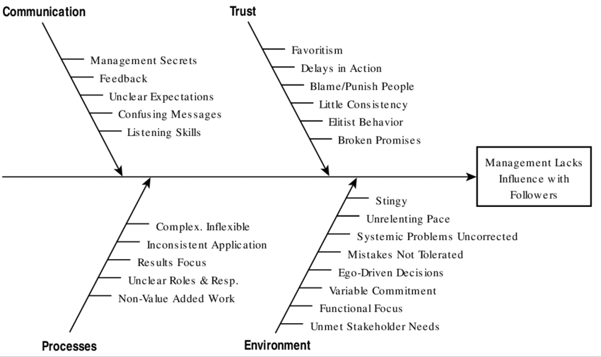
Figure 1 : Fishbone Diagram
(Source : Self-developed)

Communication hampers the causes of multiple issues in management that ultimately leads to poor staff satisfaction that is not healthy for any organisation (Chaniago et al. 2022 ). Since the workplace is the second home of employees, good communication boosts employee morale and helps increase productivity. Good communication helps to increase employees' trust in the company. Causes of poor communication are- poor leadership, unclear objectives, limited feedback, demoralised employees, cultural diversity in the workplace;and its effects are- unpredictable work environment, less effective collaboration, workplace conflict, low morale etc. However, lack of communication can lead to employee dissatisfaction and multiple issues.
- Leaders build a bridge between employees and work, employees look to them for any work or decision, but many times leaders are unable to communicate, so employees can't give their best and they can't match deadlines, so they become low morale.
- Business development does not come in an unexpected way but requires employees to work hard but to work on a specific path to achieve the target but if the leaders fail to clear this object then the work objectives of the employees are disrupted resulting in the employees being demotivated later and their efficiency decreases.
- Employees want feedback on their work, whether positive or negative. This feedback helps them to perfect their careers, but not providing feedback is an example of poor communication, resulting in negativity among employees and reducing workplace collaboration.
- Sometimes poor communication causes employees to lose their will to work and show mistrust towards the workplace, resulting in decreased productivity despite their competence, they become irritable, start conflicts with other employees in the workplace and destroy the workplace culture.

SWOT analysis of the company
Tesco is a leading brand of uk supermarket. It supplies food products and other products in 12 countries around the world. Naturally, this company will have some strengths, weaknesses, opportunities and threats. Here is the swot analysis of Tesco-
- Strength-a.Tesco has won numerous awards for its brand, service and retail excellence.b .It has improved the technology in its business thereby increasing acceptance among customers.c.As it is the largest supermarket in the world and its business continues to grow, smaller retailers are trying to follow suit.d.Tesco's financial structure is very strong to withstand any kind of threat.e.Its multi-discipline format helps to cater to the needs of people from different walks of life and hence it has been able to capture the market very easily (Moura, 2021).
- Weakness-a.Competition from other large brands in business is affecting Tesco's profit margins. Tesco should focus on other ways to solve this problem to maintain business quality.b.Tesco's retail format ideas have not worked in some countries. Tesco did not do as much market review as it should have before implementing this format.c.Tesco is more dependent on its core UK market and has not looked at branches in other countries due to which other branches have not performed as expected.d.Tesco's business has been affected as Tesco's subsidiaries such as banking have prioritised other profitable activities over working with Tesco.
- Opportunities- a.There are many opportunities to expand Tesco online services and increase customer base in surrounding areas.b.There are opportunities to create business alliances with other well-known brands which will increase Tesco's market recognition and increase customer base.c.In countries where Tesco's market awareness is low, Tesco has the opportunity to grow its business based on market research by forming business alliances with local companies.d.The new companies are adopting the strategy and the old company has chosen either Tesco Already so there are opportunities for Tesco to lead the market.
- Threat- The economic downturn affected consumer shopping and consequently affected Tesco's business.b.Consumers have cut back on their excess food purchases as consumer prices around the world rise.c.Rising wages and understaffing around the world are among the threats for Tesco.d.Current political parties are pushing to comply with the existing government infrastructure resulting in many changes in Tesco's infrastructure which are costly (Moura, 2021).

Alternative Solutions
The primary solution to address the problems and effects of poor communication is to improve communication in the workplace, be it with employees, management or co-workers.Poor communication leads to frustrated employees resulting in workplace conflict, slack in productivity, etc. It even affects the workplace culture.To improve communication, record each week's activities and employee pros and cons involved and discuss them directly with employees.To improve communication, employees need to be regularly provided with necessary training and substantial investment should be made for it.It should be ensured that the employees can have necessary communication with the authorities so that they feel important and thus the employees will have the courage and willingness to discuss any advantages and disadvantages and improve their performance.The company should assure the employees that the safety of the employees be it financial or physical is one of the priority of the company so that the employees will feel grateful to the company even if the internal communication ceases (Levius, 2018).

USE of PMI tool to identify the most appropriate option

Decisions | Plus | Minus | Interesting
Fixing poor communication should start at the bottom of any company's workforce | Lower rank people will feel needed and they will be loyal to the company | There is an organisational structure in the workplace that is likely to erode who holds the organisational culture. | The worker will not think of leaving work
Creating a safe space for communication where employees feel comfortable communicating | If the employees feel comfortable to communicate, they will raise the problems themselves, it will be convenient to solve them with the leader and the productivity will increase. | Employees will always expect leaders to solve any problems, which will reduce their problem solving power | Employees will not feel patronised by having leaders with them in problem solving
By providing positive and negative feedback on daily work | Employees will be motivated to work and focus on work if they get positive feedback every day | If you get negative feedback every day, the motivation of the employee will be lost, so his effect will also be affected | Employees will focus on their work if they get feedback, and if they get negative feedback, they will try to correct it

SMART plan for implementing the solution

SMART | Goals | How to implement | How it helps | Time Frame
Specific | To create better communication | .Uses various methods of communication dissolution such as establishing direct contact with each other | It will help employees feel valued | 1 month
Measurable | To increase company productivity as well as to make employees feel more comfortable at work | Leaders will listen and give importance to the advantages and disadvantages of the employees, i.e. by giving the employees an opportunity to discuss something | .This will make the employees feel comfortable to talk to the leaders and raise the problems so that it will be easier to solve them | 1 months
Achievable | To gain confidence and trust of employees and increase their efficiency at work | If it is not possible to talk directly with the employee, then you should use technical tools to keep in touch with them | This will increase the morale of the employees as they feel safe | 2 months
Relevant | Tesco must allow employees to do reasonable work and have relevant discussions with them | Since management is not always able to approach the workers, the leader as their representative should be allowed to discuss the relevance of the workers' work. | Employees will feel essential to their company and will be motivated to increase productivity | 1months
Time bound | The objective is to provide timely reviews that maintain quality of work and improve new production. | Provide opportunities to include portfolio updates of daily work | Employees will be sure of the correctness of their work and there will be no confusion | 7days

Communication of the plan with the stakeholders
To make communication better, all types of employees should be facilitated. No single employee can make this process effective alone, so it should be decided to improve it by discussing with all types of employees and management.Although an employee or manager should take responsibility for planning this, the decision should be made through discussion. This discussion can be done in several processes such as holding a meeting where all employees and management are present, informing each employee separately but this is a time-consuming and lengthy process, meeting separately or creating a social media group to share the information. Through presentations or if it is not possible to bring all employees together in a large company like Tesco during social distancing, then through video conferencing using technical tools like Google Meet or Zoom etc (Ramesh, 2022).
Monitoring and review techniques
It is not enough to make a plan or make a decision, to improve communication, it is also necessary to monitor whether the plan is being executed properly. But it is not possible to monitor every employee every time so some simple ways of monitoring should be adopted.For example, the first method that comes to mind is to use various tools like 360 degree feedback, 540 degree feedback etc. to help employees know whether the way they choose to work and improve communication is working properly. These tools help employees get feedback not only from internal peers, leaders but also from customers and clients.Also, the management who is tasked with monitoring the work can ask for feedback on the day-to-day work of the different teams from the different team leaders, also get information by creating a weekly portfolio to record the work of the employees. Finally, to help all employees to improve communication within the organisation. Will and as their work to give management to help them to monitor.

Conclusion
To run a company there are some internal and some external problems that put the company in the face of threats but also the company has some strengths and opportunities that help it to recover its weaknesses. As companies apply new strategies, they must maintain improvement by identifying old problems and solving them. However, lack of proper communication between the internal departments can lead to employee dis-satisfaction that needs to be properly treated.

Reference
Adamyk, K., 2019. PESTLE Analysis on Tesco PLC.
Chaniago, H. and Efawati, Y., 2022. The implementation of integrated marketing communication on retail business: Moslem consumers' perceptions. International Journal of Business and Globalisation, 30(2), pp.187-206.
Levius, S., Safa, M. and Weeks, K., 2018. Information and communication technology strategies to improve international competitiveness in the wholesale and retail trade sector. International Journal of Business and Globalisation, 20(1), pp.128-138.
Moura, M.B.L.D., 2021. Equity Research in Food & Retail Industry-TESCO PLC (Doctoral dissertation, Instituto Superior de Economia e Gestão).
Nwagbara, U., 2011. Managing Organizational Change: Leadership, Tesco, and Leahy's Resignation. E Journal of Organizational Learning & Leadership, 9(1).
Ramesh, D.N., 2022. Importance of brand strategy in stakeholder communication and satisfaction (A study on fashion retail company's stakeholder management) (Doctoral dissertation, Dublin, National College of Ireland).
Statista. (2022). Annual revenue of Tesco Group in the United Kingdom (UK) and the Republic of Ireland from financial year 2015 to 2022. Available at. https://www.statista.com/statistics/490931/tesco-group-finance-revenue-united-kingdom-uk/ (accessed on 7th August, 2022)
Tesco. (2022). Home. available at. https://www.tesco.com/ (accessed on 7th August, 2022)

