Labs4Second Attempt
Convert the following from binary to IP Addresses
PC0 NIC 11000000.10101000.01001000.00011110 /24
PC1 NIC 11000000.10101000.01001000.00101000 /24
PC3 NIC 11000000.10101000.01001000.00110010 /24
PC4 NIC 11000000.10101000.01001000.01000110 /24
Conversions

PC0 NIC 192.168.72.30 /24
PC1 NIC 192.168.72.40 /24
PC3 NIC 192.168.72.50 /24
PC4 NIC 192.168.72.60 /24

Changing the hostname of the switch:
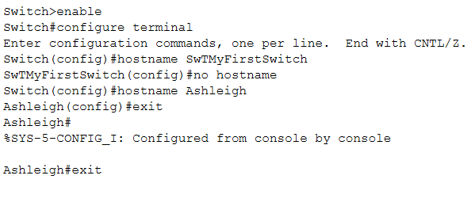
Configuring the console password:
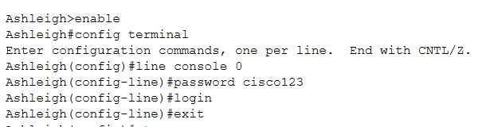
Configuring the vty password:
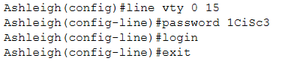
Enabling the Privileged password:
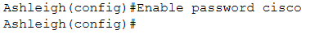
!
Running Configuration
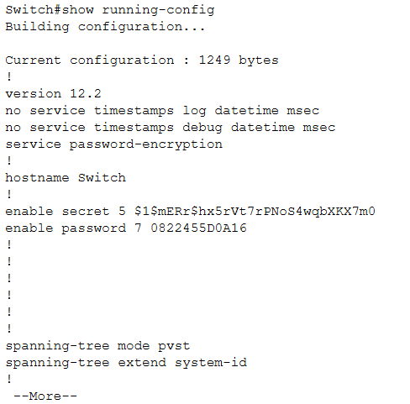
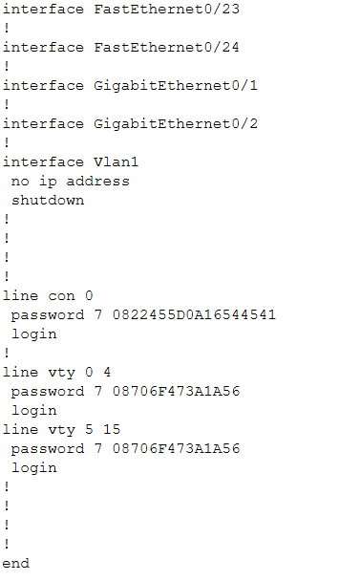
The privileged password is shown in the running configuration and it is displayed as 0822455D0A16.

Show the IP Address:
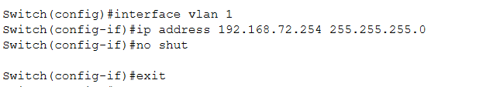

PDU information for the Switch.3, you can see the Source and Target IP has been changed and


