A PRACTIONER’S HANDBOOK

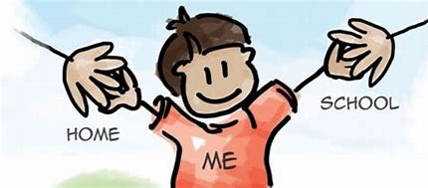
(Source: meridianschool.co.uk (nd)

A GUIDE TO TRANSITION

INTRODUCTION

The aim of this handbook is to help and support early years practitioners throughout a child’s transition period whether it being from home to pre-school or nursery to reception class. Also, this handbook will explain the meaning of transition and what it entails. The handbook will also look at the needs of the child, interventions, the environment, role of the adult, communication between the child/ren and their parents/carers or any other multi- agency involved and lastly outcomes. This handbook will also look and consider some theories that have studied transitions in early years.

CONTENTS
• TRANSITIONS

• THE NEEDS OF THE CHILD

• THE ROLE OF THE PARENT

• THE ROLE OF THE PRACTIONER/KEYWORKER

• EFFECTIVE COMMUNICATION

• INTERVENTIONS

• OUTCOMES

• REFERENCE LIST

TRANSITIONS

TRANSITIONS IS THE PROCESS OF CHANGING FROM ONE SITUATION OR CIRCUMSTANCE TO ANOTHER. (Oxford Learner’s Dictionary)
If transitions are applied correctly and effectively with commitment and perseverance from both parents/carers and practitioners. A transition can nourish and assist with the wellbeing of the child. However, if this is not applied appropriately the child unfortunately will not receive the support and care that is needed, and the child can suffer. As stated in article 6 of the UNCRC (1989) each and every child must have every support given to them so they can reach their full potential.
Therefore, by using this handbook the practitioner will be able to help, support and guide the child/ren through this process including the child’s parents or main carers.
Any new changes to a child are frightening especially when the child is leaving the safety of their own environment. This could cause emotional distress for the child who is to start in the early years sector as the child might not be able to verbally communicate and or express their feelings like an older child would be able to. Therefore, it is crucial that the early years practitioner can ease the way for the child using interventions that are suitable for each individual child.
According to Allingham (2011) a definition of transition could be any alteration to routines that a child is used to. This could be anything as straight forward as meeting someone new for the first time to entering a new environment and not just moving from one room to another room. These are known as horizontal transitions and vertical transitions. Vogler et al (2008) claims that horizontal transitions are occurrences that happen regularly or on a day-to-day basis such as children going to play outside from the nursery/classroom setting, this is normally called a “movement". Furthermore, Vogler et al (2008) suggests that vertical transitions are more important and are related to specific occurrences that do not happen often, for instance attending a nursery setting for the first time or moving from nursery class to reception class.

THE NEEDS OF THE CHILD

Every child is a unique individual so therefore for each individual child they will have their own individual needs. Lindon (2012) believes that children achieve abilities at different ages, and it is not plausible to make assumptions or statements that all children of the age of three will be able to do....... Despite this, practitioners should be able to recognise the children who are achieving their targets. Therefore, the practitioners should be able to encourage these children further. Linden (2012) also points out that the practitioner should be aware of the other children who are not doing so well and be able to encourage and motivate these children constructively.

Maslow’s Hierarchy of Needs is a model explaining the needs of an individual human. In this model the bottom stage is the starting point. Physiological Needs: These are fundamental needs that human being require for survival, that is food, air, drink, shelter, clothing, warmth and sleep. If these needs are not fulfilled the individual cannot function sufficiently. Maslow believes that physiological needs are the most important, as without these in place all the other needs become incidental until they are met. Once they have been put in place the individual can approach the second stage and move up to the rest of the needs.
Maslow’s Hierarchy of Needs
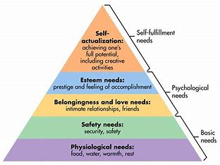
Get Psyched (2015)

According to Ackerman (2008) John Bowlby first described a theory of attachment when he investigated the effects of children when they were not with their parents or primary carers. These effects Bowlby described a parent or prime carer are inconsistent or sometimes neglectful. So, when the parent or carer return to pick up their child, the child can appear to be anxious, insecure too and they might punish their parent/carer for leaving them.

• Avoidant Attachment – The parent/carer are distant, neglectful, disorganised with their child. As a result of this the child could be seen to be quiet, withdrawn because the child believes his/her needs will not be met.

• Disorganised Attachment – This is when the child is severely confused as their parent or carer could be frightening to them then suddenly be extremely passive to them. Also, there is no strategy or plan in place to have their needs met as a result of this the child is depressed, angry, passive and could be unresponsive.

Consequently Guy-Evans (2020) suggests that Bronfenbrenner's Ecological System Theory takes the Individual child and places the child at the centre of the multiple systems. Guy-Evans (2020) maintains to learn about a child's development we must observe not only the child but also the child's surroundings. Whether it is the home environment or school environment. Bronfenbrenner separates the child environment into five different systems, the microsystem, the mesosystem, the ecosystem, the macrosystem and the chronosystem.

Bronfenbrenner's Ecological System Theory

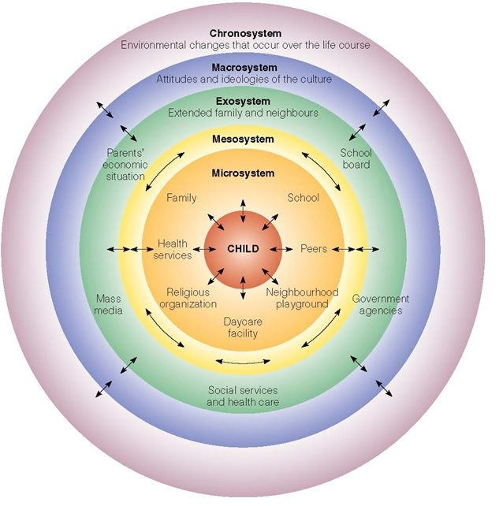
(Source: SimplyPscycology,2020)

• The Microsystem Stage – Is the first stage in Bronfenbrenner’s theory, this includes everything that the child has immediate contact within their environment, namely their parents/carers, siblings, other family members, friends or other adults in a nursery and school environment. These relationships in the microsystem are often intimate and sometimes can influence the child’s beliefs and actions. This can be turned around as the child can also influence these individuals with their own beliefs and actions. These interactions are pivotal for upholding the child’s development.

• The Mesosystem Stage – This is where the child’s individual microsystem interlinks with other factors. For instance, if a child’s parents or carers communicate effectively with the key worker or practitioner then the child's development can grow and prosper.

• The Exosystem Stage – These are the environments that usually do not affect the child directly, but they impact the child’s development. These could include politics, media, news and employment. For instance, if the parent or carer loses their job this could impact the child by what monies are entering their environment and what they can afford for the needs of their child.

• The Macrosystem Stage – This includes a much bigger scope of the surrounding environment of the child such as laws, rulings, regulations and social influences. For instance, a child which lives in a third world country would experience a different way of living.

• The Chronosystem Stage – This is the final stage in Bronfenbrenner's ecological system theory. This system includes all environmental changes that happen over the lifespan of the individual child which could impact and effect development. As well as crucial life transitions which could be anything from parents or carers separating to moving to a new school or new home.

THE ROLE OF THE PARENT

From an early age the child will form strong bonds with their primary carer, this is normally their mother. This is called attachment. Then as the child grows older the child will enter new environments such as a pre-school setting or a day nursery and meet new people who work at these settings., during these experiences the child will need to start forming new bonds. The child will need to start making friends with the other children also with the adults who work there. The child has to learn to put their trust in these individuals. The role of the parent is to make sure that there is always an honest effective communication between the practitioners and themselves. If this is in place from the start this will assist the child in having everything in place to provide the child with transition that is as effective and smooth as possible. The Edvocate (2016) claims that due to the positive influence from the parents or carers involvement in their child's education. The child/ren’s performance greatly succeeds in academic and social environments. Also as stated in Article 29 of the United Nations of the Rights of the Child education should help to develop each individual child to develop all their abilities.
According to Ackerman (2008) John Bowlby first described a theory of attachment when he investigated the effects of children when they were not with their parents or primary carers. These effects Bowlby described a parent or prime carer are inconsistent or sometimes neglectful. So, when the parent or carer return to pick up their child, the child can appear to be anxious, insecure too and they might punish their parent/carer for leaving them.

• Avoidant Attachment – The parent/carer are distant, neglectful, disorganised with their child. As a result of this the child could be seen to be quiet, withdrawn because the child believes his/her needs will not be met.

• Disorganised Attachment – This is when the child is severely confused as their parent or carer could be frightening to them then suddenly be extremely passive to them. Also, there is no strategy or plan in place to have their needs met as a result of this the child is depressed, angry, passive and could be unresponsive.

THE ROLE OF THE PRACTITONER/KEYWORKER
It is the practitioner/keyworkers responsibility to make sure that the child's transition period runs as smoothly as possible for both the child and parent/carer. Lindon (2012) suggests that all early year's practitioners sometimes need to regroup and to re-establish the professional capability and understanding that encourages the development and well-being of the child. Furthermore Lindon (2012) says that the adults who are more accommodating to the children are the adults who are more prepared to reflect on their actions and build on the outcomes.
Also, NCHC (nd) states a key worker is the primary point of contact for a family but on occasion this role can be taken over by another multi agency. Furthermore, NHCH (nd) claims that that the keyworker should have regular and maximum contact with the families to build up a strong bond and honest relationship. As stated in Article 12 of the United Nations Convention on the Rights of the Child that every individual child has rights and should be listened to. If a child is to develop to their full potential, it is vital that the keyworker or practitioner communicates with the child and child's family.
Early Education (2021) claims that for a child to develop and flourish the child must develop a positive and trusting relationship with the practitioner/keyworker. This relationship will then allow the child to establish new relationships in time as the child will feel confident and competent to do so.


(source: iStock 2017)

EFFECTIVE COMMUNICATION

It is vital that effective communication is in place when the individual child starts a pre-school/nursery setting as this helps the child transition as effectively as possible. To do this the practitioner needs to be in constant correspondence with whomever has a role in the child's life. For instance, especially the parent/carer and family. Also, the practitioner should be communicating with each and every member of staff in the pre-school or nursery setting that the child will be entering. Sometimes there might be other multi-agencies involved with the child such as health visitors, social workers and so on. When all of these individual people have communicated an individual plan can be put in place especially for that child to help their transition into their new environment with ease. According to Lindon (2009) parents play a very important and crucial role in their children's transition by assisting the staff who are caring, supporting their child during this time. Furthermore, Early Years Carers (nd) says that all children come from a different variety of religions, cultures and backgrounds. Therefore, practitioners should make sure that they are aware of this and are considerate of possible cultural and language obstacles. Additionally, article 30 of the UNCRC (1989) state that each and every individual child has the right to learn the language, custom and religion of their family and background even if these views are not shared by the majority. As the child settles into their nursery life it is vital and necessary for this communication to carry on between the adults. Early Years Carers (nd) are convinced that when practitioners communicate effectively this helps them to achieve a better understanding of the child's needs, of their likes and dislikes. Also, if there are any issues at home then this might affect the child in the nursery setting. Early Years Creers (nd) believe that with effective communication in place the practitioner will be aware of any circumstances that may be happening.
According to Communication Theory (nd) for effective communication to take place a model was produced by Scott Cutlip and Allen Carter in 1952 called the 7 C’s of Communication. This has become the most famous and used model in the world.

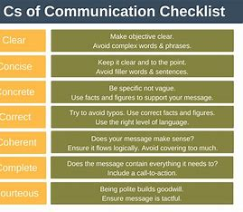
(Source: expertprogrammanagement.com, 2018)

INTERVENTIONS

According to Cambridge Dictionary (nd) the word intervention means when a person becomes involved in a situation, so that a person can help or stop the situation from getting any worse.
Jean Piaget was a psychologist who produced his theory of intellectual or cognitive development in 1936. Healthline (2018) states that Piaget’s theory concentrated on children from birth to adolescence and identified individual stages of development. These stages are language, morals, memory and reasoning. Healthline (2018) claims that Piaget believes that children build up awareness and learn different things by themselves using their own experiences.
Piaget also suggests that the children in preschool and nursery environments will learn and understand a great deal more from actively engaging the indoor environment as well as the outdoor environment.
As new children start the preschool/ nursery settings they might feel nervous and apprehensive. If this occurs the practitioner must put in place interventions to help with the transition. These could include
• Drop ins, this is when the child and their parent or carers can come into the setting when it is convenient, and this will help the child adjust more easily.
• Communication, this could be anything from phone calls, letters, emails, social media.
• Newsletters, this will help the parent or carers keep up to date with everything that is happening at the setting.
• Timetables of each day's activities can be given out to the parents also to help them understand.
• Nurture groups this will help the child even more to adjust to the new setting.
Brooks (2019) suggests that there are also different interventions that are specifically aimed for children who have additional learning needs, (ALN). If a parent/ carer or practitioner notices that a child has additional learning needs there are services that can be contacted to help the child. These could be:
• Speech Therapy
• Alternative Learning Methods
• Occupational Therapy
• Physical Therapy
• Psychological Services and Therapy
• Sensory Therapy

OUTCOMES

When a child has gone through the transition period and successfully completed it. The child should be able to enter the preschool / nursery setting happier and more confidently. The child will not rely on their parent/carer for reassurance as much or at all. They should also have enough confidence to approach their new friends with ease and be able to approach other members of staff that work there. The child should be now willing to try out new experiences without the feeling of uncertainty. They should be feeling happy, secure and confident also be to respond with assuredness to any situation that appears.
All effective communication with either parent/carers and any other multi agencies are ongoing, this will make sure that the child will keep on experiencing a pleasant stay in the preschool/nursery.
All members of staff are well informed with information regarding the child, also the staff are up to date on legislations and safeguarding policies.


(Source: clipartlibrary 2019)

REFERENCE LIST
Ackerman, (2018) What is Attachment Theory? Bowlby’s 4 Stages Explained. Available at: https://positivepsychology.com/attachment-theory/ (Accessed 22/11/2022)
Allingham, S. (2011) Transitions in the Early Years. London: Practical Pre-school Books.
Brooks, A. (2019) What is Early Childhood Intervention? What ECE Professionals Should Know. Rasmussen University. Available at: https://www.rasmussen.edu/ (Accessed 2/12/2022)
Cambridge Dictionary (nd) Intervention. Available at: https://dictionary.cambridge.org/dictionary/english/intervention (Accessed 2/12/2022)
Clipart (2019) [Image] Available at: www
Communication Theory (nd) Communication Theory. The 7 C’s of Effective Communication – explained with examples. Available at: https://www.communicationtheory.org/the-7c’s-of-effective-communication-with-examples/ (Accessed 3/12/22)
Early Education (2021) Birth to 5 Matters. Guidance by the Sector, for the Sector: Attachment and the role of the Key Person. Available at: https://birthto5matters.org.uk/attachment-and-the-role-of-the-key-person/ (Accessed 3/12/2022)
Early Years Carers, (nd) Effective Communication. Available at: https://www.earlyyearscarers.com/eyc/latest-nws/sector-news/effective-communication/ (Accessed: 2/12/2022)
Get Psyched (2015) Maslow’s Hierarchy of Needs [Image] Available at: https://sites.psu.edu/rclerin/2015/04/10/hireachy-of-needs/ (Accessed 22/11/2022)
Guy-Evans, O. (2020) Bronfenbrenner’s Ecological System Theory. Available at: https://www.simplypsychology.org/Bronfenbrenner.html (Accessed 22/11/2022)
Healthline (2018) What are Piaget’s Stages of Development and How are They Used. Available at: https://www.healthline.com/healtyh/piaget-stages-of-development (Accessed 3/12/2022)
iStock by Getty (2017) [Image] Available at: https://www.istockphoto.com/illustrations/preschool-teacher (Accessed 6/11/2022)
Lindon, J. (2009) Parents as Partners – Positive Relationships in the Early Years. London. Practical Pre-Scholl.
Lindon, J. (2012) Understanding Child Development 0 – 8 years. 3rd edn. Italy. Hodder Education.
Meridian school (nd) [Image]Available at: https://meridianschool.co.uk (Accessed 24/11/2022)
NCHC (nd) Norfolk Community Health and Care. NHS Trust Available at: https://children.nchc.nhs.uk/key-worker-service/the-key-workers/ (Accessed 26/11/2022)
Oxford Learning Dictionary (nd) Transition. Available at: https://www.oxfordlearnersdirectionaries.com/english/transition_1?=transition (Accessed 4/11/2022)
Simply Psychology (2020) Bronfenbrenner’s Ecological System’s Theory.[Image] Available at: https://www.simplypsychology.org/bronfenbrenner.html (Accessed 25/11/2022)
The Edvocate (2016) The Crucial Role of Parental Involvement. Available at: https://www.theedvocate.org/the-crucial-role0of-parental-involvement/
(Accessed 27/11/2022)
UNCRC (1989) United Nation Convention of the Rights of the Child. Article 6, 12, 29, 30. Available at: https://www.unicef.org.uk/wp-content/uploads/2019/10UNCRC-summary-1-1.pdf (Accessed 22/11/2022)
Vogler et al (2008) Early Childhood Transitions Research: A Review of Concepts, Theory and Practice Available at: https://www.research.gate.net/publication/42798544_Early_Childhood_Transitions_Research_A_Review_ of_Concepts_Theory_and_Practice/

