Childhood Transitions
Early years practitioners Handbook.

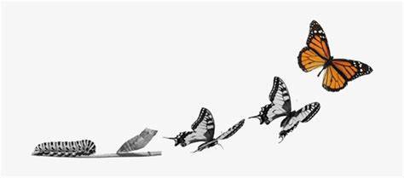
Source: Ocius Consulting (2019)

Content

PG. 3-4
Introduction

PG. 4-6

Role of the Adult

PG. 6-7
The needs of a child

PG. 8-9
Partnerships

PG. 9-10
Interventions

PG. 11-12
Proposed Outcomes

Introduction

This handbook is designed to inform Early years practitioners on the importance of effective communication for young children and learners during transitions in stages of their life. The information in this handbook will include developmental theories and methods of communication in which will support early years settings to guide practitioners to make transitions more straightforward for the children.

Transition in early years is moving from one place or a situation this can be big or small for some children and all children will react to this stage in their lives differently. Some children may get anxious about a small transition such as going from one room to another, and it can raise insecurities about their learning. Whereas other children have the confidence to cope with change and find it easier.
According to Birth to 5 matters (2007) Anne O’Connor states ‘Transition is stressful for children, just as it is for adults, and the resulting stress can have a far-reaching impact on children’s emotional well-being and academic achievements.

Transition is a big responsibly to us as Early years practitioners and the support we give to the children influences the way children cope with change whenever it occurs at any stage in their lives. Transitioning from one stage of a child’s live is important and everyone around them should be involved in this process, it is vital that parents, early years practitioners and other people in this stage of their live work together and be involved to make sure that child feels safe in their new surroundings.

Anne O’Connor 2007 states ‘settling in children who are settling (at any age) do best when:

Transition is made a priority. All key workers need to show they understand and are aware of the importance of transition by making it a priority. This enables key workers to meet the children and parents and effectively comminate to transfer information, as well as developing a curriculum and ethos that shows support of the new children.

They are familiar with the people, places, and routines. Familiarity is one of the most important factors for a smooth transition. As key workers educating yourself on new ways to ensure a child becomes familiar with a new setting and staff is essential.

They can make frequent visits to the setting. Children will benefit from frequent and informal drop off sessions with parents or a familiar adult, that allows them to gain first-hand experience of a new setting.

They receive a home visit. Home visits need to approach with sensitivity and although they may be intrusive and cost effective in both staff time and cover, they will be worth the effort. These visits will allow children and parents to associate themselves with key workers on their own territory.

They have a key worker. Children need to know they are not alone during transition. A key worker system means that a child and their family have a practitioner who is assigned to them, even though there will be others interacting and caring for them throughout their day.

Role of the Adult

Young children rely on us as Early years practitioners for their emotional security. Supporting children when they are going through change will help them feel secure and may make the process of settling in their new environment easier. According to (Tassoni,2007, p.102) children are likely to have may concerns about a change of setting, these could include

- “Will I be left all by myself”
- “Will I get into trouble if I don’t understand”
- “Will I make friends”
- “Will the carers/teachers be nice”.

(Tassoni.P 2007)

This is when we as Effective practitioners need to be there to support and help the children to realise that transition and change in their lives can be worrying sometimes but there will always be someone there for them. It is our role as the adult to provide consistency and reassurance.

Our role as early years practitioners is vital to how the child learns and behaves this was proven by bandura (1963). Albert Bandura (1963) filmed children copying behaviours of adults with a bobo doll. Bandura’s theory shows that children learn and copy from us, if practitioners have positive and happy attitudes towards something then children are more likely to copy this and pick up positive attitudes.

(Birthto5matters, n.d) believes transitions for children who are more vulnerable should be given more support by having additional times and opportunities to make the necessary readjustments to the changes ahead of them. Practitioners can help by being warm, responsive, and having the ability to recognise challenging behaviour as a manifestation of feelings.

Similarly, (K. cherry, 2022) Says John Bowlby believed that the earliest bonds formed by children with their caregivers have a tremendous impact that continues throughout life It is important that we as practitioners support the children through transitions to show them and help them develop a strong bond with us for them to feel safe and secure for them to develop happily. An example of slowly creating a bond with children could be if a child is transitioning from nursery class to Reception, small sessions could take place with the new teachers and practitioners where they could interact and get to know one another better before the official transition. This will enable the children to get familiar not only with the staff members but also the setting and routines of their new class.

Pennstate Extension (N.D) states ‘to understand how transitions affect children, think of how transitions affect you’. Even as we grow up transitioning and change is always a scary stage in our lives, as early years practitioners we need to understand what we are asking for from the children and if we can do this, we will then be able to make developmentally appropriate decisions and will be able to give better support to a child.
Our role as early years practitioners is to always be understanding towards children and during transitions this is needed, Having the skill of knowing a Childs milestones and skills will allow you to give children what they need during transition. Gaining a Childs trust is another major skill needed during transition as children are less anxious when they know an adult around them is non-judgmental and caring and they will respond a lot better to gentleness and kindness.
(4C helping communities Help children 2022) also agrees that as an adult preparing yourself and your child for a change in your lives make a transition easier. Similarly, to (pennstate Extension n.d), If you are feeling unsure about leaving a child, your child will sense ambivalence and may have a harder time leaving. (4C helping communities Help children 2022).
The needs of a child

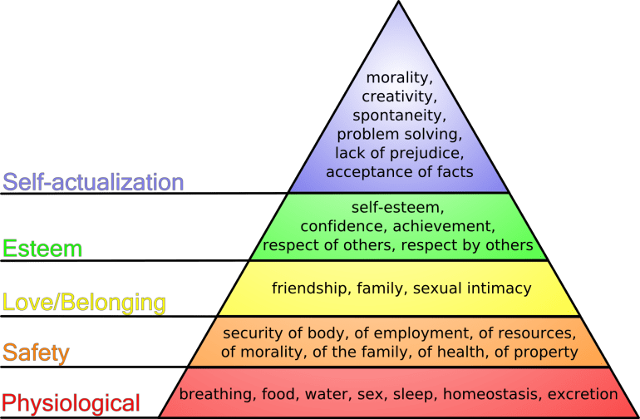
As a practitioner we should be aware of all theories of child development. Transitions are a major part of a child’s life, and we should be able to achieve a child’s full potential during this change in their life, this can be done by being able to consider a child’s overall needs. A theory that supports this is Maslow’s hierarchy of needs.
(Source: Art of Autism, 2013)

According to (Tassoni 2007 p.265) Abraham Maslow argued that humans have a range of needs. Maslow has organised his hierarchy is a pyramid form with the basic needs as the bottom. For a child to even start developing Maslow (1943) believes a child basic physiological need must be satisfied before they can attend to needs higher up (McLeod, 2007).

Likewise, to Maslow, Article 6 in the summary of the UN convention on the right of the child states ‘Every child has the right to life. Governments must do all they can to ensure that children survive and develop to their full potential’ (UNICEF, n.d). Similarly, to Maslow without the basic needs of food, water and sleep children will not be able to survive and develop to the best they could.
Children Need to feel looked after and cared for in new environments and have the feeling of belonging somewhere. As it states in (UNICEF, (n.d) Article 3 (best interests of the child) ‘The best interests of the child must be top priority in all decisions and actions that affect chidren. Likewise to Maslow’s Hierarchy of needs Second stage of ‘safety’ where he believes children need security of morality, family and healthy, John Bowlby (1907-90) suggests that children who were, at an early age, deprived of a relationship with their primary carers were more likely to have behavioural problems later in life (Tassoni 2007 p.80).The relationships and bonds we build with children as practitioners really does have an effect on their development and the way the learn and adapt to new things.

Although Bowlby (1907-90) was the first to recognise the needs of babies and young children for a good relationship with their primary carers, Mary Ainsworth (1979) expanding on Bowlby’s research and worked more on separation anxiety. Ainsworth observed children as they responded to a situation in which they were briefly left alone and then reunited with their parents. This scenario was known as ‘strange situation’ and the behaviours from this were categorised in to three types.

- Anxious – avoidant
The child will not like being alone however will be willing to be comforted by a stranger, they will show little distress when they leave the parent and continue to carry on.
(Tassoni 2007, p82)

- Securely attached
The child will get upset when the parent is not in sight but can be partly comforted by a stranger. The child paly or carry on as normal with the parent in sight but as soon as the parents’ leaves will show distress and reduce play. Reactions towards the parent and stranger are markedly different
(Tassoni 2007,p82)

- Anxious- resistant

The child will become very distressed when leaving the parent and resists the stranger comforting them. The child is ambivalent, showing frustration and anger.
(Tassoni 2007,p82)

During Transitions you may find children find it difficult to be separated from their main attachment, as a child grow older, they will have learnt to build and form new relationships with other people such as staff members However according to (Tassoni 2007, p82) babies and toddlers find it difficult to cope with the absence of their main attachments and will show distress.

Partnerships
Having that strong bond with the child is vital during transitions but also having a relationship with parents is important. According to (Tassoni 2007, p137) young children look at their parent’ reactions to decide whether they should be fearful. Children will learn to settle better when they see positive interaction.
One of the most important parts to partnerships is effective communication, as practitioners we must build trust with parents of the children and to do this, we must have good communication skills, keeping the parents informed and giving them updates and keeping them involved in their child’s development is vital.
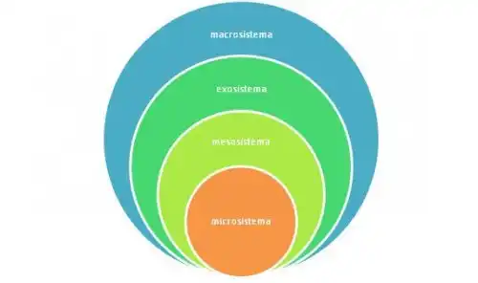

Urie Bronfenbrenner’s theory consisted of fiver systems.

1.Microsystem
2. Mesosystem
3. Exosystem
4. Macrosystem
5. Chronosystem.

(source: Exploringyourmind 2020)

According to (exploringyourmind, 2020) ‘the influence of one system on a child’s development depends on its relationship with the others’.
Bronfenbrenner looks at relationships affected by multiple levels of the surrounding environment.
The first stage ‘Microsystem’ contains the environmental settings of the child such as family and school. The relationship between this systems and a child’s development is obvious. However, the influence can go both ways. (Exploringyourmind,2020).

The second system ‘Mesosystem’ is made up of the relationships of the parents and school staff, these relationships have direct impact on a child and is therefore vital in the process of transition because if a child’s parents communicate with the child’s new teacher this will encourage and influence the child to do the same. (Simplypsychology, 2020) states ‘if the child’s parents and teachers get along and have a good relationship, this should have positive effects on the child’s development, compared to negative effects on development if the teachers and parents do not get along’.

It is important for the child to see a positive bond between parents and practitioners as they will copy and learn from what we are doing. This was proven by Vygotsky as he emphasizes that ‘children learn through social interaction that include collaborative and cooperative dialogue with someone who is more skilled in tasks they’re trying to learn’ (The Psychology Notes Headquarters,2022).

Interventions

Children’s brains are like plasters, when it’s still fresh and soft, any cracks or dents can easily be smoothed out. But once the plaster dries and hardens, even relatively minor issues become much harder to correct (Vollmer,2020).
Interventions are put in place to help support children and help them adapt to new ways of learning. Interventions during transition will support the child settle faster and gain confidence in a new setting but will also guide the parents and practitioners to develop new ways of adapting and understanding the ways of the children.

Settling – in children
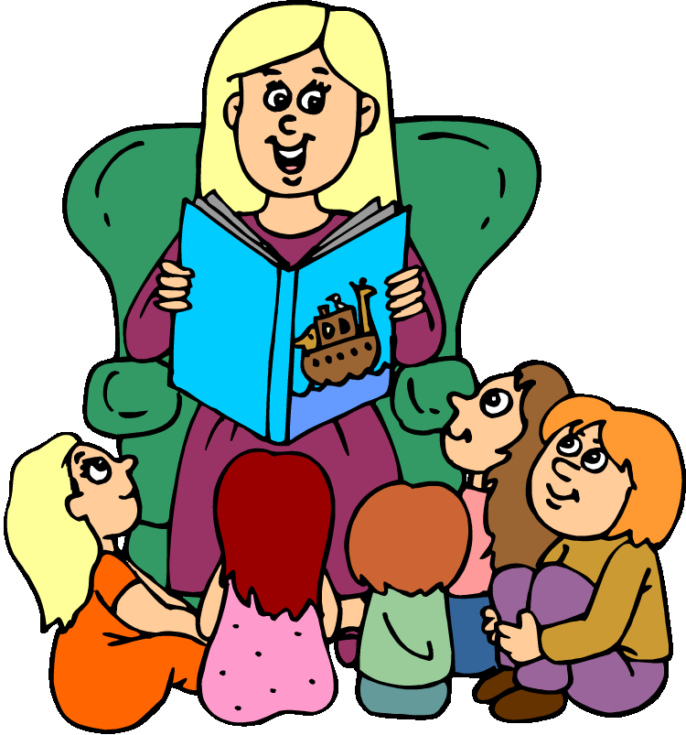
It is important as practitioners that we help children settle into a new environment. Settling in sessions are helpful and beneficial to children moving into a new setting. John Bowlby and the work of others has shown early years practitioners that children need time to settle in. (Tassoni 2007, P103). Settling in policies are designed to help children adjust to the new environments and the length of a session depends on how well practitioners believe a child is coping with separation. Settling in session will support children and practitioners to build a good trusting relationship. According to (Tassoni 2007 P.80) when children do not have a strong bond with a primary carer, they find it difficult to socialise and develop relationships with others. An example of a settling in session from Nursey to Reception could be the group of children spending a short amount of time with their new teacher and just having a story read to them, this enables the children to familiarise themselves with their new classroom but also the voice of their new teacher.
(Source: Clipart Panda, 2020)

Social stories

Social stories are a way of helping a child develop social understanding of situations and are often used to encourage appropriate behaviour, (Early years Teaching service, Leicester city council n.d). During the process of transition, the benefit of using a social story is that so practitioners or parents can show a child and event or activity that is going to happen and how the child should respond. (Early years Teaching service, Leicester city council n.d) states social stories are useful for children on the autistic spectrum as children with autism do not like change in their routine and have difficulty predicting what is about to happen. The aim of a social story is to help children understand a social situation and the motivations of other people. Regarding transition an example of a social story could be pictures of a new place a child is going to and activities that are set in that environment, once the child has been shown the social story the next stage will be then for the child to visit the new setting and hopefully will feel less stressed and the anxiety will be reduced.
(Early years Teaching service, Leicester City council n.d).

Welcome Pack/ Welcome Evening
As well as building a relationship with the children it is also important that we allow the parents to feel a strong bond with a new setting their child is transitioning to. A welcome pack or evening is a great way to do this. By inviting the parents in to see the new setting and meeting all staff members allows them to feel at ease as they will know where their child is being left and who they are being cared for by. The child will also be able to feel confident attending a welcome evening with their parent first as according to (Tassoni 2007 P.137. children look at their parents’ reactions to decide whether or not they should be fearful. If the parents are happy and feel relaxed in a new environment this will encourage the child to feel the same way.

Proposed Outcomes

During transitions early years practitioners want the children to feel they belong and to show they are coping independently. As key workers the aim is to develop relationships with the children however not to replace the parent, but to be an additional person who the child can go to when their parent is not available (Tassoni 2007 p.97).

According to (curriculum for Wales, 2015) all our young children and people will be:
- Ambitious
A child should be able to question and enjoy problem solving whilst being able to communicate effectively in differently forms and settings. They should be able to understand and explain the ideas and concepts they are learning about and undertake research and evaluate critically what they find. And are ready to learn through their lives.
- Healthy
Children should feel confident in building their mental and emotional well-being by developing confidence, resilience, and empathy. They will face and overcome new challenges in their life and be able to form positive relationships based upon trust and mutual respect. Children will have the skills to manage everyday life alone and will be ready to lead fulfilling lives as valued members of society.
- Ethical
Children should be able to understand and exercise their human and democratic rights and responsibilities, have knowledge about their culture and the world we live in, now and in the past and show their commitment to the sustainability of the planet and will show readiness to be citizens of Wales and the world.
- Enterprising
Children will be able to identify and grasp opportunities ahead of them. Take lead and play different roles in teams effectively and responsibly. They will be able to express and show emotions through different media and give off their energy so that others can benefit and will feel ready to play a full part in life and work.
(Curriculum for Wales, 2015)

In order for these to happen, a smooth transition into their next stage of learning is key as if this is not done with the four core purposes in mind there is risk of the child not being ready to develop and learn in the future.

References

O’connor.A (2007). All about transitions- Birth to 5 matters. Available at: https://birthto5matters.org.uk/wp-content/uploads/2021/03/All-about...-transitions.pdf. (Accessed: 18 November 2022).

Birth To 5 Matters (N.D). Transitions. Available at: https://birthto5matters.org.uk/transitions/. (Accessed: 18 November 2022)

Tassoni, p (2007) Childcare and Education. 3rd edn. Essex: Harlow

Cherry.K (2022). What is Attachment Theory. Available at: https://www.verywellmind.com/what-is-attachment-theory-2795337. (Accessed: 24 November 2022)

Pennstate Extension (N.D). Understanding transitions. Available at: https://extension.psu.edu/programs/betterkidcare/early-care/tip-pages/all/understanding-transitions. (Accessed: 24 November 2022).

Ocius Consulting (2019) Why people change work. Available at: https://ociusconsulting.co.uk/index.php/managing-the-human-side-of-projects-making-transition-work/.(Accessed: 24 November 2022).

Mcleod.S (2007). Maslow’s Hierarchy of needs. Available at: https://www.simplypsychology.org/maslow.html. (Accessed: 26 November 2022)

Art of autism (2013). Special Education is not about funding. Its about the people. Available at: https://the-art-of-autism.com/special-education-is-not-about-funding-its-about-the-people/. (Accessed: 28 November 2022)

Tassoni P (2007) Childcare and Education 4th Edn. Essex: Harlow.

4C Helping Communities Help Children. Transitioning for child care. Available at: https://www.4-c.org/families/child-care-referral/transitioning-to-child-care/. (Accessed: 29 November 2022)

UNICEF (n.d). Summary of the UN convention on the rights of the child. Available at: https://www.unicef.org.uk/wp-content/uploads/2019/10/UNCRC_summary-1_1.pdf. (Accessed: 29 November 2022)

Exploringyourmind (2020). Bronfenbrenner’s Ecological systems theory. Available at: https://exploringyourmind.com/bronfenbrenners-ecological-systems-theory/. (Accessed: 29 November 2022)

Evans.O (2020) Bronfenbrenner’s Ecological systems theory. Available at: https://www.simplypsychology.org/Bronfenbrenner.html. Accessed: (29 November 2022)

Psychology Notes HQ (2022). Lev Vygotsky’s sociocultural Theory of Cognitive development. Available at: https://www.psychologynoteshq.com/vygotsky-theory/. (Accessed: 29 November 2022)

Vollmer,E. (2020) Why is early intervention important?. Available at: https://therapyworks.com/blog/developmental-milestones/why-is-early-intervention-important/. (Accessed: 30 November 2022).

Clipart Panda (2020). Teacher reading to class: Remember when a teacher reads. Available at: http://www.clipartpanda.com/clipart_images/remember-when-a-teacher-reads-32436544. (Accessed: 1 December 2022)

Early years Teaching service, Leicester city council (n.d). Social Stories in Early Years. Available at: https://families.leicester.gov.uk/media/1964/social-stories-in-early-years.pdf. (Accessed: 1 December 2022).

Welsh Government (2015) The new Curriculum: Poster. Available at: https://gov.wales/sites/default/files/publications/2018-03/the-four-purposes-of-the-curriculum-for-wales.pdf. Accessed: (1 December 2022)

