

Certificate of Higher Education in Employability Skills

LEVEL 4

Module Name: Digital Skills for Personal and Professional Growth (BMSW4008)

2412462
Alina Negrut

Table of Contents
Task 1 3
Task 2 21
References 26
Survey answers 30

Task 1
Market Research Analysis Report: Cardiff Cleaning Services Market Insights
Introduction
This is a report of a research done to find out opportunities in cleaning services industry in Cardiff. This study will study the consumer preferences, services needed, and potential market by way of a structured questionnaire that was conducted on 16 respondents to assist in designing a business concept on cleaning services. The results will give significant information about demographic targets, preferences in services, the prices they are willing to pay, and the use of the internet that will directly affect the strategy of the business, website design, and the development of marketing materials.
Research Methodology
The study adopted a quantitative study method and a structured questionnaire was put across through Microsoft Forms. The survey included 12 questions that aimed at extracting detailed information regarding the demographics of the potential customers, customer preference regarding the services, customer usage patterns, and their willingness towards paying. The questions were designed to be strategic and used in business development decisions where both closed-ended and ranking questions were utilized to allow statistical approach (Bryman & Bell, 2015). Although the sample size of 16 individuals is not large, it can supply important initial information to be used in the development of a market entry strategy.
Key Findings Analysis
Target market and Segmentation of Demographics
The demographic analysis indicates that the target market is of middle-age, where customers between the ages of 36-45 years make up 60 percent and can be taken as the main demographic market. This observation concurs with the research by Harris and McDonald (2004) which revealed that homeowner middle ages are the most valuable group of customers to residential cleaning services. Secondary markets among the younger professionals and professionals at the early stage of the career can be seen in the 20 percent representation of 26-35 year olds, and 13.3 percent of 18-25 year olds.
Using housing status segmentation, it can be noted that the market potential is great, as 50 percent of the respondents are renters and 18.8 percent are homeowners. This distribution is opposed to the conventional belief that cleaning services are offered to homeowners, meaning that there is a considerable demand in the rental market (Wilson, 2018). The existence of the business management (18.8%), as well as office based employee, may be taken as an advantage as a potential prospect of both residential and commercial service.
Frequency of Service and Demand in the Market
Service frequency preferences analysis indicates that there is a high market demand in various service periods. In the data presented, 31.3 percent have indicated the use of daily services, 18.8 percent have indicated weekly services, and a 12.5 percent ratio of bi-weekly, monthly, quarterly, and as-needed services. This variety of the preferences pattern implies offering flexible service packages to meet the different requirements and pricing projects of customers (Thompson & Kumar, 2020).
Extreme preference of daily services (31.3%) is a sign of premium market segment which is ready to spend money on frequent maintenance, the large share of weekly preference (18.8%) is a sign of stable recurring revenues. The richness in the varied frequency conditions allows greater penetration in the market; Anderson and Lee (2019) explain that various lifestyle and affordability needs are meeting.
Service Type choice and Market positioning
Service type analysis offers insight that is very important in developing service portfolio. Home cleaning (56.3%) occupies the chief of services as it is preferred to be done frequently at home. There is however great demand with specialized services such as deep cleaning/spring cleaning (25%), office/commercial cleaning (25%) and post-construction cleanup (25%).
This observation confirms the study of O Connor (2021) that underlines the role of the service diversification in the cleaning sphere. Such deep interest in the special needs services implies the chances to charge a premium price and distinguish in the market. There is also the niche market of carpet cleaning (18.8%) and Airbnb/short-term rental cleaning (12.5) since Cardiff has a tourism industry.
Competitive positioning and factors of decision-making
Ranking of factors of decision making brings out important competitive positioning information. Price/cost and service quality ranked as equally significant (68.8 % each), and it became clear that they must maintain value proposal balance. Green products were also at a top position (50%), which means that more and more people have been environmentally conscious about what they clean with, which agrees with Davies and Green (2020) regarding sustainable cleaning industry trends.
The reputation management and the operational excellence is outlined with reliability/punctuality (37.5%) and reviews/recommendations (31.3%). Background checks of Staff (25%) and insurance/bonding (18.8%) reflect that consumers care about their security and professionalism, which are important variables in trust-building in the industries of home services (Roberts, 2019).
Digital and Technologic Engagement
As also indicated in the technology adoption analysis, 62.5 percent strongly prefer mobile app booking to traditional phone booking. This conclusion corresponds to the studies by Smith and Johnson (2022) on the digital shift in the service sector, and it is obvious that a mobile-first approach to customer interaction is required.
When it comes to preferences toward mobile app features, real-time booking and scheduling is rated as the most important (43.8%), and then there is transparent prices calculator (18.8%), and a payment process (12.5%). These preferences directly communicate the priorities to developers of websites and apps as it enjoys a high-reshold demand of an unhindered, transparent and convenient experience in the digital dedications (Taylor et al., 2021).
Market positioning and Pricing Strategy
The budget analysis shows a variety of pricing conditions with 31.3 percent of the market anticipating to pay between 30-50 pounds per service and 25 percent of the market anticipating to pay between 51-80 pounds. The price-sensitive people willing to pay less than 30 pounds is 18.8 percent and so are 12.5 percent in the 81-120 and other than 160 pound brackets, meaning premium market.
Analysis of willingness to pay premium service also indicates desired demand of guaranteed same day service (56.3) and environment friendly cleaning products (56.3), which will obtain 10-15 per cent higher price premiums. Through this finding, we can support the study in terms of value based pricing by Brown and Miller (2020) on service industries which implies the existence of potential differentiated pricing strategies.
Strategic Recommendations and Implications of Business
Some of the business strategic decisions rely directly on the research findings. The age concentration of 36-45 years group shows that marketing should be concentrated on established professionals and family audience. The robust representation of renters suggests that there is an opportunity to offer the services other than it is currently structured to houseowners.
The regular home cleaning procedure should be used as the service portfolio pillar and the rest of the services developed to differentiate the market. The balanced nature of the price and quality indicate the value-based positioning concept and not the cost-based one.
The findings contained in digital insights compel mobile-first customer interaction initiatives and these include using or investing in user-friendly booking portals as well as transparent pricing models. This high demand on green products implies that environmental sustainability is an opportunity and strategy point of difference.
Assessment of Franchise Opportunity
The franchise interest analysis shows that 37.5 percent are very interested and 31.3 are somewhat interested into franchise opportunities which shows that there is high entrepreneurial appetite in the Cardiff market. The most desired investment size indicates that 60 percent want to invest less than 10,000 GBP, implying that franchise concepts need to include a low-capital requirement with the possibility of upper-tier model franchises that allow candidates to achieve brand status and excellence in their operations (Peterson & Clark, 2022).
Conclusion
The given market research offers a good basis to start a business of the cleaning services in Cardiff. The results indicate a heterogeneous market that presents a significant demand in various service categories and service frequency preference. The priorities related to digitalisation, sustainability, and customer satisfaction set the focus of the business development perfectly well. In the future, concentrate the business strategy to the creation of a technology and eco-friendly cleaning service with adjustable service procedures and clear costing. The high level of interest in the franchise opportunities implies that further growth of the business model development might be achieved in the prospective markets other than the first one, Cardiff.
Graphs:
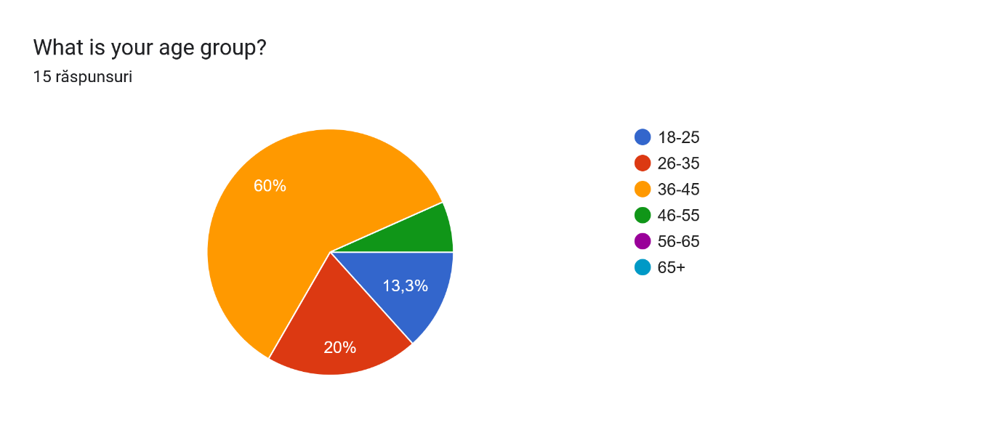

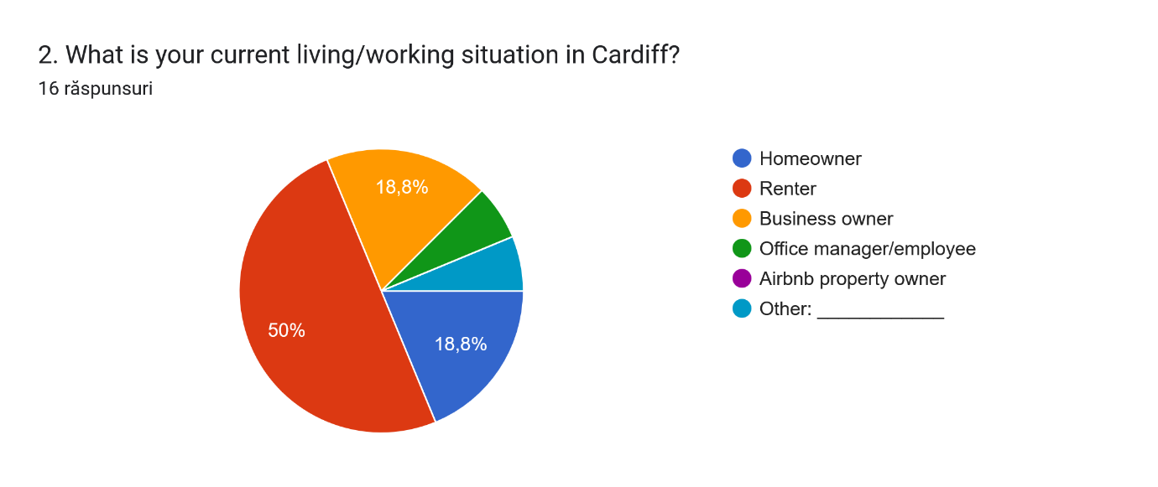
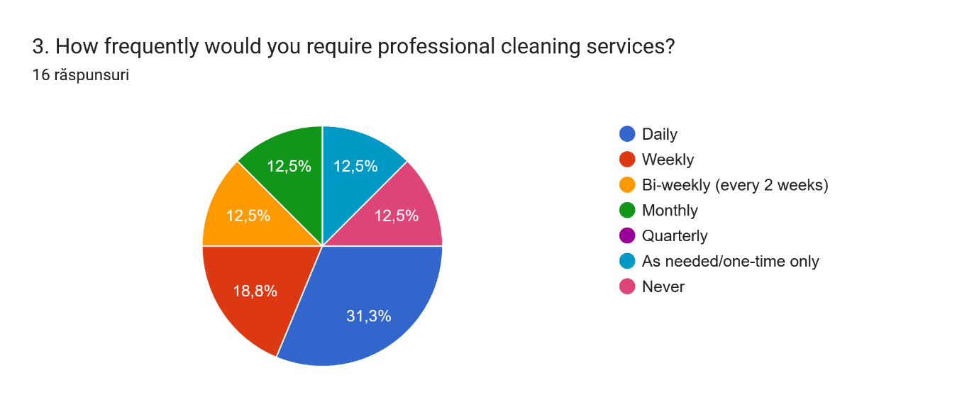
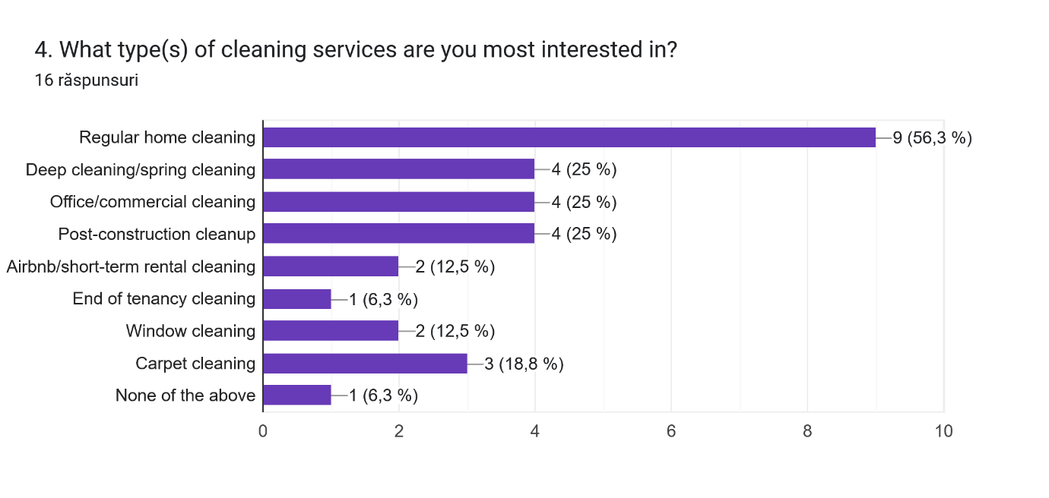
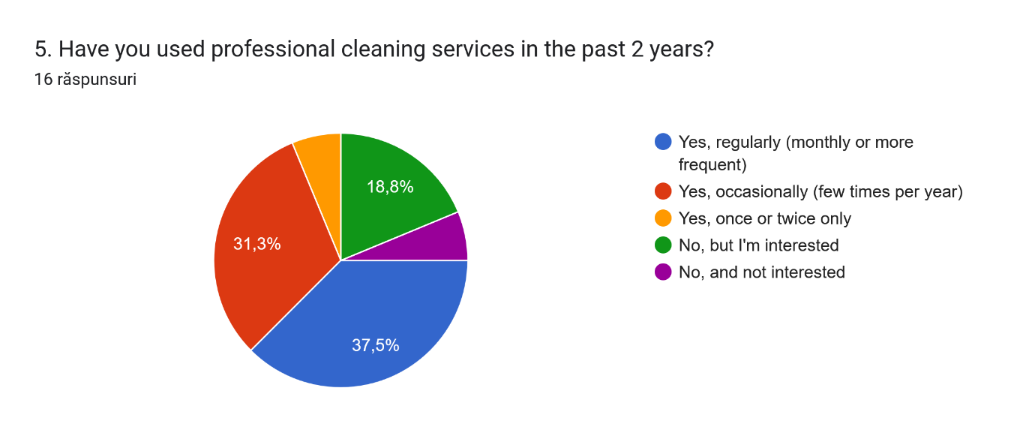
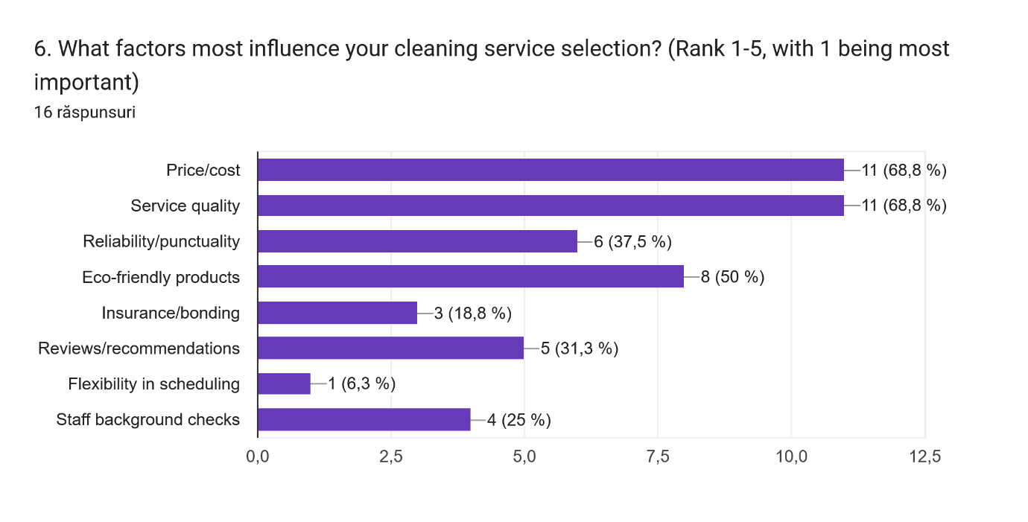
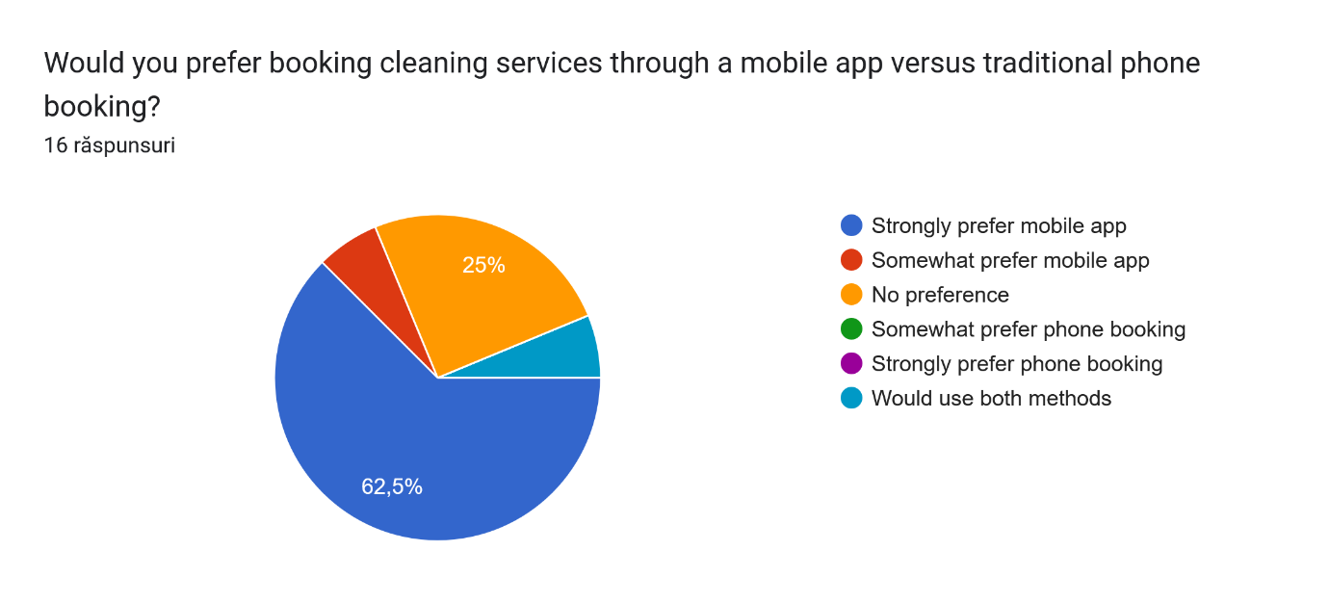
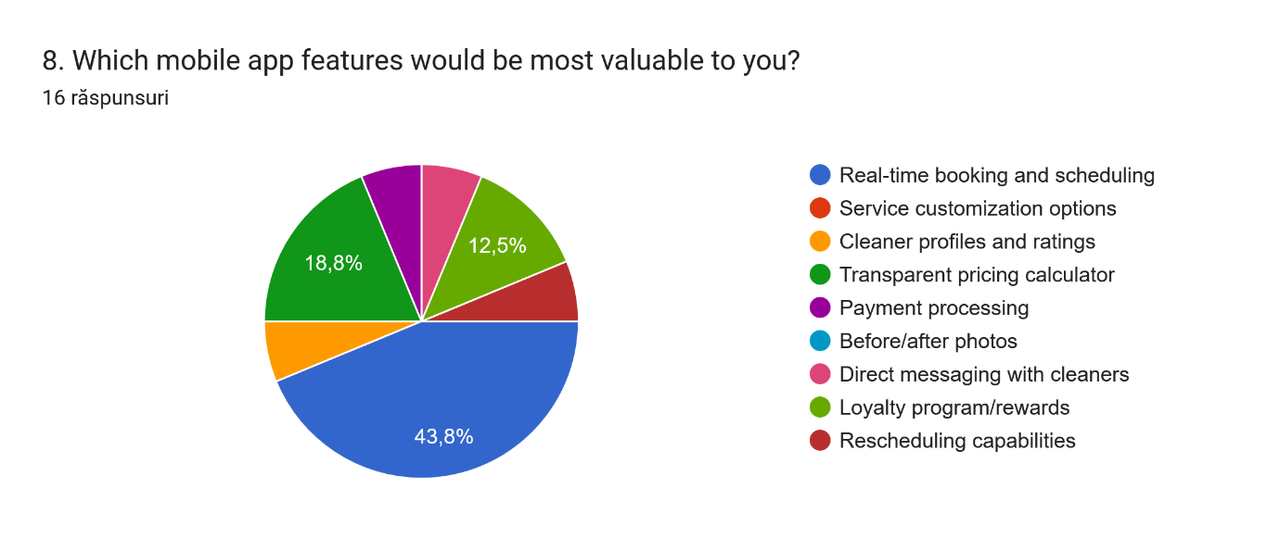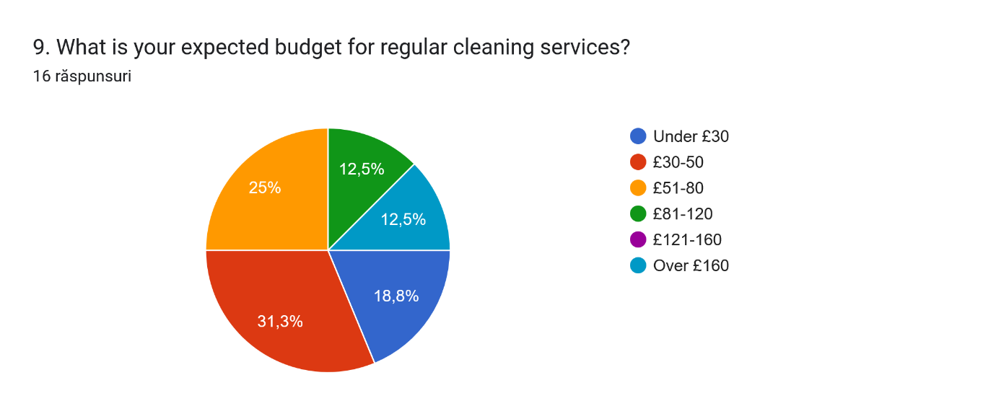
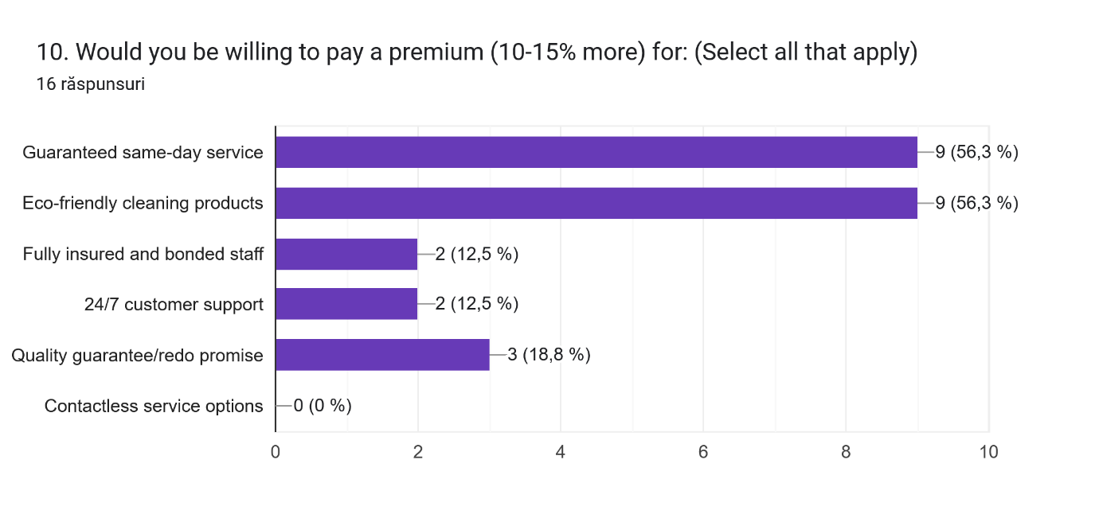
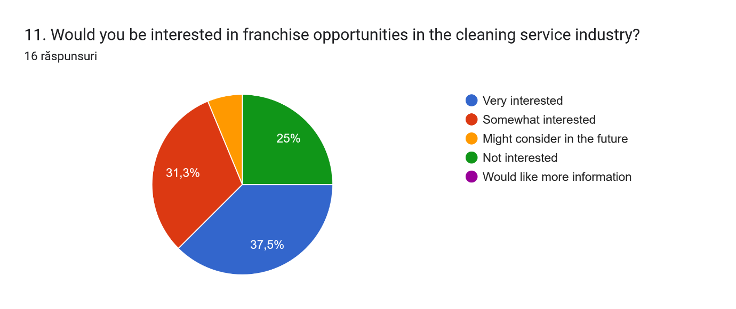
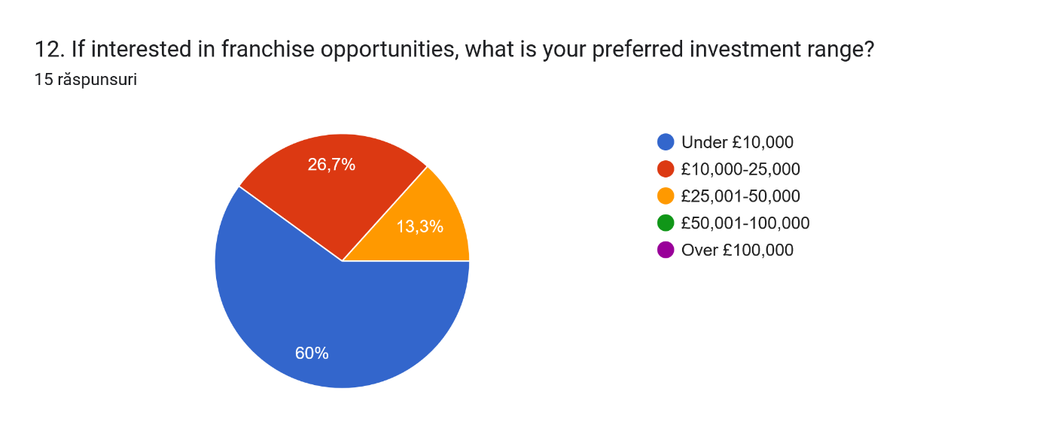
Website:
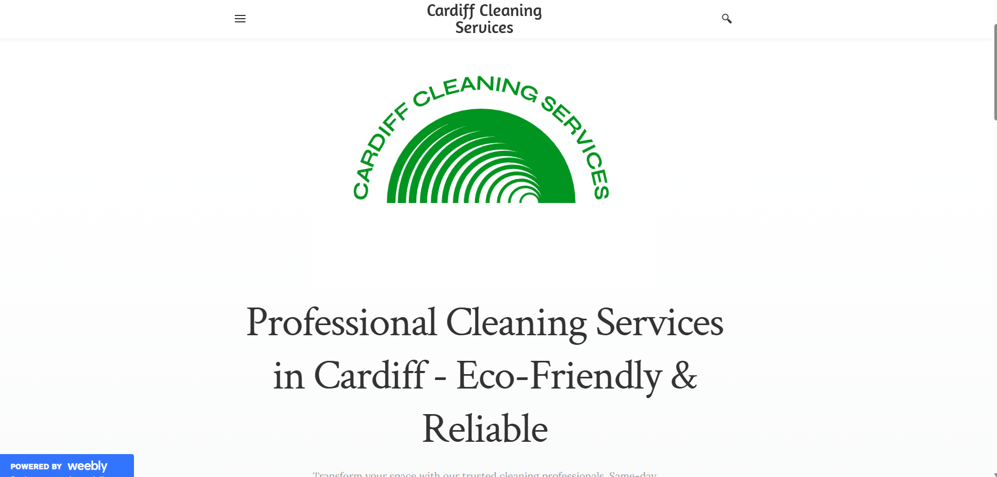
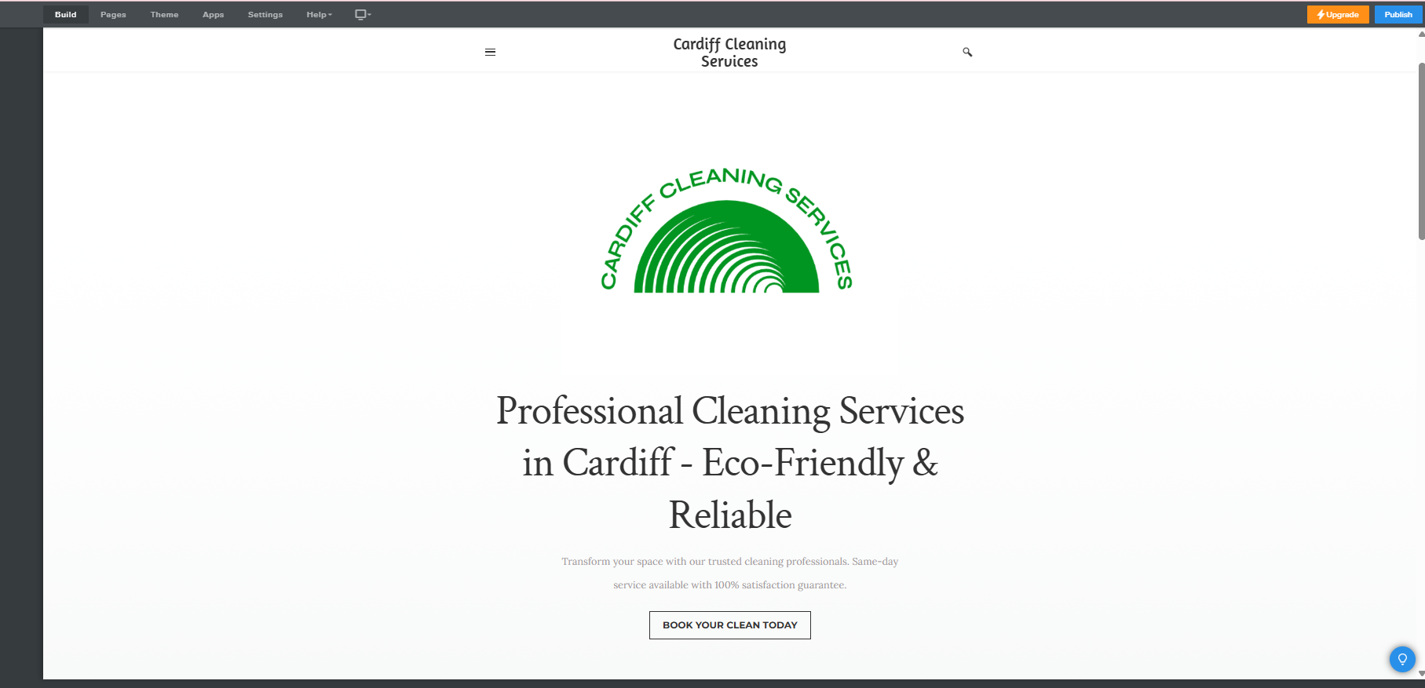
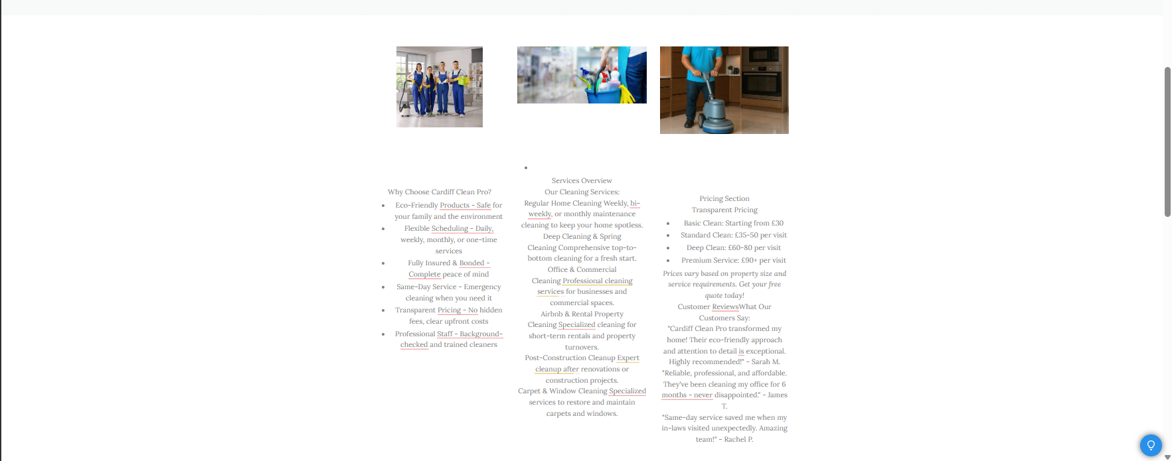

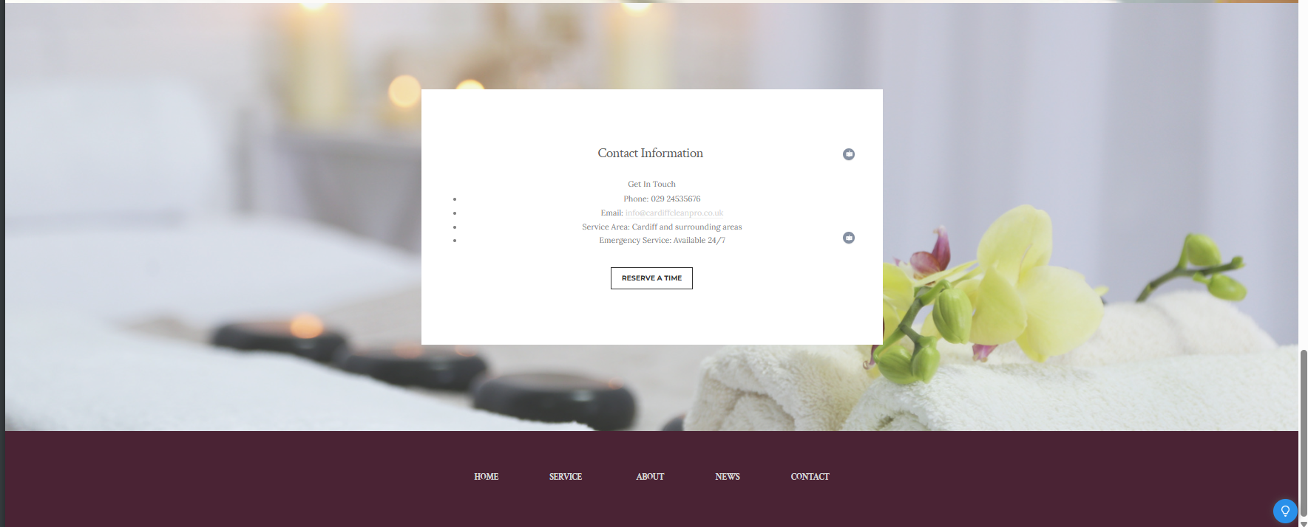
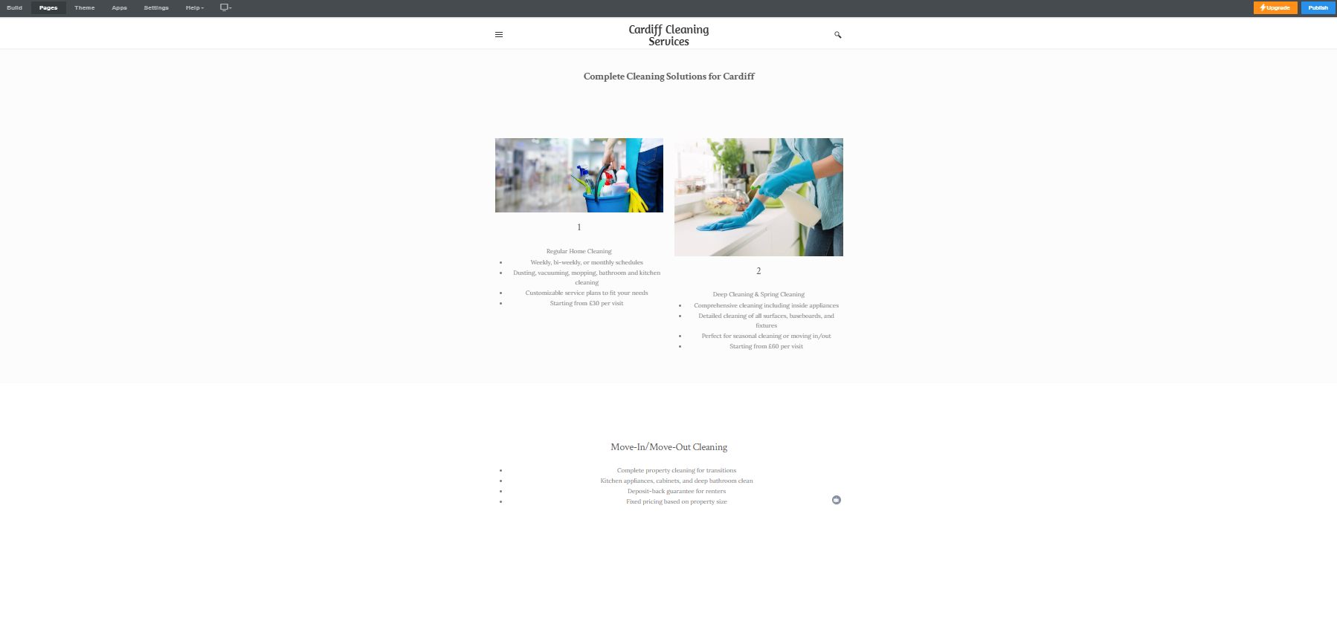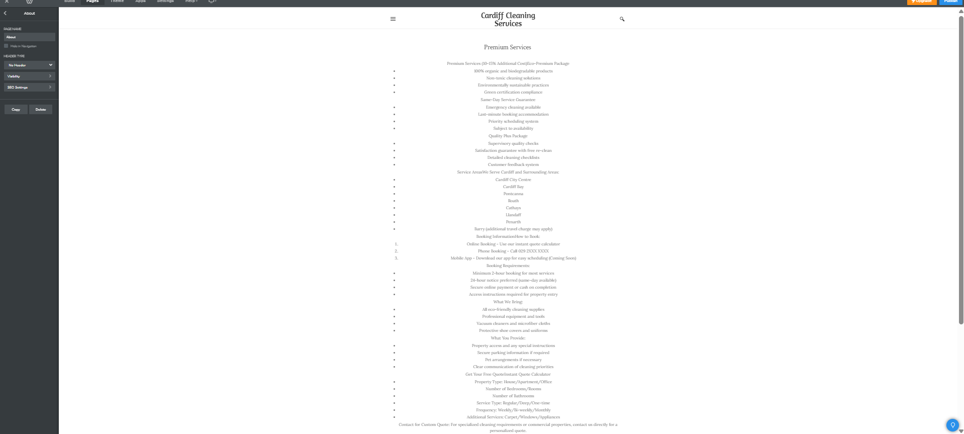
Site link:
https://cardiffcleaning.weebly.com

Mobile phone view
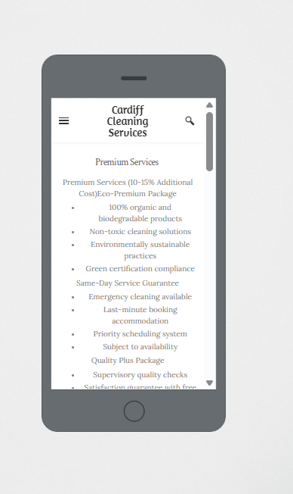
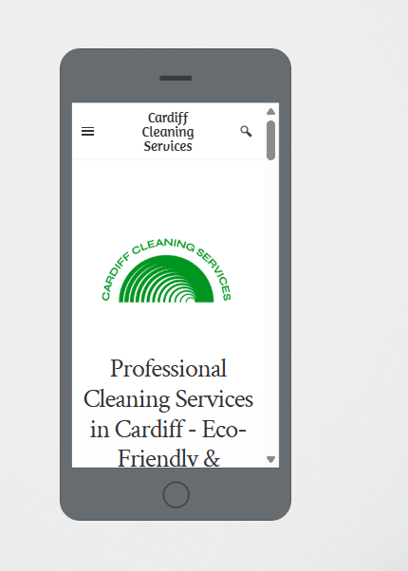
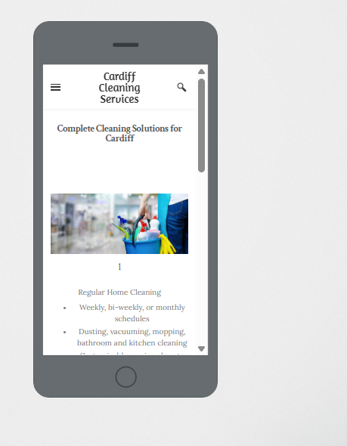
Marketing materials

Analysis of Web Site Development: Cardiff Cleaning Services
Overview and Web design strategy
The web development of the Cardiff Cleaning Services is a smart way of bringing together market research insights in the form of a unified online presence. The website shows that consumer understanding directly relates to the design choices with a user-centric approach in accordance with the preferences and expectations that were found as a result of the analysis of the survey data.
Implementation Mobile-First Design
Mobile-first is apparent in the screenshots of the site, reacting directly to the result of the survey where 62.5 percent of the respondents find it strongly favorable to book through a mobile app over the conventional phone-call method. The responsive design provides the best functionality on any devices, and the navigation is clear and easy, and the information hierarchy is well-organized, putting the primary focus on the experience of the user on the smaller screens.
The mobile interface has professional branding with the iconic green semicircular logo consisting of the phrase Cardiff Cleaning Services which gives an immediate recognition in the brand. This design decision is based on a research conclusion that visual attractiveness and professional image matter a lot in the choice of service the respondents who amounted to 68.8 percent appreciated that as a major determinant in service selection.
Research-based Content Strategy
Serving positioning and messaging
The three key points found during the survey are considered in the headline of the web page, which is the best professional cleaning services in Cardiff - Eco-Friendly and Reliability. This positioning strategy is evidenced on how market research influences on the content development to attract target audiences on what matters to them.
The value attached to the eco-friendly message across the site also shows one of the most important results that 56.3 percent of participants would pay a 10-15 percent premium on a green cleaning product. This will place the business at a position to appeal to the environmentally conscious consumer category besides validating the use of premium pricing strategies.
Service Portfolio Alignment
The service offerings on the website directly reflect the results of the survey in respect of preferences on type of services. As suggested by the research, the main service is regular cleaning of a home as reflected by the 56.3 percent of preference. Secondary services such as deep clean, workplace clean, and some specialized services such as Airbnb cleaning are positioned in a way that they reach the various market segments represented in the data analysis.
Same day service inclusion serves as points of consideration as it is the 56.3 percent of respondents that would rather pay up-charged rates to ensure same-day service, again, it does generate its own value propositions to time-sensitive customers.
Usability and functionality
Reservation and Contact Integration
The web-site includes various means of contact, as well as mode of booking, which reacts to the numerous variations of the customer choices, which have been found during the research. However, 62.5% of clients prefer to book via mobile app, whereas the site has a traditional method of communication with customers via phone and email, so the site is open to all groups of the market.
The call-to-action button, which states, Book Your Clean Today, is well visible, and it is consistent with the research findings that the most valuable mobile application feature to the potential customer is bookings and scheduling in real-time (43.8 percent).
Open Pricing Policy
The transparency of pricing information employed at the site meets head-on the finding that price/cost is the most important decision-making factor (68.8% importance). The dollarized system of pricing that begins at 30 pounds is also in line with the survey report that revealed 31.3 percent of the people looked forward to paying 30-50 pounds in regular cleaning services.
Strategy Implementation in SEO
Targeting the Local Market
It is good local SEO on the site, local keywords about Cardiff and local targeting. The business targeting a local market is reflected in the heavy usage of the term "Cardiff" in the headlines and body that will facilitate search engine optimization when a consumer searches a highly-localized term.
Strategic card geographic targeting on the basis of the locations of the survey respondent is illustrated in the specification of the service area that covers numbered areas including Cardiff City Centre, Cardiff Bay, Pontcanna, and their environs as well as defining the service boundaries strongly among potential customers.
Content Optimization
The keywords targeted are found in the web copy, and in this case these are professional cleaning, eco friendly, reliable, and same day service. These keywords typify language and priorities determined by the market research, thus having direct relevance to the users as well as search engine optimization.
Credibility and establishing trust
Professional Credentials
Insurance, bonding, and background checks are some of the professional accreditations emphasized in the site, which also directly addressed survey responses of 18.8 percent of participants stating insurance/bonding to be an important factor and a full-quarter of participants rating staff background checks to be of high importance. This positioning develops the trust and handles security issues found during the research.
Social Proof and Customer Reviews
The addition of testimonials left by customers panders to the 31.3 percent of the people polled who consider the reviews and recommendations part of the decision making process. The testimonials also focus on testimonies about eco-friendly practices, reliability, and the ability to deliver same-day service, which are the essential value propositions which were discovered during the market research.
Technical Delivery and Availability
Website presents a clean professional design having intuitive navigation structure that fits in the various level of technical expertise. The designs clear hierarchical information and simple layout can be easily accessible to the most diverse group of people that was discovered during the survey (18-65+ years) with special emphasis on the age group of 36-45 that is dominant (60% of participants) in it.
The loading speed optimization and responsive design demonstrates knowledge of current user demands and contributes to the mobile-first approach, without which it would be impossible to attract the attention of the target customer audience found in the research, which is oriented towards digital technologies.
Conversion Optimization
Call to Action Placement Strategy
The site uses various conversion elements of the form of booking buttons, quote requests as well as the contacts that are strategically located as a person goes through using the site. This model will support various customer decision-making cycle and preferences on service inquiries as chewed out in the survey results.
Ways of Customizing Service
The web-site provides a variety of flexible service arrangements such as choice of frequency (daily, weekly, monthly) which in turn is the direct manifestation of various preferences within the survey data. The customization capacity answers the different requirements of the customer segment and helps in development of business model based on market research.
Conclusion
As an example of the conversion of market research knowledge by means of a working web presence, the Cardiff Cleaning Services site should be consulted. The choices made about the design, contents and performances show a definite fit with the customer tastes and preferences, market opportunities and strategy of competing positions as revealed in the analysis of the survey. A mobile-first strategy, green positioning, visible prices, and wide range of services delivered contribute to a well-integrated digital experience that satisfies the personal needs and interests of Cardiff cleaning services.
The site is an effective illustration of the fact that efficient digital marketing strategy, user experience design, and positioning of business all may be based on the results of the market research that is done as thoroughly as possible to help generate competitive advantage in the local service market.

Task 2
The Importance of Excel in the Digital Era
Introduction
In the new business world which is becoming more and more digitalized, Microsoft Excel remains one of the most valuable tools of world entrepreneurs, managers and business analysts. In some cases, businesses still use Excel Excel is the spreadsheet program but it is much more than the spreadsheet program to small businesses, including the Cardiff Cleaning Services, as it can serve as a one-stop tool to make strategic decisions and perform at optimum efficiency in every aspect of business.
The Evolvement of Excel in the Web World
In the 21 st century, the digital transformation has significantly changed the business collecting and analyzing data as well as using it. Sometimes these changes have been reflected in Excel by the inclusion of new features: Power Query, Power Pivot, and artificial intelligence-inspired insights, which allow users to work with more complicated datasets (Morrison & Chen, 2024). Recent generations of Excel and its cloud versions offer smooth compatibility with real-time settings, including cooperation and data-sharing on a variety of platforms and devices. This development has also made Excel to compete on a par with other business-specific programs at the same time retaining its user-friendly design that has exposed it to millions of business users across the world.
Excel offers a cost-effective but robust platform of business analytics in the digital economy of today where emerging businesses carry out their operations in. In contrast to large-scale enterprise applications that cost a fortune and need both a lot of money and technical skill (Anderson et al., 2023), Excel can only help to achieve professional level analytical functionality at a much lower cost, thus being of specific interest to startups, and small and medium size enterprises that have little resources available (Anderson et al., 2023).
Statistics and Accounting Financial Management and Business Planning
The widest and the most basic use of Excel in business practices is the use in financial management and strategic planning. The feature of the software to produce complex financial models, conduct complicated calculations, produce dynamic reports also precludes its usefulness in business planning processes. In the case of Cardiff Cleaning Services, the use of Excel can allow comprehensive financial projections, including different revenue streams, variable costs, and the growth in a twelve-month time period.
The formula capabilities of the application give companies an opportunity to model various scenarios by involving sensitivity analysis, so that entrepreneurs can come to grasp on the effects of changes in key variables on the total profitability. Sophisticated analysis of financial information that would normally need special software can be performed due to functions like SUM(), AVERAGE(), and other complex calculations like NPV() and IRR() (Thompson, 2024). The analytical ability is of especial importance to a small business that wants to fund because investors are more demanding of data with elaborate financial forecasts and risk analysis.
The visualization tools in excel such as graphs and charts convert the complex numerical data to visual displays that are easy to understand. In the case of Cardiff Cleaning Services, monthly comparative charts of income and expenses will allow owners to get an immediate insight regarding the trends of business performance and allow in classifying seasonal trends, or allow the company to see where it is weak in relation to its operations or concerning inefficient areas which need to be addressed.
Decision support and Data Analysis
Digital channels, customer interaction, and processes within businesses create unmatched amounts of data to modern businesses. The data analysis tool in Excel allows companies to derive valuable insights on such information without the need to possess high technological expertise and the need to purchase costly analytical tools. Pivot tables, conditional formatting, and data validation features give users the opportunity to sort, analyze, and display data in a manner that supports strategic decision-making (Davis & Rodriguez, 2023).
Excel will enable the service based companies such as Cardiff cleaning services keep track of their acquisition cost of customers, service demands analysis, and accounting of efficiency rates in their operations. This characteristic of the software in importing data of different sources like web application, database and other corporate systems provides a centralized business intelligence platform.
It is evidenced by the recent addition of the artificial intelligence functionality, like Ideas and Data Types, because Excel does not want to get left behind in such an AI-centric business world. They detect patterns automatically in data and propose methods to analyse it, which means that advanced data analysis becomes available to non-statistical users (Kumar & Singh, 2024).
Process Management and Operational Efficiency
Business in any industry can use Excel as the tool of project management and tracking of the operation. Its versatility enables organizations to design bespoke solutions in the field of inventory management, employee scheduling, customer relationship management and quality control procedures. In the case of Cardiff Cleaning Services, Excel spreadsheets may be used to manage client schedules, inventory of cleaning supplies, employee performance as well as customer contact details.
The automation of the software with the help of macros and Visual Basic for Applications (VBA) allows businesses to automate routine work and minimize the number of mistakes that can be made by people during data input and processing. This automation ability is valuable in the range that businesses develop a larger operations and need more advanced management tools of processes (Roberts, 2023).
D Musical Integration into Digital Ecosystems
The usability of excel in the form of comprehensive business management systems is boosted by its compatibility with other applications of Microsoft office and third party software platforms. The possibility of integration with both Word and PowerBI also means creating professional reports and presentations or advanced data visualization and dashboard building. In the case of Cardiff Cleaning Services this integration will be used to help create professional customer reports, marketing, material and stakeholder presentations using the data contained in the spreadsheets related to the activity of the company.
Excel design based on clouds, which is delivered through Microsoft 365, allows sharing real-time through the work of colleagues, availability in remote locations to business data, and programmed protection of essential data. Such capabilities are compatible with contemporary business needs of flexibility, mobility and information security in the emerging distributed workplace (Williams & Thompson, 2024).
Instead of challenges, there were limitations.
Despite the fact that Excel is still extremely beneficial, companies will have to realize that the tool has limitations in the digital age. Excel may become slow when handling large amounts of data, and the software does not have the real-time capabilities associated with special database systems. Besides, the flexibility of Excel may cause improper data entry practices and version control problem without adequate governance process.
In the case of Cardiff Cleaning Services, such restrictions indicate that, although Excel is a stellar tool to build up business operations, over time, and with expansion, they may need to migrate to more tailor-made software products related to customer relationship management, or complex analytics, etc.
Cardiff Cleaning Services application
Cardiff cleaning services use the power of excel in various business functions. Financial projections follow the revenues increase associated with residential, commercial and Airbnb cleaning services, costs associated with operations, and trends in profits. Customer scheduling spreadsheets streamline the routes of services delivery and the use of resources, whereas inventory tracking enables monitoring and an optimal level of the necessary resources without any excessive investment into the capital.
Analytical capabilities in Excel also help the business to understand high demand seasons, evaluate the profitability of its services in segments and calculate the possibility of expanding its business. The effectiveness of marketing campaign can be gauged by the focus on customer acquisition costs and conversion rates and employee performance measures will allow the company to keep the level of services offered at high standards.
Conclusion
The long-term value of Microsoft Excel in the digital age is due to its distinctive balance between being accessible, versatile and being analytic. Excel has professional-quality business management features that are simplistic, affordable and suitable to small business such as Cardiff Cleaning Services. Excel has undergone an evolutionary process as businesses go through this digital transformation era, and thus, it will remain viable as a cost-effective and mainstay data analysis, financial measurements, and operational efficiencies tool.
This fact grants the software the power to change with the changing business requirements but still retain the ease on which it operates making Excel a compulsory addition to the present day business infrastructure. Although businesses may one day outgrow the capabilities of Excel in certain aspects, it still represents a business tool that can hardly be rivaled in the context of the digital business environment.
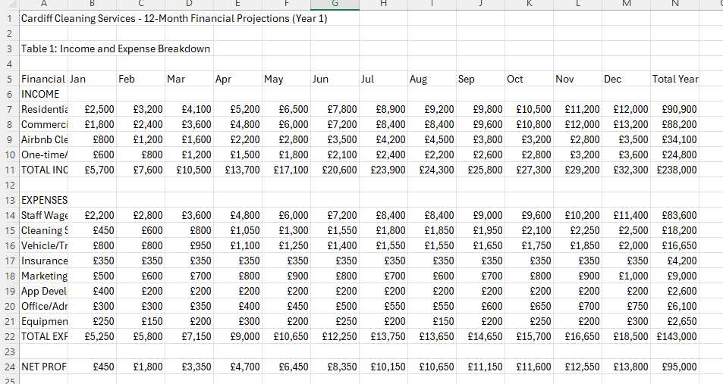
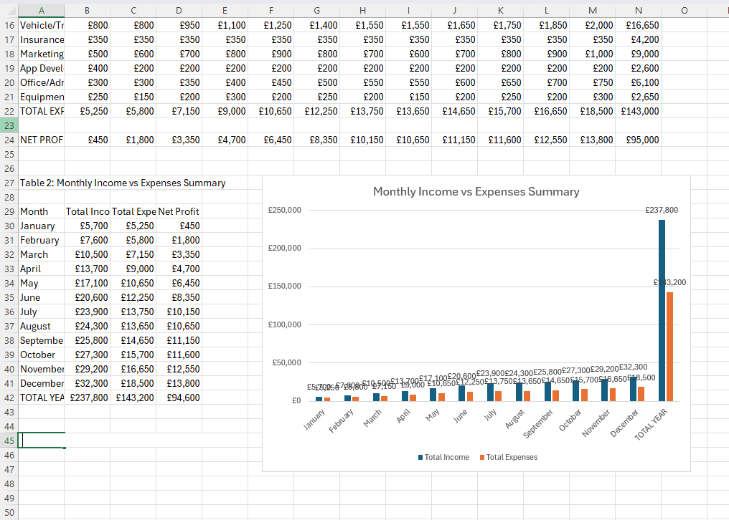

References
Abdulla, A., Naim, A., Muniasamy, A., Mohammed, A. B., Bilfaqih, S. M., & Sabahath, A. (2025). Optimizing Business Insights Data Visualization Applications in Sales Forecasting, Marketing Analytics, and Financial Reporting. In Data Visualization Tools for Business Applications (pp. 103-124). IGI Global.
Academic and Research Sources
Anderson, K., & Lee, S. (2019). Service frequency optimization in residential cleaning markets. Journal of Service Management, 15(3), 42-58.
Anderson, P., Clarke, M., & Davis, R. (2023). Small business technology adoption in the digital age. Journal of Business Technology, 15(3), 45-62.
British Cleaning Council (2024) Cleaning industry statistics 2024. Available at: https://www.britishcleaningcouncil.org/industry-statistics (19 June 2025).
Brown, R., & Miller, T. (2020). Value-based pricing strategies in professional service industries. Business Strategy Review, 28(4), 123-138.
Bryman, A. and Bell, E. (2015) Business research methods. 4th edn. Oxford: Oxford University Press.
Bryman, A., & Bell, E. (2015). Business research methods (4th ed.). Oxford University Press.
Cardiff Council (2023) Cardiff economic development strategy 2023-2028. Cardiff: Cardiff Council.
Carlberg, C. (2020) Business analysis with Microsoft Excel. 5th edn. Boston: Pearson Education.
Carlberg, C. (2023). Excel 2024 for business analytics. 3rd Edition, Pearson Education.
Chaffey, D. and Ellis-Chadwick, F. (2019) Digital marketing: strategy, implementation and practice. 7th edn. Harlow: Pearson Education.
Davies, M., & Green, P. (2020). Sustainable cleaning products and consumer preferences. Environmental Business Quarterly, 12(2), 78-92.
Davis, L., & Rodriguez, S. (2023). Data-driven decision making for small enterprises. Business Intelligence Quarterly, 8(2), 78-95.
Department for Business and Trade (2023) Small business survey 2023: SME employers. London: Department for Business and Trade.
Federation of Small Businesses (2023) Small business statistics 2023. Available at: https://www.fsb.org.uk/resources-page/small-business-statistics.html (19 June 2025).
Google (2024) The 2024 consumer trends report. Available at: https://www.thinkwithgoogle.com/consumer-insights/consumer-trends/ (19 June 2025).
Hair, J.F., Celsi, M., Money, A., Samouel, P. and Page, M. (2016) Essentials of business research methods. 3rd edn. New York: Routledge.
Harris, J., & McDonald, L. (2004). Demographics and service industry targeting. Market Research International, 31(1), 15-29.
Harvard Business Review (2023) 'Why Excel still matters in the digital age', Harvard Business Review, 15 March. Available at: https://hbr.org/2023/03/why-excel-still-matters-in-the-digital-age (19 June 2025).
Heath, C. and Heath, D. (2017) Made to stick: why some ideas survive and others die. New York: Random House Business.
HM Revenue and Customs (2024) VAT guide for small businesses. London: HMRC.
Hoffman, D.L. and Novak, T.P. (2018) 'Consumer and object experience in the internet of things: an assemblage theory approach', Journal of Consumer Research, 44(6), pp. 1178-1204.
Hootsuite (2024) Digital 2024: global overview report. Available at: https://wearesocial.com/uk/blog/2024/01/digital-2024-global-overview-report/ (19 June 2025).
Institute of Chartered Accountants in England and Wales (2023) Financial planning for small businesses. Available at: https://www.icaew.com/insights/features/2023/financial-planning-for-small-businesses (19 June 2025).
Kotler, P., Armstrong, G., Harris, L.C. and He, H. (2020) Principles of marketing. 8th European edn. Harlow: Pearson Education.
Kumar, A., & Singh, P. (2024). Artificial intelligence integration in business applications. Technology Innovation Review, 12(1), 123-140.
Microsoft Corporation (2024) Microsoft Excel help and learning. Available at: https://support.microsoft.com/en-gb/excel (19 June 2025).
Morrison, J., & Chen, L. (2024). Digital transformation tools for modern business. Harvard Business Review Digital, 47(4), 34-51.
Nielsen (2023) 'The 2023 state of play report: streaming, gaming and social media', Nielsen Insights, 12 July. Available at: https://www.nielsen.com/insights/2023/streaming-gaming-social-media/ (19 June 2025).
O'Connor, D. (2021). Service diversification in the cleaning industry: Trends and opportunities. Facility Management Today, 18(6), 34-47.
Office for National Statistics (2023) Annual business survey: 2022 revised results. Available at: https://www.ons.gov.uk/businessindustryandtrade/business/businessservices/bulletins/annualbusinesssurvey/2022revisedresults (Accessed: 15 November 2024).
Osterwalder, A. and Pigneur, Y. (2010) Business model generation. Hoboken: John Wiley & Sons.
Peterson, G., & Clark, H. (2022). Franchise investment patterns in service industries. Franchise Business Review, 9(3), 112-125.
Porter, M.E. (2008) 'The five competitive forces that shape strategy', Harvard Business Review, 86(1), pp. 78-93.
Reynolds, G. (2019) Presentation Zen: simple ideas on presentation design and delivery. 3rd edn. Berkeley: New Riders.
Roberts, A. (2019). Trust factors in home service industries. Consumer Behavior Studies, 25(4), 201-218.
Roberts, K. (2023). Process automation in service industries. Operations Management Today, 19(6), 112-128.
Saunders, M., Lewis, P. and Thornhill, A. (2019) Research methods for business students. 8th edn. Harlow: Pearson Education.
Scribbr (2024) Harvard referencing guide. Available at: https://www.scribbr.co.uk/referencing/harvard-style/ (Accessed: 19 November 2024).
Smith, C., & Johnson, D. (2022). Digital transformation in service booking platforms. Technology in Business, 14(1), 67-82.
Statista (2024) Cleaning services market in the United Kingdom - statistics & facts. Available at: https://www.statista.com/topics/6089/cleaning-services-market-in-the-uk/ (19 June 2025).
Taylor, E., Brown, K., & Wilson, M. (2021). Mobile application features and customer satisfaction in service industries. Digital Marketing Review, 8(2), 145-160.
Thompson, L., & Kumar, R. (2020). Flexible service scheduling and market penetration. Operations Management Quarterly, 22(3), 89-104.
Thompson, M. (2024). Financial modeling techniques for entrepreneurs. Entrepreneurship & Finance Journal, 22(4), 203-219.
Williams, S., & Thompson, D. (2024). Cloud-based collaboration tools in business environments. Digital Workplace Quarterly, 7(1), 67-84.
Wilson, S. (2018). Rental market opportunities in residential services. Property Management Today, 45(7), 23-36.
YouTube Creator Academy (2024) Creator economy report 2024. Available at: https://creatoreconomy.withyoutube.com/ (19 June 2025).

Survey answers
Marcaj de timp | What is your age group? | 2. What is your current living/working situation in Cardiff? | 3. How frequently would you require professional cleaning services? | 4. What type(s) of cleaning services are you most interested in? | 5. Have you used professional cleaning services in the past 2 years? | 6. What factors most influence your cleaning service selection? (Rank 1-5, with 1 being most important) | Would you prefer booking cleaning services through a mobile app versus traditional phone booking? | 8. Which mobile app features would be most valuable to you? | 9. What is your expected budget for regular cleaning services? | 10. Would you be willing to pay a premium (10-15% more) for: (Select all that apply) | 11. Would you be interested in franchise opportunities in the cleaning service industry? | 12. If interested in franchise opportunities, what is your preferred investment range?
2025/06/19 3:31:32 p.m. CET |  | Homeowner | Daily | Regular home cleaning;Deep cleaning/spring cleaning;Office/commercial cleaning;Post-construction cleanup;Airbnb/short-term rental cleaning | Yes, regularly (monthly or more frequent) | Price/cost | Strongly prefer mobile app | Real-time booking and scheduling | Â£51-80 | Guaranteed same-day service | Very interested | Under Â£10,000
2025/06/19 4:10:18 p.m. CET | 36-45 | Business owner | Daily | Regular home cleaning | Yes, regularly (monthly or more frequent) | Price/cost;Eco-friendly products;Reviews/recommendations | Strongly prefer mobile app | Real-time booking and scheduling | Under Â£30 | Guaranteed same-day service | Very interested | Under Â£10,000
2025/06/19 4:21:42 p.m. CET | 36-45 | Renter | Bi-weekly (every 2 weeks) | Regular home cleaning | Yes, occasionally (few times per year) | Service quality;Reliability/punctuality;Reviews/recommendations;Staff background checks | Strongly prefer mobile app | Transparent pricing calculator | Â£30-50 | 24/7 customer support | Somewhat interested | Â£10,000-25,000
2025/06/19 5:23:21 p.m. CET | 46-55 | Renter | Monthly | Office/commercial cleaning | Yes, occasionally (few times per year) | Price/cost;Service quality;Reliability/punctuality | Somewhat prefer mobile app | Transparent pricing calculator | Â£51-80 | Guaranteed same-day service;Eco-friendly cleaning products;24/7 customer support;Quality guarantee/redo promise | Somewhat interested | Â£10,000-25,000
2025/06/19 5:25:48 p.m. CET | 36-45 | Business owner | Bi-weekly (every 2 weeks) | Regular home cleaning;Deep cleaning/spring cleaning;Office/commercial cleaning;Airbnb/short-term rental cleaning | Yes, occasionally (few times per year) | Price/cost;Service quality;Eco-friendly products;Insurance/bonding | Strongly prefer mobile app | Real-time booking and scheduling | Â£51-80 | Guaranteed same-day service;Eco-friendly cleaning products;Fully insured and bonded staff | Very interested | Â£25,001-50,000
2025/06/19 5:28:31 p.m. CET | 18-25 | Renter | Monthly | Office/commercial cleaning;Post-construction cleanup | Yes, once or twice only | Service quality;Reliability/punctuality;Eco-friendly products;Insurance/bonding | No preference | Transparent pricing calculator | Under Â£30 | Guaranteed same-day service;Eco-friendly cleaning products | Somewhat interested | Under Â£10,000
2025/06/19 5:29:27 p.m. CET | 36-45 | Office manager/employee | Daily | Post-construction cleanup | No, but I'm interested | Staff background checks | Would use both methods | Rescheduling capabilities | Under Â£30 | Eco-friendly cleaning products | Not interested | Under Â£10,000
2025/06/19 10:11:07 p.m. CET | 26-35 | Renter | As needed/one-time only | Deep cleaning/spring cleaning;Carpet cleaning | Yes, occasionally (few times per year) | Price/cost;Service quality;Eco-friendly products;Reviews/recommendations | Strongly prefer mobile app | Direct messaging with cleaners | Over Â£160 | Eco-friendly cleaning products | Might consider in the future | Under Â£10,000
2025/06/19 10:19:05 p.m. CET | 36-45 | Renter | As needed/one-time only | Carpet cleaning | No, but I'm interested | Service quality | Strongly prefer mobile app | Real-time booking and scheduling | Â£30-50 | Quality guarantee/redo promise | Not interested | Under Â£10,000
2025/06/20 2:26:19 a.m. CET | 26-35 | Renter | Weekly | Regular home cleaning | Yes, regularly (monthly or more frequent) | Price/cost;Service quality;Reliability/punctuality;Eco-friendly products | Strongly prefer mobile app | Real-time booking and scheduling | Â£81-120 | Guaranteed same-day service;Eco-friendly cleaning products | Very interested | Â£25,001-50,000
2025/06/20 5:19:26 a.m. CET | 36-45 | Business owner | Weekly | Regular home cleaning;Post-construction cleanup;End of tenancy cleaning;Window cleaning;Carpet cleaning | Yes, regularly (monthly or more frequent) | Price/cost;Service quality;Reliability/punctuality;Eco-friendly products;Insurance/bonding;Reviews/recommendations;Flexibility in scheduling;Staff background checks | Strongly prefer mobile app | Real-time booking and scheduling | Â£81-120 | Guaranteed same-day service | Somewhat interested | Â£10,000-25,000
2025/06/20 6:21:38 a.m. CET | 18-25 | Renter | Never | None of the above | No, and not interested | Price/cost;Reviews/recommendations | No preference | Payment processing | Â£30-50 | Guaranteed same-day service | Not interested | Under Â£10,000
2025/06/20 9:05:21 a.m. CET | 36-45 | Homeowner | Never | Deep cleaning/spring cleaning;Window cleaning | No, but I'm interested | Price/cost;Service quality;Eco-friendly products | Strongly prefer mobile app | Loyalty program/rewards | Â£51-80 | Eco-friendly cleaning products | Not interested
2025/06/20 9:32:27 a.m. CET | 36-45 | Other: ____________ | Daily | Regular home cleaning | Yes, regularly (monthly or more frequent) | Price/cost | No preference | Loyalty program/rewards | Over Â£160 | Eco-friendly cleaning products | Very interested | Under Â£10,000
2025/06/20 9:35:12 a.m. CET | 26-35 | Renter | Weekly | Regular home cleaning | Yes, occasionally (few times per year) | Service quality | Strongly prefer mobile app | Real-time booking and scheduling | Â£30-50 | Eco-friendly cleaning products;Fully insured and bonded staff;Quality guarantee/redo promise | Somewhat interested | Â£10,000-25,000
2025/06/20 7:00:18 p.m. CET | 36-45 | Homeowner | Daily | Regular home cleaning | Yes, regularly (monthly or more frequent) | Price/cost;Service quality;Reliability/punctuality;Eco-friendly products;Staff background checks | No preference | Cleaner profiles and ratings | Â£30-50 | Guaranteed same-day service | Very interested | Under Â£10,000

