

Design and Testing of Analogue Digital Converters Implemented on FPGA

by
Matthew Russell

Supervisor: Jenifer Prince Devaraj
Second Marker: Gary Jones

Project submitted as part of the requirements for the award of
BEng (Hons) Embedded Electronic Systems

April 2025

APPENDIX 1: DECLARATION FORM AND FORM OF CONSENT

DECLARATION

I, Matthew Russell declare that I am the sole author of this Project; that all references cited have been consulted; that I have conducted all work of which this is a record, and that the finished work lies within the prescribed word limits.

This work has not previously been accepted as part of any other degree submission.

FORM OF CONSENT

I, Matthew Russell hereby consent that my Project, submitted in candidature for the B.Sc. (Hons) Embedded Electronic Systems degree, if successful, may be made available for inter-library loan or photocopying (subject to the law of copyright), and that the title and abstract may be made available to outside organisations.

Contents
APPENDIX 1: DECLARATION FORM AND FORM OF CONSENT 2
Abstract 5
Introduction 5
Research & Literature Review 6
ADC Types 6
Flash 6
Successive-Approximation (SAR) 7
Sigma-Delta: 7
Pipeline 8
Integrator 8
FPGA Boards 8
Basys 3 9
Arty 7 9
Development Methodology 10
Project Requirements 11
System Architecture & Block Level Design 11
VHDL Development & Best Practices 12
Simulation and Validation 13
Hardware Integration & Testing 14
Practical Performance Testing 15
Final Review 15
Design & Implementation 16
Project Requirements 16
ADC Architecture Selection 16
VHDL Development 18
Successive Approximation Register VHDL Script 19
DAC/Enable Signals VHDL Script 20
Hold Register 21
Main SAR ADC Module 22
UART Modules 23
Testbench Scripts 24
Simulation and Validation 28
Individual Modules 28
SAR Module Behavioural Simulation 28
UART Modules Behavioural Simulation 29
Full System Simulation and Verification 30
Post Synthesis Functional Simulation 32
Post Synthesis Timing Simulation 34
Post Implementation Simulation 35
Hardware Integration & Testing 36
Sample and Hold Circuit Testing 36
S&H Practical Testing 38
UART Transmission Testing 41
Performance Based Testing 43
Evaluation 45
Conclusions and Recommendations 46
Reflection 47
References 48
Appendices 50

Abstract

The aim of this project is to design and implement an Analogue to Digital Converter (ADC) onto a Field Programmable Gate Array (FPGA). The ADC shall be coded in VHDL (Very High-Speed Integrated Circuit) Hardware Description Language) [1] which is a specialised programming language known as a Hardware Description language (HDL) which has been created to program FPGA boards [2]. The ADC shall be tested in software utilising Integrated Design Environments (IDE) such a Vivado [3] but also practically against industry standards using the IEEE 1241-2010 standard for testing ADCs [4]. It shall be designed to be suitable for covering audio applications. Unfortunately, hardware implementation and testing were not fully achieved but the system worked full in Vivado’s [3] simulations and post-implementation reports. Despite not achieving all the aims the project proved a working system on FPGA with real timing constraints.

Introduction

The purpose of this project is to design an ADC in VHDL [1] and implement the design onto to a FPGA. The ADC shall be designed to meet the performance requirements for an audio application device e.g. microphone. To design such a device tools such as Advanced Micro Devices (AMD) Vivado [3] design suite shall be used.

An ADC is a type of electronic device that can convert analogous signals to digital ones and is present in nearly every digital system as they offer the ability to read real-world signals such as radio signals. There are many different types of ADC types which offer a variety of performances. The literature review covers the different types available highlighting the performance characteristics of each one and whether the design is suitable for FPGA implementation.

The designs will be initially tested in simulation using the Vivado [3] environment. Once the designs are proved to be working in simulation they will be implemented onto a suitable FPGA, which is an Integrated Circuit (IC) where internal hardware can be re-configured using HDLs such as VHDL. These then implemented FPGAs will be practically tested against the IEEE 1241-2010 standard [4] for ADC practical to understand their performance up against industry standard parameters such as ‘static performance’.

The report covers a literature review to identify a suitable FPGA implementable ADC followed by the development methodology outlining procedures used to develop the project. The Design and Implementation section executes this development methodology and explains how it was used throughout the development.
The analysis of this project shall evaluate the performance of the ADC to determine if all aims had been achieved and if not, why. This will be followed by a brief conclusion summarising the project and the findings outlining recommendations for future work.

Research & Literature Review

This section covers the research into the different types of ADCs outlining the functionality of each one along with the strengths and weaknesses concerning speed, throughput, size, resolution etc. This section will also cover the FPGA boards considered to determine which would be the most suitable for utilising an ADC for an audio application.

ADC Types

Flash
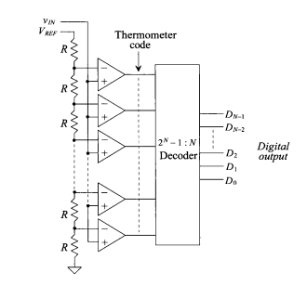
Figure 1: Flash ADC [5]

The Flash ADC is a very high speed and large bandwidth being able to output a digital value within one clock pulse. The Flash works by comparing the analogous voltage against a reference voltage using comparators. Voltages greater than the reference output a high. However, the expense of speed is size. The Flash requires 2^n-1 comparators and 2^n resistors where ‘n’ is the size in bits of the ADC. This means for higher bit applications this ADC is not viable. Further disadvantages include sparkle code and higher power consumption [6].

Successive-Approximation (SAR)
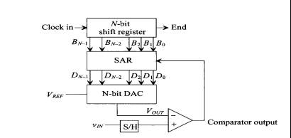
Figure 2: SAR ADC [5]

The Successive Approximation Register (SAR) ADC is one of the most widely used ADC which can perform at low power consumption, low latency and high-speed conversion however, although lacks speed compared to the Flash. Figure 2 shows a schematic of a SAR where an analogue signal is compared with a DAC where each bit is compared on each clock cycle starting with the most significant bit (MSb) [5].

Sigma-Delta:

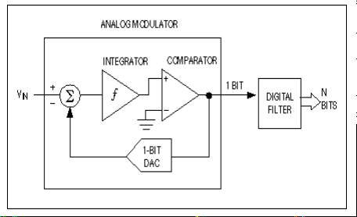
Figure 3: Sigma Delta ADC [5]

This ADC is used widely in telecommunications that use audio signals. It works by using the delta modulation [5] where the difference between two successive samples is then quantized. This method is different from the previous ADCs where input signals are compared against an absolute value. The Sigma Delta is a high resolution, low noise ADC but has a high latency [5].

Pipeline
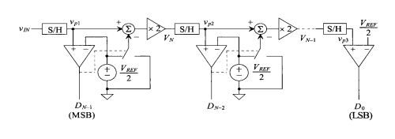
Figure 4: Pipeline ADC [5]

The Pipeline ADC is strong performer for processing high speed signals at a high resolution with a high throughput however, due to requirement that a single bit of data takes one clock cycle results in this ADC having high latency. The latency is greater than the SAR as each bit is processed by a sample and hold circuit. This results in a higher power consumption requirement for the Pipeline [5].

Integrator
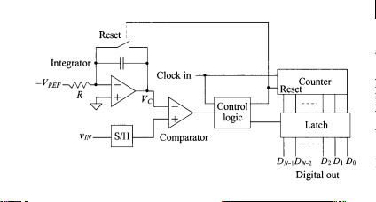
Figure 5: Integrator ADC [5]

The integrator type has high resolution but is slow and requires more power compared to previous ADCs. In laymen terms the ADC works by finding how long the analogue signal takes to be integrated. This ADC comes in two forms Single and Dual slope [5].

FPGA Boards

It was decided that FPGA development boards would be used as these offer many peripherals to interface with the board but also an ease to program the board via USB [7]. This as a result will reduce the development time of the ADC system. There is also a lot of documented support such as constraint file scripts which ease the process of hardware implementation of the VHDL. There are a number of FPGA development boards available but only the Basys 3 [7] and Arty 7 [8] were considered for this project.

Basys 3
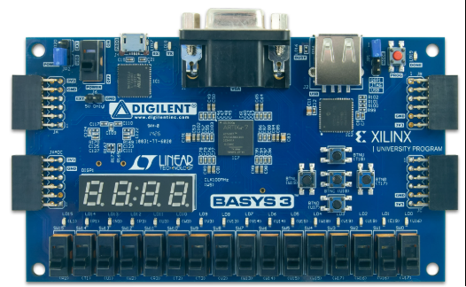
Figure 6 (Digilent): Basys 3 development board [7]

The Basys 3 board from Digilent [7] supports the Artix-7 35T FPGA which features include:
- 33,280 logic cells and 5200 slices.
- 1800Kb of RAM.
- 90 DSP slices.
- Internal clock speed of 100MHz (which can exceed 450MHz which Phase Lock Looping (PLL)).
Peripherals including:
- General Purpose Input/Output (GPIO) pins Pmod ports.
- 16 user switches.
- 16 user LEDs.
- USB-UART bridge.
- 7 segment display.

The cost of the Basys 3 is £160 [7] and is the cheaper and lowest performance of the two development boards. However, because the FPGA is only expected to work for an audio application. The FPGA and the corresponding development board offer enough logic cells, peripherals and functionality to implement the ADC for an audio application.

Arty 7

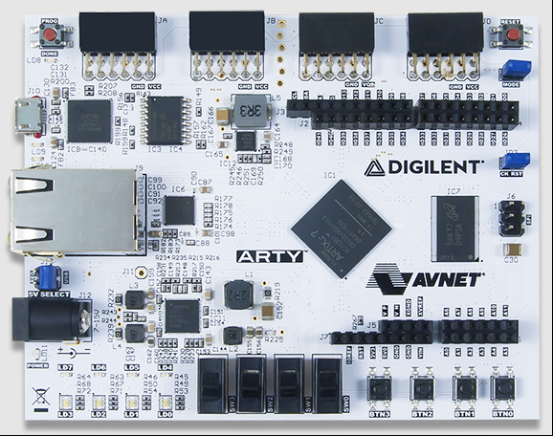
Figure 7 (Diligent): Arty 7 FPGA development board [8].

The Arty 7 is another FPGA development board from Diligent costing £299 which has a higher performance FPGA: the XC7A100TCSG324-1 [8]. The Arty 7 includes:
- 101,440 logic cells.
- 240 DSP slices.
- Internal clock speed of 100MHz (which can exceed 450MHz which Phase Lock Looping (PLL)).
- 256 MB DDR3L with a 16-bit bus at 333MHz.
- 16MB Quad-SPI flash.
Peripherals include:
- General Purpose Input/Output (GPIO) pins Pmod ports.
- 4 switches.
- 4 LEDs.
- UART & Ethernet connectivity.

Due requirements of the system of the ADC being one that works in audio ranges there was no need to invest more money into a higher end board when the Basys 3 [7] could handle all the processing required. Furthermore, the peripherals associated with the board were sufficient with no special connectors such as Sub Miniature version A (SMA) RF connectors [9] required as the frequencies would be low enough for GPIO pins to handle.

Development Methodology

The development methodology of this project was based around the IEEE Standard 1076-2019 for synthesis compatible VHDL [1] and the IEEE Standard 1241-2010 for Terminology and Test Methods for Analog-to-Digital Converters [4]. The IEEE Standard 1076-2019 is a revision on the 1076-2008 standard [1]which defines the syntax and semantics of the VHDL language.

Effective Coding with VHDL Principles and Best Practice (2016) [2] is an extensive technical book which covers the VHDL standard and provides best practices for code development as well as language syntax and semantics outlined from the standard above. This book was used as a guideline to develop effective VHDL code

To implement the VHDL source code onto FPGA, AMD Vivado design suite the AMD Vivado Design Suite User Guide: Design Flows Overview (UG892) [10] was used. This technical document outlines the design flow process and also highlights functionalities of the software such as behavioural simulation that helps with the ADC’s development. Using the documents above the following eight step design flow was created in order to structure the development of the SAR ADC on FPGA.

Project Requirements

The initial stage would be the project definition and planning stage which would involve researching ADC types to select appropriate ones against the chosen application and that could implementable onto an FPGA. It would need to be identified which components on the ADC would be FPGA implementable and which components such as the Sample and Hold Circuit (S&H) [5] would need to be made up of external components.

This stage also involved selecting an application for the ADC to be tested against such as audio, cellular or a control system application. The requirement of the system such as speed, resolution, throughput etc. would also affect which ADC type and the hardware which would be selected as highlighted in Background Research different ADCs have different performance characteristics.

A suitable FPGA development environment was also needed such as Vivado [R] which would be able to simulate and synthesise the VHDL. Finally, the IEEE standard 1241-2010 [4] was selected to build suitable practical experiments to test the performance of the FPGA implemented ADC against industry standard parameters such as dynamic performance, Effective Number of Bits (ENOB), Signal to Noise Ratio (SNR) etc [5].

System Architecture & Block Level Design

This stage involved establishing the digital and analogue components of the ADC. Both the AMD Vivado User Guide [10] and Effective Coding with VHDL [2] recommend modular design, which involves splitting the VHDL into multiple modules which are then combined together in a higher-level script via port mapping. This is similar to external functions being called from the main function like with most sequential programming.

To send the N-bit bus output of the ADC to a measuring device and/or PC the bus would need to serialised and converted to a communication protocol standard to be read. SPI, I2C and UART were all considered as all were suitable to handle the system requirements. However, the comms protocol would need to be implemented onto the FPGA as the Basys 3 [7] offered no programmable microcontroller to configure the protocol so UART was selected as it was by far the simplest to implement.

VHDL Development & Best Practices

This stage involves generating VHDL code for the modules identified from the previous section. This code would then be inputted into Vivado [3] to ensure and the code passed through the elaborated design process to ensure it is compliable. Testbench scripts shall also be written to determine functional verification to ensure the behaviour of the circuit is what is expected. Testbenches are scripts that sit at the top of the hierarchy and control the stimulus of the circuit to confirm its behaviour. These testbenches are only used for simulation and are not synthesisable.

VHDL scripts consists of 3 stages:
- Libraries.
- Entity.
- Architecture.

The library declaration is where the IEEE standard 1076-2019 [1] pre-defined libraries are loaded in which include data types, logical operators etc. The three most common standard libraries are:

- Library IEEE – standard library for digital logic
- IEEE.STD_LOGIC_1164 – Expands digital logic available std_logic and std_logic_vector (busses).
- NUMERIC_STD - Defines unsigned and signed data types for arithmetic operations.

The entity is where the module input and output signals are defined. This is often called the “black box” declaration as no logic is defined in this point it only establishes the connection ports for either connection to other modules or for peripheral connections [1].

The architecture is where the internal logical structure of the digital system is defined. In the architecture it is possible to define combinational and sequential logic, define hierarchal structure of the system (loading in other modules much like a function in sequential programming) and link to the input and output signals of the entity. The architecture is sub-divided into two sections separated by the “begin” statement. Before “begin” internal signals and other modules are defined. After “begin” is where the logic is described. Figure # shows example code of a 7-segment display where a concurrent “select” statement is used to match up the corresponding binary number with the LED segments on the 7 segments to visually display the number. Figure 8 also shows clearly the library declarations and the entity with corresponding input and output signals of the vector type meaning it is a bus of size 4-bit for the input and 7-bit for the output [1].

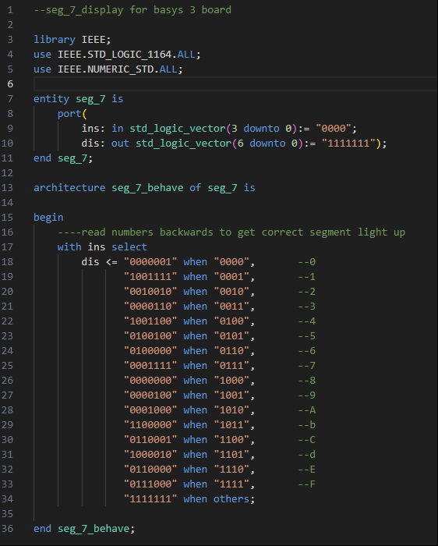
Figure 8: VHDL code for a 7 Segment Display

Simulation and Validation

The simulation and validation involve utilising the simulation tools available in Vivado to verify that the circuit works as desired. Vivado offers two main types of simulation pre and post synthesis simulation, both of which support test benching (testbench script is not synthesised). Pre-synthesis simulation also known as behavioural simulation verifies that the VHDL logic works correctly. Behavioural simulation does not consider the implementation of Register Transistor Logic (RTL) on the FPGAs Look-Up-Tables (LUTs), timing delays or any other characteristic associated with a real-world circuit, instead simulating the VHDL under “ideal conditions” [R]. Behavioural is the quickest and best for debugging the VHDL [3].

Post-synthesis is then sub-divided into two types of simulation: functional and timing. Functional simulation verifies the synthesised gate-level netlist. The netlist is the gate-level representation which includes the LUTs, Mux’s, registers etc that are available on the specific FPGA selected. The functional simulations determine the performance of the mapped logic without taking account for timing delays (optimal routing). It is a useful tool to check whether the translation of RTL logic to the FPGA components made by the synthesis process does not alter the logic and therefore change the circuits function.

Finally, post-synthesis timing simulation verifies the synthesised circuit performs optimally when timing constraints are applied and race conditions verifying that the routing of the logic onto the board does not affect the systems performance. Pre-syntheses simulation should be complete first followed by functional and then timing. Only once the circuit performs optimally at each stage should the design be verified against the next simulation type. If post-synthesises highlights any discrepancies the VHDL should be altered and simulation started again at the behavioural stage [10].

Hardware Integration & Testing

This stage focuses on the two hardware components of the SAR ADC: The S&H circuit and the Basys 3 FPGA development board [7]. The S&H circuit is used for sampling the analogue signal to pass discrete voltage levels to the comparator which would then compare this voltage with the output of the DAC.

Once an appropriate design had been selected from research the design would be built up in software utilising the Proteus [11] circuit simulation tool. Here, the circuit could be tested, and modified as necessary, using the inbuilt oscilloscope tool and developed to a point where the circuit is performing optimally. By testing in simulation first makes it quicker easier to find a setup and passive component values that work before testing on hardware. Once this is complete the hardware components used in the simulation are implemented practically and tested to ensure the performance. If discrepancies are found the circuit shall be re-designed in Proteus [11] first and then re-tested practically. Once the sampling behaviour of the circuit is optimal it will be wired with the FPGA utilising one of PMOD ports on the Basys 3 [7] .

To confirm successful UART transmission the software RealTerm [12] was used to measure real time UART readouts.

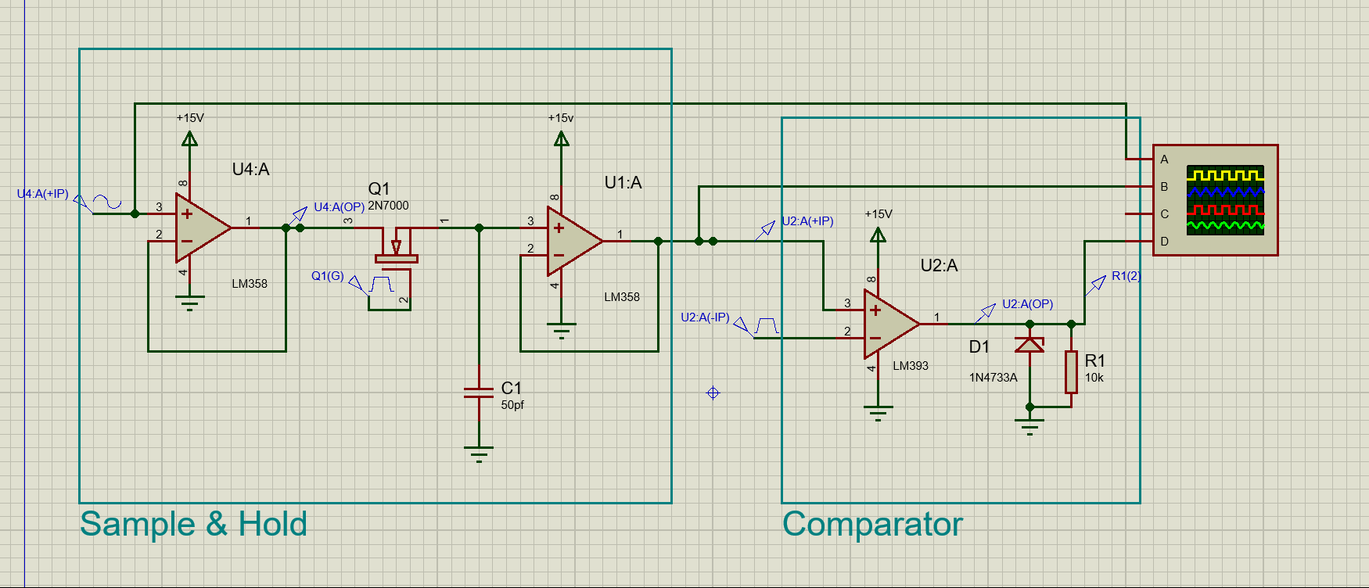
Figure 9: Sample & Hold circuit developed in the Proteus [11].

Practical Performance Testing

The IEEE 1241-2010 standard ADC testing [4] provides test setup examples and metrics to evaluate. These include:
- Dynamic Performance.
- Effective Number of Bits (ENOB) – ADC accuracy.
- Signal to Noise Ratio (SNR) – Noise performance.
- Total Harmonic Distortion (THD) – Measures non-linearities in the signal.
- Spurious-Free Dynamic Range (SFDR) – identifies any unwanted signal components.
- Throughput and Bit Rate – Determines Speed of the ADC.

The ADC will be tested against a sine wave input which will generated from a signal generator. This will then be compared against the output to determine how well the ADC performs against the IEEE 1241 standards [4].

Final Review

The results from the practical testing shall be collated and reviewed as part of this final stage along with the results and simulations from all previous stages to show the development of the project. The VHDL code will be documented and conclusion and a suggestion for future improvements of the design.

Design & Implementation

Project Requirements

The ADC would be designed to meet the requirements for an audio application.
Human ears typically have a dynamic range, the ratio of largest and smallest signal level measure in decibels (dB), of 120dB [R]. The dynamic range of a digital system can be calculated using the dynamic range formula:

Dynamic Range = 6.02 x N + 1.76 (1)

Where N is the number of bits. 16-bits gives a dynamic range of roughly 98dB. This range covers most audio and speech applications [13]. This bit-size and above would be suitable for most audio applications. This also ties in with that maximum SNR achievable by that bit word length used.

To find a suitable sampling rate the Nyquist sampling rate formula must be obeyed:

Fs >= Bandwidth x 2 (2)

Human hearing range is 20 KHz so according to Nyquist the minimum sampling rate for this range is 40KHz but most audio systems have a minimum of 44.1KHz to ensure fidelity and reception the signal [13]. A lot of systems sample higher than this including up to 192 KHz for high fidelity on very high-end audio studio equipment [R].

Another characteristic to consider is Total Harmonic Distortion (THD) which measures how the system induces signal harmonics, causing distortion, reducing audio fidelity. For systems to be considered good quality audio should have a THD in the range of -60 to -80dB. THD is particularly important for ADC as ensures accurate digital representation of the analogue signal [13].

For real time systems such as an ADC, latency is very important to ensure proper digital re-creation of the signal. Latency is the time for when the signal enters to when the digital output is available and is a product of the sampling rate, bit depth and the ADC architecture in use [13]. For example; The Sigma Delta involves a few stages of digital filtering which increasing the latency. The SAR however has no digital filtering associated with its system and has a very low latency very suitable to audio applications.

ADC Architecture Selection

The SAR ADC was selected as the primary choice as it is one that is suitable to meet the requirements of audio applications (highlighted in the background research). It is less complex than other types such as the Sigma Delta, which requires digital filters, and the majority of its architecture can be digitised making it implementable on FPGA unlike the Pipeline and Flash.

Figure 2: SAR ADC block diagram [5].

Figure # was the main inspiration for dividing the SAR ADC system in to modules. The digital modules were:
- SAR,
- DAC – via PWM, which also required an external low pass RC filter,
- Hold Block, to hold the output of the SAR result,
- Clocks – different clock speeds required for different applications were controlled from one script.
- UART Module.
Analogue Components included:
- DAC RC low pass filter,
- Sample & Hold,
- Comparator.

The SAR works by solving one bit at a time working from the most significant bit (MSb) to the least significant bit (LSb) by first setting that bit high (to a ‘1’). This bit is then sent to the Digital to Analogue Converter (DAC) and converted to the corresponding analogue voltage. This voltage is then sent to the comparator where it is compared with the sampled input voltage. The sampled input voltage is held for the duration of the 16-bit cycle of the MSb to LSb before the next voltage is sampled. If the input voltage is higher than the feedback voltage from the DAC, a ‘1’ is passed back to the SAR and the MSb remains high. If the feedback voltage is greater than the input, then a ‘0’ is passed and the MSb flips to a ‘0’. The next bit is then selected and the process repeats until LSb. Then 16-bit number is outputted and the next voltage is sampled and the cycle restarts.

The DAC is implementable on the FPGA by utilising Pulse Width Modulation (PWM) where the output voltage corresponds to the width of the pulse outputted from the FPGA. For example: a PWM which has a duty cycle (time on/time off relationship) of 50% would output half the voltage of the FPGA. Output voltage of the FPGA is 3.3V so a duty cycle of 50% would output a voltage of 1.65V. The square wave pulse would be made analogous by a low pass RC filter which feeds into the negative leg of the comparator [14].

The SAR 16-bit output is sent to a UART module enabling connectivity to external devices. The UART module was created using two modules: one was a finite state machine (FSM) which formatted the data and speed for the UART and the second module was a higher-level module which would take the 16-bit data bus and split that into 2 busses of an 8-bit required for UART. The data would be split into the Most Significant Byte (MSB) and Least Significant Byte (LSB). These two bytes would then be sent to the lower UART module one at time starting with the LSB. Once the MSB has finished sending this corresponds to the same timing of one full cycle of the 16-bit SAR and new data in loaded into the UART.

UART, which stands for Universal Asynchronous Receive Transmit, is a serial communication protocol which is popular for low speed end to end transmission. Because of its asynchronous nature it does not require a clock line; only a transmit and receive line making it a lot easier to program onto a FPGA than other protocols. The UART protocol consists of a start bit, a data word (5 to 9 bits), a parity bit (if required) and a stop bit. The UART configuration used for this project would be 1 start bit, 8 data bits and 1 stop bit (10 bits total). As seen by figure # in UART the start bit is always a ‘0’ and the stop bit a ‘1’ with the LSb transmitted first.

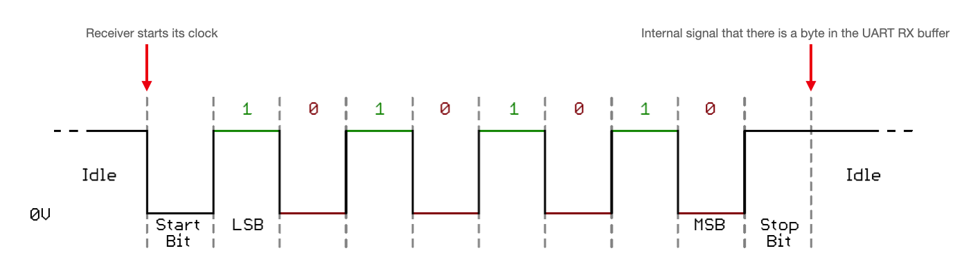
Figure 10: UART protocol [15]

The speed of the UART transmission also known as the baud rate. The baud rate is defined as the bit rate divided by the number of bits per baud. Because this was a binary transmission with no use of ASCII characters [16] the number of bits per baud is ‘1’. The bit rate will be that of the sampling rate.

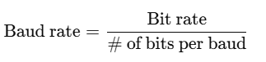(3) [17]

VHDL Development

As stated previously mentioned the VHDL would be developed in a modular approach as the IEEE Standard 1076-2019 [1] standard recommends. The first module built was a 4-bit SAR module which built to provide a proof of concept. By simplifying the architecture by reducing the number of bits and instead focusing on the logic of the architecture and becoming familiar with more advanced VHDL programming techniques.

Successive Approximation Register VHDL Script

Figure 11 shows the 4-bit VHDL script used for the purposes of proving the concept that the method of successive approximation could be executed in VHDL. VHDL is a concurrent language meaning all the statements in the code execute simultaneously and not sequentially like usual programming languages [2]. This often makes the language hard to write as it requires a different methodology to develop it. However, there is functionality in VHDL that allows sequence programming. These are called process statements. The statements inside the process are sequential but the process itself is concurrent as it executes in parallel with the rest of the system.

Process statements is one the most versatile and used statements in VHDL and despite it is appearance it has discrete differences in execution to algorithmic languages. One of these behaviours is that to maintain the concurrency of FPGA systems signals only update once a process has suspended. Another is if multiple assignments are made to a signal during a process, the last assignment is only the one to take effect when the statement suspends. These behaviours among more subtle ones can make the process statement difficult to code and its corresponding behaviour not always readily apparent.

The VHDL in figure 11 describes the successive approximation procedure of the ADC. The process statement executes whenever the signal in sensitivity list changes. Figure 11 shows the sensitivity list is located immediately after the process declaration and is sensitive to the master clock. The successive approximation was designed using the process as it allows every action to be triggered on a clock pulse preventing any signals activating prematurely. This is imperative throughout this for example when the comparison of voltages happens after the correct corresponding voltage has been sent from the DAC. Otherwise, and digitisation error will occur.
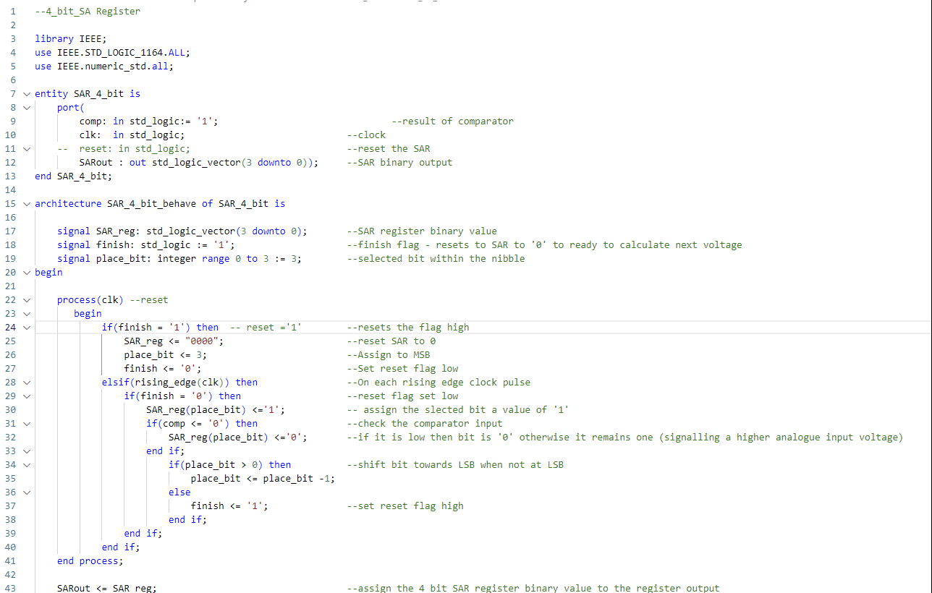
Figure 11: 4-bit SAR proof of concept VHDL
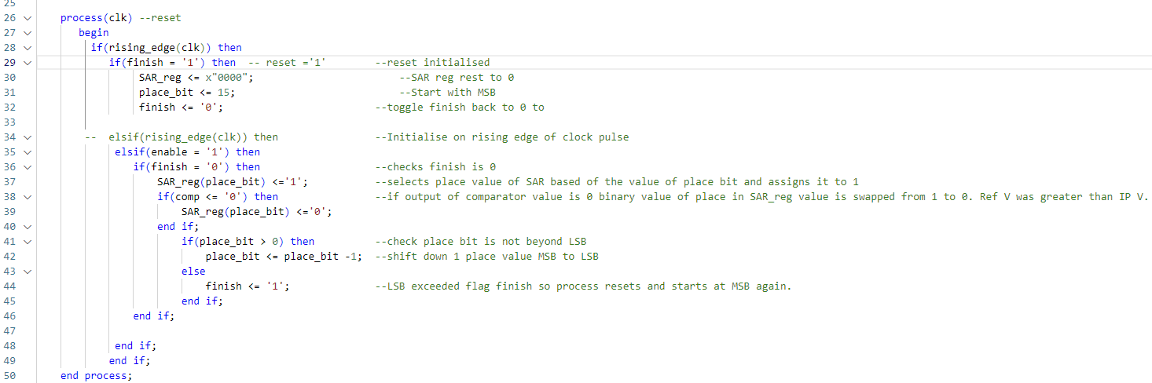
Figure 12: 16-bit SAR VHDL script

DAC/Enable Signals VHDL Script

The DAC and Enable Timer’s VHDL scripts control the corresponding pulses using timers. The timer increments on the master clock pulse and when the elapse value is reached it triggers the enable/DAC high. In the case of the DAC this elapse value is separate from the max value of the counter. Anything less than the elapse there is no pulse and anything over it is pulsed in which duration corresponds to the voltage of the digital value.

Counters were used to run the enable signals as there was a requirement for operations to happen at a slower rate to the master clock speed. This could be controlled with the timer as it’s elapse value would relate to a discrete time period occurring. Initially, these clocks where set up they were called in other process’s sensitivity lists and called using the “rising_edge” term, which although works in Vivado’s behavioural simulation it instantiates unpredictable behaviour in post-synthesis and is considered bad practices for VHDL coding (figure 13). This error was not recognized immediately and so this error was re-created across the SAR. Once this error was understood the slower clocks where taken out of sensitivity and used as enable signals and the post-synthesis behavior improved. These signals kept the name clocks to make it clear these signals were timing signals e.g. “s_clk” was the period of one bit being processed in the SAR.

.
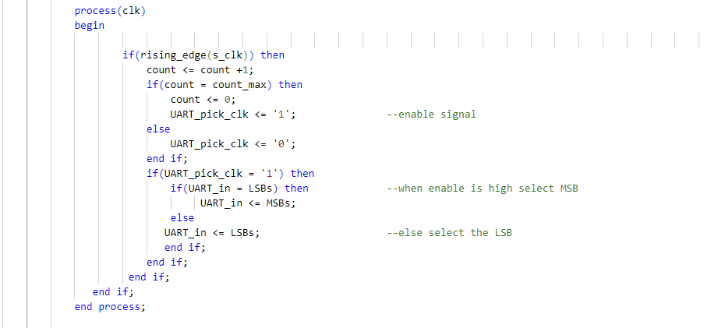
Figure13: VHDL of logically created clocks being used in “rising_edge” statement
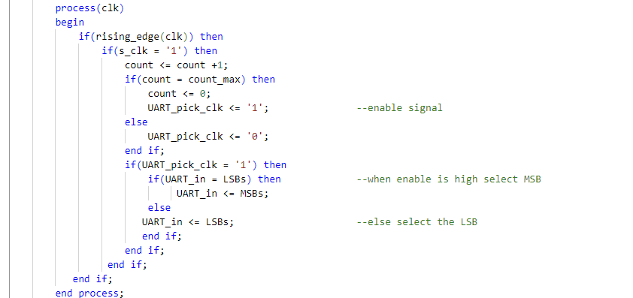
Figure14: Good practice of the enable signal being used

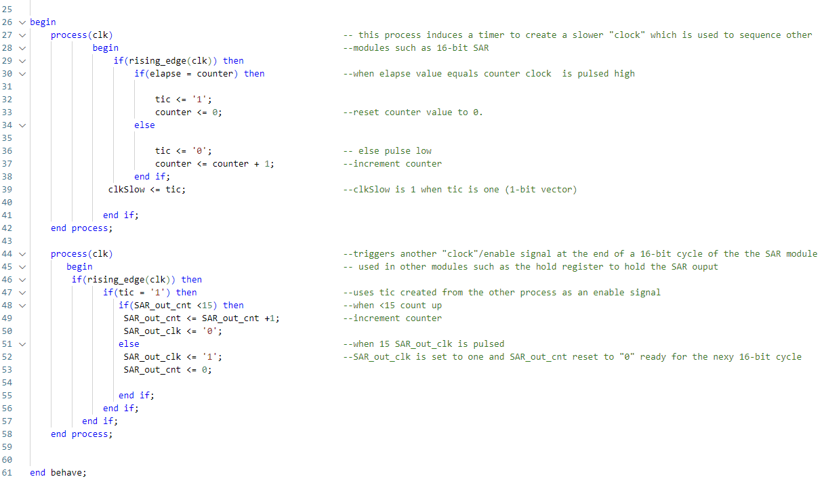

Figure 15: Enable Timers VHDL Script

Hold Register

The hold registers simply held the finished output of one 16-bit cycle of the SAR module. This was sensitive to the master clock but would only trigger when the “SAR_out_clk” was high (16-bit cycle complete). This one of the simpler modules of the design but is very important as it holds the value of the 16-bit output at the end of each cycle and does not update until the next 16-bit cycle is complete. It is this block that’s transmits the 16-bit output bus to the UART module. The block is essential to get the correct data out of the SAR. The hold block is designed as a simple D flip-flop which is a type of register where the logic passes the input to the output on a clock pulse (and enable signal in this case).

Main SAR ADC Module

This module is the top module for the SAR portion the ADC as it controls and links all the entity signals of the other modules together to create one homogeneous system. This connection of the modules is carried out through a VHDL function known as port mapping. The hierarchy of the modules is displayed in figure 16 showing that “Main_SAR_ADC” module on top of the four previous modules previously discussed which make up the SAR. The connections that connect the different modules together in VHDL is done via the port mapping technique which enables the designer to load in other modules entities as “components” and then describe the connections using a port map. Port mapping is a very efficient method to build up a system as it allows for previously defined modules to be loaded into the design with no additional logic description required only for signals to be assigned to that port maps components.

Figure #pm shows how to declare an external component as a port map which first has to be declared as a component in the architecture before the “begin” statement. The component has a very similar syntax to an entity declaration except the instead of the identifier “entity” “component” is used. The component declaration in the port map acts as the entity for the inserted module as it tells the synthesiser the amount, type and size of the signals being used [2].

The second part of the port map is where the signals from the top module are mapped to the components. For example, using the component “PWM_DAC_16bit” which is the DAC module show the signals inside the component declaration and that modules entity are identical. The mapping is done after the “begin” statement in the architecture (the area which defines logic) where these signals are mapped to one another i.e. “SAR_in” is mapped to “SAR2DAC”.

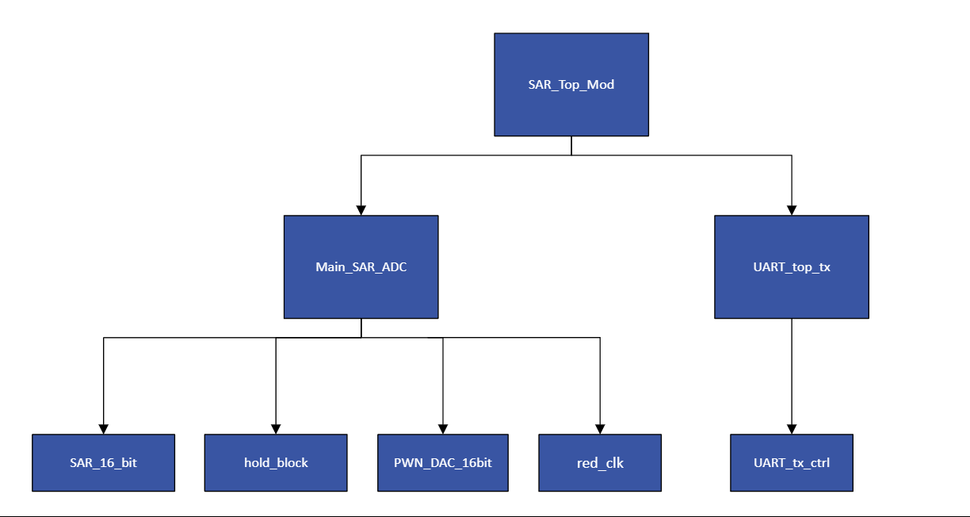
Figure 16: Flow chart showing the VHDL modules hierarchy.
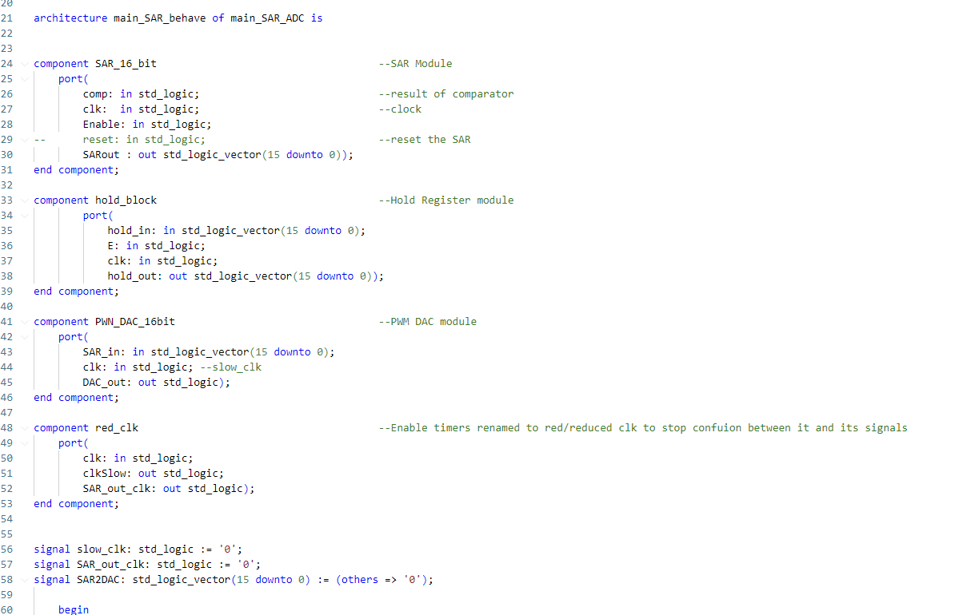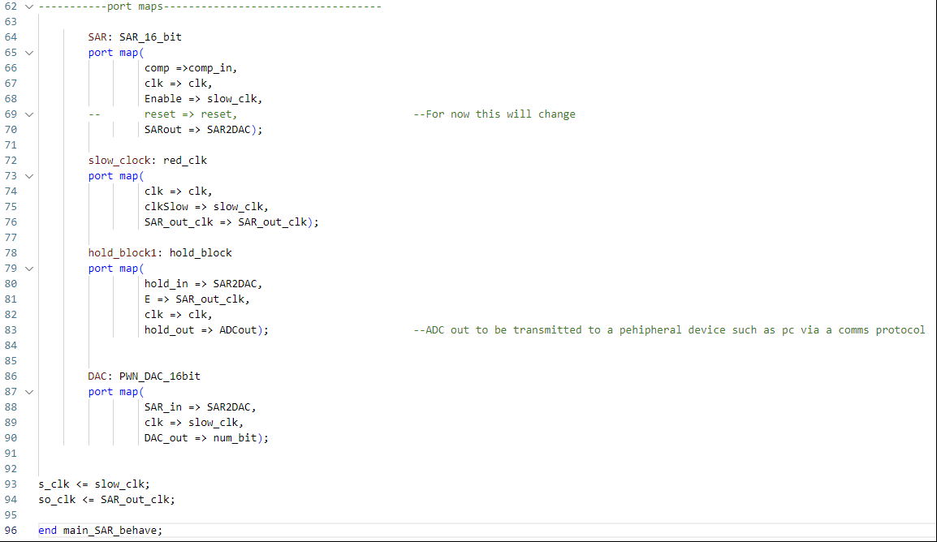
Figure 17: Top module of the SAR ADC process.

UART Modules

As already stated in the ADC Architecture Selection section the UART Top module takes the 16-bit input SARs hold register and splits it into two bytes so it is in a format that the lower module can use. The lower module, shown in figure 18, is from the FPGA book “Digital System Design With FPGA” [18] which focuses on VHDL code and development projects for the Basys 3 [7]. This script takes the 8-bit bus and formats the data into a 10-bit UART stream, with the data being padded at either end with a “0” start and “1” stop bit. This module is carries out its logic using the Finite State Machine (FSM) technique where combinational logic is carried out at a specified state capitalising on VHDL’s enumerated data types [2]. Once the combinational logic has finished for that state it triggers the next state on the next clock cycle [2].

The states are defined using the VHDL enumerated type [2] which allows for a state to be given a readable name such as “RDY” instead of a number (in synthesis this name will be converted to a value). The declaration on line 33 in figure 18 shows the definition of the enumerated type as “state type” with the following three states used in FSM defined here (“RDY”, “LOAD_BIT” and “SEND_BIT”). Later the custom “state_type” is defined to the signal “state” and is initialised to the state “RDY” when the script first executes. The process statement defines the logic of the FSM with the use of a VHDL “case” statement. Case statements in VHDL is similar to that in sequential languages and is used instead of an if-else to make to the code cleaner and more readable, less prone to errors as the synthesiser checks for missing cases and is great for formatting FSMs [2].

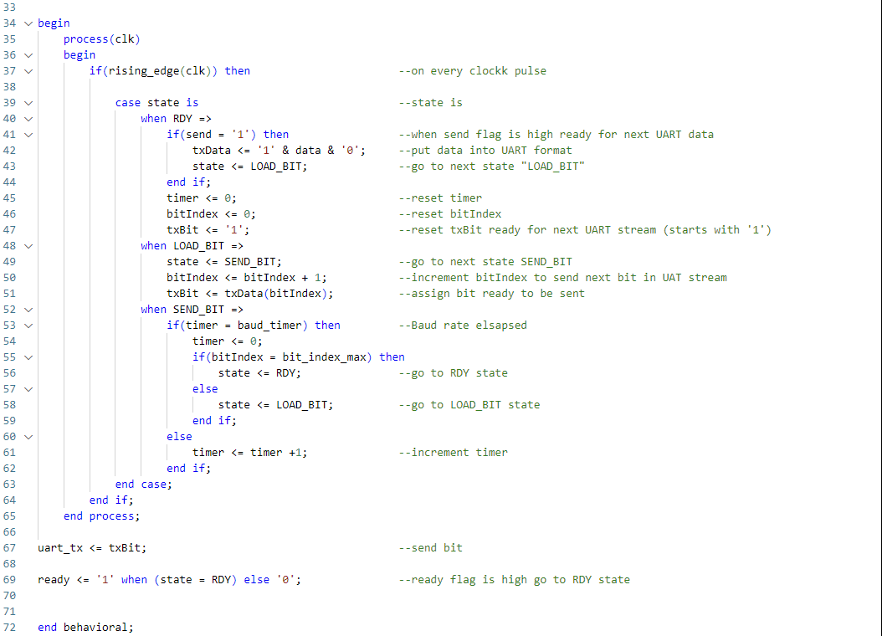
Figure 18: UART FSM transmission

Testbench Scripts

Vivado and VHDL offer the ability to generate testbenches which are high level scripts that sit on top of the top modules and are used to stimulate inputs and clocks. These testbenches are used to run simulations in Vivado [3] to get an understanding of the systems performance and if it is running as expected or not. Testbenches are not synthesisable scripts and so have access to additional functionality which VHDL has to support test benching. Effective Coding with VHDL [2] states the majority of designer’s time is spent simulating and understanding the systems behaviour as it removes the necessity of practical testing where every small change in system design which can be both expensive and time consuming.

For this project small testbench scripts were created for each module to confirm proper operation however, for testing multiple modules more advanced testbenches were used in order to get a more precise understanding of the circuit’s behaviour before physical testing. Both the SAR modules and the UART modules were first tested separately before being tested as one homogeneous system. This was done in order to easier debug with the hope both systems should work well independently before being brought together to solve any timing and translation bugs.

ROM Test script

This script was generated to simulate a sine wave passing through the ADC so it could be inputs and outputs could be easily verified whether the they were correct. The sine wave was created from a simple Matlab script (see figure 19) outputted 63 sine wave data points into a 16-bit binary format. These were then copied into the “select” statement as “ROM_Data” and mapped to a 5-bit value which was the address “ROM_address” of the particular data point. The testbench script would increment through these addresses loading the corresponding data value. Figure 21 shows the “ROM_ data” being simulated in Vivado showing a near perfect sine wave. There is a dip in the sequence due to the “ROM_data” only having 63 points whereas a 5-bit address has 64 points. On the one missing the data it defaults to “0” a useful tool to pinpoint where the data set reset.

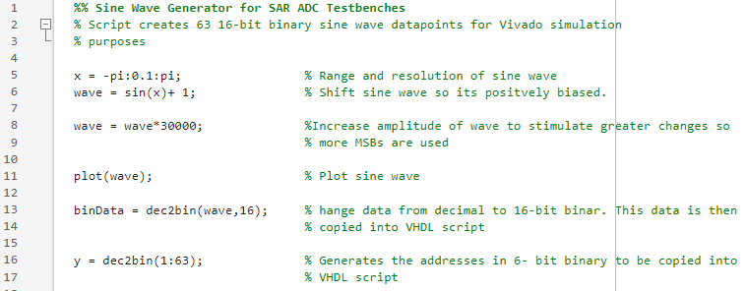
Figure 19: Matlab script generating “ROM_data”.
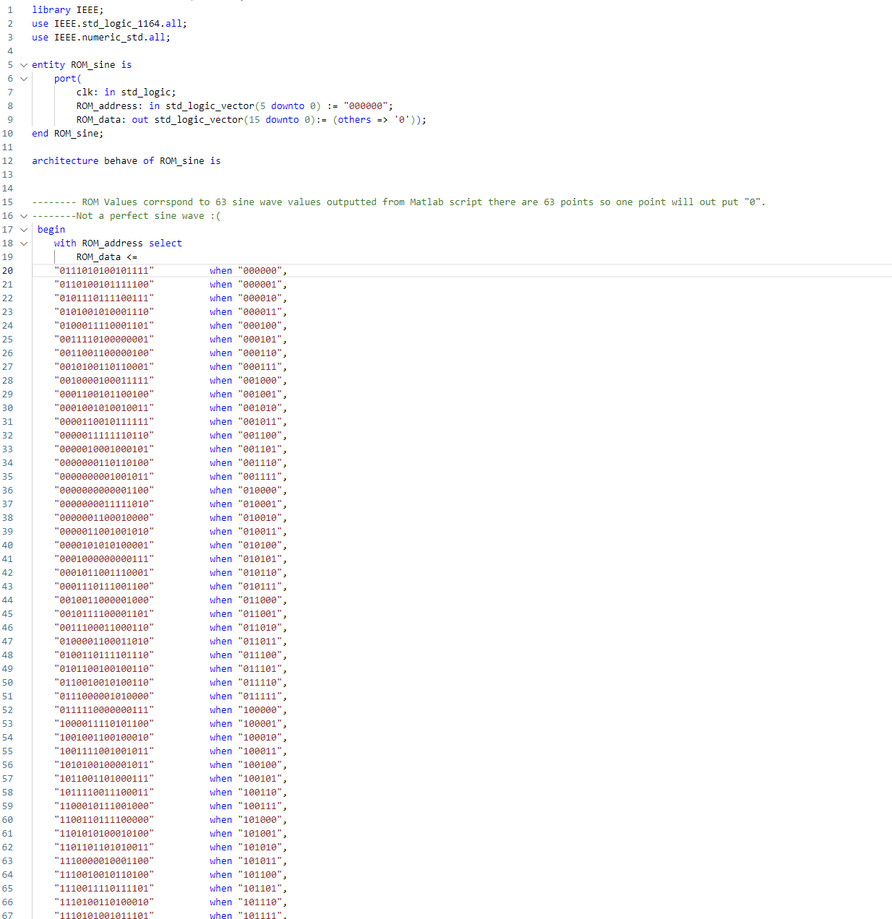

Figure 20: ROM VHDL Select statement.
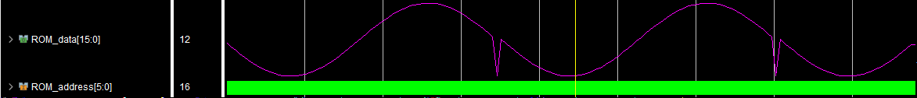
Figure 21: Visual of “ROM_data” displayed in Vivado simulation.

SAR Top Module Testbench

This script which was used to simulate the entire SAR ADC system integrating the ROM script to simulate sinusoidal data (figure 21). This script loads in the SAR’s top module “SAR_Top_Mod” through the port mapping technique and generates a clock pulse at the same frequency of the Basys 3 board [7]. This is done using “while loop” where the clock is pulse high for half a clock cycle before being pulled low again for the same duration. This then repeats indefinitely because of the loop.
The simulation is controlled in another process statement, sensitive to the master clock, which serialises the input so it is in the same format that would be expected coming from the comparator. This is done by selecting one bit individually, like with the SAR module, and cycling through each bit at the speed equivalent to the enable signal “slower_clk”/”s_clk”. The time taken for the SAR to process a single bit.

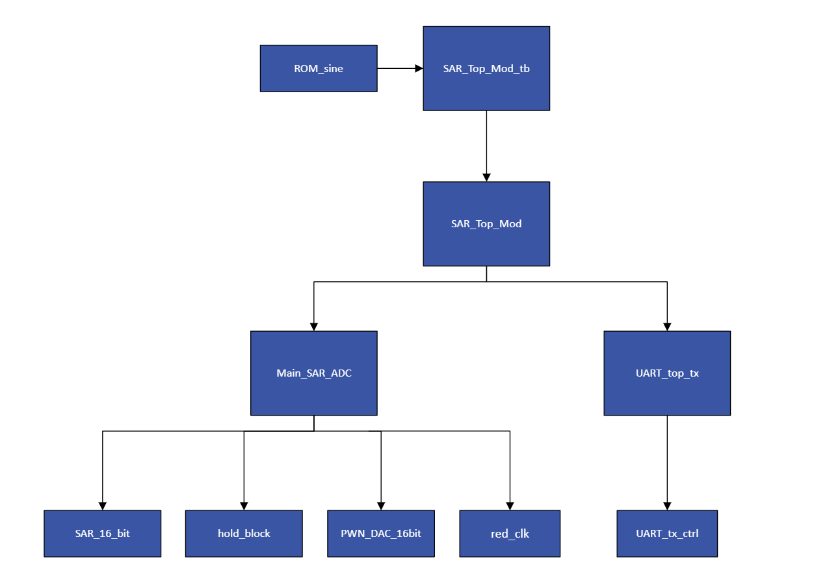
Figure 22: Hierarchal structure of system including testbenches.
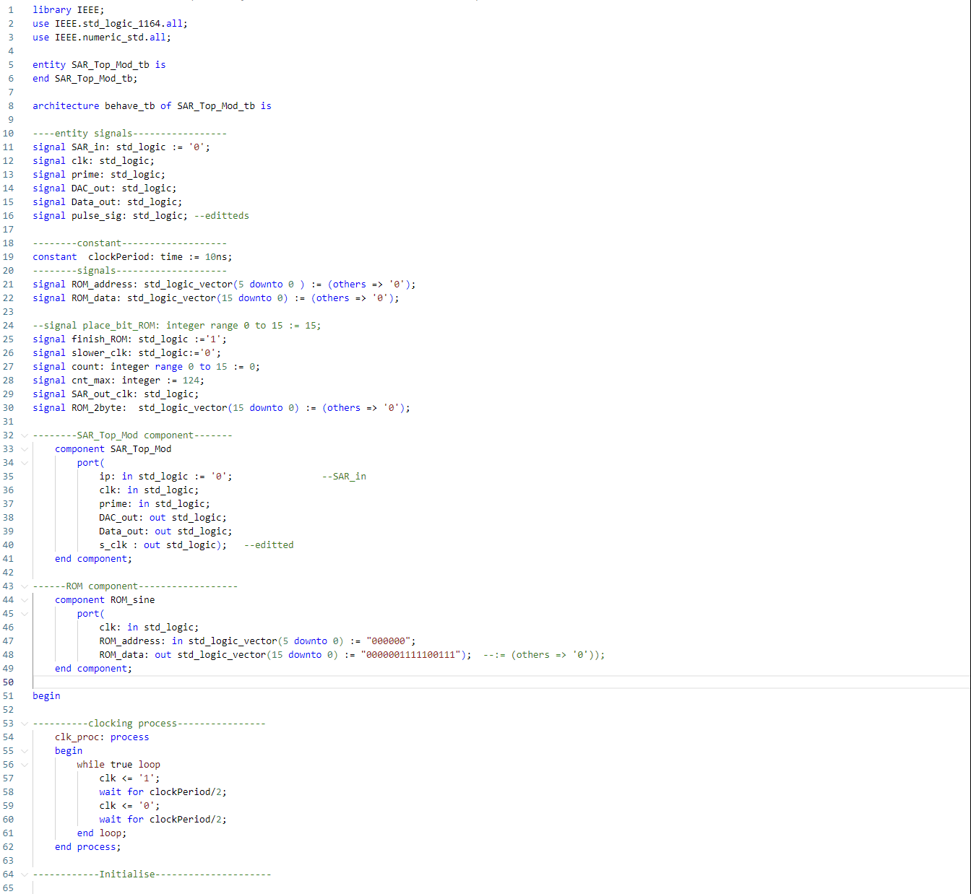

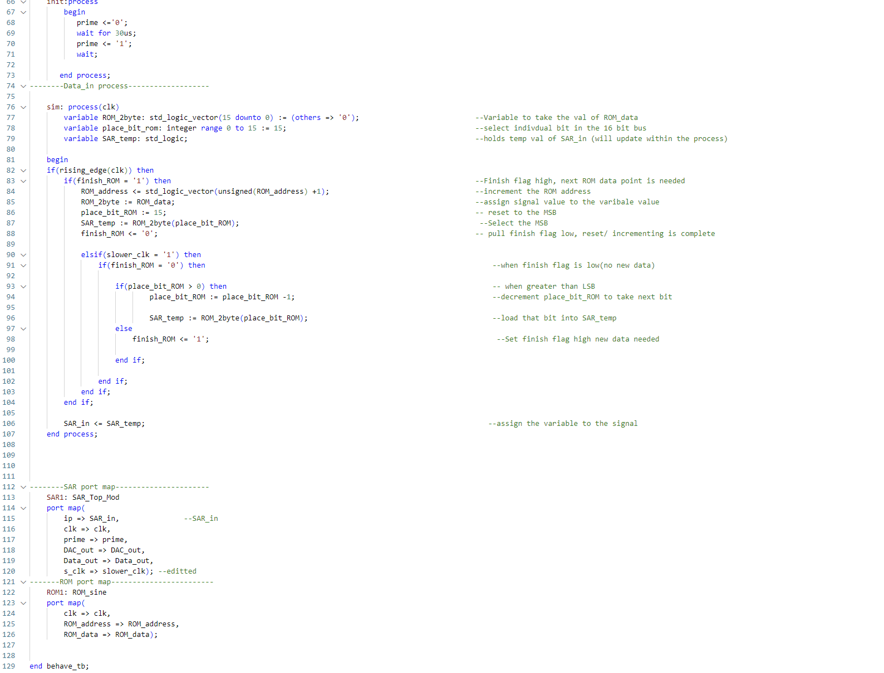
Figure 23: SAR Top Module VHDL Testbench

Simulation and Validation

This section covers the Vivado simulation of the SAR ADC. Prior to this project awareness of Vivado and all its features was very limited only having run basic logic level VHDL projects. So, initially the when simulating there was no knowledge of the different types of simulation (e.g. behavioural and post-synthesis) could have disparities between them. Furthermore, the process of synthesis and implementation was not initially fully understood which helped compound the problem. Therefore, initial simulation of the individual modules was only executed with behavioural simulation. This was done until the initial testing of the SAR and UART systems on hardware on the Basys 3 showed there was discrepancies between the simulation and real-world implementation.

Individual Modules

Initial testing was done on the individual modules in the SAR which were only simulated in behavioural simulation which only tests the VHDL RTL and not the systems implementation onto the FPGA. The simulation of the individual modules simply needed to prove that individual module was performing as expected so that it can be loaded into a top module and still expected to perform. Figure 24 shows the initial simulation and verification of the hold block which was designed to hold the SAR’s output value for a clock pulse (D- flip flop). Figure 24 shows the initial simulation of this system displaying that intended behaviour of the system that one clock pulse after the signal is assigned to hold in; it passes to hold out.

Figure 24: Hold Block Simulation

SAR Module Behavioural Simulation

The next stage was to combine modules and simulate with the aim to achieve a coherent system. This was done with the Main SAR ADC script which controls the SAR. In this simulation the ROM sine wave was sent through the system with figure 25 showing the recreation of the sine wave in behavioural simulation with “ADCout”. As expected “ADCout” is slightly lagging by a “SAR_out_clk” period.

However, prior to this there was a problem in the testbench script where the system would flip the MSb of every alternative 16-bit output. This can be seen clearly in figure 26 displaying the failing simulation where the “hold_out” signal and “ROM_data” show different value (“hold_out” is delayed by two signals). This then resulted in the digital sine wave being lost and the system outputting an incorrect digital value every other reading (see figure 26). The cause for this was not fully understood but it seemed to be related to the reset procedure where the next ROM address is selected. The solution was to read in the 1st bit of the new ROM data during the reset procedure. Figure 23, line 87 shows this addition that was also used on a later version of the testbench (figure 23) that was used to in cooperate the whole system. The hope with this is that no bit would be missed and this proved to be correct and solved this problem associated with ADC output (figure 25).

Furthermore, another unrelated problem was that for every second 16-bit value outputted from the system final bit is flipped. The reason for this was never fully understood whether this was a problem with the testbench script or the successive approximation module, but it was decided that because it was the LSb of the sample it would have a minimal effect on the signal’s distortion. Whilst this will affect the practical performance, if not testbench related, it would only be very small on the SAR’s performance such as resolution, linearity and Effective Number of Bits (ENOB) etc.

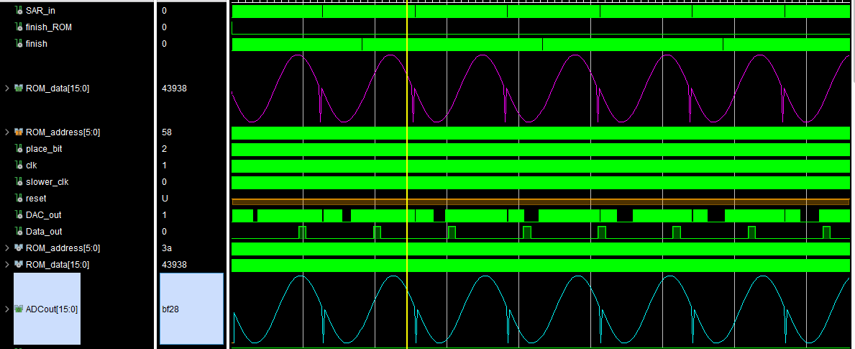
Figure 25: SAR simulation

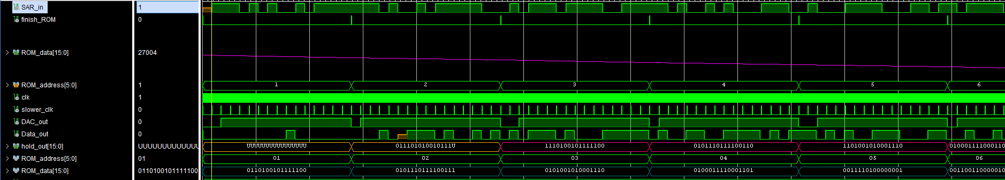
Figure 26: Failing SAR simulation (MSb bit flip)

UART Modules Behavioural Simulation

Following confirmation that the SAR Main module worked the next was to simulate the UART modules. Figure 27 shows a simulation using the UART testbench. The simulation shows the system working sub-optimally where the module is able to split inputs into two bytes but are not able to be assigned to “UART_in” correctly (input to lower module). By looking at 1ms time stamp the value “F55F” never gets read into “UART_in”.

This is because the byte selection process is asynchronous to the other system as it is not sensitive to the master clock. Furthermore, the baud rate of the system was too slow for the duration in which the data toggled from one value to another (1ms). This could be solved by increasing the wait times between each input value or by increasing the baud. The choice was to slow the input to get the correct reception of data. Because, confidence in the SAR top module was high, the next step taken was to implement the UART module onto the Basys 3 FPGA and using the “RealTerm” [12] software to try and get a proper reception of a UART transmission. This is covered in the next section practical testing.

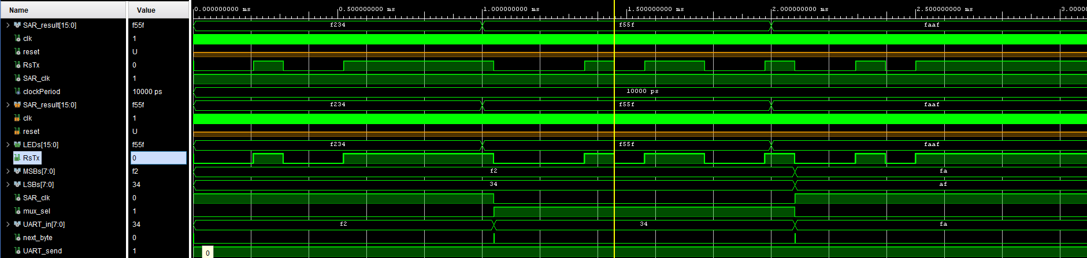
Figure 27: UART module simulation

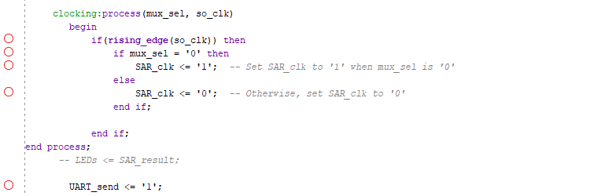
Figure 28: Mux select using logic created clock

Full System Simulation and Verification

Practical testing confirmed (see practical testing section) that UART was not working properly. The decision was made therefore to try and get a whole SAR ADC working well in simulation to show at least in simulation the system worked, before trying to correct for unforeseen practical effects.

Figure 29 shows an immediate problem that occurred which was caused by the asynchronous nature in which “mux_sel” (multiplexer select) due to the process not being sensitive to a clock. This made the process asynchronous to the rest of the system which is more susceptible to creating bugs than synchronous systems. Therefore, the mux selection process which selects the correct byte at the correct time had to be re-designed to make in synchronous to the master clock (figure 28).

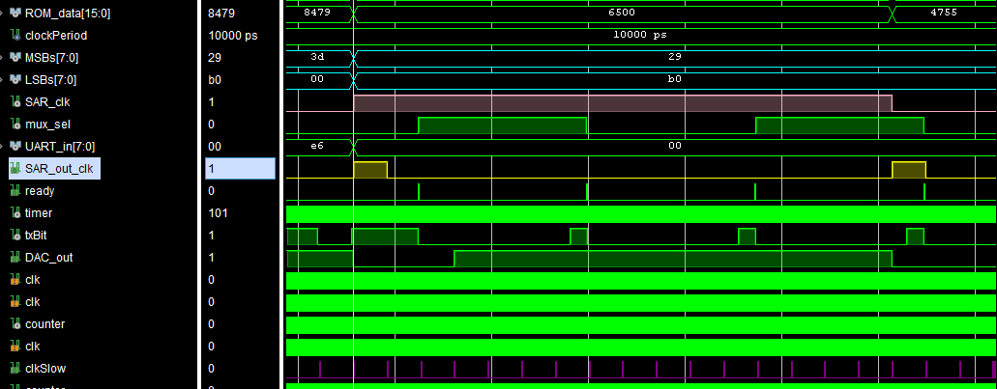
Figure 29: UART initial test showing mismatched signals

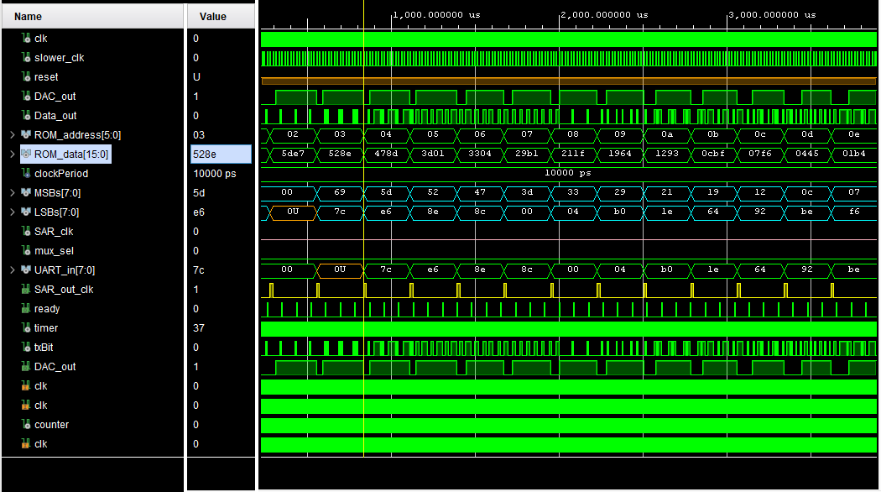
Figure 30: UART module only processing “LSBs”

Figure 31 shows the updated VHDL to in cooperated the clock “s_clk”, which is the slower clock created via a timer of the master clock, to make the system synchronous. This solved the initial problem faced with “mux_sel” (no longer used) and the correct data is fed into the system and split into 2 bytes “MSBs” and “LSBs”. This can be seen in figure 30 where the specific “ROM_data” 16-bit input “528c” (displayed as a hexadecimal). Two “SAR_out_clk” cycles later the data is visible in “MSBs” as “52” and “LSBs” as “8e”. This shows correct processing of the SAR module and reception from the UART module. However, a new problem occurs as a result of new design where only the “LSBs” gets assigned to “UART_in”. This can be seen by tracking the “UART_in” signal and seeing that the “MSBs” signal “52” never assigned to “UART_in” but the “LSBs” signal “8e” does at timestamp ~1.8ms.

This was a result of an error in fixing the bugged VHDL by replacing it with a sub-optimal solution where “UART_in” was triggered by “SAR_out_clk” which only gave the UART system enough time to process one byte as the next time “SAR_out_clk” pulsed to receive a new byte it would be from the next data set. This is clearly visible in figure 30 where the “UART_in” value changes at the same time as “SAR_out_clk” which also coincides with new data being sent to “MSBs” and “LSBs”. Therefore, the whole process statement, had to go through a substantial change where instead of “UART_in” triggering on “SAR_out_clk” it would trigger on “s_clk” which corresponds to the “slower_clk” signal which operates 16 times faster than “SAR_out_clk”. Another counter would be made that incremented on “s_clk” and would use the new internal signal “UART_pick_clk” to select which byte to send to “UART_in”. The counter would reach a max number of 7, counting on each “s_clk” pulse and then pull “UART_pick_clk” low/high depending on the previous value. Once two counts have elapsed both the MSB and LSB should have been passed to “UART_in” and new data should be sent to “MSBs” and “LSBs” from the SAR.

Figure 32 which shows the simulation of the new process which now shows the data from the ROM being processed correctly and being passed to the UART module and transmitted through “Data_Out” with the LSB first. Whilst “MSBs” and “LSBs” signals still change on “SAR_out_clk”, “UART_in” triggers on now on “s-clk” and changes on the 8th pulse to the other byte as dictated by the new counter. Also, by locating the right point in the “Data_out” stream the data from “UART_in” can be observed showing proper transmission of the UART signal from the system. It was understood that now the system was ready for hardware implementation.

However, after a quick test of testing the FPGA passing of passing 16-bit values, similar to testing the UART, it was clear no data was being received by the RealTerm terminal [12]. Therefore, the system was split back down into the UART and SAR modules and the UART modules were tested separately to confirm practical performance. This felt as a necessary step as the disparity between simulation and practical testing meant there was little faith in the simulation telling anything meaningful. It was during the UART practical testing the post synthesis and implementation simulation importance was understood. UART practical testing is covered in the Hardware and Integration section.

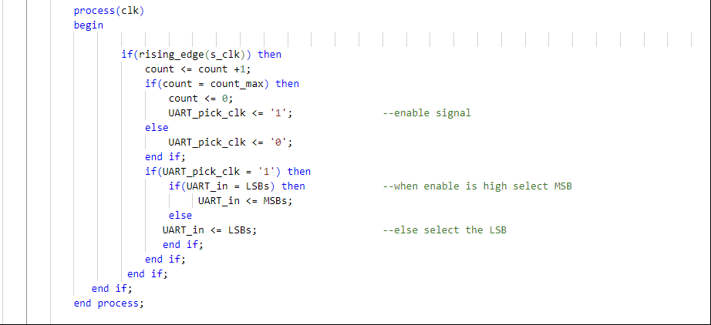

Figure 31: Updated code aimed to be synchronous to a clock

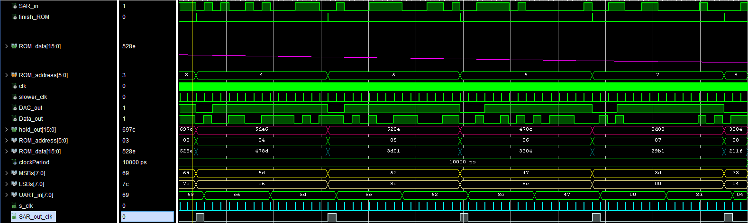
Figure 32: Working SAR ADC system in Vivado behavioural simulation.

Post Synthesis Functional Simulation

Synthesis is the process of translating the VHDL RTL logic onto the specific FPGA components e.g. LUTs. This process can change the behaviour of the system as the translation is not always a direct correlation as board component do not always have the same behaviour of RTL components. Therefore, the functional simulation is used to understand if synthesis process has created any disparities between the VHDL and the synthesis.

When first completing the functional simulation, it became immediately apparent that there was a problem as the system no longer worked and certain signals were behaving bizarrely. The clearest example of this was the “SAR_out_clk”, shown by figure 33, which periodically cycled erratically causing other signals synchronised to it to execute in a similar manner. Figure 33 shows the signals associated with “SAR_out_clk” being pulled high and low very rapidly at the start of the counter cycle. This behaviour was associated with the error in Vivado’s timing report from figure 34. The error states that the signal “tic” is not directly tied to the master clock. Hence, this made it asynchronous which resulted in the erroneous “SAR_out_clk”.

This was not a localised error just on the “tic” but also all other generated clocks based of combinational logic (i.e. counters) aimed at operating at lower frequencies to the master clock (clk). After some investigation it was discovered that using the term “rising_edge” on these signals is bad practice [19]. Generating clocks from logic are not routed using global routing resources and therefore cause timing unpredictability [19].

The solution was to use these slower “clocks” as enable signals removing them from “rising_edge” statements assigning them either a high or low value (1 or 0). Now inside every “rising_edge” is the master clock “clk” eliminating removing any clock glitches caused from logic driven clocks. Figure 36 shows a working functional simulation identical to the behavioural after all the changes were made and the circuit was now fully sequential (figure 35).

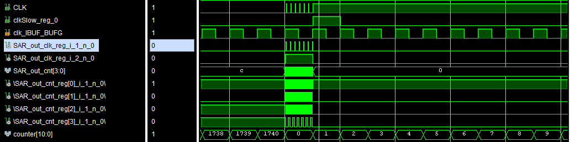
Figure 33: Post-Synthesis Functional Sim

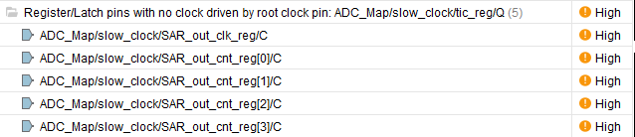
Figure 34: Timing errors brought on by bad clocking practice

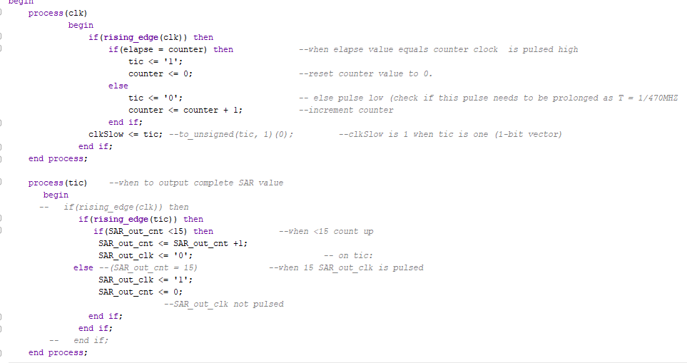
Figure 35: VHDL script using bad clocking practice causing error in “SAR_out_clk”.
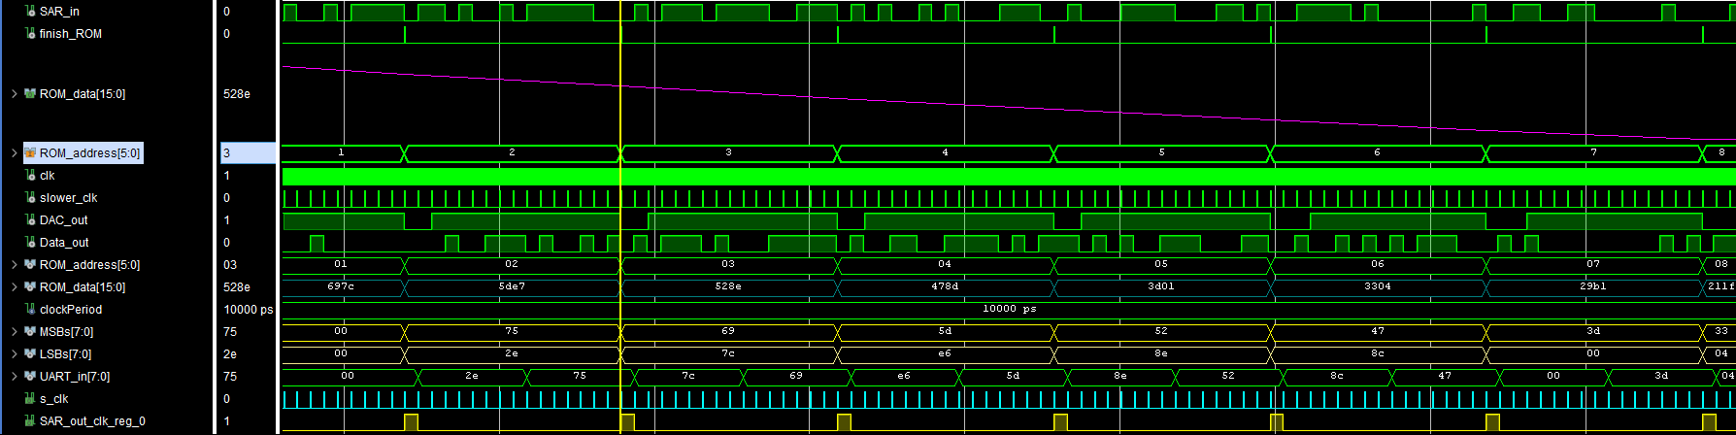
Figure 36: Functional Simulation after removing logic driven clocks.

Post Synthesis Timing Simulation

Following functional simulation, the post-synthesis timing simulation is run to how timing effects the systems behaviour. Now “ROM_data” was incorrectly being interpreted throughout the system. Comparing the first signal on the blue “ROM_data” signal line with third “MSBs” from figure 37 shows the first bit has been incorrectly assigned. Tracking the “MSBs” and LSBs” signals further it can be observed that compared to “ROM_data” the data is received correctly but is lagging by 1-bit. This tracks all the way to initial reception of the system where the first bit it registers is a “1” but it is clearly a “0” when looking at the “SAR_in” signal (the input bitstream of “ROM_data”).

The problem originated from the system having no initial state where signals such as clocks and enables could cycle before the system started receiving a signal. Looking at “slower_clk” (at the bottom of figure 37), which is the enable signal linked to “s_clk”, the first time it is pulled high coincides with when “SAR_in” first goes high. This is how the SAR system missed the first “0”. To fix this bug a two state FSM was used which would establish whether the SAR ADC was in a non-receptive idle mode or a receiving operate mode. Figure 38 shows this FSM in the top module “SAR_Top_mod”. This signal “prime” is a switch on the Basys 3 which when low allows a reception. This FSM is run crudely in the SAR testbench by holding “prime” low for 30us to allow for all the signals establish before switching high and allowing “ROM_data” to flow through. As seen from figure 39 this solved the missing bit problem and “ROM_data” was processed correctly.

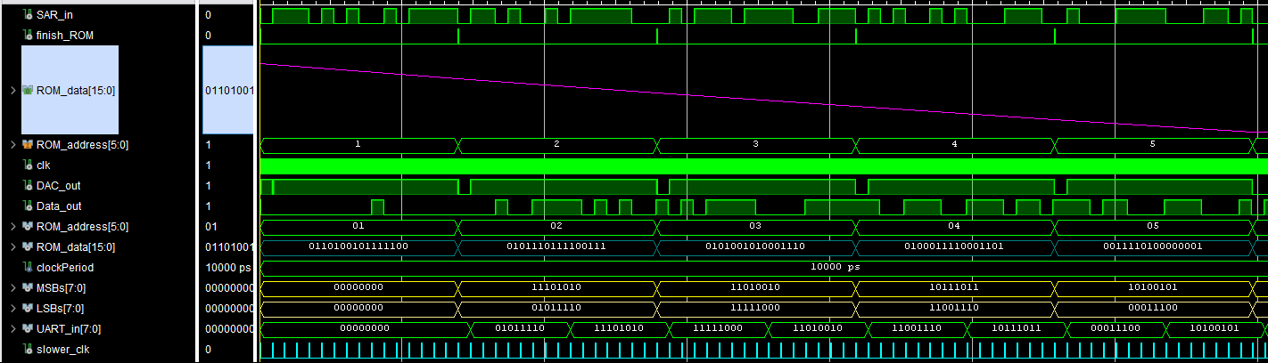
Figure 37: Post-synthesis initial timing simulation.

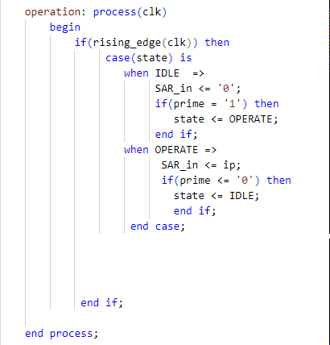
Figure 38: FSM which gives the SAR two states of operation.
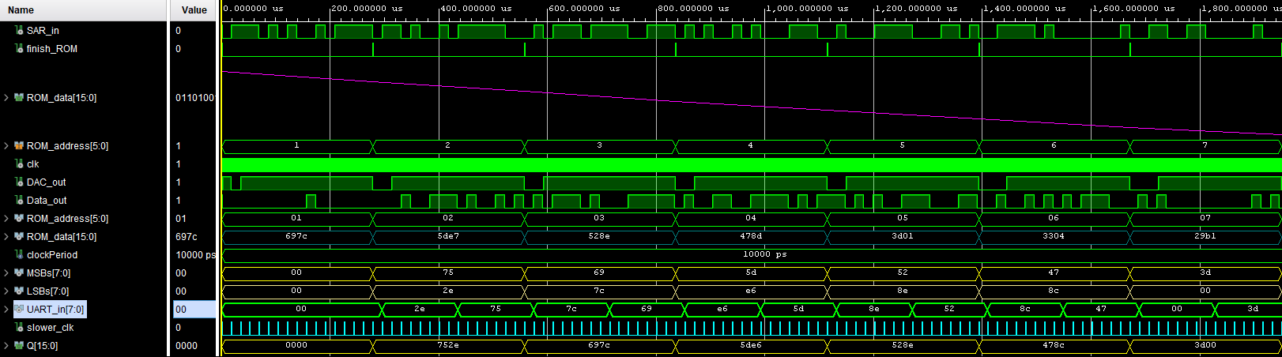
Figure 39: Post synthesis timing simulation with FSM.

Post Implementation Simulation

Final step of simulation was post implementation to see if the translation of the system onto the FPGA board created any changes to its operation. Once again these are split into functional and timing one covering the netlist and the other the timing aware simulation of the physically routed and placed logic on the FPGA. The functional simulation ran without fault however, the timing simulation showed some peculiar behaviour where signal jitter was apparent yet it didn’t affect the output of the system with the UART still sending out the correct data.

The jitter seemed to be caused at the hold register as there is no jitter on the input “D/hold_in” but there is on “Q/hold_out”. By observing figure 41 the total signal jitter duration lasts 0.1ns which is far less than one clock period of 10ns. This change is so small and because the UART is clocked as a FSM it makes it robust against post implementation artefacts. This design was therefore was thought robust enough to proceed onto implementation onto hardware.

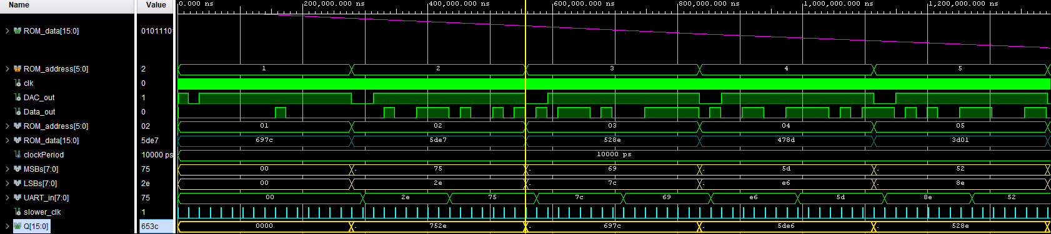
Figure 40: Post Implementation timing simulation

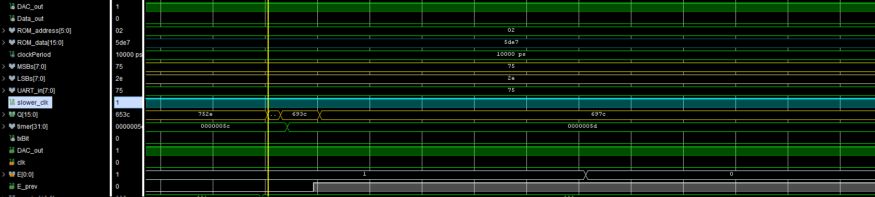
Figure41: Concentrated view seeing the signal jitter between “752e” and “697c”.

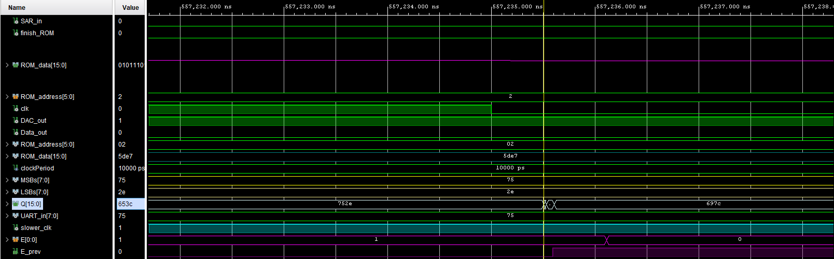
Figure 42: “E” and “E_prev” causing jitter on the “Q/hold_out” signal

Hardware Integration & Testing

This section covers the testing the Sample and Hold (S&H) circuit both in Proteus simulation and practically, the transmission of UART from the Basys 3 to the software serial terminal Realterm [12] to confirm proper transmission out of the FPGA.

Sample and Hold Circuit Testing

The S&H circuit from figure #S&H was simulated in Proteus [11] to select a design that was suitable but also to find optimal voltages and sampling frequencies of the inputs to get a good recreation of the analogue signal in a S&H format. Unfortunately, Proteus was only able to process low frequencies and so in practice the frequencies would be scaled up appropriately. Signal “U4” from figure 43 is the sine wave input. In the simulation this was set at a frequency 100Hz and an amplitude of 1V but positively biased so the sine wave oscillated between 1V and 0V. The analogue input was positively biased because the operational-amplifiers, which are LM358 [20], which are powered by a single voltage supply so can only in the +V range. So, if the sine wave was not biased half the signal would be lost. The LM358 [20] were selected so they could run off the Basys 3 power as one circuit. The voltage would be biased in practical from the signal generator.

The MOSFET would be toggled from the Q1 pulse signal controlled from the Basys 3. In the Proteus simulation this was at a sample frequency of 1KHz with a voltage of 3.3V (max output of the Basys 3). 50pF was selected as the capacitor value to hold the sample for good signal reconstruction. Figure 43 displays the virtual oscilloscope in Proteus [11] showing the yellow sine wave input and the blue S&H reconstruction of the signal. Figure 44 shows the S&H shift up to map to the sine wave showing how accurate the reconstruction was.

Figure S&H1 (repeat): S&H circuit in Proteus [11].

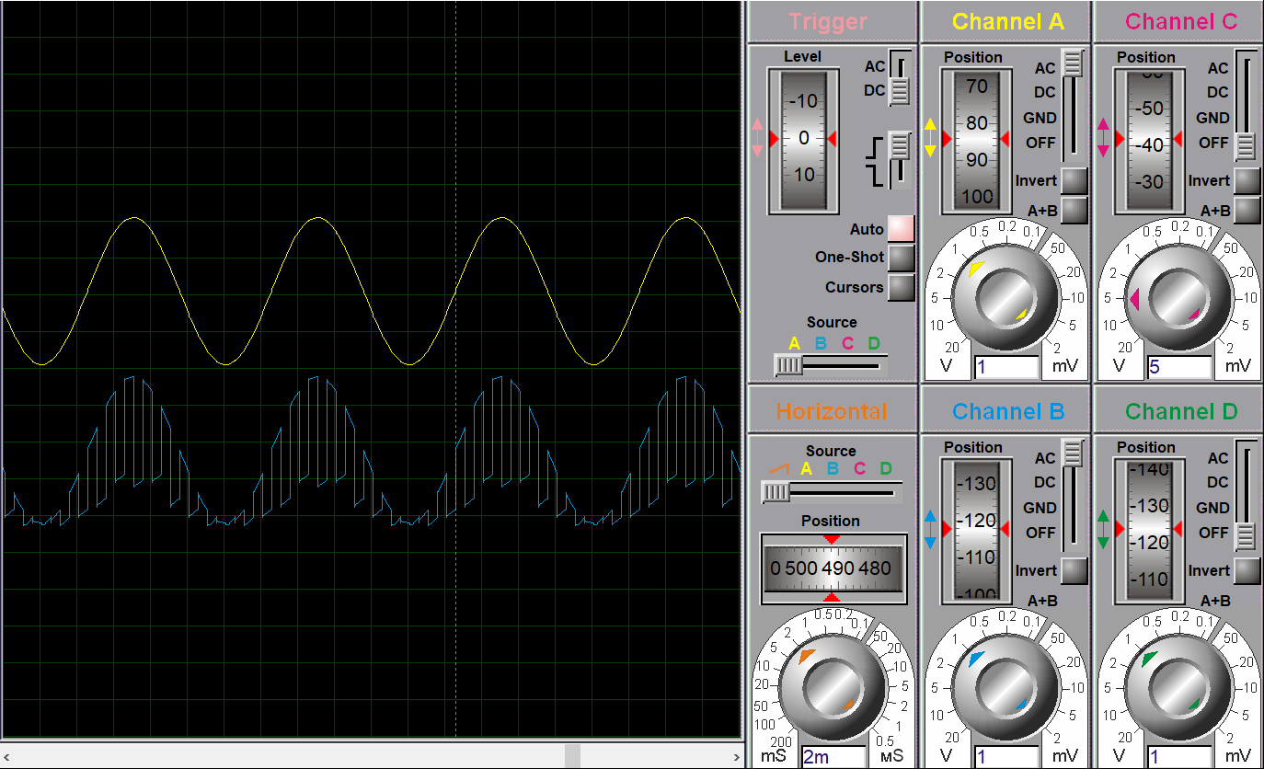
Figure 43: Comparison of the sinusoid (yellow) and the S&H reconstruction (blue) in Proteus [11].

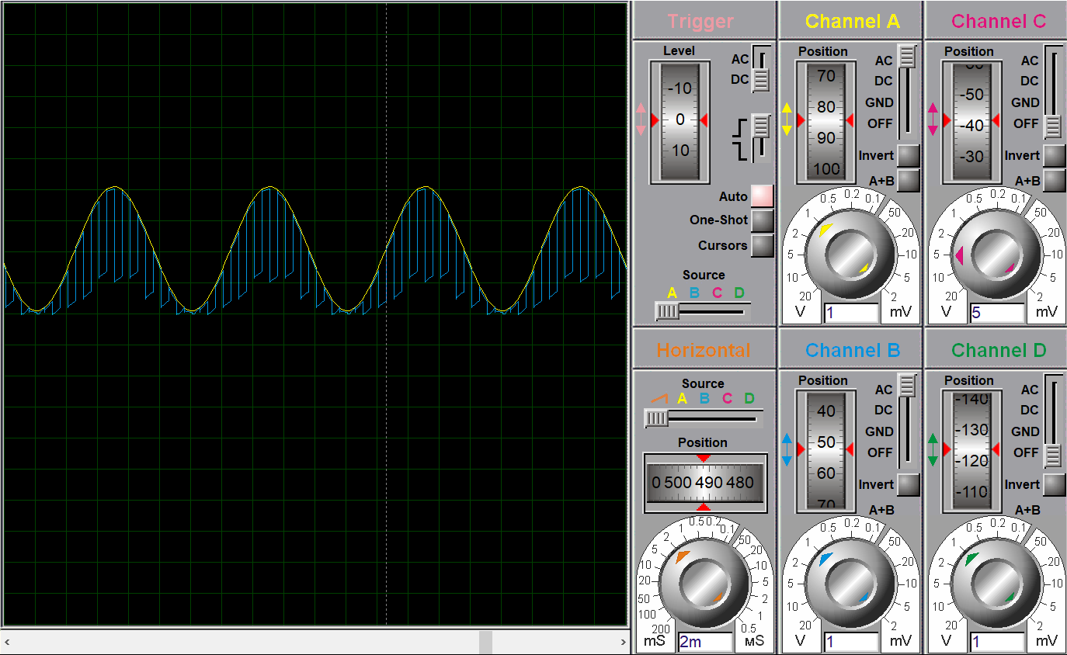
Figure 44: Direct comparison of the two signals [11]

S&H Practical Testing

After this the S&H was constructed on a breadboard the system was tested. Figure 45 shows the practical setup where both power for the op-amps and the pulse signal to the MOSFET are supplied by the Basys 3 board via its Pmod connectors. The signal generator will provide a sine wave of 10KHz, its lowest frequency, and the corresponding S&H signal would be probed to the oscilloscope. The MOSFET would be triggered at 100KHz) to match the relationship with the Proteus simulation satisfying Nyquist from (2). Figure 46 shows the breadboard construction of the Proteus circuit with all the notable modules labelled. Figure 47 shows a configuration of the signal generator use to produce the sinusoid.

Figure 48 shows one practical test on the S&H where there is a S&H reconstruction of sine wave however, it is much noisier and does not track the sine wave as well with greater distortion especially on the rising edge of the wave. Also, the signal seems to distort a maximum amplitude taking more of a square wave shape instead of that of a sinusoid.

Furthermore, at the start of each sample was a high amplitude spike which after research was thought be to from charge injection from the MOSFET when it opens [21]. In future a smaller gate drive voltage could be used or larger size capacitor to create a slower settling time. It was never determined if the S&H in this condition would work with the digital FPGA as the two were never integrated together. The purpose of this test was to confirm the S&H behaviour from the Proteus simulation could be recreated practically. In this regard the practical test was a success.
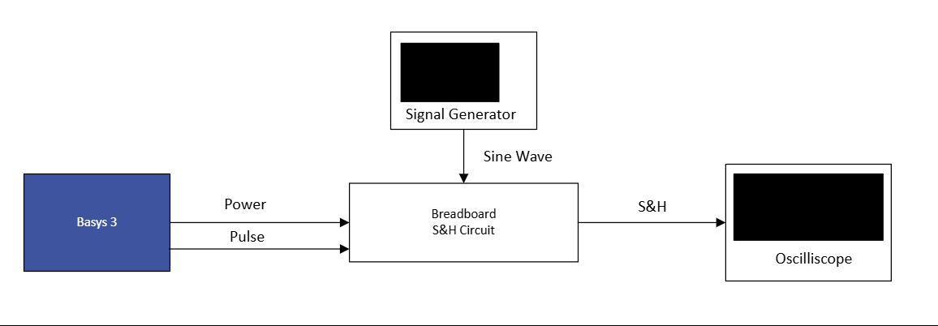
Figure 45: Practical setup of the S&H testing.
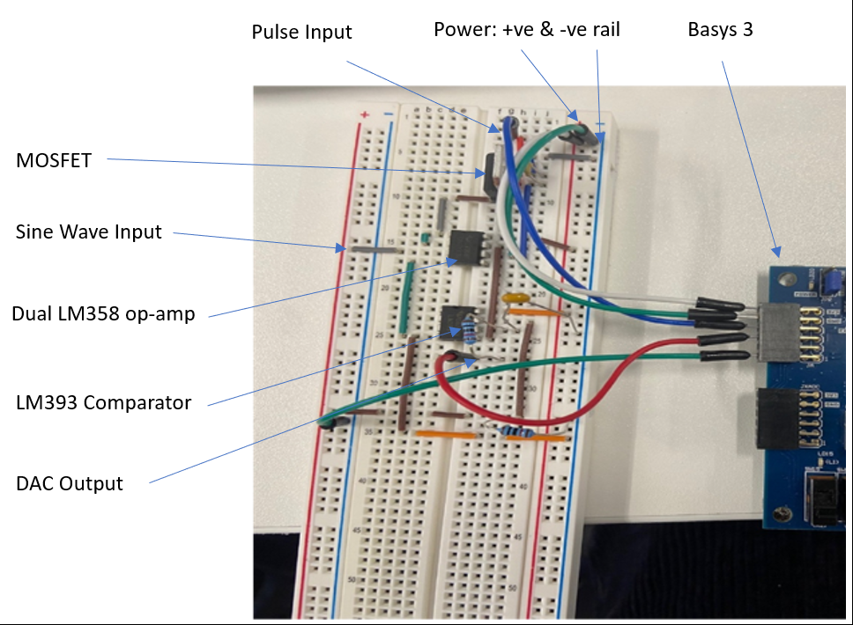
Figure 46: S&H circuit from Proteus on breadboard.

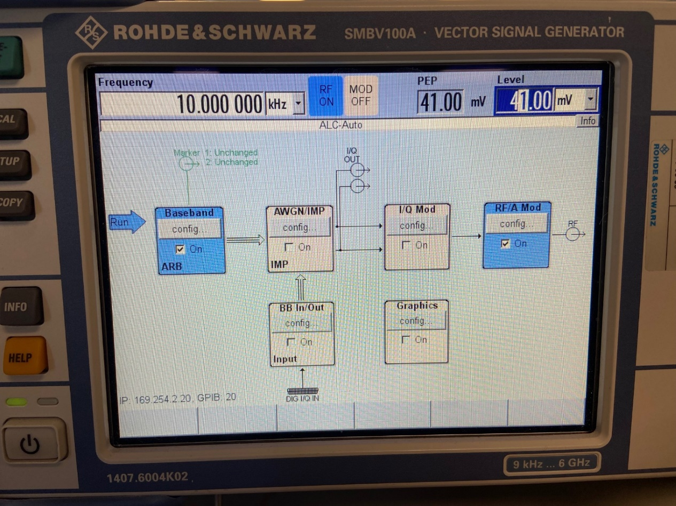
Figure47: Signal Generator setup.
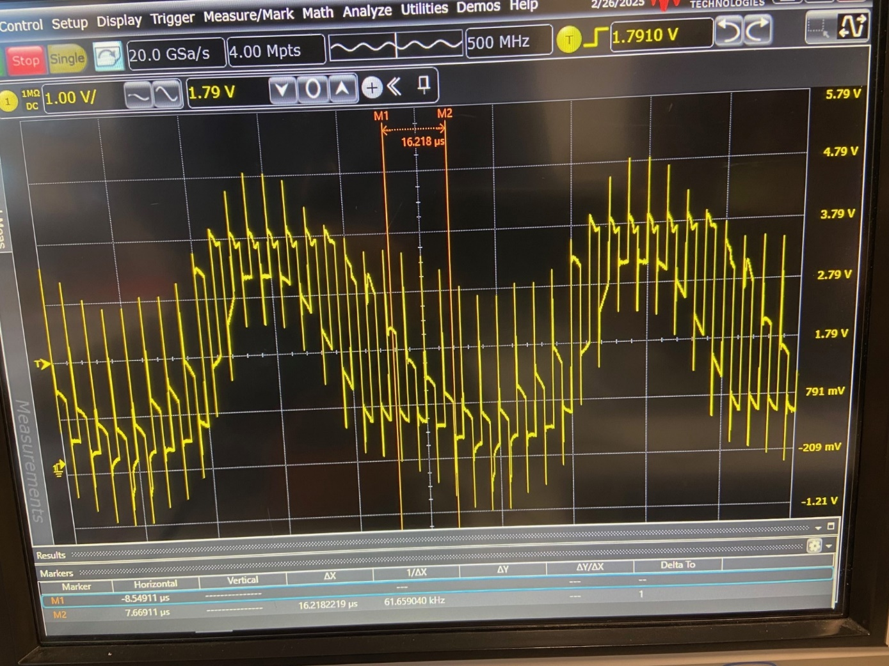
Figure 48: S&H of the breadboard circuit

UART Transmission Testing

Practical UART transmission was carried out to understand if the UART modules were transmitting properly. This was completed prior to the understanding of the importance of post-synthesis simulation and so the disparity between behavioural simulation and practical testing was unidentified. Initial testing started by using the 16 switches on the Basys 3 board [7] to be a single bit input to the UART system and use the RealTerm [12] software to receive the UART transmission. The FPGA was connected to the computer via its USB micro connector which it uses for power but can also be configured for UART transmission.

Figure 49 shows the RealTerm [7] terminal used for UART reception. The baud rate for initial transmission was set low to 19200 so that any error encountered would likely not be down to rate of transmission. Initial transmissions showed no data being received (all zeros) despite in Vivado [3] the system showed to be working and synthesis and the implementation process threw no errors it was thought the translation onto hardware would be fine. As stated previously this was due to asynchronous nature of the circuit at that time. Once this was altered, albeit by using logic-controlled clocks as discussed earlier some data started to come through. This data however, was buggy and did not directly link to the switches on the board. For example, sometimes a single switch would appear to send three ones (like in figure 49).

To understand what exactly was happening the Basys 3 [7] was wired up to an oscilloscope to see what was actually being transmitted. For this, known values which would be easier to identify on the scope. For example: 8-bit numbers such as “0000 1111 where used which should show as long prolonged highs and lows. Figure 50 shows this signal clearly in the third veridical divide with signal first being pulled low for the start bit pulling the line low followed by the signals LSB to MSB and the high stop bit. Even with known signals the transmission was erroneous.
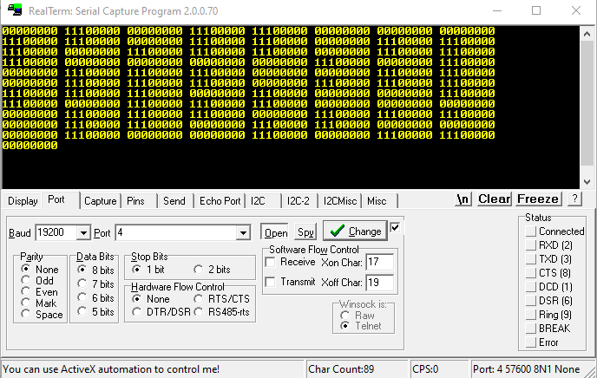Figure 49: Example of UART reception in RealTerm

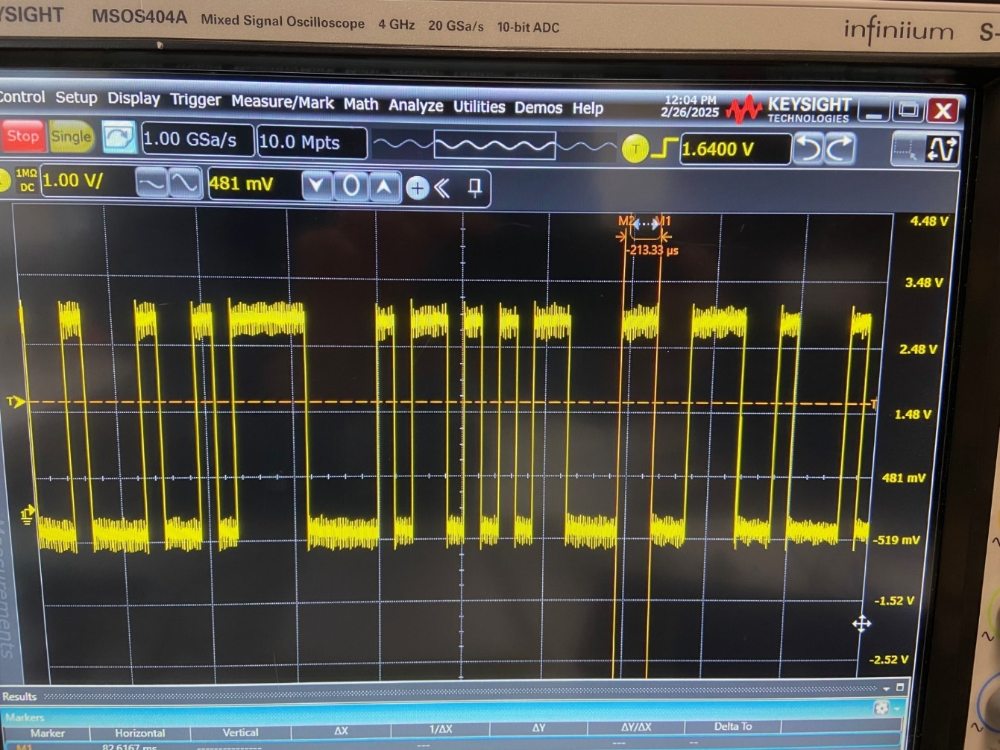
Figure 50: UART Transmission

Performance Based Testing

This section was reserved for the practical testing of the system against the IEEE 1241 standard [4] however, practical testing of the complete system was not achieved in this project however, a full understanding of the system using Vivado’s post synthesis and implementation tools was possible. Therefore, the decision was made to establish the SAR ADC performance within Vivado [3] using the post-implementation reports.

The report in figure 51 is the Power Report detailing how much power the SAR ADC on the FPGA requires and how it is divided up upon the many components. Total power consumption is 0.077 watts (W), 6% used dynamically (switching) and the rest is static which is power used just to run the board in an idle state. The static power takes up the majority of the power consumption as the FPGA is lightly utilised with most of the available logic not required for this design. The dynamic power can be sub-divided into the different switching characteristics such as clocks, input/output (I/O), logic and signals. Of these four the I/O requires the majority of the dynamic power.

The junction temperature, 25.4C, indicates a low operating temperature with little to no risk of overheating. Higher junction temperature is associated with exponential increases leakage current resulting in higher static power. Because this is parameter is low means low leakage current and no requirement for additional cooling [22].

The noise report (figure 52) of the I/O banks and the associated noise of the output pins. From this report the signal names can be associated with an I/O bank along with the voltage (3.3V) and the current (12mA). Most importantly is the remaining margin which indicates the margin before signal integrity, due to noise, is compromised. The output signals for the ADC were all the high 90% range meaning very little to no signal degradation due to noise [22].

Figure #T shows the design timing summary report which is important to determine the worst negative slack (WNS). This greatest amount of time a signal takes to travel from one location to the next. It is important to know this as if its greater than the clock period (10ns) it results in critical timing error as the signal cannot travel through the logic quick enough to meet the system’s requirement. From figure 51 the WNS is 5.364ns which is 4.636ns faster than the clock speed which is well within the acceptable limit [19]. Further to this figure 54 shows the signal paths with the WNS and figure 55 is a partial schematic of the AD showing this signal path.

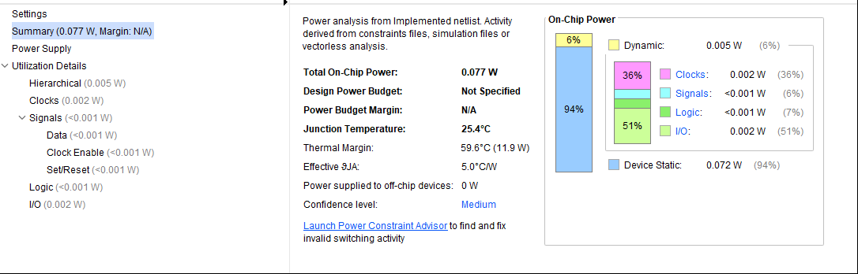
Figure 51: Power Report Post Implementation

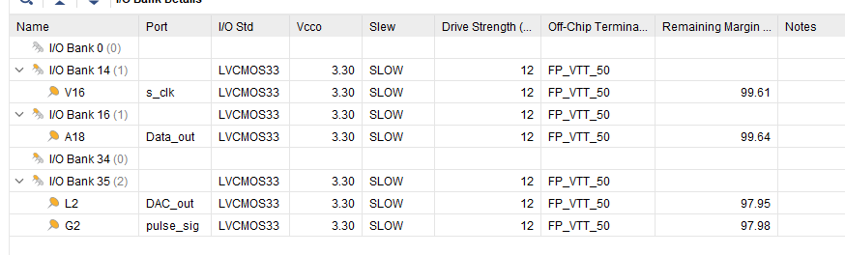
Figure 52: Noise Report Post Implementation

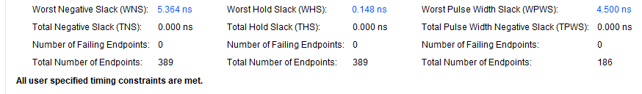
Figure 53: Design Timing Summary.

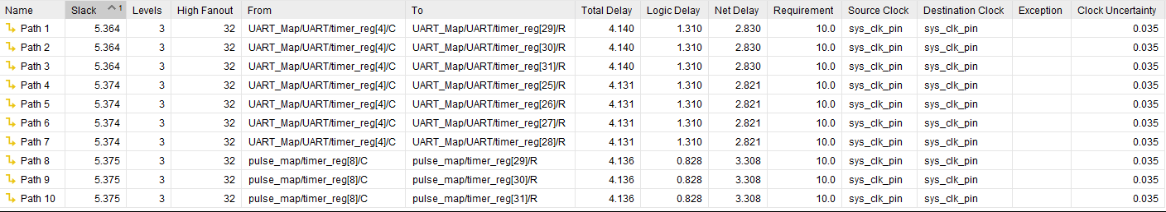
Figure 54: Intra clock paths report.
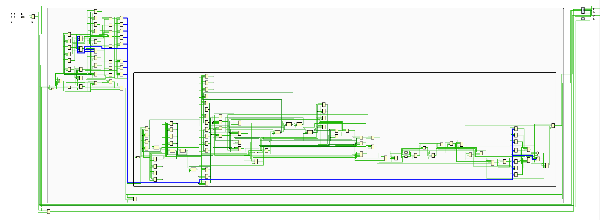
Figure 55: Vivado schematic of path 1 from figure 53

Evaluation

This project to build a SAR ADC onto a FPGA, programming the board purely using VHDL and then testing said board practically against the IEEE 1241 standard was able to achieve many major objects but was unable be implemented fully on hardware.

Despite not meeting all the requirements the project did manage to achieve some major aims. One of which was to identify a suitable ADC that could be implemented onto FPGA but also identify the components that could not be. By using the SAR most of the components would be digital and thus FPGA implementable. Many other ADC’s researched such as the pipeline [5] would not have had this characteristic. Another major aim achieved was generating the VHDL to build the logic which would carry out the ADC functionality. This also involved modules not initially thought needed (i.e UART modules) but later realised were necessary for practical testing.

In Vivado the data shows the ADC to be working well both in simulation and using the post-implementations reports. The post-implementation timing, simulation shows the complete digital system working optimally. The post implementation report shows good WNS, low power consumption and no major timing violations in regards to the clocks. The S&H circuit was also proved to be working although was unable to optimised with signal distortion still present. The next stage would be to integrate both analogue and digital FPGA together to determine practical performance.

If the project was repeated the lessons learnt and knowledge gained about good VHDL practices for synthesisable code such a focus on synchronous design, use of FSMs, proper use of process statements and clock creation using logic would be applied to ensure development proceeded quicker in the initial stages. Furthermore, now being more familiar with the development of FPGA logic using Vivado each module would be tested in all simulation types to confirm proper working order. Only then would modules be connected and the development steps repeated until the system was combined into a single homogenous system. By applying these new rules, the project would be more robust against bugs and reduce development time allowing for practical testing.

Conclusions and Recommendations

The project had the aim of designing and implementing a SAR ADC purely using VHDL with the aim of practically testing the system against IEEE 1241-2010 [4] standard used for testing and evaluation of ADCs. This project would follow a development methodology inspired but the IEEE Standard 1076-2019 [1] for synthesis compatible VHDL and the AMD Vivado Design Suite User Guide: Design Flows Overview (UG892) [10] to create a FPGA system that applied VHDL and design flow best practices to aid with system development.

The project involved researching and identifying FPGA implementable ADCs that also were audio application capable. The FPGA implementable components of each ADC needed to be identified and suitable hardware needed to be sourced to develop the analogue components e.g. the S&H circuit. The S&H circuit was tested both in simulation using Proteus [11] and practically. The S&H was not able to be implemented with the FPGA however, the concept was proved although never optimised.

The FPGA components were implemented as modules as suggested for best practices and connected using the port mapping method. Initially, due to lack of familiarity with the language bad practices were included such as logic derived clocks. These the caused unwanted behaviours in post-synthesis simulation and critical errors in the timing reports. These errors were later rectified but initially went unnoticed due to the behavioural simulation not being sensitive to it. Furthermore, a lack of awareness with the Vivado also prevented earlier response to this issue as post-synthesis simulations were not run as there was no knowledge of their existence. This was until the disparities were found with the UART practical testing and the simulation resulting in further research which allowed for the error to be noticed and then later rectified.

Unfortunately, practical testing against the IEEE 1241 standard [4] was unable to take place instead post implementation design reports in Vivado were used to establish operational effectiveness of the system. For future work, establishing a working practical system where both the S&H and FPGA worked together would be the primary goal. Despite making good progress developing the FPGA logic getting the two system to work homogenously would be challenging. For example: the DAC on the FPGA was never tested/could not be tested properly because it required interaction with the analogue components. Continuing the project this would be the area of my primary focus as this is systems performance is major unknown.

Reflection

I have found this project extremely beneficial in developing my skillset VHDL/ FPGA on an application that is used numerously in embedded systems. ADCs are integral for digital systems that need to interact with the real world and in the literature review I got to investigate the engineering of the different types. This provided me a more in-depth knowledge of these devices which now knowing could help me better select one for a future application.

This project has enabled my progression with VHDL being able to understand and implement more advanced techniques such as process statements and the use of FSMs. I have been able to grasp to use of testbenches which before the project I had struggled understanding the concept and how to implement these special scripts properly. Testbenches is a skillset I still need to develop more as they are a very powerful tool being able to create simulations which can produce pass/fail clauses and reports of particular events making debugging easier and reduce development time.

Development of my Vivado [3] expertise has been another key area that has been a personal achievement as I have managed to become more familiar with the software and the design tools such as design reports and post-synthesis simulations which I had little to no experience with prior to this project. I faced many challenges in this project surrounding Vivado [3] simulations and I was pleased in the way I managed to troubleshoot these problems realising I had misunderstood a fundamental design philosophy. I proud that I managed to effectively research this problem and apply he newly learnt techniques quickly. I am now aware of additional functionality which I can use in future projects in this project such as the IP creator.

The S&H has also given me greater confidence building and testing hardware components using testing equipment such signal generators and oscilloscopes. I was proud that I used of Proteus [11] to initially build and simulate designs and configurations to ease initial testing speeding the development time of this particular component.

I am frustrated that I was not able to practically test the ADC as this would have shown the ability to test the system against IEEE 1241 standard [4] showing my ability to this. However, I think I over-estimated the complexity of this project when I initially proposed it especially as I had only a limited knowledge of VHDL and Vivado. Knowing what I know now I am happy that I was able to get as far as I did with this project and I achieved my main personal goals which were to become more skilled at VHDL and Vivado.

References

[1] | IEEE, “IEEE Std 1076-2019,” IEEE Satndards Association, New York, 2019.
[2] | R. Jasinki, Effective Coding With VHDL, Cambridge, MA: The MIT Press, 2016.
[3] | Advanced Micro Devices (AMD), “AMD Vivado Design Suite,” AMD, 2024. [Online]. Available: https://www.amd.com/en/products/software/adaptive-socs-and-fpgas/vivado.html. [Accessed 15th October 2024].
[4] | IEEE, “IEEE Std 1241-2010,” IEEE Standards Association, New York, 2010.
[5] | R. M. Herwies, “Design and Modelling of an Analog Digital Converter Usinf FPGA Board,” California Sate University, Northridge, 2013.
[6] | J. Marques, “Renesas - Low Latency, Low Power, Precicion ADCs,” 22nd December 2021. [Online]. Available: https://www.renesas.com/en/document/whp/low-latency-low-power-precision-adcs?r=1546236. [Accessed 12th October 2024].
[7] | digilent, “Basys 3,” Digilent, 2025. [Online]. Available: https://digilent.com/reference/programmable-logic/basys-3/start. [Accessed 2024].
[8] | Digilent, “Arty A7,” Digilent, 2025. [Online]. Available: https://digilent.com/reference/programmable-logic/arty-a7/start?srsltid=AfmBOoqN7tf3AU5hLgpPbs0cDbEvZl2qlMdM_bbYM4awrFV_QebJgcBs. [Accessed 2024].
[9] | Connex, “SMA Coaxial Connectors,” COnnex, 2001.
[10] | AMD, “Vivado Design Suite User Guide: Design Flows Overview (UG892),” [Online]. Available: https://docs.amd.com/r/en-US/ug892-vivado-design-flows-overview/Vivado-System-Level-Design-Flows. [Accessed 2024].
[11] | Labcenter, “Proteus Design Suite,” Labcenter, 2025. [Online]. Available: https://www.labcenter.com/. [Accessed 2024].
[12] | SourceForge, “RealTerm: Serial/TCP Terminal,” crun, 2017. [Online]. Available: https://sourceforge.net/projects/realterm/. [Accessed 2025].
[13] | MPS, “ADCs in Audio and Video Applications,” MPS, 2025. [Online]. Available: https://www.monolithicpower.com/en/learning/mpscholar/analog-to-digital-converters/applications-of-adcs/audio-and-video-applications. [Accessed 2024].
[14] | Texas Instruments, “Using PWM Output as a Digital-to-Analog Converter,” 2008. [Online]. Available: https://www.ti.com/lit/an/spraa88a/spraa88a.pdf?ts=1730791150710. [Accessed 2024].
[15] | V. Adams, “Universal Asynchronous Reciever Transmitter (UART),” 2025. [Online]. Available: https://vanhunteradams.com/Protocols/UART/UART.html. [Accessed 2025].
[16] | ASCII Tables, “ASCII Tables,” 2025. [Online]. Available: https://www.asciitable.com/. [Accessed 2024].
[17] | Omni Calculator , “Baud Rate Calculator,” Omni, 2025. [Online]. Available: https://www.omnicalculator.com/other/baud-rate. [Accessed 2025].
[18] | B. T. Cem Unsalan, Digital Systems Design with FPGA, New York: McGraw-Hill Education, 2017.
[19] | AMD, “Vivado Design Suite User Guide: Synthesis (UG901),” 2025. [Online]. Available: https://docs.amd.com/r/en-US/ug901-vivado-synthesis?tocId=WBzTBqg68MSs1CtsSBAVwA. [Accessed 2025].
[20] | Texas Instruments, “ndustry-Standard Dual Operational Amplifiers,” October 2024. [Online]. Available: https://www.ti.com/lit/ds/symlink/lm358.pdf?ts=1745819358419&ref_url=https%253A%252F%252Fwww.ti.com%252Fproduct%252FLM358%253Futm_source%253Dgoogle%2526utm_medium%253Dcpc%2526utm_campaign%253Dasc-null-null-GPN_EN-cpc-evm-google-kr_en_cons%2526utm_content%. [Accessed 2025].
[21] | B. Razavi, Design of Anlog CMOS Integrated Circuits, New York: McGraw-Hill Higher Education, 2017.
[22] | AMD, “Vivado Design Suite User Guide: Power Analysis and Optimization (UG907),” 2025. [Online]. Available: https://docs.amd.com/r/en-US/ug907-vivado-power-analysis-optimization. [Accessed 2025].
[23] | T. L. Floyd, Digital Funditmentals 10th Edition, New Jersey: Pearson, 2009.
[24] | J. Gaisler, “A structured VHDL design method,” Gailser Research.
[25] | B. Baker, “How delta-sigma ADCs work part 1,” 2011.

Appendices

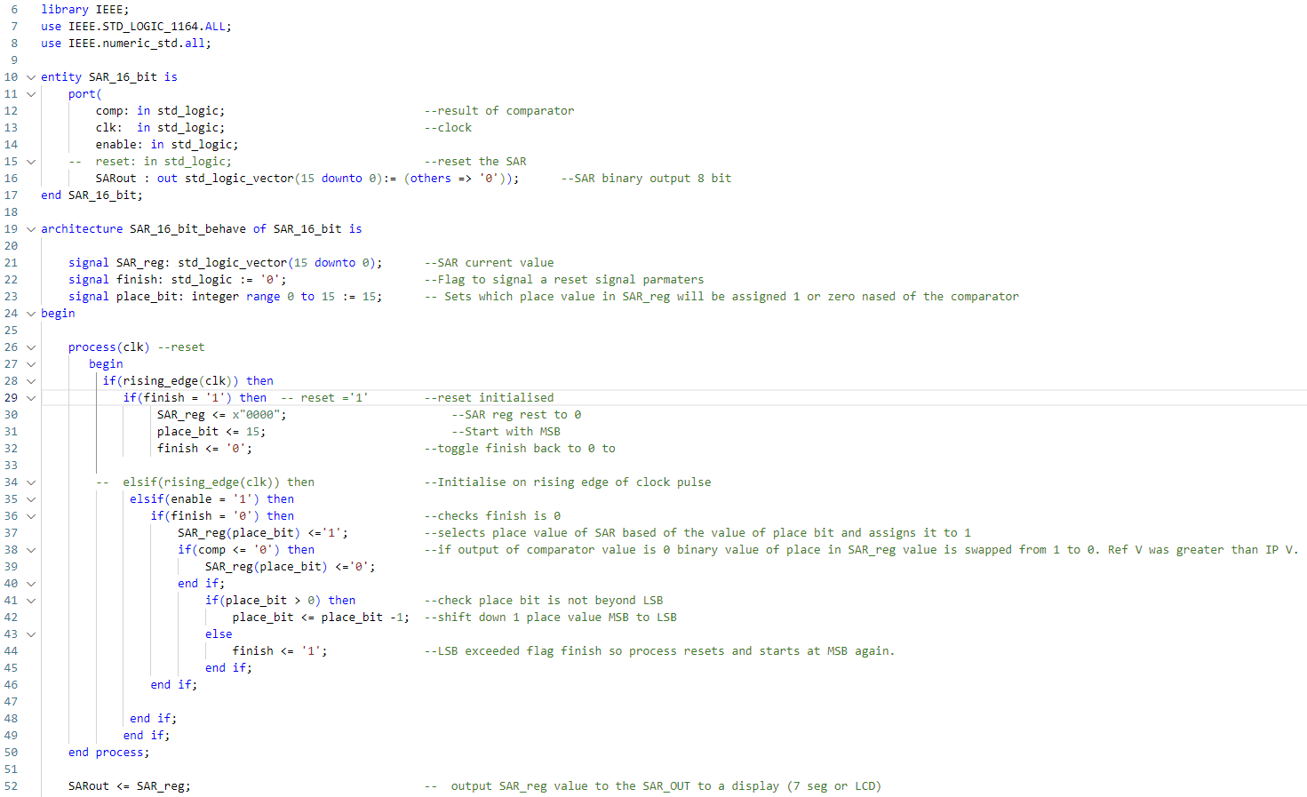
Appendix A: 16-bit SAR VHDL Script

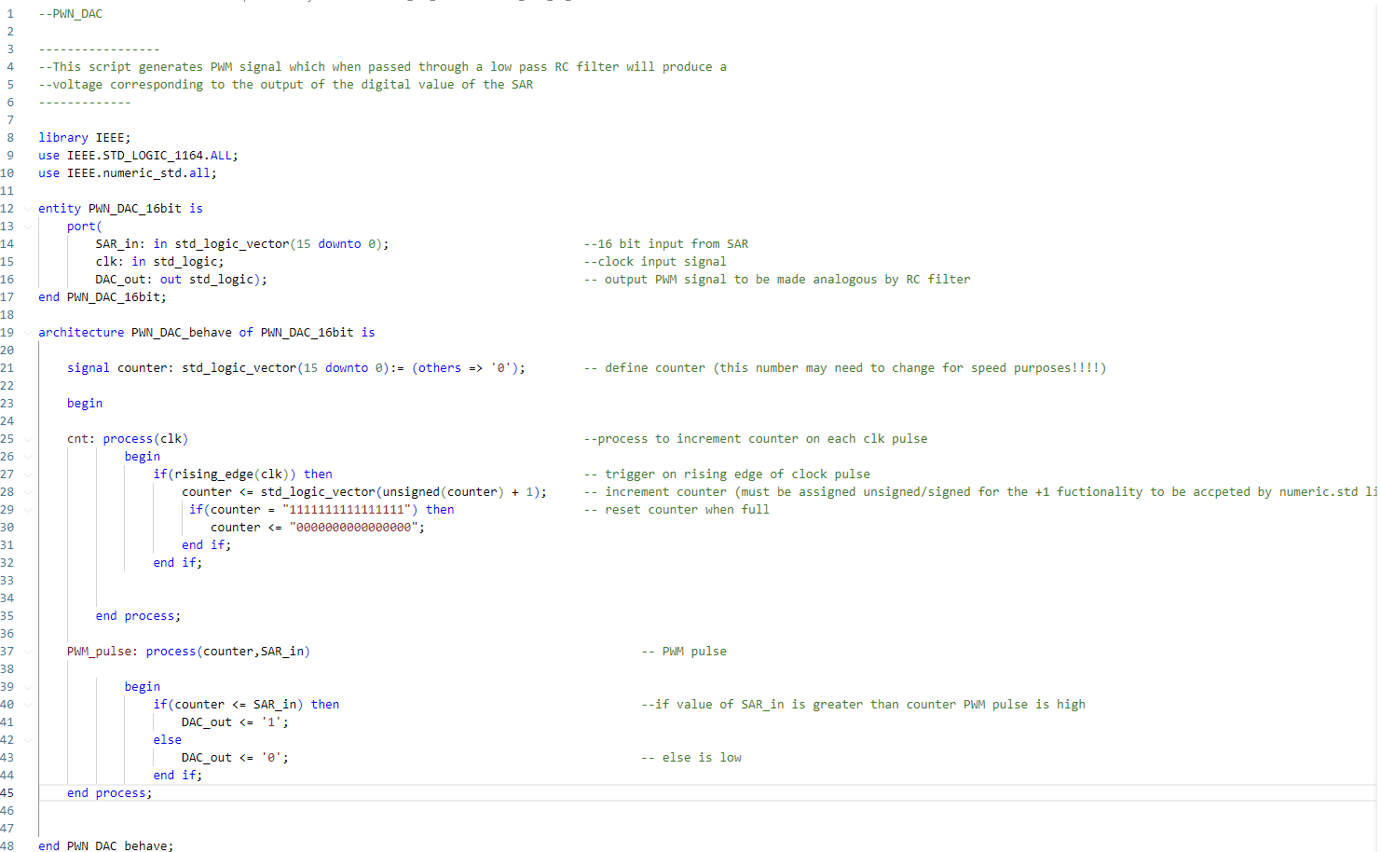
Appendix B: PWM DAC VHDL script

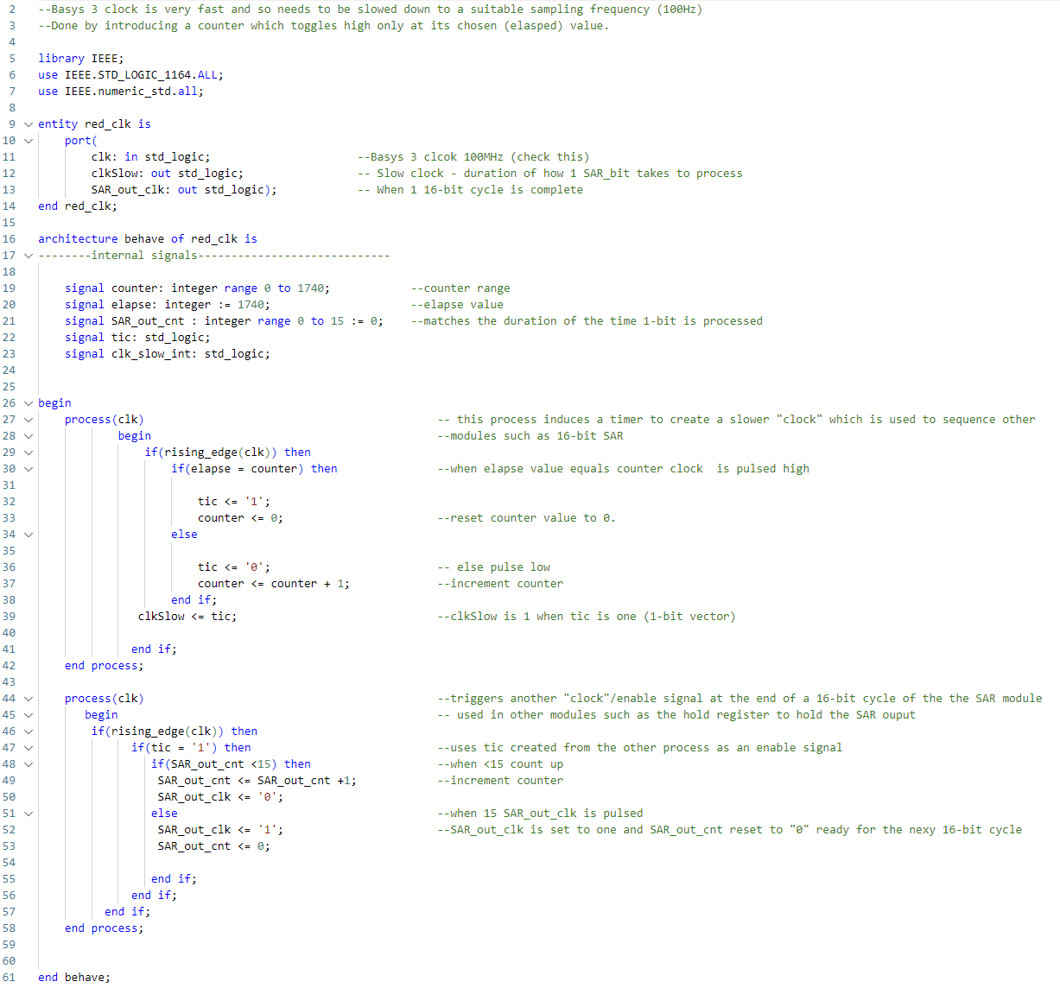
Appendix C: Enable timers VHDL Script

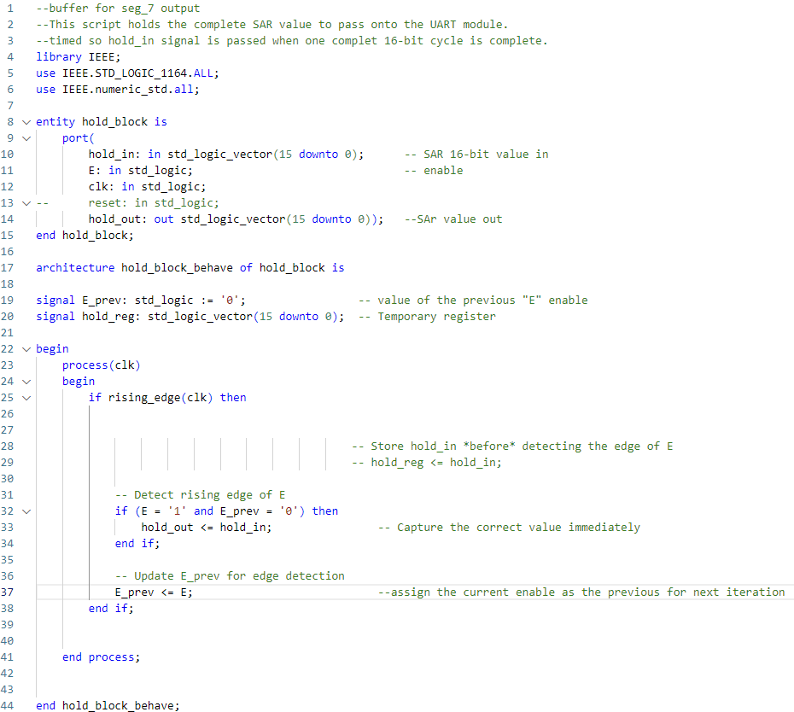
Appendix D: Hold Register VHDL Script

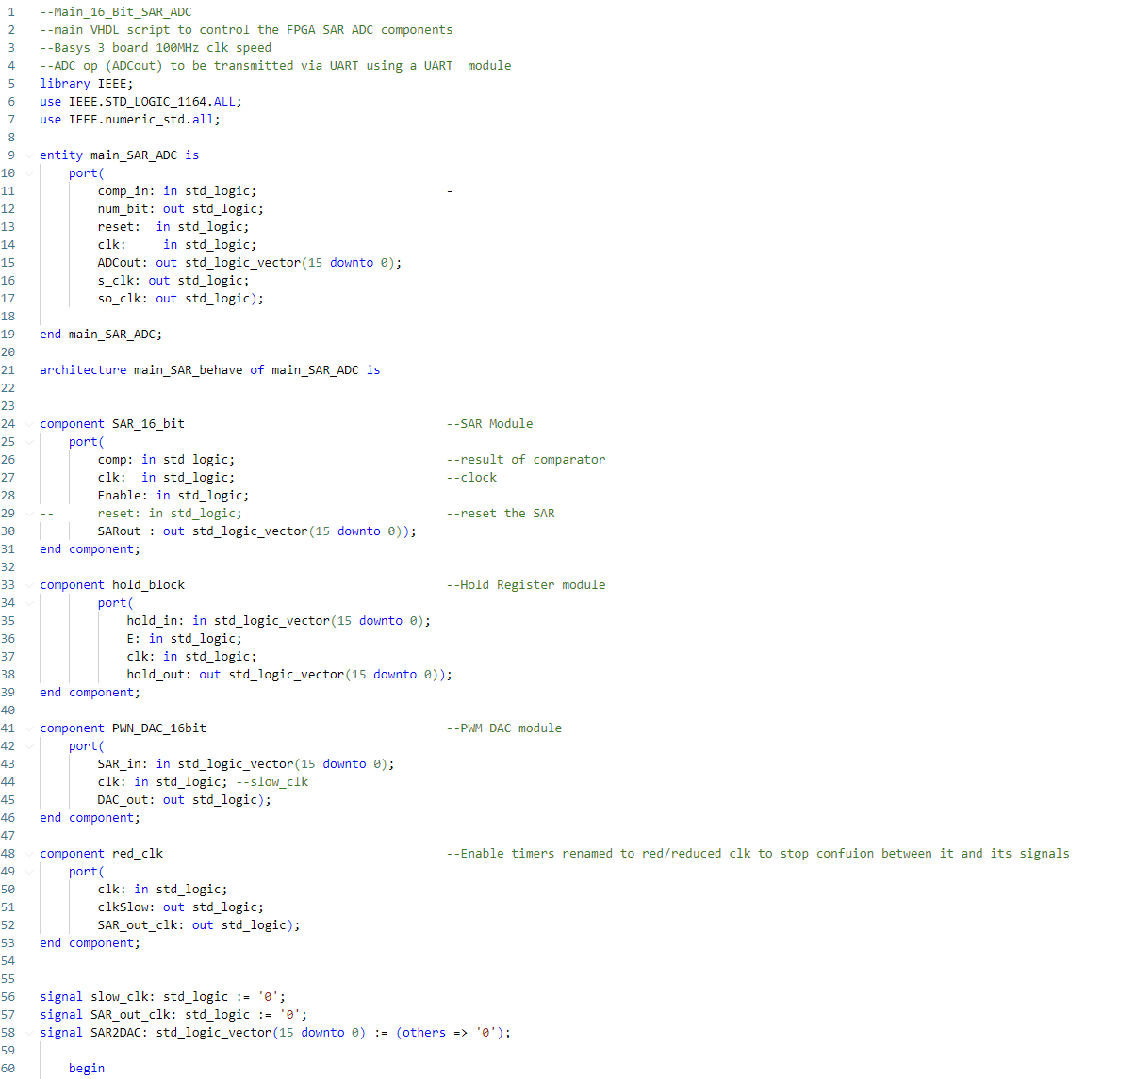
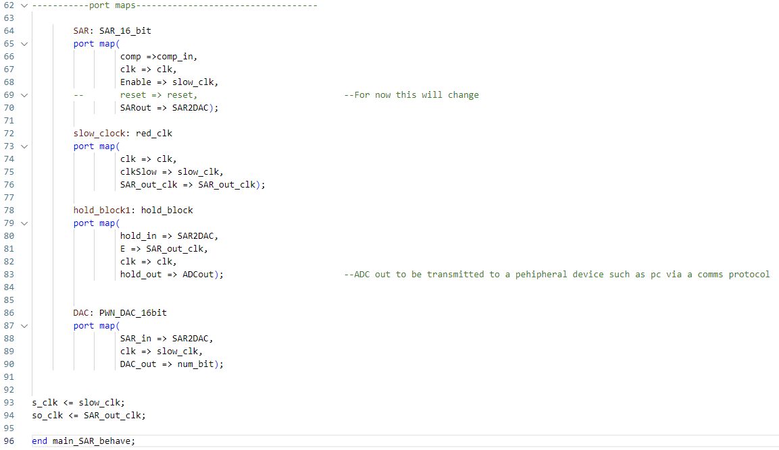
Appendix E: SAR Top Module VHDL Script

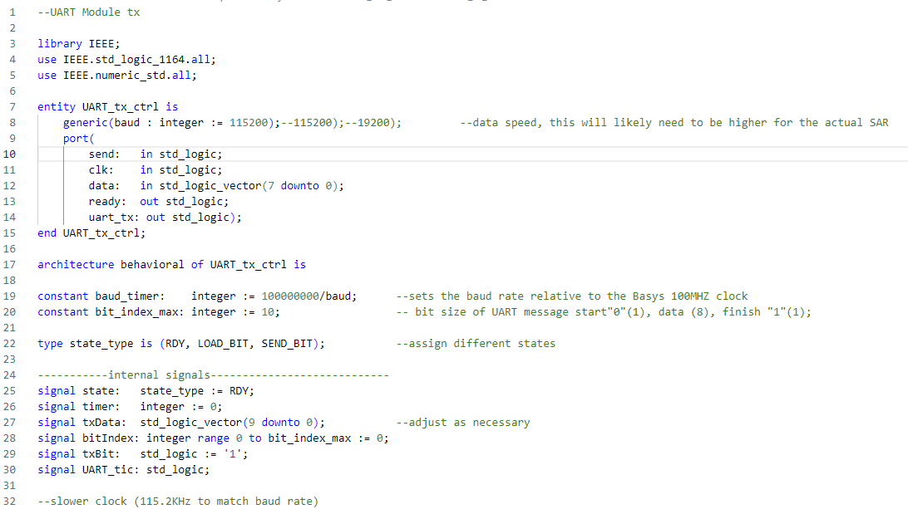
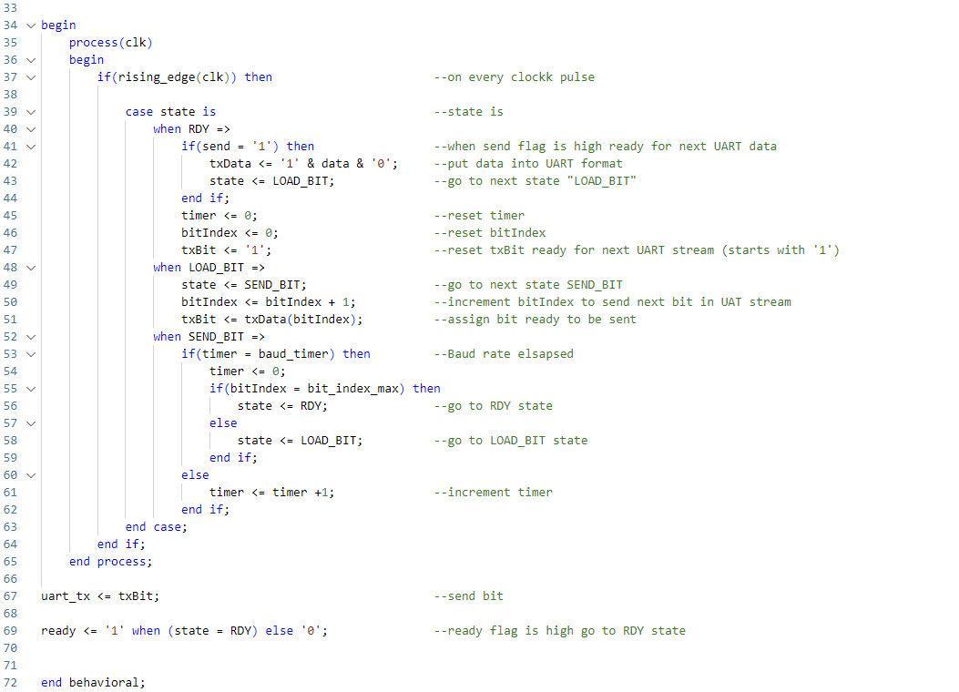
Appendix F: UART transmission lower module VHDL script

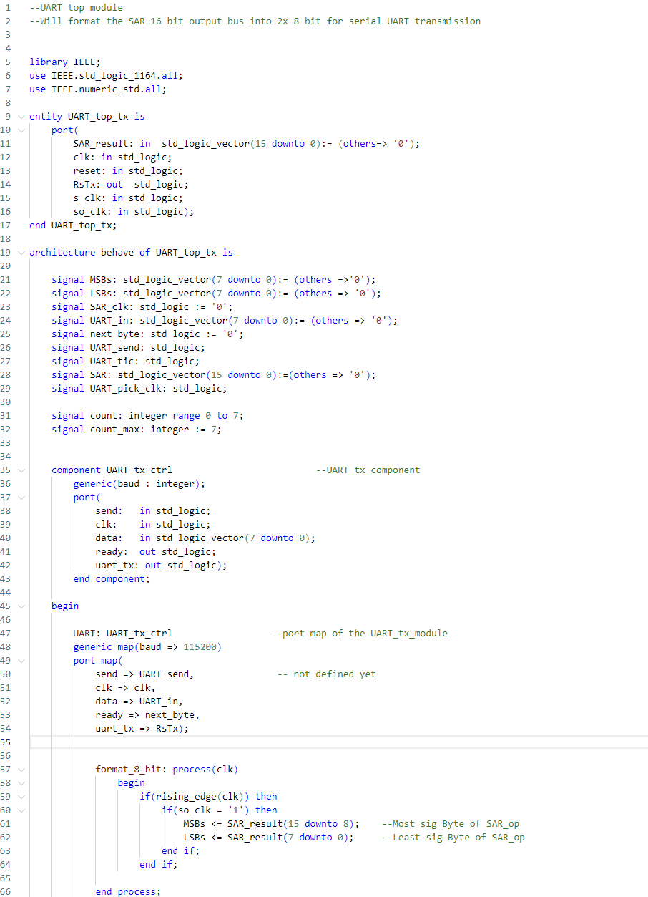
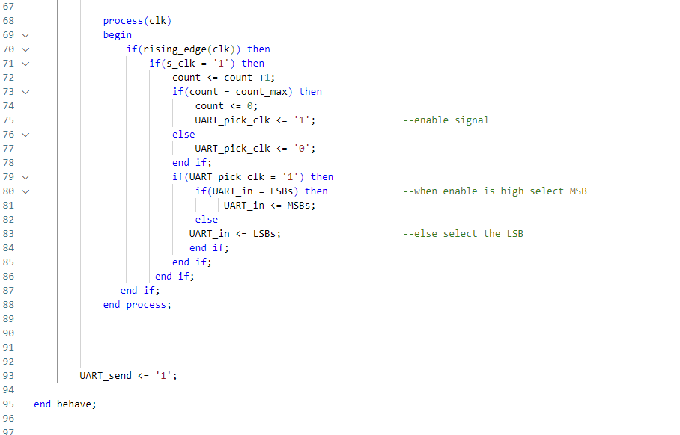
Appendix G: UART Top Module VHDL Script

Appendix H: ROM Sine wave VHDL script

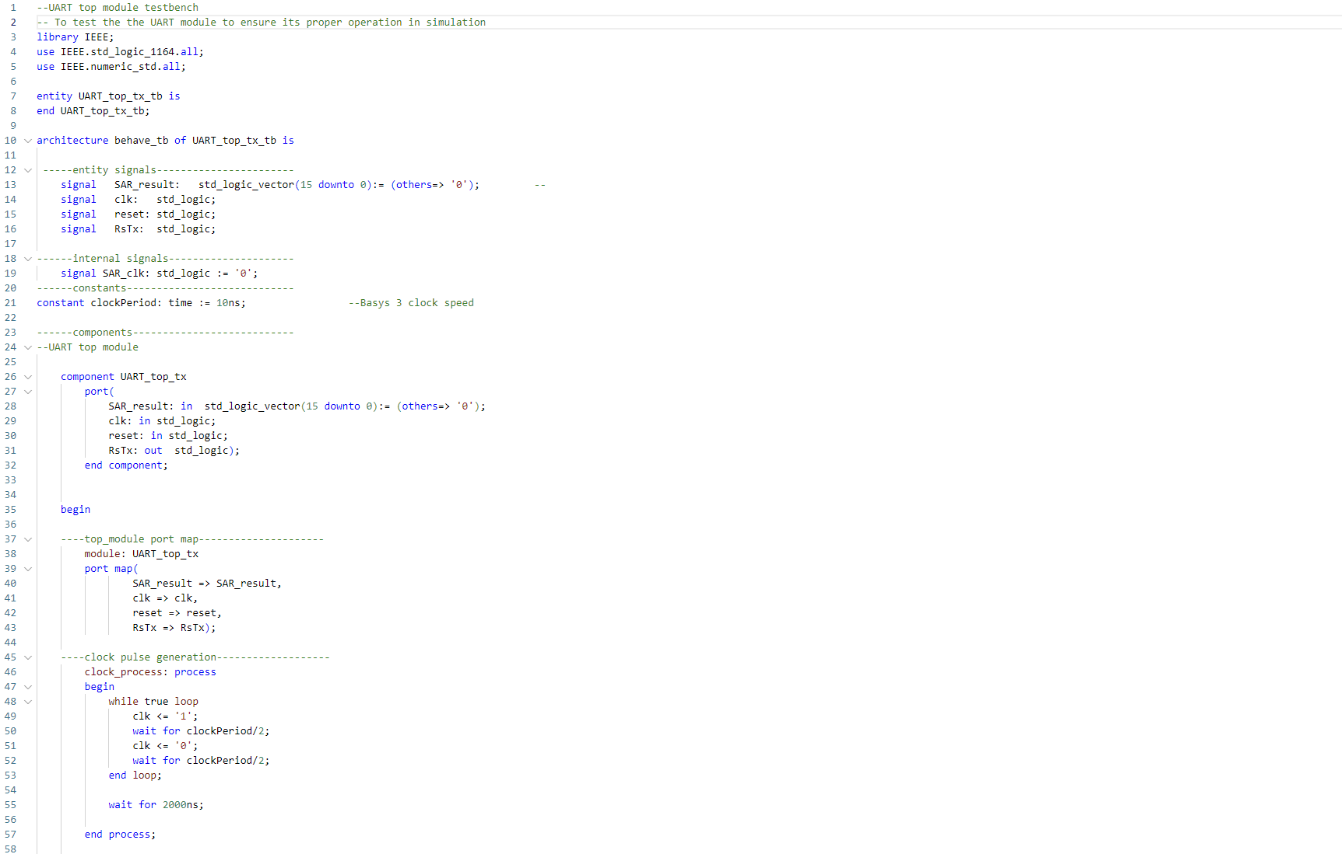
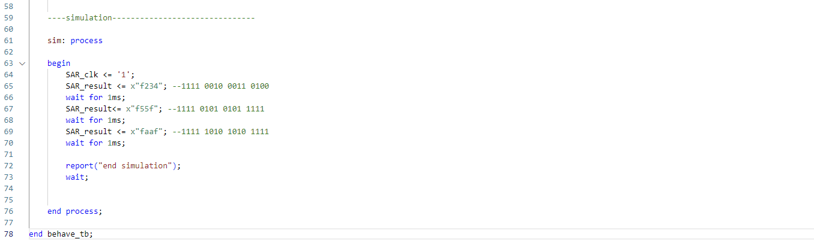
Appendix I: UART Testbench VHDL Script

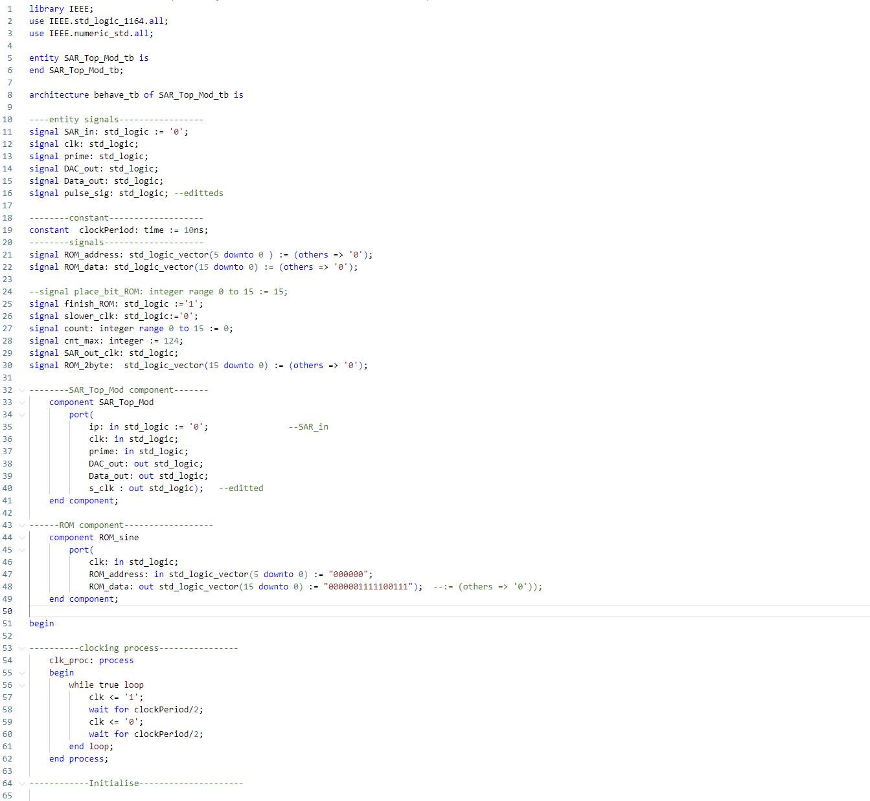
Appendix J: SAR ADC Testbench Script

