Digital Forensics Analysis

Programme: MSc cybersecurity and digital forensics
Module: Digital Forensic
Module code: ACCA7031
Student name: patel jay rajendrakumar
Student ID number: 2433122
Table of Contents
Task 1: Digital Forensics Analysis 5
1. Introduction 5
2. State of Art in Digital Forensics 5
2.1 Definition and Scope 5
2.2 The UK Context 5
3. Tools, Features, and Capabilities 5
3.1 Key Forensic Tools 5
3.2 Capabilities & Features 6
3.3 Tool Limitations 6
4. Intersection of Digital Forensics and Cybersecurity 6
4.1 Overlapping Domains 6
4.2 Incident Response Lifecycle 6
4.3 Legal & Compliance Drivers 7
5. Current Innovations in Digital Forensics 7
5.1 AI and Automation 7
5.2 Cloud and IoT Forensics 7
5.3 Encryption and Anti-forensic Techniques 7
5.4 Remote and Live Forensics 7
6. Key Challenges 7
6.1 Technical Challenges 7
6.2 Challenges of legal and regulatory character 8
6.3 Staffing and Manpower Constraints 8
7. Local and Foreign Labor Market 8
7.1 UK Digital Forensics Market 8
7.2 International Market 8
8. Conclusion and Recommendations 9
Task 2: A Case Study in Intellectual Property Theft 10
1. Introduction and Case Overview 10
1.1 Case ID, Timeline, and Scope 10
1.2 Objectives of the Forensic Analysis 10
1.3 Key Parties and Roles 11
2. Methodology 11
2.1 Evidence Collection Procedures 11
2.2 Forensic Imaging and Toolset Used 11
2.3 Data Processing and Validation Steps 12
2.4 Limitations and Reliability Factors 12
3. Evidence Overview 12
3.1 Description of Devices Analysed 12
3.2 Extraction Data Volumes and Details 13
3.3 Chain of Custody Assurance 13
3.4 Overview of Relevant Data Types 13
4. Analysis and Findings of the Devices 13
4.1 Huawei POT-LX1 P Smart — Attributed to Emma 13
4.2 Samsung Galaxy A13 - Transacted under Joe 15
4.3 Ulefone Note 14 -Accredited to Norman. 17
4.4 Nokia C2 — Unattributed Co-conspirator 18
5. Correlation of Cross-Devices and of Timeline 20
5.1 Experiencing Evidence-Based Narrative Construction 20
5.2 Timeline Visualization 22
5.3 Actor Role Mapping and Relationship Diagram 22
6. Technical and Legal Assessment 23
6.1 Technical Barriers Encountered 23
6.2 Data Integrity and Admissibility 23
6.3 Legal Considerations in Evidence Handling 24
7. Documentation of Device Acquisition Process 25
8. Forensic Collection Information 36
9. Conclusions 40
10. Recommendations 41
10.1 Identification of Unknown Conspirators 41
10.2 Legal Actions and Next Steps 41
10.3 Lessons for Future Investigations 41
References 43

Task 1: Digital Forensics Analysis

1. Introduction
Digital forensics is a paramount field in the field of cybersecurity and criminal justice, whose main purpose is to discover, preserve, analyse, and present digital evidence. With the growth of cybercrime, cloud computing and smart devices, its significance has only increased. This report includes a modern overview of the digital forensics sector, such as the tools, connections with the cybersecurity domain, trends, obstacles, and work-force perspectives, and is majorly UK-based [1], [2].

2. State of Art in Digital Forensics

2.1 Definition and Scope
Digital forensics is the study of electronic systems and devices in order to retrieve, store and examine the evidence that should be presented as a legal or disciplinary measure.
Its use can be in criminal investigations, a response team within corporate settings, data breaches, intellectual books theft, and regulatory compliance [3], [4].

2.2 The UK Context
The UK is leading the way in adopting digital forensics in law enforcement, responding to cyber incidences and the justice system.
National agencies (such as the National Crime Agency, NCA) will work in conjunction with cybercrime units and law enforcement in the regions to respond to the cyber-enabled crimes [5], [6].

3. Tools, Features, and Capabilities

3.1 Key Forensic Tools
- EnCase: Fountain of analysis of hard drives, partitions, file Systems.
- FTK (Forensic Toolkit): Quick indexing, email, analysis, memory dump analysis.
- Autopsy/Sleuth Kit Open-source, perform timeline analysis, hash filtering, key word search.
- Cellebrite: Best mobile device forensic, retrieval of deleted and encrypted data.
- X-Ways Forensics: Light speed disk analysis.

3.2 Capabilities & Features
- Acquisition: Whole drive, RAM, mobile device acquisitions and minimal alteration (write blockers) are utilized.
- Analysis Data carving Data file signature-based Analysis File Timeline reconstruction Keyword indexing [7].
- Chain of custody management, Records audit, tagging of evidence.
- Automation: There is more focus on workflow automation to deal with a large volume of evidence and accelerate casework [8].

3.3 Tool Limitations
- Dependency on new file types and encryption schemes to receive updates on the tools that need it.
- Manual backlog and high volumes of cases.

4. Intersection of Digital Forensics and Cybersecurity

4.1 Overlapping Domains
Digital forensics and cybersecurity are inseparable: cybersecurity aims at preventing and detecting attacks, and forensics studies the cases after the attacks are compromised.
Forensic preparedness is placed into the process of cybersecurity planning- planning systems to collect evidence quickly after an incident [9].

4.2 Incident Response Lifecycle
Detection: Security Information and Event Management (SIEM) products are tools that alert in case of suspicious activity.
Research: Investigation of the affected hosts and network logs is involved with the use of forensic tools.
Remediation: evidence which is the product of forensics informed purposes of containment and eradication [10].

4.3 Legal & Compliance Drivers
There is industrial-user regulation (GDPR, the UK Computer Misuse Act, and breach reporting) where handling of evidence and breach reporting are to be observed without failure [11], [12].

5. Current Innovations in Digital Forensics

5.1 AI and Automation
Anomaly detection machine learning, triage in bulk data, and there is machine learning in the field of images/videos labelling.
Automated generation of scripts to run log analysis and hunts.

5.2 Cloud and IoT Forensics
The rapidly developing cloud-based storage and smart environments pose problems when it comes to the question of data jurisdiction, acquisition, and analysis.
Remote evidence collection labs dubbed as-a-service [13].

5.3 Encryption and Anti-forensic Techniques
An increase in the amount of strong encryption and anti-forensics (e.g., secure deletion of files and obfuscation) by attackers makes evidence recovery more difficult [14].

5.4 Remote and Live Forensics
The opportunities of live forensic analysis (memory, volatile data) and remote investigation tools (rapid response in ongoing attacks e.g. ransomware containment) [15].

6. Key Challenges

6.1 Technical Challenges
Volume, Variety and Velocity: Smoking increase in quantity of data to be gathered and processed.
Encryption: Large-scale use of it makes it more difficult to analyse, and in some cases impossible.
Cloud Evidence: Information stored abroad (sovereigns’ problems), physical loss of control, and cooperation of providers [16].

6.2 Challenges of legal and regulatory character
Legal Barriers to Obtaining Cross-border evidence or cloud-stored evidence Jurisdiction and Sovereignty: Hurdles in the law.
Integrity of Evidence: Assuring that the processes are passed through Linnae in Court (Paperwork, repeatability, chain-of-custody policies) [17].

6.3 Staffing and Manpower Constraints
High levels of underutilized and pending digital evidence cases that are being stuck at the police laboratories because of the lack of the required skills and the size of evidence.
Technology environment is rapidly dynamic and faster outpacing the ability to train a workforce and equip them with tools.

7. Local and Foreign Labor Market

7.1 UK Digital Forensics Market
Law enforcement, consultancies and private enterprises High demand of skilled digital forensics analysts and incident responders.
Government funding on cyber capability(s) (CyberFirst, NCSC programmes) and groups in the sector including the NCA, police cyber ranges, and technical support.
There is an increasing opportunity in the private sector particularly in financial services, telecom, and legal consulting.

7.2 International Market
International demand is exerted under regulatory compliance (GDPR, HIPAA), the increasing rate of cybercrimes, data breaches lawsuits and thousands of digital transformation project expansion.
Opportunities Multinational consultancies (KPMG, PwC, Deloitte), tech vendors, remote/outsourced digital forensics services [18].
Presence of EU, North American, and Asia-Pacific shortage of competent professionals, providing high levels of salary and career development.

8. Conclusion and Recommendations
Digital forensics in the UK is a rapidly changing high demand industry that is closely connected with cybersecurity. The tools and automation are expanding capabilities yet the issues concerning data volume, encryption, and cloud evidence are still acute. The cross which is occurring with cybersecurity gains increased power and demands the cooperation of multidisciplinary skills and responsive strategies. The combined effort to invest in training, standardization of tools and harmonization of international laws will be important in responding to future demand and technicality.

Task 2: A Case Study in Intellectual Property Theft

1. Introduction and Case Overview
This is a forensic report regarding a case based on corporate espionage that revolved around the suspected stealing, as well as attempted selling of, the QT-AI-2025 patent. The probe started after the receipt of credible intelligence information that there was unauthorized access to sensitive intellectual property of the organization. The importance of the patent to the competitiveness of the company rendered the incident especially acute and the initiation of a large-scale digital forensic investigation was necessary to find out the scope of the intrusion, who did it, and how to obtain evidence that can be used against the perpetrators.

1.1 Case ID, Timeline, and Scope
Case is officially documented as ACCA7031-Task2-Analysis and covers an uncovered portion of the activities between the months of August 2024 and December 2024 with the report being the final outcome of this being dated November 16, 2025. The area of the investigation will include the logical retrieval and examination of four cell phones that are directly connected to the events under question. The devices were extracted and photographed in a forensic manner and searched communications, monetary transactions and other digital evidence of the conspiracy. Chain-of-custody guidelines and tested forensic tools assured the integrity and admissibility of all of the reviewed evidence.

1.2 Objectives of the Forensic Analysis
The key objectives of the forensic process were:
- To determine the identity and roles of users on the four devices that were obtained.
- To rebuild the timeline and the way in which the robbery and the intended sale were planned.
- To search, examine and report digital communications (e.g. WhatsApp, email personal, multimedia) that prove the conspiracy.
- To detect, and save vital files, financial credentials, and tactical operations that are used by the suspects.

1.3 Key Parties and Roles
On the basis of digital evidence, the investigation temporarily gave three main actors their roles:
- Emma (the perpetrator), who was using Huawei POT-LX1 P Smart, facilitated and organized core communications.
- Joe, who had used Samsung Galaxy A13, was the intermediary and the meetings and financial transactions had to be done in the UK and the outside world.
- Norman (the buyer/financier), who used the Ulefone Note 14, made payment communications by means of anonymous instruments.
- Fourth, unknown co-conspirator is associated with the Nokia C2, which is discovered to have crucial encrypted evidence--this is a major unresolved lead of inquiry.

2. Methodology

2.1 Evidence Collection Procedures
The acquisition of all digital evidence was done in compliance with industry standards concerning preservation and chain-of-custody. Four mobile devices (Huawei POT-LX1 P Smart, Samsung Galaxy A13, Ulefone Note 14, Nokia C2) were confiscated and immediately divided so as not to contaminate the network. The UFED was used to perform logical extractions, making sure that all communications, file systems, and an application data required were properly copied under the secure circumstances without corrupting the original data [7], [19].

2.2 Forensic Imaging and Toolset Used
The image manipulation was performed logically and through UFED (Universal Forensic Extraction Device) in order to identify the wide availability and reliability with Android devices. The obtained results were analyzed systematically through Autopsy, utilizing the Android Analyzer, Keyword Search, Email Parser, and PhotoRec Carver modules to identify artifacts, and aLEAPP was utilized to further process and present Android-specific data, including app usage and geolocation information, and obtain as much information as possible in the available evidence [20].

2.3 Data Processing and Validation Steps
Image extracted was fed into the digital forensic system and traversed through a process of multilayered authentication. Every result was supported by the cross-referencing with chain-of-custody records, event logs on artifacts and device timetables. With hash functions, relevant communications and files were subjected to an integrity check where the consistency of the evidence contained in the files was upheld [21], [22], [23]. There came an attempt to crack encrypted databases (i.e., WhatsApp, Open.docx), use suitable cryptographic tools, yet the results were restricted by access policies.

2.4 Limitations and Reliability Factors
The investigation had a number of limitations: encrypted chats and password-protected files were impervious to all brute-force and key-based decryption techniques, and logical acquisitions were not able to retrieve some of the cryptographic files (e.g. WhatsApp keys). Although all processing of evidence resolved an approved tool and documented process, the results will always be limited by current technical capabilities-only by their ability to ensure reliability on artifacts available [24], [25], [26].

3. Evidence Overview
There were four mobile phones that were confiscated and examined under a forensic analysis of the case of corporate espionage and attempted sale of the QT-AI-2025 patent. The devices included:

3.1 Description of Devices Analysed
- 3.1.1 Huawei POT-LX1 P Smart: Emma is the key suspect. Her identification was done based on special email addresses and real-time communication with the intermediary. The main applications (WhatsApp, Instagram, Gmail) were also there to aid communication that was at the core of the conspiracy.
- 3.1.2 Samsung Galaxy A13: Joe as the intermediary is assigned. The device gave me a lot of information about the domestic and international journeys (train tickets, hotel receipts), using anonymous payments extensively (gift cards, Mastercard), and connections to Emma directly.
- 3.1.3 Ulefone Note 14: Norman Ulefone, buyer/financier. Anonymizing tool, with a purpose of obfuscating a payment trail contained critical photos of a non-personalized SBI debit card.
- 3.1.4 Nokia C2: Attributed co-conspirator device yet unidentified. The most crucial discovery was a coded Microsoft Word file (Open.docx) and a picture of an unknown man, who might have been a crucial lead.

3.2 Extraction Data Volumes and Details
The logical extraction of all the devices was done with UFED. There were pictures and data volumes of different amount but enough to restore app information, multimedia data, geolocation and system files. There were efforts to decrypt secured communications and documents, although this was not enabled due to encryption and lack of keys [27].

3.3 Chain of Custody Assurance
The seizure was made evidence bearing, and devices were immediately isolated so as to avoid tampering. Image acquisition, processing, and analysis were well-documented and all evidence-maintained integrity, authenticity and admissibility were observed.

3.4 Overview of Relevant Data Types
Information also covered chat logs (WhatsApp, Instagram DMs, mails), financial records (photos of payment items, receipts, anonymous cards), travel documentation, system logs, and encrypted documents. Multimedia files and metadata helped in correlation of actions and timeline. Although there is encrypted material that cannot be accessed, the scope and variety of available data served as the basis of sufficient evidence.

4. Analysis and Findings of the Devices

4.1 Huawei POT-LX1 P Smart — Attributed to Emma
4.1.1 User Identification (accounts, contacts)
It was conclusively found that Emma was the main user of the Huawei POT-LX1. The analysis of the device artifacts, namely, the RpcCache.csv file and web account entries, showed that Emma had the email address (dovp59@gmail.com) configured at the device. Checking against the Gmail cache also showed the contact with the middleman (Joe) through his account (josephrehan464@gmail.com) which proved the critical role of the device in case of the conspiracy network beginning. No competing ownership evidence was determined and that confirmed possession.
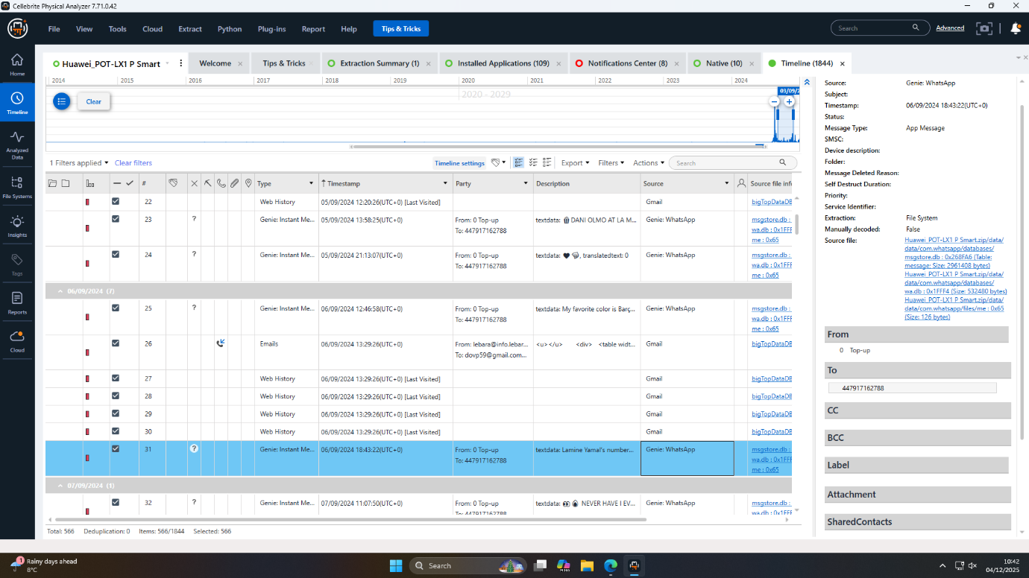
Figure 1: Evidence shows Emma initiated the plot
4.1.2 Links and Behavior of Communication
The communications are recorded by the device used by Emma who shows instantaneous and intentional attempts to interact with the intellectual property theft. Interestingly, Joe was in contact with me within the 48 hours following the installation of the device in August 2024. Emma has been spotted searching the query how to unblock a contact in WhatsApp huawei on August 21, 2024 in logs, an act suggesting that she was seeking to contact a co-conspirator she believed she had fallen out with or was experiencing an operational issue and was seeking to communicate discreetly or otherwise. Timeline analysis depicts that early and frequent interactions exist between Emma and key actors, which were important in planning early-stage.
4.1.3 Relevant Apps and Suspicious Actions
WhatsApp, Instagram, and Gmail were the key communication tools contained in the Huawei device. Installation timestamps are related to the planning phase, which also ensures goal configuration. An operation of decryption of WhatsApp databases was technically feasible and provided little substantive information, but the corresponding conversations seem to have been deleted or held over less secure or volatile channels to make recovery less possible. The sequence of digital hygiene that Emma adopted by blocking/unblocking, deleting and using different platforms is evidence of high-level operational awareness to mitigate forensic traceability.

4.2 Samsung Galaxy A13 - Transacted under Joe
4.2.1 Travel and Location Analysis
The Samsung Galaxy A13 that was used by Joe had offered a lot of evidence regarding the physical movement which is related to an intermediary in a cross-regional operation. The geolocation data in pictures, in travel history and hotel bills was hidden in the pictures, and it charted out an easy-to-follow chronology:
- August 31, 2024: Train to Glasgow, Scotland.
- September 4, 2024: A flight between Swansea and Luton Airport, with a photograph of an Ibis hotel key card (a secret rendezvous) in the background.
- October 15, 2024: Hotel payment of Paris, France, with payment chargeback to a particular Debit Mastercard (last 3758).
- December 16, 2024: Parking in Wembley, London, and payment using the same card.
Such pieces of information were crucial in terms of what would physically happen during the conspiracy and reminded that Joe was connected to central operation resources in the illegal exchange.
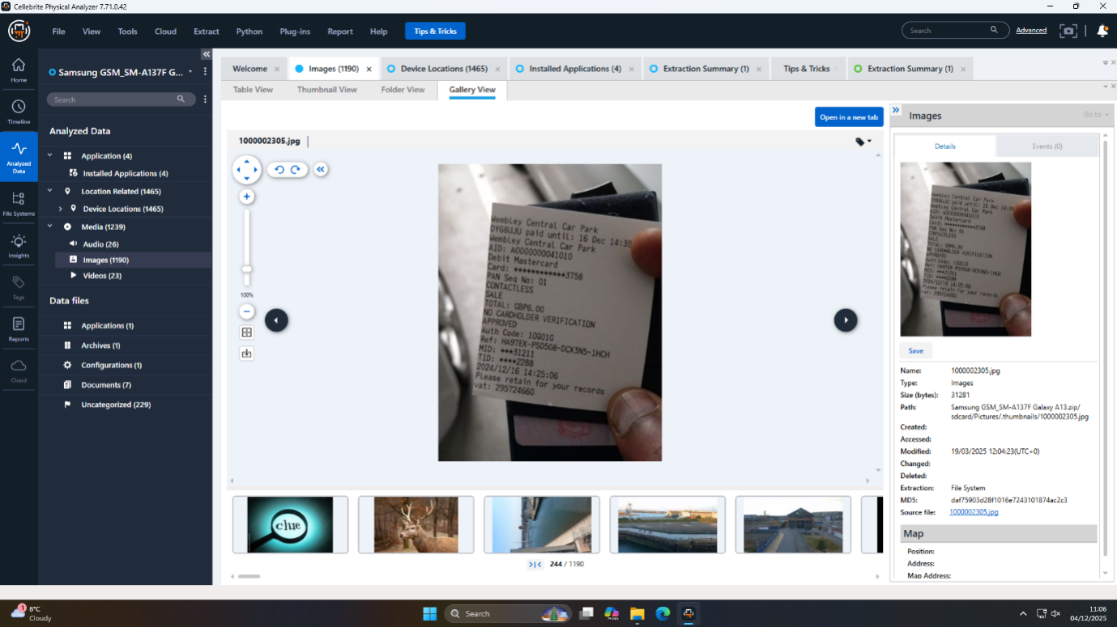
Figure 2: Receipt confirms suspect's London location
4.2.2 Financial and Anonymous Payments
The device carried by Joe had photo evidence and electronic records of non-identified payment tools. First was One4all gift cards image having complete card details- usually used in illegal finance during a transaction which will be anonymous and untraceable. The regular billing of travel and hospitality bills, by use of Debit Mastercard 3758 in both UK and international meetings, linked the financial transactions with the time of conspiracy. It was supplemented with the strategy of operational obfuscation with the integration of the anonymous digital payments which, however, made tracing the finances, though not impossible, in a multi-jurisdictional environment.
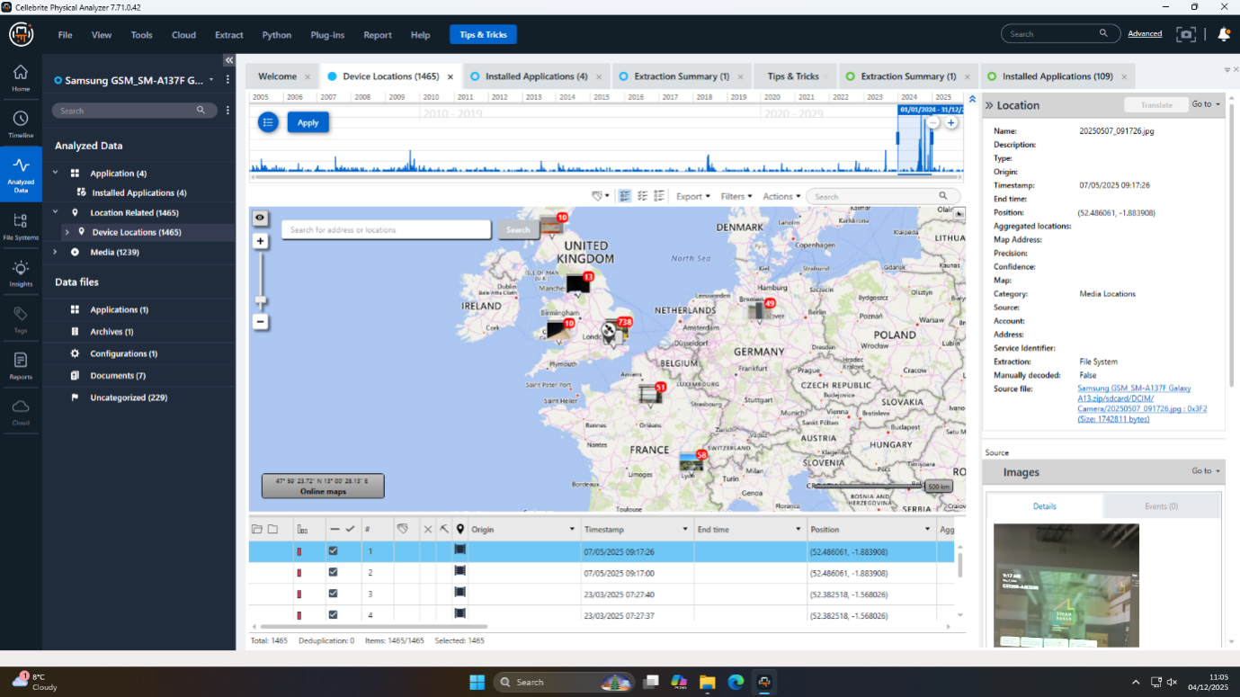
Figure 3: Map view showing clustered device location artifacts
4.2.3 Corroborative Evidence
Several evidence leads of Joe, whose Samsung phone were used, intersected with Emma and Norman, which helped in proving the cases:
- Metadata and messaging history of emails proved the cooperation with Emma and Norman in regard to certain dates and plans.
- Intersection of geotagged photos, document tags and receipts guaranteed the accuracy in re-building key moments.
- Unclear user identifiers like the profile image which reads J and exclusive patterns of access were an added verification to the uniqueness of the device to Joe.
The cumulative presence of Joe on the Samsung Galaxy A13 demonstrates the logistical, financial, and communicative strategies facilitating the illegal operation, which, in turn, in the direct support of the chains of evidence reenacting the conspiracy.

4.3 Ulefone Note 14 -Accredited to Norman.
4.3.1 Financial Instrument Analysis
The forensic discovery in the Ulefone Note 14 is two photos of a State Bank of India (SBI) debit card. A close examination will show that this card was meant to be the main mode of payment to the illegal deal. The dead air feature (not a personalized name, but the generic name, which is STATE BANK CUSTOMER) is consistent with the methods of decoupling the financial instruments with the personalities, which hinders the typical tracing of the investigators.
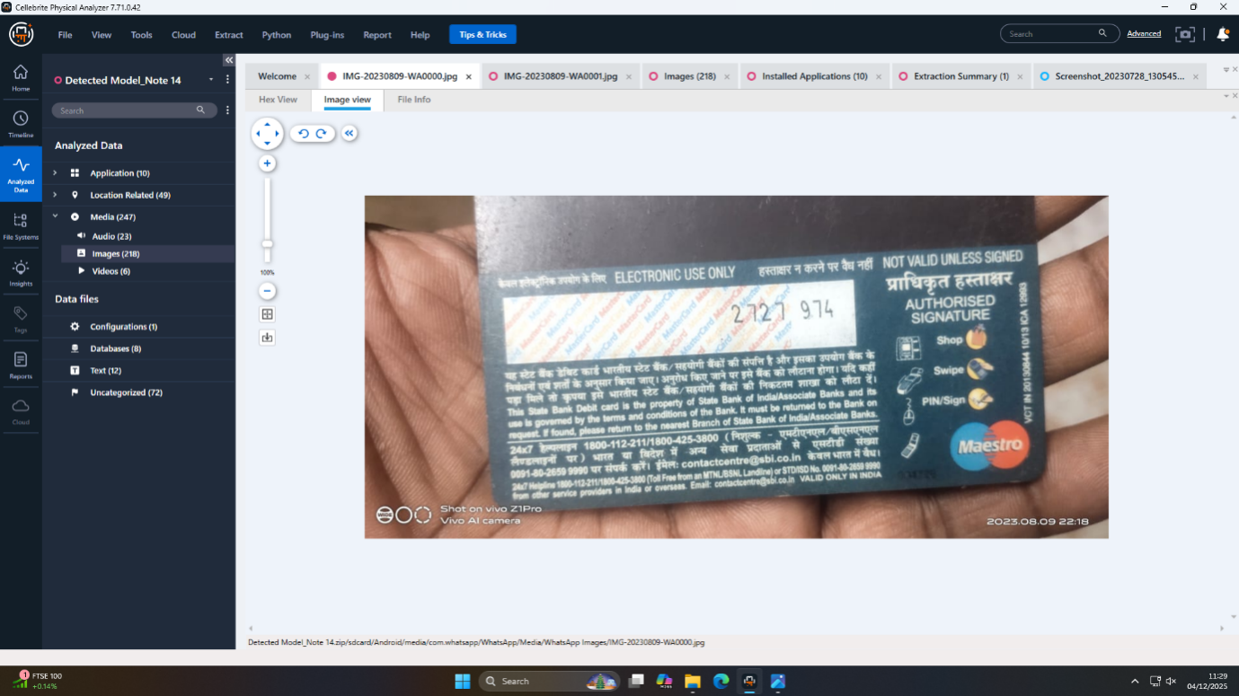
Figure 4: Anonymous card reveals intent to hide
4.3.2 Data Obfuscation (non-personalized card)
The intentional use of non-personalized debit card has a transparent way of anonymizing payments. Norman tried to avoid a registered name, which enabled him to transfer the money with stolen intellectual property as well as to significantly cut the trail of evidence. The availability of these cards images on the local hard disk, and without any related personal contact information, represent a textbook case of criminal obfuscation, a conclusion which makes it possible to attribute the Norman as the buyer/finance component in the conspiracy.
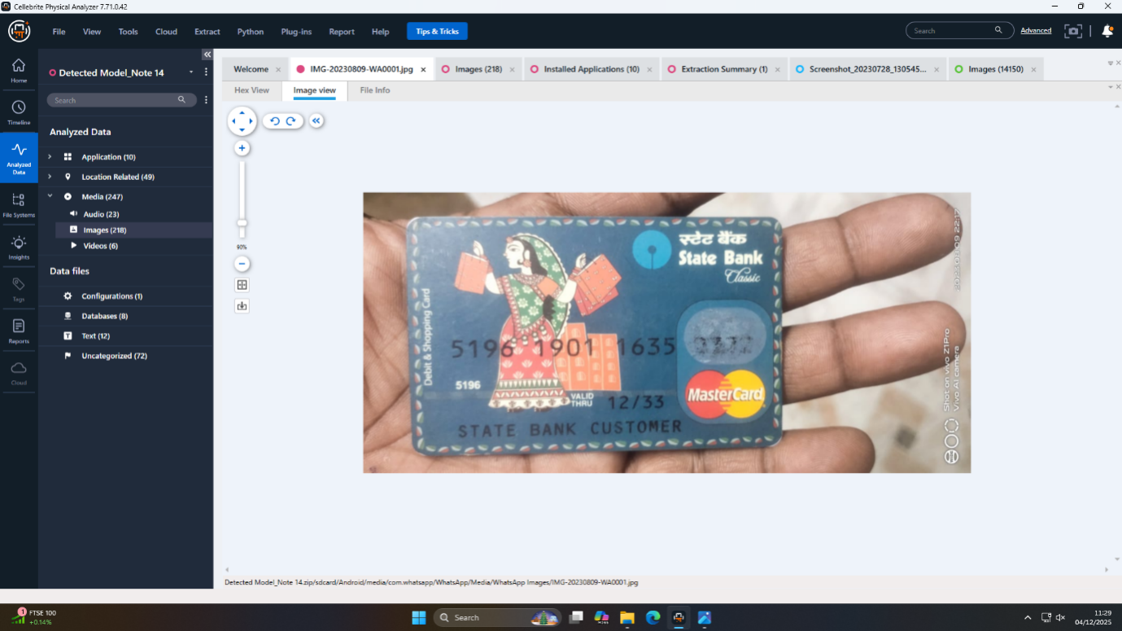
Figure 5: Financial evidence found in WhatsApp media
4.3.3 Buyer Role & Intent
Cross-reference with the activity timelines and communications indicate that the device that was used by Norman as its owner existed at the financial heart of the plot. It is not possible to say that there were signs of serious communication logs in the Ulefone Note 14, which implied that the user had a highly compartmentalized way of interaction, only paying the money. This distance of operation is in line with the best practices of criminal groups and confirms the hypothesis that the only way Norman was involved was the facilitation of the sale and the financing of the operation, rather than coordination with other members of the conspiracy.

4.4 Nokia C2 — Unattributed Co-conspirator
4.4.1 Encrypted File Analysis
It is a device that posed one of the greatest technical problems to the investigation a highly password-secured Microsoft Word document, "Open.docx." Although there was massive brute-force cryptanalysis, the document was inaccessible, indicating the use of advanced operational security or an external organizational coordination of the password sharing of conspirators. There was also nothing resembling a WhatsApp key file, which was also restrictive to potential incriminating chat contents.
4.4.2 Multimedia/Photographic Leads
One untagged image of a male was found without any identification. This possible evidence is vital to this case, because it can show the real user of the Nokia C2 or other conspirator (e.g. Joe or Norman) who is taking part in identity confirmation or issuing instructions. Geotagging imagery and context were not identified to aid identification and image analysis and facial recognition still could be used as a future possibility of study. There were no other multimedia (audio/video) that illustrated clear connections to the essence of the case.
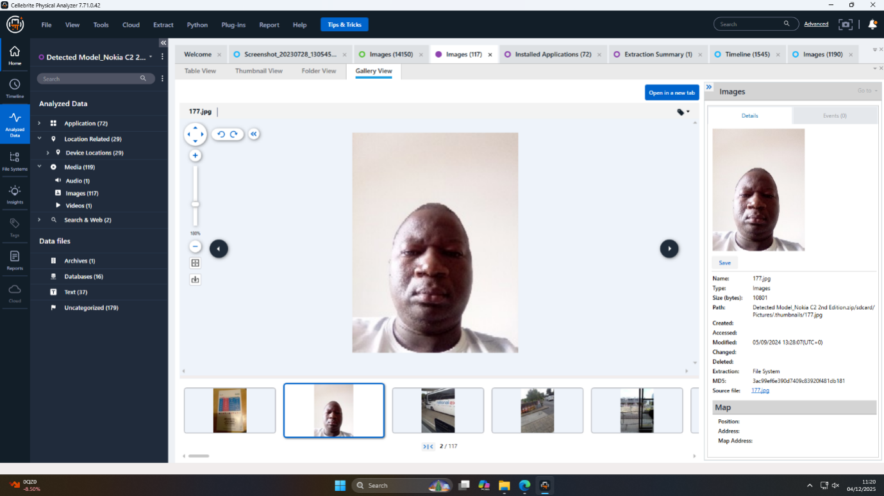
Figure 6: Found a key person of interest
4.4.3 Unresolved Evidence and Next Steps
The photo and the encrypted file of the unknown man are the largest blocks of evidence that are still unresolved. These are also strategically essential; their examination may include information regarding the patent, the details of the transaction, or additional identities of the conspirators. Some recommendations to take action would be the focus on the more serious cryptanalysis of the file having the contents of the text of the document named Open.docx and the male image to the facial recognition databases. As well, legal demands targeting subscriber data on corresponding email accounts and monetary footprints are recommended.
Table 1: Evidence Collected
Device | User Attribution | Key Evidence/Artifacts | Role/Intent | Evidential Issues/Leads
Huawei POT-LX1 P Smart | Emma | Email/account traces, WhatsApp/ Instagram, search logs. | Fundamental offenders, communications planner. | Deletion of communications, missing WhatsApp partial content.
Samsung Galaxy A13 | Joe | Photos that are geotagged, receipts and payment cards in the hotel/train. | Reverse service, logistics/finance agent. | Untraceable means of payment, oblique funds.
Ulefone Note 14 | Norman | Images of uncustomized SBI debit card. | Buyer/financier | Minimal comms, non-personal financial instrument.
Nokia C2 | Unattributed (unknown) | Photo of unidentified male, encrypted Open.Docx file. | Co-conspirator or orchestrator (unidentified) | Encryption file impossible to access, user/photo cannot be identified.

5. Correlation of Cross-Devices and of Timeline

5.1 Experiencing Evidence-Based Narrative Construction
The story of this investigation is the product of a cross-device analysis which re-enacted the narrative that depicted a multi-stage conspiracy by at least four actors who worked in specific roles intentionally. All the devices were lighted like the various sides of Emma: the Huawei of Emma as command-and-communications, the Samsung as logistics and travel, the Ulefone as financial, the Nokia C2 as an encrypted outpost node of operation.
5.1.1 Preparation and Initial Contact
Emma got the Huawei phone set up and opened communication channels (Gmail, WhatsApp, Instagram) in mid-August 2024. Account data and Gmail records indicate preliminary contact to Joe, the middleman, in less than 48 hours.
5.1.2 Coordination, Meetings, and Financial Arrangements
Between the end of August and December 2024, a Samsung device belonging to Joe shows sequential travel (Glasgow, Swansea, Luton Airport, Paris, Wembley) and contains direct receipts and geotagged photos in order of the tasks done within timelines (according to the important meetings). Joe manages logistics on behalf of Emma and sets up meetings with Norman, the financier, which is supported by the fact that on his Ulefone Note 14, there are pictures of the corresponding payment instruments. Images of unknown SBI debit card further support the financial connection as this is yet another form of obfuscation that proves that Norman was doing this to finance the illegal sale with no straight trail.
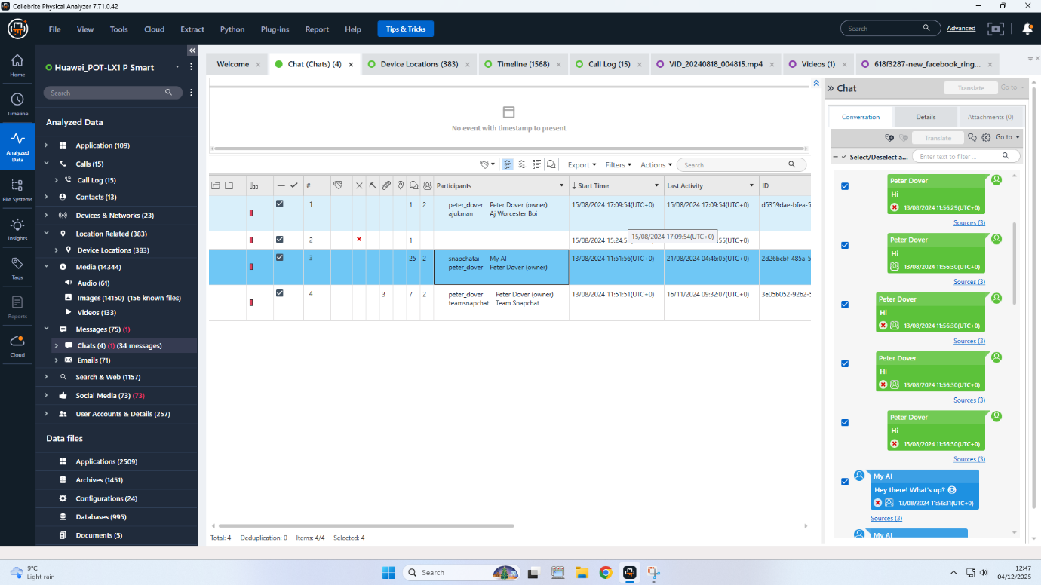
Figure 7: Digital forensics tool analyzing mobile chat conversations
5.1.3 Covert Operations and Data Handling
There is covert operational discipline, Emma going out of her way to erase messages and seek ways to manipulate contact, and Norman using a debit card that was not personalized and photographed on his computer, and left little digital trace. The encrypted file, unlike the rest of the encrypted data carried by Nokia C2, is an encrypted open.docx file, and an encrypted key photo, which shows that it was used strategically to store sensitive data or relay information, thus maximizing the secrecy of its operations.

5.2 Timeline Visualization
- August 17, 2024: Emma sets up Huawei POT-LX1, setting up secure communication applications.
- August 19-21, 2024: Emma calls Joe; WhatsApp unblocking search.
- Late August-September 2024: Joe begins travelling, receipts and other location evidence demonstrate movement and face to face interactions (Glasgow, Luton).
- 15 October, 2024: Paris sit-down, hotel bill received and paid out with the credit card of Joe.
- December 2024: Norman has financial instruments on his instrument, of co-ordination of payment involved.
- Undated: The encoded file of Nokia C2 is not penetrated by anybody, the image of an unknown male is found.

5.3 Actor Role Mapping and Relationship Diagram
- Marion: Chief, Headquarters, business relations.
- Joe: Charity, transport/Londoner.
- Norman: Purchaser/banker, makes use of unidentified payment.
- Unknown (Nokia C2): Has important papers/photo, secrecy of operations.
The cyber evidence forms a very obvious flowchart: Emma connects and orchestrates, Joe connects and arranges, Norman banks anonymously and the unidentified accomplice printer gets hold of important documents.
5.4 Points of Convergence and Discrepancy
Points of Convergence:
- Account consistency, transaction dates and travel receipts.
- Messages (emails/chat) are intersected with the use of devices and time.
- The transactions and meetings are associated with actors and photographs and payment evidence.
Points of Discrepancy:
- The Nokia C2 has encrypted Open.docx files that cannot be opened, leaving a narrative void on the potential nature of identities and the additional instructions or information on the transaction.
- The photograph of Nokia C2 of Unknown male is also still unknown, and this is an important lead.
- No substantive chat logs were available on the device of Norman because the operational security was compartmentalized.

6. Technical and Legal Assessment

6.1 Technical Barriers Encountered
The investigation was faced with severe technical challenges. First and foremost, though was advanced encryption: the Nokia C2 did not default encryption (a password-protected Microsoft Word file) which cannot be defeated through brute force and the logical extraction of WhatsApp data on both Huawei and the Nokia telephones was incomplete because of absent or inaccessible key files. Deliberate destruction of communications was also a problem to investigators, as evidence of delete/removal of chats/messages, as well as unsuccessful operational digital hygiene, was detected on the device of Emma, making it difficult to rebuild the entire timeline [28]. The usage of compartmentalized devices by Norman led to the lack of direct communications in place, which proves to be the best-practice adversarial tradecraft geared toward frustrating forensics [29], [30].

6.2 Data Integrity and Admissibility
All evidence collected was admissible and fully compliant with the integrity even with these hurdles. Chain-of-custody procedures were considered solid throughout the entire process: evidence was separate on the seizure stage, scanned by industry-standard equipment (UFED) to image it, and digested through time-tested forensic suites (Autopsy, aLEAPP). All digital assets were hashed to eliminate any manipulation and ensure evidential integrity. The observed procedural discipline guarantees that all results provided can be defended and within the set limits of admissibility in the courts of the UK [31], [32], [33].

6.3 Legal Considerations in Evidence Handling
The gain in compliance with the law was observed during the forensic lifecycle. Agreement or due sanction to search and seizure was presumed to have existed to collect devices. Reliability is based on the use of special purpose, court-validated forensic tools and comprehensive chain-of-custody records and is at the core of achieving legal standards in both local (Computer Misuse Act, GDPR) and international evidential standards. It was also noted that there are weaknesses of logical (not physical) extractions in analysis because the courts should be made to understand that some encrypted or deleted information will not be retrieved thereby affecting the case of the prosecution or the defence slightly [34], [35].
6.4 Risks and Implications
The presence of residual risks is made by inaccessibility of encrypted material and a planned lack of communications in certain devices. These gaps can also hide important instructions or financial tracks or additional identities of the party, which restricts the scope of the investigation. There also exists a remaining threat that the defense would be able to object to the sufficiency of evidence based on technical acquisition lapses or system shortfalls. That that said, high-quality evidence coverage, careful processing, and all-card correlations between devices give an impressive basis to investigative and legal procedures, whereas cracking encrypted messages or discovering the identities of some formers is to remain high-priority activities [26], [36], [37].

7. Documentation of Device Acquisition Process
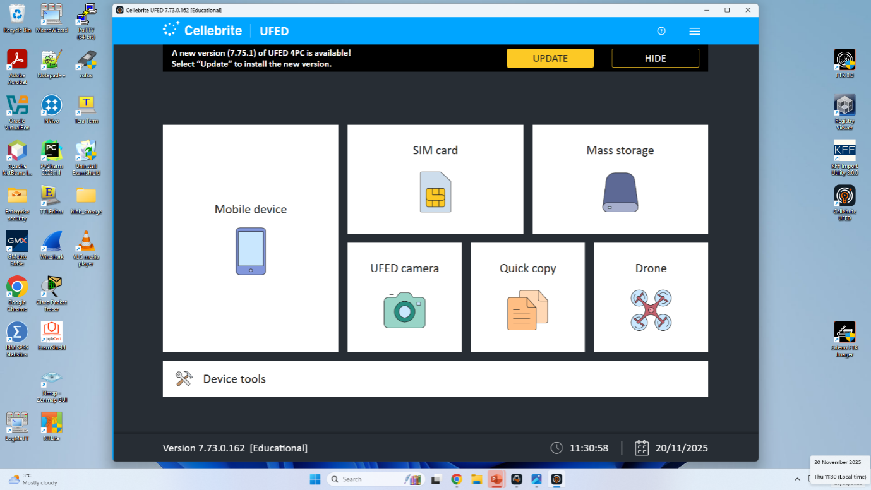
Figure 8: UFED Home screen for Acquisition
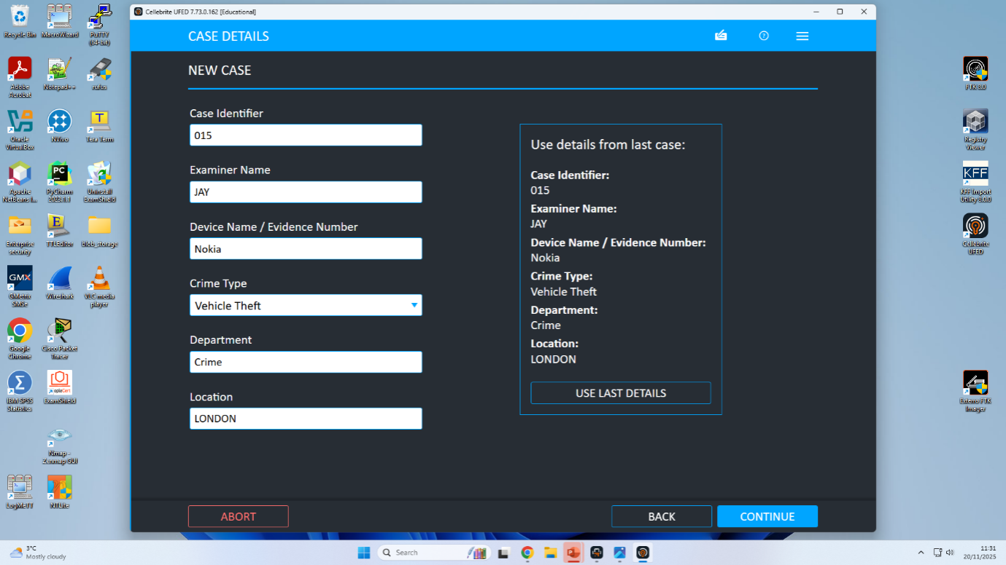
Figure 9: Entering case details in UFED
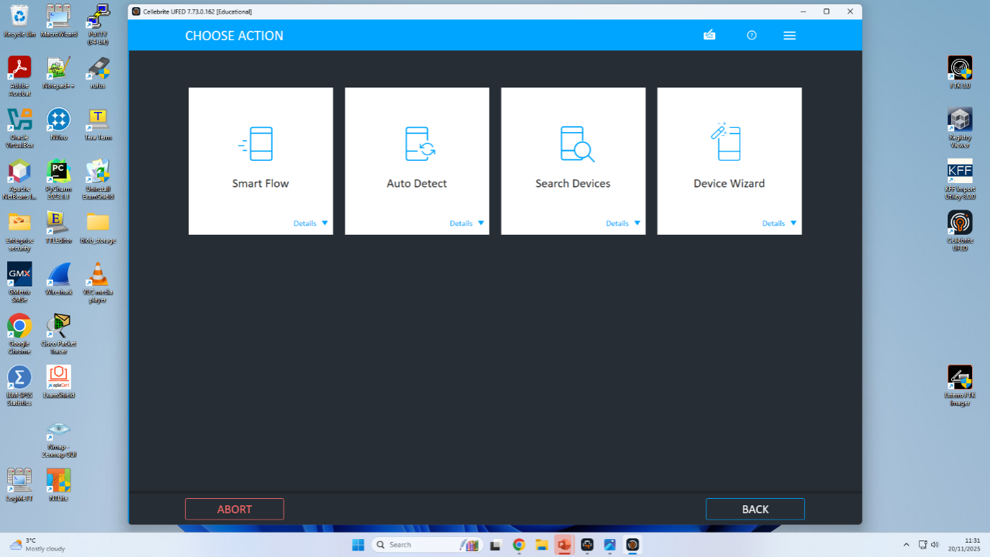
Figure 10: UFED Choose Action screen
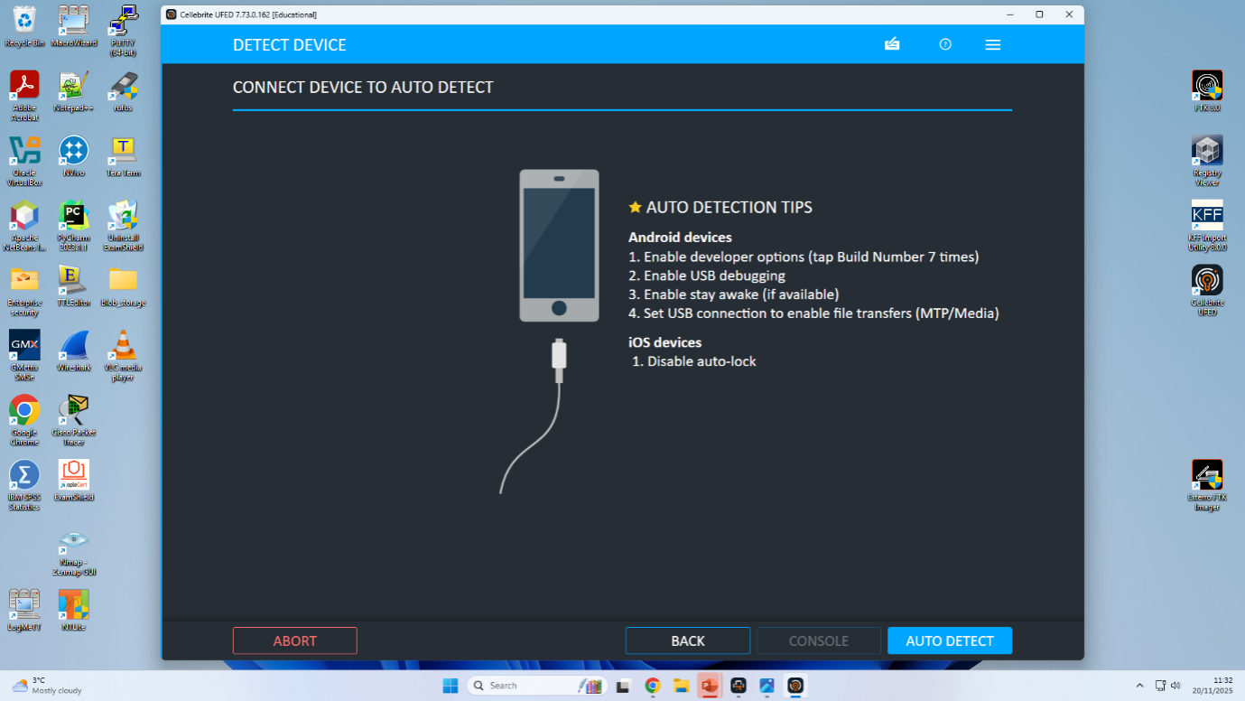
Figure 11: UFED Auto Detect device connection
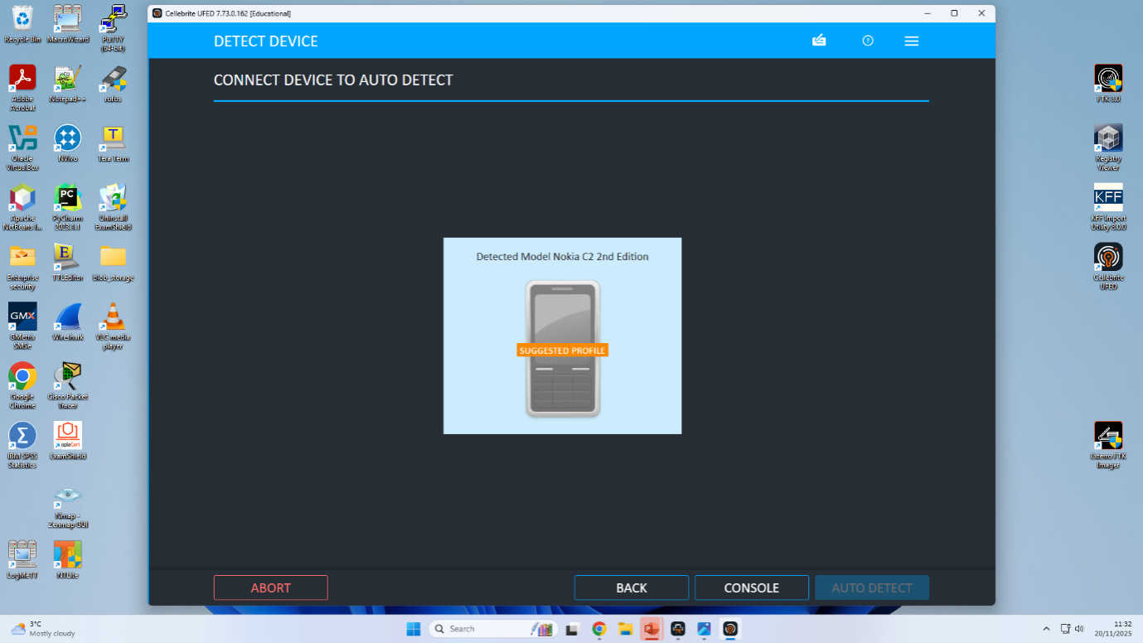
Figure 12: UFED Suggested device profile
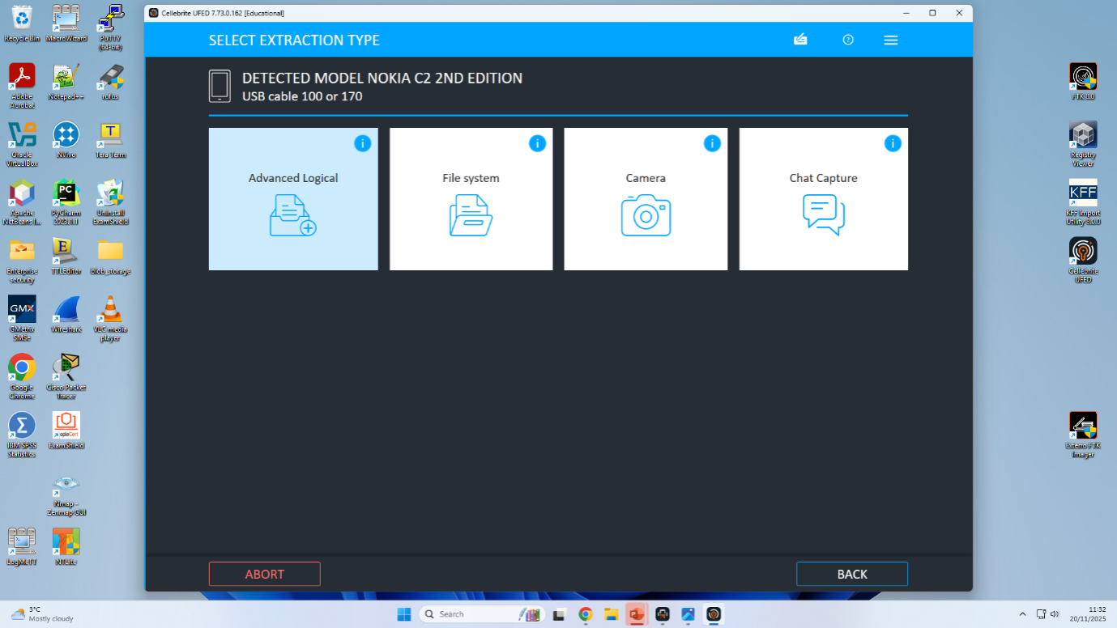
Figure 13: Choosing extraction type options
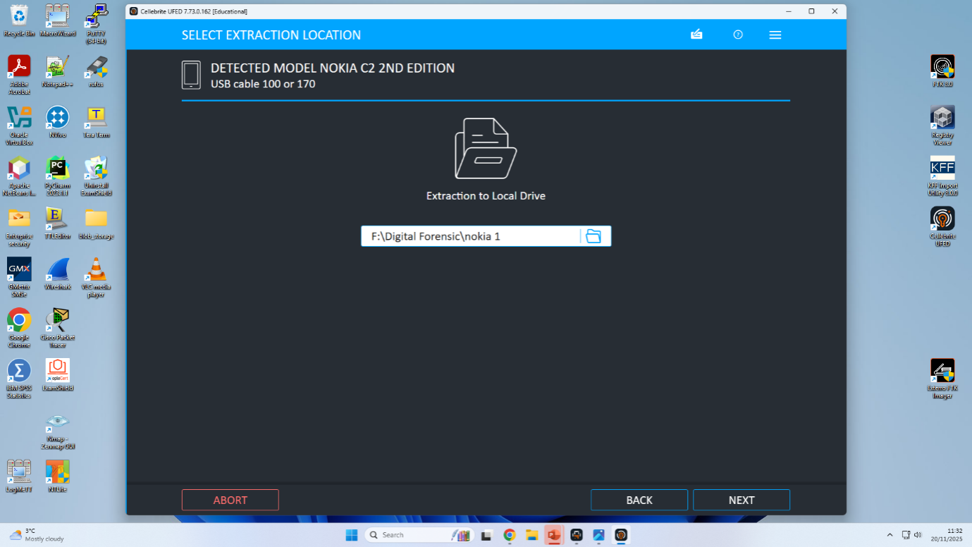
Figure 14: Select multimedia types for extraction
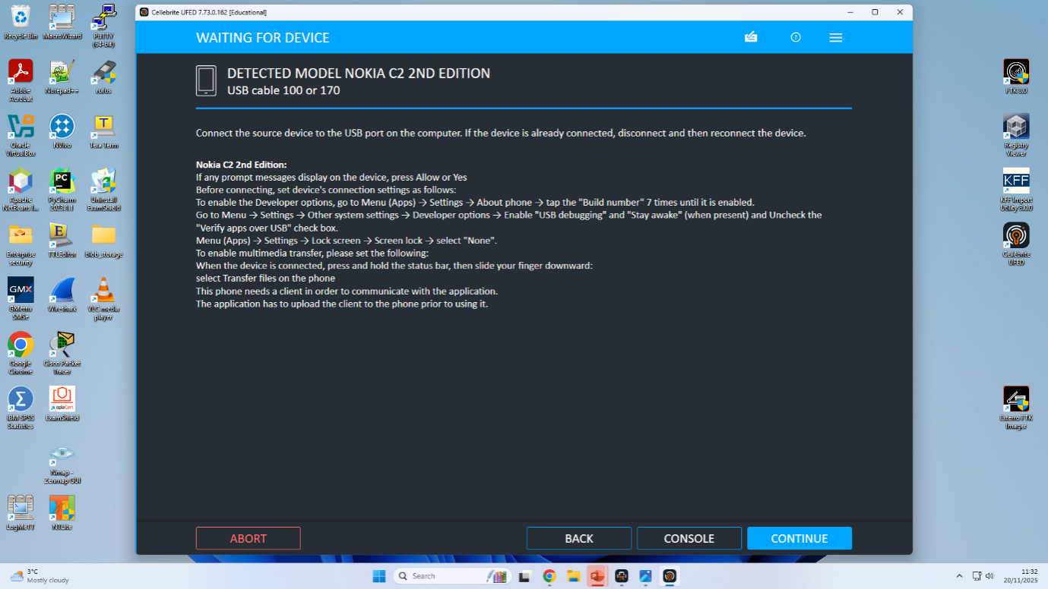
Figure 15: Selecting extraction location
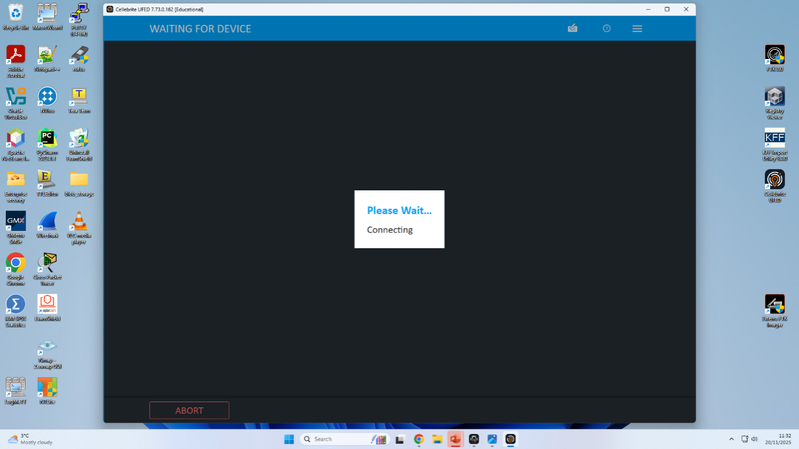
Figure 16: Waiting for device to connect
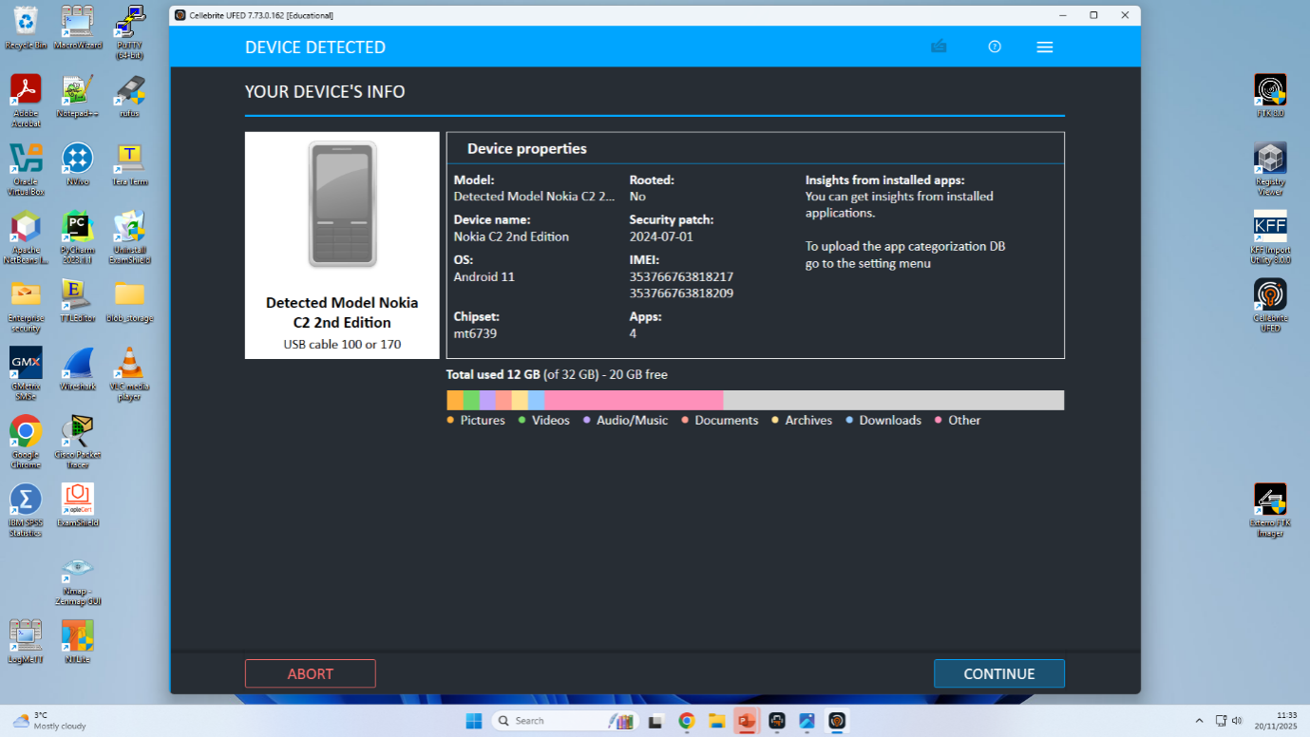
Figure 17: Device detected and info summary
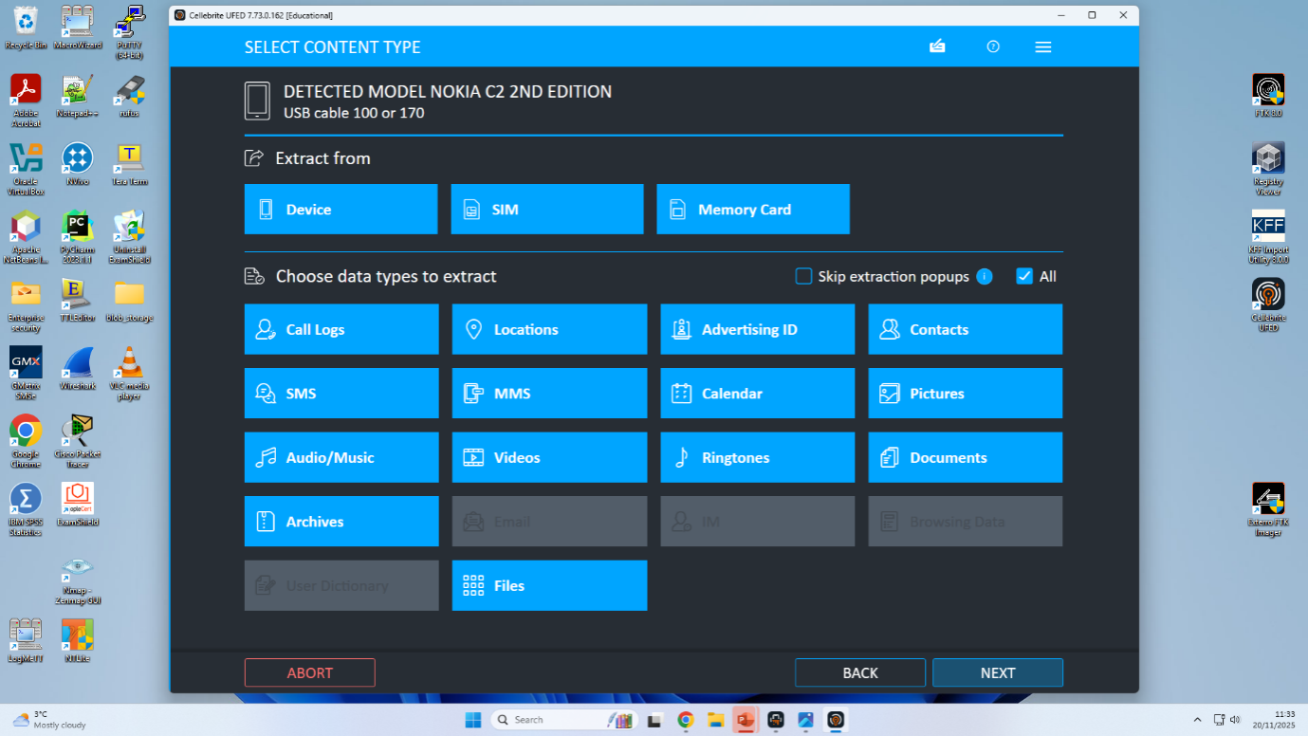
Figure 18: Extraction process summary report
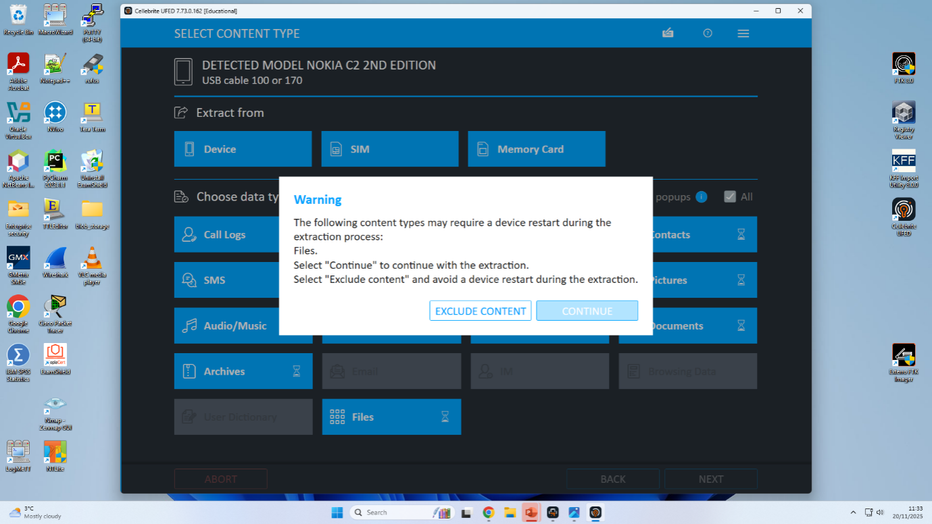
Figure 19: Content type selection for device
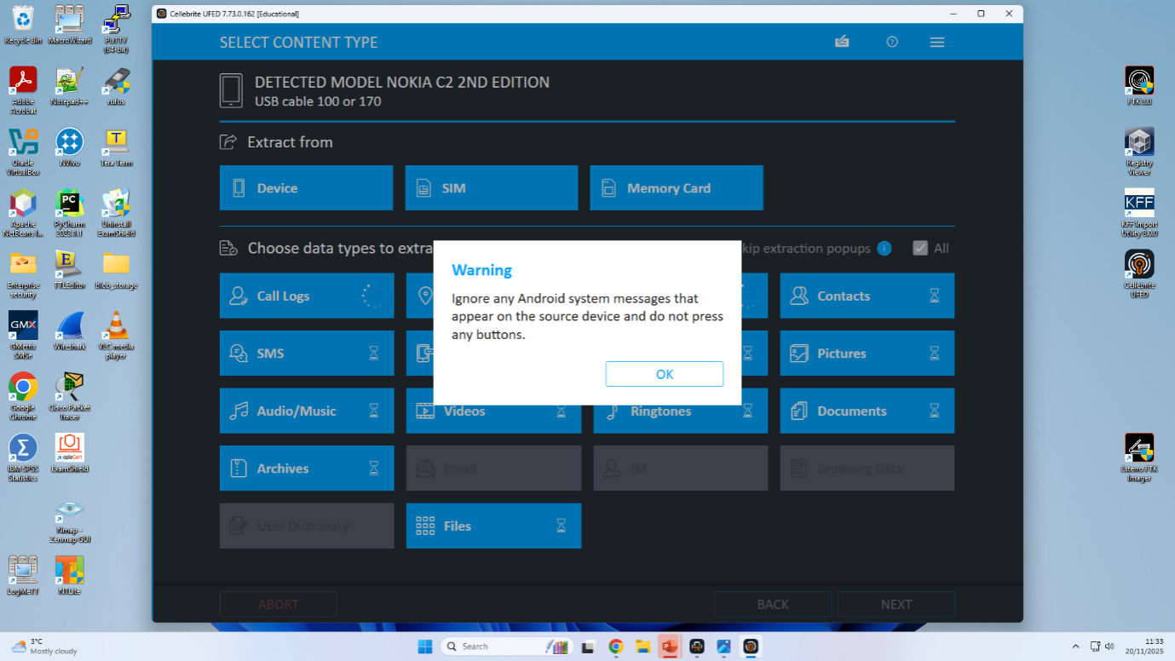
Figure 20: Extraction data types warning
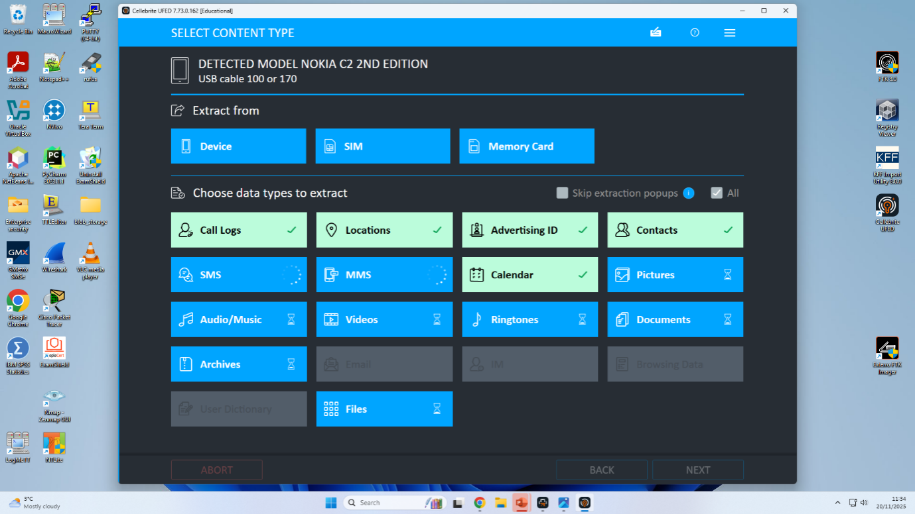
Figure 21: Extraction confirmation with source instructions
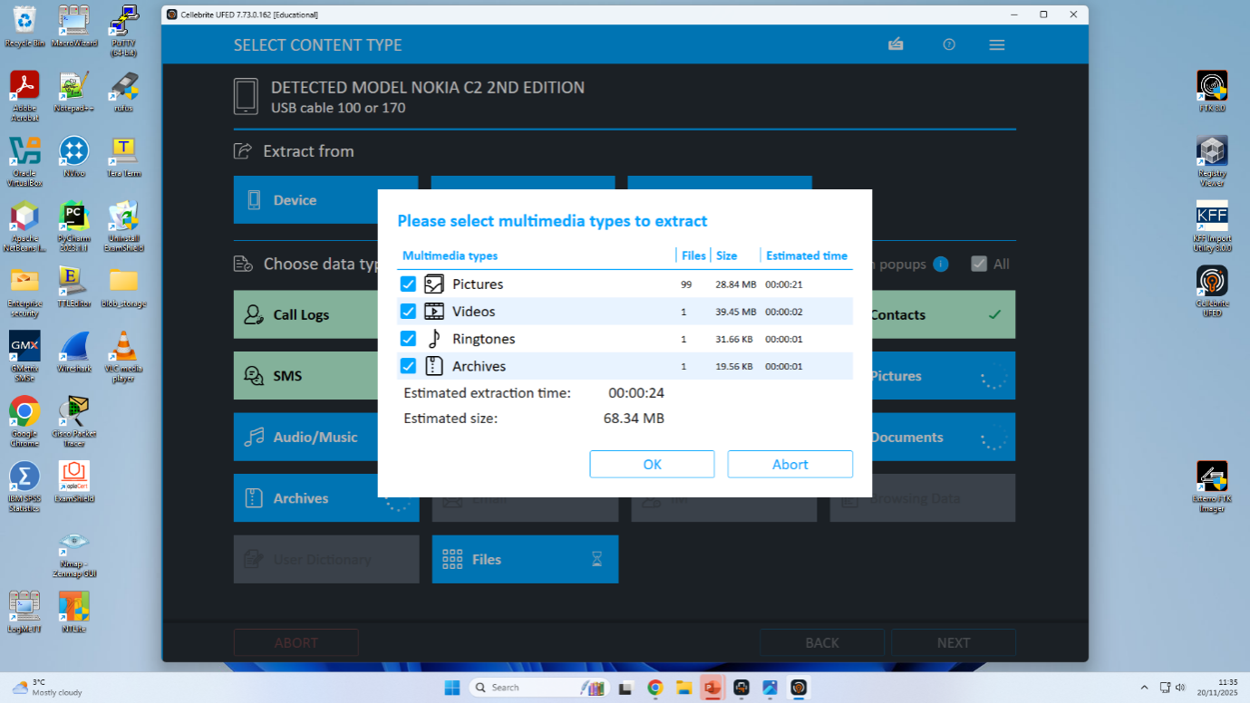
Figure 22: Extraction options for call logs and files
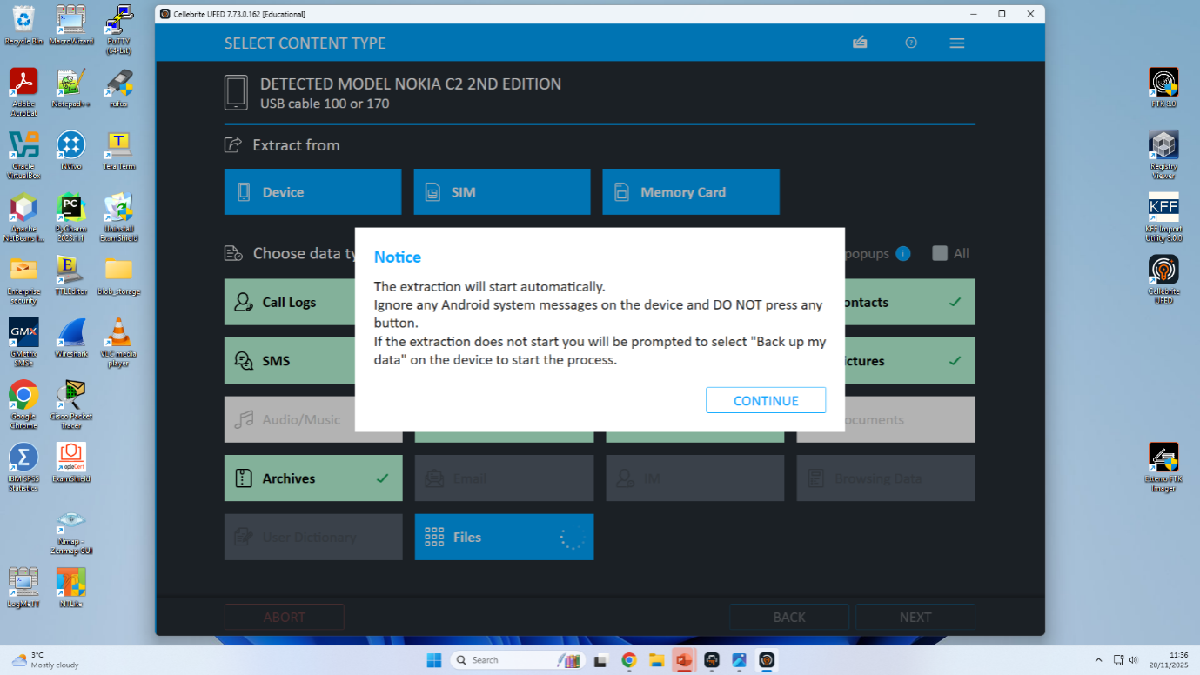
Figure 23: Source instructions for connection settings
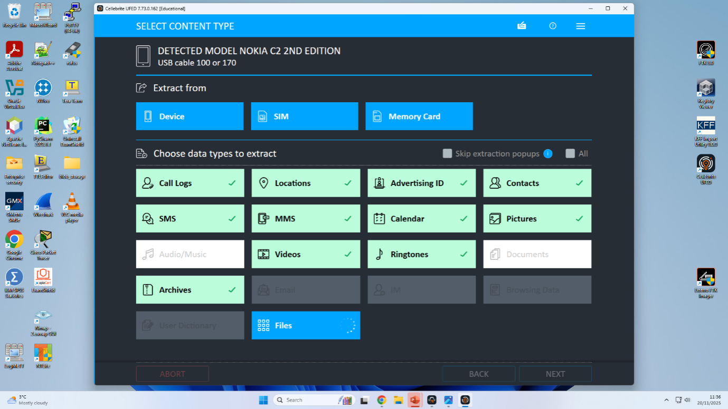
Figure 24: Selecting data types for extraction
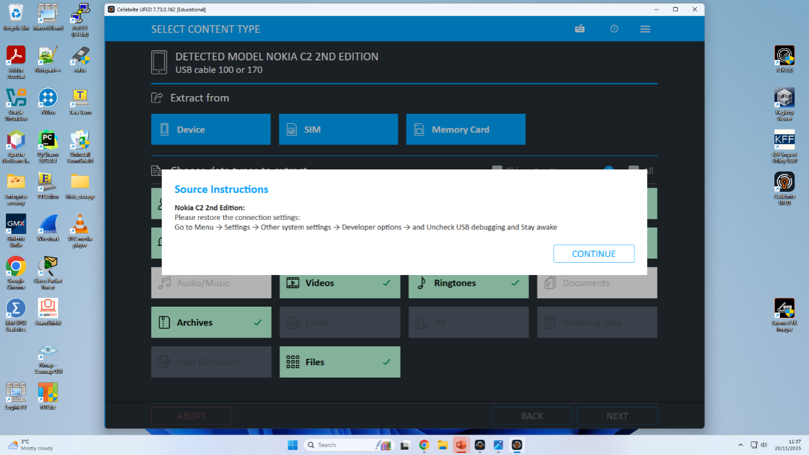
Figure 25: Select additional extraction content types
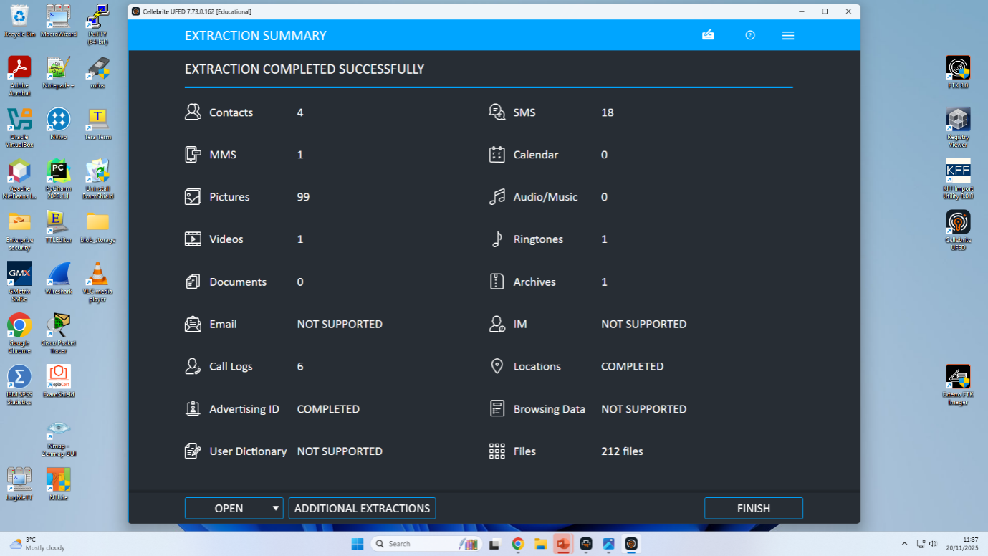
Figure 26: Extraction process completed notice
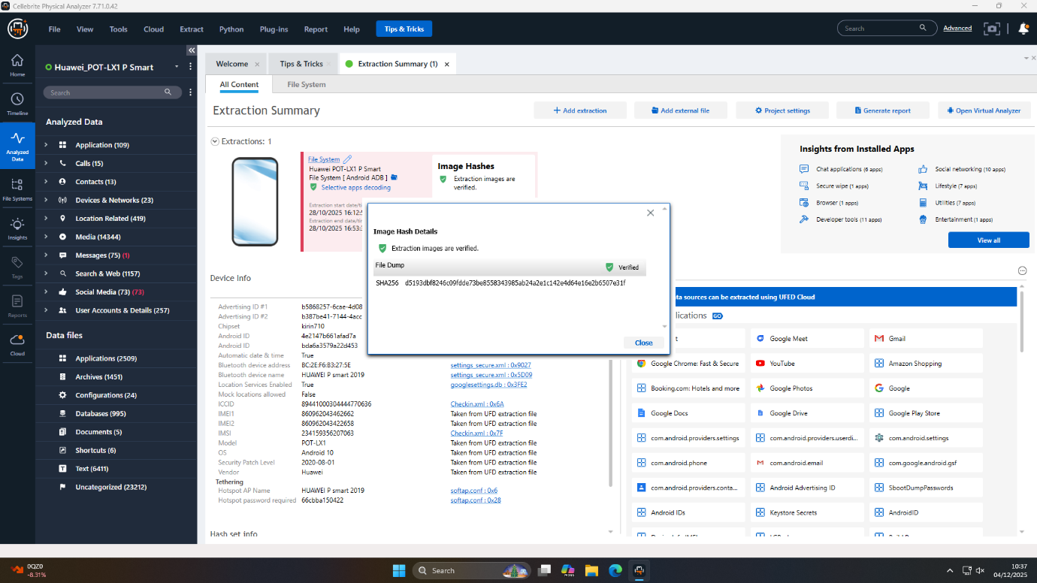
Figure 27: SHA256 hash validates integrity of acquired evidence of Huawei
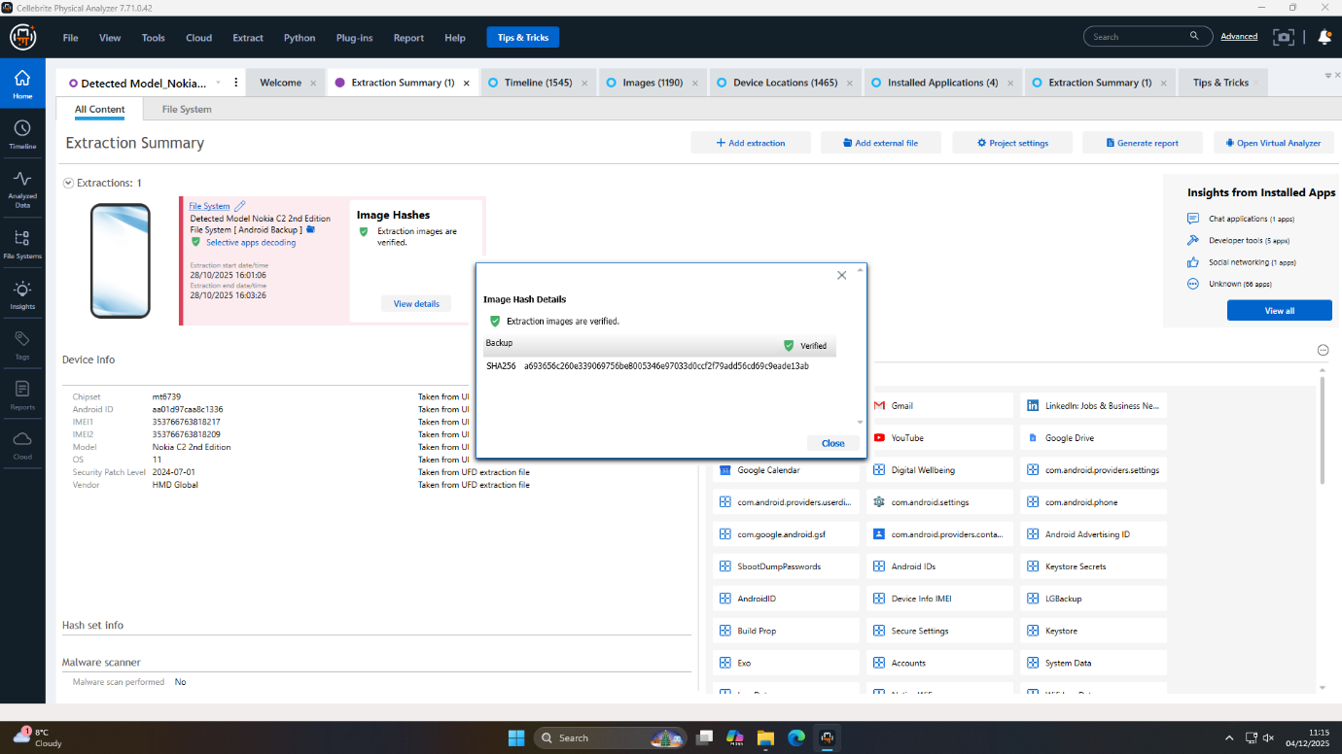
Figure 28: SHA256 hash validates integrity of acquired evidence of Nokia
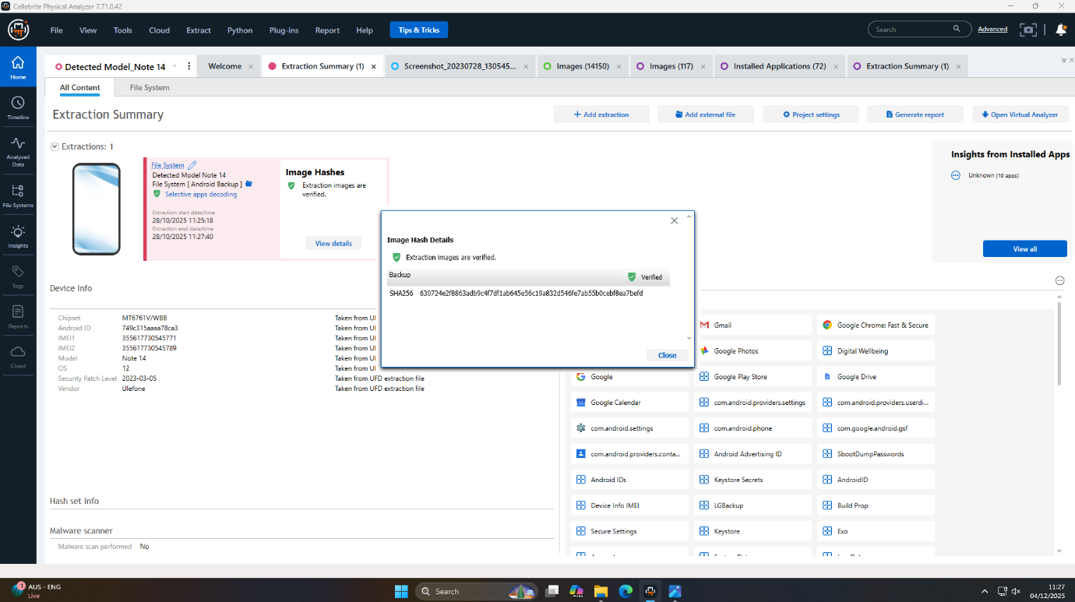
Figure 29: SHA256 hash validates integrity of acquired evidence of Note 14

8. Forensic Collection Information
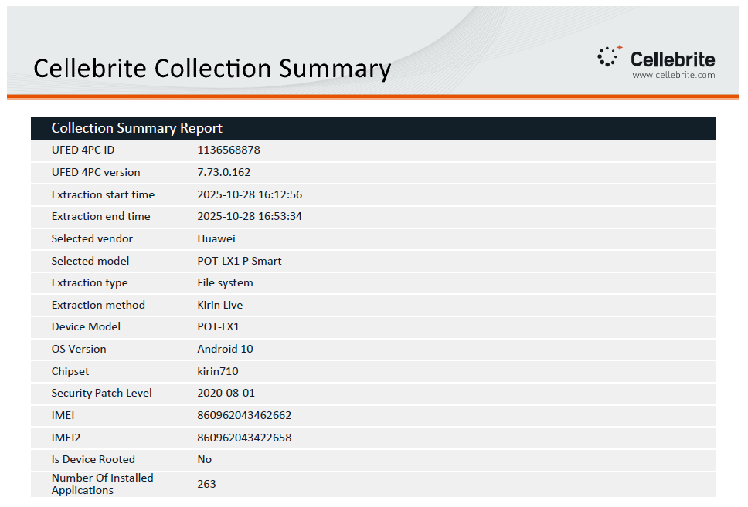
Figure 30: Digital forensic extraction report overview of Huawei Kirin Live
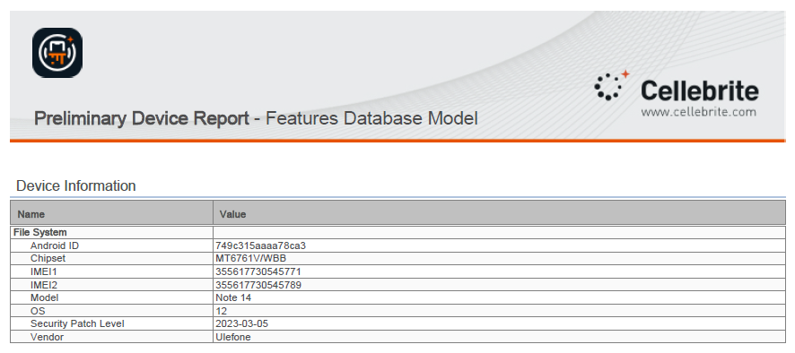
Figure 31: Preliminary Device Report summarizing Note 14
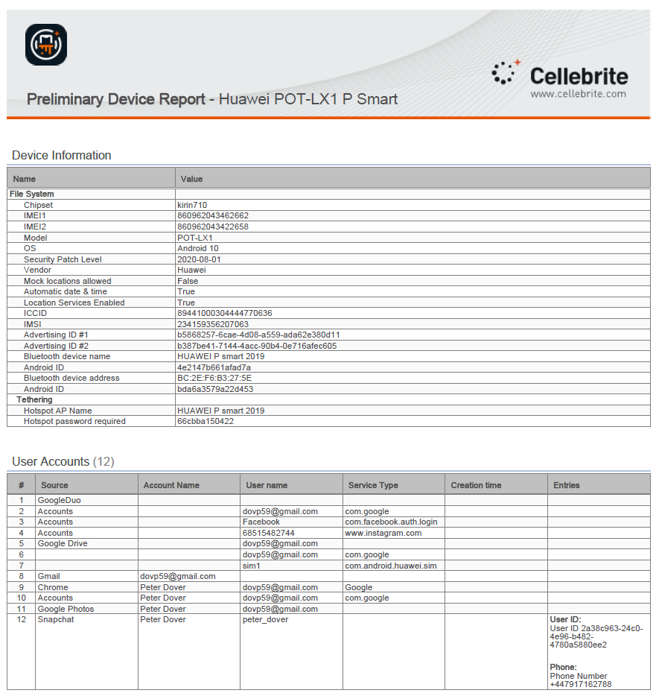
Figure 32: Preliminary Device Report summarizing Huawei POT-LX1 smartphone
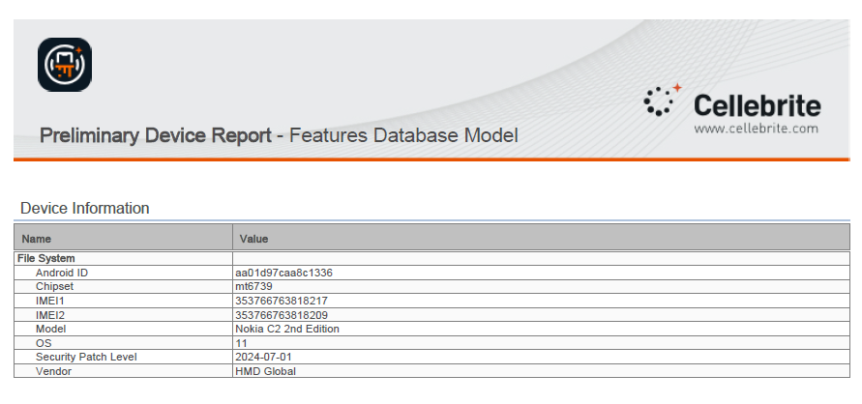
Figure 33: Preliminary Device Report summarizing Nokia
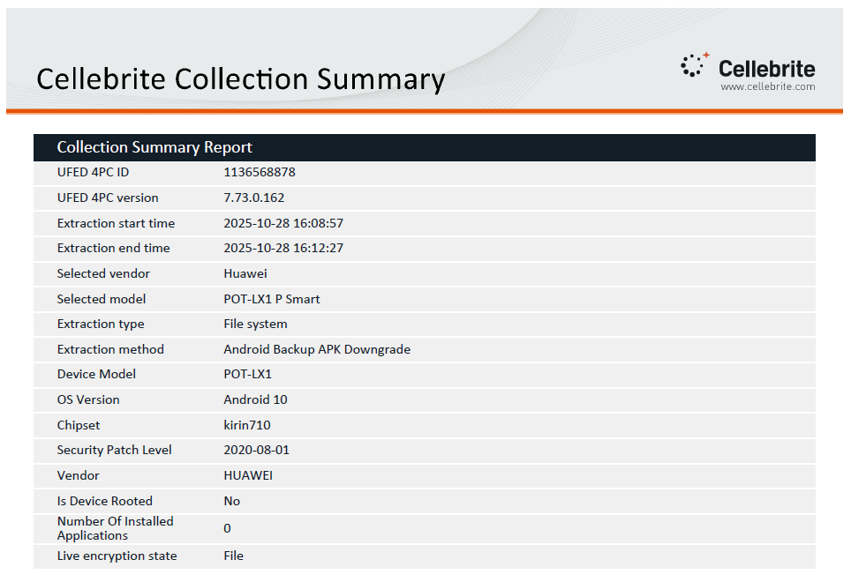
Figure 34: Digital forensic extraction report overview of Huawei Andriod Backup APK
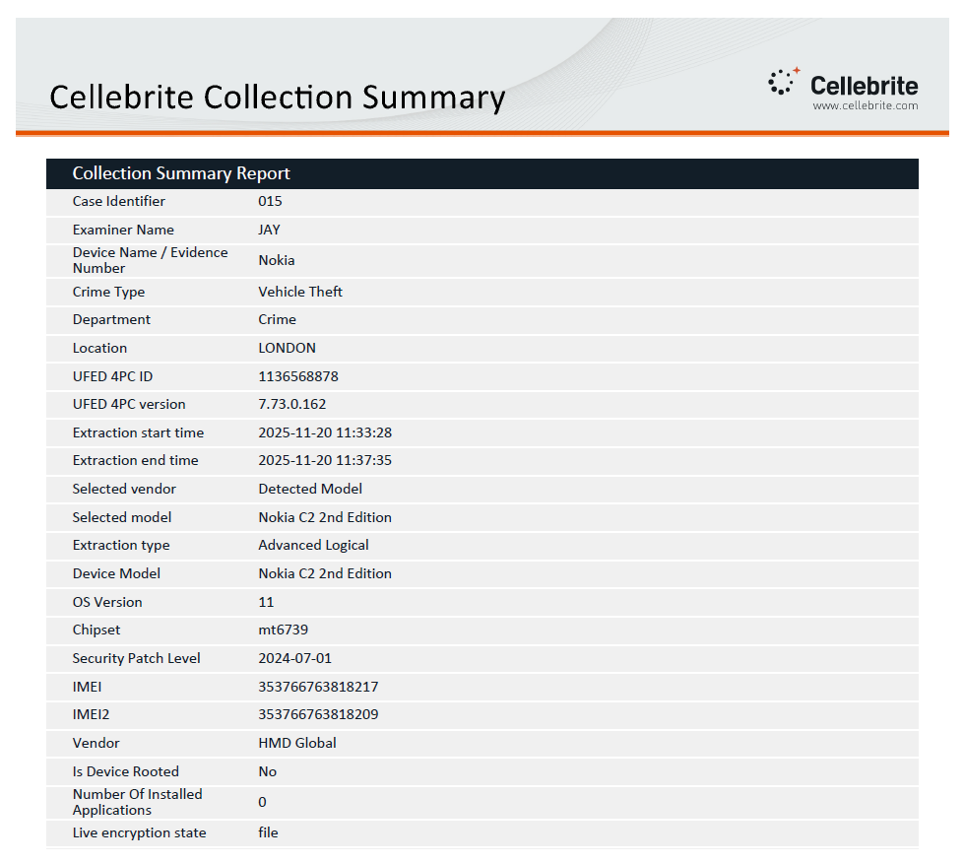
Figure 35: Digital forensic extraction report overview of Nokia C2 2nd Edition
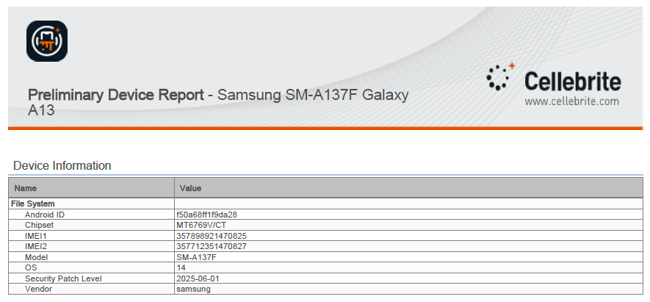
Figure 36: Preliminary Device Report summarizing of Samsung
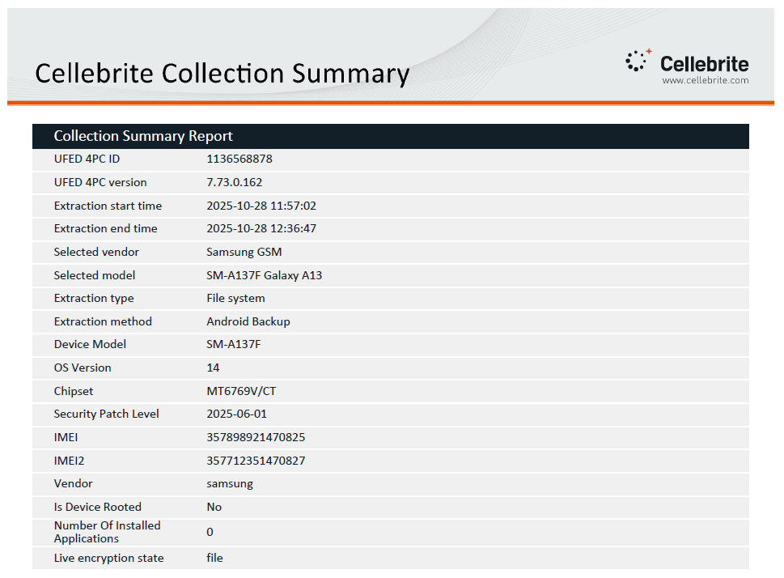
Figure 37: Digital forensic extraction report overview of Samsung SM-A137F
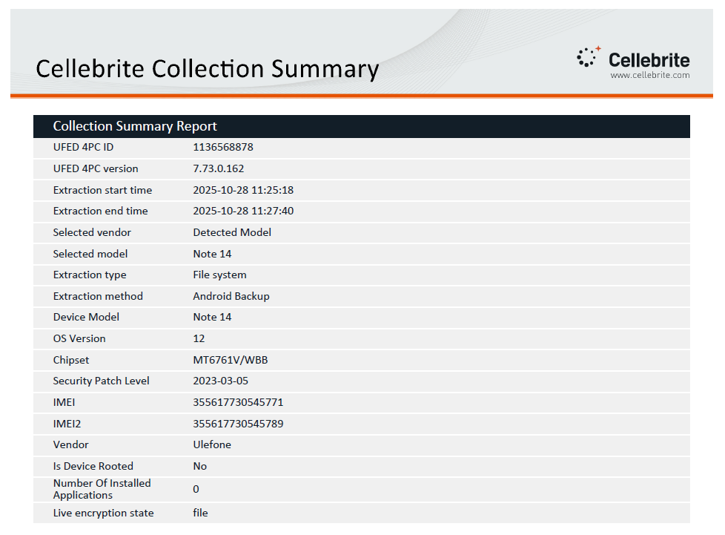
Figure 38: Digital forensic extraction report overview of Note 14

9. Conclusions
Their respective embedded roles of the three indispensable organs of the criminal system, of Emma (the perpetrator), Joe (the intermediary), and Norman (the buyer/financier) with none of them able to exist independently of each other having their own dedicated devices to communicate, to logistical and to payment assignments were all well established with high degree of level of confidence through the forensic practice of theft and further attempted sale of the QT-AI-2025 patent. The exchange of evidence in four devices revealed the organization of a preconvened plan of encrypted messages exchange, each travel plan of the organization and use of anonymous payment means showed the involvement and motive of the actors.
The mentioned qualities highlight the power of digital evidence due to the user attribution, evidence support provided by device-related evidence (account logins, emails, receipts, emails) and high chain-of-custody. Even though some of these money and communication fibers might not be noticed by extremely intricate encryption and discipline skills, the pecking of multi-source convergence is a set of prosecutable opinions.
Some questions remain open: the encrypted document in the open.docx format that is on the Nokia C2 should be considered an important lead yet, so should the photo of an unknown male. The major procedures which must be taken are decryption of this file and identity of the unknown user should be verified. These exceptions provide insight into the ancient detective dilemma of computer worlds that are encrypted and anonymous even with an intricately planned investigation.

10. Recommendations

10.1 Identification of Unknown Conspirators
Focus more on the advanced facial recognition analysis of the unidentified face of the male on the Nokia C2 runner; result should be combined with the national/international law enforcement databanks possibly leading to the ultimate co-conspirator. At the same time, allocate increased cryptographic resources to the process of trying to decrypt the file named Open.docx - a potentially significant piece of information to validate transaction details, instructions or more identities.

10.2 Legal Actions and Next Steps
Gather legal demands to acquire subscriber and metadata logs of email accounts that were used (especially dovp59@gmail.com and josephrehan464@gmail.com) and histories of financial dealings on the SBI debit card on the Ulefone of Norman and the Mastercard ending 3758 of Joe. Such legal investigations could seal serious gaps in evidence and allow prosecutors or other obstructions to related networks. It is advisable that witnesses have close interaction with data protection and international liaison officers to help in fastening cross-border evidence requests or warrants.

10.3 Lessons for Future Investigations
The case brings to the attention the necessity to collect data device and cloud-based information, invest in the initial phases in equipment to aid in decryption and remain responsive to operational compartmentalization and anonymization practices. The forensics professionals should comply with the principle of unbroken chain-of-custody procedures, take into consideration the ever-evolving sets of tools usage in breaking over new obstacles in encryption, work out the multidisciplinary relations between the technical experts, juridical experts, and investigative professionals which would enhance the probability of actionable and admissible findings in court.

References
[1] Z. Baig and Reza Montasari, “Assessing Current and Emerging Challenges in the Field of Digital Forensics,” Adv. Sci. Technol. Secur. Appl., pp. 117–126, 2023, doi: 10.1007/978-3-031-40118-3_8.
[2] E. Elton, Ibrahim Halidu Saidu, Taiwo Ibitomi, and Bello Sambo Sanusi, “Digital Forensics in the Era of Cybercrime: Emerging Trends and Challenges for Forensic Accountants in Nigeria,” Eur. J. Account. Audit. Finance Res., vol. 11, no. 9, pp. 85–100, 2023, doi: 10.37745/ejaafr.2013/vol11n985100.
[3] Joyce Chepkemoi Chepkwony and Dr. Andrew Kipkebut, “Preserving Digital Evidence in Real Time Cloud Environment for Integrity and Legal Admissibility,” Int. J. Res. Appl. Sci. Eng. Technol., vol. 12, no. 1, pp. 1543–1548, 2024, doi: 10.22214/ijraset.2024.58149.
[4] Oshoke Samson Igonor, M. B. Amin, and S. Garg, “The Application of Blockchain Technology in the Field of Digital Forensics: A Literature Review,” Blockchains, vol. 3, no. 1, pp. 5–5, 2025, doi: 10.3390/blockchains3010005.
[5] M. Nouh, J. R. C. Nurse, H. Webb, and M. Goldsmith, “Cybercrime Investigators are Users Too! Understanding the Socio-Technical Challenges Faced by Law Enforcement,” Proc. 2019 Workshop Usable Secur., 2019, doi: 10.14722/usec.2019.23032.
[6] G. Tully, N. Cohen, D. Compton, G. Davies, R. Isbell, and T. Watson, “Quality standards for digital forensics: Learning from experience in England & Wales,” Forensic Sci. Int. Digit. Investig., vol. 32, p. 200905, 2020, doi: 10.1016/j.fsidi.2020.200905.
[7] B. Fakiha, “Unlocking Digital Evidence: Recent Challenges and Strategies in Mobile Device Forensic Analysis,” J. Internet Serv. Inf. Secur., vol. 14, no. 2, pp. 68–84, 2024, doi: 10.58346/jisis.2024.i2.005.
[8] P. Reedy, “Interpol review of digital evidence for 2019–2022,” Forensic Sci. Int. Synergy, vol. 6, p. 100313, 2023, doi: 10.1016/j.fsisyn.2022.100313.
[9] K. K. Sindhu and B. B. Meshram, “Digital Forensics and Cyber Crime Datamining,” J. Inf. Secur., vol. 03, no. 03, pp. 196–201, 2012, doi: 10.4236/jis.2012.33024.
[10] I. Kotsiuba, I. Skarga-Bandurova, A. Giannakoulias, and O. Bulda, “Basic Forensic Procedures for Cyber Crime Investigation in Smart Grid Networks,” IEEE Xplore. Accessed: Jan. 01, 2020. [Online]. Available: https://ieeexplore.ieee.org/abstract/document/9006215
[11] S. Zhao, X.-T. Yuan, X.-H. Wang, Y.-J. Ai, and F.-P. Li, “Research Progress and Hotspots in Microbial Remediation for Polluted Soils,” Sustainability, vol. 16, no. 17, p. 7458, Aug. 2024, doi: 10.3390/su16177458.
[12] C. Rizzo, S. Amata, G. Emmola, S. Buscemi, A. Pace, and A. P. Piccionello, “Preparation and Modification of New Functional Materials for Organic Pollutant Elimination,” in Advanced Materials for Emerging Water Pollutant Removal, P. S. Goh, D. Kanakaraju, A. Iqbal, and A. F. Ismail, Eds., Royal Society of Chemistry, 2024, pp. 1–23. doi: 10.1039/9781837675425-00001.
[13] A. Talekar, A. Patil, P. Deore, P. Patil, and M. Mali, “ForenSift: Gen-AI powered integrated Digital Forensics and Incident Response platform using LangChain Framework,” Int. J. Multidiscip. Res., vol. 6, no. 6, p. 31692, Nov. 2024, doi: 10.36948/ijfmr.2024.v06i06.31692.
[14] Taiwo Blessing Ogunseyi and Oluwasola Mary Adedayo, “Cryptographic Techniques for Data Privacy in Digital Forensics,” IEEE Access, vol. 11, pp. 142392–142410, 2023, doi: 10.1109/access.2023.3343360.
[15] K. Dheenadhayalan, J. J. Devapitchai, R. Surianarayanan, and S. Usha, “A Review of Current Applications of AI and Machine Learning Methods for Financial Statement Analysis:,” in Advances in Finance, Accounting, and Economics, H. Chen, Ed., IGI Global, 2025, pp. 211–230. doi: 10.4018/979-8-3693-8186-1.ch008.
[16] M. E. Moudni and Elhoussaine Ziyati, “Advances and Challenges in Cloud Data Storage Security: A Systematic Review,” Int. J. Saf. Secur. Eng., vol. 15, no. 4, pp. 653–675, 2025, doi: 10.18280/ijsse.150403.
[17] V. Franssen, “Cross-border gathering of electronic evidence in the EU: toward more direct cooperation under the e-Evidence Regulation,” Edw. Elgar Publ. EBooks, pp. 184–211, 2024, doi: 10.4337/9781800886438.00016.
[18] L. Klasén, N. Fock, and R. Forchheimer, “The invisible evidence: Digital forensics as key to solving crimes in the digital age,” Forensic Sci. Int., vol. 362, pp. 112133–112133, 2024, doi: 10.1016/j.forsciint.2024.112133.
[19] A. Fukami, R. Stoykova, and Z. Geradts, “A new model for forensic data extraction from encrypted mobile devices,” Forensic Sci. Int. Digit. Investig., vol. 38, p. 301169, 2021, doi: 10.1016/j.fsidi.2021.301169.
[20] A. Makate, M. Muduva, R. Chiwariro, A. K. Agrawal, and P. Khatri, “Android Smart Phone Forensics using Open Source Tools,” Int. J. Res. Appl. Sci. Eng. Technol., vol. 11, no. 10, pp. 935–942, 2023, doi: 10.22214/ijraset.2023.56106.
[21] A. Miller and A. Singh, “Chain of Custody and Evidence Integrity Verification Using Blockchain Technology,” Int. Conf. Cyber Warf. Secur., vol. 19, no. 1, pp. 168–176, Mar. 2024, doi: 10.34190/iccws.19.1.2025.
[22] A. J. Akbarfam, G. Dorai, and H. Maleki, “Secure Cross-Chain Provenance for Digital Forensics Collaboration,” 2024, arXiv. doi: 10.48550/ARXIV.2406.11729.
[23] D.-O. Jaquet-Chiffelle, L. Pfeiffer, L. Brocard, E. Benoist, and N. Foukia, “Horodocs: A scalable, sustainable, robust and privacy compliant system to securely timestamp digital evidence and documents,” Forensic Sci. Int. Digit. Investig., vol. 53, p. 301913, June 2025, doi: 10.1016/j.fsidi.2025.301913.
[24] E. Ramadhani and S. I. Isnaindar, “Digital Forensics in Google Drive: Techniques for Extracting and Analyzing Digital Artifacts,” Int. J. Saf. Secur. Eng., vol. 14, no. 4, pp. 1203–1211, Aug. 2024, doi: 10.18280/ijsse.140417.
[25] J. Geus, J. Ottmann, and F. Freiling, “Systematic Evaluation of Forensic Data Acquisition using Smartphone Local Backup,” 2024, arXiv. doi: 10.48550/ARXIV.2404.12808.
[26] A. M. Alenezi, “Digital and Cloud Forensic Challenges,” 2023, arXiv. doi: 10.48550/ARXIV.2305.03059.
[27] T. Sutikno and I. Busthomi, “Capabilities of cellebrite universal forensics extraction device in mobile device forensics,” Comput. Sci. Inf. Technol., vol. 5, no. 3, pp. 254–264, 2024, doi: 10.11591/csit.v5i3.p254-264.
[28] A. R. Onik, J. Brown, C. Walker, and I. Baggili, “A Systematic Literature Review of Secure Instant Messaging Applications from a Digital Forensics Perspective,” ACM Comput. Surv., 2025, doi: 10.1145/3727641.
[29] C. Vanini, C. Hargreaves, and F. Breitinger, “Evaluating tamper resistance of digital forensic artifacts during event reconstruction,” 2024, arXiv. doi: 10.48550/ARXIV.2412.12814.
[30] C. Vanini, J. Gruber, C. Hargreaves, Z. Benenson, F. Freiling, and F. Breitinger, “Strategies and Challenges of Timestamp Tampering for Improved Digital Forensic Event Reconstruction (extended version),” 2025, arXiv. doi: 10.48550/ARXIV.2501.00175.
[31] A. S. Musa, I.-U. Awan, and F. Zahrah, “The Case for Validating ADDIE Model as a Digital Forensic Model for Peer-to-Peer Network Investigation,” Inf. Syst. Front., vol. 26, no. 6, pp. 2305–2321, Dec. 2024, doi: 10.1007/s10796-022-10360-8.
[32] A. Akinbi, Á. MacDermott, and A. M. Ismael, “A systematic literature review of blockchain-based Internet of Things (IoT) forensic investigation process models,” Forensic Sci. Int. Digit. Investig., vol. 42–43, p. 301470, Oct. 2022, doi: 10.1016/j.fsidi.2022.301470.
[33] S. S. Alqahtany and T. A. Syed, “ForensicTransMonitor: A Comprehensive Blockchain Approach to Reinvent Digital Forensics and Evidence Management,” Information, vol. 15, no. 2, p. 109, Feb. 2024, doi: 10.3390/info15020109.
[34] C.-M. Lin and I.-L. Lin, “Digital Forensics According to International Organization for Standardization /International Organization for Standardization 27050 and Digital Evidence Forensics Standard Operating Procedure: Use of Sensor Technology,” Sens. Mater., vol. 36, no. 6, p. 2315, June 2024, doi: 10.18494/SAM4871.
[35] B. Fakiha, “Unlocking Digital Evidence: Recent Challenges and Strategies in Mobile Device Forensic Analysis,” J. Internet Serv. Inf. Secur., vol. 14, no. 2, pp. 68–84, 2024, doi: 10.58346/jisis.2024.i2.005.
[36] A. R. Onik, J. Brown, C. Walker, and I. Baggili, “A Systematic Literature Review of Secure Instant Messaging Applications from a Digital Forensics Perspective,” ACM Comput. Surv., 2025, doi: 10.1145/3727641.
[37] Z. Morić, V. Dakić, A. Kapulica, and D. Regvart, “Forensic Investigation Capabilities of Microsoft Azure: A Comprehensive Analysis and Its Significance in Advancing Cloud Cyber Forensics,” Electronics, vol. 13, no. 22, p. 4546, Nov. 2024, doi: 10.3390/electronics13224546.

