
MAJOR PROJECT-CSAC6000
CAR SHARING IOS APPLICATION
(Lifty-Lifty)


Fabien B Edogue (1404049)
Supervisor: Renuga Jayakumar
LIFTY-LIFTY CARSHARING
LONDON
November 6, 2017

Copyright Acknowledgement:

I acknowledge that any copyright of this project report and application developed as part of the project belongs to University of Wales Trinity Saint David, London.

Abstract:
The report tackles the economic issue of high transport rate by presenting the development of an IOS Mobile Application in University Campuses. Car sharing might be quite complex as it requires high level of trustworthy among Car Sharers (Driver and Passengers) which might in some cases foreign to each other. Application develop in project takes in to consideration the aspect previously cited and provide an option for application users to contribute to the application upgrade. Another issue talked in the project is IOS development process with the introduction of a new language containing a multi library different from initial development languages.

Table of Contents
Copyright Acknowledgement: 3
Abstract: 3
Chapter 0 6
Declaration 6
Chapter 1 7
1.1 Introduction: 7
1.2- Motivations: 7
1.3- Aim: 8
1.4- Objectives: 8
1.5- Personal Objectives: 8
1.6- Project Structure 9
Chapter 2 10
2.1- Literature Review: 10
2.1.1- Mobile Application Development Approaches: 11
2.1.2- IOS mobile Applications Development: 12
2.1.3- Carsharing Application: 13
• Experiment Based Project: 14
Chapter 3 15
- Research Methodology: 15
Chapter 4 16
4.1 – Analysis: 16
4.1.1- Case Study: 16
4.1.2- Functional Requirements: 16
4.1.3- Non-functional requirements 17
4.1.4- UML Schematic explanations of Lifty-Lifty: 18
4.1.4.1- Lifty-Lifty Activity Diagram Passenger Signup and Sign in: 18
4.2- System Requirements: 19
4.2.1- Software Requirements: 19
4.2.2- Hardware Requirements: 19
4.3- Risk Analysis: 20
4.3.1- Identification: 20
4.3.2- Analysis and Prioritize: 20
4.3.3- Risk Planning: 20
4.3.4- Risk Monitoring: 21
Chapter 5 22
Design: 22
5.1- System Design: 22
5.2- Database Design (Firebase): 22
Chapter 6 25
- Implementation: 25
• Home project interface: 25
• Main Storyboard: 26
• Assets xcassets: 26
• Google Service info plist 26
• Info plist 26
• ProgressHUD bundle: 26
• Pods folder: 26
• App Delegate 27
• Networking Service: 28
• Post Trip View Controller: 30
• Search Trip View Controller: 33
• Contact US View Controller: 35
• Book set view controller: 36
• User View Controller: 38
Chapter 7 38
Testing: 38
Chapter 8 39
Self-Evaluation or Reflection: 40
Chapter 9 40
Further Enhancement: 40
Conclusion: 41
Appendix 42
Glossary: 55
Gantt Chart: 56
References 57

Chapter 0

Declaration

I, Fabien Bertrand Edogue Student number 1404049 hereby declare that the project report Car sharing IOS application(Lifty-Lifty) submitted to University of Wales Trinity Saint David under the supervision of Renuga Jayakumar for the award of a Bachelor of Science in Cloud Computing is my work and has not been presented or published at any University or institution for the award of any degree. Therefore, has never being presented in any field or department of studies for any certification.

Date: Signature: FBE

Chapter 1

Introduction:

Global warming has been a major concern and as time passes its becomes more alarming. Nowadays, Aerial photos and data collected from Astronauts, spatial companies such as NASA shows the significant change in weather conditions over certain period of time [1]. As such most energy companies and industries are switching their power source to solar energy [2]. Also, Students faces transport difficulties as they generally live far away from their families which may be in another city, town or country. The cost of travelling expense becomes a burden, sometimes a budget as they tend to visit their love ones’ every time an opportunity arise which may be during term breaks or holidays. Traditionally noticed boards, social media and direct contact were and are still utilized to leverage this cost in Universities, colleges and other higher education institutions. Some companies’ such as Blabla Car, Car sharing offers some similar platforms but this project will emphasis on students as a starting point which will be quite different from present companies offers of the same service. This report tackles the Car sharing application in a distinct approach. Application developed will be tested on both hardware device and software emulator providing any possible modifications before future release and any updates to be implemented in synchronised dates with IOS hardware upgrade. Users may be given opportunities to provide Suggestions on future feature to be improve or included.

Motivations:

The evolution of new programming languages introduction of new tools and interfaces different from traditional syntaxes led to curiosity of the functioning of this newly implemented technology. Also, Apple consider today as one of the mobile Technology giants also increased this curiosity by their provision of the Swift language which is still in its infancy. The internet of things which is the world’s convergence towards computing and hands o-on new technologies made me felt I could include my piece of knowledge to the growth of these technologies. Programming has always been my passing and during my childhood I use to communicate with my brother using codes which I develop whereby we will use numerical figures and signs to communicate (For example the hyphen meant go straight, the underscore meant lay down and car could be written as 3118).
During the winter holidays in December 2016, I was invited to France by my brother for Christmas festivities, luckily, I had a friend who was also driving to Paris during that period, we drove together and shared the cost of the journey. We could easily communicate and arrange the trip. What about those who do not have enough funds and are willing to make the same journey or to another city? This gave me some tips on how to take advantage of the situation that arise to me. I had a series of questions in my mind at that particular instant; if my friend was not making the trip how would I get there: I evaluated the possible cost and expenses if I was to travel through transport companies, the next questions was what have I learn up to present date at University and where do I want to redirect my career. At first several ideas emerged in my mind even though the final selection was quite challenging task I concluded to develop an application which will be car Sharing. On selection I tried to make research on my selected topic in which I realised several applications and websites such as Blabla CAR (Carsharing with passengers), Zimride (Help drivers find destination and arrange travel), Lift share ( Share cost of travel among travellers), Getaround (rent vehicles to users intending to go for a trip), Zipcar(rent vehicles for casual and businesses trips), Jayride(Share rides with travellers towards same location), Relayrides (Car rentals around your location), justsharelt (Share and rents neighbours motorcycles), wheelz (Car sharing among students for college and university campus as locations) [3] already existed which make me think of re-evaluating the idea of car sharing application but I decided to stick to the project. Also, I tried to view Wheelz and add some features which are not included in present applications.

Aim:
The development of a functional mobile application system for car Sharing among students of Universities and Colleges with public contribution option in future versions deployment.

Objectives:
- To Evaluate on necessary development Tools for mobile IOS Applications
- Research on Car sharing Strategies and Implementations
- Analyse Suitable Development Methodologies for Mobile Application development
- Design and Develop a user friendly and working Prototype

Personal Objectives:
- Improve development skills
- Enhance research techniques
- Simulating a real project environment
- Hardware modification and system enhancement in computers.
- Navigation and familiarity of Xcode Integrated Development Environment
- Review and analyse various database platforms available for application production platform.
- Learn new programming language swift
- Get in touch with some programming API
- Familiarize with Xcode SDK
- Apple Booming technologies led to curiosity of development grounds
- Understanding and application of work Ethics

Project Structure

The project is divided into five chapters and rearrange from the introduction to conclusion reviewing the different approaches applied in developing the application, through research on similar existing projects. Below are the brief explanations of the report’s skeleton.

Chapter 1 Introduces project, presents the motivations for project selection, elaborates the aims, objective and personal development expectations and project review

Chapter 2 Research and literature review on Carsharing applications, Hardware and software requirements, Mobile Application background research

Chapter 3 Research Methodology (Agile)

Chapter 4 Project Analysis, presents the functional, non-functional, UML diagrams, risk analysis and System requirements

Chapter 5 Design: System design and Firebase Database design

Chapter 6 Project Implementation of Application

Chapter 7 Testing

Chapter 8 Evaluation or Reflection

Chapter 9 Further Enhancement

Conclusion, Appendices, Glossary and Gantt Chart

References

Chapter 2

2.1- Literature Review:
Digital economy provides attractive and great incentives to software developers in some countries over a period the past decade. European union countries benefit greatly from this digital economic growth for example from House of common Digital Economy report the United Kingdom (Previously part of the European union) has the highest digital economic growth rate in the period between 2003-2013 [4].
The rise in the number of mobile devices favours the production of more mobile applications to manage these devices as mobile phones tend to run and operate almost all applications running on PCs thereby rendering it mini computer [5]. Also, Businesses are raising their mobile application production compare to traditional desktop or Laptop App. Applications development have made rapid evolutions and expansions from traditional web applications running on desktop computers to mobile applications on mobile phones over the pass decades. This interest in application utilization led to the rise in application development and investment that is Spending time and money to ameliorate their technology over time for example Apple and Samsung constant release of new mobile version almost every year since mobile technology emergence has placed these companies at the top of mobile software release technology [6] [7]. This expansion and evolution of mobile applications had led to the rise opportunities due to application development for example the trends in rise of the benefits of mobile applications has made companies raise their applications productivity and lower product prices to be able to face competition in tech Market [8]. The precursor to today’s complex mobile applications were the calculators, calendars and editors present in today’s and traditional mobile phones mainly for calling, texting, arithmetic operations, games and personal journal management (Agenda). Around the end of the twentieth century, new mobile technologies evolved with the introduction of multimedia phones leading to the growth in demand of mobile applications as users realise mobile technology had lot to offer if utilise at full capacity other than their ease of portability [9]. With the introduction of the internet of Things mobile devices such as phones, PDAs, PC are expected to grow from the millions already existing in the world from statistics [10] [11]. People find it more convenient to navigate through Mobile applications than websites as Apps are precise, concise and target specific searches. For example, TFL application provides specific times of departures, arrivals, delays and even cancellation of trains on the 24h/7d bases there saving time to customers who might spend several minutes searching for the similar single or multiple trips. Mobile applications play the intermediary role between human user (Human interface) and machine level (Hardware level) thereby relieving users from the burden of direct contact with the underground hardware end for navigation and utilisation. From previous statistics, mobile applications made booming economic benefits in some major information technology companies and mobile phone vendors [12].
Mobile Applications Development could be quite challenging as there is no convention on best approaches to develop mobile Apps but instead varies from project; platforms, purposes, allocation, timing, goal and performance. Native, web and hybrid mobile apps are the three Mobile Application development approaches to be discuss in this report by reviewing their pros and cons which will lead the research to the approach that suits the project [13].

2.1.1- Mobile Application Development Approaches:
Native apps are applications implemented by individuals or companies for public or private usage. These apps require the knowledge of programming languages such as Swift or Objective-C for IOS, Java for Android, C++ or Java for Google in their implementation and are made up of a collection of images, codes, videos, sometimes uses mobile integrated functions (Hardware sensors) such as camera, gyroscope, speaker to perform their functionalities which might be consider as an advantage of running applications on mobile devices whereby the API is used at the lower level of the device. Applications are install in devices in the form of binary executable files thereby raising the speed of the application as it is dependant of hardware performance in some cases and easy to deploy as every platform provides a marketing store (Play Store for Android phones and App store for IOS) [14]. In the other hand it might be disadvantageous as the world’s application market is populated with multi app vendors (Which uses different platforms) which means writing an application and trying to make it available for other platforms necessitates budget and resources thereby making it expensive to produce and maintain the application as markets consist of multi-platform devices [13] [15].
The second Mobile App Development approach is Mobile Web applications which consist of an application written in languages such as JavaScript, HTML5 and CSS3. Running on web servers they can be access via web browsers independently of the platform implemented for example Safari runs on Apple devices (IOS), Edge runs on Microsoft devices while Google Chrome’s considered universal as it runs sensibly on all devices. Advantages of Mobile Web App include Maintainability, Adaptability and movability as they are implemented to adapt across all platforms as languages remains the similar across, due to the fact that they run on the web ownership is share thereby reducing the cost of maintaining its infrastructure. On the contrary, performance variation might be affected as web App rely on internet connection thereby leading to lower performance [14].
The last development path is the Hybrid Applications Development constituting of both the Native and Web App Approaches that is Applications developed using this methodology enables the developer to take advantage of the device API to produce software as well as utilise APIs provided by open source software companies. For the fact that codes might be developed at some internal server processing updates becomes less loaded rather than sending to some Application store management team for approval. Also update apps may require direct contact with source code rather than performing remote updates thereby improving securely. Oppositely application functionality and availability may require online connection [13].
Summing up the approaches cited above could be explain in the diagrams presented in Appendices (CC1 & CC2) with the first demonstrated the skeleton of various approaches and the second illustrating their benefits, drawbacks and features [16].

- Predictions from scientist and business experts’ places massive rise in application development revenue which might be generated from either app download sales or advertisements in mobile Apps which will range from 69.7 in 2015 to 188.9 Billion US dollars in 2020 [17] (CC3).

2.1.2- IOS mobile Applications Development:
Halt! Before thinking of writing or implementing any IOS Applications developer should first register to the Apple Developer program or sign in the developer’s option for free download of Xcode tool for IOS development.
IOS is Apple’s IPhone operating system which was first release in 2007, where the public judge it was very impressive at the that time. It is considered as revolutionary because it was the “Big Bang” that trigger the evolution of mobile phone technology in the world. IOS applications were first written in Objective-C using a collection of classes (Cocoa Touch) with the aid of Xcode IDE (Apple’s Certified developers kit). At its infancy Apple Apps written rapidly matured as advancement in IPhone Hardware components correlated with the growth that is Hardware and Software growth simultaneously [18]. Few years ago, that is June 2014 Apple introduced the Swift Language during the Annual Apple World Wide Apple Developers Conference also known as the dub-dub. Below is the security report demonstrating the most vulnerable parts of IOS mobile applications [19]. Presently swift is considered as being at its infancy but still the available version is the fourth release earlier this year includes new libraries and stability compare to the previous version 3. Release this version does ease the developers task as he needs to adapt and in some case, rewrite some code functionalities to cope with the new language update.
IOS application necessitate storage and management of data collected from entities involved in application functionality process. Several databases such as MySQL, Mongo Db, SQL exist for application management but Lifty-Lifty is built using Firebase system. This is a rapid solution to manage, maintain and sustain application and web data launched in April 2012, acquired by Google in 2014. Firebase is a NoSQL Database structured in JSON with features such as Cloud Messaging, Analytics, Cloud Functions, Remote Configurations, Authentication, Database, Storage, Hosting, Functions, Test Lab, Crash Reporting and performance [20].

2.1.3- Carsharing Application:
Carsharing consist of provision of ride by an individual to a single or several others on an arrangement base which may be minimum fee compare to normal cost of such distances using other organisations or transportation means thereby leveraging the cost of ownership and responsibility of the shared vehicle to the car owner. The idea of Carsharing first surfaced in the 50s and started evolving between 70s and 80s but the evolution was unsuccessful. Later in the end of 80s Modifications and introduction of new features were made and led to an increase success rate thereby raising the audience in the utilisation of these services. Carsharing is beneficial and also had its drawbacks depending the number of members utilising this application [21]. From research conducted by [22] sharing a single car reduces road traffic by almost 13 percent which unneglectable knowing the effects of car emission to the environment. Also, Carsharing create a social environment and sometimes friendship between travellers as in some cases they may spend longer hours together say moving from one city to the other [23]. Nowadays university campuses provide less or some do not provide parking spaces for car owners which is a huge burden for students driving every class day to the campus as they might need to search for parking space. Lifty-Lifty address these issues indirectly by reducing the number of vehicles driven to campus as students might share rides among them. As seen earlier sharing a ride reduces car emissions by 13 percent thereby improving the environmental safety [24].

Experiment Based Project:
The project explains the development of an IOS mobile application through the reviewing the various approaches and techniques of application development. The project permits to gain an internal overview of developing applications in real world there by gaining experience in the various difficulties faced by software developers.

Chapter 3

- Research Methodology:
Agile technique is recommended due to the fact that the software developer serves as the client and developer simultaneously. Moreover, due to pressure exerted on developers by business managers in the development market to rapidly deliver the software solutions which when applied succeeds most of the time (mobile application development). On building the application the user can test and immediate feedback obtain thereby providing a high adaptability and fast quality delivery as the application is ameliorated daily before release from the obtained tester’s evaluation [25]. To raise the project productivity some of the For Agile Manifesto (Also known as the principles of Agile Software) points elaborated in 2001 were taken in to accounts which stipulates that [26];
- Customer satisfaction is prioritised and maintain through the constant delivery of advantageous software.
- Welcome change in client’s requirement even later in the development process to raise its competitive advantage.
- Rapid delivery of working prototype which may be weeks or months due to shorter time scale.
- Provision of suitable environment and resources for production of successive application (See Appendix CC4)

This methodology consists of the project requirements, initiation of project, development processes, release process. During the development process the changes are being constant implemented as the developer is the client and close to testers. All these processes are within a short time scale as stated in the early chapters of the report.
On selection process, due to the constant and last moment change in customer requirements Agile methodology is prefer over waterfall. From perceptive point of view waterfall seems to be advantageous but in reality, it’s far the opposite. Agile respond to changes during the development process while in Waterfall model once a stage is terminated editing project content may only be applied at the end of the project. The length of project account for Agile method as lengthy project requires more time which hardens the development process [27].

Chapter 4

4.1 – Analysis:

4.1.1- Case Study:
Let’s Consider two students (They never met before) living in Slough few Miles from London studying Bachelor Degree in Business Administration and Bachelor of Science in Cloud Computing respectively at UWTSD London. Both has to travel similar distances and directions to arrive at University every morning but one possesses a car while the other uses Public Transport to complete his daily journey. Lifty-Lifty provides a mean where both can share the cost of travelling thereby minimising load of individual journeys. The car owner could propose to share the journey or share any other journeys out of town on an arrangement basis which may be by paid fee or negotiated conditions that is cost Sharing. Lifty-Lifty provides a platform where the driver will post his trip and enable the passenger to book a trip arrangement with the driver. The could be beneficial to both the passenger as he travels to the campus at a cheaper fee compare to public transport with flexible hours depending on his booking and the driver financial gain as he made some money out of his habitual empty vehicle trip. Generalising it will create a social environment between Car sharers and in some cases friendship depending on the sharers mood.

4.1.2- Functional Requirements:

4.1.2.1- Driver:
Rides are offered by drivers where they register through the “Add Drivers” Button present in the main page. Other drivers’ functionality includes manage bookings made on their vehicles. Drivers attributes include the Name, Vehicle name, Model, Email, Password, Destination and Photo card upload fields. Information fill in this form are saved in the database by selecting the validation “Add” button as seen in the simulator topology in Appendix CC5.

4.1.2.2- User:
Also known as Passengers they are considered as the main users of the Car System. This function consists of registering with the register form available under the Login form through the orange button to request for drives which access through the login Page. The information obtained from passengers include name, course, email, password and a validation retype password. The Login page is utilised both by drivers and passengers to manage their respective journeys (see Appendix CC6).

4.1.2.3- Admin:
The aim of the administrator is to validate identification of drivers through the review of the photo card provided, manage underlying administrative services from the database, application and implementation of users, drivers’ suggestions.

4.1.3- Non-functional requirements

4.1.3.1- Performance:
Mobile Application is very demanding in the worlds application market as several providers compete in software provision. This therefore raises the customer expectancy in mobile application Performance as users tend to search for markets best options for reasons such App delay, functionality and in some cases Price [28]. Developers improve development techniques to provide efficient and competitive applications to the public. Firebase provides a monitoring panel to view and maintain application performance through the utilization of SDK to collect data which is analysed to improve, repair bugs arising in Lifty-Lifty.

4.1.3.2-Scalabilty:
Scalability refer to the number of users and services provided by an application in these circumstances consist of the ability of Carsharing application to maintain and manage users and services. As firebase database premium account is utilised few users and services are allowed to function on the application but for an extra monthly or yearly fee the features will be functional.

4.1.3.3- Responsiveness:
Analytics provides the flow and movement of data to and from mobile application is also provided by firebase. This service manages traffic, protocols, network and Hosting which boost application quality [20].
4.1.3.4- Usability:
Lifty-Lifty is user friendly as it is produced in a simplified, handy with clear available options to the various services as detail in the documentation. To evaluate Lifty-Lifty some targets will be set and success rate will depend on [29];
- Efficiency that is users performing a task say signup should be error free.
- Learnable Ease in manipulation even for new users with all text fields and buttons clearly display and functional.
- Memorable Easily reusable even after a while without opening the application without restarting the learning process.
- Satisfaction application should generate satisfaction to a user booking a trip or posting a trip.
- Error messages display should be clearly stated in an understandable language to the user (English Language). Error occurring in App should be minimal and disastrous errors avoided or be recoverable.

4.1.3.5- security:
Securing an IOS application is quiet though as it necessitates taking into account the various layer of the IOS Architecture. From the schema below Attacking an IOS application might be through any of the layers in this model. Coming back to our database implies exploring security features provided by firebase for example Database option provide a ‘rule’ tab which specifies the user authorised to Write or Read data in or present in Firebase DB respectively [19] (Appendix CC7).

4.1.3.6- Maintainability:
The language in which Lifty-Lifty is implement is an evolving, new methods and libraries are introduced or existing modified which is point out in Xcode clearly. Every change performed in Swift language is clearly explain in the language documentation with forums such as Stackoverflow and coursera also an open forum for ideas concerning IOS application development. Crash reporting is activated with custom logs enable in firebase which generates reports on various App Crashes over a period of one month or more depending on the App manager’s choice [20].

4.1.4- UML Schematic explanations of Lifty-Lifty:

4.1.4.1- Lifty-Lifty Activity Diagram Passenger Signup and Sign in:

The schema in Appendix CC8 presents the activity diagram of passenger Signup and Sign in for Lifty-Lifty Car sharing initiated by getting the user to either Sign in or Signup where if the user selects the signup action he will be prompted to the optional where a validation will be made to check if the user is already in the database the yes case will be initiated and request the user to sign in else registration successful there by taking the user to the passenger journey display. This serves in modelling the control flow from one entity to another. But on the other hand, if the user selects the sign in he will input his email and password if password incorrect it displays an error message else it will carry the user to the passenger Journey display.

4.1.4.2- Use Case Diagram for Lifty-Lifty System:
In the use case diagram in Appendix CC9 the entities involve in the application functionality process are display that is Passenger, Driver and Admin with each presenting their field of action which is extended and included to the variety of functions (Login, Logout, Cancel Booking, manage Booking, Book Journey). The diagram is implemented in such a way that Drivers will inherit from some passenger’s functionality associated with theirs which consider the driver as a partial high-level user (Where his access level permits him to perform some user and administrative duties).

4.1.4.3- Sequence Diagram for Passenger Activity:
Passenger activity in Lifty-Lifty is summarised in the sequence diagram in Appendix 10. This consist of messages and interactions exchange with the database through the application system initiated by a login and terminating with logout. More so, it illustrates the sequence of messages exchange with the system before carrying out the functionality.

4.2- System Requirements:

4.2.1- Software Requirements:

- IOS 10.3 or Later Operating System version for every device
- StarUML
- OpenProj
- Apple Developer Platform (Apple Account)
- Logo Image Produce resized at https://makeappicon.com/
- Sketch Application from https://www.sketchapp.com/ for logo production
- Xcode Integrated Development Environment (Version 8.2.1 (8C1002) and Xcode 9.0 Beta) free download from Apple developer platform

4.2.2- Hardware Requirements:
- IPhone 6 Mobile phone
- Mac Book pro Computer
- 4GB upgrade to 16GB
- At least 15GB Hard drive but for developer’s safety the size should be double
- Processor 2.5Gz
- Graphic Card: Intel HD Graphics 4000 1536 MB for software emulation

4.3- Risk Analysis:

4.3.1- Identification:
This is the process of identifying or recognizing any possible threats or issues that could decrease the success rate of the project which may be natural or Artificial. Enumerating the various threats of Lifty-Lifty implies:
- Design Error
- Technical Failure
- Force of Nature
- Time Management

4.3.2- Analysis and Prioritize:
Analysing, presenting and sorting of possible threats that may affect Lifty-Lifty development process from the most critical to the least.
- Design Error: Designing Lifty-Lifty requested profound research on IOS application suitable interface layout. The design error could arise in the application system or database as the software is man-made.
- Technical Failure: This encompasses system, software and operating system crashes arising during the development process. Examples include application crash, update of development tool operating system and update of IDE. This is generally every failure mechanical or electronic device involve in the development process.
- Natural Disaster: Any disaster that occurs during the process which may be firebase database shutdown during demonstration process, hardware accidental damage or loss of application root files.
- Time Management: Timing planning and organisation always determine the success rate of the software developed. As developers will provide clients with specific project timing but not always gives the exact time for the project implementation as any of the previous analyse features might arise.

4.3.3- Risk Planning:
Resolving the previous cited issues necessitate great resources and research on techniques to secure project files and ease of recovery.
- Research on application development design best practices before implementation.
- Dynamic Constraint settings to adapt with the application structure in the various testing devices and landscape mode.
- 4 locations backup rule to minimise the loss of project files which might be two online backup options, an offline (Independent USB Stick) and the last one in the system utilise hosting the implementation.
- Timing is managed by allowing plenty of time before the termination of the project to handle unwanted application errors.
- Capturing the various development stages to easy rollback in an event of unlike situation in the process.

4.3.4- Risk Monitoring:
Firebase database provides an interface for the monitoring and recording software crash during its utilisation process where statistical reports produce which could be used for business intelligence process. Also, performance is also monitor which could serve for application update process to provide long term advance versions of the software (See Appendix 11).

Chapter 5

Design:

5.1- System Design:
The application interface consists of a collection of storyboards initiated by the Tab Bar Controller, being the entry and serves as a pivot point to other storyboards directly attached to it. Each storyboard contains a View Controller (Swift File) which determine the various functions or task perform. These storyboards are interlinked by a threaded one-way arrow. The arrow indicates the direction of movement or the interface once a task is performed for the change of View Controllers. The threaded arrows are known as segues each of which carries an identifier utilize during the implementation (Coding) process to set the task each can perform in the swift File (View Controller). The figure in Appendix 12 illustrates the various storyboard or application skeleton of Lifty-Lifty which does not display the data stored in Firebase Database.
The collection of files and folders display on the left-hand side of image are the total content of Lifty application. For clarity and illustration files are grouped dependent on their purpose utility and size. In the screenshot, the Various View Controllers involve are drop down. Model consist of files segmenting each VC to lower the task of maintainability whenever required. Supporting Files consist of heavy files such as images, info. plist all of which serve for application networking process. Finally, Pods are files connection Lifty to the online database from Authentication to storage. This folder is set up through a file open in a text editor and install through Terminal Command Line in Mac OS Computer.

5.2- Database Design (Firebase):
Lifty-Lifty utilises Firebase database that is an online Real-time database provision and managed by Google services. The Firebase is a NoSQL database which save data into tables known as buckets and as JSON Objects in an unstructured format. This is tree-like structure with the parent at the top nested by child data. Nesting in firebase could go up to 30 branches but on these applications, it is advisable to nest the least possible nodes or branches to lower the cost and burden of data withdrawal.
More so, Firebase provides the capability of building rapid application database without managing the infrastructure at lower cost. Services offered followed the Cloud Computing concept where by “users take advantage of the cloud at lower cost anytime and anywhere”. This is so because cloud clients only pay on the usage per base there saving them the cost of building massive data centres and end up utilizing less than twenty percent.

setup:
Firstly, Installation of CocoaPods Library is essential for the management of Swift and Objective-C application projects. Secondly, initializing data storage process in Firebase is through the download of Pod text file (using pod init command) editable in the any text editor. This automatically create a POD folder and project on firebase Website. Setting up services is done by editing the pod file and integration of the desired Firebase library. Examples include [pod ‘Firebase/Database’] links the project to our firebase page. Others include pod ‘Firebase/Auth’ and pod ‘Firebase/Storage’ for Authentication and Storage respectively.

Features Implemented:
Firebase provides a variety of application data storage services and options such Authentication, Database, Storage, Hosting, Functions, Test Lab, Crash Reporting and performance but the report limits to three major ones. Below is detail explanation of data structures and organisation performed in Lifty-Lifty.

Authentication:
Installation is through insertion of pod command previous cited above and running the pod file in terminal command line on the project host system. Proceeding leads to the setting up of the authentication code retrieve from Firebase documentation. Enabling email authentication is through the sign-in Method option as shown in Appendix 13.
In addition, the screenshot also shows the various sign-in options and activation could be made depending on the application usability or developer’s requirements. Also authorised domains in Lifty app is displayed beneath. For the moment Lifty is limited to email and Password.
Appendix 14 are the authenticated users allowed in Lifty-Lifty with an option to either create, update or delete a user. The interface displays the creation and last login dates of users to the Application.

Database:
Database is generally one of the most sensible feature in an information technology system as personal, business and confidential data are organise throughout. Firebase provides a real-time highly secure database. The database option is organised into Data for the displayed of stored or referenced data, rule for grants or revoke permissions, backups for data recovery and usage for data usage and statistical operations involve in Lifty database. The linking of database has been previously explained and proceeding we dives into the data structure organisation.
The first thing to do is to grant rights of read and write to the database but this could be set to only authenticated users at the end of the project to facilitate the data organisation process as shown in the diagram in Appendix 15.

The second screen provides the various tables and data structure of each table involved in Lifty-Lifty project. Four tables involved which include Drivers, Passengers, Journey for posted Journey and Journeys Details for booked journeys all indented to the project name as Database could also host different project names and types, that is website (See Appendix 16).

Storage:
This is the last option utilize in Lifty it contains application heavy files all group in photo card folder (Known as buckets). This permits drivers to upload their Licence for verification issues and security purpose. The file is link to the database through a URL created and stored as string which could be access by administrator Gmail Account irrespective of time and location of either the user or admin. Rights are also set here as seen in Appendix 17.

finally, statistical data for processes and purchases performed are displayed on Appendix 18 on date bases but for the moment data sorted is set to displays all stats between the date of 1-31 November 2017 in the features involved.
Concluding on Firebase database design implies as the options utilized for Lifty-Lifty are Limited because of trial version of the app the features explained above are also limited. The user may be able to process minimum usability functions to satisfy their will.

Chapter 6

Implementation:

Considered as the core chapter of the project, it encompasses the segments (View Controller and other swift files) that forms Lifty-Lifty. These files are grouped into folders each performing specific task as simplified below.

Home project interface:

The screen represents the project homepage with various network and apple connectivity. Identity are unique in every IOS application as Apple utilizes them to different between applications. Applications might have similar names but not bundle identifier. Each application permits the developer to create a team and assign certificates for the commercialisation of the application. Deployment target indicate the IOS version on which the application is to be built. Even though Lifty is built in IOS 10.13 its backward compatible and might still run IOS 11 but with little bugs.

Main Storyboard:
Appendix CC12 represents the main user interface design and various layouts are performed. Explained earlier in the project, it could also be design programmatically but has been design on the storyboard layout to maximise project output. Some minor features as seen on view controllers are programmatically design. Xcode enable the synchronisation of designing interfaces through programming and through the storyboard simultaneously. Mastering the coding structure of view controllers will be perform progressively with the updates performed.

Assets xcassets:
The beneficial advantage of Assets folder catalogue is to facilitate the management and hosting of the various images the various present in the app design. Even though images drop in other folders of the project could still be available, this organisation helps by providing single location for all image files running in the project. They are further sub-grouped into app icons for different devices icons on which the application will function.

Google Service info plist
This file is necessary for the creation and addition of Lifty-Lifty to the real-time firebase database. It is set up with the aid of the project bundle identifier that is project unique name utilize by Apple to uniquely host Lifty-Lifty application.

Info plist
Information property list are set through this file. Some of which are permitting the application to access Camera, photo Library, Microphone and other hardware functions. Configuring camera access to permit drivers to upload photo Licence to the database for the confirmation of drivers account.

ProgressHUD bundle:
This is an Objective-C library provided by cocoa touch to indicate the status of task perform in an application. For Lifty couple of HUDs are set on instances such as login, sign up, post and book journey.

Pods folder:
This folder hosting the various firebase features which one set generate subfolders. This folder is automatically created once the first pod install is run and integrates subfolders every time a pod is install. Each pod subfolder is a collection of objective-C files to

App Delegate

This is the entry point of the app initiated by the importation of the UIKit from end framework for user interface and enabling firebase features by importing its library. It contains a class similar to the file name as throughout the project. Connecting Firebase to its online database is performed with line code 19 (FirebaseApp.configure()).
Line 21 represents the colour of the status bar which at the moment set to default which enables the items to be visible whenever any page or feature is runt. The following line enables the off-line Capabilities of Firebase database where a sign is pause when device performing an action say sign In and resume when Online. The return type is true.

Networking Service:

The folder known as Model containing class and functions aim at performing specific tasks. The first file is the Networking Service, which consist of a collection of functions for both create and login user. The screen shown two functions the first is the login user which returns the action perform. Parameters of email and password are passed which are of both String data type, associate to the ProgressHUD parameters which both return void except the associate message attached to the parameter. The signing code is provision by firebase and adapter by the programmer to suit Lifty wants. The second function that is signup is almost similar to signing but only varies on the designation of the database as data inputted are to be stored. From line 35 reference to the data base are created and data input type assigned. The messages previously discuss are set to be on action depending on success or failure of the signup action implemented. Line 44 shows the printing of error in case once arise during the signup process with the specific site of error discovery.

The screen is the extension of the previous one where we had the user login and signup. In this section, add driver function is implemented which encompasses the driver registration, photo card saving to firebase storage.
Line 59 present the storage reference of licence photo card to the database, the bucket hosting the photo files and line 60 pushes the photo to the storage. Before pushing the photo, error is check and if no error the file is push and URL location of file obtained. The function save User Information is created to create drivers in database and all fields completed including the image storage URL previously created. Parameters are passed and set on the final function to be called in the register driver view controller.

The final function to be implemented is the reset user password which is both utilised in driver and passengers’ login page. The only parameter passed in this function is email and when implemented email is check if available in authentication page and when successful an email is send to the address to reset by creation of new one.

Post Trip View Controller:

Posting trips requires text fields and the passing the driver name from the previous view controller. These text fields and label are set to their various data types like line 12 – 17. Line 18 present the setting of the journey post button which is either activated or deactivated depending on the status of the text fields (activated-fill all fields, deactivated any empty field). View did load automatically runs any code within its braces, that is create date picker to pick date from tapping the date text field. Function add journey create another table call journey to post trips with attributes id auto generated, driver name, starting point, destination point which are all mapped to their corresponding text fields. Examples driver Name mapped to name Label, starting Point Mapped to start Text Field with string as data type. The text accompanying indicate that the data is end as text to the data base and exclamation is to avoid throwing back errors whenever one appears.

The screen above is the continuation of the previous and from Line 48, the data forward follows the order indicated where refJourney is the database location, key is the table primary key and journey is the table name. Line 55 indicate the return to previous view controller whenever the return button is tapped. The above journey indication the function add journey but to enable the action the sender has to be trigger on the post view controller. The sender in this case is post Trip Button and once tapped the app will check for empty fields and once any exist it proceeds to the error message displays that else case otherwise it runs the add journey function and perform the segue with the identifier postJour directly attached to the post trip controller.
The function createDatePicker permits users to be able to pick a date once the date text field is picked. First the tool bar is set to field any call keyboard type. In Line 73 the done button is created which is of type UIBarButtonItem one of the libraries provision by Xcode. The toolbar is set to be animated once the done button is clicked.

The following line that is 77 is assigning the date Picker to the date field, selecting the date format. The following Line that is 84 create a done clicked function which is exposed to Objective-C library as the methods are available on Xcode. This function set the styling, size of the picked date. At the end setting an end editing style to true one the date is picked.

Search Trip View Controller:

Implementing journey search necessitated extensive thinking as it represents the main logic of the app. Table view is implemented in this instance to display the various journey departure, destination, date and driver name. Two methods are call in search trip class namely the UITableViewDelegate and UITableViewDataSource. They are both protocols with the first enabling the management of table view cells through either configuring sections, deletion or addition of new cells. The second that is data source permits to call index Path rows and columns there by permitting the management of data in rows or column.
Lines 14 and 15 declares two variables my Index initiated at zero and journeyList mapped to the journey Model file. This file declares and initiate variables available through the project to represent data retrieve from data. This following Lines 17 - 21 illustrates two functions available in table view namely numberOfRowsInSection returning the number of journeys from firebase and heightForRowAt setting the size of a row. Line 27 declare the firebase reference main project where data is retrieved. In line 29 an outlet is set from the storyboard as initially the view controller is not aware of table view. The way round to retrieving data and mapping data could be directly from a table view controller. Line 33 design a reusable cell to retrieve data and set to the various labels design in the user storyboard. With line 38 counting the number of rows, the following lines set each row to its corresponding field retrieve from firebase.

The following line returns a cell with all the information previously pre-set. ViewDidLoad automatically runs any code within its braces as it is the super view of the swift file. The search journey function is responsible for interacting with firebase and this is done the observe event method proceeding the specific table to be observed. In line 57 journeyList is initialise to zero and snapshot that is sort of photo of the data recorded for any child data present in Journey table every field or attribute assign a variable which are then return and to the application interface (as in Line 68). The journey list (Journey model) append the data to the journey present at cellForRowAt and data reload for any data newly added.

Prepare for segue is meant to set data retrieve data from search trip view controller and prepare the data for forwarding to book set view controller for booking confirmation. The variables getStart, getStop, getDate and getName are declare in bookSetViewController and called in search trip to map data obtained from the selected journey row.

Contact US View Controller:

The contact us view controller is a possibility of application user to directly contact Lifty help desk for any inquiry concerning journeys or cancellations. The various buttons are attached to actions that instantly exit the app by taking the user to Lifty social media platform depending on the button tapped. As show the lass is of type view controller and the various links attached to buttons. The links are all of type NSURL with no completion handler at the moment.

Book set view controller:

The book set view controller responsible for forwarding the selected journey originating from search view controller. Consisting of collection of IBOutlets, functions and IBActions to perform data storage in database duty. Outlets presented from line 15 – 18 represents the data to be forward which are obtained, forward and stored in the labels. From Lines 20-21 declares two variables, the first one an array to store user info and the second one stores a string to string the user name when transitioning from the search view controller to the book set. The postOulet button enables to perform the activation and deactivation functions on book button. Line 25 set the database reference on a variable and line 32 creates the reference location. Line 36 presents the initiation of add journey to permit the user to select and book a journey whenever requested. The following line checks sign in user before a journey could be booked.

If a user is authenticated, the booking process proceeds by creating a key that will be the tables primary key and dictionary on the arrangement of data in the database. Line 49 creates sets the dictionary values to the variable created for the purpose accompanied to the success message and below is the else condition of the check in for authenticated users.
The next Line 59 displays the action enable on the back button permitting the user to return to the previous view controller. The dismiss method is one of the forms to return to the previous view controllers in Xcode. Following this method is the booking action where empty fields are check within the labels and if any is empty the user is redirected to the login view controller else the button triggers the add journey function accompagnied with the segue sending the user to the user view controller.

User View Controller:

The user view controller is aimed at displaying the user profile together the its journeys in the table view. The profile is split into two sections the user info details and the user’s journey details. A database reference is created to display details to connect any function utilizing firebase on this view controller. In addition, a table view outlet to activate the table view. Variable journey list creation is aimed as storing user journey in an array derived from the journey model swift file (This file creates and initiates a set of variables and makes them available throughout the project). The view did load function instantiate the user and its journey details. The function in line 32 returns the number of rows to be display in the table view and at this stage the table returns the number of journeys details obtained from journey List. Line 36 sets the size in heights cells containing data should measure which is returned from the table view. Line 40, this function obtain data from the array variable previously define assign data to the various labels and return cells with the various labels as shown from lines 45 – 52 below.

Firebase provides two formats to retrieve from its database which could be by either observing a single event or observe a group of events. In user Details function a single event is observed and data collected is assign to the various labels present in the corresponding storyboard controller. Trip details is almost similar to user details but only differs in the various or tables retrieved.

Log Out button created contains the log out function at the end aim at login off the user once button tapped. Initially the function checks from the firebase if any user is logged in and if condition true it performs the sign out action else the process is dropped out.
Lines 109 presents an IB action design to take the user for selection of a new journey through performing segue action and at the end is the sign out button running the function previously explained.

Chapter 7

Testing:

Test Case Application Population & Action Results

Driver Registration

Registering a driver automatically takes the driver to the add journey view controller with the driver’s name displayed at the top of the journey insertion.

Validation on Home
View Controller

Triggering the search button with any empty field checks the validation on view controllers. Thereby validating sorting the journey to search and display the journeys in table view formats.

Search Trip

Enter details to retrieve journeys from first view to the second view. The second view controller provides the possibility to return to the home page search journey.

Chapter 8

Self-Evaluation or Reflection:
The rapid expansion of the number of multimedia devices over the past years has led to the curiosity of exploring technologies that underpin these devices [3]. At first, the perception of high cost of production of software makes novice developers to be reluctant in pursuing careers in IOS development. My willingness to understand the tips and tricks in IOS application development raise the curiosity of developing these Apps. My perception application development initially seems to be very laborious and tedious but the more I coded and got familiar to the development environment the more the anxiety to terminate the application. The instability in Swift Language and Xcode utilize in the development process raise the level of variation of application interface and backend development. Techniques acquire during the development of Lifty include Swift 4 (recently release that is September 19, 2017), Some Objective-C libraries, Xcode 9 IDE, Firebase database (founded in 2011 and acquired by Google in 2014). Even though the addition or modification of such features are aimed at aiding developers in the development process time is required to familiarised to these features. In addition, project management environment with the utilization of development methodologies. Time management is sometimes considered as a myth until the realities are faced throughout the development process with last minute fall out of host operating system. When implementing Lifty-Lifty I faced the difficulty of changing environment as constant release of Xcode version, swift language update led to regular change of code structure as previous versions causes code bugs and application crash. Linking to online firebase necessitates the update of pods install in Lifty-Lifty.

Chapter 9

Further Enhancement:
For future possibility of application release several features including review of the disclaimer if to be review, discuss, enhance and release. Lifty-Lifty Update will be perform prioritizing the following points in order descending order.
- Integration of two-factor Authentication to enhance application security through phone authentication.
- Integration of student photo card identity option.
- Reviewing and modelling of the user interface
- Look into possibilities of integration of Apple pay and Card Payment Systems

Conclusion:
The report presents the project that is Lifty-Lifty Car Sharing, reviews the motivations and objectives of developing IOS applications, procedures essential in the development process walking through historical background of Swift programming language, agile methodologies. Even though few objectives are to be met almost ninety percent of the development process has been implemented. At the initiation of the project these objectives seen to be unachievable due to the instability of swift language and Xcode. But at the evolution of time, research and effort led to the project conclusion.

Appendix

CC1-

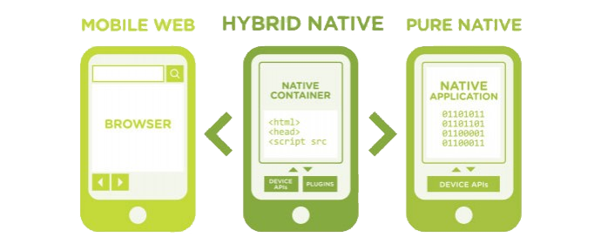

CC2-

CC3-

CC4-

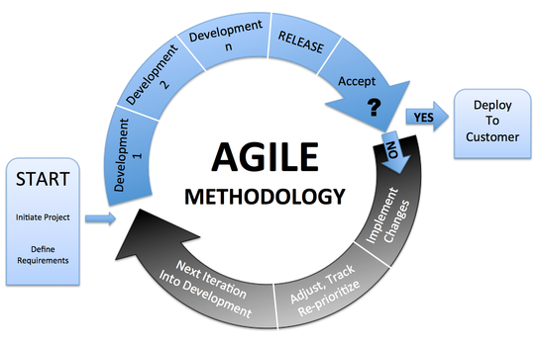 from Cryptex Technologies PVT. LTD. : http://www.cryptextechnologies.com/blogs/new-age-new-methodology-agile-methodology

CC5-

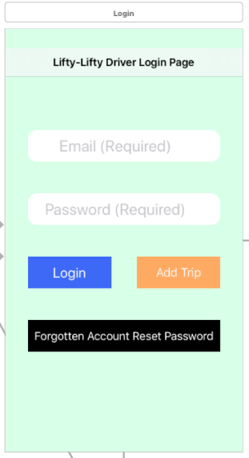
Driver Profile Page Driver Login Page
Driver Register Page Add trip Pag
CC6-
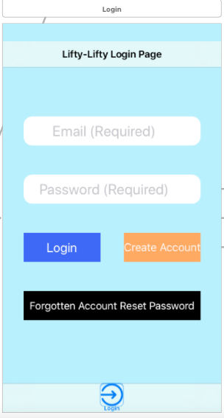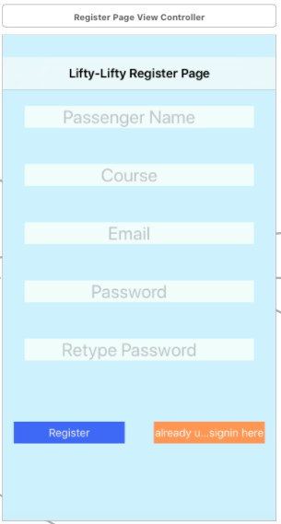
Passenger Profile Page Passenger Login Page Passenger Registration page

CC7-

CC8-

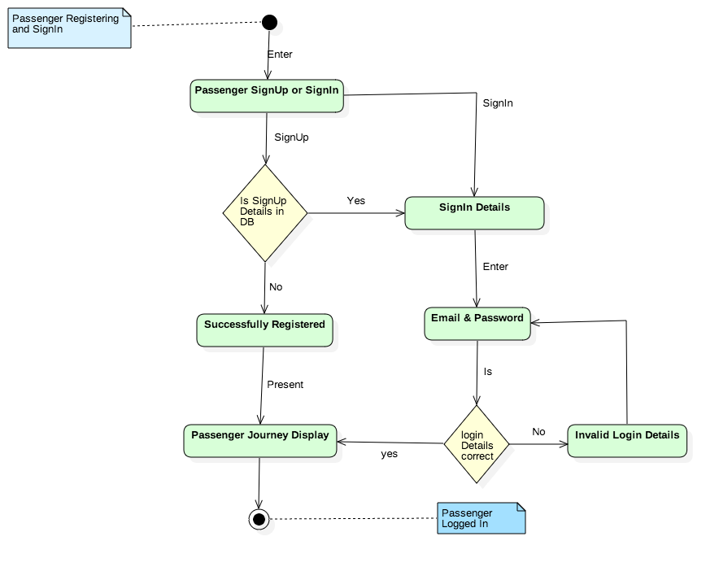

CC9-

CC10-

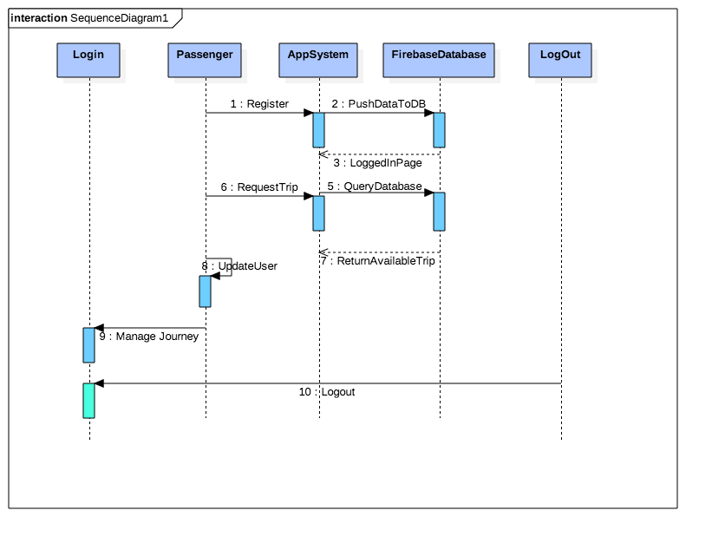

CC11-

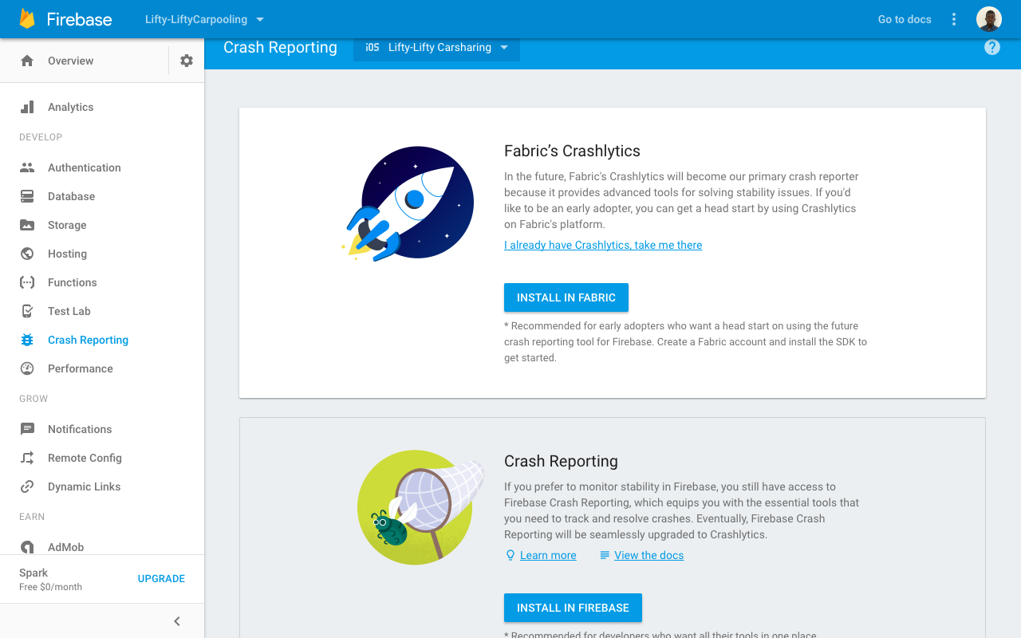

CC12-

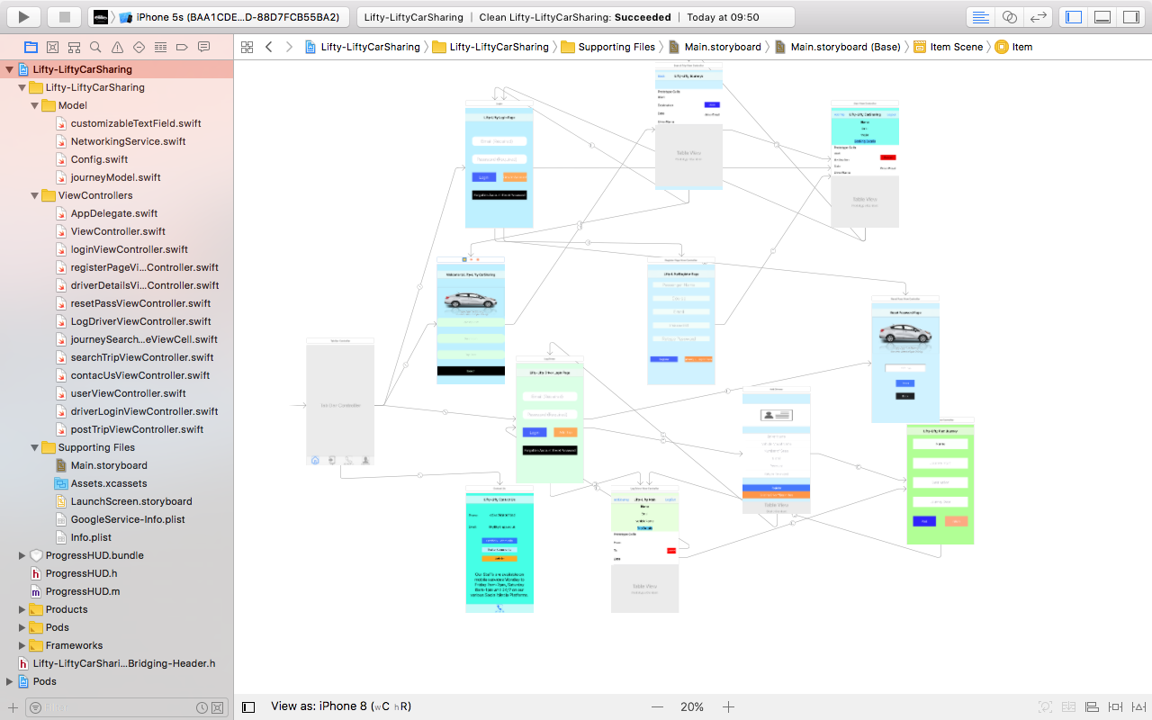

CC13-

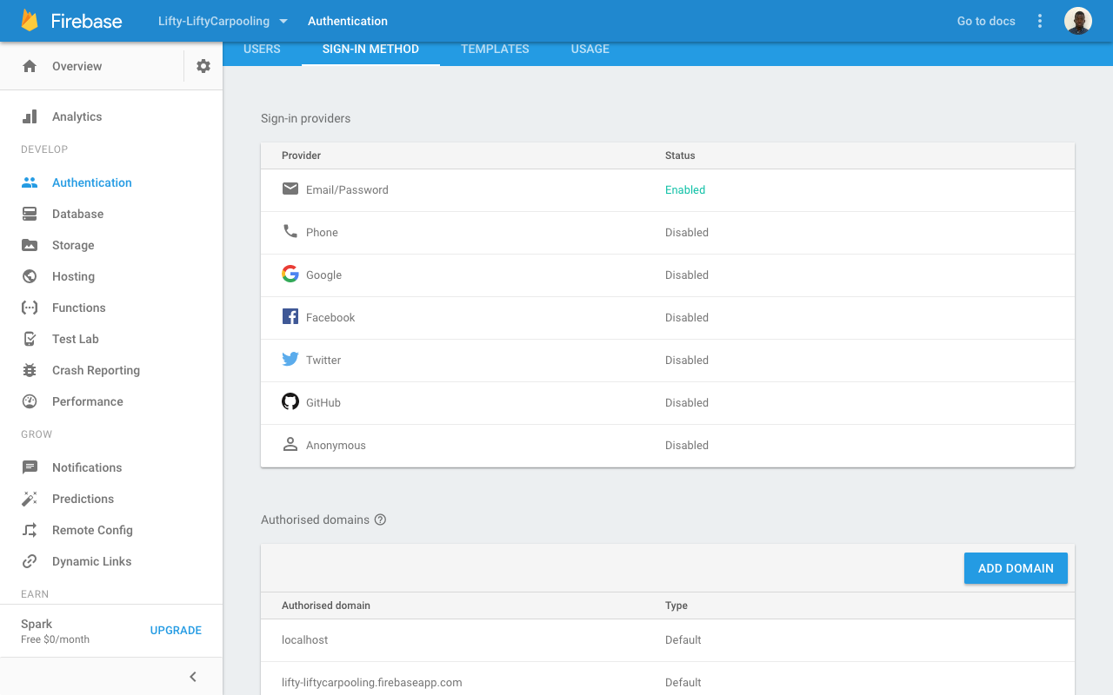

CC14-

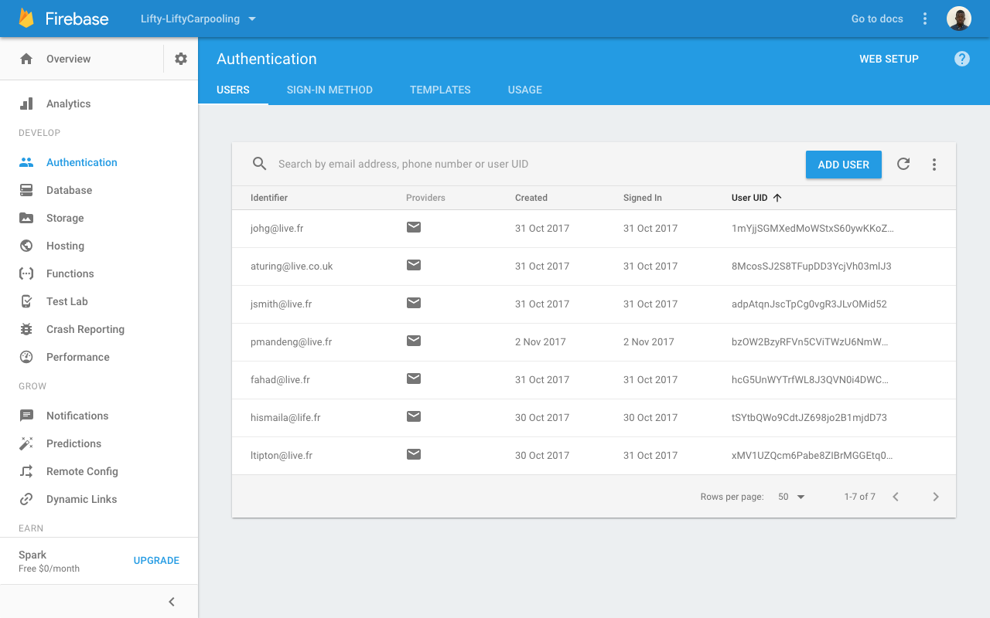

CC15-

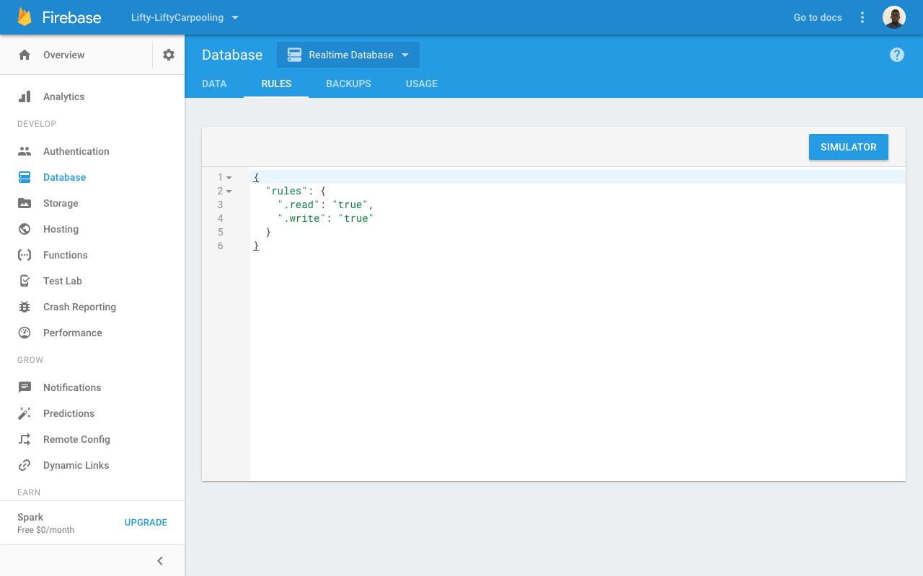

CC16-

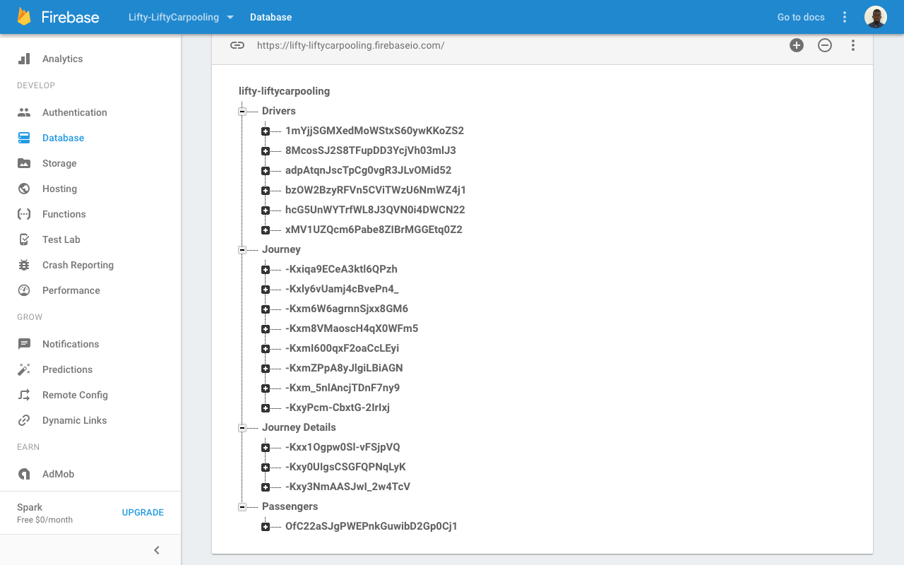

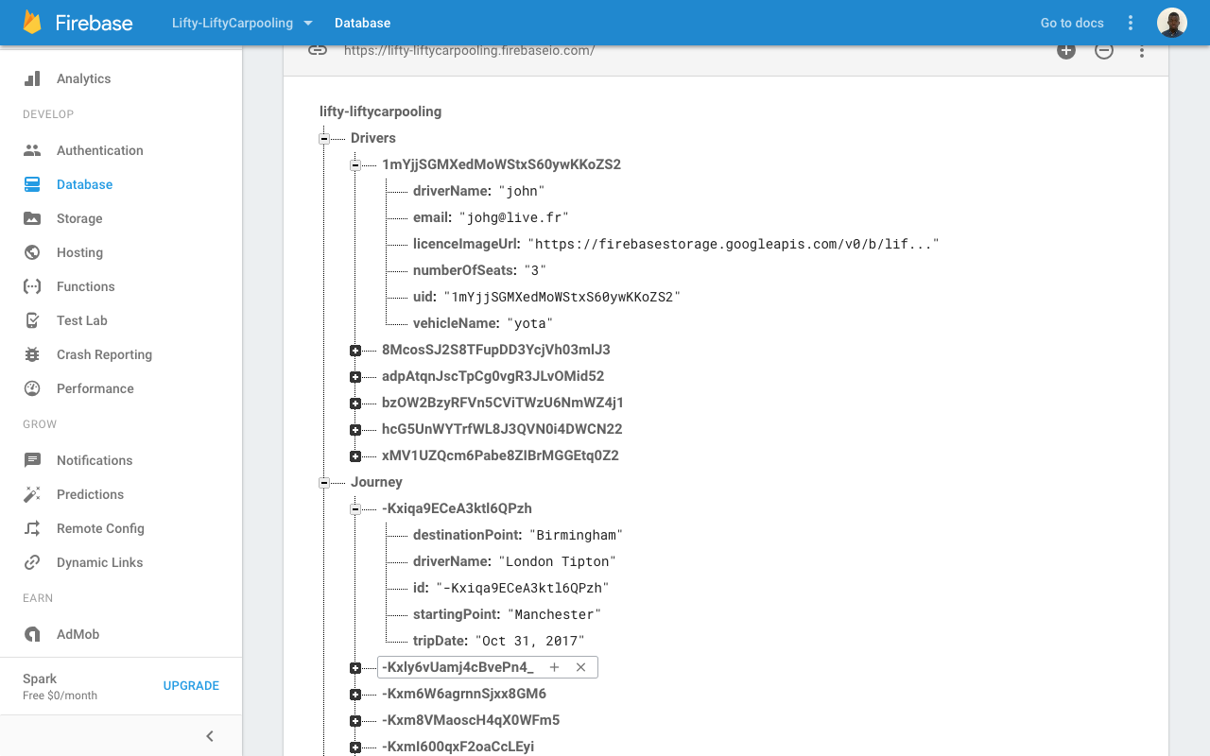

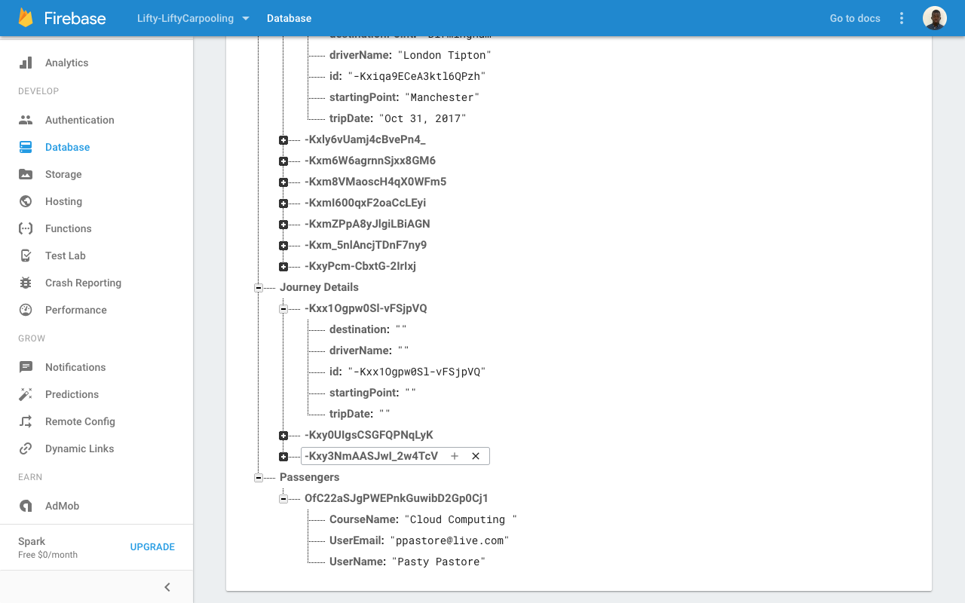

CC17-

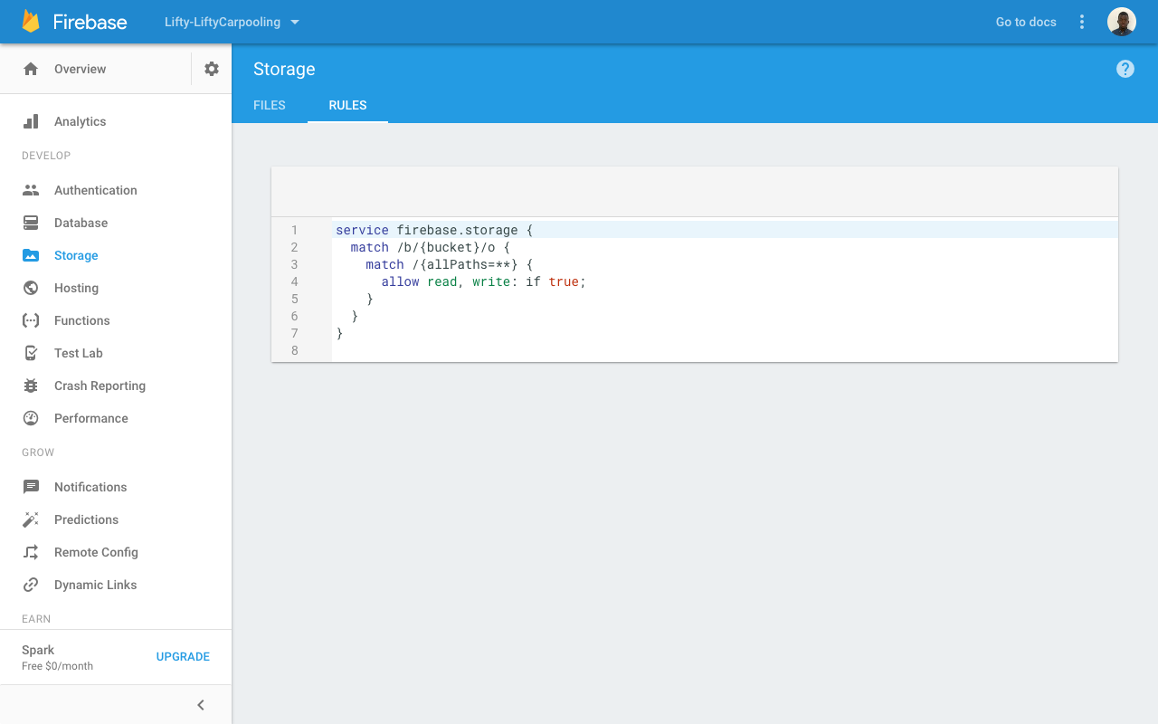

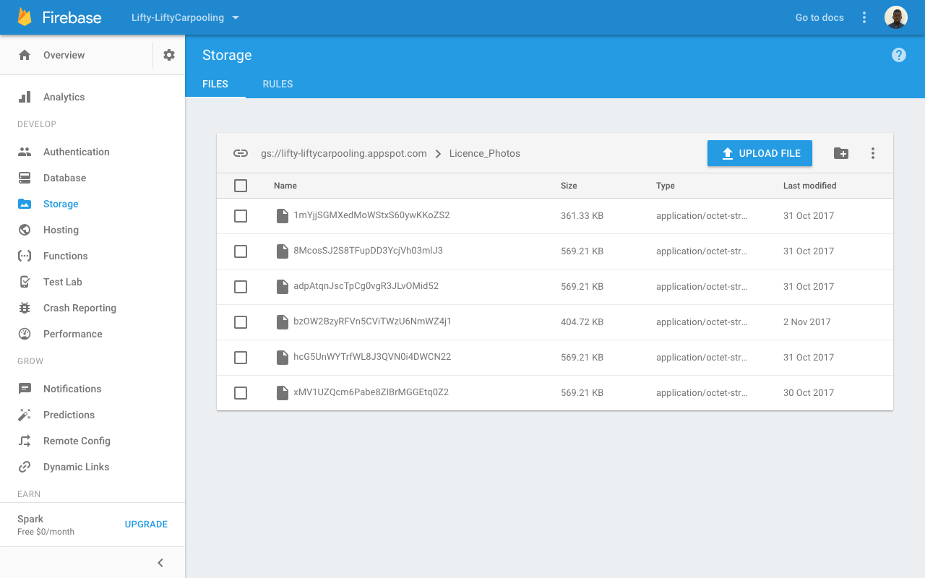

CC18-

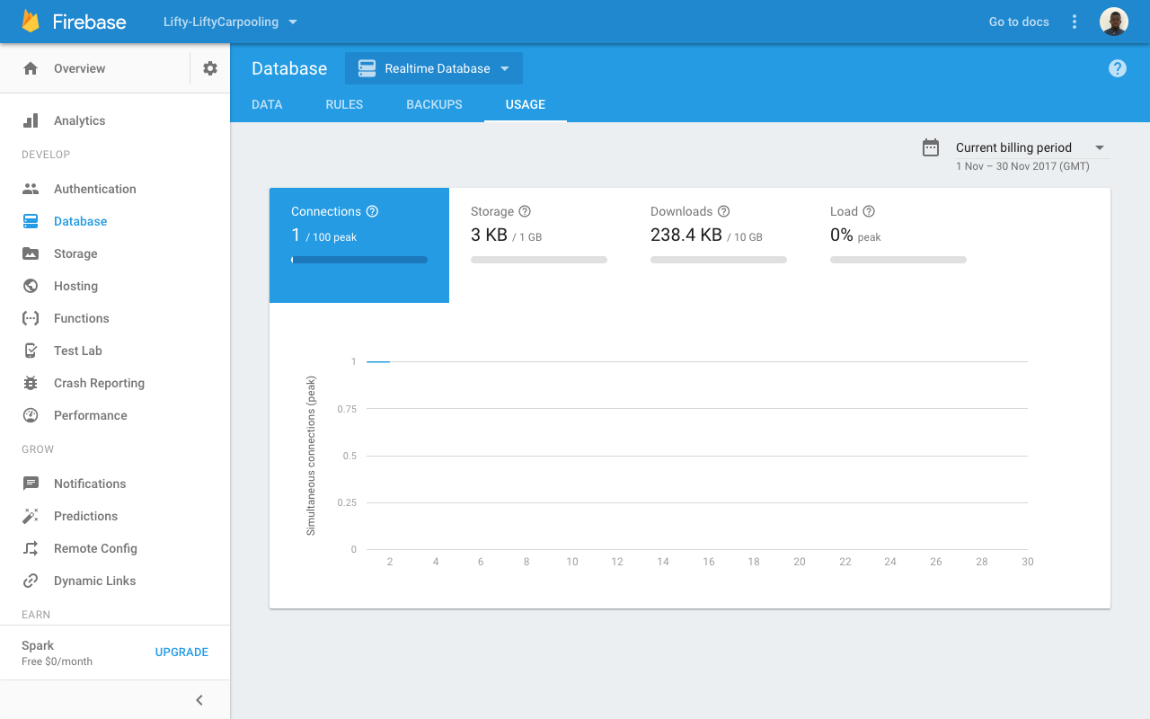

Glossary:

API -> Application Programming Interface

App -> Application

Apps -> Applications

TFL -> Transport for London

GPS -> Global Positioning System

IDE -> Integrated Development Environment

IOS -> formerly IPhone Operating system but now Mobile Operating System created and developed by Apple

NASA -> National Aeronautics and Space Administration

PC -> Personal Computer

PDA -> Personal Digital Assistant

SDK -> Software Development Kit

Stats -> Statistics

Tech -> Technology

UML -> Unified Modelling Language

UWTSD -> University of Wales Trinity Saint David

UX -> User Experience Design

Gantt Chart:

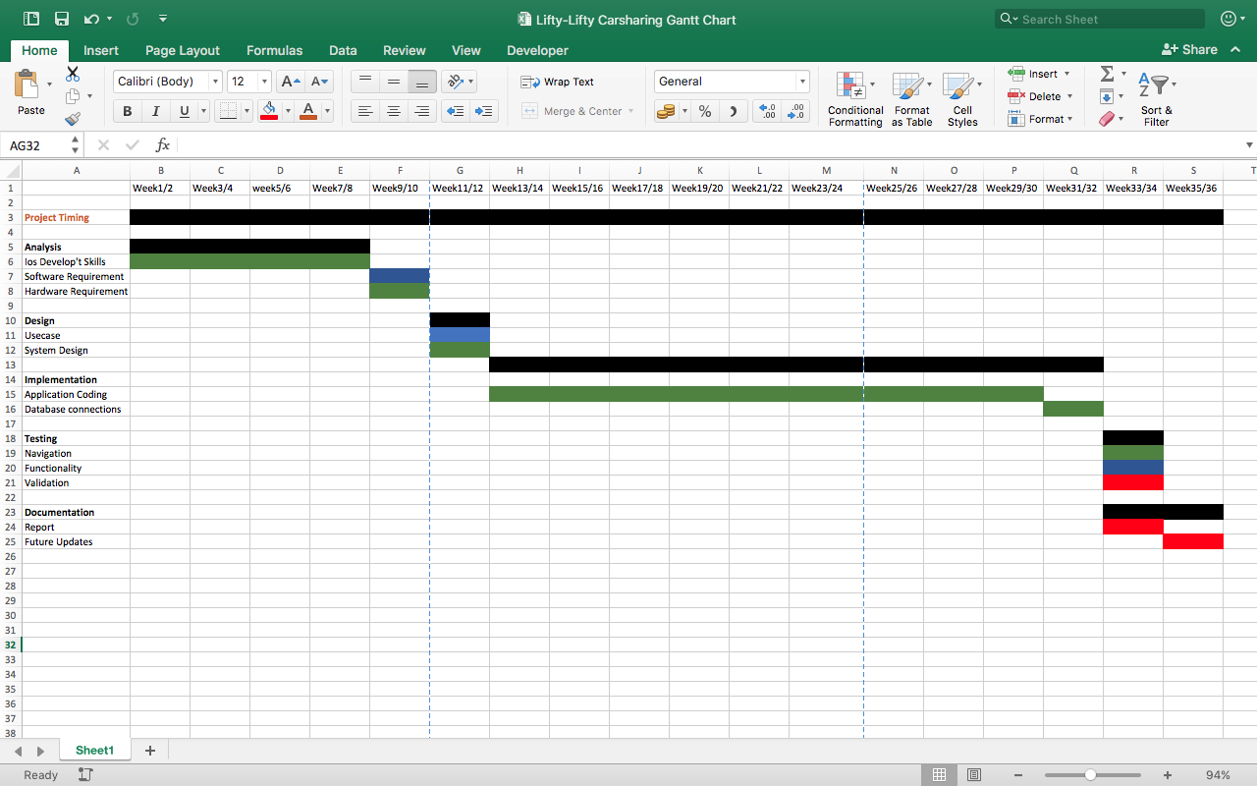

References

[1] | National Aeronautics and Space Administration (NASA), NASA Global Climate Change, Geneva: NASA, 2016.
[2] | C. Baraniuk, “Why Apple and Google are moving into solar energy,” British Broadcast Corporation, 2016 October 2016.
[3] | AppAppeal, “Top 8 Free Car Sharing Apps,” 2017. [Online]. Available: http://www.appappeal.com/apps/car-sharing. [Accessed 29 June 2017].
[4] | House of Commons, “The Digital Economy,” House of Commons, London, 2016.
[5] | EDUCAUSE, “Mobile App Development,” 7 Things should know about , pp. 1-2, 19 April 2011.
[6] | Compuware. The Technology Performance Company, “Make App Survey Report,” Detroit , 2012.
[7] | C. C. Miller and N. Wingfield, “Mobile Apps Drive Rapid Change in Searches,” Business Day, 7 January 2013.
[8] | Accenture Digital PLC, “Growing the Digital Business: Spolight on Mobile Apps,” Dublin, 2015.
[9] | Cellular News, “International Telecommunication Union Statistics NewsLog,” International Telecommunication Union , 2011.
[10] | I. M. Rashedul, I. M. Rofiqul and M. A. Tahidul, “Mobile Applications and Its Global Impact,” International Journal of Engineering and Technology, vol. 10, no. 06, pp. 72-78, December 2010.
[11] | D. Chaffey, “Mobile Marketing Statistics Compilation,” Smart Insights, 01 March 2017.
[12] | M. Strain, “1983 to today: A history of Mobile apps,” theguardian, 13 February 2015. [Online]. Available: https://www.theguardian.com/media-network/2015/feb/13/history-mobile-apps-future-interactive-timeline. [Accessed 7 April 2017].
[13] | IBM Software; WebSphere, Native, Web or Hybrid Mobile-app development, Somers, New York: IBM Corporation, 2012, pp. 02-09.
[14] | Mobility Practice Happiest Minds, Dealing with the Dilemma, Bengaluru: Happiest Minds Technologies Pvt Ltd , 2012.
[15] | L. Williamson and R. Snook, A Mobile app development primer, I. M. IBM Software, Ed., Somers, New York: IBM Corporation 2015, 2015.
[16] | I. A. from, http://redflag.ie/services/mobile-application-development/hybrid-mobile-app-development/.
[17] | Statista, “Worldwide mobile app revenues in 2015, 2016 and 2020 (in billion U.S. dollars),” 2017. [Online]. Available: https://www.statista.com/statistics/269025/worldwide-mobile-app-revenue-forecast/. [Accessed 3 July 2017].
[18] | T.-M. Gronli, J. Hansen, G. Ghinea and M. Younas , “Mobile Application Platform Heterogeneity: Android vs Windows Phone vs iOS vs Firefox OS,” in 2014 IEEE 28th International Conference on Advanced Information Networking and Applications(AINA), Victoria, BC, 2014.
[19] | M. Park, “Mobile Application Security: Who, How and Why,” Trustwave, London , 2012.
[20] | Firebase, “Firebase by Platform,” Google Developer, 2014. [Online]. Available: https://firebase.google.com/docs/. [Accessed 2 August 2017].
[21] | F. Ciari, M. Balmer and K. W. Axhausen, “Concepts for a large scale car-sharing system,” ETH, Zurich, 2008.
[22] | E. Martin, S. A. Shaheen and J. Lidicker, “Impact of Carsharing on Household Vehicle Holdings: Results from North America Shared-Use Vehicle Surver,” Journal of Transportation Research Board , no. 2143, pp. 150-158, 2010.
[23] | D. S. Le Vine, A. Zolfaghari and P. J. Polak, “Carsharing: Challenges and Opportunities,” European Automobile Manufacturers Association, Bruxelles, 2014.
[24] | R. Danielis, L. Rotaris, A. Rusich and E. Valeri, “The potential demand for carsharing from university students: An Italian Case study,” SIET, 2015.
[25] | L. Williamson, A Mobile Application Development Primer, Sommers, New York: IBM Corporation Software Group, 2012, pp. 2-11.
[26] | M. Ross, The Distributed Agile e-Book, SOCOCO, 2015, pp. 08-11.
[27] | S. Balaji and S. M. Dr. Murugaiyan, “Waterfall vs V-Model vs Agile: A Comparative Study on SDLC,” International Journal of Information Technology and Business Management, vol. 2, no. 1, pp. 26-30, 29 June 2012.
[28] | R. Bennet, Moblie Application Performance, Microstrategy, Ed., Richmond, Virginia: MSTRWORLD, 2015.
[29] | mHIMSS, “Selecting a Mobile App: Evaluating the Usability of Medical Applications,” Healthcare Information and Management Systems Society, July 2012. [Online]. Available: http://s3.amazonaws.com/rdcms-himss/files/production/public/HIMSSguidetoappusabilityv1mHIMSS.pdf. [Accessed 10 August 2017].
[30] | [Online].

PROJECT RESEARCH Approval Form (Ethics)

Have you considered whether there is any problematic ‘ethical issues’ in your proposed research project? If not, you really should talk to your Course Tutor or Supervisor to discuss if there are any issues you need to address.

If you have already completed an ‘Ethics Approval Form’ within your Faculty/School, you do not need to complete this form. However, you haven’t considered the ethics issues in your proposal, you need to complete this form.

Not all details necessarily apply to your area of study, so you may leave some boxes blank, but do try and complete it as fully as you can. All sections deal with potential ethical issues which need careful consideration before you commence your research, to ensure you deal with them properly (in accordance with the law, for example). You may find it easier to complete the form with assistance from your tutor/supervisor.

Name: | Fabien Bertrand Edogue
Project/Research Title: | Lifty-Lifty Carsharing Application
Name of Supervisor: | Renuga Jayakumar
School/Dept. | University of Wales Trinity Saint David
Faculty: | School of Applied Computing
Proposed Start Date: | 20 February 2017 | End Date: | 9 November 2017

1. Summary of planned research please indicate briefly below the purpose of your planned project/research, together with your aims, main research questions and research design – you can continue onto a separate sheet if necessary
The development of a functional mobile application system for car Sharing among students of Universities and Colleges with public contribution option in future versions deployment.
-Development of a simple prototype of an IOS Car Sharing Application

2. Methodology you need to be clear about the methodology you intend to use in your study; this could include any number of methods, so either tick those shown below (where appropriate) or put the details in the box marked *

 | Interviews |  | Participant Observation |  | Use of personal data
 | Focus groups |  | Questionnaire | Y | Literature Review
 | Performance |  | Presentation |  | Other (state below)*

3. Participants - Does your proposed project/research involve human participants?

 | 1. Yes, as a primary source* |  | 2. Yes, as a secondary source* | Y | No- go to section 4

*If you have ticked yes, you are likely to need an Advanced CRB check before undertaking your study

If yes, indicate who your participants are:

 | Early years/Pre-School children |  | Adults - give details below
 | School age children |  | Vulnerable people - give details below
 | Young People aged 17-18
 | Unknown at this stage

4. Other Ethical issues (tick all that may apply to your research)

 | Administration of drugs incl. alcohol |  | Deprivation
 | Unpleasant stimuli in any manner or form |  | Active deception or withholding information
 | Collection of highly personal information |  | Payment

5. Are there any ethical concerns other than those listed above?

NO

6. If there are any ethical concerns, please state how you intend to minimise any risk of harm or distress that could be caused

No

You should enclose the research proposal form, together with any materials (e.g. questionnaire, interview schedule) when submitting this form to your tutor/supervisor.

Student Signature: FBE Date 29 AUGUST 2017
**********************************************************************************
Supervisor’s Signature: Renuga JayAkumar Date: 09 November 2017

Ethics clearance given at Faculty Level
Clearance not given at Faculty level – forwarded for discussion at the next meeting of the University Ethics Committee. Details below:
Comments:

Chair’s Initials |  | Date

Details on this form will be always be dealt with in accordance with the terms of the Data Protection Act 1998. The completed form will be retained on the student’s file after approval (for audit purposes) and may be forwarded firstly to the Faculty Board and thereafter to the University Ethic

