
BMSW4004
Problem Solving and Decision Making

Table of Contents
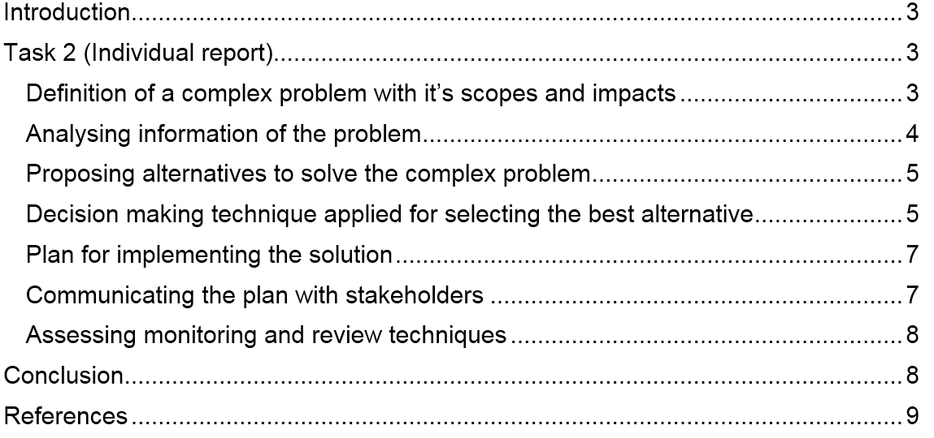

Introduction
In the business sector, managers sometimes face lots of complexities to operate their business which is solved by using various tools (Widodo, et al. 2020). Also, the capability is of the management and the leaders in any organisation related to problem-solving creates a huge impact on the long-term success of the business. Mostly it has been found that the majority of the problems are developed internally which sometimes creates issues related to profitability and employee satisfaction (Suranata, et al. 2020). The satisfaction of the employees can be described as the positive feeling of the employees towards the working environment and the work itself in any particular workplace. In the UK, it has found that the employee turnover rate has been increased by 5.3% in the last 3 years (Proctor, 2021). The basic reason for employee turnover rate in hands mint in the UK has been identified as job dissatisfaction. This assessment has been developed into different types and the first task includes a role-play to identify the complex problem of job dissatisfaction faced by the employees within the UK. Here, a dialogue has been presented working as a management consultant with one of the students acting as an unsatisfied employee in the online classes. Here, I act in the role of management control than in a small and medium type company. One of my peers has been appointed as my partner in this role play station as an unsatisfied employee. The second task of this report has been developed as an individual report to identify a problem in my workplace named John Super shop and also provide an appropriate solution as the proposal to that particular problem.

Task 2 (Individual report)

Definition of a complex problem with its scopes and impacts
I have been working as a part-time supervisor in the small-medium type of retail store in the UK named John Super shop. Here, I have identified various types of problems that are also faced by some of my colleagues in that period (Proctor, 2021). But the most complex problem that I have faced related to the workplace has been in leg importance given to the opinion of the employees in terms of decision making. There were 13 employees available in that particular retail store which was one of the most popular local change shops in that area (Price, et al. 2021). But the employees of that business were not so satisfied with the attitude and behavior of the owner. Even the customers faced problems and the employees tried to provide solutions to the owner but the opinion given by the employees are not regarded as important. Again, the employees are not given appropriate flexibility which is creating complex is to maintain their personal and professional life (Mohanty, 2021). For this reason, the employees within that small shop were not satisfied with the systematic way of allocating tasks to manage the work-life balance. So, that was one of the major and complex problems that I have faced in my workplace in the recent past.
The scope of that complex problem of not providing an opinion in terms of decision making or any improvement activities in the workplace this factor demotivated most of the employees (Minda, 2020). Also, the impact was quite negative as the employee turnover rate of that store has been increased in last 3 years. In total, 19 employees have been joined and left the business because there was not a friendly environment in which the owner receives the opinion of other members in terms of taking any decisions.

Analyzing information of the problem
The complex problem has been identified as a lack of scopes to have a better work-life balance and the lack of attention provided by the owner to take opinions from the employees in the decision-making process of the business (Mahammed and Benslimane, 2021). Here, it has found that total of 19 employees has been left in last 2 years from that particular business because of job satisfaction. Again, it has also been found that the company has made around £3,000 loss on average in the last two years because of the increasing rate of employee turnover (Lal, 2021). The work-life balance is not maintained as it is found that in the UK every individual on average only gets 8 hours out of 24 hours to spend with their family. So, it has been difficult for the employees to manage better work-life balance which has been one of the basic reasons for job dissatisfaction.
Also, the owner of my organization has provided motivation and given lots of incentives to the employees but the result was similar because the owner preferred to make decisions regarding the business with his idea (Govender, 2021). For this purpose, no new ideas were supposed to generate which could have differentiated the business from other local shops in the UK (Brown, 2020). Besides, the owner identified a few of the problems that have been faced by the employees in the workplace related to the environment and also focused on solving them. For example, social distancing has been maintained in the recent pandemic covid-19 period (Mohanty, 2021). Also, the owner has increased the salary and the increment was around 10% to 15% based on the experience of the employees in the workplace (Ottonicar, et al. 2021). But, some of the senior employees left the business as they have not been given any type of opportunity to provide their opinion to take decisions of business or even provide new ideas that have been generated in their mind. So, the problem seems to be very much complex for John Super shop as the owner was also not aware of the fact that employees are not happy with the behavior of the owner to not take the opinion of the employees in the decision-making process.

Proposing alternatives to solve the complex problem
By evaluating the situation lots of alternatives can be suggested for the particular small business that has been mentioned in the above section. Among them, the first one is going to be applied to the participatory model of leadership in the workplace to ensure the engagement of all the employees in the decision-making process of the business (Proctor, 2021). Another alternative solution can be to provide the appropriate option to the supervisors in a different team to manage their team and achieve the given target. For this idea implementation, the owner needs to develop a division of structure of a business by which each division is going to be managed by one individual working as a leader (Mohanty, 2021). Again, to ensure appropriate work-life balance the employee should be given one or two-day weekly work from home facilities by which they can relax in their house and contribute at the same time to the development of the business. Those three alternatives seem to be much more suitable for John Super shop. Now, from those two alternatives, one is going to be selected by using the appropriate decision-making technique in the next stage.

Decision-making technique applied for selecting the best alternative
Here, the systematic process of decision-making has been applied for evaluating the two alternatives that have been selected for solving the particular complex problem of employee dissatisfaction. The process is illustrated below in short.
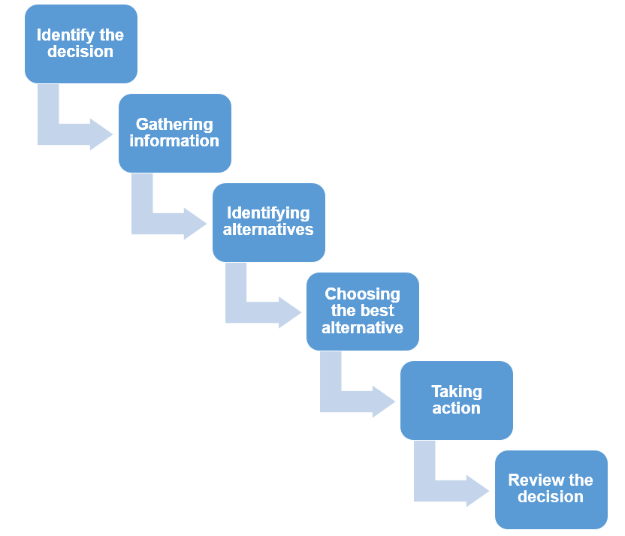
Figure: Problem-solving process
Source: (Mohanty, 2021)
Identify the decision
Here, identification of the decision related to the problem has found that the majority of the employees in the small retail shop mentioned in the above section faced that they are not given appropriate opportunity to share their opinions (Minda, 2020). Also, it has been found that there is no proper flexibility in working time which reduces the work-life balance in their regular life. Also, not getting enough flexibility to maintain work-life balance and also not providing an opinion in the decision-making has been the major reason for job dissatisfaction of the employees working in a small-medium business named John Super shop.
Gathering information
In this stage, information has been gathered by observing the behavior of the employees within John Super shop related to their satisfaction and dissatisfaction (Govender, 2021). Based on the observation, it can be said that the majority of the employees are not satisfied with the working schedule provided by the owner of John Super shop. Also, because of having online orders in the shop, the employees are involved in delivery activities using their cycle (Lal, 2021). So, both internally and externally the employees have to contribute to the development of the business but there is a lack of scope for managing time for their relation and family. Also, few of the employees who are assigned for only computer-related activities are not given enough flexibility as they have to spend lots of time in the office to the entry about data and managing the inventory in the digital segment.
Identifying alternatives
The possible alternatives that have been identified for solving the issue of maintaining better work-life balance for the employees and also ensuring the option to receive the opinion and applied opinions of the employees in the decision-making process has been using the participatory model of leadership and offering work from home facilities in few cases (Price, et al. 2021). Also, another alternative has been found to develop the divisional culture and structure in the workplace to assign one leader for each division to accomplish tasks and targets.
Choosing the best alternative
Here, considering the factors of John Super shop it can be said that the application of the participative model of leadership can be much more suitable to resolve the issue of opinion as well as work flexibility (Proctor, 2021). Here, by using the participatory model of leadership the employees will be given appropriate facilities to share their opinions as well as they can share their flexibility factors in the workplace. Thus, they will be highly satisfied in the workplace.
Taking action
Now, the owner of John Super shop needs to develop a few sessions of training to train up the employees to apply the guidelines of the participative leadership model (Govender, 2021). Also, various types of informal approaches will be applied by John Super shop for encouraging the employees to share their opinions in the decision-making process. Thus, the employees will be notified about the changes due to the application of the participative leadership model and they will be provided appropriate access to delete it talk with the owner to provide their opinion related to the improvement of the business.
Review the decision
Then, the decision is going to be reviewed by observing the changing behavior of the employees in the workplace of John Super shop (Suranata, et al. 2020). Also, the changing rate of employee turnover across the company is going to be the factor to review the decision that has been made to implement the participative leadership model.

Plan for implementing the solution
The following sets of actions need to be applied for implementing the plan of the solution to apply the participatory model of leadership in John Super shop.
- Share the information of the potential changes in John Super shop to the employees to prepare them for the changes.
- Arrange regular training sessions both online and offline for increasing the involvement of the employees in the decision-making process.
- Arrange informal meetings with the employees to increase the confidence level of the employees to share opinions with the owner about improvement.

Communicating the plan with stakeholders
The plan is also going to be communicated with the stakeholders for example the customers of retail business (Govender, 2021). Here, the owner, as well as the employee, should encourage the general customers of the business to provide their opinion to improve the business process of John Super shop. Also, the owner needs to ensure that all the suppliers and vendors of various products in the retail shop are also provided equal opportunities to provide their opinion regarding the improvement of John Super shop in different internal operations.

Assessing monitoring and review techniques
Here, for reviewing and monitoring the successful implementation of the plan regular internal audit is going to be conducted by the owner himself (Brown, 2020). Also, by using the tool of fishbone diagram different problems are going to be identified as the monitoring process. Besides, the use of the scorecard strategy is also going to be applied for measuring the performance of each employee after implementing the plan of the participative model of leadership in John Super shop.

Conclusion
So, at last, it can be said that finding any problem effectively requires appropriate model implementation and the decision-making process of problem-solving is highly appreciable globally for solving problems. In my previous work experience in John Super shop, I have shared one of the complex problems which have been identified as the employees have not able to share their opinion in the decision-making process and also did not get enough work-life balance because of huge pressure. In this individual report, few alternatives have been identified like providing work from home facilities, developing divisional structure, and implementing a participative leadership model for solving the issue. But the most suitable one has been selected for John Super shop which is the implementation of the participative model of leadership.

References
Brown, S.W., 2020. Problem-Solving and Decision Making in a Web-Based PBL.
Govender, C.M., 2021. Creative Accelerated Problem Solving (CAPS) for Advancing Business Performance. In Handbook of Research on Using Global Collective Intelligence and Creativity to Solve Wicked Problems (pp. 84-109). IGI Global.
Lal, A.T., 2021. Business Communication-A Problem Solving Approach. Abhigyan, 38(4), pp.53-55.
Mahammed, N. and Benslimane, S.M., 2021. Solving a Business Process Optimization Issue With a Genetic Algorithm Coupled With Multi-Criteria Decision Analysis Method. International Journal of Organizational and Collective Intelligence (IJOCI), 11(1), pp.71-94.
Minda, J.P., 2020. The psychology of thinking: Reasoning, decision-making and problem-solving. Sage.
Mohanty, S., 2021. Decision Making And Problem Solving. Springer. DOI, 10, pp.978-3.
Ottonicar, S.L.C., Valentim, M.L.P. and Bouthillier, F., 2021. From Business Information Literacy to Decision-Making, Problem Solving, and Innovation. International Journal of Media and Information Literacy, 6(1), pp.66-76.
Price, A.M., Kim, C.J., Burkholder, E.W., Fritz, A.V. and Wieman, C.E., 2021. A Detailed Characterization of the Expert Problem-Solving Process in Science and Engineering: Guidance for Teaching and Assessment. CBE—Life Sciences Education, 20(3), p.ar43.
Proctor, T., 2021. Absolute Essentials of Creative Thinking and Problem Solving. Routledge.
Suranata, K., Apriliana, I.P.A. and Ifdil, I., 2020. The Effect of Problem-Solving Training to Improve Student’s Critical Thinking and Decision-Making Skills: Racked Analysis. Acta Counseling and Humanities, 1(1), pp.1-9.
Widodo, S.A., Irfan, M., Trisniawati, T., Hidayat, W., Perbowo, K.S., Noto, M.S. and Prahmana, R.C.I., 2020, October. Process of algebra problem-solving informal student. In Journal of Physics: Conference Series (Vol. 1657, No. 1, p. 012092). IOP Publishing.

