THE GLOBAL BUSIONESS ENVIRONMENT
LCBB4005
Assessment 1
Environmental Analysis of Automobile Industry
BMW

Prepared by: DOREL GABRIEL TLICA
ID student:2114961

Dr. Molly Jack

University of Wales Trinity St David
Date: 12/01/2022

1.Hystory
2.Cars with aircraft engine
3.Performance BMW
4.Five forces for BMW
5.SWOT and analysis

- Hystory

After proving that they could produce not only aircraft engines but also motorcycles, German engineers took the opportunity to purchase an existing car factory

Munich was not the place where BMW cars were first produced. Also in terms of lesser known details is the paternity of the first four-wheeled BMW, the Dixi model.
After 1933, when it came under the control of the armed forces, the company's activity was mainly redirected to the production of aircraft engines and weapons. Despite this, cars or motorcycles were still
manufactured, even though the BMW R75 motorcycle and the BMW 325 car were only available to military personnel. In 1941, however, the order to stop car production was put into practice, so only 132, 801 or 003 aircraft left the Bavarian-owned factories.
In 90s are a glorious start for BMW, with the launch of a legendary grand tourer. The BMW 8 Series was only available with V8 and V12 engines, and the 850 CSi boasted a 5.6-liter engine and 381 hp. In 1994, the BMW factory in Spartanburg, South Carolina, USA, started operations, just in time for the BMW Z3 to go into production the following year. Left without a roadster in the range and with fierce competition from Porsche and Mercedes-Benz, the Bavarians retaliate with a model that has become a classic since life, thanks to the fluid design and impeccable road holding. Also in 1994, BMW made an unprecedented move in the company's history and bought the British group Rover, along with the Land Rover, Range Rover and Mini brands.

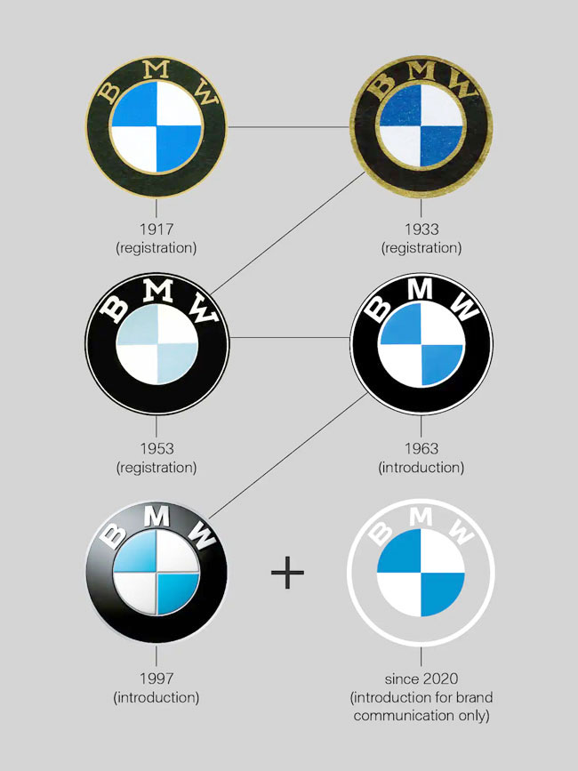

2. Cars with aircraft engine

The Bavarian engine factory is a name respected by fans and feared by the competition. Models that proudly wear BMW initials are appreciated for their dynamic driving, without compromising on comfort. Like any other difficult name in the automotive industry, this brand has found its identity through the audacity to innovate, but has always combined inventiveness with passion. It could not have been otherwise, given that the first industrial product in the history of BMW was an aircraft engine, and until 1928 it manufactured exclusively motorcycles. Founded on March 7, 1916, the company was formed by merging the companies of Gustav Otto and Karl Rapp, and the name Bayerische Motoren Werke became official a year later. Today, the white-and-blue logo shines on both four-wheeled and two-wheeled vehicles.

Legend that the combination of white and blue dials is a stylization of a moving propelle.
In support of this myth is often the image made by graphic designer Henry Ehlers, which depicts two planes in flight, over whose propeller is superimposed the well-known BMW logo.
Shield, used in BMW communication since the late 1920s, is a visual evocation of the colors used on the Bavarian coat of arms.

Throughout 2010, BMW has consistently ranked first in the top of car brands in a wide range of studies, where in terms of public appreciation or the opinion of specialists.
At the end of 2010, two new studies certified the success of the BMW brand on the market, again placed BMW in first place in the top car brands.
The survey conducted by Deadalus Millward Brown among the users of the auto.ro site included over 13,700 online interviews between January and October 2010. Several criteria were followed, which included road holding, design, reliability, fuel consumption. , the interior finish and the quality / price ratio between the owners of each brand. The results show that BMW models rank first in terms of overall satisfaction as well as in terms of value for money. The ranking on the third position in the top of the purchase intention, behind two German volume brands, is also remarkable.
BMW ended an exceptional year and established itself as the most appreciated car brand in Romania. The results were also confirmed by the sales performance, where BMW has established itself as a leader in the premium market since the beginning of the year.
BMW ranks seventh and is the best representative in the automotive industry, with an index of 9 out of 10. "This indicates that the demand for BMW models It is still very large, but the timing of the purchase is delayed due to the recession, but customers remain loyal to the brand, "explains the top makers.
The total value of the top 100 brands is $ 1950 billion, an increase of 1.7 percent. " In today's situation, where the value of many businesses has declined, brands have become more important because they help companies keep up with difficult times ," said Joanna Seddon, CEO of Millward Brown Optimor. "Those who have invested in their own brand will be better positioned to grow their business as the economic situation improves."
There are a total of 15 new entrants this year. The most successful is Pampers, ranked 31st, followed by Nintendo (32) and VISA (36). The brands that offer a good price-quality ratio registered significant increases: Wal-Mart (+ 19%), ALDI (+ 49%) or Auchan (+ 48%).

3. Performance BMW

BMW or Bayerische Motoren Werke - is a leader in the car industry, being considered one of the safest luxury cars in existence.

It currently produces a variety of models, including the 1 Series created in 2004, the smallest car produced by BMW. The 3 Series is a compact class car that has been in production since 1975. The 5 Series is BMW's middle model in the executive class, and the 7 Series has a hydrogen engine, more and more common in the automotive industry due to the attention paid to which the internal combustion engine affects the environment.

BMW - leader in efficiency
* BMW - the most successful manufacturer in terms of reducing emissions and fuel consumption
* The average level of emissions for cars delivered in 2008 is 156 g C02 / km
* BMW respects the 1998 ACEEA commitment and reduces emissions by 25% between 1995 and 2008
* The average emissions for the BMW fleet are comparable to those of European volume manufacturers, at a considerably higher level of performance
* Over 1,200,000 cars equipped with EfficientDynamics technologies in 2 years
* The EfficientDynamics development program includes hybrid propulsion, electric models and hydrogen powered motors.

After more than five years of development, the BMW EfficientDynamics program was unveiled exactly two years ago at the Geneva Motor Show. This now gives BMW the top spot in terms of reducing CO2 emissions and fuel consumption, but also adds dynamic performance to all models in the range.
EfficientDynamics makes a close link between dynamic performance, fuel consumption and mass. Maximum performance for minimum consumption is goal for every engine we produce. Strategic innovations in areas such as propulsion systems, lightweight materials and aerodynamics have succeeded in resolving the "conflict of interest" between performance, consumption and mass.
Dr. Klaus Draeger member of the Board of Management for Developmenthe said make sure that driving pleasure does not always affect fuel consumption, and that fuel consumption does not affect driving pleasure.
Unlike other manufacturers, BMW offers the BMW EfficientDynamics kit in standard equipment for all models in the range, from the BMW Z4 sports car to the BMW 7 Series sedan, from the compact BMW 1 Series to the spectacular BMW X6. This has led to the largest number of cars equipped with measures to reduce fuel consumption - more than 1,200,000 in just two years since its launch.

The BMW Group outperforms the largest carmaker in Europe and equals the level of emissions of some manufacturers with a portfolio of models made up mainly of small class cars.
BMW has the highest car market in Europe with an average level of emissions for the 2008 car fleet of 158g CO2 / km, an average consumption of 5.9 liters / 100 km at a power average of 133 kW. The other premium manufacturers record higher emissions for a lower power level (181g / 6.8 liters / 118 kW, respectively 167g / 6.3 liters / 97 kW). These figures also place BMW below the German market average of 165 g CO2 / km.

All these results have led in recent years to a number of important awards such as the World Green Car of the Year Award for the BMW 118d, the Grüne Lenkrad (Green Steering Wheel) from the weekly Bild am Sonntag, the Paul Award Pietsch ”from the German magazine“ auto, motor und sport ”or“ ÖKO-TREND Auto-Umwelt-Zertificat ”for BMW 118d, BMW 520d and BMW 318d. These led the US Enviromental Defense Report 2008 to state that "BMW is the best manufacturer in terms of reducing CO2 emissions".
This year, series hybrid models for the BMW 7 Series and BMW X6 will be presented. From the perspective of EU test estimates, an optimum consumption of about 20% is expected and an improvement in performance with extra power and especially torque from electric motors.
At the same time, BMW is working on new solutions to improve the support for internal combustion engines. One such example is the TEG (ThermoElectric Generator) system, which is now under development. This system borrows a technology that already equips NASA satellites and in the case of BMW aims to generate electricity based on the heat accumulated in the exhaust.

This system is expected to improve efficiency by up to 5%. At the same time, less and less engine power will be converted into electricity, which improves dynamic performance. The time horizon for the introduction of this system is about 5 years.

Another important step of the BMW Group is the "project i", which aims to develop mobility concepts for large urban agglomerations (over 5 million inhabitants) based on electric motors. In this regard, the MINI E was presented, an electric model developed on the MINI platform that offers 204 hp, 220 Nm and a range of about 250 km. The model was developed for the purpose of technology testing and is to be delivered in 515 units to selected institutions and individuals in Los Angeles, New York, Berlin and Munich for a one-year lease. Following partnerships with energy suppliers (E.ON in Munich and Vattenfall Europe AG in Berlin), the energy with which these models are powered comes from renewable sources, ensuring a truly zero-emission model.

Among the successes achieved by the German manufacturer is the performance of BMW Motorrad, with a total of 471 units sold, being for the first time in the history of the brand when the threshold of 400 deliveries is exceeded.
Even in the context of the pandemic, we remain strong, with only a minor decrease in sales compared to the strong 2019, even setting a record with BMW Motorrad. In 2020 we returned to the first position as an importer of premium cars in Romania, BMW and MINI, we excelled in electrification and sports cars and we confirmed the value of the xDrive system, becoming, for the first time, the most successful importer of all-wheel drive cars from Romania. 2021 remains extremely unpredictable. We understand, in the context of the global pandemic, that cars and individual mobility are now more important than ever, and from here we see growth potential for this year, ”explains Dr. Josef Reiter.
4. The five forces the the BMW :

* The average level of emissions for cars delivered in 2008 is 156 g C02 / km
* BMW respects the 1998 ACEEA commitment and reduces emissions by 25% between 1995 and 2008
* The average emissions for the BMW fleet are comparable to those of European volume manufacturers, at a considerably higher level of performance
* Over 1,200,000 cars equipped with EfficientDynamics technologies in 2 years
* The EfficientDynamics development program includes hybrid propulsion, electric models and hydrogen powered motors.

5. Swot and analysis :

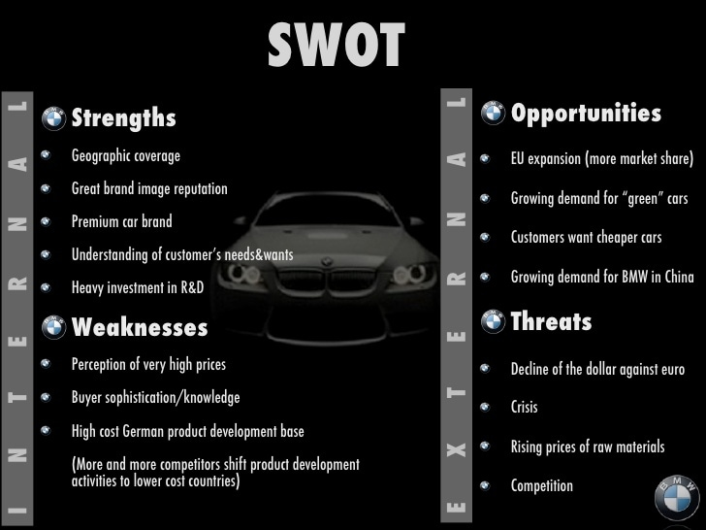

Refences
www.htpps //Autovit.ro/BMW -hystory-brand-performance and innovation
www.htpps//BMW-competitors -Analysis and swot

