DISSERTATION

“WOMEN IN MANAGEMENT POSITIONS WITHIN
CORPORATE ORGANISATIONS”
-A MORRISONS Case Study-

MIHAELA MUSAT
STUDENT ID: 1915928
MODULE: LCBB6000
UNIVERSITY OF WALLES TRINITY SAINT DAVID

Table of Contents
Chapter 1: Introduction………...…………………………………………………………………….7

1.1 Significance of the topic………………………………………………………………...7
1.2 Purpose of the research………………………………………………………………… 8
1.3 Research aim……………………………………………………………………………9
1.4 Objectives……………………………………………………………………………….9
1.5 Research questions……………………………………………………………………..10
2. Literature review………………………………………………………………….………..10
3. Gap of literature……………………………………………………………………………12
4. Methodology………………………………………………………………………………13
4.1 Research philosophy…………………………………………………………………..13
4.2 Research approach…………………………………………………………………….. 13
4.3 Research methodology…………………………………………………………………13
4.4 Research strategy………………………………………………………………………13
4.5 Sampling method……………………………………………………………………….14
4.6 Data collection…………………………………………………………………………14
4.7 Data interpretation……………………………………………………………………..14
4.8 Timeline………………………………………………………………………………. 15
4.9 Ethical consideration………………………………………………….……………….15
5. Conclusion………………………………………………………………………..………..16

Chapter 2: Literature Review…………………………………………...………………………..16
2.1 Introduction………………………………………………………………………………..16
2.2 Conceptual Framework…………………………………………………………………….17
2.3 Theoretical Underpinnings……………………………………………………...…………18
2.3.1 Concept of workplace equality………………………………………………………...18
2.3.2 Role of women in management positions in Morrisons………………………………..20
2.3.3 Current Trends and advantages of women working in management positions in Morrisons…………………………………………………………………………...……….22
2.3.4 Disadvantages of women in workplace positions …………………………………… 24
2.3.5 Identification of mitigation strategies for the issues women employees face working in management positions in Morrisons………………………………………………………..24
2.4 Theoretical Understanding……………………………………………………………….. 27
2.4.1 Feminist Theory……………………………………………………………………… 27
2.4.2 Cognitive Development Theory……………………………………………………… 28
2.5 Literature Gap…………………………………………………………………………….. 28
2.6 Summary………………………………………………………………………………….. 28
Chapter 3: Research Methodology 28
3.1 Introduction 28
3.2 Research Philosophy 29
3.3 Research approach 30
3.4 Research Methods 31
3.5 Research Strategy 32
3.6 Sampling Method 32
3.7 Data Collection 33
3.8 Data Interpretation 34
3.9 Research Timeline 35
3.10 Ethical Considerations 36
3.11 Summary 36
Chapter 4: Findings and Analysis 36
4.1 Introduction 36
4.2 A brief introduction outlining how the research went, the issues and shortcomings, and the challenges encountered during the research. 37
4.3 Data collection 37
4.3.1 Survey 37
4.3.2 Interview 42
4.4 Analysis of Primary Data through survey results 43
4.5 Analysis of Data through Interview results 50
4.6 Analysis of Secondary Data 50
4.7 Summary 53
Chapter 6: Conclusion, Recommendation, and Reflection 54
6.1 Introduction 54
6.2 Conclusion 54
6.3 Linking with Objectives 54
6.4 Recommendations 54
6.5 Reflection 55

Reference List and Bibliography…………………………………………………………….. 59

List of Figures
Figure 1: Employment rate male vs female……………………………………………………….8
Figure 2: Share of female held leadership positions in FTSE companies………………………...9
Figure 3: Gantt chart……………………………………………………………………………..15
Figure 2.2: Representation of women by corporate role in 2022………………………...…….. 19
Figure 2.3: Proportion of women in managerial positions worldwide from 1991 to 2020…….. 21
Figure 2.4: Share of females who held leadership positions in FTSE companies in the United Kingdom in 2021……………………………………………………………………….. 24
Figure 2.5: Gender pay gap for gross hourly earnings in the United Kingdom in 2021, by industry sector …………………………………………………………………………………. 26
Figure 3.2.1: Research Philosophy 29
Figure 3.3.1: Research Approach 30
Figure 3.4.1: Research Methods 31
Figure 3.5.1: Research Strategy 32
Figure 3.6.1: Sampling Method 33
Figure 3.7.1: Data Collection 34
Figure 3.9.2: Gantt chart 36
Figure 4.4.1: Age of the participants 43
Figure 4.4.2: Gender of the participants 44
Figure 4.4.3: Experience of the participants 44
Figure 4.4.4: Number of employees who know about women managerial positions 45
Figure 4.4.5: Workplace equality at Morrisons 46
Figure 4.4.6: Hiring of women employees 46
Figure 4.4.7: Organisational Performance at Morrisons 47
Figure 4.4.8: Role of Gender Pay Opportunity 48
Figure 4.4.9: Inclusion of female employees in other companies other than Morrisons 48
Figure 4.4.10: Challenges due to women employment 49

List of Table
Table 1 : Timeline …………………………………………………….…………………………15
Table 3.9.1: Research Timeline 35
Table 4.3.1.1: Age of the participants 37
Table 4.3.1.2: Gender of the participants 38
Table 4.3.1.3: Experience of the participants 38
Table 4.3.1.4: Number of employees who know about women managerial positions 38
Table 4.3.1.5: Workplace equality at Morrisons 39
Table 4.3.1.6: Hiring of women employees 39
Table 4.3.1.7: Organisational Performance at Morrisons 40
Table 4.3.1.8: Role of Gender Pay Opportunity 40
Table 4.3.1.9: Workplace Equality in other companies other than Morrisons 41
Table 4.3.1.10: Challenges due to women employment 41
Table 4.3.2.1: Interview Table 42
Table 4.7.1: Interview Table 52
Table 6.5.1: Action Plan 57

Chapter 1: INTRODUCTION

Despite long-standing anti-discrimination legislation in the UK and across Europe women are still underrepresented in many occupations, significantly in the high-level posts (Netchaeva, 2022). Motivating women to hold senior management positions is considered an essential part of the global drive to enhance equality between women and men (Frankiewicz, 2020). Morrison’s is considered the fourth largest supermarket chain in the UK (Morrisons, 2022). In the present times, the market share of Morrison’s is 14.8% and in the UK grocery industry (Statista, 2022). The company has generated 17.6 billion British Pounds turnover in the UK. The company has eighteen “manufacturing sites for fresh foods along with five hundred stores in the UK. The company has more than 18000 customers per week (Statista, 2022). The research is conducted to know the factors or challenges that hinder women to hold senior positions in corporate organisations.

1.1 Significance of the topic
The government of the UK is strictly commuted to achieving gender equality and the empowerment of girls. There is a range of initiatives taken by the government of the UK such as providing financial services to thirty-six million women and helping three million women to improve their property rights and land issues. Several actions have been taken against women's abuse, violence, and forced marriage to promote the peace and security of women. However, still, a review exposed that there is a lack of women in executive director roles in the UK (BBC, 2022). Thus, the research is significantly important to identify the issues faced by women in management positions in corporate organisations such as Morrison. This business is deep rooted and is difficult to change. More than forty retail companies have signed the BRC D&I Charter and committed to make their industry better with more equal opportunities for everyone. According to the diversity and inclusion report the retail industry is close on achieving 33% women on boards. However, presently, one in five retailers has all male boards and 15% has no female employees in their executive committees (BBC, 2021).

1.2 Purpose of the research
In the UK 15.52 million women who belong to 16 years old age group were employed from October to December 2021 according to the reports of ONS’s UK labour Market Bulletin. The number is more than 153,000 than the previous year. In 2022, the employment rate of males in the United Kingdom was 79% while females were only 72.3% in the UK (Statista, 2022).
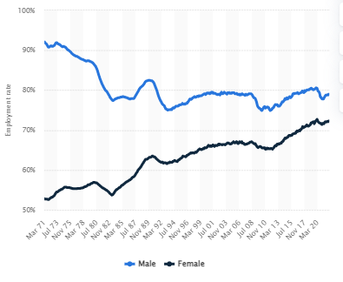
Figure 1: Employment rate male vs female
(Source: Statista, 2022)

In 2021, eight per cent of FTSE 100 companies had a female CEO in comparison to four per cent among FTSE 250 companies (Statista, 2022). However, the number of executive directors is significantly less than in non-executive positions.
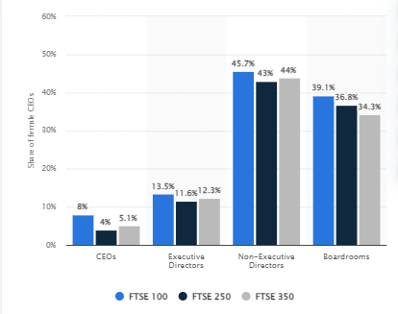
Figure 2: “Share of female held leadership positions in FTSE companies”
(Source: Statista, 2022)

According to the reports of Timmins (2022), in 2021 only 13.5% of executive director positions were held by women employees however it was less than 14.2% in the previous year (BBC, 2022). Although four out of ten of UK FTSE 100 board positions were held by female employees the positions were non-executive such as human resource positions.

1.3 Research aim
The aim of the research is to analyse the role of women in management within Morrison’s.

1.4 Objectives
The objectives of the research are described below:
- To analyse the role of women in management positions within Morrison’s.
- To obtain the present trends and advantages of women working in management positions in Morrison’s.
- To identify the mitigation strategies for the issues women employees face working in management positions in Morrison’s.

1.5 Research questions
The research questions are given below:
- What is the role of women in management positions in Morrison’s?
- What are the advantages of women employees working in management positions in Morrison’s?
- What are the strategies to mitigate the issues faced by the women employees with management positions in Morrison’s?

2. Literature review
Definition of workplace equality
According to Garcia et al. (2019), Equality in the workplace can be defined as providing equal job opportunities and fair chances for every employee and job applicant. It means treating people due to the reasons protected by discrimination law. On the other hand, in the perspective of Hardaker and Subasi (2018), workplace equality suggests ensuring a safe and inclusive work environment and provisioning equal opportunity to everyone.

Characteristics of workplace equality
According to Horowitz et al. (2018), there are many characteristics of workplace equality such as salary and bonus transparency, “addressing equality issues head on”, “Diverse mentoring programs”, and shifts in mind-set. Assumption and beliefs, visible commitments towards equality and others. On another hand, in the perception of Post et al. (2019), there should be an alignment between the promises and actions within the workplace, along with different “promotional strategies for women” is important to maintain equality in the workplace.

Importance of workplace equality
According to Van Lair et al. (2019), workplace equality promotes a work culture in the long term that values talent beyond the stereotypes and enables people to reach their potential by providing their best without any prejudice. In addition to that equality in the workplace also fosters better efficiency and productivity. Workplace equality helps to recruit people from diverse backgrounds such as teams from different geography, and gender, which improve business decisions and company performance. For example, ALDI is said as a female-dominated company where 66% of the employees are women. In the perspective of Madsen et al. (2020), failure in embracing equality in the workplace cab lead business organisations to suffer from serious reputational damage. Promoting workplace equality boosts brand image incorporating increased sales, good publicity, and higher employee satisfaction. It also improves the productivity of the organisation along with boosting employee morale. For example, Tesco is the leading retail organisation in the UK where women occupy 37.4% of the highest-paid jobs (gov, 2022).

Models of workplace discrimination
According to Simon (2019), the authoritarian personality intrapsychic factors as they accuse of blatant discrimination. The theory argues that individuals associated with nationalism, conservatism, and fascism tend to develop a rigid personality and express conventional beliefs and often identify themselves as authority figures. Thus, most of the group members may publicly possess equality and still can possess a negative attitude towards minority groups and others. For example, in organisations with fewer female employees, the gender pays gap is more explicit than in other organisations. On the other hand, from the perspective of Makoni et al. (2021), theories like symbolic racism, and modern racism says that conflicts and ambivalent attitudes of the majority group members. According to the theory, unprivileged persons and humanitarian sympathy often go hand in hand and they blame the victims for not complying with individualistic values. For example, in Lidl workers won sex discrimination claims where the authorities tried to pressurise female employees to swim in front of them.

Advantages and present trends of women employees in management positions
According to the international labour organisations (2022), women promote gender equality that helps to improve creativity, openness, and innovation which improves the reputation of a company and helps to gauge more customer satisfaction. It has been obtained that increasing female employment at the national level positively impacts the GDP of a country. On the other hand, in the point of view of Youssef (2020), many services have done to check whether employees have equal opportunities and inclusion policies in their enterprises. However, as per the reports more specific actions are required to ensure women's empowerment and visible promotional strategies in different areas of business. For example, Aldi is adapting principles to avoid discrimination in the workplace and improve the position of women employees by addressing women empowerment in the organisation (Aldi South Group, 2022).

Disadvantages of women in workplace positions
According to Ali and Salisu (2019), in the contemporary corporate culture women, are recognised as having the perfect combination of skills for leadership, with superior leadership styles and extraordinary effectiveness. As opined by Madsen et al. (2020), the belief is widespread that women often come second to men in the competition of attaining leadership positions. For example, in Tesco women workers argued that they have failed to get equal pay for work and equal value with their male colleagues in the distribution centres (BBC, 2021). They are portrayed as “suffering disadvantages “to get access to management or leadership positions and moreover they resist prejudice when they occupy these roles.

Strategies to mitigate issues faced by women employees
According to Horowitz et al. (2018), attracting and recruiting more women into leadership positions can improve the position of the employees in an organisation and can be beneficial in mitigating the challenges faced by women in the workplace. On the other hand, according to Post et al. (2019), improving women the opportunity to develop their skills, flexibility and challenging tasks helps them to go forward in their careers. For example, Tesco provides women employees flexibility through a hybrid working model and skill development opportunities through training and development (Tesco plc, 2018). In the present times, 40% of the board positions of the big companies in the UK are filled by women (BBC, 2022).

3. Gap of literature
The literature has covered discussion on the role of women employees in management positions its benefits challenges and mitigation strategies in corporate organisations. On the other hand, it does not focus on the past challenges and history of women's employment along with the way the trends changed in recent times.

4. Methodology

4.1 Research philosophy
Can be referred to as the philosophy that relates to assumption, nature of the study and knowledge (Snyder, 2019). Among to the types of research philosophy here the researcher will use pragmatism philosophy. In the present study pragmatism philosophy will be implemented because the researcher will collect both primary and secondary data.

4.2 Research approach
The research approach can be referred to as the methods of data collection and analysis and gets the general differences between quantitative and qualitative methods (Cr, 2020). Among several research approaches such as deductive, indicative, and abductive approaches. The researcher will use the deductive research approach here. In addition to that, the deductive research approach also helps to generalise the data findings and at the same time helps researchers to analyse quantitative data.

4.3 Research methodology
Research methodology can be defined as the specific approaches or techniques that are used to select identify, analyse and process the information about a particular topic (Snyder, 2019). Here the researcher will use a mixed technique using both primary and secondary research to get accurate results.

4.4 Research strategy
Research strategy provides an overall direction to the research and includes the process through which research is conducted (Cr, 2020). There are many types of research strategies such as survey, case study, action research, experiment, grounded theory, ethnography and others. Here the researcher will use a survey along with an interview of the mid-level managers in retaining organisations to gather data on the role of women in management positions.

4.5 Sampling method
The sampling technique can be illustrated as the principle that is used to determine and select the group of population to accomplish a study (Snyder, 2019). In the current research h, random sampling will be implemented for survey so that all respondents get equal chance to participate in the study. On the contrary, purposive sampling will be used for conducting the interview. Lastly,, inclusion and exclusion strategy will be used for selecting secondary data. Here, 13 female employees of Morrisons will be chosen for survey and 2 mid-level female managers will be selected from Morrison’s for the interview. Lastly, three themes will be created for secondary analysis.

4.6 Data collection
Data collection can be defined as the process of collecting information from all the related sources to get the answers to all the answers of the research questions to evaluate the results (Cr, 2020). Here the data will be collected using the primary data collection technique through survey and interview. At the time of conducting the survey, close ended questionnaires will be sent to the employees of Morrisons through email. The open- ended questionnaires will be designed for conducting the interview. The secondary data will be collected through literature review and thematic analysis. The secondary data will be collected through a process known as Boolean search strategy.

4.7 Data interpretation
Data analysis is the systematic process of analysing the primary and secondary data using different methods. Here, to analyse the survey data, the researcher will use frequency calculation. On the contrary, the interview data will be analysed through constant comparison. The secondary data will be analysed through thematic analysis.

4.8 Timeline
Activities | Start date | Duration (days) | End date
Topic selection | 22/7/2022 | 3 | 25/7/2022
Deciding aim and objectives | 25/7/2022 | 4 | 29/7/2022
Arrangement of literature | 29/7/2022 | 2 | 31/7/2022
Identifying relevant method | 31/7/2022 | 3 | 3/8/2022
Data collection | 3/8/2022 | 2 | 5/8/2022
Data interpretation | 5/8/2022 | 7 | 12/8/2022
Preparation of draft | 12/8/2022 | 4 | 16/8/2022
Submission of final file | 16/8/2022 | 3 | 19/8/2022
Table 1: Timeline
(Source: created by the learner)
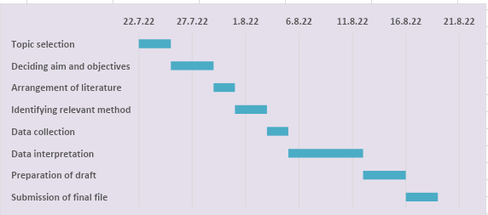
Figure 3: Gantt chart
(Source: created by the learner)

4.9 Ethical consideration
Ethical considerations can be illustrated as the technique through which the researcher operates ethically during conducting the research and protected the gathered information and details of the participants (Ranjit, 2020). Here the researcher will use the general data protection act 2018 to conduct the research ethically by taking the necessary consent of the participants and providing proper credit to the authors.

5. Conclusion
To conclude it can be said that improving the place of women in management positions will improve the overall performance and brand image of Morrisons. The above study suggests that the position of women in management has significantly raised in the past time, however, the numbers are still not satisfactory and requires more strategies rules and strategies to improve the position of women in management positions in corporate organisations. The study has provided a broad literature review based on the aim and objectives of the research followed by an appropriate methodology for further research on the topic.

Chapter 2: Literature Review

2.1 Introduction
“Workplace Equality” is defined as equal fairness and job opportunities for employees as well as for job applicants (Schumann et al., 2020). In this context, different countries have different definitions and laws to prevent discrimination. The UK government and its developed policies have been strictly aligned with the promotion of gender equality in terms of empowering girls for participating in corporate organisations (García‐Sánchez et al., 2020). In terms of the global drive, studies have found that motivating the women population of the UK in terms of holding a senior management position has been considered to be an essential process. In this context, Morrisons is considered one of the 4th largest supermarket chains in the UK with a market share of approximately 14.8% (Morrisons, 2022). The Literature Review Section of this research report will discuss the concept of gender equality in the workplace along with the inclusion of the current trends of women working in management positions.

2.2 Conceptual Framework

Associated Theories
Cognitive Development Theory

WOMEN IN MANAGEMENT POSITIONS WITHIN CORPORATE ORGANISATIONS"- A Morrison
Concept of workplace equality
Providing fair chances and equal job opportunities
Lack of Discrimination
Outperform their competitors
Importance of workplace equality
Discriminations are removed
Diverse Mentoring Programs
Strong Employment Relations
Non-binary Inclusive Environment
Gender Equality
Feminist Theory

Inclusive working environment
Employee Satisfaction

Figure 2.1: Conceptual Framework
(Source: Created by Learner)
In the above conceptual framework, three aspects related to Women's Empowerment at Morrisons including the “Concept of Workplace Equality, Importance of Workplace Equality, and associated theories” has been described in a visual representation. In accordance with the “Concept of Workplace Equality”, it has been observed that workplace equality often helps in providing fair chances and equal job opportunities to female candidates. Moreover, Lack of Discrimination, as well as Employee Satisfaction, are some of the advantages that are achieved through the implementation of Workplace Equality. At Morrisons, the development of an “Inclusive Working Environment” has helped the organisation in boosting morale and build employee trust. Moreover, in accordance with the “Importance of Workplace Equality”, Morrisons through hiring women have been able to build strong employee relations, develop diverse mentoring programs, and include gender equality in the organisation.
In addition, the associated theories which are included in the concept of Workplace Equality are Feminist Theory and “Cognitive Development Theory”. In accordance with the feminist Theory, it has been observed that a feminist theory especially focuses on the concept of gender inequality through which it recognises the fact that the location of women in terms of experience in social situations is different as compared to men in the same social situations. In addition, “Cognitive Development Theory” focuses on the concept of “Gender Inequality” which has long been acquired by the managers of different companies who hold their commitment to include “Diversity and Inclusion” in the workplace.

2.3 Theoretical Underpinnings

2.3.1 Concept of workplace equality
“Workplace Equality” can be defined as providing fair chances and equal job opportunities to every employee and job applicant. On this note, Chang, and Milkman (2020) assert that one of the most basic illustrations of workplace equality is associated with the “Lack of Discrimination”. It is regarded as the fair treatment of people regardless of their gender, race, religion, disability, age, and nationality. Some of the primary branches of workplace equality are “Diversity and Inclusion” (Dewidar et al., 2022). For instance, companies that entwine diversity and inclusion within the workplace in all aspects of their businesses have been observed to statistically outperform their competitors (Scott, 2020). In further reference to the discourse of Ud Din et al., (2018) stated that equality in the workplace ensures that employees are provided with equal opportunities and are equally paid in terms of their performance and acceptance. In addition, Hardacre and Subašić (2018) noted that workplace equality ensures that any instances of discrimination are removed from the working environment.

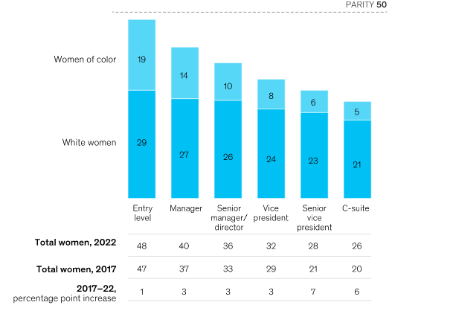
Figure 2.2: Representation of women by corporate role in 2022
(Source: Krivkovich et al., 2022)
Workplace equality is directly proportional to the concept of “Gender Equality” with certain industries across the globe that have a greater “Gender Pay”. According to statistical records, approximately 70% of the population of UK residents have claimed that companies that have “Equal Gender Pay” have a positive impact on the concept of gender equality (Clark, 2021). According to the opinions of Opara et al., (2020), there are many characteristics that are associated with the enhancement of gender and workplace equality. These characteristics are bonus transparency, salary payments, career experience, development of “Diverse Mentoring Programs”, shifting mind-sets, and a “Non-binary Inclusive Environment”. As per statistical records of 2020, in contemporary days, women hold approximately 28.3% of all managerial positions across the world. This record has increased from the reports of 1991 in which only 23.6% of women were in managerial positions (Forbes, 2019). However, despite the increasing trends in women's representation in managerial positions in organisations, the share of women managers within the industry has declined from 27.4% to 26.7% during a period of one year from 2010 to 2013 (Clark, 2022).

2.3.2 Role of women in management positions in Morrisons
Morrisons is one of the fourth largest supermarket chains located in the United Kingdom with a market share of approximately 14.8% within the UK grocery industry (Morrison, 2022). In the context of “Workplace and Gender Equality”, Morrisons has announced a commitment in terms of identifying the “Female Business Leaders” for the future as a part of the target of doubling its female junior managers as well as senior managers. Moreover, Morrisons has set a target of reaching approximately 30% female representation for the positions of “Senior Management Group” (SMG) of the company (Morrisons, 2022). Furthermore, managers at Morrisons believe that increasing the scope for women's representation will bring various advantages to the company in terms of increasing the customer base and the interest of the shareholders who possess a bugger talent pool in the company (Morrisons, 2022). This will help to deliver a message to the targeted customers of Morrisons that “Our Management are more representative of our customers and employees”.

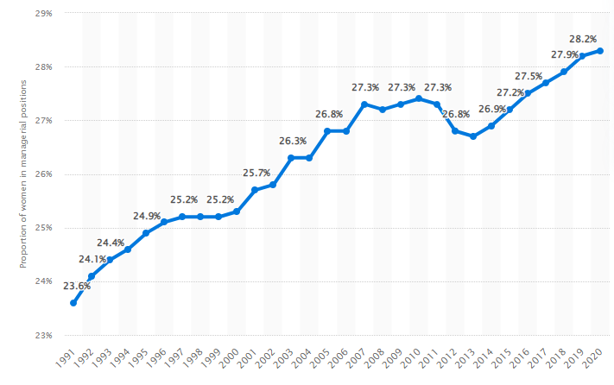
Figure 2.3: Proportion of women in managerial positions worldwide from 1991 to 2020
(Source: Clark, 2022)
The 2021 report which explored the percentage of women in managerial positions in the UK found that approximately 8% of the “FTSE 100 companies” have female CEOs as compared with around 4% of “FTSE 250 companies” with female CEOs. Moreover, “FTSE 100 Companies” have approximately 39.1% of female employees participating in boardroom meetings along with “FTSE 250 companies” with 36.8% of Boardroom female employees (Clark, 2022). In order to ensure that the employees, as well as customers, feel a sense of equality at the workplace, the UK-based supermarket chain has been building a “Diverse and Inclusive Workplace” that will help in reflecting the serving communities. In this context, women at Morrisons make up almost 60% of the workforce with the managerial positions and senior roles being filled up by the women population. Naoum et al., (2020) have opined that the role of women is represented by working closely with the “Family and Carers” as well as increasing the work stream in terms of raising awareness and addressing stigma to “Women’s Health”.

2.3.3 Current Trends and advantages of women working in management positions in Morrisons
According to the report which illustrated the gender pay gap in accordance with different sectors for 2022, the United Kingdom stands in the 22nd position in terms of the “Global Gender Gap Index”. The ranking of the UK falls behind other European Countries such as Germany, France, and Ireland. In terms of FTSE Companies, only 8% of the female population is employed in the CEO position, and 13.5% of the female population is employed in the position of Executive Directors (Clark, 2022). This indicates that the low share of women in accordance with the top positions contributes to the overall “Gender Pay Gap” across the UK. The share of women's employment has accounted for a mere 15.4% as compared to all the workers within the industry. Moreover, in terms of employment, women are less likely to get job opportunities for a full-time course which is only 45% as compared to 61% of men who are more likely to get job opportunities within the same sector (Clark, 2022). This implied that the UK has been facing the pressing issues of “Gender inequality” in the workplace.
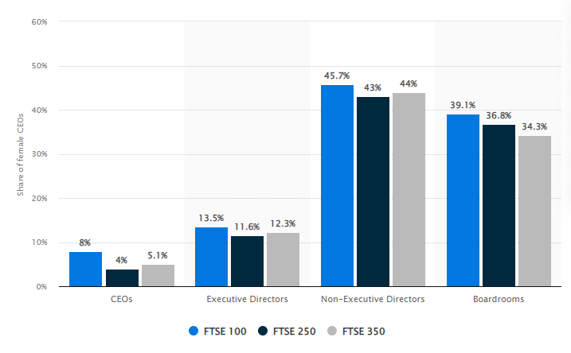Figure 2.4: Share of females who held leadership positions in FTSE companies in the United Kingdom in 2021
(Source: Clark, 2022)

Krivkovich et al., (2022) found that increased equality between men and women results in a multitude of positive and liable outcomes for everyone within the employment industry. Increasing gender equality in the workplace develops a stronger economy due to increased levels of women's participation. Moreover, “Women Empowerment” introduces a multiplier effect by providing benefits to the generations of women who tend to play a vital role in maintaining the health and well-being of older generations and children. On the converse front, Grissom (2018) has claimed that women are still “Underrepresented” at a dramatic rate in terms of leadership roles despite the prudent progress.
There are several advantages that are associated with women working in management positions at Morrisons. Some of the notable advantages are as follows:
- Increase in the diversity of problem-solving: Women's Empowerment has been advantageous because of the fact that the problem-solving approach of women leaders is less inclined to “Confrontational Matters” (Barrientos et al., 2019). Moreover, the increased representation of women employees at Morrisons has cracked the diversity approach to problem-solving due to the fact that it fosters interaction in terms of different approaches and worldviews (Morrisons, 2022).
- Growth in Employee Engagement: The inclusion of women employees and leaders have provided them with the success of establishing effectiveness in the team’s communication approaches (Hasan et al., 2020). This has helped in the development of open communication and the inclusion of more cohesive teams. In addition, women business leaders at Morrisons build employee trust and also boost their morale.
- Hike in organisational collaboration: In the current scenario, the women population in the UK has been spiralling as “Strong Leaders” who are responsible for supporting equity, advancing diversity, and inclusion efforts in the workplace (Barrientos, 2019). This has been proven to be advantageous for the UK-based supermarket chain in the development of varied policies for addressing the health requirements of women employees. These developments at Morrisons have proven that women employees are more inclined towards peer collaboration.
- Improvements in financial issues: The success of a business is defined by the organisational profitability that is often dependent on the rates of “Gender Parity”. In this context, it has been observed that Gender-diverse organisations have been able to increase their profitability by approximately 21% (Clark, 2021). In a similar context, Morrisons is considered to be a Gender-diverse organisation that has been able to outperform its competitors through the inclusion of women empowerment in the workplace (Morrisons, 2022). This has also resulted in an increase in the “financial performance” of Morrisons due to an increase in female leadership.
2.3.4 Disadvantages of women in workplace positions
In the contemporary days of corporate culture, the women population in the UK has been recognized to possess the perfect combination of skills in order to place them in leadership and managerial positions. However, Bicquelet-Lock et al., (2020) have stated that there are several disadvantages for women business leaders who are employed in the workplace. Some of the notable disadvantages of women in workplace positions are as follows:
- Women who hold the positions of CEOs, Executive Directors, or other higher positions in the workplace do not get enough time for their families (Treanor and Marlow, 2021).
- Women working at Morrisons have often complained that they face immense pressure that is related to work stress and thus, often face “Conflicts of interest” due to arguments with colleagues arising from work stress (Morrisons, 2020).
- Several tasks that are assigned to female workers often become stressful and in this regard, the women employees are unable to handle high levels of work-related stress leading to conflicts and disagreements (Opara et al., 2020).
- Work stress is often associated with arsing of anxiety and depression among female employees of a company (Davila Delgado et al., 2020).
- Equal pay opportunities are often not considered for women employees and they have argued that they are not given equal value as compared with their male colleagues within the distribution centres of the company (McDowell, 2020).

2.3.5 Identification of mitigation strategies for the issues women employees face working in management positions in Morrisons
- It has been observed that recruiting and attracting more number of women employees into leadership positions has been beneficial in terms of mitigating the challenges that are faced by them in the workplace. Moreover, in order to gain new skills and grab enhancing job opportunities, the women population of the UK has been switching jobs. However, the women leaders at Morrisons have been facing the issues of work stress due to the heavy loads of work along with the issue of the “Gender Pay Gap” that has been declining their morale as compared to the men workers. In this context, various mitigation strategies have been developed by Morrisons in order to tackle the contemporary issues of “Gender Inequality”.
- In Opoku and Williams (2018) view, several companies across the world have shown their interest in accordance with the promotion of “Diversity and Inclusion” in the workplace. Gender inequality differs per the different types of industries across the globe. According to the statistical data on the gender pay gap for different sectors in 2021, the “Financial and Insurance Sector” in the UK has been ranked as one of the highest sectors that has the largest rates of “Gender Pay Gap” for all employees. The rate at which this sector stands at the first position is approximately 30% (Clark, 2021). On the contrary, the “Transportation and Storage Sector” has been ranked as the lowest in terms of gender inequalities in the UK with only 4.6%. In addition, “Household Employment” has a negative “Gender Pay Gap” of -1.9% in 2021 (Clark, 2021).

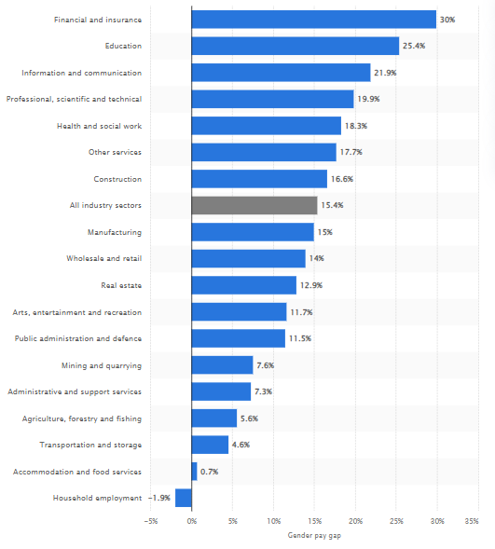
Figure 2.5: Gender pay gap for gross hourly earnings in the United Kingdom in 2021, by industry sector
(Source: Clark, 2021)
Despite all the progress that has been made over the years in terms of motivating women for senior management positions, gender inequality in the workplace has become one of the most common issues. According to the statements of Fine et al., (2020), the lack of gender equality in the working environment of a company has become one of the “Pain Points” for global companies. In line with this context, some of the mitigation strategies that are utilised at the workplace in order to reduce the rates of gender inequalities among employees are as follows:
- The establishment of an inclusive working environment will help the company continuously improving the company’s culture. Moreover, an inclusive environment in the workplace will build an employer's brand in order to retain and attract a diversified workforce (Naji et al., 2020). In the case of Morrison, the leaders are continuously improving their company’s culture with a commitment to include “Diversity and Inclusion”.
- Implementation of a fair “Compensation Practice” will help in reducing gender inequality in the workplace through compensating bands in terms of each position such as junior as well as senior levels by considering their experience, education, and skills (Bilan et al., 2020). In the case of Morrison, the development of “Incentive Compensation” and “Deferred Compensation” has been designed in order to represent the women employees at all phases of the company’s life cycle.
- “Offering equal pay for equal work” is one of the policies that will help global companies in redressing the payment balance among employees (Parker and Donnelly, 2020). In this regard, “Morrison’s Equal Pay Claim” has been developed that will be based on the amounts of store work being valued in accordance with men as well as women. This claim or benefit for equal pay will provide justice to the women population at Morrisons in terms of making claims as per their workload.

2.4 Theoretical Understanding

2.4.1 Feminist Theory
“Feminist Theory” is referred to as the extension of feminism in terms of fictional, theoretical, and philosophical discourse. According to the views of Benstead (2021), the primary aim of “Feminist Theory” is associated with understanding and exploring the nature of gender inequality. The different themes that are included in the feminist theory are discrimination, stereotyping, objectification, and oppression. As per the opinions of Bell et al., (2019), a feminist theory especially focuses on the concept of gender inequality through which it recognises the fact that the location of women in terms of experience in social situations is different as compared to men in the same social situations. In the case of Morrisons, female employees have claimed that they are equally paid as compared to their male competitors due to the inclusion of “Equal Pay Claims” (Morrisons, 2022). Moreover, Morrisons has been increasing the rates of women representation from 13% to 30% to align their commitment to “Diversity and Inclusion” in accordance with their company’s culture (Morrisons, 2022). This shows that Morrisons and their women business leaders are highly valued and respected in terms of Gender Equalities which has helped them in gaining success over the years.

2.4.2 Cognitive Development Theory
“Cognitive Development Theory” is associated with outlining the fact that cognitive processes are directly proportional to the formation of “Gender Constancy”. As per the statements of Castro-Alonso et al., (2019), the primary goal of the “Cognitive Development Theory” is associated with the engagement of employees in the development of learning for gender equality in the workplace. In other words, “Cognitive Development Theory” is associated with acquiring skills and actions through the learning processes of others (Ellis, 2019). In the case of Morrisons, the concept of “Gender Inequality” has long been acquired by the managers of the company who hold their commitment to include “Diversity and Inclusion” in the workplace (Morrisons, 2022). In this regard, proper training approaches have been developed by the business leaders of Morrisons in order to enable the learning behaviour of employees for understanding the concept of gender equality along with the importance of the inclusion of a diversified workforce (Morrisons, 2022).

2.5 Literature Gap
The Literature has explored several aspects regarding the concept of “Gender Equality and Workplace Equality” in the current scenario. However, in this section of the research report, Morrison, and their perspectives in terms of “Women in Management Positions” have been considered. However, Gender Inequality has become one of the pressing issues in contemporary days in almost all global companies which has not been assessed briefly on a global basis.

2.6 Summary
It can be summarised from the above findings that women play a huge role in the inclusion of “Diversity and Inclusion” in the workplace. Several articles have claimed that women's empowerment is a necessary factor in terms of bringing success to the organisation through their skills and flexibility. In this regard, the “establishment of an inclusive workplace environment” is essential in order to reduce the rates of gender inequality in the UK.

Chapter 3: Research Methodology

3.1 Introduction
The “Research Methodology Section” has focused on the discussion and analysis of different methodological tools and techniques that have been utilised by the researchers to aid in the completion of the overall research project within the provided time frame. This section also plays a key role in contributing to the collection and interpretation of reliable, relevant, and authentic sets of data. In addition, ethical considerations will also be focused on in this section to analyse the authenticity of the data sets collected from the respondents.

3.2 Research Philosophy
“Research Philosophy” is associated with the knowledge, assumption, and nature of the overall research study. According to the comments of Žukauskas et al., (2018), the research philosophy can be defined as the beliefs and assumptions of the phenomenon that has been used by the researchers in order to aid in the collection of authentic and reliable data. The Research Philosophy is divided into 4 types such as “Pragmatism, Realism, Interpretivism, and Positivism”. In the context of the present research project, “Pragmatism Research Philosophy” has been adopted in order to help the researcher in the collection of data from both primary as well as secondary sources. As per the statements of Maarouf (2019), the pragmatism approach of research philosophy has been proven to be beneficial because it helps to generalise the sets of collected data through the inclusion of a holistic approach. Moreover, the pragmatism approach deals with method designs and leverages a mixed structure of both quantitative and qualitative data collection methods.

Figure 3.2.1: Research Philosophy
(Source: Created by Learner)
However, one of the most notable disadvantages of the “Pragmatism Research Philosophy” is that this methodological approach gives rise to discrepancies between data sets due to the large consumption of time (Maarouf, 2019). In the case of the present research project, the pragmatism approach has helped the researchers in adopting the mixed structure of data collection to analyse the perception of women managers at Morrisons.

3.3 Research approach
“Research Approach” can be referred to as the processes and plans that are used by the researchers in order to span the steps for the broader assumptions of data analysis, collection, and interpretation. According to the statements of Newman and Gough (2020), the concerned section of the research methodology is defined as the processes that are adopted for collecting and analysing data sets to establish a general difference between quantitative and qualitative methods. Based on the categories, Research Approach is divided into three sub-divisions such as “Deductive, Inductive, and Abductive.” In the case of the concerned research study, the “Deductive Research Approach” has been used. As per the statements of Patel and Patel (2019), the deductive approach has been proven to be advantageous and aids in the establishment of a causal relationship between the concepts and the variables. In addition, this research approach also aids in the measurement of concepts on a quantitative basis.

Figure 3.3.1: Research Approach
(Source: Created by Learner)
On the converse front, the “Deductive Research Approach” is associated with one of the major limitations which states that this approach limits the scope for creativity and generalises collected data sets making it difficult to create differences. Moreover, this specific research approach is accused of making assumptions that are based on the disciplines of natural science (Patel and Patel, 2019). In the case of the research project based on the concept of corporate governance of Morrisons, the deductive approach has helped the researchers in analysing the collected data on a quantitative basis in terms of analysing the facts of managerial positions of women in the corporate industry.

3.4 Research Methods
“Research Methods” can be referred to as the specific approaches or techniques that are leveraged by the researchers to aid in the selection, identification, processing, and analysing of the information regarding a particular topic. According to the views of Bleiker et al., (2019), it can be defined in simple words such as research methods are the processes that are responsible for the collection and analysis of gathered data. In the case of analysing information for the managerial positions of women at Morrisons, two research methods such as “Primary and Secondary” has been used by the researchers. As per the views of Cr (2020), “Primary Research Methods” is associated with the accumulation of data that are collected by the researchers directly. The various sources that are utilised for the collection of primary data are interviews, surveys, and experiments.

Figure 3.4.1: Research Methods
(Source: Created by Learner)
On the other hand, “Secondary Research Methods” can be defined as the data that are collected from secondary sources indirectly (Busetto et al., 2020). Some of the sources that are utilised for the collection of secondary data journal articles, books, government publications, research papers, and so on. In the case of the concerned research project, both primary, as well as secondary research methods, have been utilised to interpret the collected data sets. Furthermore, in order to collect primary data, surveys and interviews have been conducted whereas the secondary data are collected through secondary sources such as research articles.

3.5 Research Strategy
“Research Strategy” can be referred to as a stepwise action plan that is used by the researchers that aids in providing them with a direction in terms of moving with the research project systematically. According to the opinions of Al-Ababneh (2020), the research strategy section in the research methodology aims to help the researchers schedule the progress of the project along with the production of quality results and detailed reporting.

Figure 3.5.1: Research Strategy
(Source: Created by Learner)
There are several types of research strategies ranging from descriptive, correlational, case study, and action research to surveys and interviews. In the concerned research project, the researchers have chosen surveys and interviews to assess the collected data for understanding the role of women in managerial positions at Morrisons. As per the opinions of Abutabenjeh and Jaradat (2018), surveys are a method of gathering information based on relevant questions from a sample of people to make a brief understanding of the population.

3.6 Sampling Method
The “Sampling Method” can be illustrated as the principle of determining data along with the selection of population groups in order to accomplish a study (Gabriel et al., 2019). In the case of the specific research project, “Random Sampling” has been used for the survey process in order to give equal chances to all the respondents for participating in the entire study. According to the comments of Sarstedt et al., (2018), “Random Sampling” is used in order to make generalisations in the data sets and also serves the advantage of simplicity and lack of biases. On the other hand, for the collection of data through an interview method, “Purposive Sampling” has been used by the researchers. Serra et al., (2018) have opined that one of the main advantages of purposive sampling is that it provides valid research outcomes from the minutest population and data sets.

Figure 3.6.1: Sampling Method
(Source: Created by Learner)
Furthermore, in the case of the collection of secondary data sets, the researchers have leveraged the concept of exclusion and inclusion strategy. In the case of accumulating data sets, thirteen female employees working at Morrisons have been selected to take part in the overall survey. On the other hand, for the conduction of the overall interview process, two mid-level female managers have been chosen who are working at Morrisons. Finally, three themes have been selected for the conduction of the thematic analysis.

3.7 Data Collection
“Data Collection” can be defined as the overall process of the collection of data and information with the inclusion of all data sources to get the answers in accordance with the research questions as well as the evaluation of data sets. According to the comments of Hochbein and Smeaton (2018), data collection is referred to as the accumulation and collection of information based on variables of interest within an established systematic research approach. In the case of analysing the role of women managers at Morrisons, all the primary data has been collected through the approach of surveys and interviews.

Figure 3.7.1: Data Collection
(Source: Created by Learner)
On the other hand, all the secondary data related to analysing the roles of women managers, literature review as well as thematic analysis have been used by the researchers. In the case of conducting the surveys, close-ended questionnaires have been designed that are sent to the managers of Morrisons while open-ended questionnaires have been designed to conduct the overall interview process.

3.8 Data Interpretation
To analyse the data that have been collected both through primary and secondary methods, Frequency Calculation has been utilised. It has been observed that Frequency Calculation has been proven to be advantageous because it helps in the representation of data through charts and graphs. On the other hand, to interpret the data that have been collected through the interview process, the method of “Constant Comparisons” has been leveraged. On the other hand, all the secondary data that is collected will be analysed through Thematic Analysis.

3.9 Research Timeline
Activities | Start date | Duration (days) | End date
Topic selection | 22/7/2022 | 3 | 25/7/2022
Deciding aim and objectives | 25/7/2022 | 4 | 29/7/2022
Arrangement of literature | 29/7/2022 | 2 | 31/7/2022
Identifying relevant method | 31/7/2022 | 3 | 3/8/2022
Data collection | 3/8/2022 | 2 | 5/8/2022
Data interpretation | 5/8/2022 | 7 | 12/8/2022
Preparation of draft | 12/8/2022 | 4 | 16/8/2022
Submission of final file | 16/8/2022 | 3 | 19/8/2022

Table 3.9.1: Research Timeline
(Source: Created by the learner)

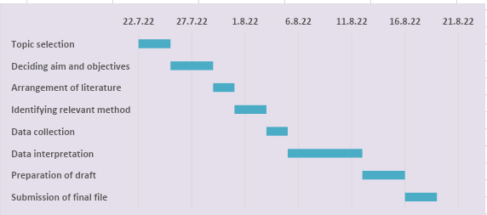

Figure 3.9.2: Gantt chart
(Source: Created by the learner)

3.10 Ethical Considerations
Research ethics is one of the most important sections of the overall research methodology because it helps in comply with all the researcher laws and regulations to be utilised for the conduction of interviews and surveys. In the case of this research project, the answers of some of the respondents were deemed to be sensitive and, in this regard, the “Data Privacy Act 2018” of the UK has been followed. This privacy act is related to addressing as well as protecting the confidential entities of the participants to make fair, transparent, and lawful utilisation of personal data and information (ico.org.uk, 2021).

3.11 Summary
It can be summarised from the above research report that to complete the overall research project, interviews, as well as surveys, have been conducted in order to aid in the collection of data sets. In a similar context, both primary and secondary research methods have been used for the efficient collection and interpretation of data sets.

Chapter 4: Findings and Analysis

4.1 Introduction
The “Findings and Analysis Section” of the research study aims to focus on illustrating the results and findings of the entire research work. The findings section has included data from two sources such as primary and secondary. The primary data have been exhibited in the form of survey questionnaires and interview questionnaires. On the other hand, the secondary findings have been exhibited in the form of thematic analysis. Both the survey and interview processes have been conducted while complying with all the aspects of research ethics.

4.2 A brief introduction outlining how the research went, the issues and shortcomings, and the challenges encountered during the research.
In this research study, a total of thirteen female employees working at Morrisons have been chosen to participate in the survey process. On the other hand, two mid-level female managers have been selected to participate in the entire interview process. The survey questionnaires have been sent to all thirteen participants through the mail. Moreover, while conducting the interview process, it has been observed that the answers of the participants contained some sensitive responses and thus, the “Data Privacy Act 2018” of the UK has been followed for maintaining confidentiality and anonymity.

4.3 Data collection

4.3.1 Survey

Q1. What is your age?
“Responses” | “Percentage of respondents” | “Number of  respondents” | “Total Number of  respondents”
21-30 | 55% | 7 | 13
31-45 | 30% | 3 | 13
46-60 | 15% | 3 | 13

Table 4.3.1.1: Age of the participants
(Source: Created by the learner)

Q2. What is your gender?
“Responses” | “Percentage of respondents” | “Number of  respondents” | “Total Number of  respondents”
Male | 40% | 5 | 13
Female | 55% | 5 | 13
Others | 5% | 3 | 13

Table 4.3.1.2: Gender of the participants
(Source: Created by the learner)

Q3. For how many years are you working at Morrisons?
“Responses” | “Percentage of respondents” | “Number of  respondents” | “Total Number of  respondents”
0-10 years | 50% | 4 | 13
11-20 years | 40% | 6 | 13
More than 20 years | 10% | 3 | 13

Table 4.3.1.3: Experience of the participants
(Source: Created by the learner)

Q4. Do you think that women play a huge role in managerial positions?
“Responses” | “Percentage of respondents” | “Number of  respondents” | “Total Number of  respondents”
Yes | 65% | 7 | 13
No | 20% | 4 | 13
Not Sure | 15% | 2 | 13

Table 4.3.1.4: Number of employees who know about women managerial positions
(Source: Created by the learner)

Q5. Do you think Morrisons follow workplace equality
“Responses” | “Percentage of respondents” | “Number of  respondents” | “Total Number of  respondents”
Yes | 70% | 5 | 13
No | 25% | 6 | 13
Not Sure | 5% | 2 | 13

Table 4.3.1.5: Workplace equality at Morrisons
(Source: Created by the learner)

Q6. Do you think that the company is being benefitted from hiring women employees?
“Responses” | “Percentage of respondents” | “Number of  respondents” | “Total Number of  respondents”
Yes | 80% | 9 | 13
No | 5% | 2 | 13
Not Sure | 5% | 2 | 13

Table 4.3.1.6: Hiring of women employees
(Source: Created by the learner)

Q7. Do you think that organisational performance is being degraded by recruiting women employees?
“Responses” | “Percentage of respondents” | “Number of  respondents” | “Total Number of  respondents”
Yes | 30% | 4 | 13
No | 50% | 6 | 13
Not Sure | 20% | 3 | 13

Table 4.3.1.7: Organisational Performance at Morrisons
(Source: Created by the learner)

Q8. Do you think that the “Gender Pay Opportunity” plays a huge role in diverse employment?
“Responses” | “Percentage of respondents” | “Number of  respondents” | “Total Number of  respondents”
Yes | 55% | 7 | 13
No | 35% | 4 | 13
Not Sure | 10% | 2 | 13

Table 4.3.1.8: Role of Gender Pay Opportunity
(Source: Created by the learner)

Q9. Do you think the inclusion of female employees in managerial positions should also be considered by other companies?
“Responses” | “Percentage of respondents” | “Number of  respondents” | “Total Number of  respondents”
Yes | 75% | 8 | 13
No | 15% | 4 | 13
Not Sure | 10% | 1 | 13

Table 4.3.1.9: Workplace Equality in other companies other than Morrisons
(Source: Created by the learner)

Q10. Do you think Morrisons has been facing challenges due to women employment?
“Responses” | “Percentage of respondents” | “Number of  respondents” | “Total Number of  respondents”
Yes | 35% | 3 | 13
No | 60% | 7 | 13
Not Sure | 5% | 3 | 13

Table 4.3.1.10: Challenges due to women employment
(Source: Created by the learner)

4.3.2 Interview
“Number of Participants” | “What are the advantages that Morrisons has been gaining through women employment?” | “What are the viewpoints of the male employees in regard to the role of women in management positions at Morrisons?”
Mid-level Manager 1 | “As per my opinion, I would like to mention that female employees are more advanced in solving confrontational matters in a more efficient way that occurs within an organisation. Moreover, an increased quality between men and women in the workplace results in positive and liable outcomes within the employment industry.” | I have an experience of more than 20 years with Morrisons and thus, would like to say that female employees should be recruited for management positions because they are unable to manage elevated levels of workload and stress in a corporate environment.
Mid-level Manager 2 | I have been working with Morrisons for more than 10 years and I would like to state that the recruitment of female employees in managerial positions has been degrading the organisational performance. This can be attributed to the fact that female employees are unable to oversee high levels of work. | I have an experience of only 5 years with Morrisons and thus, can clearly say that the female employees are more efficient in handling jobs and responsibilities as compared to their male counterparts. this can be attributed to the fact that female managers consider all the grievances of the employees in a much calmer way and thus, helps in resolving confrontational matters.

Table 4.3.2.1: Interview Table
(Source: Created by the learner)

4.4 Analysis of Primary Data through survey results
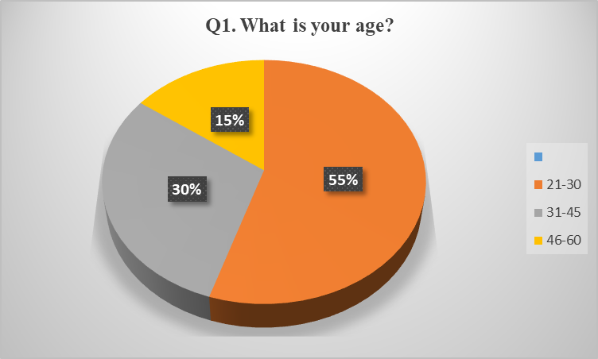

Figure 4.4.1: Age of the participants
(Source: Created by the learner)
In this question, the researchers got mixed responses from the participants which ensured that the diverse age group of respondents have been selected for the survey process. The conduction of the survey has revealed that approximately 55% of the participants belonged to the age group of 21-30 years whereas almost 30% of the population belonged to the age group of 31-45 years. In addition, only 15% of the respondent population had 46-60 years of age. This indicates that Morrisons believe in hiring young employees to drive organisational performance.
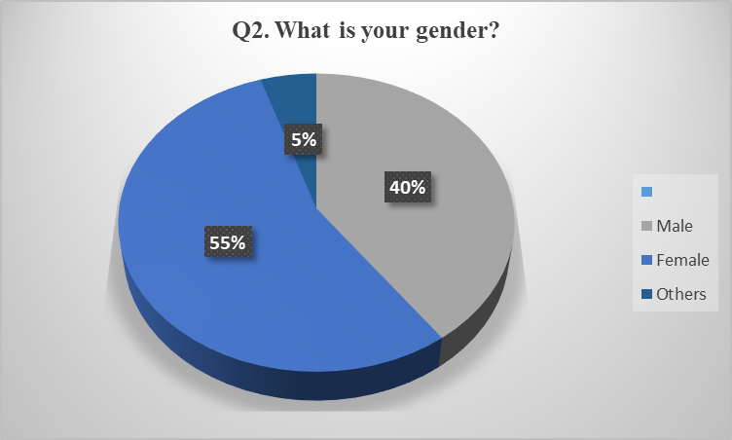

Figure 4.4.2: Gender of the participants
(Source: Created by the learner)
In the case of analysing the genders of the participants, it has been observed that almost 55% of the employees were female while 40% of the employees working at Morrisons were male employees. However, other gender groups are also included as employees with a minimum of 5% proportion at Morrisons. This survey result shows that Morrisons is committed to the aspects of “Diversity and Inclusion” by hiring more female employees to reduce confrontational matters and thus, help in fostering interaction between the employees.
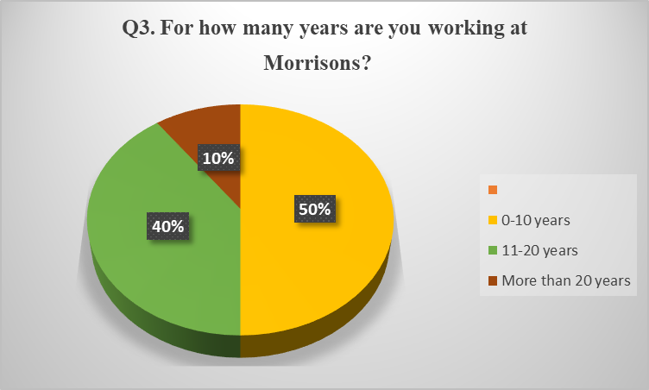

Figure 4.4.3: Experience of the participants
(Source: Created by the learner)
In terms of asking about their experience at Morrisons, it has been seen that almost 50% of the employees are new to the organisation with only 0-10 years of experience. On the other hand, approximately 40% of the participants claimed that they have an experience of 11-20 years whereas only 10% of them confirmed that they are working at Morrisons for more than 20 years. This result indicates that only a few of the employees have experienced the increasing and improving roles of women in managerial positions along with the development of the organisation by hiring more female employees.
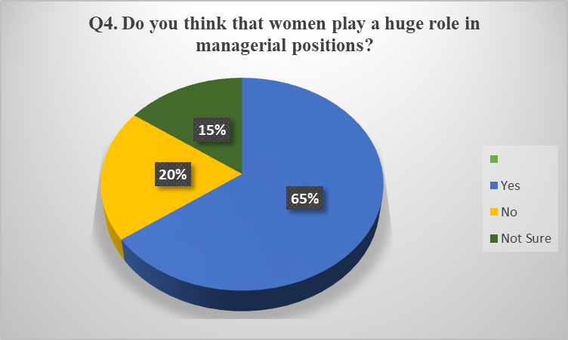

Figure 4.4.4: Number of employees who know about women managerial positions
(Source: Created by the learner)
In this survey questionnaire, the participants have been asked about the role of women in managerial positions of the concerned organisation. In this context, it has been observed that more than 65% of the employees know and are convinced of the role of women in management positions. Merely 20% of the participants are not convinced with the increasing role of women in managerial positions along with 15% of the participants who are not sure about the concept. This indicates that employees at Morrisons are convinced of the role of women in managerial positions because this approach increases organisational collaboration with the inclusion of advancing diversity, strong leadership, and peer collaboration.
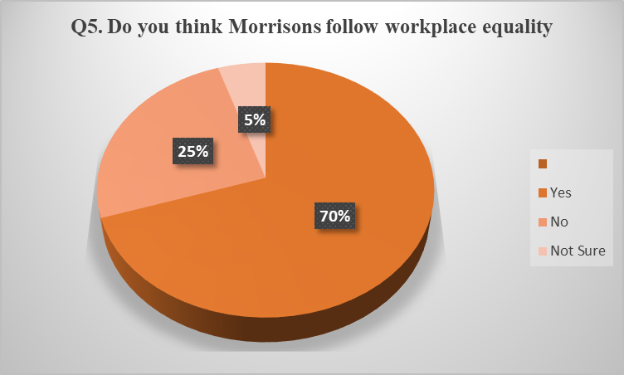

Figure 4.4.5: Workplace equality at Morrisons
(Source: Created by the learner)
In this question, the participants are asked about the concept of workplace equality and whether this approach is followed at Morrisons. In this regard, it has been observed that more than 70% of the respondents have agreed that Morrisons follow the rule of workplace equality while only 25% have claimed that they are suffering from instances of workplace inequality. The other 5% of the employees stated that since they are new to the organisation, they are not sure about the concept of workplace equality. In this regard, it has been seen that Morrisons follows the concept of workplace equality and thus, has been successful in tackling usual challenges that are related to confrontational matters and the health of women employees.
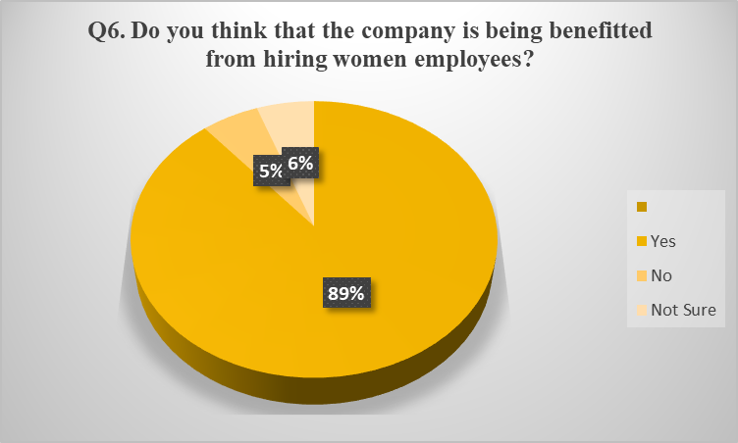

Figure 4.4.6: Hiring of women employees
(Source: Created by the learner)
In terms of asking this question, it has been observed that almost all of the 13 participants accounting for nearly 89% have agreed to the fact that Morrisons have benefited due to the recruitment of women employees. However, only 11% of the respondents responded to this question by saying that they do not know about the benefits that the organisation has achieved. Thus, this survey result shows that Morrisons have received huge benefits in accordance with the recruitment of female employees in terms of “Growth in Employee Engagement” and “Improvement in Financial Issues.”
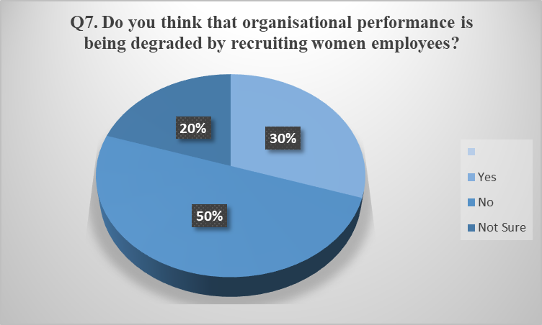

Figure 4.4.7: Organisational Performance at Morrisons
(Source: Created by the learner)
In terms of analysing the disadvantages of the role of women in management positions through survey questions, it has been seen that more than 50% of the participants have stated that organisational performance is not being degraded by the hiring of female employees. On the contrary, only 30% of the proportion has agreed that the organisational performance is being degraded due to women taking on management positions. In this regard, it has been observed that Morrisons has been successful in complying with the concept of “Diversity and Inclusion.”
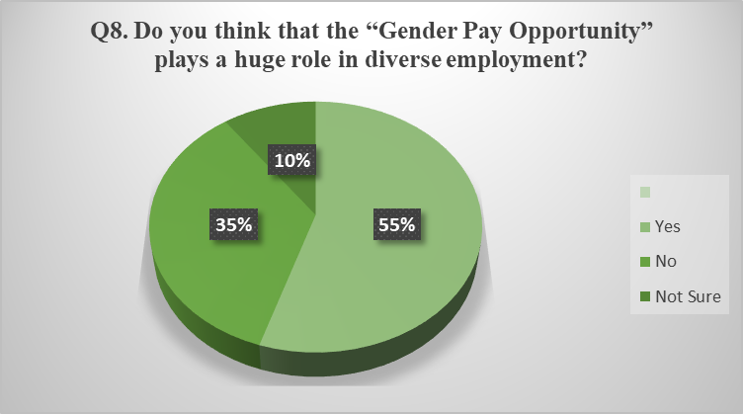

Figure 4.4.8: Role of Gender Pay Opportunity
(Source: Created by the learner)
The researcher has asked this question to all the thirteen participants to address the rate of “Gender Pay Opportunities” that is implied at Morrisons. The survey results have shown that almost 55% of the employees have agreed that “Gender Pay Opportunities” is fully followed at Morrisons which gives rise to the concept of “Equal Gender Pay”. On the converse front, only 35% of the female employees have claimed that they are not paid equally as compared to their male colleagues. A mere 10% of the proportions have stated that they are not sure of the “Gender Pay Opportunities” being followed in Morrisons. This result indicates that “Equal Gender Pay” have a positive impact on the broader concept of gender equality.
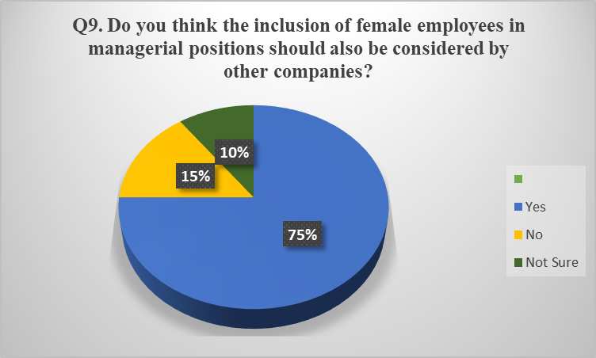

Figure 4.4.9: Inclusion of female employees in other companies other than Morrisons
(Source: Created by the learner)
In this survey questionnaire, the researcher has aimed to know about the importance of inclusion of female employees in other companies. In this regard, it has been observed that more than 75% of the participants have claimed that other companies must include female employees in their employment opportunity cell as well as in management positions. Conversely, only 15% of the respondents stated that there is no requirement of including female employees in the workplace. In this context, the survey results have indicated that the inclusion of female employees in the workplace will help in driving organisational performance through enhancing organisational collaboration and resolving confrontational matters.

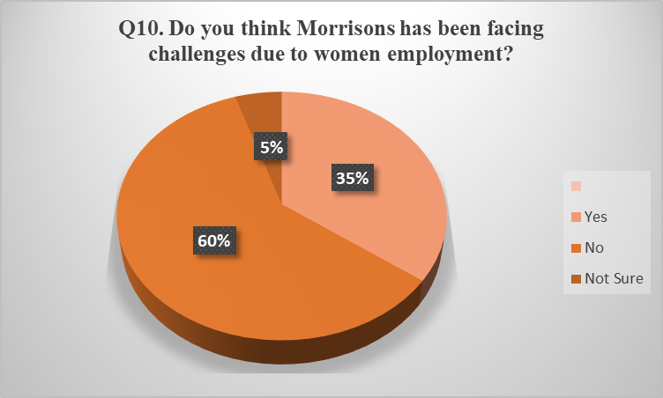

Figure 4.4.10: Challenges due to women employment
(Source: Created by the learner)
In this survey questionnaire, the researcher has asked about the challenges that Morrisons have been facing due to the recruitment of female employees in the management positions of the company. in line with this context, it has been observed that more than 60% of the employees have stated that Morrisons have been facing only minimum challenges regarding women employment. On the other hand, 35% of the female employees have claimed that Morrisons has been facing various challenges such as “Conflicts of Interest” arising due to arguments and work stress. in addition, only 5% of the women employees have stated that being new to the organisation, they are not sure or do not know about the challenges. This indicates that although Morrisons face challenges in terms of conflicting interests due to women employment, the organisation still is running successfully with the recruitment of women employees.

4.5 Analysis of Data through Interview results
The interview results have been observed to contain mixed responses from 2 mid-level female managers of Morrisons. According to the responses of Manager 1, it has been exhibited that Morrisons have benefitted from the recruitment of female employees in its management positions because of the fact that their role helps in driving organisational performance. However, Manager 2 who has an experience of more than 10 years has claimed that the organisational performance and effectiveness are being degraded due to the role of women in managerial positions. This is because female employees are often unable to handle high amounts of work.
In the case of analysing the viewpoints of other employees, it has been observed that Manager 1 has stated that female employees should not be recruited for managerial positions recuse of the fact that they often get panicked due to workload pressures and thus, suffers from workplace stress. On the contrary, Manager 2 has stated that there should be an increased number of women employees in management positions to resolve the grievances of other employees in a much calmer way.

4.6 Analysis of Secondary Data
NAME OF THEME | AUTHOR | NAME OF THE ARTICLE | YEAR | FINDINGS
Role of women in management positions in Morrisons | “Wikaningrum, T. and Yuniawan, A  Elias, E” | “The relationships among leadership styles, communication skills, and employee satisfaction: A study on equal employment opportunity in leadership”  “Lessons learned from women in leadership positions” | 2018  2020 | In the first article, the women leadership in retail organisations have been studied to support “Equal Employment Opportunities”.  In the second research article, the study has assessed gender-based challenges in terms of recognising the outcomes of organisational performance.
Advantages and challenges of recruiting women in management position | “Fine, C., Sojo, V. and Lawford‐Smith, H  Hmoud, B. and Laszlo, V” | “Why Does Workplace Gender Diversity Matter? Justice, Organizational Benefits, and Policy”  “Will Artificial Intelligence Take Over Human Resources Recruitment and Selection?” | 2020  2019 | The former article has dealt with the organisational benefits of “Workplace Gender Diversity” to assess the behavioural outcomes.  The latter research article has analysed the role of AI and ML in the recruitment of female employees.
Ways of solving issues women face in managerial positions of Morrisons | “Topić, M  Fernandez-Mateo, I. and Kaplan, S” | “Introduction to special issue: women and leadership in public relations”  “Gender and Organization Science: Introduction to a Virtual Special Issue” | 2021  2018 | In Article 1, diversity is an issue and have analysed the sufferings of women employees in management positions.  In Article 2, gender differences and their outcomes have been analysed to assess their leadership roles as compared to previous times.

Table 4.7.1: Interview Table
(Source: Created by Learner)

Analysis
Theme 1: Role of women in management positions in Morrisons
According to the comments of Wikaningrum and Yuniawan (2018), in accordance with the leadership styles, female employees can run their “Task-oriented Leadership” in a much efficient way without avoiding the aspects of a good relationship with their employees. However, Elias (2018) has stated that women employees often become too close in supporting their employees in accordance with tier grievances which results in the emergence of a “Pervasive Fear” of failure. In this context, it has been observed that the positive association of female employees with organisational performance and employee productivity has been considered to be essential for the maintenance of corporate governance.
Theme 2: Advantages and challenges of recruiting women in management position
“Gender Diversity Initiatives” are controversial which often gives rise to concerns that are related to unfair treatment of the female gender. In this regard, Fine et al., (2020) have commented that physical differences between men and women focus on the emergence of implications that women employees are less able to bear workload pressure and work stress while being in managerial positions. Thus, the concept of “Gender Parity” should be observed as a critical strategy for maintaining business imperatives in terms of minimising gender differences. On the contrary, Hmoud and Laszlo (2019) have argued that the use of technological advances such as “Artificial Intelligence” (AI) and “Machine Learning” (ML) provides a strong solution for the efficient recruitment of women employees. It has been predicted that the utilisation of technologies will help in the recruitment of women employees not on the basis of their physical appearance but on the basis of their “Intelligence Quotient” (IQ) level.
Theme 3: Ways of solving issues women face in managerial positions of Morrisons
In the contemporary days, women in managerial positions often face “Gender Diversity Issues” in terms of achieving their job aims and objectives. Topić (2021) has opined that in order to tackle these issues, organisations must be able to address gender-related barriers as well as the pay gap challenges. Moreover, it has been found that women employees often struggle to progress to leadership positions which exhibits the levels of inequalities at different organisations. In this regard, global organisations must follow the development of an inclusive environment to mitigate gender-related issues. On the other hand, Fernandez-Mateo and Kaplan (2018) have contradicted that gender-related biases can only be mitigated through the implementation of a “Fair Compensation Practice”.

4.7 Summary
It can be summarised from the overall research work that most of the employees at Morrisons have agreed on the fact that gender and workplace equality plays a huge role in maintaining an inclusive and conducive working environment.

Chapter 6: Conclusion, Recommendation, and Reflection

6.1 Introduction
In this section of the research study, an overall summary of the findings has been presented along with a brief discussion of the overall research process. The present chapter has also covered a section of suitable recommendations to suggest the chosen company for the possible methods of mitigating the issues of gender inequality. In addition, linking with objectives along with a section of personal reflection has also been added.

6.2 Conclusion
The third chapter of the methodology section has dealt with the selection of various methodological tools and techniques to aid in the overall research conduction process. The present research study has been done by gathering primary as well as secondary quantitative data that is followed by pragmatism philosophy, deductive approach, and primary and secondary research strategy. Moreover, in this current research topic, the primary data have been collected through both interviews and surveys. In addition, the results of the interviews have been analysed through purposive sampling and the results of the survey have been analysed through random sampling. Finally, the discussion and analysis section has been covered in the fourth chapter followed by a conclusion section that has included a recommendation, objectives linking, and personal reflection. Furthermore, recommendations have been made based on the findings of the research.

6.3 Linking with Objectives
The first objective “To analyse the role of women in management positions within Morrison’s” has been linked in Chapter 2 under the sub-section 2.3.2 along with its further explanation in Chapter 4 under sub-sections 4.3, 4.4, and 4.5
The second objective “To obtain the present trends and advantages of women working in management positions at Morrison’s” has been met in Chapter 2 under the sub-point 2.3.3 and is further explained in Chapter 4 under sub-points 4.3, 4.4, 4.5, and 4.6.
The third objective “To identify the mitigation strategies for the issues women employees face working in management positions at Morrison’s” has been met in Chapter 2 under sub-heading 2.3.5 and is further explained in Chapter 4 under sub-headings 4.3, 4.4, 4.5, and 4.6.

6.4 Recommendations
Based on the research work, it can be recommended to the researchers that
- In order to mitigate the issues of gender inequality at the workplace, organisations and their Human Resource Departments must follow the concept of “Gender Pay Opportunities” as well as “Equal Gender Pay” in terms of reducing the instances of gender gap and differences.
- Furthermore, from the comprehensive research report, it has been observed that the newly hired employees do not know the concept of gender equality being followed at Morrisons. Thus, to make them aware of the gender gap issues along with their possible solutions at Morrisons, a brochure must be provided to the new employees with the inclusion of contents regarding “Gender Differences” and “Gender Gap”.
On the basis of the entire research work, it can be recommended to Morrisons that
- In order to overcome the entire issue of gender inequality, the development of the policies of “Equal Pay Claim” will help the company in providing justice to the women population of the company in terms of making pay claims as per their workload.
- The implementation of different technological advances such as AI and ML will help the HR department in recruiting female employees on the basis of IQ levels and not on the basis of their physical appearance or physical abilities.

6.5 Reflection
Gibbs Reflective Cycle
The reflection part of the present research project has been done by following the components of the “Gibb’s Reflective Cycle.” The six components of this reflective cycle include “Description, Feelings, Evaluation Analysis, Conclusion, Action Plan”.
Description
The entire research work has enabled me to understand and gain knowledge of the concept of gender equality and its importance in the workplace. In this regard, it has been observed that the consideration of “Diversity and Inclusion” within an organisation to drive organisational performance. At Morrisons, it can be seen from the study more than half of the female employees have been working in managerial positions which have delivered a strong message to the targeted customers of Morrisons that the management is more representative of their female customers and female employees. I have also learned from the study that more than 60% of the workforce of Morrisons is made up of female employees who have been working closely with families and carers and thus, have been increasing the work streamlining in management and senior roles positions.
Feelings
In the comprehensive research report, I learned that I was less aware of the role of women in managerial positions who are working at Morrisons. In this context, this research has helped me in understanding the role of women in accordance with the corporate governance department of Morrisons. Moreover, the research project has cleared my perception that women play a huge role while designating themselves in managerial positions. I have also learned that Morrisons believes in the concept of “Diversity and Inclusion” and thus, recruits’ women in more significant numbers in order to take part in the managerial position of the company. Furthermore, I have come to know many positive as well as negative sides of recruiting women in managerial positions in accordance with different organisations. In line with this context, it has been observed that workplace equality shares a direct positive relationship with the concept of “Gender equality” and “Gender Pay Opportunities”. Moreover, according to the statistical data, it has been observed that approximately 70% of global companies are in direct compliance with “Equal Gender Pay” resulting in a positive impact on the perspectives of gender equality.

Evaluation
Although women play a huge role as senior managers in Morrisons and have also helped in driving organisational performance, I have observed that they also face negative outcomes while working in management positions. I have been able to link this issue to the fact that because of extensive workload and work stress, these female employees often face the issue of work-life balance and thus, do not get enough time for their families. Moreover, female senior managers struggle from immense pressure that arises due to “Conflicts of Interests,” arguments, and disagreements. In addition, I have also experienced that female employees at lower levels working at Morrisons have complained that they suffer from the issues of “Equal Pay Opportunities” because their work and jobs are not recognised and given value as compared to their male counterparts.
Analysis
It can be analysed from the entire research report that workplace equality shares a direct and positive relationship with “Lack of Discrimination” which is also associated with fair treatment of employees regardless of their race, gender, religion, age, disability, and nationality. I have also compared that companies that consider “Diversity and Inclusion” at their workplace the entire employee base, have been able to outperform their competitors in terms of organisational performance and employee productivity. Moreover, it has also been analysed that inclusion and diversity are two related factors that help in the attraction as well as retention of skilled and talented female employees for a longer period of time. In line with this context, I have conducted a survey which has helped in analysing the fact that to create an inclusive and conducive working environment, the leaders and the managers of both genders are required to remove any instances of discrimination from the working environment.
Conclusion
It can be concluded from the comprehensive research work that Morrisons follows workplace equality to a greater extent which can be determined from the evidence that 60% of the workforce consists of female employees in both junior and senior managerial positions. Moreover, I have seen from the survey results that female employees have agreed with the fact that other companies should be able to follow workplace equality to drive organisational performance. This can only be achieved through the implementation of an “Equal Pay Claim” for the entire employee base.

Action Plan
ACTIVITIES | HOW TO IMPROVE | RESOURCES | TIME FRAME
Communications Skills | Improvement in verbal communication skills is required to collect data from the respondents more efficiently | - Reading blogs about communication skills  - Regular video conferencing with employees | 2 months
Listening Skills | Visualising the responses from the participants can help in improving the listening skills as a researcher | - Online Lyrics Training  - Listening and writing of responses | 2 months
Information Analysis Skills | Participating in analysis-based student projects can help in improving information analysing skills as a researcher | - Solving problems related to gender equality | 3 months

Table 6.5.1: Action Plan
(Source: Created by Learner)

Reference List and Bibliography

- Abutabenjeh, S. and Jaradat, R., 2018. Clarification of research design, research methods, and research methodology: A guide for public administration researchers and practitioners. Teaching Public Administration, 36(3), pp.237-258.
- Acas.org.uk. 2022.Improving equality, diversity, and inclusion in your workplace. [Online] Available at:<https://www.acas.org.uk/improving-equality-diversity-and-inclusion#:~:text=Equality%20in%20the%20workplace%20means,law%20:> [Accessed on 22nd July, 2022]
- Al-Ababneh, M.M., 2020. Linking ontology, epistemology, and research methodology. Science & Philosophy, 8(1), pp.75-91.
- Ali, M.A. and Salisu, Y., 2019. Women entrepreneurship and empowerment strategy for national development. Journal of Economics, Management and Trade, 22(3), pp.1-13.
- Asda.com.2022. [Online] Available at:<https://www.asda.com/about:> [Accessed on 22nd July 2022]
- Bark, 2021. Diversity and inclusion in UK retail: where are we now and what comes next. [Online] Available at:< https://brc.org.uk/media/677267/diversity-and-inclusion-in-uk-retail-in-depth-research-and-analysis-from-brc-the-mbs-group-and-pwc-2021-002.pdf:> [Accessed on 17th August, 2022]
- Barrientos, S., 2019. Gender and work in global value chains: Capturing the gains. Cambridge University Press.
- Barrientos, S., Bianchi, L. and Berman, C., 2019. Gender and governance of global value chains: Promoting the rights of women workers. International Labour Review, 158(4), pp.729-752.
- Bbc.com.2021. Tesco staff win legal argument in equal pay fight. [Online] Available at:<https://www.bbc.com/news/business-57343892:> [Accessed on 22nd July 2022]
- Becky Frankiewicz, 2020. Five ways we lack gender balance in the workplace. [Online] Available at: https://www.weforum.org/agenda/2020/01/5-ways-companies-can-progress-more-women-into-leadership-roles/:> [Accessed on 17th August, 2022]
- Bell, E., Meriläinen, S., Taylor, S. and Tienari, J., 2019. Time’s up! Feminist theory and activism meets organization studies. human relations, 72(1), pp.4-22.
- Benstead, L.J., 2021. Conceptualizing and measuring patriarchy: The importance of feminist theory. Mediterranean Politics, 26(2), pp.234-246.
- Bicquelet-Lock, A., Divine, J. and Crabb, B., 2020. Women and Planning.
- Bilan, Y., Mishchuk, H., Samoliuk, N. and Mishchuk, V., 2020. Gender discrimination and its links with compensations and benefits practices in enterprises. Entrepreneurial Business and Economics Review, 8(3), pp.189-203.
- Bleiker, J., Morgan-Trimmer, S., Knapp, K. and Hopkins, S., 2019. Navigating the maze: Qualitative research methodologies and their philosophical foundations. Radiography, 25, pp.S4-S8.
- Busetto, L., Wick, W. and Gumbinger, C., 2020. How to use and assess qualitative research methods. Neurological Research and practice, 2(1), pp.1-10.
- Castro-Alonso, J.C., Wong, M., Adesope, O.O., Ayres, P. and Paas, F., 2019. Gender imbalance in instructional dynamic versus static visualizations: A meta-analysis. Educational Psychology Review, 31(2), pp.361-387.
- Chang, E.H. and Milkman, K.L., 2020. Improving decisions that affect gender equality in the workplace. Organizational Dynamics, 49(1), p.100709.
- Clark, D., 2021. Gender pay gap in the UK 2021, by sector. Available at: https://www.statista.com/statistics/760342/gender-pay-gap-uk-by-sector/ [Accessed on: 21 October 2022]
- Clark, D., 2021. To what extent do you think the following actions would make a positive impact to achieving gender equality? Available at: https://www.statista.com/statistics/991418/gender-equality-actions-in-great-britain/ [Accessed on: 21 October 2022]
- Clark, D., 2022. Gender inequality in the UK - Statistics & Facts. Available at: https://www.statista.com/topics/5273/gender-inequality-in-the-uk/#:~:text=In%202022%2C%20the%20United%20Kingdom,powers%20with%20a%20female%20leader. [Accessed on: 21 October 2022]
- Clark, D., 2022. Proportion of women in managerial positions worldwide 1991-2020. Available at: https://www.statista.com/statistics/1259478/women-in-managerial-positions-worldwide/ [Accessed on: 21 October 2022]
- Clark, D., 2022. Share of female held leadership positions in FTSE companies UK 2021. Available at: https://www.statista.com/statistics/685195/share-of-female-ceo-positions-in-ftse-companies-uk/ [Accessed on: 21 October 2022]
- Cr, K., 2020. Research methodology methods and techniques.
- Cr, K., 2020. Research methodology methods and techniques.
- Cr.aldisouthgroup.com.2021. ALDI GB/IE signs UN Women’s Empowerment Principles. [Online] Available at:<https://cr.aldisouthgroup.com/en/responsibility/news/aldi-gbie-signs-un-womens-empowerment-principles:> [Accessed on 22nd July, 2022]
- Davila Delgado, J.M., Oyedele, L., Beach, T. and Demian, P., 2020. Augmented and virtual reality in construction: drivers and limitations for industry adoption. Journal of Construction Engineering and Management, 146(7), p.04020079.
- Dewidar, O., Elmestekawy, N. and Welch, V., 2022. Improving equity, diversity, and inclusion in academia. Research Integrity and Peer Review, 7(1), pp.1-10.
- Ekaterina Netchaeva., 2022. Research shows many women do not desire to scale the corporate ladder, especially in male dominated fields. Can smarter diversity initiatives help? [Online] Available at:https://www.bbc.com/worklife/article/20220718-the-aspiration-gap-why-many-women-aim-lower-than-men: [Accessed on 17th August, 2022]
- Elias, E., 2018. Lessons learned from women in leadership positions. Work, 59(2), pp.175-181.
- Ellis, N.C., 2019. Essentials of a theory of language cognition. The Modern Language Journal, 103, pp.39-60.
- Fernandez-Mateo, I. and Kaplan, S., 2018. Gender and organization science: Introduction to a virtual special issue. Organization Science, 29(6), pp.1229-1236.
- Fine, C., Sojo, V. and Lawford‐Smith, H., 2020. Why does workplace gender diversity matter? Justice, organizational benefits, and policy. Social Issues and Policy Review, 14(1), pp.36-72.
- Fine, C., Sojo, V. and Lawford‐Smith, H., 2020. Why does workplace gender diversity matter? Justice, organizational benefits, and policy. Social Issues and Policy Review, 14(1), pp.36-72.
- Forbes, 2019. 14 Characteristics of A Gender-Equal Business Culture. Available at: https://www.forbes.com/sites/forbescoachescouncil/2019/02/11/14-characteristics-of-a-gender-equal-business-culture/?sh=13479b441666 [Accessed on: 21 October 2022]
- Gabriel, A.S., Podsakoff, N.P., Beal, D.J., Scott, B.A., Sonnentag, S., Trougakos, J.P. and Butts, M.M., 2019. Experience sampling methods: A discussion of critical trends and considerations for scholarly advancement. Organizational Research Methods, 22(4), pp.969-1006.
- García Johnson, C.P. and Otto, K., 2019. Better together: A model for women and LGBTQ equality in the workplace. Frontiers in psychology, 10, p.272.
- García‐Sánchez, I.M., Oliveira, M.C. and Martínez‐Ferrero, J., 2020. Female directors and gender issues reporting: The impact of stakeholder engagement at country level. Corporate Social Responsibility and Environmental Management, 27(1), pp.369-382.
- Gov.uk.2022.UK Commission on the Status of Women - National Statement. [Online] Available at:<https://www.gov.uk/government/news/uk-commission-on-the-status-of-women-national-statement#:~:text=The%20United%20Kingdom%20Government%20is,our%20right%20to%20be%20equal:> [Accessed on 22nd July, 2022]
- Grissom, A.R., 2018. Workplace diversity and inclusion. Reference & User Services Quarterly, 57(4), pp.242-247.
- Hardacre, S.L. and Subašić, E., 2018. Whose issue is it anyway? The effects of leader gender and equality message framing on men’s and women’s mobilization toward workplace gender equality. Frontiers in psychology, 9, p.2497.
- Hardaker, S.L. and Subasi, E., 2018. Whose issue is it anyway? The effects of leader gender and equality message framing on men’s and women’s mobilization toward workplace gender equality. Frontiers in psychology, 9, p.2497.
- Hasan, M.R., Bueno, P.B. and Corner, R.A., 2020. Strengthening, empowering, and sustaining small-scale aquaculture farmers' associations. FAO Fisheries and Aquaculture Technical Paper, (655), pp.I-181.
- Hmoud, B. and Laszlo, V., 2019. Will artificial intelligence take over human resources recruitment and selection. Network Intelligence Studies, 7(13), pp.21-30.
- Hochbein, C. and Smeaton, K.S., 2018. An Exploratory Analysis of the Prevalence of Quantitative Research Methodologies in Journal Articles. International Journal of Education Policy and Leadership, 13(11), p.n11.
- Horowitz, J.M., Igielnik, R. and Parker, K., 2018. Women and leadership 2018. Pew Research Centre, 20.
- ico.org.uk, 2021. About the DPA 2018. Available at: https://ico.org.uk/for-organisations/guide-to-data-protection/introduction-to-data-protection/about-the-dpa-2018/ [Accessed on: 05 November 2022]
- Ilo.org.2022. Women in leadership bring better business performance. [Online] Available at:<https://www.ilo.org/global/about-the-ilo/newsroom/news/WCMS_701767/lang--en/index.htm:> [Accessed on 22nd July, 2022]
- Krivkovich, A., Liu, W., W., Nguyen, H., Rambachan, I., Robinson, N., Williams, M., and Yee, L., 2022. Women in the Workplace 2022. Available at: https://www.mckinsey.com/featured-insights/diversity-and-inclusion/women-in-the-workplace [Accessed on: 21 October 2022]
- Maarouf, H., 2019. Pragmatism as a supportive paradigm for the mixed research approach: Conceptualizing the ontological, epistemological, and axiological stances of pragmatism. International Business Research, 12(9), pp.1-12.
- Madsen, S.R., Townsend, A., and Scribner, R.T., 2020. Strategies that male allies use to advance women in the workplace. The Journal of Men’s Studies, 28(3), pp.239-259.
- Makoni, K. and Kasak-Gliboff, H., 2021. The effects of ideological value framing and symbolic racism on pro-environmental behaviour. Scientific reports, 11(1), pp.1-10.
- McDowell, L., 2020. Looking for work: youth, masculine disadvantage, and precarious employment in post-millennium England. Journal of Youth Studies, 23(8), pp.974-988.
- Morrisons, 2022. Home. Available at: https://groceries.morrisons.com/ [Accessed on: 21 October 2022]
- Morrisons, 2022. Looking after our colleagues. Available at: https://www.morrisons-corporate.com/morrisons-sustainability/people/colleagues/#:~:text=We%20ensure%20that%20all%20leaders,almost%2060%25%20of%20our%20workforce. [Accessed on: 21 October 2022]
- Morrisons, 2022. Morrisons Commits to Unlocking Female Talent. Available at: https://www.morrisons-corporate.com/media-centre/corporate-news/morrisons-commits-to-unlocking-female-talent-/ [Accessed on: 21 October 2022]
- Morrisons, 2022. Register for the Morrisons Equal Pay Claim today. Available at: https://morrisons.payjustice.co.uk/#:~:text=The%20Morrisons'%20Equal%20Pay%20Claim,this%20is%20disputed%20by%20Morrisons). [Accessed on: 21 October 2022]
- Morrisons-corporate.com.2022. About Us. [Online] Available at:<https://www.morrisons-corporate.com/about-us/:> [Accessed on 22nd July 2022]
- Naji, G.M.A., Isha, A.S.N., Al-Mekhlafi, A.B.A., Sharafaddin, O. and Ajmal, M., 2020. Implementation of leading and lagging indicators to improve safety performance in the upstream oil and gas industry. J. Crit. Rev, 7, pp.265-269.
- Naoum, S.G., Harris, J., Rizzuto, J. and Egbu, C., 2020. Gender in the construction industry: Literature review and comparative survey of men’s and women’s perceptions in UK construction consultancies. Journal of management in engineering, 36(2), p.04019042.
- Newman, M. and Gough, D., 2020. Systematic reviews in educational research: Methodology, perspectives, and application. Systematic reviews in educational research, pp.3-22.
- Opara, V., Sealy, R., and Ryan, M.K., 2020. The workplace experiences of BAME professional women: Understanding experiences at the intersection. Gender, Work & Organization, 27(6), pp.1192-1213.
- Opoku, A. and Williams, N., 2018. Second-generation gender bias: An exploratory study of the women’s leadership gap in a UK construction organisation. International journal of ethics and systems.
- Parker, J. and Donnelly, N., 2020. The revival and refashioning of gender pay equity in New Zealand. Journal of Industrial Relations, 62(4), pp.560-581.
- Patel, M. and Patel, N., 2019. Exploring Research Methodology. International Journal of Research and Review, 6(3), pp.48-55.
- Post, C., Latu, I.M. and Belkin, L.Y., 2019. A female leadership trust advantage in times of crisis: Under what conditions. Psychology of Women Quarterly, 43(2), pp.215-231.
- Ranjit, K., 2020. Research methodology.
- Researchbriefings.files.parliament.uk.2022. Women and the UK economy. [Online] Available at:<https://researchbriefings.files.parliament.uk/documents/SN06838/SN06838.pdf:> [Accessed on 22nd July, 2022]
- Sarstedt, M., Bengart, P., Shaltoni, A.M. and Lehmann, S., 2018. The use of sampling methods in advertising research: A gap between theory and practice. International Journal of Advertising, 37(4), pp.650-663.
- Schumann, C., Foster, J., Mattei, N. and Dickerson, J., 2020, May. We need fairness and explainability in algorithmic hiring. In International Conference on Autonomous Agents and Multi-Agent Systems (AAMAS).
- Scott, C., 2020. Managing and regulating commitments to equality, diversity, and inclusion in higher education. Irish Educational Studies, 39(2), pp.175-191.
- Serra, M., Psarra, S. and O’Brien, J., 2018. Social and physical characterization of urban contexts: Techniques and methods for quantification, classification, and purposive sampling. Urban Planning, 3(1), pp.58-74.
- Simon, Y.R., 2019. A general theory of authority. Pickle Partners Publishing.
- Snyder, H., 2019. Literature review as a research methodology: An overview and guidelines. Journal of business research, 104, pp.333-339.
- Statista.com.2022. Employment in services for women as a share of total female employment in the United Kingdom from 2000 to 2019. [Online] Available at:<https://www.statista.com/statistics/595457/services-employment-as-share-of-total-female-employment-united-kingdom-uk/#:~:text=The%20employment%20level%20in%20services,points%20when%20compared%20to%202000:> [Accessed on 22nd July, 2022]
- Statista.com.2022. Market share of grocery stores in Great Britain from January 2017 to June 2022. [Online] Available at:<https://www.statista.com/statistics/280208/grocery-market-share-in-the-united-kingdom-uk/:> [Accessed on 22nd July, 2022]
- Statista.com.2022. Share of female held leadership positions in FTSE companies in the United Kingdom in 2021. [Online] Available at:<https://www.statista.com/statistics/685195/share-of-female-ceo-positions-in-ftse-companies-uk/:> [Accessed on 22nd July, 2022]
- Statista.com.2022. [Online] Available at:<https://www.statista.com/statistics/280120/employment-rate-in-the-uk-by-gender/#:~:text=In%20the%20three%20months%20to,females%20it%20was%2072.3%20percent:> [Accessed on 22nd July, 2022]
- Tesco plc.com.2018. Career development opportunities for women. [Online] Available at:<https://www.tescoplc.com/updates/2018/career-development-opportunities-for-women/:> [Accessed on 22nd July, 2022]
- Topić, M., 2021. Introduction to special issue: women and leadership in public relations. Journal of Public Relations Research, 33(3), pp.131-135.
- Treanor, L. and Marlow, S., 2021. Paws for thought? Analysing how prevailing masculinities constrain career progression for UK women veterinary surgeons. Human Relations, 74(1), pp.105-130.
- Ud Din, N., Cheng, X. and Nazneen, S., 2018. Women’s skills and career advancement: a review of gender (in) equality in an accounting workplace. Economic research-Ekonomska istraživanja, 31(1), pp.1512-1525.
- Van Liar, C., Meeusen, L., Feldman, J., Van Groote, S., Stark, N. and Jacobs, C., 2019. Coping with stigma in the workplace: Understanding the role of threat regulation, supportive factors, and potential hidden costs. Frontiers in psychology, 10, p.1879.
- Wikaningrum, T. and Yuniawan, A., 2018. The relationships among leadership styles, communication skills, and employee satisfaction: A study on equal employment opportunity in leadership. Journal of Business and Retail Management Research, 13(1).
- Youssef, E., 2020. Role of social service institutions on social empowerment of women at the United Arab Emirates: A field analysis study. Multicultural Education, 6(4), pp.99-111.
- Žukauskas, P., Vveinhardt, J. and Andriukaitienė, R., 2018. Philosophy and paradigm of scientific research. Management culture and corporate social responsibility, 121.

