Introduction
The purpose of this report is to discuss how employers perform at communicating. I will be using findings from a friend’s real-life experience and suggest ways workplace communication can be improved. “Verbal and nonverbal communication among group members defines much team life. Individual goals, team goals, structure and norms are evident in the communication patterns that develop among members. Tasks are accomplished, and relationships managed through interpersonal interaction. Yet not all communication is positive and as a result team performance can be compromised. Communication skills are foundational for individual, team and organisational success (Kinnick & Parton 2005) for example oral communication and interpersonal skills are often citied as the most important criteria in evaluating job candidates”.
Griffiths, B.A. and Dunham, E.B. (Certificate in higher education skills for the workplace, 2017)
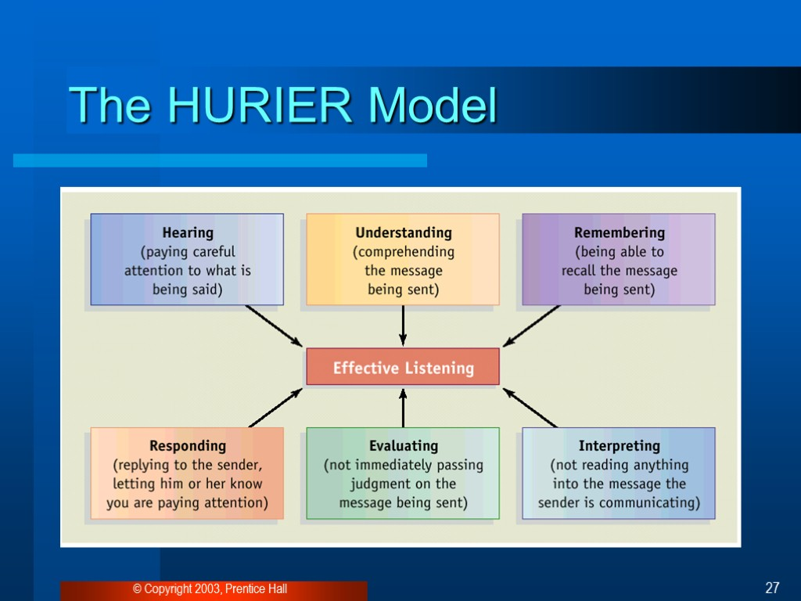
Quintanilla, K.M. and Wahl, S.T, (Certificate of higher education skills for the workplace, 2017). page no.100
There is another model of communication which is called “Shannon and Weaver Model of communication”. It was established in 1948 when Claude Elwood Shannon wrote an article “A Mathematical Theory of Communication” in “Bell System Technical Journal” (publication history 1922-1995) with Warren Weaver. The model is outstandingly described how to enhance the effective communication between sender and receiver. This model allocated with several convictions such as information source, Noise, Channel, transmitter, message, receiver, information destination, encoder and decoder. In communication Noise could be four types
which are: Semantic, Physical, Rhetoric, and Pragmatic.
Different type of communications:
Words play a small percentage of how we communicate with each other. However, this is often disregarded. I will explain four various types of communication, and how utilise them effectively can enhance performance, morale, teamwork and success in the workplace.
“Verbal (In-Person) Communication. Whenever possible, use face-to-face communication in the workplace to eliminate many of the misunderstandings that can occur. Speaking directly with someone in person allows both of you to see and hear the bigger picture. As you or your team member speak, you can see each other's facial expressions and body language. The emphasis on focusing on one another and the conversation promotes a feeling of value and credibility. You may think it will take longer for you to leave your office and walk to the other end of the building to speak face-to-face with someone. But having one quick conversation rather than a multitude of emails can make it more efficient in the end. Wheelan and her associates have developed a classification system called the Group Development Observation System GDOS as a way of categorizing and analysing the verbal interactions that take place among group members”.
(Wheelan, Davidson, and Tilin,2003). Certificate in higher education skills for the workplace 2017 Page no.48
“Body Language & Facial Expressions. As mentioned above, your body language and facial expressions play a vital role in how effective or ineffective you are at communicating with staff members. Eye contact makes people feel acknowledged as they talk and listen. A relaxed stance with your arms by your sides encourages employees to feel comfortable in a meeting. If you rehearse what you're going to say before a meeting, do so in front of a full-length mirror so you can see if what your body language says matches up with your words. Employees will receive your words more positively if your facial expressions and body language don't put them on edge or the defensive.
Phone Conversations. Use of the phone is a common part of most every business day. Some people enjoy talking to team members by phone. If the staff you lead is remote and spread out throughout the state, country or world, the phone will be a vital communication tool. You can positively impact the effectiveness of your phone communication by doing three simple things. Smile while you talk (in an appropriate conversation, of course); it sounds silly, but it gives your voice a friendlier tone. Take notes before the conversation and use them to ensure you cover all points. Finally, speak clearly and slowly so your words are understood.
Written Communication. Written communication acts as a permanent record of the organisation and can prove very useful for future references, emails, memos and notes are common forms of written communication. But there are some common disadvantages of written communications as well. Of all four communication styles, this is the one that can lead to the most misunderstandings.
People often read between the lines or feel that there are implied messages or emotions in written forms of communication. In a workplace situation, this should and can be avoided. Before someone send an email to someone employees, distribute a memo or post an important notice on the staff bulletin board, have an objective pair of eyes read it first”.
(MILLER RACHEL, www.sandler.com 2016)
My friend Salina works in Sainsburys and has been doing so for the past 4 years. She works there on a part time basis. I sat down with her to understand how communication from her manager is carried out in her workplace. She explained her manager is a people person for example he will say ‘Good Morning’ to all the colleagues as he walks in to work and will do the same as he leaves at the end of his shift. There will be daily huddles at 11 am every morning where the manager will speak about what is planned for the day. The previous days performance etc. the huddles consists of bringing all the colleagues that are working on the day to come to the warehouse and stand in a circle and be addressed by the manager. This will be a two-way conversation so if any wants to ask any questions they can do so very easily. The manager displays verbal communication along with body language and facial expressions, so all colleagues can understand the message that he is trying to deliver.
They also communicate daily through WhatsApp. The manager has created a WhatsApp group that has all colleagues on it. This enables quick and easy communication that the manager can deliver to all the colleagues at any given time. This is seen as both phone and written communication. Use of smartphones allows this information to be shared to all very efficiently. Again, this is a two-way conversation between the manager and all the colleagues.
Finally, my friend also receives monthly newsletter from her manager which discusses all the key info that has happened during the month, highlighting key dates and explaining what is planned to happen in the future. This is again written communication which the manager feels is important and significant for all colleagues. This source of communication via a newsletter is something that the manager has chosen to do it is not a company requirement it is only specific to the manager and his style of communication. So, it is quite clear that my friend’s manager values the significance of communication and totally recognises the benefits of having a team that is totally aware of what is happening within their store and company.
He understands that having a team around him that are fully engaged and up to date with information will value his management and leadership skills. My friend’s manager values communication and fully understands the significance behind it. He clearly uses all the channels available to him to make sure there is constant two- way communication platform at his disposal and therefore encourages his team to always conversate and feel comfortable doing so.
To conclude I will discuss what improvements to communication can be made in the workplace. These are a few I strongly believe will be effective:
Always give your complete attention whether you're in a group meeting or with one employee, staying focused with those you're with will greatly improve how you're received. Many a times when we are in a conversation with someone we can easily distracted, we may start playing with our smartphone or focus elsewhere while talking or listening. Lack of focus lessens the conversation causing people’s attention to divert. It is very important to try and maintain eye contact during conversations as this will allow you to have the other person engaged in what you are saying.
Always be willing to listen. Do not dominate the conversation. After a while, people will lose concentration and your message will be lost.
Be careful with your words, pause after important points to take questions or check for understanding. This will help your staff members feel that they play an active role in the conversation. This will also enable you to keep them engaged.
Keep an open-door policy or keep it open as often as possible. As this allows employees to feel comfortable. They will feel that their views and concerns will be heard. They will feel a sense of security and importance. Try to refrain from annual reviews to communicate with your employees, monthly one-on-ones are very current and appealing as it keeps everything fresh. Furthermore, it helps to create a more approachable atmosphere and environment around the workplace. Arrange one hour meetings every month. You’d be pleasantly surprised how much your employees have to say that they might not bring up if you didn’t initiate these slotted talking times.
Words are only a fraction of the message which we spread to our colleagues. Body language carries the most weight, it plays a significant part in how communication is perceived on the other end. Preserve a calm attitude and facial expression while speaking with employees. Try to refrain from a more defensive position like crossing of the arms across the chest. Always try to maintain eye contact, smile when it's suitable and acknowledge that your listening by moving your head positively.
It is always good to follow up any communication in writing. No matter how conclusive your meeting was, it's probable that those in attendance will not remember everything that was shared. Prior to the meeting, elect a note taker. Integrate this information into bullet points as its clearer and more precise and easily understood. Short, brief notes will help store key information fresh in people's minds.
“Communication should never be solely top-down, or only one way. Regardless of the means through which you are communicating, always encourage your employees to share their thoughts, offer feedback, and get involved in a discussion.
Finally, communication is a form of information exchange. Explaining and clarifying your thoughts and ideas is important in a leadership role. But passing on information to your team is only half of the equation. As a leader, it's vital to your business that your communication efforts inspire your team as much as they educate them. Plan for meetings and conversations so you can effectively mix information and inspiration. If this is particularly challenging for you, the support of a mentor or coach can be helpful.
The effects of improved communication may or may not appear overnight. Stick with it for the long haul, and eventually your business will reap the rewards of better communication in the workplace. Check in with a business peer or mentor whenever possible to talk about how things are going and brainstorm ways to continue improving communication between employers and employees”.
(MILLER RACHEL, Management & Leadership. www.sandler.com 2016)

REFERENCES:
GRIFFITHS, B.A. AND DUNHAM, E.B.(Certificate in higher education skills for the workplace, 2017)
QUINTANILLA, K.M. AND WAHL, S.T, (Certificate of higher education skills for workplace 2017) page no.100
(Wheelan, Davidson and Tilin,2003) (Certificate of higher education skills for the workplace 2017) Page no.48
[Online] Available from www.sandler.com (MILLER RACHEL,2016) Accessed:25 July 2018 [Online] (MILLER RACHEL, Management & Leadership. www.sandler.com 2016)
Available from www.sandler.com (Accessed: 3 August 2018)

