Blog 1.
Project management for MacMillan Charity.
Art fundraising event.

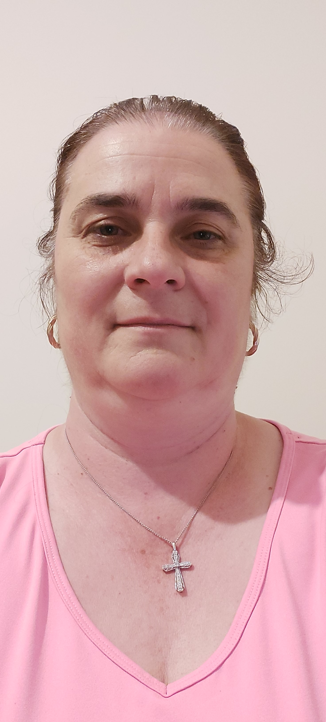

This project was developed to provide some stages for planning and executing an event to support MacMillan charity in assisting a family with a child who has cancer. The proceed from this fundraising art event will be donated to this family. We hope to raise £ 1000.
Some of the skills that can be contributed to the project are critical thinking, decision-making, time management, and communication and leadership skills. These skills can be used to build the project's efficiency (Bednar and Ljudvigova,2020).
As per the contribution of the Belbin questionnaire, I have interacted with the team members by anticipating the roles of the team. By identifying and assigning team members roles that align with their strengths and preferences, the team can optimise their performance and address any gaps or potential conflicts that may arise. This has been useful in turning ideas into actions and organising the required effort.
However, Belbin's model weaknesses may be a tendency to be indecisive and to maintain uncommitted positions during discussions and decision-making.

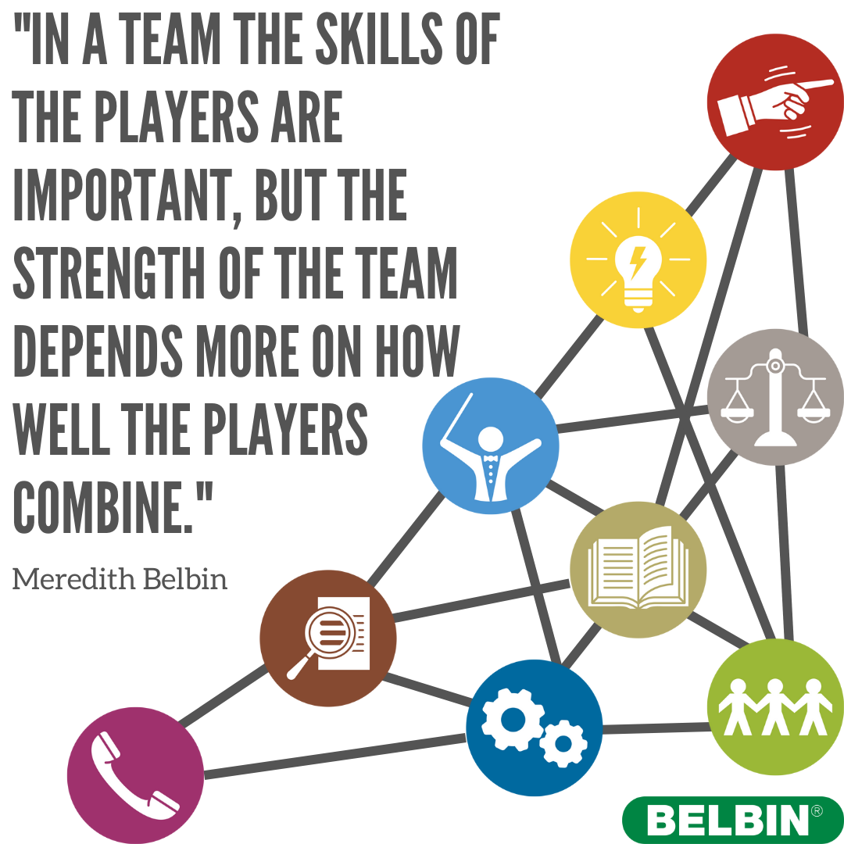

References
Bednar,R. and Ljudvigova,I.. (2020). Belbin team roles in a start-up team. In SHS web of Conferences (vol. 83, p. 01002) EDP Sciences.

https://www.facebook.com/BelbinTeamRoles/photos/a.10150901340769127/10160081285094127/?type=

