Lowri Johnson- ECAD4008
1901545
Cycle 1 Leading the Learning: what, how and why am I teaching?

Targets

- Read more around the topic.
- Link your targets to explicit strategies.
- Proof-read your work carefully.

Good teaching and learning means employing a blend of approaches including direct teaching.

Good teaching and learning sets tasks and selects resources that build on previous knowledge and experience and engage interest.

Good teaching and learning ranges within and across Areas of Learning and experience.

(Donaldson 2015:68)

Consider the 3 pedagogic principles outlined above. Discuss these principles in relation to your experience in school showing secure understanding, identifying strengths and areas for development for each principle.

Introduction

For this assignment I will be discussing 3 pedagogical principles from Donaldson’s ‘Successful Futures’ report in relation to my experience in my placement school. I am currently carrying out my placement in a nursery class, with children aged between 3 and 4, who have a range of abilities and learning needs. There are currently 65 pupils in morning nursery and around 30 in afternoon nursery, so planning and preparation is key to the execution of each lesson. During this portfolio I will be discussing the importance of cross-curricular teaching, and how it can reflect good and poor teaching practice. I will also discuss the role of the pupil within the foundation phase and how pupil voice has become a predominant feature in the curriculum. I plan to relate these aspects to my own personal experience of being in placement whilst linking it to recognised good practice, as well as the new curriculum.

My placement school, along with every school In Wales follows the Foundation Phase Framework, which provides “a nationally consistent baseline assessment which aligns with the end of phase outcomes” (Welsh Government 2015). My understanding of the framework is that it provides teachers with a guideline of what children should be taught, relating to the Statutory Areas of Learning, whilst also displaying outcomes of what the Welsh Government believes is the expected standard. The Foundation Phase Framework aims to provide a “developmentally appropriate curriculum which will work alongside a child’s particular needs and interests” (Welsh Government 2015). From reading through the framework it is clear that it is built on the principles of learning through play and focuses on the child being at the centre of learning. The Foundation Phase is unique to wales in that it has seven Areas of Learning which are delivered through active learning experiences and practical activities both outdoors and indoors. The new curriculum devised by Graham Donaldson ‘Successful Futures’ follows a similar vision in that the curriculum is split into six broad Areas of Learning and Experiences. The differences between this new curriculum and the current curriculum is that there has been a greater focus on cross-curricular learning. Previously, literacy and numeracy were seen as a priority for the pupils to have a clear understanding on, however it has been reviewed that “digital competency is increasingly fundamental to learning and life and that it should have a similar status within the curriculum to that of literacy and numeracy” (Donaldson 2015). The review, therefore, recommends that numeracy, literacy and digital competency should be “Cross-Curriculum Responsibilities” for all teachers. It is clear that in the new curriculum there is effort to make teaching and learning more inclusive and universal. This has been recognised by Kirsty Williams, who said that “We're moving away from an outdated, narrow curriculum that sets out subject by subject, topic by topic and hour by hour what pupils should be learning” (BBC 2019). Implying the importance of incorporating and implementing cross-curricular teaching.

Main body

In schools, teachers have to follow a framework which provides them with a guideline of what is expected of the pupils throughout the academic year. The teachers then deliver the content of the curriculum to the class which is refered to as a pedagogy. A teacher will often consider different ways to deliver the content which will be based on a number of things including, their “personal experiences, teaching preferences and the context that they teach in” (TES 2018).

In relation to my placement school, it is evident that the class teacher adapts her teaching to the pupils in several ways. The age group of the pupils are between 3 and 4, therefore, a lot of the teaching is in the form of experiential learning. Froebel believed that “play is the highest expression of human development in childhood for it alone is the free expression of what is in the child’s soul” (Early Education) According to Froebel, through direct experience with the environment in the form of play, children are able to construct their understanding of the world, which outlines one of the benefits of experiential learning. The class teacher tries to incorporate many different learning environments, to expand the pupils’ knowledge and ability to learn through play. The class being split into groups makes the whole environment accessible for the pupils, as there is plenty of space for the pupils to explore. The nursery class have their own sheltered outdoor area which is equipped with resources such as outdoor chalk, and a water area, as well as having a bigger yard for physical activities, which is equipped with bikes and balls. Jan White, Forest schools, Rosseau and Froebel all support this idea of outdoor play and that learning is created through hands- on play activities. Rousseau theory suggested that allowing children to “develop naturally without constraints imposed on them by society will help them to achieve their fullest potential both morally and educationally” (Pound 2005). Jan white theory on outdoor play also suggests similar views to this as she believes that children are “biologically designed to be in nature” (Early Education) and therefore thrive by being in contact with it. These theories link with Donaldson’s pedagogy that ‘good teaching and learning means employing a blend of approaches including direct teaching’. Donaldson is implying that an example of good teaching practice involves using different environments and resources within direct teaching to maximise the learning outcomes from the pupils emphasising the importance of cross-curricular teaching. Including the environment into everyday teaching and learning has been proven to be effective by Loris Malaguzzi, as one of their principles and implemented in schools in Reggio Emilia is the environment being the ‘third teacher’. From reading a book by Louise Cadwell (1997), teachers in Reggio Emilia ensure that the environment is properly equipped and laid out so that the environment invites the children to engage in play. This is similar to my placement school, as the staff put a great deal of effort into the outdoor play area by introducing new toys and learning resources. The staff in nursery recognise the importance of outdoor play and where possible try to incorporate outdoor environment into their direct teaching.

It is clear in the Foundation Phase Framework and in the ‘Successful Futures’ report that cross- curricular teaching is advocated throughout and the Areas of Learning should be taught in conjunction with each other and not as individual subjects. This is made evident in the Foundation Phase Framework which suggests that “emphasis is placed on developing children’s skills across the Areas of Learning, to provide a suitable and integrated approach for young children’s learning”. Cross curricular teaching is also advocated in one of Donaldson’s pedagogical principles, which states that ‘good teaching and learning ranges within and across Areas of Learning and experience’. In my opinion this principle suggests that good teaching involves teaching the required curriculum and including information within the Areas of Learning but also providing opportunities for the children to learn valuable information that is not within the curriculum or Areas of learning. For example, how to look after oneself and cooking skills.

My placement school is fortunate to have an open plan nursery class which enables the class teacher to vary the resources and opportunities that are available to the pupils. The classroom is split into different learning zones whereby each zone has a particular focus with regards to the Areas of Learning. There is a creative area for painting, gluing and any messy activities, a quiet area full of books, cushions and blankets for the pupils to relax and reflect, a role play area to allow the children to use their imagination and communication skills, and a snack area which encompasses the children’s health and wellbeing by educating them on washing their hands and the importance of healthy eating. There are 3 separate learning zones that are equipped with relevant material with regards to numeracy, welsh language and literacy. My placement school adopts a thematic approach, whereby many areas of the curriculum are integrated and connected together within a theme. From reading an ESTYN report about good practice, there are certain features that I think would be beneficial practice in my own teaching as well as in my placement school. A particular school in Wales ensures their learning zones are stimulating and visually pleasing to the children. The school includes the pupils’ suggestions on how to decorate the learning zones in order to make the pupils want to go there. In order to make these zones beneficial to the pupils’, the school adopts a strategy where there are starred challenges in each zone. The purpose of this is to ensure that the pupils are benefiting educationally from the learning zones by challenging themselves to work independently. The school has noticed that by “creating an environment for child-initiated learning and equipping all pupils with leadership and decision-making skills, pupils’ wellbeing has improved” (ESTYN 2019). Similarly, the school has recognised that the starred challenges in each learning zone promotes the development of literacy and numeracy skills in real life contexts, which have led to higher standards of learning as well as the pupils enjoying learning. I think this example of good practice is a good idea in including pupils in directing their learning, but also providing them challenges in the Areas of Learning, this practice is one that I will include in my own teacher in the future.
From reading a book created by Jonathan Barnes it has enlightened me on the positive outcomes that arise from teaching in a cross-curricular way. He suggested that cross- curricular methods can be effective in “teaching, and reading ethical solutions, building individual and group motivation, sustaining interest and raising standards” (Barnes 2011). I found this to be true when observing and assessing my own lessons.
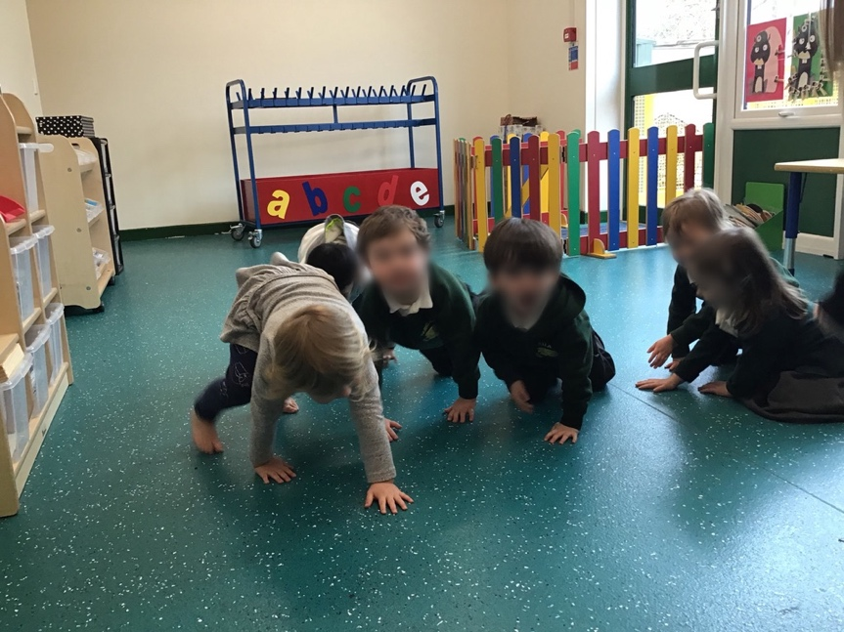
Evidence of cross-curricular learning that has been implemented in my own teaching, include a matching activity task based on the classes theme of animals. The purpose of the lesson was for the pupils to establish the difference between baby animals and adult animals by matching them to the correct specie and identifying which one is ‘bigger/smaller’ than the other. (Personal photograph of the pupils matching the animals). The lesson focus was science and knowledge of the real world; however, this lesson incorporated many cross curricular links, including numeracy, literacy, language and communication and some physical activity. In a different area of the classroom, pupils were required to act out the animals that what featured in the book ‘dear zoo’. The lesson focus on this was physical activity, and the cross-curricular links, included language, communication and knowledge of the real world. I found that including cross-curricular links helped to engage the pupils for longer which supports Barnes theory, as well as developing the extra skills identified in the Foundation Phase Framework.
(Personal photograph of pupils ‘pretending’ to be the animals in the ‘dear zoo’ book)
In Jonathan Barnes book on cross-curricular learning, he also mentioned that cross-curricular teaching could lead to confusion or an unclear lesson focus. Therefore, it Is important that when I am teaching in a cross-curricular way that I have a clear focus on what I want my outcome to be.

Donaldson’s third pedagogical principle refers to the planning and preparation that goes into teaching the curriculum. The pedagogy that is in relation to this is ‘good teaching and learning sets tasks and selects resources that build on previous knowledge and experience and engage interest’. In my opinion this pedagogical principle suggests that teachers should try and plan lessons that build on prior knowledge and experiences by using varied resources and environments that will engage the pupils and make them interested in the topic. Lesley Abbott suggests the “important role of interaction between adults and children on learning and development”, and that children should be “active learners” (Pound 2007). This suggests that in order to ‘engage interest’ in the children, then the children should be encouraged to voice their opinions and suggest ideas on what information they would like to learn. A report by ESTYN on pupil participation defines participation as “participation means that it is my right to be involved in making decisions, planning and reviewing any action that might affect me, having a voice, having a choice” (ESTYN 2016).
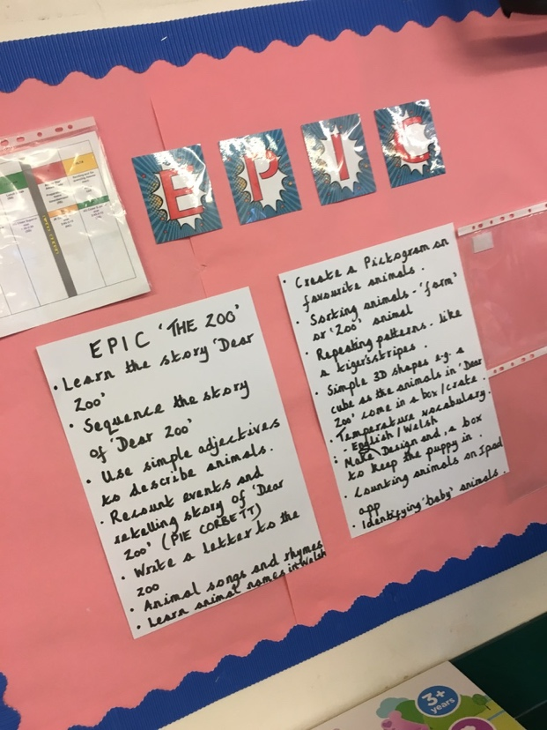
To achieve this, in my placement school the teachers focus a lot on the pupils’ opinions and suggestions to direct the teaching and what activities are planned for each term topic. The school advocates pupil voice and believes that if the pupils suggest activities that relate to the class topic and are relevant then the class teacher should incorporate them into the class timetable. ESTYN has recognised a school that has adopted a similar approach to this as being good practice. The report states that a school in Wales, hold a ‘discovery day’ termly in order to establish a framework for the following terms work. The staff plan the curriculum based on the pupils’ ideas and questions by using the framework in order to ensure progression and development. A factor that I liked about this school’s approach is that they also “involve the parent’s suggestions and during the end of every term the theme ends with an invitation for adults to join the class and celebrate their learning’ (ESTYN 2016). I may incorporate this feature into my own learning because I feel it is a nice way to involve the parents and recognise the pupils’ efforts during the term. John Dewey also believed in this approach and suggested that children learn through a hands-on approach (Teachthought 2020). Dewey had the idea that especially in a primary school context, subjects should be seen as experiences and activities rather than knowledge to be acquired. A book by Jonathan Barnes also agrees with this because in his book on cross-curricular learning he suggests that “children having the feelings of control over certain aspects of their life, can act as a motivator for learning but is also central for future security and good health” (Barnes 2011). These positive outcomes that can arise from allowing pupils to direct their learning has been recognised and implemented in my placement school. My placement school has a strategy called EPIC which stands for Everyone Planning In Class. (Personal picture of the EPIC display board). It is a strategy that enforces pupil voice and article 12 of the UNCRC, which states that young people and children have the human right to “have opinions and for these opinions to matter” (UNCRC 2020). The article suggests that the opinions and feelings of young people and children should be considered when adults make decisions about things that involve them. My placement school have regular discussions with the pupils and brainstorm the ideas suggestions that they put forward. The class teacher will review the suggestions and adapt them so that they are suitable for the pupils and relates back to the curriculum. Maria Montessori and the Montessori method supports this idea of independence and allowing children to self-direct their learning (Montessori Group 2020). This is encouraged in her theory as she believes that children learn best in a carefully prepared learning environment. In my nursery class, the teaching is often in the form of experiential learning so therefore the teacher will set out suitable resources for the pupils to independently complete. I have also noticed in the class that creative activities and learning through songs and dance are used frequently to encourage the children to recognise sounds and meanings of words. The teachers also found that It helps children remember number patterns or new languages, which is similar to Piaget’s findings of schemas. Steiner’s theory (1919) supports this as he gave a detailed outline of a developmentally based curriculum strongly infused with the arts. A Steiner curriculum often uses separated subjects, but also provides regular opportunities to put subject learning in cross-subject contexts like plays, displays and walks in the countryside (Steiner Waldorf Education 2020). Therefore, it is valuable to note that incorporating a Waldorf method of teaching by including songs and plays could be beneficial in increasing pupils learning. Vygotsky (1976) believed that children learn best through interactions, implying that the curriculum and teaching should be designed to emphasize the interaction between learners and learning tasks. Linking to my Nursery class, the teachers and I interact daily with the pupils during carpet time, where we sing songs, revise their welsh language and check in with each other. The class teachers also plan to carry out focus tasks one-to-one with the pupils regularly, the teachers adopt this approach, so they are able to determine the pupils individual progress and therefore adapt the task and level of support to the pupils’ current ability. This strategy is supported by Vygotsky’s theory of scaffolding, where the adult continually adjusts the level of his or her help in response to the child’s level of performance (Pound 2005). In my placement school the teachers assess the pupils progress by scribing in their books whether they completed the task independently or with some support. The teacher will then revisit the task again and see whether the child needed further help or managed to compete it independently. This form of formative assessment is proven to be effective because Dylan William recommended that this process of assessment “is not just a day-to-day or hour-to-hour, it’s a minute-to-minute process” (Cox 2020). Implying that assessment should be taking place all the time in classroom interaction. To improve the way the teachers, carry out their assessment, they could make it a regular occurrence and constantly provide help or guidance to the pupils.

Conclusion

To conclude, the three pedagogical aims that I have discussed have made clear suggestions on the implementation of cross-curricular learning as well as pupil voice for the new curriculum. It is clear that these two approaches to teaching are important and valuable for the success of the pupils and the experience of their time in school. Donaldson’s pedagogical aim on ‘good teaching and learning means employing a blend of approaches including direct teaching’, in my opinion has a strong focus on cross-curricular learning. It is clear that the new curriculum is trying to incorporate more of this by stating that there are many skills that are “essential to being able to participate successfully and confidently in the modern world” (Donaldson 2015). This focus on cross-curricular teaching is an approach that only this new curriculum is recognising for its importance and value. Donaldson’s second pedagogical aim ‘good teaching and learning sets tasks and selects resources that build on previous knowledge and experience and engage interest’ is focusing a lot on the pupil through the ‘engaging interest’ part. From my examples of good practice on pupil participation, a ‘discovery day’ is a strategy that I intend to include in my own teaching. I think that this approach is a good way to motivate the pupils and engage them into each topic. Barnes (2011) has influenced my opinion on this by stating that pupil participation can help with “group motivation, sustaining interest and raising standards.” The ‘successful futures’ report has recognised the importance of a child centred curriculum and this has been made evident on page 10, where it says “it is essential that the curriculum is designed in ways that will engage the interest of all children and young people and enable them to achieve.” This links with Donaldson’s third pedagogical aim about ‘good teaching and learning ranges within and across Areas of Learning and experience.’ This last aim in my opinion refers to cross-curricular learning also, as it suggests learning ‘within and across the AOLE’s’. It is clear that this new curriculum has a strong focus on cross-curricular teaching, so it is important that I use it effectively and efficiently in my own teaching. It is important that I focus on my lesson aim of the task so that I don’t create confusion. In my opinion the curriculum is encompassing features that matter. Pupil participation, cross-curricular links and experiential learning have all proven to be effective in the success of pupils in school.

References

- Barnes, J. (2011) Cross Curricular Learning 3 – 14. London: Sage Publications

- BBC News (2019) Education: Draft school curriculum for Wales published. Available at: https://www.bbc.co.uk/news/uk-wales-48094118 (Accessed: 24th March 2020)

- Cadwell, L. (1997) Bringing Reggio Emilia Home: Innovative Approach to Early Childhood Education. Teachers College Press.

- Children & Young People’s Commissioner Scotland (2020) Article 12. Available at: https://www.cypcs.org.uk/rights/uncrcarticles/article-12 (Accessed on: 23rd March 2020)

- Cox, T. (2020) Assessment for Learning. Available at: https://moodle.uwtsd.ac.uk/pluginfile.php/356940/mod_resource/content/1/AfL%20Intro%20%28All%20parts%29%20pdf%20presentation.pdf (Accessed on 25th March 2020)
- Early Education. About Froebel. Available at: https://www.early-education.org.uk/about-froebel(Accessed: 23rd March 2020)

- Early Education. Jan White. Available at: https://www.early-education.org.uk/jan-white (accessed: 24th March 2020)

- Education Wales (2015) Foundation Phase Profile Handbook. Available at:https://hwb.gov.wales/storage/f9d85dba-85a4-4e87-bb58-a24730ad7e57/foundation-phase-profile-handbook-revised-september-2017.pdf (Accessed:20th March 2020)

- ESTYN (2016) pupil participation: a best practice guide. Available at: https://www.estyn.gov.wales/sites/www.estyn.gov.wales/files/documents/Pupil%20participation_0.pdf (Accessed: 25th March 2020)

- ESTYN (2019) Learning through play to support independent learning. Available at: https://www.estyn.gov.wales/effective-practice/learning-through-play-support-independent-learning (Accessed 25th March 2020)

- Montessori Group (2020) What is Montessori? Available at: https://www.montessori.org.uk/about-us/what-is-montessori( Accessed on 23rd March 2020)

- Pound, L. (2005) How children learn. London: Practical Pre-School Books.

- Pound, L. (2009) How children learn 3 Contemporary thinking and theorists. London: Practical Pre-School Books.

- Professor Graham Donaldson (2015) Successful Futures. Available at: https://webcache.googleusercontent.com/search?q=cache:F1bmpZy8hYJ:https://www.nasuwt.org.uk/asset/A788604C-3046-4005-A1EA0EAFF023E0DD/+&cd=3&hl=en&ct=clnk&gl=uk&client=safari (Accessed: 23rd March 2020)

- Steiner Waldorf Education (2020) What is Steiner education? Available at: https://www.steinerwaldorf.org/steiner-education/what-is-steiner-education/ (Accessed on 23rd March 2020)

- TES Editorial (2018) What is pedagogy? Available at: https://www.tes.com/news/what-is-pedagogy-definition (Accessed: 24th March 2020)

