Feasibility Plan for an International Meeting: ‘Diversity, equity, and inclusion (DEI): Addressing the challenges faced by minorities and immigrant workers in the UK hospitality and tourism industry’

BMIH6007 International Meetings Management for the Hotel Industry
Lecturer: Kathryn Flynn

Flor Yasmin Perez Paula, 2226712

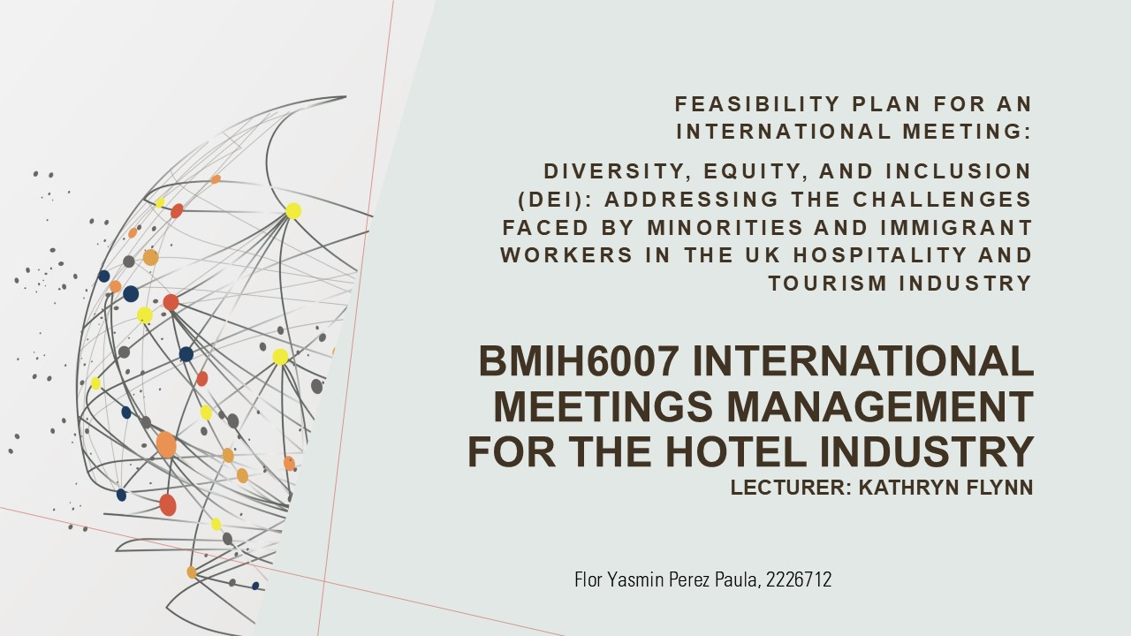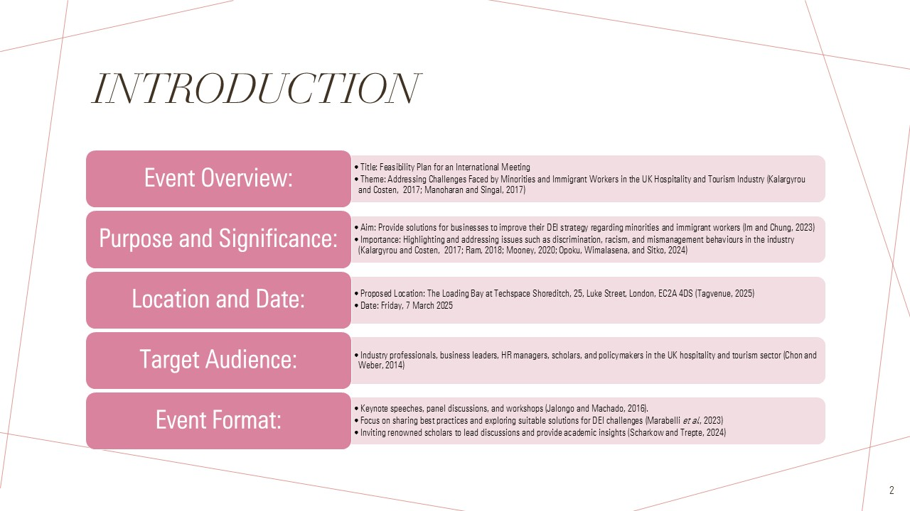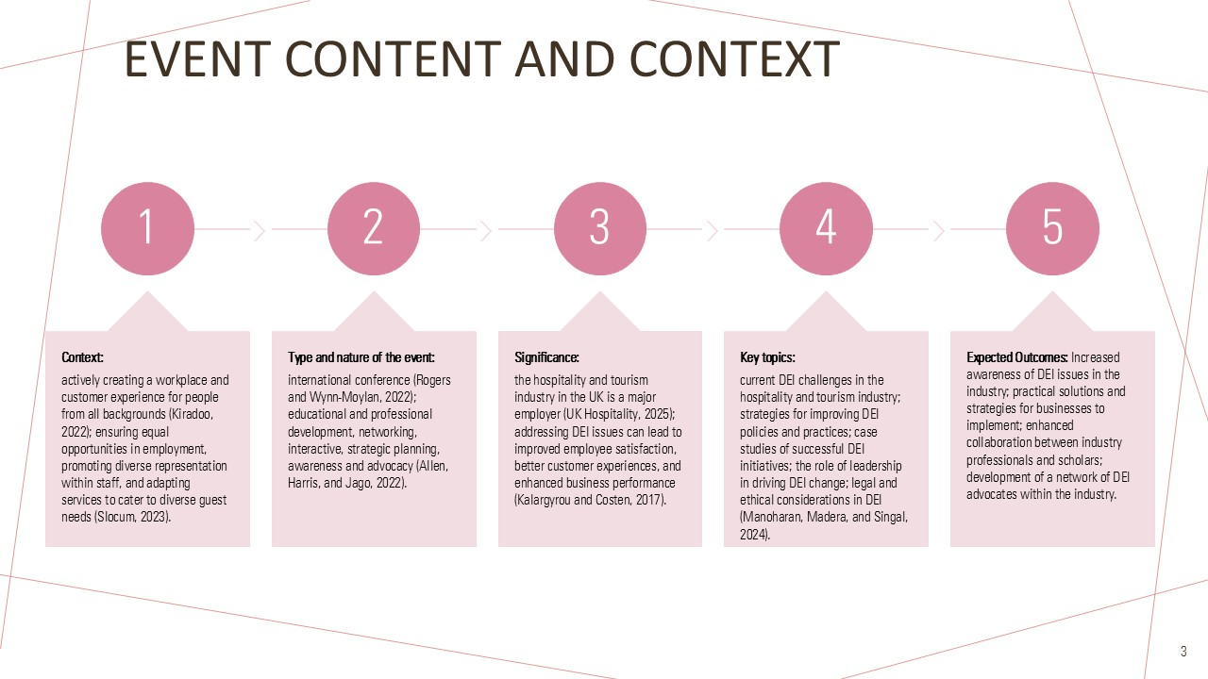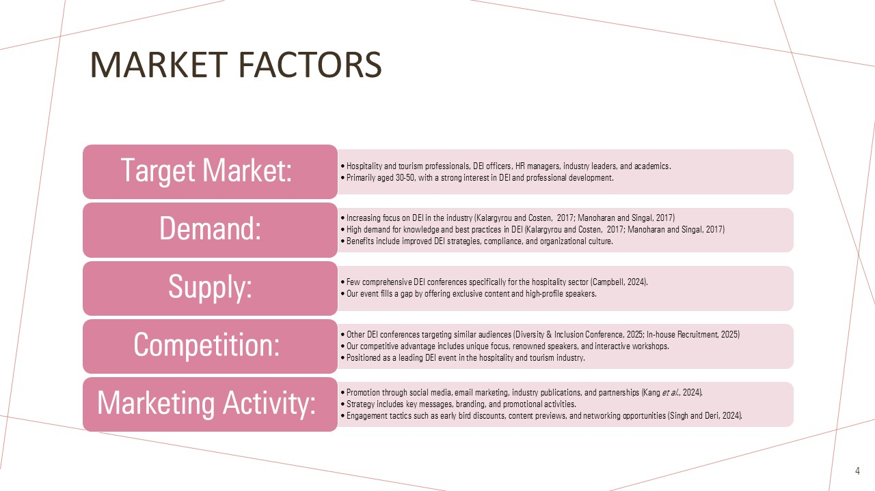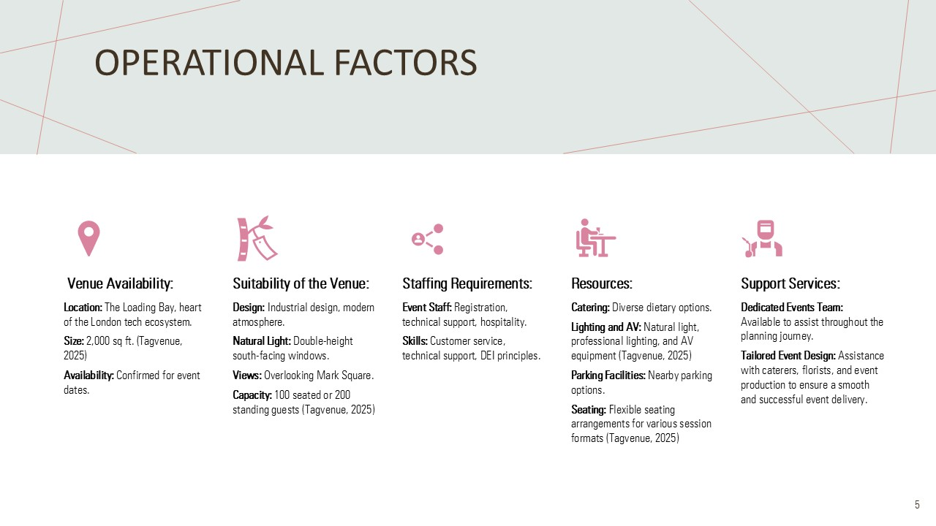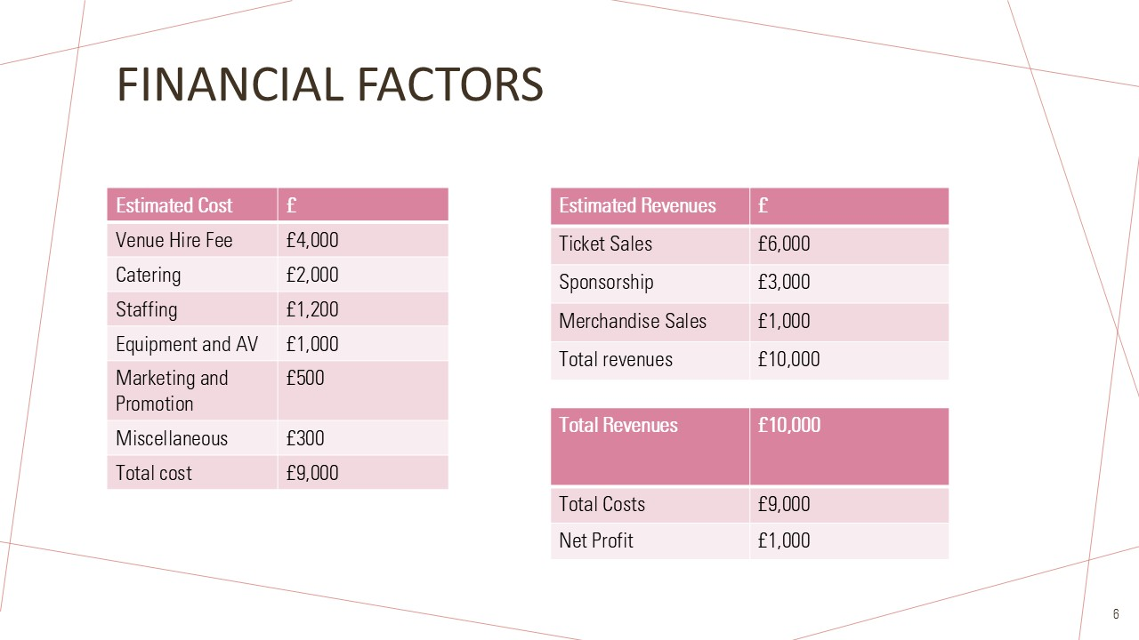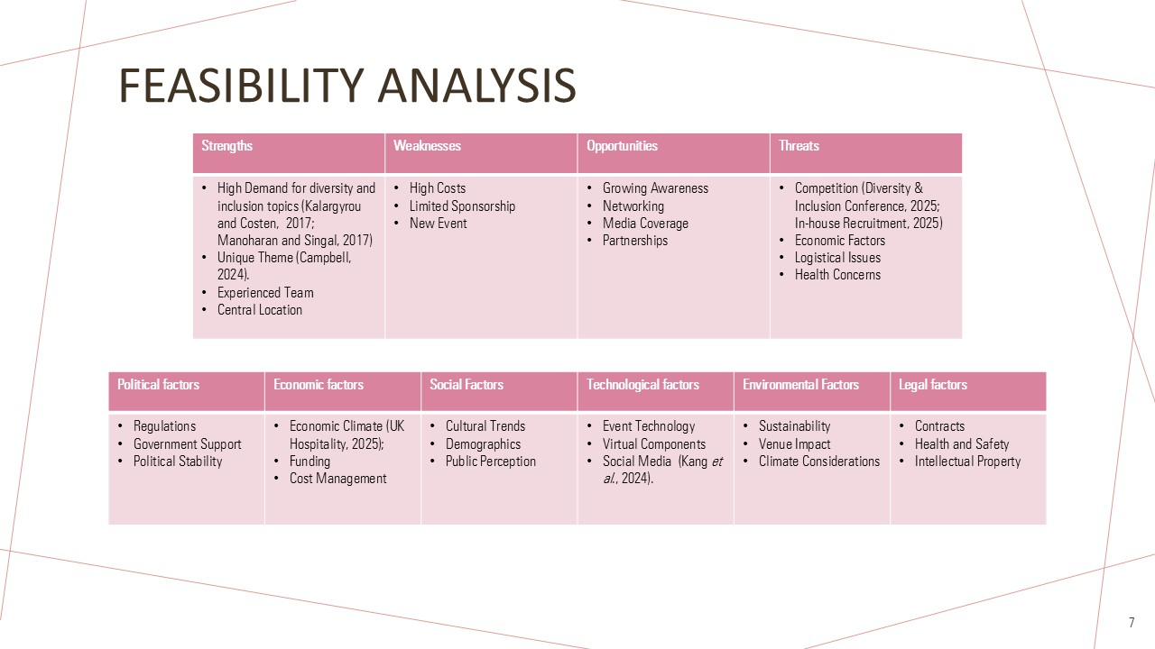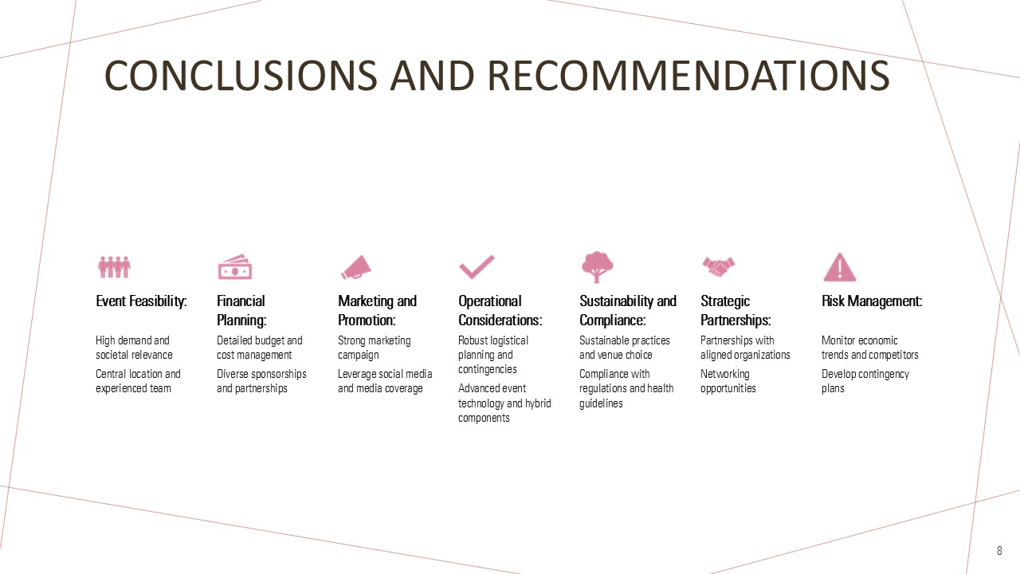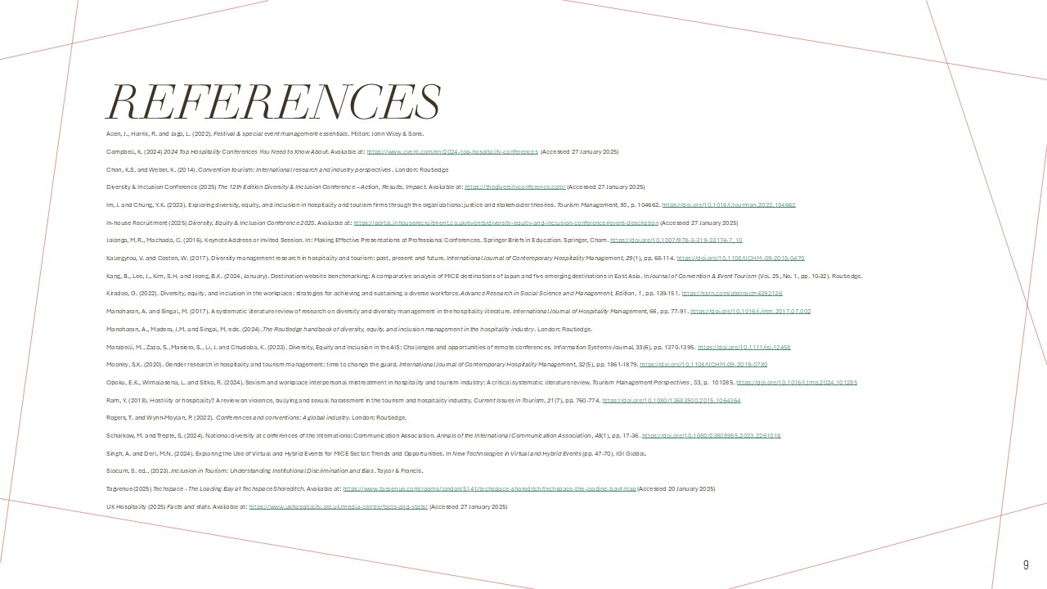

References

Allen, J., Harris, R. and Jago, L. (2022). Festival & special event management essentials. Milton: John Wiley & Sons.
Campbell, K. (2024) 2024 Top Hospitality Conferences You Need to Know About. Available at: https://www.cvent.com/en/2024-top-hospitality-conferences (Accessed 27 January 2025)
Chon, K.S. and Weber, K. (2014). Convention tourism: International research and industry perspectives. London: Routledge
Diversity & Inclusion Conference (2025) The 12th Edition Diversity & Inclusion Conference – Action, Results, Impact. Available at: https://thediversityconference.com/ (Accessed 27 January 2025)
Im, J. and Chung, Y.K. (2023). Exploring diversity, equity, and inclusion in hospitality and tourism firms through the organizational justice and stakeholder theories. Tourism Management, 95, p. 104662. https://doi.org/10.1016/j.tourman.2022.104662
In-house Recruitment (2025) Diversity, Equity & Inclusion Conference 2025. Available at: https://portal.inhouserecruitment.co.uk/events/diversity-equity-and-inclusion-conference#event-description (Accessed 27 January 2025)
Jalongo, M.R., Machado, C. (2016). Keynote Address or Invited Session. In: Making Effective Presentations at Professional Conferences. Springer Briefs in Education. Springer, Cham. https://doi.org/10.1007/978-3-319-23174-7_10
Kalargyrou, V. and Costen, W. (2017). Diversity management research in hospitality and tourism: past, present and future. International Journal of Contemporary Hospitality Management, 29(1), pp. 68-114. https://doi.org/10.1108/IJCHM-09-2015-0470
Kang, B., Lee, J., Kim, S.H. and Jeong, B.K. (2024, January). Destination website benchmarking: A comparative analysis of MICE destinations of Japan and five emerging destinations in East Asia. In Journal of Convention & Event Tourism (Vol. 25, No. 1, pp. 10-32). Routledge.
Kiradoo, G. (2022). Diversity, equity, and inclusion in the workplace: strategies for achieving and sustaining a diverse workforce. Advance Research in Social Science and Management, Edition, 1, pp. 139-151. https://ssrn.com/abstract=4392136
Manoharan, A. and Singal, M. (2017). A systematic literature review of research on diversity and diversity management in the hospitality literature. International Journal of Hospitality Management, 66, pp. 77-91. https://doi.org/10.1016/j.ijhm.2017.07.002
Manoharan, A., Madera, J.M. and Singal, M. eds. (2024). The Routledge handbook of diversity, equity, and inclusion management in the hospitality industry. London: Routledge.
Marabelli, M., Zaza, S., Masiero, S., Li, J. and Chudoba, K. (2023). Diversity, Equity and Inclusion in the AIS: Challenges and opportunities of remote conferences. Information Systems Journal, 33(6), pp. 1370-1395. https://doi.org/10.1111/isj.12458
Mooney, S.K. (2020). Gender research in hospitality and tourism management: time to change the guard. International Journal of Contemporary Hospitality Management, 32(5), pp. 1861-1879. https://doi.org/10.1108/IJCHM-09-2019-0780
Opoku, E.K., Wimalasena, L. and Sitko, R. (2024). Sexism and workplace interpersonal mistreatment in hospitality and tourism industry: A critical systematic literature review. Tourism Management Perspectives, 53, p. 101285. https://doi.org/10.1016/j.tmp.2024.101285
Ram, Y. (2018). Hostility or hospitality? A review on violence, bullying and sexual harassment in the tourism and hospitality industry. Current Issues in Tourism, 21(7), pp. 760-774. https://doi.org/10.1080/13683500.2015.1064364
Rogers, T. and Wynn-Moylan, P. (2022). Conferences and conventions: A global industry. London: Routledge.
Scharkow, M. and Trepte, S. (2024). National diversity at conferences of the International Communication Association. Annals of the International Communication Association, 48(1), pp. 17-36. https://doi.org/10.1080/23808985.2023.2261018
Singh, A. and Deri, M.N. (2024). Exploring the Use of Virtual and Hybrid Events for MICE Sector: Trends and Opportunities. In New Technologies in Virtual and Hybrid Events (pp. 47-70). IGI Global.
Slocum, S. ed., (2023). Inclusion in Tourism: Understanding Institutional Discrimination and Bias. Taylor & Francis.
Tagvenue (2025) Techspace - The Loading Bay at Techspace Shoreditch. Available at: https://www.tagvenue.com/rooms/london/5141/techspace-shoreditch/techspace-the-loading-bay#map (Accessed 20 January 2025)
UK Hospitality (2025) Facts and stats. Available at: https://www.ukhospitality.org.uk/media-centre/facts-and-stats/ (Accessed 27 January 2025)

