

Software Development

Lecturer: Renuga Jayakumar

Student ID:2019923

Enachi Iulian

Contents
Introduction 3
Understanding 3
A1. Different types of control structures in programming. [1] 3
A2. Types of loops in Python [3] 4
A3 Defining lists and the differences between lists and normal variables. [2] 5
Implementation in practice of the accumulated knowledge. 7
Exercise Number 1. 7
a) Logical stages. 7
b) Code with annotation. 8
Testing 9
Normal “Happy Path”. 9
Boundary Conditions 9
Impossible-Out of range 10
RESULT 10
Exercise Number 2. 10
a) Logical stages. 10
b) Code with annotation. 11
Testing 11
Normal “Happy Path”. 12
Boundary Conditions 12
Impossible-Out of range 12
RESULT 13
Exercise Number 3. 13
a) Logical stages. 13
b) Code with annotation. 14
Testing 14
Normal “Happy Path”. 15
Boundary Conditions 15
Impossible-Out of range 17
RESULT 17
Exercise Number 3. 17
a) Logical stages. 17
b) Code with annotation. 18
Testing 18
Normal “Happy Path”. 20
RESULT 20
Checking without the random library. 20
RESULT 21
RESULT 21
RESULT 21
RESULT 22
RESULT 22
Conclusion 22
Bibliography 23

Introduction

This paper aims to highlight the student's knowledge gained in the Software Development module. And it is composed of 2 parts:
A. Understanding and B. Implementation.
Part A will explain the theoretical part of:
A1. Explanation of differences between structure control in programming
A2. We will compare two main types of loops in Python
A3. It will explain the difference between the lists and the usual variables. And it will explain how to access an item in the list.
In part B it will be implemented in action and 4 case studies will be solved, code examples will be brought, and it will be tested in the end if the code is executed correctly and does not allow user errors to appear.

Understanding

A1. Different types of control structures in programming. [1]
Control structures in programming are actually a method of controlling the specifics of the flow of code execution. Any algorithm is much clearer if it contains some logical, self-executable structures. In reality, these modules only analyse in which direction the flow of an algorithm will continue based on different conditions.
There are three main types of structure control.
1. Sequential.
2. Selective.
3. Iterational.
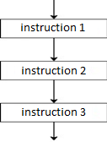
Sequentially, as can be seen from the name, it is certainly the most widespread and is based on a linear structure of code execution. Usually, the most complicated problems in themselves are still based on a sequential relationship of code flow.
As in the example on the left:

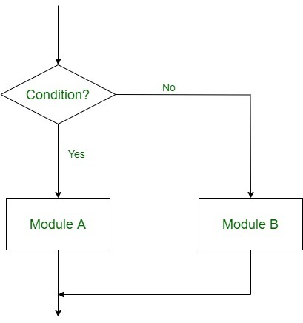
Selective logic certainly relates to certain parameters that direct the flow of the code execution algorithm. Their structuring is of 3 types.
- Single Alternative that has only one condition, an "if" statement.
- Double Alternative has a double structuring such as an "if" and an "else" statement.
- Multiple Alternatives sure depends on several statements used "if", "ëlif", "elif", "else".

An example:
a = 14
b = 29
if b > a:
print("b is greater than a")
elif a == b:
print("a and b are equal")
This program has 2 options to run.
1. In case the message in the "print" statement will be printed on the screen.
2. If b = a respectively the message in that instruction will be displayed on the screen.

A2. Types of loops in Python [3]
Iteration Logic is a repetitive logic and is divided into 2 categories "for loop" and "while loop".
For loop While loop

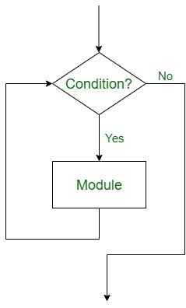
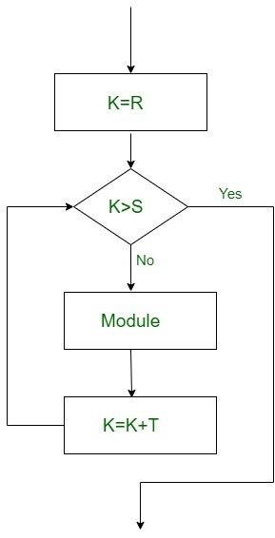

Repeat for i = A to N by I: Repeat while condition:
[Module] [Module]
[End of Loop] [End of loop]

for loop
"for" loop is used to iterate the elements of a code sequence. It is usually used when you have a piece of code that you want to repeat “N” many times.
"for" loop is distinguished by an explicit loop counter or loop variable.
Example of for loop: [3]
fruits = ["apple", "banana", "cherry"]
for x in fruits:
print(x)

We also have the option to print a certain series of numbers starting with one value and ending with another. It should be mentioned that the last value will not be shown on the screen.

for x in range(1, 9):
print(x)

A more complex example is the following when the given sequence will be incremented by 3 units by adding this value in parameter 3.

for x in range(4, 32, 3):
print(x)

A3 Defining lists and the differences between lists and normal variables. [2]

Lists in Python are used to store multiple items in themselves. Such as string or float or integer. And they allow the repetition or duplication of these elements.
A list of elements is considered as a single variable and is a built-in function to create a list in Python. To create lists, use square brackets as in the example: list = ["a", "b", "c"]
However, at least the list is considered to be a single variable, there is a big difference between variables and lists. Because lists can hold multiple data types and it can be sorted, rearranged and edited both by developer and by automatic mode (by code). [6]
To access any item in the list it is necessary to determine its index. The first item in the list has index 0 as in the example: list = ["index 0", "index 1", "............"].
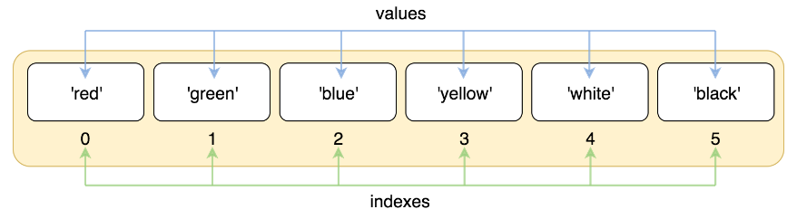
We can also decrease the indexes starting with -1 so the index -1 will be at the last element of the list as in the example: list = ["...........", "- 2", "- 1"].
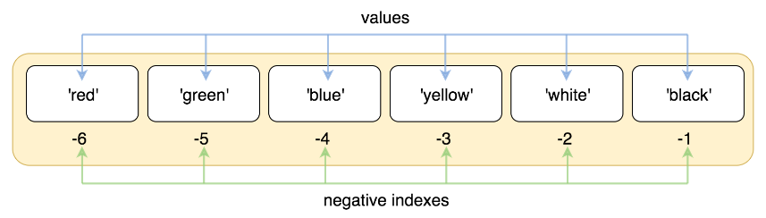
- It is also possible to measure the length of the list using the "len" function. ex: list.len()
- Growing arrangement is done with "sort" ex: list.sort ()
- The counting of the elements is done with "count". ex: list.count ()
- Reverse list with "reverse”. ex list. reverse ()
- To remove from the list, we will use "remove”. ex list.remove ()
- To add a value to a specific index then we will use "insert". ex list.insert (index No:, Value to insert)
- To add a value at the end of the list we will use "append". list.append (value)
A very useful tool in python is also the lists because we can easily slice them by extracting only the necessary information in a database as in the following example:
- Here we will see from the list only the values under indices 2,3,4,5,6
nums=[1,2,3,4,5,6,7,8,9]
slice= nums[2;6] output>>>>>>>>>[3,4,5,6,7]
Slicing also works without knowing the number of indexes, for example we can see the last 4 elements in the list.
nums=[1,2,3,4,5,6,7,8,9]
slice= nums[-4;] output>>>>>>>>>[6,7,8,9]
- We can also view the values of the first n index numbers.
nums=[1,2,3,4,5,6,7,8,9]
slice= nums[;3] output>>>>>>>>>[1,2,3,4]
- The above functions will work and vice versa for example to view all the elements of the list except the first 4
nums=[1,2,3,4,5,6,7,8,9]
slice= nums[3;] output>>>>>>>>>[5,6,7,8,9]
- It will also work with negative indexes.
nums=[1,2,3,4,5,6,7,8,9]
slice= nums[;-4] output>>>>>>>>>[1,2,3,4,5]
- It is possible to activate any nth element of the list.
nums=[1,2,3,4,5,6,7,8,9]
slice= nums[: :2] output>>>>>>>>>[1,3,5,7,9]
- The same search procedure works similarly to reverse function.
nums=[1,2,3,4,5,6,7,8,9]
slice= nums[: :-1] output>>>>>>>>>[9,8,7,6,5,4,3,2,1]
There are many other functions that can work wonders in our code, but we will check the function of substituting parts of the list.
- We use the slice created to replace the first elements in the list with others. [7]“
nums=[1,2,3,4,5,6,7,8,9]
nums[3;] = [5,5,5,5 ] output>>>>>>>>>[5,5,5,5,5,6,7,8,9]
It will work and for more or less elements introduced in this case our lists will be resized.
- There is a way to change any Nth item in the list with a value we want
nums=[1,2,3,4,5,6,7,8,9]
nums[::2] = [5,5,5,5,5] output>>>>>>>>>[5,2,5,4,5,6,5,8,5]

- It is also possible to delete any N-th element.
nums=[1,2,3,4,5,6,7,8,9]
nums[::2] = [] output>>>>>>>>>[2,4,6,8]
Certainly, here the functionality in Python does not stop and there is still much to explore. It all depends on the imagination and attention focused on practical exercises.

Implementation in practice of the accumulated knowledge.

Exercise Number 1.
It is asked to make a program that asks for the Customer's Name, asks for the Product Quantity and the Product Price and then does the total calculation of the purchase. To use data types that coincide with the requirements, not to allow the introduction of ironed data such as price or quantity with negative value.

a) Logical stages.
1. Prompt user to enter the name of customer.
2. Display what kind of data type it is.
3. Prompt user to enter the price of the product.
4. Check if the price of the product is higher than 0. In case the price is less than or equal to 0 then print the message asking to enter the price once more and return to step 3.
5. Display what kind of data type it is in case if the input is validated.
6. Prompt user to enter the quantity of the product.
7. Check if the quantity of the product is higher than 0. In case the price is less than or equal to 0 then print the message asking to enter the quantity again once more and return to step 6.
8. Display what kind of data type it is in case if the input is validated.
9. Make calculation to find out the Total cost of the purchase.
10. Display the final message telling the customer name and the total cost of the purchase.

b) Code with annotation.
CustomerName = input("Please input Customer Name as string ") # input the CustomerName
print(CustomerName, "-----this DATA is ", type(CustomerName)) # print on screen what type of data is the variable CustomerName
ProductPrice = float(input("Please input Product Price as float ")) # input ProductPrice as float data
while ProductPrice <= 0: # using while loop to check for input errors
print("The Product Price can not be negative or equal to 0") # message in case of misstake
ProductPrice = float(input("Please input Product Price as float ")) # loop statrs again in case of mistake
print(ProductPrice, "-----this DATA is ", type(ProductPrice)) # prints the Product Price
ProductQuantity = int(input("Please input Product Quantity as integer ")) # Input Product Quantity
while ProductQuantity <= 0: # filter for mistakes
print("The Product Quantity can not be negative or equal to 0") # message in case of mistake
ProductQuantity = int(input("Please input Product Quantity as integer ")) # loop statrts again in case of mistake
print(ProductQuantity, "-----this DATA is", type(ProductQuantity)) # prints on screen type of data for Product Quantity
a = ProductPrice*ProductQuantity # Make the calculation
b = float("{:.3f}".format(a)) # Format the answer to have maximum 3 characters after the comma
print("The customer", CustomerName,"Made a purchase with The total cost of ",b) # prints de final message on screen

Testing:

Normal “Happy Path”.
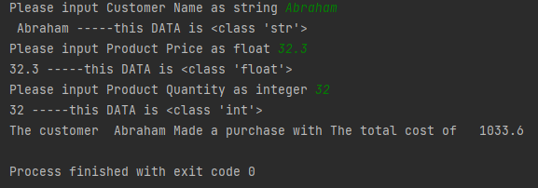

Boundary Conditions
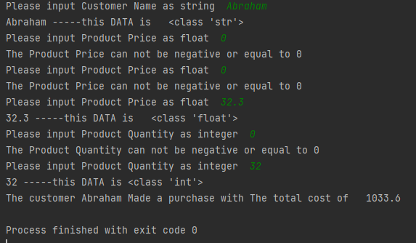

Impossible-Out of range

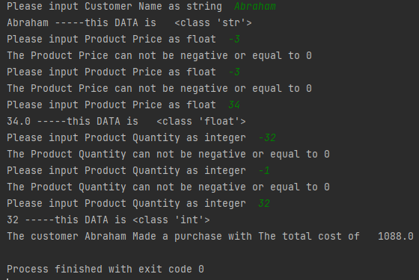

RESULT
The user could not enter data less than or equal to 0 the calculation was done correctly.

Exercise Number 2.
Under the conditions, it is required to build a program that will calculate the shaded area that is represented by the difference between the area of the large circle and the area of the small circle that overlap.

a) Logical stages.
1. Prompt user to enter radii 1.
2. Check number entered for radii if is above 0 (if not, back to 1).
3. If it is less than or equal to 0, it is requested to re-enter the radius. Return to step 1 in this case.
4. The message with the entered radii is printed on the screen.
5. Calculating firs area of the circle.
6. Print out the area of first circle.
7. Prompt user to enter radii 2.
8. Check number entered for radii 2 if is above 0 (if not, back to 5).
9. If it is less than or equal to 0, it is requested to re-enter the radius. Return to step 6 in this case.
10. The message with the entered area is printed on the screen.
11. Calculating firs area of the circle 2.
12. Print out the area of second circle.
13. We compare the areas of the circles, choose the largest one and subtract the smallest from it.
14. In case the areas are equal then display the message "Shaded area is equal to 0"

b) Code with annotation.
r1 = float(input("Please input R1 ")) # input R1
while r1 <= 0: # check for input errors
print("r1 can not be negative or equal to 0 ") # message in case of input error
r1 = float(input("Please input R1 ")) # loop the process again
print("R1= ", r1) # print R1 on screen
a1 = 3.14 * r1 ** 2 # Calculating Area of circle 1
print("Area of the first circle is ", a1) # Print Area of circle 1
r2 = float(input("Please input R2 ")) # input R2
while r2 <= 0: # check for input errors
print("r2 can not be negative or equal to 0") # message in case of input error
r2 = float(input("Please input R2")) # loop the process again
print("R2= ", r2) # print R2 on screen
a2 = 3.14 * r2 ** 2 # Calculating Area of circle 2
print("Area of the second circle is ", a2) # Print Area of circle 2
if a1 > a2: # Filter if Area of circle 1 is bigger than Area of circle 2
r3 = a1 - a2 # Calculating area of shaded area in this case
r4 = float("{:.3f}".format(r3)) # Format the answer to have less decimals
print("The shaded area is equal to ", r4) # Print on screen the answer
elif a2 > a1: # Filter if Area of circle 2 is bigger than Area of circle 1
r3 = a2 - a1 # Calculating area of shaded area in this case
r4 = float("{:.3f}".format(r3)) # Format the answer to have less decimals
print("The shaded area is equal to ", r4) # Print on screen the answer
else: # The areas can be equal ,so the shaded area will be 0
print("The shaded area is equal to 0 ") # Print the shaded area is equal to 0 in this case

Testing

Normal “Happy Path”.
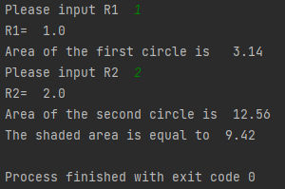
Boundary Conditions

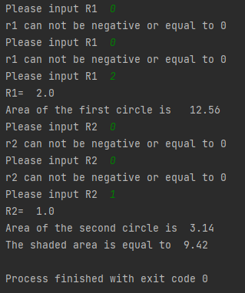

Impossible-Out of range

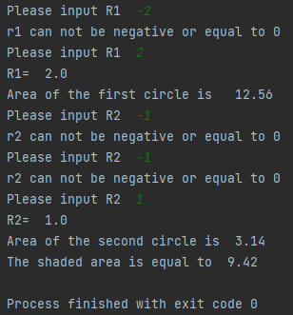

RESULT
The user could not enter data less than or equal to 0 the calculation was done correctly. Plus it doesn't matter which circle is bigger anyway the program will compare and subtract from the largest to the smallest and thus calculate the shaded area.

Exercise Number 3.
It is required in the conditions of the problem to build a program that will introduce in a list 5 employees in IT and in another list their salaries.
then the total salary will be calculated, after which the computer will tell us how much money it will mean a total increase of salaries by 10% and which will be the total after the increase.

a) Logical stages.
1. We define 2 lists "Name" list and "Salary" list.
2. We make a "while loop" provided that it is repeated as long as the list length is less than 5.
3. In the "while loop" you are asked to enter the employee's name and salary.
4. Another "while loop”, content in the first loop, does not allow the introduction of a salary less than or equal to 0 and in this case a message is printed asking you to re-enter the amount of the employee's salary.
5. If the data is validated then the items are entered at the end of the lists.
6. Merge, format and print the data on the screen.
7. The total amount of the salary of the 5 employees is calculated and printed on the screen.
8. It calculates the increase by 10% of their total salary and it calculates the total salary increased by 10% and it is printed on the screen.

b) Code with annotation.
Name=[] # define list Name
Salary=[] # define lits Salary
while len(Name)<5 : # the loop is executiing while list Name has less than 5 members
# No need to define lench of Salary array
Name.append(input("please input Name of IT crew member ")) # adding to the list usin append
a=float(input("please input Salary of IT crew member ")) # define a varialble "a"
while a <= 0: # filter for "a" in case if is neggative or equal to 0
print("please check again the input of Salary and REINPUT it ") # message in this case
a = float(input("please input Salary of IT crew member ")) # is executin again
Salary.append (a) # if "a" is positive we add it to the Salaty array
Array="\n".join("{} has {} pounts/month".format(x,y) for x,y in zip(Name,Salary)) # join our arrays and formatiing
print(Array) #print the joined arrays
TotalSalary = sum (Salary )
# sum of Salary array
b=TotalSalary
print("Total Salary of IT department is ",float("{:.3f}".format(b))," pounts per month") # print out the Total
IncreasedTotalSalary=TotalSalary*1.1 #calculatiing total increased salari by 10%
print(" A 10% salary increase of IT department would mean ",IncreasedTotalSalary," pounts per mounth total charge") # print out the result above
DiferenceIncreased=TotalSalary*0.1 #Calculatiing the diference of 10 %
print(" A 10% salary increase of IT department would mean ",DiferenceIncreased," pounts per mounth extra charges") # print it out on the screen

Testing

Normal “Happy Path”.

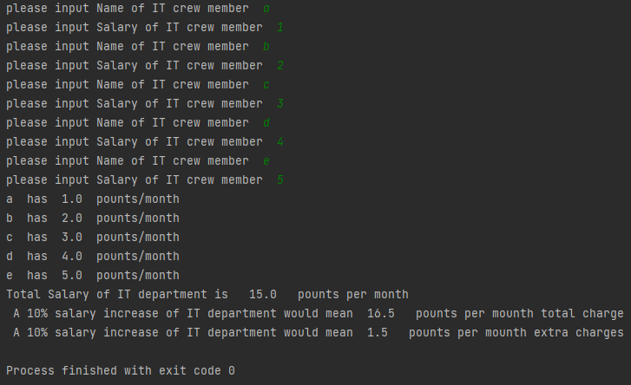

Boundary Conditions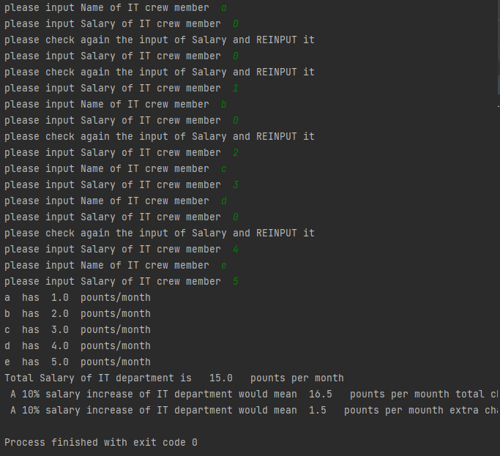

Impossible-Out of range

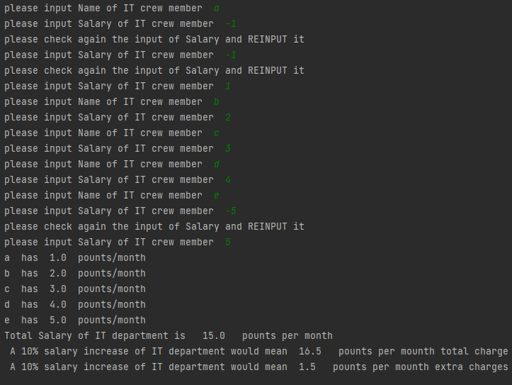RESULT
The user could not enter data less than or equal to 0 the calculation was done correctly. The program calculated and organized the result in an easy-to-read manner.

Exercise Number 4.

In the exercise we are asked to build a game of chance that offers 3 random numbers. Depending on the numbers obtained, the score earned by the player is determined. If you have 999 you get 2000 points, if you have two of 9 anywhere in the set you get 200 points, if you have any three identical numbers except 9 then you get 15 points, if you have two numbers of the same kind except 9 you get 5 points, if they do not match numbers have 0 points.

a) Logical stages.
1. We define the start () function that will be activated in case the player wants to play. And we include random library in it. We print them on the screen.
2. We filter the result starting from the least probable variant [9,9,9] and we set the congratulatory message.
3. In case the above variant is false, a second variant should be checked with two of 9 in the set.
4. The above variants are false then we set the variant with three matching numbers and set the greeting message
5. False above? Then we set the version with two matching numbers, and the greeting message.
6. The final variant is an "else" which indicates that we have no coincidences, and the score is 0.
7. Prompt the user to the question if he wants to play, and enter "y" for yes, and another option for no.
8. In case "y" is entered, a "while loop" is created which activates the function defined above start () and then asks again if we want to play again.
9. If something other than "y" is entered then the program thanks for the game and stops

b) Code with annotation.
def start(): # define the fuction "start"
print("Good luck!!!!!!!") # wishing Goog luck to polayer
import random # importiing random library to generate random numbers
n1=random.randint(0,9) # define n1 as random number from 1 to 9
n2=random.randint(0,9) # define n2 as random number from 1 to 9
n3=random.randint(0,9) # define n3 as random number from 1 to 9
print("Youre numbers are [[[ ", n1, n2, n3, " ]]]") # print out the numbers
if n1 == n2 == n3 and (n1 * 3) == 27: # the least likely variant [999] will be checked.
print("congratulations YOU win 2000 points") # print out the win message
a=int(2000) # "a" represents the value of the score earned
summa.append(a) # add the value "a" to a predefined list.
g = int(sum(summa)) # we add up all the elements of the list.
print("At the moment you have won ",g ," points") # we print the current result of points
elif n1 == n2 == 9 or n1 == n3 == 9 or n2 == n3 == 9: # the second the least likely variant [99N][9N9][N99] will be checked.
print("congratulations YOU win 200 points") # print out the win message
a=int(200) # "a" represents the value of the score earned
summa.append(a) # add the value "a" to a predefined list.
g = int(sum(summa)) # we add up all the elements of the list.
print("At the moment you have won ",g ," points") # we print the current result of points
elif n1 == n2 != n3 or n1 == n3 != n2 or n2 == n3 != n1: # Check if we have a number that is repeated twice
print("congratulations YOU win 5 points") # print out the win message
a=int(5) # "a" represents the value of the score earned
summa.append(a) # add the value "a" to a predefined list.
g = int(sum(summa)) # we add up all the elements of the list.
print("At the moment you have won ",g ," points") # we print the current result of points
elif n1 == n2 == n3: # check if we have a number that is repeated 3 times
print("congratulations YOU win 15 points") # print out the win message
a=int(15) # "a" represents the value of the score earned
summa.append(a) # add the value "a" to a predefined list.
g = int(sum(summa)) # we add up all the elements of the list.
print("At the moment you have won ",g ," points") # we print the current result of points
else:
print("Youre point are 0") # if none of the above is true then it prints on the screen
a = int(0) # "a" represents the value of the score earned
summa.append(a) # add the value "a" to a predefined list.
g = int(sum(summa)) # we add up all the elements of the list.
print("At the moment you have won ",g ," points") # we print the current result of points
e=input("Spin? y/n ") # Ask the user to enter "y" for yes and "n" for no
summa=[0]
while e == "y": # Define actions for "y"
print("Let´s Spin then") # print out a message
start() # execute te function "start()" from above
e = input("Spin? y/n ") # looping the algorithm
else : # Define actions for another input
print(" Thank you for the game") # print out a message
summa.clear()

Testing

Normal “Happy Path”.

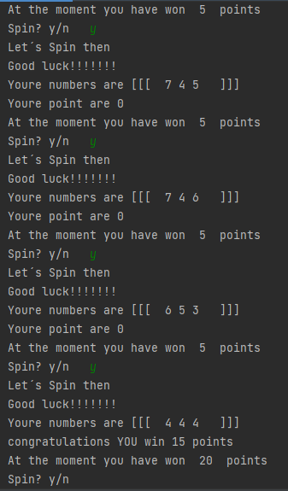

RESULT

The program works correctly and the previous spin score is added to the currently accumulated score.

Checking without the random library.

Instead of random numbers were introduced [9,9,9]
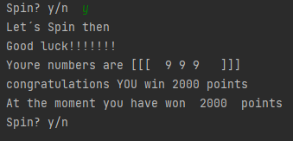

RESULT
The program offered the expected number of points, so it works correctly.

Instead of random numbers were introduced [8,9,9]

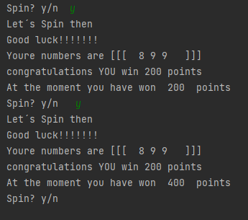

RESULT
The program offered the expected number of points, so it works correctly and the score from the previous spin is added to the score currently accumulated.

Instead of random numbers were introduced [8,8,8]

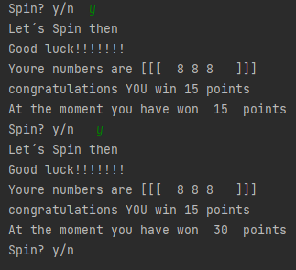

RESULT
The program offered the expected number of points, so it works correctly and the score from the previous spin is added to the score currently accumulated.

Instead of random numbers were introduced [7,8,8]

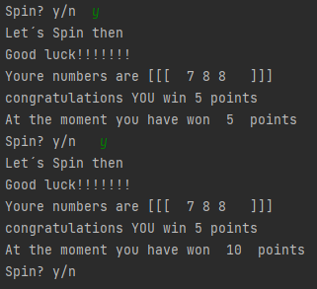

RESULT
The program offered the expected number of points, so it works correctly and the score from the previous spin is added to the score currently accumulated.

Instead of random numbers were introduced [7,8,9]

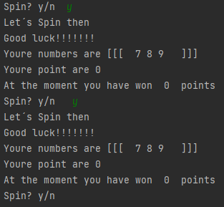

RESULT
The program offered the expected number of points, so it works correctly.

Conclusion
It is worth mentioning that Python is a high-level programming language is easy to use. The codes and possibilities of this programming language are limited only by the developer's imagination and the attention he pays. Thank you!!!

Bibliography
[1] “Control Structures in Programming Languages,” GeeksforGeeks, Jan. 15, 2020. https://www.geeksforgeeks.org/control-structures-in-programming-languages/.
[2]“Python for Machine Learning: Indexing and Slicing for Lists, Tuples, Strings, and other Sequential Types,” Blog by Railsware, Oct. 03, 2018. https://railsware.com/blog/python-for-machine-learning-indexing-and-slicing-for-lists-tuples-strings-and-other-sequential-types/.
[3]“Python While Loops,” www.w3schools.com. https://www.w3schools.com/python/python_while_loops.asp.
[4]“Python Conditions,” W3schools.com, 2019. https://www.w3schools.com/python/python_conditions.asp.
[5]“Python For Loops,” W3schools.com, 2019. https://www.w3schools.com/python/python_for_loops.asp.
[6]“Python Lists,” W3schools.com, 2019. https://www.w3schools.com/python/python_lists.asp.
[7]“Python - Add List Items,” www.w3schools.com. https://www.w3schools.com/python/python_lists_add.asp (accessed Jul. 26, 2021).

