Academic Skills Assignment 2 2018 – Reflective Report



12TH MARCH 2018

MODULE NAME: ACADEMIC SKILLS - M4X01434
Project Name: THE RISING STARS
Name: RHODRI SHEPherd
Student Number: 1702359

Table of Contents

1. eXECUTIVE sUMMARY 1
2. Introduction 2
2.1 Report Remit 2
2.2 Brief background on your project 2
3. Models of reflection 2
4. Masterclass Sessions 5
4.1 Influence of Masterclasses on the Project 5
4.2 Influence of the masterclasses on personal learning & development 7
4.3 Conclusion 10
5. References 11
6. APPENDICES………………………………………..……………………………………………………….13

List of Figures

Figure 3-1 Driscoll’s Three Stage Model (Driscoll, 2007) 3
Figure 3-2 Kolb’s Experiential Learning Model (Muscat & Mollicone, 2013) 3

eXECUTIVE sUMMARY
The purpose of this report is to analyse the way particular masterclasses had influenced my time while working with the organisation The Rising Stars and also on my personal learning and development. The masterclasses gave an insight into various skills such as confidence, communication, time management, and problem solving, some of which I will mention in more detail in this report.
Our project was to raise awareness for the charity The Rising Stars; they are a charity who help young children and adults express themselves through the medium of drama and performing arts. We were set out to achieve 3 to 5 aims, and the masterclass sessions helped us to achieve the main aims successfully. One of the major ways the masterclasses influenced the project was while the guest speakers talked about confidence and time management skills, as these are important not only in day to day life, but also within a working environment. These two skills were essential while working with The Rising Stars as certain tasks and jobs needed to be tackled with ease, confidence, and time effectiveness in mind. Also, having good marketing was a skill that we learned from masterclasses and this took part majorly in the project, as the overall main aim was to market and raise their awareness as a local charity.
The masterclass sessions helped me to see things from a different perspective personally, because if I never participated in the masterclasses, my whole outlook on certain situations would be different. As a result of the masterclasses, I had developed my public speaking skill, as before the masterclasses I was not confident in talking and presenting in front of an audience, but now my confidence has increased as a result.

Introduction

Report Remit
This report is seeking to achieve how the various masterclass sessions have impacted on me as a person in conjunction with the skills I have learned and the impact of its delivery on the project while working with the organisation The Rising Stars. Also, the models of reflection will also help to reflect on the feelings and experiences I have had while working with the organisation and also while participating in the masterclass sessions.
This report will also include a brief background on the project I have been working with during the first semester in university. This report will also include the influence various masterclass sessions have had on the development of my confidence as well as other skills.

Brief background on your project
During the first semester the project the group were allocated with was The Rising Stars Theatre Company. This charity works with children and adults with learning difficulties to enhance their acting and performing arts skills, and by doing this increasing their overall confidence while communicating with other people. The group had first-hand experience while working with the ground and saw how the charity operate from week to week. The charity depends on the generosity of the public in order to get their donations to keep running. (The Rising Stars, 2018)
While working with this charitable organisation, as a group we raised as much awareness as we could in order for more people to know about The Rising Stars, and what they are giving back to the community. In order to raise awareness, we created a blog site online to reach audiences worldwide, and this proved to be a success as we reached countries such as America, Spain, and India. Also, we created posters and put them in various local businesses in the Swansea area in order for the local community to pull together to help this great cause.

Models of reflection
This section of the report will concentrate on the introduction of the models being used in order to describe the experiences during the course of this project. There are many models of reflection that can be used to look back and reflect on experiences and opportunities that have been, and look on how to improve in the future. (Leeds Beckett University, 2015) Some of these models include Driscoll’s (1994) Three Staged Model, Gibbs’ (1988) Reflective Cycle, Cottrell’s (2010) Core Prompt Model, and Kolb’s (1984) Experiential Learning Model. The two models I will concentrate on in this report is Driscoll’s Three Stage Model, and Kolb’s Experiential Learning Model, which will be demonstrated below.

Driscoll’s Three Stage Model of Reflection

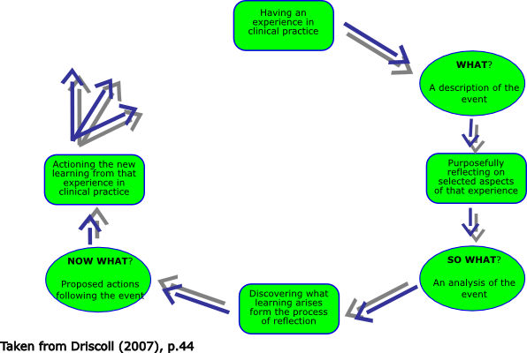
Figure 3-1 Driscoll’s Three Stage Model (Driscoll, 2007)

The diagram above shows Driscoll’s (1994) Three Stage Model of Reflection. This diagram simply states, “the what”, “so what” and “now what” aspects. These three aspects refer to 3 different themes. The what indicates the current experience at hand, and also what was seen and done, and also your own reaction and that of other people’s. The ‘so what’ refers to the importance of what has been experienced and learnt. Lastly, the ‘now what’ refers to how the project will be done differently in the future. (Driscoll, 2007)

David Kolb’s Experiential Learning Model
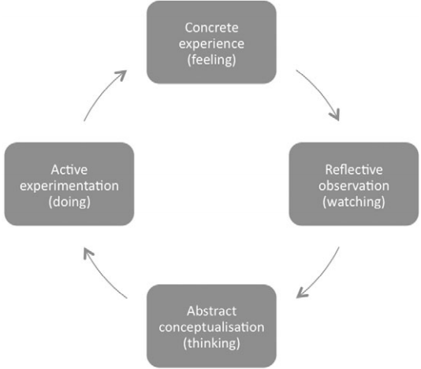

Figure 3-2 Kolb’s Experiential Learning Model (Muscat & Mollicone, 2013)

The diagram above shows Kolb’s Experiential Learning Model. The model consists of 4 different aspects: The Concrete Feeling refers to the activity or experience at hand, which in this case was raising awareness for The Rising Stars. The Reflective Observation is the time period to reflect on what has been said or done. The Abstract Conceptualisation is where all experiences have been concluded and a reflection of what has been learned or experience. Lastly, the Active Experimentation is implementing the changes for the future. (LearningTheories, 2007)
Kolb (1984) said “learning is the process whereby knowledge is created through the transformation of experience” (Kolb, 1984, p. 41). This has been used throughout the course of the project as learning from experiences is important in order to develop and enhance certain skills, such as confidence and time management, which I will speak about in section 4.2 of the report.

Masterclass Sessions
We attended masterclass sessions during the first semester in order to gain an insight into real life organisations and the effort and determination each owner has been through to set them up. Each guest speaker gave a brief background of how they started their business and how their businesses have grown to be a success over the years. According to Mullins (2016):
“It is recommended strongly that you maintain a portfolio of what you have learned in your personal development and the employability skills you have attained or enhanced during your course of study. This can provide a useful basis of discussion with a potential employer.” (Mullins, 2016, p. 22)

This was true about the masterclass sessions; each guest spoke about all the employability skills that look appealing to potential employers and therefore helping out my personal development ahead of the future, and they outlined the skills and barriers they overcame in order to be successful. In this section I will talk about the two guest speakers who had the biggest influence on me while doing the project as well as my personal development.

One of the guest speakers who had a big impact on myself was Stifyn Parri who owns “Mr. Producer”. His persona was very confident and outgoing which he had developed while owning this company and hosting various events. He said that as a child he was not very confident, but he overcame that barrier by taking part in presentations and television interviews for example. As well as confidence, determination played a big part in the success of his business as being determined is one of the key skills to have in order to succeed. (Parri, 2017)
Kate from Gower Cottage Brownies was a speaker who gave a brief talk which resonated with me. She spoke about the various marketing techniques she used for her business in order to be cost effective. She spoke about the power of marketing and advertising as a whole, which we used throughout out project often. According to Kotler & Armstrong (2018) “Marketing is engaging customers and managing profitable customer relationships” (Kotler & Armstrong, 2018, p. 28), this is one of the key themes Kate talked about in her presentation which we implemented into our project throughout.

Influence of Masterclasses on the Project
The masterclasses had a big impact on the way the project was carried out, as the guest speakers gave valid help and determination tips on how to tackle different situations with ease and confidence. During the course of the project with The Rising Stars, various situations needed to be tackled with confidence, such as participating in their weekly classes, and talking to different members of the team, and therefore because of this my confidence grew and I wasn’t faking it as much and it became more natural.

Implementing Driscoll’s Three Stage Model to the project
By implementing Driscoll’s Three Stage model, ‘the what’ referred to the experience at the time. While the guest speakers were presenting we took part in various activities therefore other people were involved. (The University of Nottingham, n.d) the importance and influence of working with others during these masterclasses was critical while undergoing various tasks during the project. Unfortunately, during some stages of the project, communication and meeting up as a team prove to be difficult as some members were absent as they lived away, therefore this effected our overall productivity and effectiveness. The ‘so what’ concentrates on the feelings at the time, compared to the future. While participating in the masterclasses my general feelings were ‘how can I implement this while doing the project?’, and Driscoll’s 2nd part of the model answers this. When writing the blog posts and putting up posters as a part of raising awareness for The Rising Stars, my feelings were different to as they were during the masterclasses. I felt more determined and motivated to complete tasks to a good standard and by the deadline in order not to delay other tasks. (ETC Toolkit, n.d) Lastly, the third aspect of Driscoll’s model is the ‘Now What?’, which refers to the future. Not all aspects of the project were completed to its full potential, as various tasks were not completed as we thought would be. Not all aims and objectives were carried out, and this was because of the barriers that stopped us from doing them. Some of our main aims was to put an article about The Rising Stars in a newspaper, but we did not get to do this. Therefore, if the project was done again in the future, I would make sure that more planning went in to ensure the completion of all tasks.

Kate from Gower Cottage Brownies
Marketing played a major part in the project while working with The Rising Stars, as advertising and raising awareness for the charity was one of our main aims and objectives. Guest speaker Kate’s talk was relevant to this and had a big influence on the undertaking of the whole project. Kate mentioned that she only spent £200 on creating and designing a website for her company, yet she has reached a very extensive customer base. Her website mentions some of her loyal customers: “our regular and loyal customers include Richard Curtis & Emma Freud, The Welsh Rugby Squad” (Kate, 2016) Also, she spoke about the power of social media and how it has helped her business succeed over the years. As a part of our project we created a blog site in order to demonstrate the power of social media. Although our blog was only done for a short amount of time, we still reached over 300 viewers worldwide, in countries such as the United States, Germany, South Africa, and India.
To conclude, communication would be a major skill that would need to be developed on if the project was to be done again in the future. While taking part in our project communication was one of the things that let the team down and stopped us from completing each task within the time given and to the best possible standard. According to a study conducted by the Katz Business School of the University of Pittsburgh: “oral and written communication skills were important in predicting job success, as was the ability to communicate well with others in the workplace.” (Anon, 2010, p. 10). This then shows that working within a team and communicating effectively will ultimately be one of the things that make you look more employable to future employers. Communication was a problem for our group as some team members had to go home to other countries and therefore this was one thing that affected out communication overall.

Influence of the masterclasses on personal learning & development

Confidence Development
A common theme throughout most masterclass sessions was confidence. The guest speakers stated that confidence is key in setting up a successful business whether it be in making presentations, networking, in meetings, or just talking to customers from day to day. This has a major impact on me as confidence is a skill that is widely used in businesses from day to day, especially as there will always be new people to talk to. Psychology Today (2018) describes having confidence as “too much of it and you can come off as cocky and stumble into unforeseen obstacles but having too little can prevent you from taking risks and seizing opportunities” (Psychology Today, 2018). This means that by having too much confidence, a person could go into a business proposition blindly or take an unnecessary risk for example and be too ignorant to fully understand the importance of the situation. Before starting university, I majorly lacked confidence, but while doing the masterclasses and the project in the first semester my confidence has grown. Doing presentations on the reflection of different opportunities I had experienced while undertaking the project were the main reasons that my confidence had grown. Amy Cuddy once talked about confidence during a TED Talk, which is relevant to this topic, she said: “Can you fake it until you make it? Can you do this for a little while and actually experience a behavioural outcome that makes you seem more powerful” (Cuddy, 2016) In the past, when taking part in group tasks and doing presentations or interviews, this was one of the techniques I was using in order to come across more confident to people whom I talked to, but while participating in various masterclasses my confidence grew and so faking it was no longer needed. Therefore, while doing this project, the skill of confidence was continuously growing which will be a very important skill while working as a part of a team in a workplace in the future, as without confidence your personality won’t come across well to potential employers and could effectively affect your relationship with peers and managers.
Stifyn Parri’s talk had a big influence on my personal learning and development because he spoke about various techniques in order to come across more confident and outgoing during professional presentations and interviews. He spoke about how body language was important in order to look more professional as well as remaining calm in pressured situations. This skill is one of the most important in order to increase your personal profile and look more employable to future employers. This skill will become very useful during my time in university as well as after university when looking for employment. Although this skill will be important in employment, this skill will also help my personal life as I will find it easier to talk to people who I have never met before. (Parri, 2017) Parri’s website states “The company offers a wide range of creative services including developing creative concepts, mentoring on presentation skills and confidence.” (Parri, 2016). This shows that he is highly trained and very professional therefore any information and tips given from him will definitely be of help in the future.

Time Management
Time management was another key topic discussed during the masterclasses. Time management is another skill that’s important for employability as aims, objectives, tasks and deadlines must be met in order for a business to maintain its economies of scale for example. Kate from Gower Cottage Brownies briefly spoke on time management as she has to ensure that she meets delivery dates while delivering brownies to her customers. Similarly, in the past I have had to ensure that I complete tasks before a deadline, and this is a skill that I still need to use in the future. According to Adair (2008) “Time management is about managing your time with focus on achievement: of doing and completing those things which you want to do and which need doing” (Adair, 2008, p. 4). Although time management is important, it is also result orientated, therefore the end product must have been done to a high standard in order for the time management to have been effective. (Adair, 2008) With regards to the project, we had deadlines therefore time management was important. Although time management was important during the project, personally, completing a task within the time given gives self-satisfaction, and show’s that I can work under pressure. While undertaking different tasks, some tasks must be finished before another one could be started. Sometimes this was proven to be difficult in some situations while doing the project, as some team members did not complete certain tasks on time, which delayed the whole process. Time management must be taken into consideration if a project like this was ever done again in the future.
To conclude, in order to improve these skills even further in the future, effective time management must be taken seriously in order to meet certain deadlines with confidence. According to Activia Training (2018) “Good time management skills can mean the difference between feeling like you are being pulled in a hundred different directions and getting any meaningful work done” (Activia Training, 2018) Therefore, effective time management is a skill most employers look at in potential employees because although their job description only concentrates on one thing, there are many sub tasks that need to be completed within a time limit in order to finish the core task or project. Time management is an important skill that I haven’t been conscious about in the past, but by doing university assignments this has taught me that my time management skill needs to be developed further ahead of the future.
By implementing Kolb’s Experiential Learning Model and looking specifically at the abstract conceptualisation. Ahead of the future there are many strengths and weaknesses to be developed on. My main personal strengths are that I can work effectively within a team. Although confidence is not one of my strong skills, I can still contribute to group discussions and give valid points and opinions on how to solve a certain problem. In order to further develop this skill, I will need to increase confidence which will lead to my opinion and points coming across more accurate during discussions. As already mentioned, confidence is one of my weaknesses, as I do not have much experience in group or personal presentations in front of an audience. According to ‘The Balance’ (2017), preparing and engaging the audience are amongst the top things to do in order to mitigate the fear of doing presentations. (The Balance, 2017). Therefore, these are some of the steps that I need to consider in order to better this skill in the future.

Conclusion
This report has given an insight into how various masterclasses has helped my overall personal development as well as the project with The Rising Stars. I have learned that different skills are essential in the delivery of certain talks, and some of these skills need to be developed more in the future. The masterclasses influenced me personally and during the course of the project. As a result, confidence is a key skill that needs to be developed now and in the future, because it is very important in a day to day aspect, as well as while working within a team in an organisation. Although my time management skill has not proven to be a weakness overall, this skill can always be developed more in order to deliver the end product with excellence and to a good quality.

References

Activia Training, 2018. Importance of Good time Management. [Online]
Available at: https://www.activia.co.uk/soft-skills/why-is-having-good-time-management-important
[Accessed 11 March 2018].
Adair, J., 2008. The Best of John Adair on Leadership and Management. London: Thorogood Publishing.
Anon, 2010. Effective Communication Skills. s.l.:MTD Training & Ventus Publishing Aps.
Cottrell, S., 2010. Skills for Success: Personal Development and Employability. 3 ed. London: Macmillan Publishers.
Cuddy, A., 2016. Amy Cuddy TED Talk - Fake it till you make it. s.l.: TED.
Driscoll, J., 2007. Practising Clinical Supervision: A Reflective Approach for Healthcare Professionals. 2nd ed. Edinburgh: Bailliere Tindall Elsevier.
ETC Toolkit, n.d. Driscoll (1994) Model of Reflection. [Online]
Available at: https://www.etctoolkit.org.uk/media/1127/driscoll.doc
[Accessed 10 March 2018].
Gibbs, G., 1988. Learning by Doing: A Guide to Teaching and Learning Methods. Oxford: Oxford Further Education Unit.
Kate, 2016. Gower Cottage Brownies. [Online]
Available at: http://www.gowercottagebrownies.co.uk/
[Accessed 11 March 2018].
Kolb, D., 1984. Experiential Learning: Experience as the Source of Learning and Development. Englewood Cliffs: Prentice-Hall.
Kotler, P. & Armstrong, G., 2018. Principles of Marketing. 17 ed. Harlow: Pearson Education Limited.
LearningTheories, 2007. Experimental Learning (Kolb). [Online]
Available at: https://www.learning-theories.com/experiential-learning-kolb.html
[Accessed 11 March 2018].
Leeds Beckett University, 2015. Models for structuring reflection. [Online]
Available at: http://skillsforlearning.leedsbeckett.ac.uk/preview/content/models/01.shtml
[Accessed 12 March 2018].
Mullins, L. J., 2016. Management and Organisational Behaviour. 11th ed. Harlow: Pearson Education Limited.
Muscat, M. & Mollicone, P., 2013. Using Kolb's Learning Cycle to Enhance the Teaching and Learning of Mechanics of Materials. International Journal of Mechanical Engineering Education , 40(1), pp. 66-78.
Parri, S., 2016. Mr Producer. [Online]
Available at: https://mrproducer.co.uk/homepage/
[Accessed 11 March 2018].
Parri, S., 2017. Mr. Producer. Swansea: s.n.
Psychology Today, 2018. Confidence. [Online]
Available at: https://www.psychologytoday.com/basics/confidence
[Accessed 6 March 2018].
The Balance, 2017. 7 Tips to Help You Overcome Your Fear of Public Speaking. [Online]
Available at: https://www.thebalance.com/overcome-fear-of-public-speaking-2951708
[Accessed 11 March 2018].
The Rising Stars, 2018. About Us. Swansea: s.n.
The University of Nottingham, n.d. Driscoll (By Borton). [Online]
Available at: https://www.nottingham.ac.uk/nmp/sonet/rlos/placs/critical_reflection/models/driscoll_what.html
[Accessed 10 March 2018].

appendices
APPENDICES
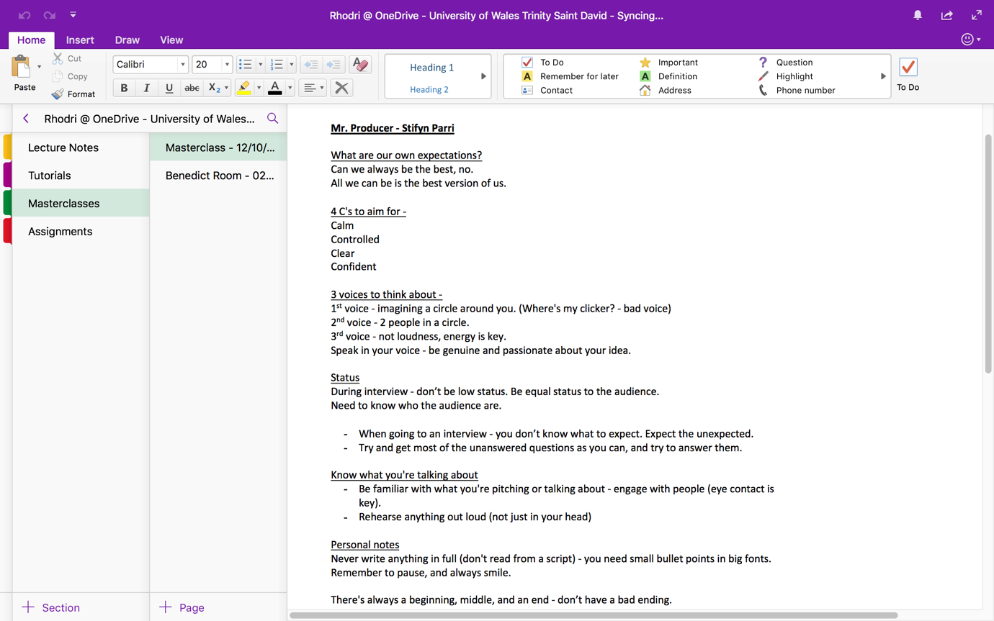
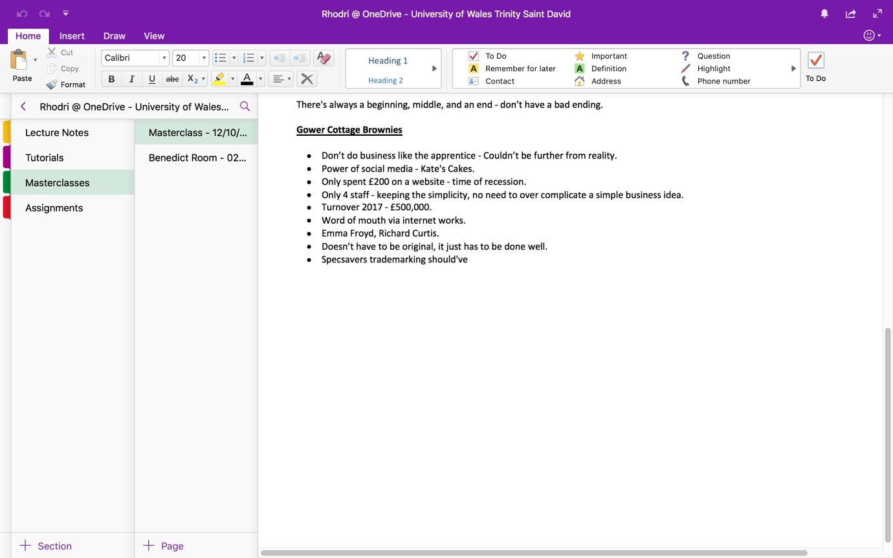

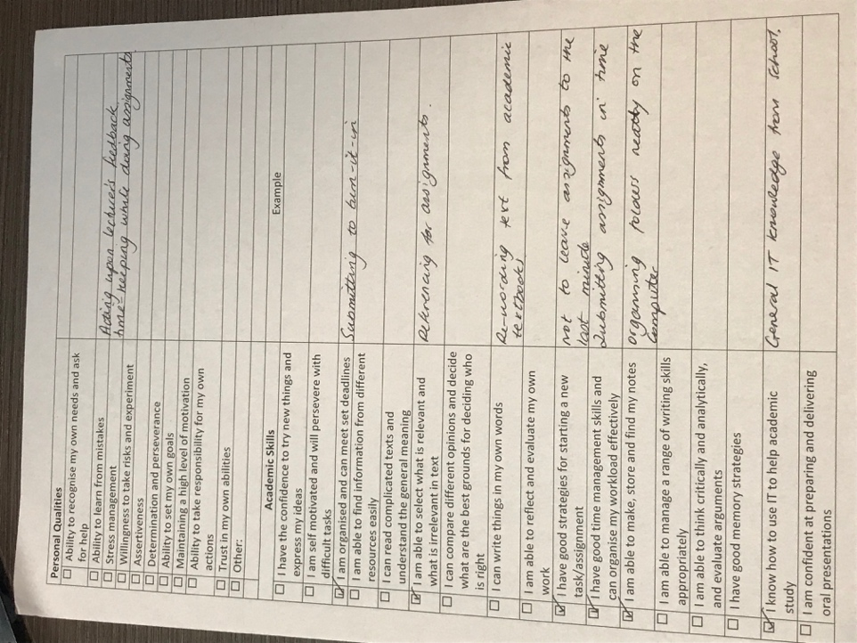
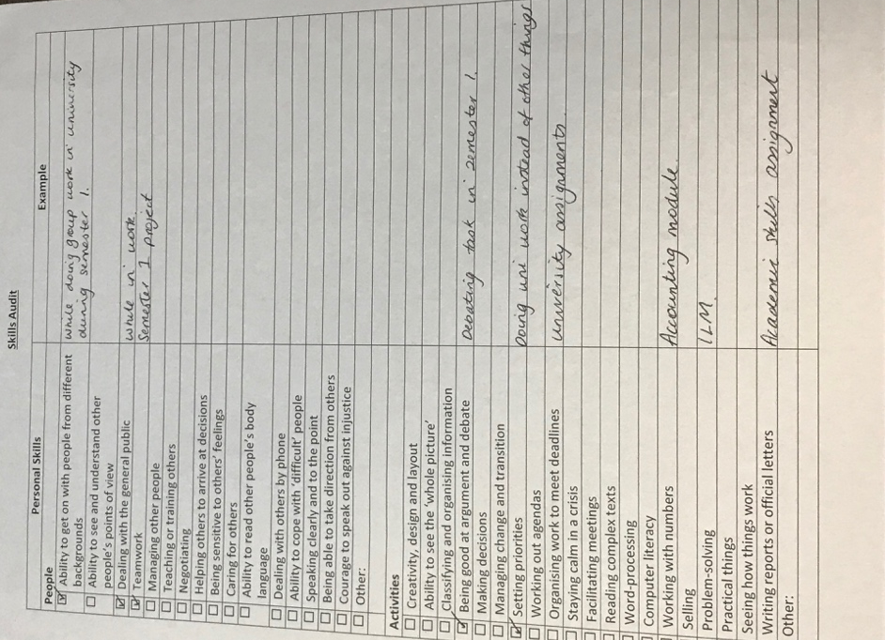
APPENDICES

