What are the current challenges that the industry is facing that is affecting employee retention



Name: Sophie Edmunds
Student Number: 2100303
Module Title: Personnel Resourcing & Development
Module Number: BMIH5005
Lecturer’s Name: Kathryn Roberts

Word Count: 2,113

Contents page

Introduction…………………. ……………………………….3
Discussion/Literature
PESTLE Analysis……………………………………………3-7
The SWOT Analysis…………………………………………7-8
Evaluation and Conclusion…………………………………9-10
References…………………………………………………..11-15

Introduction
The hospitality industry is facing unprecedented challenges from many external and internal current affairs (Meyers, 2021). The hospitality industry is struggling to retain its staff. Human Resources (HR), General Managers and employers need to look at methods to revive the employee lifecycle and maintain growth for future generations by looking into employee engagement and retention. This report will discuss issues of retention that is stemmed from Brexit, post-Covid, tax, inflation, the cost-of-living crisis, technology, and climate change. The report will use industry examples, with the use of PESTLE (Political, Economic, Social, Technological, Legal and Environmental factors) and SWOT (Strengths, Weaknesses, Opportunities and Threats) analysis to prepare Hilton, Cardiff for their future and what might impact retention within the hotel including the recruitment crisis, current trends amongst the Millennial and Gen-Z generation, poor management and insufficient training.

Discussion/Literature
The PESTLE Analysis
To begin with, it is vital to highlight that one of the main issues currently facing the hospitality industry is retention rates. McAllister (2022) states in a study by “workforce management specialist Bizimply, more than 80% of hospitality operators are facing recruitment and retention challenges.” He also adds that 84.3% of hospitality organisations struggle to build their team and do not have the right strategies for growth now and in the long-term future.
Looking at the political and economic factors, in an article by Moates (2022), he mentions there is a “tough” journey ahead. Recently the chancellor Jeremy Hunt announced the autumn budget for 2022 to bring “stability” to the UK economy (BBC News, 2022). Currently interest and inflation rates are at a twenty-year high (Moates, 2022). ITV News (2022) published that the rise in taxes and “the current cost of living crisis is affecting millions of the vulnerable and poorest income earners of the UK”, meaning that many people are cutting back on spending, going out to restaurants or hotels and reducing their luxury items over Christmas. This, therefore, has a consequential impact on the hospitality industry where revenue decreases for businesses and the cost of buying goods are increasing. This implies people are having to leave their jobs due to low wages, and as businesses cannot find or retain recruits, it increases workload on current staff within this sector which can drive them to leave, find better paid jobs, and manageable hours elsewhere (Hennessy, 2022).
Furthermore, there are social elements in the PESTLE analysis and the generational demographics of Hospitality workers changing, it has had an impact on career attitudes of future employees. Kim and Spears (2020) studied on students’ attitudes towards work. They found that “it is important for practitioners and educators to understand culture and diversity” in the workplace. Gen-Z want to feel valued in the growth of “organisational outcomes” as well as “group and individual performances.” This conveys there is a change in belief towards the “work-life balance” that the boomer generation and predecessors once valued (Olya, 2022). Olya (2022), continues saying that Gen-Z will job hop if a role does not fit them; “they are constantly looking for advancement in their careers and overall quality of life.” This shows that social elements are evolving, and it has a strong link to technological influences.
For example, there has been a growing trend on a social media platform called TikTok, which is called “quiet quitting”. According to Acres (2022), this trend is putting a “fresh face to an old problem.” It is whereby employees become disengaged in their work and Patel (2022, quoted in Acres, 2022) says it means they “put no more effort than necessary into their job.” It is said this trend is used to “empower” individuals to “resist unsatisfying work culture.” This has become more abundant post-Covid-19 where employees are establishing boundaries with employers, valuing personal leisure time over work and relates employers lack of positive engagement with their employees (Kudhail, 2022). In response, HR need to actively seek ways to engage their employees in order to retain their talent and lead the business to success (Torrington, et al, 2020, pg. 288). Employee engagement has become a growing industry trend whereby prospective employees want to know what benefits a company can provide for them (Gallup, 2022). This is a method to secure and retain their team’s employee lifecycle within the organisation (Armstrong, 2020, pg. 451).
Additionally, the management of employees plays a vital role in their performance. Poor management in hotels can lead talent away from a company (Nink and Robison, 2016). Management needs to be fully trained and suited to their job roles (such as personality, experience and qualifications) to be a leading figure in their team’s motivation, engagement and encouragement levels (Dosser and Mullins, 2013, pg. 189). Otherwise, it can decrease the levels of happiness, job satisfaction and performance of customer service from their team (Nink and Robison, 2016). Dosser and Mullins (2013, pg. 192) say that a manager’s objective should aim towards an “optimum working environment”, that meets the demands of the company “for effective performance and productivity.” All the while supporting, being empathetic and boosting the morale of the people at work.
Alongside social media, the development of technology is making a growing impact on the hospitality industry which is bringing what Wood (2013, pg. 100) says is “higher productivity and efficiency.” Introducing innovation like contactless payments, touchpoints/self-serve check-in systems, robotic butlers and concierge. Hotels like The Sheraton in Los Angeles provides a group of autonomous robots to carry out room service (Hertzfeld, 2018) and in Japan there is the Henn-na Hotel that is primarily staffed by multi-lingual robots from check-in to porter robots who carry luggage to guest rooms (Hertzfeld, 2019). However, there is little evidence to support the addition of robotics are affecting retention rates within hotels, they can in fact help ease some of the workload and are not replacing employees (Diller, 2022).
The legal factors that affect the retention of employees are levels of inadequate training provided by the workplace. This can lead to legal disputes in a situation of an accident or claim of injury at the workplace under the Management of Health and Safety at Work Regulations 1999 (gov.uk, 2022). Furthermore, employers, general managers and HR need to work together to make the workplace safe and keep up to date with the compliance of the Health and Safety at Work Act 1974 (gov.uk, 2022). Brexit has also had an impact of retention of employees. Where according to the ONS (2021), “three in ten hospitality businesses [were] finding vacancies difficult to fill” between the 23rd of August to the 5th of September 2021. *
The ONS (2021) continued to say that 25% of businesses that had recruitment issues agreed it was because of a reduced number of EU applicants influenced by both Brexit and the Covid-19 Pandemic.

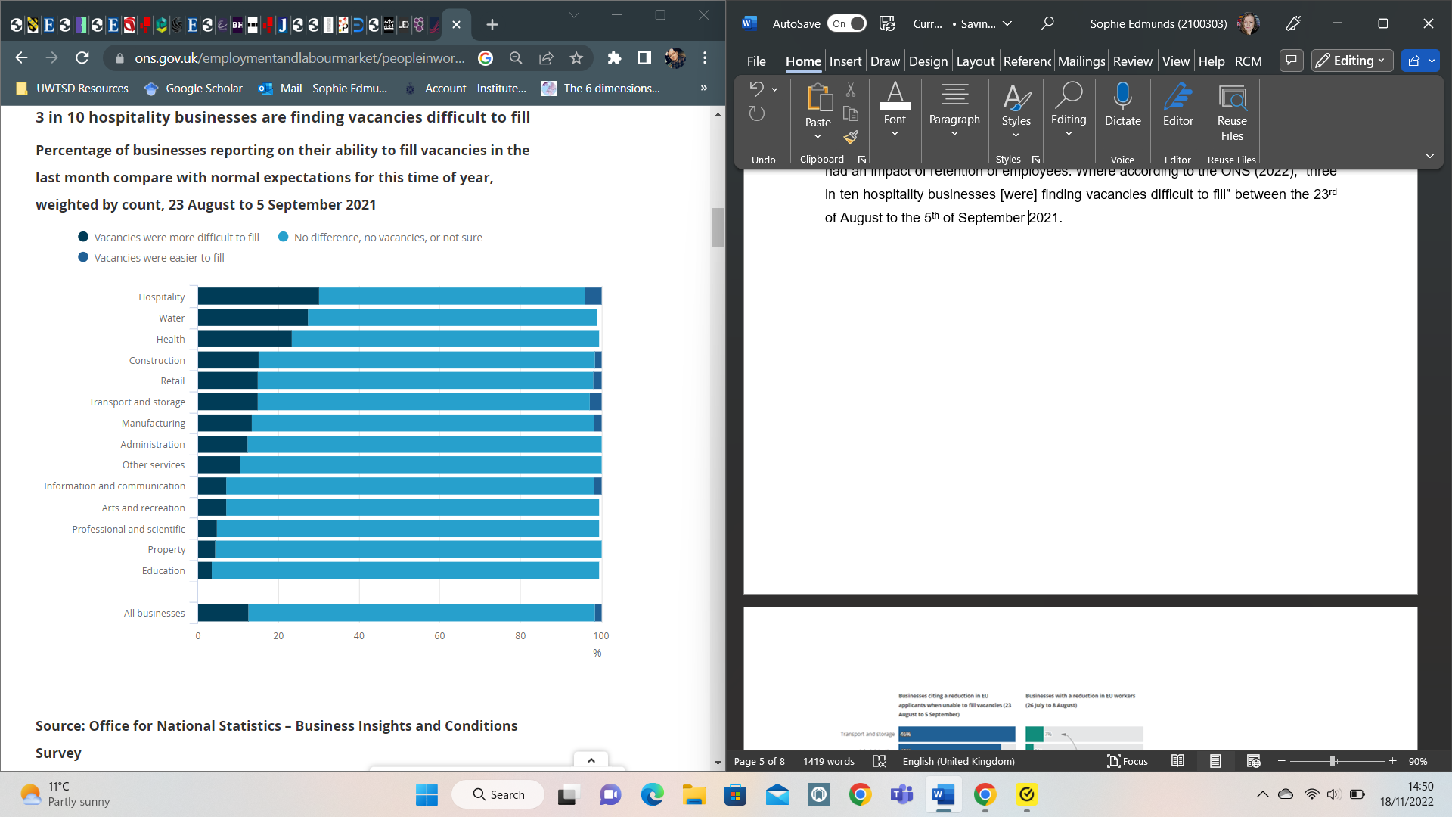

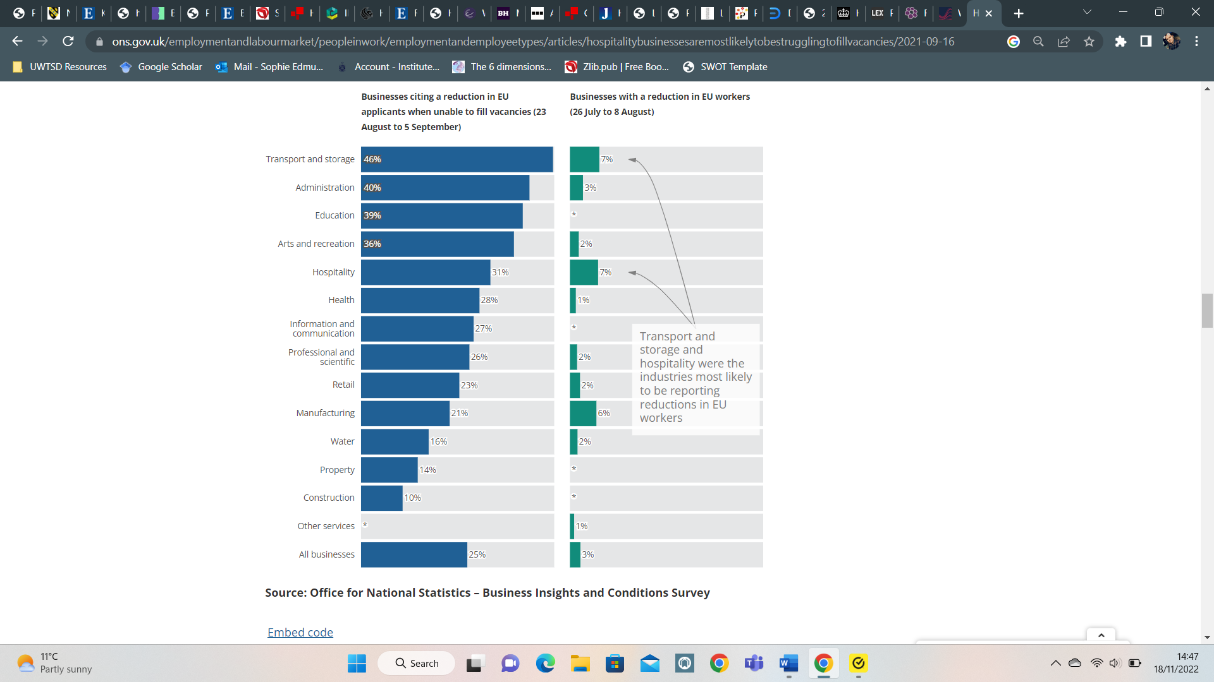

*Tables sourced from the Office for National Statistics 2021 showing the recruitment crisis the Hospitality industry faces.

Additionally, with the growing ethical responsibilities, corporate firms must drive for ethically strong leaders (Wibbenmeyer, 2022) in order to contribute to global environmental goals from becoming Net Zero to sustainability of procurement resourcing. Hilton (2020) takes pride motivating their staff to prevent waste and use responsibly sourced supply chains. Not only that, during the Covid-19 pandemic, HR teams in Hilton also acted “immediately” to support “the safety and wellbeing of their Team Members” which showed a positive act of engagement with their workforce in aiming to retain their staff and “support their learning and development.”
The SWOT Analysis
With the use of a SWOT analysis and information from the PESTLE analysis, it can identify internal areas for recommendations and potential solutions that Hilton, Cardiff can follow and strategize to retain the current and future Team Members.
Strengths
- Hilton has high levels of employee engagement from their team members. (Thrive at Hilton, 2020)
- Hilton is #2 on the “World’s Best Workplaces list” for 2022 (G.P.T.W., 2022).
- The “Thrive at Hilton” scheme has been a great success for the team and their culture with the development of the employees’ growth and wellbeing (Thrive at Hilton, 2020).
Weaknesses
- The current recruitment crisis has impacted on all hospitality trade (Lake, 2022). This is partly because of the reduction in EU workers and the status quo that job roles in the industry entail (long hours, few breaks, low wages etc.) (District Magazine, 2022).
- The BBC (2017), published “Hilton was fined $700,000 for mishandling two separate data breaches.” This was just before GDPR law came into force in 2018 (gov.uk, 2022). Since then, investment in security has been improved (Hilton, 2022). However, this has had an affect with the level of trust between stakeholders of Hilton due to the amount of time it took to notify the public of the breach (Borner, 2017).
- The reduction in guest bookings in relation to the cost-of-living crisis, has also had an impact on staff having reduced shifts/hours in the workplace due to the rising costs that businesses face (Green, 2022).
Opportunities
- Take advantage of planning new marketing strategies, such as usage of social media platforms to engage the younger generation of potential team members to work in Hospitality (Armstrong, 2020, pg. 521) with Hilton on applications like TikTok, YouTube and Snapchat (YEC, 2021).
- Collaborate with current employees on how the company can help them to continue their engagement, growth and career via the Thrive at Hilton scheme and plan for change (Armstrong, 2020, pg. 1039). Provide surveys to employees and review the current strategy.
- Work towards collaboration with employees and sustainability to prosper the company vision and mission. The opportunity of sourcing products locally can be investigated and encourage what Williams, et al (2019) says is “meaningful corporate social responsibility.”
Threats
- The current cost of living crisis has created a detrimental butterfly effect in the supply and demand of bookings and maintaining supply of materials, this has been rooted from a reduction in HGV drivers and fuel prices rising (McAllister, 2022).
- Brexit and Covid-19 have placed a significant gap in sourcing labour from EU nationals which the UK hospitality industry heavily depended upon (NITA, 2022).
- Continuous generational changes of career attitudes could result the business being out-of-touch with current industry trends (Jones, et al., 2008, pg. 50).

Evaluation and Conclusion
Utilising the PESTLE and SWOT analysis, it can assist with finding solutions and recommendations to retain employees in the Hilton, Cardiff.
Firstly, the abundant issue in the hospitality industry is the cost-of-living crisis. Howlett (2022) states it has created low levels of morale and productivity in work, with many people working second jobs to pay bills leading to burnout. It is vital that Hilton address their team members and seek solid solutions to support them during this challenging time. For example, suggestions could be an extra day of annual leave provided, offering discount schemes, providing wellbeing sessions and maintaining communication with employees to listen and understand what they are going through to help them feel valued. Although, this can be costly for the business, it is worth investing in human capital in order to maximise retention rates of team members and support their mental health and wellbeing (Armstrong, 2020, pg. 95).
Next, planning should be organised for a new phase of marketing to engage and attract new talent to work at Hilton. The PESTLE and SWOT analysis has provided an understanding of the changing generational attitudes and technological changes. As a recommendation, the Hilton Cardiff hotel may be in a position alongside the Welsh Government (2022) initiatives, to inspire today’s youth and “shine a spotlight” on careers in the tourism and hospitality sector, potentially developing a training programme for school-leavers onwards to aspire to engage and grow a career within the Hilton brand, and the hotel industry.
Furthermore, management within Hilton may require further training to better equip their knowledge and understanding of team leadership and development. A way this could be broadcast is providing a trip to a conference to watch and listen to motivational speakers or having an online training course. Also, it is crucial to recognise and evaluate current engagement methods within the workplace and review what is working and what can be improved. It is important to carefully analyse a balance of good employee engagement and leadership from the company, down to managers and HR. A way of reviewing this is by carrying out surveys to team members.
Finally, it is without saying that this report has highlighted the seriousness of the circumstances that are challenging the retention rates of employees in the hospitality industry. Therefore, it is imperative that managers and organisations consider actively acknowledging and exploring avenues of preserving current employees’ engagement as well as plan for change (Armstrong, 2020, pg. 1039) for future talent to maintain and prosper the hotel for generations to come.

References
Acres, T. (2022) The growing trend of 'quiet quitting' - and whether you should worry about being 'quiet fired’, Sky News. Article available at: [https://news.sky.com/story/the-growing-trend-of-quiet-quitting-and-whether-you-should-worry-about-being-quiet-fired-12735833] (Accessed on: 17/11/2022).
Armstrong, M. and Taylor, S. (2020) Armstrong’s Handbook of Human Resource Management Practice. London: Kogan Page, Limited.
BBC News (2022) Millions to pay more in tax and energy bills but Hunt vows to protect the poorest. Article available at: [https://www.bbc.com/news/live/uk-63591754] (Accessed on: 17/11/2022).
BBC News (2017) Hilton Hotels fined for credit card data breaches. Article available at: [https://www.bbc.com/news/technology-41834679] (Accessed on: 21/11/2022).
Borner, P. (2017) Hilton is fined for Data Breach, The Data Privacy Group. Available at: [https://thedataprivacygroup.com/blog/hilton-is-fined-for-data-breach/] (Accessed on: 21/11/2022).
Diller, N. (2022) Hotels have gone to robots, The Washington Post. Article available at: [https://www.washingtonpost.com/travel/2022/06/07/robots-hotel-jobs-labor-shortage/] (Accessed on: 18/11/2022).
District Magazine, (2022) This is why no one wants to work in hospitality anymore. Available at: [https://districtmagazine.ie/uncategorized/this-is-why-no-one-wants-to-work-in-hospitality-anymore/part-2] (Accessed on: 21/11/2022).
Dossor, P. and Mullins, J. L., (2013) Hospitality management and organisational behaviour, 5th ed. Pearson: Harlow.
Gov.uk (2022) Data Protection Act 2018. Available at: [https://www.gov.uk/data-protection#:~:text=The%20Data%20Protection%20Act%202018%20is%20the%20UK's%20implementation%20of,used%20fairly%2C%20lawfully%20and%20transparently] (Accessed on: 24/11/2022).
Great Place to Work, (2022) World’s Best Workplaces. Available at: [https://www.greatplacetowork.com/worlds-best-workplaces] (Accessed on: 21/11/2022).
Green, A. (2022) Inflation driving one third of hospitality businesses toward failure. Available at: [https://www.hospitalityandcateringnews.com/2022/10/inflation-driving-one-third-of-hospitality-businesses-toward-failure/] (Accessed on: 22/11/22).
Health and Safety at Work Act 1974, Available at: [ https://www.legislation.gov.uk/ukpga/1974/37/contents] (Accessed on: 24/11/2022).
Hennessy, M. (2022) Hospitality workers: Industry's 'downward spiral' will remain until pay and conditions change. TheJournal.ie. Available at: [https://www.thejournal.ie/hospitality-staffing-5772543-May2022/] (Accessed on: 17/11/2022).
Hertzfeld, E. (2018) LG introduces robots to replace hotel employees, Hotel Management. Available at: [https://www.hotelmanagement.net/tech/lg-introduces-robots-to-replace-hotel-employees] (Accessed on: 18/11/2022).
Hertzfeld, E. (2019) Japan’s Henn na Hotel fires half its robot workforce. Hotel Management. Available at: [https://www.hotelmanagement.net/tech/japan-s-henn-na-hotel-fires-half-its-robot-workforce] (Accessed on: 18/11/2022).
Hilton (2020) Hilton 2020 Environmental, Social and Governance (ESG) Report. Available at: [https://cr.hilton.com/wp-content/uploads/2021/04/Hilton-2020-ESG-Report.pdf] (Accessed on: 18/11/2022).
Hilton Careers (2020) How Our Global Team Members Thrive. Available at: [https://jobs.hilton.com/us/en/blogarticle/how-our-global-team-members-thrive#:~:text=At%20Hilton%2C%20we%20believe%20that,do%20for%20our%20Team%20Members.] (Accessed on: 21/11/2022).
Howlett, E. (2022) Eight million employees have low productivity as a result of the cost of living crisis, study finds. People Management. Available at: [https://www.peoplemanagement.co.uk/article/1805565/eight-million-employees-low-productivity-result-cost-living-crisis-study-finds] (Accessed on: 23/11/2022).
ITV News (2022) Jeremy Hunt unveils tax hikes in Autumn Budget as he confirms UK is now in recession. Article available at: [https://www.itv.com/news/2022-11-17/autumn-budget-chancellor-jeremy-hunt-unveils-tax-hikes-and-public-spending-cuts] (Accessed on: 17/11/22).
Jones, I., Hyde, M., Victor, R. C, Wiggins, D. R, Gilleard, C and Higgs, P. (2008) Ageing in a consumer society: From passive to active consumption in Britain. Bristol University Press. Available at: [https://www-jstor-org.ezproxy.uwtsd.ac.uk/stable/j.ctt9qgmgm.6?seq=4#metadata_info_tab_contents].
Kim, H. Y, and Spears, D. (2020) Differing career expectations in the hospitality industry: a cross-cultural study, Vol. 36, No. 2, 2022. Journal by International Hospitality Review, Emerald Publishing Ltd: College of Merchandising, Hospitality and Tourism, University of North Texas, Denton, Texas, USA. Available at: [https://www.emerald.com/insight/content/doi/10.1108/IHR-08-2020-0033/full/pdf?title=differing-career-expectations-in-the-hospitality-industry-a-cross-cultural-study] (Accessed on: 17/11/2022).
Kudhail, P. (2022) Quiet quitting: The workplace trend taking over TikTok. BBC News. Article available at: [https://www.bbc.co.uk/news/business-62638908] (Accessed on: 17/11/2022).
Lake, E. (2022) Hospitality Rising: major recruitment campaign launches to tackle staffing crisis. The Caterer. Available at: [https://www.thecaterer.com/news/hospitality-rising-campaign-recruitment] (Accessed on: 21/11/2022).
Management of Health and Safety at Work Regulations 1999, Available at: [https://www.legislation.gov.uk/uksi/1999/3242/contents/made]
McAllister, J. (2022) Food costs rocket by 'up to 40%' for hospitality businesses as supply chain fragility hits hard. Available at: [https://www.bighospitality.co.uk/Article/2022/07/18/hospitality-food-costs-rocket-by-up-to-40-as-supply-chain-fragility-hits-hard] (Accessed on: 22/11/2022).
McAllister, J. (2022) Majority of operators facing a recruitment and retention challenge. Big Hospitality. Available at: [https://www.bighospitality.co.uk/Article/2022/09/14/more-than-80-of-operators-struggling-with-recruitment-and-retention-staffing-challenges] (Accessed on 17/11/2022).
Meyers, D. (2021) video by Wall Street Journal on The Future of Restaurants. New York. Available at: [https://video-alexanderstreet-com.ezproxy.uwtsd.ac.uk/watch/danny-meyer-on-the-future-of-restaurants?utm_campaign=Video&utm_medium=MARC&utm_source=aspresolver] (Accessed on: 17/11/2022).
Moates, J. (2022) 'We may be busy, but we are busy losing money': Hospitality sector warning ahead of autumn statement. ITV. Article available at: [https://www.itv.com/news/utv/2022-11-15/economist-warns-we-are-looking-at-an-economy-that-is-stuck] (Accessed on: 17/11/2022).
McWilliams, A., Rupp, E. Rupp., Siegal, S. D., Stahl, K. G., and Waldman, A. D., (2019) The Oxford Handbook of Corporate Social Responsibility: Psychological and Organizational Perspectives. Oxford University Press: Bristol. Available at: [https://academic.oup.com/edited-volume/34252?login=true]
Nink, M. and Robison, J. (2016) The Damage Inflicted by Poor Managers. Gallup. Available at: [https://news.gallup.com/businessjournal/200108/damage-inflicted-poor-managers.aspx] (Accessed on: 23/11/2022).
NITA (2022) Hospitality leader calls on Government to ease Brexit visa regulations. Available at: [https://ntia.co.uk/hospitality-leader-calls-on-government-to-ease-brexit-visa-regulations/] (Accessed on: 22/11/2022).
Office for National Statistics (2021) Hospitality businesses are most likely to be struggling to fill vacancies. Available at: [https://www.ons.gov.uk/employmentandlabourmarket/peopleinwork/employmentandemployeetypes/articles/hospitalitybusinessesaremostlikelytobestrugglingtofillvacancies/2021-09-16] (Accessed on: 18/11/2022).
Olya, G. (2022) Gen Z vs. Boomer Job Seekers: What Each Generation Really Wants, Yahoo! Finance. Available at: [https://finance.yahoo.com/news/gen-z-vs-boomer-job-000022625.html?guccounter=1&guce_referrer=aHR0cHM6Ly93d3cuZ29vZ2xlLmNvbS8&guce_referrer_sig=AQAAAJH0S_4XYlcNmt0vieRiuyMLyKvz7lnYJmsO6lgLG0LYPqr6bk3Q0kUU0Xi7XLUkD9_19QfvZDuFa3tp2NhDhreSlMCCKgQLMLeeA6RkU0NKs1cg_16wSZMB-7jp0TUfrem4HF614bTvY5LgMiI1RFxCT5l3wUro0_6DHcq0SggE] (Accessed on: 17/11/2022).
Torrington, D, Hall, L, Atkinson, C, & Taylor, S (2020), Human Resource Management, PDF eBook, Pearson Education, Limited, Harlow. Available from: ProQuest eBook Central.

Welsh Government, (2022) Tourism and hospitality: a great sector to work in, which helps important experiences come to life – Economy Minister Vaughan Gething. Press release. Available at: [https://gov.wales/tourism-and-hospitality-great-sector-work-which-helps-important-experiences-come-life-economy] (Accessed on: 23/11/2022).

Wibbenmeyer, K. (2022) Technology Innovation and Adoption in the Modern Workplace: Resistance, Ethics, Reassurances, When to Say “No”: Exploring Ethical Problems in Today’s Technological World. Purdue University Global: USA.
Wood, C. Roy, (2013) Key concepts in hospitality management. SAGE Publications Ltd.
YEC, (2021) 10 Ways To Attract Young Talent To Your Company. Forbes. Available at: [https://www.forbes.com/sites/allbusiness/2021/08/30/10-ways-to-attract-young-talent-to-your-company/?sh=7316d48b5efa] (Accessed on: 22/11/2022).

