Heat exchanger laboratory analysis

P149128 Iwan Rhys Dyer m5x004006
Lecturer Rob Goodson

Introduction
This document is a lab report about an experiment using a cross flow heat exchanger, held on 12 of February 2019. There were 3 experiments, first were the effects of varying water flow rates on the efficiency of the cross-flow heat exchanger. The second was the effect that a varying air flow rate would have on the efficiency of the heat exchanger. Then the third and final experiment, was the effect of varying the temperature of the heat exchanger.

Contents
Introduction 2
Aims 2
Research 2
Methods 3
Analysis 4
Conclusion 13
References 14
figures and tables 14

Aims
- To show how the change in water rate will effect how the heat exchanger functions.
- To show how a difference in the rate of air flow effects well a heat exchanger works
- To show the effect of varying temperature has on the exit temperature of the heat exchanger.

Research
Heat exchanger is a form of heating/cooling system, the most common example of a normal heat exchanger would be a radiator in your house which is used to transfer heat from the boiler (or water in the lines) to the air in the house. Essentially exchanging the heat from the boiler to the room, in turn increasing the heat. This is a very rudimental heat exchanger as it just runs of the principal of convection, being that hot air rises and cold air will sink. A heat exchanger can be used to increases the temperature of something but there can also be used to cool something, for example that is what a radiator in a car does. Its primary use is to cool the engine down to stop it over heating. Excluding the basic there are 3 types of heat exchanger the first being parallel flow which as the name suggests is when the fluid is run parallel to the flow of the exiting fluid. The second one would be a counter flow heat exchanger is where the fluids flow in opposite directions to each other. They are the most effective of the 3forms of heat exchangers. Finally, we get to the cross-flow heat exchanger which was the he exchanger used during the experiment. A diagram of a cross flow is showed below.

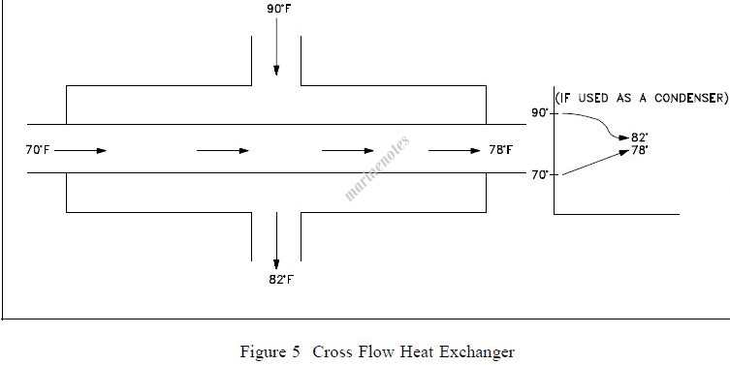
Figure 1
(Anon., 2013)
This diagram shows how the two fluids of the heat exchanger would the first is piped perpendicular to the flow of the of other fluid. As the graph on the right shows if the cross flow is used as a confesses the majority of the heat transfer will occur where the stream changers state. This however would not really affect this heat exchanger.

Methods
To start off with there are a few things that must be prepared before any of the tasks can be undertaken. Firstly, the heat exchanger must be set up correctly, so that means that the TD1007 must be set up with the parallel connecter. The parallel connecter that will be used is the 2 parallel banks of 16 tubes in series its surface area is 0.1558m^2. After that has been set up the sensors must be put in place, so this includes the air, water temp and air flow rate. After this turn on the heat exchanger along with the fan. Once everything is set up take the ambient air pressure for the day. While the heat exchanger is warming up it would be in your best interest to make some form of table to store the information you gather, although this is not necessary, it may save time in the long run.
For the first task heat the temp to 60C and allow the tank to raise to temp. then set the orifice so that the pressure drop is 250Pa and set the flow rate of the water to 2.25 litters a minute. Once these parameters are reached allow at least five minutes for the heat exchanger to reach equilibrium and change any of the settings according to any changes that occur. Once the equilibrium is reached and all of the parameters are within tolerance you can begin testing. As stated above the premise behind the first test is to see what effect varying the flow rate will have on the heat exchanger. The prosses for going about this would be take the temperature at 2.25 litters per minute and then take a reading of the temp at this flow rate. After this reduce the flow rate by 0.5 litters per minute and wait for it to become stable, then take the temperature at this flow rate. Repeat this prosses till you reach 0.25 litter per minute. Once the data has been collected the aim is to first find out the change in temp between the inlet and the outlet of the water, so from 60C to the second value. The second part of this task is to turn the water flow rate to mass flow rate and then also work out the air mass flow rate of the pipes. Thirdly work out the specific heat capacity of water for each of the flow rates. Then finally for this task produce 3 graphs one being heat immitted and power absorbed, second being air, water and mean efficiency and lastly being overall heat coefficient.

For the second experiment, the effect of varying air flow rate. The start temp is still 60C the pressure drop to start is 250 Pa and the flow rate is 0.25 litters per minute. Once the temp and flow rate are stable ,begin taking reading. After the first reading is taken drop the pressure to 200Pa and then repeat this in every mutable of 50 till you get to 50Pa . Making sure that you take down the temperature difference so it can be used in the tasks. The task to find the change in temp and use that to work out the air density and water density. The second task is to work out the water and air mass flow rate. After this the last task is to make the graphs. The first graph is heat admitted and heat absorbed by the water and air and then the mean of the two. The second graph is the efficiency of the air water and then the mean temp. and the final graph is the heat transfer coefficient.
The final experiment is almost identical to experiment 2 but the only difference is that the temperate is to be set to 45C . All other parameters and changes to parameters follow experiment 2, so reducing the size of the orifice.

Analysis
task 1 analysis
Firstly, in task one the is the change in the water temperature from the input to the output. The water in all of task one was approximately 60C with a variation of +/-0.8C as a maximum difference from 60C. from my results it is possible to see how drastic of a effect the flow rate of what can have on the change in the temperature of the water.
Figure 2 & figure3 ( for a full view check the appendix)
As can be seen by the table there isn’t a proportional change in temperature when compared to the change in flow rate of water though the low the flow rate the cooler the water gets which is to be as expected. the water is in contact with another fluid which in this case would act as a coolant as it is colder than the water itself, this fluid being air. This follows the rule that all systems tend towards thermo equilibria. The table above also shows the density of water along with the density of air, the density of water goes from at its least dense, being 983.9 kg/m³, to its most dense being 988.2 kg/m³. The density changes as water tends to become denser as it approaches 0C as and the hotter it gets the more the particles expanded. Air is different to water in one way that is as it approaches 0c is when it became denser as water as a solid is far less dense (typically) then its liquid state counterpart.
Part two of task 1 is to calculate mass flowrate of air and convert flow rate to mass flowrate for water. figure4
The figure above shows the comparative flow rates between the water mass flow rate and airs mass flow rate. The water rate is the easier of the two too work out being simply density*flow rate / 1000*60 to give the unit of kg/s.
figure5
This figure shows the correlation between flow rate and the waters specific heat capacity. Tit seems to have a none-liner relationship between the two. For example, there is not a steady decrease in a linier fashion. It seems to get exponentially worse as the flow rate decreases. This is due to the fact that the colder so is less willing to give up its energy to the air in the heat exchanger.

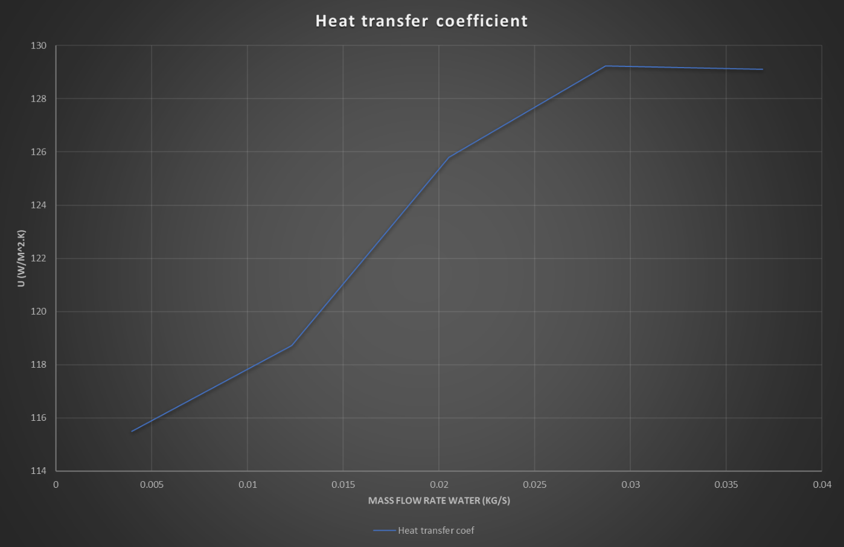
Figure… g1
This graph shows the effect of varying the mass flow rate against watts per meter kelvin. The line itself shows a s shaped line. The graph clearly shows how increasing the mass flow rate substance increases the heat transfer up to a certain point where it becomes a detriment to have such fast-flowing water.
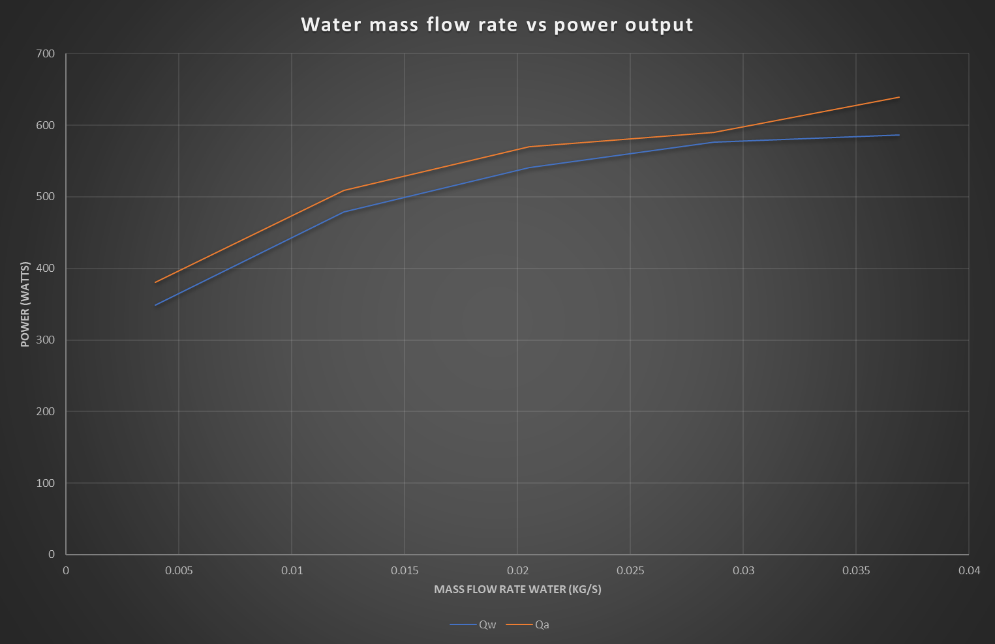
Figure … g2
This graph shows the comparison between mass flow rate of water and the power that is absorbed by the or emitted depending on whether it is water or air that you are looking at. The orange line being air, and water being the blue line. The graph shows a clear positive correlation between energy moving across the system as the mass flow rate increases.
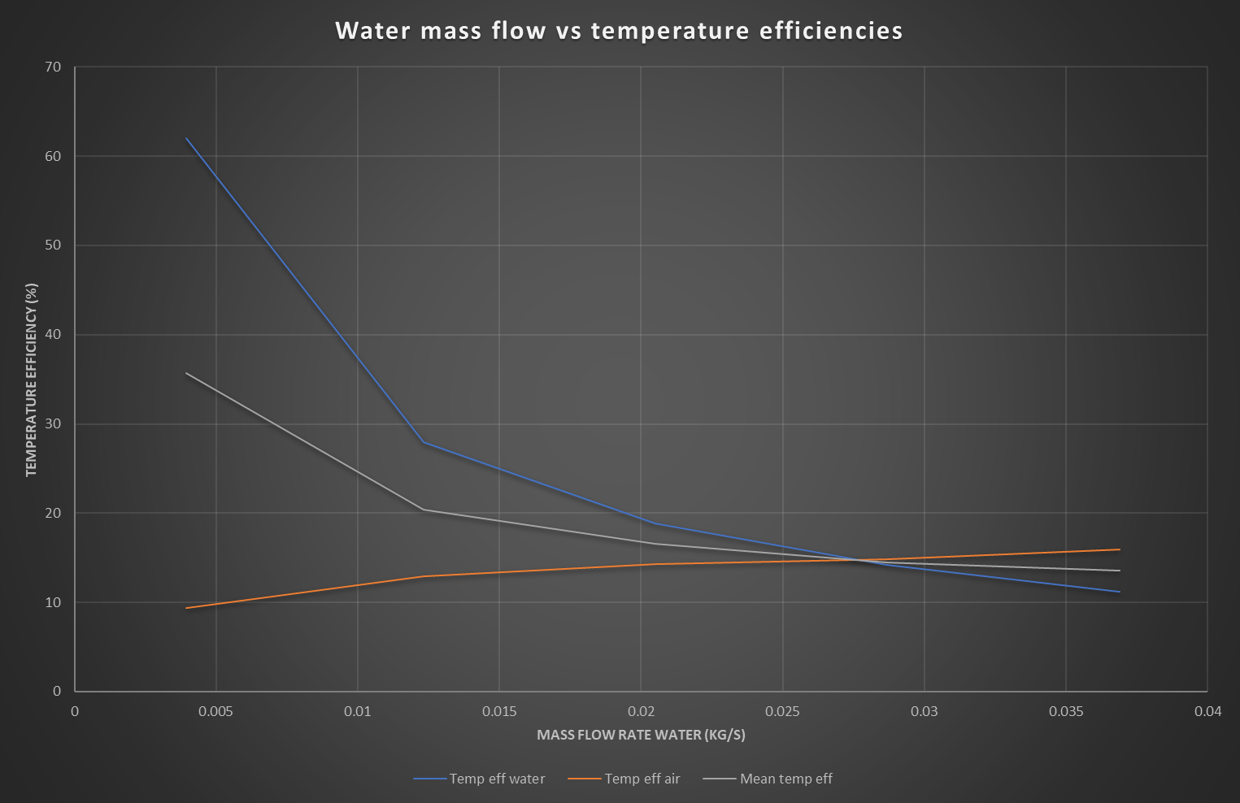
Figure … g3
This graph shows the effect off mass flow rate on the efficiency of the heat exchanger as you clearly see in increases the efficacy of the air in a fairly liner manner where water seems to be a curve and the mean temp efficiency is every smaller in shape to the water though much shallower due to the effect that the air temperature has on it.

Experiment 2
Figures 6& figure 7
The figures above show the dater for change in temperature and density for water and air respectively. As the first figure shows, the lower the pressure drops, the less heat is extracted from the water by the air, this obviously has a positive influence on the temperature, so as the pressure drop gets lower the air temperature increases. The effect in this experiment on the density of both fluids is the same as in experiment 2, as the temperature increases the fluid becomes less dense.

Figure 8 (engineering-edge, 2001)
The figure above shows the mass flow rate change with respect to the pressure drop. The table clearly proves that water gets denser as it gets cools. The difference in the mass flow rate is very likely 2-fold as the temperature would influence the density of the air passing though the heat exchanger. The biggest factor though is probably the back pressure caused by the smaller exit that the air is pushed through.

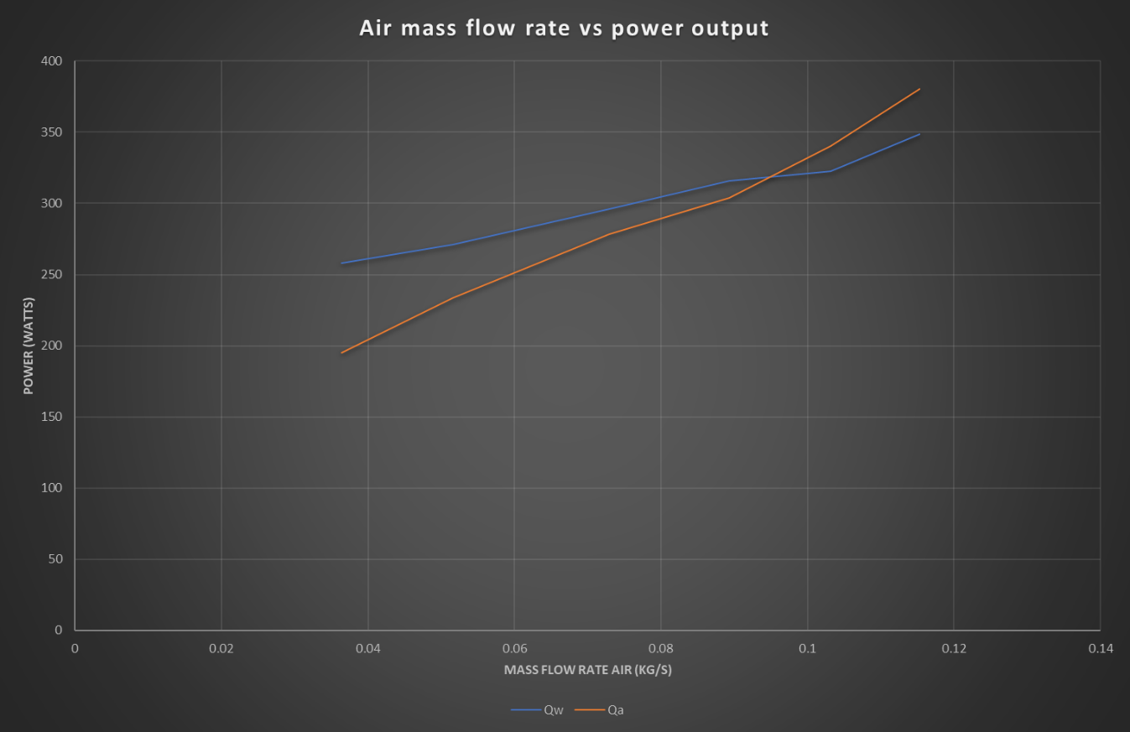figure … g4
This graph shows the comparison between mass flow rate and the power emitted or absorbed by the fluids the blue line represents water being the energy emitted and the origin line is air being the energy absorber. The graph shows a positive correlation between both the emission of water and absorption of air as the mass flow rate of air increases this is to be expected however as one increases by the fundamentals of physics, energy can nether be created or destroyed.

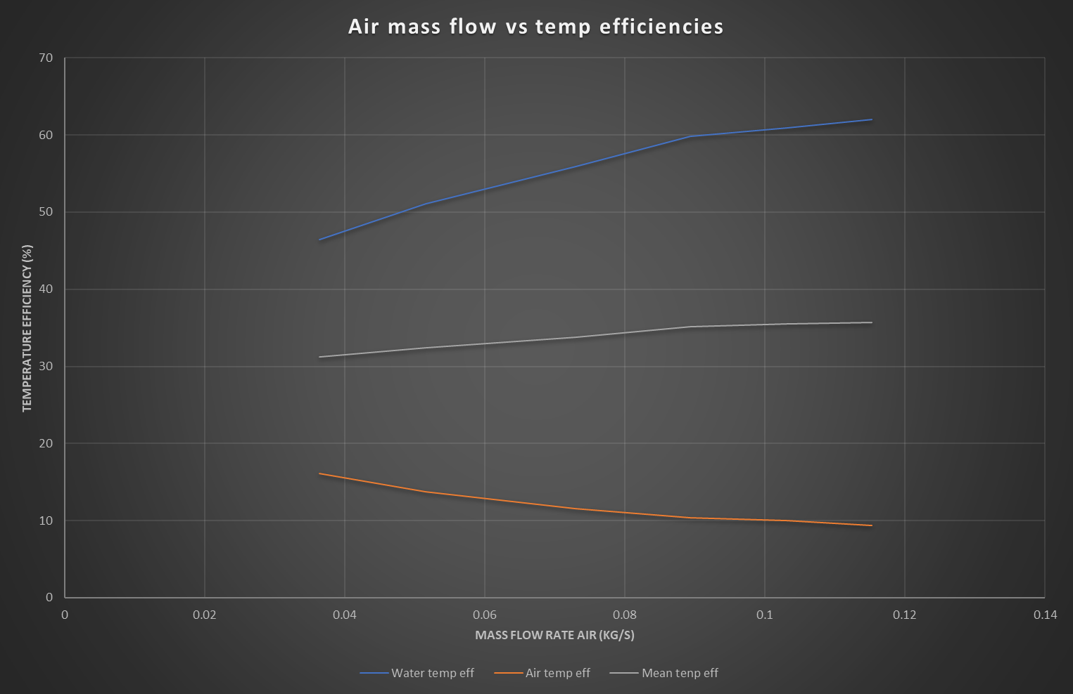
Figure g5

This graph describes the efficiency of the heat exchanger in respect to the mass flow rate of air. As can be clearly seen the efficiency of the water increases with the higher mass flow rates however the air gets less efficient as the mass flow rate gets faster. The average is tending towards a positive increase but this may leave out with increased mass flow rate as can be seen by the gradient of the water its slowly getting shallower meaning parodically it is getting worse.
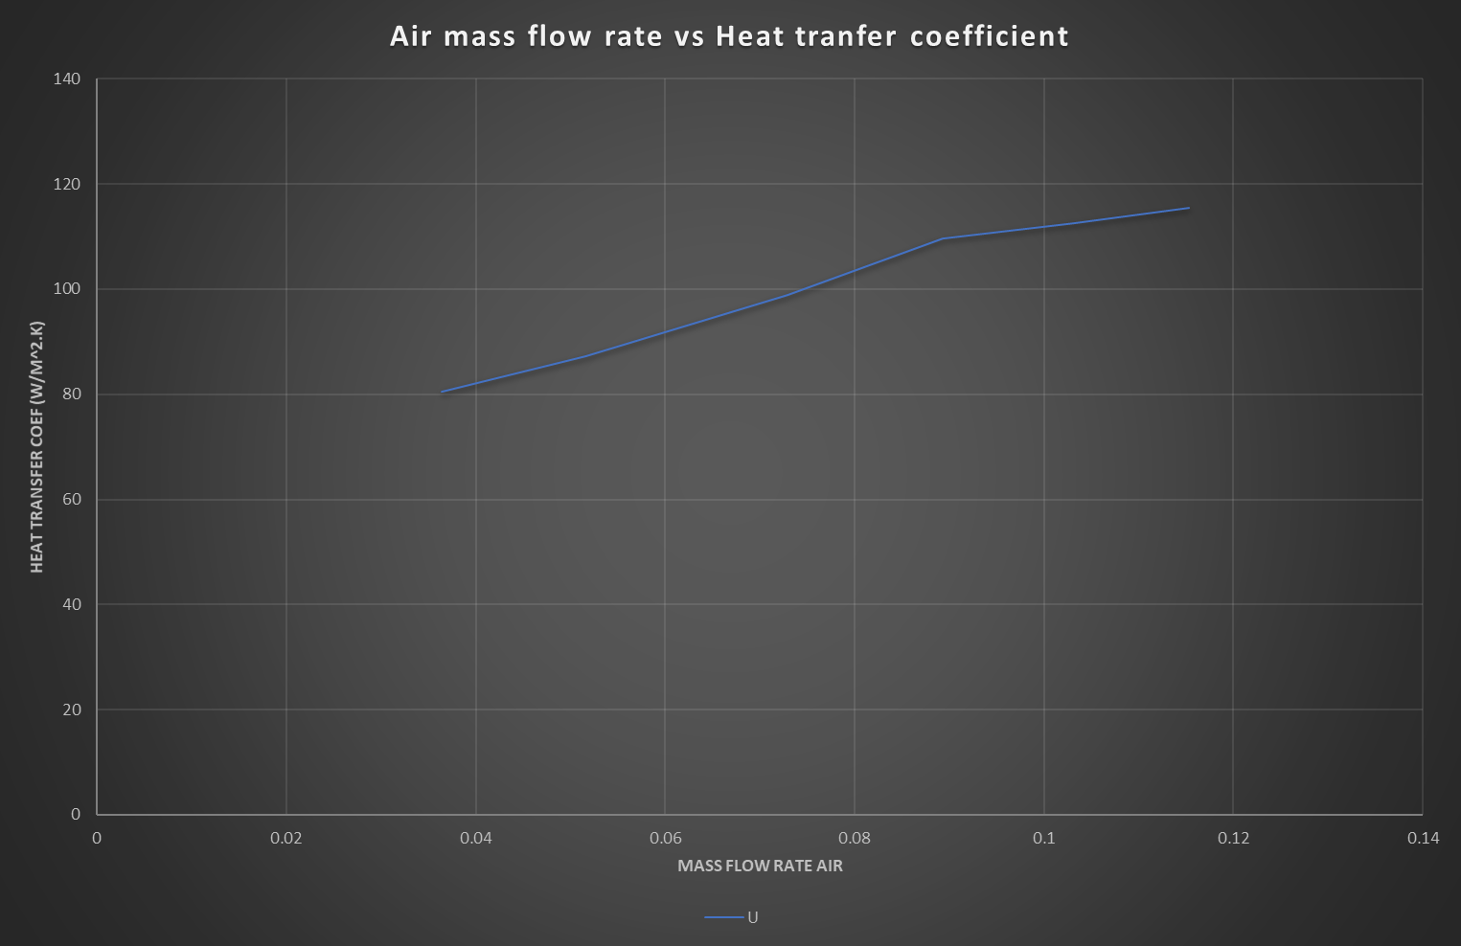
Figure … g6
As this graph shows there is not that much change between the heat transfer coefficient and the mass flow rate of air. Being an increases of approximately 35 over the increases of mass flow rate from 0.4 to 0.115. which when looking at some of the other tests isn’t a large deviation.

Experiment 3
Figure9 &10 (rubber, 1971)
These figures show very similar information to figures …&… the only substantial difference in them is the temperature of the water, this then has a knock on effect of all the other units of heat as the delta is lower for the water then this reduces the energy absorbed by the air drastically.

figure 11
This figure shows the comparison between the mass flow rates of water and air though the heat extranger during experiment 3. As you can see clearly water has nearly no mass flow rate change during the experiment, air on the other hand does. It decreases by a substantial amount but as stated previously this is to be expected as the heat is expanding the air along with there being back pressure in the heat exchanger dew to the small exit area.
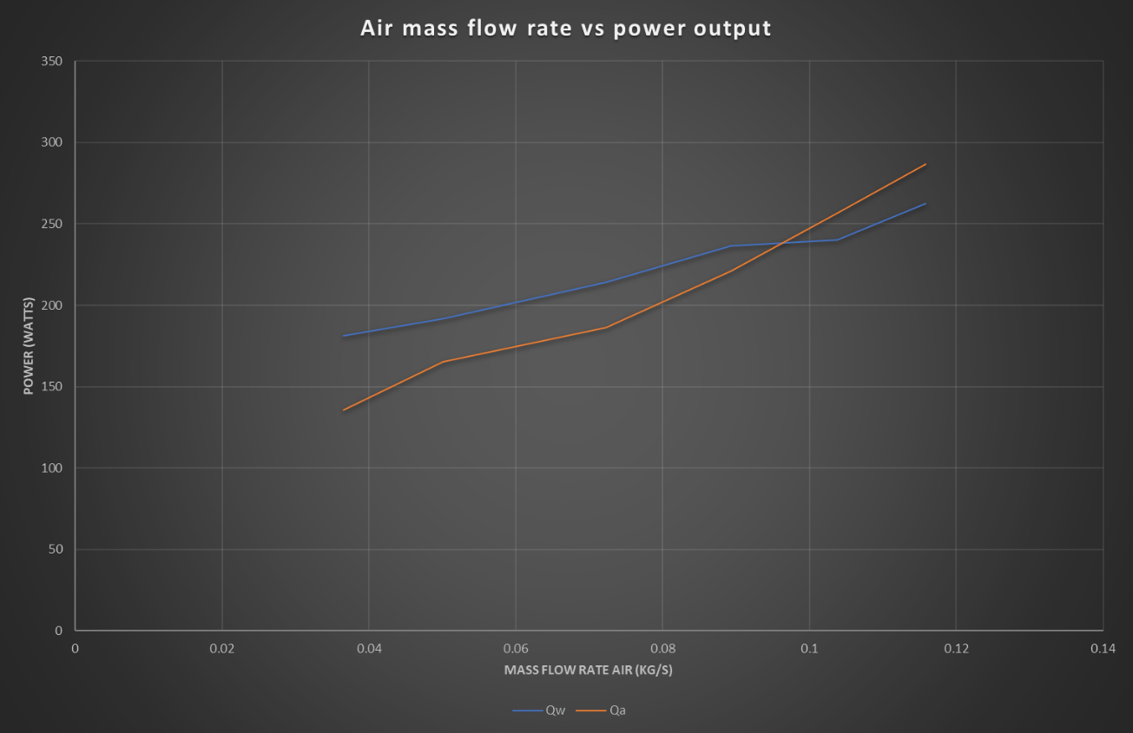
Figure … g7
This graph describes the relationship between mass flow rate of air and the power absorbed or emitted. As the graph clearly shows there is a point of intersect between the energy emitted by the water and absorbed by the air. As the graph shows that there is a very liner trend for the energy absorbed by the air and the same can be said for the water however there is a liner trend though it does seem to be increasing very slowly.

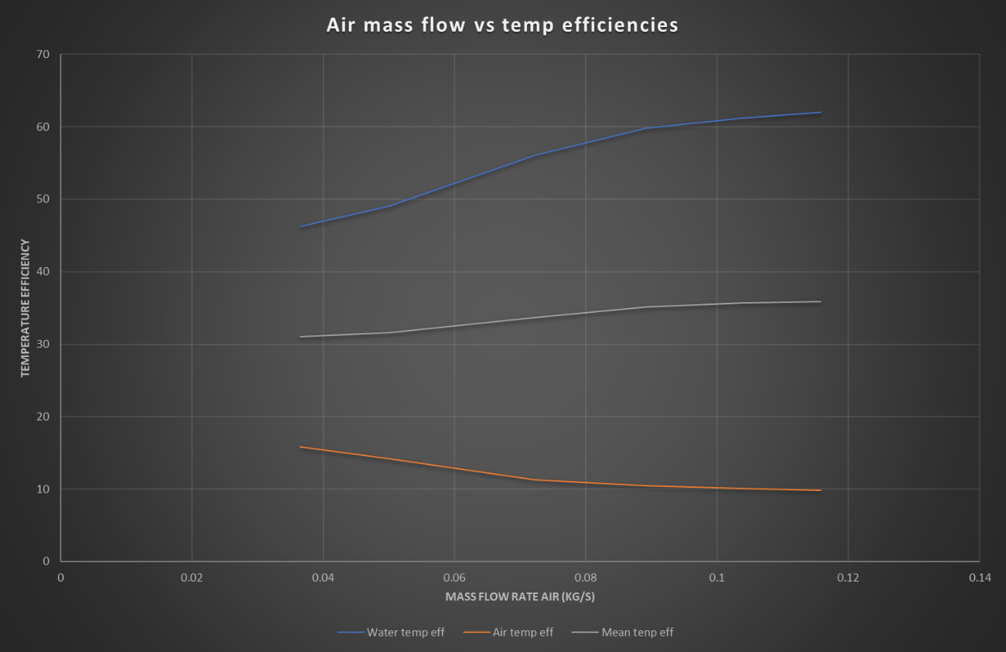
Figure… g8
This graph is almost identical to figure … so reference the analysis of that for this.

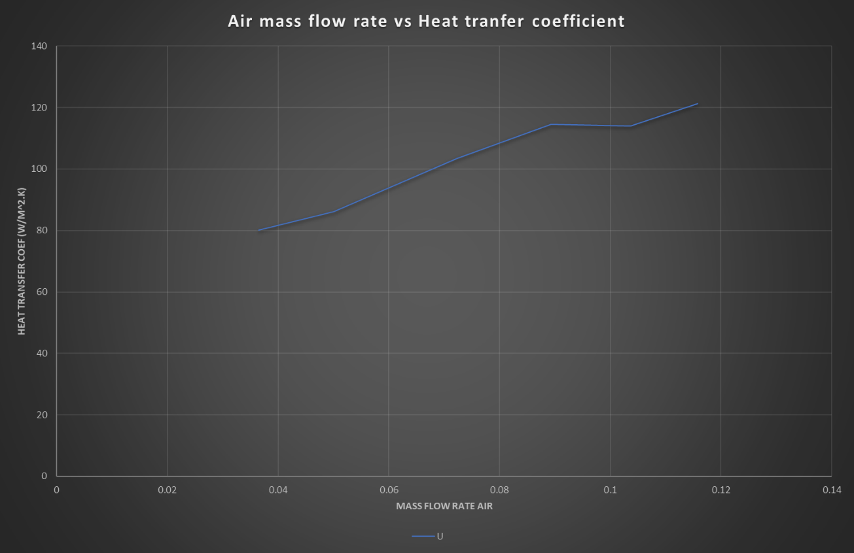
Figure … g9
As is clearly shown by the graph above, in experiment 3 the heat transfer coefficient tends to increases the higher the mass flow rate becomes.

Conclusion

In conclusion the heat exchanger work as what would be expected with very little variation from what would be expected of any cross flow heat exchanger. When the mass flow of ether water or air was increased the heat transfer coefficient increased, in the case with water to a point. also, in the case with the variation in mass flow of air the efficiency just increased as the flow increased. With water flow rates however, this is different as the mass flow rate increased, there was an exponential decrease in the effectiveness of the heat exchanger. This though no matter how drastic is to be expected as the water would have less time to releases its energy in to the heat exchanger so would become less efficient.
I think a way to increases the efficiency of the heat exchanger would be to insulate the corridor where the air passes though, this currently is just metal. Metal transfers heat incredibly well, taking this in to consideration I believe this should be the first port of call to increase is efficiency. Secondly insulate in pipes used to transfer the water to the cross exchanger as there as susceptible to being cool, though the pipes within the cross flow should have as little insulation as possible or even be made from a metal such as copper to increase its ability to transfer heat. (tech, 2016)

References

Anon., 2013. [Online]
Available at: http://marinenotes.blogspot.com/2012/10/types-of-heat-exchangersparallel.html
[Accessed 4 4 2019].
engineering-edge, 2001. engineering edge. [Online]
Available at: https://www.engineersedge.com/fluid_flow/mass_flow_rate.htm
[Accessed 4 4 2019].
palemo, E., 2013. live sic=nce. [Online]
Available at: https://www.livescience.com/38862-selective-laser-sintering.html
[Accessed 2019].
rubber, c., 1971. chemisty%physics. In: handbook of chemistry & physicis. s.l.:chemical rubber.
tech, s., 2016. mahan's. [Online]
Available at: http://mahans.com/how-to-improve-heat-exchanger-performance/
[Accessed 4 4 2019].

List of figures and tables

Figures 1 -20

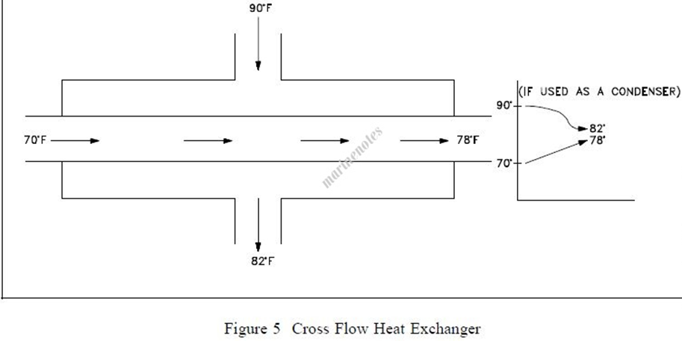

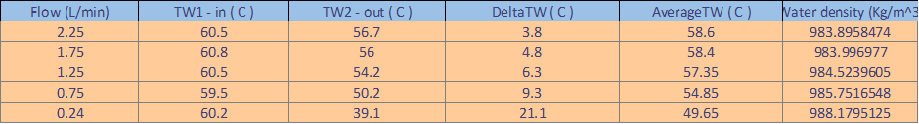

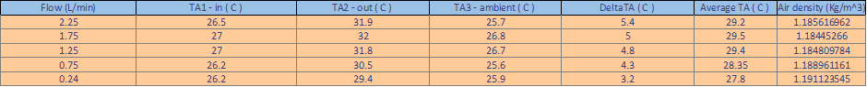

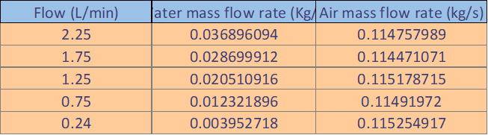

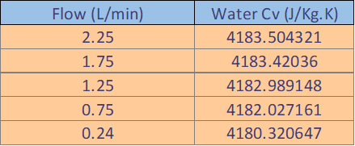

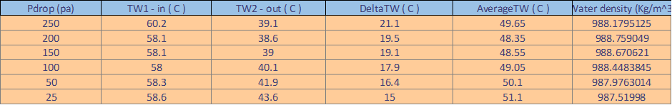

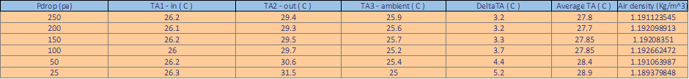

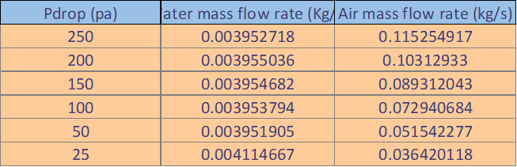

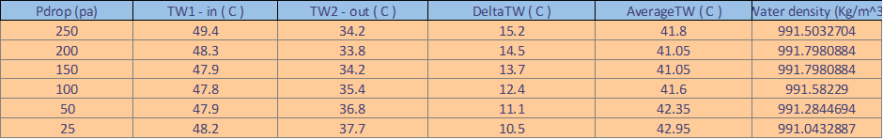

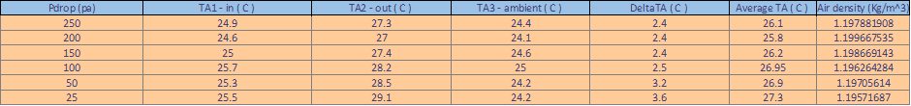
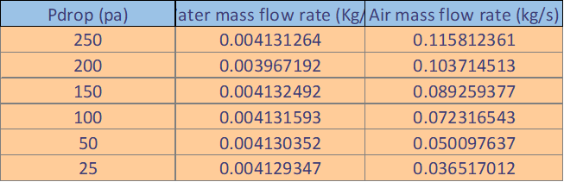

Graphs 1-9



