Abdul Islam
Student ID: 1806293

Strategic Management

BMSW6104

Table of Content

Introduction 3
Task 1 4
Task 2: 6
Task 3: 12
Task 4: 14
Conclusion 16
Reference 17

Introduction
Strategy is basically the plans or the process of an organization to make the strategic decision, planning and evaluation and strategic management refer to deciding the set of managerial decision or activities which helps to determine the long-run objective and performance of an organization. Strategic management includes both the internal and external environment assessment, planning, strategic decision making, formulation of planning, and evaluation of the outcome of the planning. Strategic management plays a significant role in an organization because it helps to look forward, and set the objective of the organization, and through effective strategic management, an organization can make the best possible decision for an organization. In this report, the strategic management of an organization will be explained briefly and through this discussion in this report, one will get to understand the various sides of strategic management. The report is required to choose an organization to discuss the impact of strategic management in the real field. The aim of the report is to discuss the models and theories of strategic management over the chosen organization, find out the limitations, and critically evaluate the possible solution for the organization. In short strategic management is about setting goals of an organization, analyzing the goals, formation of the strategy, implementing it, and monitoring the overall process and in this report, these steps and theories of strategic management will get briefly discussed in an organization and the chosen organization is Procter and Gamble which is an American multinational organization.

Task 1
The report is based on the strategic management of an organization and the aim is to discuss strategic management and how it works in an organization. To have a brief discussion of the report requires choosing an organization and here, Procter and Gamble has been chosen as the organization. Procter and Gamble is an American multinational organization that was founded in 1837 (James, 2016). The founders were William Procter and James Gamble. The company is a consumer goods-based corporation and it has a huge product line. The headquarter of Procter and Gamble company is in Cincinnati, Ohio, United States. Procter and Gamble offer its, consumers, a very wide range of products which includes Consumer health or Personal health care products and hygiene products. Procter and Gamble have organized its products in various segments which are beauty products, health care products, grooming, baby products, fabric, home care, and family care, etc. Procter and Gamble also offer diversified products which also includes beverage, snacks, and foods as well (Smith, 2019). Procter and Gamble knew as P&G worldwide and it is a public corporation that operates its business almost in every country in the world except North Korea. The current Chairman of Procter and Gamble is Jon R. Moeller. The product line of Procter and Gamble includes cleaning agents, Skincare, and Personal care. The number of employees of is almost near to 101,000. It offers a huge portfolio of products and has launched almost 100 brands of personal care, skin care, and cleaning agents. Although the Procter and Gamble was founded in 1837 but the company is continuing its development till now and the major reason for the success of Procter and Gamble is its continuous development, diversified product line, portfolio, and its innovative development in operating business. In 1930 the company started its international journey. The company has gained and associated with a huge number of other companies to serve their customers diversified product line and it has helped a lot to increase the profit margin significantly. Procter and Gamble have split its products or consumer goods into many categories to make an efficient brand management plan because if they make a portfolio of their brands and separate it, this will be helpful to be more focused on specific brands which are significant to reach the target market and fulfill their requirements specifically. Procter and Gamble expanded its business by making an entry into the food business in 2012. Procter and Gamble also get a huge response in their food business. In 2014 Procter and Gamble decide to start streamlining and this was a very wise move for Procter and Gamble. It has started to make a portfolio and for this reason, the company can minimize the losses and maximize the profit margin (Twain, 2021). In 2015 the company Procter and Gamble divested Vicks Vapo Steam U.S which is a liquid inhalant business and this move of Procter and Gamble was a way to restructure the brand. After moving to this business the company planned and moved into another business in order to expand its business more. The company Procter and Gamble introduced its beauty brand to its customer after some years, manufactured it, and after that Procter and Gamble company decided to complete the transfer of Duracell to Berkshire Hathaway by exchanging of shares in February 2016. The company Procter and Gamble completed its acquisition of the consumer health portion of Merck group in December 2018. The company renamed this in Procter and Gamble health limited which was in May 2019. Procter and Gamble restructure its corporation and made it simple with six businesses in July 2019. From the beginning of Procter and Gamble company till now the company made various changes in its operation and structure to keep its development continues and the company made sure that it is the development and the development is compatible with the current market and consumer needs and demands (Carson and Bain, 2018).
The vision of Procter and Gamble is to serve the best consumer goods and services to the world and to improve the products on a continuous basis. The mission of Procter and Gamble is to clear the purpose of the company and support the vision of the company. The main purpose of Procter and Gamble is to serve its target market with the best possible products, establish the brand as a strong brand, make the repeat customers, and expand the business more. To reach the mission of Procter and Gamble the organization makes critical and effective plans. The company tries to understand its consumers and target market, the requirements of the target market, and serve the target market the right products. Besides that the company expands its business every year by adding a various range of products every year and the company can do this because of having a feasible plan to launch new products r to associate with new brands or to increase the volume of the target market. Procter and Gamble make its strategic plan very effective to reach the objective. The company has expanded its business almost all over the world except in North Korea now the company is focusing to increase its target market by expanding the product line which will help the company to increase its profit margin. Procter and Gamble or P&G now hold a strong and huge market share in the consumer goods industry (Mill, 2021). Procter and Gamble are taking various steps to reach its vision. The vision of an organization basically refers to the objective of the organization which means after some years where the company will reach or what the owners of an organization want his or her organization to reach. Since the vision of Procter and Gamble has the vision to be the superior in the market by providing the consumers with the best products that is why Procter and Gamble are now focusing on improving its product quality and increasing the brand value by offering the best products.
Task 2:
Strategic models and theories of an organization define the way of an organization builds its strategy, plans for it, implements it, and evaluates it. Without an efficient strategy of an organization, the organization will never be able to reach its objective or fulfill its vision. Strategic management has 5 stages that a manager needs to follow or maintain to build up a proper strategy for an organization to reach out an objective. Strategic management also includes how the organization works, what are the things an organization needs to acquire the objective, and how to implement it. 5 Stages of strategic management have been described below:
- Goal Setting: Goal setting is an essential and the most important part of an organization. Procter and Gamble has set its goal very critically. A goal of an organization first needs to be feasible enough to implement it and before setting the goal the organization must need to observe the internal and external environment, the capability to reach the goal and the feasibility of the resources which are required to reach the goal. The purpose of goal setting is basically a way to clear out the vision of the organization. In this stage, Procter and Gamble identify 3 keys those are, the organization at first define the short-term goal and the long-term goal after that the organization identifies the process and lastly customizes the procedure of reaching the goal based on the employees and consumers (Bonar, 2017).
- Analyze Information: After setting the goal of an organization, the organization needs the relevant information for the next stages of strategic management. To make the proper strategy in order to run a business the organization needs relevant information to understand the mission and vision of the organization, and the feasibility of plans and besides that information helps to decide the process as well.
- Formulation of Strategy: After setting the goal and analyzing the information the third step is to formulate the strategy. In this stage the company Procter and Gamble what resources the company has to reach the goal and to make the mission successful, what are the resources they need to gather from outside, what are the obstacles the company might face to reach out the goal, and what can be the alternative plans.
- Implement the strategy: After the formulation of the strategy, this is the stage where an organization implements the strategy. At this stage, Procter and Gamble company completes its formulation of strategy and the organization knows about the requirements, obstacles, and possibilities and the company makes sure that every one of the organizations is clear about the overall situation and started their work accordingly.
- Evaluation and Control: Evaluation and control is a sensitive stage of strategic management. Because in this stage the organization evaluates the whole process of reaching out the goal of the organization and finds out the limitations, obstacles, and challenges of the process. After evaluating these the organization tries to control the situation by taking necessary steps and if the organization fails to evaluate the process properly it might cause the repetitive mistakes which are not good for any organization.
These are the steps of strategic management that are essential for an organization to develop and implement effective strategic management for an organization. To implement these steps an organization needs to utilize some models of strategic management and the models of strategic management will be demonstrated here:
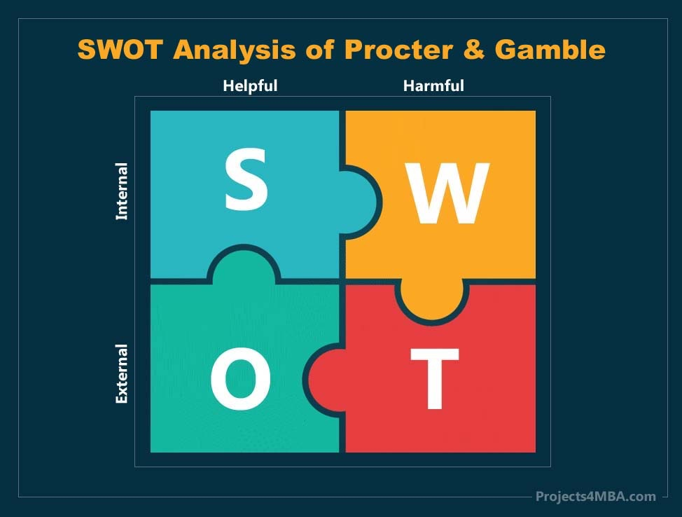
SWOT Analysis of Procter and Gamble:

Figure 1: (Long, 2012)
Strength: Strength defines what a company excels at. The strength of Procter and Gamble is it has an innovative product line and its product line is huge. The company has a strong brand image and strong customer loyalty. Another major strength of Procter and Gamble is the company has a very diversified business structure but the most effective strength of Procter and Gamble is its consumer loyalty.
Weakness: Weakness of an organization refers to those factors for which an organization cannot reach out its goal. Procter and Gamble's company has some weaknesses as well besides its strength and the weaknesses are the company views product performance only and it increased expenses in the promotion to keep the sales healthy. Customer concentration is its another weakness (Satinoff and Teitelbaum, 2013).
Opportunities: Opportunities of an organization refers to those external factors which are favorable for an organization and which create a competitive advantage for an organization. Procter and Gamble provide eco-friendly products, the company has an emerging market, the company offers its target market a better product experience and sells the product directly to the consumer which is an amazing opportunity for the company. If an organization can utilize its opportunities fully, the chances of getting success will increase immensely (Schmalt and Langens, 2019).
Threat: Threats to an organization refer to those factors which might be harmful to an organization and those factors work as the obstacle to an organization. Procter and gamble organization has some threats as well to its business. Threats are: Substitute brand of Procter and Gamble has almost similar kind of product and they offer the cheaper rate, consumer spending has been slow down, the key competitors of Procter and Gamble are expanding their products portfolio through acquisitions and the major threat for this organization is Vicks got banned in U.S market (Delisle, 2010).

Figure 2: (Russell, 2014)

Porter’s Five Forces Analysis of Procter and Gamble:
Porter’s five forces analysis model is such type of model which helps to analyze the competitive environment of an organization. Nowadays the world is very competitive and to cope with the situation Procter and Gamble company must need to analyze these factors.

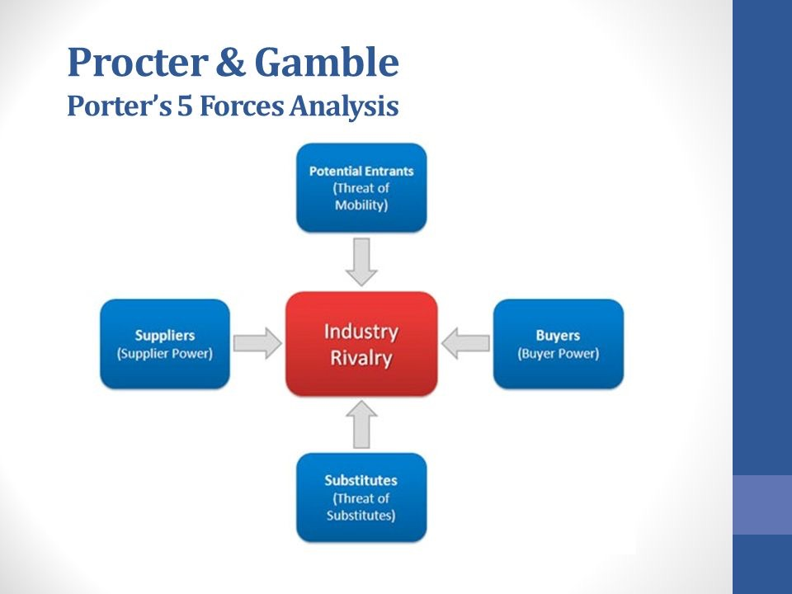
Potential Entrants: Procter and Gamble is a very renowned brand and this organization is doing very well. Though they are offering an amazing product line to its target market yet a new entrance of an organization with some new methods and innovation might be a threat to the company (Whiteley, 2012).
The threat of Substitutes: Procter and Gamble produce products in various segments and the organization offers multiple brands in one segment which creates a substitute for other products under P&G. Besides that some other organization is also offering the same kind of products at a cheaper rate which is a threat.
Bargaining power of Customers: Though P&G is offering a wide range of products yet the consumers have a wide range of options too in the market. To keep the customer and make them loyal P&G offers a market competitive price and sometimes they offer discounts in their products as well.
Bargaining power of suppliers: The company Procter and Gamble has so many suppliers all over the world and since the company is huge and it has a huge product line and market share that is why it has huge suppliers as well. Though the suppliers provide the raw materials yet suppliers cannot control the market because the company can easily switch suppliers.
Competitive Rivalry: P&G has some strong competitors in the market and they are possibly Unilever, Johnson and Johnson, Dabur, and so on. These companies have a wide range of products and segments too. There is no major difference in the products as well. To control the market P&G needs to upgrade its product line on a continuous basis and needs to have a strong marketing strategy.

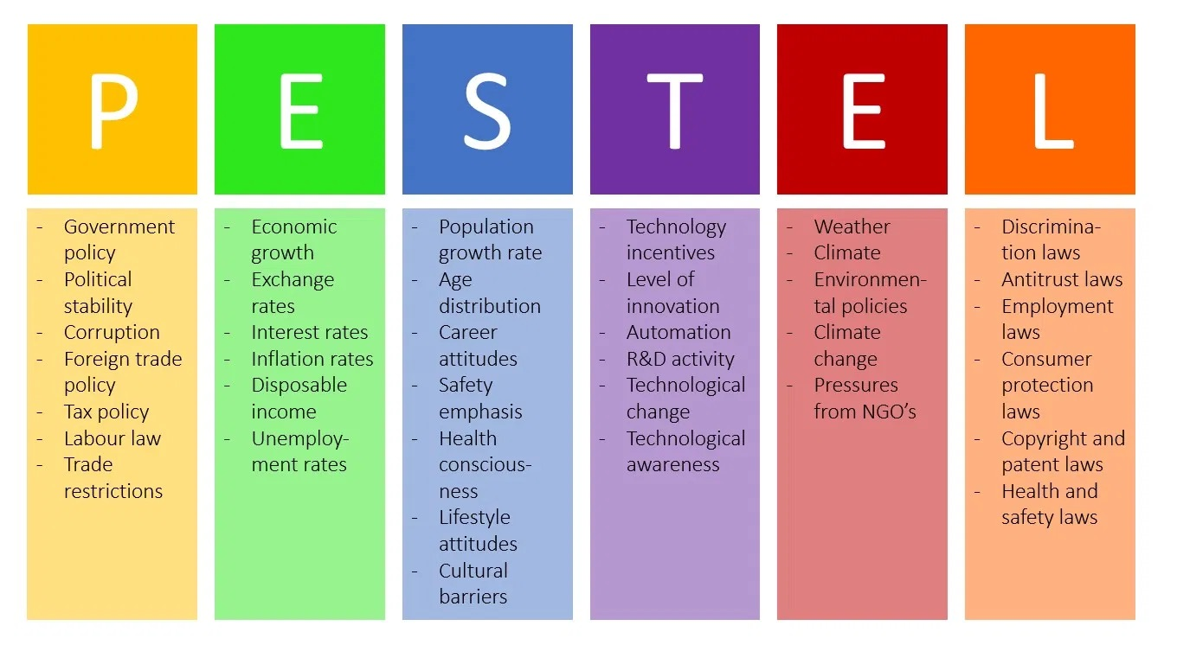
PESTEL analysis of Procter and Gamble:

Figure 3: PESTEL Analysis (Twain, 2021)

PESTEL analysis is basically a way to analyze the macro-environmental factors which mean the external environment of a business such as how the external environment impacts a business and how it works.

Political: P&G is operating its business all over the world and it is getting enough support politically from the government in its home country. The government policies for doing a business, political stability, and tax policy are very flexible for the business (Abeysinghe, 2019).
Economic: P&G is getting a high and fast growth rate in developing its target market which is helping to expand the market. The disposable income is increasing in the market and economic stability is major support because people have the ability to purchase a product. The government interest rate is lower which is beneficial.
Social: Nowadays the consumers are very conscious about their purchasing decision. Consumer preferences are increasing for the high quality products and increasing the demand for healthful products which is a positive side for P&G. The company is well known for the high quality and healthy products all over the world (Bidgoli, 2012).
Technology: Nowadays people cannot think of anything without the help of technology. Especially after the Covid situation, online marketing, and online purchasing have been very popular. Using of technology has made the business operation easier and online shopping has made the shopping hassle free.
Environmental: P&G is an eco-friendly or environment friendly organization which means the organization does not do any activities which might be harmful to the environment. But here are some threats to the organization which is forest conversion is not growing that much and the weather pattern is changing gradually which affects the farming (harker, 2017).
Legal factors: P&G always ensures that legal factors are in alliance with the activities of the company. The product safety rules are increasing gradually which is a positive side. Besides that, the business sustainability is also increasing which is a great opportunity for the organization (Miller, 2018).

Various models and theories of strategic management have been described in this part of this report on the P&G company to get a real understanding.

Task 3:
The vision of an organization plays a significant role because without a concrete vision no organization will be able to get the success. The ultimate goal of any organization is to maximize the profit, increase the market share and create a strong brand image. To achieve these objectives the organization, Procter and Gamble have taken the strategy to provide the best products out of the market to be the superior in the market. The company Procter and Gamble wants to maximize the profit and create a strong brand image by proving to its target market the best quality products. To achieve the objective or the reach the vision some strategic tools and models have been discussed before in this report but here are some both advantages and disadvantages of the mission or the strategy of Procter and Gamble. Those advantages and disadvantages have been discussed below about the organization Procter and Gamble (Bareja, Żyto and Tym, 2011).
Advantages:
Procter and Gamble is a very renowned organization all over the world and the company has a very strong and loyal customer base almost all over the world. Strong and loyal customers are the biggest advantage of the company. Procter and Gamble offer its consumer high quality products and the company never compromise with the quality. The eco-friendly environment is another advantage of this organization. The political environment is supportive enough for Procter and Gamble which is great for any organization (Wit, 2020). Procter and Gamble is a socially recognized brand and the company maintains the health, and safety of its products. Besides that, the company launches its products according to the target market’s age, income, and preference. The current economic situation is stable and favorable enough for the company which is a great advantage. Technology came as a blessing for the company because with the help of technology the company can develop products, observe the market easily, and can take the customer’s opinion. The company can run the online market because of the advanced technology (Rowe, Mason and Dickel, 2017). Automation has made easier everything for an organization. The organization Procter and Gamble follow all types of legal regulations in order to run a smooth business because without maintaining the legal rules and regulation no organization will be able to operate a business. Procter and Gamble have some outstanding experts who can easily maintain and observe all types of legal issues. Procter and Gamble have another advantage which is the organization hires employees very selectively as a result the company gets the best manpower who are talented, innovative, and efficient enough to operate an organization in a proper manner and smoothly. Since the chosen organization for this report is very well known and reputed as well as the biggest advantage for the company (Stroebe, 2014). For that reason, the threat of new entrance is very low because it will take a lot more time to create this much brand value as Procter and Gamble and enter with this much popularity as this organization. This organization has an immense control over the supplier's market as well. Since the company Procter and Gamble is a huge and very renowned company and it operates its business almost all over the world that is why this company orders a lot to make products for the target market as the company needs a huge amount of raw materials which is why this organization can easily control the suppliers market as well. The Vision of the company is to offer quality products to the consumer and the reputation of the organization is its main advantage of it (Knowledge Management in the Sharing Economy, 2013.).
Disadvantages:
Procter and Gamble is an American multinational company that is in fast-moving consumer goods industry and a public organization. In this report earlier the advantages of its strategy and mission have been discussed briefly but these have some disadvantages as well and now the disadvantages will be discussed in this part of this report (Dyregrov and Dyregrov, 2018). Procter and Gamble's company spends so much money on their marketing strategy and it might cause the high price of their products. In the fast moving consumer goods industry, Procter and Gamble have so many strong competitors who are doing amazing, and sometimes those companies are offering the same kind of products at a cheaper rate which is a disadvantage for the Procter and Gamble. Another major strategic disadvantage of Procter and Gamble is this company is launching multiple products under the same segments of products and for that reason; the products under the same brands are becoming their own substitute. Procter and Gamble have a strong position in the market yet a new and innovative method of launching products under a different company is a great disadvantage for Procter and Gamble. Another major disadvantage for the company is the weather is not stable nowadays which is really alarming for any country (Twain, 2021). The vision of the company is to offer the best products to the customer who is good but sometimes for offering the best products the price of the products is getting higher and for that reason, Procter and Gamble is losing a wide range of customers who cannot afford their products which is a major disadvantage.

Task 4:
The chosen organization for this report is Procter and Gamble. The report is about the strategic management of this organization. To get the successor to be a successful organization, an organization must need to select its goal or mission and vision (Jauch and Glueck, 2016). From that perspective, the chosen organization Procter and Gamble has done this task. The vision of Procter and Gamble is to provide the best products in the market and to achieve this vision the company Procter and Gamble use some strategies such as SWOT analysis, PESTEL analysis, and Porter’s five forces analysis, and so on. The SWOT analysis of the company Procter and Gamble helps to find out the Strength, weaknesses, opportunities, and threats of the company. This SWOT analysis helps to understand the impact of internal and external factors on an organization. After finding out the weaknesses the company can take necessary steps to develop that particular area and can turn the weaknesses into the strength of the organization. Through the SWOT analysis, this organization also can find out its threats as well which will help the organization to understand the environment and take proper precautions to defeat the threat. This is how the SWOT analysis will help the organization to develop the company. In this area, the organization is doing good and the organization needs to improve on its weaknesses and threats (Brown, Bessant and Jia, 2011).
The another strategy is the PESTEL analysis. PESTEL analysis of Procter and Gamble company helps to determine the political situation of a country and taking business steps considering the political situation even in case of business expansion the organization must need to understand the political situation of a country. To run the business the company Procter and Gamble need to understand the economic state of a country because the price of the product needs to be comparable with the buying capability of customers. Social influence acts as a major component in business. Through the PESTEL thus organization gets to know about the social value, facilities, and limitations of a business. Nowadays technology plays a significant role in any business. And to analyze this portion or strategy of a business PESTEL analysis is significant. Procter and Gamble is utilizing the technology in a proper manner. The current environment is not stable at all and in order to cope with the current environment, the organization needs to work on it. The organization maintains the overall legal issues of the country where the organization is operating its business. The organization is doing well from the perspective of PESTEL analysis which is a positive side for the organization. Through the PESTEL analysis, it is clear that the organization is on the right track from the perspective of PESTEL analysis. Another strategic tool or model that the organization Procter and Gamble uses for its strategic management is Porter’s five forces analysis. Through the model of Porter’s five forces analysis, the organization gets to know about the current competitors’ situation, the current situation of the company, the new entry company impact, and so on. Though there is a very less chance to get harmed by the new entry into the organization Procter and Gamble but the organization Procter and Gamble need to bring improvement with their strategy about its competitors. As the competitors of Procter and Gamble are very strong, and the organization must need to bring some improvement with this plan. Since the organization Procter and Gamble is very renowned and old as well that is why does the organization has already some good and capable employees who can look after the organization efficiently and effectively and the organization is doing well overall because of the overall condition of the organization is good as the organization has some loyal customers, offers quality products and renowned.

Conclusion
Strategic management of an organization is a very sensitive part of an organization and tricky as well because the success of the organization is highly related to the strategic management of the organization (Berman and Evans, 2013). To implement an efficient strategy the strategic management of an organization needs to be efficient enough. In this report to explain the strategic management with a real example, the organization P&G has been chosen and the history of P&G has been explained very briefly in this report. The strategic management tool which the organization Procter and Gamble uses to make the strategy for the organization and to observe the real situation of the organization have been discussed in detail such as how the organization does its SWOT analysis, PESTEL analysis, and Porter’s five forces analysis and how the results of these tools help the organization to make the right and proper strategic management for the organization and in the last part of the report the area of improvement has also been discussed. This report will give a clear and detailed idea about strategic management.
Reference
Berman, B. and Evans, J., 2013. Retail management. Upper Saddle River ( N.J.): Prentice Hall.
Brown, S., Bessant, J. and Jia, F., 2011. Strategic Operations Management.
Jauch, L. and Glueck, W., 2016. Business policy and strategic management. New York: McGraw-Hill Book Company.
2013. Knowledge Management in the Sharing Economy.
Miller, A., 2018. Strategic management. Boston: Irwin McGraw-Hill.
Rowe, A., Mason, R. and Dickel, K., 2017. Computer models for strategic management. Addison-Wesley.
Bareja, S., Żyto, K. and Tym, S., 2011. Mis. Warszawa: BestFilm.
Bidgoli, H., 2012. MIS.
Twain, M., 2021. Life On The Mississippi. Chicago: Otbebookpublishing.
Wit, J., 2020. Mis. Tilburg: Zwijsen.
harker, M., n.d. The OB. 2017.
Reading, P., 2019. Ob. Newcastle upon Tyne: Bloodaxe Books.
Twain, M., 2021. Life On The Mississippi. Chicago: Otbebookpublishing.
Long, R., 2012. Motivation. Hoboken: Taylor and Francis.
Russell, I., 2014. Motivation. Dubuque, Iowa: Wm. C. Brown.
Satinoff, E. and Teitelbaum, P., 2013. Motivation. New York, NY: Springer.
Schmalt, H. and Langens, T., 2019. Motivation. Stuttgart: Verlag W. Kohlhammer.
Stroebe, R., 2014. Motivation.
Twain, M., 2021. Life On The Mississippi. Chicago: Otbebookpublishing.
Whiteley, P., 2012. Motivation. Oxford (UK): Capstone.
Abeysinghe, S., 2019. PHP Team Development. Birmingham: Packt Pub.
Bonar, S., 2017. The conservation professional's guide to working with people. Washington, DC: Island Press.
Carson, D. and Bain, A., 2018. Professional risk and working with people. London: Jessica Kingsley Publishers.
Delisle, M., 2010. Mastering PhpMyAdmin 2. 11 for Effective MySQL Management. Birmingham: Packt Publishing, Limited.
Dyregrov, K. and Dyregrov, A., 2018. Effective grief and bereavement support. London: Jessica Kingsley Publishers.
James, C., 2016. How very effective primary schools work. London: Paul Chapman Pub.
Mill, J., 2021. On Liberty. La Vergne: GENERAL PRESS.
Smith, S., 2019. The forgotten mourners. London: Jessica Kingsley Publishers.

