

Academic and Employability Skills

Moodle ID: ACCC4000
Submission Date:13.05.2020
Student ID: 1912650

Provide a brief personal overview of yourself.
I am Flavius Claudiu Butucel pursuing a Benchelor's Degree in IT a first year at University of Wales Trinity Saint David. It is one of UK's reputed Universities. I was able to gain key knowledge about cloud computing and software technologies in my short time I have been here for and I will keep developing myself here. Academic qualification helps me to become a successful Game Developer. I've already graduated from Haringey sixth form Centre with a Level 3 Extended Diploma in IT, this is also a reputed college in London. These institutes have offered me different forms of valuable information about a IT in my courses up until now . I was able to gain information about a vast range of IT processes and related topics. My passions include reading books/manga, watching anime and playing football. When I work in a IT environment, this helps to achieve results. It also played a major role in making some appropriate arrangements to work effectively for my future. I have obtained knowledge from other experienced friends, too. They help me continue my career so that I can hit my goal. I was able to figure out some issues during the period I was self-observed about myself. Communication ability is required to work as an effective specialist, with little lakes in my correspondence.

Include 4 screengrabs from your initial PowerPoint presentation that introduced yourself.
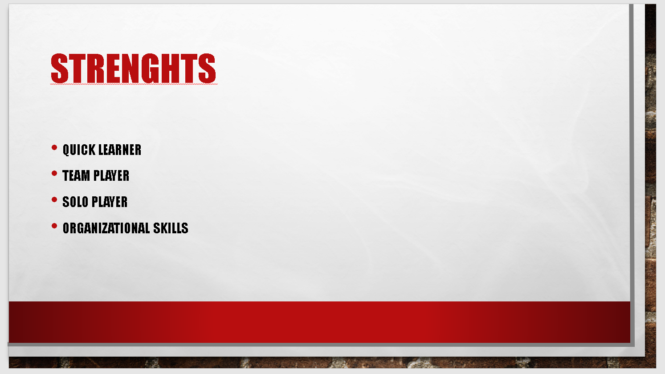
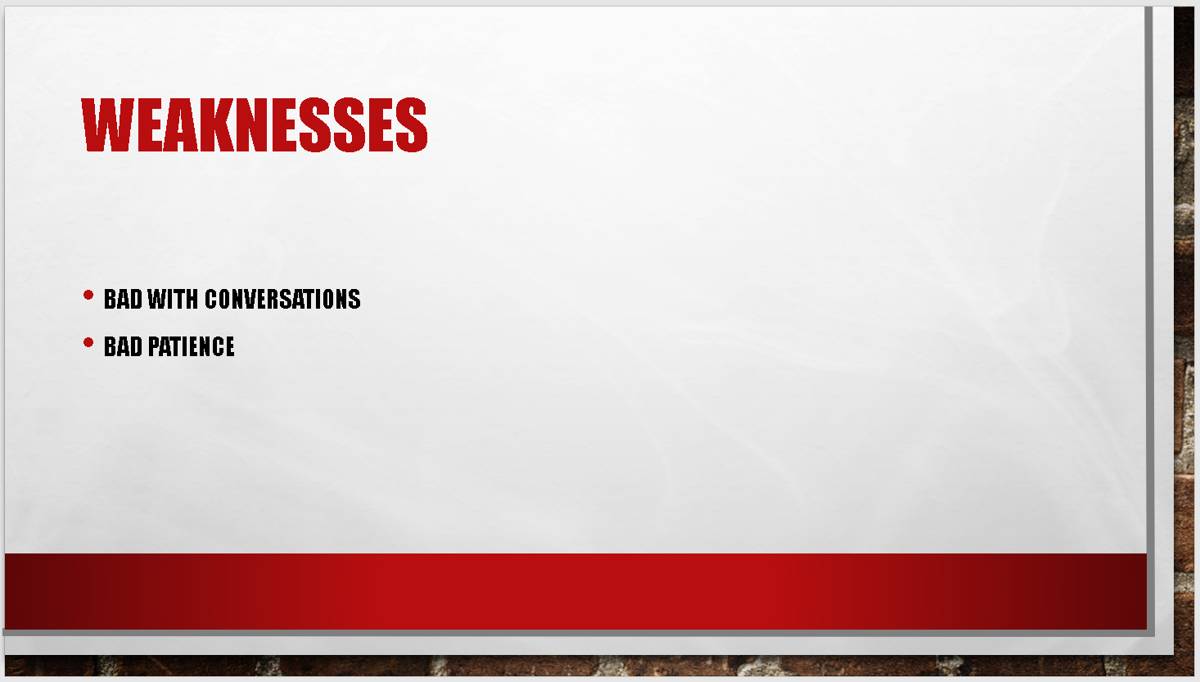

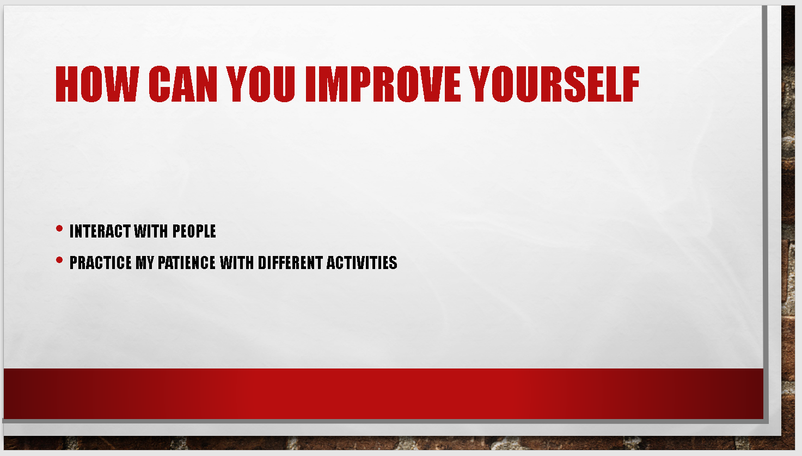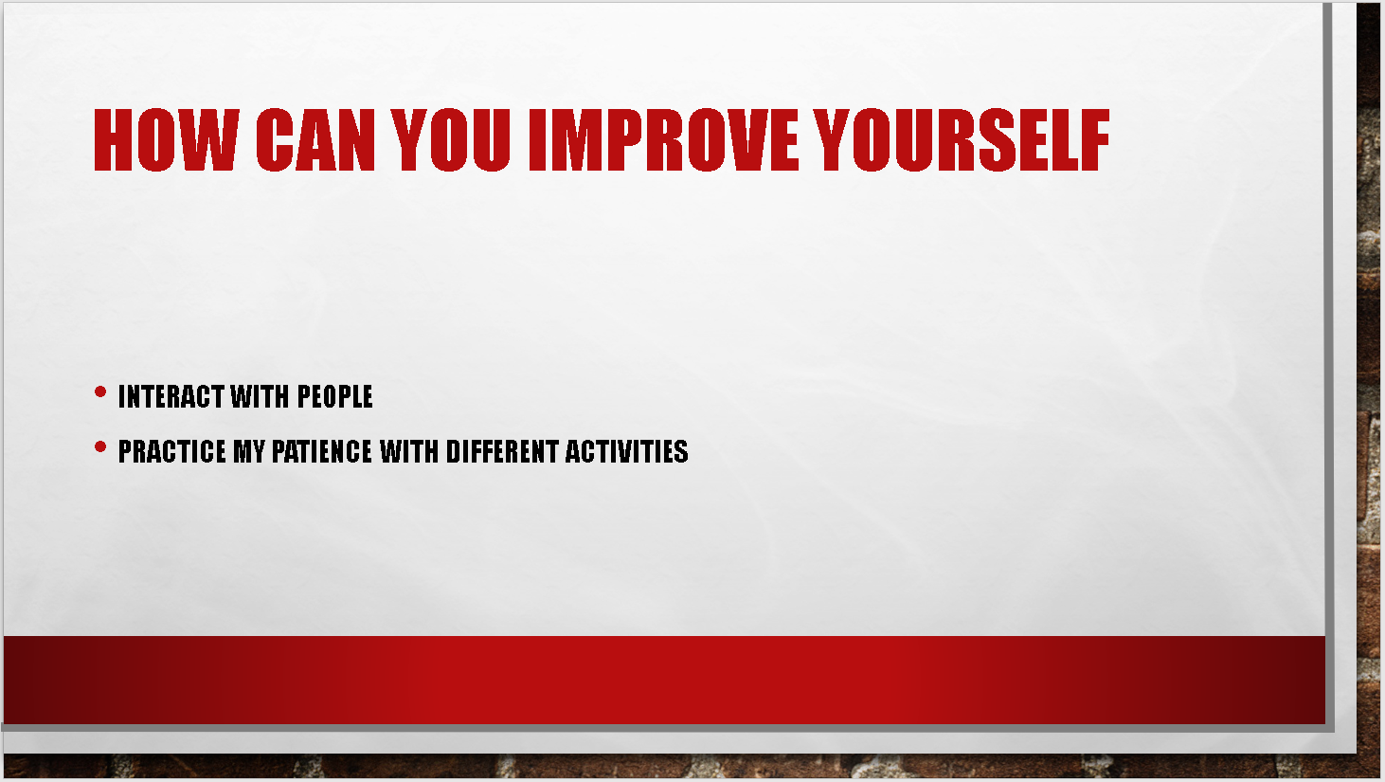
List the key points that you learnt when trying to produce and deliver a successful PowerPoint presentation.
Slide transitions and sound effects: transitions and sound effects, which in turn distracts the viewer, can become the centre of attention. Worse yet, if a presentation with several effects and transitions runs much slower on a computer than the one it was created on, the result is sluggish, almost comical when viewed. Such gimmicks rarely improve the idea that you are trying to get across. Unless you present yourself at a convention on science fiction, leave the laser-guided text out! Leave the Hollywood filmmakers with the fad-ins, fade-outs, wipes, blinds, dissolves, checkerboards, cuts, covers and breaks.
Standard Clipart: PowerPoint is now so commonly used that the clipart included with it has become a "visual cliché," showing a lack of imagination and a fatigued adherence to a traditional type. First, make sure you need graphic images to improve your post. Use your own scanned images or graphics of better quality from companies like PhotoDisc or Hemera's Photo Items, if you do. Screen captures can add realism to present Website or computer programme information. Snagit for Windows and Snapz Pro are two common screen capture programmes. Both are available in shareware format.
Presentation Templates: Templates force you to fit your initial ideas into a pre-packaged mould of someone else. The designs also have distracting backgrounds, and bad combinations of colours. Choose a good Web graphics book and apply the same concepts to your slides. Build your own distinctive look or use your business logo in a screen corner.
Text-Heavy Slides: Projected slides are a good medium for graphically depicting an idea or giving an overview. Slides are a poor medium for attention to detail and reading. Avoid paragraphs and quotations, and even full sentences. Limit your slides to five text lines and use words and phrases to score your points. The public will be able to more easily digest and retain key points. Do not use the slides as instructions for speakers or simply create a presentation outline.
The "Me" Paradigm: Presenters often scan a table or graphic image directly from their current corporate print content and include it in their slide shows. Quick always the tests are sub-optimal. Visuals for printing are typically intended to be viewed from 8-12 inches, rather than from several feet. These images are usually too small, too detailed and too textual for successful visual display. The same is valid for font size; when the text is in front of you, the 12 point font is appropriate. In a slideshow, aim for a font with at least 40 points.
Reading: A verbal presentation should concentrate on engaging expression and listening, not on the speaker or the audience reading it. The demands of both spoken and written language differ markedly. The language which is spoken is shorter, less formal and more direct. Reading text destroys a lecture. A similar issue for the public has to do with handouts. As a presenter one of the goals is to catch and retain the attention of the audience. Before your presentation, if you distribute materials, your audience will read the handouts, rather than listen.
Identify and explain the skills required for successful (1) HE learning (2) Employability.
Create leadership qualities
A good leader's traits include role modelling, setting goals, inspiring others, transparency, and shaping future organisational leadership. Both companies want inspiring leaders, and most of them are preparing such individuals for these positions, but it is also up to the workers to find circumstances where they can use their abilities and show resourcefulness. Although there's no substitute for practise, workshops and seminars on leadership training are a perfect way to prepare for success as a potential leader.
Planning and goal setting
Some of the most realistic ways to achieve several objectives at the same time, without being too distracted, is by priority. Start by listing all your goals and getting feedback from your peers and advisors, then sort those goals out by urgency into categories. Setting clear and precise objectives, setting a timetable for the same, and setting out a thorough action plan, is crucial.
Talking in public
Learning to speak and improving communication skills in public are crucial to your success. Clarity of thinking is the first step towards improving strong public speaking skills as it helps you to be succinct, deliver high impact message and build reputation. A good speech or presentation will get others on board, while at the same time showing senior management that you are serious about your growth forecasts.
Problem solving and settling disputes
When interviewing, one of the soft skills employers search for is the ability of a person to consider and solve complex problems. It is crucial to ensure that the goals set by your seniors are met while at the same time making the most of yourself and of your team. This makes it easier to rise without stirring discontent across the ranks.
Mastering negotiation skill
The art of negotiation may appear to be the most difficult skill to acquire, but with practise, it can become a true talent that distinguishes you. Department-wide bargaining is used to get the full benefit out of every job and every investment. The aim is to listen to any point of view and reach an agreement that fairly satisfies all interested parties
Conduct a Self-Evaluation exercise to discover your strengths and weaknesses, personality type, suitable career suggestions etc. (Blank/Example Self-Assessments information can be found on Moodle but you should also perform your own independent research to obtain alternative methods of evaluation such as on line web based tests).
Strengths  Quick learner Organised  Team player Independent | Weaknesses  Inpatient  Shut-in
Threats  Not respecting my schedule  Not being able to find a job | Opportunities  Different job websites  eBooks and online courses

Compare and contrast the results of this formalised self-evaluation to your own initial description of yourself given in your initial PowerPoint presentation. How do the results compare? What have you learned from this exercise?
Compared to my previous attempt in power point earlier in the semester I believe I have developed a bit in using academic language as seen on the small table above I have managed to use different terms in some cases and was able to express myself easier. For example in the power point I have done before in the weakness slide I have wrote that I am “bad with conversations” and I have “bad patience” I now realise these terms were not appropriate and for the self-evaluation table above I have used the terms “inpatient” and “shut-in” as these would have described best the terms used before. The same would apply for the other three categories.

Action plan listing both your short term and long term goals

 | Short term | Mid term | Long Term
My goals | Understand everything that I am learning so far | Start an Internship | Start a careen in game development
Skills and knowledge to be learnt | Basics for programming languages  Basics in employability skills | Academic skills  Presentational skills  Programming skills | The ability to work with many programming languages
Future steps | Practice the skills listed daily | Practice extra courses that will help me develop faster | Start developing my own game that people could enjoy
Resources | Books  Online courses | Start working so I can start depending on myself | Get a better laptop so I don’t have to worry about bad hardware
Time Schedule | Wed -Friday practice programming and apply for jobs | Allocate more time to do more practical work | 8am -morning coffee  9am – start work  6pm - go home
When do I start | NOW | Starting from the second semester | January 2024
When do I expect to finish | By the end of the second term | Late 2021 | One day hopefully

Create an Action Plan for the Academic and Personal/Professional Skills you need to attain or improve. Refer to section 2 (self-evaluation).
 | Academic | Personal / Professional
My goals | Be able to reference better and use more sources | Develop myself as a person
Skills and knowledge to be learnt | Read more articles | Improve my communicational skills
Future steps | Read at least 2 articles in the weekend | Communicate with more people and engage in more conversations
Resources | News websites | Everywhere
Time Schedule | Sat -Sun | Daily if possible
When do I start | This week  (13.May.2020) | This week  (13.May.2020)
When do I expect to finish | End of the second semester | Early 2021
Looking after your data
Ways I protect the data on my personal computer:
I am alert of impersonators
Knowing who gets my personal or financial information. Unless I have made the contact or know who I am communicating with, I don't send away personal details on the call, via the mail or over the Internet. I had cases when an organisation pretending to have an account with me sends an email demanding personal information, I report it and send it to my junk email straight away. Then I go on the official company website and contact them via customer support.
I encrypt my data
I keep my browser secure. I use encryption software to guard my online transactions which scrambles the information I send over the internet. A click in my browser's status bar indicates that my information is protected as it is sent. The extension will show a lock before submitting personal or financial information online and that assures me that the information is safe.
I keep my passwords private
I use powerful passwords for my devices and accounts that I use, like my social media my mobile phone my laptop and so on . Most of the time I am creative, I think of a special sentence, and use each word's first letter as your password sometimes. Other times I replace numbers for a few words or letters. For example, 1AaW4L might become "I am a weeb for life”
I use security software
On my personal devices I have installed many protective software like anti-virus, anti-spyware and firewall. Setting my preferences for regularly updating my essential software is key. Through downloading security fixes for my operating system and other software applications, I can easily defend against intrusions and viruses that can damage my computer files or passwords.
I avoid phishing and spam messages
I don't open files, click on links or access strange programs shared thru my emails. Opening a file from someone I don't know could expose my device to a virus or spyware capturing my passwords or other details that I use.
Wi-Fi Check
Before sending personal information to a public Wi-Fi in a public place through my laptop or smartphone I always check if my information is being covered. If I use an encrypted website, it will only secure the information that I am sending to and from that site. If I use a secure wireless network, all information I send is secured on that network. That is why I use applications like North VPN that protect my computer and encrypt the data I am sending on a public network
Protecting my laptop
I only keep financial information on my laptop when needed. I don't use an automatic login feature that will save my username or password, and always log off when I’m done with whatever activity I am doing online . That way, it will be harder for a thief to get my personal information if my laptop is stolen or hacked into.
Time management and organisation:
Being organised it's about managing my time and work efficiently and systematically. This is especially important when I’m first away from home. If I can find mechanisms that work for me, I can have greater efficiency and less tension. I will also have more time to do the stuff that I want
I write down everything
I can agree that most of the time I having a difficult time remembering things. Putting it in paper, or on a digital notebook helps recall things all the time.
Keeping a to-do lists and other information written somewhere enables me to look back at it whenever I hit my head and forget something.
I regularly clean up my room and belongings
The easiest way to keep organised is to reserve the de-clutter and cleaning for evening hours. Usually cleaning up doesn’t even take me a lot of time, as 15 to 30 minutes a day is enough. This helps me know where stuff is in my room and allows me not to forget about anything when going out.
Leave a buffer-time between activities.
Jumping from one task to the next right away may seem like a good use of time, but it does have the opposite effect. The body needs time to clear and refresh the mind by going for a stroll, taking a nap or even daydreaming. This is a key action during my day and it really helps me freshen up after a task
It's harder to stay focused and motivated without that break. Scheduling buffer-time can also prevent your next meeting from running late. I consider an optimal amount of break-time between tasks to be no more of 25 minutes.
I have been thought that being time aware will bring about self-improvement and achievement of goals. That is true in my work as well as in my personal life. These next tips have helped me a lot to improve my time management.
I do a time check as often as I can
Knowing precisely what you're wasting time with. Knowing the tasks in my house which steal my time is key . I can then do something about it. I may spend an hour on social media , for example, rather than completing important tasks. Knowing precisely where your my is going helps me make choices about delegating tasks to speed up those processes at a faster pace .
I set time limits to tasks I am doing
It can be fun to set a time limit for a task. Actually, it can be like a game. In reality, some companies divide employees into groups, and the group which completes a project or task first gets a reward. That principle can be applied to any function. Setting a definite time limit, for instance an hour or two. Then try to complete the job within the time allotted and feel the anticipation as I do.
I keep make a list of my daily activities
It is always a time saver to have a list. Having a list, I have never had to have to wonder what's on my schedule, or what to do next. A list keeps me centred and inspired, centred on feeling the sweet gratification whenever I tick a task off my list. Lists also let me see my progress and monitor it. Even if the distractions surround me, my list will keep me on the right track.
Starting with the important stuff first is a must.
Carrying out the most important activities in the morning is vital. All those boring things, the most challenging tasks I do them in the morning. The explanation for that is clear. In the morning I have the most strength, I am fresh and i can handle the activities effectively and competently. Plus, the feeling of success will make the rest of the day much easier by getting the most important tasks accomplished first.

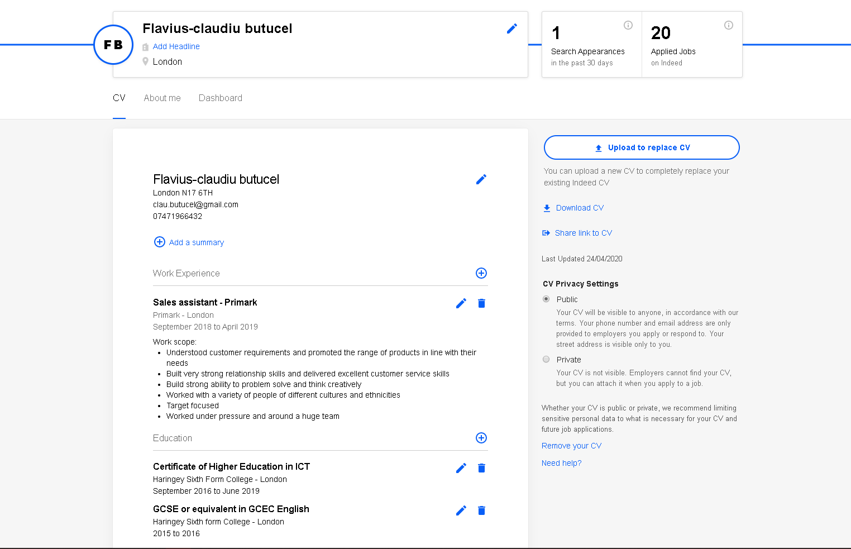
Provide screenshots as evidence of your completed e-Portfolio/PDP implementation with a brief written explanation of its content and structure (use the snipping tool as demonstrated in class!) . You should also include your optional Linkedin profile (or similar) if you have created it.

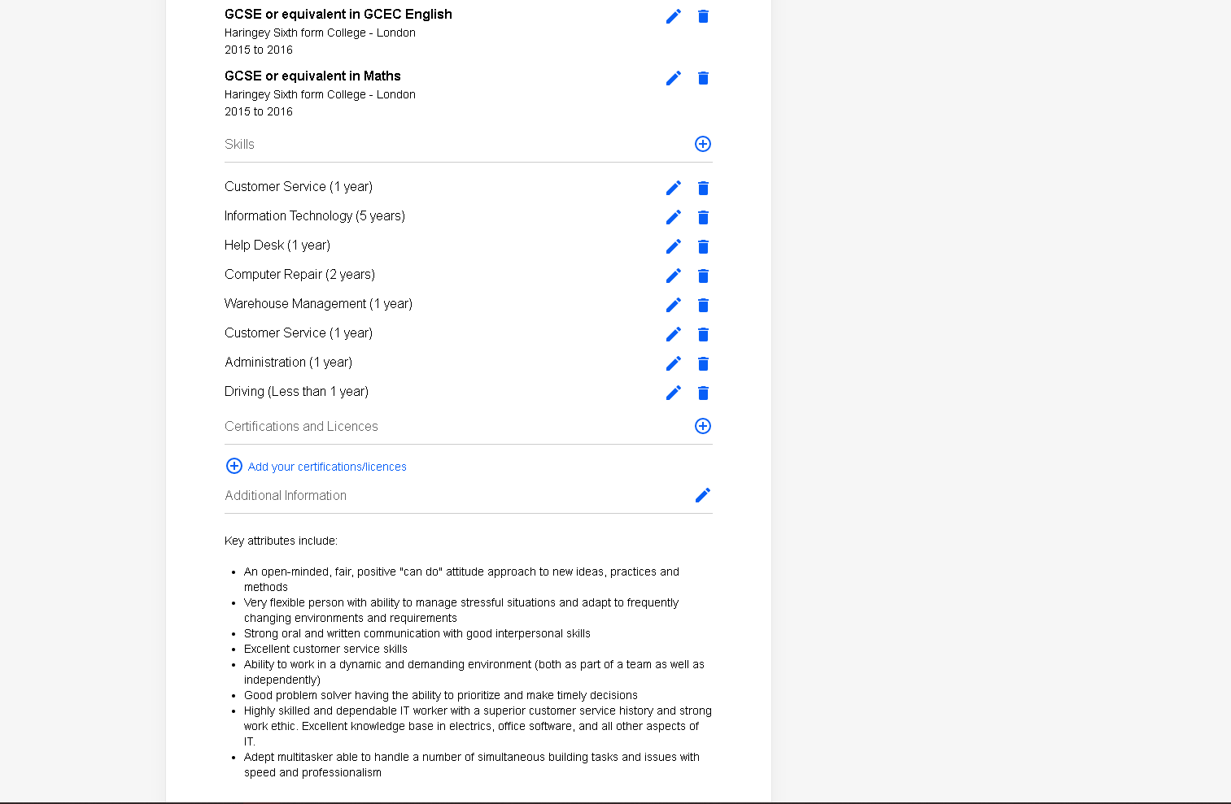

Summarize and document your conclusions / key-findings during the study of the various topic areas in the AES module.

Recommend areas of interest for further study and consideration.

Include any additional screenshots of completed Skills Evaluation questionnaires, surveys, Cryptowall exercise etc...

References

Tips for Making Effective PowerPoint Presentations 8/8/2017 Available at: https://www.ncsl.org/legislators-staff/legislative-staff/legislative-staff-coordinating-committee/tips-for-making-effective-powerpoint-presentations.aspx

Economictimes.indiatimes.com (2019). Five skills needed to achieve your career goals Available at: https://economictimes.indiatimes.com/wealth/earn/five-skills-needed-to-achieve-your-career-goals/articleshow/51165539.cms?from=mdr (Accessed : 25 April 2020).

