Marketing Plan of Grand Hyatt

Student name: Sarda Anu Stefania Kumar
Student ID number: 2230813
Module title: Marketing Essentials BMIH4005
Lecturer name: Chris Wilkin
Word count: 1368

Introduction
The purpose of this marketing plan is the identifying of an issue or a marketing opportunity for Grand Hyatt Hotel.
There will be used more types of frameworks such as SWOT analysis, and PESTLE analysis and marketing mix among with other references about customers and competitors.
The Grand Hyatt brand owns a number of 58 hotels in multiple countries. These properties are providing welcoming hospitality paired with the local experiences specific for each country in the matter.
Grand Hyatt is defined by luxury, targeting influent travellers with inventive restaurants, spas, and elegant meeting spaces. (Hollander, 2022)
Situation Analysis
For this company a SWOT analysis was conducted and the strengths found are that this hotel values the family concept; it offers a variety of services 24/7; the staff is highly trained; it is also providing luxury and budget-friendly tour packages (Kazis, 2021).
When it comes to the weak spots we have mainly the prices, the tour packages are still more expensive in contrast with others hotels offers.
As opportunities we have the capability of continuously innovating and the chance to grow internationally; especially when one of the threats was the pandemic crisis that affected all the hotel industry. (Hyatt, 2023).
As a result, its target market includes customers aged above 25, businessmen or plain customers who enjoy the premium experience (Law et al., 2020).
The Grand Hyatt properties compete mainly with big names in the industry such as InterContinental, Fairmont and JW Marriott hotels and although Grand Hyatt is the most expensive one, it is also the one that offers the highest quality in reports with its prices, the number one competitor for it being JW Marriot.
The PESTLE analysis shows that in the current political scenario, the only thing a multinational hotel chain should adhere to is the changing policies of different countries’ governments (Franco, 2021).
The economic factors that affect Grand Hyatt’s external environment is the growth in international tourism, inflation, and economic events. (Arif et al., 2016)
Grand Hyatt has to keep in mind that customers of every ethnicity, race, and cultural and religious background can be encountered due to the different countries they operate in (Bissoon, 2018).
In the technological field, the best approach for hotels is the introduction of social media as a marketing strategy (Adam, 2018).
Every country has different laws concerning hotels and accommodation services, therefore, related companies have to make sure they meet every legislation, especially in terms of health and safety laws, food and beverage requirements. (Jooss et al., 2019).
Finally, the world is on the brink of an environment collapse, so hotels have to make sure they are sustainable in every sense, especially in terms of providing for the environment by practicing green implications (Maclean et al., 2018).
Objectives
There are specific goals for Grand Hyatt like increase the sales over next three quarters by 30% over the same quarters last year and increasing the same stores sales by 30% over a specific time period using similar advertising budget.
The metrics have to be carefully decided because wrong ones can lead to unpleasant consequences; for example – focus on click through rate on sites, but keep in mind that the social media business can led to fake and sensational content which can create consumers backlash.
Enabling the staff is a necessary condition in order to achieve the goals set. This means that the staff must have the skills, comptences, systems, tools and enthusiasm to deliver. (Jobber, D. et al, 2020)
Managers at all levels in Grand Hyatt should take the feedback of employees on the ground to set realistic goals.
The targets set should be clearly specified in time. For example the project should have a specified end data, for example 90 days, one month or the next three quarters.
Strategy
The Grand Hyatt wants to grow and in order to do so they came to the conclusion that more customers are needed. For this to happen the chosen strategy – showed in a Ansoff matrix – is to offer more services or packages at lower prices for a limited amount of time.
The market penetration strategy will be for the hotel to spend extra money on advertising and to make some improvements on the facilities offered.
The product development would be basically to rely on getting money from the existing customers to invest in order to attract new ones. The market development means to find more services for the existing consumers and as diversification is the extend in other countries.
Tactics
The main issue for the Grand Hyatt hotel is the fact that most customers think the prices are much higher than the ones at competitors, but they are not always making count of the quality offered in exchange.
New communications can be used in order to clarify that although the hotel is more expensive, it also offers a much larger variety of services and many of them are 24/7 for the customers to reach.
The RACE framework can be used easily in this issue as the first thing to do is to reach to the customers. The Grand Hyatt would have to promote and publish their content on all social media, considering that they already are on all of the most popular ones and they can take advantage of the value per visit measure.
The next step is to make decisions based on the relevance of the clicks they got that can be measured by time on site, shares or likes, comments etc.
The convert phase could be the remarketing to ensure the relevance of the content and it can also be made relying in the feedback got from the comments on the sites and a key measure is the revenue obtain in cases of online booking.
The last is the engaging – it refers to the ability of making the customers/ visitors to be thrilled to return to you it this way the hotel gets to have a loyal customer base.
As a marketing mix, shortly, the products offered by Grand Hyatt are its luxurious hotel services; as place the Hyatt Hotels headquartere is in Chicago, USA, but Grand Hyatt is located all over the world in almost every continent.
Since it is a luxury brand, the pricing strategy Grand Hyatt follows is the premium pricing strategy and since the company is sizable, it uses almost every marketing technique to make sure the right kind of customers are attracted to its brand.
Although Grand Hyatt is already on all social media, they could improve their posts about the offers that they have, the promotions for holidays or others promotions should be highlighted on the social networks and advertised accordingly in order to attract more customers that can afford and want to pay more money for luxurious services.
Action
To properly understand what Grand Hyatt should do by keeping the marketing plan in sight, a Gannt Chart filled with relevant activities with their approximate time requirements can be observed in the appendices.
Some of the advertising will be made via direct marketing, such as e-mails and text messages around the holidays that will be sent directly to existing customers to ensure they are aware of the holidays discounts; another way of advertising is the TV because is the most watched channel of information in the first month of the year until the summer vacations starts.
Control
Key measures indicators can be checking its official website’s traffic insights to uncover the number of visitors after its implementation, indicating that if they have increased; the revenues, the increasing of the profits and also the number of new customers after the new marketing strategies and advertising.
Conclusion
In conclusion, this marketing plan analysed how Grand Hyatt can improve its marketing strategies in attracting the right kind of customers amidst an increasingly competitive market.
The plan highlighted the hotel’s issue could be the prices above average, but this could be also because the customers are not explained well enough what they will get in return of the money paid, so a recommendation would be better advertising in order for the new potential consumers to be informed exactly about the price-quality report they are getting for the extra amount of money given at Grand Hyatt.

References
Books/ Articles
- Adam, I., 2019. Drivers of physical accessibility among hotels. Anatolia, 30(4), pp.560-571.
- Arif, T.M.H. and Hossin, M.Z., 2016. A comparative analysis of internal and external environments between Hotel Hyatt, UK and Hotel The Cox Today, Cox’s Bazar, Bangladesh. IOSR Journal of Humanities and Social Science, 21(6), pp.13-22.
- Bissoon, O., 2018. Corporate social responsibility in Mauritius: an analysis of annual reports of multinational hotel groups. Asian Journal of Sustainability and Social Responsibility, 3(1), p.2.
- Franco, S., 2021. The influence of the external and internal environments of multinational enterprises on the sustainability commitment of their subsidiaries: A cluster analysis. Journal of Cleaner Production, 297, p.126654.
- Iranmanesh, M., Ghobakhloo, M., Nilashi, M., Tseng, M.L., Yadegaridehkordi, E. and Leung, N., 2022. Applications of disruptive digital technologies in hotel industry: A systematic review. International Journal of Hospitality Management, 107, p.103304.
- Jooss, S., McDonnell, A., Burbach, R. and Vaiman, V., 2019. Conceptualising talent in multinational hotel corporations. International Journal of Contemporary Hospitality Management.
- Law, R., Sun, S. and Chan, I.C.C., 2020. Hotel technology: A perspective article. Tourism Review, 75(1), pp.286-289.
- Maclean, M., Harvey, C., Suddaby, R. and O’Gorman, K., 2018. Political ideology and the discursive construction of the multinational hotel industry. Human Relations, 71(6), pp.766-795.
- Yang, H., Cheung, C. and Li, W., 2022. Intercultural communication competency practices in the hotel industry. Journal of China Tourism Research, 18(1), pp.162-184.

Websites
- Hyatt SMART Goal Analysis / Framework (embapro.com) accessed on 10th may 2023
- Hyatt. 2022. Hyatt to Enter Exclusive Collaboration Agreement with Lindner Hotels AG. (online). Available at: Hyatt Hotels Corporation - Hyatt to Enter Exclusive Collaboration Agreement With Lindner Hotels AG, to Significantly Increase Brand Footprint in Germany and Key European Leisure Destinations Accessed on: 6th of March 2023
- Hyatt. 2023. Grand Hyatt. [online]. Available at : https://www.hyatt.com/brands/grand-hyatt Accesed on 10th of March 2023
- Jobber, D. and Ellis-Chadwick, F (2020), Principles and practice of marketing (online) – Available at: EBOOK: Principles and Practice of Marketing, 9e - David Jobber, Fiona Ellis-Chadwick - Google Books accessed on 11th of May 2023
- Jordan Hollander October 12, 2022 (online) – Available at: Hyatt's 14 Hotel Brands Explained (hoteltechreport.com) accessed on 10th may 2023
- Kazis, N., 2021. Challenges and Opportunities for Hotel-to-Housing Conversions in NYC. (online) – Available at Challenges and Opportunities for Hotel-to-Housing Conversions in NYC (furmancenter.org) accessed on 11th of May 2023

Appendices
- SWOT analysis
Strengths | Weaknesses
- The hotel’s value in family makes its hospitality services top-notch.  - It offers apartment-style accommodations with kitchens, living rooms  - Its staff is highly trained professionally  - It provides luxury and budget-friendly tour packages (Kazis, 2021)  - Its customer service is available 24/7. | - Its operating costs are tad unnecessary.  - Despite its tour packages, it is still very expensive for most customers.  - The hotel largely depends on tourism rates due to its nature.  - To keep its staff well-trained, Grand Hyatt has to spend extra on such programmes.
Opportunities | Threats
- Growth in international tourism after the pandemic.  - Its capability to continuously innovate itself.  - The Internet’s wide array of operations, ready-to-use. | - Increasingly tough competition.  - Dishonest online businesses have made customers distrust Internet marketing.  - Alternatives, like Airbnb, are swiftly replacing expensive hotel stays.  - Hygiene concerns.

- Competitors
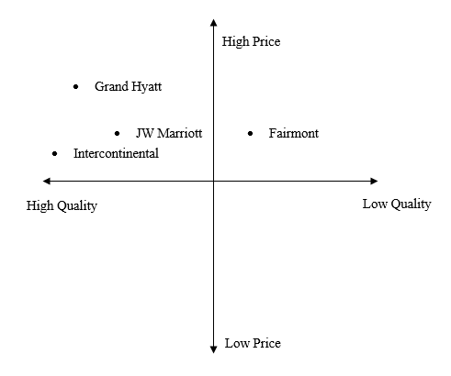

- Grand Hyatt – Gannt Chart

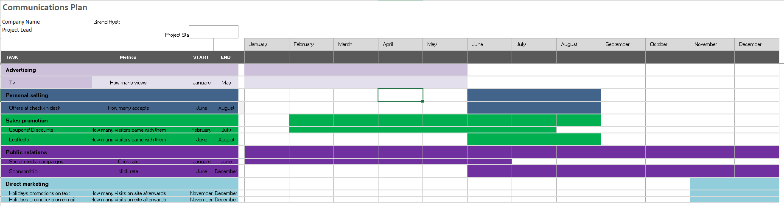

Presentation


