Bethan Davies
2101063
History and Theory Essay- M4X01975

Robie House–Frank Lloyd Wright

Historical Background
Despite beginning construction in 1909, the Robie House was not completed until 1910. It was designed by Frank Lloyd Wright and built-in Hyde Park in Chicago on the campus of the University of Chicago. The building shows some inspiration for falling water because of the Cantilevered eaves. Robie House was heavily influenced by the Japanese-style housing with very plain walls on the inside and some lights hanging above to make it appear more natural, Wright was also influenced by the prairie style because of the way the horizontal lines echo with the flat prairie landscape that surrounds the building- (Andrew, B., 2021.). Wright designed many homes in the prairie style because wright believed if people understood the connection to nature, then people would act responsibly towards it. Wright also liked the arts and crafts movement because of the craftsmanship and simplicity behind those types of buildings. The purpose of the building was designed as a single-family home, and it provides some public spaces and some private spaces, but the house would alternate serve as an office, classroom, and dormitory- (GoChicago, 2019). The Robie House was supposed to feature some Wright-designed Furniture by it was never in the house because the house had Financial Troubles. There were two attempts to demolish the house, one in 1941 and then again in 1957 but wright and the public campaigned to save the house. Several people lived in the Robie House, but the last people to live there departed in 1926 (WTTW, n.d.).The Robie House was named a National Historic Landmark in 1963 and 1991 and was one of the 10 most significant buildings of the 20th century. (Vincent, n.d.).
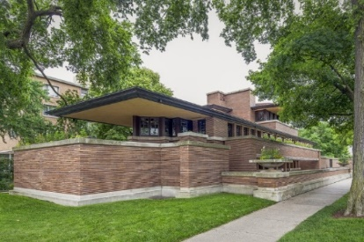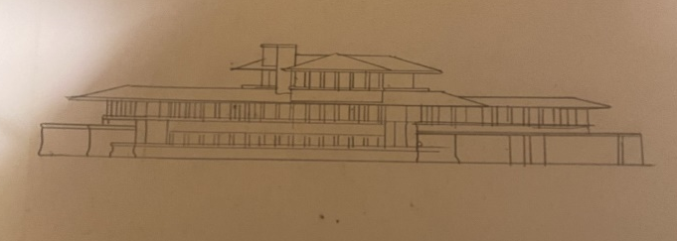
Figure 1- Photograph of the Robie House- (Keegan, 2022) Figure 5- Robie House Drawing- (Bethan, 2022)

Bethan Davies
2101063
History and Theory Essay- M4X01975

Materials And Light
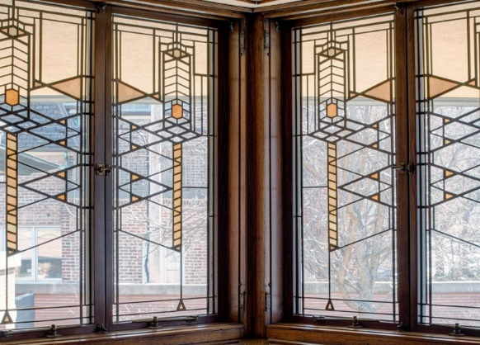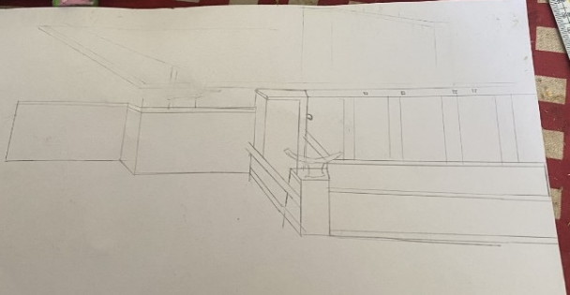
Figure 4- Window Detail- (Andrew, 2021) Figure 6- Robie House- (Bethan, 2022)

The building was built from red roman bricks and horizontal bands of limestone, and it was one of the first designs Frank did where he incorporated steel beams into the overhang and floating balcony. The building has a dramatic cantilevered roof and overhanging eaves for a sense of privacy- (Frank Lloyd Wright Trust , n.d.). Wright placed it there so that clients would not be distracted by the cantilever roof and could enjoy the beautiful views in front of them and having the low, hipped roofs that extend out beyond the walls creates a sense of shelter and protection. Most of the building's weight is carried by concealed steel beams in the ceiling and floors, exposing the main level to masonry-bearing walls. While natural light enters the building, the windows are frosted to shield recessed lighting, providing a sense of privacy but you can see the landscape that surrounds the building. The interior of the house also features artificial lighting. The building's plated glass windows allow light to enter during the spring and fall, creating a similar mood to the sunset. There was harmony between the patterns within the windows of the Robie House and the horizontal structure. (William, J. C.,). Rugs and light fixtures are inspired by natural patterns and geometric shapes designed specifically for the building. The colours inside the building balanced out with the heavy dose of natural wood and stone- (Rethinking the Future, 2021). The reason why wright placed the windows in continuous ribbons running along the eaves is that he wanted to express his idea that indoor and outdoor spaces should be unity and should be equal. - (MunHong, 2018). By having the indoor spaces open on to each other it allows light to travel through the building nicely, this way natural light can enter the building, which will have a reflect on the building to make it more natural to the surrounding.

Bethan Davies
2101063
History and Theory Essay- M4X01975

Plan And Section of the Building :
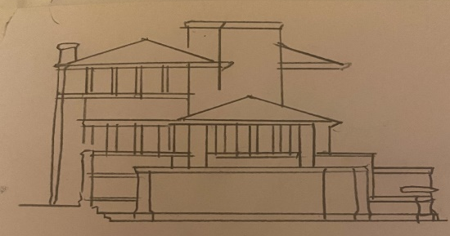
Figure 2- Drawing of the Robie House- (Bethan, 2022) 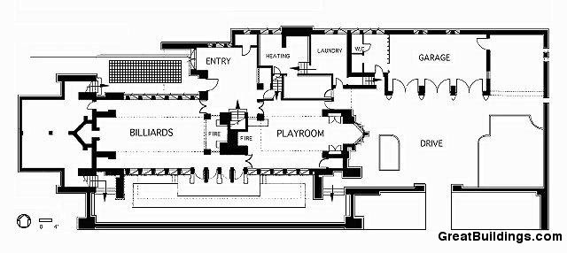
Figure 3- Plan of the ground floor- (Adelyn, 2020)

The building is 60 feet wide by 180 feet long at the corner of Woodlawn Avenue. There are 20 feet long cantilever roofs, long linear walls, and low terraces to enjoy the beauty of the surroundings. The building is three stores- (rethinking the Future, 2021). On the Plan, you can see that entrance is not visible because Frank wanted it to be a journey through the building, not something that you would expect to see because he wanted people to gain a better understanding of his design, That is why he put the entrance towards the back of the house - (Adelyn, 2020). The ground floor plan of the house features two private rooms from playrooms for children and a three-car garage along with a kitchen, servants’ rooms, and guest rooms. The main family rooms are located on the smaller third floor- (Teaching by Design , 2020). Wright wanted an open plan design, and he wanted to create a modern flexible living space. The Entrance Hall, kitchens and bedrooms with bathrooms, and the staircase were all placed on the North-eastern side of the house on the Second Floor, Wright also put the master bedrooms on the same floor because he wanted to make the most of the views that the bedrooms could see (Getty, 2019). There is a sense of more freedom in the home and open plans for the rooms that can flow into each other. - (MunHong, 2018) Wright did want the indoor spaces to be closed and isolated from each other but to be open to each other because he didn’t want the typical “box” like homes that are in buildings today.

Idea and Theories underpinning the Design
An idea or theory about the Robie house is that the basement of the Robie House is thought to have been removed by Wright to build the first floor, this goes to show that wright was able to adapt his design to suit what the client wanted. According to a theory, the roof served as a device that heated
Bethan Davies
2101063
History and Theory Essay- M4X01975
in the winter to keep the occupants warm and cooled in the summer to keep them cool. Wright also used elongated Roman brick laid with deep reveals of shadow joints, so the bricks would not be visible to the naked eye because he wanted the roman brick to intertwine with the house (Kenneth, 1980). In the period leading up to the first world war, the Robie House represented the development of a modern concept of space, which was inspired by the amount of available space in the area post-World War 1. The Robie House influenced most American Architecture today because of the Prairie. Homes he designs- (William, 1900). After Wright died, there were many questions about the Robie house like “if the Robie House was built for him or the Client?”- (Vincent, 2020). People didn’t believe right when he wanted to design in a prairie style, they thought he wanted to do another “Right House”, but Wright didn’t understand what they were talking about - (Melinda, 2016).
Conclusion
In conclusion, the Robie House was a success because Frank responded to the client well, because of the client's desire for privacy, Frank designed the house with that in mind, which is evident from the very beginning. Wright believed that every house should have a journey, so he did not want the entrance to be clear, he wanted people to find their way through a building. As a result, the Robie house meets the architect's aims and objectives because the architect believed that the house would respond to the natural environment. After all, that would improve the health and well-being of the people who live within its walls. The colours, materials, and even the brick colour were all selected to capture the attention of people walking past or even inside the building because of this, it has become one of America's most important buildings today. Building structure, interior, and exterior, and even the Furniture are connected in their way, the way the brick harmonizes with the windows to give the building a sense of calmness and to give the building its unique style. Many buildings have been influenced by Frank Lloyd Wright because of the Cantilevered eaves and the horizontal style building, one building that shows this is the Barcelona Pavilion by Mies Van Der Rhoe. Frank Lloyd Wright influenced modern buildings today because of the way he captured light in a quite simple way and the ventilation in buildings.

References
Adelyn, P., 2020. AD Classics: Frederick C. Robie House / Frank Lloyd Wright. [Online]
Available at: https://www.archdaily.com/60246/ad-classics-frederick-c-robie-house-frank-lloyd-wright
[Accessed 27 April 2022].
Andrew, B., 2021. Robie House. [Online]
Available at: https://architecture.uchicago.edu/locations/robie_house/
[Accessed 27 April 2022].
Bethan, D., 2022. Robie House. [Art].
Frank Lloyd Wright Trust, n.d. Wrights's Life and Work. [Online]
Available at: https://www.teachingbydesign.org/about/robie-house/
[Accessed 20 April 2022].
Getty, F., 2019. Frank Lloyd Wright Prairie Vision. s.l.:s.n.
Chicago, 2019. Frank Lloyd Wright's Robie House. [Online]
Available at: https://www.gochicago.com/tourist-attraction/frank-lloyd-wrights-robie-house/
[Accessed 20 April 22].
Kenneth, F., 1980. Modern Architecture has a critical history. s.l.:s.n.
Melinda, M., 2016. usonian and prairie style architecture from Frank Lloyd Wright. [Sound Recording].
MunHong, C., 2018. Theory and History of design Robie House FLW. [Sound Recording].
ReThinking the Future, 2021. ReThinking The Future. [Online]
Available at: https://www.re-thinkingthefuture.com/case-studies/a5120-frederick-c-robie-house-by-frank-lloyd-wright-prairie-style-of-architecture/
Teaching by Design , 2020. Wright's Life and Work. [Online]
Available at: https://www.teachingbydesign.org/about/robie-house/
[Accessed 27 April 2022].
Vincent, M., 2020. Robie House. [Online]
Available at: https://www.britannica.com/topic/Robie-House
[Accessed 27 April 2022].
William, J. C., 1900. Modern Architecure since 1900. s.l.:s.n.
WTTW, 2020. Frank Lloyd Wright Robie House , s.l.: WTTW.
WTTW, n.d. Robie House. [Online]
Available at: https://interactive.wttw.com/tenbuildings/robie-house
[Accessed 20 April 2022].

