The First 1000 Days

Throughout the early stages of a child's life, it is important to consider how important the first 1000
days are to a child for their holistic development. Children begin going through a stage of rapid
development in which they begin to learn through play and sensory, Welsh Government (2019).
The period of conception to birth is an extremely important time, as the wellbeing of the mother can
have an effect on the outcome of the baby. However, it is essential to remember at birth the
importance of skin-to-skin contact. Evidence suggests that not only does skin to skin contact benefit
in physical ways, but it also helps both the baby and mother mentally as it provides comfort and
relaxation (UNICEF, nd). The first 1000 days are considered significant due to the period in which the
child can rapidly develop. Throughout this assignment, I will be discussing the importance of respectful
care, the holistic development, the benefits of professional roles and professional love.

The Importance of Respectful Care
Respectful Care is defined to be when you give the child the opportunity to learn activities and
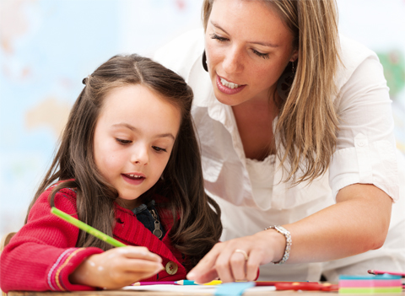
simple actions by completing it themselves. This could simply mean you observe or give simple
instructions guiding them through a task, but by doing
this, you are allowing the child to feel a sense of
independence and creating a level of respect and trust
between you both. It is also considered important that
children have the opportunity of freedom of movement.
Activities such as tummy time are most commonly used and encouraged by staff as it gives the child
the ability to develop mentally and physically (Tops Day nursery, 2020).

Holistic Development
The start of a child's development begins when the baby's brain begins forming within the womb.
Throughout this development, a baby develops neurons, which then go on to create stronger
connections during infancy. All of the connections formed throughout the early stages of the child's
life is an underlying aspect of a child's development. Holistic development refers to the idea that every
part of learning and growth is connected to every other being, Yang (2004).
As suggested by Professor Paul Jones (2016), It's important for parents to understand the
seriousness of children's early years development. Providing children with experiences implements
their development throughout life (National Scientific Council on the Developing Child, 2008).
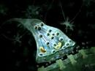

1 - Neurotransmitter Synapse
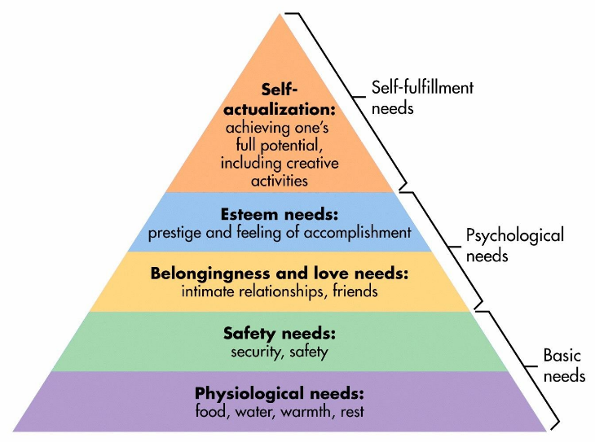
Maslow’s Hierarchy of Need (1943) is seen as
important theory as it shows the needs of an
individual. His theory also shows the correct way for
a child to be cared for, for the best outcome.
It's believed that an individual cannot reach the self-
fulfilment needs without correctly following the
Hierarchy of Need. The aim is to achieve the basic needs first, and then build your way up to the final
stage, which is fulfilment.

Not only is it deemed crucial for the correct interactions from the parents, but the communication
from the practitioner is essential too. This is so that the child can develop their social and
communication skills in the best way possible. All practitioners should appropriately communicate
with the child to develop their knowledge and understanding. By doing this, it will create a bond
between the child and the practitioner. Interactions like this shape and create the brain architecture,
however, if the ‘serve and return’ interactions aren't met, it could possibly lead to brain architecture
impairment. (Harvard University, 2017).
Credited theory founder Bowlby (1948) and Ainsworth founders (Van Rosmalen, L., Van der Horst, F.
and Van der Veer, R, 2016) found that the child needs a stable, healthy relationship with a parent so
that their development isn't affected in any way. in agreement with this, Lindon (2010) states that a
child's view on life and any experiences they face may be affected if a child was to face any
distressing or traumatising events.

Professional Roles
Practitioners
For children, creating relationships with practitioners is a daunting time, although it is important that
the child creates that bond and a sense of familiarity, Dowling (2014).
Urie Bronfenbrenner (1976) ecological theory also implies that the environment a child is
surrounded by has an effect on how a child develops throughout life. Considering this, it’s important
to consider the environment in which you will be seeing the child will be. Although a child may feel
comfortable with you, its important that the space they are in makes them feel welcomed too.
Donaldson (2015) also gives the impression that as practitioners, it is our priority to work in the
correct manner with the child to form the most positive relationship.
A crucial professional that is involved in the developmental stage of the first 1000 days is a community
practitioner as they help families when the neurological development is taking place (Marmot et al,
2008).
Evidence suggests that the positive bond between a professional and the child at hand is crucial to a
strong development, however, also is the environment. Studies have suggested that children within a
neglectful, abusive, unstable structural family can cause chronic stress to the child by the time they
reach the age of 9 due to the trauma within the first 1000 days (Mitchell et al, 2014).

Professional Love
If you were to consider a child's basic needs to survive, we would instantly think of the basics
such as food and water. However, if you were to think deeper, a child really needs a lot more than
that, such as to be cared for, loved and respected.
The concept of professional love is a term researched by Dr. Jools Page, who states that it is related
to the relationship between a practioner and the child (Dr. Ann Clare, 2016). Dr. Ann Clare (2016),
carried out a survey in which 793 Practioners responded too in relation to how they personally
reviewed the idea of professional love. In response to this survey, it was discovered that the majority
of early years practitioners had a positive attitude towards playing a part towards professional love
within their settings. It was then stated by most that they felt able and comfortable in their position
professionally to interact with a child in order to form a positive attachment, by taking part in
activities such as hugging.
Professional love is built on the basis of the idea that another being (so in this instance the
practitioner) should care for another (the child). It’s therefore only when this relationship deepens
that the level of intimacy becomes recognised as professional love. This idea is based upon Nodding’s
(2003) ‘Ethic of Love’.
It is most commonly understood that the longer in which the relationship between the professional
and the child is, the deeper the connection within the relationship that will lead to a secure and strong
attachment. However, there is a barrier when it comes to the idea of ‘professional love’ and how
people interpret it. It is said that the communication between the practitioner and the parents is vital
to ensure that nobody is undermined and that everyone feels as equally involved within the
relationship. It’s important that the practitioner can apply emotional resilience throughout the
relationship and can continue to be reflective throughout as suggested by Etherington (2007).
Etherington (2007) suggests that keeping a reflective journal will help the practitioner come to terms
with the daily interactions with a child as a practitioner.

Enabling Adult and Enabling Environment

The role of an adult in a child's life is extremely significant, Welsh Government (2021). It is the role
of the adult to set the correct expectation of learning, creating safe spaces and trustworthy bonds.
No matter what comes their way, it’s the adults responsibility to manage a child's transition and
changes in life.
It is the enabling adults responsibility to care and observe the child in the correct manner. To begin,
it’s important to allow the child to begin to learn independently, with the enabling adult there for
support. However, an adult should be aware of when the correct time to intervene is.
Enabling experiences for children is a crucial part of a child’s experience within the first 1000 days.
Being more hands on in situations is more meaningful to a child’s progression. It is the enabling adults
responsibility to ensure that they encourage a child to be as independent as possible to ensure that
they have the most successful learning experience.

Sensory activities within an early year setting
Sensory activities are deemed to be an important part to a child's development and growth. These
types of activities are said to stimulate a child's senses in all way. Within the first 1000 days, a child
begins exploring the world with their five senses (touch, taste, hearing, smell, seeing). This is the way
in which a child learns the environment in which they are in and experiencing the world around
them. This is an opportunity for play to support a child's development with their engagement and
observation skills, cognitive growth, and their interactions.
Multi – sensory opportunities should offer all children the chance to be inspired and respond and
express themselves creatively. It is important to consider that children have a range of materials with
different senses to engage and express themselves clearly. As a practitioner, it is considered our
responsibility to encourage children to use and develop their problem-solving skills and thinking skills.
Jean Piaget (1966) suggested that children need environmental stimuli in order to develop their
cognitive ability, so sensory play was suggested as a key feature.

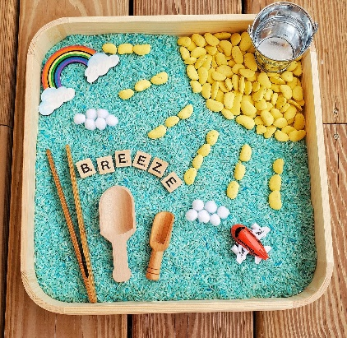
Sensory Bins
Begin by filling small tubs with objects. For example, you could fill a
tub with things in relation to nature such as leaves, rocks or sand.
Another example could be filling it with items such as food. This
could be items such as cooked pasta or beans. You could then go on to put in spoons and scoops to
allow the child to play around with it.
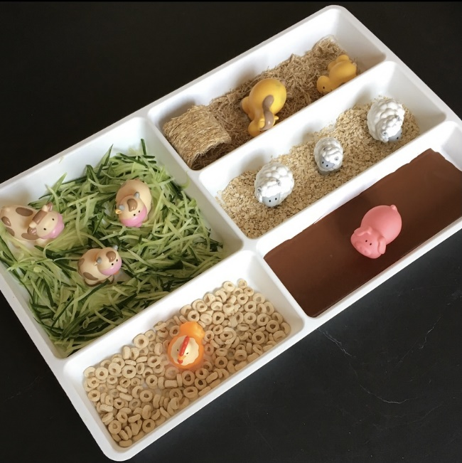
Playing with food
Another idea is allowing a child to play with food on a tray.
Allow the child to squish, smear, squeeze and taste the food.
The one way a child loves to learn is by putting things in their
mouth, so allow them to do so. Use foods that are suitable to
them such as noodles, yogurt or beans. You could even
consider using food colouring to intrigue them even more.
Let their curious hands have a play!

Sound Tubes
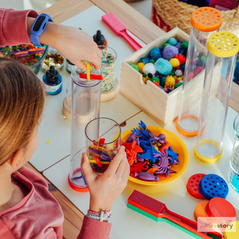
Begin by finding empty paper towel roles and securely
covering the one end of the tube. Then set out lots of
different objects or foods they can fill the tube with. You
could consider using beads, pasta etc. Once this has been
done, be sure to secure the other end of the tube. Finally,
when this is done, allow them to play with it and shake it. The
child will enjoy hearing the different sounds and this will
stimulate them.


Sensory Sight Bottles
Begin by finding empty plastic bottles, of any size. Then allow the child to fill the bottles with water,
food colouring, glitter etc. This then creates different patterns and textures.

Reference list

Available at: https://www.savethechildren.org.uk/content/dam/global/reports/education-and-child-protection/lighting-up-young-brains.pdf (accessed on: 9th July 2022)

Available at: https://www.topsdaynurseries.co.uk/how-our-respectful-care-approach-benefits-your-child/ (accessed on: 9th July 2022)

Available at: https://www.unicef.org.uk/babyfriendly/baby-friendly-resources/implementing-standards-resources/skin-to-skin-contact/ (accessed on: 9th July 2022)

Bowlby’s attachment theory, Available at: https://www.simplypsychology.org/attachment.html (Accessed: 10th July 2022)

CA: University of California Press.

Dowling, M. (2014) Young Children’s Personal, Social and Emotional Development. 4th Ed. London: Sage.

Harvard University. (2017) Science key concepts. Available at: https://developingchild.harvard.edu/science/key-concepts/serve-and-return/ (Accessed: 10th July 2022)

https://www.masterclass.com/articles/a-guide-to-the-5-levels-of-maslows-hierarchy-of-needs#:~:text=Maslow%27s%20hierarchy%20of%20needs%20is,%2C%20and%20self%2Dactualization%20needs. (Accessed: 13th July 2022)

https://www.pacey.org.uk/news-and-views/pacey-blog/2016/july-2016/%E2%80%98professional-love%E2%80%99-in-early-years-settings/ (Accessed: 11th July 2022)

Jean Piaget and Barbel Inhelder, The Psychology of the Child (New York: Basic Books, 1966).

Lindon, J. (2010) Understanding Child Development 2nd Ed. London: Hodder Education.

Marmot M , Friel S , Bell R , Houweling TA, Taylor S. (2008) Closing the gap in a generation: health equity through action on the social determinants of health. The Lancet 372 (9650): 1661-9.

Mitchell C, Hobcraft J, McLanahan SS, Siegel SR, Berg A, Brooks-Gunn J, Garfinkel I, Notterman D. (2014) Social disadvantage, genetic sensitivity, and children's telomere length. Proceedings of the National Academy of Science of the United States of America 111(16): 5944-9.

National Scientific Council on the Developing Child (2008) The timing and quality of early experiences combine to shape brain architecture. National Scientific Council on the Developing Child: Harvard. Available at: http://developingchild.harvard.edu/wpcontent/uploads/2007/05/Timing_Quality_Early_Experiences-1.pdf

Neurotransmitter Synapse Video, 2007 , Available at: https://www.bing.com/videos/search?q=impulse+travelling+down+an+axon&ru=%2fvideos%2fsearch%3fq%3dimpulse%2520travelling%2520down%2520an%2520axon%26qs%3dn%26form%3dQBVR%26sp%3d-1%26pq%3dimpulse%2520travelling%2520down%2520an%2520axon%26sc%3d0-31%26sk%3d%26cvid%3d5C4A9E3A72B34E568CE1B96C12AFAD2C&view=detail&mid=2AA317B3015A741950A62AA317B3015A741950A6&rvsmid=596BB99D21E85E70A45C596BB99D21E85E70A45C&FORM=VDQVAP (accessed on: 14th July 2022)

Noddings, N. 2003. Caring: A Feminine Approach to Ethics and Moral Education. 2nd ed. Berkeley

PACEY, Dr. Ann Clare (2016) Professional Love. Available at:
Urie Bronfenbrenner and Child Development. Available at: https://www.gulfbend.org/poc/view_doc.php?type=doc&id=7930 (Accessed: 11th July 2022)

Van Rosmalen, L., Van der Horst, F. and Van der Veer, R. (2016) ‘From Secure Dependency to Attachment’, History of Psychology, 19(1), pp.22-39. Available at: https://content.ebscohost.com/ContentServer.asp?T=P&P=AN&K=2016-05673-002&S=L&D=pdh&EbscoContent=dGJyMNHr7ESeqLA4zOX0OLCmsEieprNSsK%2B4S6%2BWxWXS&ContentCustomer=dGJyMPGqtVGxp7FRuePfgeyx44Dt6fIA (Accessed: 11th July 2022)

Welsh Government, 2019. https://publications.parliament.uk/pa/cm201719/cmselect/cmhealth/1496/1496.pdf (Accessed on:15th July 2022)

Yang, B. (2004). Holistic learning theory and implications for human resource development . Advances for Developing Human Resources

