Architecture in your hometown

by Valerie Emma Vaughan
(2103742)

History and Theory 1
(M4X01975)
Ian Standen
University of Wales Trinity Saint David
BSc Architecture

24th January 2022

Table of Figures

Figure 1: St David's Cathedral, taken by author from the southwest viewpoint 3
Figure 2: St Mary's Church, taken from the main entrance (St Mary's Church Haverfordwest, 2020) 4
Figure 3: Hand drawn plan drawing of St David's Cathedral taken from Medieval Heritage (n.d.a) 5
Figure 4: photo taken by author, with oval showing the change in stonework (possible window replacement) in the south wall of the nave of St David's Cathedral 5
Figure 5: transverse section through the west wall of the nave of St David's Cathedral (Ruskin, et al., 1899) 6
Figure 6: hand drawn plan of St Mary's Church, taken from Medieval Heritage (n.d.b) 6
Figure 7: photo taken by author of the rib vaulting in the north transept in St David's Cathedral 7
Figure 8: photo taken by author of the fan vaulting in the tower in St David’s Cathedral …………………..........7
Figure 9: photo taken by author of the fan vaulting in the south aisle in St David’s Cathedral …...................7
Figure 10: photo taken by author of the timber ceiling in the nave in St David’s Cathedral ……………....……...7
Figure 11: photo taken by author of the light purple sandstone at the entrance of St David’s Cathedral......7
Figure 12: photo taken by author of the window tracery at St David’s Cathedral .........................................7
Figure 13: photo taken by author of the rose window in the west wall of the nave of St David’s
Cathedral ........................................................................................................................................................8
Figure 14: photo taken by author of St David’s Cathedral at twilight …………………………………………………………8
Figure 15: external south wall of St Mary’s Church, built with yellow sandstone (Ross, n.d.) .......................8
Figure 16: photo looking down to the east wall of the chancel in St Mary’s Church (Medieval Heritage, n.d.b) ..............................................................................................................................................................8
Figure 17: stained-glass window in the east wall by C. E. Kempe at St Mary’s Church (Harries, 2016) .........9
Figure 18: timber ceiling of nave at St Mary’s Church (Medieval Heritage, n.d.b) ........................................9

Introduction
Architecture can be seen as an identity for built environments, in which different areas will have different architecture. When an area uses its local materials, style, and space, it creates a unique, vernacular structure that could never be replicated. In the modern world, most buildings look identical to another, but historical buildings have meaning and are distinctive. This essay will look at how St David’s Cathedral and St Mary’s Church compare to one another as they were built around the same time, same area and using locally sourced materials.

Context and Historical Background:
St David’s Cathedral is situated in St David’s, Pembrokeshire, the smallest city in the UK as shown in Figure 1. It is situated in a valley hidden by high stone walls in which was meant to prevent invasions, which proved unsuccessful (Medieval Heritage, n.d.a). The sloping of the cathedral is said to be due to subsidence, pulling the foundations and subsequently the cathedral into the ground, along with the pressure from the tower (St David’s Cathedral, n.d.). Construction commenced under Bishop Peter de Leia’s orders in 1181. However, the main restoring architects were John Nash and George Robert Scott in the 1790s and 1861 respectively (St David’s Cathedral, n.d.). Various stages of Gothic architecture can be seen throughout the building; however, the main architectural style of the nave is Transitional Romanesque (Tudor Times, 2019). This can be seen by the rounded arches, pillars, and barrel vaults.
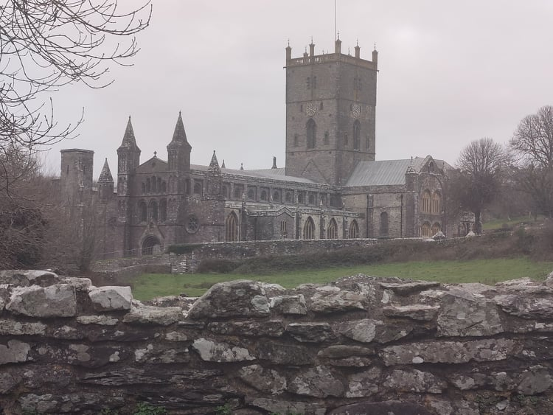

Figure 1: St David's Cathedral, taken by author from the southwest viewpoint

Figure 2 shows St Mary’s Church in Haverfordwest, Pembrokeshire which was built in the late 12th century (no exact date) and is situated at the top of a high street which was the main meeting point in the town at the time and on the route to St Davids (Barker, 2009). The architectural style of this church is mainly Early English and Decorated Gothic, but the foundations date back further so could resemble the Romanesque style as well (Lloyd, et al., 2004). The architect of the church could not be found but was restored by Ewan Christian in 1884 (Pembrokeshire County Council, n.d.).
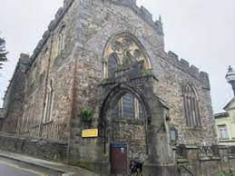

Figure 2: St Mary's Church, taken from the main entrance (St Mary's Church Haverfordwest, 2020)

Plan and Section:
As with most religious buildings, the original cathedral is in the shape of a crucifix as shown in Figure 3. The sloping of the cathedral can also be seen in the plan of the chapel. You can see the gradual expansion of the cathedral from the original structure and what has been restored by Nash and Scott (St David’s Cathedral, n.d). As the Medieval Heritage (n.d.a) site states, most of the windows can be seen to have restoration work done to them, which can be seen by the change in stonework in Figure 4. The section through the west wall of the nave (restored by Scott) shows straight through to the altar and the doorways through to the north and south transepts.

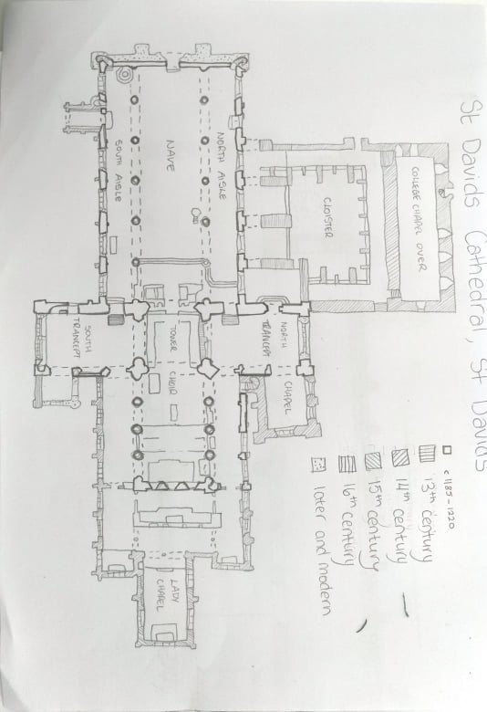

Figure 3: Hand drawn plan drawing of St David's Cathedral taken from Medieval Heritage (n.d.a)
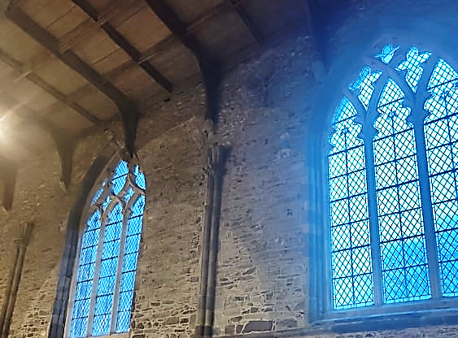
Figure 4: photo taken by author, with oval showing the change in stonework (possible window replacement) in the south wall of the nave of St David's Cathedral
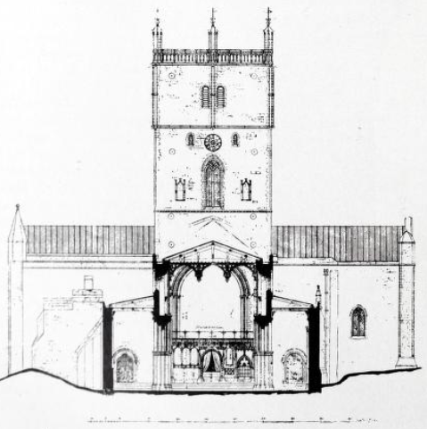

Figure 5: transverse section through the west wall of the nave of St David's Cathedral (Ruskin, et al., 1899)
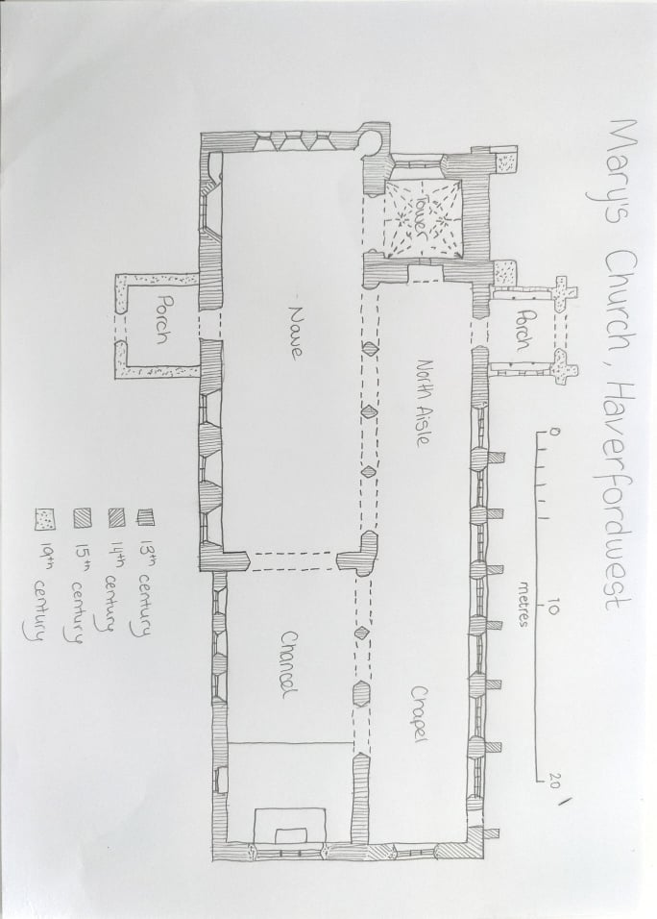
The plan of St Mary’s Church in Figure 6 shows a different layout to St David’s. The tower is in the corner rather than in the centre. However, the main porch entrance walls are in the shape of a crucifix, but not its main structural shape that St David’s had. St Mary’s Church has had no major extensions from the original building like the cathedral had, with only the restoration work and porches being the newest add-ons (Medieval Heritage, n.d.b). The thicker walls of the nave suggest that the style was transitional Romanesque into early Gothic.

Figure 6: hand drawn plan of St Mary's Church, taken from Medieval Heritage (n.d.b)

Materials and Light:
Most of the rooms in the cathedral have stone vaulting, such as rib vaulting in the north transept (Figure 7) and fan vaulting in the tower (Figure 8) and in the south aisle (Figure 9). However, the nave was made with a timber ceiling (Figure 10) with pendants rather than stone vaulting. This was due to subsidence and for originality (Medieval Heritage, n.d.a). The light purple sandstone (Figure 11) on the original structure gives the cathedral a rustic but elegant finish (Chroustchoff, 2008). The windows have simple but intrinsic intersecting tracery, as shown in Figure 12. A few of the windows are stained glass, with the rose window in Figure 13 in the south aisle reflecting colours onto the entrance. Figure 14 shows the effect the windows and lighting have on the surrounding space.
Figure 12: photo taken by author of the window tracery at St David's Cathedral

Figure 11: photo taken by author of the light purple sandstone at the entrance of St David's Cathedral

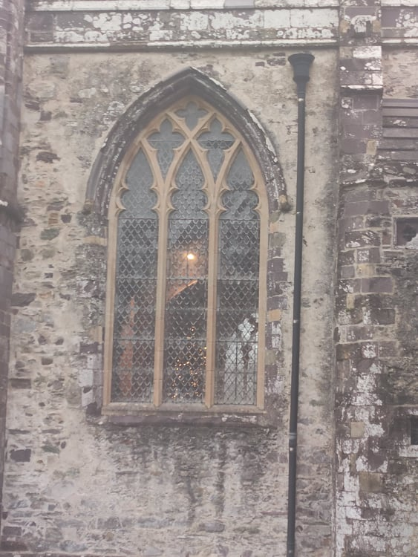
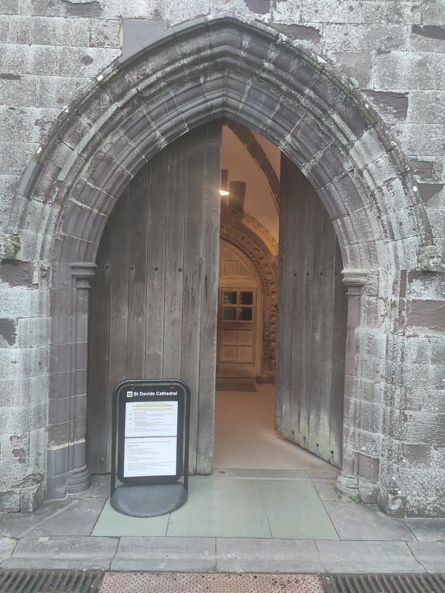
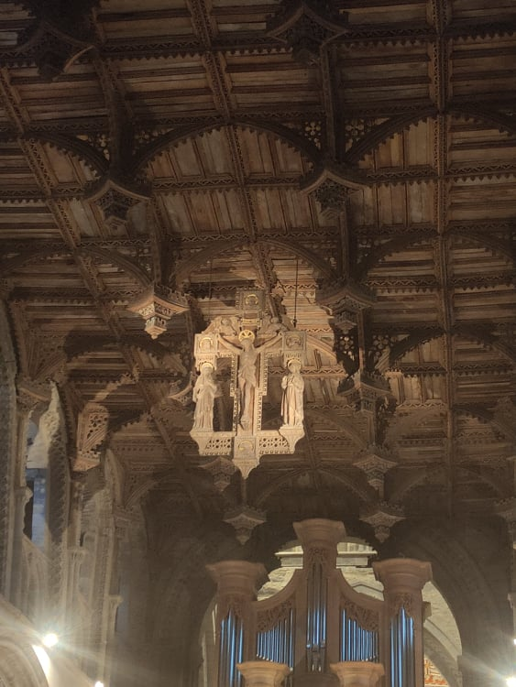
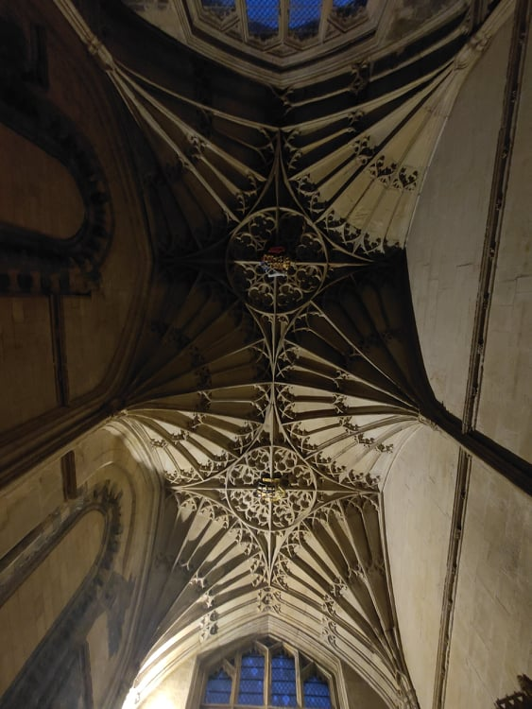
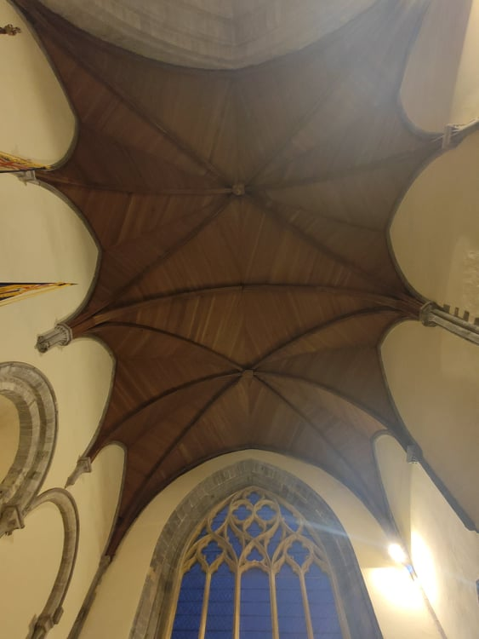
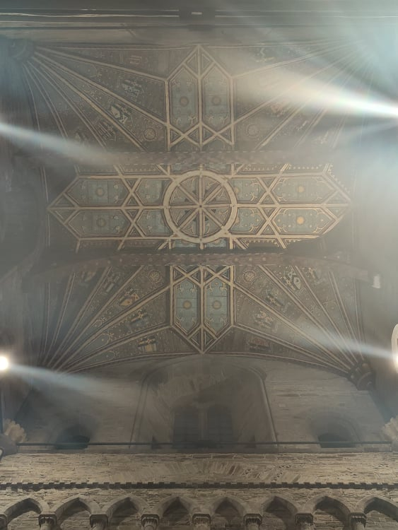
Figure 10: photo taken by author of the timber ceiling in the nave in St David's Cathedral

Figure 9: photo taken by author of the fan vaulting in the south aisle in St David's Cathedral

Figure 7: photo taken by author of the rib vaulting in the north transept in St David's Cathedral

Figure 8: photo taken by author of the fan vaulting in the tower in St David's Cathedral

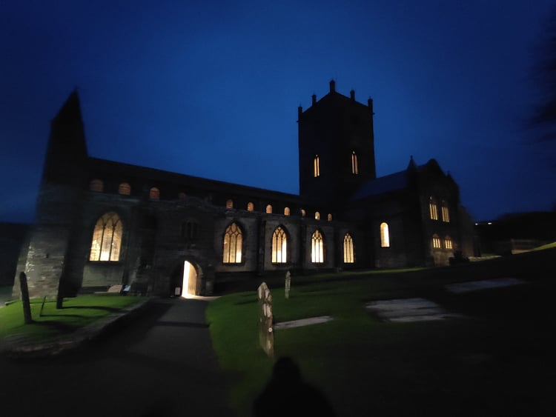
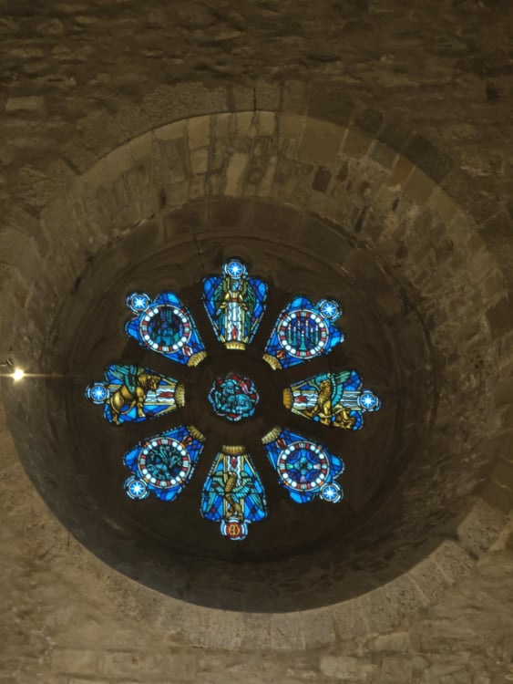
Figure 13: photo taken by author of the rose window in the west wall of the nave of St David’s Cathedral
Figure 14: photo taken by author of St David’s Cathedral at twilight

St Mary’s Church was built using local yellow sandstone as shown in Figure 15, which was used for its durability and its weather resistance (Dyfed Archaeological Trust, n.d.). The internal walls have been rendered to give a smooth finish that details the underlying stonework (Figure 16). The church also has a vast number of stained-glass windows, both on the ground floor and clerestory to admit light into the building, such as in Figure 17. The nave has a similar timber carved ceiling (Figure 18) to St David’s Cathedral, showing the style of that time.

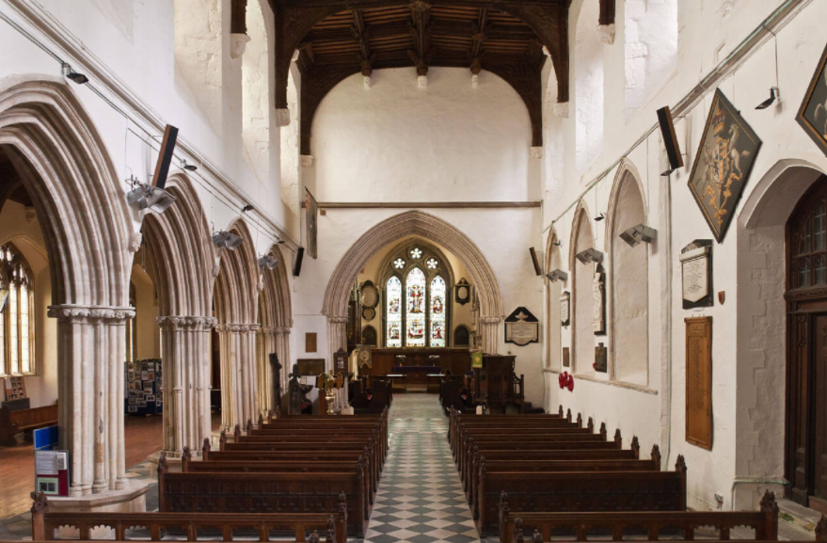
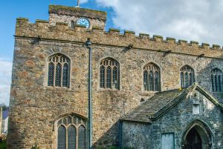
Figure 15: external south wall of St Mary’s Church, built with yellow sandstone (Ross, n.d.)
Figure 16: photo looking down to the east wall of the chancel at St Mary’s Church (Medieval Heritage, n.d.b)
Figure 15: photo looking down to the east wall of the chancel in St Mary’s Church (Medieval Heritage, n.d.b)

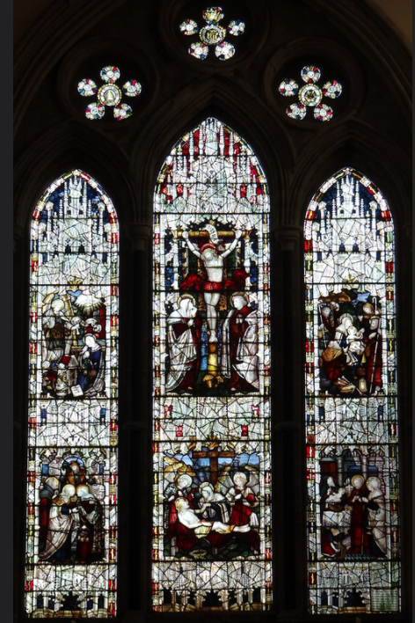

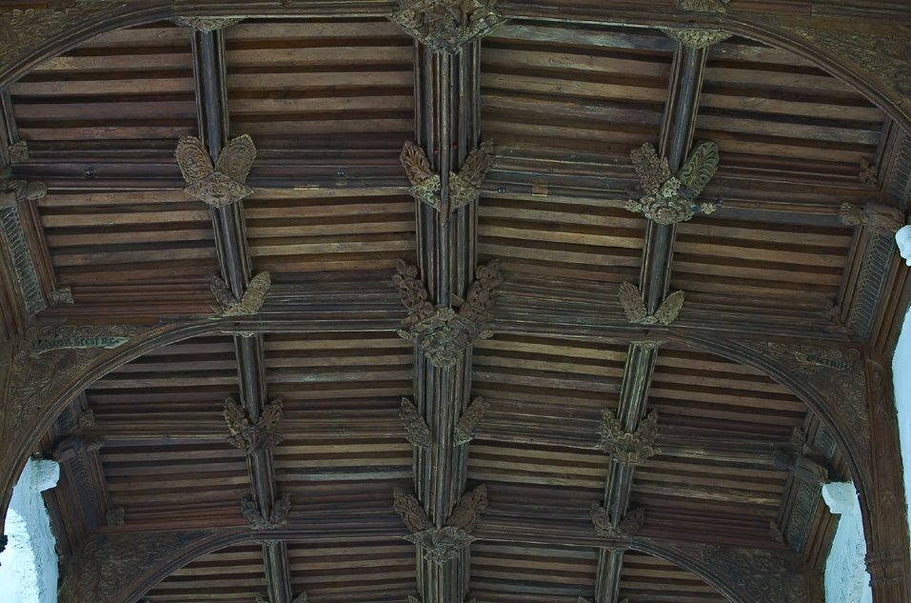
Figure 17: stained-glass window in the east wall by C. E. Kempe at St Mary’s Church (Harris, 2016)
Figure 18: timber ceiling of nave at St Mary’s Church (Medieval Heritage, n.d.b)

Use:
The nave of St David’s Cathedral is now used for mass services and for walkthroughs, with the Lady Chapel and Bishop’s Chapel used as quiet zones and the tower blocked off from the public. The entrance is through the south porch leading into the back of the nave, and the exit is through the cloister opening. The layout seems to be successful after watching the public move through the building, in that there does not need to be any signs (apart from do not enter) to tell people which way to go.
St Mary’s Church is open to the public with the nave being used for services. Most people enter and leave the church through the north porch entrance for convenience, with only a few through the south entrance. I would say the church is good for small gatherings, but the floor plan does not have enough space for larger crowds. However, in terms of religious usage, the space and acoustics are good for services.

Conclusion:
As both buildings were built around the same time, there is a definite similarity of style, such as both having similar timber ceilings and the Transitional Romanesque to Early English Gothic style. They are both located in the centre of their areas with profound religious interest. Both were built with locally sourced sandstone that have clearly been durable, with windows in the clerestory bringing more light into the buildings. It is clear that this style of architecture is still considered a work of art with excellent craftmanship, and just shows how a style can be interpreted differently.

References
Barker, P., 2009. St Marys Haverfordwest. [Online]
Available at: http://www.stmaryshaverfordwest.org.uk/documents/History.pdf
[Accessed 17 January 2022]

Chroustchoff. N. C. de, 2008. SM7525: Caerbwdi stone, St David’s Cathedral. [Online]
Available at: https://www.geograph.org.uk/photo/741366
[Accessed 18 December 2021]

Dyfed Archaeological Trust, n.d. St Mary, Haverfordwest, Pembrokeshire. [Online]
Available at: https://www.dyfedarchaeology.org.uk/wp/discovery/projects/churches/st-mary-haverfordwest-pembrokeshire/
[Accessed: 20 January 2022]

Harris, R., 2016. Chancel, east window, by C E Kempe, 1893 - Annunciation and Visitation, Crucifixion and Deposition, and Nativity and the Presentation in the Temple. [Online photograph]
Available at: https://www.flickr.com/photos/sheepdog_rex/27980098895/in/photostream/
[Accessed 20 January 2022]

Lloyd, T., Orbach, J. & Scourfield, R., 2004. Pembrokeshire: The Buildings of Wales (Pevsner Architectural Guides: Buildings of Wales). London: Yale University Press

Medieval Heritage, n.d.a. St Davids – Cathedral. [Online]
Available at: https://medievalheritage.eu/en/main-page/heritage/wales/st-davids-cathedral/
[Accessed 16 December 2021]

Medieval Heritage, n.d.b. Haverfordwest – St Mary’s Church. [Online]
Available at: https://medievalheritage.eu/en/main-page/heritage/wales/haverfordwest-st-marys-church/
[Accessed 17 January 2022]

Pembrokeshire County Council, n.d. Pembrokeshire County Council Records. [Online]
Available at: https://records.pembrokeshire.gov.uk/CalmView/Record.aspx?src=CalmView.Catalog&id=HDX%2F254%2F2
[Accessed 17 January 2022]

Ross, D., n.d. Haverfordwest – St Mary’s Church. [Online photograph]
Available at: https://www.britainexpress.com/attractions.htm?attraction=573#extraphotos
[Accessed 20 January 2022]

Ruskin, J. et al., 1899. The Architectural Review: For the Artist & Craftsman. Volume V, pp. 114-121, 210-217, 247-254

St. David’s Cathedral, n.d.a. The History of the Cathedral. [Online]
Available at: https://www.stdavidscathedral.org.uk/discover/history/cathedral
[Accessed 16 December 2021]

St Mary’s Church Haverfordwest, 2020. St Mary’s Church Haverfordwest, taken from the main entrance. [Online photograph]
Available at: http://www.stmaryshaverfordwest.org.uk/
[Accessed 17 January 2022]

Tudor Times, 2019. St David’s Cathedral. [Online]
Available at: https://tudortimes.co.uk/places/st-davids-cathedral/the-cathedral
[Accessed 16 December 2021]

