
Applied Leadership and Management in the Workplace
Module Assignment Submission
Student Name: | Siam Rahman
Student Number: | 1710176
Module No: | BMSK4012
Module Title: | Enterprise and Intrapreneurship
Statement of Confirmation of Authenticity
By the act of making this submission, the student declares that this is the work of the student named above. The work has not, in whole or in part, been knowingly presented elsewhere for assessment, or where assessment has been built on a previous assessment, this has been identified. Where materials have been used from other sources it has been properly acknowledged. If this statement is untrue, the student acknowledges that an assessment offence has been committed.
Attention is drawn to the plagiarism and unfair practice policies of both the University and of ILM.

Siam’s Slim Cutz
Haircut makes everything better
ETB 2023

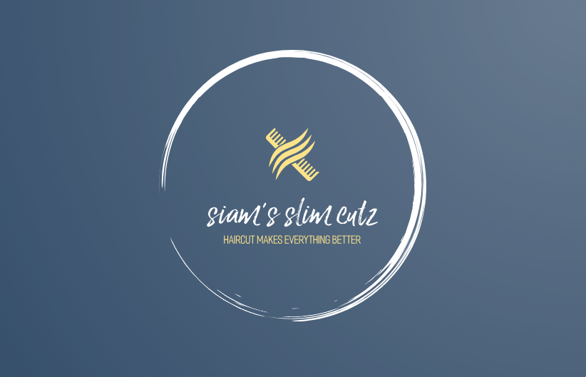
(Logo Maker | Used by 2.3 Million Startups, 2020)

Owner: Siam Rahman
Contact Number: 07710 835601
Email: slimcutz23@outlook.com

Table of Contents
Executive summary 4
Introduction 4
Operations 5
Market Research 7
Revenue and Pricing Strategy 10
Financial Information 10
Cash Flow Table 11
References 12
Appendices 14
Business card 21
Price list/Menu 22
Curriculum Vitae 23

Executive summary

My name is Siam Rahman and my business idea is a Mobile grooming/barber service. I will be self-employed and I will trade as a sole trader. I will be the only member of staff taking full responsibility of all aspects of the business. This business plan outlines the establishment and operations of a mobile barber service, which aims to provide convenient and professional grooming services to customers preferred location. By leveraging market research, developing effective marketing strategies and ensuring efficient operations. The business aims to achieve profitability while meeting the needs of its target market. I am fully trained and attended barber school for 12 weeks to learn skills that I will apply when providing services to my customers. From the research that I carried out there are not many barbers who are providing home visits since Covid, most barbers are trading from a shop which makes my business plan a unique selling point as I will be mobile.

Introduction

My business idea is starting a Mobile Barber service by offering Mobile grooming services. Bringing barber services directly to clients homes, offices and other convenient locations. The business aims to provide a premium haircut experience with maximum convenience and comfort. In modern day especially after experiencing a global pandemic mobile services are becoming the norm and these services are cutting edge ventures that address the demands of modern consumers by offering these mobile services. I will provide a barber service by travelling to locations across Cardiff with all the necessary equipment and tools required in order to provide the best service possible. I am a fully trained and qualified barber where I attended a barber school for a period of 12 weeks to learn techniques and to put practice in to play. (Barbering Course London Level 3 NVQ - 12 Weeks | Beginner to Master, 2023). Once my training was complete I did some work experience in a barber shop to gain as much knowledge and experience as possible before I venture off and start my own business, learn as much as I can and I also practiced cutting hair on staff members before I attempted to cut any of the barbershops clients hair. I did eventually cut some of their clients hair and I had positive feedback stating they ‘loved’ the haircut and would let me cut their hair again, this gave me a great confident boost and it pushed me to start my own business.
I will be self-employed and I will trade as a Sole trader, I will appoint an accountant to register the business with HMRC and I will also be in charge of all aspects of the business from taking bookings from clients to managing finances for the business and will be responsible for any profit and loss. (Government Digital Service, 2012)
Siam Rahman will be the sole owner of the business ‘Siam’s Slim Cutz’ dealing with day to day operations as well as attending client locations to provide a service.
The services and products Siam’s Slims Cutz will be providing are haircuts for men, children over the ages of 5 and women who like to cut their hair short and require a fade using clippers, I will provide hair patterns and designs, hot towel shave and beard trims in my service. I will also try to upsell to all my clients for example the products that I will have for sale are hair gel, shaving cream, hair spray, aftershave, face cream and shampoos.

Operations

The activities from an operational side will include scheduling appointments, managing the business, equipment maintenance and getting electrical goods PAT tested and ensuring high quality standards are consistently met. (PAT (Portable Appliance Testing) - HSE’s Answers to Popular Questions, 2023) The business will prioritise high level of hygiene using disinfection products therefore for every client the equipment will be nice and clean.
To start the business I will be using £10,000 that I have been saving for many years for a business venture like this, I will also be getting £10,000 from my parents as a gift who have also been saving for me to start a project or business venture, I will be securing another £5000 from the bank as a loan to get me started. I will get a 5 year loan at 9.9% APR which works out at £91.60 payments a month. The first £4950 of the funds was used for Barber training, to be a qualified Barber. The rest of the allocated funds will be used towards to get a business phone as a communication tool to communicate with clients when taking bookings etc, I will use funds to buy a vehicle and the maintenance of the vehicle such as road tax, business insurance, MOT and fuel. The funds will also be used for marketing to promote the business, leaflets and posters, business cards, advertising on the local radio, advertising in the local newspaper and I will set up social media accounts for the business for example Facebook, Instagram, Twitter and I will have the facility to take online bookings too via my social media accounts. I will also require liability insurance which is required in the event of, if a member of the public or my client decides to make a claim for injury or property damage and this insurance will cover these potential scenarios. From the research I undertook found that it would be very important to have this insurance cover. (Gold, 2022)
I will also register with an accountant to complete my end of year taxes to submit to HMRC, funds will be required to pay the accountants fees.
I will also allocate funds to buy all the essential equipment that is required to become a barber for example full clipper set with all the guards which will include combs, a beard trimmer, blue disinfection liquid to clean and sanitise my equipment, spray bottle for water, hair gel, a stool for my clients to sit on when I visit them at their location, a mirror for the client to see the progress of their haircut. Barber cape and disposable neck strips, cut throat, shaving cream, aftershave, shampoo, a bag or a small suitcase to store my essential equipment when attending appointments from client to client. I will also buy a blow dryer, barber aprons and uniform with my business logo printed, tissue, small fold away table to put all on my equipment on whilst I am cutting a clients hair, I will also buy a ring light to provide me with good lighting which will assist greatly whilst I cut a clients hair. I will be buying cleaning products and dust pan and brush to clean/tidy up after finishing my clients haircut. Lastly I will buy products to upsell to my clients such as shampoo, hair gel, hair spray which can potentially generate more revenue for my business.
The location of my business will be covering all areas of Cardiff and I will travel to all areas within Cardiff to meet customer demands. I will travel to appointment locations via a van, fully equipped with all the tools required to carry out my services. Below is a map of Cardiff and the areas which shall be my target market.
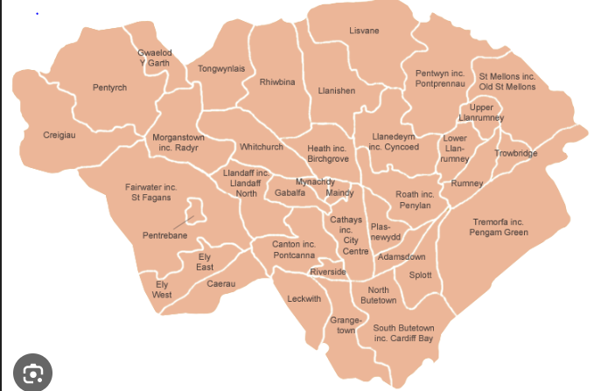
(Cardiff Council, 2023)

The days I will conduct my business are, from Monday to Saturday and Sunday business will be closed as I will use that day as a rest day and to recuperate to enable me to provide the best service possible when I am attending to clients’ needs and requirements. The hours of business will be based on customer requirements but I will start taking appointments from 9am in the morning and my last appointment of the day will be 9pm in the evening. There is a 12 hour window for customers and clients to book an appointment. I believe my trading hours caters for people who work all hours for example for people who are working during the day and finish 5pm they can book an evening appointment up to 9pm and for people who work nights or evenings I will be available for appointments during the day.
To secure appointments I will take full details of the client, their name, the address of where the client would like me to provide my services for example their home or their work place. A deposit of £10 will be required for every single appointment in order to confirm a booking. I will provide details of where to send their deposit and I will send them confirmation when the deposit is paid that the booking is now confirmed and will also provide the customer with a receipt for the deposit. The deposit will be deducted from the final amount due for example if the client books a treatment and my service totals to £30 the customer will only pay £20 at the end of their haircut as they have already paid £10 as a deposit. The reason behind taking a deposit is to stop time wasters and to cover my time if a client cancels their appointment. If a client makes a booking and doesn’t pay a deposit and the client is unable to attend the appointment it will have a detrimental affect on the business financially and also I could have booked another client in the same slot, I believe taking a deposit will eliminate such issues. To take deposit I will ask customers to transfer the funds to the business bank account and after treatment the client can use 3 payments methods to pay for my services, cash or card payment or BACS transfer. (Credit Card Machines | No Long-Term Contracts | Dojo, 2022). I have entered a contract where I will have a portable card machine and have negotiated to pay monthly at the amount of £20 a month. I have approached a reputable bank and discussed opening a business bank account with the facility of having a £1000 overdraft. The bank could not offer a higher overdraft amount as I am a new business and I am still at early stages of trading.
At present there will only be one member of staff which will be myself. I will assess the business for a period of 12 to 18 months to determine if I would need to recruit another barber to meet customer demands and if the business has expanded.
Health and safety will be a pivotal and paramount part of the business, my clients wellbeing and safety will be my upmost priority. I will be getting liability insurance to cover the business if an unfortunate event was to occur for example if one of my clients got injured whilst I was treating their hair. When I enter a clients home or premises and I have been shown where I will be working and providing my excellent services, the first task I will carry out is I will survey and check the room to identify if there is any health and safety hazards in my work environment. When I plug in my clippers I will inform the client to notify anyone else present at the premises that there is a wire coming out of the plug socket and make them aware that there is a potential trip hazard and to be mindful. I believe if I make the client aware and anyone else present this will eliminate any potential accidents.
From the research and the information I gathered, I established that for a mobile barber or hairdresser a licence is not required to perform the services you provide in Wales and England. (Get Licensed UK - Hairdresser Licence, 2023)

Market Research

My marketing strategy will be to promote my business via business social media accounts, I will use Instagram, Facebook and Twitter which are very popular platforms currently with millions of users. It will focus on a combination of digital marketing, targeted marketing, local partnerships and user friendly websites/app with online booking capabilities. The social media accounts will be utilised to showcase before and after transformations, allowing potential customers to visualise the convenience and quality of the services. Additionally partnerships with corporate clients, residential communities and event planners will be pursued to secure regular bookings and expand the customer base. I will also advertise in the local newspaper, I will advertise on the local radio, I will produce posters, leaflets and business cards which I will leave (with permission) in community centres, gyms, hospitals, GP practices and local businesses such as takeaways and restaurants. Once I have become an established business and I have made regular customers I will provide my regular clients with loyalty cards and the promotion that I will run is the client will pay ‘half price’ on their 5th hair cut. I believe when a business runs promotions and has loyalty cards the client will feel well looked after and privileged and you as a business will get repeat trade from this client. Also the client will spread the word to friends, family and colleagues that they received a good service from you and that will entice other potential customers to use your service which will ultimately increase your client base which will generate more revenue for the business.
My unique selling point will be that I am highly trained barber with hands on experience. The service I will provide will be very personable, warm and welcoming. I will make my client feel at ease, make them feel comfortable and make them feel like a ‘million dollars’ after I finish cutting their hair. I will build rapport with all my clients and will aim to get to a relationship the client considers me as their friend rather than their barber. Another unique selling point will be the fact that the client will be getting treated in the comfort of their own home and on route to the appointment I will stop at a shop to get my client a drink or coffee just to be a little different to my competitors. I will not charge for this drink it will be out of goodwill gesture at my own cost and will not be bought from using money from the business. My other unique selling point will be my prices, I will charge competitive prices but when I start I will charge a little less than my competitors in order to gain custom and once the business has established and I have regular customers I will increase my prices slightly as I don’t wish to lose my clients due to pricing. I do not intend to raise my prices within the first year I will look to increase my prices after the first year of trading. I also believe my trading hours are a unique selling point as my trading hours will cater for people who work in the day and for people who work in the evening too, which I believe this meets customers’ requirements and convenience.
Below is a PEST analysis table for the barber industry
Political | Economic | Social | Technology
Tax policy,  Political stability,  Legal requirements,  Health and Safety,  Trading policies,  Government policies | Inflation,  Summer period is peak season,  Recession,  Economic climate since Brexit,  Confidence declining,  Number of customers | Population,  Lifestyle,  Global pandemic Covid 19,  Younger customers open to new ideas,  Clients prefer not to travel and prefer same service from comfort of their own home | Good quality clippers,  Online booking platform  Social media,  Advertising online,  Use of a mobile phone,  Use of a vehicle

Below is a SWOT analysis table for barber industry
Strengths | Weakness | Opportunities | Threats
Hygiene standards,  Trading hours,  Range of hair treatments,  Excellent customer service, | Being the only member of staff,  Building portfolio and clientele from scratch,  Lack of experience running a new business | Market growth,  Internet opportunities  Stock products,  Partnerships,  Treatment packages for customers, | Other mobile barbers,  New barbershops opening,  Competitors dropping their price

I carried out a research of mobile barbers operating in the area of Cardiff which will ultimately be my competitors that I will be competing against. Below is a map of Cardiff showing my competitors who are in business and currently trading in the Cardiff area.

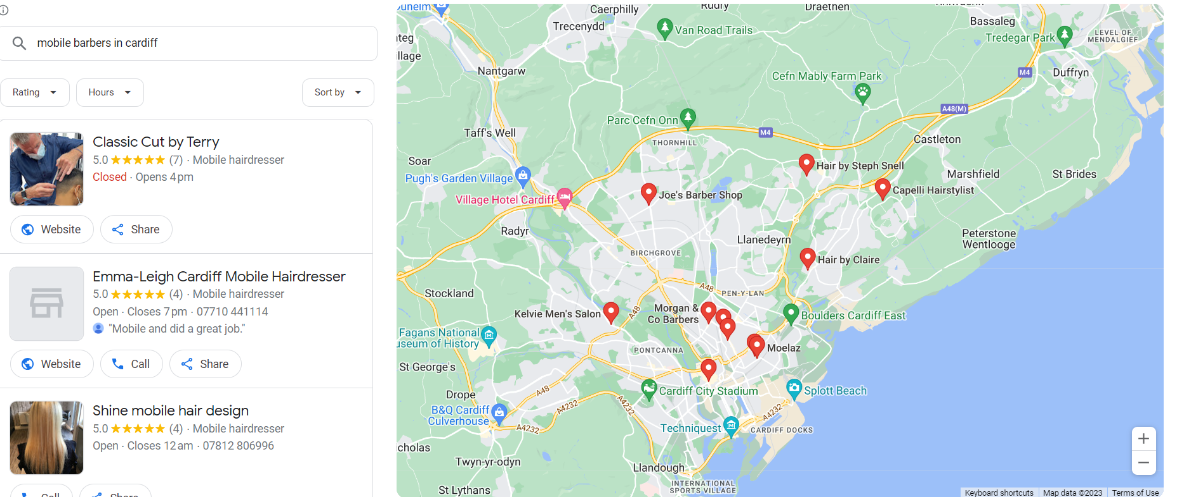
(Mobile Barbers in Cardiff, 2013)
From the research I performed I established that, most of the mobile service providers are hair dressers and not many are mobile barbers. I believe I have found a gap in the market and I believe my business plan can be successful as there is very little competition providing mobile barber services. When I called some of my competitors to see if they provide a service where they visit clients at their home most of the replies that I got was ‘we only did home visits during Covid, now we purely trade from our barber shop’. Now that I conducted research on competitors I believe as I am one of few who will be providing a mobile service this is my unique selling point.
My target market will include adults and children of all ages above the age of 5. The reason why I would like to cut hair for children above the age of 5 is I find that children under the age of 5 are fidgety and move a lot which can make it difficult for the barber to cut their hair. I came to a decision from a health and safety perspective is not to cut under 5 year olds hair in order to avoid any potential accidents. If there came a situation where an accident occurred to a child it could have detrimental impact on my business and it could affect my reputation as well as the child’s well-being, in business it is extremely hard to build a good reputation but it doesn’t takes very little for it to be tarnished and I wouldn’t like to jeopardise my reputation therefore I have decided not to cut hair for under 5 year olds. This choice I made may change in the future after I gain more experience and feel more confident cutting under 5 year olds hair. The target market for Mobile barber services will also include busy professionals, individuals with mobility challenges, seniors and those who prefer the convenience of at home grooming services. Additionally the business will target corporate clients, residential communities and event organisers to offer on-site grooming solutions for their employees, residents or event attendees. My base and location will be Cardiff and I will travel to all areas within the city to provide my excellent grooming services to my clients.
Cardiff’s current population is 488,153 and if I target 1% of Cardiff’s population which will be just over 4000 people, for a starting business that will be realistic figure to aim towards. My intention will be to do 10 haircuts a day trading 6 days a week which will total at 60 haircuts per week 240 haircuts per month 2880 haircuts per year. (Cardiff Population 2023, 2023)

Revenue and Pricing Strategy

The pricing strategy I decided on was to see what barbershops are charging in Cardiff and in my first year of trading I will charge slightly less than my competitors and possibly increase my prices in year 2 depending on customer demands and satisfaction. For example on average most barbers are charging between £17 to £20 for a standard haircut, £18 to £22 for skin fades, beard trims £11 to £12, patterns £25 to £30. (Groom for Men Club, 2023). My strategy is to charge a little less than my competitors to build a customer base. In conjunction I will be charging less and providing a service at the clients preferred location which I believe will be another great unique selling point.
The prices I will charge for my services is as follows, standard haircut £16, skin fades £17, beard trims £10, clean shave £10, regular haircut and beard £26, skin fade and beard £27, children’s haircut £10, haircut and blow-dry £20, seniors hair cut £10 and head shave £15. In my opinion the prices I am charging are very reasonable and competitive which I believe will be appealing to my target market.
My income streams will consist of selling products to my clients such as hair gel, shaving/face creams, hair spray, hair wax and shampoos as well as providing grooming services to my clients. I intend to generate as much revenue as possible from my income streams and produce profit for my business.

Financial Information

The financial projections estimate start up costs, including purchasing a vehicle to travel to appointments, insurance, MOT, road tax, marketing expenses, good quality equipment such as clippers and hairstyling products. Operating expenses and projected sales revenue have been illustrated below including financial structure and profit margins. Revenue will be generated from individual appointments, group bookings, corporate contracts and events.

Cash Flow Table

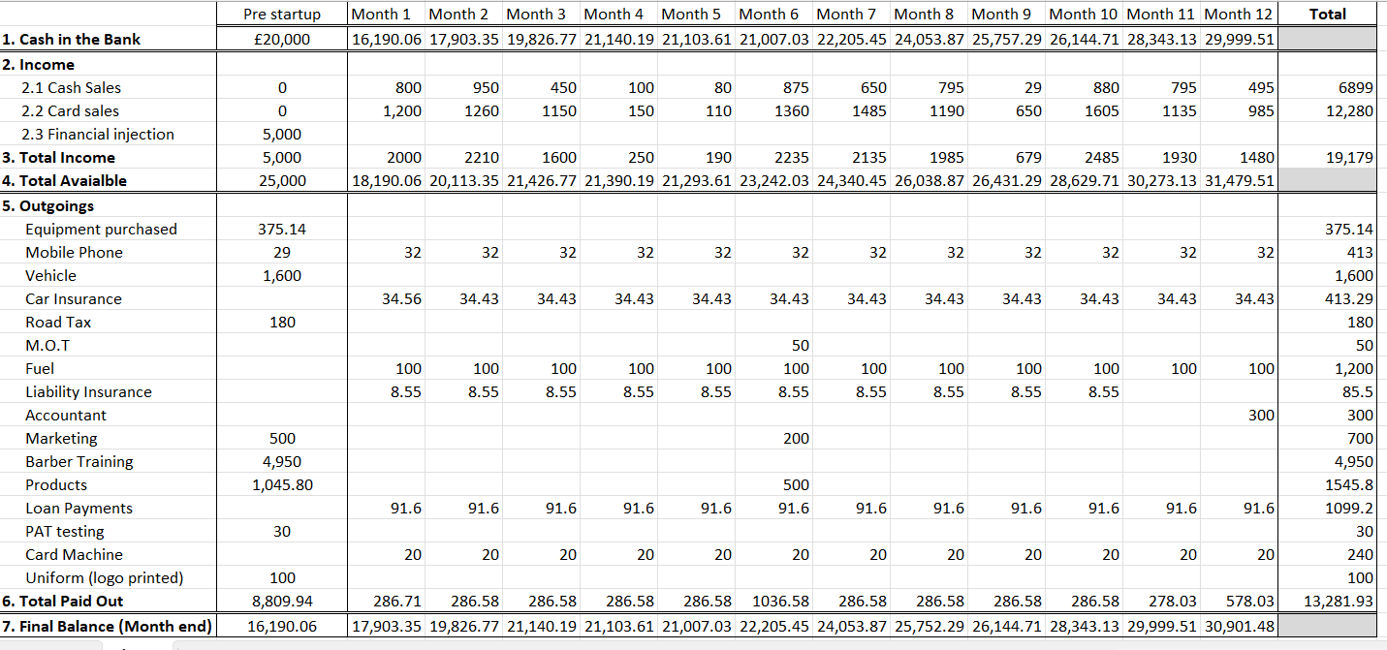

My startup funds were £25,000, I generated £19,179.00 in sales from month 1 to month 12 my total expense for the year was £13,281.93. It costs me on average £286 a month to run the business and provide my services to my client. Month 6 my expense was higher at £1036.58 as I restocked on my products that I use and I sell to my clients and in month 6, I resumed my marketing efforts. Month 12 my expense was higher as I had to pay fees to the accountant that is representing me. My gross profit for the year is £30,901.48. My net profit for the year is £5,897.17 My annual turnover for the year is £30,901.48.

References
Logo Maker | Used By 2.3 Million Startups. (2020). Looka.com; Looka. https://looka.com/editor/136064135
Barbering Course London Level 3 NVQ - 12 Weeks | Beginner to Master. (2023, July 3). The London School of Barbering. https://www.londonschoolofbarbering.com/courses/masters-barbering-cosmetologists-nvq2-nvq3/?gad=1&gclid=EAIaIQobChMIuZrqv--BgAMVnjoGAB0cjAe2EAAYASAAEgIQYfD_BwE
Government Digital Service. (2012, July 3). Set up as a sole trader. GOV.UK; GOV.UK. https://www.gov.uk/set-up-sole-trader

PAT (Portable appliance testing) - HSE’s answers to popular questions. (2023). Hse.gov.uk. https://www.hse.gov.uk/electricity/faq-portable-appliance-testing.htm

Gold, S. (2022, November 24). Freelance & Mobile Hairdressing Insurance | SG® UK. Salon Gold. https://www.salongold.co.uk/hair-and-beauty-insurance/freelance-mobile-hairdresser#:~:text=Public%20liability%20and%20treatment%20risk,the%20course%20of%20a%20treatment.

Cardiff Council. (2023). Cardiffhousing.co.uk. http://www.cardiffhousing.co.uk/common/map.php?map=private

Credit Card Machines | No Long-term Contracts | Dojo. (2022). Dojo.tech; Dojo. https://dojo.tech/lp/card-machine/?utm_source=google&utm_medium=cpc&utm_campaign=GS_UK_en_GEN_Card-Machine_EXA&utm_term=portable%20card%20machine&utm_matchtype=e&utm_device=c&adpos=&gad=1&gclid=EAIaIQobChMIhMq3wceigAMVcEBBAh1XMw3FEAAYAiAAEgLx6_D_BwE

Get Licensed UK - Hairdresser Licence. (2023). Get-Licensed.co.uk. https://www.get-licensed.co.uk/licence/hairdresser-licence

mobile barbers in cardiff. (2013). Google.com. https://www.google.com/localservices/prolist?g2lbs=AP8S6EOHUJstQA224wzaJUV50NXStK2OJICBDjtMbs9x9eoS659HX2nvTRdqEMAboxv8cfxtRK1iiC4x7MnYFH-dU_0G-YgGb3-EMLn3xrEIdQXDsTUY5Hi5DCU9II1JJn1sVOSQJpfu&hl=en-GB&gl=uk&ssta=1&q=mobile%20barbers%20in%20cardiff&oq=mobile%20barbers%20in%20cardiff&src=2&serdesk=1&sa=X&ved=2ahUKEwis-ayZv52AAxVyRkEAHVr7C5MQjGp6BAgWEAE&slp=MgBAAVIECAIgAGABaAGaAQYKAhcZEAE%3D&scp=ChBnY2lkOmJhcmJlcl9zaG9wEiAiCG1hcCBhcmVhKhQNlxuqHhXRngb-HUGEvh4lS0c5_hoObW9iaWxlIGJhcmJlcnMqC0JhcmJlciBzaG9w

‌Cardiff Population 2023. (2023). Worldpopulationreview.com. https://worldpopulationreview.com/world-cities/cardiff-population

Groom For Men Club. (2023). Barber Group Cardiff. https://thebarbergroup.co.uk/shop/groomformenclub

‌

Appendices

Below is a list of equipment I purchased to get this business started with prices listed, my total spend for equipment is £375.14 which includes Hair clippers which comes with guards, hair brush and full comb set, beard shaver with guards, mirror for clients to see the progress of their grooming treatment, stool for my clients to sit on whilst getting a haircut, cut throat, blow dryer, barber bag to carry my essential equipment, apron, barber cape, plain t shirts which I will get my logos printed on, ring light to provide me with good lighting in order for me to carry out my services, folding table to put my equipment on such as clippers, brush combs, mirror etc. Mats for my folding table, disposable neck strips 1 roll has 100 strips and I have purchased 10 rolls which gives me a 1000 strips, dustpan and brush to clean/tidy up post treatment, disinfectant jar to keep my barber appliances clean and a spray bottle to fill up with water.

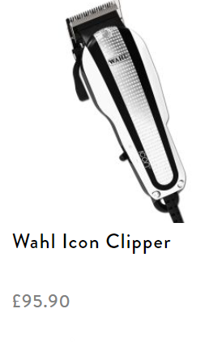
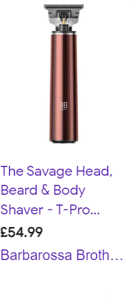


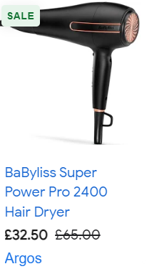
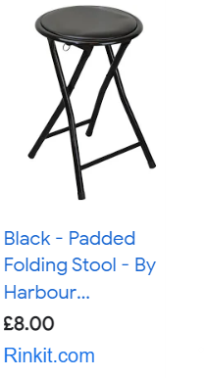
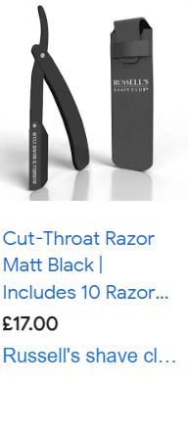

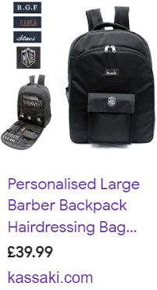
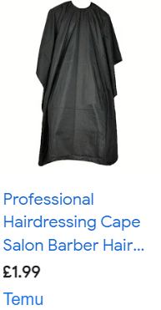


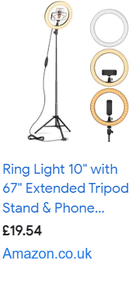
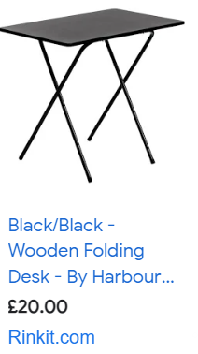
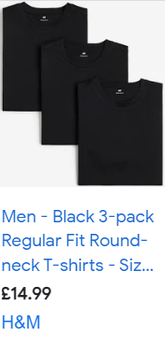

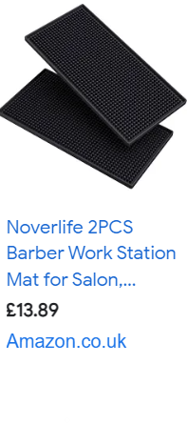
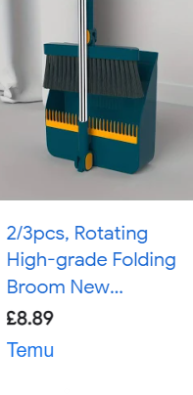
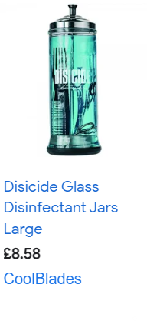
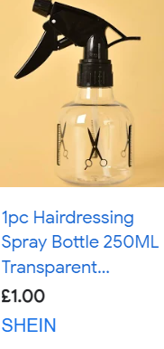

Below are a list of products that I will be using for my clients when they have a haircut and the customer will also have the option to buy these products from me at a slight mark up from cost price. I will purchase 10 units of each product in order to have a decent stock level for me to use and to sell to my customers. My total expense came to £1045.80.



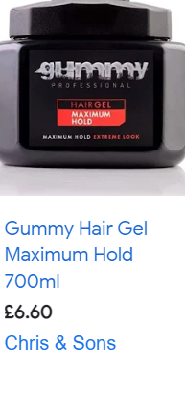

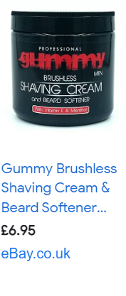
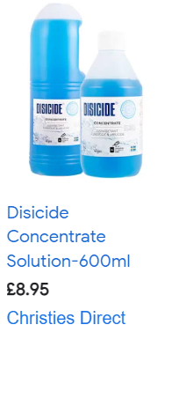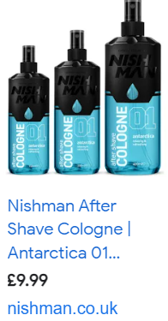
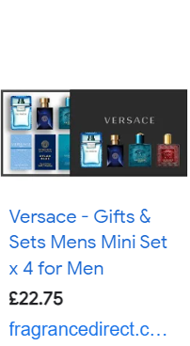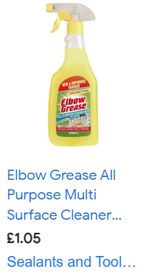

Below is a van I purchased to travel to appointments which came at a cost of £1,600 and will also add logos and contact details on the side of the vehicle. I have attached my business car insurance which I have decided to pay monthly £34.56 a month.
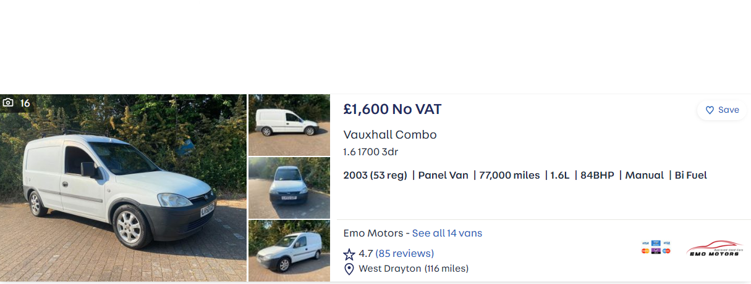

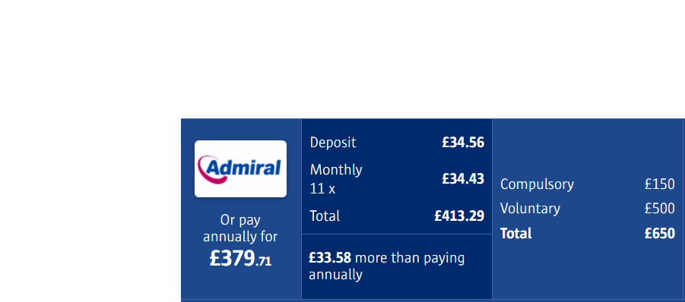

I have also taken out a mobile contract to use as a business phone which will cost £32.00 a month

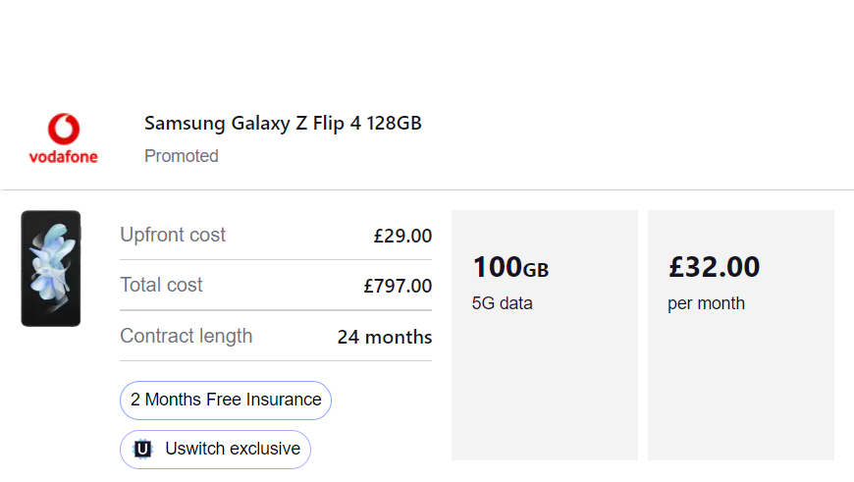

I have taken out business liability insurance at £8.55 which will be paid over the period of 10 months

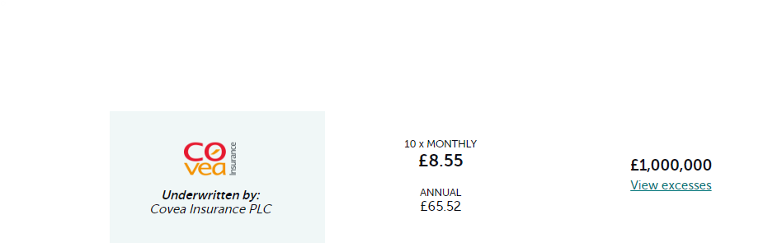

Business card



Price list/Menu

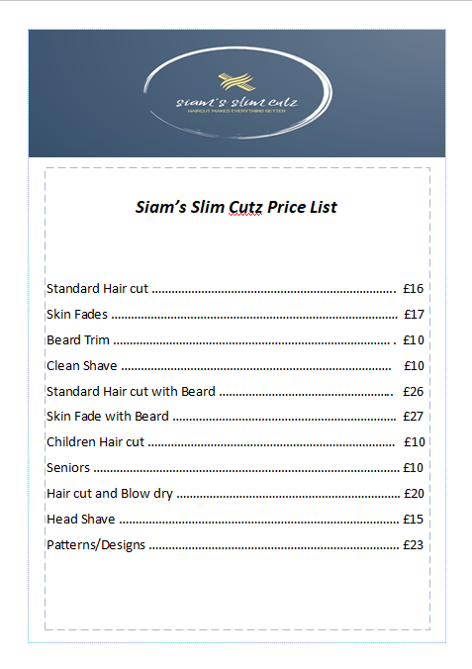

Curriculum Vitae

Siam Rahman
101 Albany Road
CF24 2NG
Cardiff
07710 835601
slimcutz23@outlook.com
Full UK Driving Licence

Personal Statement

I am professional, competent and a motivated individual with hands on customer service and administration experience. I combine effective communication skills with extensive product knowledge to identify opportunities and deliver a satisfactory outcome for both customer and company whilst working alone and as part of a larger team. I have a clear, logical mind with a practical approach to problem solving and a drive to see tasks through to completion. My attention to detail and excellent time management skills means that every task is completed efficiently and to the highest possible standard. I am an organised individual which helps me complete and prioritise my workload. My strengths lie in a positive attitude coupled with the ability to work hard. I am enthusiastic, passionate and always strive to work at my maximum potential.

Education/Qualification

Barbering Course London
February 2023 to May 2023
Level 3 NVQ

St David’s Catholic College
From September 2004 to July 2006
BTEC First Diploma Sport- Distinction

St Teilo’s Church in Wales High School
From September 1999 to July 2004
GCSE’S 11 A-C’s including Maths and English

Career History

Siams Slim Cutz (Barber/Owner)
From June 2023 to Present
- Started own business after undergoing training in a exclusive barbering school in London for 12 weeks
- Mobile Barber
- Providing grooming services at customers preferred location
- Taking appointments via phone, email, social media platforms
- Services provided for adults, seniors and children
- Adhering to health and safety
- Implementing high level of hygiene

Euroclad (Account manager/ Order Fulfilment Administrator)
From July 2021 to January 2023
- Managing client accounts and being their first point of contact
- Processing orders for clients upcoming projects
- Organising convenient dates to deliver order
- Liaising with transport department to honour dates agreed with the client
- Seeing a project to completion from receiving the order, processing it on our system to production and then finally delivery to site.
- Keeping all clients updated at all times via telephone and email and managing their expectations
- Working with other departments to achieve company targets
- Worked within business timescales in order to complete workload
- Sending payments requests to clients before we deliver order
- Paying close attention to detail to make sure the order is accurately processed to prevent any errors as most order as high value order

Vista Retail Support (Technical Service Administrator)
From August 2020 to July 2021
- Dealing with queries and requests from retailers via telephone, email and post
- Providing 1st Line Technical Support remotely to retailers we service
- Organising engineers to attend if an issue can’t be resolved remotely
- Planning travel time for engineers and arrange accommodation if overnight stay is required
- Managing engineers holiday calendar and authorising annual leave if there is availability
- Placing orders for parts required by our clients to resolve an issue
- Liaising with other departments to provide the best service for our customers
- Work as a team to complete work load and to hit targets within business timescales
- I am first point of contact to engineers for the region I cover
- Assist and facilitate training new members of staff
- Logging new calls when clients have technical difficulty logging calls through the portal

Henry Schein (Technical Service Administrator)
From January 2019 to August 2020
- Dealing with queries and requests from dental practices
- Having a good relationship with engineers and liaising with engineers to get information on parts
- Providing engineer support to dental practices to fit parts or to make repairs on faults
- Provide engineer support for remote calls
- Placing orders for spare parts
- Dealing with queries via telephone, post and email
- Sending service kits before a service is due on equipment and agreeing a convenient date for both customer and engineer to carry out service
- Getting quotes and providing quotes to customers for repairing or replacing equipment
- Working as a team to achieve targets for example closing calls and working as a team to avoid back log and customer complaints
- Liaising with other departments to achieve good level of service for customers
- Contacting suppliers in order to check if they have particular part in stock, if they still supply part and getting prices on items that are not set up our system
- Having basic general knowledge about dental chairs
- Planning travel time for engineers and arrange accommodation if overnight stay is required
- Dealing with complaints, showing empathy, listening and understanding in order to resolve the issue
- I was primary contact for engineers and clients based in the North region as I was responsible for covering a region (Scotland and North England)
- Lead team meetings discussing stats, how we can help each other with work load and everyone sharing latest communication updates received from suppliers and engineers
- Responsible for booking annual leave for engineers and managing their diary

Peacocks Head office (IT and Maintenance Administrator)
From March 2015 to January 2019
- Dealing with IT and Maintenance issues at store and at Head office
- Resolve first line IT issues
- Dealing and processing invoices received from contractors
- Getting quotes from contractors for maintenance work
- Dealing with queries via email and telephone
- Dealing with general post
- Making outbound calls to contractors and stores to ensure that maintenance works were complete
- Send repaired goods (Hand Held Terminals) to store
- Working with a team to ensure we achieve department targets
- Trained and facilitated new members of staff, helped them integrate into the role and teach them how our systems operate
- Dealing with complaints effectively, listening and empathising with customer
- Liaising with other departments sharing updates
- Assisted team leader in team meetings discussing stats and how to improve our service as a team and set small incentives to motivate colleagues

Source Commercial (Administrator)
From December 2013 to December 2014
- Dealing with customer and insurance broker queries via email, telephone and post
- Setting up new clients on the system for the client to get an insurance quote
- Creating invoices, processing payments and generating receipts for clients
- Using live chat to communicate with certain insurers to get relevant or additional information
- Making outbound calls to clients to ensure they have received all documents
- Keep up to date with process updates
- Worked within business timescales in order to complete workload

The Royal Bank of Scotland (Customer services/Administrator)
From October 2007 to November 2013
- Dealing with customer enquiries in line with company guidelines to ensure that we are Treating Customers Fairly
- Complete systemised daily reports, prioritise these to ensure it’s completed within business timescales
- Assist other departments with administration work on a regular basis
- Consistently exceed sales targets set by the business by matching the benefits of our product to the customer
- Work within a team environment, supporting others to ensure our team target is achieved
- Train and facilitate new members of staff and help them integrate into the company
- Multi skilled in Motor Customer service, Payment Account and Travel insurance and have excellent knowledge of the products we service
- Receive and resolve complaints following the Financial Services Authority (FSA) guidelines whilst Treating Customers Fairly
- Keep up to date with communication updates and underwriting of products to enable me to deliver excellent customer service
- Adhere to FSA requirements and call guides
- Dealing with batches of documents and logging it into our system
- Sending insurance documents to customers
- Sending credit agreements to customers to sign and return
- Sending letters to customers requesting additional information for their insurance policies
- Sending letters to customers making them aware their account is in arrears and to contact us to settle outstanding amount

Juboraj Indian Restaurant
From September 2005 to September 2007
- Responsible of checking stock on a daily and weekly basis ensuring that we had correct products to suit customer needs
- Taking orders face to face and over the telephone
- Required to achieve 100% accuracy against takeaway orders
- Required to get orders out on time
- Excellent active listening skills whilst communicating face to face in a busy environment
- Dealt with complaints effectively, listening, understanding and emphasising with customer
- Cleaning responsibilities to ensure Health and Safety regulations are met
- Train and facilitate new members of staff to be competent within a restaurant environment and teach them how to use the computerised system to take orders

Hobbies/Interests

As an energetic individual I enjoy exercise of various kinds, I play football, go gym, swimming, cycling and play badminton in the local Leisure Centre. In my spare time I like to socialise with friends and family, going to the cinema and going to a restaurant for a meal. To relax I like listening to music and reading.

