7/24/2026

Student: Federico Mossa
ID:2314622
Lecturer: Dr. Fahad Ahmed
University of Wales, Trinity Saint David

Usability Engineering
Assignment 01: User Requirements and Prototype

Table of Contents
1. Introduction 2
2. Personas and user requirements 2
2.1 Method 2
2.2 The four personas 2
Persona A: Andrei (Secondary) 2
Persona B: Elira (Primary) 3
Persona C: Doina (Supporting) 3
Persona D: Mariana (Prototype evaluation participant) 4
3. Gathering information: the questionnaire 4
3.1 Instrument and sampling 4
3.2 Results 4
3.3 Findings and design consequences 5
3.4 Limitations 6
4. Designing for usability 6
4.1 Six heuristics applied to the storyboards 6
4.2 Cooperative mechanics and flow 6
5. Wireframe storyboards 7
5.1 Navigation model and Storyboard 7
5.2 Key screens 7
5.3 Iteration: v1.0 to v1.1 10
6. Collecting feedback on the prototypes 10
6.1 Method 10
6.2 Results 11
6.3 Resulting improvements (v1.2) 11
7. Peer evaluation 13
7.1 Method 13
7.2 Feedback received and responses 13
8. Conclusion 14
Appendix A: Requirements categorised with the MoSCoW criteria 15
A.1 Must have 15
A.2 Should have 16
A.3 Could have 16
A.4 Won't have (this release) 17
A.5 Revisions after questionnaire 17
Appendix B: Complete storyboard set (v1.1) 18
Appendix C: Questionnaire and Analysis of the data collected 25
Appendix D: UX Research & Evaluation Dashboard 26
Appendix E: Prototype Evaluation Evidence 28

1. Introduction
This report presents the user research and interface design for Outbreak: Campus, a mobile adaptation of the cooperative board game Pandemic set on a university campus. Up to six players take university roles and work together to contain four infection strains before the campus closes [1].
It covers the four personas and their requirements, the questionnaire behind them, the usability reasoning, and twenty wireframe storyboards (S01 to S20), with key screens in Section 5 and, in Appendix B, a narrative storyboard of one session followed by the full set. The prototypes are wireframe only, since low fidelity keeps early feedback on structure rather than polish [2]. The design was iterated visibly: v1.0 from personas and literature, v1.1 from the questionnaire (Section 5.3), v1.2 from feedback (Section 6). This follows the double diamond sequence taught in the module, discovering, defining, developing, then refining, and the storyboards follow the week 2 class exercise.

2. Personas and user requirements

2.1 Method
The personas follow the goal-directed construction process [3]: variables were identified, participants were mapped, patterns were consolidated and one persona was designated primary. Each is written as a quote, primary and secondary goals, pain points and design implications, so every detail traces to a finding rather than invention. As the brief requires, they span age, ability, language and living situation. Requirements use FR and XR identifiers; the MoSCoW lists are in Appendix A.

2.2 The four personas

Persona A: Andrei (Secondary)
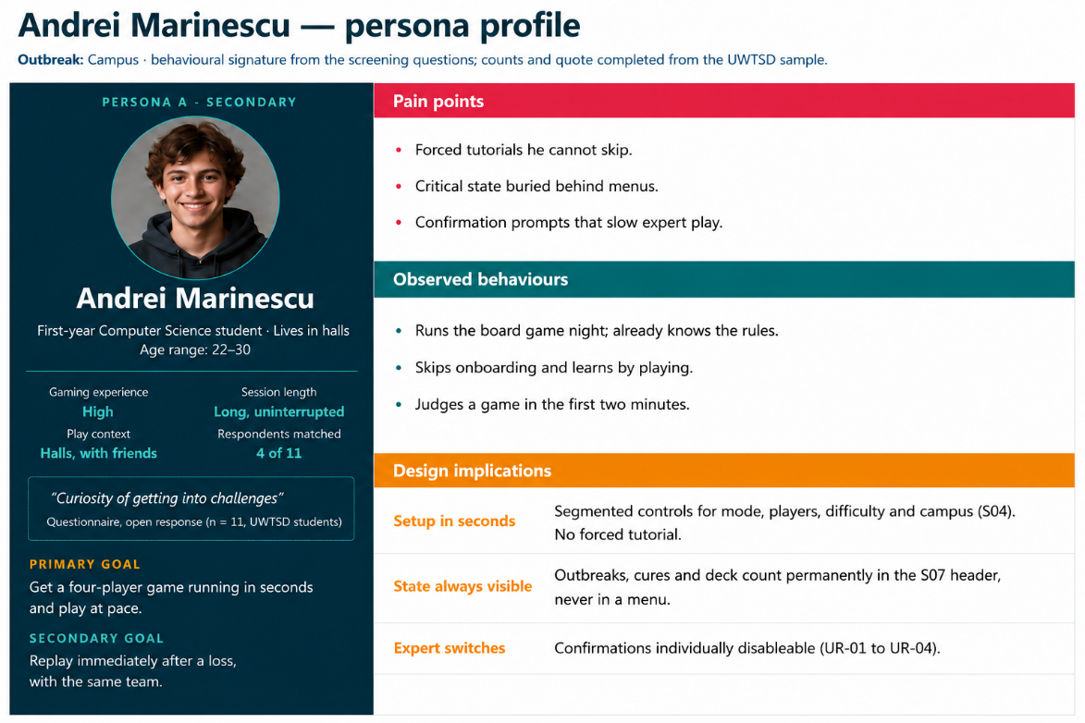

Persona B: Elira (Primary)
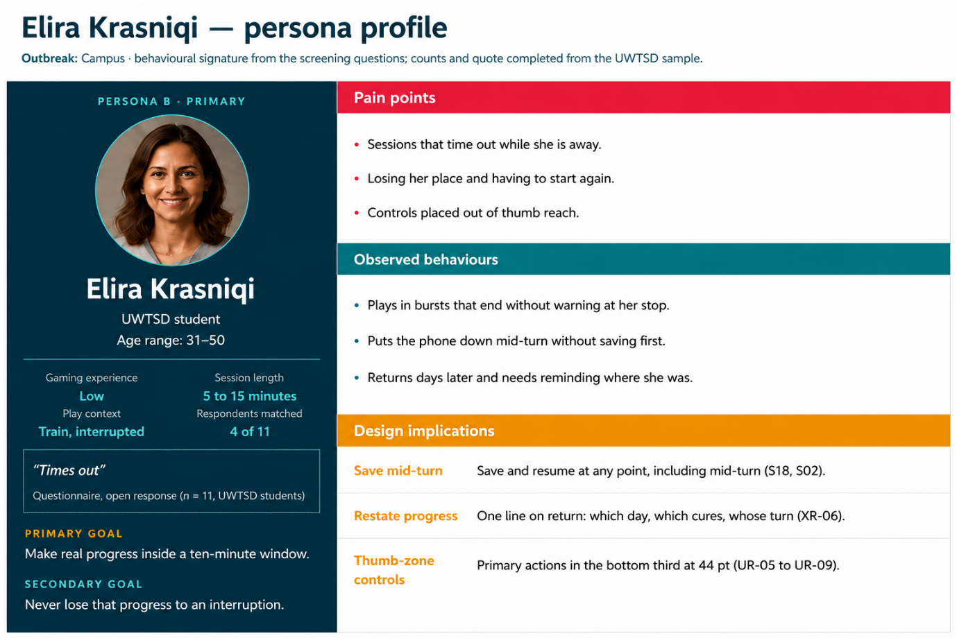

Persona C: Doina (Supporting)
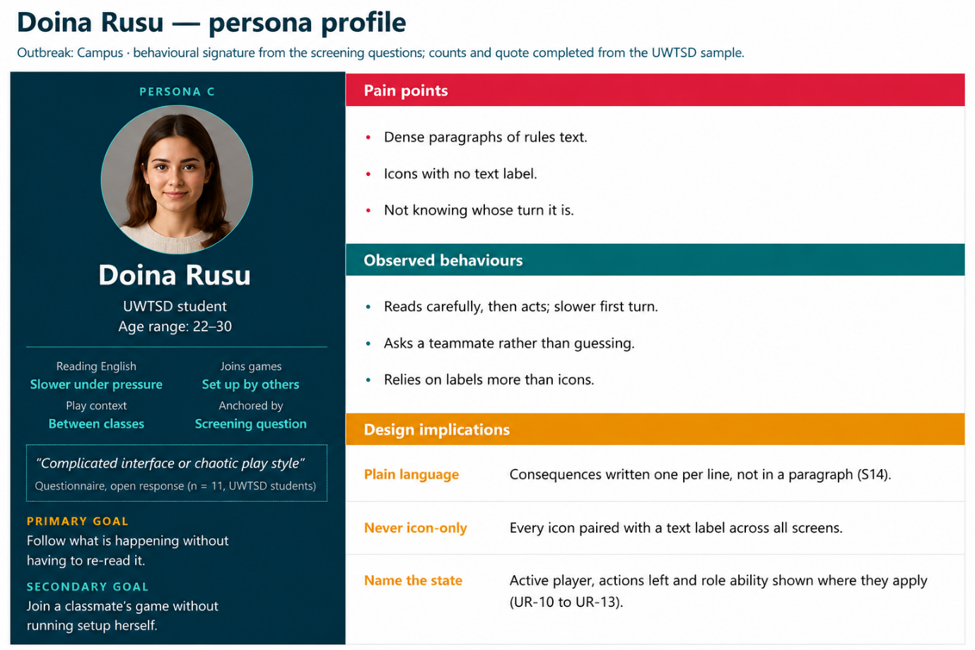

Persona D: Mariana (Prototype evaluation participant)
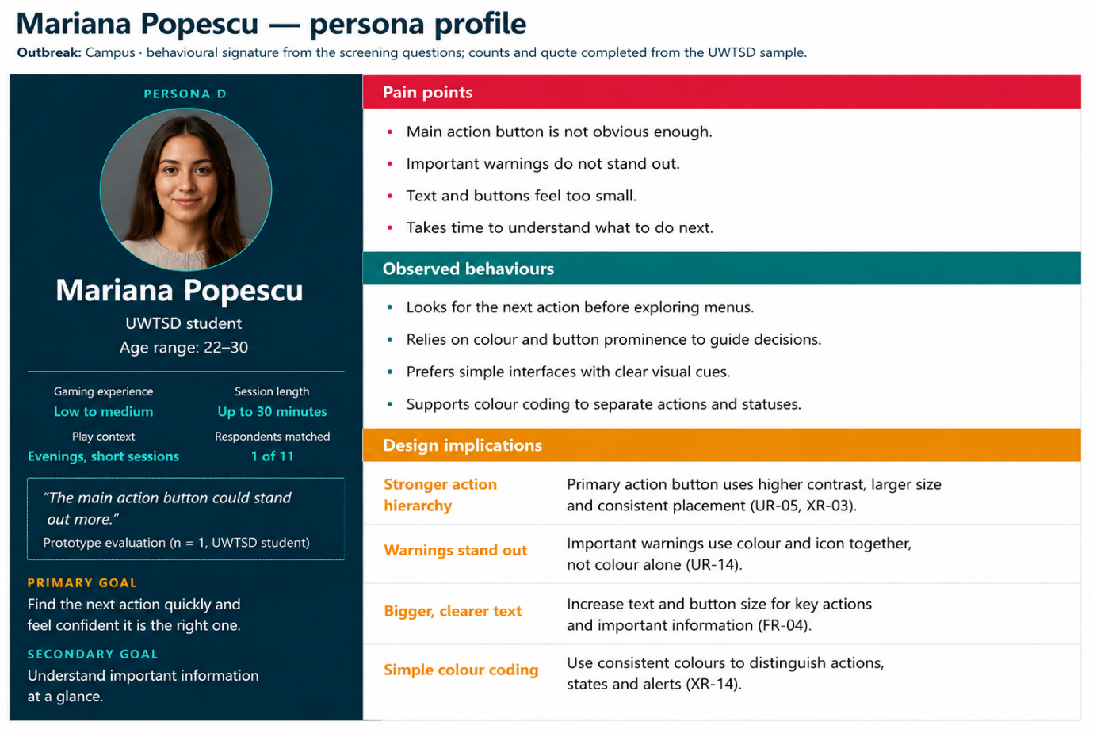

3. Gathering information: the questionnaire

3.1 Instrument and sampling
An online questionnaire (Google Forms; Appendix C) was distributed to current UWTSD students only, so that all data analysed comes from within the university; a screening question removed anyone who was not a current student. Eleven responses are analysed. Open items are coded against the flow components of clear goals, immediate feedback and matched challenge [4]; cooperative-feel options draw on published cooperative patterns [5]; and feature priorities are unconstrained ticks, with prioritisation done afterwards, since participants left to prioritise freely rate most requirements critical [6]. Closed questions are reported as frequency distributions and open answers coded thematically, from data to codes to themes; the full analysis is in Appendix D.

3.2 Results
All eleven respondents are current UWTSD students. Closed questions are reported as frequency distributions rather than means, since the items are categorical and the sample small (Appendix D.1); full tallies are in Appendix C.
Three questionnaire variables carry the analysis, the axes on which the personas were separated [3]: comfort with apps and games, realistic session length, and any reported access need. Each respondent is assigned to the first persona whose signature they match, tested in the order D, C, B, then A, so the mapping is reproducible, and it tests whether the personas describe people actually in the cohort. Three of the four match: four respondents fit Andrei, four Elira, three Doina. Persona D does not, since no respondent reported an access need, so she is retained on design grounds rather than sample evidence. The mapping table is in Appendix C. The five classmates who later evaluated the prototype (Section 6.1) are also current UWTSD students.

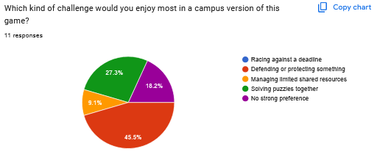
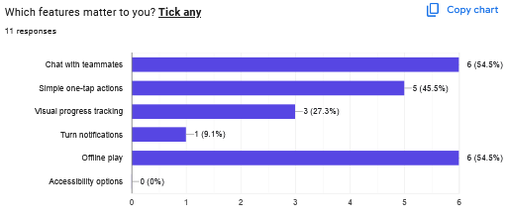

3.3 Findings and design consequences
Complementary roles validated. The most-chosen definition of cooperation was one shared goal completed together (6 of 11), with roles that need each other close behind (5 of 11), so the complementarity pattern the role design implements is supported but not dominant [5]. Role appeal is shown in Chart 1; the Librarian drew no picks at all despite being mechanically load-bearing, so v1.1 reframes its card as "the team's fixer: hands anyone the card they need".
Short sessions and persistence. Ten of eleven capped sessions at thirty minutes or less, six choosing five to fifteen, confirming mid-turn save (FR-04) and progress restatement (XR-06). Seven wanted progress remembered across sessions and only one chose to reset, so a legacy layer enters Could-have (FR-18). These answers map respondents to Elira, making her primary and Andrei secondary.
Chat and simplicity. Chat tied top with offline play at 6 of 11 against an original Won't-have; vote counts do not dictate priority [6], but a joint-top result cannot stay excluded, so preset quick-chat pings move to Could-have (FR-15R) while free text stays out. One-tap actions (5 of 11) support XR-03 and XR-04, so confirmation is scoped to steps that spend a game action, an error-prevention measure [7], with an expert off-switch (XR-09). Offline play confirms pass-and-play; turn notifications drew one tick and stay deprioritised.
All three flow components appeared unprompted, their absence cited as quit triggers [4], licensing the always-visible cure tracker, per-action updates and a forgiving lowest difficulty tier.

3.4 Limitations
The sample is eleven UWTSD students, nine aged 31 to 50, so it under-represents the 18 to 21 group. Across four personas that leaves zero to four per group, too few for cross-tabulation or significance testing, so the analysis stays at frequency counts and persona mapping (Appendix D.1). Findings are indicative, and the personas stay open to revision [3].

4. Designing for usability

4.1 Six heuristics applied to the storyboards
Six of Nielsen's ten usability heuristics carry the most weight here, each applied to a named screen [7].
Visibility of system status [7]. The map hub (S07) keeps the outbreak track, cure states and deck count in a persistent header, with the current player and action pips above the action bar. Nothing needed to judge danger is hidden.
Match between the system and the real world [7]. Locations are campus buildings, roles are university jobs, and the difficulty tiers are Fresher, Honours and Dean.
User control and freedom [7]. Every action that spends a game action uses select-then-confirm with a visible Cancel; movement (S09) filters the map to legal destinations, as do share (S11) and cure (S12).
Error prevention [7]. The same pattern prevents the costliest slip: wasting an action through a mis-tap.
Recognition rather than recall [7]. Role abilities are restated inline: the treat button on S08 reads "Wellbeing: removes all 3". Ineligible options are dimmed with the reason, so the interface teaches the rule it enforces.
Aesthetic and minimalist design [7]. Each screen carries one job, with contextual actions in a bottom sheet over the map.

4.2 Cooperative mechanics and flow
Cooperation is forced by structural mechanics, not assumed from co-presence [5]: complementarity, synergy (the Librarian-to-IT-Support pipeline), and abilities usable only on another player, inside one shared goal with the outbreak track as a Race archetype.
The three flow conditions are interface decisions [4]: the shared goal is always legible in the S07 header, feedback is immediate, and challenge is tuned through three difficulty tiers plus a defeat screen (S20) naming the losing condition, making failure learnable.

5. Wireframe storyboards

5.1 Navigation model and Storyboard
The full set is in Appendix B; Figure 1 shows the navigation model. S07 is the hub: every action radiates from it and returns to it, and transient interactions open as overlays, so context is never lost.
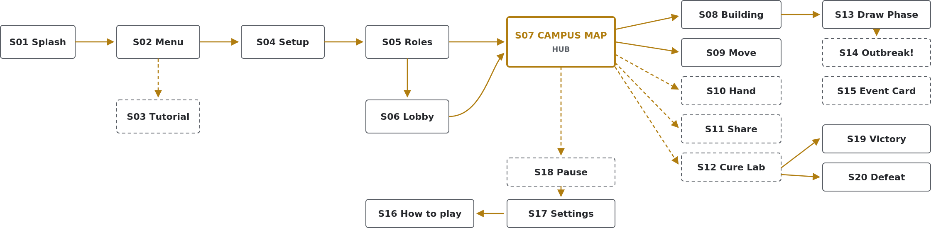
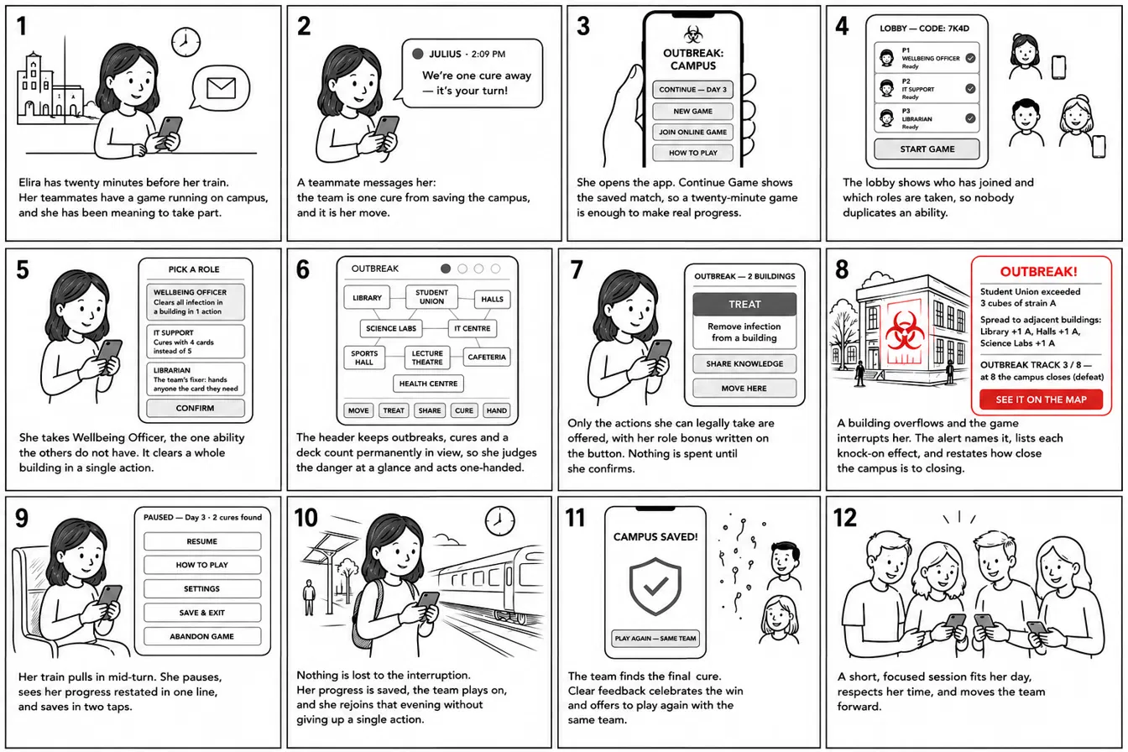

5.2 Key screens
The map hub (Figure 2, left) carries the design's central commitments: threat state permanently visible, controls in the thumb zone, and infection shown as strain letters, never colour alone. Role selection (Figure 2, right) presents six interlocking roles as cards, each stating its single ability plainly.
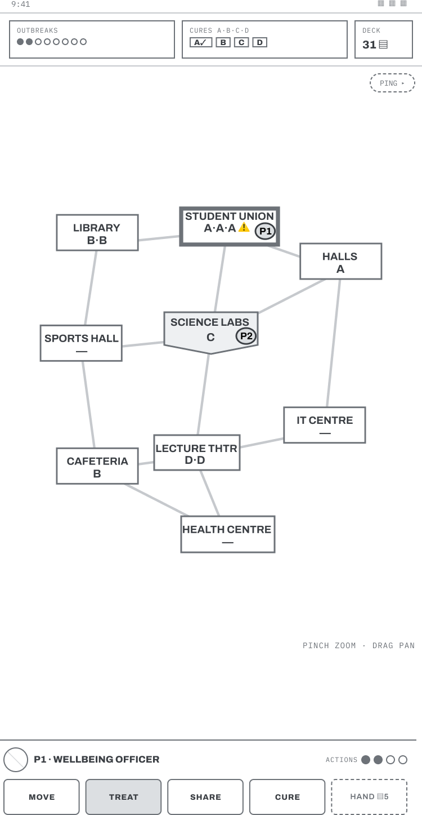 | 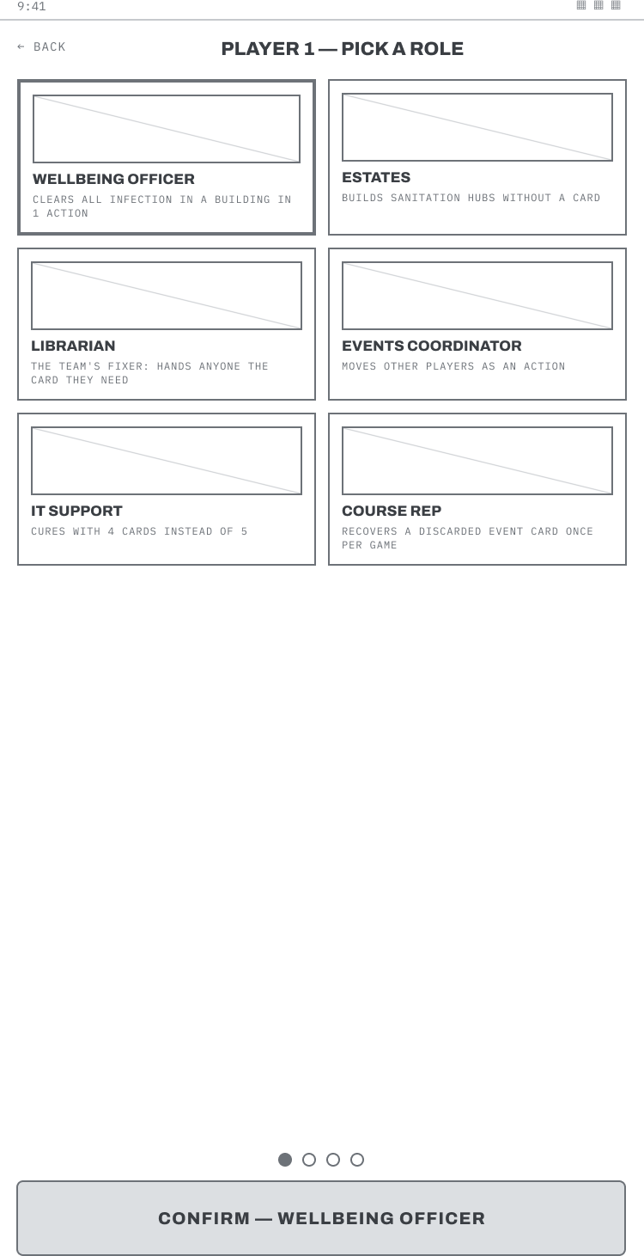
Figure 2. S07 Campus map hub (left) and S05 Role selection (right).
The building sheet (Figure 3, left) shows cube counts, players present and only the legal actions. Movement (Figure 3, right) shows select-then-confirm: the map filters to legal destinations.
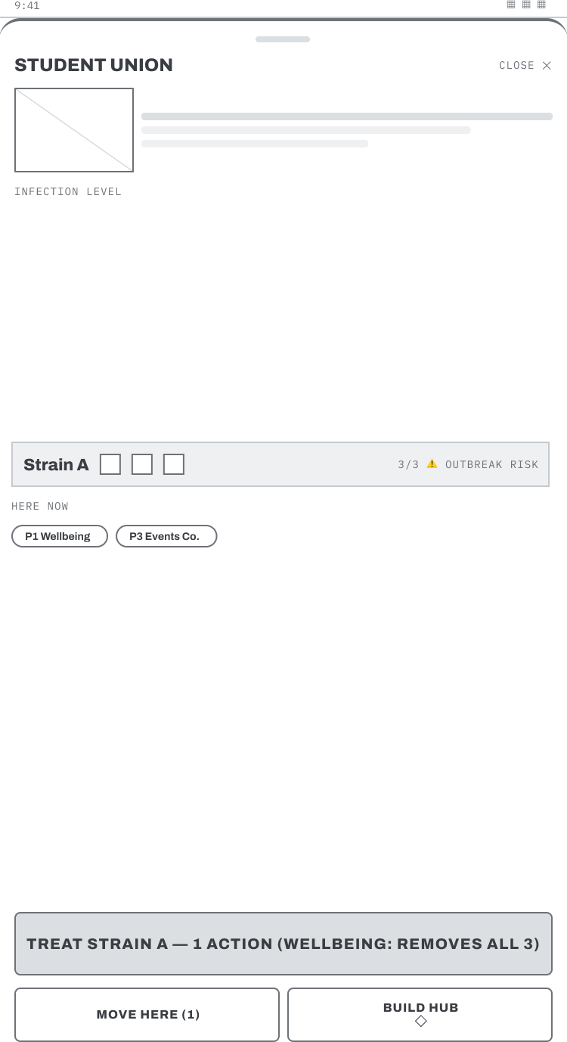 | 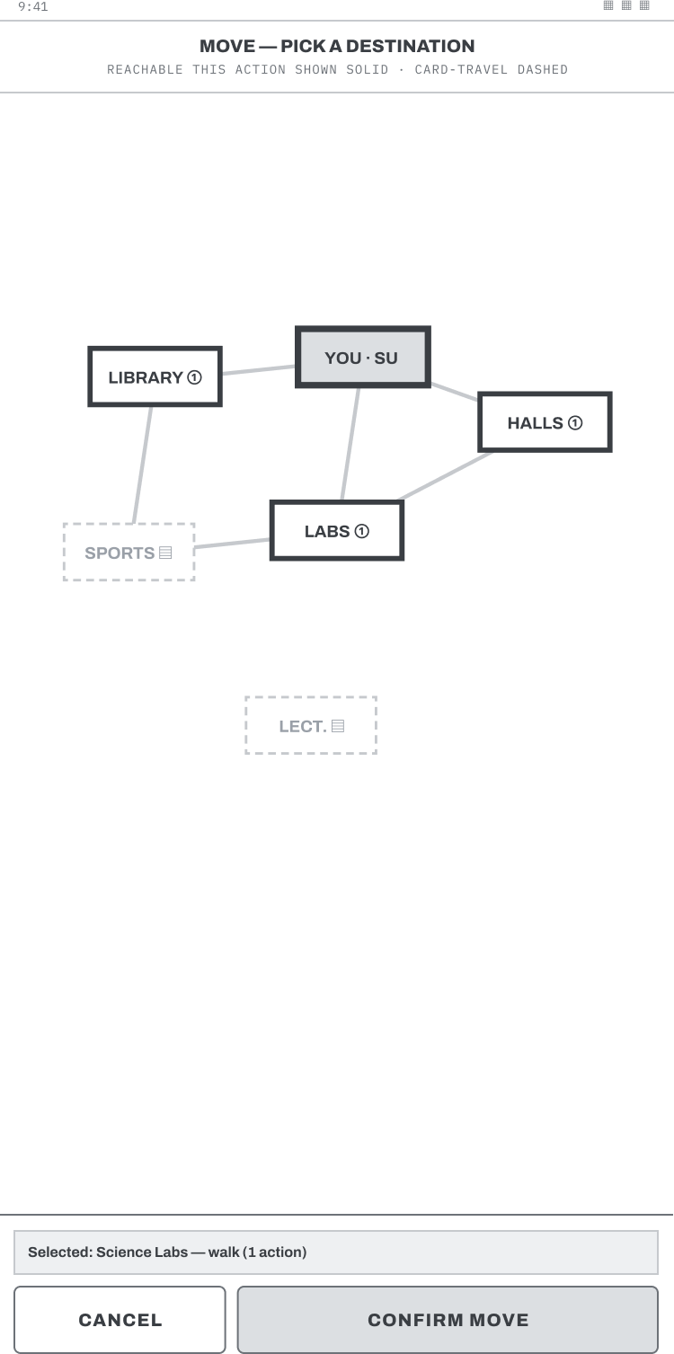
Figure 3. S08 Building detail bottom sheet (left) and S09 Move mode (right).
The draw phase (Figure 4, left) flips both cards face up and states any crisis in plain language, so automatic phases never resolve silently. An outbreak (Figure 4, right) names the trigger and lists each chain effect on its own line.
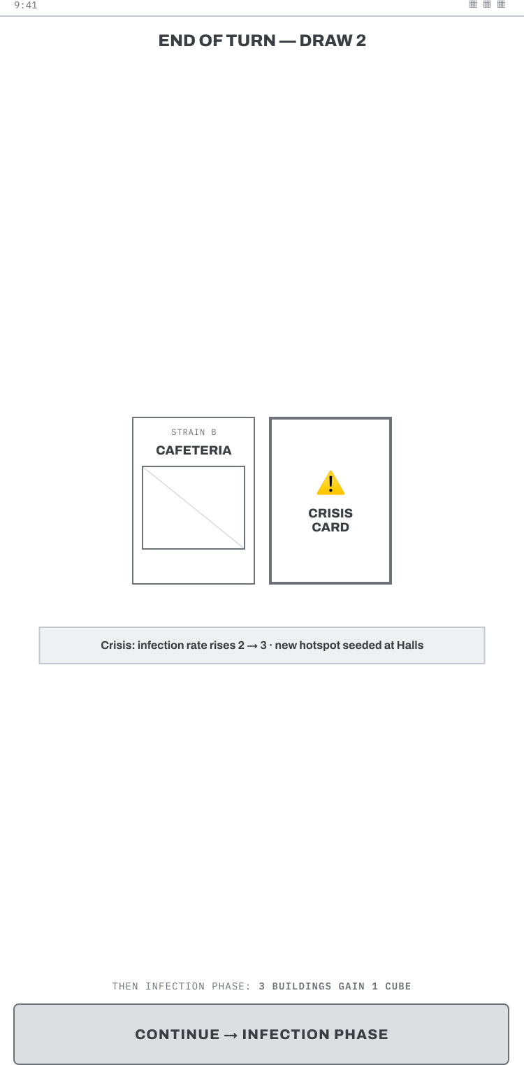 | 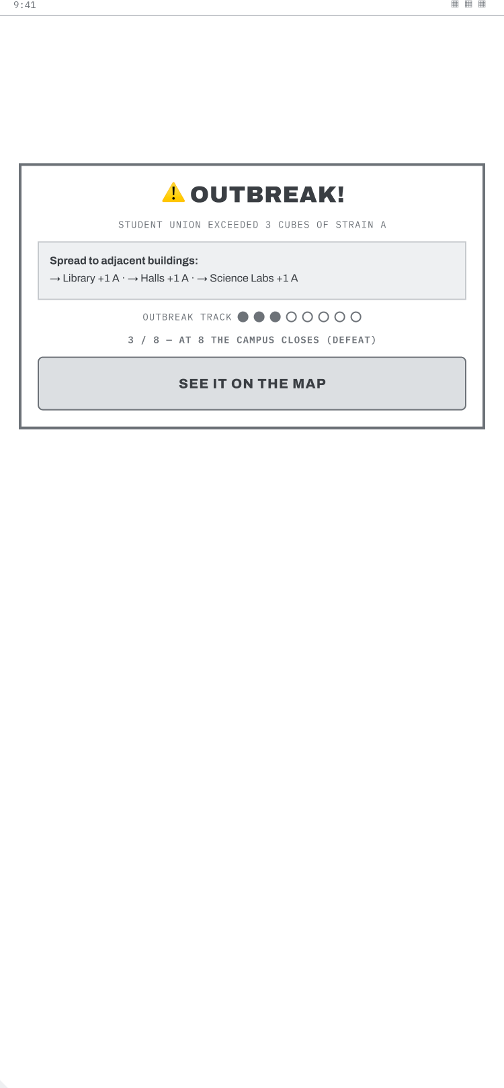
Figure 4. S13 Draw phase with crisis reveal (left) and S14 Outbreak alert (right).

5.3 Iteration: v1.0 to v1.1
Three changes followed the questionnaire, each traceable to Section 3.3: the Librarian card reframed, protection language adopted, and a provisional quick-chat ping added to S07 (dashed, FR-15R). Changes deliberately not made are recorded too: no legacy screens for FR-18, no notification interface for a feature ticked once. The cheapness of these revisions, and the discipline of refusing others, is low-fidelity prototyping in practice [2].

6. Collecting feedback on the prototypes

6.1 Method
Feedback came from five classmates, all current UWTSD students, each shown the twenty-screen storyboard set (Appendix B) and asked four short questions: was anything confusing or unclear where to tap (a lightweight check of whether each screen's controls carry enough information scent [8]), which role they would pick, how the outbreak screen made them feel, and one thing they would change. A short, conversational set over a messaging app was chosen to raise response rate. As individual evaluators catch only a fraction of problems alone, responses were aggregated and issues raised by more than one participant treated as the strongest signals [9]. They were then coded inductively into themes (Appendix D).
Persona coverage. Those experienced with games align with Persona A; those fitting play around a busy life align with Persona B. Persona C was represented only indirectly, and no participant had a colour vision deficiency, so Persona D was verified by design review against the greyscale-safe wireframes rather than by testing.

6.2 Results
Positive feedback. Participants described the wireframes as well organised and easy to follow, the game flow as clear from start to finish, and the layout as consistent throughout. The campus map was called simple and easy to understand and the roles clearly presented. One participant singled out the accessibility options as “a good addition”, which is direct support for the Persona D requirements rather than a general compliment. Two participants reported that nothing in the design confused them. Role choices divided rather than clustered, two taking the Wellbeing Officer and one IT Support, and the reasons were about the ability: one chose Wellbeing for its power to “clear all infection in a building in one action”, another IT Support “because I like solving problems and using logic”. Different players drawn to different abilities is complementarity working as intended [5].
Emotional response. The outbreak screen did its job: participants reported “a sense of urgency” that made them “want to act quickly” and felt the situation “had become more serious”. One felt “a bit annoyed” on realising they had lost, a negative emotion that still confirms the defeat screen reads clearly. The goal of an escalating, legible threat (Section 4.2) was met.
Negative feedback. Three of the five raised legibility and hierarchy independently, which makes it the clearest finding: one asked for a larger font, one wanted the main button “to stand out more so it is obvious where to tap first”, and one asked for stronger visual hierarchy, adding that the busier screens show too much at once. This maps to XR-03. The other two said nothing confused them, so it is a majority, not a consensus. Raised singly: a clearer welcome screen with the game title, less empty space, menu or restart options on the outbreak screen, and a little colour on the warning.

6.3 Resulting improvements (v1.2)
Two changes were made in response, shown before-and-after below.
Change 1 - larger buttons and text, stronger primary action (three of five). Buttons and body text were enlarged and the primary action on each screen given more weight than the secondary options, so the first tap is obvious. This best-evidenced change supports the aesthetic-and-minimalist and visibility heuristics (1) and XR-03.
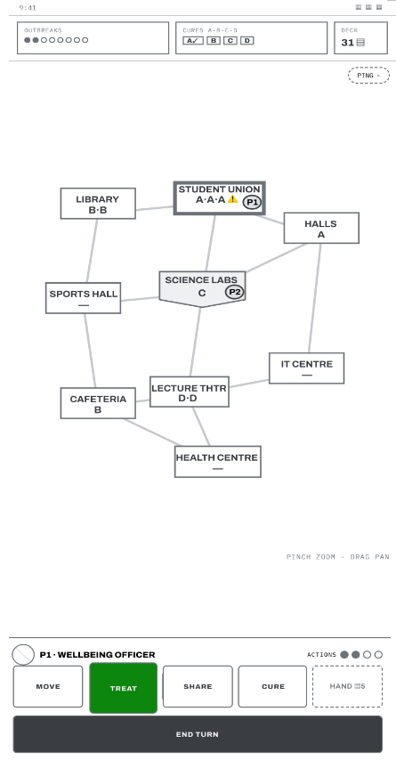
Figure 5. Before (left, v1.1) and after (right, v1.2): larger controls and a clearer primary action on the campus map.
Change 2 - reinforcing colour on the outbreak alert (one participant). A colour wash was added to heighten urgency, but only as reinforcement: the strain letters, patterns and counts remain the primary carriers, so the request is met without breaking the colour-independent principle (UR-14).
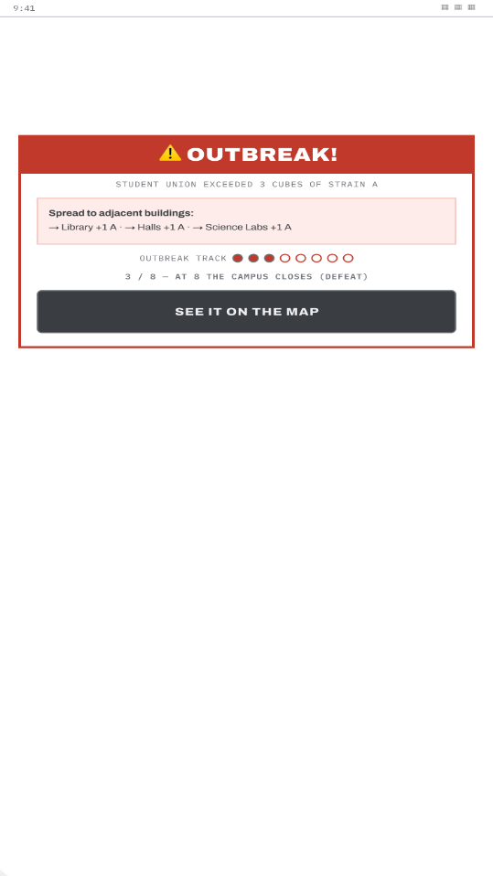
Figure 6. Before (left, v1.1) and after (right, v1.2): reinforcing colour on the outbreak alert, with letters and patterns retained as the primary cue.
Point judged already addressed. Menu and restart options are already on the defeat screen (S20), which offers “Retry” and “Back to menu”; v1.2 makes these more prominent per Change 1. A request for phone-frame mockups was declined: device-level fidelity is reserved for the next design stage [2].

7. Peer evaluation

7.1 Method
Peer evaluation was reciprocal: the author evaluated a peer's wireframe and received evaluation of this one. To keep critique method-based, each peer design was assessed against the six heuristics of Section 4.1 and checked for clear navigation. Findings received were aggregated rather than acted on singly [9] and triaged into accepted, deferred, or declined with justification, since the requirement is a justified response, not compliance.

7.2 Feedback received and responses
Given by the author. Evaluating a peer's wireframe, the design was strong on plain-language onboarding and an explicit map legend. Two points were raised against their own stated requirements: the turn counter implied a longer game than their stated ten-to-thirty-minute sessions; and infection state relied on filled dots, risking the colour-dependence this project avoids.
Received on this design. Peer evaluation echoed the classmate feedback: the flow was clear, with the main suggestion again to make the interface easier to read at a glance. As this reinforced the finding already actioned in Section 6.3, it was accepted without a separate change, and the phone-frame suggestion was declined for the same reason. No finding contradicted the personas or requirements.

8. Conclusion
Four personas generated twenty-four prioritised Must-have, Should-have and Could-have requirements; a questionnaire of eleven UWTSD students supported the complementary role structure and the short-session assumption, and promoted Elira to the primary persona. Feedback from five classmates drove two v1.2 changes: larger controls and reinforcing colour on the outbreak alert. Twenty wireframes cover the major functionality with explicit navigation; their greyscale constraint also provides an accessibility baseline, and the retained requirements carry into the higher-fidelity stage.
9. References
[1] | Z-Man Games, “Pandemic,” [Online]. Available: https://www.zmangames.com/game/pandemic/. [Accessed 2026].
[2] | S. K. I. S. Rudd Jim, “Low vs. high-fidelity prototyping debate,” Interactions, vol. 3, no. 1, p. 76–85, January 1996.
[3] | R. R. C. D. Cooper Alan, About Face 3: The Essentials of Interaction Design, 3 ed., Indianapolis: Wiley, 2007.
[4] | M. Csikszentmihalyi, Flow: The Psychology of Optimal Experience, 1 ed., New York: Harper & Row.
[5] | J. B. Rocha, S. Mascarenhas and R. Prada, “Game Mechanics for Cooperative Games,” Braga, Portugal.
[6] | A. A. Berander Patrik, “Requirements Prioritization,” W. C. Aurum Aybüke, Ed., Berlin, Springer, p. 69–94.
[7] | Nielsen Norman Group, “10 Usability Heuristics for User Interface Design,” 30 January 2024. [Online]. Available: https://www.nngroup.com/articles/ten-usability-heuristics/. [Accessed 2026].
[8] | M. H. Blackmon, P. G. Polson, M. Kitajima and C. Lewis, “Cognitive Walkthrough for the Web,” New York, NY, 2002.
[9] | Nielsen, Jakob; Molich, Rolf, “Heuristic Evaluation of User Interfaces,” in Seattle, Washington, New York, NY.

Appendix A: Requirements categorised with the MoSCoW criteria
Applied as a Numerical Assignment technique: category meanings were fixed before prioritisation to prevent inflation towards Must-have, and feature-level requirements were kept separate from framework-level ones (8). FR items are functional; XR items are experience qualities. Sources trace each requirement to a persona (P-A to P-D), the brief, or the questionnaire.

A.1 Must have
ID | Requirement | Source | Screens
FR-01 | Support 2 to 6 players, each with one of six unique university roles (Course Rep, Wellbeing Officer, IT Support, Events Coordinator, Librarian, Estates) with complementary interlocking abilities (3) | Brief | S04, S05
FR-02 | Full cooperative loop: 4 actions per turn, draw phase, infection phase, crisis cards, outbreaks | Brief, P-A | S07, S13, S14
FR-03 | Local pass-and-play and online co-op modes | P-A, P-C | S04, S06
FR-04 | Save and resume any game, including mid-turn | P-B; questionnaire | S18, S02
FR-05 | Win and loss conditions detected and announced with explicit cause | Brief, P-B | S19, S20
XR-01 | Strain information encoded by letter and pattern as well as colour, in every context | P-D | All screens
XR-02 | All critical game state visible on the hub without opening menus | P-A, P-C | S07
XR-03 | Primary controls in the bottom third of the screen, minimum 44 pt targets | P-B | S07, S08
XR-04 | Every icon paired with a text label | P-C | All screens
XR-05 | Automatic phases require acknowledgement, no silent state changes | P-B, P-C | S13, S14

A.2 Should have
ID | Requirement | Source | Screens
FR-06 | Interactive three-panel tutorial, skippable and replayable | P-B | S03, S16
FR-07 | Four-character room codes, copy on tap | P-C | S06
FR-08 | Select-then-confirm for all actions that consume a game action | P-B, P-D | S08, S09, S11, S12
FR-09 | Only legal actions offered; illegal options dimmed with a reason | P-B, P-C | S08, S09, S11
XR-06 | Match progress restated in one line on every resume and pause | P-B; questionnaire | S02, S18
XR-07 | Text scaling, reduced motion and screen-reader labels in settings | P-D | S17
XR-08 | Role abilities restated inline where they apply | P-C | S07, S08, S12

A.3 Could have
ID | Requirement | Source | Screens
FR-10 | Optional turn timer for online games | P-A | S17
FR-11 | Post-game team statistics and "play again, same team" shortcut | P-A | S19, S20
FR-12 | Defeat analysis naming the pivotal moment of the loss | P-B | S20
FR-13 | Additional campus maps beyond the launch campus | P-A | S04
XR-09 | Confirmation prompts individually disableable for expert users | P-A | S17
FR-15R | Preset quick-chat pings between teammates (no free text) | Questionnaire | S07
FR-18 | Lightweight legacy layer: progress, statistics and unlocks persist across sessions | Questionnaire | S19, S20

A.4 Won't have (this release)
ID | Requirement | Rationale
FR-14 | Competitive or versus modes | Contradicts the cooperative design intent of the source game
FR-15 | Free-text or voice chat | Moderation cost is high; groups co-ordinate via existing apps. Revised after the questionnaire: preset pings moved to Could-have as FR-15R
FR-16 | Real-money purchases or cosmetic store | Out of scope for an academic prototype
FR-17 | Tablet and desktop layouts | Brief specifies mobile phone form factor

A.5 Revisions after questionnaire
Free-text chat stays a Won't-have but preset quick-chat pings were added as a Could-have, since chat was one of the most-requested features.
A lightweight save-progress-across-sessions feature was added as a Could-have, as most respondents wanted their progress remembered and none wanted it reset.
The mid-turn save and the one-line progress reminder were confirmed as firm requirements, since the large majority play in sessions of thirty minutes or less.
Turn notifications were deprioritised, as almost no one asked for them.
Elira became the primary persona and Andrei the secondary, reflecting how many respondents play in short, interrupted sessions.

Appendix B: Complete storyboard set (v1.1)
This appendix contains two artefacts. The first is a narrative storyboard following Elira, the primary persona, through a single session from opening the app to saving mid-turn; it shows the user rather than only the screens, and states what she does at each step and why. The second is the complete set of twenty wireframe screens at mobile phone proportions (design frame 375 x 812 pt), each captioned with what the user physically does at that point and where it leads. The direction of travel is marked with arrows in the captions and shown in full in Figure 1.
The wireframes and the storyboard frames were built in Figma. The working file is viewable HERE.
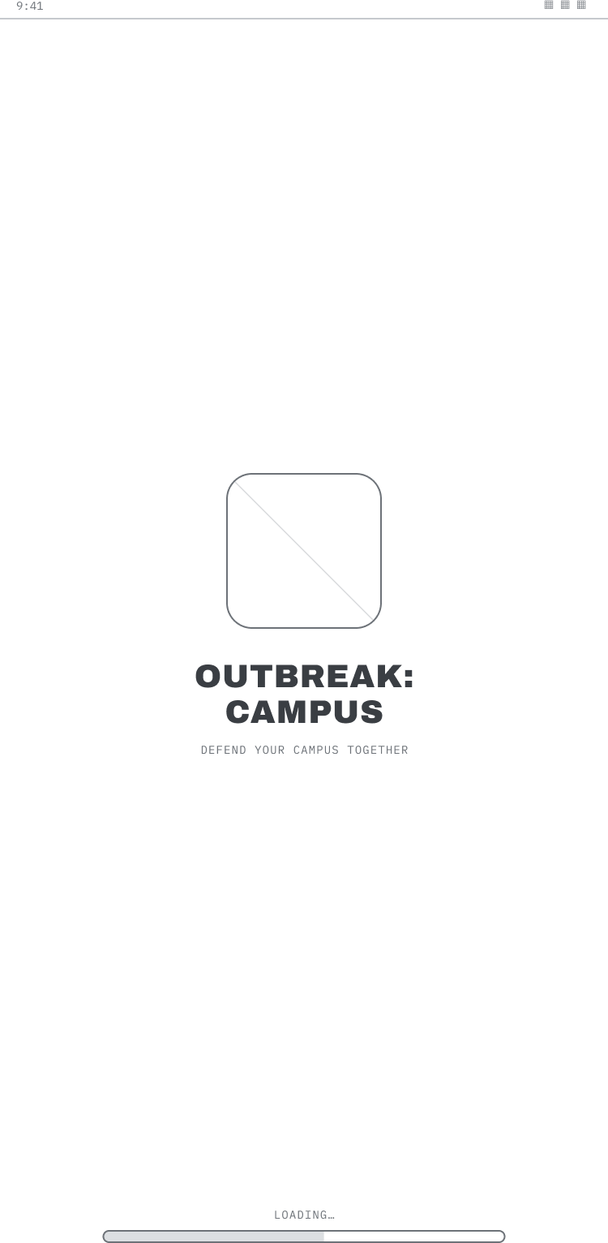  - Splash. Elira taps the icon while waiting on the platform; the screen confirms the game has launched and carries her forward by itself, so no tap is wasted. → S02 (first launch → S03). | 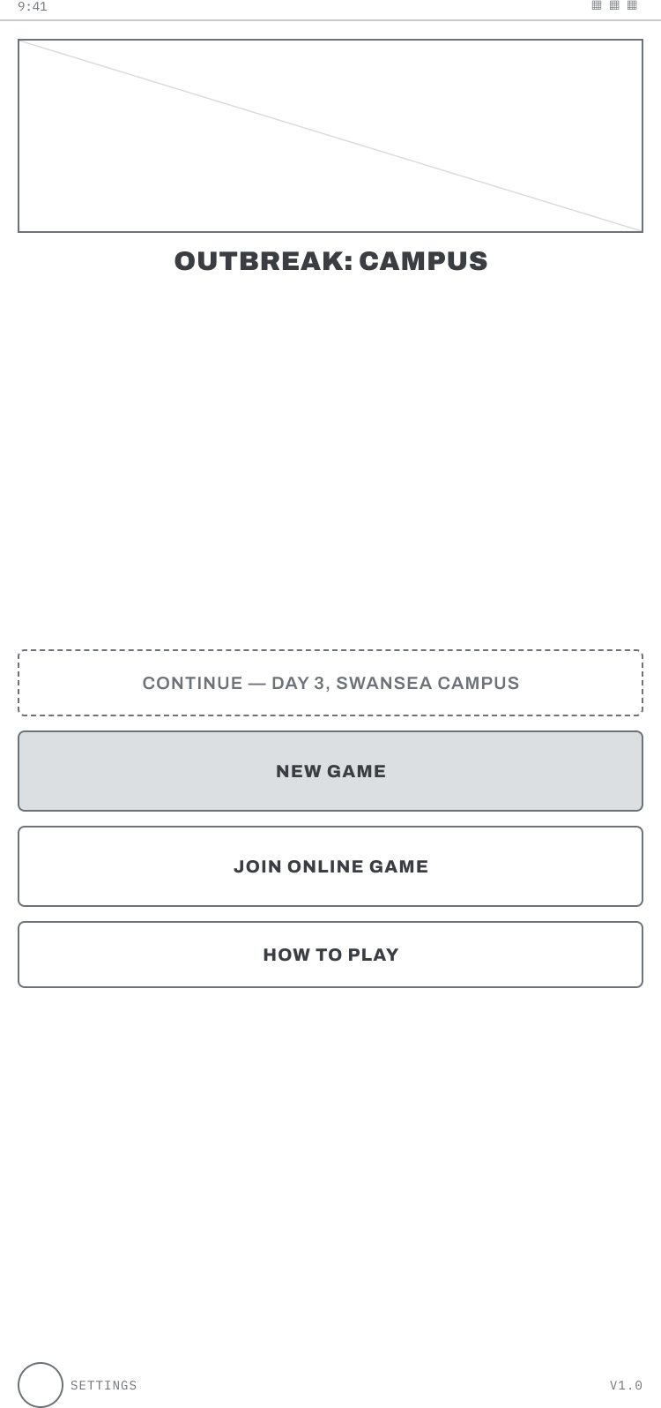  02. Main menu. She thumbs down the list and taps Continue, which names her saved match, so she resumes yesterday's game instead of starting over. → S04 New Game, → S06 Join, → S16 How to Play, → S17 Settings.
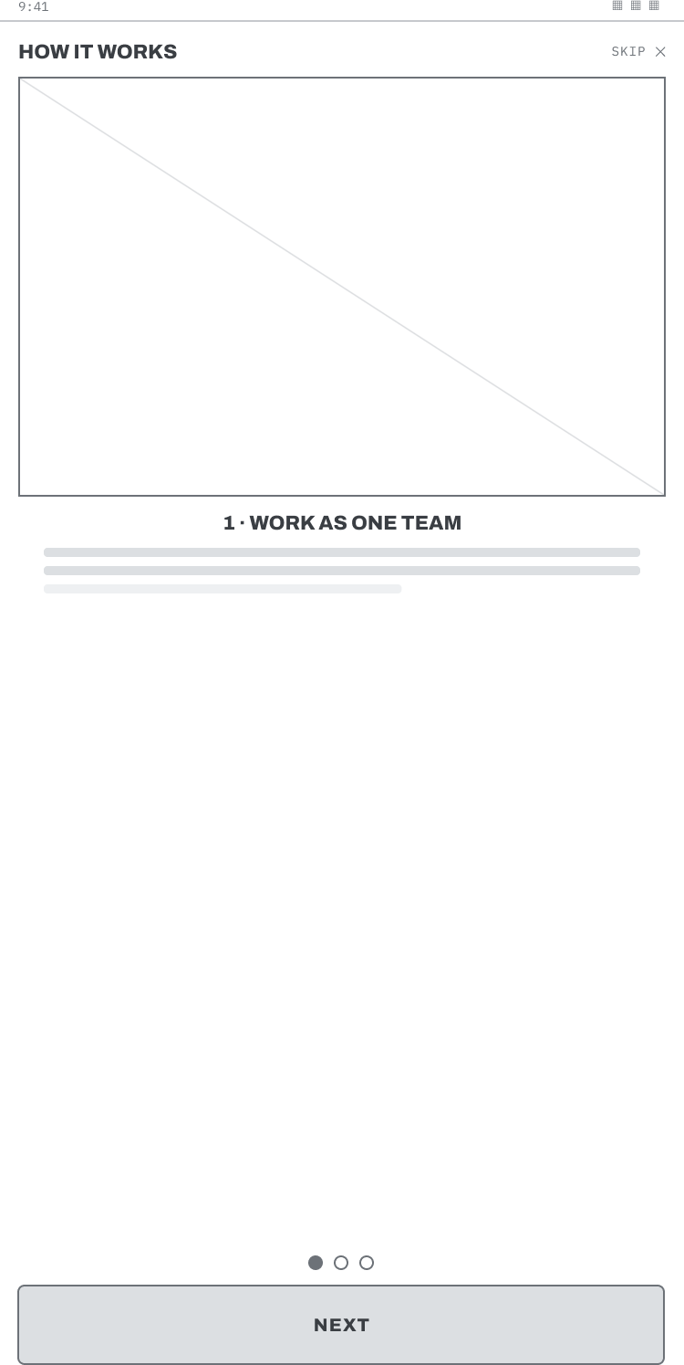  03. Tutorial carousel. A first-time player swipes through three short panels explaining the shared goal; an experienced player taps Skip and moves straight on. → S02. | 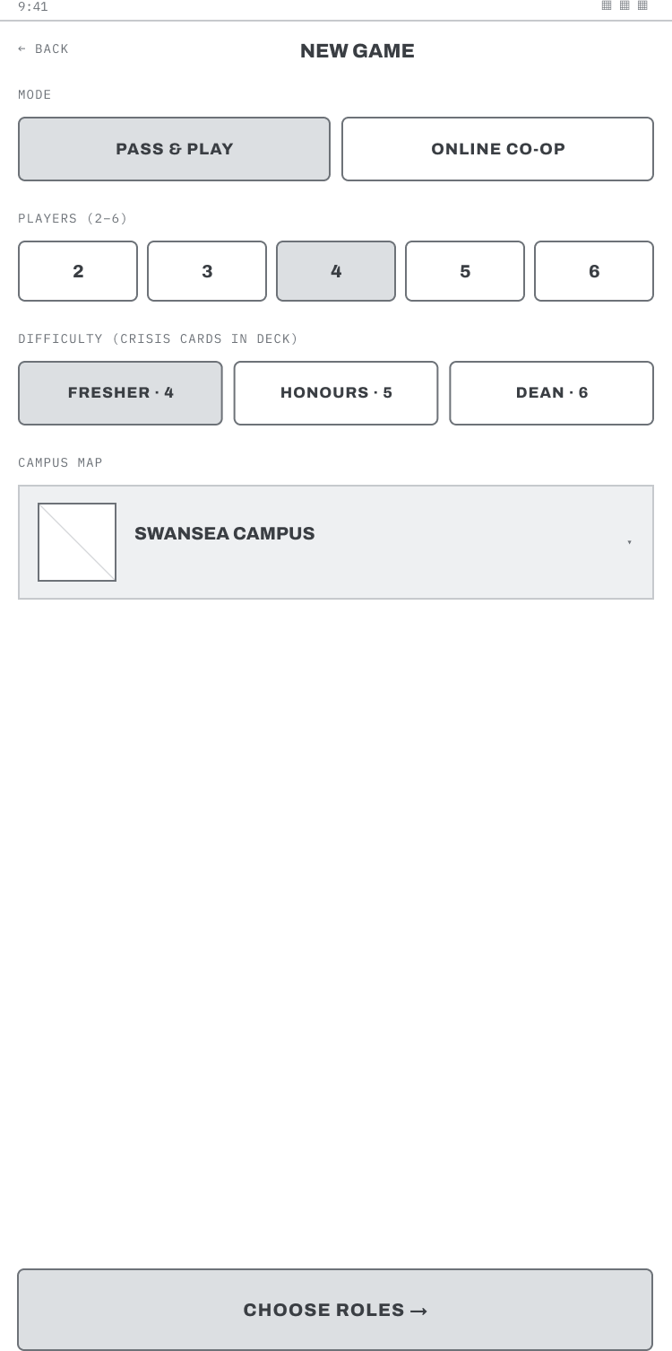  04. Game setup. Andrei taps across the segmented controls, mode, players, difficulty, campus, building a four-player game in seconds without reading any help text. → S05.
05. Role selection. Each player scrolls the six cards, reads one plain line, and taps to claim the ability that supports the team rather than duplicating it. → S07 (or → S06 online). | 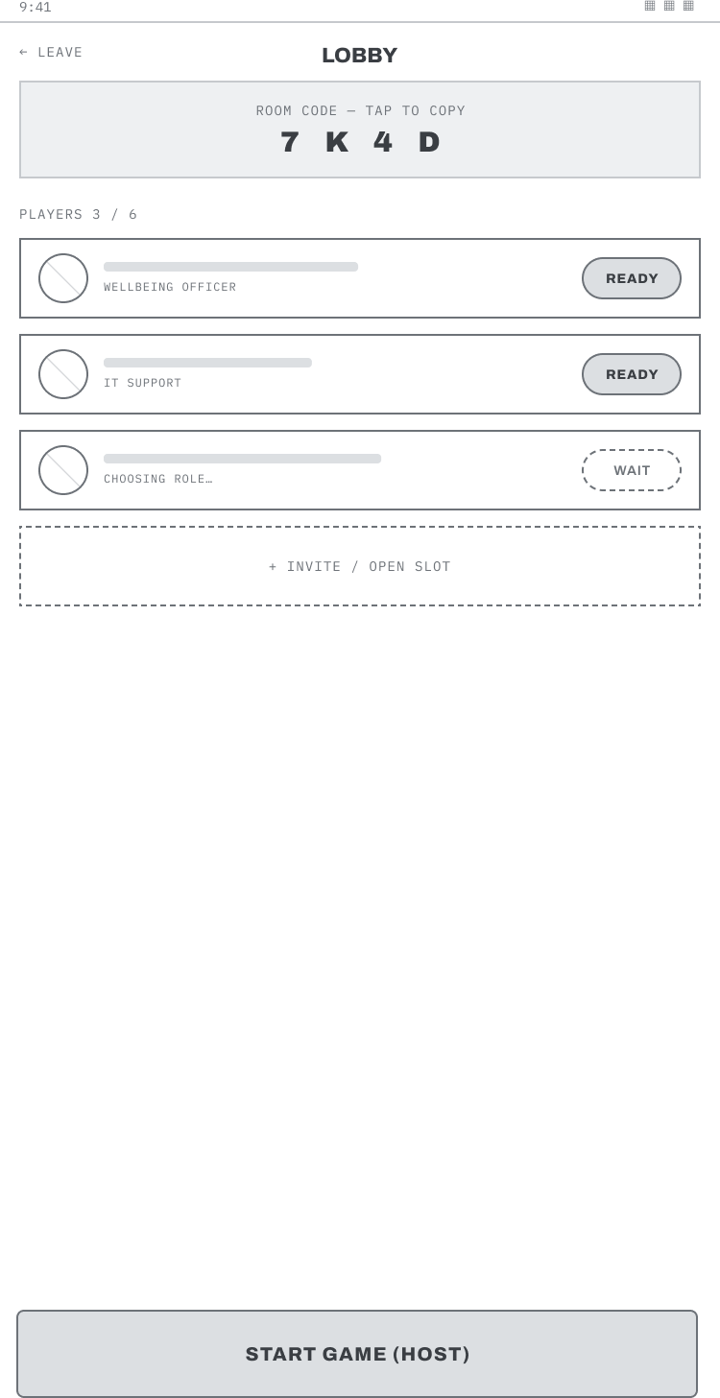  06. Online lobby. Doina types the four-character code, watches the slots fill as classmates arrive, and taps Ready; the host then starts the match. → S07.
07. Campus map hub. Where players spend the game: Elira glances up at the permanent header to judge the danger, pinches to zoom the map, then reaches down with her thumb to the action bar. → S08 to S13. | 08. Building detail. She taps a building and a sheet slides up from the bottom, showing how bad the infection is and offering only the actions she can legally take, her role bonus written on the button.
09. Move mode. She taps Move and the map filters to the places she can actually reach; she taps a destination, then Confirm, and only then is the action spent. | 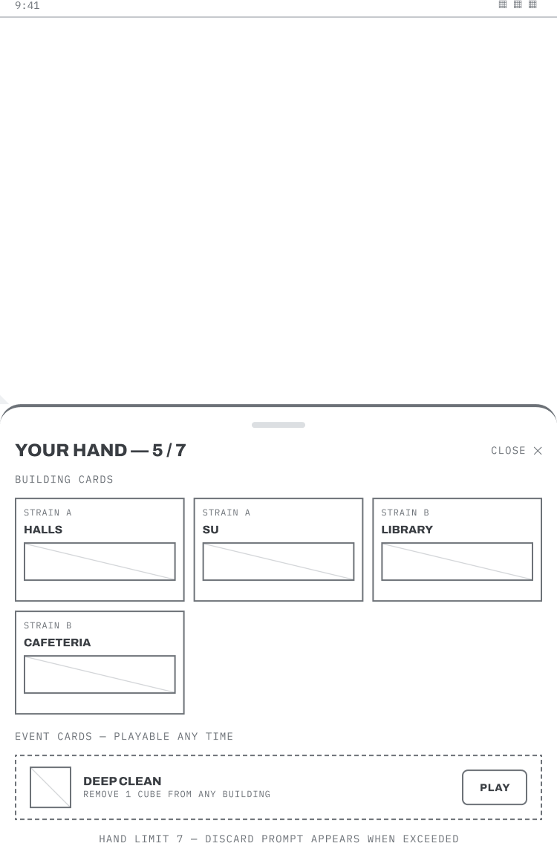  10. Hand of cards. She swipes open her hand, grouped by strain, weighing whether to keep collecting towards a cure or pass a card on.
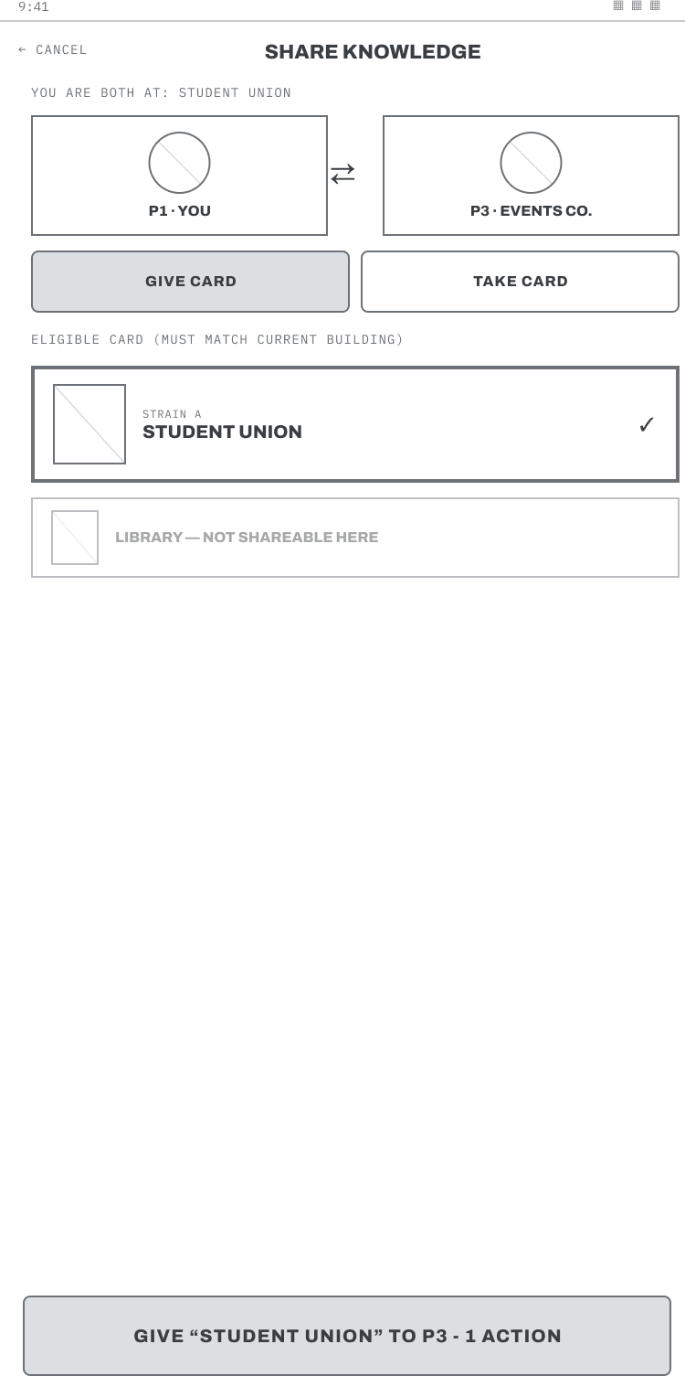  11. Share knowledge. The Librarian taps Share, picks the teammate standing in the same building, and hands the card across; cards that cannot be shared stay dimmed with the reason given. | 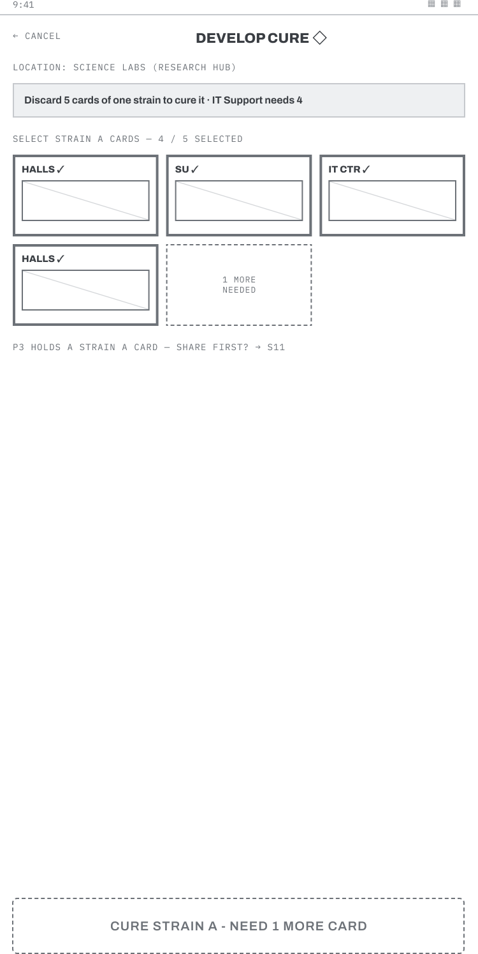  12. Develop cure. Standing at the research hub, the team taps matching cards one by one and watches the counter fill, the confirm button naming whatever is still missing.
13. Draw phase. She ends her turn and two cards flip face up in front of her, a plain-language strip spelling out what any crisis card has just done, so nothing changes behind her back. | 14. Outbreak alert. A building overflows and the game interrupts her: the alert slides in naming the building and listing each knock-on effect on its own line, and she taps See it on the map to follow the spread. → S07.
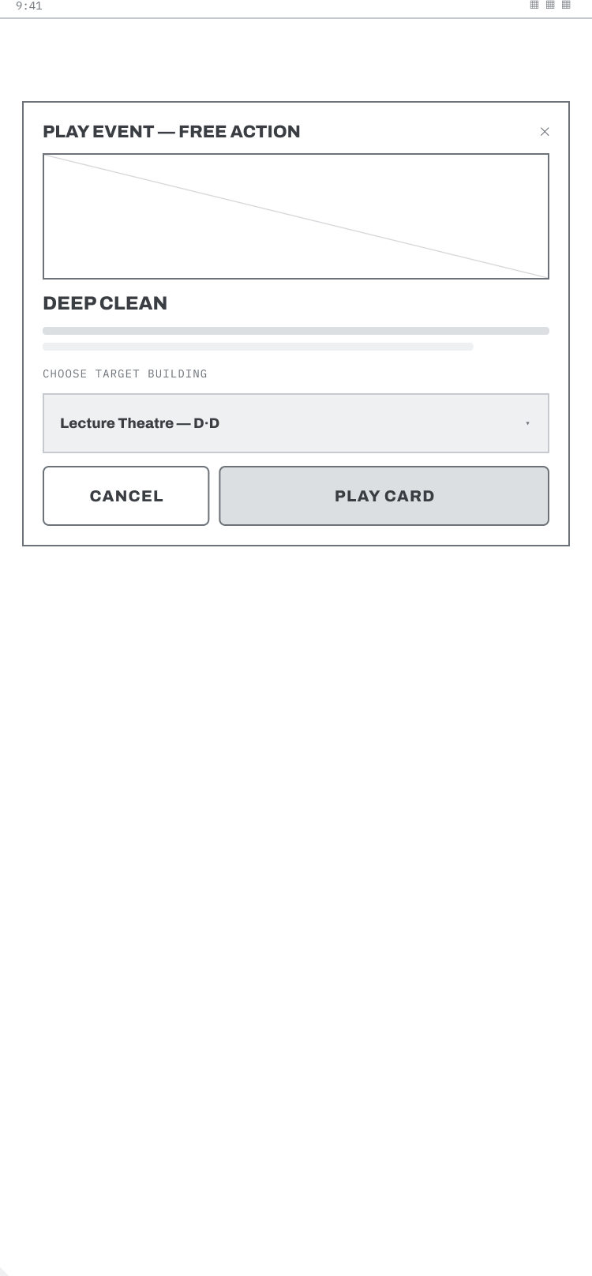  15. Event card. A free event is offered mid-turn; she reads the effect and taps Play to use it at no action cost, or Cancel to keep it for later. | 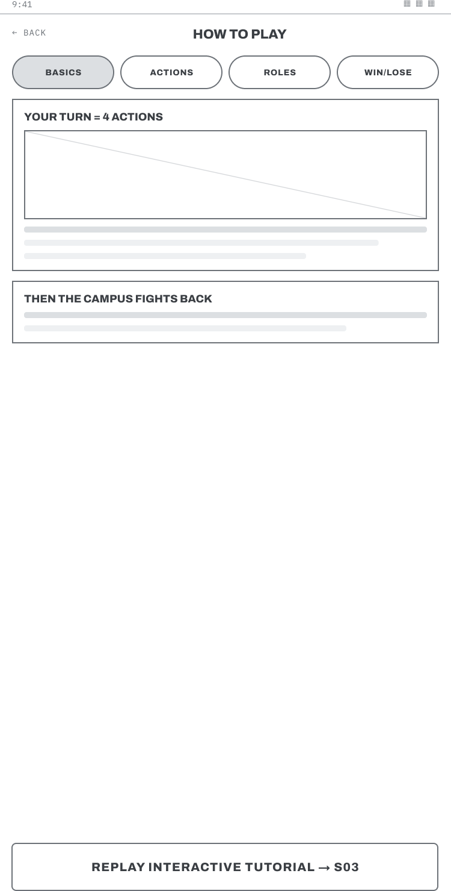  16. How to play. Mid-match, Doina taps through short labelled sections to check one rule, then returns without losing her place. → back to play, or → S03 tutorial.
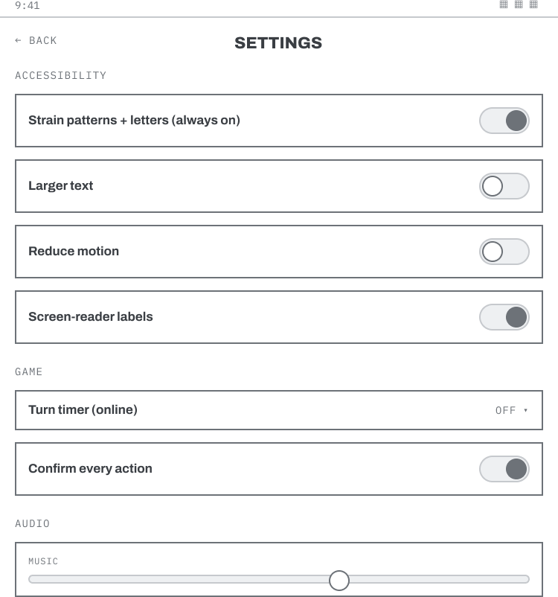  17. Settings and accessibility. Anisa opens settings and finds letter and pattern coding already switched on, so she scrolls past it, drags the text size up, and returns to play without repairing anything. | 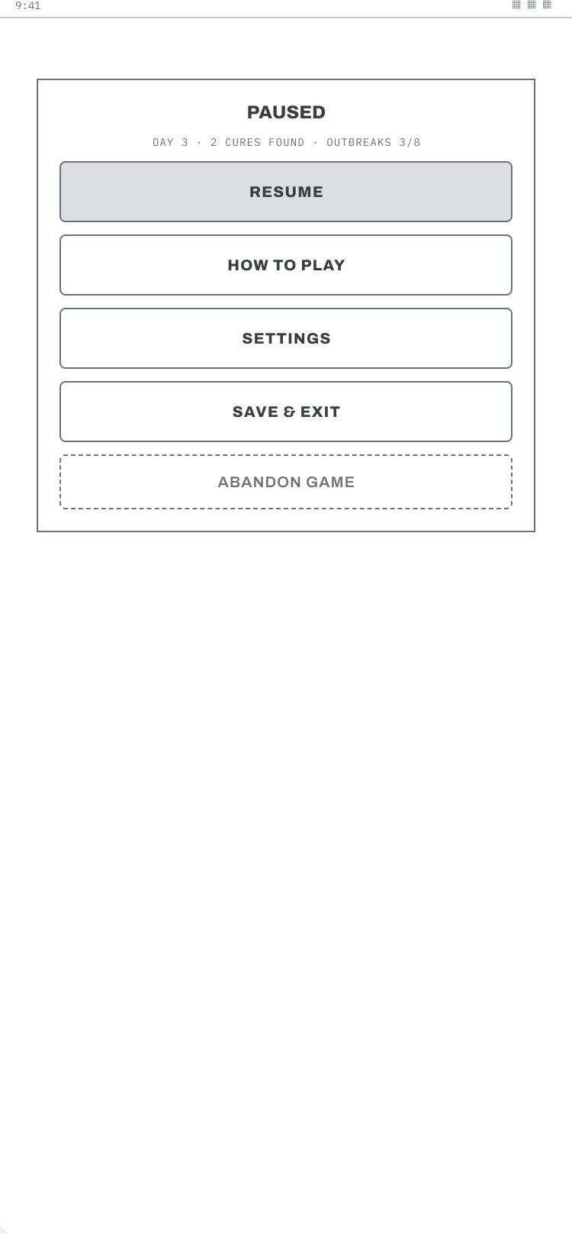  18. Pause. Her stop approaches: she taps Pause, reads her progress restated in one line, and taps Save and exit, two taps, mid-turn. → S02.
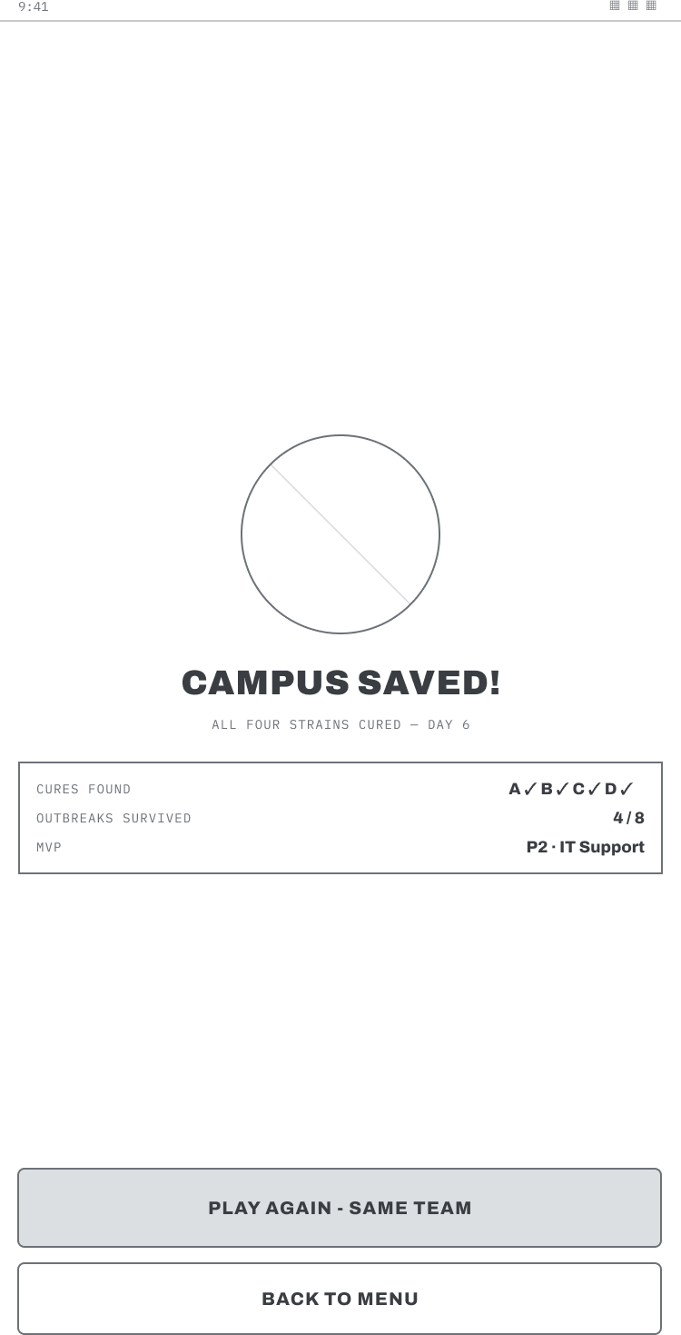  19. Victory. The team watches the last cure complete; the shared result is shown rather than individual scores, and one tap starts another game with the same group. | 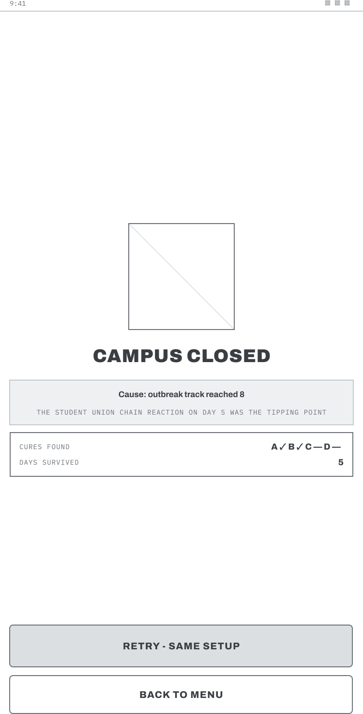  20. Defeat. The campus closes; the screen names the exact condition that lost the match and the moment it turned, and a single tap restarts so the loop stays tight.

Appendix C: Questionnaire and Analysis of the data collected
Instrument: Campus Co-op Game questionnaire, Google Forms. open at the time of writing.
Items: respondent type; course or situation; age range; accessibility needs; comfort with mobile apps; frequency of cooperative play; definition of cooperative feel (up to two); preferred challenge type; role appeal (any); progress persistence; feature priorities (any); two open flow prompts; realistic session length.
Note: The questionnaire was restricted to current UWTSD students, with a screening question removing anyone who was not a current student. Eleven responses are analysed; the tallies above are completed from the live form
D.1 Quantitative analysis
Closed questions were analysed as frequency distributions: Table C1 reports how many respondents chose each option rather than a mean, because the items are categorical and the sample is small. Percentages are avoided for the same reason, since with eleven responses a single answer shifts a figure by more than nine percentage points. No scaled instrument was used, so significance testing and reliability measures would not be meaningful at this sample size.
D.2 Qualitative analysis of the questionnaire (deductive coding)
Open answers were analysed by working from data to codes to themes. Coding here was deductive: the two open items, on what made time pass quickly and on what would cause a player to stop, were coded against the three flow components, then grouped into themes.
Codes: clear objective; right level of difficulty; rapid feedback; playing with friends; involvement and satisfaction.
Theme 1: Flow conditions are the reason play continues. Design response: permanent cure tracker, per-action feedback, three difficulty tiers.
Codes: no clear goals; chaotic interface; over-complicated actions; too many things happening at once; timing out.
Theme 2: Loss of flow is the reason play stops. Design response: one job per screen, select-then-confirm scoped to actions that cost, plain-language phase announcements.
D.3 Qualitative analysis of the prototype feedback (inductive coding)
The five sets of prototype feedback were coded inductively, taking the codes from the responses themselves rather than from a framework, and then grouped.
Codes: font size too small on some screens; primary action not obvious; unsure of the next step; weak visual hierarchy; too much shown at once; empty space on some pages; welcome screen lacks the game title.
Theme 1: Visual hierarchy and legibility. Raised independently by three of five participants and actioned as v1.2 Change 1.
Codes: felt urgent and motivated; wanted to act quickly; the situation felt more serious; annoyed at losing.
Theme 2: Emotional response to escalation. Confirms the outbreak and defeat screens communicate as intended; no change required.
Codes: layout clean; flow easy to follow; complete journey present; role choices spread across the set.
Theme 3: Structural clarity. Treated as validation of the navigation model; no change required.
Codes: wanted colour on the warning; wanted menu and restart options on the end screen.
Theme 4: Reinforcement and exit control. Colour actioned as v1.2 Change 2 (reinforcement only, letters and patterns retained); exit options already present on S20.

Appendix D: UX Research & Evaluation Dashboard
This dashboard combines questionnaire findings used to develop the personas and requirements with the subsequent WhatsApp prototype evaluation. It demonstrates how research findings informed the storyboard, wireframes and final design improvements.
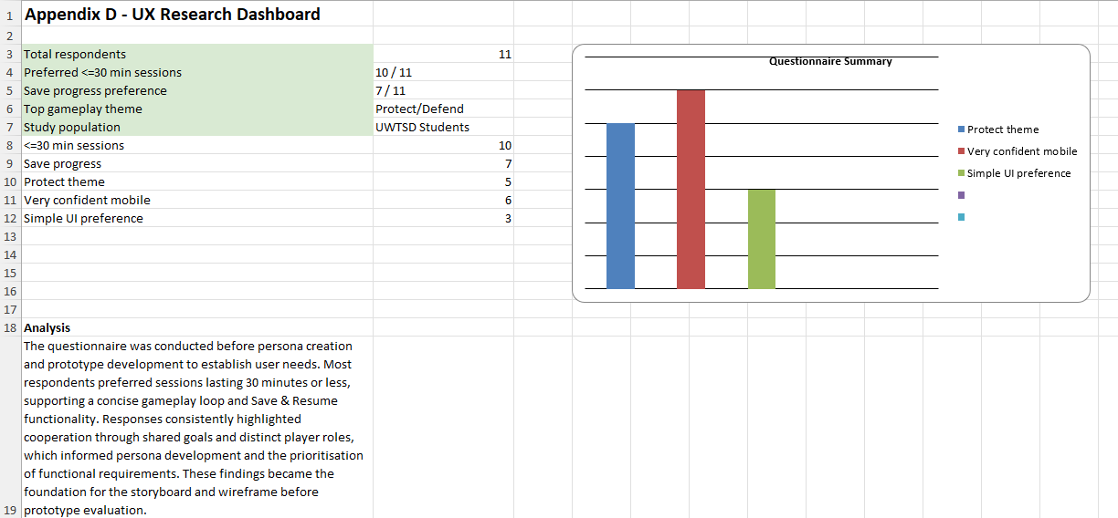
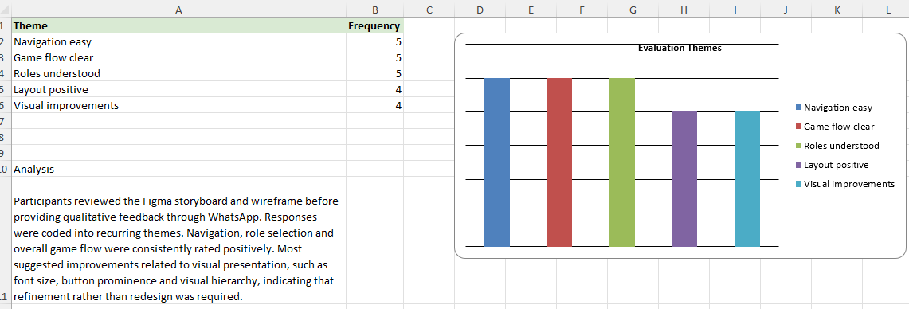
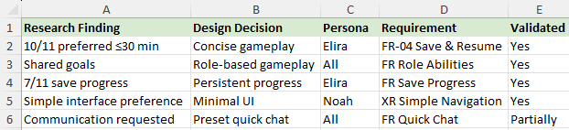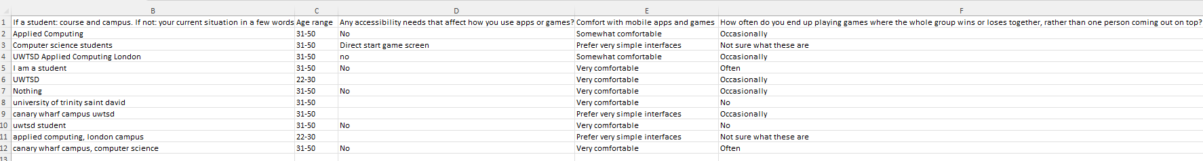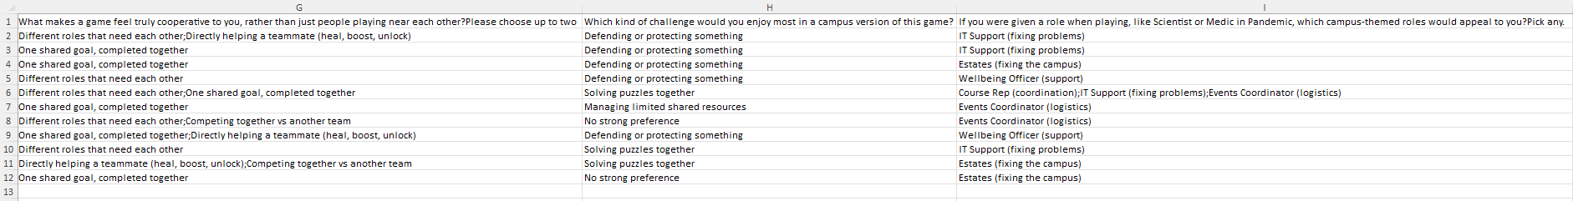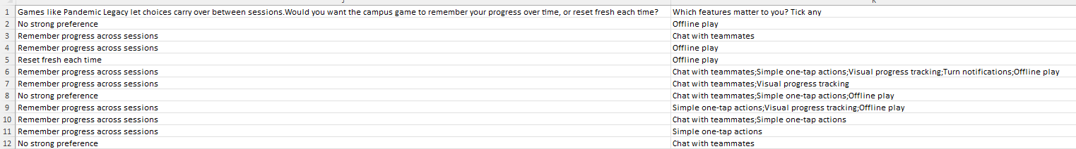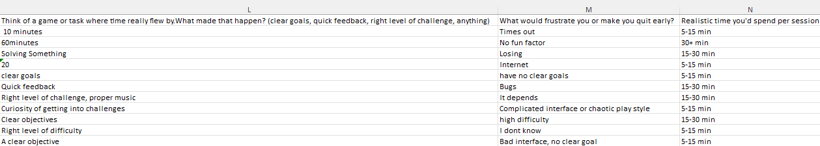

Appendix E: Prototype Evaluation Evidence
The following anonymised WhatsApp conversations provide the raw evidence used during prototype evaluation.
Figure E.1 – Participant 1
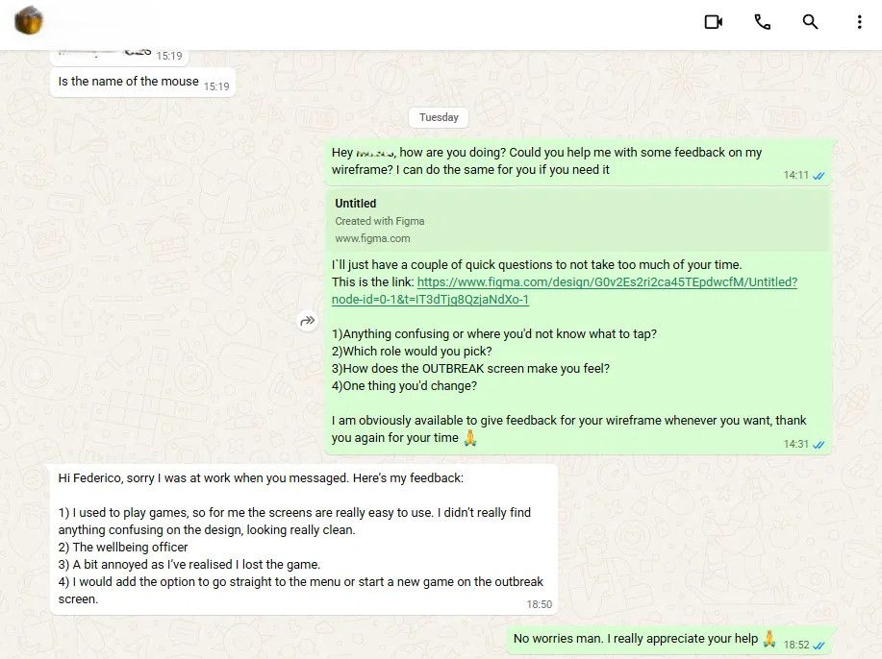
Figure E.2 – Participant 2
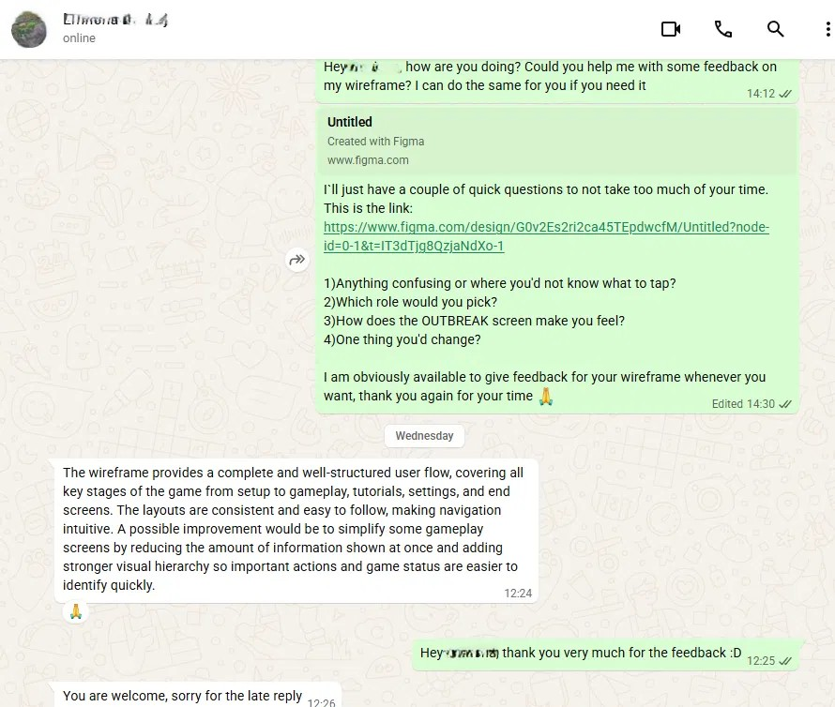
Figure E.3 – Participant 3
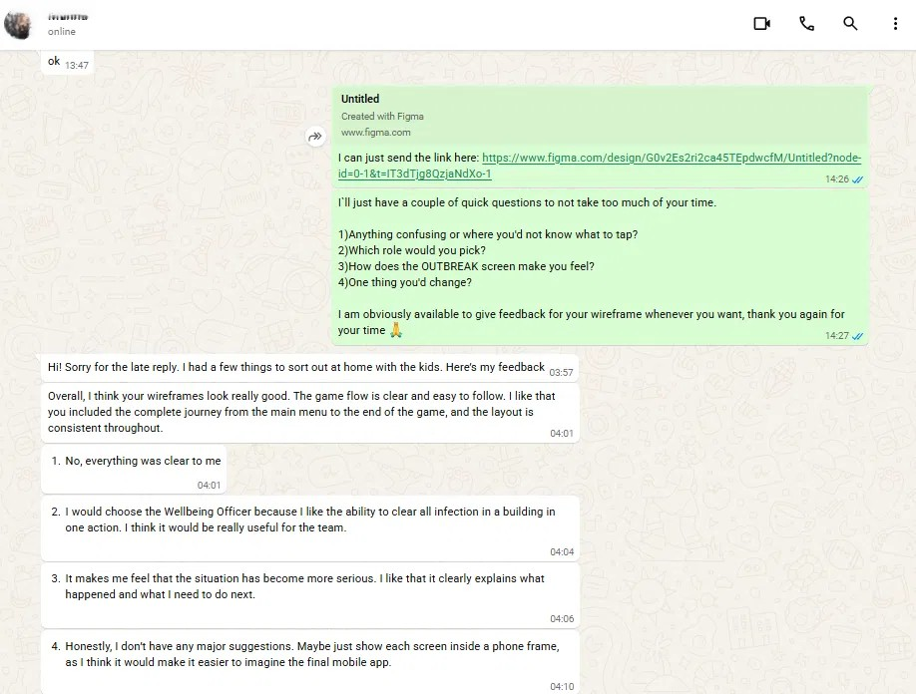
Figure E.4 – Participant 4
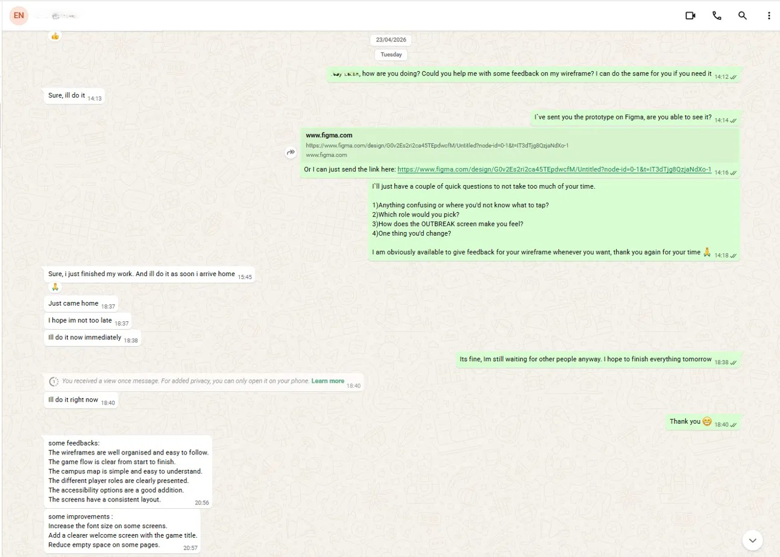
Figure E.5 – Participant 5



