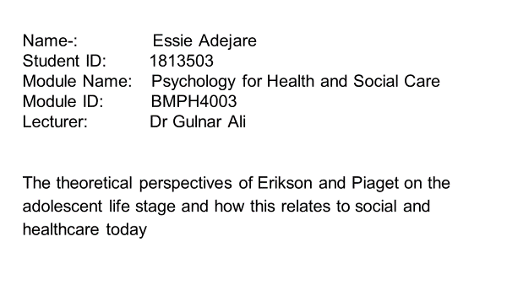

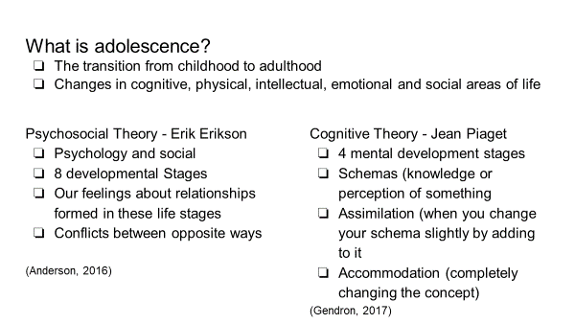

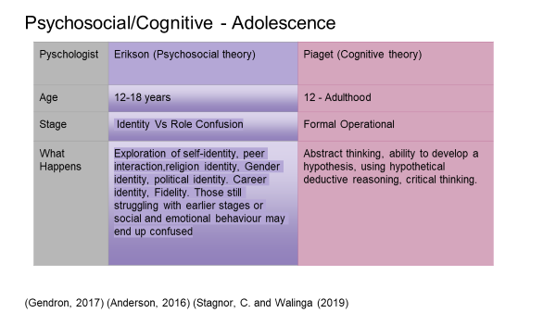

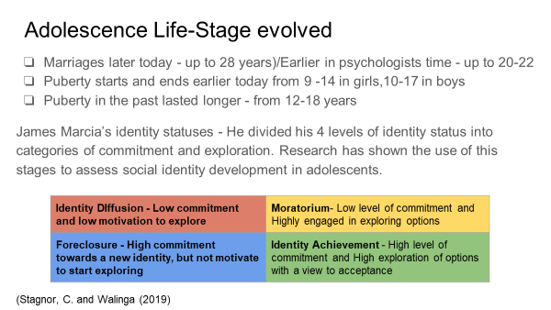

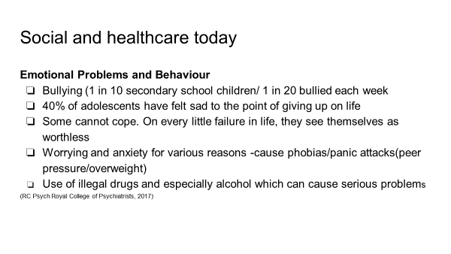

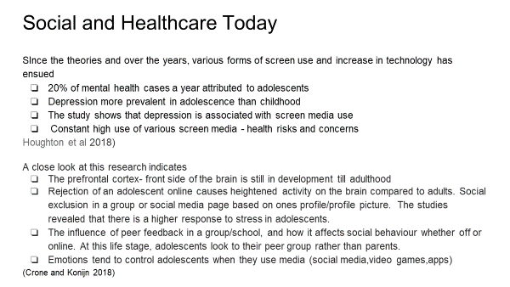
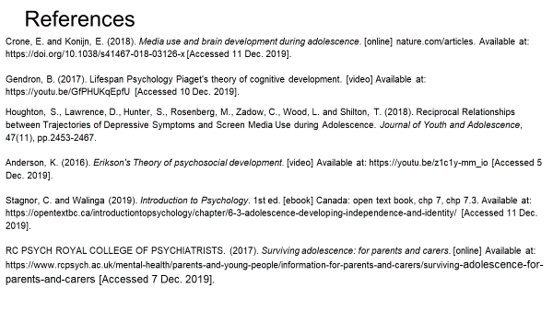

REPORT

INTRODUCTION
This paper is to explain the logic and reasoning for my chosen topic of research and presentation. The topic in question is the theoretical perspectives of Erik Erikson and Jean Piaget on the adolescent life stage and how this relates to the evolvement of social and healthcare today

Reason for choice
I have watched my 23 year old daughter grow and particularly found the beginning of her teenage years up till date very interesting and challenging. My son on the other hand who is now 17 relays a different development picture, although he is somewhat challenged. In the last 10 years I have been intrigued by the adolescence life stage and found it interesting in terms of comparison during my own days as a developing teenager. I have been fascinated by the impact or effect of changing times and general changes in the areas of life that embodies the different generations. The only yardstick for comparison is my days as an adolescent until adulthood. When look back to the during my youthful years, I realise parents in that era, (generation X) were lucky in comparison to myself as a parent to children of this present generation - Z or the centennial generation as it is called, This differences has inspired me to choose this life stage (independent.co.uk, 2019)

Significance of the Psychological theories and in relation to this day
Erik Erikson the creator of the psychosocial theory (psychology and social) and the father of the term “identity crisis” developed 8 stages a human being would need to go through from birth to old age. He was of the view that it was important for relationships to be formed and how we feel about them. Erikson explores the adolescence development of their inner self and how they interact with society. At this stage in life, they go through a process of resolving a conflict of identity crisis. In all of human development this is the time when most changes occur physically, biologically and emotionally in terms of hormones as they experience puberty. According to Erikson this theory is important because the teenager is seeking to develop an identity of self after much exploration of beliefs, values and goals in terms of what they will become in life and what they want to happen. Rebellion and indecisiveness occurs during this stage. Acquiring a strong sense of personal identity enables them to succeed in adulthood. He states that they then attain the virtue of fidelity –ability to accept people irrespective of their differences. It will take a lot of time and that is why we find there is a struggle and conflict. In cases where the adolescent is unable to find their identity, they become confused and this may result in mental health problems or/and a delayed development. The key to success in this stage is for the teenagers to be focused towards finding a strong identity, even though the teenager will want to experiment different options. This gives them a solid foundation for progressing in life, boosts their self-esteem, self-confidence. Erikson’s adolescent stage has been paramount to other psychologists and scholars research since his time till date. To prevent or reduce role confusion, it is very significant that parents are constantly guiding and advising their youth in a diplomatic subtle way. (Morelli and Zupanik , rsas.org 2019).
In 1966, James Marcia expanded on Erikson’s theory by developing four levels of development identity status which fall into the categories of exploring options towards an identity and commitment. This has been widely used and still in use today as an immense guide for youth. (Stagnor and Walinga 2019)

According to Royal College of psychiatrics, this generation of adolescents are faced with challenges ranging from i) peer pressure in terms of over or under weight and appearance.
ii)Anxiety or, and depression and becoming suicidal
iii) Being bullied and bullying peers
iv) Risky behaviours such as taking illegal drugs, smoking and un protected sex
If the youth is not giving proper counselling, therapy or help it may result in an identity crisis or even suicide in extreme cases.

On the other hand, the cognitive theory was created by Jean Piaget providing a framework of four stages of mental development that every human being encounters in life at different age groups. He was of the view that as you age, you move to the next stage. He believed that humans learning and thinking process develops through interacting and understanding of the environment and the world and not merely being static in a classroom. During or by the end of this stage, the young person is able to apply critical and abstract thinking to solving problems. They are able to reason logically and deductively in complex situations. The reasons above validate the relevance of this theory.

World Health Organization (WHO) predicted that 20% of adolescents have mental health challenges which are mainly depression. Constant use of the screen with the advent of technology and various devices and platforms online is a health risk. (Houghton, et al 2018)
Adolescence use of social media consistently and their inability to cope with the aftermath of their interaction is a grave concern. Unlike adults, their prefrontal cortex of the brain is in the process of formation, therefore emotions take control during the use of social media and online/video games. They rely on peer feedback and research has indicated stress on the brain in this regard. (Crone and Konijn 2018)

His fourth and last stage incorporates ages 12 to adulthood, which differs to Erikson’s psychosocial theory which has a stage solely for adolescence. Basically Piaget’s opinion in this respect is that using a formal operation thought process continues after adolescence into adulthood.

Culture and Adolescence
Culture and background has a great impact on a developing adolescent. A research on this has shown that Asian and Latino youths valued family duties more than other European backgrounds.
Teenagers with a lesser amount of family commitments were not as happy as those who had more duties. (Weir K, 2017)

CONCLUSION
In totality, Piaget and Erikson were born into an old era and developed their theories during a different generation which experienced wars, post wars and manual processes. The world has evolved since then and we have seen other generations come with improving technology in every area of life, including food. They have developed their theories taking into consideration the factors affecting those generations, therefore adolescence in present day healthcare is faced with more challenges and in need of support and therapies to save the youth.

REFERENCES

Anderson, K. (2016). Erikson's Theory of psychosocial development. [video] Available at: https://youtu.be/z1c1y-mm_io [Accessed 5 Dec. 2019].

Barr, S. (2019). From millennials to baby boomers: Which generation are you from?. [online] The Independent. Available at: https://www.independent.co.uk/life-style/generation-definitions-what-am-i-millennial-generation-x-y-z-baby-boomers-golden-age-young-old-a8679741.html [Accessed 18 Dec. 2019].

Crone, E. and Konijn, E. (2018). Media use and brain development during adolescence. [online] nature.com/articles. Available at: https://doi.org/10.1038/s41467-018-03126-x [Accessed 11 Dec. 2019].

Gendron, B. (2017). Lifespan Psychology Piaget's theory of cognitive development. [video] Available at: https://youtu.be/GfPHUKqEpfU [Accessed 10 Dec. 2019].

Houghton, S., Lawrence, D., Hunter, S., Rosenberg, M., Zadow, C., Wood, L. and Shilton, T. (2018). Reciprocal Relationships between Trajectories of Depressive Symptoms and Screen Media Use during Adolescence. Journal of Youth and Adolescence, 47(11), pp.2453-2467.

Anderson, K. (2016). Erikson's Theory of psychosocial development. [video] Available at: https://youtu.be/z1c1y-mm_io [Accessed 5 Dec. 2019].

Morelli, A.Zupanic C (2019). Child Development Theory Adolescence (12-24). [online] Risas.org. Available at: https://www.risas.org/ [Accessed 17 Dec. 2019].

Stagnor, C. and Walinga (2019). Introduction to Psychology. 1st ed. [ebook] Canada: open text book, chp 7, chp 7.3. Available at: https://opentextbc.ca/introductiontopsychology/chapter/6-3-adolescence-developing-independence-and-identity/ [Accessed 11 Dec. 2019].

RC PSYCH ROYAL COLLEGE OF PSYCHIATRISTS. (2017). Surviving adolescence: for parents and carers. [online] Available at: https://www.rcpsych.ac.uk/mental-health/parents-and-young-people/information-for-parents-and-carers/surviving-adolescence-for-parents-and-carers [Accessed 7 Dec. 2019].

Weir, K. (2017). How does culture sway teens. [online] https://www.apa.org. Available at: https://www.apa.org/monitor/ [Accessed 16 Dec. 2019].

