Introduction to web and database concepts
Coursework 1 – 25th April 2023

Networks and Cyber Security
Che Morris - 2203458

Contents
Initial Investigation 2
Entity Relationship Diagram 4
Database: Tables & Fields 6
Table: Attendees 6
Table: Branch 6
Table: Branch Managers 6
Table: Department 6
Table: Department Heads 6
Table: Equipment 7
Table: Event 7
Table: Event Patrons 7
Table: Invoices 7
Table: Orders 7
Table: Payments 8
Table: Staff 8
Table: Suppliers 8
Table: Tickets 8
Database: Relationships 9
Database: Reports 10
Report: All Attendees 10
Report: All Current Events 10
Report: All Current Equipment 11
Report: Total Tickets Sold 11
Database: Queries 11
Query: All supply orders placed in the current week 11
Query: All supply orders placed on the current date 12
Query: Search for events by patron 12
Database: Forms 12
Form: Editing, adding or removing records 13
Form: Database start page 17
Form: Staff member homepage 18
Form: Event Patron Homepage 19
Brief User Guide 19

Initial Investigation
The different types of users who might need to access the database would be the following people:
- Event patrons – They may need to access the database to view information related to the event that they have paid Northern Lights to plan and execute. This may include information about the event schedule and how many people will be attending and their information.
- Staff members – They may need to access the database to access information related to their department for the event, for example staff in the audio-visual department may need to access it to view information on what equipment is going to be used and the availability of said equipment, the marketing and sales department may need to view ticket sales or to generate invoices.
- Department heads – They may need to access the database to assign tasks to the staff, monitor progress and make sure that individual departments are getting their jobs done on time and that they are on track.
- Branch managers – They may need to access the database to view any new events requested by patrons and their requirements so that they can assign the tasks to the department heads.
As the branch managers is the primary point of contact with event patrons, we wouldn’t need to have a department of people who manage the patrons, however the staff at both branches are put in charge of multiple important parts of the planning and execution of these events including setting up audio and visual equipment, selling tickets, cleaning and maintaining and administrating events. The company also uses several suppliers to get supplies for the events and day-to-day running of the company, it is not specified in the overview if the staff oversee this or not, but since they also take on marketing and setting up of the event, I’ll assume that they oversee getting the supplies also. Based off this, I will split the staff into the following departments.
- Audio and Visual – The staff in this department set up and oversee the audio and visual equipment used during the events. They would set up the equipment and maintain it during the event to make sure that it’s working correctly and will make sure that if it faces any issues, they are solved quickly.
- Marketing and Sales – The staff in this department will be responsible for selling the tickets for the events, in turn managing the sales process, issuing the tickets, processing payments and managing any refunds or cancellations that may be necessary.
- Cleaning and Maintenance – The staff in this department will make sure that the venue the events are held in are clean both before and after the event, this would make sure that no increased cleaning costs are added by the venue and will also make sure that the venue remains well-maintained.
- Event Planning and Administration – The staff in this department would be responsible for tasks related to the planning of the event and the execution. They would communicate with the branch manager to see what the event patron’s requirements are and what the budget is, they would they assign the relevant tasks to the other departments. They would also make sure all the documents are kept being given later to the patron, including financial records, customer details and information about ticket sales.
- Supply Management – The staff in this department would be responsible for making sure that the other departments have the resources necessary for the event, this would include them ordering supplies, scheduling deliveries and managing the inventory once the supplies have arrived.
A user requirement that has been highlighted is that staff and clients will need to access the database to query and view information based on event schedules, ticket sales, attendees and equipment requirements. This will be done through a form on the database that will allow both types of users to generate reports and use queries where needed.
Another user requirement to be highlighted was when purchases are made from suppliers, the relevant department, in this case the Supply Management, should be able to view, record and generate invoices for the transactions. This will be done through a separate table in the database to keep track of orders, payments and reports will be used to generate invoices automatically based on the transaction details previously added to the database.

Entity Relationship Diagram
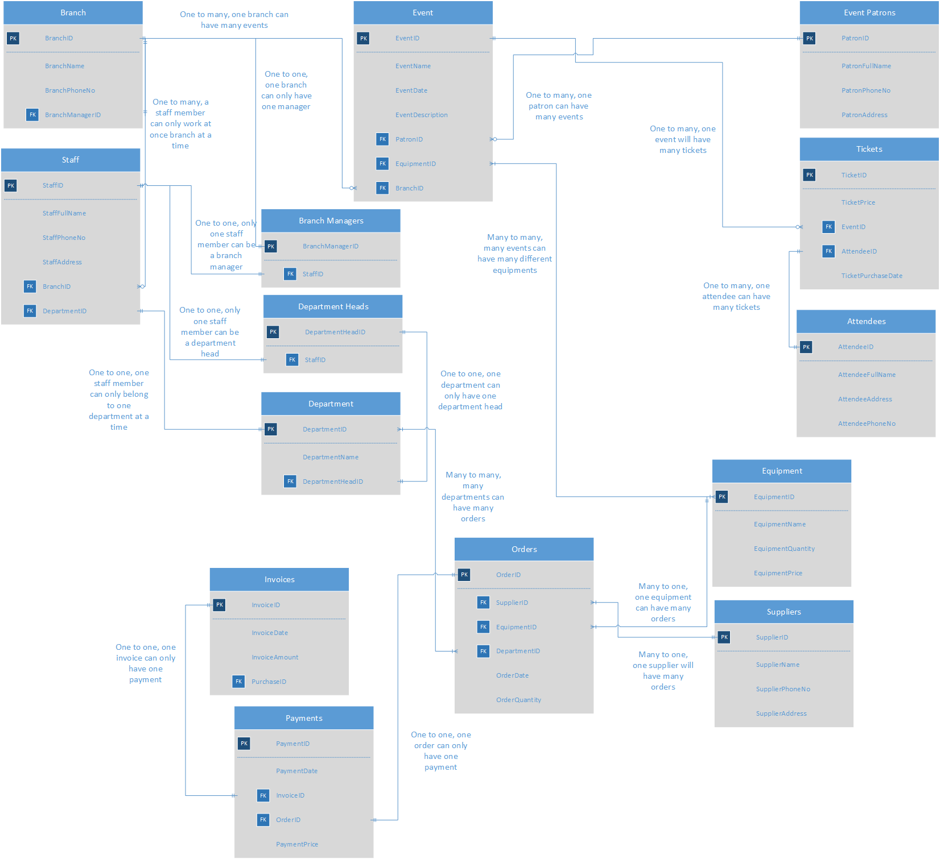
The tables that will be used in the database are:
- Branch – this will include information about the two separate branches, will also allow us to allocate staff and branch managers to their respective branches.
- Staff – this will include information about all the staff, what branch they are at and what department(s) they are in.
- Branch Managers – this will include an ID for the branch manager and their staff ID just so we know who the branch manager is of each branch.
- Department Heads – basically a copy of Branch Managers so we know who the head of each department is.
- Department – this will include the name of each department, only exists so that we can allocate staff to a department.
- Event – this will include information about each event including the name of the event, the date, the description given by the patron, the ID of the patron, the ID of required equipment and the ID of the branch organising the event.
- Event Patrons – this will include information about the event patrons such as their name, their phone number and their address.
- Tickets – this will allocate each ticket an ID and will include the price of the ticket, the IDs of the event and the attendee so we can find out how many people will attend each event and the date the ticket was purchased.
- Attendees – this will allocate each attendee an ID and will also store their full name, address and phone number.
- Equipment – this will allocate all the equipment ordered an ID, will store the name, the quantity of the equipment ordered we have and the price of the equipment.
- Suppliers – this will include information about the suppliers and allocate them an ID so we can invoice them accordingly, it will also store the phone number and address of the supplier in case they need to be contacted at any time.
- Orders – this will include information about the orders sent out to suppliers, therefore will store the ID of the supplier, equipment ordered and the department that ordered it. It will also store the date the order went out and how many of those orders were made.
- Payments – this will include information about the payments for the orders, including the date and the price. It will also include the invoice ID and the order ID so we know what order and invoice it belongs to.
- Invoices – this will include information about the invoices and will allocate an invoice ID to each, it will also add a date and an amount owed and will be related to the purchase ID

Database: Tables & Fields
The tables and fields in the database will follow the Entity Relationship Diagram created earlier on and will keep the same datatypes I chose earlier.

Table: Attendees
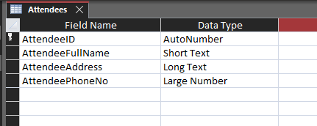

Table: Branch
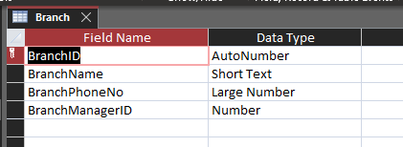

Table: Branch Managers
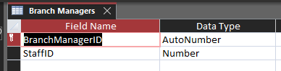

Table: Department
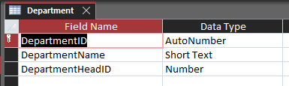

Table: Department Heads
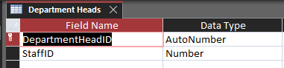

Table: Equipment
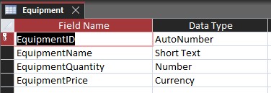

Table: Event
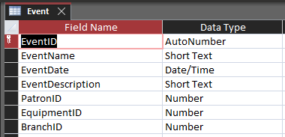

Table: Event Patrons
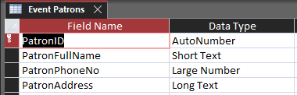

Table: Invoices
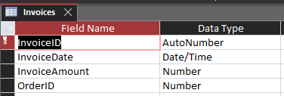

Table: Orders
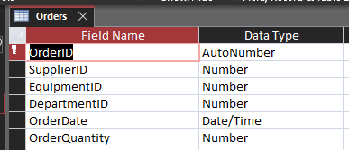

Table: Payments
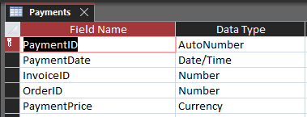

Table: Staff
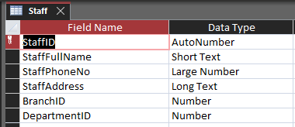

Table: Suppliers
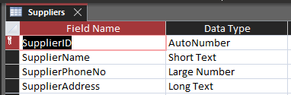

Table: Tickets
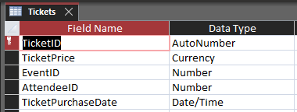

Database: Relationships
The relationships I’ve created between tables mimic the exact same ones I previously created on the Entity Relationship Diagram. I’ve not added any fields I’ve just renamed some as some were mislabelled compared to my ERD. The relationship types also remain the same and have not changed in the database. The following screenshot will show how the relationships remain in Access.
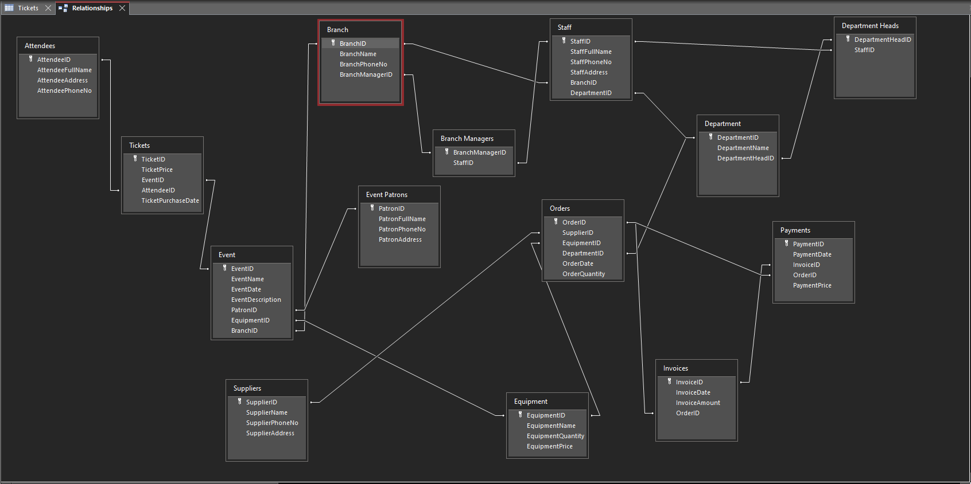

Database: Reports
I am going to create reports based on the events table, attendees table, tickets table and the equipment table. All of these will be visible to the staff and to the patrons later when I create the forms. The forms will include buttons to go to each report.

Report: All Attendees
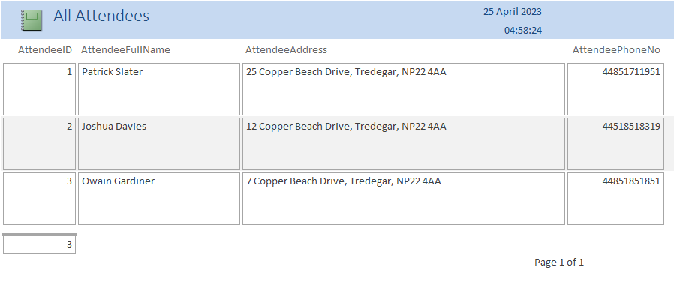
This report lists all attendees, the attendees are used in both the event and ticket tables, this report can be viewed by both patrons and the staff to get an idea of what attendees will be showing up to what event.

Report: All Current Events
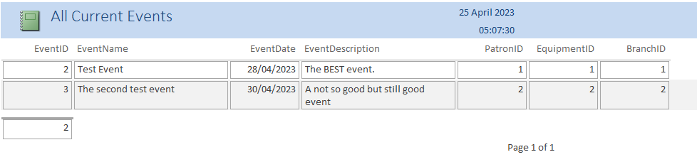
This report lists all the current events in the database, this will show what patron has started the event, what equipment is being used at that event and what branch will be organising the event. This will be viewable to both patrons and staff.

Report: All Current Equipment
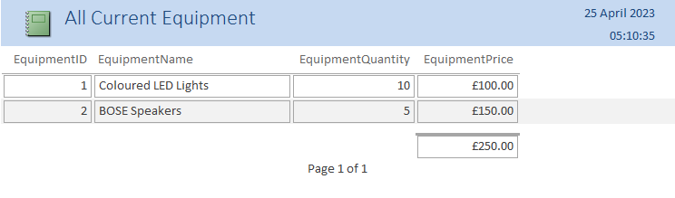
This report shows all the current equipment in stock at the company, it also shows how many of each equipment the company has. It will also show how much the equipment costs if the company needs to order the same equipment again.

Report: Total Tickets Sold
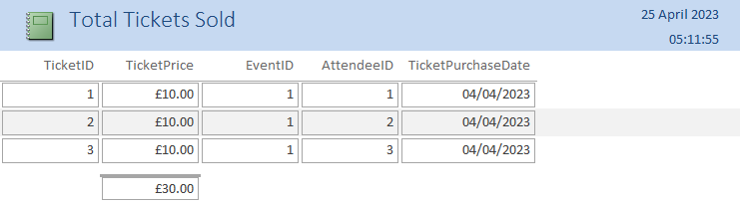
This report shows all the tickets that have been sold for all the events, it also shows which attendee bought the tickets and will show what event they bought the ticket for. It also shows the price that they paid for the ticket and will show the total amount spent on tickets.

Database: Queries

Query: All supply orders placed in the current week
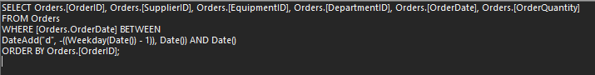
I used that SQL code in a Query to search the OrderDate field in the Orders table for all the supply orders in the last week, this will return the following if there are orders found in the last week. This will be accessible only to staff members.
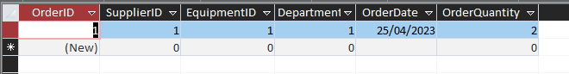

Query: All supply orders placed on the current date
This is a modified version of the previous SQL code for the same table, this will return all the orders placed on that current day. This would be useful for the branch manager or for department heads to check what the spending has been on an event on that day. This will only be accessible for staff members as patrons do not need to see this information. This will return the following if there have been orders placed on that day.
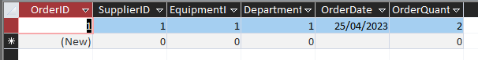

Query: Search for events by patron
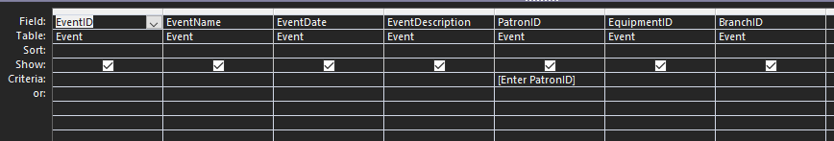
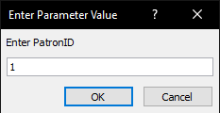
This query will prompt the user for a patron ID using the [Enter PatronID] criteria, once a patron ID that exists has been entered, it will return for any events that have been paid for and requested by that patron. As an example, if we enter PatronID number 1, this will be the results returned. This will be accessible to both patrons and staff members.
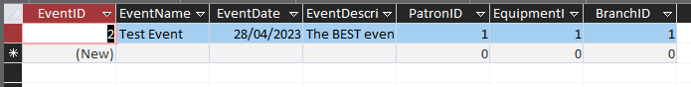

Database: Forms
I will create a staff home page form that allows for staff to enter a form for any table in the database and edit, remove or add new records. I will also add reports and query buttons to this page to allow for them to query the database and will allow them to see reports showing all the events in progress, all tickets sold, all attendees and all equipment. I will also create an event patron home page form which will let them see some of the reports, mainly based on current events, attendees and ticket sales.

Form: Editing, adding or removing records
The following forms are the forms that are used for editing, adding or removing records. These remain the same throughout each form and will allow for staff members of the company to remove any records that are not necessary, edit and save records, create new records and browse through the records as they need to.
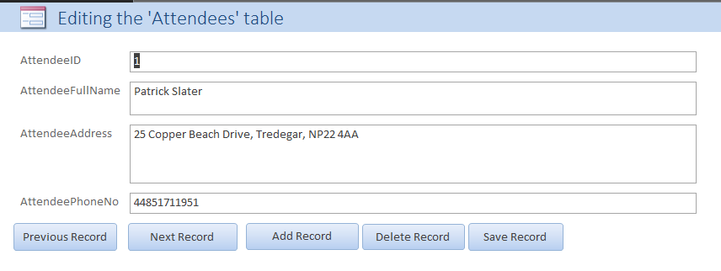
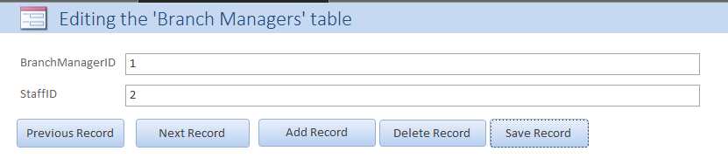
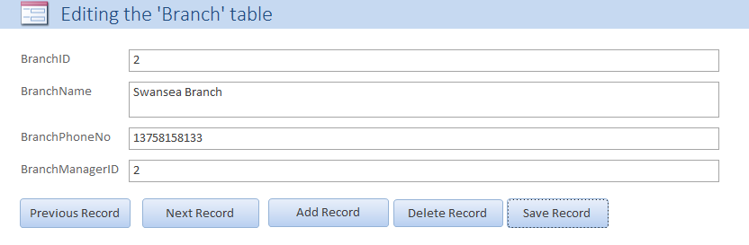
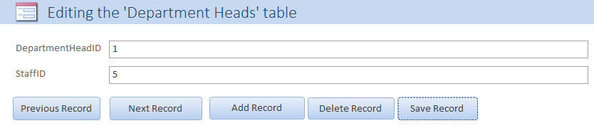
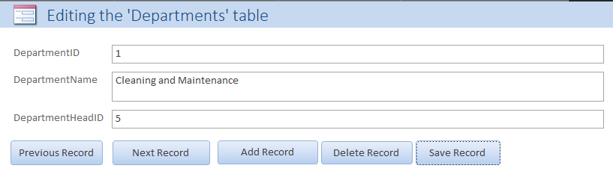
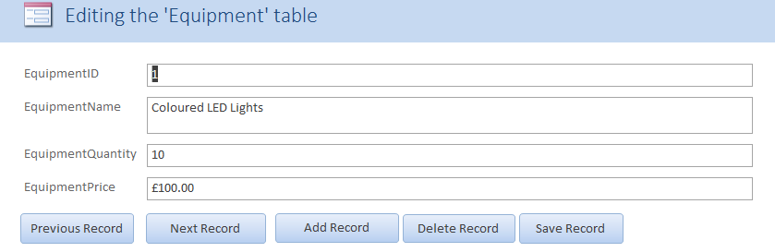
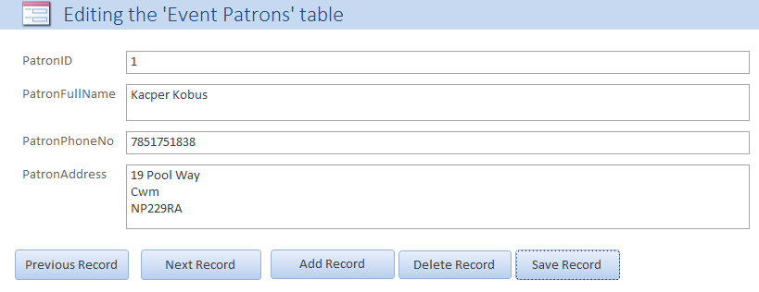
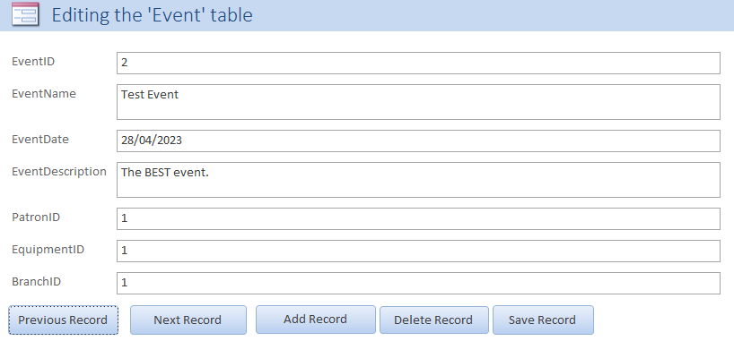
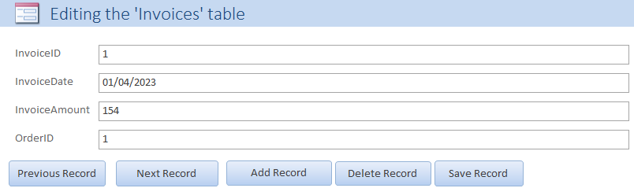
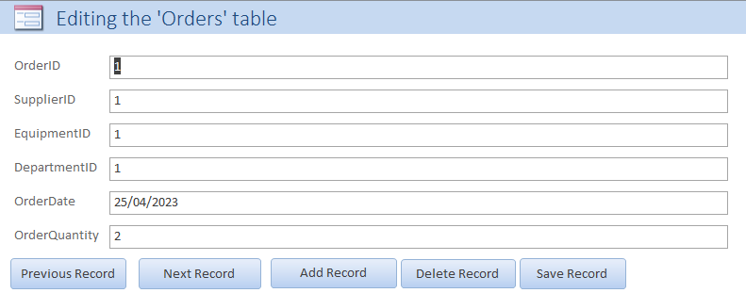
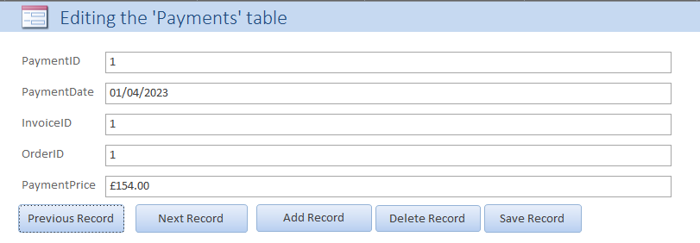
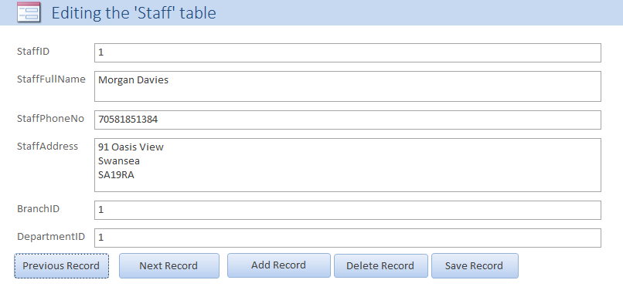
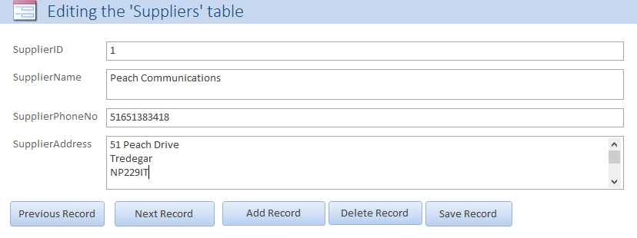
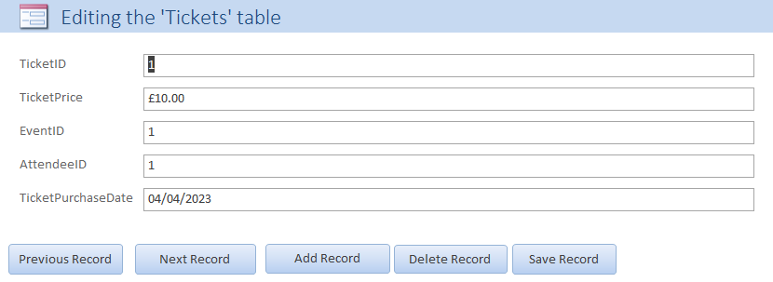

Form: Database start page
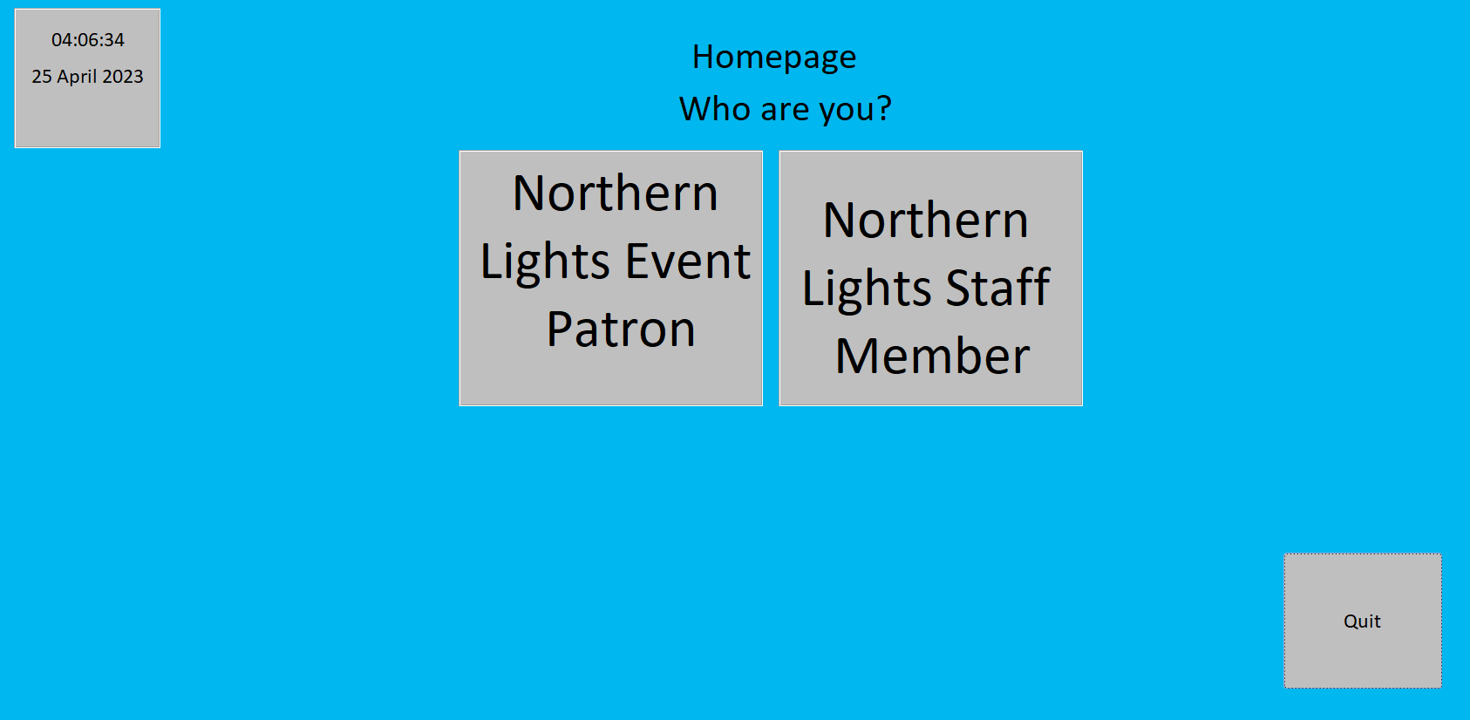
When you first open the database, the following form will show up and will ask you if you are an event patron or a staff member. Once you click the button of which you are, you will be taken to the respective home page. I’ve also added the date and time to this since it’s a home page, this was done using =Time() and =Date() as these return the time and date in Access, this will remain throughout all other home pages. I’ve also added a quit button that uses the following macro code to quit access altogether if they change their mind. This will also be on every home page.
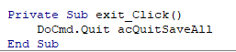
I set it to open when you open the database by going into the access options, going to the current database and setting the display form to ‘Database Homepage’ which is the name of this form as shown below.
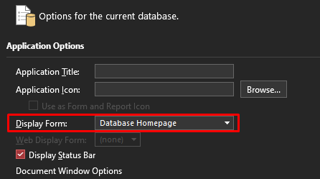

Form: Staff member homepage
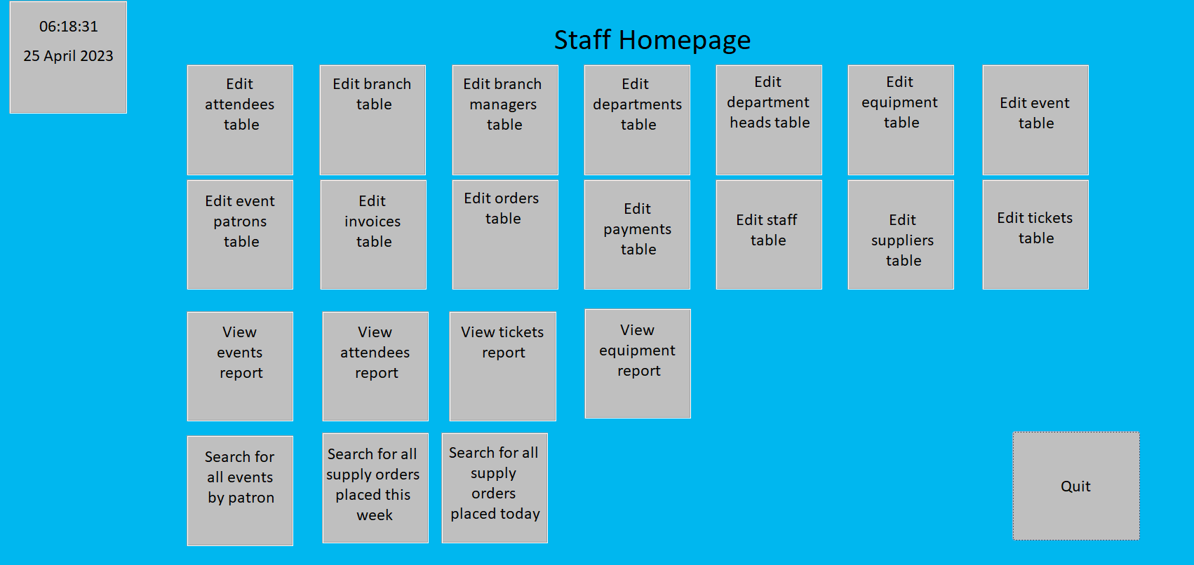
The staff homepage will allow staff members to edit every table in the database, view reports based on events, attendees, tickets and equipment and will allow staff to run a few useful queries based on all events ordered by certain patrons, all supply orders placed by a certain department, all tickets sold for an event, all supply orders placed in the last week and all supply orders placed in the last day. I’ve already made all the other forms, reports and queries so the buttons are already linked to go to where they should go.

Form: Event Patron Homepage
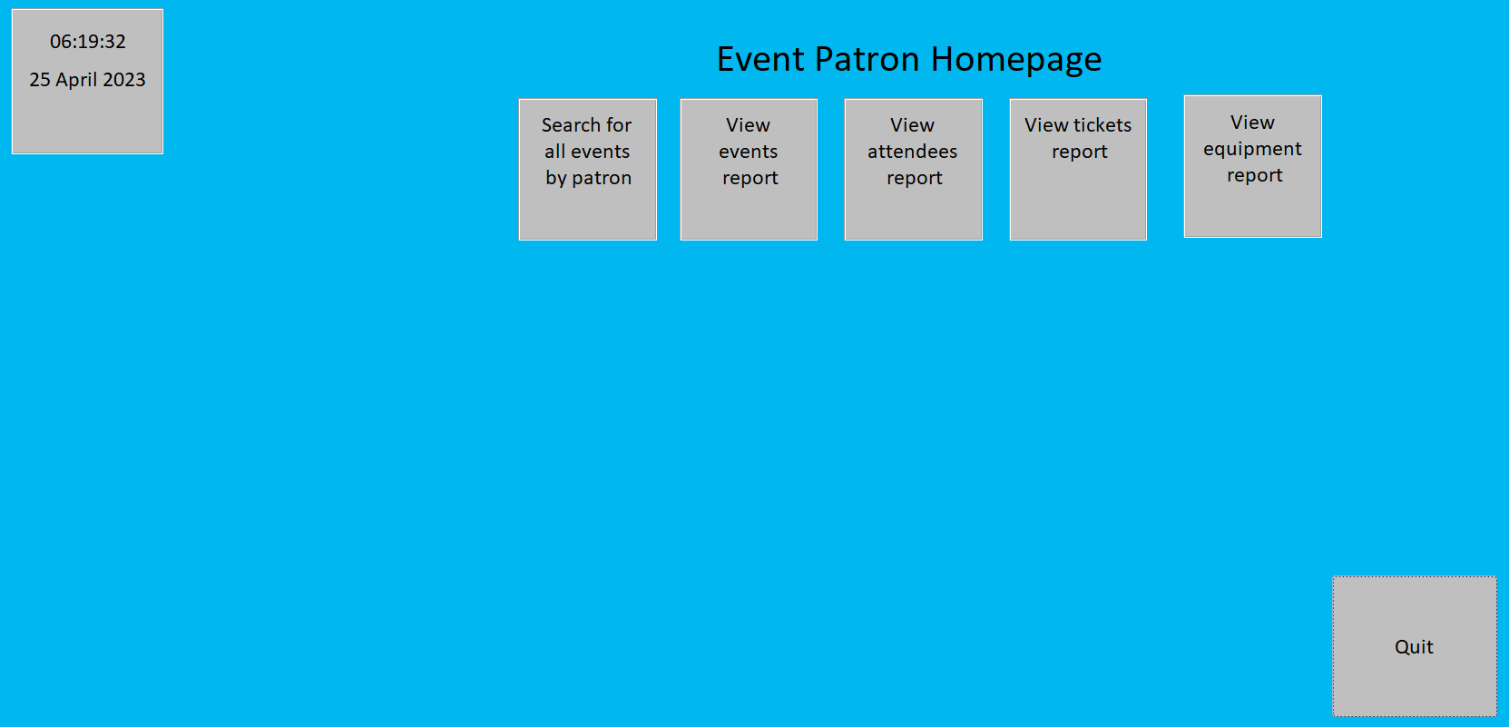
The event patron homepage will give the user access to a few reports and one query relevant to them. It will not give them access to anything related to the supply orders as they do not need that information and it will not give them access to edit any tables as they also do not need that. I’ve already made all the other forms, reports and queries so the buttons are already linked to go to where they should go.

Brief User Guide
Once you open the database, you will be greeted by the Database Homepage which looks like this.
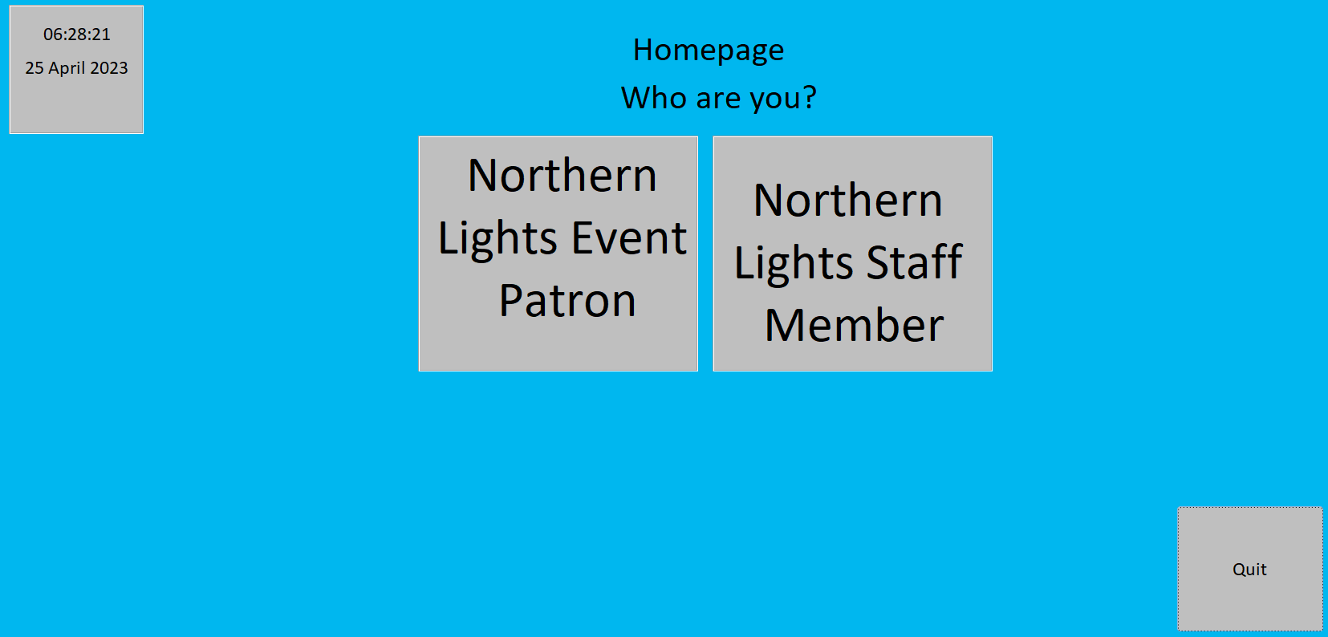
Click which user you are, and you will be greeted by one of two pages. I’ll begin by taking you through the Event Patron page.
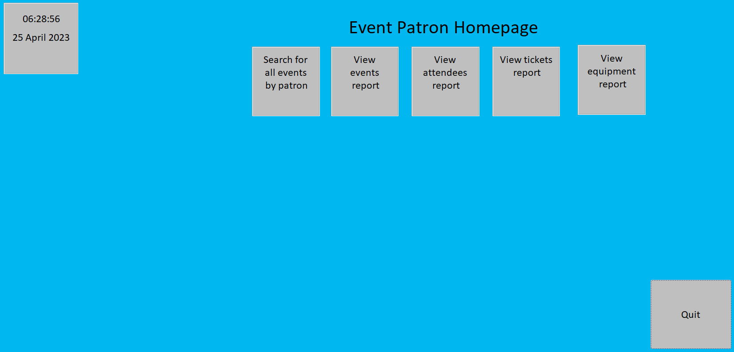
The Event Patron homepage gives you access to search for all events by a patron and gives you access to a few reports, clicking on one of the reports will greet you with a report filled with information that will look something like this one, this one below is the Events report.
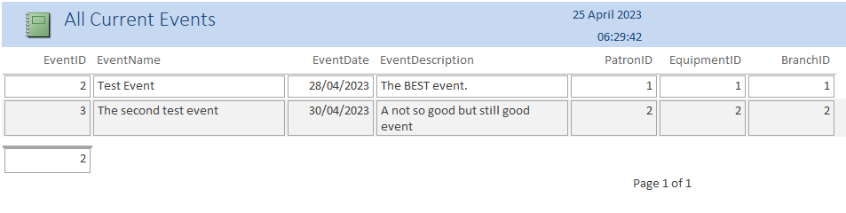
If you decide to search for all events by a patron, assuming you are a patron it will be yourself, you will be asked for a patron ID. We will use patron ID number 1 for this example.
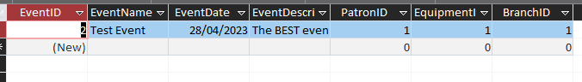
This will return all events by the specified patron, in this case patron ID number 1 has requested for event ID number 2 to be setup and ran and the date, a description of the event, the name of the event, what equipment is needed and the branch organising the event is shown.

Next, we will go through the staff page. If you click ‘Northern Lights Staff Member’, you will be greeted by this page.
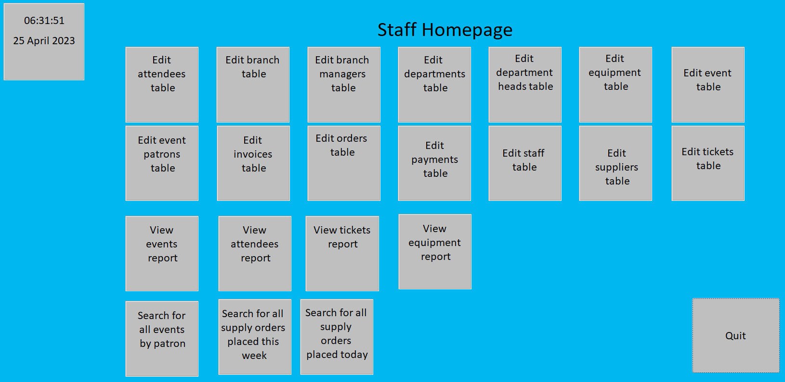
Any of the ‘Edit’ buttons will take you to a form that will allow you to edit, remove or add new records to the table you clicked on; for example, we will click on the ‘Event’ table.
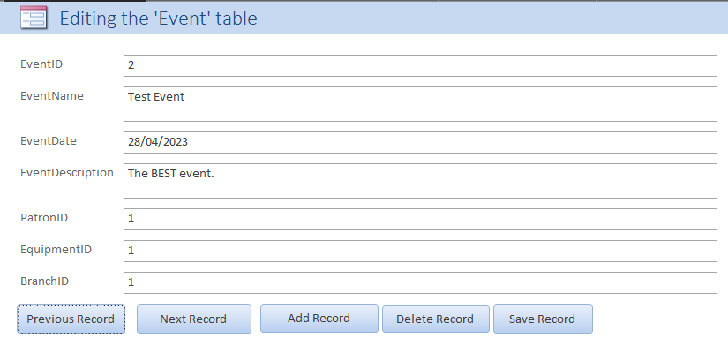
This will return results from the ‘Event’ table. On this form you can view previous or next records, add a new record, delete the current record or save a record once you have finished editing it. To edit a record, navigate to the record you wish to edit and change what you need to and press ‘Save Record’.
If you chose to view a report or use a query, this will work the same as it would on the event patron page as stated above.

