
UNIVERSITY OF WALES TRINITY SAINT DAVID
Name: Abdul Rahim
Student ID : 2210095

Demonetization of India in 2016: Impact on Common People and Companies

Master’s Degrees by Examination and Dissertation
Declaration Form.
1. This work has not previously been accepted in substance for any degree and is not being concurrently submitted in candidature for any degree.
Signed…….……………………………………………………………………...
Date ………………………………………………………………………………...

2. This dissertation is being submitted in partial fulfilment of the requirements for the degree of Master in Business Administration.
Signed……………………………………………………………………….
Date………………………………………………………..…………...
3. This dissertation is the result of my own independent work/investigation, except where otherwise stated.
Other sources are acknowledged by footnotes giving explicit references.
A bibliography is appended.
Signed candidate: Abdul Rahim……………………………….……………….
Date: …………19/10/2022………………………………………….……………………….

4. I hereby give consent for my dissertation, if accepted, to be available for photocopying, inter- library loan, and for deposit in the University’s digital repository
Signed (candidate)…………………Abdul Rahim…………………….………….…………...
Date……………………19/10/2022…………………………….…………….……………..
Supervisor’s Declaration.
I am satisfied that this work is the result of the student’s own efforts.
Signed: ………………………………Jia Miao…………………………………………..
Date: …………………………………19/10/2022…………………………………………...
Abstract

Demonetisation in India was a sudden withdrawal of legal currency on 8th November 2016, aiming towards the economic betterment of the country and public life. Despite well-promoted promises and aims, the consequence of demonetisation affected the public life of India, and the organisational practices were also affected due to it. The financial cycle of the country faced multiple difficulties due to the ban on currency and MNCs and SMEs of the country faced socioeconomic and sociocultural issues, due to which supply chain management was affected by several adversities. The research has portrayed a detailed discussion of the consequences of demonetisation in India in 2016, and how people and organisations cope with it after an overnight announcement.
Acknowledgement
I am thankful to my guide for providing me ample opportunities to conduct the study with academic acts and activities, and I am also thankful for the kind and considerate attention to the entire research work. I am thankful for the assistance and care I received for data collection and analysis. I am also thankful to my classmates and friends for their friendly support and guidance to me to conduct the research as per the aims and objectives.

Table of Contents
Chapter 1: Introduction 7
1.1 Background of the Study 7
1.2 Research Rationale 7
1.3 Aims and Objectives 8
1.4 Research Questions 8
1.5 Literature Review 8
Investigating the immediate and long-term effects of demonetization on common people’s financial behaviour 8
Examining the obstacles that enterprises, whether large or small, face during unexpected cash withdrawals 9
Comprehending the efficacy of demonetization in fulfilling its stated objectives 9
Discovering coping techniques used by individuals and businesses to navigate the financial crisis 10
Research Gap 11
Summary 11
1.6 Brief Methodology 11
Research Strategy 11
Data Collection Method 12
Data Analysis 12
Research Philosophy 13
Ethical Considerations 13
Limitations 13
1.7 Summary 13
Chapter 2: Literature Review 14
2.1 Introduction 14
2.2 Immediate and long-term effects of demonetisation on Indian Citizens 14
2.3 Obstacles that enterprises, faced during unexpected cash withdrawals during the demonetisation of India in 2016 18
2.4 Efficacy of Demonetisation 20
2.5 Coping Techniques of the People and Business of India 24
2.6 Literature Gap 27
Chapter 3: Methodology 28
3.1 Introduction 28
3.2 Research Philosophy 28
3.3 Research approach 28
3.4 Research Strategy 29
3.5 Data Sampling 29
3.6 Data Analysis 30
3.7 Ethical Consideration 30
3.8 Research Timeline 31
Chapter 4: Findings 33
4.1 Introduction 33
4.2 Thematic Analysis 34
4.2.1 Economic disruption for the demonetization of India in 2016 34
4.2.2 Digital adoption for the demonetization of India in 2016 35
4.2.3 Real estates and Gold Markets during the Demonetization of India 40
4.2.4 Impact of corruption and black money during the demonetization of India 41
4.3 Discussion 46
4.4 Conclusion 48
Chapter 5: Conclusions and Recommendations 49
5.1 Recommendations 49
5.2 Conclusions 50
5.3 Research Limitations 52
5.4 Future Opportunities of the Research 52
References 53
Appendix 58

Chapter 1: Introduction

1.1 Background of the Study
Demonetization was a historic economic move made by the authorities of India in 2016 to tackle black money, forged currencies, as well as corruption. On November 8, 2016, the Indian government, led by Prime Minister Narendra Modi, announced the abrupt discontinuation of 500 and 1,000 denomination notes of currency, amounting to nearly 86% of the country's total amount of cash in circulation. This measure was intended to enhance the economy through the Internet, increase tax compliance, as well as disrupt illegal financial activities (Beyes and Bhattacharya, 2017). The aforementioned phenomenon had a substantial influence on conventional enterprises, compelling them to adjust their operations in order to include digital payment mechanisms. Moreover, the administration emphasised the possible advantages of demonetization in mitigating the funding of terrorists, since it would make the passage of illegal cash via the legitimate banking system more arduous. Nevertheless, the execution of demonetization also gave rise to a multitude of obstacles. The abrupt discontinuation of high-value banknotes led to an instantaneous scarcity of cash, leading to extensive line-ups at financial institutions and automated teller machines (ATMs) nationwide (Singh, 2022).

1.2 Research Rationale
According to the study's background information, the historic demonetization step in India in 2016 provides a rich and complicated picture that needs further investigation and analysis. This research proposal aims to thoroughly evaluate the effectiveness of demonetization in accomplishing its stated purposes via this study. This research provides a deeper picture of the policy's impact on the macroeconomic environment by examining economic metrics like GDP growth, inflation rates, and tax compliance. Demonetization's social implications, notably those in the unorganised economy and those with lower incomes, also call for careful study. The impact of the abrupt cessation of notes in circulation on consumer behaviour, livelihoods, and financial inclusion will be looked at in this research (Duvendack et al., 2023).
By conducting polls and interviews with people who will be personally and professionally affected, we can comprehend the human effect of this policy shift. Policymakers may better design future methods for addressing problems connected to black money, corruption, and financial transparency by determining the benefits and drawbacks of demonetization. This study intends to give a comprehensive evaluation that may guide future decision-making processes and contribute to the larger discussion on economic reforms and their effect by examining their economic, social, and policy components.

1.3 Aims and Objectives
This research aims to look at the consequences of India's demonetization program in 2016 on regular residents and companies. The objectives are as follows:
- To investigate the immediate and long-term effects of demonetization on common people's financial behaviour.
- To examine the obstacles that enterprises, whether large or small, face during unexpected cash withdrawals.
- To comprehend the efficacy of demonetization in fulfilling its stated objectives.
- To discover the coping techniques used by individuals and businesses to navigate the financial crisis.

1.4 Research Questions
RQ.1: How did the unexpected demonetization policy affect regular folks' daily lives and banking transactions?
RQ.2: What were the main obstacles that businesses in various sectors faced as a result of the rapid currency withdrawal?
RQ.3: Did demonetization work to reduce black money and promote a digital economy?
RQ.4: What ways did individuals and businesses use to alleviate the negative consequences of demonetization?

1.5 Literature Review

Investigating the immediate and long-term effects of demonetization on common people’s financial behaviour
Unquestionably, demonetization has had an impact on how Indians behave financially daily. As a result of individuals being compelled to utilise electronic payment methods because there was not enough actual money to go around, there was a sudden rise in digital transactions. Pazarbasioglu et al.’s research from 2020 showed that this early move towards digital payments was not just a reaction to need but also potentially a driver for advancing financial inclusion and a less cash-based economy.
It is essential to bear in mind that not all of these alterations were enduring in nature. Bhandari and Soni (2019) observed a shift back to cash-based transactions after the first surge in digital transactions. This demonstrates the durability of conventional financial practices and implies that without consistent efforts to advance digital financial literacy and infrastructure, the effect of demonetization on altering these practices may be limited.

Examining the obstacles that enterprises, whether large or small, face during unexpected cash withdrawals
During the moment of abrupt demonetization, companies, particularly small and medium-sized ones, faced severe obstacles. Bhanot and Gupta (2018) noted that these companies, which often depend significantly on cash transactions, found it difficult to adjust to the unexpected cash shortage. Across industries, supply chain snarls, payment snafus and even layoffs were reported. This emphasises the necessity for a more measured and cautious approach when putting into practice such broad economic policies.
The sudden implementation of demonetization posed significant issues for corporations, namely those categorised as small and medium-sized enterprises (SMEs). Nan and Park (2022) emphasised that firms reliant on cash faced significant challenges in adapting to the unforeseen shortage of cash. Multiple industries had interrupted supply chains, disparities in payment, and even cutbacks in labour. This emphasises the necessity for a prudent and deliberate strategy when implementing comprehensive economic measures in order to mitigate such extensive disruptions.

Comprehending the efficacy of demonetization in fulfilling its stated objectives
Demonetization has generated a lot of discussion on its success in attaining its goals. According to research by Bose (2017), the policy's main objective of eradicating black money was not met since a sizeable amount of the demonetized cash returned to the established banking system. Additionally, the ensuing slowdown in GDP growth suggested probable short-term negative effects on the economy.
The achievement of demonetization's goals has sparked significant controversy, leading to intense scholarly discourse. In the opinion of Balamurugan and Saravanan (2023), there was a notable deficiency in accomplishing the primary objective of the programme, which was to eliminate illicit funds, since a substantial proportion of the demonetized currency found its way back into the official banking system. Moreover, the ensuing decrease in GDP growth has exacerbated worries about possible negative effects on the entire economy in the near term.

The discrepancy between the desired outcomes and the actual outcomes emphasises the difficulties involved in putting these extensive economic plans into practice.

Discovering coping techniques used by individuals and businesses to navigate the financial crisis

After demonetization, a severe financial crisis developed, forcing people and companies to come up with different coping mechanisms. According to Gupta and Sengupta (2018), people's reactions to the crisis were marked by an unpredictable combination of financial behaviours. People used a variety of techniques, including a mix of digital transactions along with dependence on informal networks to secure ongoing access to cash, to manage the difficult environment. This adaptive behaviour highlights the fortitude of ordinary individuals in the face of difficulty. The need for enterprises to minimise interruptions led to the investigation of novel solutions. Credit-based network transactions became a notable strategy in this environment, enabling enterprises to continue trading despite the current financial limitations.
Additionally, some enterprises resorted to the revival of barter systems, reflecting their resourcefulness in finding alternatives to conventional monetary exchanges. These strategic manoeuvres underscore the creative ways in which businesses sought to maintain operations and stabilize their financial positions.
In sum, the aftermath of demonetization instigated a multifaceted response to the financial crisis, where individuals and businesses demonstrated adaptability and resourcefulness. This complexity in coping mechanisms showcases the diverse ways in which various stakeholders navigated the challenging environment brought about by the policy change.
Demonetization caused a financial upheaval, but people responded with astonishing adaptation by diversifying their financial endeavours. Lines et al. (2022), noted that some people used community-based loans and local savings clubs in addition to digital transactions and unofficial networks to get around the lack of real cash. Businesses also used creative survival strategies, such as working together within their ecosystems for credit-based transactions, exhibiting their adaptability and ingenuity in the face of the abrupt legislative shock.

Research Gap
Although the literature analysis offers a thorough comprehension of the immediate and long-term impacts of demonetization on the financial behaviour of people and the operational aspects of enterprises, there exists a deficiency in comprehending the intricate interaction between these effects. There is a dearth of scholarly investigation about the impact of coping strategies utilised by people and enterprises on the wider economic milieu.

Summary
The literature review illustrates the many ways that demonetization has affected consumer financial behaviour and business operations. By investigating the extensive effects of demonetization on individuals, businesses, along the economy, this research intends to address the imbalances already in place while also shedding light on the intricate dynamics of economic transformation and its real-world effects.

1.6 Brief Methodology

Research Strategy
The present research has been conducted with the help of secondary research sources. With the help of the previously published articles and other publications, the research has been conducted. The research has been followed with the help of an inductive research approach which will help to analyse the quantitive data and information.

Data Collection Method
A thorough approach to gathering secondary data will be used in order to guarantee the validity of the study's conclusions. Using this approach, the emphasis will be on acquiring precise information that is directly related to the goals of the study. Gathering the data from the online databases will be the main method used to gather data because they have been shown to be effective in gathering a variety of opinions and insights from the target audience. The secondary data and information will be gathered with the help of various data sources on the internet such as Google Scholar, IEEE, Research Gate and ProQuest. Additionally, sources such as Statista and other statistical websites will also be employed in the research. These data and information are quite reliable and trustworthy (Lemon et al., 2020).

Data Analysis
Quantitive data analysis technique is the process which has been taken in order to conduct the present research. From this data, the researchers will draw important narratives that will illuminate the consequences of the demonetization on common people and businesses (Braun and Clarke, 2023). The obtained data will be meticulously examined as part of the quantitive analysis process in order to spot recurring statistics and significant findings. Researchers want to uncover compelling stories from the data that will provide readers with a thorough grasp of how demonetization has affected both people and companies. This analytical strategy will make it easier to extract important findings that provide insightful perspectives on how the policy affects businesses and common people (Keshri et al., 2022).
This examination will cover several major statistics. The focus will be on alterations in financial behaviour, revealing changes in patterns of saving, investing, and spending as a result of the demonetization step. Additionally, corporate concerns will be investigated in order to give insight into the difficulties experienced by firms, potential interruptions in supply chains, and methods used to negotiate the current economic climate. Another significant issue will be the adoption of digital financial services, which will illustrate how far consumers and businesses have gone in adopting digital transactions. The study will also go into the subject of black money and how the policy affected its flow. Finally, the analysis will take into account broader public opinion to determine how the population feels and how they perceive the demonetization programme (Braun and Clarke, 2023).

Research Philosophy
The interpretivism approach accepts that subjective perceptions and meanings impact social realities. This approach is consistent with the research objectives since it provides for a more in-depth knowledge of individuals' and businesses' experiences and reactions to the demonetization program. This approach will provide significant insights into the various ways in which demonetization affects people's lives and business operations by focusing on individual perspectives and contextual elements (Alharahsheh and Pius, 2020).

Ethical Considerations
When using secondary sources, always keep ethics in mind. First, researchers need to ensure the privacy of the data. The authors of the selected publications have been properly credited. To credit them, the research has used the Harvard style citation throughout the whole research (Husband, 2020).

Limitations
Despite its strengths secondary research comes with limitations. It can be time-consuming and resource-intensive to collect, process, and analyze secondary data. Sampling bias is a potential issue, as the sample might not fully represent the entire population due to selection biases. The data collection process could also be influenced by subjectivity, impacting the objectivity of findings and availability. Additionally, secondary sources can be problematic as the information might be outdated. Lastly, secondary research might lack the latest context or broader perspectives, limiting the understanding of long-term trends. Recognizing and addressing these limitations is crucial to interpreting the findings accurately and drawing meaningful conclusions from the secondary data collected (Hill et al., 2020).

1.7 Summary
The purpose of this study is to expose the complex impact of the 2016 demonetization on ordinary Indians and enterprises. The study tries to provide a nuanced understanding of the obstacles, coping mechanisms, and results that occurred in the aftermath of this unusual legislative action by using secondary data analysis, quantitive analysis, and an interpretivism approach.

Chapter 2: Literature Review

2.1 Introduction
Demonetisation refers to stripping the face value of a currency and its acceptable status in an economy and devaluing its legal tender (Ananthajothi et al. 2022). Withdrawal of the existing forms of a currency and its wide use is programmed by the governmental bodies, and as a replacement, new coins or notes are endorsed in a demonetised economy. According to Sivathanu, (2019), it is a drastic intervention, which affects conventional public life and the business activities followed. Economic chaos is created due to demonetisation, and the intrinsic practices throughout the economy are lost due to sudden changes and modulations. On the other hand, Viswanathan et al. (2021), argue that the initiative of remonetisation is simultaneously programmed by the government to protect the national interests and public life, and the legal proceeding is an immediate act. Rajagopalan, (2020), refutes the argument by identifying the menace in public monetary practices that are derived from demonetisation, and the report further identifies the national instabilities that affect the transparent notion of economic programmes. India, the largest democracy in the world and a rising economy experienced demonetisation in 2016, and professional and personal practices faced multiple obstacles.
The chapter of the study will analyse different aspects of demonetisation faced by India in 2016 and the long-term effects of the sudden announcement. The consequences of the unexpected withdrawal and the coping techniques utilised by individuals and institutions will also be evaluated.

2.2 Immediate and long-term effects of demonetisation on Indian Citizens
According to Wu et al. (2022), a sharp fall in GDP was observed in the case of the Indian Economy, which created issues in the daily public life of Indian citizens and market programmes. Being a third-world country, India has faced the disintegration of social practices and monetary distribution in a fragile manner. The downfall of GDP affected the middle class and lower economy, as their purchasing capacity suddenly became limited. As the people were not ready to accept the sudden transition of the economy, their daily lives were pushed into deep trouble water. On the other hand, Roy, (2019), mentions that the commercial integrity of SMEs was affected due to demonetisation and later, the introduction of the “Goods and Services Tax” hindered their traditional growth. The drastic changes in the economy forced the liquidity sucked out of SMEs, which affected their business outlook on a significant scale. The report also mentions that institutional damage was further observed in the case of market programmes and business activities, while the security of business was questioned due to stakeholder issues. The maximum economic burnt was borne by the SMEs, and their commercial relationship with customers was affected severely.
The chart observed in Figure 1, refers to the changes in GDP growth in India. It can be observed from the chart that in 2016-2017, the GDP growth of the country was observed at 8.3%, which reduced to 7.3% in 2020-2021. The loss of GDP impacted the daily life of India on a significant scale, as the power of purchasing dropped, and the country was forced into trouble regarding commercial preferences and programmes. The dilemma led to public life difficulties and the economic settlements that were aimed by the act of demonetisation did not happen as promised or estimated. Moreover, the downfall of GDP affected foreign investment in the country, as well.
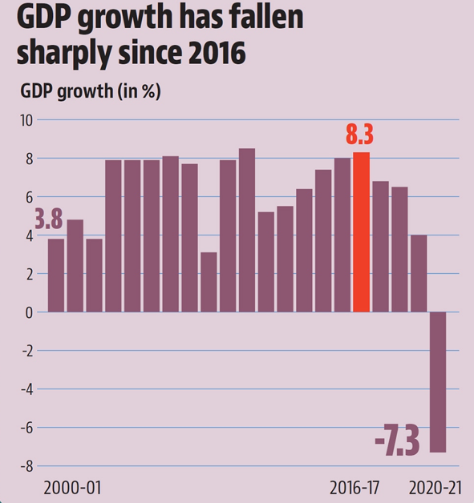
Figure 1: Fall of Gross Domestic Product
Source: Wu et al. (2022)
As Fouillet et al. (2021), mention the rural life of India faced economic devastation due to the nationwide announcement of demonetisation, and the banking activities in the rural areas faced different hindrances due to the breakdown of the conventional trajectory. The report portrays that between 2017 and 2019, the rural lifestyle came across significant hindrances due to monetary issues, and the banking methods lost the usual status quo. It is observed from the report that the downfall of money lending amounts by different banks led to the severity of the problem and the rural infrastructure failed to accept different changes put forward by the government to create opportunities for people. Kim et al. (2022), mention that the emergence of urbanisation in India is not as progressive as changing the course of the economy and lifestyle in rural areas, while the economic pressure created by demonetisation made the situation more critical. Between 2017 and 2019, as per the report, the rural market was hit by scorching inflation and farming practices were affected on a major scale. The outcomes created chaos and tension among people as their livelihoods were restricted due to demonetisation and its consequences.
The chart depicted below refers to the slow lending by Indian banks in rural India, and in this regard, two definite timelines have been considered, including the second half of 2016 and the second half of 2017. It can be observed that in FY 2016, the nationalised banks used to lend money to the rural population of the country by 13.3%, which decreased to 0.5% between September 30 2016 to March 31 2017. On the other hand, it can also be observed from the chart that SBI and its associates lent money at 13.7% in FY 2016, and due to monetisation and its severity regarding banking activities, a downfall to 0.6% affected the traditional money lending procedure. However, in the case of private banking, the downfall was observed in a vivid way, and the statistics show that lending led to 14.6% in FY 2017 from 28.4%.

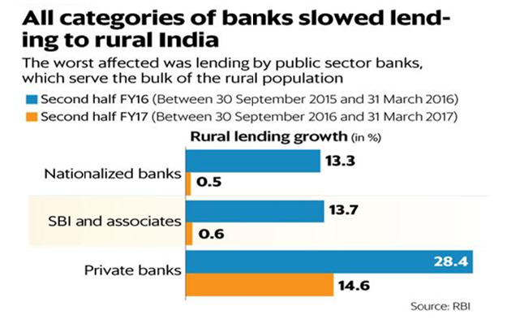
Figure 2: Slow Lending by Banks in Rural India
Source: Fouillet et al. (2021)
The hope of purging unaccounted cash as aimed by demonetisation was extinguished as in 2017, the budgetary session stated the failure of demonetisation to act as per the objectives. According to Singh and Ghosh, (2021), a steady downfall of the market in the rural and urban scenarios was observed due to the lack of market practices and business programmes, and the lack of resilient economic manners affected the infrastructure of the country, while the changes made forward with long-term effectiveness failed to propagate any further hope for the common people. The report states that the rural growth of India fell by 8.9% in the demonetised economy of India, and the lower economic class became the first victim of it. The ardent moves that were propagated by the government did not work as per the aims and objectives, and the security of public life also came into trouble. The lack of sincerity and awareness among people limited the practice of digital banking, as remonetisation was not an immediate step endorsed widely by the government. Raut et al. (2021), argue that the increasing notion of digital banking and transactions became a prominent key to the successful notion of demonetisation in India. Viswanathan et al. (2021), strongly counter the statement by identifying the limited availability of digital banking in India in 2017-2018, especially in rural areas. However, the report also mentions that the elasticity of economic practices lost substantial efforts, which led to the scenario of disagreement between the people and the government, and nationwide foliage of the incapability of institutions and governmental bodies came into the daylight.
Singh and Ghosh, (2021), mention that public life was further hindered as the cash circulation in the country dropped on a significant scale. According to the report, in 2015-2016, currency in circulation was observed as 12.1% of the country’s nominal GDP, which dropped to 8.7% in 2016-2017. On the other hand, the banking system struggled to put the cash back into the system due to demonetisation. Though digital practices increased in the post-demonetised market of the country, the reformation of economic values and market promotions were affected since the ratio between nominal GDP and cash circulation moved higher. However, Kim (2022), argues that the digital literacy and economic literacy of the country were moved slightly high in the post-demonetised economy, but that is not enough to change the Indian economy as per the expectations and hopes estimated by demonetisation and relevant practices.

2.3 Obstacles that enterprises, faced during unexpected cash withdrawals during the demonetisation of India in 2016
This investigation by Wu et al. (2022) focused on the impact of the Indian government's demonetization initiative on micro, small, and medium-sized enterprises (MSMEs). Micro, small, and medium-sized enterprises (MSMEs) play a crucial role in fostering an entrepreneurial mindset and accelerating the innovation process because of the opportunities they provide to individuals and the development they contribute to the overall economy. Small and medium-sized businesses (also known as SMEs) must make constant and proactive modifications to the environment in order to maintain a competitive advantage, as the business landscape is constantly changing and becoming more dynamic.
To effectively address emergent opportunities and hazards, it is essential to foster innovation. In today's ever-changing business environment, businesses that do not think creatively and pursue continuous development will falter. In the past several years, India's utilization of technology and implementation of demonetization regulations have undergone significant transformations. In response to this new development, businesses of all sizes are adopting precautionary measures. Nonetheless, Rajamohan et al. (2019) mentioned that it is critical to acknowledge that the pervasive adoption of this strategy has led to the demise of numerous organizations.
It cannot be disregarded the gravity of the situation. The overarching objective of the study is to gain insight into how business proprietors have adapted to the effects of demonetization and technological advancement. After currency demonetization, numerous micro, small, and medium-sized enterprises (MSMEs) have obtained success by proactively employing innovative strategies (PS and Parikh, 2022). According to the research conducted by Fouillet et al. (2021), the number of officially registered micro, small, and medium-sized enterprises (MSMEs) has increased dramatically. In order to deal with the complications and repercussions of this economic policy shift, they have implemented process innovations in response to demonetization. In an endeavour to reduce costs, an increasing number of companies are adopting technological solutions. There has been an increase in the number of businesses that rely on technology not only for financial transactions but also for design processes and other administrative responsibilities. This study aimed to examine the potential effects of an automated monetary policy on the MSME sector in India. By analyzing how this regulation has impacted SMBs, we hope to gain a better understanding of the potential repercussions of the pervasive adoption of digital transactions in this industry. This study's primary objective is to forecast the reaction of India's MSMEs to the transition to a cashless economy. The research's primary objective is to shed light on the potential effects of the transition to a digital economy on these companies.
In an increasingly electronic world, micro, small, and medium-sized enterprises face unique challenges that are examined by Ahmed and Sur (2021). In addition, potential solutions to these issues are provided. These outcomes are the result of an evaluation of secondary data that underwent rudimentary statistical processing. This study's primary purpose is to evaluate the economic impact of the current policy of demonetizing MSMEs. A denomination of currency is "demonetized" when the government determines that it is no longer legal tender. The purpose of this study is to provide a quantitative evaluation of the effects of demonetization on micro, small, and medium-sized businesses across a spectrum of economic variables. For this investigation, descriptive research methodologies will be used to collect data. More than fifty secondary sources (publications, journals, and studies) provided the information for this study.
As Ahmed and Sur (2021) demonstrate, SMEs are playing an increasingly important role in the endeavours of many developing nations to reduce poverty and unemployment. It is anticipated that demonetization will have far-reaching effects across many industries. Capital-intensive industries and businesses would be the most severely affected. This analysis of demonetization's effects on the Indian economy concentrates on the automobile industry, the pharmaceutical industry, agricultural, and the consumer market. Especially when they are founded in underdeveloped regions, micro, small, and medium-sized enterprises (MSMEs) play an essential role in assisting to remedy regional inequalities. Small and medium-sized businesses' participation in the economy of a developing nation may be extremely beneficial.
As per Viswanathan et al. (2021), when MSMEs are established in economically depressed regions, they serve to address regional inequities by creating new employment, encouraging new forms of entrepreneurship, and bolstering current economic activities. The local unemployment rate has decreased and the average family income has risen as a result of the presence of these enterprises. Not only do MSMEs assist local economies, but they also encourage citizens to take initiative and perhaps establish their own businesses using the skills they have gained from MSMEs. The value of micro, small, and medium-sized enterprises (MSMEs) in enhancing economic opportunities in underdeveloped regions is widely recognized. Khadi and rural businesses are examples of micro, small, and medium-sized enterprises (MSMEs). Numerous data indicate that these companies consistently offer some of the highest rates of new employment opportunities.

2.4 Efficacy of Demonetisation
When the transfer initially started, people hurried to trade in their old money for the new one, sending the economy into a spiral. The widespread cash shortage brought on by the dramatic rise in demand for foreign money had a negative impact on a variety of economic sectors. As per Deep (2022), proponents of demonetization point to the widespread use of digital transactions and the huge drop in the movement of illegal money as proof that the program is working as intended. The destruction of huge sums of cash stored outside the legitimate banking system is seen as a major factor in how demonetization has helped reduce illegal financial activity. The program aimed to discourage the shadow economy and the amassing of unexplained riches in order to foster more transparency and accountability in monetary dealings. Proponents of the policy argue that it sped up the shift to a cashless digital economy. Contactless options, like mobile wallets and Internet banking, have become essential for doing business in the wake of demonetization. As more people switch to using digital payment methods, we should expect to Official data show that the number of digital transactions increased dramatically in the days and weeks after demonetization began. Due to the sudden and widespread lack of real cash, people and companies were likely forced to expand their dependence on digital transactions (Mandala and Mohanty, 2019).
As per the statistical records submitted by Das (2019), 958 million digital transactions in December 2016, 2016 broke the previous record established in November. The demonetization drive has a dramatic impact on the national economy and is partly responsible for the parabolic growth in digital transactions. Fewer people used electronic payment methods before the demonetization process. Customers moved their attention to digital channels for financial transactions once this rule went into effect. The revolutionary impact that demonetization has had on the economy as a whole is directly responsible for this massive growth in digital transactions (Kulal, 2022).
The aforementioned policy shift was enacted with the primary goal of decreasing the circulation of "black money," or untaxed riches. But there's a wide range of opinions on whether or not this tactic helped root out black money. By supporting the above factors, Prasad et al. (2023) mentioned that the method proposed included demonetization, or the removal of specific currencies from circulation, to stem the flow of illegal monies. This operation was planned to force people hiding their wealth to come out or face dire repercussions, and to undermine the crooked financial system. Supporters of the idea claim it has considerably cut down on the movement of illegal cash. According to news accounts, tensions escalated and prompt action was taken when bills with high denominations went missing. Several sources say that a significant portion of the demonetized cash has been deposited back into financial institutions. This incident has seriously undermined confidence in the policy's capacity to identify illegal payments. It is critical to address the concerns raised, especially on behalf of people who lack even basic access to digital infrastructure, in light of these challenges (Kandpal et al., 2019).
This issue has been extensively discussed and examined by both academics and the general public. The present state of inequality in society has been met with severe criticism. Unforeseen consequences of the recent push toward digitization include the establishment of a digital divide between people with and without consistent access to the internet and a shortage of resources to address the digital skills gap. This disparity is especially noticeable among certain racial and ethnic groupings, particularly in economically disadvantaged areas and rural areas (Sutar et al., 2022). They struggle to meet their most basic needs including nutrition, clothing, housing, medical treatment, and access to the Internet.
According to Benjamin and Banu (2019), the widespread use of digital wallets and the substantial growth in the usage of digital payment systems are only two examples of the far-reaching consequences of demonetization legislation on the digital economy. Especially in terms of money transfers and individual financial management, the digital world will be profoundly affected by the massive shift from paper currency to electronic payment systems. Since the government initiated the process known as "demonetization," more individuals than ever have turned to using digital payment systems. Digital payment methods became more popular as individuals sought alternatives to utilizing actual cash owing to its scarcity. The rise may be largely attributed to the simplicity and security offered by online currency exchanges. The transition to digital wallets occurred at a rapid pace after demonetization.
E-wallets, also known as digital wallets, are rapidly replacing traditional payment methods like credit cards and cash at both brick-and-mortar stores and on the Internet (Maity and Ganguly, 2019). The government's recent initiatives to promote online business have met with great success. Significant progress has been made in this direction with the advent of the Unified Payments Interface (UPI) and the widespread usage of mobile wallet apps. The rise of online trade calls for a thorough analysis of how people are using computers and other digital devices throughout the country. It's crucial to take larger tendencies in the use of digital technologies into account when thinking about the meteoric growth of digital transactions.
On the other hand, Lahiri and Deb (2022), when taken together, these two factors allow for a more nuanced comprehension of the results and repercussions of the proliferation of digital transactions.
India's demonetization effort in 2016 had a mixed record in terms of its anticipated objectives. There has been a lot of talk about "black money" and other types of illegal cash since the advent of digital transactions brought the issue to light. The far-reaching ramifications of this legislation on the unveiling of hidden riches and the development of a robust digital economy are still hotly contested among academics and businesspeople. It is important to examine both short-term and long-term implications when assessing a policy's influence on India's economy. According to Aparna and Ashok (2022), policymakers and analysts may have a better understanding of the ramifications at hand by keeping these two things in mind. Short-term disruptions may be understood by looking at how the policy has affected certain economic sectors in India.
The majority of the invalidated amount was placed back into banks, according to data from the Reserve Bank of India (Rajamohan et al., 2019). Total invalid notes returned amounted to Rs 15.41 lakh crore, for a sum of Rs 15.31 lakh crore. Former finance minister Piyush Goyal claimed to Parliament in February 2019 that Rs 1.3 lakh crore in black money has been recovered as a result of demonetisation and other anti-black money operations.
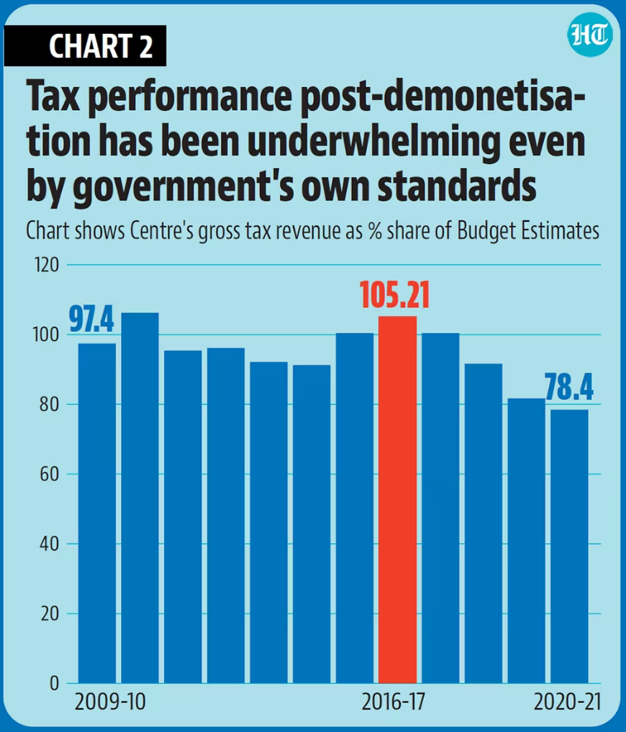
Figure 3: Tax Performance: Post Demonetization
Source: hindustantimes.com (2021)
The government estimated that between Rs 3 and 4 trillion in unaccounted-for black money will be eliminated as a result of the demonetisation process. The data shows that demonetisation did not succeed in revealing black money in the system. Meanwhile, the confiscation of illegal cash is still rather routine. The RBI reports that in FY22, counterfeit circulation of the Rs 10 note rose by 16.45 per cent and counterfeit circulation of the Rs 20 note rose by 16.48 per cent. There was an 11.7% rise in counterfeit Rs 200 notes. According to the numbers, the number of uncovered fake Rs 50 notes decreased by 28.65 per cent and Rs 100 notes decreased by 16.71 per cent between 2016 and 2018. The Reserve Bank of India only found 6.9% of them; the other 93.1% were found in other banks.
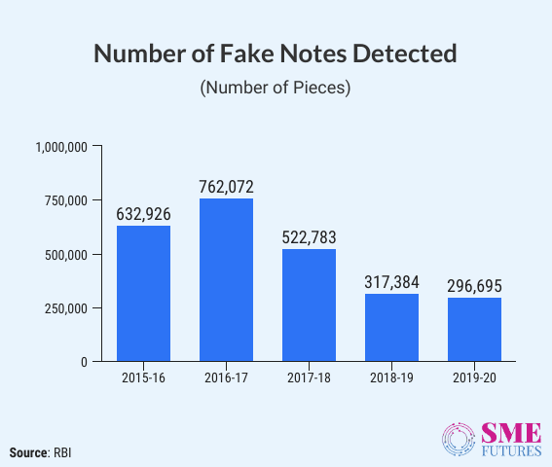
Figure 4: Number of Fake Notes detected
Source: Sai Soundarya et al. (2021)
In 2016, the same year that demonetisation was introduced, 6.32 million counterfeit notes were found and subsequently recovered. The Reserve Bank of India estimates that between 2014 and 2018, the government of India seized around 18.87 lakh counterfeit notes of different denominations. In the three years after demonetisation, the counterfeit Rs 100 note accounted for the greatest percentage of all notes confiscated: 1.7 lakh in 2019-20, 2.2 lakh in 2018-19, and 2.4 lakh in 2017-18. According to RBI data, the circulation of counterfeit Rs 10 notes increased by 144.6 per cent, counterfeit Rs 50 notes increased by 28.7 per cent, counterfeit Rs 200 notes increased by 151.2 per cent, and counterfeit Rs 500 [Mahatma Gandhi New Series] notes increased by 37.5%.

2.5 Coping Techniques of the People and Business of India
After demonetization, it became obvious that most people and businesses would rather transact with digital currency. As a result, mobile payment systems like app-based wallets and internet banking are gaining popularity. There has been a recent proliferation of mobile and web-based payment applications like Paytm, Google Pay (formerly known as Tez), and PhonePe. The widespread use of digital payment methods, the growing acceptance of mobile banking, and the convenience offered by these platforms all play a role in this remarkable increase. These networks' position inside the digital payment infrastructure has grown as the adoption of contactless payments has increased. The number of companies using the company's electronic payment processing services has grown as a direct consequence of this. Mobile wallets and other forms of prepaid payment have seen a significant uptick in usage, according to data from the Reserve Bank of India (RBI). From 28 million in October 2016, a whopping 88 million were completed in December of the same year using these same means. The findings shed light on the fast-developing mobile wallet and prepaid payment option markets in India.
Contactless payment solutions are being promoted by a number of companies as a method to expedite corporate processes and boost consumer satisfaction. Promotional pricing and incentives are limited to those who pay online. Businesses have a vested interest in encouraging the widespread usage of credit cards and debit cards since doing so increases their profits. Possibilities include higher productivity with fewer resources, reduced costs, improved workplace safety, and satisfied clients. A growing number of companies are rewarding customers who have completed the transition from paper checks to digital wallets with special discounts. Discounts are often offered to customers who pay using contactless cards or mobile devices. When clients pay using a digital payment system, businesses often give them a discount. Customers' dislike of using cash has paved the way for the elimination of physical money. Restaurants and stores often provide discounts and other perks to consumers who pay with their smartphones or online wallets. This strategy, which aims to increase consumer loyalty and profits, relies heavily on the convenience and widespread use of online shopping. These companies are rapidly resorting to digital payment systems in an effort to attract and maintain a bigger number of customers who have different payment preferences and habits than in the past. In the data we examined, the aforementioned change was plain to see. The Reserve Bank of India (RBI) reports that between October 2016 and December 2016, the number of retail e-payments increased substantially. The number of transactions increased in December 2016 from the 67 million recorded in October 2016 to the 98 million recorded for the whole year. During the study's time frame, the prevalence of electronic payment methods in the retail sector increased considerably.
In recent years, businesses, particularly those located in major metropolitan areas, have rushed to install point-of-sale (POS) terminals that accept credit cards. This technological advancement is great news for business owners and their clients since it streamlines the transaction process. POS devices have swiftly been adopted by a significant number of businesses as a result of the many benefits they provide and the increasing need for contactless payment solutions in today's digital environment. Customers may use cards for a broader variety of purchases than ever before, reducing or even eliminating the requirement for cash transactions. The Reserve Bank of India (RBI) reports that during the period of only two months, the number of POS terminals used by banks throughout the country increased dramatically. For instance, there were 1.45 million point-of-sale terminals as of October 2016, but this number had climbed to 2.34 million by December of the same year. During the time period analyzed here, financial institutions increasingly used point-of-sale terminals.
The proliferation of e-commerce platforms may largely be attributed to the increasing number of consumers who would rather make uncomfortable purchases using digital currency. The number of online purchases has exploded in recent years, according to statistics from this industry. Recent increases in revenue may be attributable in part to an increase in the percentage of buyers willing to pay in cash on delivery. The widespread use of electronic payment methods for online transactions has caused a sea shift in people's purchasing patterns. There may be some debate about the precise statistics that correspond to the period after demonetization, but it is important to highlight the pattern that emerged during this time.
Demonetization initiatives in several nations have caused profound changes to the monetary system and the concept of financial inclusion. Those who were formerly considered "unbanked" or "underbanked" are being actively urged to join banking services. Jan Dhan Yojana was an Indian government program that encouraged citizens to create bank accounts so that the country's hitherto unbanked population could benefit from banking services.

Given the complexity and diversity of demonetization's global effects, a range of approaches to mitigating them should be given significant consideration. Due to the absence of a robust digital infrastructure, significant difficulties have emerged in rural areas. The broad use of digital solutions was slowed by a lack of necessary technology. This barrier reduced access to the utilization of critically important services including education, healthcare, and e-commerce. The inability to connect online exacerbated the challenges already experienced by persons living in rural areas. The instability of the connection impeded any internet activities. This includes learning and working from home, as well as participating in commercial and financial operations. The "digital divide" between urban and rural regions exacerbated the social and economic disparity that existed between these two groups to begin with. Several circumstances, particularly the COVID-19 epidemic, led to a temporary stop in commercial activity in rural areas. Due to the cessation of physical operations and transportation restrictions, those who relied on local businesses had a far more difficult time making ends meet. Since we have no other choice at this point The increased use of electronic payment systems is a direct outcome of these initiatives, which have also helped to stabilize and modernize the economy as a whole.

2.6 Literature Gap
The study has argued and evaluated several aspects of demonetisation in India in 2016, and the discussion regarding its impact on the Indian economy and public life, as well as, the obstacles faced by enterprises have been a key focus of the study. The discussion of literature and the development of academic insights could have been better if the regional discrimination and discomfort faced by the people were observed (Raut et al. 2021). Due to the wide notion of socioeconomic and sociocultural paradigms, the country upholds the existence of multiple cultures and languages, and the research could have been more vivid and appropriate with the discussion of regional issues. The research could have been more effective and vivid with the discussion of the changes in economic infrastructure and budget system enforced by different organisations to cope with the consequences of demonetisation.

Chapter 3: Methodology

3.1 Introduction
The research methodology component may be conceptualised as a compendium of guidelines to facilitate the implementation of a successful research attempt. It can also be indicated as a systematic methodology or strategy for conducting tests. Furthermore, it has the potential to be transformed into a comprehensive and systematic examination of a particular issue. The study will employ a mixed methodological approach to gather primary and secondary data through quantitive research. The research methodology portion of the study proposal will elucidate the methods, research design, and research strategy the responder is anticipated to employ in assessing the research issue (Pandey and Pandey, 2021). Furthermore, the ethical considerations associated with this study proposal will be considered.

3.2 Research Philosophy
The research makes an effort to employ a positivist research philosophy. The prevailing perspective is commonly seen as an adherence to both ontology and epistemology. It also includes the visible and distinct elements and occurrences reliably and consistently making this valuable for academic research. The study project would use the interpretivism research philosophy to investigate the importance of employee engagement and its impact on the demonetization of India, focusing on enhancing the impact of familiar people and companies. The concept of interpretivism will be employed to allow for a more expansive and unrestricted exploration of the observed data, hence serving the study's objective.

3.3 Research approach
The research methodology employed in this study may assist researchers in gathering the necessary knowledge and documents about the issue of the research project, enabling them to develop a comprehensive understanding and arrive at a conclusive outcome (Fetters and Molina-Azorin, 2019). The researcher intends to employ a deductive technique for the suggested investigation. The primary reason for this is implementing a deductive approach in the technique, which focuses on evaluating the credibility of the sources for the research project. The study effort will further employ the abductive technique. The research subsequently assesses the gathered material to ascertain its alignment with the hypothesis. The collection and analysis of secondary data will be undertaken to facilitate the identification of appropriate projections.

3.4 Research Strategy
The utilisation of a systematic body of knowledge has facilitated the adoption of a secondary research method to get more insights about the subject matter under investigation. A qualitative model is commonly employed to comprehend the importance of precise data and the subsequent reactions of individuals (Bagur-Pons et al., 2021). By employing descriptive statistical methods, experts will analyse statistical information about the influence of business. The researcher has determined that employing the interview and article review methodology would result in optimal results in investigating the consequences of the demonetisation policy implemented in India in 2016, specifically focusing on its ramifications for the general populace and corporate entities. The selection has been made in the context of conducting an academic research study. It necessitates examining comprehensive information derived from a credible source, such as the demographic characteristics of the research participants.

3.5 Data Sampling
The specific way of sampling, which is often acknowledged as a selective or judgmental form of analysis, is a descriptive research strategy that relies on the researcher's discretion to analyse the data collected through the fundamental quantitive approach (Ngozwana, 2018). This study proposal outlines using a purposive sampling method to collect data from a sample of seven Indian members through the implementation of an interviewing technique. The study uses stratified random sampling to gather information from various sources, which may be utilised in the interim to collect quantitative data. An accurate representation will not lead to considerable bias if the knowledge set is sufficiently broad. Conversely, acquiring a large sample size may be expensive and intricate. Researchers may employ either a qualitative, quantitative, or mixed methods approach during an interview. The categorisation will encompass interviews conducted using questionnaires, employing a range of scales to measure different degrees.

3.6 Data Analysis
The research initiative will employ an analysis of themes and secondary analysis to assess the data gathered through the research methodology. Thematic data analysis is a valuable method for accurately identifying pertinent information to be uncovered, such as evaluating a discourse inside research. In this instance, the diverse systems will exemplify the distinct perspectives and understanding of the subject matter for which they were approached to express their opinions (De Block and Vis, 2019). Secondary data analysis is the systematic examination and assessment of information from another knowledgeable individual or entity to fulfil a particular objective or purpose. Secondary data is acquired either by a systematic or random approach, which is determined by the specific characteristics of the information being utilised by the researcher.

3.7 Ethical Consideration
The comprehensive delineation of research-related concerns is of utmost importance as it facilitates a profound comprehension of the deficiencies and potential avenues for enhancing the findings. Prospective researchers and evaluators will systematically examine the limitations to ascertain their impact on the analysis of the subject matter. One of the primary goals of this study is to provide a precise clarification of this notion, which may afterwards be utilised in future investigations to explicate the variables under examination (Suri, 2020).
The study technique also considers the diverse causal assessments, the acquisition of which might incur significant costs in terms of time and resources. The interview will serve as a valuable opportunity for the researchers as well. The inclusion of ethical considerations is a crucial component within the framework of a research initiative. In order to begin the research project, the researchers must complete the requisite documentation and obtain informed consent from those who participated in the analysis.
The documentation process will incur expenses for the team as well. The study approach incorporates an examination of the intimate audits acquired, which establishes the rational trustworthiness of the participants and provides light on the limitations of the knowledge-gathering process. Sincerity and dedication may be another ethical concern throughout the interview (Hancock et al., 2020). Researchers are expected to adhere to principles of integrity and confidentiality within the boundaries of legally authorised discretion. The individuals involved in this study were affiliated with the demonetisation of India in 2016. Consequently, the researchers need to provide adequate resources to fulfil the participants' requirements. The total cost of the entire operation includes the provision of necessary materials for the undertaking.

3.8 Research Timeline

Activity | Week 1 | Week 2 | Week 3 | Week 4 | Week 5 | Week 6 | Week 7 | Week 8
The creation of a research framework
To gather the literature reviews
Evaluation of journals
To determine the gaps
To conduct the methodology
To conduct the interview and questionnaires
To finalize the participants
To complete the documentation work
To establish the interview
The collection of the data
To evaluate the findings of the study
To provide the recommendation and conclusion

Chapter 4: Findings

4.1 Introduction
The demonetization initiative implemented in India in 2016, under the leadership of Prime Minister Narendra Modi, was the invalidation of high-denomination notes with denominations of Rs 500 and Rs 1,000. This policy has far-reaching consequences for the general populace and businesses inside the country. This policy measure aimed to mitigate the issues of illicit funds, fake currency, and corrupt practices, although its outcomes were diverse.
Demonetisation imposed in 2016 vented out key consequences in the conventional economy of India, and the currency system of the country faced difficulties on a major scale. The overnight announcement created a huge blow in the socioeconomic and sociocultural practices of the country, and the entire system was dismantled as well. The economic issues primarily affected the lower class of the economy, as their socioeconomic position and spontaneity of life were affected. Though the digital acts and activities for cashless payments increased on a significant scale, the economic spontaneity of the country faced several difficulties. Apart from this, business bodies also experienced several difficulties due to monetary factors and issues, while the changes brought into action were not compatible in nature. The supply chain management and employee programmes were affected, and the initiatives were affected as well. The issues with the stock market, employee programmes, employment and others have affected the qualitative values of companies, and the lack of competitive advantages was also observed in India.
The concerned chapter of the study will identify numerous secondary data relevant to demonetisation in India and in this regard, several graphs and charts will be identified by the researcher. Moreover, the data derived from different secondary databases will be critically discussed as well to gain new insights into the research work and better comprehension of data.

4.2 Thematic Analysis

4.2.1 Economic disruption for the demonetization of India in 2016
As the research, based on the demonetisation in 2016 in India, is based on a secondary data collection method, several graphs and data charts will be considered by the researcher, and the impact of demonetisation will be examined from different statistical findings. Numeric and non-numeric data will be examined to understand the consequences of demonetisation in the largest democracy in the world.

Short term cash crunch: The news of demonetization aroused widespread astonishment throughout India. In a sudden turn of events, the two dominant currency denominations experienced a loss of validity within a short period. The general populace, encompassing those reliant on daily wages, had a severe scarcity of monetary resources necessary to meet their fundamental requirements (Lahiri, 2020). The abruptness of the decision resulted in a lack of preparedness among individuals, resulting in extended line-ups at financial institutions and automated teller machines.
The impact on the SMEs: The impact on small and medium-sized firms (SMEs), primarily operating in areas reliant on cash transactions, was substantial. The organisation needed help meeting financial obligations such as staff compensation, procurement of raw materials, and other operating expenditures (Kumar, 2023). Many businesses had to implement workforce reductions, and a few were compelled to cease operations temporarily.
The disruption of the supply chain: Disruptions were observed in supply networks across many industries. Procuring raw materials and delivering completed items posed significant challenges for businesses. Consequently, there were delays in both the manufacturing and distribution processes, resulting in a detrimental effect on revenues.
The decline on the spending of the consumers: Due to a scarcity of available funds, there was a significant decline in consumer expenditure. Individuals exhibited restraint in engaging in discretionary spending, resulting in a decrease in the demand for products and services that are considered non-essential. The decline in consumption had a widespread impact on several sectors, including retail and hotels (Shekhar et al., 2020).
Hence, the demonetization policy implemented in India in 2016 resulted in significant and wide-ranging economic ramifications. The event above significantly impacted the general populace, particularly individuals engaged in the informal sector, and resulted in considerable upheaval for small enterprises. The disruption of supply chains and a reduction in consumer spending resulted in notable swings within the real estate and gold markets. Nevertheless, it is essential to note that this phenomenon also expedited the digital transformation inside the economy, resulting in a notable augmentation of government income (MOHANTY and PATTNAIK, 2021). The ongoing discourse over the relative merits of long-term advantages vs. short-term disruptions remains controversial.

4.2.2 Digital adoption for the demonetization of India in 2016
The demonetisation initiative implemented in India in 2016 was a significant turning point in the nation's economic trajectory, precipitating notable transformations in digital usage. Implementing this extraordinary measure, which declared Rs 500 and Rs 1,000 currency notes unconstitutional, was undertaken to address the issues of illicit funds, corrupt practices, and fraudulent currency. One of the noteworthy outcomes of the demonetisation policy was the expeditious advancement of digitisation within the Indian sector (Agarwal et al., 2019). The implementation of demonetisation resulted in an instantaneous and significant surge in digital payment transactions. Due to the scarcity of actual currency, individuals have increasingly resorted to digital alternatives to conduct routine financial transactions. There was a significant increase in the utilisation of mobile wallets, also known as digital banking applications and online payment systems. This alteration in consumer behaviour signalled the commencement of a more digitally accessible economy (Sam et al., 2021).
Mobile wallets such as Paytm, PhonePe, and Google Pay saw significant traction during and beyond the demonetisation period, resulting in widespread use and popularity. These platforms provided a simple means for individuals to make payments for products and services, top-up mobile phones, and even facilitate money transfers to acquaintances and relatives. The fast popularity of mobile wallets can be attributed to their high user-friendliness and wide-scale acceptability. The demonetisation process further expedited the acceptance and use of digital financial services (Sivathanu, 2019). Traditional financial institutions significantly invested in their online and mobile banking infrastructure in response to the growing need for digital transactions. This initiative not only yielded advantages for those residing in metropolitan areas but also extended its impact to rural regions, fostering financial inclusivity advancement.

Figure 5, depicted below, represents a bar graph, developed from a survey conducted to understand the opinion of first-time voters in 2019 across India on the impact of demonetisation on the Indian economy and public life. According to the graph, 26% of participants opted for a strong positive impact of demonetisation on the economy of the country, while 29% of participants suggested that a slight positive impact can be observed due to the changes empowered by demonetisation in India in 2016. It can also be observed from the bar graph that 15% of people opined that demonetisation does not have any kind of remarkable impact on the Indian economy. On the other hand, 14% of people advocated a slight negative impact on the economy, while 16% of the rest opined that the changes brought into action by demonetisation in 2016. It can be observed from the survey that a large section of participants did not consider demonetisation as a positive change in Indian society, and the changes have not been able to influence Indian public life effectively. The perception of first-time voters has been significant, as the future governmental decisions and their critical analysis depend on them and their choices for Indian democracy will impact the Indian economy.

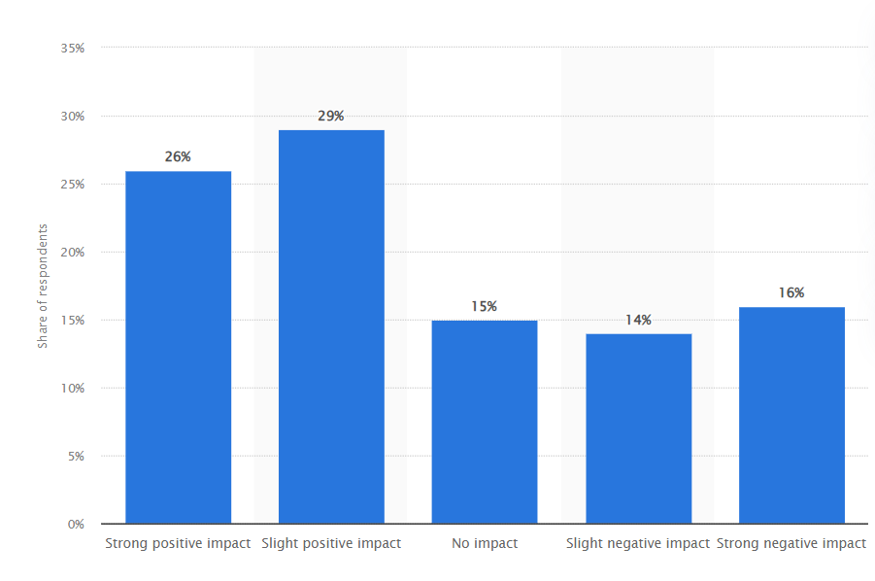
Figure 5: Opinion on the impact of demonetization among first-time voters across India in 2019
Source: Statista, (2022)

Figure 6, as presented through a bar graph, identifies different applications widely accepted by Indians for cashless payments in post-demonetised India. A survey has been conducted based on a certain number of participants, and it can be observed that 4% of participants opted for PhonePe as the key digital platform for their economic transactions. On the other hand, it can also be observed that 6% of the rest preferred BHIM at personal and professional practices for the electronic transaction of money. It can also be depicted from the graph that 10% of people, who participated in the survey, opted for Amazon Pay, and their usual transactions were observed with the preferable options and opportunities provided by the online platform. Google Pay, as observed by the survey, was considered as the key economic platform for transactions by 14% of participants in the research work. Lastly, it can also be observed from the bar graph that 33% of participants opted for Paytm as the major electronic platform for cashless transactions for economic purposes. The highest number of Indians advocated for Paytm for monetary practices more effectively, as their basic platform at the personal and professional stages.
According to Keshava, (2023), the increasing notion of digital payments in the post-demonetisation phase has empowered the digital practices and skills, as well as, digital literacy of the country. It can be observed from the report that in the rural area of North India, the digital literacy rate has increased by 0.83% in 2017-2020, and their investment practices have been more productive in nature. On the other hand, Jain et al. (2020), refute the advantage of digital literacy by highlighting the impact of the sudden withdrawal of currency as a long-term factor. The report mentions that 75-78% of Indians went through a psychological dilemma about their future and their monetary issues hampered their daily life. Investment policies and programmes were affected due to the sudden changes, and the public life of India was pushed into deep trouble.

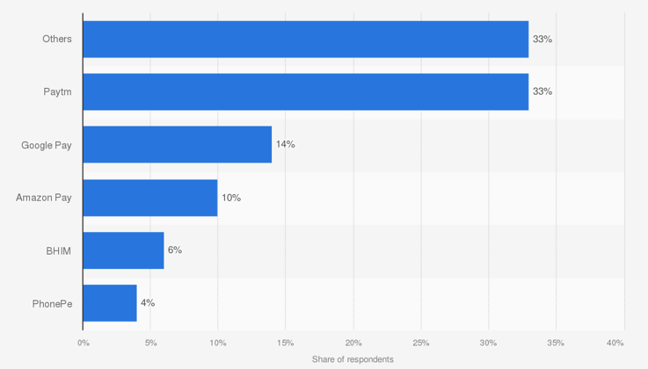
Figure 6: Digital Payments in Post-Demonetised India
Source: Statista, (2023)
Figure 8, as depicted below, identifies different statistics, based on payment and cash transactions in post-demonetised India at its immediate phase. According to the chart, in post-demonetised India, 70% of those who bought a property in the last seven years had to pay a component of the price in cash, while 16% paid over half of the amount in cash. On the other hand, it can also be observed from the data chart that 95% of those who have used cash to pay for services in the last twelve months. 3 in 4 have used it for paying for services, like household, home repairs or beauty.
It can also be observed from the data chart observed in Figure 8 that 67% of Indians' cash transactions are now less than 25% of their total transactions. It is further observed that 95% of those who have used cash for purchases in the last twelve months, paid for groceries, eating out and food delivery. It is found from the data chart that people preferred cash for purchasing the highest amount of products essential for their daily lives and activities. The preference can also be identified as an outcome of demonetisation and its sociocultural impact.

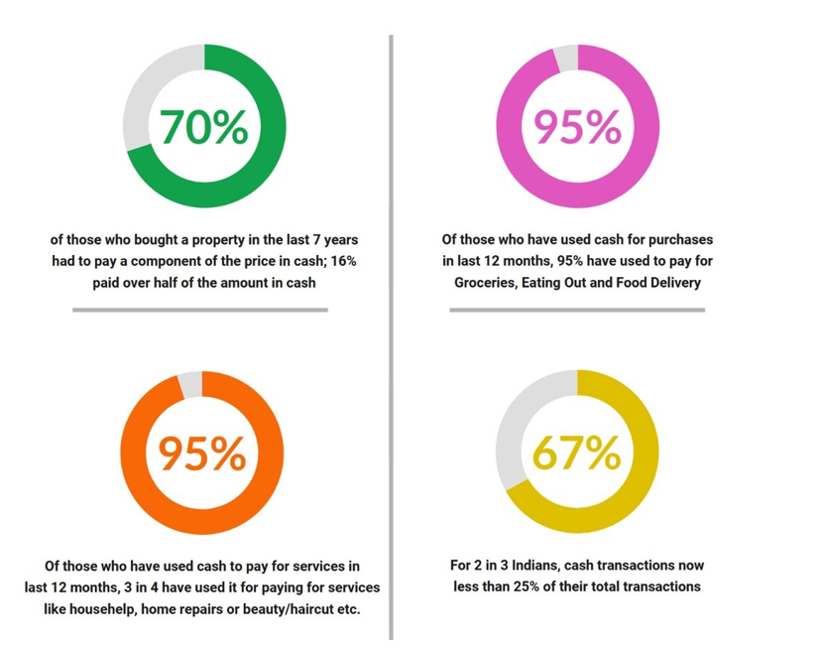
Figure 7: Payment and Cash Transactions in Post-Demonetised India
Source: Jain et al. (20223)

Figure 8, observed below refers to the digital payment transactions by volume in India in the post-demonetised market of the country. According to the chart, in FY 2017-2018, the total amount of transactions as per the Reserve Bank of India and National Payments Corporation of India and Banks, was 2072 crores. In 2018-2019, the amount increased to 3134 crores, which further increased to 4571 crores in 2020-2021. On the other hand, the chart identifies that in 2020-2021, the total amount of monetary transactions through digital platforms was observed at 5554 crores, and the as per the report followed by the graph, in FY 2021-2022 (up to March), the amount was calculated at 8193 crores.
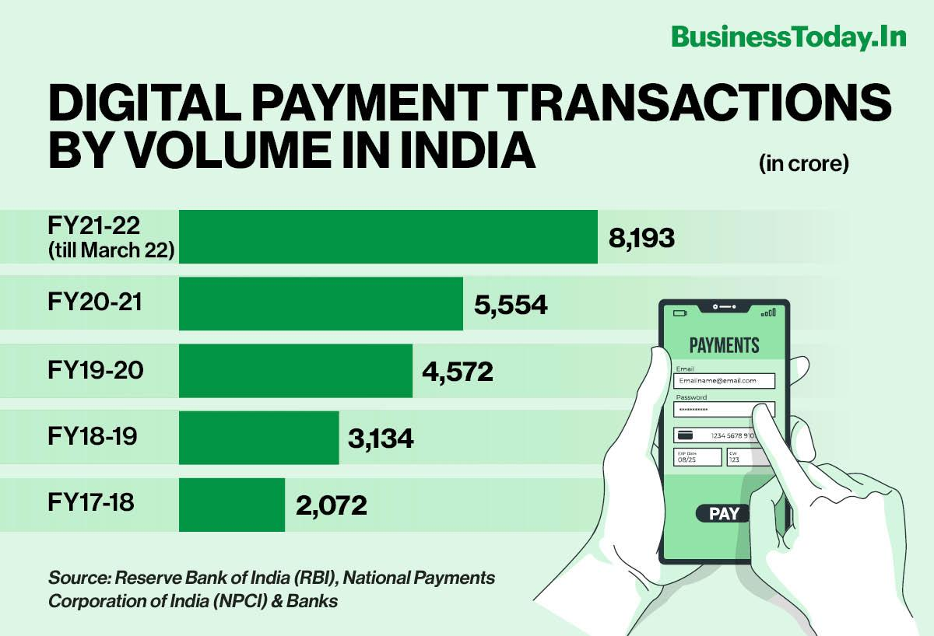
Figure 8: Digital Payment Transactions by Volume in India
Source: buisnesstoday, (2022)

4.2.3 Real estates and Gold Markets during the Demonetization of India
India's demonetisation in 2016 resulted in notable disruptions in the real estate and gold sectors. The governmental policy implemented to address the issues of illicit funds and unethical practices has significantly influenced the conventional methods employed for concealing unrecorded assets. The real estate industry in India has historically been a preferred avenue for the concealment of undisclosed assets, owing to its capacity to accommodate substantial financial transactions (Dey and Sampath, 2020). Demonetisation aimed to mitigate this phenomenon by rendering high-value currency notes invalid and enhancing transparency in real estate transactions. Following the implementation of demonetisation, a notable deceleration was observed in the real estate industry. Property transactions experienced a notable decrease as buyers and sellers encountered difficulties in managing the abrupt shortage of liquid funds. The prevailing atmosphere in the market was characterised by pessimism, leading potential purchasers to take a cautious strategy of observing and assessing the situation before making any purchasing decisions (Nippani and Malhotra, 2020). As a result of declining demand and stagnation in property transactions, real estate prices started a process of correction in several places. The observed price adjustment can be attributed to a decline in market liquidity and a reduction in speculative purchasing driven by illicit funds.
Consequently, property developers needed help selling their current stock at previously inflated rates. One of the enduring consequences of the demonetisation policy on the real estate sector was a notable transition towards enhanced levels of openness. The Real Estate (Regulation and Development) Act, enacted in 2017, enhanced openness by imposing more stringent regulations and requirements on developers regarding standards and disclosures (Ghosh et al., 2023). Buyers exhibited a heightened sense of caution and meticulously examined property transactions to ascertain their adherence to tax requirements. Real estate developers saw financial strain as they grappled with the completion of current projects and the commencement of new ones. In order to entice consumers, several developers were compelled to include discounts and flexible payment alternatives. The impact of the liquidity crisis hindered their capacity to get funding for future ventures. Throughout history, gold has been widely regarded as a favoured asset class to conceal illicit funds and unreported riches in India. The primary objective of the demonetisation policy was to curtail the influx of illicit funds into the gold sector and enhance transparency within the gold market (Kulal, 2022). During the implementation of demonetisation, there was a significant rise in the demand for gold. Moreover, the individual attempts to exchange outdated monetary bills for valuable metals to safeguard their financial assets. There was an increase in sales, as reported by gold jewellers and dealers.

4.2.4 Impact of corruption and black money during the demonetization of India
The demonetisation of India in November 2016 was a significant and audacious measure undertaken by the Indian government to address several pressing concerns, including corruption and the proliferation of illicit funds. This strategy aimed to restrict the circulation of currency notes with high denominations, specifically the 500 and 1000 rupee notes, due to their suspected extensive use in illicit practices like tax avoidance, corruption, and accumulating undisclosed assets (Reddy, 2021).
The instant impact on the black money economy was a notable consequence of demonetisation. During a single night, individuals who possessed significant amounts of undeclared cash unexpectedly found themselves in a perilous predicament. Individuals were allowed to submit their outdated notes to financial institutions, contingent upon disclosing the origin of the cash and fulfilling tax obligations and fines for any undisclosed assets. This pushed several individuals to step forward and reveal their undisclosed riches, leading to the retrieval of an essential amount of illegally obtained money (Jain et al., 2020). Moreover, the demonetisation initiative significantly influenced the prevalence of corruption. The discontinuation of high-value currency notes has significantly impacted traditional practices of bribery and corruption, which frequently relied on the exchange of substantial amounts of physical currency. This phenomenon posed a more significant challenge for corrupt authorities and people seeking to partake in unlawful operations, as they were compelled to seek alternate approaches for conducting their transactions (Reddy, 2022). Adopting digital payment methods and electronic transactions has also played a role in diminishing prospects for corrupt practices since it establishes a recognisable electronic record.
Nevertheless, it is essential to recognise that the demonetisation endeavour had difficulties and critiques. A significant critique revolved around the transient economic upheaval it engendered. The abrupt removal of 86% of the nation's circulating money resulted in a scarcity of cash, extended waiting times at financial institutions, and a deceleration of economic operations, particularly within the informal sector that mainly depends on cash-based transactions (RANI, 2019). During this era, small firms and individuals engaged in daily wage labour experienced significant adverse impacts. Another critique was specific individuals who utilised innovative methods to transform their unlawfully acquired funds into lawful assets, such as gold real estate, or by taking advantage of the Jan Dhan Yojana accounts belonging to economically disadvantaged citizens. The existence of these loopholes, along with the ingenuity of individuals engaged in corrupt activities, somewhat diminished the enduring consequences of the demonetisation of illegal money. Furthermore, the financial implications of executing demonetisation were significant, encompassing expenditures associated with the production of fresh currency bills, the recalibration of automated teller machines (ATMs), and the effective handling of the logistical complexities involved in disseminating the new currency throughout the expansive nation (Chandra et al., 2020).
The critics contended that the economic benefits of the demonetisation process were insufficient to warrant the associated expenses.
In the wake of demonetisation, a discourse emerged about how the initiative effectively accomplished its intended objectives. Although the introduction of concealed riches into the official economy and the temporary disruption of corrupt practices were seen, the enduring effects on black money and corruption have continued to be a subject of scholarly discourse. In a nutshell, the implementation of demonetisation in India substantially influenced the prevalence of corruption and the circulation of illicit funds. Implementing this measure compelled individuals to reveal their concealed assets and undermined traditional bribery and corruption methods (Bhanot, 2020). Nevertheless, the implementation of this policy was accompanied by temporary economic disruptions and encountered critiques about its cost-effectiveness and the potential exploitation of certain loopholes. The efficacy of demonetisation in tackling these concerns is a subject of continuing discourse, and its enduring implications for the Indian economy and society are being examined and investigated.
Figure 9, as observed below, refers to the total value of Rs. 500 notes in circulation, and in this regard, the pre-demonetisation and post-demonetisation phases of India have been presented. In this regard, the timescale between 2009-10 to 2018-2019 has been considered, and the changing values of the amount have been depicted. According to the bar graph, in 2009-10, the amount of cash circulating through 500 notes was 3.64 lakh crore, which increased to 4.45 lakh crore in 2010-2011. On the other hand, it can also be observed from the graph that in 2011-2012, the amount of cash that circulated in India through Rs. 500 notes was 5.12 lakh crore, which gradually reached 5.35 lakh crore in 2012-2013.
In 2013-2014, as observed, the amount was calculated at 5.70 lakh crore and in 2014-2015, the amount increased to 6.56 lakh crore in India, and the increasing notion is an outcome of the emerging economy of the country. In 2015-2016, the total value of Rs. 500 notes in circulation was calculated at 7.85 lakh crore. A certain downfall of the total value, based on Rs. 500 notes, and it can be observed from the chart that in a certain period, the amount dropped to 2.94 lakh crore. In 2017-18, the amount increased to 7.73 lakh crore, and in 2018-2019, as observed, the total value of Rs. 500 circulations increased to 10.75 lakh crore.
As Gupta and Kumar, (2021), the amount of cash available in the market is targeted to keep high to keep the economy active and spontaneous, and the public life is focused on developing as per the economic aims and objectives. The report suggests that the downfall of Rs. 500 overnight created socioeconomic and sociocultural chaos among Indians as their conventional life was affected due to demonetisation. The economic trouble entwined with the social issues, and the consequences hindered the economic course of the country. As the government failed to fulfil the promises, the issues remained critical and further problems arose.
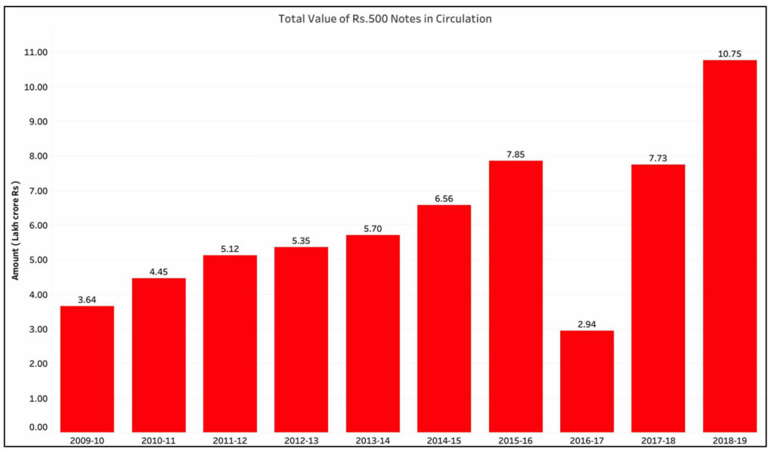
Figure 9: Total Value of Rs. 500 notes in circulation

Source: Ansari and Sensarma, (2023)

The chart observed in Figure 9 reflects the real impact of the demonetisation process on mid- and small-sized stocks and some sectoral indices. According to the chart, BSE reality experienced a drop in stock by 15.1%, while BSE consumer durables faced a steady drop in stock by 8.2%. It can also be observed from the graph that BSE SmallCap and BSE Midcap experienced a downfall of stock by 6.85 and 6.1%, respectively, while BSE Consumer Discretionary faced a drop in stock by 5.9%. Lastly, the BSE 500, experienced a drop of stock 4.9%, while Sensex dropped by 3.9%. Demonetisation affected the conventional price range of products on a significant scale, and the stock market experienced a downfall, as well.
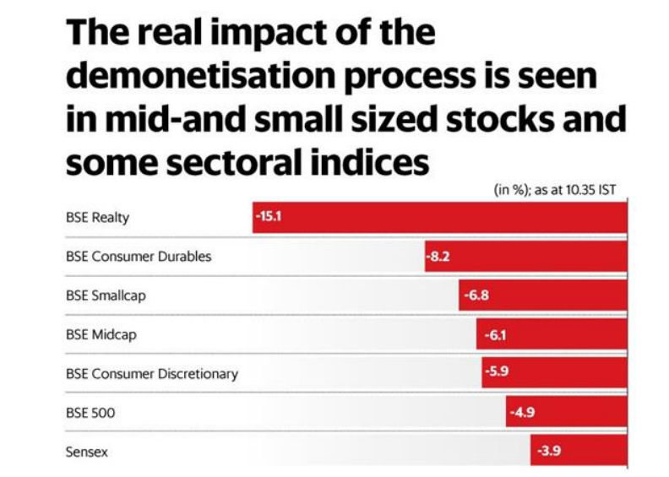
Figure 10: The Real Impact of the Demonetisation Process in Mid-and Small-Sized Stocks and Some Sectoral Indices
Source: Ansari and Sensarma, (2023)

Another report by Mehta and Moradia, (2021), mentions that business bodies and their economic programmes were also affected due to demonetisation, as the supply chain performance in India dropped. The report suggests that the supply chain management for SMEs in India dropped by 17.8% in 2017-18, and for the larger companies it was observed at 6.98%. The lack of economic values and market factors affected the collaborative growth that used to be endorsed by different companies, and the stakeholder issues also came out as a major threat to them. On the other hand, Wang, (2020), mentions that the ICT management in SMEs was also affected due to the lack of economic support and market programmes, while the usage of tools and techniques was affected due to the lack of centrality and concern.
In the post-demonetised phase, the digital acts and activities have been facilitated with an increasing budget of 19.43%, while the public guidance has also been generated by platforms to empower the growth with effective acts and activities (Mandala and Mohanty, 2019). SMEs have mandated the improvement of UPI transactions and internet banking to protect the business interest as per the organisational needs.
The bar graph observed in Figure 11, refers to the transaction value of digital payments in the post-demonetised period in India, and in this regard, the timescale between 2017 to 2023 has been considered. According to the graph, mobile POS payments and Digital commerce have been presented, while the total value has also been depicted in the graph. It can be observed from the graph that in 2017, the total amount of transaction value was $41.035 million, which increased to $51.105 million in 2018. On the other hand, it can also be observed from the graph that in 2019, the total transaction value in India through digital payments was $64.787 million, and in 2020, as observed, it reached $81.197 million. In 2021, the value further increased to $95.655 million, and in 2022, as per the graph, the total value reached $116.324 million. Lastly, in 2023, the total amount through digital transactions in India reached $134.588 million. The increasing notion of amount through digital payments denotes the popularity and practices of digital payments in India in the post-demonetised era.

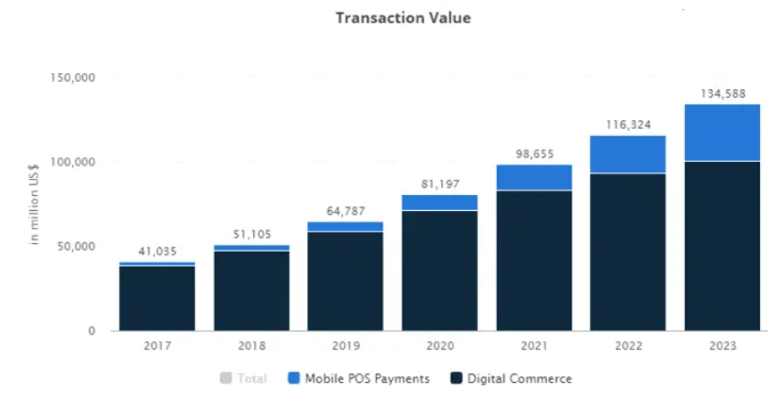
Figure 11: Transaction Value of Digital Payments in Post-demonetisation Period
Source: Statista, (2023)

4.3 Discussion
In the previous section, secondary data, based on the research topic has been presented, and it can be observed that demonetisation impacted different socioeconomic aspects of India on a significant scale. The challenges that appeared due to the sudden withdrawal affected the conventional framework of monetary acts and activities, while the changes affected the public life of the country (Kataria, 2019). The security of monetary stability was questioned as the currency was devalued with an overnight announcement. It can also be observed from the findings that though the digitalisation of the banking system and financial programmes was initiated by the government before demonetisation, it did not come out as a protective measure for people. In the post-demonetised state, it was observed that the daily life requirements of people were hampered and their requirements got into a difficult cycle. On the other hand, the socioeconomic practices and their ill-distribution which were already vibrant in the Indian society, were triggered through demonetisation and the trouble eventually surged into different sections of the Indian society (Jain et al. 2020). Moreover, uncertainties and dilemmas came to daylight which affected the business programming for different companies, and the role of the management was not enough to hold the practices as per requirements.
It can be observed from the findings that the emergence of different digital platforms in India played a key role in economic transactions in India, and digital activities eventually became an obvious part of Indian culture and financial practices. The rise of cashless transactions changed the economic course of the country, as less time-consuming factors empowered by mobile banking changed the conventional framework of the financial system (Mehta and Moradia, 2021). On the other hand, the security with services and servers developed by the digital platforms created customer credibility, and through basic digital literacy, a larger section of people was able to use digital transactions. The digital security and effective programs created by the platforms are also able to increase the number of users, and it can be observed that the usage of BHIM, PhonePe, Google Pay, Amazon Pay and others has been a constant support for people at professional and personal levels. Moreover, the increasing notion of digital payments was also impacted by customer services and communication provided by the platforms to ensure a better understanding among people. Offers and cashback have also influenced people to use such platforms frequently (Prasad et al. 2023). Lingual services and opportunities in the post-demonetised Indian market, as observed, have also increased.
The downfall of the stock market due to the lack of economic acts and activities provoked by demonetisation can also be observed in the previous section. The fall in GDP and inflation affected the stability of the economic programmes of the country, while inflation hit the economic base of the country (Jain et al. 2020). Inflation affected the common life in India, and public life was also hampered due to the issues in the health sectors. The medical emergencies got delayed due to the overnight withdrawal of regular currency, and it appeared lethal in several cases. On the other hand, it can be observed that the findings that the total value of Rs. 500 notes dropped on a significant scale which affected the in-cash transaction and people faced troubles while purchasing products for their daily life. Moreover, the issue also affected the healthcare industry of the country, as people could not meet their demands even if they had cash (Prasad et al. 2023). The cashless transaction was limited at the primary stage of demonetisation, and in the later phase, its limitation among a certain section of the economic hierarchy was observed. The groundwork of the decision was not vivid and acceptable in any definite economic point of view.
The business bodies in the country, as observed felt difficulties due to the drop in the stock market, and public services were also affected. The supply chain management and ICT programmes were affected due to demonetisation, and the financial institutions, other than banks, faced some major difficulties. As the currency was withdrawn, several business bodies, especially the SMEs lost a massive share in the Indian market, and in the case of foreign companies active in the Indian market, were also affected due to the stakeholder and shareholder issues (Kataria, 2019). The local business associations failed to continue their strategic efforts as the unexpected chaos in the country’s economy made them vulnerable. The business bodies also failed to incorporate new business programmes and strategic activities, due to the lack of economic support and monetary practices, and the challenges came out as key threats for further activities. Moreover, the infrastructural issues and problems with employee management were also viable due to the ineffective financial support, necessary for the growth of business in different forms. The competitive advantages for India-based MNCs met a huge drop, as the productivity and profitability of companies did not meet the estimated values, set forward by the management in the Indian market.

4.4 Conclusion
From the above discussion, it can be identified that the implementation of demonetisation in India in 2016 generated varied outcomes for both the general populace and corporate entities. Although its primary objective was to tackle problems such as illicit funds and unethical practices, the immediate consequences of this initiative were experienced by the general public and several enterprises. The enduring consequences of this phenomenon continue to be a subject of academic discussion, whereby proponents contend that it facilitated heightened digitalisation and formalisation of the economy, whilst opponents maintain that it had only minor success in attaining its declared goals.
The chapter of the study has identified different secondary data from reliable sources, and in this regard, multiple graphs and charts have been presented by the researcher. It can be concluded from the chapter that the overnight announcement of demonetisation affected public life in India on a major scale, while the security of thoughts and further monetary programming were hindered as well. Issues came out in an explicit way, while the existing system of the country failed to cope with the changes effectively. It can further be concluded from the chapter that the business bodies in India also faced several difficulties, as the supply chain management and ICT programmes faced multiple issues.
It can also be concluded from the chapter that the lack of economic support and productive facilitations impacted the financial infrastructure of the country. As the stock market dropped, new business bodies failed to venture into the market with effective support and care, and private services were also affected due to the lack of a central approach and steady economic policies. The expansion of digital payments and programmes facilitated companies to develop a better IT market, based on which the digital transaction rate and success were increased effectively. Moreover, the changes adopted by digital payment platforms were effective on an extended scale.

Chapter 5: Conclusions and Recommendations

5.1 Recommendations
- A well-crafted and well-designed plan should be nurtured by the government before the announcement of any such national programmes so that public life and firm-based activities can be maintained as per requirements. Sudden withdrawal of cash and the digital activities should be considered with the hand-to-hand theory, and awareness campaigns should be run through digital platforms and personal communications via e-mails and messages for a better understanding (Prasad, 2019). The consequences of any such intervention should be well-promoted to people so that they can consider their decisions regarding financial acts and planning.
- The efficiency of digital planning for digital payments should be enhanced so that the maximum number of people can benefit from it. Digital and financial literacy of India should be increased through governmental acts and activities and the growth programmes should be promoted for the benefit of organisations and people. A widespread digital platform should be encouraged by the government so that business bodies and people can synchronise their financial practices effectively.
- The coping mechanism for organisations should be empowered by technical growth and prosperity and maintain a steady public life in India, the consistency of such tools and techniques should be maintained. On the other hand, the digital periphery of practices should be increased for future practices and activities, and the efficiency of dealing with market changes should also be considered before the incorporation of digital plans and activities (Khanna and Mukherjee, 2021). The digital market of the country should be promoted under effective acts and activities, and governmental regulations should be a perpetual segment of any such plans.

5.2 Conclusions
Demonetisation, declared in 2016, aimed at certain objectives and a set of promises was made by the government of India for the financial benefit of the country. The people and organisations of the country were not ready for the sudden announcement, and it is observed that the daily life in India was affected by the unfulfilled promises and the immediate outcomes of demonetisation. The overnight announcement created a chaos in the Indian market, as Rs. 500 and Rs. 1000 were banned as legal currency of the country since 9th November 2016.
It can be concluded from the research that the conventional finance of the country and the economic infrastructure were affected on a significant scale, as the usage of cash faced a huge blow from demonetisation. The public life of India faced difficulties while purchasing products, and the organisations also faced massive problems due to the lack of legal currency (Khanna and Mukherjee, 2021). It can also be concluded from the research work, that the market effectiveness of products and services was reduced to a minimum scale of reliability and access, as the sudden withdrawal affected the supply chain management. The dependency of business bodies on the supply chain management is inarguable, and the economic loss diverted the entire financial trajectory of the country into a deep water of trouble. The spontaneity of business lost the projection towards vital movements and prosperities, and the people were forced into a troublesome period (Prasad, 2019). A subjective disorder was also observed in financial decision-making, and it can be concluded from the research that the low scale of digital and financial literacy of the country was triggered due to it. The propagation of thoughts as propagated by the government convinced a huge section of people, and the forthcoming years proved them wrong as the banking sector of the country faced different difficulties in lending money and equivalent activities.
The foreign direct investment in the country also experienced a certain drop, which affected several companies in India, and India-based MNCs failed to strategize any subjective model to cope with situations. SMEs of the country were also affected due to the lack of market programming and business growth, and the economic issues affected the quality of market practices and stakeholder and shareholder relationships (Prasad, 2019). It can be concluded that despite such adversities, people and organisations experienced a steady inclination towards digital payments and facilities for their daily life activities. Though the digital activities for payments and market programming were limited, but organisations protected their economic facilitations with the involvement of digital payments. The interdisciplinary zone shared by customers and business bodies was technically uplifted for the public life in India, while digital payments paved a pathway towards the digitalisation of the country. Google Pay, PhonePe, Internet banking and others came out with a vibrant notion and people’s preferences shifted to it with a redesigned and remodelled paradigm of financial acts and activities at personal and professional levels. The improvement of digital payment methods paved a distinct pathway for the country to stabilise the economic factors that are essential to be considered for the development of business practices and others. The public relationships became more dynamic and consistent, and the digital activities are cosigned to minimum effort and expenses (Sutar et al. 2022). Demonetisation and its consequences have been comprehended from different charts and graphs, and the condition of real estate and gold markets reflect the scenario, the country went through. Cash shortage and the hindrances faced by the financial activities of the country cut off India’s GDP, which has a huge impact on the country’s entire economy and employment.
The secondary data collection method has been utilised by the researcher, and secondary data has been beneficial for the research work, as verified sources have been considered by the researcher to ensure the development of research acts and activities. It can be concluded from the research work that by considering JSTOR, Google Scholar, Statista and others, the researcher has been able to create several opportunities for the research, based on a wide scale of data (Choudhary, 2021). Interpretivist research philosophy has been successfully incorporated by the researcher to interpret the social and academic values of data, while the subjective reality of procured data has also been examined.

5.3 Research Limitations
The research work has critically presented the consequences of the demonetisation of 2016 in India, and how people and bodies coped with the issue of financial acts and activities. Despite a detailed discussion, the research faced several limitations, due to which the academic spontaneity of the research work has been affected. Firstly, the timeframe of the research work was limited, and the research lagged behind several required factors due to the limited timeframe. On the other hand, the limited timeframe of the research affected the data collection method of the research, while the qualitative growth of the research was hindered (Ross and Bibler Zaidi, 2019). The research lagged behind more critical analysis which would have been beneficial for the research and its future programmes with academic comprehension.

5.4 Future Opportunities of the Research
The research has been able to create several future opportunities, based on which the effective acts and activities of the research work can be efficient with a broad discussion and subjective analysis. The research, based on any such future declaration of demonetisation, can be conducted and the measures that should be governed by companies and people can further be understood with certain aims and objectives (Lines et al. 2022). On the other hand, the future challenges of demonetisation and its impact on the third-world economy can also be comprehended with effective data collection and critical analysis. The future of digital payments and practices can also be examined as per their steady acceleration in India’s public life.

References
Agarwal, S., Ghosh, P., Li, J. and Ruan, T., 2022. Digital payments and consumption: evidence from the 2016 demonetization in India. Available at SSRN 3641508.
Alharahsheh, H.H. and Pius, A. 2020. A review of key paradigms: Positivism VS interpretivism. Global Academic Journal of Humanities and Social Sciences 2(3), pp. 39-43.
Ansari, M.G. and Sensarma, R., 2023. Monetary Policy, Liquidity Shock and Bank Lending: The Case of Currency Demonetization in India (No. 575).
Bagur-Pons, S., Rosselló-Ramon, M.R., Paz-Lourido, B. and Verger, S., 2021. Integrative approach of mixed methodology in educational research. RELIEVE-Revista Electrónica de Investigación y Evaluación Educativa, 27(1).
Balamurugan, J. and Saravanan, S. 2023. A Public Perception on the Effects of Demonetization in Indian Economy–an Analytical Study. South Asian Journal of Social Studies and Economics 20(1), pp. 17-24.
Beyes, P. and Bhattacharya, R. 2017. India’s 2016 demonetisation drive: A case study on innovation in anti-corruption policies, government communications and political integrity. In OECD Global Anti-Corruption Integrity Forum, pp. 14-28.
Bhanot, S., 2020. A Study on the Perception of People About the Impact of Demonetization on the Indian Economy. IIBM'S Journal of Management Research.
Braun, V. and Clarke, V. 2023. Toward good practice in thematic analysis: Avoiding common problems and be (com) ing a knowing researcher. International Journal of Transgender Health 24(1), pp. 1-6.
Chandra, V., Srivastava, S. and Jindal, M., 2020. Impact of Demonetization on the Various Sectors of Indian Economy. International Journal of Engineering and Management Research, 10(6), pp.130-134.
Choudhary, U., 2021. The impact of demonetization on Indian economy.
De Block, D. And Vis, B., 2019. Addressing the challenges related to transforming qualitative into quantitative data in qualitative comparative analysis. Journal of Mixed Methods Research, 13(4), pp.503-535.
Dey, S. and Sampath, A., 2020. Returns, volatility and spillover–A paradigm shift in India?. The North American Journal of Economics and Finance, 52, p.101110.
Duvendack, M., Sonne, L. and Garikipati, S. 2023. Gender inclusivity of India’s digital financial revolution for attainment of SDGs: Macro achievements and the micro experiences of targeted initiatives. The European Journal of Development Research, pp. 1-23.
Fetters, M.D. and Molina-Azorin, J.F., 2019. A checklist of mixed methods elements in a submission for advancing the methodology of mixed methods research. Journal of Mixed Methods Research, 13(4), pp.414-423.
Ghosh, C., Panchapagesan, V. and Venkataraman, M., 2023. On the Impact of Infrastructure Improvement on Real Estate Property Values: Evidence from a Quasi-natural Experiment in an Emerging Market. The Journal of Real Estate Finance and Economics, pp.1-35.
Gupta, V.K. and Kumar, A., 2021. Five Years Of Demonetization In India: What Has Changed In The Economy. Academic Social Research:(P),(E) ISSN: 2456-2645, Impact Factor: 5.128, Peer-Reviewed, International Refereed Journal, 7(1).
Hancock, J.T., Naaman, M. and Levy, K., 2020. AI-mediated communication: Definition, research agenda, and ethical considerations. Journal of Computer-Mediated Communication, 25(1), pp.89-100.
Hill, T.D., Davis, A.P., Roos, J.M. and French, M.T. 2020. Limitations of fixed-effects models for panel data. Sociological Perspectives 63(3), pp. 357-369.
Husband, G. 2020. Ethical data collection and recognizing the impact of semi-structured interviews on research respondents. Education Sciences 10(8), p. 206.
Jain, D., Dash, M.K. and Thakur, K.S., 2022. Development of research agenda on demonetization based on bibliometric visualization. International Journal of Emerging Markets, 17(10), pp.2584-2604.
Jain, D., Thakur, K.S. and Dash, M.K., 2020. Demonetization move in India: a conceptual study. Journal of Money Laundering Control, 23(4), pp.863-869.
Jain, D., Thakur, K.S. and Dash, M.K., 2020. Demonetization move in India: a conceptual study. Journal of Money Laundering Control, 23(4), pp.863-869.
Kataria, P., 2019. Impact Of Demonetization On Indian Economy. Think India Journal, 22(14), pp.16886-16895.
Keshava, D.S., 2023. Demonetization in India: Rationale, Efficacy and Impact. SSRN.
Keshri, S., Kumar, R., Kumar, D., Singhal, T., Giri, S., Sharma, I. and Vatsha, P. 2022. Insights Of Artificial Intelligence In Brain Disorder With Evidence Of Opportunity And Future Challenges. Journal of Pharmaceutical Negative Results, pp. 10853-10867.
Khanna, G. and Mukherjee, P., 2020. Political Punishment and Financial Safety Nets: Evidence from India's Demonetization. Available at SSRN 3514947.
Kulal, A., 2022. Impact of Demonitisation on Indian Economy: A Conceptual Study.
KUMAR, P., 2023. IMPACT OF DEMONETIZATION ON INDIAN AUTOMOBILE INDUSTRY.
Lahiri, A., 2020. The great Indian demonetization. Journal of Economic Perspectives, 34(1), pp.55-74.
Lines, R., Walker, J.F. and Yore, R. 2022. Progression through emergency and temporary shelter, transitional housing and permanent housing: A longitudinal case study from the 2018 Lombok earthquake, Indonesia. International Journal of Disaster Risk Reduction 75, p. 102959.
Mehta, A.C. and Moradia, A., 2021. Impact of Demonetization on Indian Real Estate Indices. International Journal of Research in Commerce, Economics and Management, 11(5), pp.5-11.
MOHANTY, M. and PATTNAIK, S., 2021. Financial Disruption and Stock Market Reaction: A Study on Indian Banking Sector and Announcement of Demonetisation. Finance India, 35(3), pp.845-860.
Nan, W. and Park, M. 2022. Improving the resilience of SMEs in times of crisis: The impact of mobile money amid Covid‐19 in Zambia. Journal of International Development 34(4), pp. 697-714.
Nippani, S. and Malhotra, D., 2020. The Impact of Demonetization on the Short-Term and Long-Term Returns of India’s Leading Real Estate Index. The Journal of Wealth Management, 23(1), pp.88-97.
Pandey, P. and Pandey, M.M., 2021. Research Methodology Tools and Techniques.
Pazarbasioglu, C., Mora, A.G., Uttamchandani, M., Natarajan, H., Feyen, E. and Saal, M., 2020. Digital financial services. World Bank, 54, pp. 14-28.
Prasad, S.R., 2019. Measuring the efficiency of indian real estate firms during the pre-and post-demonetization period by adopting data envelopment analysis. Baltic Journal of Real Estate Economics and Construction Management, 7(1), pp.98-109.
RANI, R., 2019. Demonetization and Its Impact. Think India Journal, 22(4), pp.821-834.
Reddy, D.N., 2021. DEMONETIZATION, CORRUPTION AND BLACK MONEY: THE UNFOLDING DANGERS OF OPPORTUNISTIC POLITICS IN THE ERA OF POST-TRUTH. Discourses on Corruption: Interdisciplinary and Intercultural Perspectives, p.143.
Reddy, D.N., 2022. Demonetization, Corruption and Black Money. ON CORRUPTION, p.92.
Ross, P.T. and Bibler Zaidi, N.L., 2019. Limited by our limitations. Perspectives on medical education, 8, pp.261-264.
Sam, J.S., Chakraborty, A. and Srinivasan, J., 2021. Cashlessness in India: Vision, policy and practices. Telecommunications Policy, 45(8), p.102169.
Shekhar, S., Manoharan, B. and Rakshit, K., 2020. Going cashless: Change in institutional logic and consumption practices in the face of institutional disruption. Journal of Business Research, 114, pp.60-79.
Singh, M.O.H.I.N.D.E.R. 2022. Digital Payment Systems in India: Trend and Structural Changes after Demonetisation. Finance India 36(3), pp. 953-970
Sivathanu, B., 2019. Adoption of digital payment systems in the era of demonetization in India: An empirical study. Journal of Science and Technology Policy Management, 10(1), pp.143-171.
Suri, H., 2020. Ethical considerations of conducting systematic reviews in educational research. Systematic reviews in educational research: Methodology, perspectives and application, pp.41-54.
Sutar, G., Dhalmahapatra, K. and Chakraborty, S., 2022. Impact of India’s Demonetization Episode on its Equity Markets. Asia-Pacific Financial Markets, pp.1-27.
Wang, Y., 2020, January. Effect of Demonetization on India's Financial Sector. In 2019 International Conference on Education Science and Economic Development (ICESED 2019) (pp. 308-311). Atlantis Press.

Appendix

Thematic Table

Theme 1: Economic disruption for the demonetization of India in 2016 | - MOHANTY, M. and PATTNAIK, S., 2021. Financial Disruption and Stock Market Reaction: A Study on Indian Banking Sector and Announcement of Demonetisation. Finance India, 35(3), pp.845-860.  - Lahiri, A., 2020. The great Indian demonetization. Journal of Economic Perspectives, 34(1), pp.55-74.  - KUMAR, P., 2023. IMPACT OF DEMONETIZATION ON INDIAN AUTOMOBILE INDUSTRY.  - Shekhar, S., Manoharan, B. and Rakshit, K., 2020. Going cashless: Change in institutional logic and consumption practices in the face of institutional disruption. Journal of Business Research, 114, pp.60-79.
Theme 2: Digital adoption for the demonetization of India in 2016 | - Sivathanu, B., 2019. Adoption of digital payment systems in the era of demonetization in India: An empirical study. Journal of Science and Technology Policy Management, 10(1), pp.143-171.  - Sam, J.S., Chakraborty, A. and Srinivasan, J., 2021. Cashlessness in India: Vision, policy and practices. Telecommunications Policy, 45(8), p.102169.  - Agarwal, S., Ghosh, P., Li, J. and Ruan, T., 2022. Digital payments and consumption: evidence from the 2016 demonetization in India. Available at SSRN 3641508.
Theme 3: Real estates and Gold markets during the demonetization of India | - Kulal, A., 2022. Impact of Demonitisation on Indian Economy: A Conceptual Study.  - Ghosh, C., Panchapagesan, V. and Venkataraman, M., 2023. On the Impact of Infrastructure Improvement on Real Estate Property Values: Evidence from a Quasi-natural Experiment in an Emerging Market. The Journal of Real Estate Finance and Economics, pp.1-35.  - Dey, S. and Sampath, A., 2020. Returns, volatility and spillover–A paradigm shift in India?. The North American Journal of Economics and Finance, 52, p.101110.  - Nippani, S. and Malhotra, D., 2020. The Impact of Demonetization on the Short-Term and Long-Term Returns of India’s Leading Real Estate Index. The Journal of Wealth Management, 23(1), pp.88-97.
Theme 4: Impact of corruption and black money during the demonetization of India | - Bhanot, S., 2020. A Study on the Perception of People About the Impact of Demonetization on the Indian Economy. IIBM'S Journal of Management Research.  - Chandra, V., Srivastava, S. and Jindal, M., 2020. Impact of Demonetization on the Various Sectors of Indian Economy. International Journal of Engineering and Management Research, 10(6), pp.130-134.  - RANI, R., 2019. Demonetization and Its Impact. Think India Journal, 22(4), pp.821-834.  - Reddy, D.N., 2022. Demonetization, Corruption and Black Money. ON CORRUPTION, p.92.  - Jain, D., Thakur, K.S. and Dash, M.K., 2020. Demonetization move in India: a conceptual study. Journal of Money Laundering Control, 23(4), pp.863-869.  - Reddy, D.N., 2021. DEMONETIZATION, CORRUPTION AND BLACK MONEY: THE UNFOLDING DANGERS OF OPPORTUNISTIC POLITICS IN THE ERA OF POST-TRUTH. Discourses on Corruption: Interdisciplinary and Intercultural Perspectives, p.143.

