Internship & Volunteerism: Critical Appraisal
BMSP6003

Jordan John Coller (1706820)

Lecturer: Davina Evans

Internal Verifier: Jessica Shore

BA Business and Management

University of Wales Trinity St. David

Carmarthen Business School

Executive Summary
Recently, education establishments have become increasingly interested in the integration of promoting extracurricular activities such as, internships and voluntary participation (Baert et al., 2019; Saniter, Schumann, & Siedler, 2018). By implementing an internship and volunteerism module to the curricular, universities sustain their reputation in the eyes of The Quality Assurance Agency (QAA), which is an independent establishment which grants higher education institutes with degree awarding power. However, it was also created for the purpose of monitoring the actions of these institutes in order to provide quality assurance reviews and ranking, which is transparent to the public (Baldock et al., 2015; Morgan, 2015).
Implementing the module is not only beneficial to the institute themselves, but also the pupils undertaking the module. Firstly, personal development plays a significant role when concerning potential outcomes from undertaking work-practices. The motivation behind gaining personal development can be in the form of many intrinsic/extrinsic motivational factors such as, exploring job prospects, improving existing skills, gaining new skills, gaining work-based confidence and developing subject knowledge among others (Chen, Hu, Wang & Chen, 2011; Divine et al., 2007; Cook, Parker & Pettijohn, 2004; Gault et al., 2000).
This brings us to the second potential outcome component, gaining employability skills. Within Baert’s (2019) field experiment, where he sent 1,248 fictitious resumes to employers, the results concluded that the applicants with internship experience have a 12.6% higher probability of employment. Furthermore, The National Association of College and Employers (NACE) states that 91% of US employers favor graduate students that have undertaken professional work-experience as it was assumed that students who have completed an internship are more ambitious, reliable and risk-averse, as opposed to students who have not (NACE, 2020; Baert, 2015).
The paper aims to document the extra curricula activity of level-6 BA Business & Management student/intern, Jordan Coller during and after his placement with the sustainable energy provider known as “Egni Co-operative” - recording each step of the student’s placement journey, performing the role of “Marketing and Communications Developer” with ADHD and Generalised Anxiety Disorder.
Preliminary to the placement, extensive planning was made mandatory by placement coordinator, Louise Emmanuel. Requiring the student to formulate a Pre-placement Skills audit, were it is mentioned that the intern lacks in skills such as Communication and Time-management. Subsequently, SMART aims are created from the Pre-placement Skills Audit. They are as followed, Gaining Marketing Experience for Future Employment, Improving Communication Skills and Improving Time-Management Skills. This is where a Gantt Chart was formulated, with the purpose of scheduling and simplifying the tasks which the intern would perform on placement, in order to achieve the SMART aims, in order to display personal development consequential to undertaking placement.
Within Section 2.5, Performing as a Marketing and Communications Developer, we document each task performed by the intern, in order to make a positive impact and development towards the Pre-Placement Skills Audit, initially analysed before placement. Additionally, the section will mention the student’s hardships with management and the methods in which he had overcome them, emphasising how learning development was achieved during each task.
Thirdly, within Section 3.0, the Pre-placement Skills Audit will be compared with the Post-Placement Skills Audit, to allow the reader insight regarding the development of each skill, conveying a measurable contrast of the intern’s development journey. Furthermore, a first-person reflection will be offered to the reader, to convey the intern’s conclusive and personal thoughts and feelings reflecting the placement.
Lastly, recommendations will be formulated from the student’s extra curricula experience of undertaking the placement, emphasising suggestions to Egni Cooperative, UWTSD and himself for personal development and future employability, as this paper will serve it’s purpose as a reflective reminder how the student can develop post-graduation.

1.0 Introduction

1.1 Aims & Objectives
The overall aim of the paper is to display how participating in an internship has impacted/developed the UWTSD (University of Trinity St. David) intern’s skills and ability to perform within a professional environment, during a 20-day placement. Within the first section of the Main Findings, preparative and fundamental steps pre-placement will be analysed. Most significantly, the Pre-Placement Skills Audit (Pre-PSA) will be depicted, to later be used for a comparative analysis by contrasting Pre-PSA with the Post-Placement Skills Audit (Post-PSA); highlighting and measuring how the intern’s skills has been impacted from undertaking the placement, or what skills were developed.
The Main Findings will portray the steps taken when performing on placement, describing each individual event paints the picture of the intern’s experience. Documenting each individual variable is fundamental to the paper’s findings as it allows us to measure how each separate event has implicitly/explicitly impacted the intern’s behavior. Not only this, but the reflection of each event creates an opportunity for the intern to measure how each event has impacted their behavior and pre-existing skills.
The paper’s conclusion will consist of a critical reflection, summarising each of the paper’s components whilst emphasising the intern’s own thoughts and feelings concerning the most significant scenarios during the placement.
Lastly, once thorough analysis is met, recommendations will be formulated in order to guide the intern in the future. Additional recommendations will be made to the University and placement provider.

1.3 Overview of Placement Provider: Egni Co-operative
The placement provider, Egni Co-operative, is a community shareholder-driven social enterprise, based in Abertawe, Wales. Egni Co-operative is the first of its kind, leading the largest renewable community energy movement in Wales. Their core values concern, shifting community and shareholder behavior by encouraging them to make more sustainable and ethical decisions. This is achieved through building awareness about their renewable solar energy service within local educational institutes, to inspiring future generations to act sustainably and creating sustainable communities for the future (Egni Co-op, 2019).

2.0 Main Findings

2.1 Preparation Through Relevant Education
Within the intern’s three-year BA Business & Management course, various modules were provided which broadened and focused upon the development of skills. The knowledge gained throughout higher education offers the intern a foundation of professional acquisitional skills, insuring competence, that would not necessarily be taught without undertaking internal business-practices. Furthermore, acquisition skills gained through higher education enhances the student’s likelihood of future employment (Conde et al., 2016; Gault et al., 2000; Divine et al., 2007). For the purposes of the paper, only the modules that are most relevant to the placement will be mentioned within Appendix A.

2.2 Placements for Good: Bristol Field Exhibition
On 12th June 2019, the intern was invited to the ‘Placements for Good’ (PFG) Workshop event held in Bristol. This event had the intention of pre-enhancing the student’s skills by offering an extensive range of training-courses [Figure 1.0]. However, the offer was refused, due to personal circumstances, leading to a missed opportunity, as the intern could have benefited from the free entrepreneurial training offered.
Nevertheless, alternative arrangements were made. This involved arranging a Skype conference with PFG’s representative named ‘Baker’. During the conference, Baker informed the intern of each component within the workshop using Microsoft PowerPoint. The skype conference was helpful as fundamental information was passed that would have otherwise been overlooked.

Figure 1.0
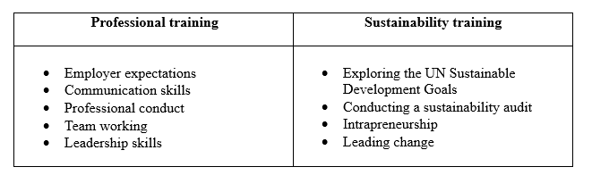

2.4 Implementation Plan

2.4.1 Pre-Placement Skills Audit
Firstly, a Pre-PSA was completed by the intern [Appendix B]. The method of utilising an initial skills audit offers the student several fundamental advantages, some of which involve, the tailoring of assessment to individual encouraging learning and skills development, as opposed to only meeting a minimum standard. By auditing one’s self strengths and weaknesses, improvements can be made independently, and life-long learning can be achieved; these outcomes alone are desired graduate attributes (Gibbings & Brodie, 2006).

When assessing the Pre-PSA, it is made apparent that the intern has two significant characteristics that may hinder the outcome of the placement. The first being, diagnosed ‘Generalised Anxiety Disorder’ (GAD) – A mental health disorder which may evidentially hinder the individual’s confidence, risk-taking ability and communication skills (Bystritsky et al., 2013). The second detriment concerns the intern’s Attention Deficit Hyperactivity Disorder (ADHD), which negatively impacts the intern’s organisational and communicational skills (Mayes, Calhoun & Crowell, 2000).
However, the student has adopted many positive skills from both higher education and entrepreneurial experience. Drawing from Appendix B, it is emphasised that the experience gained from maintaining the role of ‘Team Leader’ within Tesco and being a father has allowed the student to inherit contemporary management skills such as, team leadership/cooperation whilst conveying the ability to maintain life-long commitments, emphasising a strong ambition and the will to focus.

Once completed, the intern decided to actively seek a placement provider earlier than the remainder of his peers, as securing a placement any later would be deemed as unwise; when the limited number of choices concerning paid placements that were available are put into perspective. However, many placements were not suitable for the intern, as they were either too far away to commute to, or unpaid. Although volunteering could potentially offer the experience needed for personal development, an internship which offers a labor salary would provide additional financial security, lessening the risks involved. Financial security is a significant factor for the intern, as he will need to manage both the internship, a household and an infant/dependent. However, perhaps due to the intern’s specific needs, finding a suitable placement provider was made more difficult.
Subsequently, the intern was signposted by another student colleague to the placement agency called PFG. PFG is a sustainable placement agency which offers students the opportunity of experiencing the sustainable working culture by advocating them not only whilst seeking a placement, but also during the placement itself.
Once the Pre-PSA was assessed by PFG’s representative, Baker, they were able to find a suitable placement which met the intern’s specific needs and intended outcomes within 2-working days and the intern was put into contact with McCallum, Egni Cooperative’s managing director. This relieved the stress involved in seeking an internship and enabled the student to focus on additional assignments.

2.3.2 The Job Role
Subsequently, the Job Profile (JP) was received by the intern via email [Appendix C], granting the intern with the role title of ‘Marketing and Communications Developer’. Drawing from Section 2.1, it was made apparent that the student had a great level of knowledge surrounding the subject of social and ethical marketing, however, this was an opportunity to expand his own knowledge in a more practical way.
In hindsight, the JP allowed the intern to assess the aims and objectives required for completing the internship, whilst also appraising whether he could fulfill them competently by contrasting the JP with the Pre-PSA – Within Appendix D, the cross evaluation is made by linking the relevant tasks with the intern’s strengths. Subsequently, the intern’s weaknesses will also be linked with the tasks that could be hindered. Drawing from the cross evaluation, the intern can be perceived to uphold suitable characteristics for the job role.
However, the job role had many aims without clear instructive objectives, making the profile somewhat vague, thereby indicating that McCallum overestimated the intern’s capability. However, due to the intern’s previous knowledge surrounding marketing, along with the lack of clear instruction, the opportunity to be creative was made implicit.
Furthermore, the JP allowed the intern to evaluate which resources were required [Appendix E]. For instance, since the placement is based in Carmarthen, the intern will need to commute, making transport a fundamental requirement needed to complete the placement. However, commuting from Pembrokeshire, 5-days a week, can be deemed as expensive, this is where paid internships present their advantages, as the hourly rate of £8.21 would enable the student to commute with less financial stress.

2.4.3 SMART aims
Based upon the intern’s weaknesses identified within the Pre-PSA, the planning and implementation of the framework known as ‘SMART aims’ was assigned by the intern’s tutors in order to formulate Specific, Measurable, Achievable, Relevant and Timely intended outcomes used for personal purposes. These smart aims can be found below and within Appendix G.
- Aim 1: Gaining Marketing Experience for Future Employment
- Aim 2: Improving Communication Skills
- Aim 3: Improving Time-Management Skills

The use of planning and implementing SMART aims during placement, can be related to both Schunk (1989) and Zimmerman’s (2008) research, where it is implied that simple and broad goals such as “doing one’s best” can be perceived as unproductive; through undertaking tasks in a series of intervals, allows one to monitor and pursue personal growth.
The Framework known as SMART aims were supposedly created by Doran (1991) and later extensively fostered by Drucker (1995). The approach has been adopted by mainstream business culture, applied by performance managers and team operators due to the strategy’s ability to aid in the formulation and underpinning of objectives (Moore, 2017). However, whilst SMART aims can also be utilised in order to enhance planning of business operations, the framework can serve the additional purpose of reflecting upon one’s own personal development (Fielding 1999; Schunk 1989; Zimmerman, 2008).

2.4.4 Gantt Chart
The use of SMART has its shortcomings, as Murphy (2015) suggests that the framework can “lead to an overly ambitious approach”, which does not cater for those willing to adopt the strategy if limited time-restrictions are present. This was certainly relevant to the time restrictions of a 20-day placement, as 20-days can be assumed to be too short, minimising the amount of experience gained. Nevertheless, this limitation was neutralised by implementing suitable time-management and prioritising each task by implementing a Gantt Chart [Appendix F] (Shahin & Mahbod, 2007; Kirillov et al., 2015). The use of a Gantt chart was made mandatory by the intern’s lecturers, becoming a fundamental component for completing the first Internship and Volunteerism module. The creation of a Gantt chart can be perceived to enhance the student’s time-management skills by setting independent instructions and schedules.
Prior to creating the Gantt chart, SMART objectives were formulated, which correlates each task to each relative aim. This created a list of tasks that will be used when creating the Gantt chart, in order to simplify achieving the SMART aims [Appendix H]. However, the duration of the plan’s creation was extended due to the lack of coherent objectives from the placement provider, concluding with the Gantt chart becoming based upon the intern’s own hypothetical assumptions, meaning the chart became a waste of time (Geraldi, & Lechter, 2012).

2.5 Performing as a Marketing and Communications Developer Intern

2.5.1 The Induction
18th July 2019 – A Skype induction was held, where Egni’s director, McCallum, outlined the role of the Marketing and Communications Developer. At this time, the intern learned that he would be performing his role in cooperation with another intern from the same course. For the purposes of the study, he will be referred as ‘Kilgariff’. McCallum informed the interns that their true mission was to develop Egni’s social media presence, whilst formulating internal marketing frameworks. However, McCallum’s method of presenting the tasks involved in achieving these aims offered little-to-no clarity, signifying several concepts; so either McCallum did not know the role, or he had overestimated the intern’s capability, causing confusion within the group. This concluded in both interns interpreting the lack of information given as a legitimate management approach. At the time, it was thought by providing less objectives, McCallum had implicitly encouraged his interns to be creative, as empirical research confirms that creativity can improve employee intrinsic motivation and provide valuable learning curves (Harackiewicz & Sansone, 2000). Furthermore, fundamental documentation was discussed not only for ensuring evidential and safety purposes, but also to provide a clear understanding of both the student’s and placement provider’s expected and intended outcomes [Appendices I-M].
During the induction, McCallum had agreed that the intern could work remotely from home, as this allowed the intern to cut travel costs. However, throughout the placement, issues occurred which promptly outweighed the intended benefits, as the intern’s busy household became too much of a distraction, hindering the amount and standard of work completed, causing conflict with management.

2.5.2 Formulating the Marketing Plan
The intern’s first task was to devise a marketing plan based upon the activities scheduled within both of the intern’s Gantt charts. This task was formulated within Microsoft Excel, as data and task inputs were produced into simplified and comprehendible mediums of meaningful data. The task of creating an advanced Excel datasheet was second nature to the intern, as these skills were inherently learned from undertaking the ‘Generating Business Data & Analysis’ module (Quinlan, Babin, Carr & Griffin, 2019; Mullins, 2017). Likewise, the fundamental marketing framework known as 4Ps (Price, Promotion, Product and Place), learned within the ‘Social & Ethical Marketing’ module aided with the formulation of the objectives and stakeholder analysis (Shore, 2018; Kotler, Kartajaya & Setiawan, 2017).
The plan displayed the intern’s development of marketing experience and time management skills, thus putting academic theory into work-based practice, which can be utilised for future development (Newton, 1992). However, the task of creating a marketing plan was time-costly, as it took four working days to conclude, due to the intern’s lack of instruction from management. This could indicate that the student still requires to improve upon these skills, or it may suggest that the duration of the task stems from the lack of direction from management (Grissom, Loeb & Mitani, 2015). The student’s confusion decreased their motivation for completing the task as they had become unsure if they were wasting their own efforts.

2.5.3 Publishing Press Releases
The interns were requested to formulate articles to be later published by external news outlets; these were named ‘press releases’ within the marketing culture. Press releases are an effective method of gaining exposure for a project, through external promotion, promotional information is sent to a mutual audience or ‘digital tribe’ (Kotler, 2017). Throughout the duration of the placement, the intern had produced several separate press releases, each conveying a variety of stories/messages. Subjectively, each press release could be seen to fulfill its purpose as it resulted in strengthening the bond between both placement provider and consumer. The student’s competency in completing this task conveyed that the intern’s communication and marketing skills were progressively improving throughout the placement and could develop further with practice, in order to utilise these skills within further employment (Wells & Moriarty, 2011).
However, the initial complexity involved with writing a press release was overbearing for the student, as management had not contributed to the completion of the work, but only offering the interns vague instructions, whilst maintaining a stringent approach to management’s preferences concerning the press release’s format. Additionally, the motivation to create content was compromised by management when they decided to communicate in a passively aggressive manner if the interns requested clear instructions or feedback from the task; it is worth mentioning that this would occur frequently. Motivation was also hindered when McCallum provided the interns with minimal praise if the task was performed correctly (Pant & Baroudi, 2008).
Nevertheless, McCallum’s lack of feedback and instruction towards the task could have stemmed from factors, such as, problems in his personal life which were conveyed within employment, carelessness, the over expectations of the intern’s capabilities, or he may have felt he was not obliged to instruct the interns. This conveys that McCallum’s management approach was unsuitable for an intern who required extensive acquisition and training for personal development (Conde et al., 2016; Gault et al., 2000; Divine et al., 2007).

2.5.4 Email Marketing
As seen within Appendix E, the intern was required to formulate a company-based email address and email signature, as a professional email format portrays the intern’s legitimacy and professionalism (Gilmore, Gallagher & Henry, 2007).
After the completion of each press release, the search for suitable press outlets to publish the content began. The task was simplified by the intern’s own intuition, as the intern was aware that many press outlets displayed editorial contact information on their websites. The gained information was saved within a subsection within the Excel marketing plan. The data gained would prove to be an efficient method of storing stakeholder information for future marketing development purposes. Furthermore, by learning a correct and fundamental approach of how to communicate with marketing stakeholder this improved the intern’s written communication skills, which can be used within future employment (Stevens, 2005).
However, difficulty occurred once the intern was required to operate the Microsoft attachment software known as ‘Mail Merge’ due to lack of experience. Mail Merge can be utilised to efficiently enhance time management skills for marketers in order to send mass email’s to multiple recipients. In essence. the software performs the purpose of minimising the time spent from emailing each recipient individually (Fariborzi & Zahedifard, 2012). Nevertheless, the interns had no instruction from management; this created stress within the group, as the time required to complete the task was lengthened throughout the full working-day. As the student was a paid intern, this created a sense of guilt, as working hours were spent unproductively at the cost of the placement provider.
Subsequently, the interns were required to ‘follow-up’ each email, by phone calling each individual email-recipient. In hindsight, this was an optimal opportunity to develop oral communication skills (NHS, 2019). However, the recipients of the phone calls emphasised a sense of annoyance or avoided communication altogether; this may stem from the intern’s lack of charisma. Nevertheless, through a trial and error approach in an attempt to improve the intern’s charisma skills, this still proved unsuccessful (Spinello, 1999). In summary, although a positive outcome did not present itself, a valuable lesson was learned for future employment (Ulinski & O'callaghan, 2002).

2.5.5 Social Media Marketing
Developing Egni’s social media presence was uncomplicated for the student, as he was born into and exposed to the digital age, being a ‘Digital Native’. A digital native is a generalised characteristic where the individual has inherited digital literacy skills, as opposed to these skills becoming adopted (Tuten & Soloman, 2018; Selber, 2010; Prenksy, 2001).
Performing marketing operations through content creation allowed the intern to engage with Egni’s stakeholders and potential consumers, forming relationships within their ‘digital tribe’ with measurable success, gaining approximately 250 followers daily (Tudor, 2009; Kotler & Armstrong, 1996). This was a positive outcome in the perception of the intern, as development to the intern’s communication and marketing experience was gained. Additionally, intrinsic motivations ensued as Egni’s content conveyed thematic context such as positivity relating to sustainability, a concept learned through the Globally Responsible Business module. Furthermore, the intern’s knowledge of the external software known as ‘Hootsuite’ allowed the intern to schedule content published within each of Egni’s social media platforms, becoming a fundamental tool when managing workhours efficiently (Geho & Dangelo, 2012).
The success of the intern was quickly recognised by McCallum and was immediately governed. However, it was soon discovered that McCallum had minimal skills regarding the use of social media – this could be due to McCallum upholding characteristics of a ‘Digital Immigrant’ (Prenksy, 2001). The governance of McCallum resulted in a new task in requiring the interns to post 40 Twitter posts daily, thus forcing the interns to unwillingly use the path of spamming the newly established followers, rather than McCallum trusting the interns and learning from their already established relationship marketing approach. More so, a business’ practice of spamming can be deemed (subjectively) as unethical, due to the consequential harassment of content (Spinello, 1999). The consequence of ‘spamming’ Twitter was a decrease in the brand’s follower count and disengagement from its previously loyal followers. Although, this was a negative scenario, fundamental lessons were learned by the intern that can be carried in to future employment. For instance, the intern will in future advise employers to trust his marketing approaches.

2.5.6 Attending Events

University of Sheffield ‘Community Energy Conference’ 200
Firstly, the intern was offered the opportunity to attend the ‘Community Energy Conference’ at Sheffield University. In hindsight, the attending of conferences proved to be a prime method of developing communication skills, as the task involved the intern experiencing the marketing culture through networking with mutually minded businesses and potential stakeholders in a more tangible way, whilst broadening the intern’s knowledge of sustainable business.

Extinction Rebellion event
The second event which was offered was Swansea’s ‘Extinction Rebellion’ protest. This required each member of staff to participate in social activism. However, this seemed more of a ploy to promote Egni’s share offer package, causing conflict of the intern’s personal values. Additionally, McCallum explicitly stated that the opportunity may lead to the intern’s lawful arrest, as the practices required were deemed as illegal. The concept of being arrested caused a sense of internal anxiety for the intern consequentially leading to the intern resigning from the placement.

3.0 Conclusions
Comparing both Pre-PSA [Appendix B] and Post-PSA [Appendix N] documents, it is made apparent that personal development has been achieved during the placement, gaining experience for future employment and an improvement in Communication and Time-Management Skills.

3.1 Post Placement Review & Feedback
Subsequently after leaving the placement, the intern requested that McCallum completed a Post Placement Review & Feedback document [Found within Appendix O] in order to compare the Pre-PSA to the Post-PSA. This comparison would be used to measure the intern’s level of skill progression. The time took for the document to be completed by McCallum was longer than expected; only when the intern prompted him two-weeks before the relevant assignment was due, did McCallum complete it, signifying that McCallum did not perceive the intern’s academic outcome as important. Nevertheless, McCallum provided the intern with a mostly positive review, stating that the intern had performed the role of a ‘Marketing and Communications Developer’ adequately. McCallum also goes on to mention how the limitation of anxiety may present itself as a problem within the future. Furthermore, he mentioned that the interns values were “more important than he thinks”, potentially indicating that McCallum had also learned something of value from the student; this could likely be linked to the competency differences between McCallum’s and the intern’s performance on social media.

3.1 Personal Critical Reflection
Firstly, the effectiveness of the implementation plan will be discussed. The formulation of SMART aims can be perceived as an effective approach for my own personal development, identifying my own weaknesses which required further prioritising.
The Gantt chart was created too early and the formulation of the chart felt too hypothetical and was a waste of time, as each placement task was determined by management and not by my own ideologies. Marketing and sustainability studies are two significant passions of mine and becoming an intern for a sustainable enterprise seemed on the face of it, ideal. I feel as though my aims were achieved as I feel a lot more confident in my capability of becoming a marketer post-graduation. However, I did not appreciate the negativity portrayed from management, as I felt like just another number, rather than a valued member of the team. Although, McCallum portrayed me as valuable, I would have hoped that his management skills would reflect this, as throughout the placement, I felt unmotivated to help Egni, due to his negativity and lack of praise.
However, whilst many negative events happened, a few positive scenarios also occurred from participating as an intern. For example, The Tenby Observer, a local Pembrokeshire newspaper, recognised my achievements and marketing profitability – This increase motivation to achieve a higher grade within university, in hopes of becoming successful in the local marketing culture. Additionally, from experiencing McCallum’s negative marketing approaches, I had learned how to be more independent and acknowledge how positive management approaches/soft human skills can improve the motivation of employees (Haslam, Powell & Turner, 2011).

4.0 Recommendations

4.1 Future Recommendations for Egni
- Reflecting upon Egni as an enterprise, I can see great potential, the brand portrays a positive ethos and the potential to do good (sustainably). However, the implementation of “soft human skills”, conveyed from management, could become beneficial and speaking from firsthand experience, by positively encouraging employee wellbeing, productivity is enhanced through greater motivation. I suggest McCallum starting this approach by respecting their employee’s life-long commitments.

4.2 Future Recommendations for UWTSD
- Firstly, when the Pre-PSA completed independently, inaccurate information may present itself. Several factors can be liable for this, such as, assumptions can be made within the audit based on a singular perception, students may lower their initial scores, therefore lessening the effort required to develop.
- I recommend extending the amount of days needed to undertake placement. 20 days is not enough to notice much development. However, this may not be possible for many students, due to inflexibility of time.
- The Gantt Chart was deemed as an optimal tool for time-managing purposes. However, in this case was created based on purply hypothetical ideologies. This was a waste of time. I purpose that the Gantt chart is formulates after the intern is aware of the tasks required, during placement.

4.3 Personal Skills Development
- In retrospect, assigning PFG with the task of searching for a placement can be perceived as somewhat counterproductive. Furthermore, Legg & Porter’s (2017) research implies that the task should have been carried out independently by the student himself, therefore practicing and creating structure, if an improvement to organisational skills was to be pursued.
- Although, the negative characteristics stemming from ADHD and GAD are both diagnosed disabilities, perhaps there are additional underlying reasons as to why the intern lacks in the said skills. Rather than the intern blaming their own disabilities for the lack of communication and organisational skills, the intern should assess beyond the disability by practicing self-development techniques; for instance, perhaps self-therapy techniques such as, cognitive behavioral or exposure therapy could be suggested. This is where the intern could experience scenarios outside of his ‘comfort zone’ in order to become desensitised and well-practiced; which reflects the same intended outcomes as the internship itself (NHS, 2019; Baert et al., 2019).
- If the intern had requested an extensive directory of objectives, perhaps this would of displayed an improvements to both Time-management skills, as the time lost from formulating strategies would be lessened, and Communication skills, as the intern would display the ability to communicate efficiently by confidently/directly request extensive information. To avoid a similar scenario from occurring, whilst producing content in future, the intern should arrange an interview face-to-face with the employer if instructions are unclear, in order to reduce confusion (Noe, Hollenbeck, Gerhart & Wright, 2019).

References
Baert, S., Cockx, B., Gheyle, N., & Van Damme, C. (2015). Is there less discrimination in occupations where recruitment is difficult? ILR Review, 68, 467–500.
Baert, S., Neyt, B., Siedler, T., Tobback, I., & Verhaest, D. (2019). Student Internships and Employment Opportunities after Graduation: A Field Experiment. Institute of Labor Economics. doi: 2365-9793
Baldock, J., Blanchard, C., Burns, H., Meehan, D., & Kitching, M. (2015). Higher Education Review: University of Wales Trinity Saint David [PDF]. Gloucester: The Quality Assurance Agency for Higher Education. Retrieved from https://www.qaa.ac.uk/docs/qaa/reports/university-of-wales-trinity-saint-david-her-15.pdf?sfvrsn=f3fcf481_6
Bystritsky, A., Khalsa, S., Cameron, M., & Schiffman, J. (2013). Current Diagnosis and Treatment of Anxiety Disorder. Journal of Pharmacy and Therapeutics, 38(1). Retrieved from https://www.ncbi.nlm.nih.gov/pmc/articles/PMC3628173/#__ffn_sectitle
Chen, C. T., Hu, J. L., Wang, C. C., & Chen, C. F. (2011). A study of the effects of internship experiences on the behavioral intentions of college students majoring in leisure management in Taiwan. Journal of Hospitality Leisure Sport & Tourism Education, 10, 61–73.
Conde, M., Hernández-García, Á., García-Peñalvo, F., Fidalgo-Blanco, Á., & Sein-Echaluce, M. (2016). Evaluation of the CTMTC Methodology for Assessment of Teamwork Competence Development and Acquisition in Higher Education. Lecture Notes in Computer Science, 201-212. doi: 10.1007/978-3-319-39483-1_19
Cook, S., Parker, R. S., & Pettijohn, C. E. (2004). The perceptions of interns: A longitudinal case study. Journal of Education for Business, 79, 179–185.
Divine, R. L., Linrud, J. K., Miller, R. H., & Wilson, J. H. (2007). Required internship programs in marketing: Benefits, challenges and determinants of fit. Marketing Education 23 Review, 17, 45–52.
Egni Coop (2019). Why Invest? Retrieved 30 October 2019, from https://egni.coop/join-egni-coop/why-invest/
Emanuel, L. (2019). Globally Responsible Business (BMSP6001). Moodle Archive, Carmarthen
Fariborzi, E., & Zahedifard, M. (2012). E-mail Marketing: Advantages, Disadvantages andImproving Techniques. International Journal Of E-Education, E-Business, E-Management And E-Learning, 2(3), 232-236. doi: 10.7763/ijeeee. 2012.v2.116
Fielding, M. (1999). Target setting, policy pathology and student perspectives: learning to labour in new times. Cambridge Journal of Education 29(2). 277–287.
Gault, J., Leach, E., & Duey, M. (2010). Effects of business internships on job marketability: the employers' perspective. Education & Training, 52, 76–88.
Geho, P., & Dangelo, J. (2012). The Evolution of Social Media as a Marketing Tool for entrepreneurs. Entrepreneurial Executive, 17, 61-66. Retrieved from https://www.abacademies.org/articles/eevol17no12012.pdf#page=69
Geraldi, J., & Lechter, T. (2012). Gantt charts revisited. International Journal of Managing Projects in Business, 5(4), 578-594. doi: 10.1108/17538371211268889
Gibbings, P., & Brodie, L. (2006). Skills audit and competency assessment for engineering problem solving courses.
Gibson, K., Rimmington, G., & Landwehr-Brown, M. (2008). Developing Global Awareness and Responsible World Citizenship with Global Learning. Roeper Review, 30(1), 11-23. doi: 10.1080/02783190701836270
Gilmore, A., Gallagher, D., & Henry, S. (2007). E‐marketing and SMEs: Operational lessons for the future. European Business Review, 19(3).
Grissom, J., Loeb, S., & Mitani, H. (2015). Principal time management skills. Journal of Educational Administration, 53(6), 773-793. doi: 10.1108/jea-09-2014-0117
Harackiewicz, J., & Sansone, C. (2000). Intrinsic and Extrinsic Motivation: The search for optimal motivation and performance. London: Academic Press.
Haslam, S., Powell, C., & Turner, J. (2011). Social Identity, Self‐categorization, and Work Motivation: Rethinking the Contribution of the Group to Positive and Sustainable Organisational Outcomes. Journal of Applied Psychology, 49(3), 319-339. doi: 10.1111/1464-0597.00018
Kirillov, A., Tanatova, D., Vinichenko, M., & Makushkin, S. (2015). Theory and Practice of Time-Management in Education. Asian Social Science, 11(19). doi: 10.5539/ass. v11n19p193
Kotler, P. & Armstrong, G. (1996). Principles of Marketing. Prentice Hall, Englewood Cliffs, NJ.
Kotler, P., Kartajaya, H., & Setiawan, I. (2017). Marketing 4.0. Hoboken, New Jersey: John Wiley & Sons, Inc.
Legg, T., & Porter, E. (2020). ADHD: Do’s and Don’ts. Retrieved 4 April 2020, from https://www.healthline.com/health/adhd/parenting-tips#what-to-do
Mayes, S., Calhoun, S., & Crowell, E. (2000). Learning Disabilities and ADHD. Journal of Learning Disabilities, 33(5), 417-424. doi: 10.1177/002221940003300502
Moore, J. (2017). Setting SMART objectives. Headteacher Update, (6), 14-14. doi: 10.12968/htup.2017.6.14
Morgan, J. (2015). Is Economics Responding to Critique? What do the UK 2015 QAA Subject Benchmarks Indicate? Review of Political Economy, 27(4), 518-538. doi: 10.1080/09538259.2015.1084774
Mullins, R. (2017). Generating Business Data and Analysis (BMSP4004). Moodle Archive, Carmarthen.
Murphy, M. (2015). 'SMART' Goals Can Sometimes Be Dumb. Retrieved from https://www.forbes.com/sites/markmurphy/2015/01/08/smart-goals-can-sometimes-be-dumb/#59b13ef9718e
NACE. (2020). Employers Prefer Candidates with Work Experience. Retrieved 1 April 2020, from https://www.naceweb.org/talent-acquisition/candidate-selection/employers-prefer-candidates-with-work-experience/
Newton, K. (1992). Theory into practice. Basingstoke: Macmillan.
NHS. (2019). How it works: Cognitive behavioral therapy. National Health Service.
Noe, R., Hollenbeck, J., Gerhart, B., & Wright, P. (2019). Fundamentals of human resource management (8th ed.). Whitby: McGraw-Hill Education.
Pant, I., & Baroudi, B. (2008). Project management education: The human skills imperative. International Journal of Project Management, 26(2), 124-128. doi: 10.1016/j.ijproman.2007.05.010
Permaculture Magazine. (2019). Biggest Rollout of Rooftop Solar in Welsh History. Retrieved 30 October 2019, from https://www.permaculture.co.uk/news/biggest-rollout-rooftop-solar-welsh-history
Prensky, M. (2001). Digital Natives, Digital Immigrants Part 1. On the Horizon, 9(5), 1-6. doi: 10.1108/10748120110424816
Quinlan, C., Babin, B., Carr, J., Griffin, M. (2019) Business Research Methods. 2nd Ed. Andover, UK: South Western Cengage
Saniter, N., Schumann, M., & Siedler, T. (2018). The effects of student internships on graduates’ labor market outcomes. Mimeo.
Schunk, D.H. (1989) ‘Social cognitive theory and self-regulated learning’. In Self-regulated learning and academic achievement: Theory, research and practice, ed. B.J.
Selber, S. (2010). Multiliteracies for a digital age. Carbondale: Southern Illinois University Press.
Shore, J. (2017). Social & Ethical Marketing (BMSP5003). Moodle Archive, Carmarthen.
Stevens, B. (2005). What communication skills do employers want? Silicon Valley recruiters respond. Journal of Employment Counseling, 42(1), 2-9. doi: 10.1002/j.2161-1920. 2005.tb00893.x
Tudor, A. (2009). The Emergence of Digital Tribes. Retrieved 12 March 2020, from https://www.theguardian.com/digital-tribes/emergence-digital-tribes
Tuten, T., & Soloman, M., (2018). Social media marketing (3rd ed.).
Ulinski, M., & O'callaghan, S. (2002). A comparison of MBA students' and employers' perceptions of the value of oral communication skills for employment. Journal of Education For Business, 77(4), 193-197. doi: 10.1080/08832320209599070
Wells, W., & Moriarty, S. (2011). Advertising: Principals and practice (5th ed.). Frenchs Forest, N.S.W.: Pearson Australia
Zimmerman, B.J. (2008). Goal setting: A key proactive source of academic self-regulation. In Motivation and Self-Regulated Learning, ed. D.H. Schunk and B.J. Zimmerman, 267–295. New York: Lawrence Erlbaum Associates.

Appendices

Appendix A – Preparations Though Higher Education
Social & Ethical Marketing
Within this module, the student critically explored activities and trends in social and ethical marketing referring to the 4Ps (Price, Promotion, Product and Place) marketing-mix framework and how they can be applied to social problems. This allowed the student to critically assess marketing processes, concepts and techniques, whilst identifying stakeholders and their impacts on marketing activities, in order to create value in a social context (Shore, 2018; Kotler, Kartajaya & Setiawan, 2017).

Generating Business Data & Analysis
Modern information systems are dependent on the development and creation of databases. The module allowed the student to comprehend how data systems perform. Furthermore, the practical aspect of the module involved the formulation of data bases. This allowed the student to critically evaluate trends in data generation and understand fundamental database principles. Understanding how to navigate and utilise data sheets will prove beneficial when formulating plans or consumer-related storing data (Quinlan, Babin, Carr & Griffin, 2019; Mullins, 2017).

Globally Responsible Business
Within this module, the challenges involved in becoming an ethical, sustainable and globally responsible business were explored. The module encouraged the student to critically analyse and evaluate approaches to responsibility in business, in order to propose solutions to these global business challenges. The module was a fundamental benchmark, as it allowed the student to further develop his understanding of sustainable businesses (Emanuel, 2019; Gibson, Rimmington & Landwehr-Brown, 2008).

Appendix B – Pre-Placement Skills Audit
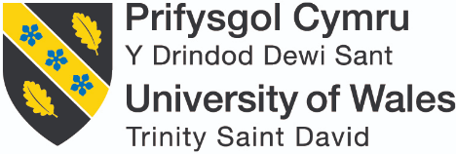

INTERNSHIP & VOLUNTEERISM
Assessment 1 – Pre-Placement Skills Audit
Name: Jordan John Coller

Placement Provider: Egni Co-operative

Date: 06/06/2019
The purpose of this skills audit is to assess your skills set prior to you undertaking your placement to establish what skills you need to improve on during your placement. Please be honest, take some time for self-reflection and when responding to each skill try to think of an example of when you may have done this.
Skill | Already there | Well on the way | Gathering speed | Not currently
I think about the whole system when working to solve problems and developing ways of doing things |  |  | X
Example: 2 years of working as a Team Leader in Tesco Express has granted me with semi-proficient skills in problem solving, whilst being aware that policies and regulations should be taken into account.
I have the ability to ability to address current and future problems creatively |  |  | X
Example: I have knowledge of micro and macro environments, which are associated with an organisation’s agility. I have not had first-hand experience in this area; although, I have learned about it within my module assignments.
However, it is apparent that I do have a creative mind-set, as I have won UWTSD’s Rethinking Business Awards 2017 & 2018 for designing innovative and sustainable products.

I am confident in assessing and critiquing a range of information sources |  |  | X
Example: During my undergraduate Business and Management degree, I have developed my skills to think critically and analyse information. Additionally, I feel that I am proficient with databases, which are used to visualise a range of data, which can then be analysed for problem solving.

I have a critical understanding of connections between environment, social and economic factors |  | X
Example: I have a theoretical background through the modules of my degree, so I am aware of the environment, social and economic factors which can affect businesses. Specifically, regarding my placement, social and ethical marketing is an area in which I wish to extensively develop my skills.

I am capable of engaging in self-reflection and analysis |  |  | X
Example: I am currently aware of my own barriers and limitations; although, I am consistently researching how to overcome them. As an example, during my time as Team Leader in Tesco Express, when handling logistical problems, I would often assess my own performance to analyse what was successful and which aspects could be improved. For instance, this kind of scenarios could include customer confrontation, handling reviews or meeting sales targets.

I have a commitment to life-long | X
Example: Fatherhood, as I aim to raise child at the best of my ability, putting the child at the highest of my priorities. Additionally, I aim to raise my child and teach him ethics, all whilst incorporating sustainability within our culture.

I am committed to supporting and encouraging others with life-long learning | X
Example: As a former Team Leader in Tesco Express, I was continually influencing and teaching others to self-improve in order to develop their relevant skill-sets within the industry. I take satisfaction in witnessing other’s personal development; this is an aspect of business that I take pride in.

I am innovative and adaptable, proactive rather than reactive |  | X
Example: I have won UWTSD’s Rethinking Business Awards 2017 & 2018 for designing innovative and sustainable products; in which required myself to be innovative and adaptable. My prior knowledge of micro and macro environments learnt within my module assignments, has inspired me to be aware of the importance of being proactive rather than reactive.

I am an engaging and dynamic communicator (written) |  |  |  | X
Example: My ability to be an engaging and dynamic written communicator could be improved upon, as I write conversationally; and have little to no experience in formally communicating with authority figures.

I am an engaging and dynamic communicator (oral) |  |  |  | X
Example: My ADHD and anxiety presents limitations within my oral communication. These limitations could be perceived as: Talking too extensively, the fast-paced speed of how I communicate, the inability to keep on topic, and my own struggles to portray a linear sentence with relevant context.

I am an effective networker |  | X
Example: I am an effective networker, because of my experience in the NUS. Social media is a catalyst to my networking skills, as I grew up in The Digital Age, and so I am sensitive to the way people network through the social media medium.

I am an effective facilitator |  | X
Example: During my time as Team Leader in Tesco Express, I would simply tasks and projects so they could be executed efficiently. This was performed through a delegation process, where I would measure each colleague’s skills and decide which tasks would be optimal for them, to improve efficiency.

I work well in cooperation with others | X
Example: Team work is a practice which I believe is truly beneficial to a project’s success. My strong belief stems from my past experiences as a Tesco Express Team Leader, where I cooperation and communication would be a fundamental practice.

I am a well-practiced and effective active listener |  | X
Example: I comprehend instructions which are used to carry out tasks. An example of this could regard my undergraduate lectures. This is where we are taught information which can be used for not only future assignments, but knowledge that can be used for future life.

I can organise myself and manage my time effectively |  |  |  | X
Example: Organizing and managing my time effectively would not be my strongest asset and will need addressing in the future. This can be conveyed within my undergraduate work, where I would not manage my time efficiently, therefore occasionally I would submit my course work late. However, with support, this is rectified.

Although during my time at Tesco, I would manage time effectively, as I was in a team; and the time utilised to perform tasks would be delegated.

I understand how to act as a responsible citizen | X
Example: I do I understand how to act as a responsible citizen. This is conveyed through my years at Tesco, as I was trained to be respectful, abide by rules and policy when performing tasks. I believe that when you work for a business, you are representing that business.

I have a clear vision of forthcoming change and how to act to realise a sustainable future |  | X
Example: Within my undergraduate studies, I am learning how to integrate sustainable harmony within the business culture; the modules within my course conveys how to apply theory into practice.

I feel competent in leading on change for social, environmental and/or economic benefit |  | X
Example: Although I do not uphold an example of being competent in leading on change for social, environmental and/or economic benefit, an objective of mine is to be self-employed, with my own Social marketing firm. Within my own future self-employment role, I aim to employ those with a positive mindset regarding sustainability. I feel I uphold suitable knowledge and passion regarding sustainability and ethics, in order to implement sustainable harmony and ethics into future marketing projects.

I feel comfortable speaking openly about my values |  |  |  | X
Example: Unfortunately, I am a diagnosed anxiety sufferer. My mental illness often results in self-exclusion in oral communications, thus, limiting my comfort when speaking openly about my values.
I can lead with integrity driven by my own values |  | X
Example: As written in the box’s above, 2 years of working as a Team Leader in Tesco Express has granted me with semi-proficient skills in problem solving, whilst being aware that policies and regulations should be taken into account.
As a Team Leader in Tesco Express, I was continually influencing and teaching others to self-improve in order to develop their relevant skill-sets within the industry. I take satisfaction in witnessing other’s personal development; this is an aspect of business that I take pride in. During my time as Team Leader in Tesco Express, I would simply tasks and projects so they could be executed efficiently. This was performed through a delegation process, where I would measure each colleague’s skills and decide which tasks would be optimal for them, to improve efficiency. My years at Tesco, as I was trained to be respectful, abide by rules and policy when performing tasks. I believe that when you work for a business, you are representing that business. I would manage time effectively, as I was in a team; and the time utilised to perform tasks would be delegated.

Appendix C – Role Profile
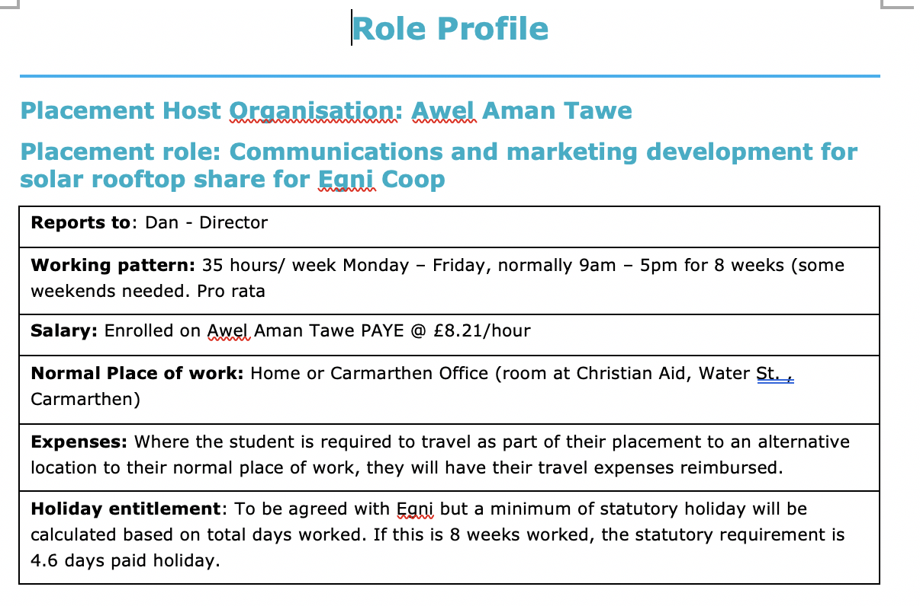
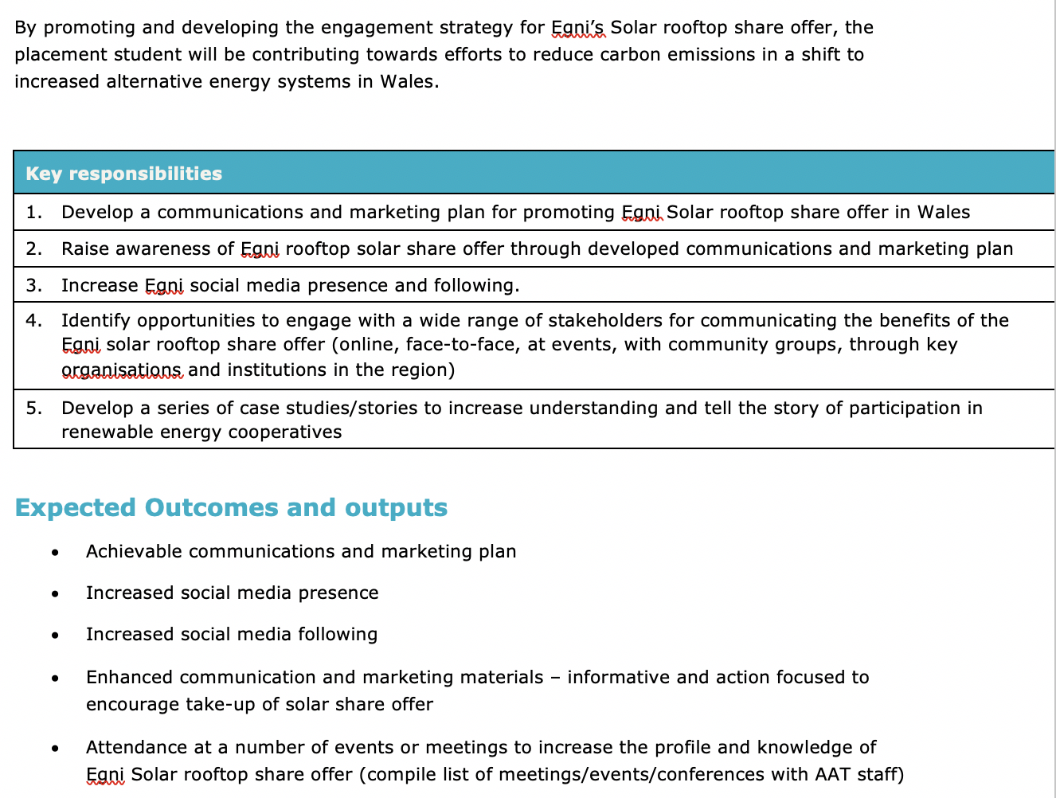

Appendix D – Cross Evaluation of Appendix B & C
Strengths (‘Already there’ & ‘Well on the way’)

Develop a communications and marketing plan | Raise awareness of Egni rooftop offer | Increase Egni’s social media presence | Engage with stakeholders | Develop case studies/stories
I work well in cooperation with others.  I am an effective facilitator.  I have a clear vision of forthcoming change and how to act to realise a sustainable future. | I am an effective networker.  I work well in cooperation with others.  I feel competent in leading on change for social, environmental and/or economic benefit. | I am innovative and adaptable, proactive rather than reactive.  I am an effective networker.  I work well in cooperation with others. | I understand how to act as a responsible citizen.  I am committed to supporting and encouraging others with life-long learning.  I am an effective networker.  I work well in cooperation with others.  I am a well-practiced and effective active listener. | I have a critical understanding of connections between environment, social and economic factors.  I work well in cooperation with others.  I have a clear vision of forthcoming change and how to act to realise a sustainable future.

Weaknesses (‘Not currently’ & ‘Gathering speed’)

Develop a communications and marketing plan | Raise awareness of Egni rooftop offer | Increase Egni’s social media presence | Engage with stakeholders | Develop case studies/stories
I can organise myself and manage my time effectively.  I have the ability to ability to address current and future problems creatively  I think about the whole system when working to solve problems and developing ways of doing things |  |  | I feel comfortable speaking openly about my values.  I am an engaging and dynamic communicator (oral). | I am an engaging and dynamic communicator (written).  I am confident in assessing and critiquing a range of information sources  I am capable of engaging in self-reflection and analysis.

Appendix E – Resources Required
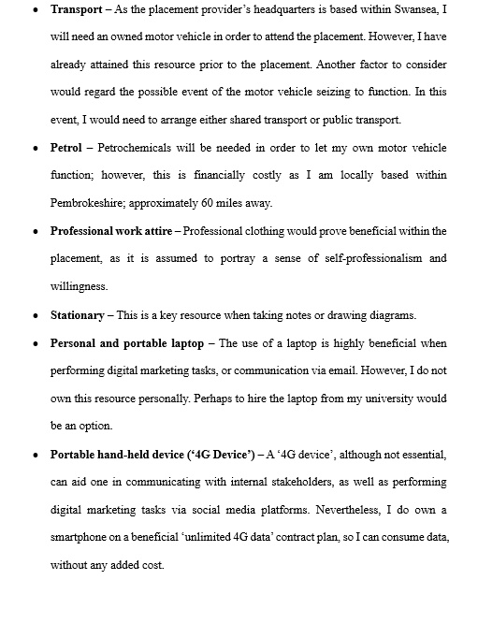
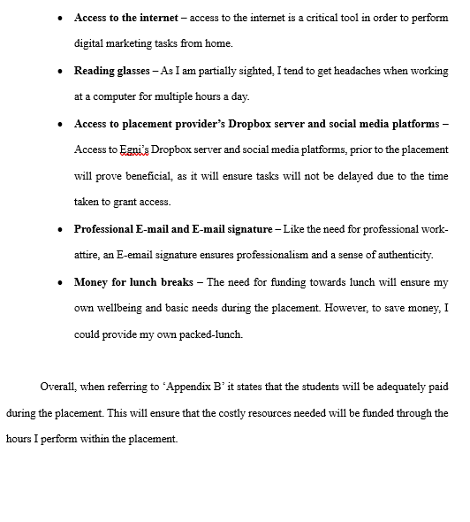

Appendix F – Gantt Chart
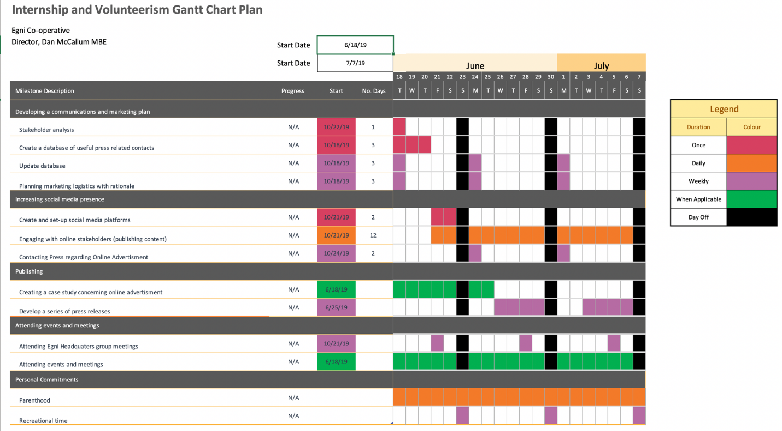

Appendix G – SMART Aims
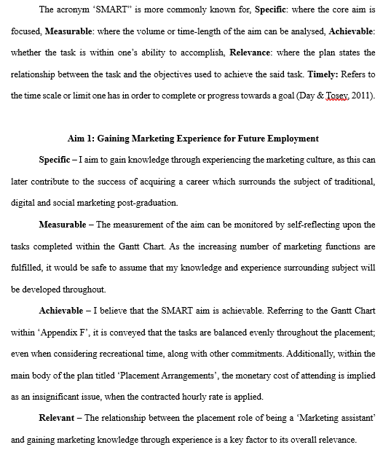

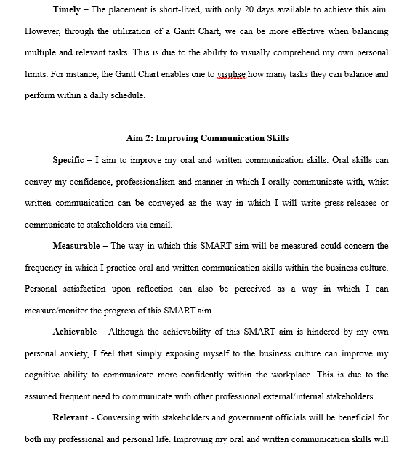

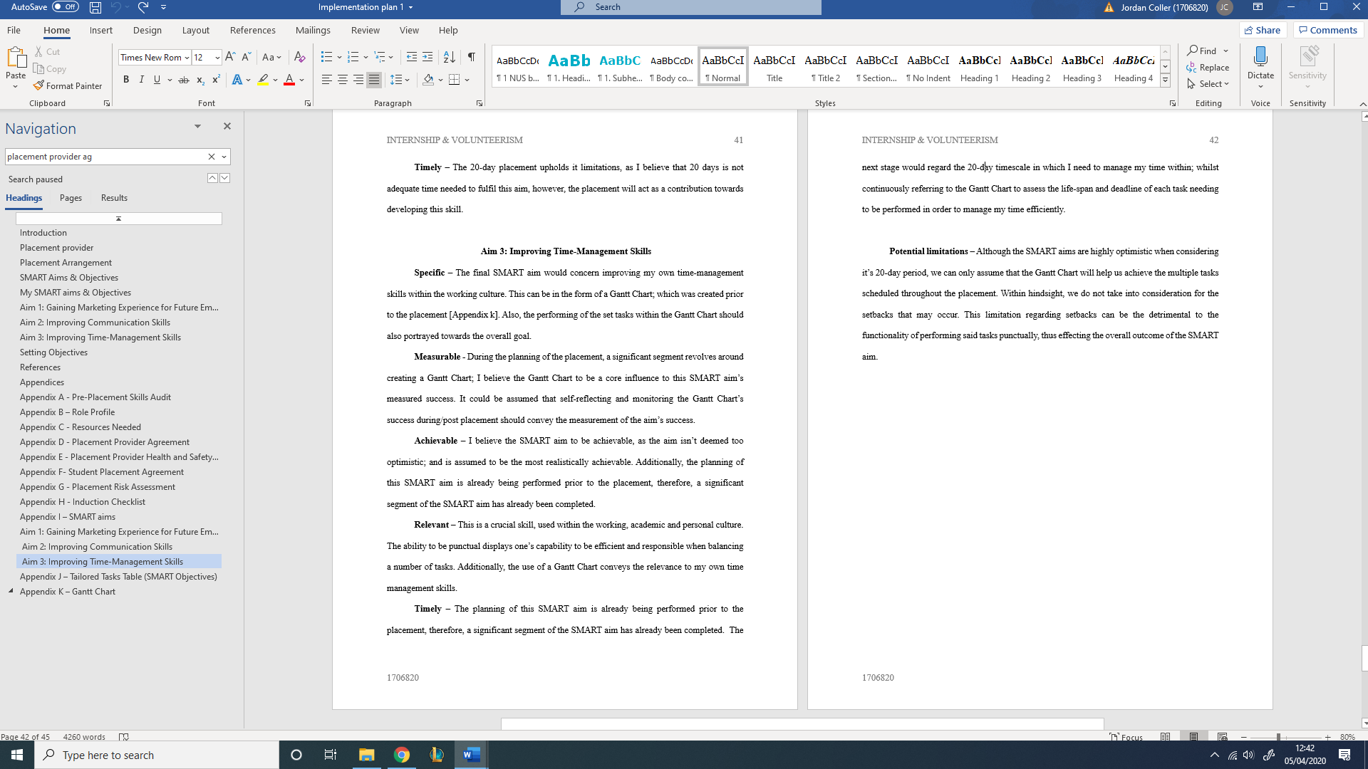

Appendix H –SMART Objectives
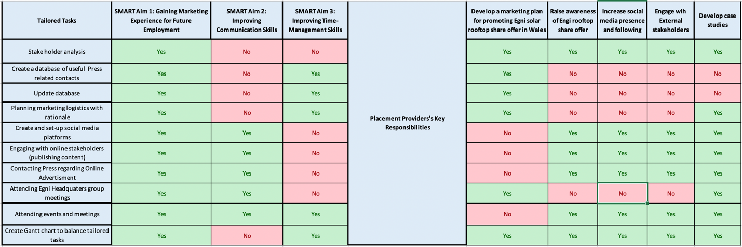

Appendix I - Placement Provider Health and Safety Questionnaire
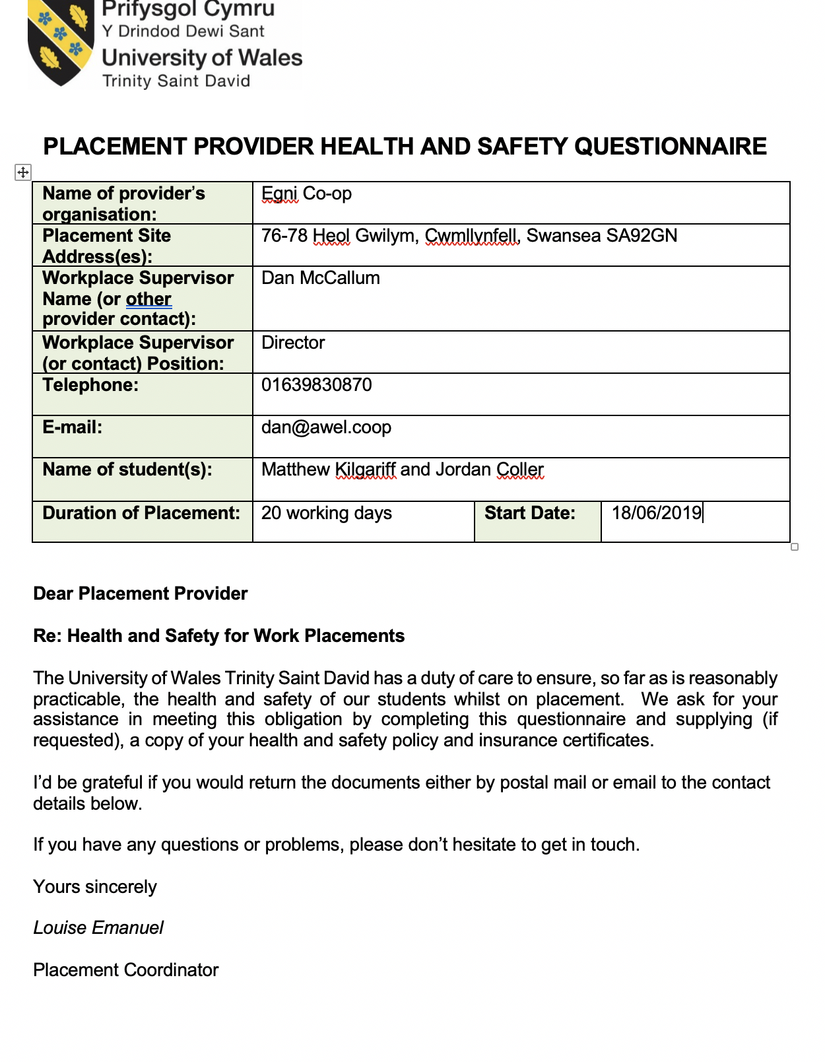
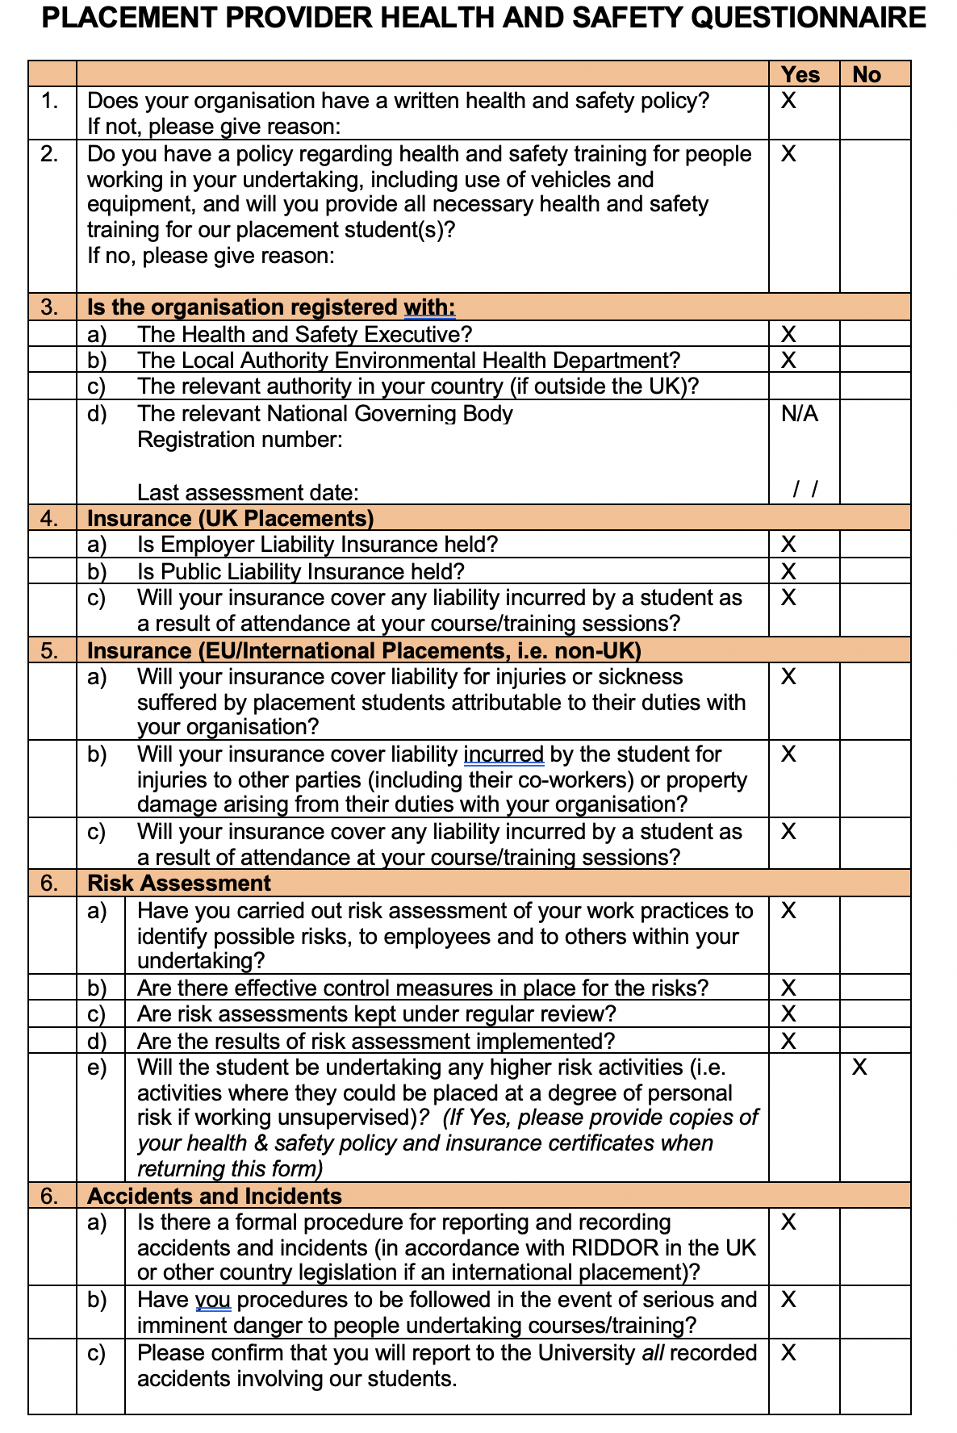
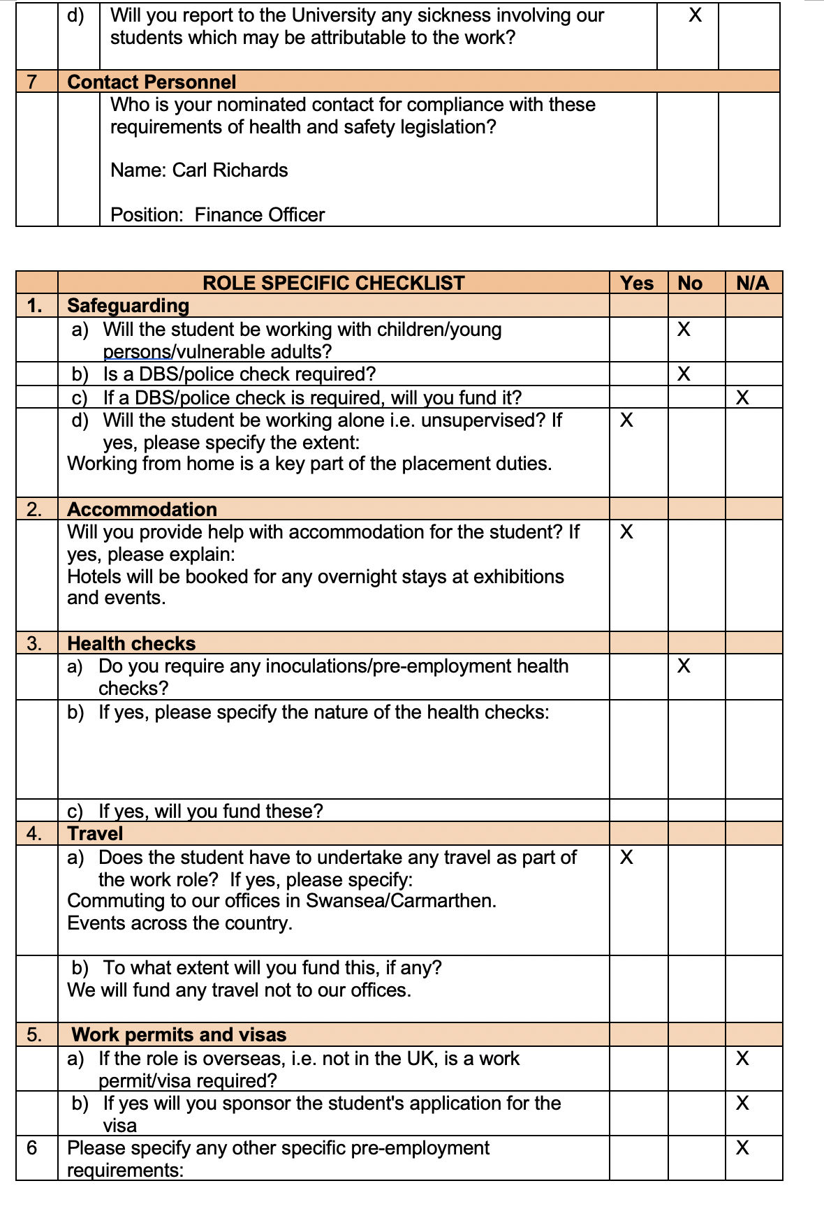
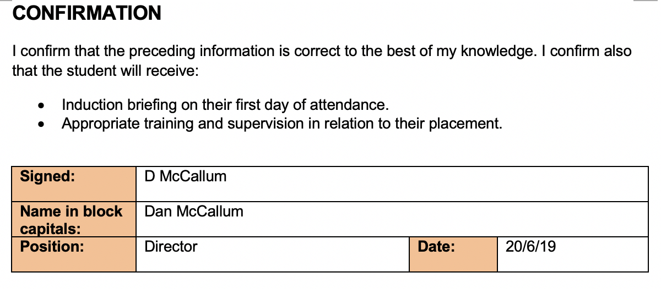

Appendix J - Placement Risk Assessment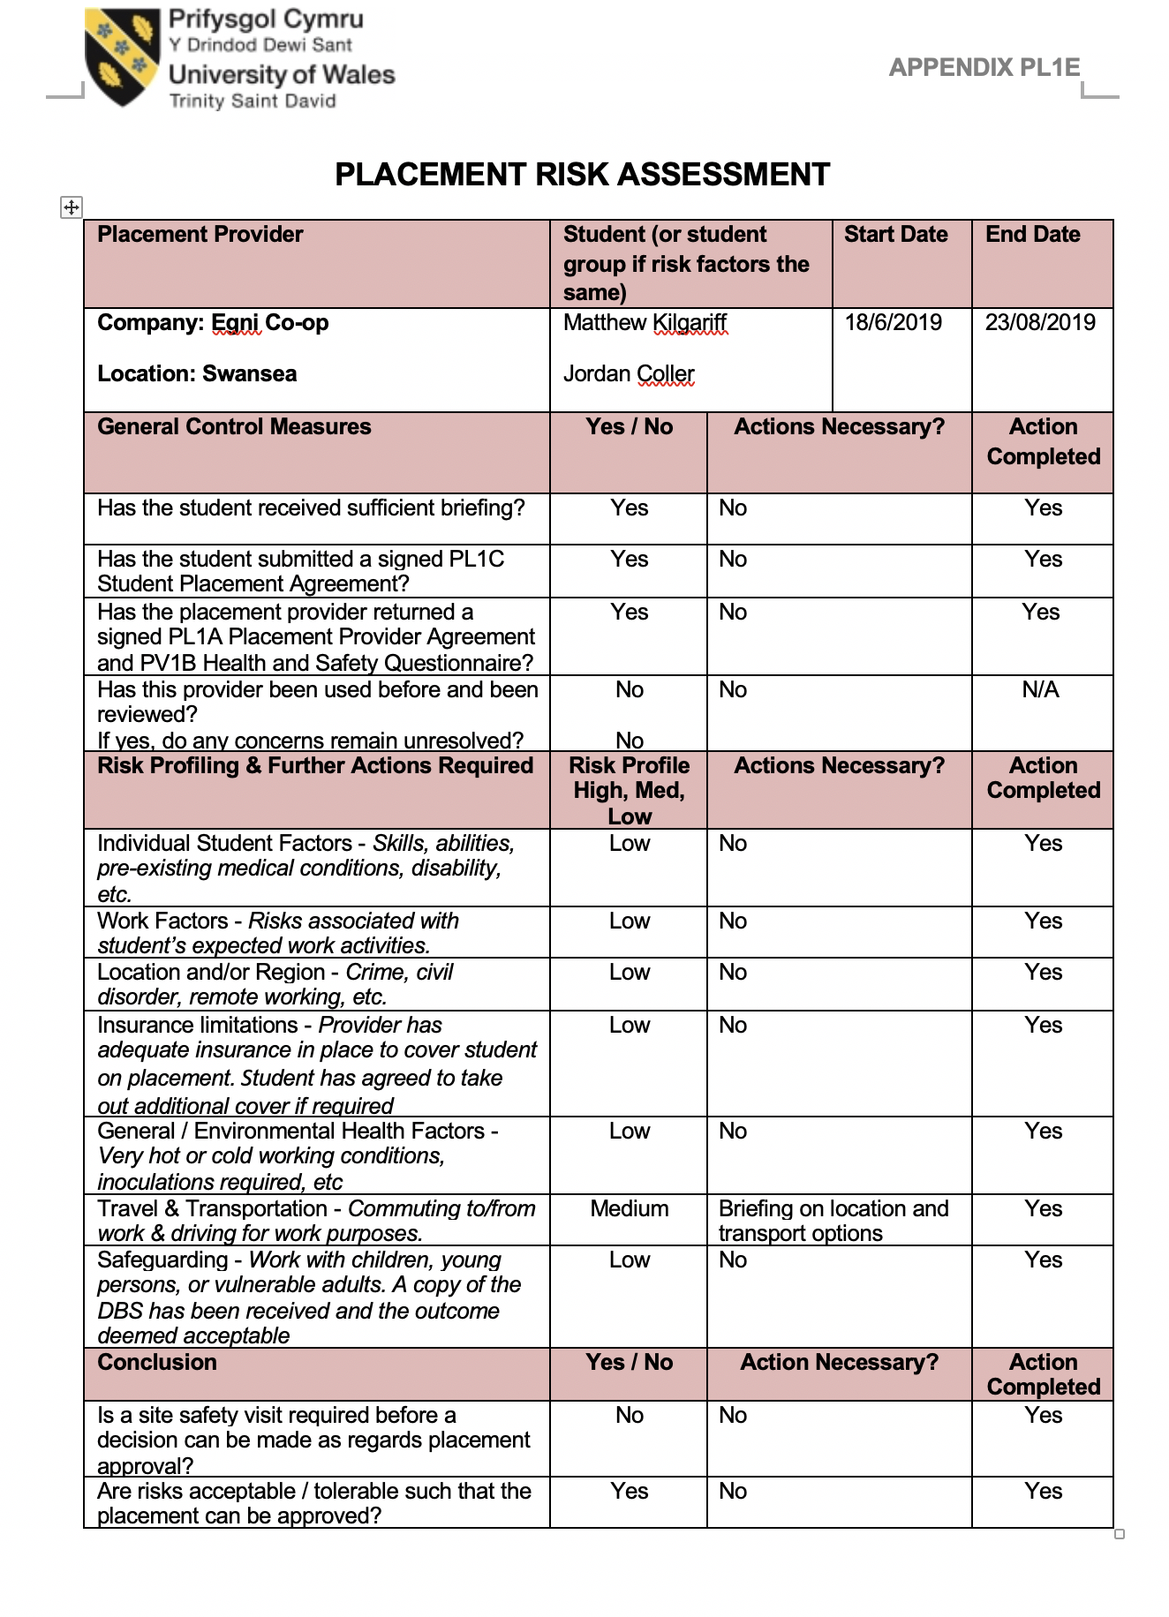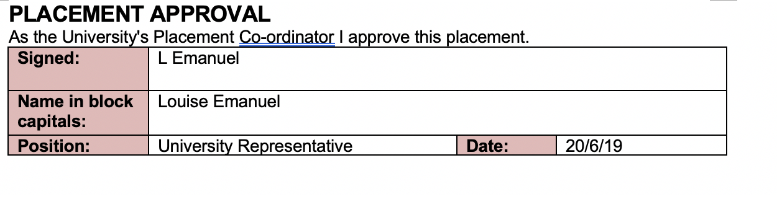

Appendix K- Student Placement Agreement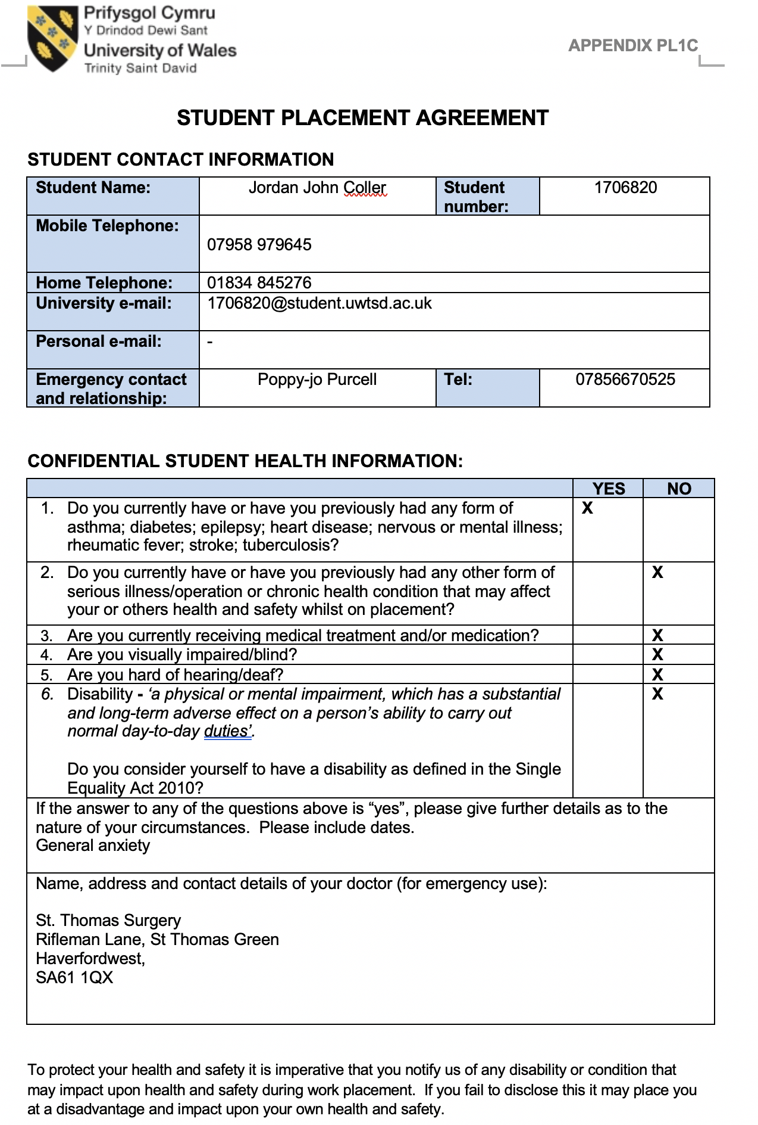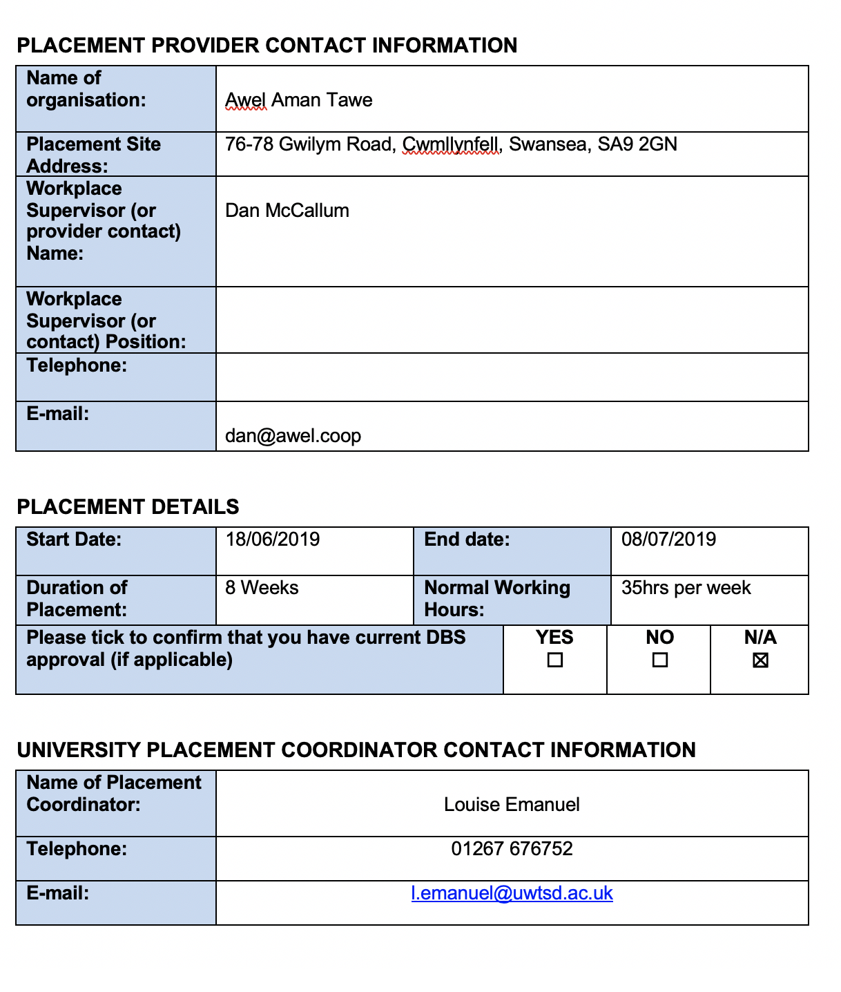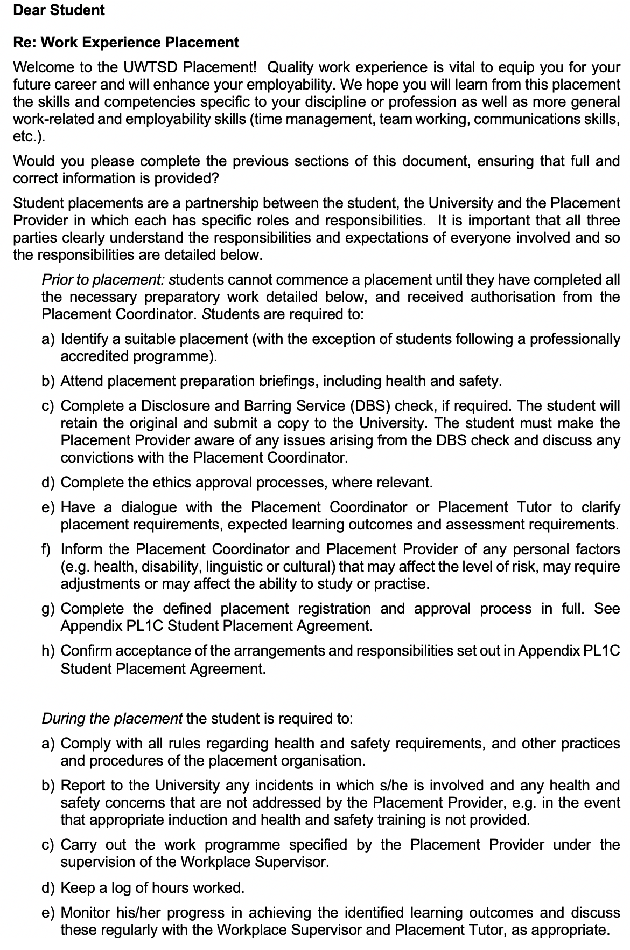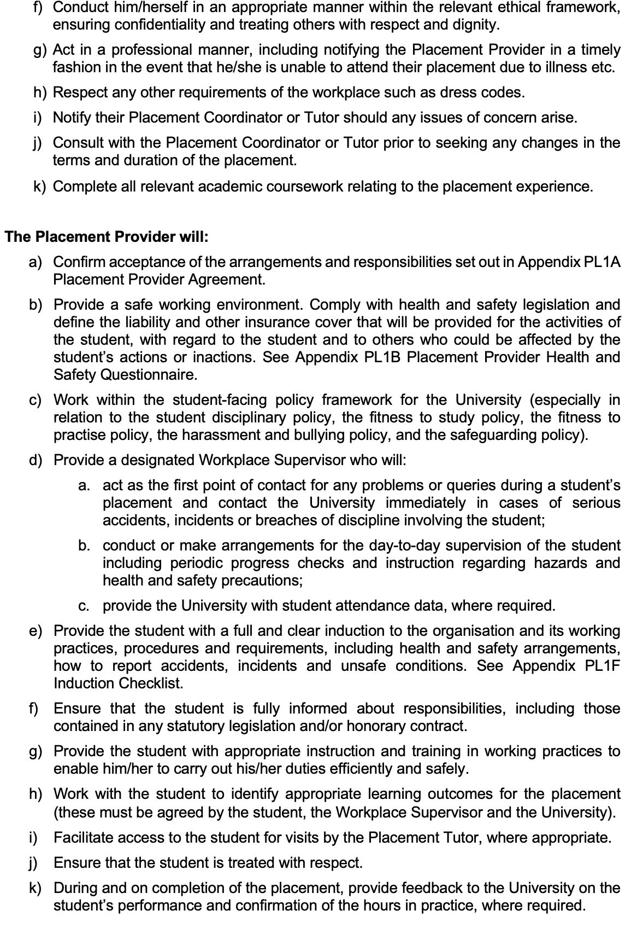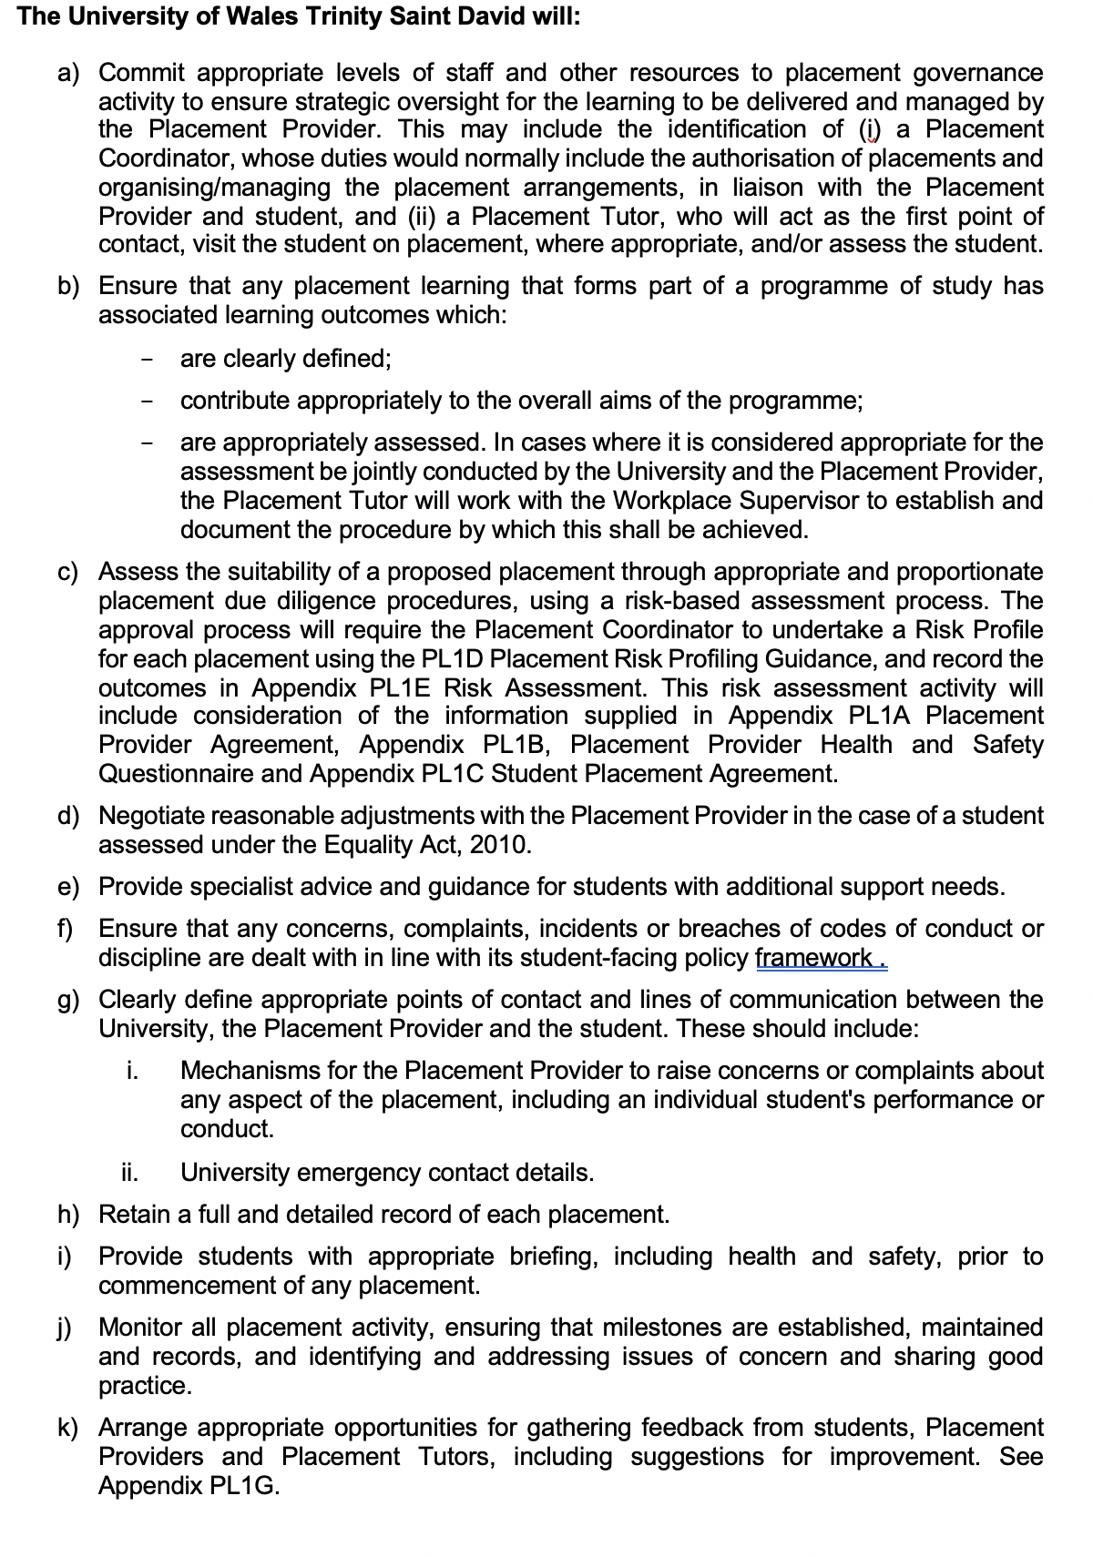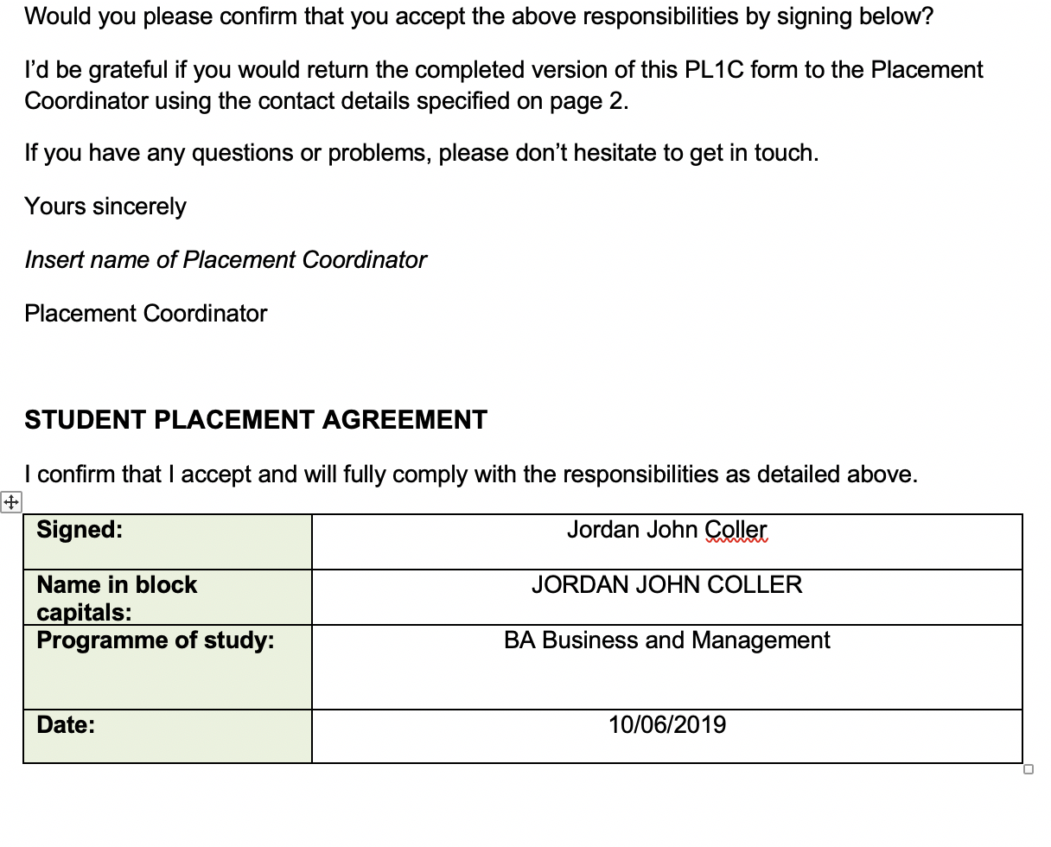

Appendix L - Placement Provider Agreement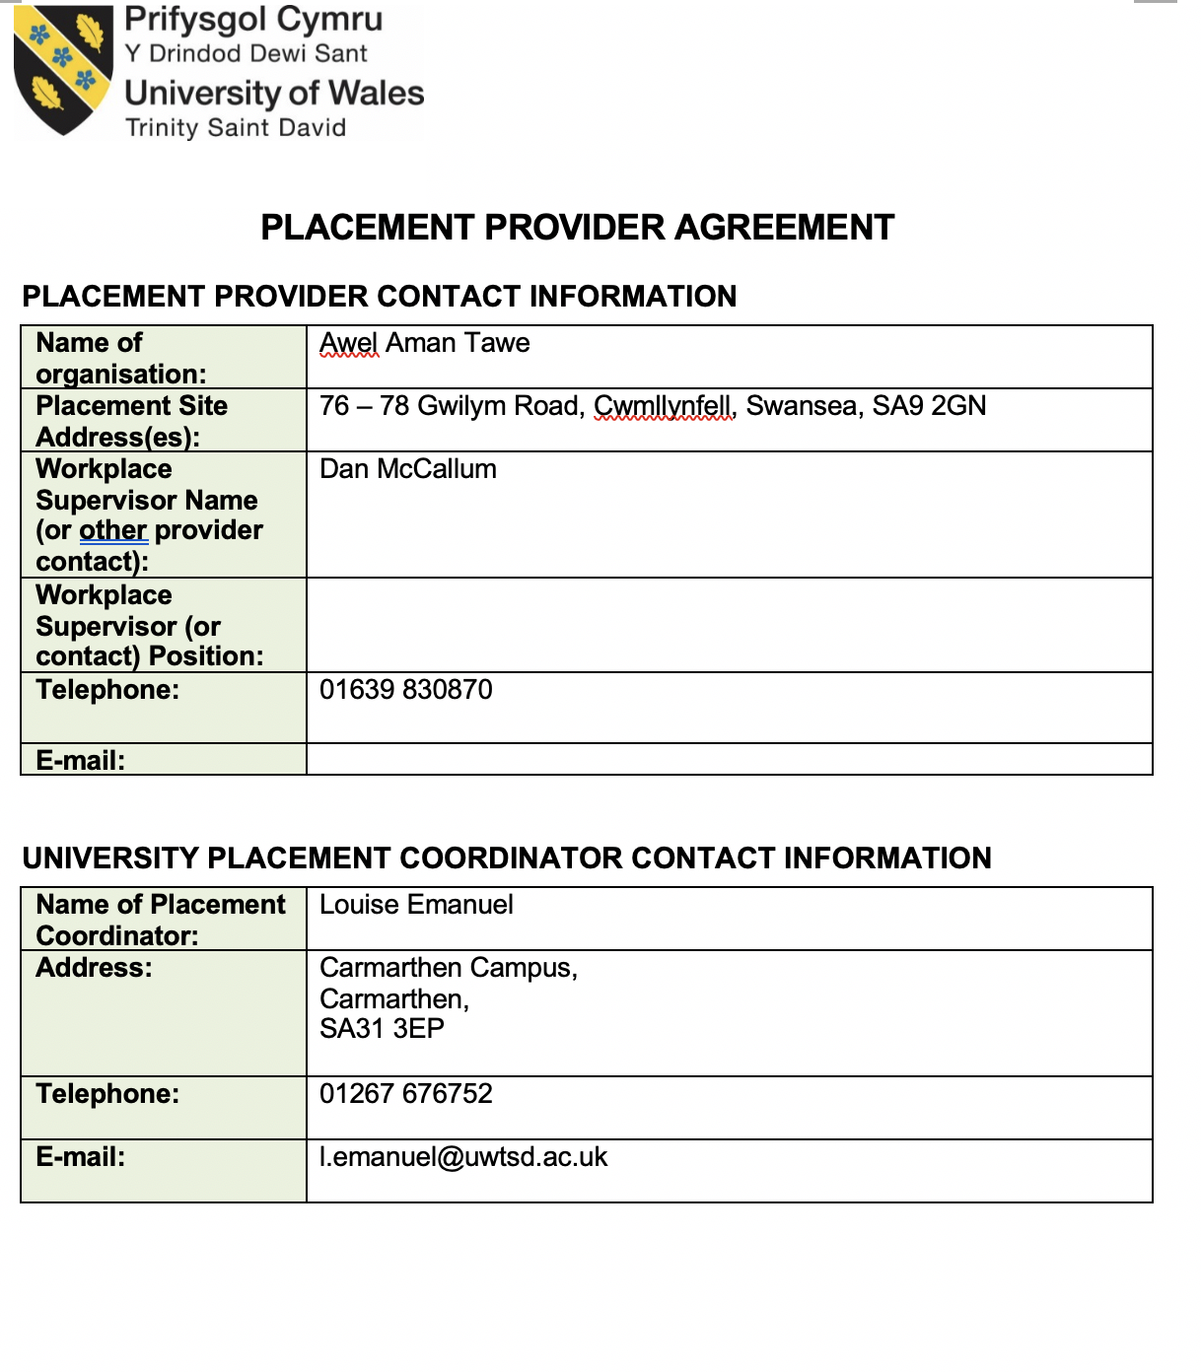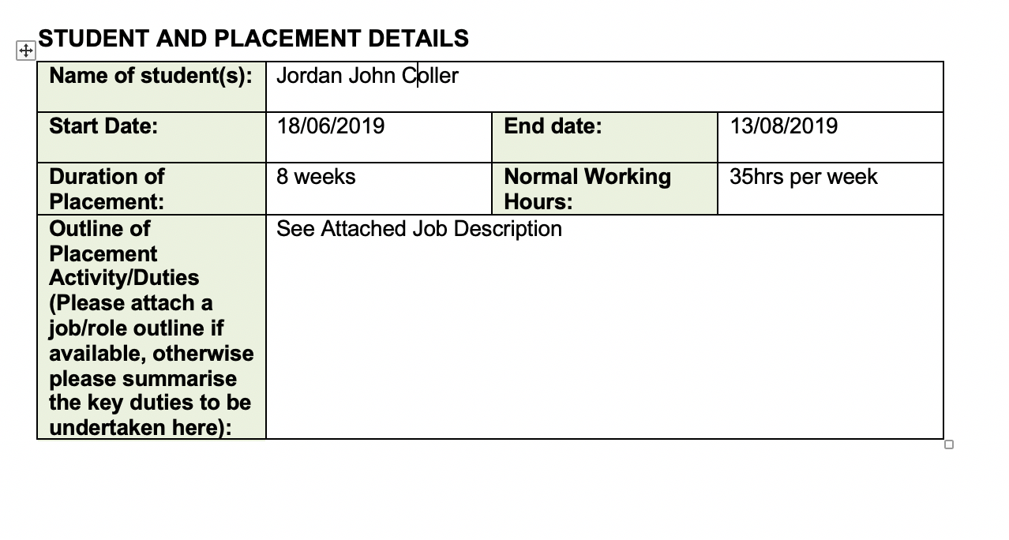

Appendix M - Induction Checklist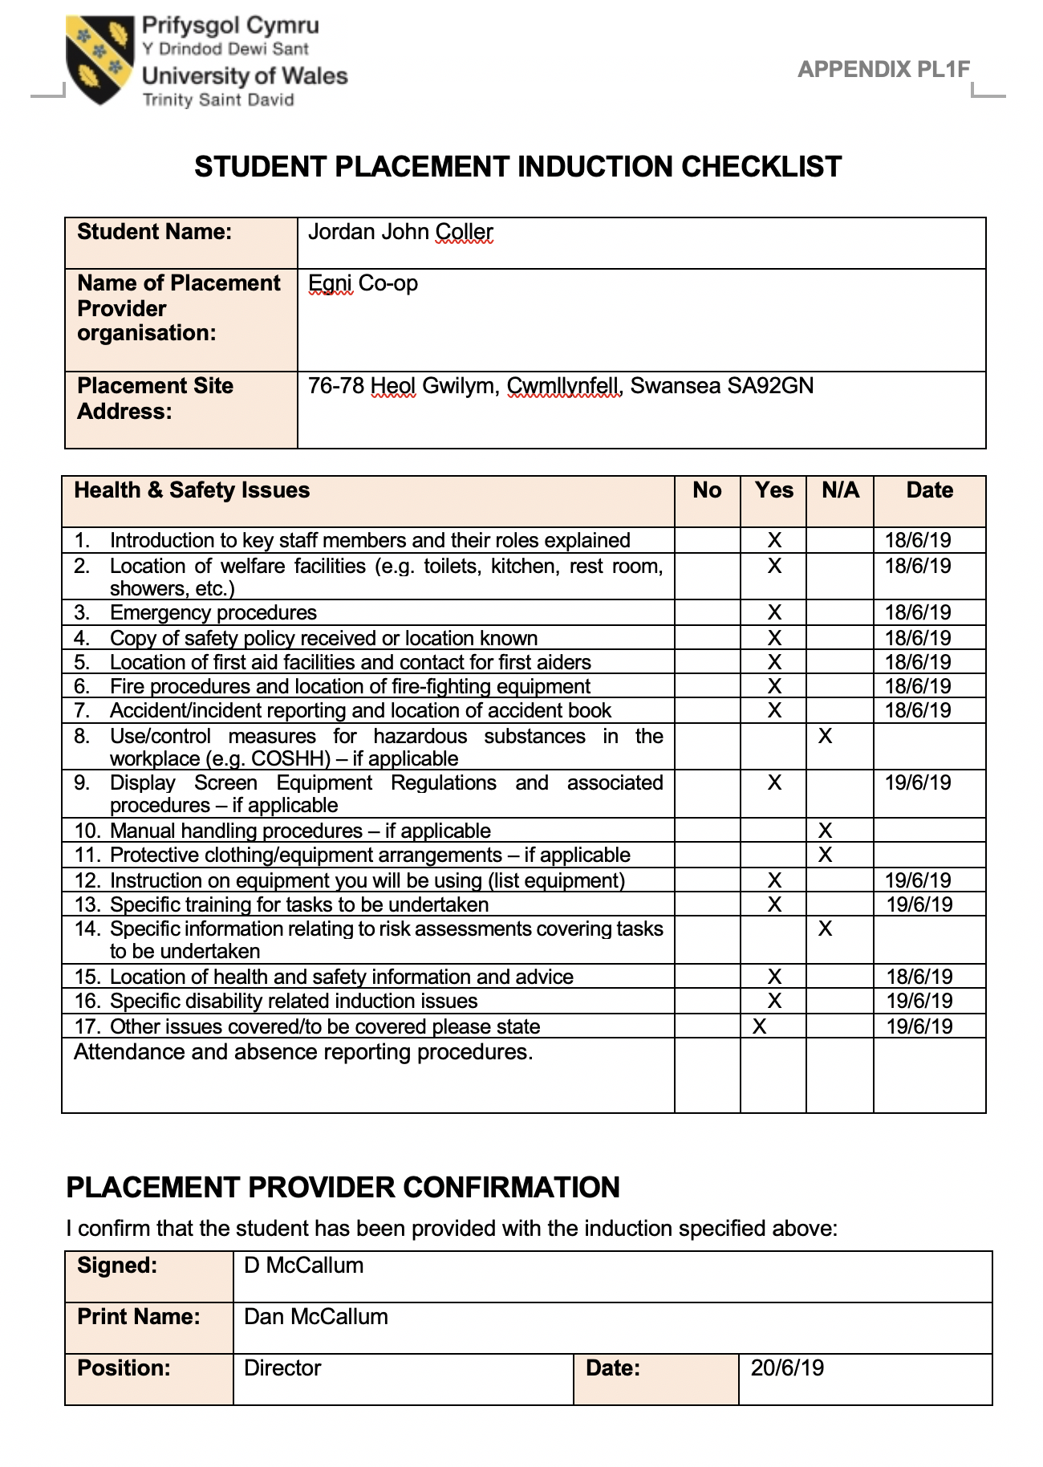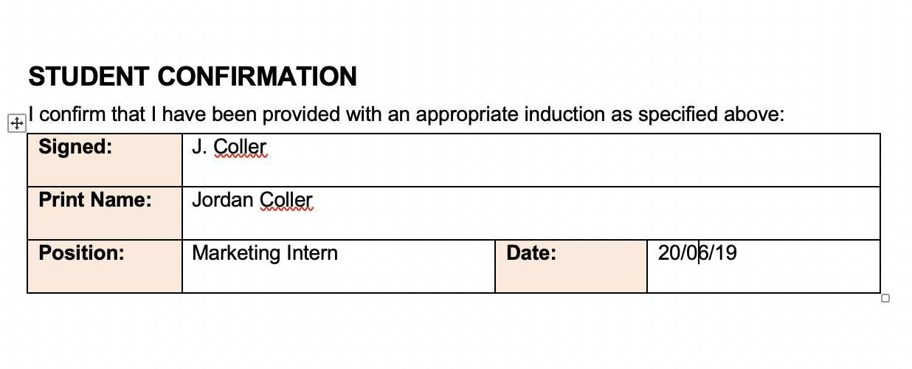

Appendix N – Post-Placement Skills Audit
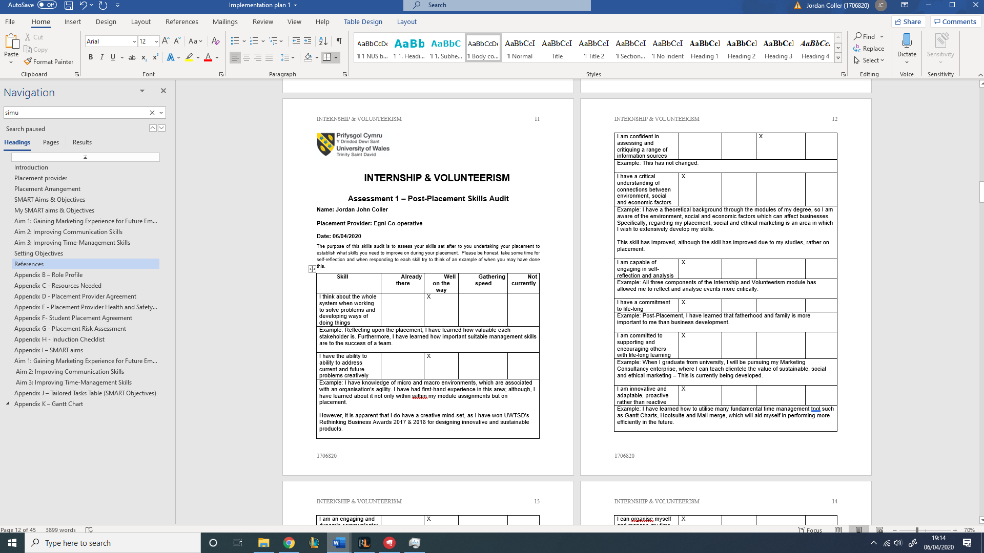

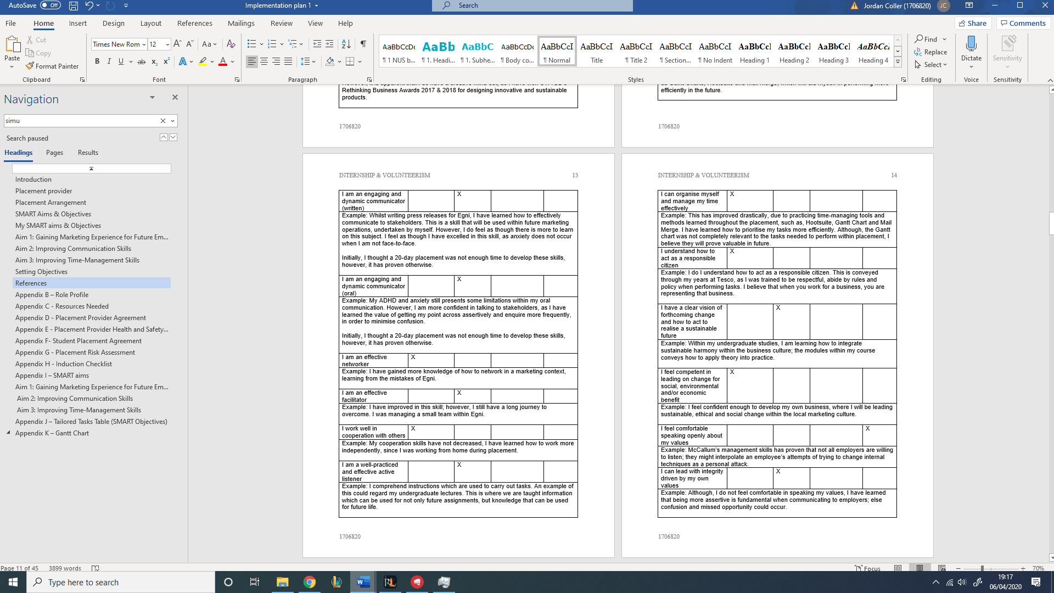

Appendix O - Post Placement Review & Feedback


