ETL Plan – National Archive Invoices
Analyst(s): Dr Nik Whitehead

The existing data source is an Excel spreadsheet. The new data warehouse star schema is given below:

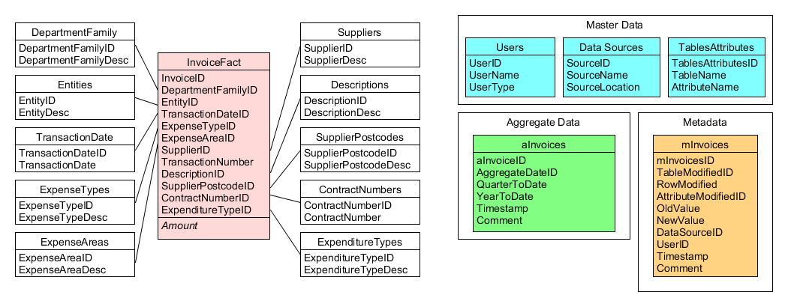
Database to data warehouse table mapping:

DATABASE TABLES | DATA WAREHOUSE TABLE
Spreadsheet | InvoiceFact
Spreadsheet | Dates
Spreadsheet | ExpenseType
Spreadsheet | ContractNumber
Spreadsheet | ProjectCode
Spreadsheet | DepartmentFamily
Spreadsheet | Entity
Spreadsheet | Supplier
Spreadsheet | TransactionNumber
Spreadsheet | ServiceDescription
Spreadsheet | ExpenditureType
Not Applicable – This table needs to be generated from scratch | Users
Not Applicable – This table needs to be generated from scratch | Data_Sources
Not Applicable – This table needs to be generated from scratch | TablesAttributes
Not Applicable – This table needs to be generated from scratch | mInvoices
Not Applicable – This table needs to be generated from scratch | aInvoices

Database to data warehouse attribute mapping

INVOICEFACT
TARGET ATTRIBUTE | SOURCE(S) | PROCESSING REQUIRED | MISSING VALUE? | INCORRECT VALUE?
InvoiceID | PK | Automatically generated |  | Refer to staff
DepartmentFamilyID | Spreadsheet.DepartmentFamily | Linked to DepartmentFamily dimension | 1 (=Unknown) | Refer to staff
EntityID | Spreadsheet.Entity | Linked to Entity dimension PK | 1 (=Unknown) | Refer to staff
DateID | Spreadsheet.Date | Linked to Date dimension PK | 1 (=Unknown) | Refer to staff
ExpenseTypeID | Spreadsheet.ExpenseType | Linked to ExpenseType dimension PK | 1 (=Unknown) | Refer to staff
ExpenseAreaID | Spreadsheet.ExpenseArea | Linked to ExpenseArea dimension PK | 1 (=Unknown) | Refer to staff
SupplierID | Spreadsheet.Supplier | Linked to Supplier dimension PK | 1 (=Unknown) | Refer to staff
TransactionNumberID | Spreadsheet.TransactionNumber | Linked to TransactionNumber dimension PK | 1 (=Unknown) | Refer to staff
ServiceDescriptionID | Spreadsheet.ServiceDescription | Linked to ServiceDescription dimension PK | 1 (=Unknown) | Refer to staff
ContractNumberID | Spreadsheet.ContractNumber | Linked to ContractNumber dimension PK | 1 (=Unknown) | Refer to staff
ProjectCodeID | Spreadsheet.ProjectCode | Linked to ProjectCode dimension PK | 1 (=Unknown) | Refer to staff
ExpenditureTypeID | Spreadsheet.ExpenditureType | Linked to ExpenditureType dimension PK | 1 (=Unknown) | Refer to staff
Amount | Spreadsheet.Amount |  |  | Refer to staff

SUPPLIERS
TARGET ATTRIBUTE | SOURCE(S) | PROCESSING REQUIRED | MISSING VALUE? | INCORRECT VALUE?
SupplierID | PK | Automatically generated |  | Refer to staff
SupplierType | Spreadsheet.SupplierType |  | “Unknown” | Refer to staff
SupplierNumber | Spreadsheet.SupplierNumber |  | “Unknown” | Refer to staff
SupplierPostcode | Spreadsheet.SupplierPostcode | If not present, first check other records for that supplier for a postcode; if a postcode exists for that supplier then use it, otherwise set to “Unknown” | “Unknown” | “NOT UK” data format error

ENTITY
TARGET ATTRIBUTE | SOURCE(S) | PROCESSING REQUIRED | MISSING VALUE? | INCORRECT VALUE?
EntityID | PK | Automatically generated |  | Refer to staff
Entity | Spreadsheet.Entity |  | “Unknown” | Refer to staff

TRANSACTIONNUMBER
TARGET ATTRIBUTE | SOURCE(S) | PROCESSING REQUIRED | MISSING VALUE? | INCORRECT VALUE?
TransactionNumberID | PK | Automatically generated |  | Refer to staff
TransactionNumberDescription | Spreadsheet.TransactionNumber |  | “Unknown” | Refer to staff

SERVICEDESCRIPTION
TARGET ATTRIBUTE | SOURCE(S) | PROCESSING REQUIRED | MISSING VALUE? | INCORRECT VALUE?
ServiceDescriptionID | PK | Automatically generated |  | Refer to staff
ServiceDescriptionText | Spreadsheet.ServiceDescription |  | “Unknown” | Refer to staff

EXPENDITURETYPE
TARGET ATTRIBUTE | SOURCE(S) | PROCESSING REQUIRED | MISSING VALUE? | INCORRECT VALUE?
ExpenditureTypeID | PK | Automatically generated |  | Refer to staff
ExpenditureTypeDescription | Spreadsheet.ExpenditureType |  | “Unknown” | Refer to staff

EXPENSETYPE
TARGET ATTRIBUTE | SOURCE(S) | PROCESSING REQUIRED | MISSING VALUE? | INCORRECT VALUE?
ExpenseTypeID | PK | Automatically generated |  | Refer to staff
ExpenseTypeDescription | Spreadsheet.ExpenseType |  | “Unknown” | Refer to staff
ExpenseAreaDescription | Spreadsheet.ExpenseArea |  | “Unknown” | Refer to staff

CONTRACTNUMBER
TARGET ATTRIBUTE | SOURCE(S) | PROCESSING REQUIRED | MISSING VALUE? | INCORRECT VALUE?
ContractNumberID | PK | Automatically generated |  | Refer to staff
ContractNumberDescription | Spreadsheet.ContractNumber |  | “Unknown” | Refer to staff

PROJECTCODE
TARGET ATTRIBUTE | SOURCE(S) | PROCESSING REQUIRED | MISSING VALUE? | INCORRECT VALUE?
ProjectCodeID | PK | Automatically generated |  | Refer to staff
ProjectCodeDescription | Spreadsheet.ProjectCode |  | “Unknown” | Refer to staff

DATES
TARGET ATTRIBUTE | SOURCE(S) | PROCESSING REQUIRED | MISSING VALUE? | INCORRECT VALUE?
DateID | PK | Automatically generated
Day | Spreadsheet.Date | Full date | Set to last day of current accounting period | Refer to staff
Week | Spreadsheet.Date | Calculate financial week number | Set to week of current accounting period | Refer to staff
Month | Spreadsheet.Date | Month | Set to month of current accounting period | Refer to staff
Year | Spreadsheet.Date | Year | Set to year of current accounting period | Refer to staff

Comments
In general, the fact table is where most of the problems will occur as this is going to be by far the largest table in the schema. The foreign keys should be extractable from the other tables, and if these are not present then the only thing for it is to have a member of staff check what’s missing. If this is happening a lot then the organisation has some serious data quality/data governance issues that need to be addressed at source system level.

Problems with the dimension tables tend to be less drastic. Always ensure that there is a record in each dimension to represent an “Unknown” value (or, in a date dimension, a date that is an identifiable date in the past that only has problem records attached to it).

Master Data, Metadata and Aggregate Data tables

Users
TARGET ATTRIBUTE | SOURCE(S) | PROCESSING REQUIRED | MISSING VALUE? | INCORRECT VALUE?
UserID | Generated from user list | None – Primary key | Shouldn’t happen | Refer to staff
UserName | Generated from user list | None | Refer to staff | Refer to staff
UserType | Generated from user list | None | Refer to staff | Refer to staff

Data_Sources
TARGET ATTRIBUTE | SOURCE(S) | PROCESSING REQUIRED | MISSING VALUE? | INCORRECT VALUE?
SourceID | Generated from source list | None – Primary key | Shouldn’t happen | Refer to staff
SourceName | Generated from source list | None | Refer to staff | Refer to staff
SourceLocation | Generated from source list | None | Refer to staff | Refer to staff

TablesAttributes
TARGET ATTRIBUTE | SOURCE(S) | PROCESSING REQUIRED | MISSING VALUE? | INCORRECT VALUE?
TablesAttributesID | Generated from schema | None – Primary key | Shouldn’t happen | Refer to staff
TableName | Generated from schema | None | Refer to staff | Refer to staff
AttributeName | Generated from schema | None | Refer to staff | Refer to staff

Comments
These tables are set up at design time and will change very rarely thereafter. Data sources will change only as the organisation changes its upstream data collection process. Table and attribute changes will occur as the data warehouse is expanded to include new stars. Users will change as staff change, but the user table should also include records for the ETL system and for the operational system so that automated tasks can be logged in any metadata tables.
mInvoices
TARGET ATTRIBUTE | SOURCE(S) | PROCESSING REQUIRED | MISSING VALUE? | INCORRECT VALUE?
mInvoicesID | Generated | None – Primary key | Shouldn’t happen | Refer to staff
TableModifiedID | Updated table | Link to TablesAttributes | Reject and rollback transaction | Reject and rollback transaction
RowModified | Updated table | Get RowID from updated table | Reject and rollback transaction | Reject and rollback transaction
AttributeModifiedID | Updated table | Link to TablesAttribtes | Reject and rollback transaction | Reject and rollback transaction
OldValue | Updated table | Original data value | Set to NULL | Reject and rollback transaction
NewValue | User/ETL Process | New data value | Reject and rollback transaction | Reject and rollback transaction
DataSourceID | Source system | Link to Data_Source | Reject and rollback transaction | Reject and rollback transaction
UserID | Login/ETL Process | Link to Users | Reject and rollback transaction | Reject and rollback transaction
Timestamp | DBMS | Generated | Reject and rollback transaction | Reject and rollback transaction
Comment | User/ETL Process | None | Reject and rollback transaction | Reject and rollback transaction

Comments
This table records who did what and when to the data warehouse and MUST be updated every time a change is made to the fact or dimensions in order to maintain an audit trail through the data. As a result, if any data is missing or incorrect then not only is the mOrders row insert rejected but the transaction that caused the insert must also be rejected and rolled back.

aInvoices
TARGET ATTRIBUTE | SOURCE(S) | PROCESSING REQUIRED | MISSING VALUE? | INCORRECT VALUE?
aInvoicesID | Generated | None – Primary key | Shouldn’t happen | Refer to staff
AggregateDateID | Generated | Link to Date_Dim | Rollback and write to log | Rollback and write to log
QuarterToDate | Orders_Fact | Sum TotalCost over time | Rollback and write to log | Rollback and write to log
YearToDate | Orders_Fact | Sum TotalCost over time | Rollback and write to log | Rollback and write to log
Timestamp | Generated | None | Rollback and write to log | Rollback and write to log
Comment | ETL Process | None | Doesn’t matter | Doesn’t matter

Comment
The aggregate table is generally updated monthly once the main body of the ETL process has completed for the month. As this is an automated process that does not tend to have a significant impact on the operation of the data warehouse any problems in the aggregation process are generally written to an error log file for investigation by a staff member.

