  Component One:  What are the key skills required when working in the housekeeping team? 750 words (+/- 10%)  Contribution to Overall Module Assessment: 25% | Student No: | Florin-Nicolae Matache 2126293
 | Module Title: | Operating Hotel Facilities
 | Module Code: | BMIH4006
 | Lecturer: | Ffion Cumberpatch
In the hospitality industry, this is essential for the housekeeping staff to be liable of ensuring that guests’ areas are spruce and trim. Without housekeeping, the condition of the hotel premises would fast deteriorate. The housekeeping department has been the backbone of the hotel and this plays a crucial role in keeping guests extremely satisfied. According to Choy, Cheng and Yu (2021), green practices that expectedly yield a wide range of paybacks, such as minimising waste and energy saving, have become highly popular in hotel housekeeping. Housekeeping skills are necessary that facilitate the housekeeper to be effective in their job. These skills might range from customer service to be detail oriented and they might differ depending on the housekeeper’s particular duties and space of employment.
Time management skills- Most often, housekeeping work by their own or they might work with the small group of other housekeeping and should complete thee set of cleaning every day. Being capable off properly managing time as well as a set schedule has been the key skill required by the housekeepers for ensuring that they complete all essential cleaning on time (Tra, 2020). They should also be very punctual too clean appointments as well as finish cleaning in the time as anticipated by the client.
Attention to detail- To be proficient at their work of housekeeping, the housekeeper should be extremely detail oriented. Olimovich, Bakhtiyorovich and Salimovna (2020) stated that these cleaning experts require a good eye for detail to successfully perform their duties that range from arranging a variety of household things to making sure that windows and floors are clean and left streak free. A housekeeper's performance will improve if they are more meticulous in finishing their responsibilities.
Communication skills- Housekeepers should be extensively focused on regularly communicating with supervisors, co-workers and clients for ensuring that the expectations for each of the cleaning processes has been thoroughly understood. As stated by Pai et al. (2020), with not having a good hold on the communication skill, the housekeeper might never be in favourable state to meet the necessities of the guest or even overlook significant components that are needy for completing a specific job.
Interpersonal skill- The housekeepers most often work directly with clients and even should be capable of working well with others for being successful in their job. Common interpersonal skills required by the housekeepers for performing their job properly include teamwork, responsibility and dependability. The housekeeper might check to see whether they understand all of the instructions, they are given. In the event of inconsistencies, anomalies, or other conundrums, they also decide when to make more inquiries. According to Sulaiman and Limbing, 2019), hotel housekeepers uphold their interpersonal skills by always attending training sessions as well as new strategic insights gained out of reading motivational books and precepts. Housekeepers can enhance their careers in this position by having the capacity to listen intently and respond properly.
Flexibility- Numerous housekeepers are very essential to work a variety of hours every day depending on the necessities of the clients. Currently, flexibility extends beyond meeting the needs of particular groups as the term "flexible capitalism" indicates to the modern economic system in which adjustments to employment practises, production methods, and management techniques have changed the nature of the workplace. For instance, in case the housekeeper has been tasked with cleaning the hospitality building, then they might require waiting until all staff has left the building for the evening. New culturally acceptable criteria of flexibility are created and reinforced by digital technology, such as being reachable and attentive via connectivity (Whiting and Symon, 2020). A few of the housekeepers even engage in working altogether overnight or even early in the morning. Hence, being flexible can be extremely helpful for the housekeeper being available for more number of jobs as well as potentially making more money.
Customer service- To succeed in their jobs, housekeepers need to have excellent customer service abilities. According to Yu et al. (2022), this is because the performance of housekeeper is dependent on the client's approval, making client satisfaction essential to success in this line of employment.
Housekeeping hard skills- Housekeepers require developing numerous hard skills for being successful to perform their tasks (Tran, 2020). Hard skills are particular skills necessary for performing certain tasks. As discussed by King (2020), most common hard skills required for being a good housekeeper are inclusive of carpet cleaning, deep cleaning, window treatment cleaning, sweeping, mopping, dusting, polishing, bedroom and bathroom cleaning, vacuuming, infection control etc.

Word Count | 750

Component Two:
Contribution to Overall Module Assessment: 25%
In this scenario – You have just been promoted to team leader for a floor within the hotel. A guest complains that on their arrival, their room had not been properly cleaned. Create an action plan and answer the following questions.

Problem | Why did it happen? | What are you going to do? | How will you prevent this from happening in the future? | What measures would you introduce to improve team effectiveness?
The guests are complaining to management about in-room cleanliness concerns. | This happened due to the reason that the cleaning staffs were busy with other work or mistakenly missed that room. | Maintenance of cleanliness is the crucial part of healthy living because this is the aspect of cleanliness only, which supports in improving their personality by keeping clean internally or externally. | This is at prior essential to make a chore list. The housekeeping manager will stay focused on properly determining the things or spaces in the hotel that are essential to be cleaned such as removing clutter, grime or dust, things that must be sanitised such as minimising the spreading of germs, killing viruses and bacteria, etc. This is further essential to assign cleaning priority levels. This must be noted that high traffic or high touch areas must be having a high level of priority rather than the storage rooms or equipment, which is hardly used. | As discussed by Choirisa (2022), the housekeeping staff should focus on cleaning as well as disinfecting touched surfaces most frequently on a day-to-day basis. In order to ensure strategic improvement, this is necessary to establish a perfect schedule for weekly as well as daily cleaning in addition of disinfection activities depending on the level of contamination and location. This is essential to clean most often in case the guests are having any sick family member. Clutter must be avoided to limit areas wherein dirt and dust can be collected. In precise, as discussed by Fuhrken (2022), all processes must be streamlined and timely changes should be brought in the SOPs. For improving teamwork, management should filter the staff for eliminating reluctant workers from the team.
Issues with temperatures have also been reported to the management. | The hotel has been using old versioned ACs, which is failing to maintain essential temperature. | This is at prior essential to install new version of ACs that are highly electricity efficient and even have the feature of automatic temperature controller. | The issue of temperature control can be avoided in the future by properly maintaining condition of ACs by periodic check-ups. | Proper organisation of staff will be crucial in improving team effectiveness and hence avoid such adverse situations of temperature inconsistencies.
The hotel is receiving criticisms about unpleasant odours within premises. | The hotel premises smell bad for not proper cleaning. In addition, this is earnest to mention that humidity, moisture, etc. are just a few of the main reasons that cause bad smells in commercial spaces. | For getting rid of musty odour, this is prior essential to make use of air freshener or even odour neutraliser after application of drain cleaner to the plug drains and overflows. These types of odour are effective in properly controlling as well as improving the air quality of air that is experienced by the guests. | In the near future, bad odour in the hotel premises can convincingly be prevented by appropriate usage of a few of the best possible odour eliminators such as coffee grounds, vinegar, baking soda, oats, tea, etc. In fact, leaving a bowl of any of such odour absorbers in the room, which is because for a little freshening up would be helpful in properly clearing out the unpleasant smells from the air within the hotel premises. | Once the hotel is having the housekeeping team properly established this is important for investing in their success such that they crave for staying as well as growing in the hotel rather than always making investment on training newly recruited staff starting from scratch. For bringing in tactical improvement, this is at prior essential to discover roles that are changing in the hospitality industry and accordingly adapt with the dynamic and competitive market (Sunil et al., 2022). Integration of a flexible business model will be very effective in facilitating teammates to become highly agile about the changing approaches of working.  Setting up a daily training schedule is essential. As opined by Alzate-Galiza (2020), the employees must be trained on tasks assigned to them. This will help in properly up-skilling the housekeepers in a variety of elements, which will serve in making them better workers such as job focused courses on hygiene as well as natural cleaning techniques, generic personal development courses such as ways of working better in the team and even time management. Doing these, the staff will be feeling highly satisfied in their roles and they would become best employees working in team.

Component Three:
Contribution to Overall Module Assessment: 50%
Your task is to create and prepare a presentation following the detailed scenario provided below.

As the floor housekeeping manager and given the recent guest complaints you need to put together a basic training presentation for your colleagues within the housekeeping team to get the best out of them, ensure that brand standard is being achieved and that Health and Safety procedures are also being followed.

Slide 2: Introduction
- Housekeeping is essential in hotels for managing supplies and equipment, schedules and time and chores and duties of housekeeping department.
- As discussed by Shin and Kang (2020), ensuring high level of effectiveness in housekeeping is very essential for controlling as well as eliminating workplace hazards.
- This entails maintaining staff clothes, hotel bedding and visitor attire as well as maintaining complete hotel areas, comprising rooms, open areas, rear areas and rooms.

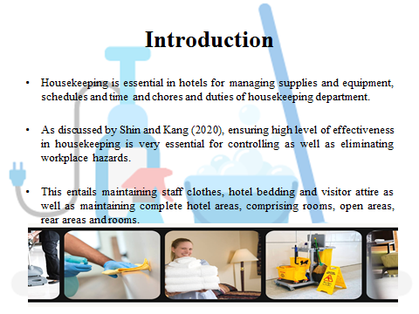
Training Notes:

Building and maintaining ideal housekeeping team has never been a simple task. However, when the protocols have been clearly defined, this in turn enables staff to successfully manage their daily chores and be more productive. This is without a doubt a formula for success to hotels. The personnel will be pleased since they will be setting up for success no matter the difficulties with a well-organized workforce. In addition, the hotel will thrive regardless of swings in occupancy.

Slide 3: Main responsibilities involved in housekeeping
- Hospitality staff assures well-maintained as well as furnished public areas and guestrooms in the hotel.
- Team leader check excellence in housekeeping sanitation, comfort, aesthetics and safety for the hotel guests.
- The housekeeping department should coordinate as well as administer all projects and programs of housekeeping (Chan, Gao and McGinley, 2021).
- The housekeepers act as crucial source of contacting in interdepartmental communications, professional agencies, vendors, etc.
- This is essential to act in providing budget, forecasting relevant to housekeeping and budget control.

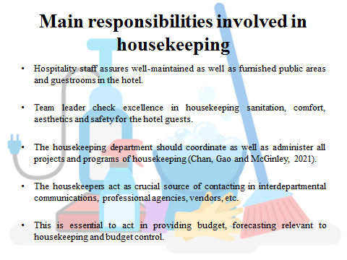
Training Notes:

There are far crucial responsibilities, which are essential to be focused in housekeeping. This is important to accomplish maximum efficacy to ensure the comfort as well as care of guests and in the smooth functioning of the department. In addition, the housekeepers should be engaged in ensuring courteousness and reliable services to the guests from all staff. High emphasise must be given on well establishing a welcoming atmosphere. For ensuring a high standard of cleanliness as well as general upkeep in every area for which the housekeeping department is responsible. Furthermore, for providing linen in banquet halls, rooms, conference halls, restaurants, health clubs, etc. in addition of maintaining a proper inventory for such activities, the housekeepers must be held accountable.

Slide 4: Important role assigned to housekeepers
- The housekeepers impart a crucial role in ensuring cleanliness and hygiene (Pillai et al., 2021).
- The housekeepers should focus on catering to the laundering necessities of hotel linen, guests and staff uniform within the workplace.
- They further provide and maintain floral decorations apart from the landscaped areas within the hotel.
- Housekeepers coordinate renovation as well as refurbishment of property consulting with management and interior designers.
- They deal with all lost and found articles in hotels.

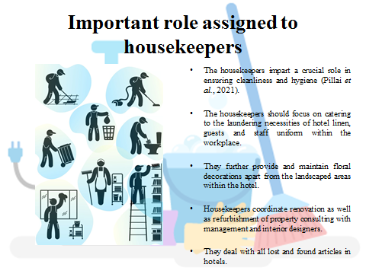
Training Notes:

The housekeepers’ main role is coordinating with the purchasing department for the perfect procurement of guest supplies, equipment, carpets, fabrics, cleaning agents and other related products used in the hotel premises. They further necessitate engaging in carpet maintaining by shampooing. Experience with housekeeping, great observational abilities, attention to detail, and verbal and nonverbal communication skills are required for the position. Dealing proficiently with guest complaints, requests and queries is regarded as their most important responsibility.

Slide 5: Best housekeeping practices for cleanliness
- As stated by Sadhale (2021), all areas have been perfectly cleaned top to bottom and corner to corner including surfaces.
- Storage, cabinets and closets areas have also been kept clean.
- Fixtures and furniture should be appropriately dusted; metal fixtures and doorknobs are polished with usage of suitable metal polishing chemical.

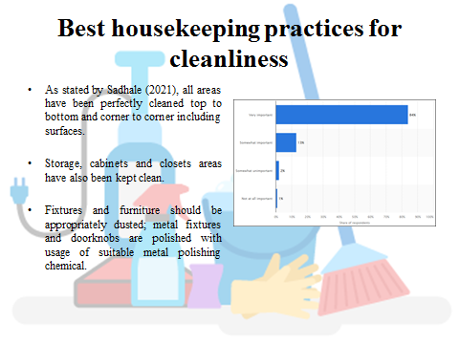
Training Notes:

The housekeepers must be engaged in dusting as well as polishing glass and window panels. They should practice polishing, shampooing and vacuuming floors whenever essential. The cleaners must make sure that the grounds are free from dirt and litters.

Slide 6: Best practices for maintaining orderliness
- Fixtures and facilities are appropriately arranged as well as installed in perfect location by housekeepers.
- All linens are carefully folded.
- As discussed by Khymdeit (2022), all amenities in rooms are appropriately installed in perfect location.
- Beds are made up appropriately, linen are kept wrinkle free.

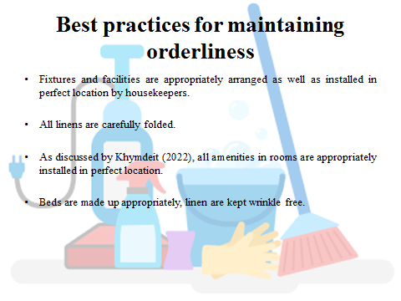
Training Notes:

Effective team management requires delegation. Establish all responsible parties and department heads for staff to contact in case of orderliness issue. Another important strategy for enabling the workers to take initiative and develop their problem-solving skills is delegation. The housekeeping personnel will take more initiative and want to show themselves by performing above average work the more autonomous they feel.

Slide 7: Best efforts to maintain sanitation
- The hotel area should be made free from all sources of bacterial contamination such as indisposed garbage, stagnant water, leftovers, etc. (Sudarmayasa et al., 2022).
- All wet garbage should be appropriately underlined with plastic, disposed on regular basis and covered.
- Jugs and glasses installed in guestrooms should be kept covered.

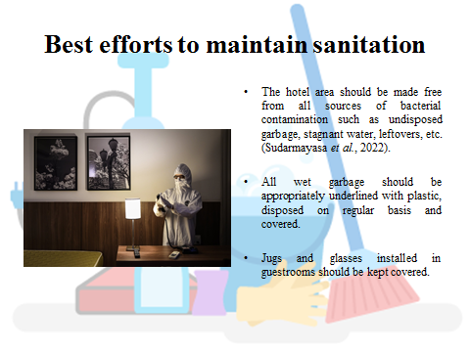
Training Notes:

To safeguard guests from potential bacterial infection, sanitising detergents should be utilised for cleaning guest personal objects, which come in touch with the body such as glasses, linen, cutleries, etc.

Slide 8: Practices for developing guest relations
- Guest concerns and requests provide rapid and even appropriate attention.
- Housekeepers exhibit pleasant and warm disposition while dealing with guests.
- Diplomacy as well as tact must be observed to deal with difficult circumstances and complaints.
- Customer feedback must be solicited for determination of guests’ satisfaction.

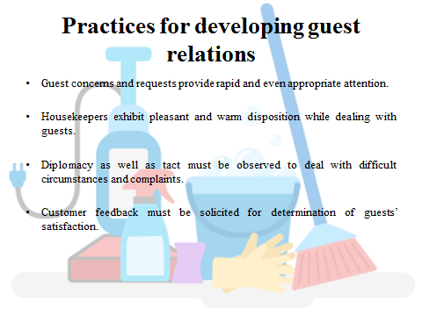
Training Notes:

Customer concerns as well as feedback must essentially be logged down as well as discussed for corrective activity during meetings. This is at prior very essential to listen to the complaints raised by guests patiently. Listening is very important while this comes to guest satisfaction. Be all ears to the guests, while that are complaining, suggesting and requesting. Active listening supports in avoiding miscommunication. This ensures that the expectation of the guests is prominently understood.

Slide 9: Health and Safety in Hotels
- Training the staff regarding safety and health protocols is effective.
- The team leader must always communicate with guests about emergency plans (Robina-Ramírez et al., 2021).
- The housekeepers must aware guests about potential hazards in hotels.
- Occupational safety committee can be developed for the guests’ welfare.

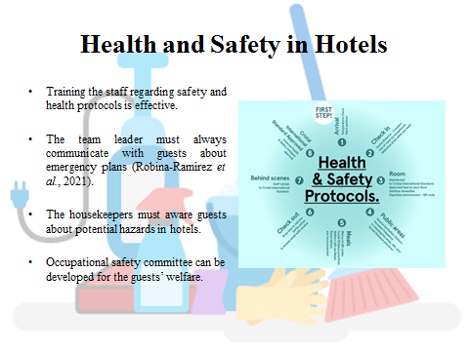
Training Notes:

Following these strategies would be very effective to maintain safety and healthiness in the hotel premises. Precisely the safety committee will daily address deficiencies in hotel’s health and safety protocols.

Slide 10: Conclusion
- Housekeeping is considered as the hidden secret to hotel’s success.
- Employees and guests must be a perfect perceiver of this aspect in hotels in order to ensure better business deliverables.
- Modern hoteliers should be extensively focused on housekeeping to thrive.

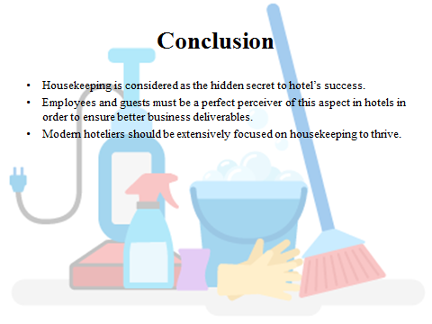
Training Notes:

Housekeeping might go unperceived; however, this work behind the scenes is regarded as the most crucial component to achieve guest satisfaction and generate positive impression.

Slide 11: References

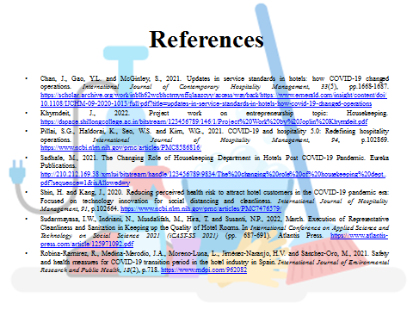

References
Alzate-Galiza, D.M.E.L., (2020).Customer Care Practices of Standard Hotels in Northern Philippines: A Stakeholders’ Perspective.https://www.jcreview.com/admin/Uploads/Files/61c8da5967aa83.19388270.pdf
Chan, J., Gao, Y.L. and McGinley, S., (2021). Updates in service standards in hotels: how COVID-19 changed operations. International Journal of Contemporary Hospitality Management, 33(5), pp.1668-1687.https://scholar.archive.org/work/inblh62wcbhctmynffqlaazcyy/access/wayback/https://www.emerald.com/insight/content/doi/10.1108/IJCHM-09-2020-1013/full/pdf?title=updates-in-service-standards-in-hotels-how-covid-19-changed-operations
Choirisa, S.F., (2022). The impact of the Covid-19 pandemic on the hotel industry in Indonesia. Economics, Management and Sustainability, 7(1), pp.86-94.https://jems.sciview.net/index.php/jems/article/download/172/102
Choy, M., Cheng, J. and Yu, K., (2021).Evaluating the environmental sustainability strategies of the housekeeping department: the case of an international hotel chain in Hong Kong, China. Tourism Critiques: Practice and Theory, 2(1), pp.115-132.https://www.emerald.com/insight/content/doi/10.1108/TRC-01-2021-0001/full/pdf
Fuhrken, F.F., (2022). How can business process automation prepare Hotels to increase productivity in a growing digital world?. Signature.https://www.modul.ac.at/uploads/files/Theses/Bachelor/Undergrad_2022/BBA_2022/1811001_FUHRKEN_Felix_BBA_Thesis.pdf
Khymdeit, J., (2022). Project work on entrepreneurship topic: Housekeeping.https://dspace.shillongcollege.ac.in/bitstream/123456789/146/1/Project%20Work%20by%20Joplin%20Khymdeit.pdf
King, N.M., (2020). Future of Philippine Online Residential Cleaning Services: A Technology Foresight through Scenario Building (Doctoral dissertation, University of the Philippines Diliman).https://www.academia.edu/download/63441338/TM_299_-_project_report_-_KING_-_2604202020200527-15250-1wzczy1.pdf
Olimovich, D.I., Bakhtiyorovich, T.M. and Salimovna, N.G., (2020). Improving of personnel training in hotel bussines. Academy, (2 (53)), pp.18-19.https://cyberleninka.ru/article/n/improving-of-personnel-training-in-hotel-bussines.pdf
Pai, A., Manjunath, M., Kowshik, C.S., Ayedee, N., Malarout, N. and Naik, N., (2020).Soft Skills As A Key Competency For The Future Leaders Of The Hospitality Industry. PalArch's Journal of Archaeology of Egypt/Egyptology, 17(9), pp.4341-4355.https://archives.palarch.nl/index.php/jae/article/download/4607/4556
Pillai, S.G., Haldorai, K., Seo, W.S. and Kim, W.G., (2021). COVID-19 and hospitality 5.0: Redefining hospitality operations. International Journal of Hospitality Management, 94, p.102869.https://www.ncbi.nlm.nih.gov/pmc/articles/PMC8586816/
Robina-Ramírez, R., Medina-Merodio, J.A., Moreno-Luna, L., Jiménez-Naranjo, H.V. and Sánchez-Oro, M., (2021).Safety and health measures for COVID-19 transition period in the hotel industry in Spain. International Journal of Environmental Research and Public Health, 18(2), p.718.https://www.mdpi.com/962082
Sadhale, M., (2021).The Changing Role of Housekeeping Department in Hotels Post COVID-19 Pandemic.Eureka Publications.http://210.212.169.38/xmlui/bitstream/handle/123456789/9834/The%20changing%20role%20of%20housekeeping%20dept..pdf?sequence=1&isAllowed=y
Shin, H. and Kang, J., (2020).Reducing perceived health risk to attract hotel customers in the COVID-19 pandemic era: Focused on technology innovation for social distancing and cleanliness. International Journal of Hospitality Management, 91, p.102664.https://www.ncbi.nlm.nih.gov/pmc/articles/PMC7476579/
Sudarmayasa, I.W., Indriani, N., Musdalifah, M., Hira, T. and Susanti, N.P., (2022), March.Execution of Representative Cleanliness and Sanitation in Keeping up the Quality of Hotel Rooms.In International Conference on Applied Science and Technology on Social Science 2021 (iCAST-SS 2021) (pp. 687-691).Atlantis Press.https://www.atlantis-press.com/article/125971092.pdf
Sulaiman, D. and Limbing, L.P.B., (2019). Professionalism and Entrepreneurial Action Housekeeper Hotel. Jurnal Entrepreneur dan Entrepreneurship, 8(1), pp.13-18.https://journal.uc.ac.id/index.php/JEE/article/download/1112/911
Sunil, L., Ashish, D., Archana, D. and RC, P., (2022). Maintaining hygiene and sanitation in food handlings areas of hotels amid covid-19 outbreak. Education, 30(81.13), pp.18-86.https://jmpas.com/admin/assets/article_issue/1656872016JMPAS_MAY_-_JUNE_2022.pdf
Tra, T., (2020). Action plan for training new Housekeeping Employee: case: Hotel Indigo Helsinki.https://www.theseus.fi/bitstream/handle/10024/343779/ACTION%20PLAN%20FOR%20TRAINING%20NEW%20HOUSEKEEPING%20EMPLOYEE.pdf?sequence=2
Tran, N., (2020). Future expansion of bTaskee Limited Company's on-demand household service in Malaysia.https://www.theseus.fi/bitstream/handle/10024/341913/Tran_Nhung.pdf?sequence=3
Whiting, R. and Symon, G., (2020).Digi-housekeeping: the invisible work of flexibility. Work, employment and society, 34(6), pp.1079-1096.https://journals.sagepub.com/doi/pdf/10.1177/0950017020916192
Yu, J., Fang, Y., Zhong, Y., Zhang, X. and Zhang, R., (2022).Pricing and quality strategies for an on-demand housekeeping platform with customer-intensive services. Transportation Research Part E: Logistics and Transportation Review, 164, p.102760.https://ink.library.smu.edu.sg/cgi/viewcontent.cgi?article=8070&context=lkcsb_research

