

Mark Jones

Assignment 1 – programme control

School: Built Environment
Subject: Construction management

Hand In date: 04/05/2020
Lecturer: Deborah Hughes

2020

Contents

Task 1 3
Task 2 3
Task 3 6
Task 4 9
Task 5 12
References 15
Figures 16

Task 1
See attached document of Gantt chart showing critical path, demonstration how tasks overlap, and the floats established for tasks.

Task 2
The software utilised was Asta power project, this software was used to show the distribution of labour demonstrating how many workers were appointed to each task along with the estimated duration. Although due to Covid-19 restricting access to the IQ building the Gantt chart was uncompleted, therefore a distribution of plant and materials is shown in the table below (figure 6). The table also estimates a costing for each resource, allowing for an estimate of cost for the development. The costings were analysed through the use of the Spon’s book (2018), personal experience and case studies similar to the proposed development.
Estimated costings including distribution of resources (duration specified on Gantt chart, separate document)
Tasks | Estimated cost (including labour, plant and material)
Preconstruction stage | -
Initial discussion with client | £500
Land survey and preliminary | £3206
Plan design | £20000
Landscaping design | £3100
Bidding and submittals | £2460
Permit, licence and contracts | £1780
Site planning | -
Site layout considerations | £956
Walkways for students and workers | £750
Site access and boundary hoarding | £8600
Site entrance and exit, security and delivery route installation | £4500
Site offices welfare container facilities | £18000
Machinery equipment delivery to site | £36000
Site preparation | £890
Foundations | -
Excavation | £12100
Pile construction | £42700
Pile cap construction | £13450
Raft construction | £23600
Foundation inspection | £400
Backfill | £800
Below ground services/drainage | -
Identification of nearby services | £500
Underground services installation | £39900
Drainage system installation | £17600
Connection between new and nearby services | £890
Frame | -
Continuous scaffolding | £36000
Substructure construction | £145000
Super structure – concrete frame | £99500
Superstructure cure concrete and strike/false work | £39800
Superstructure steel frame | £36700
Ground floor slab build up | £13800
Upper floors and stairs construction | £54000
Frame inspection | £1000
Roof | -
Roof frame construction | £76000
Waterproofing | £49800
Finishes for roof | £67500
Roof inspection | £1500
Envelope | -
Brick plinth | £42900
External wall and cladding installation | £125600
External doors and windows installation | £86000
Entrance features | £38700
External finishes | £69080
Envelope inspection | £2200
Stage 1 internal construction | -
Internal partitioning and door/fame installation | £146000
First fix electrics | £80780
First fix plumbing | £13210
First fix lift core | £45800
First fix suspended ceiling | £59800
First fix HVAC | £38900
First fix floor construction | £63420
Inspection | £1600
Initial hard and soft landscaping | £38700
Stage 2 – internal construction | -
Wall finishes | £97000
Second fix plumbing | £58900
Second fix electrics | £87600
Second fix lift installation | £49600
Second fic HVAC | £45600
Protective/safety equipment installation | £27700
Inspection | £1000
Landscaping | -
Carpark construction | £57800
Walkways and floor pavers | £52000
Road construction | £39000
Lamp post installation | £17800
Landscaping finishes | £70800
Finishes | -
Floor finishes | £46800
Suspended ceiling finishes | £24690
Other finishes (general fixings etc) | £30600
Internal glass installation | £21000
Fit out | £53900
Final external drainage finishes | £37800
Final inspection/checks | -
Safety equipment checks | £2600
Inspection of overall services | £2600
Snagging | £8900
Inspection of works by client | -
Site removal | -
Site hoarding removal | £200
Site offices and welfare facilities removal | £200
Site machinery and equipment removal | £200
Completion | -
Contract completion | £400
Handover | -
Estimated project cost = | £2,560,662

Figure 6 – Distribution of resources and cost

The calculations in figure 6 show the estimated cost of works with labour rates included, although there are certain professionals who will remain on site from the beginning of the project through to the completion date.
- Project manager
- Quantity survey
- Site manager

The individuals who will remain on site at all times will need to have their wages calculated separately, their rates can be seen in figure 7 this will add to the estimated total. Once the new total has been calculated then a 10% sum should be added on top for any potential hazards or unforeseen threats.

Job title | Hourly rate (£) | Weekly Rate (£)
Architect | Price work | Price work
Architectural technologist | Price work | Price work
Quantity surveyor | £27.98 | £1091.22
Project manager | £27.41 | £1068.99
Trainee Structural engineer | £9.12 | £355.68
Site manager | £21.78 | £849.42
Trades man | £19.32 | £753.48
Specialist | £15.46 | £602.94
Concrete form worker | £15.78 | £615.42
Steel fitter | £14.34 | £559.26
Labourer | £8.97 | £349.83

Figure 7 – Pay grades

Task 3
Incentivisation
Incentivisation is the act whereby the two parties will agree an incentive to motivate a party to do something more efficiently, this is used commonly by the client in construction to enhance the productivity of the contractor (workforce) usually agreed within a contract at the beginning of a project. There are two common forms of incentivisation as stated by Constructingexcellence. (2000), Financial incentives and psychological. Financial incentives can be separated into two groups ‘hard and soft’. Hard incentives aim to provide benefit to the client through money or duration for example, an incentive may be given to the contractor to finish a task early inevitably increasing production for the client and in return this would benefit financial performance. Soft incentivisation would include the contractor increasing production by providing regular training courses to the workforce, aiming to increase quality of work this in return:
“may provide the contractor with repeat business from the same client, attract other (new) clients to use that contractor giving the contractor a commercial advantage” Constructingexcellence. (2000).
Psychological incentivisation as explained by Constructingexcellence. (2000) is where the client incentivises contractors without financial profit, the contractor benefits form recognition, encouraging feedback, the promise of appointing them the main contractor for future work and job promotion etc. This type of incentivisation is less common in construction as it is already expected if the contractor preforms their work correctly, therefore the type of incentives recommended to the client will be financial.
The purpose of incentives is to motivate a party, to return benefit the client. The advantages to incentivisation are:
- “To increase productivity,
- To drive or arouse a stimulus work,
- To enhance commitment in work performance,
- To psychologically satisfy a person which leads to job satisfaction,
- To shape the behavior or outlook of subordinate towards work,
- To inculcate zeal and enthusiasm towards work,
- To get the maximum of their capabilities so that they are exploited and utilized maximally.” Managementstudy (2017).

It is known that incentives can be positivise or negative, Pinsentmasons (2019) states that positive incentives can be used in construction to incentivise the contractor with regards to cost, time and quality, this will directly benefit the client as the contractor will ultimately aim for the best possible result. Negative incentives are used to motivate the contractor from aspects such as liquidation or loss of work etc, these will not bring the client any tangible benefits although will encourage the contractor undertake the work efficiently. This type of incentive, is less suited towards the client as the contractor is agreeing to do “something that would have been achieved anyway as a result of the threat of the penalty” Pinsentmasons (2019), and the contractor would see negative incentivisation as another contractual device to improve performance with no tangible reward. This will increase the complexity of the contract in return possibly enhancing the chance of the client getting into a dispute with the contractor.
The aim of the incentivisation scheme is for both the client and contractor to set clear objectives (exactly what the project requires), clear targets (which sub/contractor) clear incentive (what is the positive or negative incentive) and lastly measure how successful the undertaken work is and reward each party. The success rate determined by the client should allow them to know if it was beneficial and profitable and if the scheme should be utilised again.
There are different types of contracts the client may wish to utilise in order to achieve ultimate quality, cost and time of a project. JCT provide a contract whereby clauses can be added to incentivise the contractor to exceed the target of works, the clause ‘cost savings and value improvement’ encourages the client to negotiate an amount to be paid to the contractor if work is surpassed. Keeley, A and Gantley, M (2018) express that if the client incorporates incentives early to both the contractor and sub-contractor on a construction project benefits are more likely as all parties have the opportunity to begin with a high quality of work to progress throughout the project.
Pinsentmasons (2019) adds that the new “NEC4 Alliance” Contract, is capable of balancing the positive and negative incentives to achieve optimal performance for the client. The Contract uses positive incentives whereby if the contractor surpasses the agreed target and the client benefits, then the client provides the agreed incentive. The contract also integrates negative incentive stating that if the agreed targets are not met then the contractor will either go into liquidation or the client will be reimbursed. This type of contract utilises a performance table to work out the amount that the client or contractor must pay depending on which incentive is applied (positive or negative), it is a useful contract ideal for ensuring cost, quality and time, therefore it is the recommended contract to the client for incentivisation.
Performance indicators are common in construction contracts, Cips.org. (2006) state that they are used by the client to allow the contractor to decide how much profit they potentially earn. The client will describe in the contract what work is poor, satisfactory, good or excellent in order to allow the contractor to determine how much of a profit they will receive. A distinguished price will be allocated for each grade and the contractors work (once undertaken) will establish what price they obtain. From the contractor agreeing to the indicators, he/she is taking on much risk as the level of work is rated by the client. “It is normal to balance such schemes so that the amount the supplier puts at risk (the downside) is equal to the amount they could earn over and above the normal margin expected for a satisfactory or good performance (the upside)” Cips.org. (2006).
There are many individuals who do not agree with incentivisation statin the disadvantages as:
- Lack of production – whereby individuals believe that the higher the incentives the less production is generated by the workforce.
- Often work is rushed and quality is worsened
- It can encourage individuals to cut corners and can results in work being poor or uncompleted.
- If tasks are repeated often a contractor may decide to focus on achieving a minimum standard repeatedly to ‘get the job done faster’ potentially achieve more financial gain than if the contractor takes his/her time.

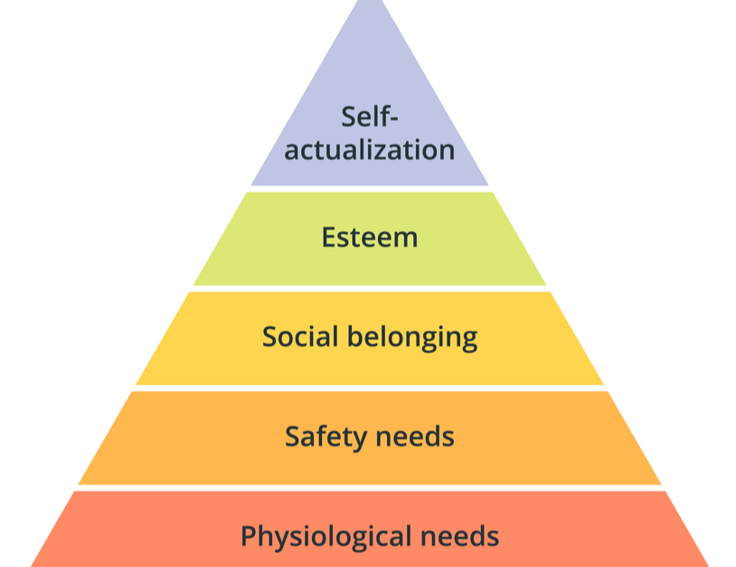
Figure 4 – Pyramid of need. Darge, G (2019)

The pyramid of need as shown in figure 4 explain the requirement for needs before self-actualization is achieved. The pyramid is general although can be focused and analysed from a construction point of view, the client may wish to familiarise themselves with the main stages in order to create a contract between parties that is beneficial to the sub/contractor which in return would benefit the client. The concept is that the client should set objectives that revolve around these stages, not setting standards that are too strenuous or unachieved able, reassure with safety of position in workforce and ultimately reward and praise for good quality work.
Conclusion
To increase or improve production, incentivisation is key for a client when trying to enhance the quality of work. Therefore Time, cost and quality become major factors to consider in the incentivisation scheme. In my opinion the client should include ‘hard’ financial incentives into the contract and ensure the contract incorporates both positive incentives along with negative incentive, although this will be determined by the type of contractor selected. If positive and negative incentive would be added into the contract, then a NEC4 Alliance contact would best suit. “this contract is different from the others within the NEC4 suite as it is a multi-party contract with an integrated risk and reward model” Neccontract (2020). As the library will mainly need to focus on quality, incentivisation is vital it will allow the client to achieve good quality work and potentially allow for a fast and cheaper project as performance tables allow for the client to determine how much the contractors earns on how well they achieve the objectives and targets set. The less skilled/ poor contractors will potentially not want to get into an agreement if the correct negatives incentives are established. Performance indicators are recommended for this type of construction also as quality is vital, in my opinion it should be agreed early on that performance indicators are set into each task (e.g. foundations, frame, stage 1, stage 2, finishes) therefore quality will be maintain throughout the whole construction.

Task 4
Figure 1 represents the whole view of the area, highlighting the development site, the university, car park and access road. The image shows the safe zone for public (university students) with a dashed line, this illustrates the construction zones where there may be hazards apparent. The site will have banners/poster located on the hoarding to warn students and public of the work being undertaken on site. The site will provide leaflets and send emails to every student and lecture in the university informing them of the work that is proposed and the potential hazards the construction may arise. The scaffolding on the development will utilise safety nets around the building to prevent any falling objects, this will in return prevent any injuries to workers along with providing safety to the public/students.
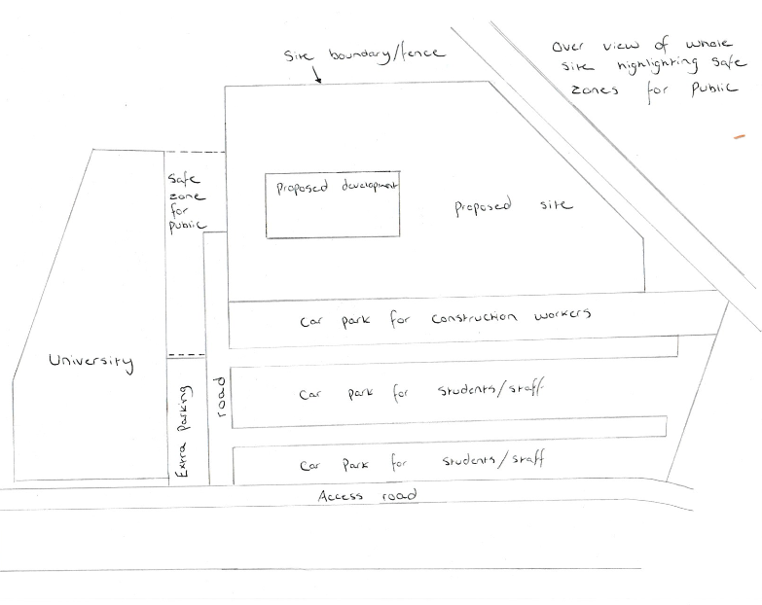
Figure 1 – Overview

Figure 2 represents the focused in view of the proposed site, public access will not be permitted without having an accompanied member of staff or without the relevant PPE. The site fencing will be totally enclosed meaning only access from the main entrance will be available, where security will only let certain individuals in. A delivery route is highlighted along with turning bays to channel where the lorries have access. Again, a safe working zone is shown with dashed lines to represent the area machinery and equipment should not be operating in. The scaffolding and hoist system is shown along with all the active materials displayed around the site; these will be the only things that are continuously moving to suit the needs of the construction. Storage and secure storage have been added throughout the site to protect valuable content on site at all times, these will be locked when the site is not in use. Welfare facilities and offices are shown in figure 2, these will not move through the construction stages of the development. Wheel washing facilities have also been added in to prevent dirt escaping the site and ruining the public roads.

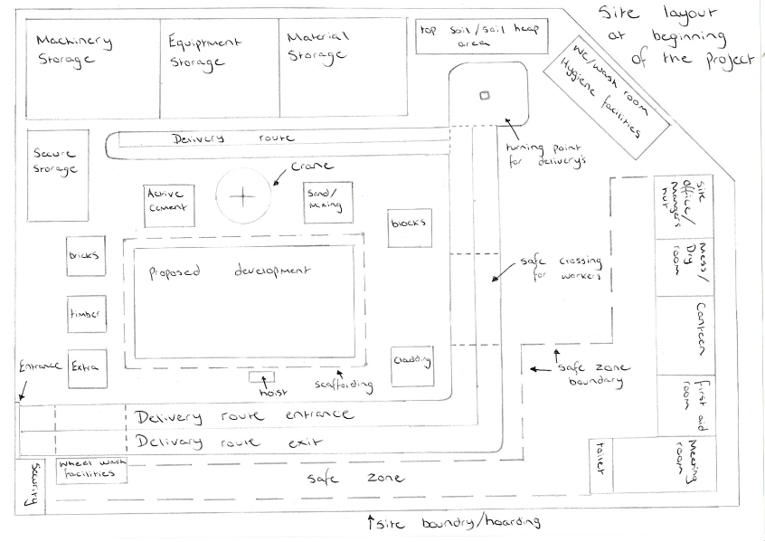
Figure 2 – Focused view of proposed site

Figure 3 illustrates the site after the main construction stage, when the landscaping stage is active. This site layout protects the public by only allowing access through the main door straight to the car park. This is done through channelling the site boundary to allow space in the front of the IQ building for construction work. The site layout changes slightly as the entrance moves and delivery route adapts, security will need to change to suit the entrance and the wheel washing facility is removed all together. This layout will only be for two months towards the end of the project.
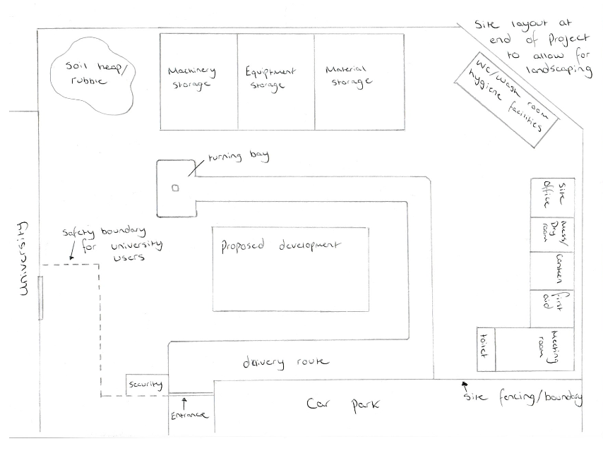
Figure 3 – Focused view of site after initial construction stage.

Task 5
The client needs to bring the project in according to the original completion date, which is 2 weeks earlier than the programme you have produced. What suggestions could you make to the client to achieve this.
As the new development needs to be completed two weeks earlier than the original completion date different approaches will need to be considered that do not affect the projects schedule of works drastically, along with not altering the cost of the project significantly. Although by adding in additional labour, plant and resources there is inevitable going to be a change in cost. Direct costs (plant, materials, sub-contractor) will be affected along with in-direct costs (inspection, preliminaries), therefore the need to workout how much the project cost will change is vital. There is a range of approaches that can be utilised to shorten the programme:
- Critical path revaluation
- Additional (plant and material)
- Prefabricated construction
- Overlapping tasks
- Increased working hours
- Working over weekends
- Additional supervision/inspections
- Additional faster operating machinery can be utilised

Critical path
The objective would be to find the critical path and correctly utilise it to shorten the duration, obviously the critical path is the longest duration possible and by creating a critical path it will highlight the float for each task that is not included in the critical path. This can be analysed and resources can be distributed into the critical path tasks to reduce the amount of time each task takes. There are only four roofers on the waterproofing and slating task for the roof, therefore a suggestion to the client would be to increase the amount of workers to double, which would in return reduce the initial 7 week duration to 3 ½ weeks. Although this form of resolving an issue may arise another by having too many workers on the same task, this will mean overcrowding of one area and the increased chances of employing poor roofers.
Tasks can overlap
Tasks overlapping would be an ideal solution to the duration issue, it will allow tasks to start earlier than expected, overlapping other tasks meaning work does not need to stop. The Gantt chart currently overlaps many tasks in order to achieve a quicker completion date therefore it will need to be analysed further in order to gain two weeks.
Currently the landscaping tasks are not overlapped with any other tasks, this is due to the close proximity of the IQ building being used by students/lecturers and the fact that machinery is commonly used around the site which would prevent labourers laying paths and walkways. Therefore, the landscaping tasks can be reorganised in order to achieve a two-week early finish. The carpark construction (in landscaping) is illustrated as a four-week task and has been highlighted as a critical task that can be moved. Therefore, it will be brought forward to start the same date as “Stage 1 – initial construction” freeing up an added four weeks. Although this will mean that some of the car park used by students, lecturers and construction workforce will be sectioned off to allow for construction works.
The “external door and window installation” task is already overlapping the “envelope” task by five days, although it can be brought forward by another 10 days (2 weeks) as it is a task that can start earlier, the only downfall is there will be two ‘gangs’ working at a close proximity, this will decrease the finish date by two week without major disruption.
Added hours
Another approach for accelerating a construction programme would be to introduce longer working hours and working on the weekends for the workforce, this will inevitably reduce the overall time of a construction project. Although by introducing ‘overtime’, rate of pay for each workforce member will increase. This as a result will affect the direct costs producing a more expensive construction.
Conclusion
The suggested option for gaining two weeks on the proposed development would be to adopt a number of approaches in order to not disrupt the schedule excessively. Firstly, The Gantt chart (separate document provided) illustrates the critical path therefore a task form there will need to be selected that can afford to be modified. After analyses, the task best suited was the “roof - waterproofing and slating” task, this task is initially 7 weeks long. The aim is to double the workforce on the site for that task (from 4 roofers and 4 labourers to 8 roofers and 8 labourers), this approach will inevitably speed up the construction task (re-calculated to 3½ weeks) see figure 5.

Before acceleration
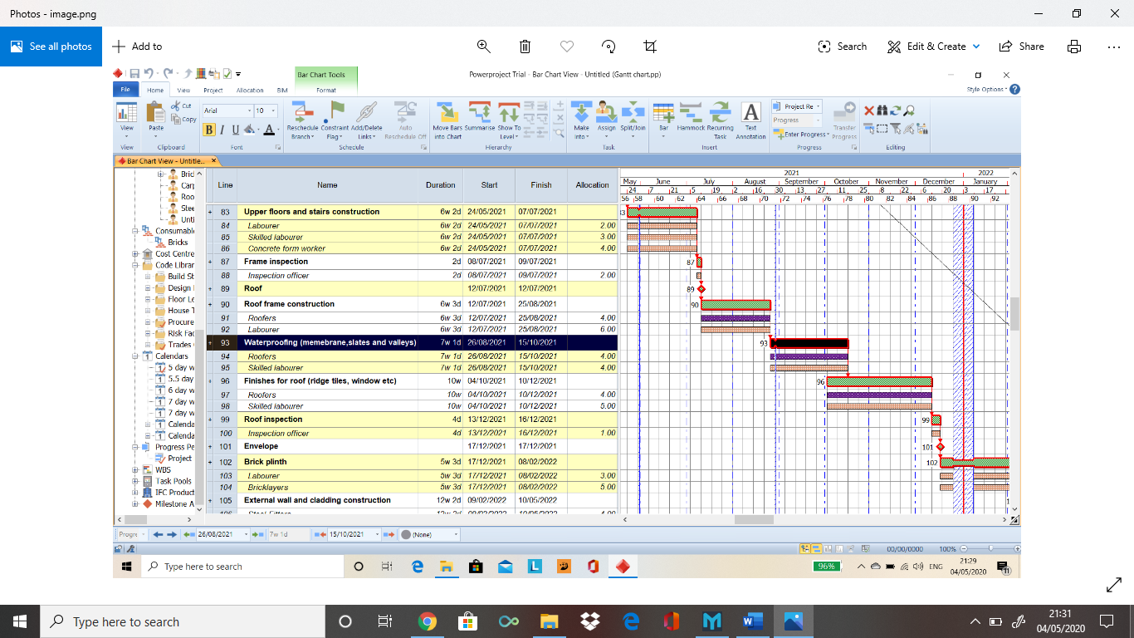
Figure 8 – Roof – waterproofing task before alterations

After acceleration
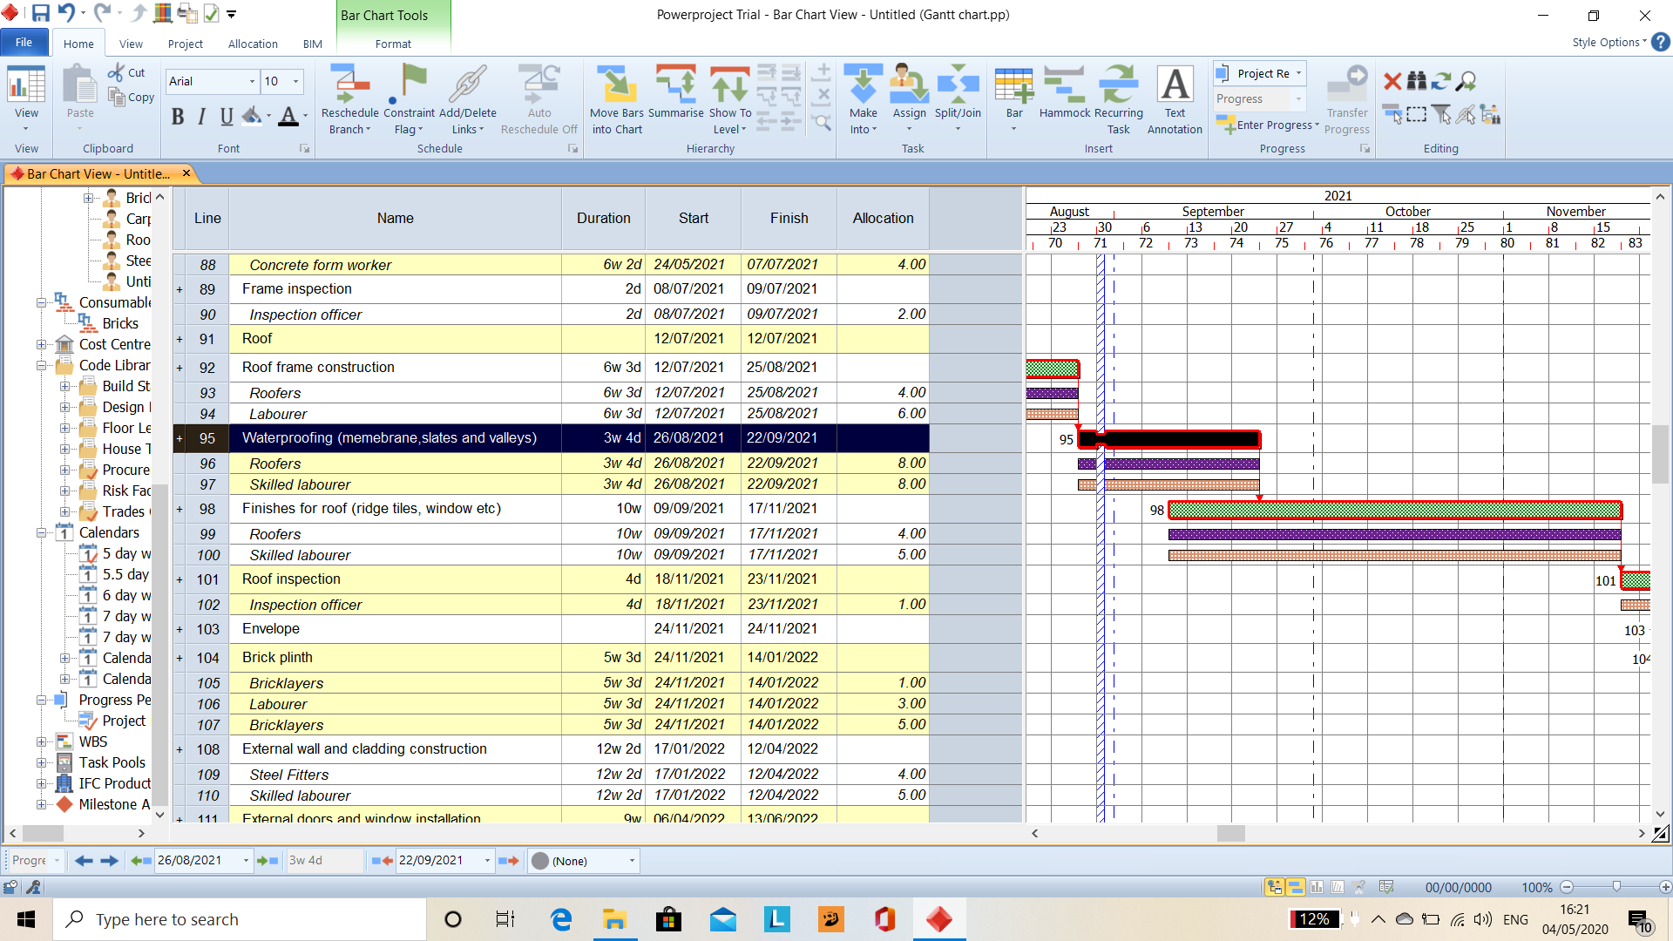
Figure 5 – Accelerated Gantt chart task (two-week acceleration)

As an added approach to ensure that work is accelerated for the extra two weeks, the working hours for the workforce will be extended from 6am – 8pm, this will ensure that the aim (2 weeks acceleration) is met. Although from introducing these approaches it will certainly increase the overall cost of the project, mainly affecting the direct costs. This approach may reduce quality if the workforce are trying to ‘rush’ the task, therefore a good idea would be to incentivise the roofing workforce to complete the job, with high quality (through the use of performance indicators) allowing all stakeholders to benefit from the acceleration.

References

Cips.org. 2006. [online] Available at: <https://www.cips.org/Documents/Resources/Knowledge%20Insight/Incentivisation.pdf> [Accessed 3 April 2020].
Constructingexcellence. 2000. [online] Available at: <https://constructingexcellence.org.uk/wp-content/uploads/2015/03/D6Disc-inc.pdf> [Accessed 3 April 2020].
Darge, G., 2019. Why Recognition Is The Secret Behind Self-Fufillment | Perkbox. [online] Perkbox. Available at: <https://www.perkbox.com/uk/resources/blog/recognition-self-fufillment> [Accessed 3 April 2020].
Keeley, A. and Gantley, M., 2018. Legal: Incentivising Innovation. [online] Building. Available at: <https://www.building.co.uk/new-technology/legal-incentivising-innovation/5094228.article> [Accessed 3 April 2020].
Managementstudy 2017. Motivation Incentives - Incentives To Motivate Employees. [online] Available at: <https://www.managementstudyguide.com/motivation_incentives.htm> [Accessed 4 April 2020].
Neccontract.com. 2020. NEC4: Alliance Contract - NEC Contracts. [online] Available at: <https://www.neccontract.com/NEC4-Products/NEC4-Contracts/NEC4-Alliance-Contract> [Accessed 3 April 2020].
Pinsentmasons.com. 2019. [online] Available at: <https://www.pinsentmasons.com/out-law/analysis/using-incentives-to-drive-contractor-behaviour> [Accessed 3 April 2020].

Figures

Figure 1 - overview
Figure 2 - Focused view of proposed site
Figure 3 - Focused view of site after initial construction stage.
Figure 4 - Pyramid of need, Darge, G (2019)
Figure 5 - Accelerated Gantt chart task (two-week acceleration)
Figure 6 - Distribution of resources and cost
Figure 7 - Pay grades
Figure 8 - waterproofing task before alterations

