Lab 8
cisco@ubuntu:~$ cd Downloads/
o Enter libreoffice secret.odt & at the prompt to view the document.
▪ cisco@ubuntu:~/Downloads$ libreoffice secret.odt &
Here, & is used to append the operation to run in background
What is the message in the secret.odt?
”The secret document”
cisco@ubuntu:~/Downloads$ gimp keyboard.jpg &

cisco@ubuntu:~/Downloads$ steghide embed -cf keyboard.jpg - ef secret.odt
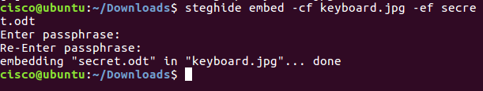

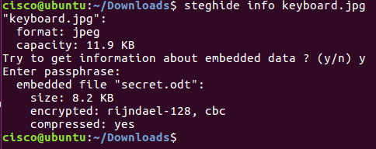

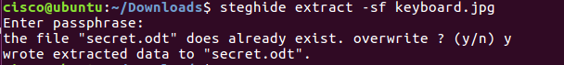

Task 1
Password: Password
HIYA!!! Great work - You deserve a PIZZA!!!

